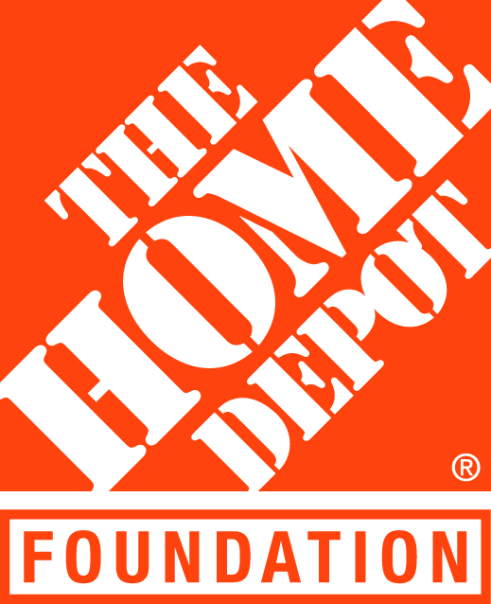
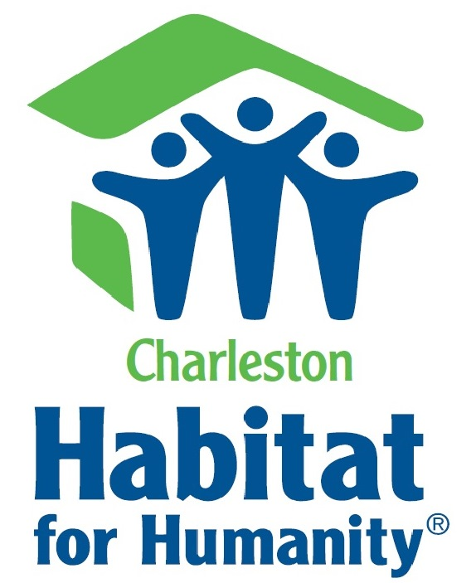

Contact:

Nancy Lee
Charleston Habitat for Humanity
O: 843.203.4025
C: 864.884.1657
nancy@charlestonhabitat.org

November 9, 2016
Charleston Habitat selected to participate in 2016 Repair Corps program to help local veterans
Habitat for Humanity and The Home Depot Foundation partner to help build or repair homes of U.S. military veterans and their families through Charleston Habitat’s Repair Corps program
Charleston, SC– Charleston Habitat for Humanity has been selected to participate in Habitat for Humanity’s Repair Corps program, an initiative funded by The Home Depot Foundation to help build, rehabilitate or repair homes in partnership with U.S. military veterans and their families.
Charleston is one of more than 45 communities across the country that will partricipate in more than 200 projects slated to take place as part of the 2016 program. York County Habitat for Humanity was also selected to represent South Carolina in this round of funding and programmatic work.
“By providing safe, affordable home repair options to local veterans, we are able to do our small part in honoring the impact these courageous men and women have made on our lives,” states Jeremy Browning, Executive Director of Charleston Habitat for Humanity. “We are honored and humbled to receive this funding to support the state’s first Veterans Build intiative.”
Habitat’s Repair Corps projects range from new construction to critical home repair, such as weatherproofing, installation of access ramps and kitchen or bathroom renovations for wheelchair access. Applications will be posted at charlestonhabitat.org in December.
Since 2011, The Home Depot Foundation has funded Habitat’s Repair Corp program, which to date has helped repair or renovate the homes of nearly 600 U.S. military veterans and their families nationwide.
About Charleston Habitat for Humanity
Established in 1989, Charleston Habitat for Humanity works to strengthen communities and eliminate substandard housing conditions in downtown Charleston, West Ashley and the City of North Charleston. Charleston Habitat for Humanity builds quality affordable housing in partnership with deserving, low- and moderate-income working families. In the past 27 years, the affiliate has built 82 new homes, renovated 16 houses and supported 45 homes in Honduras - improving over 600 lives through homeownership. More than 1,000 volunteers invest more than 4,000 volunteer hours per house to make safe and affordable housing a reality for Charleston residents.

About Giving Back at The Home Depot
Since the first The Home Depot store opened in 1979, giving back has been a core value for the Company and a passion for its associates. Today, The Home Depot, in partnership with The Home Depot Foundation, focuses its philanthropic efforts on improving the homes and lives of U.S. military veterans and their families and aiding communities affected by natural disasters. Through Team Depot, the Company’s associate-led volunteer force, thousands of associates dedicate their time and talents to these efforts in the communities where they live and work.

Since 2011, The Home Depot Foundation has invested more than $138 million in veteran causes, and along with the help of Team Depot volunteers, has transformed more than 25,000 homes for veterans. To learn more and see Team Depot in action, visit www.homedepot.com/teamdepot.

###

