EXAMPLE: MEDIA ADVISORY 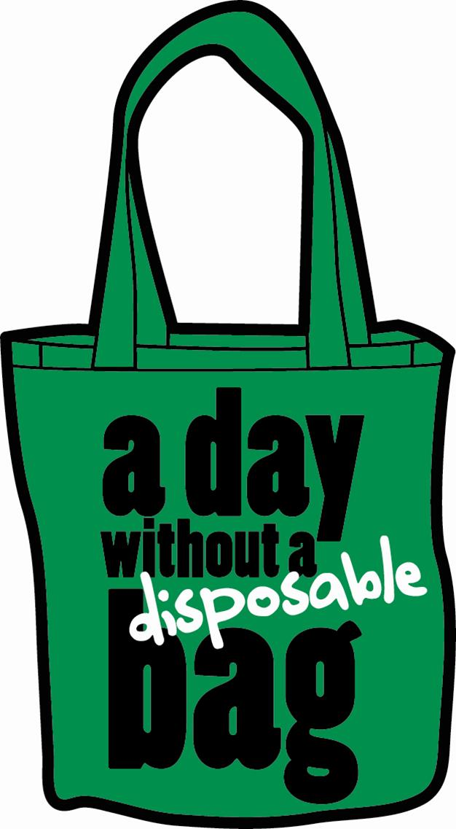

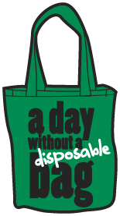
A ‘GREEN’ HOLIDAY
Retailers, cities link to distribute free reusable bags across <<Your county/city/district/neighborhood>>

‘A DAY WITHOUT A BAG’
Thursday, December 17, 2009

WHAT: Example: “Green” Santa Claus, The Bag Monster, and other local elected leaders are scheduled to hand out thousands of free reusable shopping bags to holiday shoppers at more than _ #__ locations throughout (city/county/district/neighborhood)

WHO: Your group/org is organizing the annual “A Day Without a Bag”. A broad coalition of local environmental groups and retailers, including name of participating retailers and environmental groups is conducting giveaways and promotions throughout _ your county/city/district/neighborhood_.

WHY: A gift to the environment, reminding consumers about ecological and economic benefits of using reusable totes rather than single-use paper or plastic bags.

WHERE: Main media sites
    - Place– Time: press conference
Participants, guests and location
    - Place – Time. press conference
Participants, guests and location

Other colorful sites
    - Other events and giveaways

List county and city officials staffing any of the giveaways. See (doc/web page) for times/addresses.

CONTACT:

