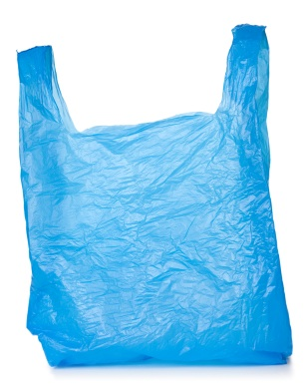
The True Cost of Single-Use Bags

The Guinness Book of World Records has named the plastic bag the most ubiquitous consumer product of 2009 as it is produced on a worldwide scale by the trillions. But what is the real cost of this throw-away consumer item? There is an external cost to provide free bags, not just to the environment, but also to taxpayers and businesses. The best solution is to decrease these external costs by avoiding disposable bags in the first place. Policy approaches, including bans and pollution fees, have proven effective tools to achieve source reduction and positively change consumer behavior.
$?

Plastic Pollution Devalues Our Economy and Threatens Jobs

- Plastic litters our beaches, exacts a toll on our environment, and costs cities money to clean up. In fact, plastic pollution alone is costing developing and industrialized nations up to $1.3 billion annually as it threatens the fishing, shipping and tourism industries.

- Plastic pollution threatens California’s ocean economy, valued at $43 billion. An estimated 408,000 jobs mostly in the tourism and recreation sectors are tied to the Ocean economy.

- The total cost of litter collection, disposal and enforcement in the U.S. is estimated to be at least $11.5 billion annually. Businesses bear the burden of this cost, spending $9.1 billion annually and representing 79.5% of the total cost of litter abatement.

Taxpayers Subsidize Cleanup and Litter Abatement of Single-Use Bags

- Over 123,000 tons of plastic grocery and merchandise bags comprise the California waste stream. This is equivalent to 16 billion plastic bags. Cities have estimated that the taxpayer cost to subsidize the recycling, collection, and disposal of plastic and paper bags amounts to as much as 17 cents per bag. Each year, San Francisco estimates it spends $8.5 million in plastic bag clean up.

- LA County Public Works and Flood Control District reported spending $18 million in litter collection for stormwater pollution prevention and flood control channel cleanup. Litter characterization reports plastic bags make up some 25% of litter stream. In 1994, the County of Los Angeles spent $4 million alone to clean up 31 miles of trashed coastline.

- States, cities, and counties together spend $1.3 billion on general litter abatement. These are taxpayer dollars out of your pocket to subsidize the cost of waste. Much of this money could otherwise be redirected to pay for much needed public services such as parks, libraries, and public safety.

Business and Consumers Pay for ‘Free’ Plastic Bags

- Retailers spend hundreds of millions of dollars annually to provide single-use bags to customers. For example, supermarkets can spend up to $1,500 to $6,000 a month just to provide single-use bags to their customers at the check-out. Even major retailers such as Target and CVS are realizing this significant cost burden and are offering discount incentives to customers who bring their own bags.

- Stores typically pay 2 to 5 cents per plastic bag; these costs are embedded in food prices which are then passed onto consumers.

Paper Bags – Not Much Better for the Environment or Your Wallet
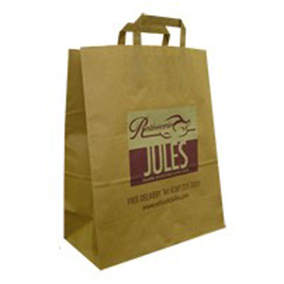
Paper bags are not a good alternative to plastic single-use bags because like disposable plastic bags they come with their own costs to the environment. Although some paper bags contain no old-growth fiber, contain some post-consumer recycled content and are recyclable, the production of most paper bags contributes to deforestation, greenhouse gas emissions, and additional waterborne wastes.

Businesses and Consumers Pay for ‘Free’ Paper Bags

Stores typically pay more for paper bags than plastic, anywhere from 5 to 23 cents per bag; these costs are then embedded in the food prices which are eventually passed on to consumers.

The Solution: Paper or Plastic? NEITHER. Choose to REUSE

The key is getting consumers to avoid using disposable plastic and paper bags in the first place. One reusable bag can replace 600 or more paper and plastic bags over its lifetime.

Several countries and cities worldwide have committed to addressing the single-use bag pollution problem. For example, Bangladesh, Belgium, China, Denmark, Germany, Hong Kong, Ireland, Kenya, Mexico City, Netherlands, New Delhi, India, South Africa, and Taiwan all have imposed fees, taxes, bans, or a combination to encourage consumers to switch to reusable bags, a more sustainable alternative. Collectively, these countries represent an estimated 25% of the world’s population that has committed to reducing single-use plastic bags.

California Integrated Waste Management Board 2008 Waste Characterization Study <http://www.calrecycle.ca.gov/Publications/General/2009023.pdf>
ACC determined 2000 plastic carryout bags weighs 30 lbs. Conversion of 123,000 tons to pounds multiplied by 2000 bags and divided by 30 pounds generates 16.4 billion: http://www.americanchemistry.com/s_plastics/sec_content.asp?CID=1102&DID=5615 (Accessed on 6/21/2010)
References Cited: ? Guinness Book of World Records (2010).“Top 100 Records of the Decade: Most Ubiquitous Consumer Item.”Available at http://2010.guinnessworldrecords.com (Accessed on 1/7/10)
McIlgorm, A., Campbell H. F. & Rule M. J. (2008). “Understanding the Economic Benefits and Costs of Controlling Marine Debris in the APEC region (MRC 02/2007). A report to the Asia-Pacific Economic Cooperation Marine Resource Conservation Working Group by the National Marine Science Centre (Univ. of New England & Southern Cross Univ), Coffs Harbour, NSW, Australia, Dec 2008.
Kidlow, J. et al. (July 2005). “California’s Ocean Economy,” report to the California Resources Agency, prepared by the National Ocean Economics Program.
National Visible Litter Survey and Litter Cost Study (2009). Prepared for Keep America Beautiful, Inc. by Mid- Atlantic Solid Waste Consultants. New Market, MD, Sept. 18, 2009.
City of San Francisco Dept of the Environment “Bag Cost Analysis” (Nov.18, 2004).
City of San Francisco Department of the Environment, “Bag Cost Analysis,” November 18, 2004.
Los Angeles County Flood Control District taken from the LA County Paper Plastic Bag Report: Cost Impact
City of Los Angeles Catch Basin Cleaning (June 10, 2004) taken from LA County Paper Plastic Bag Report: Cost impact
Los Angeles River Trash TMDL, approved by the Los Angeles Regional Water Quality Control Board, Aug. 9, 2007.
National Visible Litter Survey and Litter Cost Study (2009). Prepared for Keep America Beautiful, Inc. by Mid- Atlantic Solid Waste Consultants. New Market, MD, Sept. 18, 2009.
Downing, J. “Free Grocery Bags Targeted for Extinction in California,” Sacramento Bee, Aug. 25, 2008. Estimates from bag manufacturers and the Food Marketing Institute.
Horovitz, B. “Target, CVS Put Plastic Bags in the Bull's-Eye, Pay for Reusables,” USA Today, Oct. 19, 2009.
Los Angeles County (Aug. 2007). “An Overview of Carryout Bags in Los Angeles County: Staff Report to the Board of Supervisors,” Table 9. Based on assumption that average person uses about 600 plastic bags per year.
Australian Department of the Environment and Heritage Plastic Shopping Bags – Analysis of Levies and Environmental Impacts Final Report, prepared by Nolan-ITU, December 2002, Page 33; U.S. Energy Information Administration, U.S. Department of Energy, “Energy-Related Carbon Emissions in the Paper Industry, 1994,” (Retrieved 12/31/08); U.S. EPA Toxic Release Inventory 2006 data for Paper Industry-NAICS code 322. (Retrieved 12/31/08).
Los Angeles County (Aug. 2007). “An Overview of Carryout Bags in Los Angeles County: Staff Report to the Board of Supervisors,” Table 9. Based on assumption that average person uses about 600 plastic bags per year.
World Development Indicators 2008 population estimates. Available at: www.web.worldbank.org

