January 28, 2015

Dear

As the president of the board of Sacred and Profane I would like to request your help in our fundraising effort: we need names and addresses of people, friends or family of yours to whom we may send our yearly donation letter. Historically, our donors come from the immediate circle of colleagues, friends, parents, and grandparents of our singers. Some of our donations are as small as $25 – and they are very welcome. When the group changes or expands, we need to update our list. If you have the names and addresses (plus ZIP codes) ready – please give them to George-Ann right away. If you do not have the correct address at hand right now – fill out the names only and we will contact you by email for further information. You can check your contacts against our current donor list.

Thank you so much for your help!
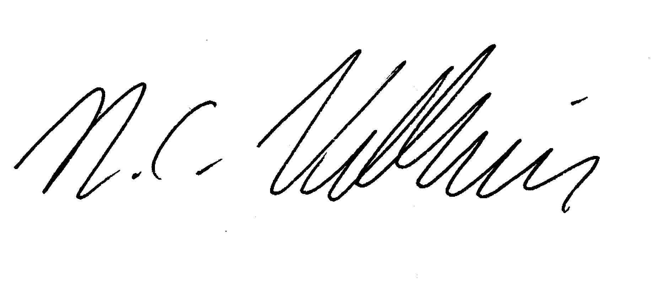
Sincerely,

Niek Veldhuis
Board President, Bass

Name | Street | Place | ZIP

