Mexico Ministry Trip
April, 2015
Tim Roehl

Prelude
I had the privilege of training Steve Cosslett and Jonny Forsythe, part of our OMS missionary team in Mexico, with basic coaching skills and as Grip-Birkman coaching skills at OMS HQ in December of 2014. They enjoyed the training so much that they asked me to come do training for leaders in Mexico. In addition, OMS Mexico missionary Margaret Neff has been a friend for a long time, and she said she’s been praying for me to come to Mexico. So, a trip to Mexico City came together!

As with most international trips, planning took place over a period of months with many Skype calls and emails. I always pray for and ask to leverage trips like these to serve as many people as possible while I’m there. This trip turned out to be four scheduled opportunities to minister, and then whatever “divine appointments” the Lord had on His schedule! I have learned that although we have a “schedule” I’ve got to stay flexible and sensitive to whatever the Lord has in mind.

I was able to invite Jose Banales to join me for this trip, too. Jose traveled with me to Mozambique in September 2014. He asked if we could do the training together again…and I’m glad to have him. Jose and Audrey lived in Mexico as missionaries for several years and travels there regularly leading work teams. Having Jose as a guide and translator will be wonderful.

I found plane tickets for a great price. Jose is flying a different airline from Tulsa, but we’ll get into Mexico City close to the same time.

Day One, Monday, April 5th
We had our family all together at Easter for the first time in a long time! Aubrey, Dylan, Ian and Xavier came from Iowa and Elise and her boyfriend Tim Morris came from Minnesota. What wonderful time we all had together!
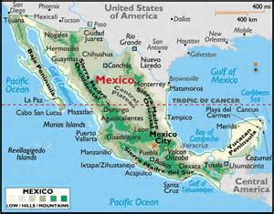
My flight left on Monday morning very early…up at 3:30 am and to the airport by 5:30. When you are packing for 10 days and four different training events, it’s a challenge to know how to pack. I got everything into three bags, including nearly 100 pens as small gifts for folks I’ll be training. It was an early start, but my main concern was flying through Chicago, which is notorious for flight delays. Sure enough, our flight was delayed about an hour, but not too bad. The cool thing was that when I arrived in Mexico City after a four hour flight, I met Jose in the immigration/passport line! Perfect timing!

Margaret Neff was there to greet us…sure good to see her! We exchanged some money—14.5 pesos to the dollar. I always try to get some gifts for family and sometimes supporters. My rule of thumb: affordable and portable. We had a meal at the airport…my first “tacos al pastor”…taco meat on a spit. It was good.

We’re staying at the seminary building…about an hour from the airport. Mexico City is beautiful, crowded...bustling! It is a city built on many hills…about 30 million people, so roads are crowded. Many vendors selling food, knick knacks, cold drink and other things are ever-present at stop lights. We can see an active volcano in the distance.
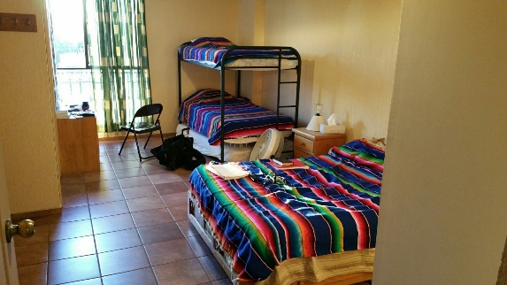
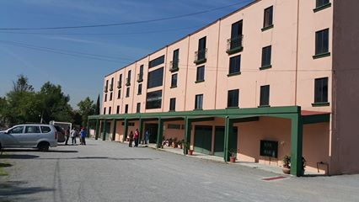
We got to the seminary. It’s a beautiful building…three stories. We’re on the top floor (and Mexico City is at 7,500 feet elevation, so you can tell it when you climb the steps!), where one side is several bedrooms and a nice kitchen/living room area. I’ll have a nice bedroom with a bathroom, a hot shower and internet. It’s nicer than I expected. This will our home base for most of the trip.

(The rest of these notes are adapted from my Facebook posts)
Day Two, Tuesday, April 6th --morning of my first full day here in Mexico City after a good day of travel yesterday...glad to see Margaret Anne Neff, one of our OMS team, when we arrived!
We begin our "four stage training tour" today. First stop--my team mate Jose Banales and I will equip leaders with coaching skills at a retreat for pastors, missionaries and other church leaders.
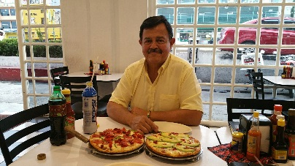
I've already had two distinct Mexican meals..."tacos al pastor" (tacos with meat carved off a spit and toppings) and pizza with refried beans instead of tomato sauce for the base with hot sauces for an extra topping! Very good.
We're at 7,700+ elevation...pray for us as we serve leaders here...physical strength, wisdom, favor, spiritual power and a servant's heart. My word for the day is "Ebenezer" (I Samuel 7:12)..."The Lord has helped us this far..." We want to follow His leading each day. Thanks for your prayers!
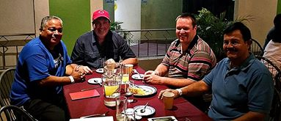
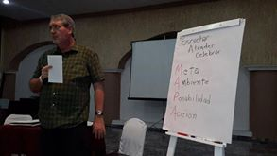
Day 3, Wednesday April 7th in Mexico. I'm at a retreat for ministry leaders and their families about two hours outside Mexico City. We are blending in about 7-8 hours of coaching skills training for almost 60 leaders. They are from the Unifam denomination, our OMS partner in Mexico. Jose and I are thankful for the growing understanding and response we see. For many, this is a new way to work with others...but they like it and want to learn more!
After our first day of training we had a good dinner meeting with Alfredo, the President of Unafam, Jonny Forsythe, OMS Team Leader, Jose and me. Alfredo was very enthusiastic about what he had learned about coaching that day. I hope he will continue to feel this way and encourage coaching for all the leaders of his denomination!
I learned something about Mexican culture…meal times are different here. Breakfast is about 8 am. Lunch is around 2 pm and dinner about 8 pm. Every culture has unique qualities…it’s interesting to learn them and adjust to them on my trips.
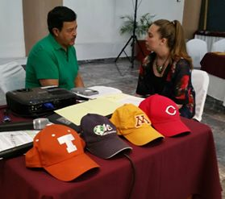
Day 4, Thursday, April 8th-- early morning day four in Mexico. Got to talk to Shirley by WeChat this morning...so glad to see her face! 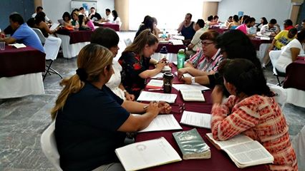
Training went well. I demonstrated coaching by coaching Alfredo. It’s a big deal for the “leader” to allow that to happen. In many cultures, including Mexican, the leader tells everyone else what to do. Listening to others is usual. When we debriefed the coaching demonstration and I mentioned that I had a doctoral degree in leadership and church multiplication, it surprised many. They would have expected me to give direction because of my education and expertise. Instead, I coached Alfredo to come up with his own options and determine his own action steps…and they were good! Coaching really invites people to do leadership in new ways. As people practiced at various times, they really embraced the skills of listening, asking and inviting discovery and taking responsibility for developing their own action steps beautifully. The feedback is similar to what I have heard in many nations where I've equipped people with coaching skills--"This is new to us...is it so important to listen better...we need these skills...this will help us...thank you for training us!"

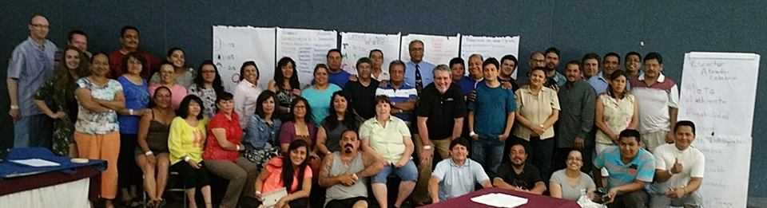One more picture of the coaches we trained...from teenagers to veteran leaders, pastors, denominational leaders, OMS missionaries, local church leaders, church planters, trainers...a wonderful group! May this training multiply and increase their ministry effectiveness! Grateful for good feedback...many shared how they will use coaching skills to help others. Three more ministry times ahead...thank you for your prayers!

Day 5, Friday, April 9th
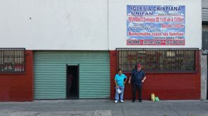
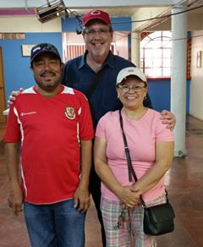
Friday was a day of education for me. Jose, Mim (Miriam, a young intern from Wales), Alexander, Paty and I drove to the Drop In Center that ministers to street kids. Seven years ago they purchased an old car repair shop that was in ruins. Today they feed, cloth, care, provide job skills and share the love of Jesus with people who have no home. What an incredible ministry!
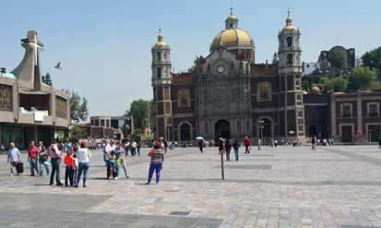
Jose gave us a good session on Mexican history--the Aztecs, Spanish and especially the spiritual influences that affect the way of life here. We rode the subway to see the Basilica of the Virgin Guadalupe. It was sobering in many ways.
We took time to visit with some of the street people that our team ministers to...some living in a park, some on a sidewalk. Watching Alexander and Paty, the couple who work at the Drop In Center, was very powerful. Their love for the children and adults who have no home is beautiful. It was an honor to be part of their team if only for a little while yesterday.
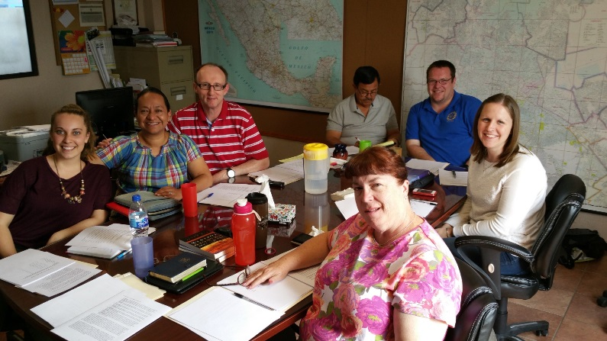
Saturday and Sunday, Mexico, Day 6 and 7, April 11th and 12th
Here's a picture of our OMS Mexico team...we come from several nations--United Kingdom, Ireland, Wales, Mexico, United States...all here to serve the people of Mexico. The team works with homeless people, teach in a seminary, equip leaders, teach English and ministers in many other ways. They are making a difference for God here! Not everyone is on the field right now...some are in their home countries raising support. It is an honor to work with great people like them!
From Facebook: These past two days have been a mixture of "ugh" and "wow"...
The "ugh"...something I ate got me...feverish, weak and other effects (you can probably guess). I learned again how God shows Himself strong when we are weak.
The "wow"--wonderful time with our OMS team on Saturday morning...we processed some concepts about how you best relate to God (sometimes called "Spiritual Temperaments" or "God Languages")...great insights and discovery. We also practiced coaching each other about how we can create more room for our relationship with the Lord in the ways that are the most meaningful to us. We have a great team here in Mexico!
Jose Banales is an incredible tour guide...he wants us to learn about Mexican culture and spiritual influences to better understand the Mexican heart and how to bring the Good News of Jesus to them.
Saturday, Jose took Miriam (an OMS intern from Wales) and I to see a museum that had been a Jesuit college. Ornate statues and artwork, but little about Christ. Why do we complicate something so simple and wonderful as the Good News of Jesus? It was a good reminder for me to keep focused on Him.
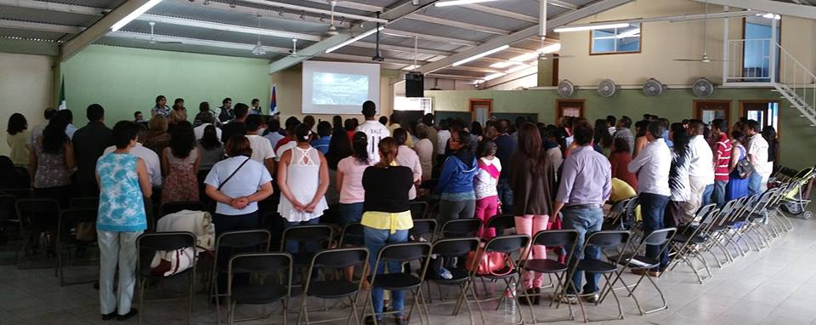
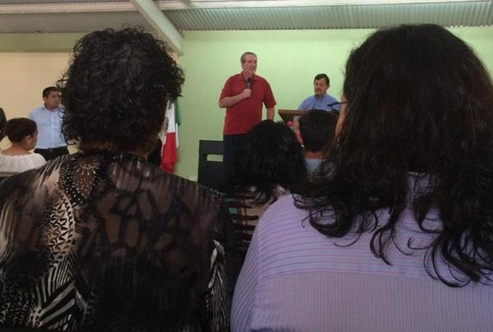
My biggest and best "wow"--got to preach twice today at Campanario Church. We had a service at 8 am and another at noon with a family breakfast time and Sunday School classes in-between. I was still not feeling well but the Lord helped me. I preached on "Living Easter Every Day"--that the power and joy of our Risen Jesus is not a once-a-year event, but can be a daily reality. Jose did a great job again translating for me. One lady came up after the service with 3 pages of notes she had taken from the message. That was encouraging! Best of all, over a dozen people made decisions to give their lives to Jesus today! Seeing someone come to Christ is always my greatest joy!
Today after church, he took me to see the Teotihuacan ("Tee-oh-tay-wha-can") pyramids...an ancient civilization we know little about, but they left amazing buildings and structures behind.
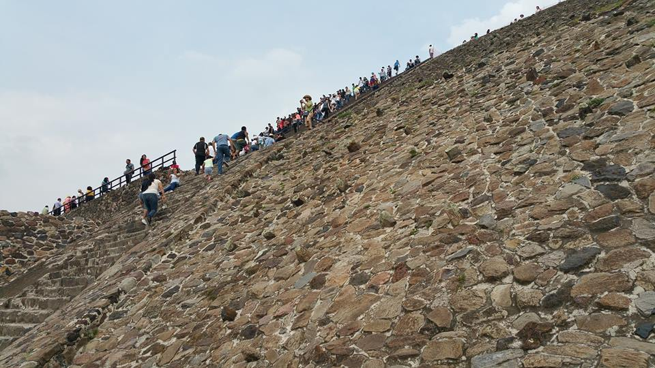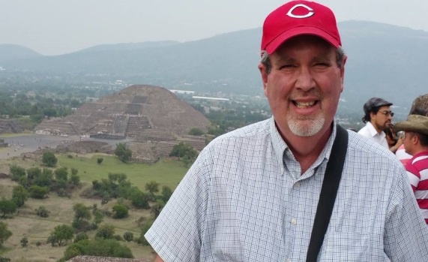
Tomorrow we begin "stage four" of our training in Mexico...two days of training leaders how to use Interactive Adult Learning methods. I'll need lots of wisdom to train this well...please keep praying for us! Ministry like this is always a team effort...some of go, some pray, some support...and we all share in the results of what God does!
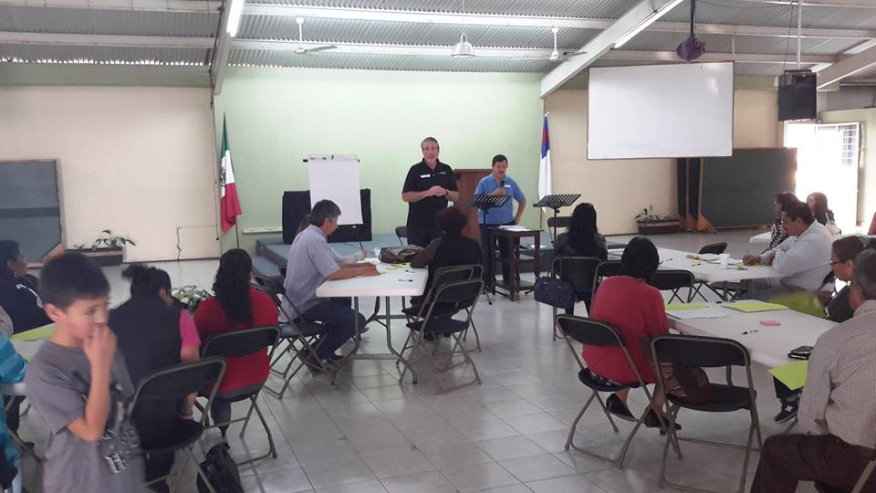
Monday, April 13th, Day 8 in Mexico. Today we began two days of training for Interactive Adult Learning with about 26 leaders from a number of local churches and three ministry organizations. Samantha, a wonderful help with all the planning of these events, took these pictures. We have one more day of training before we head home on Wednesday. Thanks again for your prayers!

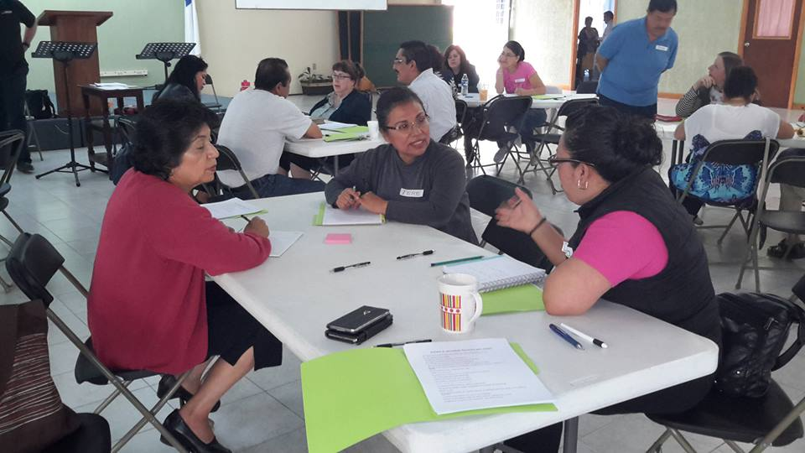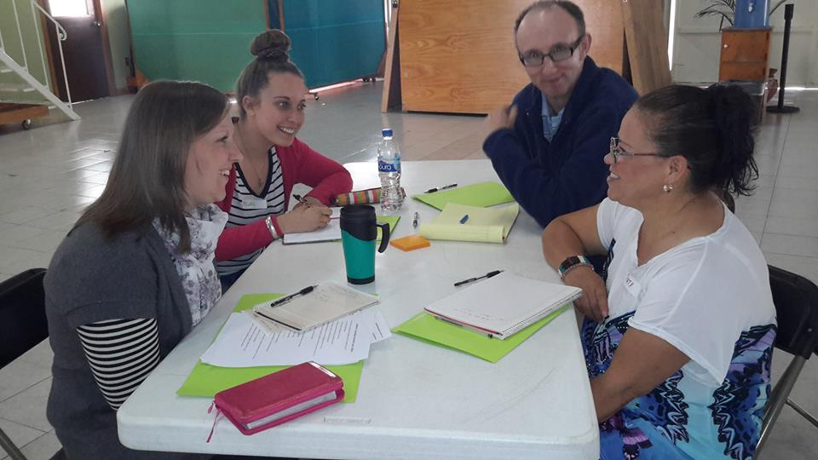
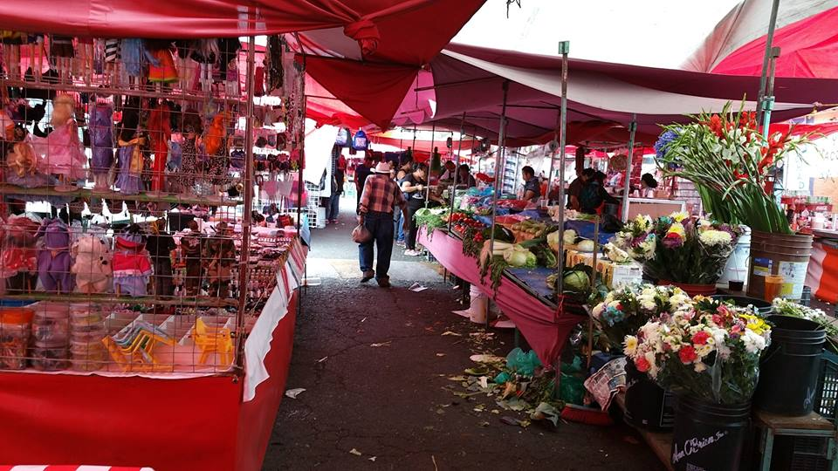
After our training today, Jose and I walked across the street to the market that meets along this road on Mondays. Each day dozens of vendors sell everything from fresh meat, vegetables, fruit, CDs, clothes...you name it, they might sell it! The "moving market" meets in a different place each day of the week. You can see a "street level view" and a "view from above" with the seminary building in the background. 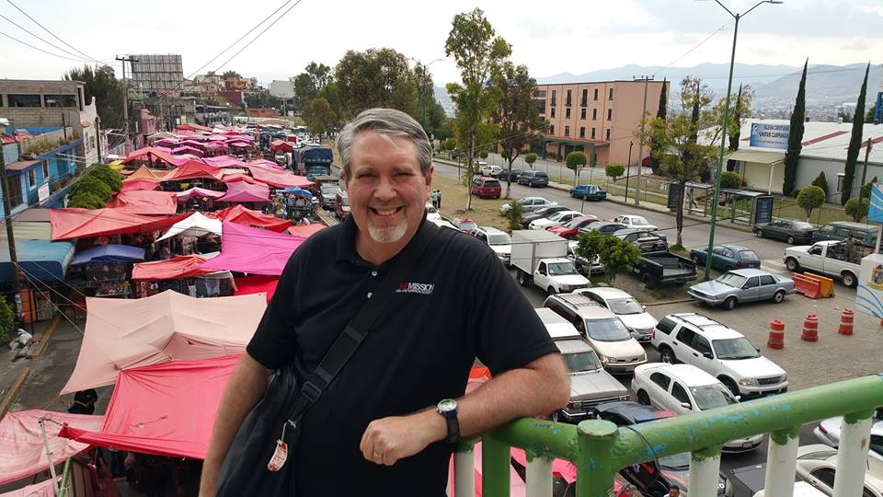
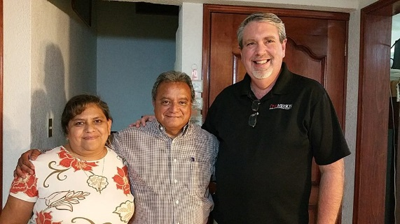
This evening we had a wonderful meal with Pastor Juan Jesus and his wife Elisa. They both shared their stories of how they came to Christ and then were called into ministry. What amazing stories! For many years, Juan Jesus worked full time in a bank and then many more hours working in the ministry of the church. Their stories are ones of sacrifice, perseverance and joy. It's an honor to serve the Lord with leaders like them.

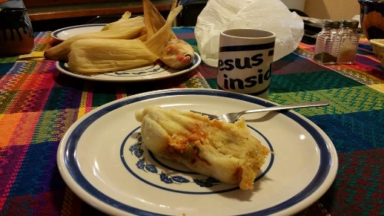
Tuesday, April 14th, Day Nine last day in Mexico. Our day started with a true Mexican breakfast...Jose and I walked across the street and bought tamales from a street vendor he knows. Fresh, hot, tasty!

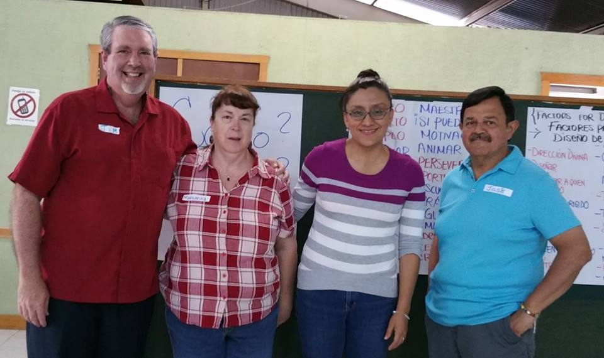
Our last day of training in Interactive Adult Learning skills went better than we hoped...their engagement, "learning by doing" and feedback about what we equipped them to do was so encouraging. They will use these skills in many ministry settings to more effectively train an ever-widening number of children, youth and adults. I love being a part of God's multiplication! Jose has been a joy to work with...he seems to know everybody here and is highly respected. Margaret and Samantha did an awesome joy behind the scenes with logistics. Great training is always a team effort!

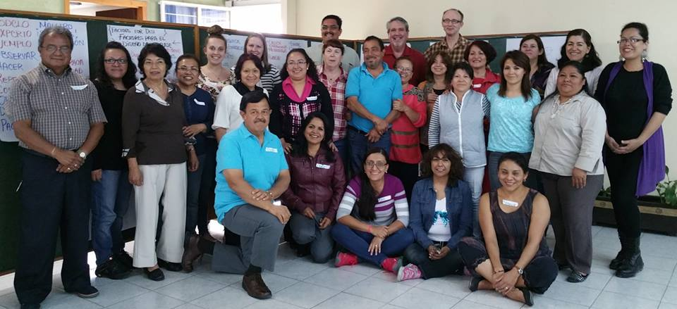
This evening we went for steak at a restaurant nearby (again, Jose knows the owners well) with most of the OMS team. We had a delightful time of eating and sharing. It was the first time I've ordered french fries and they came with some fried cactus as well! They gave us nice gifts and we gave each other many blessings and thanks. Gemma Forsythe shared with me that the young woman who gave her heart to Christ when I preached Sunday is beginning a Bible study with her this week! It's been a fruitful and memorable time here in Mexico.

Two more miracles to go...1. Get everything packed in my suitcases. 2. Get home to my Shirley Roehl!

Wednesday, April 15th, Day Ten
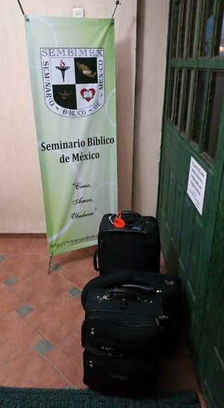
Jose was on his way to the airport by 4:30. I was awake and packing when he left. My ride came at 7. Had a good ride and visit with Jonny Forsythe before I got on the plane. He’s a sharp, godly man who is growing in his leadership and ministry. It’s an honor to invest in leaders like him. It was a joy to invest in dozens of leaders here in Mexico. I often learn as much as I share with others. Everything is in the Lord’s hands as far as the long term results. Thanks for your interest and prayers.

The flights home went well…it was so good to be back home with my Shirley!

Thanks for your interest and support. We can do this ministry work because of the wonderful team of prayer and financial partners we work with. Together, we're making an eternal difference!

