Training Leaders in Haiti
Tim Roehl Trip August 10-16, 2014

The Invitation

As 2014 opened, the Lord gave me an incredible year verse from Psalm 2:8: “Only ask, and I will give you the nations, the whole earth as your inheritance, the whole earth as your possession.”

That promise has stretched my heart and mind and prayers! I’m learning how to pray in expanded ways… and the Lord is expanding my territory! I’ll make four international trips this year…more than ever before. So far I’ve been to Ecuador (my first trip to South America), Canada (the Lord’s giving me influence with the C&MA folks there) and now to Haiti.

Dave Graffenberger, who has served here in Haiti for over 20 years (16 years one stretch and four more years recently) went through my coach training back on 2008. Dave is a legend at OMS…was head of ECC (Every Community for Christ) for a number of years and is highly regarded around the world. He asked if I could come do “Coaching II” in Haiti. He had done the training once, but wanted to do another round at the request of the leaders here.

Dave and I talked and prayed and designed our training over a couple visits while he was at OMS HQ. We’ve got my TransforMissional Coach training now in IAL (Interactive Adult Learning) format in several languages. For Haiti, it will now be in Creole! Dave got the materials translated and they’ve done a first draft of the TransforMissional Coaching book in Creole. I’m excited to see the materials in more languages!

We’re planning to train about 30-35 leaders—ECC trainers, pastors, seminary students and some other national church leaders. I’m excited to equip these different kinds of leaders of leaders! What Dave and I will do for them will have a rippling effect across their country and beyond!

Beginning the Trip

The trip to Haiti started on Sunday morning, August 10th. I had just gotten home from speaking at the National Church Multiplication Conference for the Evangelical Friends Church the day before (got delayed an extra day due to bad weather), so it was a quick turnaround.

I was pretty tired and also a bit concerned that we had gotten all the items (materials, books, passport and travel info, the right clothes, etc.) packed in time. Thankfully, it looks like we did.

I fly through Atlanta to Fort Lauderdale, where I had to stay overnight in a hotel before catching an early flight the next day. The Men for Missions folks use the hotel all the time, so that was nice. After getting in and talking with Shirley and Elise for a while about how camp went (Elise was the Youth Director and did a great job), I was in bed before 8:30 pm. It was a short night, so I needed the rest.

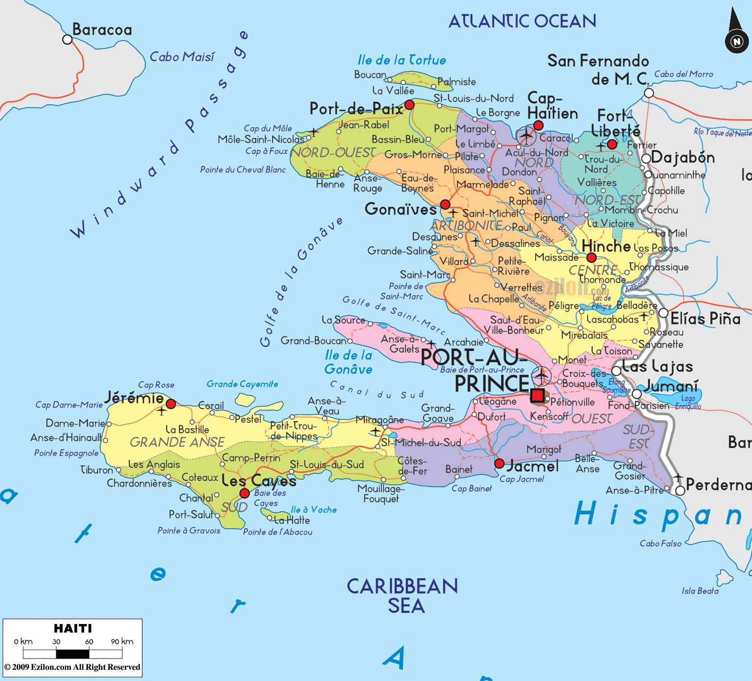

Monday, August 11th

Up at 3:25 am to catch a cab at 4 am. Had to repack my bags to make the weight better and still had to pay extra (only $16). I’m carrying extra gifts for some people here and a bunch of my books to donate to the seminary, the Cowman school for kids K-12 and some other leaders.

Standing in line, I noticed an older Haitian gentleman with a book under his arm called “The Art of Leadership”. When I commented on it, he smiled broadly and said, “When I came to Jesus, I gained two new friends…Jesus and books!” I found out that this man and his friend knew of OMS and were good friends with Dave Graffenberger! The Lord provided me two guides to help me get into the country.

The 1 ½ -hour flight in a small jet was smooth. I was pretty tired, but was able to read. I can’t sleep very well on airplanes, but I can get a lot of reading done.

Arriving in Cap Haitian, (Haiti’s second largest city with about 700,000 people, see the top of the map) on the northern coast of Haiti, was beautiful. I saw forest covered mountains and fields with small communities of houses sprinkled across the landscape.

Getting through customs went really well…one of the two Haitian leaders spoke on my behalf and they put me right through. A man took my baggage tag and “offered” to get my bags for me. I gave him a couple dollars for his help.

Getting out the door, there was a crowd of people waiting outside. Many were trying to ask me about needing a cab ride or asking for money. It was one of the first indications of the hardship of the people here.

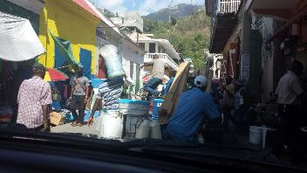
Dave Graffenberger met me outside. We got my gear loaded and headed into Cap Haitian. It was a crowded city with cars, “Tap-Taps” (a small pickup with a topper that serves as a small bus or taxi for local folks, many motorcycles zipping in and out of traffic and lots of people everywhere. Further in the city, the streets are very narrow and crowded…vehicles, people walking and women with loads on their heads. Small shops and many street vendors vie for attention and business. For many, that’s the only way they can make a living. Dave had a few items to pick up…it took us many questions and much driving to find the stores that had what we needed. It is a crowded city with much need.

Finally, we headed out to the OMS Center just outside in the small suburbs of Cap Haitian. OMS has a Retreat Center that has many buildings. They’ve had it for over 55 years. They host work teams, retreat groups from inside and outside OMS, have a school and a clinic…and other groups use it, too. There’s much going on.

I’m staying with Graffenbergers, who live in a nice concrete house with three bedrooms. We have power each day from 6 am to 9 pm, then some things can run on batteries through the night. I’m glad for that so I can use my breathing machine. They do have wireless internet while the power is on, so I was able to use WeChat to call Shirley and let her know I made it all right. So grateful for technology! No air conditioning, though, so it’s hot and sticky.

Dave and Marilyn show me around a bit, then we go to the “Holiday House” next door where many people eat their meals. The house has some bedrooms and a gift shop along with a good sized dining room. Our noon meal was egg salad sandwiches, fresh mango and salad. They wash the vegetables so they are safe to eat for a guy like me from outside the country. Otherwise, there can be lots of issues for a traveler. Thankfully, the water is drinkable without boiling.

Dave took me over to see our training room after lunch. We loaded tables, chairs and several men helped us set up the room. It’s in a cinder block building with screens and the decorative cement blocks for the air to get through. We’ll have fans, but it will be hot.

It’s hot and humid here…not oppressively so, but still I’m sweating a lot. The folks remind me to make sure to drink lots of water. I will!

Later in the afternoon I laid down for an hour or so…found our OMS radio station (4VEH, 94.1 in Haiti) and listened to the broadcast in Creole. I can’t understand it, but appreciate how powerful the ministry has been over the years. It’s also on the Tune In radio app on my phone!

Dinner was a hot dish, avocado slices and cake. They have a team here replacing the two AM radio towers, so got to visit with them a bit. Also met three ladies who serve here…I sure honor the kind of work they do! Two of them work in the clinic and one does many jobs in the office.

By 8 pm, it was time to head for bed. I found a book called “Voodoo in Haiti” and began reading it. Wow! There’s a lot of spiritual darkness and demonic things here because of the people’s history with voodoo here.

The Lord gave me Psalm 91 as my promise for the trip and it really applies to my need for spiritual covering, protection and favor….I’ve been reading it, meditating on it and claiming it for this trip.

Psalm 91
¹ Whoever dwells in the shelter of the Most High will rest in the shadow of the Almighty.^{[a]}
² I will say of the Lord, “He is my refuge and my fortress, my God, in whom I trust.”
³ Surely he will save you from the fowler’s snare and from the deadly pestilence.
⁴ He will cover you with his feathers, and under his wings you will find refuge;
his faithfulness will be your shield and rampart.
⁵ You will not fear the terror of night, nor the arrow that flies by day,
⁶ nor the pestilence that stalks in the darkness, nor the plague that destroys at midday.
⁷ A thousand may fall at your side, ten thousand at your right hand, but it will not come near you.
⁸ You will only observe with your eyes and see the punishment of the wicked.
⁹ If you say, “The Lord is my refuge,” and you make the Most High your dwelling,
¹⁰ no harm will overtake you, no disaster will come near your tent.
¹¹ For he will command his angels concerning you to guard you in all your ways;
¹² they will lift you up in their hands, so that you will not strike your foot against a stone.
¹³ You will tread on the lion and the cobra; you will trample the great lion and the serpent.
¹⁴ “Because he^{[b]} loves me,” says the Lord, “I will rescue him; I will protect him, for he acknowledges my name.
¹⁵ He will call on me, and I will answer him; I will be with him in trouble, I will deliver him and honor him.
¹⁶ With long life I will satisfy him and show him my salvation.”

I stayed awake until nearly 10, then it was time to sleep. No air conditioning, so it was hot and sticky, but I’m grateful for a breeze.

Tuesday, August 12th

Up at 5:30 am…good time in the Word and prayer. I’m especially claiming the promises of Psalm 91 and putting on God’s armor as described in Ephesians 6. A lukewarm shower feels good…it’s muggy even in the morning.

We have coffee and a banana at Graffenbergers. We head over to the training room at 7 am. After a few of us prayed, several more arrived and we had some devotional time. Pastor Luke-say, head of ECC, led us into the Word…he chose Psalm 91! That was a wonderful confirmation for me. We sang…them in Creole, me in English. Sometimes I know the words, sometimes I just make them up and sing from my heart. Another brother shared a good word from Matthew 28 on the Great Commission. Then we headed over to breakfast.

Breakfast was spaghetti with some meat sauce and fresh fruit juice. There were also sliced onions and peppers. Many people put ketchup and mayo on their spaghetti. It was my first time having spaghetti for breakfast.
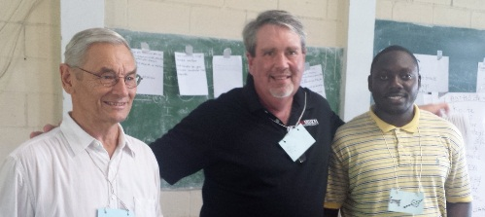
Greg is my translator. His Dad was a longtime friend of Dave G’s and now Greg is Dave’s assistant. He’s a sharp, intelligent young man and he works hard to translate what I say or what others say so I can understand. Whenever you teach/preach/train with a translator, you have to learn each other’s capabilities and develop a good rhythm together. It took us awhile, but we did.

Training sessions—our day is full of training until 6 pm. We're training 25-30 leaders here with coaching skills. They are pastors, seminary students, pastor's wives, church multiplication trainers, national church leaders...a great group of leaders of leaders! Topics we covered were, “What is Coaching?” “The Biblical Basis of Coaching”, Listening and Asking, a coaching demonstration, 7 Habits of Coaches, the G*R*O*W plan for coaching. When I demonstrated coaching with Pastor Job, Greg translated for me and Dave translated for Job! Our coaching demonstration went well and gave us an example to refer to for the rest of the training.

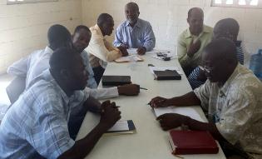
The training went well...the leaders interact with the materials well and grasp how we are training them to "empower anyone, anywhere, anytime about anything" with coaching skills. My translator Greg did a good job. Working with Dave Graffenberger, who is highly respected, is delightful.
It's hot and humid here! Sweat runs off just sitting, but a breeze helps.
There are about six women who are serving as prayer warriors all through the training. They are praying in an upstairs room and sometimes come quietly into our training room to listen and pray. Sometimes they sing their praises and prayers…beautiful prayers in song! I got a video of them…sweet music in heaven!

Meals— the cooks make most of our food outside on a charcoal fire in large pots. We had rice and beans and chicken for lunch. Snacks were a fruit drink with cheese and crackers. Supper (“souper”) was hot chocolate and bread with a little peanut butter. Hot chocolate on a hot day was interesting! It reminds me of the old saying, “Where He leads me, I will follow. What they feed me, I will swallow!”

The evening is catching up on email, chatting with Shirley by WeChat and writing this journal. At 8:30, it’s time for bed. I read for a while, finishing the book “Understanding Voodoo in Haiti”. Wow. Dave told me several stories of our OMS pastors dealing with witch doctors (and leading many of them to the Lord), casting out demons…they know how to deal with the spirit world here more than we do!

I spray down with skeeter spray before sleep, but still felt something bite me in the night. Hope it wasn’t a bad mosquito!

Wednesday, August 13th

Rise and shine at 5 am this morning…I was awake and couldn’t sleep any longer. Good time in the Word and prayer. It’s already warm and sticky…looks like another Haitian day!

Meals:
Breakfast—toast, peanut butter and mango with coffee at Dave’s. Scrambled eggs and a hot dog at the dining hall.
Lunch—Rice, beans, a little meat sauce and fruit juice
Supper—soupy oatmeal, a piece of bread with peanut butter.

Training

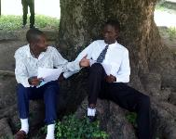
Our second full day of training, from 7:30 am to 6 pm. They take a rest time after lunch for about an hour, which I used to catch up on some work. The training went well. Coaching skills focus on great listening, asking open questions and following a plan to help the person you coach clarify a goal, paint a picture of their current reality, develop some options to accomplish the goal and then they determine their action steps to help them move toward accomplishing their goal…in our two days! We gave them lots of time to process and practice...interactive adult learning is important.

Today we reviewed, reinforced and practiced the “Listen, Care, Celebrate…G*R*O*W” all day long. In Creole, GROW becomes “Objective, Reality, Options, Plan”….pretty close. As they practiced, Dave walked around and listened and helped them. I wish I could have done that, too. Not knowing the language is a hindrance. However, by the end of the day, we feel nearly everyone has grasped the coaching plan and knows how to use coaching skills…25-30 more coaching apprentices serving the Lord!

Many leaders express their thanks. Dave feels it went real well. Pastor Lucce (Luke-say), the head ECC leader in Haiti, also told me he was appreciative. Each culture is unique, but people are people no matter where you are. The 25-30 leaders (people came and went through the day) struggled at times with the concepts, but by the end of the day, most all of them got it! Several testified that during their coaching practice, they got great help on a real life issue! My translator Greg, a real sharp young man, was a great help. My co-trainer and veteran missionary Dave Graffenberger felt things went real well, and got lots of good feedback from the leaders we trained. That's what matters most to me.

The 25 leaders made faith goals to train more coaches...their total was over 600! That's the wonderful rippling effect of multiplying leaders.

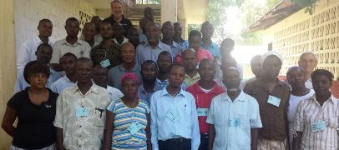
At the end of the day, I was able to speak words of encouragement and pray a prophetic blessing over them. What an honor to minister to God’s choice servants!

I also thanked the prayer team several times for their good ministry. These folks know the power of prayer! They know the spiritual battle we are in. They understand things in the spirit realm, often much better than we do in our country. I’m grateful for their good intercessory work.

Language
I’ve been working hard on learning some words and phrases, as I always do. I carry around a 3x5 card and write down the English word or phrase and then the phonetic spelling of the Creole. Many words have a similar sound as English or Spanish. Some are brand new to me. As I try the words, the Haitians smile and sometimes correct me graciously. I think they appreciate that I’m trying to enter their world and meet them in their heart language. Many of them speak some English, some very well.

Here’s a few phrases with my “spelling”…

Good morning Bon jour
Good afternoon Bon swah
Good job Bon tra-vi
How are you? Koman oo yah?
Nice to meet you Mweh conta rancontre oo
Brother Fra
Sister Sah
Thank you merci
Let’s pray ohnu pree yay
God bless you Bon dya ben nee oo
Pastor Pas

I’ve got about 30 words or phrases so far…love learning new things!

Thursday, August 14, 2014

Up at 5 am this morning…the power went completely out about 5:15, so I read my Bible on my phone. A verse from Ezekiel where the Lord searches for a man to stand in the gap on behalf of His people is always a powerful invitation and reminder to me. I want to be that kind of man!

After breakfast, we head back to the Training Room, where today we will have a meeting of ECC (Every Community for Christ, the church multiplication team of OMS) from across Haiti. They report on the results of ECC ministry from around the world and from there in Haiti. Each leader introduced themselves, told a bit about their family, where they served and what their ministry is and how many planters they are training. We work at equipping leaders to multiply new disciples of Jesus, leaders and churches. The stories of some of the leaders I have met are amazing and inspiring! They do so much with so little. It's an ongoing lesson for me about how much we depend on buildings, equipment and programs in the US. These leaders depend on God more than anything else.

During this time I wasn’t feeling well…feverish, very tired, and my back was hurting. At the break, Dave asked the ladies of the prayer team to pray for me. It was sweet, powerful and greatly appreciated! I went back to my room and slept for a couple hours…that really helped.

This afternoon I did more computer/email work and we went out to see the Emmaus Seminary, about 10 miles away from the OMS Retreat Center. The road is paved in some spots and pretty bumpy. The countryside is beautiful…lush fields with beautiful high hills around.

The Seminary is a newer campus, only about 17 years old. The buildings are all concrete, clean and very functional. There are about 50 residential students on campus when school is in session. They have to raise $600 per year and help with work/study. Each student also receives a scholarship of $2,000, which is raised by people in the States. I met Matt and Stacy Ayers and their kids. Matt is the president of the seminary. He’s fairly young, but very intelligent. Dave and I got to bear a burden and pray with him.

I also got to see Phil and Emily Heckman and their family! We had become friends at CROSS Training in July 2013. They serve as hospitality, operations and anything else that needs to be done. Emily was very excited to see me, because she had been thinking about coaching 4th year students to better understand their personality and gifts. We talked about some ways to do that…one of my divine appointments here in Haiti this trip!

We came back and I got to meet Brent and Angie Bundy and their four kids. They had just flown in from the States today. They are the field leader for OMS here with lots of responsibilities. Angie asked me about how we could use our Grip Birkman profiles to help them be a better team. I’m happy to help with that!

Meals Today:
Breakfast: Toast, banana and peanut butter with coffee at Graffenbergers. Boiled banana with some kind of fish sauce at the dining hall.
Lunch: Rice with some kind of meat and sauce. I think the meat was goat.
Supper: Spaghetti with meat sauce and salad with a bread roll.

I think I’ve got my gifts figured out…and should be able to get all of them at the gift shop at the Holiday House. Trying to shop in Cap Haitian can be quite difficult, so I’ll do it here.

Good to talk to Shirley by WeChat again…so grateful for that kind of technology!

Dave says if our inverter goes out, we’ll be heading over to another building. Hope we don’t have to do that.

Friday, August 15, 2014

Haiti, Day Five
Today I got to see more of the wonderful breadth and depth of OMS ministry in this part of Haiti. Dave Graffenberger took me on a tour that included:
* The medical clinic, which sees people for many needs physically and spiritually. There were many people who came for some kind of help. I'm humbled by how our team cares for so many with so little.
* The dental clinic, where folks with those kinds of needs are cared for.
* The wood shop, which provides jobs for many and beautiful furniture for those who buy their products. They said it is a slow time of year because many people are trying to find the money to send their children to school and don't have money for furniture. The Haitian oak is beautiful.
* A video of our Starfish kids ministry, which provides schooling, food and the love of God for children...over 1,000 kids!
* A tour of Radio 4VEH, which is an award winning ministry broadcasting to many thousands each day. It is a respected and trusted source of help spiritually as well as information about physical health, farming and other practical needs. Storly Michel is the head of the station...had a great time visiting and praying with him at our evening meal.
* Cowman School, which provides a quality education for about 90 kids. One parent I talked with said the environment at the school has made a powerfully positive impact on his kids. It was a joy to donate copies of my "Jesus books" to the school. Hopefully those stories will help children here "see" Jesus and love Him more!
* Debriefing our training with Dave...got good feedback from the Haitian leaders we trained and we talked about how to expand the coaching skills training to more people in more places.
* OMS office, which so much support is given to the various ministries. Brett Bundy leads our Haiti team...they all want and need our prayers as they work with the good people here.
Watching Dave interact with people almost continuously here is a joy. There always seems to be someone waiting to see him. He stops our vehicle to visit with someone many times. Dave loves the people and they love him. There are many families where he first knew the parents, then their children and now the grandchildren. Many come with burdens needing wise advice. Dave loves them all. That's what a long term commitment to a people can do!
It's been a wonderful trip. As the Director of Training at OMS, I help shape and coordinate how we equip leaders in over 70 nations. Every time I get to visit one of those nations, I become a student and a servant to those I meet. It's a joy and honor.
Head home tomorrow...leave for the airport about 7am and should be home by 7:30 pm. Can't wait to see my Shirley!

Other Thoughts
I was able to buy all my gifts in the little “gift shop” at the Holiday House. In almost everywhere I go, you can find a tourist/souvenir place. I think Haiti is so poor that it’s hard to do that here. We could have gone into Cap Haitian, but it would have been very crowded as it was a holiday. I’m again reminded how much I take for granted and how much “extra” we have in our lives.

Looks like I’ll be able to get everything into two bags…easier to get home that way.

In bed at 8:30 and lights out just after nine.

Trip Home—August 16th, 2014

Up early and packed, ready to head home. Had a nice breakfast with Dave and Marilyn and we headed into Cap Haitian. Even at 7:00 am it is busy and the street full of people, motor bikes, trucks. It occurs to me that Dave and I are the only white faces in a sea of Haitian folks. It helps to know what it’s like to feel like when you are the minority.

We head over to where the three-man team is repairing the towers for Radio 4VEH. It’s a large sandy area about five acres with a block fence all the way around and a couple small buildings. The three-man team fix radio towers all over the world. They bring in everything they need, including tents, fans, cots, refrigerator, power supplies…you name it, they brought it! They had a very difficult time getting through customs…the authorities took out everything and then threw it back in no particular order. The guys were not happy about that. They will be replacing two towers, one 200 feet tall and one 270 feet tall. Incredible for us to consider, not a big deal to them! We talked for a bit and then prayed with them and headed for the airport.

Dave dropped me off at the airport with the same man who had helped us when I arrived. Many other men offered to “help” me, but I just stuck close to the one guy. Getting my paperwork and luggage through was chaotic but made it. I had to pay $60 to exit the country. They brought us to a large waiting room packed with people with a couple fans running. I still didn’t have a ticket. Sat for a long time trying to figure out what was going on. For an impatient guy like me, you have to learn to just wait sometimes, especially in other nations. Finally, after the scheduled time for departure, I was able to go through their version of customs and get out to the plane.

The rest of the flights home went well…it was sure good to see Shirley, even though I’d only been gone a week. In some ways, I was a whole world away, even though I wasn’t that far from the US.

Dave and I debriefed a bit more by email and I wrote an “executive summary” of the trip for the ECC leaders and others. I’ll add it to the end of this journal.

Reflections
As often happens when I’m away on a trip to a nation like this, I come back with a wide spectrum of feelings and reflections….
- I’m humbled by how much we have and take for granted in the US.
- I’m amazed at how little people have in other parts of the world. I’m also amazed at their joyous attitudes and relational focus.
- I’m frustrated by the consumerism and me-ism of the church in the US. We spend so much on ourselves and do so little for our brothers and sisters elsewhere in the world.
- I’m grateful to be able to serve some of God’s choice servants and leaders in places that are hidden to the rest of the world. Little known on earth, these leaders are heroes in heaven.
- I’m re-energized to pass along the skills the Lord has given me in a multiplying, rippling way to leaders around the world. I have felt for a long time that I would have more impact outside the US than inside. These kinds of trips confirm that feeling.
- I’m thrilled that I get to help our leaders become better teams. Conversations with several leaders, including Emily Heckman and Angie Bundy about how to use resources like “Discovering Your Ministry Identity” and “Your Leadership Grip” confirm to me that our “fit and flourish” approach to leadership and team building is needed and wanted by our leaders.
- I need to find more ways not just to do training events, but to train trainers in these nations to pass along these skills. Bringing together the OMS Coaching Network will need to be a priority the rest of the year.
- I’m honored to work alongside great leaders like Dave Graffenberger. He’s the kind of leader I want to emulate as I continue to age. I want to finish well!
- Whether or not I come back, and I hope I can come back, it’s a joy to serve the Lord like this in this season of our lives. I’m grateful!

Tim Roehl Training Trip to Haiti
August 10-16, 2014
Thank you and Trip Summary

To: ECC Team
From: Tim Roehl

I have just returned from a week-long trip to train leaders in Haiti with basic coaching skills. The trip originated with Dave Graffenberger’s invitation to do another round of coach training. Dave had some training with ECC leaders in Haiti in 2013 and they requested more coach training.

OMS ECC graciously paid for my plane fare for the trip…THANK YOU! It was very helpful and encouraging to me to have that kind of support.

Prep for the Training: Dave and I adapted an IAL version of my TransforMissional Coaching training that has also been used in the Caribbean and Ecuador. The IAL version should allow national leaders to train others with coaching skills beyond any training trip I might make.

Our Training: We did two full days of coach training on August 12th and 13th. Dave and I co-trained the materials. I also got to attend a meeting of ECC leaders from across Haiti on another day and hear how God is working through ECC around the world and especially in Haiti. Hearing the reports of some of the pastors/workers/trainers was very exciting!

Dave and I trained 25-30 leaders (some coming and going)…a nice blend of pastors, ECC workers and trainers, seminary students, pastor’s wives and committee members. We had a good number of leaders who had taken the first coach training with Dave G, and a good number who were taking coach training for the first time. We also had the wonderful intercessory support of about six women, whose prayers and praises covered all we did. That kind of powerful ministry is sweet music in heaven!

Feedback and follow up: The feedback we got from the training was very positive. Luke-say (sp?), the head of ECC, thanked me several times and told me how helpful the training is for them. Many of the Haitian leaders, both young and old, specifically thanked me. Several testified to real life breakthroughs during our “practice”. The only “negative” comment was from one pastor who said that “the weakness of the program is that it lacks help for the physical.” We felt that he did not understand how coaching skills could be used to help address physical needs. Dave will follow up on that.

At the end of the training, we made sure each new “apprentice coach” had a partner who they would practice their coaching skills with at least once a month for the next three months. Luke-say will follow through with the ECC trainers and Dave will follow up with all the participants when he returns in November.

The Haitians asked if they could get some kind of badge or certificate for doing the training. We shared with them that they are now “apprentice coaches”. We felt we can acknowledge that they completed the coach training course as an apprentice coach on a local level, but we don’t have a certificate on a larger OMS level. Dave and I talked about this and recognize there are also some cultural dynamics to giving leaders a certificate as a “coach” that need to be wisely addressed.

Dave Graffenberger’s thoughts: Early in the training, he was feeling discouraged by how the Haitians did not seem to grasp what we were training. However, by the end as he listened in as they practiced, he knew they were doing much better. The Haitians, especially the ECC trainers who had gone through the coach training a year ago, shared with him that they felt this training was very helpful for them.

Dave wrote me in an email, “Thanks for coming, you would have been pleased on Sunday afternoon to hear Damas the 4th year student who sat at the end of table #2 from the right side, ask me multiple questions as I responded, more questions, more questions.

He caught it!”

Dave will pursue ECC trainers in the north to do coach training at the seminary. He also feels that we can do coach training as a very useful skill with our teachers (Cowman and Starfish).

We need to translate the IAL trainer’s notes into good Creole. The handouts we used at the training have already been translated into Creole.

Tim’s thoughts: This training reinforces for me that good basic coaching/mentoring skills are essential for all our missionaries and the leaders we train in all the nations where we serve. It is especially important that our field leaders and leaders in key leadership positions (like our seminary, Cowman school, 4VEH, etc.) be proficient in these skills. I will continue to follow up with Dave Graffenberger and other OMS and Haitian leaders as I have opportunity to make sure we build our coaching ministry in Haiti and beyond.

In addition to the days training Haitian leaders, I got to visit and meet with leaders from our seminary, the health clinic, dental clinic, wood shop, OMS office, Cowman school and Radio 4VEH. It gave me a new and great appreciation for what we do in Haiti!

It was an honor to visit the field! Getting to learn about our good ministries there and learning from our Haitian leaders was wonderful. Not only did I get to visit with missionaries I had helped to train through Orientation and CROSS Training, but I got to meet more of our team on their field, a valuable experience.

As we continue to develop our OMS Coaching network, our ability to equip and empower leaders with basic coaching skills (anyone, anywhere, anytime about anything) and specialization uses (T4T, Train and Multiply, etc.) will continue to enhance how we equip leaders around the world and expand our ability to equip leaders to multiply disciples, leaders and churches for the glory of God.

Respectfully submitted, Tim Roehl

