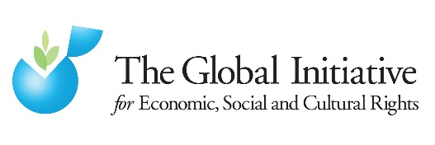

Privatisation in education in Morocco and the right to education: summary factsheet
  - Brief to the Committee on the Rights of the Child, 31/01.2013

Contacts
- Sylvain Aubry, lead researcher: aubry.sylvain1@gmail.com / 0033 7 81 70 81 96 (French, English)
- Ahmed Sehouate, President, Coalition Marocaine pour l’Education pour Tous: sehouate@yahoo.fr (French, Arabic)
- Bret Thiele, Co-Executive Director, Global Initiative on Economic, Social and Cultural Rights: Bret@globalinitiative-escr.org (English)

Policies
Through the National education and training charter and the 2009 – 2012 Emergency plan, the government set itself an objective of 20% of pupils trained in private primary and secondary education institutions by 2010.
Measures taken to promote private education:
- Tax incentives
- Policy incentives, flexible legal framework
- Support to research fund
Applicable laws include:
- National education and training charter
- Law 06-00
- Dahir n° 1-00-202
- Décret n° 2-00-1015

Rapid increase in privatisation
Private enrolment at the primary level has more than tripled from 4% in 1999 to 13% in 2012, while between 1995 and 2010 private enrolment at all levels has more than doubled, with an annual average growth of 6%.

Between 2000 and 2012, the number of students enrolled at the primary level (in government and non-government schools) increased by 347,500 students, while in the same period enrollments in private primary schools increased by 344,500 students, which is the equivalent of 99% of the total increase.

Inequalities in the Moroccan education system
Private schools target essentially children from rich urban households.

Several indicators reflect growing inequalities. For instance, just taking one measurable leaning outcome – basic in reading: % of children who achieve an international minimum learning standard in reading, according to the results to the PIRLS (Progress in International Reading Literacy Study).
In 2006, 33% of the least advantaged group (rural poor) reached minimum learning standard in reading, against 75% of the most advantaged (urban rich). The difference between the two groups was of 42%. There was almost no difference between rural rich and urban rich.
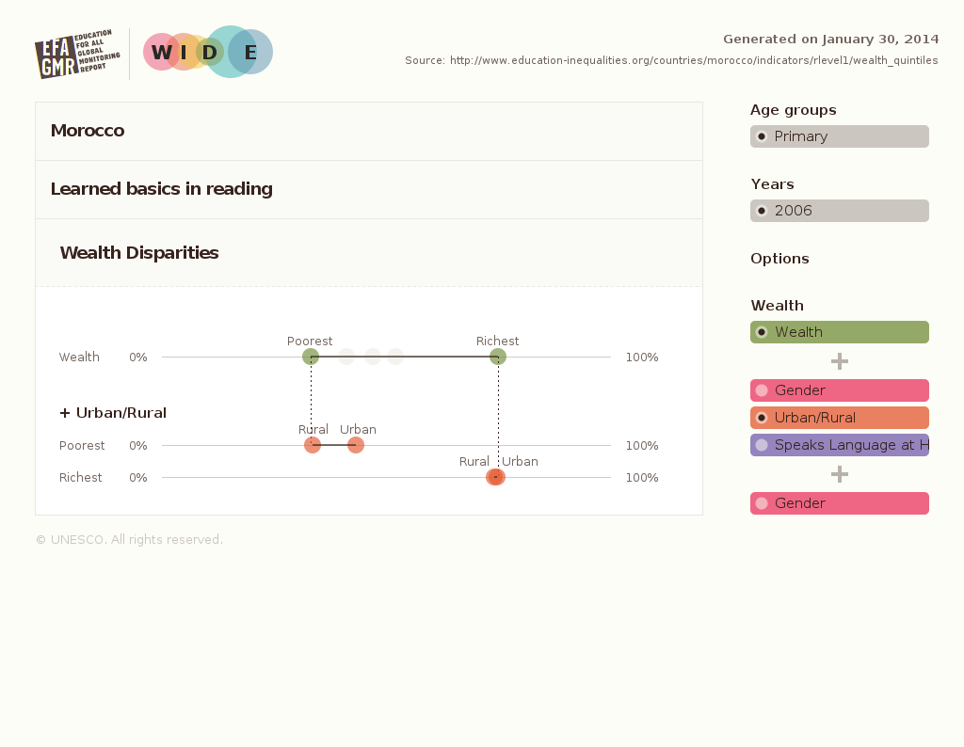
In 2011, the least advantaged group’s results went down by 2% to 31% of poor rural children managing basics in reading, whereas the most advantaged group’s results went up by 9%, with 84% of rich urban children achieving minimum learning standards in reading.
The inequalities between rural poor children and urban rich children went up by 26%
In the meantime, the difference between rural rich and urban rich, which was insignificant in 2006, has grown by 340%
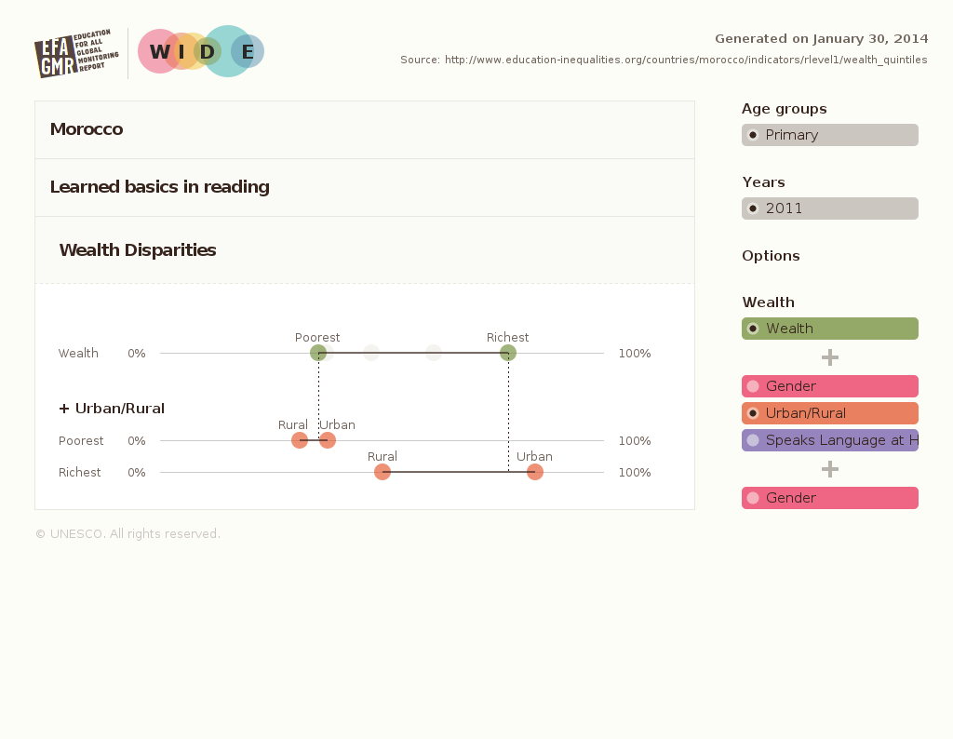

Quotes on private education in Morocco
Former UN Special Rapporteur on the Right to Education, Mr. Vernor Muñoz Villalobos, country report on Morocco (2006).
‘the State party has a two-speed education system with a striking difference in level between public and private education which denies equal opportunities to low-income sectors of society’.
E/C.12/MAR/CO/3, para. 30.

‘the State, and not local associations, nor the private sector, is responsible for guaranteeing the realization of the right to education’.
A/HRC/4/29/Add.2, para. 16

‘an apparently excessive promotion by the authorities of private education’
A/HRC/4/29/Add.2, para. 16

United Nations Committee on Economic, Social and Cultural Rights (CESCR), concluding observations on Morocco (2006).

King of Morocco “Speech To [the] Nation On [the] Occasion Of [the] 60th Anniversary Of [the] Revolution Of King And People” (2013)

Recommendations for the list of issues
1. Has the State party assessed whether its policy of privatizing education in Morocco is the most effective in terms of realizing the Convention rights, in particular in order to address discrimination and how has it done so?
2. How does the State Party regulate, monitor and evaluate the provision of education by private providers in Morocco to ensure that it is consistent with Convention rights?

‘a large number of families are compelled to pay huge fees for their children to study in foreign schools or private education institutions in order to avoid the pitfalls of the state school and enroll their children in an efficient system’.
King of Morocco, 20 August 2013.

UNESCO Institute for Statistics, 2013.
UNESCO, Education au Maroc: Analyse du secteur, 2010/ED/FU/RAB/PI/2, p. 49.

