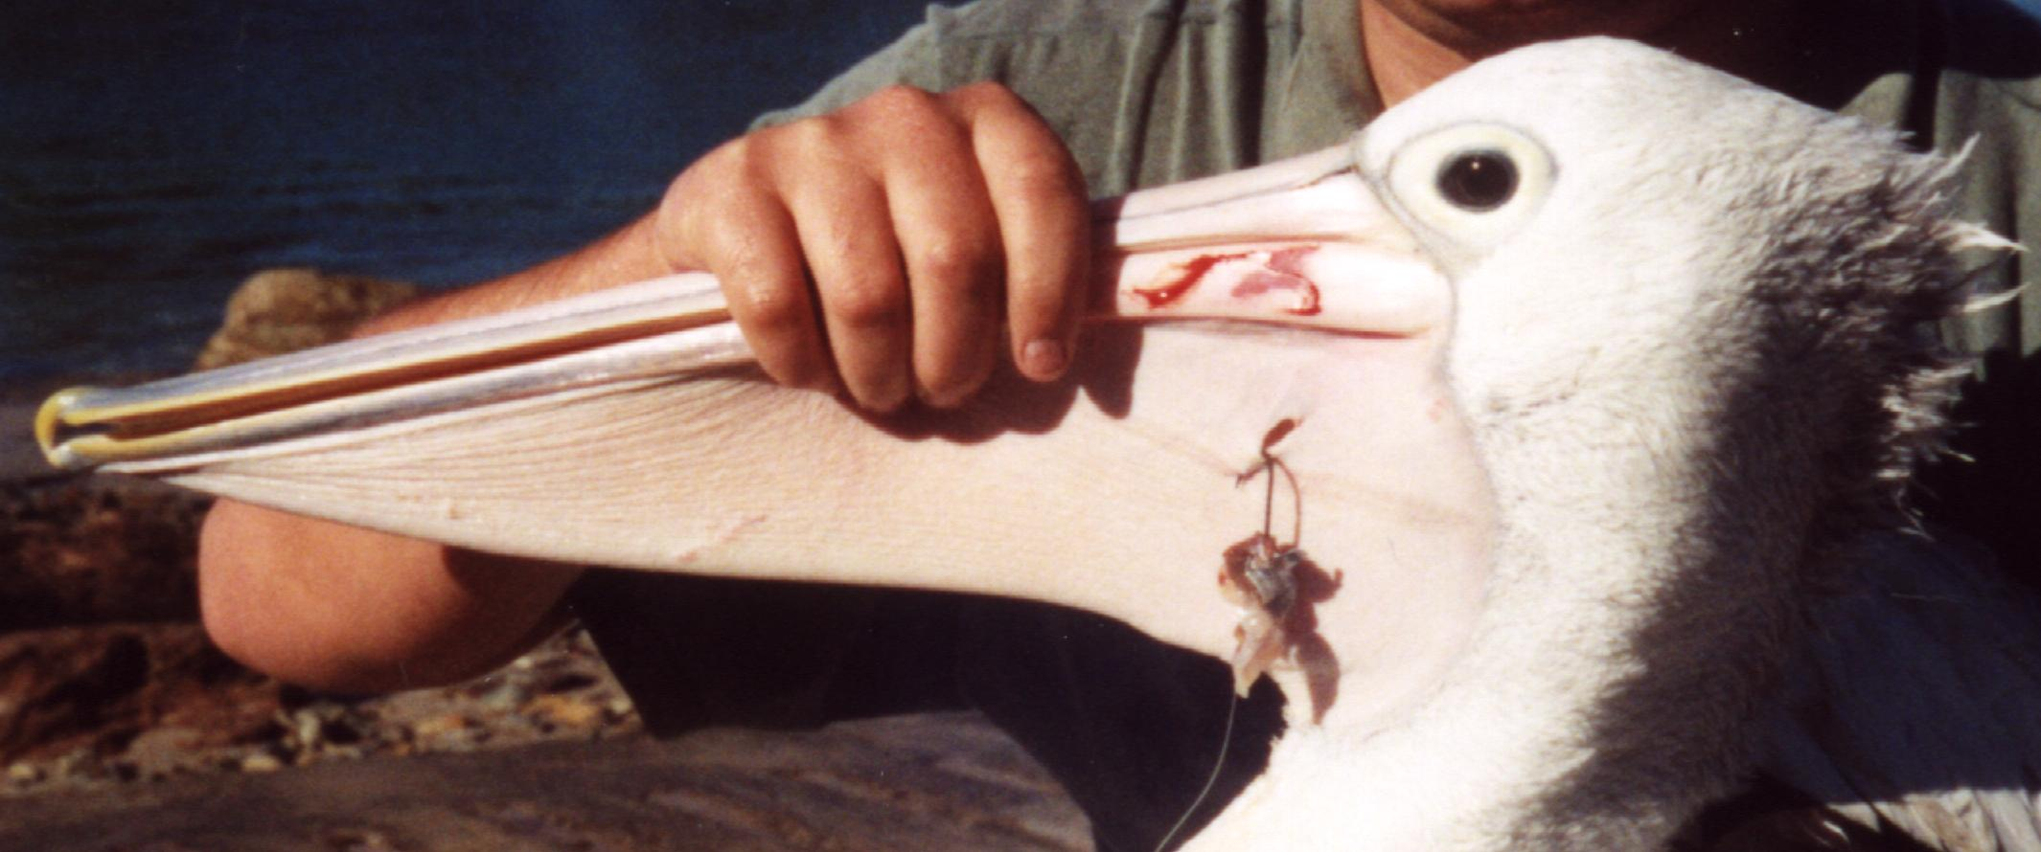
THE PLIGHT OF
THE PELICANS…

PELICAN & SEABIRD RESCUE WORKSHOP NAROOMA

Presented by: Julie Dunn, Founder of Australian Seabird Rescue South Coast

WHEN: Saturday, 22 February 2014

TIME: Registration 9.15am Workshop 9.30am – 3.30pm

WHERE: ClubNarooma, 88 Princes Highway, Narooma

Topics covered include:
- Understanding pelicans, recognising/locating injured pelicans, handling, and first-aid.
- Capture techniques for pelicans that can still fly (and any bird that can be lured).
- Seabird handling and first-aid; and rehabilitation issues for pelicans and seabirds.
Note: There will be a field session where you will be in contact with birds
Pelicans and other seabirds are frequently injured by accidental hooking. The hooks do not simply rust away, and fishing line can sever limbs and wings.
If left unattended, these injuries can cause infection, gangrene/loss of limbs and a slow, painful death.
If you’d like to learn how to rescue these beautiful birds and become a member of Australian Seabird Rescue, or learn more about pelicans and other seabirds in general come along.

LIMITED SPOTS AVAILABLE. REGISTRATION ESSENTIAL COST:
$30.00 - Includes tea/coffee & comprehensive manual (BYO or Purchase your own lunch)
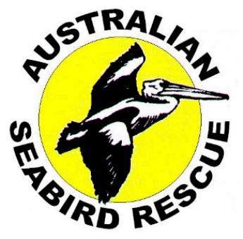 | TO REGISTER Phone: Kirsten on 0400121775 or the ASR South Coast Hotline on: 0431282238  or Email: horty@exemail.com.au
~~~~~~~~~~~~~~~~~~~~~~~~~~~~~~~~~~~~~~~~~~~~~~~~~~~~~~~~~~

