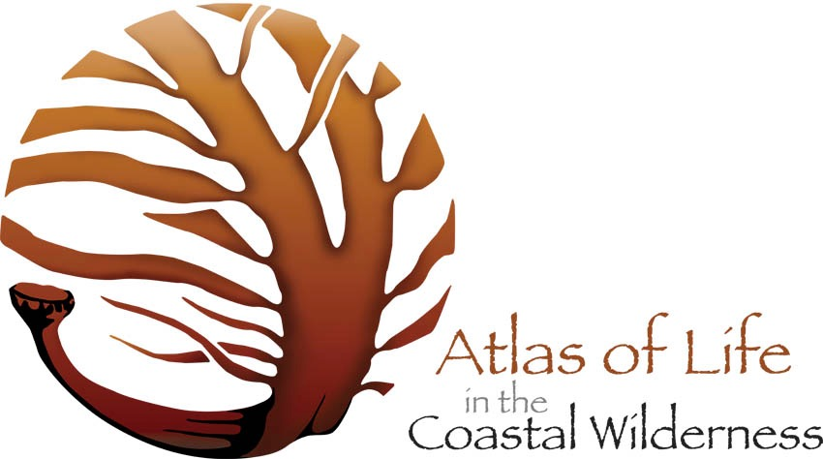
Chair’s report 2017

It is now 6 years since we launched the Atlas of Life website and we have now recorded 21,341 sightings of 5,626 species from 346 members. Since we moved the Atlas of Life to the NatureMapr recording platform and database in August last year we have seen a significant increase in records and in people joining the Atlas to record what they see. Our most prolific recorder is Steve Burrows, who now has a very impressive 2,100 records in his own journal. Steve’s photos are really good and he has extended his interest from mainly botanical sightings, to now covering the whole range of species he sees.

The database is now looking very good with significant numbers of new species added to our species list and a treasure trove of amazing and beautiful photos for everyone who wishes to explore what lives in our area. We can see that our database is indeed becoming the significant repository for information and images that we have been aiming for since the project’s inception. This has been a year of consolidation and growth and I thing we can all congratulate ourselves on how much we have achieved.

We again have to give a huge thank you to Aaron for all his hard work and contributions to make this a really excellent platform and we are pleased to announce the newly developed apps for both iPhones and Android, which is today with Apple for their final approval before it can be released within the next week. a huge contribution. We are all looking forward to trying it out and Aaron is seeking feedback from all users. We have to say how wonderful it is to have such a responsive platform designer, as Aaron seems to work all the time to try and help make his system as good as it can be.

We also need to thank everyone who has been contributing to the support of the database and the Atlas project generally: from Patricia Daly, Liz Allen, Sarah James, all our Moderators, and our colleagues at Canberra Nature Map, particularly Michael Mulvaney who has been instrumental in promoting the value of the Atlas of Life and NatureMapr to everyone, and especially all our regional natural resource managers.

At the last AGM, I announced our main objective for the next 12 months to be to engage and support each of or regional natural resource managers to undertake at least one project using NatureMapr and our Atlas of Life network to deliver good results and value to their own work. We received a grant from BVSC of $6,000 to enable us to undertake this work. The projects that have been identified so far are:
- BVSC and OEH Save our Species – surveys of the Merimbula Star-hair (Astrotricha sp. Wallagaraugh) around Tura Beach as part of Heritage Week
- Landcare: Coastal Weeds – this will be a project encouraging community members to record any sightings of invasive weeds along our coast. Community efforts will enhance the work of the existing weed eradication program
- OEH SOS and OEH/ANU/ Canberra Nature Map: Glossy Black Cockatoo project
- BEEC: Schools project – now we have the NatureMapr platform, work with BEEC to encourage Schools to set up water bowls, camera traps and record visitations, as part of a wider familiarisation initiative
- BVSC : Estuary Management programme – plans to establish camera posts for walkers to record landscape changes over time plus NatureMapr familiarisation to establish records at each main estuary along the coast
- BVSC: Treasures of Tura, an ongoing project started earlier this year where community members are encouraged to record nature around their homes

Although we have yet to run substantive project described above, we have agreement in principle for all our nrm’s and are awaiting their funding applications to be able to commence most of these projects. Our partnerships and collaborations have developed well over this year and all the good people with common interests continue to enjoy and find value in working together.

This year’s BioBlitz was organised at the request of the “From Little Things Grow”organisation as a precursor to the development of their site as a sustainability centre in the heart of Merimbula. This was a new model of BioBlitz as it was decided to hold it on one day only and to have it on a Saturday, so there was no schools only programme developed. In spite of early rain, there were over 100 participants and Survey Leaders travelled from Canberra, Sydney and other places to contribute their expertise, for which we were most grateful. We expect to be working on an ongoing programme with FLT as their centre becomes a reality. We received funding from BVSC to support this event.

Thanks to Raymond Daly for organising our application to become an Environmental Organisation with DGR status. We recently learned that we have been successful in our application and look forward to the benefits that will accrue. We have also received a Mumbulla Foundation grant to enable us to purchase a new projector which will work with our Microeye microscope and also a projector screen which will be of great benefit in promoting the Atlas more widely.

We now have a fine tool in our NatureMapr platform and good working relationships with our community and aligned organisations. We still need to secure funding to allow us to use the database and receive support and upgrades from NatureMapr, so it is still a key objective to prove its value to all our natural resource management organisations. I commend the proposals from Kerri-Lee Harris and Paul Whitington as to how we might raise the profile and levels of engagement with the Atlas.

We again played a significant role in helping to develop the Sapphire Coast Regional Science Hub. We ran a very successful National Science week programme with a Questacon major exhibition as the centerpiece allowing all Hub members to showcase their work to all the school students and families that attended. Sadly Doug and I were so busy following this that we missed the deadline for applying for a grant to showcase another such exhibition next year. We did receive a grant to hold 5 “Hub in the Pub” events targeting 18 – 35 year olds. So far we have run 3 successful evenings: Zombie Animals, with Prof Cryd Fraser from ANU, Taming Tinder, and most recently the On The Perch evening showcasing career opportunities in science. There is currently a large grant opportunity for Maker Spaces, but it is unlikely we will be able to put in an application. Scott Baker, BVSC Libraries and I recently attended a NSW Science Hub workshop in Sydney and have brought back lots of ideas and contacts for exciting initiatives next year – if we can find the resources! Our Hub is seen as a leader in this space.

Patricia has again been superb in managing our database, supporting contributors with any queries and leading NatureMapr familiarization workshops. Her time and expertise is fundamentally important to what we do and we wish to acknowledge that with grateful thanks. I would like to thank all the Atlas of Life Office Bearers, Committee and all contributors who have given so much time, energy and enthusiasm to making our project such a joy to be part of. Thank you all and we look forward to more fun and good company together in the next year.

Attached is a list of key activities undertaken in the last 12 months for your information

Libby Hepburn December 10th 2017

Atlas of Life in the Coastal Wilderness Dec 2016 – 2017 activities

- Development work with Dean, Macca, OEH SOS, BVSC Kyran Crane, Dan Murphy, Scott Baker, Andrew Morrison, Landcare Chris Post, CMN Ali Rodway, Doug Reckord- BEEC, Anthony Osbourne Nature Tourism
- Lennard’s island field trip
- Treasures of Tura presentations and Merimbula Star-hair survey
- Canberra Nature Map, Michael Mulvaney visit and presentations
- Mulloon Institute, Arthur Synodinus Press Club, Mike Kelly advocacy
- Sea Slug Census, SC & Narooma
- Andrew Claridge – Quoll presentation
- March For Science Canberra
- NatureMapr workshop Conservation Management Network
- SC Science Hub Cryd ,Zombie animals, Taming Tinder, On the Perch
- Prof Patrick De Deckker ANU - Belgica expedition presentation
- From Little things BioBlitz 16th & 20th Sept
- ANU Fenner School, Saul Cunningham
- Atlas “Wild Eye” 2017 Photocomp with EyeQ Merimbula
- U3A Atlas and NatureMapr sessions Bermagui
- Citizen science US/Global, Aussie Mozzie proj
- Mumbulla School insects & pollination, Bega High school
- SC Reg Sci Hub, AAEE

