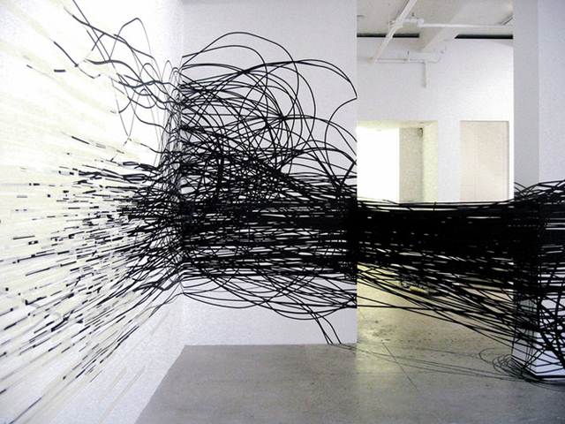
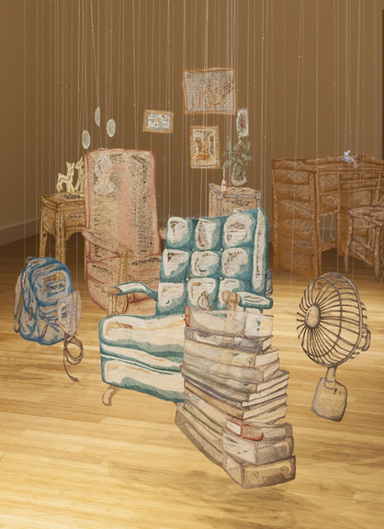
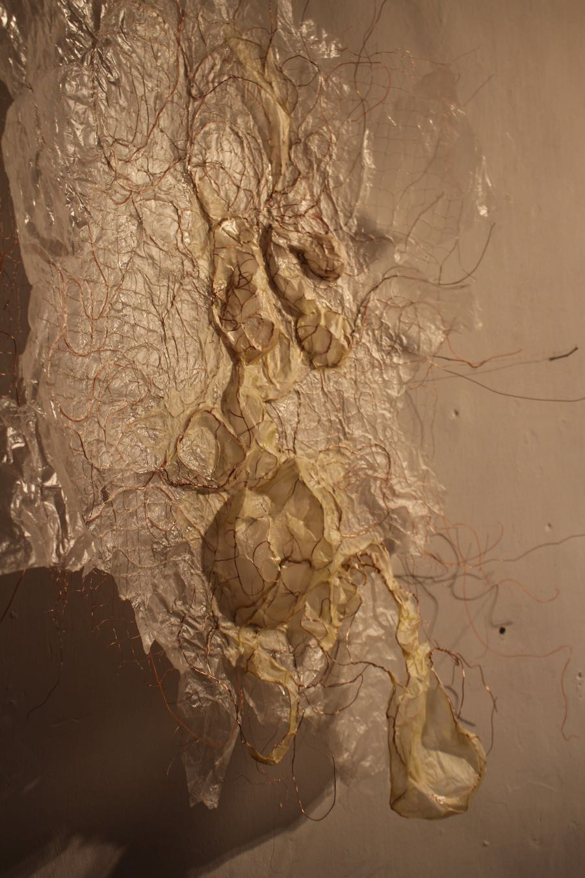
QUESTIONNAIRE
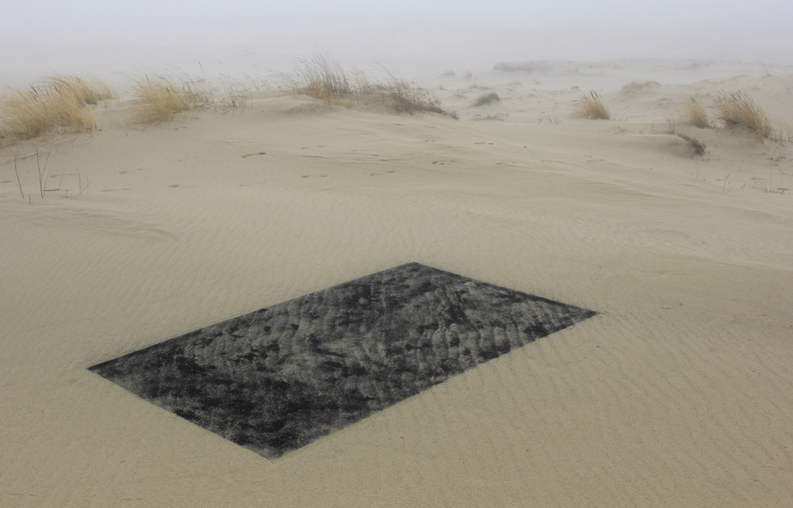
1. Monika Gryzmala, black and white tape, 2010
2. Amanda McCavour, Thread/machine embroidery, 2014-15
4. Laurie Lax, ‘Oblong’, charcoal sifted onto sand, 2014
3. Fiona Campbell, paper, wire, twine, oil

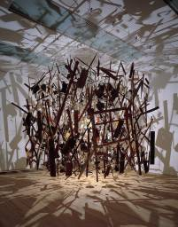
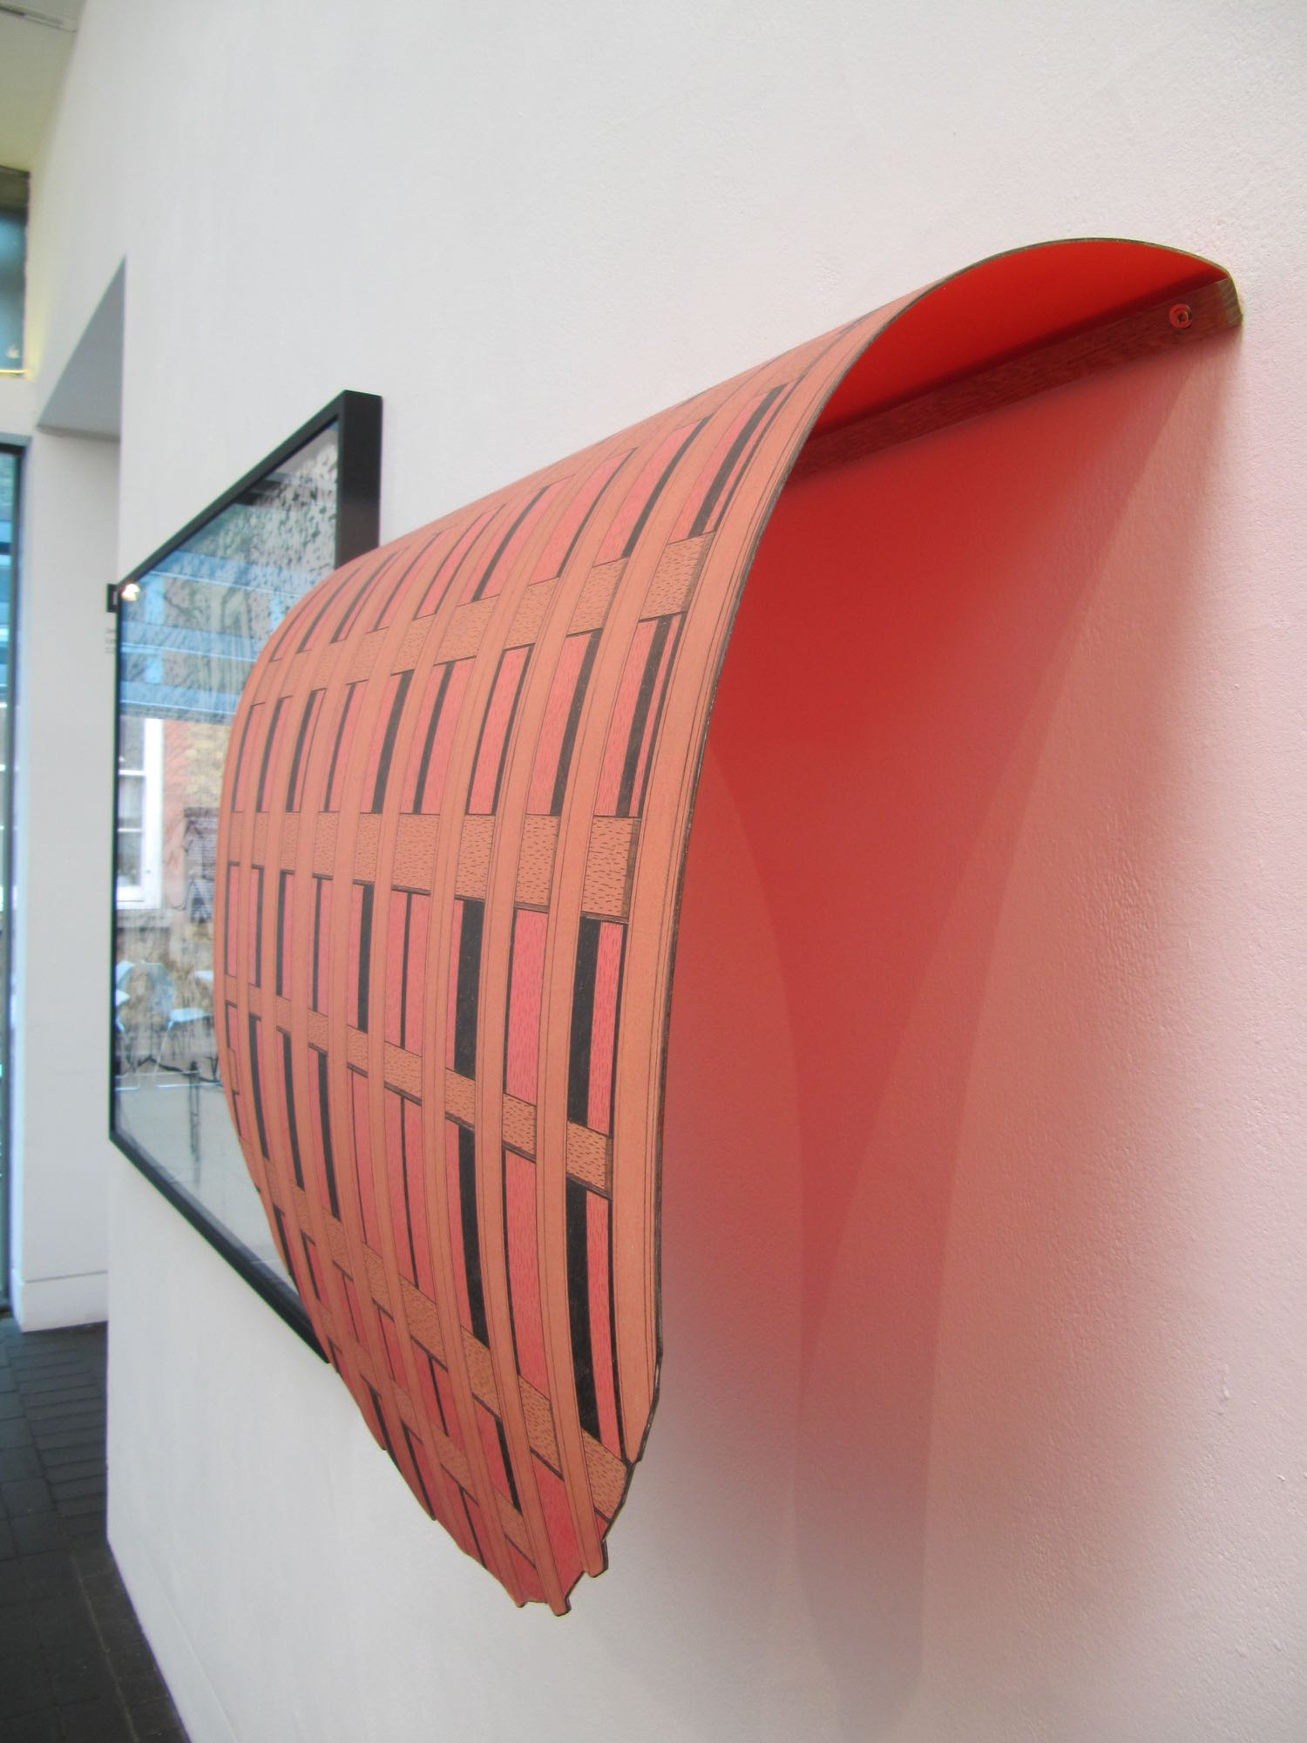
5. Cornelia Parker, Cold Dark Matter: an Exploded View, exploded garden shed contents, 1991
6. Kelly Chorpening, ‘Tried and Found Wanting’, Pencil, paper on steel, 2016
How would you categorise these artworks?

Image | 1 | 2 | 3 | 4 | 5 | 6
a. Drawing

b. Sculpture

c. Neither

d. Both

Please expand briefly with a description of this work and/or comment on your choice of category:

1.

2.

3.

4.

5.

6.

In your view, what are 3 essential characteristics of:

a. Drawing

b. Sculpture

THANKS FOR YOUR TIME!

