BASIC PILATES WORKOUT

The following pages contain a sample Pilates workout. Anytime you want to go through a quick routine designed to give you a balanced and challenging set of Pilates exercises, this is an excellent routine. The workout is appropriate for all levels and modifications are given for exercise.
This workout will include:
- Pelvic Curl
- Spine Stretch
- The Hundred
- Single Leg Stretch
- Swimming
- Plank
- Saw

For more information on Pilates and its value in increasing core strength, improving posture, and in aiding breathing efficiency, go to www.pilates.about.com

PELVIC CURL
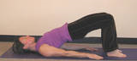

- Lie on your back with your knees bent and your feet flat on the floor. Make sure that your feet, ankles, and knees are aligned and hip-distance apart. This exercise starts in neutral spine. In neutral spine, the natural curves of the spine are present so the lower back is not pressed into the mat.

- Begin Sequential Breathing Inhale. Bring your breath into your chest, then belly, and down to the pelvic floor.
Exhale. Release the breath from the pelvic bowl, the belly, and then the chest.
Inhale, Exhale
- Do a pelvic tilt by engaging the abdominal muscles and pulling your bellybutton down toward your spine. Let that action continue so that the abs press the lower spine into the floor. In the pelvic tilt position, your back is very long against the floor and the pelvis is tilted so that the pubic bone is a little higher than the hip bones.

- Inhale press down through your feet allowing the tailbone to begin to curl up toward the ceiling. The hips raise, then the lower spine, and, finally, the middle spine. You will come to rest on your shoulders at the level of your shoulder blades, with a nice straight line from your hips to your shoulders. Do not arch beyond this point. Be sure to support this movement with the abdominals and hamstrings.

- Exhale As you let your breath go, use abdominal control to roll the spine back down to the floor.
Begin with the upper back and work your way down, vertebrae by vertebrae, until the lower spine settles to the floor.

- Inhale Release to neutral spine. Prepare to repeat the exercise by initiating the pelvic tilt on the exhale.
Repeat this exercise 3 to 5 times.

SPINE STRETCH
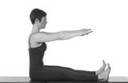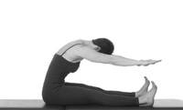

Pilates mat exercise, spine stretch, is useful anywhere in a workout. It is a great stretch for the back and the hamstrings, as well as a moment to center oneself before moving on to more challenging exercises.
- Sit up tall on your sit bones. Your legs are extended about shoulder width apart, and your feet are flexed.
- reach the top of your head to the sky but let your shoulders stay relaxed. See image at right.
- Inhale and extend your arms out in front of you, shoulder height. A modification here would be to place the fingertips on the floor in front of you between your legs.
- Exhale as you lengthen your spine to curve forward. You are going for a deep C-Curve.
Allow a deep release in the hips as you keep your shoulders down and reach your fingers toward your toes.
- Inhale and reach a little further as you enjoy the fullness of your stretch.
- Exhale and initiate your return by using the lower abdominals to bring the pelvis upright. Roll up through the spine to sitting.

THE HUNDRED
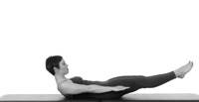
The hundred is a classic Pilates mat exercise. You will be asked to perform it during the beginning of almost any Pilates class you take. The hundred is often used as a dynamic warm-up for the abdominals and lungs. It requires that you coordinate your breath with the movement, and be strong and graceful at the same time. It is challenging, but the hundred is an easy exercise to modify (make harder or easier). See the tips at the end of the exercise description for modification ideas.
- Lie on your back with your legs bent in tabletop position with your shins and ankles parallel to the floor.
- Inhale
- Exhale: Bring your head up with your chin down and, using your abs, curl your upper spine up off the floor. Keep the shoulders engaged in the back. Your gaze is down into the scoop of the abdominals. Stay here and Inhale.
- Exhale: At the same time, deepen the pull of the abs and extend your arms and legs. Your legs reach toward where the wall and ceiling meet in front of you. You can adjust them higher if need be, or lower for more advanced work. They should only be as low as you can go without shaking and without the lower spine jumping up off the mat.Your arms extend straight and low, just a few inches off floor, with the fingertips reaching for the far wall.
- Hold your position.
- Take five short breaths in and five short breaths out (like sniffing in and puffing out). While doing so, move your arms in a controlled up and down manner - a small pumping of the arms. Be sure to keep your shoulders and neck relaxed. It is the abdominal muscles that should be doing all the work.
- Do a cycle of 10 full breaths. Each cycle is five short in-breaths and then five short out-breaths.
The arms pump up and down a few inches, in unison with your breath.
Keep your abs scooped, your back flat on the floor, and your head an extension of your spine, with the gaze down. OK - not hard!
- To finish: Keep your spine curved as you bring your knees in toward your chest. Grasp your knees and roll your upper spine and head back to the floor. Take a deep breath in and out.
Tips:
- To make the hundred more challenging: Lower your legs. Do not lower your legs past where you can control the movement. Don't let your spine peel up off the floor as you lower the legs.
- To modify the hundred for back or neck problems: Do this exercise with your knees bent and the feet flat on the floor.
- You can do this exercise with the legs extended but the head left down on the floor. This modification is often used by people who need to protect their necks.
SINGLE LEG STRETCH
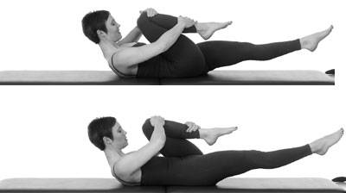
Single leg stretch is all about learning to move from center. It trains the abdominals to initiate movement, and to support and stabilize the trunk as the arms and legs are in motion. Many people find it especially helpful in targeting the lower abs. There is an element of coordination to this exercise as well.
- Prepare: Lie on your back with your knees bent and your shins parallel to the floor. This is tabletop position for the leg
Take a few moments to breathe deeply into the back and lower abs. See Sequential Breathing for more on working with the breath
- Inhale Exhale: Pull your abs in, taking your bellybutton down toward your spine, as you curl your head and shoulders up to the tips of the shoulder blades. As you curl up, your left leg extends at a 45-degree angle.
The right leg remains in tabletop position with the right hand grasping the right ankle and the left hand moving to the right knee.
You will maintain your upper-body curve throughout the exercise. Be sure to keep your shoulders relaxed and your abdominals deeply scooped.
Inhale: Switch legs on a two-part inhale. Bring air in as the left knee comes in, and bring more air in as you gently pulse that knee toward you. Now the left hand is at the left ankle and the right hand at the left knee. Exhale: Switch legs. Bring the right leg in with a two-part exhale/pulse and extend the left leg.
The hand to leg coordination continues with the outside hand of the bent leg going to the ankle and the other hand moving to the inside of the knee. Repeat: Switch legs up to 10 times. Release the exercise if you are finding tension in your shoulders and neck or if your lower back is taking the strain.

Modified leg stretch It is possible to get a good abdominal workout while protecting your neck and back. You can do this exercise with your head down. If the small of your back is starting to come off the floor, or you are feeling back strain, then your legs are too low. Raise your legs so that you are working your abs and not your back. As your core strength increases, you may want to experiment with lowering the legs and/or raising the head and shoulders.

SWIMMING
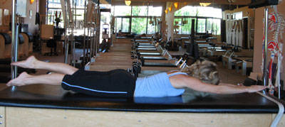
Swimming makes a great counter stretch for the many Pilates Mat exercises that require forward flexion. Swimming makes a great counter stretch for the many Pilates Mat exercises that require forward flexion.
- Lie on your stomach with the legs straight and together.
- Keeping your shoulder blades settled in your back and your shoulders away from your ears, stretch your arms straight overhead.
- Pull your abs in so that you lift your bellybutton up away from the floor.
- Reaching out from center, extend your arms and legs so far in opposite directions that they naturally come up off the floor. At the same time, get so much length in your spine that your head moves up off the mat as an extension of the reach of your spine. Keep your face down toward the mat; don't crease your neck.
- Continue to reach your arms and legs out very long from your center as you alternate right arm/left leg, then left arm/right leg, pumping them up and down in small pulses.
- Coordinate your breath with the movement so that you are breathing in for a count of 5 kicks and reaches, and out for a count of 5.
- Hopefully you feel like you are simulating swimming!
- Do 2 or 3 cycles of 5 counts of moving and breathing in, and 5 counts moving and breathing out.
Tips
- Keep everything long, long, long, reaching from your center.
- Keep your head and neck working as extensions of your spine and don't break the line at the neck.
- Protect your lower back by keeping your tail bone moving down toward the mat.
- If the breathing pattern is too complicated at first, leave it out.

PLANK Modified Plank
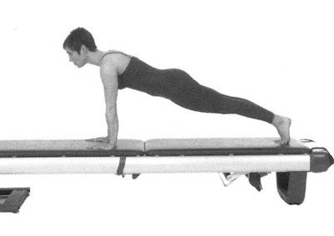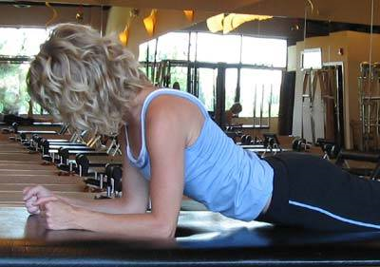
Plank, or front support in Pilates, is a well-known exercise. It is one of the most popular exercises for developing core strength and stability.While Plank really targets the abdominals and shoulder stability, you will find that plank is an excellent way to get a full body challenge. In order to do Plank properly there must be integration of all the core stabilization muscles. The arms, glutes, and legs are active as well. Plank can look like the up part of a regular push up. But, in most cases, a regular push up entails much more strain in the upper body -- especially in the shoulders and neck -- than plank in Pilates or yoga. You may want to begin with a modified version of Plank and work up to the full version, especially if you are weak in the upper body or have neck strain issues. Please see the plank prep exercise. You will know you're doing plank well when you have good form, feel your center working, and have good shoulder stabilization yet are not incredibly rigid.
Step 1: Preparation Begin on your knees. Place your hands on the floor in front of you, fingers pointing straight ahead. Your arms are straight and elbows are not locked.
Engage your abdominals and lengthen your spine, extending energy through the top of your head and down through your tail bone.
Lean forward to put your weight on your hands. Align your shoulders directly over your wrists.
If bearing weight on your hands causes wrist pain, use a wedge or pad to lift the heel of the hand enough to relieve pressure on the joint.
Step 2: The Extension
With your abdominals lifted, extend your legs straight behind you. Keep them together and send energy through your heels.
Your toes are curled under so that some weight is on the balls of your feet.
Without over-tightening, activate your legs (especially your hamstrings) and bring them together, emphasizing the center line. Similarly, activate but do not clench your gleuts (butt muscles) -- think of pulling your sit bones together.
Breathe deeply, allowing the breath to expand into your lower ribs and back.
Hold your position for three to five breaths.
Take a break and repeat up to five times.
Reminders: Your body is in a straight line from the ears, through the shoulders and hips, and to the heels. Do not arch or sag. Keep the abdominals lifted throughout this exercise. You want to engage the muscles of the pelvic floor Put some space between the base of your scull and your neck. If you start to shake, release the pose, breathe, and start again.
SAW

Saw is an intricate back and hamstring stretch. I like it a lot because it is a wonderful way to experience oppositional stretch - with the chest and upper back pulled open by the front and back arms reaching in opposite directions. As you become more familiar with the exercise, the oppositional dynamic between the front shoulder and the opposite hip is also very interesting. Saw is an important lesson in pelvic stability as well. While there is a lot of activity in the upper body, the abdominals must keep the hips still and even throughout the exercise.
Saw Preparation: Sit up straight on your sit bones. Your legs are extended in front of you, about shoulder width apart. If you have tight hamstrings you may need to prop your hips up on small lift, like a folded towel. Arms are stretched out to the side, even with your shoulders.

TURN AND REACH Inhale: Get taller as you turn your whole torso, but use your abs to keep your hips even with each other. Exhale: Let your gaze follow your back hand as you stretch forward and reach the pinky finger of your front hand across the outside of the opposite foot. Inhale: Get taller as you turn your whole torso, but use your abs to keep your hips even with each other. Exhale: Let your gaze follow your back hand as you stretch forward and reach the pinky finger of your front hand across the outside of the opposite foot. Exhale a little more as you reach a little further.

THE RETURN Once your reach extends to its furthest point, maintain your turned position as you inhale and return to sitting. Exhale and undo your turn, coming to the starting position.
Repeat this exercise 3 times to each side.

Edited by peter McCaffery

