EQUAL JUSTICE PROJECT
END OF YEAR REPORT 2018
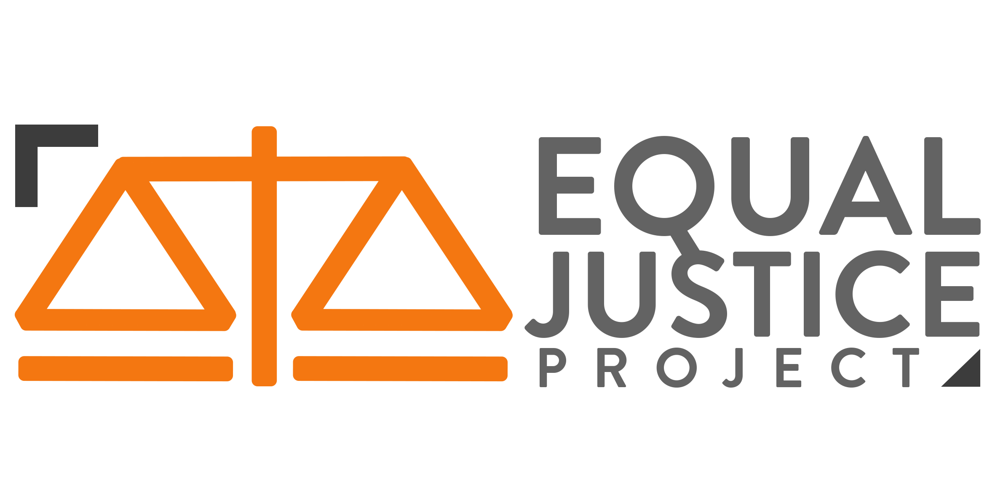
Contents
Directors 4
Outline of the Role 4
People management 5
Risk management 5
Strategic vision 5
Management Structure 6
The Co-Directors 6
The Executive 6
Advisory Board 6
Reflections 6
Mid-Year Function 7
Volunteer Recruitment 7
Opening Function 8
Training Day 8
Rebranding 9
Equal Justice Award 9
Advisory Board Recruitment 10
Relationships 10
Meredith Connell 10
ADLS 10
Auckland Action Against Poverty (AAAP) 10
The MALOSI Project 11
Law for Change Canterbury 11
The Faculty 11
Reflections and Improvements for 2019 11
Conclusion 12
Access 13
Outline of role 13
Presentations 13
Symposia Events 16
Retribution Vs Restoration – What Is The Future Of The Prison System In New Zealand? (Semester 1) 16
Modern Slavery In New Zealand – Time To Act (Semester 2) 17
Symposia Papers 18
Promotion 18
Accomplishments 19
Relfections 19
Relationships with other teams 20
Team Structure 20
Volunteers 20
Outstanding volunteer award Recipients 21
Improvements for next year 21
Contacting schools and other education providers 21
Presentation Materials 22
Symposia Papers 22
Team Bonding 22
Volunteer Selection process 22
Education Outreach Programme 23
Communications 24
Outline of role 24
Public Relations 26
Website & Social Media 26
Website 26
Facebook 28
Linkedin 29
Instagram 29
Inter-EJP relationships 30
Accomplishments 31
Team Structure 32
Head Editor Role 32
Volunteers 33
Improvements for next year 34
Inter-Team 34
Spelling, grammar, and the NZLSG 34
Focussing too much on impressive CVs 35
Time Commitment 36
Website help 36
Community 37
Outline of Manager Role 37
Outline of Volunteer Role 38
Community Work 38
Auckland Community Law Centre 38
Clinics 39
Mangere Community Law Centre 39
Shakti Legal Unit 39
Waitemata Community Law Centre 39
2018 Volunteer List 40
Auckland Community Law Centre 40
Mangere 41
Shakti 41
Wailaw 41
Position/Structure 42
Management Structure 42
Team Structure 42
Reflections 43
Improvements 43
Pro Bono 46
Outline of Role 46
Research undertaken in 2018 46
Project One: Ihumatao (Save Our Unique Landscape) 46
Project Two: Mental Health and Addiction Inquiry 47
Project Three: Modern Slavery Legislation 47
Project Four: Civil Litigation Court Fees 48
Project Five: Declaratory Judgment in Relation To Sexual Harassment As Misconduct 48
Project Six: Online Dispute Resolution and Social Justice Issues 48
Project Seven: Auckland Action Against Poverty 49
rEFLECTIONS on Research Undertaken In 2018 49
Management and Team Structure 50
Management structure 50
Team structure 51
Volunteers 52
Pro bono volunteer list 2018 52
Volunteer numbers 52
General contributions 53
Reflections 53

Directors
The directors for 2018 were Ella Stolwerk and Jane Wang.

Outline of the Role
There are three key components of the role of an EJP Director: people management, risk management and setting the strategic vision for the organisation.

People management
This year, we held weekly meetings with the EJP Executive as a whole. These meetings were an important way for the Directors to remain abreast of issues that presented themselves to different teams. The meetings also ensured that each team’s Managers were informed about the work of their colleagues. It gave the opportunity to get a variety of opinions and ideas to help target problems which arose in each team. Further, it helped EJP to foster a collaborative team environment.
The Directors also interacted with volunteers to get their feedback on aspects of EJP. However, because the Director role is removed from the day-to-day operations of the organisation, we will be releasing an anonymous survey to receive feedback about the EJP experience. Volunteer feedback is an invaluable source of information for the Directors. The experiences of our volunteers is what helps drive our organisation.

Risk management
Risk management involves the Directors assessing potentially contentious situations (such as projects or external relationships) and making decisions about whether EJP should engage in those areas or not. The Advisory Board is an important, helpful feature of the Directors’ risk management processes. The Directors are also responsible for securing EJP’s sponsorship and maintaining EJP’s financial records. In this sense, the Directors have for a long time been the de facto treasurers of the organisation. They must ensure that the internal records we keep are up to date and comprehensive, as this assists EJP when applying for external funding.

Strategic vision
The Directors set the tone for the Executive and guide EJP according to their ‘strategic vision.’ Typically, this involves meeting with the new Executive at the beginning of the year and clearly examining each team’s goals for the year ahead. The goal of strategic planning is to set specific goals that are underpinned by a broad commitment to EJP’s general values. We condensed our ideas to fit within the ambit of three goals: diversity, internal outreach and external outreach.

Management Structure
The management structure for the Directors is quite clearly laid out. The Directors decide the direction of EJP as an organisation, particularly in terms of strategy, fundraising and the overall vision of EJP for that particular year. On a day-to-day basis, the Directors ensure that the Managers are all completing the tasks they need to so that the organisation is on track to meet its goals. The Advisory Board then sit to the side of the Executive and provide advice on big-picture issues.

The Co-Directors
The two-year overlapping Director term has continued to work well and ensure continuity across years, and allows the directors to plan with a more long term vision for the longevity and success of EJP as an organisation. We have worked well together and have each brought different skill-sets to the table to complement each other. Both of us have had very busy lives outside of our EJP commitments but have managed to always keep the lines of communication open and transfer our workloads where needed. We’ve also been able to support one another and offer advice, and have built a strong partnership and friendship over the year.

The Executive
The Executive is made up of two Co-Managers from each of our four teams, in addition to our web consultant. We met frequently with our Managers this year, and also organised a number of social events, which we believed have strengthened and fostered a sense of collegiality amongst our Executive. We have tried to remain approachable to the Executive and open to feedback, and we hope that the Managers have felt comfortable coming to us for advice and support. We have also recruited a new Web Consultant who will begin her new role in the coming year, on the advice of the Communications Managers.

Advisory Board
Our Advisory Board is a valuable resource for the Co-Directors and the organisation as a whole. The Advisory Board sit to the side of the Co-Directors; the Co-Directors do not require the Advisory Board’s approval before finalising every decision they make, but they should recognise that the Advisory Board primarily exists to guide the Co-Directors and help minimise the risk they expose the organisation to. We are very grateful for their insight and guidance.

Reflections
In general the Director position and our roles have worked well in 2018. The role changes from year to year as different values and events are prioritised. This year, the Directors agreed on a set of shared goals prior to our opening event. We tried to make sure the Executive as a whole felt included in as much of the decision-making as possible, and on board with our shared vision.

We believe we have successfully created a collaborative environment where Managers are supported and we contribute towards the work they are undertaking. We have provided consistent oversight of their work through weekly Executive meetings and have made concerted efforts to have one-on-one catch ups where needed. We made a great deal of effort to create a strong social relationship within the Executive. We did this through our Executive retreat during the middle of the year and the frequency of our meetings. The nature of volunteer work like this is that it can be thankless and is often time consuming at inopportune times of the year (such as during assignment-heavy periods). We feel that we have supported our Executive and built friendships as well as professional relationships.

This year has been challenging in the sense that our goals were quite ambitious. Our vision to expand our organisation to other universities was not easily realised, and we were made aware of various hurdles that we would face (quality control, differing communities and resources) by the Advisory Board. This has been instructive however, and Jane can learn from the key takeaways for next year.

We are confident that the decision made last year to seek a new Co-Director who will be able to commit to the role for 2 years was a good one. Ella has shown Jane the ropes, and helped her to find her feet. We are excited to see the fresh perspective that our new Co-Director will bring to the role.

Mid-Year Function

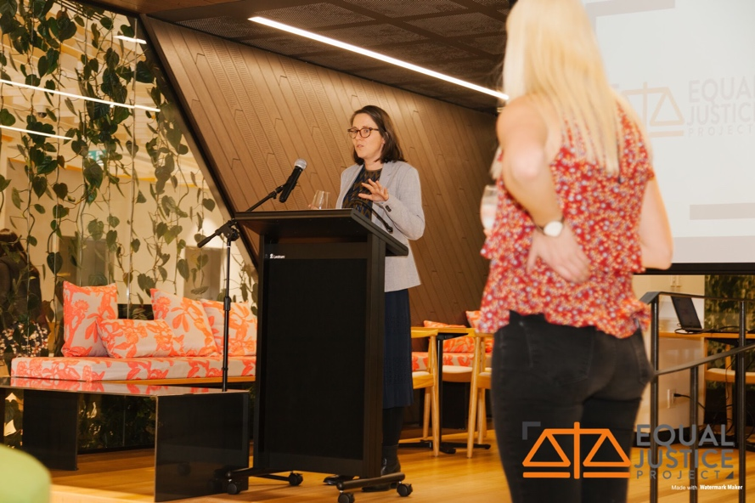
We have continued our relationship with Meredith Connell and we again hosted our Mid-year function at their offices. We did this to reconnect with our volunteers, and provide them with food, drinks and a guest speaker to show our appreciation for the time and dedication which they have given for EJP and our community. Our guest speaker was Zoë Lawton, the founder of the #Metoo blog, a platform for legal professionals and students to share their experiences of sexual harassment, bullying and discrimination. The short speech followed by question and answers proved to be very successful as many of our volunteers were interested in the topical subject. The mid-year function was an important opportunity for volunteers to touch base with their teams and form relationships with the wider EJP whanau.

Volunteer Recruitment
2018 was the first year where we required returning volunteers to re-apply. We made this decision after the experience of 2017, when there were over 200 applications for only 60 spots. This was not in an effort to replace all returning volunteers, but rather to give a chance to younger passionate students in favour of returning volunteers who were beginning to lack motivation.

This proved to be a successful decision. We received over 200 applications for the 2018 intake. However, we received a higher proportion from second- and third-year students. This has meant that our volunteer cohort this year has included more younger students than previous years. Although this is ideal in establishing EJP as a constant in the law school experience, the future directors must look at retention of quality volunteers. A lot of the work that EJP does requires a number of more experienced law students, further on in their studies. The future Directors should shift their focus to the retention of quality older volunteers in addition to attracting younger students.

Opening Function
We hosted the Opening Function at Thievery Studio. In attendance were members of our Advisory Board and we extended invitations to a number of law student associations and equity groups (including Te Rakau Ture, the Pacific Island Law Students’ Association and Rainbow Law). Our guest speaker was the Court of Appeal judge, Justice Helen Winkelmann. She spoke extensively and passionately of her career and her desire to see equal justice within the legal system. We also presented the Equal Justice Award to Sylvia Bell for her dedication to progressing human rights in New Zealand.

Training Day
Due to the success last year’s arrangement, we have continued to host the Training Hui in conjunction with the Opening Function at the start of the year. The event was a success with over 100 volunteers present at each event, beating our previous year’s record attendance of 70 volunteers. The speakers included: YouthLaw, Treasa Dunworth, Anna Hood and Mark Harborow from Meredith Connell. The speaker line up had a diverse range of different experiences. This year we had a particular focus on international law through our talks with Dunworth and Hood. The day also included team-specific training. This increased the social connections within the teams, crucial for our retention strategies.

We believe this initiative should continue because it allows an opportunity for our volunteers to meet and form connections early in the year. We gave out our new t-shirts that were purchased by our volunteers. This further allowed for opportunity to grow a sense of community within the organisation. It also gives an educative benefit as the speakers and presenters embody the values which drive our organisation. This allows our volunteers to understand and take these values out into the community when they are representing our organisation.

Rebranding
Before the 2018 year began, we made the decision to rebrand EJP. This was primarily done for two reasons. The first being a desire to give EJP a more modern feel. The old logo and colours of blue and yellow have long served to identify EJP, but we considered them too dark and outdated. The vibrancy of the orange and white better reflects an organisation of youth driven by equal justice. Secondly, as a significant goal for EJP this year was to increase our number of male and Maori and Pasifika students, we believed that a new brand and logo would be a symbolic way to separate us from the old stigmas which surrounded EJP.

Equal Justice Award
The Equal Justice Award was established to recognise outstanding contributions to the spirit of equal justice and community service in the Auckland legal community. Previous recipients include Peter Williams QC for his lifelong contributions to criminal justice reform and Judges Lisa Tremewan and Ema Aitken to celebrate their efforts in establishing the Alcohol or Other Drug Treatment Courts. Last year the award was presented to Darryn Aitchison and Neil Shaw, co-managers of Auckland Community Law Centre. EJP recognised Darryn and Neil for their tireless dedication as managers of the Auckland Community Law Centre.

This year the award was presented to Sylvia Bell to recognise her unwavering commitment to the development of human rights in this country. She has spent her career advocating for some of the most marginalised people in New Zealand and has been a central figure in the development of human rights over the last three decades. She has been involved over many years in the arena of hate speech and developing the Human Rights Commission's position and approach. She appeared as counsel in many leading cases on discrimination, including Atkinson v Minister of Health, and immigration (Attorney-General v Zaoui). In addition, on top of all this she has written the texts with Warren Brookbanks on Mental Health Law and authored the Brooker's Human Rights Law treatise.

The Award enables us to raise awareness about our own work, particularly as the Award is always presented at our annual Opening Function, which members of the profession, academics, our community partners, and students are invited to attend. We believe the number and quality of nominations received demonstrates that receipt of the Award is now recognised as a desirable achievement by the legal and wider community, and furthermore, that EJP is acknowledged as a legitimate and reputable charity.

Advisory Board Recruitment
This year we farewelled Samuel Moore and Janet McLean. We would like to thank the invaluable guidance and the time which Samuel and Janet have given our organisation. We have greatly appreciated your work and hope to continue our relationships in a different capacity.

We will be welcoming our new advisory board members, Barbara Hunt and Carrie Leonetti. Barbara specialises in criminal trial and appellate work as well as commercial litigation and dispute resolution. While Carrie will be providing a new perspective having experience with law student clinics in the United States. We also welcome her to the law school as a new lecturer.

We are thankful for the time our advisory board members give to our organisation. Your extensive experience within the legal community ensures helps guide our organisation and contributes to the success of our organization.

Relationships

Meredith Connell
Our relationship with Meredith Connell continues to go from strength to strength. This year Meredith Connell once again hosted and funded our mid-year function, where Zoë Lawton was the guest speaker. We are very grateful to Meredith Connell once again for accommodating us so generously, and even providing a speaker for our opening function. We look forward to this relationship continuing in the future.

ADLS
In 2018 our relationship with ADLS has continued. EJP volunteers sit on committees, and ADLS generously sponsored our opening function. We would like to invest more time into this relationship in 2019, and see if EJP can assist ADLS in more ways. We would like to thank Jodi Libbey for her continued support of EJP and look forward to meeting with her as soon as possible with the new Co-Directors to see how we can progress the relationship moving forward.

Auckland Action Against Poverty (AAAP)
This year, EJP has formed a new relationship with AAAP in conjunction with the Auckland Community Law Centre (ACLC). AAAP is an organisation which concentrates on fighting unemployment and poverty. The majority of their work is in political action, education and research as well as beneficiary advocacy. EJP volunteers are working with lawyers at the ACLC in order to assist in the latter. This project was initiated by Advisory Board member Hanna Wilberg and we are grateful for the chance to assist in a worthy cause. This project as continued for the past few weeks and has been adopted into our Pro-Bono team.

The MALOSI Project
This year we initiated a formal relationship with the MALOSI Project. The MALOSI Project, or the Movement for Action and Law to Overcome Social Injustice, is an initiative at the law school which aims to empower Pacific Islanders in our wider community. Their work includes: school workshops aimed at Year 11-13 Pacific Island students, community workshops for families to educate them on their legal rights and a blog which identifies legal issues impacting Pacific Islanders. The MALOSI Project and EJP are driven by similar values in the pursuit of equity in our communities. EJP welcomes this new relationship and is looking forward to the many collaborations in the coming years.

Law for Change Canterbury
This year we reached out to a similar organisation based at the University of Canterbury Law School, Law for Change. After some initial emails, Jane met with a leader from their organisation in Christchurch. This meeting was an excellent beginning to a relationship between our two organisations. As an initial meeting, it was beneficial to learn about the differences in the day-to-day operations in our organisations. Law for Change Canterbury operates more like a university club, with club membership rather than an application process. It was a rewarding experience to discuss the similar values on which we base our work and celebrate the successes of the organisations. We are excited for a future relationship between our two organisations. This has begun with plans for future attendances at each other’s events.

The Faculty
This year the relationship with the Faculty has consisted of us (the Directors) asking for assistance with the end of year function, because ADLS was unable to assist us. With a new Dean in 2019, it would be good to get this relationship up and running from the start of the year, and perhaps have an agreed sponsorship arrangement from day 1.

Reflections and Improvements for 2019
The nature of the Director role includes a lot of discretionary power. Therefore, on reflecting upon the year that has been we can see that the role is what the Directors make of it. Some key recommendations from 2018 looking forward to 2019 include:

- Getting the Executive away for their retreat early (perhaps planning ahead in 2018) to ensure maximum team bonding
- Start planning events early, and make sure the workload is evenly shared across both Directors
- Invest time into relationships particularly with ADLS, the Faculty and the Advisory Board
- Look for alternative forms of sponsorship (Campus Life funding is drying up as there is an abundance of student clubs, so firms and other organisations that align with the values of EJP would be good places to look to)
- Set goals that are S.M.A.R.T. to ensure maximum fulfilment in the role and success
- Assist the Managers in the selection of volunteers who will be motivated and committed to the role, and not focussed solely on their other commitments
- Come up with new ways to improve the inclusivity of the organisation as a whole
- Invest time into methods that will attract more diverse applicants throughout recruitment period

Conclusion
All in all, it has been a fantastic year. We have thoroughly enjoyed working with our Executive. We wish the 2019 Directors and wider Executive the very best and hope they have a lot of fun leading this incredible organisation. We cannot wait to see all the things they achieve.

Access
This year’s Access Co-Managers were Gussie Cohen and Chloé Wilson.

Outline of role
As Access managers, our role includes establishing relationships with educational facilities, liaising with them throughout the year to organise presentations, and running bi-annual symposia events.

The most important part of our Education Outreach Programme is establishing and maintaining relationships with the educational facilities. We always try to tailor our materials to suit their needs, as well as seek feedback to ensure we are constantly improving. This aspect of the role also involves ensuring we have up-to-date, relevant and interesting content in our presentations, as well as ensuring that our volunteers are prepared and enthusiastic about the topics on which they present.

Organising symposia events involves choosing a topical legal issue, finding appropriate panel members and a moderator, organising volunteers to create promotional materials (e.g. posters, brochures, panellist profiles), writing a symposium research paper and questions for the moderator to pose to the panellists on the night. It is also necessary to book a room, book microphones, run a promotional bake sale, and organise refreshments and food for the event.

This year we focused on expanding the audiences of our Education Outreach Programme, which included presenting at the Life Beyond School Programme and a conference run by Social Innovation New Zealand. In addition, we added new presentations to our repertoire enabling us to reach and educate a wider range of students.

Presentations

We began this year by getting our volunteers to update the content in all of our existing presentations, which include:
- Civics
- Privacy
- Family, Sex, Relationships
- Police
- Consumer Rights
- Employment
- School leavers

Throughout the year, our volunteers created three additional presentations, which are outlined below:
- New Zealand History and Equity: What is equity? How does it differ from equality? This presentation aims to inform students about New Zealand's history, the impact of colonisation on the Māori people, and how these effects are still prevalent today. The presentation is interactive and serves to educate and enable students to see history from a different perspective, with the goal of improving outcomes for New Zealand as a whole.
- Mental Wellbeing: What is mental wellbeing? What are my rights if I’m not in a good headspace? In the form of an interactive and open discussion, this presentation aims to answer several questions and myths surrounding mental health that every student will come face to face throughout their studies and beyond. It encourages conscious thought about how the law can both impede and support us with the aim to de-stigmatise mental health problems.
- Life After the Halls – Tenancy/Employment/Budgeting: This presentation is geared towards students as they prepare to leave the halls of residence, and begin looking for flats and potentially for jobs. In terms of tenancy, we have advice about flat viewings, applications and tenancy agreements. We then cover how to terminate a lease agreement. We also have information on employment, including applying for jobs, employment rights, contracts, hours, wages and resignation. Lastly, we have a short section on budgeting.

This year we presented:
- At the following schools:
  - Education Action (x2)
  - Baradene College (x2)
  - Glendowie College (x2)
  - Eden Campus Teen Parent Unit (x2)
- At an after school programme called “Life Beyond School” (x2)
- At a conference run by Social Innovation New Zealand (x 1)

Education Action and Eden Campus were existing connections from last year, and they were enthusiastic to welcome us back. While we contacted all former connections from previous years, unfortunately we did not hear back from many of them. As a result, we decided to search for new connections, and we sought to change the scope of the programme to suit a more diverse range of audiences.

In particular, we have developed the two new presentations detailed above (“Mental Wellbeing” and “New Zealand History and Equity”). The New Zealand History and Equity presentation has been very popular with higher decile schools, who have been interested in learning more about the history of colonisation and some of the historical injustices that persist today.

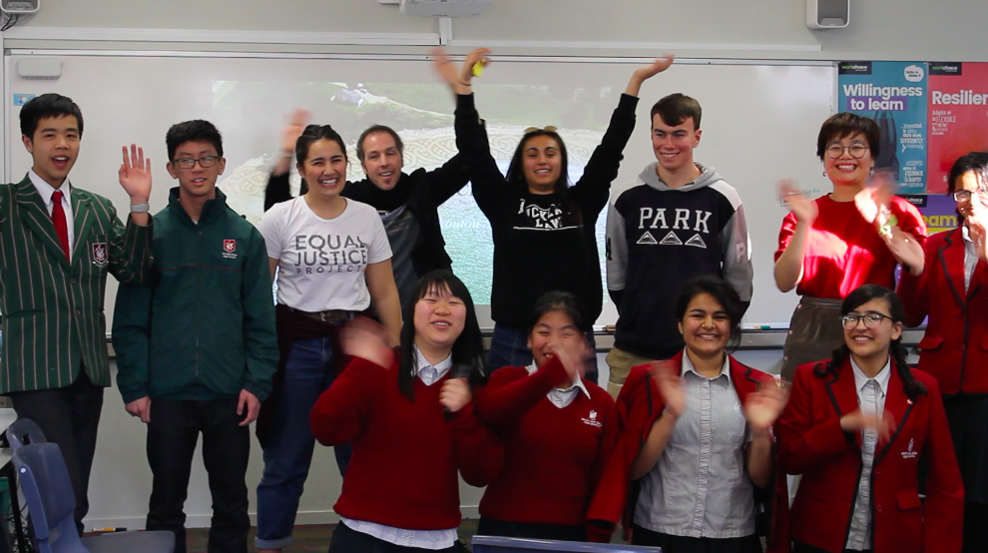

We have also developed an official information pack this year to attach to emails when we contact new Education providers. This allows for shorter, catchier emails, as well as giving Access a more official appearance. This has proven to be more effective in getting a response from education providers, and we recommend continuing this in the future.

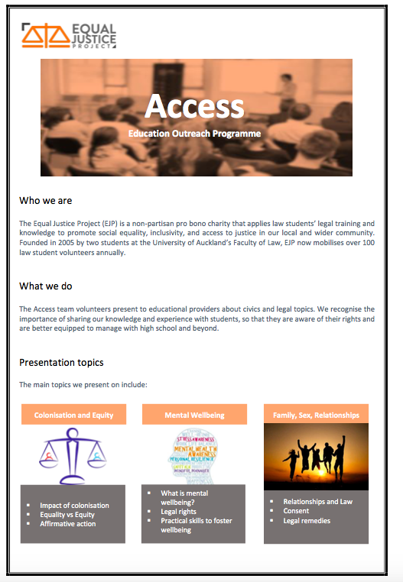

We received really positive feedback about our presentations this year. Below are some comments we were sent:
- “The group of 5 young mums were very interested and involved. The content was well presented. Adriana and Gary made it very relevant and engaging. They obviously love their work. The activity of creating your own party and policies worked well. The girls asked Adriana and Gary to come back and do another one!” – Eden Campus
- “Wonderful presentation this afternoon, conveyed with aplomb by your talented volunteers. LBS would love to have you back again for more presentations of a similar nature in future.” – Life Beyond School
- “The students wanted more time because they were also SO interested in the two speakers themselves and how they got to uni, what subjects they took at school, what advice they had for them - our girls just love having young female role models to ask questions of!” – Baradene College
- Following our New Zealand history presentation at Baradene College, the Year 10 Students wrote an article for their school newsletter. Below is one girl’s reflection:
  - “The presentation given was very informative and made us more aware of our New Zealand history in terms of Maori and Pakeha relations. I took a lot away from their presentation especially because I am Maori and enjoy learning more about my culture, but also because I was able to understand the opportunities provided for Maori and Pacific Islander Students (MAPIS) in New Zealand. They spoke about how programmes like MAPIS and Tuakana are not unfair advantages but instead they are encouragements of equity within our universities. For me personally, I could not be more grateful for programmes like these as they offer opportunities which would not be available to us otherwise. From the presentation I took away plenty, much of which motivates me to stay connected to my Maori heritage and continue to work hard to achieve my endeavours. I am thankful for what we were able to learn from the presentation given and believe that through this knowledge attained, I will continue to be inspired by the trials of my ancestors throughout my education.”

We are excited that all of our connections this year have expressed interest in us returning next year to deliver more presentations.

Symposia Events
We ran two successful symposia events this year. Both events had a great turn out from students as well as lawyers in the Auckland community. Each of the topics is detailed below.

Retribution Vs Restoration – What Is The Future Of The Prison System In New Zealand? (Semester 1)
Our first symposium of the year was focused on the Criminal Justice System. In the context of record high rates of incarceration (despite decreasing crime rates), significant overrepresentation of Maori in the Criminal Justice System, and the government's pending decision at the time on whether to build the largest prison New Zealand has ever seen, we hosted a symposium to facilitate a discussion on whether we should be moving away from a punitive and towards a rehabilitative focus. Our diverse range of panellists debated this question. On the panel we had Justice Christian Whata, Marie Dyhrberg QC, Annah Stretton, Dr Fleur Te Aho, David Garrett and Jude Noel Sainsbury as the moderator.
This turned out to be a very timely discussion, because the government made its decisions soon after not to go ahead with the prison plans.
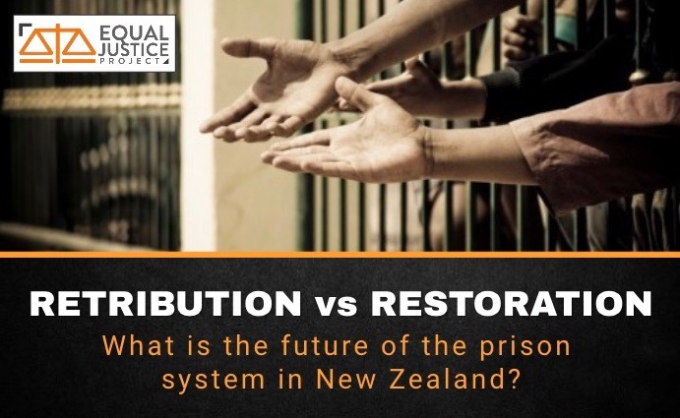

Modern Slavery In New Zealand – Time To Act (Semester 2)
Slavery is not merely a historic atrocity. It continues at shocking rates today, constituting an assault on human dignity and freedom. In light of the continued exploitation of migrant workers in New Zealand, increasing rates of human trafficking, the issue of orphanage tourism as a form of modern slavery, and limited supply chain accountability for businesses, we hosted a symposium to discuss whether New Zealand should follow the lead of the United Kingdom and Australia and adopt a Modern Slavery Act, or whether we should pursue other policy options. On the panel we had Rob Fyfe, Chief Judge Christina Inglis, Dr Christina Stringer, Hannah Reid and Dr Jackie Blue as the moderator.
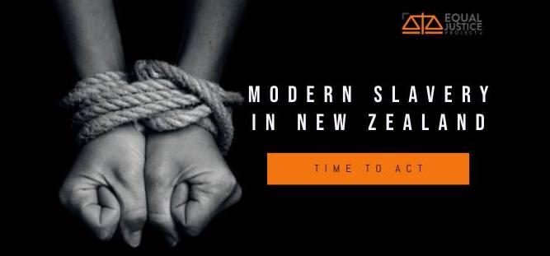
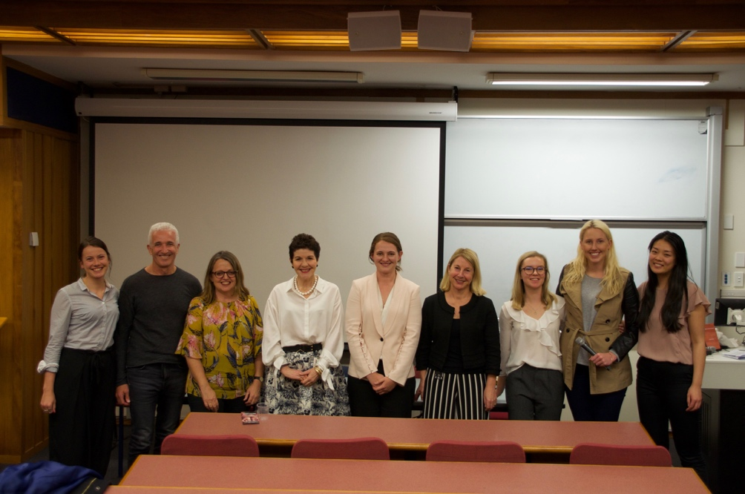

Symposia Papers
This year we published two symposia research papers (one for each of the events). These are informative documents, detailing the main legal and social issues related to the topics, as well as offering some potential ways forward.

In terms of organising the papers, we found that appointing a chief editor to oversee the writing of 3-4 volunteers was a really effective way to ensure that the writing style was consistent and the paper was well structured and coherent.

Promotion

Effective promotion of the event is really important. We appointed volunteers to make brochures, posters and speaker profiles for each of the events. This year we decided to release one speaker profile a day on the Facebook event page, which was a great way to expand the reach and audience of the event.

Access Managers should continue to be granted administrative roles over the Facebook for promotion purposes. We also recommend making use of our Advisory Board and ADLS to promote the event. However, it is important to keep in mind that materials need to be prepared in advance so that ADLS have time to distribute them.

Accomplishments
- Running two successful symposia events.
- Delivered a series of informative presentations – all of which received great feedback.
- Updating the material in all existing presentations and creating three new presentations
- Making an official information pack to attach to emails when reaching out to new education providers. This details the mission of EJP, the role of the Access team, as well as the presentations we offer.
- Branching out to a wider variety of educational providers
- Creation of promotional videos for EJP. We hope this will aid in attracting a wider range of EJP volunteers, as well as being useful for general EJP promotion to our external stakeholders.
- Made a series of templates which can be used for event organisation, contacting schools, running bake sales etc.
- Started a database to keep track of what schools we have contacted and what response we have received.

Relfections
We believe that the Access team has great potential to continue expanding its Education Outreach Programme. We just need to be open-minded and willing to adapt to the needs of different providers. For example, by tailoring materials to suit certain audiences. We also see a continuing role for Access in higher decile schools in terms of providing education on issues of equity, inequality, New Zealand history and mental health. While we have traditionally targeted lower-decile schools, we think it is important to expand because addressing inequality – no matter what form it takes – is the responsibility of everyone, not just those subject to oppression and marginalisation. In saying this, we still believe Access should continue its great work in lower-decile schools, and we believe the collaboration with the Malosi project team is one avenue to achieve this.

Relationships with other teams
The Directors were always engaged and supportive of our projects throughout the year, helping us whenever we needed (especially with our symposiums). We also thoroughly enjoyed working closely with the other teams. We are grateful to Communications for their support in promoting our events and our symposium papers, and to Pro Bono whose research was the inspiration for our second symposium.

Team Structure
At the beginning of the year, we split our volunteers into teams to work on updating our existing presentations. However, we did not limit our volunteers to the topics they worked on in terms of presentations throughout the year. We wanted to ensure that everyone had exposure and experience presenting on a range of topics.

As needed, we created sub-committees within the team. This was especially useful for running the symposium events. We also had a Video Team in charge of capturing the footage for our promotional videos. This was comprised of Georgia Kane, Gary Hoffman, Adriana Bird and Georgia Moore.

Volunteers
General Contributions

Overall, we had a great group of volunteers who were engaged in presentations, extremely helpful in the organisation of our symposium, and were enthusiastic to create new materials for our Education Outreach Programme. We greatly value the contribution of all our volunteers who have made this year such a success for the Access team.

Volunteer Numbers: 16

We reduced the number of volunteers to 16 this year and found this worked really well. We would recommend keeping the Access team small to ensure everyone has an active role and there is greater accountability.

Volunteer List 2018:
- Sophie Vreeburg
- Adriana Bird
- Laura Wang
- Josie Butcher
- Sasha Cuthbert
- Nancy Chen
- Sana Al-Alshraf
- Veronica Shepherd
- Georgia Kane
- Emily Lyons
- Mukti Rathod
- Gary Hofman
- Georgia Kelly Moore
- Carrissa San Diego
- Rima Shenoy
- Denischa Cetty (1st Semester only)

Volunteers that went above and beyond
We are very appreciate of all the volunteers who made the symposiums the success they were. Georgia Moore, Rima, Josie, Nancy and Gary made fantastic promotional materials. We would also like to thank our Symposium Paper teams for their time and effort in producing the research papers. The volunteers for these were Josie Butcher, Sana Ashraf, Nancy Chen, Adriana Bird, Emily Lyons, Sophie Vreeburg, Mukti Rathod, Laura Wang and Veronica Shepard.
Adriana, Gary and Josie were always willing to do presentations, even at short notice. They were all extremely competent, knowledgeable and enthusiastic when presenting.
We would also like to thank Georgia Kane, Josie and Adriana for creating the New Zealand History Presentation, and Sophie Vreeburg for her great work creating a new mental health presentation. There has already been a lot of interest in these presentations from schools, so we greatly appreciate the knowledge and expertise of the volunteers in putting them together.

Outstanding Volunteer Award Recipients
- Josie Butcher
- Adriana Bird
- Gary Hoffman

Improvements for next year

Contacting schools and other education providers
We recommend doing this as early on in the year as possible. It can take a long time to hear back, and school calendars fill up quickly – something which we did not fully take into account. We also recommend making use of the volunteer’s connections to schools, as it is much easier to get a response when somebody knows a current staff member or student. If you do not hear back via email, we recommend phoning schools to follow up.
We struggled again this year connecting with lower decile schools. We believe that contacting them earlier in the year, as well as the prospect of working with the Malosi Project, will help next year.

Presentation Materials
Although we have improved and refined all of our presentations this year, we received the following feedback from Baradene College:
“A strategy for taking information away from the presentation would be ideal e.g. structured worksheet / mind map / something simple so they are not writing everything down, but just to remember the key ideas. Students find it hard to 'take notes' - they either write too much or nothing usually, so some framework for the presentation in terms of recording key idea as set out at the very start could be useful. Although - this is something the teachers can think about and arrange with their students if they know the key points of the presentation ahead of time.”

We have done this for the New Zealand History and Equity presentation. We recommend developing worksheets, mind maps or summary sheets for the other presentations which the students can use during the sessions, and keep to remind them of the content covered.

Symposia Papers
We did not have any screening mechanism for writing ability in our application process this year. This meant that the quality of writing submitted for the papers varied and sometimes considerable work was required to get certain sections up to a publishable standard. In order to address this issue and to foster cross-team collaboration, we recommend having the Communications volunteers research and write the papers next year. Otherwise, include some sort of screening mechanism in the application process, which enables them to opt into writing the paper if they submit a short piece of writing.

Team Bonding
While it is always hard aligning everyone’s schedules, a fun team bonding event should be done at the very beginning of Semester One. We also did dinners or a breakfast each semester after our Symposium events to celebrate.

Volunteer Selection process
We would recommend to the future Managers that when selecting the 2019 volunteers they ensure that the volunteers commit to attending all the meetings, dedicate hours every few weeks for potential presentations, and show a willingness to do extra work in the lead up to symposiums. We found that it was hard to get people to commit or even respond to Facebook posts as the year went on, and it ended up being the same core group of volunteers that did the work. We therefore recommend keeping in mind the volunteer’s other commitments, and whether they have the motivation and the availability to fully commit for the whole year. We would also recommend asking them to provide contact details for any school connections, so that they can be contacted early in the semester.

Education Outreach Programme
We recommend continuing to develop and expand the Education Outreach Programme by approaching higher decile schools, making a concerted effort to reach out to lower decile schools in collaboration with the Malosi project, and being willing to expand beyond schools to university groups, conferences, community groups etc. While we didn’t get an opportunity to present our new “Life After the Halls” presentation, we have made contact with the halls this year to look at collaborating with them during student flatting week next year.

Communications
This year’s Communications Co-Managers were Daniel Gambitsis (continuing from 2017) and Claudia Russell.

Outline of role
As Communications managers we have a pretty consistent workload. We, along with our Head Editor, edit roughly two to four articles a week, depending on how many have been submitted by volunteers. The editing is the most time-consuming aspect of the job. We then upload the articles to the EJP website, format them, and post about the articles on our social media pages once they’ve been published.

The time that it takes for an article to be ready for publication varies depending on the volunteer. It has in the past been the custom to make edits to volunteers’ work, send it back to them for approval, then undertake the relevant formatting and make graphics for the final draft. Last year we decided to only send the articles back to the volunteers in situations where we made significant edits or had issues with some of the content. This year we continued with this system, as we found it sped up turnaround. As many of our volunteers are skilled writers, in the majority of cases edits are only minor and not worth the time it takes to seek approval. This process will likely continue over the coming years.

Sometimes checking up on volunteers is necessary in order for our publication schedule to run to plan, but for the most part, our team is self-motivated and committed to doing their part. We’re relaxed with extensions so long as they are within reason and do not disrupt the posting goals that we have to meet (and most volunteers only need one). We understand the pressures placed on all of our volunteers, and they almost always pull through with a great article in the end. We have noted in the past that volunteers are hesitant to request an extension, because they are either worried about what we might think or simply did not get around to warning us that they were not going to be able to hand in their articles on time. We have since attempted to let volunteers know that they are more than welcome to ask for extensions, and that we would prefer this to publishing unpolished work. This year we implemented a rotating ‘roster’ of sorts whereby Daniel, Hannah (our Editor), and myself (Claudia) would take turns messaging volunteers to check up on article progress roughly a week before the due dates. We found that not only did this help volunteers keep track of their responsibilities, but it helped us as managers keep track of what had been handed in.

The Communications Team produces two main categories of publications – Amicus Curiae and Cross-Examination. We believe that we were able to ensure a healthy balance between ensuring that both types of pieces had regular, good-quality coverage. As was the practice with previous years’ Managers, we regularly posted in the Communications Facebook group when relevant topics came up in the media and other outlets that we thought would make great articles. Volunteers were then encouraged to ‘claim’ the article topic by commenting on the post. We would give feedback, decide on whether the topic was appropriate, then inform the volunteer of a due date and have them confirm it before entering it into the schedule. Writing articles that are on topic with the latest news headlines is a big driver for article engagement and increasing our social media presence. The majority of topics were chosen on volunteers’ own initiative, but some did opt for the topics we suggested.

Some volunteers do not check the Google sheets schedule, and are uncertain about due dates or what topics have been chosen as a consequence. It is imperative that volunteers pay heed to our Facebook messages, even if they do not choose our article suggestions.

This year, we continued the policy from 2016 and 2017 of having every volunteer in Communications write one Amicus and one Cross-Examination per semester (a total of four articles). This mix meant that volunteers could write more opinionated, casual articles with a quicker turnaround and often connected to recent media events, as well as longer, more researched pieces (allowing for volunteers to write about areas that they were passionate about that were not necessarily topical but still well-researched and presented).

In terms of topics, like previous years, we have been relaxed about the requirement for articles to have a legal focus. We believed that restricting volunteers from writing about social justice issues purely because there had not been much legal intervention or connection with them in the past was unfair. We are now able to point towards our updated mission statement and our new Media Policy if volunteers are unsure about what sort of content is aimed for. We have also been more willing to allow coverage of international events, provided that such events were compared to the New Zealand context. Such pieces can attract above-average social media attention and draw attention to important causes which relate to domestic issues; however, the majority of our articles will continue to have a more local focus.

We had some issues with volunteers sticking to deadlines this year, mostly due to university commitments. Next year it would be useful to stress that, although work for the Communications team can be done in one’s own time, it is still a big committee to take on alongside a law degree. However, the vast majority of volunteers were very motivated and submitted work to a high standard. Our three-strike policy remains an effective way to resolve issues with volunteers who fail to submit work.

Public Relations
This year we continued reciprocal relations with the Public Policy club, whereby we would share each other’s events via social media. We also developed our relationship with Craccum further by having multiple articles published in issues of the magazine throughout the year. This was an excellent way to extend the reach of EJP throughout the university. Similarly, we worked with the law school magazine, Verbatim, to have articles with strong legal themes republished.

Last year we were able to have articles republished in ADLS’s Law News. This year we had an article by volunteer Lauren republished in Law News, which was great to see. Other media organisations can be difficult to keep in contact with. Next year we should continue to reach out to news sources beyond the university and try to develop stronger relations with Law News and our existing media partners.

Website & Social Media

Website
We rebranded out website to match our new logo at the start of the year. This came with rebranding our Facebook, Instagram and event posters. With help from our head editor Hannah, we went from the royal blue logo to a more modern and inviting orange one.
Almost all of our readers come from Facebook, according to the website statistics, so our emphasis should always be on Facebook. The graph below shows that our biggest month is March, during application season, after which views remain broadly constant until November. These statistics prove that our current posting strategy (where we do not post much during November, December and January) is probably the wisest course, because everyone is on holiday. While it never goes amiss to post content, we can get away with posting links to interesting articles and save original content for the semesters. It is interesting to note, nevertheless, the spike in views in February, proving that it is not pointless to post content even during the holidays, if the Managers do wish to do so.
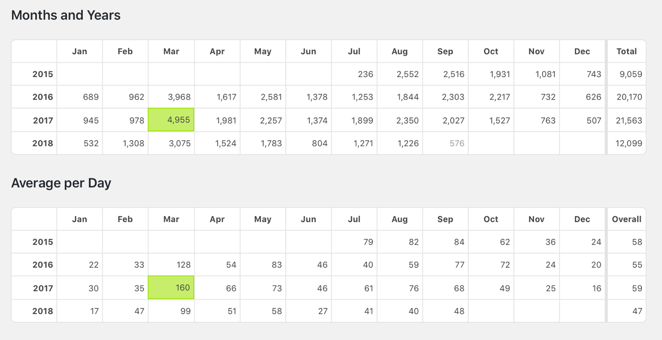
Unsurprisingly, our top posts related to sexual harassment scandal and applications. Older articles are still viewed over the years.

Top Posts by Number of Views
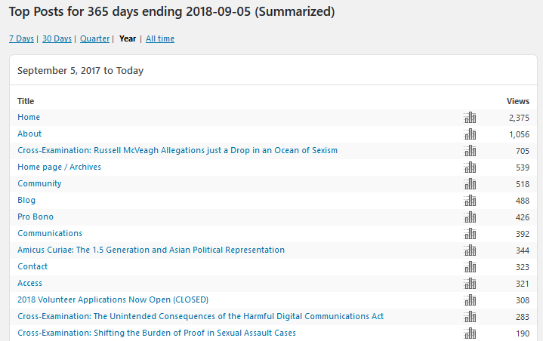

EJP’s audience is surprisingly wide.
Our top articles of all time:
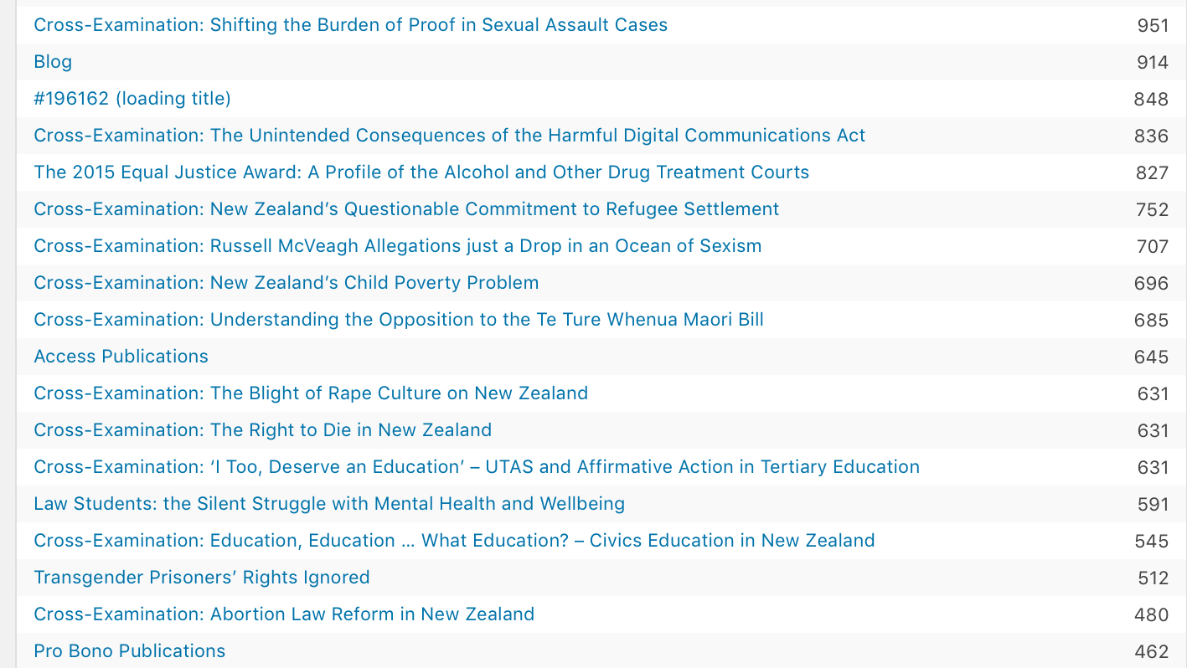

Facebook
One of our recurrent goals in Communications is always to increase our Facebook engagement, as it is our primary means of communicating with volunteers and publicising the organisation’s many events. In 2016 we increased from 846 likes in February, to about 1,073 likes in Semester 2. In 2017, we have increased from 1124 likes on January 3rd to 1425 likes in October. In 2018, we have now reached 1682. The increase in likes has been consistent throughout the year, which is a testament to the quality and regularity of our output.

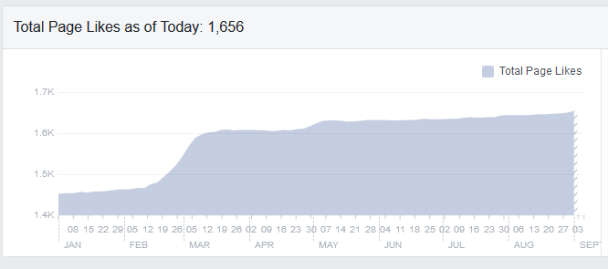

As shown by the graph, our post reactions have been very varied throughout the year, which would largely reflect the university schedule. We have continued the policy of not posting excessively during breaks when many students might be on holiday, or during times of the day when they are less likely to be online.

Linkedin
We deleted our duplicate and inaccessible account last year. Through dogged promotion on Facebook and posting on the account, our LinkedIn has surpassed the number of followers of the old account by 100% (the old account had 60 followers).
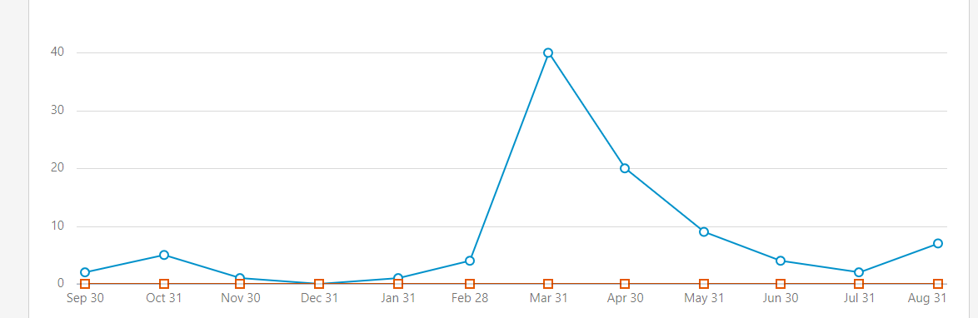
LinkedIn will never have the same reach as our Facebook account, but it is still useful in order to make EJP look professional and active as volunteers can add EJP to their volunteering history. It also gives the Managers another outlet to promote articles. The graph above again proves that the time when we are most likely to gain followers significantly is during applications in March – so our LinkedIn should be the most active during this period.

Instagram
Last year we began an Instagram. Unfortunately, our follower count has been stalled at about 300 for most of the year. Last year posts of our volunteers were the most popular content, so we decided to focus almost exclusively on this. Although likes have been consistent, there has not been a corresponding increase in followers.

Communications has been left in charge of Instagram, but the other teams (especially Community and Access) should ideally post more content seeing as they do the most people-centric, and photo-ready work. We have had to constantly badger the other teams for photos, because our own team’s work is simply not photogenic! It would be preferable that EJP continues to hire professional photographers for all our big events, to give us the best quality content.

Some volunteers and other pages shared our content throughout the year, which is one of the best ways to increase our reach. We would love if more volunteers shared their own content, as they should be proud of it. We hope to encourage volunteers to do this more regularly next year.

Inter-EJP relationships
The majority of our inter-team collaboration was with the Directors, Access and Pro Bono. This year we added the Access Co-Managers to the EJP Facebook page so that they could promote their events themselves, rather than having to create their own events. That was the case last year and it was awkward to promote the event when a private user’s account was in control of the page. Access did a fantastic job promoting their symposia on their event page, which proves that giving them access to the Facebook account was a wise decision.

We generally work with the other teams to promote their events across our social media, in particular Access’ bake sales and symposia. We also promoted the Ihumatao and modern slavery causes on which Pro Bono did significant research.

Our other key relationship was with the Directors, because we run the website, our social media, create promotional content and manage the applications processes for volunteers, Managers and Directors.

We had very little interaction with Community, due to the nature of their work.

We rely on the other teams to provide us photographs from their events and meetings so we can promote their teams and EJP generally; this was not always forthcoming.

Accomplishments
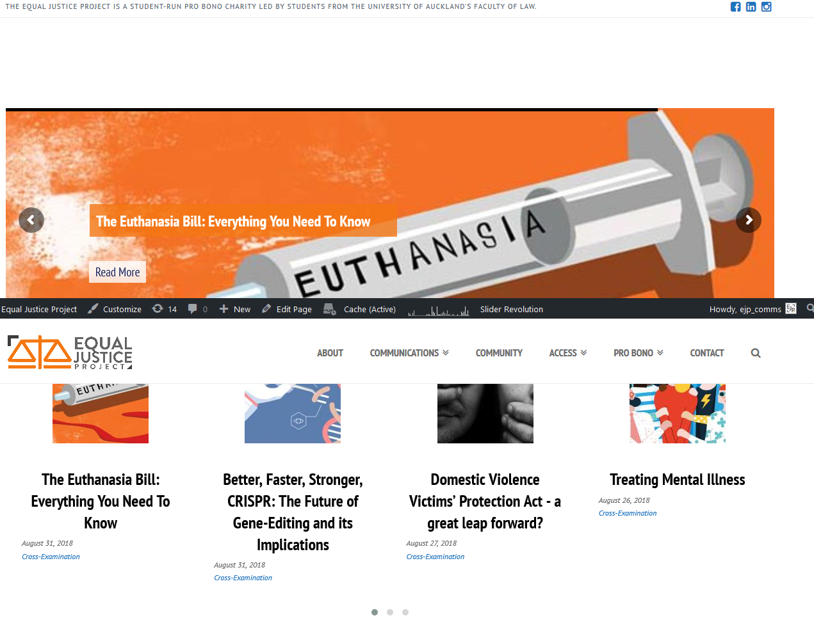
We organised the application process in March and October via Google Forms. We received more than 220 applications in March.

Our volunteers completed around 60 articles for our website, several of which were republished.

We have posted regularly on our website and promoted these articles on Facebook; we posted on LinkedIn and Instagram as well.

We have been lucky to have had several re-publications and the opportunity to promote EJP through other media, including Craccum, Verbatim and Law News. These came about due to existing relationships with members of these publications’ teams, so it is essential that the Comms Managers maintain and build these and additional relationships.

Claudia successfully re-branded the website and we rebranded our social media accounts. We also made minor changes to our publications, such as no longer including the blog title (Amicus or Cross-Examination) in the article titles. We decided that very few people understood or cared about the difference between these blogs and that they simply clogged our article titles, which should be more concise and catchier. We continue to distinguish between these article types in terms of categorising them on the website, although the difference between them in practice is minute other than the word-length. We also decided to simply write the author’s name (e.g. ‘John Doe’ rather than ‘By John Doe’) because this looks more professional.

To that end, Daniel completed a Comms Managerial and Style Guide, to be used and updated by future Managers. This should negate the need for a handover guide in future if neither Manager continues in the role over a second year.

This year for the first time we made it compulsory to complete a group project in either first or second semester, in groups of nine. Volunteers signed up on a first-come first-served basis. This worked well. The aim was to diversify our team’s output beyond articles and to make the team more prestigious for potential volunteers (in a perhaps forlorn effort to attract more applicants in future). However, there would not be sufficient enthusiasm from volunteers to increase the workload any further.

This year our aim had been to complete two bill submissions (as we had also hoped to last year!) In the first semester volunteers successfully completed a parliamentary bill submission on the CPTPP. Yet again, the volunteers ended up working predominantly alone, after an initial team meeting. We attempted to make the bill sub team leader position more important, so that the leader could take over from the Managers most of the job of ensuring volunteers are making progress and helping with any issues that arose for volunteers. However, this did not happen. This role should be reserved for a particularly enthusiastic and committed volunteer.

Unfortunately, yet again the timing of bill submissions did not work for second semester bill submission. However, we managed to find work in second semester for a second group to complete – a summary of the Pro Bono team’s extensive work on Voluntourism and an article to further promote the Ihamatao cause on which Pro Bono did significant work.

We ensured the publication of Access’ symposia reports and photos of their events, and organised, edited and published this report.

Team Structure

Head Editor Role
The Head Editor role was first created in 2017 and it was a great success in terms of managing our workload as well giving an opportunity for one our volunteers to take on more responsibility. This year we decided to flesh-out the role and make it give the Head Editor a much larger role and responsibilities. This year the Head Editor was responsible for editing one-third of all our work, including articles and other projects such as bill submissions. To make this possible, the Head Editor was given a role as Admin on the Facebook page and given the credentials for our website.

Hannah Yang has been an amazing Head Editor. She took her role very seriously and knows the Law Style Guide inside and out. She is an expert editor and never skimps on improving volunteers’ work and working with them to improve their work.

This role should be continued going forward.

Volunteers
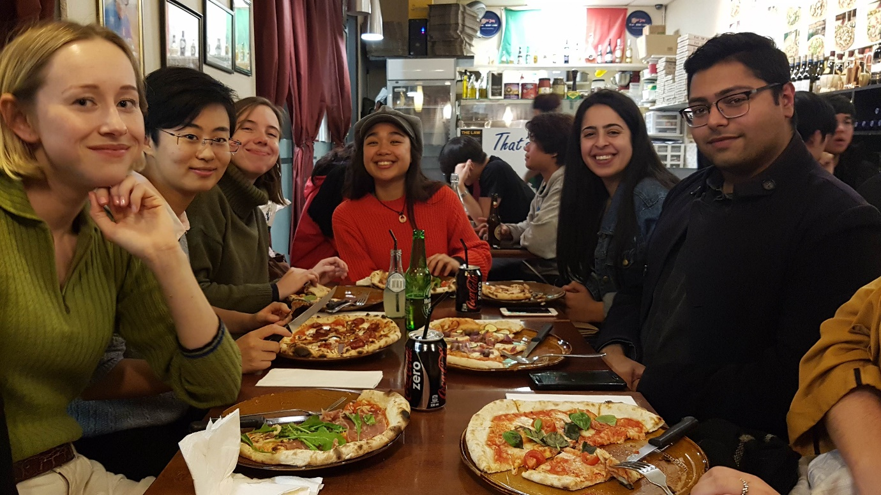
- Hannah Yang (Head Editor)
- Katrina Bernadette
- Rachel Buckman
- Haya Khan (Returning)
- James Adams (Returning)
- Anuja Mitra (Returning)
- Benjamin Bowley-Drinnan
- Eve Gamet
- Patricia Lu
- Lauren White
- Nithya Narayanan
- Akhil Parashar
- Milly Sheed
- Georgia Osmond
- Valeeria Slaiman
- Amy Dresser

Outstanding Volunteer Award Recipients
- Lauren
- Benjamin
- Anuja

Improvements for next year

Inter-Team
The Communications team should always be responsible for creating promotional materials for EJP, in order to check spelling and formatting is up to standard. This should be the case even when the materials are for another group, such as Access’ symposia promotional materials. In the past there have been spelling mistakes in EJP’s posters, because there was insufficient editing (although this did not happen this year).

There needs to be more communication between EJP’s teams and the Co-Directors as far as concerns our big events during the year. Having said that, it would be worth considering reducing the weekly exec meetings to every 2 weeks during periods where we don’t have big projects like our symposia or opening day to coordinate – often there simply isn’t enough to say to justify having a meeting.

It would be preferable that EJP continues to hire professional photographers for all our big events, to give us the best quality content.

Spelling, grammar, and the NZLSG
While much of the volunteers’ writing this year was of fantastic quality and it was clear they had taken the time to look for the specific applicable rule in the Law Style Guide, others either struggled with or did not pay enough attention to grammar and referencing.
Some common grammar/punctuation issues were:
- Subject-verb disagreement;
- Improper sentences;
- Inconsistency in tense; and
- Incorrect use of commas.
Some common referencing issues were:
- Not using pinpoints;
- Using the rule for newspaper articles where the rule for internet materials should be applied instead, and vice versa;
- Pasting the entire URL of a webpage instead of only that of the homepage;
- Using incorrect abbreviations for journals; and
- Footnoting sections from legislation where unnecessary.
This year we decided to go through a more rigorous and also hopefully more constructive editing process, where articles with tracked changes and comments were sent back to the volunteer either for revision or merely for future reference. It was hoped that in this way, volunteers would quickly learn which errors they had made and avoid repeating them in the future. Whether this aim has actually been effective, however, is not currently clear, due to the small number of Cross-Examination articles each volunteer must write in a year (only two) and the unlikely chance that the same editor would read both from the same person. Furthermore, due to the large number of volunteers, this approach meant that editors had to deal with multiple instances of the same errors from different people during the first semester.
A more effective approach next year might be for the next Head Editor to run a brief referencing workshop at the beginning of the year, so that those who are new to the details of legal referencing get a head start right off the bat, rather than be inundated with edits after they hand in their first of only two Cross-Examination articles. The points listed above could be used as focus points, as they seem to be the most common given the nature of our articles. As for grammar, it is hoped that a better selection process next year will reduce the need to address this separately. More on this below.

Focussing too much on impressive CVs
EJP’s executive team should not blinded by impressive CVs when hiring new volunteers, managers or directors.

In the context of the Communications team in particular, less emphasis should be given to CVs and more to the submission of written work. It is easy to be star-struck by an outstanding CV, and certainly many of our volunteers with great CVs have done excellent work. However, for the purposes of our team, the quality of the writing is what is most important, and often people who write well but are lacking in previous experience miss out because they didn’t have sufficiently impressive CVs. It is important to give people the opportunity to step up to the plate and show what they can do.

Choosing people solely based on how many clubs, charities, organisations, and so on, they have had previous experience with, fosters a ‘rich get richer’ situation. Many law students are hyper-competitive and already over-committed and simply wanting to burnish their CV. The volunteers with too many commitments tend to not be very engaged and do only the bare minimum. We want to support less experienced law students and help them gain experience and new skills, especially given the competitive nature of law school.

Time Commitment
In the application forms this year we, as usual, asked volunteers to confirm that they can commit to the workload of the Comms Team. The workload is not very heavy – 4 articles and 1 group project. However, just like in the past volunteers complained about being too stressed and busy to complete work and several resigned.
We understand that students are busy, and we are more than happy to give extensions and as much help as is necessary. However, at the end of the day students should not treat EJP as at the bottom of their priority list. We think that this is a particular issue for the Comms team, which is not as prestigious as the other EJP teams. It is for this reason that we do not hesitate to remove team members who did not fulfil their commitments (as per the 3 strikes policy). We must always reiterate that volunteers must fulfil their commitments to the Comms team, but that we will always be happy to give extensions and help with any issues that arise for our team members.

Website help
We successfully rebranded the website with our new branding earlier this year. However, some technical savoir-faire is beyond our competencies, and EJP needs somebody to be on call to help make changes to our website. This need not be a full-time role, and we will have to search beyond the law school – a call-out for a tech assistant in the usual law Facebook groups produced not a single willing applicant.

Community
This year’s Community Co-Managers were Alexandra Sims and Katie Pigou.

Outline of Manager Role
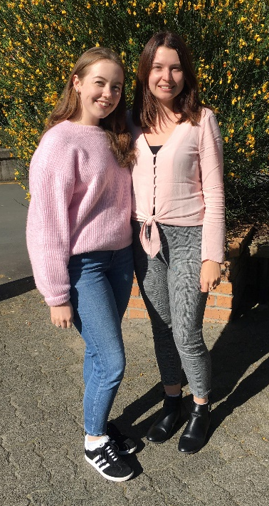
The co-managers of the Community Team are responsible for recruitment of community volunteers, communicating with the Community Law Centres, organising volunteer schedules, training volunteers and organising social events. The beginning of the year is the busiest time of year for the community managers. Initial communication and meetings with Community Law Centres must begin before recruitment takes place. During meetings with the community law centres we discussed how many volunteers each centre wanted for 2018, and discussed any suggestions they had from the previous year of working with EJP volunteers. A lot of our discussions this year were centred around trying to gain more volunteer spots for 2018, as there were an overwhelming number of applications for the Community Team in 2017. We entered discussions with the Waitemata Community Law Centre and the Auckland Community Law Centre who were both interested in taking on more volunteers for 2018. The Auckland Community Law Centre were in the process of establishing legal clinics and were interested in having more EJP volunteers to work in these clinics. Waitemata also wanted to increase their capacity and take on more volunteers. At the end of discussions with all of our community law partners we were able to increase our volunteer positions from 40 in 2017 to 80 in 2018.
One of our key roles throughout the year is communicating with our volunteers and liaising with the centres to ensure volunteers are fulfilling their commitments, and that volunteers were having a positive experience. We held meetings at end of the first semester with all of our volunteer teams. Before we held this meeting we emailed our centre contacts to ask them if they had any feedback for our volunteers. During the meetings, we relayed any feedback the centre contacts had given us and asked the volunteers for feedback on what their experience had been so far. We then communicated with the centres about what the experience of our EJP volunteers had been so far. The rest of our communication with our volunteers throughout the year took place via Facebook and email. We set up Facebook Messenger group chats for all the different centre volunteers so that they could communicate with us and between themselves to cover shifts they could not attend. We also set up a Facebook group page for everyone in the 2018 Community Team. This was an easy way for us to regularly communicate with all of our volunteers and encourage them to get involved in EJP-wide events.

Outline of Volunteer Role
The time commitment for volunteers in the Community Team differs from centre to centre. For example, volunteers at the Auckland Community Law Centre volunteer for two hours a week. Our volunteers at Wailaw volunteer for 3 and a half hours either in the morning or afternoon. Most of the practical oversight comes from the centres when our volunteers attend their sessions.
This year we decided to ask representatives from the centres to come in and do an initial training at our opening day Hui. A staff member from each centre came along and took the volunteers through general expectations and some training for the year ahead. This was of good value to the volunteers as it gave them a taster of what was to come in the year. We recommend that this be repeated next year.

Community Work
We maintained relationships with four of the organisations/centres with whom EJP worked with last year. We reached out to Citizens Advice Bureau to explore what a relationship with them would look like. A lot of the work was not strictly ‘legal’ which we felt may have taken away from the legal experience EJP provides to our law students. The process for recruitment would have been very lengthy and did not involve much collaboration with us as managers, which we felt was a cornerstone of the EJP team environment. As such, we did not pursue this option. Perhaps discussions could happen going forward, however we felt it was more important to maintain and strengthen our existing relationships.

Auckland Community Law Centre

Triage
As in previous years, there were 20 spots for our volunteers on Triage at ACLC. The triage shifts involve calling clients, writing legal advice and relaying that advice to the client. This year, a new manager at ACLC was appointed, Susie, and so we had various meetings with her in first semester to ensure that we were all on the same page in terms of expectations for the volunteers. Susie brought up a valid point that she would like to have more to do with the recruitment process of the volunteers. This is something that should be examined and discussed further with the 2019 Directors.
Something new that we did in collaboration with Susie was to do a mid-year survey, asking how the volunteers were finding their experiences and the environment specifically at ACLC. These answers were collated solely for the purpose of ACLC to ensure their processes were adequate. We recommend a mid-year survey be adopted by the 2019 Managers for all centres, whether specifically for the centres to review their processes, or also to look at EJP’s processes.

Clinics
The clinics were a new opportunity this year and included an evening clinic that employed six volunteers in rotation, and various different clinics around Auckland including Glenn Innes, Sylvia Park, Glenfield and Wesley. However, the Glenfield and Wesley clinics were cancelled half-way through the year, which was not completely unexpected as they were new clinics. As some of these clinics are in different parts of Auckland, it is imperative that the applicants at the beginning of the year specify their availability to determine who might be available to go to which clinic.
We also had some specialist clinics available: family law clinics, bankruptcy clinics and employment clinics. These opportunities should be retained for older students, specifically fourth- or fifth-year students who have preferably completed a course that relates to these topics e.g. the family law elective. This means that upon recruitment at the beginning of the year, there needs to be efforts to target these particular groups. We had a total of 18 volunteers in the clinics this year, and the responses from them have been very positive. It is a great opportunity for students to gain experience one-on-one with a client, observe an experienced lawyer working first-hand and gain legal writing experience.

Mangere Community Law Centre
As with last year, there were 3 volunteers in Mangere. This centre is located quite far from University campus. The activities at Mangere are similar to ACLC, and range from in-person clinics to more administrative tasks. The response has been very positive from both students and staff at this centre.

Shakti Legal Unit
This year we had 6 female volunteers at Shakti Legal, two more positions than last year. This meant the volunteers worked once every two weeks, which on reflection from the centres has not been ideal; they would rather have less volunteers in more frequent times so that the volunteers have a deeper understanding of the cases they are working on.
The role at Shakti includes advising on cases and sitting in on meetings that are of a very sensitive nature (i.e. domestic violence). The in-depth training at the beginning of the year was good for the volunteers, as the content that Shakti deals with is of a very sensitive nature. Because of this, we recommend older female students.

Waitemata Community Law Centre
This year, Waitemata asked for an increased number of volunteers from last year’s count of 12. They asked for 4 volunteers in the morning shifts, and 4 volunteers in the afternoon shifts. We had 28 as our total number, due to many volunteers finding it difficult to reach the Waitemata centre. The work at Waitemata entailed calling clients and providing legal advice to them after researching.
We recommend that this number be reduced as we had problems throughout the year with reliability, possibly in part due to the location. Proper carpooling needs to be established to ensure that this is not a barrier for students.

2018 Volunteer List

Auckland Community Law Centre
- Rebecca Ranjan
- Lucy Nolan
- Rashida Hassif
- Anna Moore-Jones
- Siobhan Pike
- Tiffany Ang
- Katie Budgen
- Harshil Mistry
- Ruby Chen
- Yuvika Kumar
- Kiseob Lim
- Lucie Buckton
- Min Yong Shin
- Rachael Machado
- Emily Duckett
- Jane Tuhiwai-Pou
- Emily James
- Nicole Saunders
- Susie McCluskey
- Conor Masila

Clinics
- Victoria Chan
- Taha Brown
- Anna Louise Herzog
- Sichen Xi
- Tracy Liang
- Samantha Noakes
- Natalia Schollum
- Siobhan Reynolds
- Adayla Williams
- Chantal Hoeft
- Peter Muz
- Anita Chung
- Kayleigh Penrose
- Ben Maitland
- Emmalene Lake
- Tiffany Ye
- Lafoi Luaitalo
- Annalise Chan
- Monica Sayani
- Samantha Noakes

Mangere
- Avary Patoutama
- Rewa Kendall
- Tupou Valu

Shakti
- Amy Fry
- Layla Darwazeh
- Megan Liu
- Miji Lee
- Jessica Zhou
- Jessie Rao

Wailaw
- Ben Spick
- Haejin (Kate) Eom
- Emily Quirk
- Laura Hewett
- Samuel Yang
- Aidan McManus
- Alysha Vaigalu
- Olive Brown
- Ashley Williams
- Rox Soriano
- Hazel Tansley Broad
- Ruby Taura
- Alice Barker Reid
- Leigh Fletcher
- Lena Kree
- Lucy Cao
- Arman Arkansky
- Dinuki Karunasekera
- Hurya Ahmad
- Hayley Botha
- Nirusha George
- Sophie Barton
- Jayna lee
- Madeline Christensen
- Shireen Harper
- Molly O’Brien Gortner
- Yukie Tan
- Lucy Na
- Deborah Rawson
- Sargi Anthony

Position/Structure

Management Structure
We generally divided the work for the four centres between us, but we kept in constant communication with each other about what was happening at the centres. We visited the community law centres together to make sure we both formed strong relationships with our community partners. We maintained regular contact by messaging each other on Facebook and meeting up in person. Our weekly meetings were another way we stayed in contact and it also enabled us to get feedback and ideas from the EJP directors and EJP’s wider executive team.

Team Structure
We did not have any centre liaisons this year and instead maintained direct contact with all volunteers within the teams. We also directly communicated with our community law contacts at the centres. If one of our community contacts wanted to discuss anything we would arrange a meeting with them to discuss any feedback or concerns they had.

Reflections
Due to the increase in volunteer positions for 2018 we believe that next year it would be really helpful to reintroduce centre liaisons. Centre liasons would be chosen by the managers at the beginning of the year as links in the chain between the managers and the volunteers and the centres. The liasons would report back on regular happenings at the centres and be ‘eyes on the ground’ for the managers. It can be difficult to maintain contact with all of our volunteers on a regular basis when there are only two managers. The meetings we held in small groups with our volunteers were really helpful for us as managers and for the centres. We were able to think of ideas and ways we could improve the Community Team for next year and we were able to relay any feedback and advice for improvement from the centres to our volunteers. It also provided a great opportunity for our volunteers to tell us how they were finding the volunteering experience.

Improvements
2018 was a great year, and we are really proud of the work our volunteers completed. To improve this going forward, we recommend looking at reducing the number of volunteers. Due to the number of great applicants we have each year, we were very excited about providing more opportunities for students this year. However, the sheer size of the team is quite difficult to manage and we found that some of our volunteers were more dedicated than others. As such our numbers did drop throughout the year, which tends to happen due to students over-committing themselves.
To ensure that we are recruiting students who are genuinely interested and passionate about social justice, and have good people skills and the ability to think on their feet, learn as they go and are personable, the recruitment process needs to be revised. We were very rushed to look through 120 written applications this year in one week. This timeline needs to be extended so that an accurate shortlist can be made with sufficient time to include the centres in these initial discussions.
We also are aware that with only two people recruiting for such a large team, we would have had some unconscious biases. These need to be mitigated through expanding the recruitment selection panel, either through more support from the directors, or involving the centres directly in recruitment. These are discussions the 2019 Executive Team will need to have going forward.

Pro Bono
This year’s Pro Bono Managers were Imogen Neilson and Lucy Kelly.

Outline of Role
This is both Imogen and Lucy’s first year as managers of the Pro Bono team, having both been volunteers with the team previously. The Pro Bono Mangers’ role is to make contact with legal practitioners, human rights interest groups, community groups and academics who share our goal of promoting equal access to justice and have need for pro bono legal research. We meet with these clients, discuss what research they need doing, create project briefs, and assign work to our volunteers, who then produce high-quality legal research on the questions at hand.
We also aim to be a support system for our volunteers to ensure that they have the skills and ability to produce this high calibre research. At the EJP training day we discussed and explained requisite knowledge such as how to format research, the New Zealand Law Style Guide, and key research techniques.
In order to organise projects for the team, we reach out to groups and people who are pursuing similar values to that of EJP, and maintain ongoing relationships with those we have worked with before. This involves meeting and collaborating with clients, producing project briefs, distributing tasks, supporting and following up with project managers, and finally reviewing the research put together by the volunteers. The workload varied throughout the year – it was more intensive when we met with clients to organise projects and create project briefs. When the volunteers were completing their research, our job involved being available for assistance, monitoring our emails, organising social events and team meetings, and keeping the team updated via Facebook.

Research undertaken in 2018
This year the Pro Bono team continued to work with practitioners and academics with whom we already had a working relationship, as well as taking on research projects from new connections.

Project One: Ihumatao (Save Our Unique Landscape)
We continued to work alongside Associate Professor Claire Charters, Pania Newton, Tim McCreanor and the team from SOUL (Save Our Unique Landscape) throughout 2018. This has involved assisting in a research and an analytical capacity to explore potential avenues for stopping Fletcher Residential from continuing with their planned development of the land. Ihumatao is an area of cultural and archaeological significance where developing housing on the land would be in conflict with mana whenua. The aim is to protect this unique landscape to ensure it becomes part of the Otuataua Stonefields Historic Reserve for future generations.
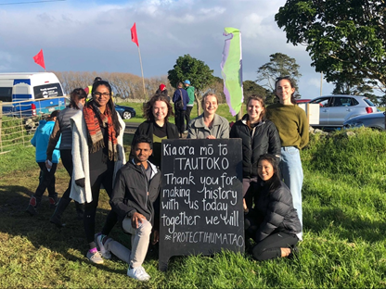
Our relationship with SOUL began at the start of 2017, and we have since produced ongoing research for a variety of issues in relation to this land. In July, SOUL took an appeal to the Environment Court regarding the historical significance of this site. The Pro Bono team provided SOUL and their legal representative with research regarding potential legal avenues and consequences of certain actions by Fletcher Residential.

Project Two: Mental Health and Addiction Inquiry
Professor Ron Patterson is currently chairing a Mental Health and Addiction Inquiry with the purpose of reporting its findings back to the Government. The Pro Bono team worked with Ms Sylvia Bell, Principal Researcher for the New Zealand Human Rights Commission, in conducting research into the effects of social media and its implications in relation to addiction and mental health.
Our team produced a comprehensive 50-page paper, which was added as an appendix to the New Zealand Human Rights Commission’s comments to the Inquiry.

Project Three: Modern Slavery Legislation
Before the start of the first semester, our previous manager Christina Liang put us in touch with solicitor Hannah Reid, who is also an EJP alumnus. Hannah was conducting research into protections against modern-day child slavery. Hannah has personally seen how “voluntourism”, in which travellers, typically young adults, participate in voluntary work in developing countries, has transformed orphanages into business ventures, allowing orphanage owners to profit from child abuse. Despite many countries implementing statutory protections against this, New Zealand has yet to follow suit.
The Pro Bono team produced research in relation to the need for legislative protection in New Zealand against child exploitation through orphanage tourism. This was a highly interesting topic for the researchers working on this project, and having Hannah discuss her experiences and her goals for this research in person with our team was hugely valuable. This led to an article on “voluntourism” being published by the Communications team based on our research, as well as becoming the topic of the Access team’s second symposium.

Project Four: Civil Litigation Court Fees
This year the Pro Bono team revived a project that was discussed in 2016 but never actually carried out, involving research for the Auckland District Law Society’s Civil Litigation Committee. This research looked into the costs relating to filing and hearing fees in comparative jurisdictions to New Zealand, in order to assess whether New Zealand’s court fees are too high. The Committee is concerned that the cost of court filing and hearing fees poses a barrier to access to justice. This impediment may conflict with the rule of law, and thus the Committee hopes to make a submission to the Ministry of Justice recommending that access to the courts should be more affordable.
One of our researchers was sitting on the Civil Litigation Committee as a student member, and she was therefore able to help coordinate and manage this project, in communication with the Committee. Our research looked into ten different jurisdictions and covered both lower court and appeal court fees. The findings were presented to the Committee at its August meeting.

Project Five: Declaratory Judgment in Relation To Sexual Harassment As Misconduct
In February 2018, Zoë Lawton, a legal researcher, set up a #metoo blog to enable legal professionals and law students to share their experiences of sexual harassment within the legal profession. During this month, Zoë was contacted by 21 female lawyers who wanted to report experiences of sexual harassment to the Law Society, but had signed a confidentiality agreement with their current or former employer. Zoë, assisted by Frances Joychild QC, is exploring the option of applying for a declaratory judgement on behalf of these women who are unable to identify themselves due to their confidentiality agreements. The judgement would state that sexual harassment as defined in the Human Rights Act amounts to serious misconduct under the Lawyers and Conveyancers Act (Lawyers: Conduct and Client Care) Rules 2008, and thus confidentially agreements which prohibit a lawyer from reporting to the Law Society are void and unenforceable on public policy grounds. We reached out to Zoë at the beginning of 2018, and were excited to be able to conduct research in support of this application. All our volunteers were also able to benefit from hearing Zoë speak about gender issues in the legal profession at EJP’s mid-year function.

Project Six: Online Dispute Resolution and Social Justice Issues
The Pro Bono team previously worked alongside the former director of the New Zealand Centre for ICT Law, Judge David Harvey, in both 2016 and 2017 regarding access to justice for self-represented litigants. This year, Judge Harvey returned to the Bench on Acting Warrant, and Professor Ian Macduff stepped into the role of director for the Centre. Excitingly, the Centre is hosting the eighteenth annual Online Dispute Resolution Forum in November 2018.
The Pro Bono team were given the opportunity to conduct research for Professor Macduff into the social justice issues that are raised by online dispute resolution (ODR). This involved looking at how the implementation of ODR has affected certain sectors of society in Australia, Canada, the United States and the United Kingdom. The team will then present a panel on their findings at the Forum, alongside experts in this field. The aim is that our five researchers who will be on this panel will represent the “youth voice”, critical to this up-and-coming area of law. Furthermore, our research paper will be added to the conference booklet that every attendee of the conference will receive.
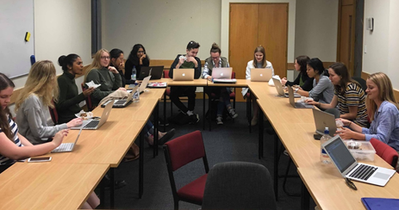

Project Seven: Auckland Action Against Poverty
Towards the end of this year the Pro Bono team undertook a new project which was brought to EJP by Associate Professor Hanna Wilberg. This project involved working under the Auckland Community Law Centre on claims brought to them by Auckland Action Against Poverty concerning making submissions for Benefit Review Committees. This involves three of our volunteers, as well as Lucy our Co-Manager, completing fortnightly clinics in which they write written submissions for beneficiaries who have had a sanction placed on their benefit. We are in the preliminary stages of setting up the clinic and taking on our first clients. We aim to continue this through to next year.

rEFLECTIONS on Research Undertaken In 2018
On the whole, the projects undertaken by the Pro Bono team this year were both hugely successfully and subjects of real interest for our volunteers. This was great for both maintaining good relationships with our previous clients, and forging new connections with others whom we would be very pleased to work alongside again in future.
One factor that was especially positive this year was the “real world” nature of many of our research projects. One downside of the Pro Bono team in the past has been that we are typically the most “behind the scenes” team. The details of our research are often confidential, and our volunteers tend to never see the results of their research and what it is used for. Several projects this year allowed our researchers to meet the client for whom the work was requested. For example, Hannah Reid attended one of our team meetings to discuss our research on modern slavery, and where it would be going towards. Likewise, the volunteers involved with our ODR project were able to meet with Professor Macduff multiple times throughout the research and panel-preparation process, and will soon be presenting their findings at a prestigious international forum. Our team attended a protest at Ihumatao, and were also given the opportunity to attend the Environment Court hearing. Finally, volunteers were able to hear from Zoë Lawton in person at our mid-year function. Therefore, we feel pleased at the high amount of interaction and real engagement with our projects that we have been able to offer our volunteers this year, in comparison with previous years.
We are also very happy with the coverage and exposure our research has been able to obtain for the Equal Justice Project. Having our research papers published in their entirety for the Human Rights Commission’s comments to the Mental Health Inquiry and in the accompanying information for the Online Dispute Resolution Forum has been a great outcome of our researchers’ hard work. Our research has also gained exposure from Communications articles published based on it, as well as the Access team’s second symposium. This has been hugely effective in raising greater awareness for our clients’ causes. It has also allowed us to work more closely with the other EJP teams than we usually would, which has been a positive experience for both us as Managers and for our volunteers.

Management and Team Structure

Management structure
Imogen was hired in 2017 and shadowed the previous managers, Christina and Holly, in the second half of semester two. This enabled continuity in the handover to 2018 as Imogen was able to learn key techniques to managing the Pro Bono team that had worked successfully in 2017. Lucy was hired towards the end of 2017 and will be continuing as Co-Manager in 2019. With different leadership styles, we complemented and worked well together. We both have really enjoyed our time as Managers, largely due to the people we have worked with and the projects we have had the privilege to be a part of and bring to the team.

Team structure
Having a project manager for each project was a strategy we continued from last year and this allowed volunteers to take on a leadership opportunity. This will be continued into next year, and we have decided that indicating interest for taking on a leadership position such as project managing should be a part of the application process for 2019. Delegating the workload and allowing a project manager to take on tasks such as following up on deadlines with volunteers, proofreading research, and combining separate pieces of research into one cohesive document ensure that the Managers can spend more time in other areas such as maintaining relationships with clients, which contributes to the success of the Pro Bono team. It also allows our volunteers to take on more responsibility and better understand the processes of our team.
However, we will also be making some small changes to the project manager position for 2019. This includes making our project manager guidelines document more comprehensive, meeting up with the project manager one-on-one soon after the research is assigned to discuss their role, and asking the project manager to communicate to us immediately if any volunteers are being unresponsive. In the first semester we realised we could have communicated better with our project managers, and these intended changes reflect this.
Furthermore, the feedback we got from our project managers was also to allow for more time between the volunteers’ deadline and the project manager deadline. During the first semester, we allowed around four days from the time when the volunteers had to send their research to the project manager, to the time when the project manager had to submit their research to the managers. This proved to be too short a timeframe: some volunteers requested slight extensions, putting pressure on the project managers to edit their work in a much shorter period of time. Also, the length of the research was longer than anticipated (for example, one project was 70 pages) and this meant that the workload for the project manager was too heavy to comfortably complete in four days.
Therefore, in the second semester we extended these timeframes, allowing a week for the project managers to edit the research, and two or three days for the Managers to go through it before passing it on to our client. This worked much better and eased the pressure on us, our project managers and our researchers. These timeframes will be continued in 2019.
Additionally, this year we implemented a new policy that required all volunteers to submit a first paragraph to be checked by their project manager, usually around two weeks before their research due date. This was to pick up errors and allow the project manager to communicate the need to correct them at an early stage, to prevent excess work when compiling the final memorandum. It also enabled the volunteers to clarify any style guide and research formatting questions. Next year this first paragraph policy will be continued, but we have realised the need to better explain that this paragraph should not be the introduction, but rather the first paragraph of substantive research that is written.

Volunteers

Pro bono volunteer list 2018
- Renée Zhang
- Libby Brown
- Rosa Gavey
- Madi Hughes
- Jodie Llewellyn
- Jess Dellabarca
- Lexi Finucane
- Emma Barnes
- Yash Patel
- Jarod Davies
- Carissa Fleury
- Madeline Hay
- Kyra Maquiso
- Cade Kennedy
- Helen Loveridge
- Shivani Thirayan
- Jennifer Van Rooveroy
- Kayleigh Ansell

Volunteer numbers
We recruited twenty volunteers in the Pro Bono team this year, which was the same number as the team had in 2017. However, two volunteers were unable to complete research and dropped out of the team in the second semester. Therefore, our actual number of volunteers for 2018 was only eighteen. Because we only sought enough work so that each volunteer would work on one project per semester, this was not an issue for completing our research. We had the ideal amount of research both semesters, meaning that each of our eighteen volunteers who were with us all year worked on two research projects, one per semester, with the exception of our longstanding researcher on the Ihumatao project who completed three pieces of research throughout the year. We feel that around twenty volunteers is still the best size for this team, and will continue with this number in 2019.

General contributions
Our volunteers this year were enthusiastic, reliable and highly competent, and on the whole we are extremely happy with their work and commitment to the team. Last year many volunteers only contributed to one project over the course of both semesters, whereas this year every volunteer worked on two different projects, with some working on more ongoing projects such as the ODR research and panel discussion. Every volunteer was very willing to put their hand up for work, and we were usually able to allocate work depending on their personal interest areas.
As Managers we made a conscious effort to hand out research as early into the semester as possible. This meant that our volunteers could complete their projects before the busiest periods such as exam time. Overall, this worked well and meant that work was either completed on time or warning was given as to a possible delay. We aimed to be approachable and understanding of competing time pressures, and we feel that on the whole this resulted in open and helpful communication between us and our volunteers.
Team meetings were held approximately three times a semester, and attendance at these meetings was generally good. It was especially rewarding to have some of our volunteers attend the Stand on the Land protest for Ihumatao, despite never having worked on this project themselves.
Although the quality of research was good from the beginning, there was a noticeable improvement during the second semester, especially in regard to correct formatting and citations. We were happy to see this, as adherence with the New Zealand Law Style Guide is an important aspect of our research, and we therefore made this a focus of a training session during the Hui. At the beginning of the second semester, we discussed the slight formatting issues at our team meeting, and feel that this led to greater understanding and a higher standard of work during the second semester.

Reflections
A high calibre of research, writing and referencing skills will always be essential to the Pro Bono team, and therefore we feel that asking applicants during the application process to edit a paragraph to be compliant with the Law Style Guide is necessary and should remain in 2019. This year the question was better explained than it had been the previous year, and so we feel that it was a relatively good gauge of legal writing skills, as shown by the quality of the volunteers we chose. We had around 50 applications for the Pro Bono team and only took twenty volunteers, meaning we had to be scrupulous in the application process in getting high-quality volunteers who also had a demonstrated passion and commitment to EJP’s values. Based on the work our team has produced this year, we will be retaining much of the same application process. However, we plan to add in a question asking whether the applicant would be willing to take on a position with greater responsibility within the team, so we can ascertain who our potential project managers could be.
We also hope to have an easier application process for returning volunteers. This year we had only four returning volunteers, and this meant that everyone else was entirely new to how our team operates. We would like to create a more ongoing volunteer base, so that the skills and knowledge volunteers build up over the course of a year are not immediately lost again. Returning volunteers would also be fantastic project managers, as they will have a grasp of what is expected, having already undergone the research project themselves. It is possible that the lengthy process of applying for the Pro Bono team, especially in comparison to that of other teams, contributed to our low number of returning volunteers.
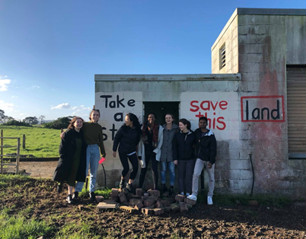
Finally, an ongoing issue for the Pro Bono team has been the lack of socialisiation due to the individual nature of legal research. We have tried to counter this by having more defined research project teams, headed by a project manager, and by encouraging these groups to meet up and discuss their research. We have also held team meetings to discuss everyone’s research, so volunteers can hear about and feel a part of projects which they did not get to personally work on.
Finally, we attempted to set up social team activities, such as hosting a pot luck. However, we found that these were not prioritised by our team members, who tended to pull out or not respond to such events. In response to this, we consider that a “start of semester” social event, somewhere conveniently close to the law school, might be a possible way to counter this. It would make the event less of a commitment to attend, and having it at the start of the semester would incentivise those who might otherwise be too busy later in the semester to come.

Goodbye from the 2018 Executive!

