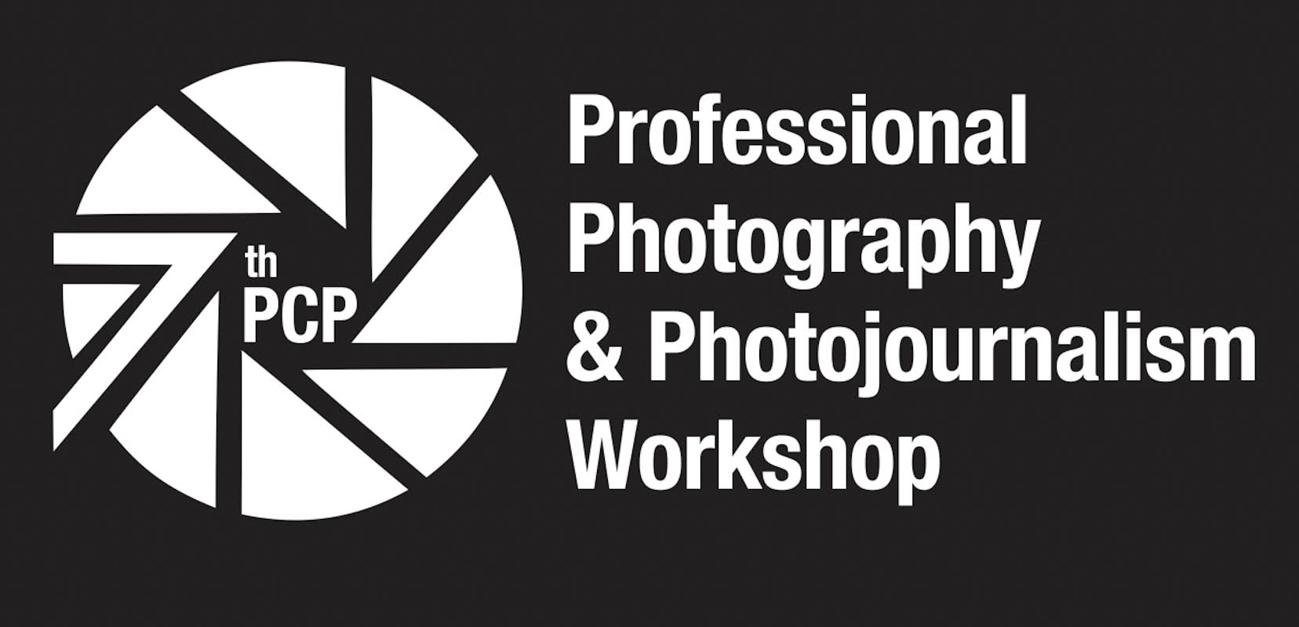
WORKSHOP GRANTS FOR STUDENTS
to the 7th PROFESSIONAL PHOTOGRAPHY AND PHOTOJOURNALISM WORKSHOP of the PHILIPPINE CENTER FOR PHOTOJOURNALISM

The grant entitles a student to participate fully in the workshop free of charge inclusive of all that is due to a paying participant.
To qualify, an applicant must be currently enrolled preferably in communication, journalism or allied courses in a recognized state, public or private college or university.
WHAT TO SUBMIT:
1. Sample of published and unpublished photojournalistic works
- 15 single, properly captioned pictures captions;
Kindly rename file to: 7thPCPW_ Grant _INITIAL(Name/Surname)_Singles_File#
e.g. 7thPCPW_Grant_GC_Singles_001.jpg
- 1 photo story consisting of 8-12 images and with an introductory text of not less than 300 words.
Rename file to: 7thPCPW_ Grant _INITIAL(Name/Surname)_PS_File#/(total number of photos)
e.g. 7thPCPW_Grant_GC_PS_001.jpg

2. PCP Workshop Grant Application Form
3. Proof of Enrolment
Email the following requirements to pcpworkshops@gmail.com
with Subject Title: 7thPCPWorkshop_WorkshopGrantApplication_Initials(Name/MiddleName/LastName) on or before October 31, 2012.

PHILIPPINE CENTER FOR PHOTOJOURNALISM
WORKSHOP GRANT APPLICATION FORM

(Please type your answers in this column. Don’t change the columns widths. Let the blocks expand as you type.)
Name
Nickname
Date of Birth / Age
Email address
Contact Numbers
Current Mailing Address
Current Provincial Address
Camera systems owned or borrowed
School/University
Course and Year
Involvement in journalism or communication activities and initiatives in school (enumerate)
Other non-academic involvement in school (enumerate)
Statement of Purpose. Begin by answering the question “Where do you see yourself in the next five years in relation to photography and photojournalism” and then tell us more about yourself and why you need the workshop grant.
What can you contribute to the growth of PCP in the next two years?
Give at least two character references
Waiver and quit claim. In the box, tell us in your own way that you are applying on your own will and that if accepted or given the grant, you will not hold PCP, its officers and members and the workshop organizers responsible for any untoward incident/accident that may happen to you during the duration of the workshop.

