Location | Drill | Rep | Yield | SPW
Top | Horsch | 1 | 10.285051 | 72.96
Top | Horsch | 2 | 9.684169154 | 73.36
Top | Horsch | 3 | 9.381741294 | 73.14
Top | Horsch | 4 | 9.870783582 | 72.2
Top | Horsch | 5 | 9.544029851 | 72.37
Top | Horsch | 6 | 9.470507463 | 73.32
Top | Cross Slot | 1 | 9.794635685 | 77.15
Top | Cross Slot | 2 | 9.741981004 | 74.56
Top | Cross Slot | 3 | 9.585616011 | 75.34
Top | Cross Slot | 4 | 9.49419403 | 71.9
Top | Cross Slot | 5 | 9.653481343 | 71.54
Top | Cross Slot | 6 | 9.548173507 | 72.28
Top | John Deere | 1 | 10.54843284 | 73.6
Top | John Deere | 2 | 10.03976928 | 75.1
Top | John Deere | 3 | 10.62109142 | 74.92
Top | John Deere | 4 | 10.70192164 | 72.62
Top | John Deere | 5 | 10.66843905 | 72.26
Top | John Deere | 6 | 10.42759701 | 74.03
Bottom | Horsch | 1 | 9.504664179 | 74.8
Bottom | Horsch | 2 | 9.522899254 | 72.77
Bottom | Horsch | 3 | 9.740487562 | 74.54
Bottom | Horsch | 4 | 9.887404229 | 73.53
Bottom | Horsch | 5 | 9.895982587 | 72.98
Bottom | Horsch | 6 | 9.892296642 | 72.32
Bottom | Cross Slot | 1 | 9.157274084 | 72.45
Bottom | Cross Slot | 2 | 9.817408412 | 75.11
Bottom | Cross Slot | 3 | 10.56749525 | 74.87
Bottom | Cross Slot | 4 | 9.446293532 | 74.36
Bottom | Cross Slot | 5 | 9.490563433 | 72.5
Bottom | Cross Slot | 6 | 10.47745833 | 73.88
Bottom | John Deere | 1 | 9.971315299 | 73.61
Bottom | John Deere | 2 | 9.429850746 | 73.51
Bottom | John Deere | 3 | 9.740882463 | 73.38
Bottom | John Deere | 4 | 9.381689552 | 72.81
Bottom | John Deere | 5 | 9.895515672 | 73.96
Bottom | John Deere | 6 | 10.09355075 | 73.91

1: Trait=Yield

1.1 Summary plots
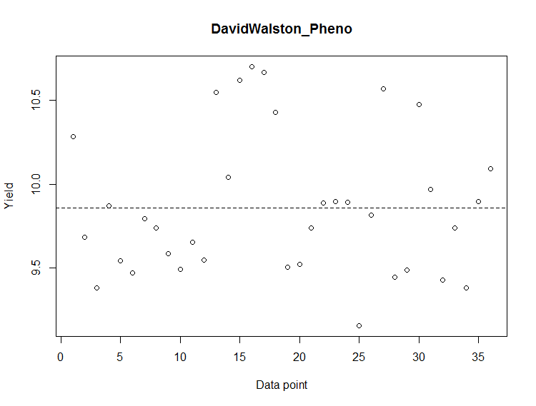

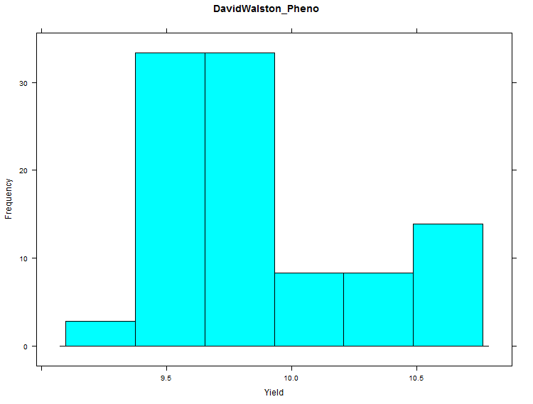

1.2 ANOVA anlaysis:

ModelName<-"AOV_Trait_Location_Drill"

DATAaov<-aov(Trait~Data$Location+Data$Location/Data$Drill, data=Data)

ANOVA summary table:

TraitName:
1 Yield

Df Sum Sq Mean Sq F value Pr(>F)
Data$Location 1 0.275 0.2754 2.585 0.118383
Data$Location:Data$Drill 4 2.796 0.6990 6.561 0.000644 ***
Residuals 30 3.196 0.1065
---
Signif. codes: 0 ‘***’ 0.001 ‘**’ 0.01 ‘*’ 0.05 ‘.’ 0.1 ‘ ’ 1

1.3 LSD analysis
> LSD<-LSD.test(DATAaov, "Data$Drill")
> LSD
$statistics
Mean CV MSerror LSD
9.860407 3.310336 0.1065452 0.2721479

$parameters
Df ntr t.value alpha test name.t
30 3 2.042272 0.05 Fisher-LSD Data$Drill

$means
Trait std r LCL UCL Min Max
Cross Slot 9.731215 0.4104584 12 9.538777 9.923652 9.157274 10.56750
Horsch 9.723335 0.2567485 12 9.530897 9.915772 9.381741 10.28505
John Deere 10.126671 0.4683552 12 9.934234 10.319109 9.381690 10.70192

$comparison
NULL

$groups
trt means M
1 John Deere 10.126671 a
2 Cross Slot 9.731215 b
3 Horsch 9.723335 b

2 Trait= SPW

2.1 Summary plots
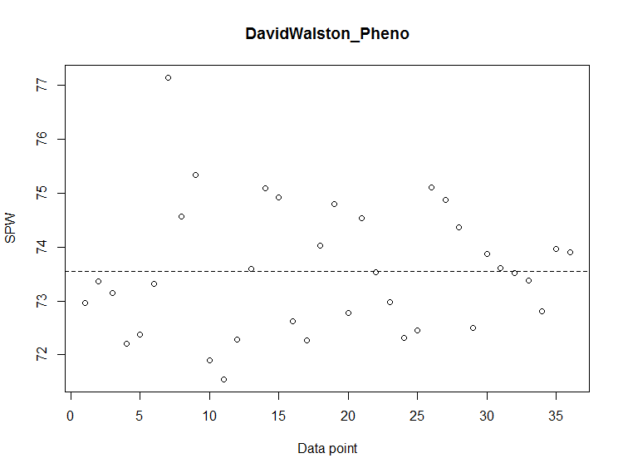
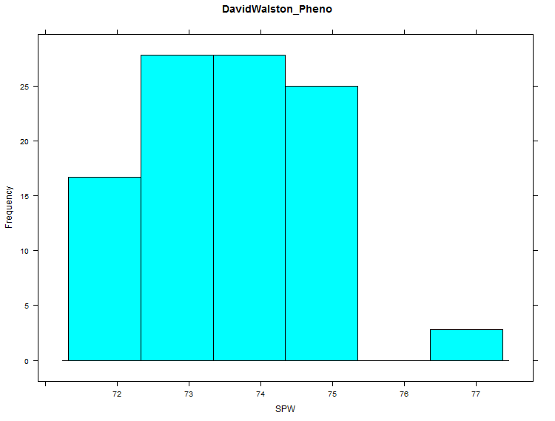

2.2 ANOVA analysis
Df Sum Sq Mean Sq F value Pr(>F)
Data$Location 1 0.19 0.1936 0.127 0.724
Data$Location:Data$Drill 4 3.63 0.9063 0.595 0.669
Residuals 30 45.72 1.5241

2.3 LSD analysis

> LSD<-LSD.test(DATAaov, "Data$Drill")
> LSD
$statistics
Mean CV MSerror LSD
73.55389 1.678434 1.524122 1.029314

$parameters
Df ntr t.value alpha test name.t
30 3 2.042272 0.05 Fisher-LSD Data$Drill

$means
Trait std r LCL UCL Min Max
Cross Slot 73.82833 1.7024999 12 73.10050 74.55617 71.54 77.15
Horsch 73.19083 0.8124761 12 72.46300 73.91867 72.20 74.80
John Deere 73.64250 0.8430478 12 72.91466 74.37034 72.26 75.10

$comparison
NULL

$groups
trt means M
1 Cross Slot 73.82833 a
2 John Deere 73.64250 a
3 Horsch 73.19083 a

3 Location
> DATAaov<-aov(Trait~Data$Location, data=Data)
> SUMaov<-summary(DATAaov)
> SUMaov
Df Sum Sq Mean Sq F value Pr(>F)
Data$Location 1 0.275 0.2754 1.562 0.22
Residuals 34 5.992 0.1762
> LSD<-LSD.test(DATAaov, "Data$Location")
> LSD
$statistics
Mean CV MSerror LSD
9.860407 4.257618 0.1762475 0.2843912

$parameters
Df ntr t.value alpha test name.t
34 2 2.032245 0.05 Fisher-LSD Data$Location

$means
Trait std r LCL UCL Min Max
Bottom 9.772946 0.3679943 18 9.571851 9.974041 9.157274 10.56750
Top 9.947868 0.4659133 18 9.746773 10.148962 9.381741 10.70192

$comparison
NULL

$groups
trt means M
1 Top 9.947868 a
2 Bottom 9.772946 a

