Holywood Music Festival
Safeguarding Policy

Designated Officers of Holywood Music Festival:

Olive Elliott Mobile 07745 379006

Christine Hall Mobile 07803830660

TABLE OF CONTENTS
Page

Introduction 2

Terms used in this policy 3

Child Protection Policy Statement 4

Responsibilities of those with Parental Responsibility 5

Reporting Concerns 6

Code of Behaviour 10

Complaints Procedures 11

Appendix A – Useful Contacts 12

Appendix B – Supporting documentation 14

Appendix C – Safeguarding Policy Statement 15

Appendix D – Holywood Music Festival Entry Form 17

Appendix E – Safeguarding Compliance Documents 19

INTRODUCTION

Holywood Music Festival provides a platform for amateur performance combined with an educational element from professional musicians. By developing procedures and guidelines, we will help to minimise the potential for abuse and create a positive environment for everyone involved. Our child protection policy is therefore designed to protect children and vulnerable adults from harm and abuse, protect the organizing committee and volunteers against false allegations and protect the reputation of the organisation.

There is a moral obligation on anyone who is involved with children and young people to provide them with the highest possible standard of care. Secondly, there is a legal responsibility, under the common law Duty of Care, for such organisations to take reasonable steps to ensure the safety and wellbeing of all children and vulnerable adults involved with Holywood Music Festival.

The fundamental principle in childcare law and practice is that the welfare of the child must always be the paramount consideration in decisions taken about them. This is set out in The Children (NI) Order 1995, which provides the legislative basis for child protection practice in Northern Ireland and which is underpinned by the standards of the United Nations Convention on the Rights of the Child.
Vulnerable Adults; Regional Policy and Procedural Safeguarding Guidance, 2006, also under-pins our practice.

We would like to acknowledge the Volunteer Development Agency who developed an overarching child protection policy on behalf of the Arts Council of Northern Ireland, for use by organisations such as ours in the arts sector in Northern Ireland. This policy outlines legislative and good practice guidelines for working with children and vulnerable adults.
TERMS USED IN THIS POLICY

Throughout this document, the following applies when reference is made to:

Child/children – to promote best practice, the definition adopted is a person under 18 years of age, as defined under The Children (NI) Order 1995 and the United Nations Convention on the Rights of the Child.

Vulnerable Adult - A vulnerable adult is any person aged 18 years or over who is, or may be, unable to take care of him or herself against significant harm or exploitation.

Parent/Guardian - individuals who have parental responsibility for children, as defined by The Children (NI) Order 1995.

Parental responsibility (defined by The Children (NI) Order 1995) - the natural mother always has parental responsibility. The natural father gains parental responsibility:
- If married to mother at time of birth or subsequently marries her.
- Through an Agreement witnessed by solicitor or a Parental Responsibility Order.
- Post 15 April 2002 if they jointly register the child’s birth.

Holywood Music Festival Officials and Volunteers

- This refers to Office Bearers, Committee members and Volunteers associated with Holywood Music Festival. For the purposes of running the annual Festival and other activities related to the running of the Festival.

CHILD PROTECTION POLICY STATEMENT

The Committee and volunteers of Holywood Music Festival are committed to practice which promotes the welfare of children and young people and protects them from harm.
There is the same duty of care to Vulnerable Adults.

Committee members and volunteers involved in this organization accept and recognise our responsibilities to develop awareness of the issues which cause children harm, and to establish and maintain a safe environment for them. We are committed to reviewing our policy, procedures and practice at regular intervals, at least every three years.

Holywood Music Festival endeavours to safeguard children and Vulnerable Adults by:

- reporting concerns to statutory agencies who need to know and involving parents/guardians and children appropriately;

- adopting child protection guidelines through a code of behaviour;

- sharing information about child protection and the protection of Vulnerable adults and good practice with children, parents/guardians, committee members and volunteers;

- ensuring general safety procedures are adhered to.

Responsibilities of Parents/Those with Parental Responsibility

While attending the Festival all children, Young People and Vulnerable Adults must be in the care of, or supervised by an appropriate adult as identified by those with Parental Responsibility for the child or Young person or a person representing them, such as a teacher or appointee. The same safeguard is applied to Vulnerable Adults. This is made clear in our syllabus and applies also to.., rehearsal prior to the Festival with an Accompanist. Such a rehearsal must be supervised by an appropriate adult identified by those with Parental Responsibility for the child or young person.

At no time during the Festival are any Committee members or volunteers responsible for the care and/or supervision of children, young persons or vulnerable adults. As a consequence of this Holywood Music Festival, in line with advice from the British Festivals Federation, has confirmed that none of the roles carried out by the Committee and Volunteers comes within the definition of “Regulated”, both in terms of the tests on Intensivity and Frequency.

Our Child Protection information is sent out to all Performers and their parents/teachers and their responsibilities in relation to the care and supervision of children, young people and vulnerable adults clearly identified.

Effective Management of Festival officials and Volunteers

We will

- provide a clearly defined volunteer role description for all volunteers

- . provide training to ensure that all committee members and volunteers are aware of organizational policies and procedures,

- Ensure that all committee members and volunteers have a copy of our Code of Behaviour, know the identity of the Designated Officer and are familiar with the protocol of reporting concerns

- ensure that a copy of our Child Protection Policy is on display during the Festival for consultation

REPORTING CONCERNS

Holywood Music Festival will highlight its dedication to ensuring that committee members and volunteers respond appropriately to concerns, allegations or disclosures of abuse and harm, by:

- providing guidelines about what constitutes suspicion or a child protection concern;

- providing guidelines about how to respond to concerns and disclosures;

- developing a procedure for recording and reporting information in a confidential manner;

- appointing a Designated Officer to deal with child protection issues.

What may constitute a concern about a child?

A concern relates to the possibility of a child suffering harm or abuse. Indicators of this may include:

- sudden, unexplained or worrying changes in behaviour (e.g. becoming withdrawn, displaying sudden outbursts of temper or displaying inappropriate sexual awareness for their age).

- physical signs or symptoms that may be indicative of abuse (e.g. unexplained or suspicious injuries or for which the explanation given seems inconsistent, or physical appearance such as weight loss for no apparent/guardian reason or a dirty or unkempt appearance).

- worrying remarks made by a child.

- a situation where a child has been exposed to potential risk of harm.

Due to the nature of expressivity involved with all arts forms, staff and volunteers should be aware that children may express their emotions in different ways. Any concerns about a child should be reported in line with the reporting procedure.

The following may be applicable for working with children with a disability:

    - the nature of the disability may appear to ‘explain’ signs and symptoms (e.g. bruising, inappropriate sexual behaviour).
    - a child may often be more dependent on adults (e.g. physical contact & support needs, intimate care) and may be cared for by a number of adults.
    - a child may be unable to recognise abusive behaviour and differentiate between appropriate and inappropriate touch.
    - children with communication or language difficulties may be unable to convey an experience to others and it may be difficult to convey information to a child.
    - Staff and volunteers should be aware that they may have a greater reluctance to accept that children with a disability can be abused.

What is a disclosure?

A disclosure is when a child tells a member of staff or a volunteer that they have been or are being harmed or abused in some way. This may constitute physical, sexual or emotional abuse, or neglect or bullying.

Dealing with disclosure

If a child makes a disclosure, it is important that you:
- stay calm - do not panic!
- reassure the child that they have done the right thing in telling.
- listen to what the child is saying, do not rush them or ask leading questions.
- do not promise to keep secrets, as the child’s welfare is paramount and they must pass this information on to their Deputy/Designated Officer.
- record in writing what was said and/or observed as soon as possible so that they do not forget any information and try to write exact words if possible.
- report without delay within the reporting procedure.
- record they made the report.

What is a concern or allegation about the behaviour of a Festival official or a volunteer?

Inappropriate or unacceptable behaviour or communication, favouritism or negligence, or a breach in the code of behaviour may constitute a concern about the conduct of a committee or a volunteer.

An allegation about a committee member or volunteer occurs when a child, parent/guardian or another committee member or volunteer reports specific unacceptable behaviour where a child has been harmed or abused in some way.

Responding to concerns, disclosures and allegations

Festival officials and volunteers should be aware that signs and symptoms are not a checklist or definite indicators that abuse or harm has occurred, as other areas of a child’s life may affect their behaviour at a given moment (e.g. separation anxiety, homesickness or bereavement). In some instances, it may be appropriate for a Festival official or volunteer to check out a concern with the Designated Officer.

All concerns, disclosures and allegations should be recorded and passed to the Designated Officer as outlined in the reporting procedure, no matter how insignificant they may seem and regardless of whether they relate to situations internal or external to Holywood Music Festival (i.e. any concerns connected to a family or school situation should be noted as well as concerns within Holywood Music Festival

If there is an emergency and the Deputy/Designated Officer cannot be contacted, staff and volunteers should contact Social Services, the PSNI or the NSPCC directly. These contact numbers can be found on pages 12, 13 & 14 of the attached appendix A.

Holywood Music Festival will maintain a confidential record, of any concerns, complaints or allegations made.

Designated Officers

Designated Officers Holywood Music Festival

Olive Elliott Mobile 07745 379006

Christine Hall Mobile 07803830660

The Designated Officer/S has/have attended specialist training to deal with child protection concerns, disclosures and allegations. The role is to:

- provide information and advice on training requirements in relation to child protection.

- ensure that child protection policy and procedures are being followed.

- contact local statutory organisations (Social Services Gateway Team, the PSNI and/or NSPCC) about concerns and make a formal referral, if applicable. Our procedure is that the Designated Officer will contact a statutory organisation by phone and follow this up in writing.

Having more than one Designated Officer means that if one Designated Officer is on holiday/off sick or if an allegation is made against them, this can be reported to one of the other Designated Officers.

Allegations about a member of staff/volunteer

An allegation against a Festival official or a volunteer must be referred to the Deputy/Designated Officer.

In the case of an allegation against one of the Designated Officers, a referral should be made to the other Designated Officer, or directly to a statutory agency.

Allegation
Allegation about a member of staff or volunteer
Allegation about a Designated Officer
Refer to other Designated Officer or statutory agency

Refer to Designated Officer

.

If a referral about a criminal offence is made to the PSNI and it instigates a criminal investigation, the organisation should not conduct an internal investigation or gather evidence that could prejudice a criminal investigation.

CODE OF BEHAVIOUR

Don’t

Use inappropriate language

Promise to keep secrets

Allow children to use inappropriate language unchallenged

Ever be alone with a child or vulnerable adult

Engage in inappropriate games such as horseplay with children

Let allegations by a child go unrecorded

Allow or engage in inappropriate touching

Take children alone on a car journey

Make or receive private calls/texts while supervising an activity

Contact young people or vulnerable adults through social networking sites such as Bebo, MSN, Facebook

DO

Treat each child with dignity and respect

Think about how you communicate with children

Ensure that children are not left unattended/unsupervised

Ensure that dangerous behaviour and/or bullying is stopped

Ensure that any communication with young people via phone, text, email is only done with parental consent

Be careful about the language you use.

Complaints Procedure against officials or volunteers

Stages of Complaints Procedure

Informal

Volunteers will be encouraged to discuss issues informally to facilitate a speedy resolution of any problems.

Formal

If the issue cannot be resolved informally, a meeting can be arranged with the Chairman to address and resolve the problem. This will be fully recorded.

If the issue is still unresolved a meeting can be requested with the volunteer and a third party can be present if the volunteer wishes. The complaint will be made in writing and a record made of the meeting and signed by the Chairman and the volunteer.

Any formal complaint will be addressed as quickly as possible and an investigation by the most appropriate person will be carried out within an agreed time frame.

Procedures for dealing with accidents, incidents and emergencies

All accidents are reported to the Chairman and recorded in an accident report book and signed by witnesses. It should be reported to those with parental consent.

Insurance

Holywood Music Festival is insured under the auspices of the British Federation of Festivals. A copy will be displayed during all sessions.

Photographs

The taking of photographs and videos is prohibited and this is clearly stated both in the programme and on the entrance tickets.
Any press photography is only with the consent of those with parental responsibility.

APPENDIX A - USEFUL CONTACTS

PSNI Child Abuse Investigation Units

From 31 March 2008, Child Abuse Investigation Units have replaced the CARE units.

A District (North and West Belfast) 028 9070 0604
B District (South and East Belfast) 028 9025 9832
C District (Castlereagh, Carryduff, Dundonald) 028 9056 1767
D District (Lisburn, Antrim, Newtownabbey, Carrickfergus) 028 9448 2633

Health and Social Services Trusts – Gateway Teams

Belfast Trust
Belfast Referrals 02890650222

Northern Trust
Referrals should be made to 0800234333

Southern Trust
Referrals should be made to Central Gateway Team 02837415285

South-Eastern Trust
Dunmurry and Greater Lisburn 028 90602705
Newcastle and Downpatrick 028 44613511
Bangor, Newtownards and Ards Peninsula 028 91818518

Western Trust
Enniskillen 028 6634 4037
Omagh 028 8283 5043
L’Derry 028 7131 4090

Out of Hours Emergency Social Work Service

Belfast Trust 028 9056 5444
Northern Trust 028 9446 8833
Southern Trust Craigavon & Dungannon 028 3833 4444 / Newry 028 3083 5000
South Eastern Trust 028 9056 5444
Western Trust Enniskillen 028 6638 2000/Omagh 028 7134 5171 L’Derry 028 7134 5171

Useful organisations

AccessNI
Brooklyn
65 Knock Road
Belfast
BT5 6LE
Tel: 0300 200 7888
www.accessni.gov.uk

Child Care Policy Directorate
DHSSPS
Room D, C3.24, Castle Buildings
Stormont Estate
Belfast
BT4 3SL
Tel: 028 9052 2131 / 028 9052 2644 / 028 9052 8288/028 9052 8329
www.dhsspsni.gov.uk

Children’s Law Centre
Philips House
York Street
Belfast
BT15 1AB
Tel: 028 9024 5704
www.childrenslawcentre.org

Kidscape
2 Grosvenor Gardens
London
SW1W 0DH
Tel: 020 7730 3300
www.kidscape.org.uk

Early Years
6C Wildflower Way
Apollo Road
Boucher Road
Belfast
BT12 6AT
Tel: 028 9066 2825
www.nippa.org

NSPCC
Northern Ireland Divisional Office
Jennymount Court
North Derby Street
Belfast
BT15 3HN
Tel: 028 9035 1135
www.nspcc.org.uk
Helpline (24 hours) 0808 800 5000

Volunteer Development Agency
129 Ormeau Road
Belfast
BT7 1SH
Tel: 028 9023 6100
www.volunteering-ni.org

YouthNet
5th Floor
Premier Business Centre
20 Adelaide Street
Belfast
BT2 8GD
Tel: 028 9033 1880
www.youthnetni.org.uk

APPENDIX B
SUPPORTING DOCUMENTATION

PUBLICATIONS

An Introduction to the Children (NI) Order 1995
Available from: The Stationery Office (028 9023 8451)
Buskers Guide to Inclusion
Available from: www.commonthreads.org.uk
Choosing To Protect – April 2008 Version
A guide to using the Protection of Children, Northern Ireland [POC (NI)] Service
Available from: www.dhsspsni.gov.uk/poc.pdf
Cooperating to Safeguard Children
Volume 6, Regulations and Guidelines of the Children (NI) Order 1995
Available from: The Stationery Office (028 9023 8451)
Creative Youth Partnerships
Child Protection Code of Practice
Available from: www.cypni.org.uk
Getting It Right
Standards of Good Practice for Child Protection
Available from: www.volunteering-ni.org
Our Duty to Care
Principles of good practice for the protection of children and young people
Available from: www.volunteering-ni.org

WEBSITES

Anti bullying:
- Bullying Online www.bullying.co.uk
- Kidscape www.kidscape.org.uk
- Anti-bullying Alliance www.anti-bullyingalliance.org.uk
- ChildLine www.childline.org.uk

First aid
- British Red Cross www.redcross.org.uk
- St John’s Ambulance www.sja.org.uk
- Department for Education & Skills (DfES) www.dfes.gov.uk/publications

Protecting children online
- Child Exploitation and Online Protection Centre (CEOP) www.ceop.gov.uk
- Internet Watch Foundation (IWF) www.iwf.org.uk
- Stop it Now! www.stopitnow.org.uk
- Childnet International www.childnet-int.org
- Department for Education & Skills (DfES) www.safety.ngfl.gov.uk/schools
- Get Safe Online www.getsafeonline.org

APPENDIX C

HOLYWOOD MUSIC FESTIVAL SAFEGUARDING POLICY STATEMENT 2014
1 PURPOSE AND FUNCTION OF ORGANISATION: Holywood Music Festival, in the full meaning of The Children Act 1999, is not a Child-Care Organisation. It is, however, committed to practice which protects children from harm. The festival is established to provide a platform for amateur performance combined with an educational element from professional musicians. It is established to encourage people, but not exclusively the young, to become actively involved in such activities. Our aim is also to promote and develop the arts for the benefit of the general public in the area of benefit, to encourage appreciation of music and stimulate the artistic creativity of people in the area of benefit and to promote, organise and manage a festival of music. Within the document, the word “staff” refers to officers and members of the Festival committee who give of their time entirely voluntarily. The term “volunteers” refers to additional people who assist the Festival committee members with running the festival, who also give of their time entirely voluntarily.

2 THE FESTIVAL ENVIRONMENT: The festival is normally held in The Queen’s Hall, Holywood or local venues within the Holywood town area. It is our policy to involve and inform parents/guardians/carers and teachers in partnership with ourselves in order to ensure, as far as reasonably practicable, a safe environment at the festival which is run by volunteers. With the exception of teachers, there is an entrance charge for all adults accompanying children to the festival. As the festival is held in a public area, the festival volunteers cannot be held responsible for the care or safety of children whilst they are away from the supervised areas where classes are held.

3 TO WHOM THIS POLICY APPLIES: This policy relates to children under the age of 18 years and those vulnerable adults of any age who are identified to the organisers prior to their arrival at the festival. This should be done by contacting the designated officer/s at the address or telephone number at the bottom of this document. In recognising the needs of children from minority ethnic groups and children who are disabled, the festival actively seeks to meet needs notified to the festival by parents/guardians/carers and/or teachers.

4 FESTIVAL PERSONNEL: Staff vacancies are filled at the Annual General Meeting on the recommendation of the committee members. Volunteers are recruited from the teaching profession, from local churches and organisations. They are also recruited by personal contact and recommendation from existing volunteers. Volunteers are made fully aware of the policy and receive instructions as how best to implement the policy. The festival has appointed a Safeguarding Designated Officer whose name appears below. This officer will be responsible for the checking and maintenance of volunteer’s records. During the Festival, all staff and volunteers wear identifying badges. Anyone wearing a badge can be approached and will be able to direct you to someone who will deal with your problem. The Designated Officer will be in attendance throughout the Festival. We take every problem seriously. In the event of any incident, this will be fully documented and dated.

5 ATTENDANCE AT THE FESTIVAL: This policy is passed to all parents/guardians and carers in order to inform them that, where they are not attending with their children, it is their responsibility to ensure that their children are adequately supervised at the festival by adults acting on their behalf. It is passed to parents directly, or via teachers, in time for them to make arrangements for their children to be supervised when attending the festival. Teachers are expected to take responsibility for seeing that parents or carers of their pupils are aware of this policy and to inform the festival organisers that they accept the responsibility. A copy of this policy appears in the programme and at the festival venue.

6. PERFORMANCE AREAS AND REHEARSAL AREAS: As the Festival is held in a public area, parents/guardians/carers should be aware that, due to the location of the separate performance areas within the festival venue, it may be necessary, from time to time, for children to pass through or attend unsupervised areas such as the foyer, public toilets. It will be the responsibility of those parents/guardians/carers to ensure that children in their care are accompanied at all times, whilst away from the supervised performance areas.

7 PHOTOGRAPHS, VIDEOTAPES AND PRESS PHOTOGRAPHY: It is our policy that no recording, other than photography by accredited photographers, will be permitted within the performance areas and signs to this effect will be clearly displayed. Volunteers and staff who are on duty have been instructed to prevent an unauthorised recording, should this be attempted. Press have been invited to take photographs and if you do not wish your child to be photographed then you must let the photographer know. IT is the responsibility of parents/guardians/carers to ensure that their child, or child in their care, is not photographed if they do not wish this to take place.

8 THE LEGISLATION AND GUDIANCE THAT SUPPORTS THIS POLICY: The Rehabilitation of Offenders Act 1974; The Children Act 1989; The Police Act 1997; The Data Protection Act 1998; The Human Rights Act 1998; The Protection of Children Act 1999; The Criminal Justice and Court Services Act 2000; The Children Act 2004, The Vulnerable Groups Act 2006.

9 POLICY REVIEW: The organisers will constantly review their policy, improving and enhancing as necessary. In doing this, they will look to The British and International Federation of Festivals for support and that body in turn will look to other agencies for good practice, most notably the NSPCC and Arts Council of Northern Ireland policy guidelines.

DESIGNATED SAFEGUARDING OFFICERS:

Mrs Olive Elliott, Mobile: 07745379006
Mrs Christine Hall, Mobile: 07803830660

Please see website www.holywoodmusicfestival for the unabridged version of Holywood Music Festival Safeguarding Policy.

APPENDIX D
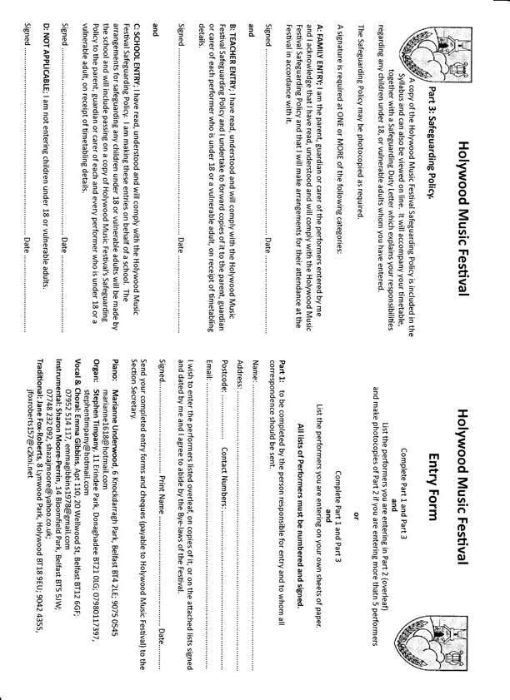

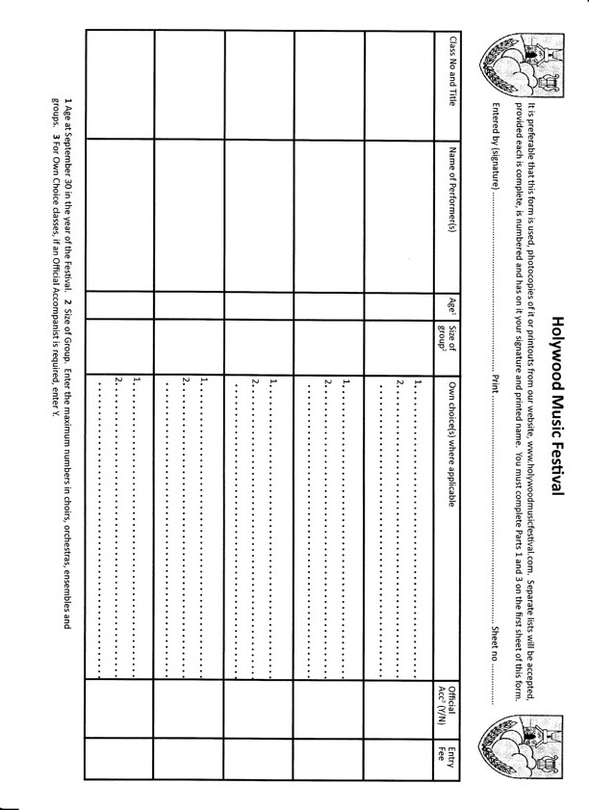

APPENDIX E

(Family Entry)

Subject: Holywood Music Festival

Thank you for your entry/entries to the Holywood Music Festival. Please find attached details of venue, class dates and times for each entrant, along with a copy of the Festival’s Safeguarding Policy Statement which applies to each entrant under 18 years.

Please ensure that you are familiar with the contents of the Festival’s Safeguarding Policy Statement and, in cases where you will not be available to attend in person, please pass the Safeguarding Policy Statement on to the person/s to whom you are delegating parental responsibility on the performance day/s

If you have any queries, please do not hesitate to contact me. My contact details are below
Yours sincerely,

Signed

(Teacher’s Entry)

Subject: Holywood Music Festival

RE: ALL CHILDREN ENTERED BY YOU FOR CLASSES IN HOLYWOOD MUSIC FESTIVAL

Thank you for your entry/entries to the Holywood Music Festival. Please find attached details of venue, class dates and times for each entrant, along with a copy of the Festival’s Safeguarding Policy Statement which applies to each entrant under 18 years.

Please ensure that the Festival’s Safeguarding Policy Statement is given/passed on by email to the parent/person with parental responsibility for each entrant under 18 years.

ONE FINAL STEP IS URGENT AND ESSENTIAL* IF YOU ARE TO ENSURE THAT YOUR PUPIL/S IS/ARE ELIGIBLE TO COMPETE IN THE FESTIVAL. IN ORDER TO COMPLY WITH OUR SAFEGUARDING RESPONSIBILITIES WE MUST HAVE EVIDENCE THAT YOU HAVE PASSED ON OUR SAFEGUARDING POLICY STATEMENT. There are three options for this:
1. Sign and date this document - scan and return the signed document, by email to contactus@holywoodmusicfestival.com
2. Post the signed and dated letter to 107 Demesne Road, Holywood, BT18 9EY
3. If you have received this communication by email simply reply to that message [don’t compose a new message] saying that you have read the contents and have complied with the request of Holywood Music Festival that you make their Safeguarding Policy Statement available to all parents/guardians/carers of your 2013 entrants aged under 18 years.
*Replies to be with us within 5 working days of receipt of this communication
If you have any queries, please do not hesitate to contact me. My contact details are at the bottom of this letter.

I confirm that I have given a copy of the Holywood Music Festival Safeguarding Policy Statement 2013 to the parent/person with parental responsibility for each of my entrants aged under 18 years

Signed: __________________________________________ Date: ________________
(Teacher)

Date

(School Entry)

Subject: Holywood Music Festival

RE: ALL CHILDREN* ENTERED BY YOU FOR CLASSES IN HOLYWOOD MUSIC FESTIVAL

Thank you for your entry/entries to the Holywood Music Festival. Please find attached details of venue, class dates and times for each entrant/s, along with a copy of the Festival’s Safeguarding Policy Statement which applies to each entrant under 18 years.

If you have any queries, please do not hesitate to contact me. My contact details are at the bottom of this letter.

Yours sincerely,

* This correspondence refers to those children entered by you/your school who will be accompanied to the Festival by members of school staff.

