National Craft Initiative Research Report 2014

Mapping the Australian Craft Sector – Findings and Recommendations

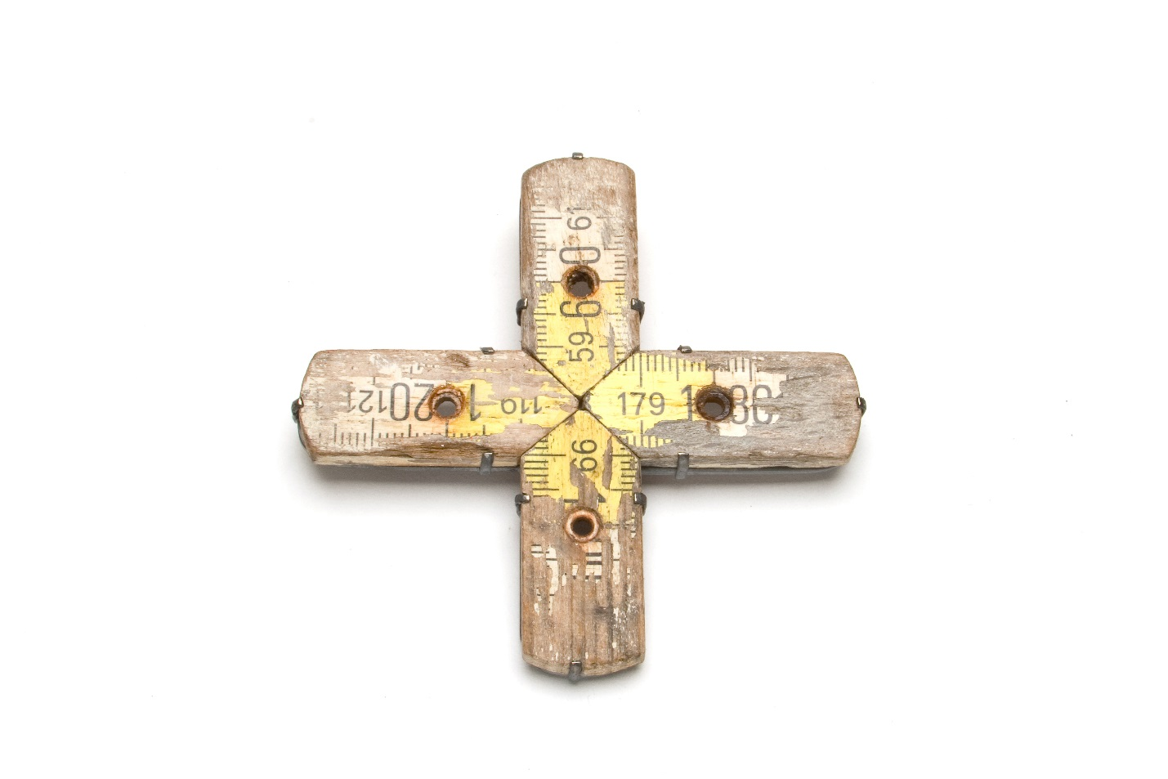

Joe Pascoe
DRAFT FOR APPROVAL 6/12/2013

Mapping the Australian Craft Sector – Findings and Recommendations

National Craft Initiative Research Report

First published Sydney, Australia, 2014

Author: Joe Pascoe
Research and Attachments: Bridie Moran
Editor: Prof. Robert Pascoe
Reader and Google Map: Pip Menses
Design:

Manager National Craft Initiative: Bridie Moran

National Craft Initiative Steering Committee:
Brian Parkes
Prof. Ian Howard
Tamara Winikoff
Pippa Dickson
Liana Heath
Rae O’Conner

ISBN

Acknowledgements:
I would like to thank the steering committee, craft makers and industry leaders and my family Lyndel, Eve and John. Special thanks are gratefully extended to Bridie Moran and Tamara Winikoff for guidance. This report is dedicated to my three muses Ailsa Giles, Pam Gullifer and Grace Cochrane.

Supporters and sponsors:

(Logos) NAVA, ACDC, Australia Council, Insect

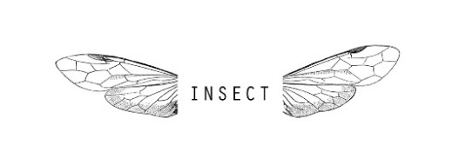

Cover: Roseanne Bartley Intersection – Brooch; wooden ruler, 925 silver, stainless steel.
2006. 8cm diameter. Image Credit Terrence Bogue 2006
Text copyright Joe Pascoe 2013

Contents

1. Executive Summary 4

2. Definitions of Craft 6

3. History and Evolution & Identified Trends 9

4. Current Landscape 16

5. Key Issues 44

6. Where Should We Be Heading? 52

7. Recommendations 56

8. List of Attachments 61

1. Executive Summary

1.1 Overview

Elements of the Australian craft sector are world class. Exceptional craft works are often made, over 2 million Australian make craft, however organizations within the craft sector infrastructure are all at different phases of business development, and are not in a position to fulfill their potential.

This report does not play the blame game, but rather puts forward a set of recommendations that are designed to drive structural reform that will set the craft sector on a path that should bring a heightened benefit to Australian society.

Its drivers are; changing the business plan methodology that underlines the national funding regime, establishing a new professional association open to all craft organizations and conducting a national conference that is open, exciting and informative. Two other legacy-style projects are advocated; a real-time information portal that identifies opportunities for craft makers and an online register of post-graduate research on the crafts, so as to address the profound issue of intergenerational knowledge transfer. A sixth recommendation is conducting a pilot program with one of the new type of craft organizations that are emerging.

1.2 research process

The methodology was based on honouring the idea that there now many ways of crafting, acknowledging that craft making is happening in the home as much as via professional situations, consideration of the history of Australian craft, a widely distributed online survey, in depth discussions with some 30 industry professions, and analysis within the context of international developments, and an analysis of previous research and current events.

The Attachments are all very much worth studying, as they contain an impressive array of material that is immediately useable, whatever your interest in the crafts may be. The message is that in Australia, craft is an artform open to everyone.

1.3 Recommendations

- It is recommended that the forthcoming NCI conference seek to have a broad foot print in the Australian craft sector, so as to cross fertilize the sector, and re-establish the crafts (and its organizations) as a significant component of the Australian cultural landscape.

- It is recommended that NCI start planning to establish an online portal by 1 June 2014 that offers highly relevant career enhancing information to Australian craft makers, and, that the portal has an easy to use ’Craft Knowledge’ section that acts as an online register of post-graduate and doctoral research on all aspects of Australian craft.

- It is recommended that the NCI Steering Committee engage with the Australia Council to discuss and implement changes to the Business Planning template advocated by the Australia Council for the funding of cultural infrastructure, which has the capacity to introduce macro planning concepts into the sector, including joint ventures with cultural outcomes.

- It is recommended that the NCI Steering Committee engage with Australian Craft and Design Centres to re-birth ACDC into an ‘Australian Craft Association’.

- It is recommended that a policy be developed for supporting Australian craft, through a sector led process.

- It is recommended that the National Craft Initiative encourage new modes of craft making through the active support of innovative new models and platforms for craft making.

2. Definitions of Craft

Defining the crafts has been a considerable issue for the sector. The public often describes the crafts by example, naming an activity such as knitting, while those within the sector often refer to the notion of process and types of material. Craft makers themselves may use media specific terms such as jewellery, especially if their qualification is in that area. The following selection of definitions scopes some options, to then nominate a preferred term for this report.

- The Merriam Webster online dictionary offers a short and a long definition of craft.

¹craft
noun \ˈkraft\
: an activity that involves making something in a skillful way by using your hands
: a job or activity that requires special skill
crafts : objects made by skillful use of the hands

1: skill in planning, making, or executing : dexterity
2a : an occupation or trade requiring manual dexterity or artistic skill <the carpenter's craft> <the craft of writing plays> <crafts such as pottery, carpentry, and sewing>
b plural : articles made by craftspeople <a store selling crafts> <a crafts fair>
3: skill in deceiving to gain an end <used craft and guile to close the deal>
4: the members of a trade or trade association

- The online Oxford dictionary also gives the origins of the word craft.
http://www.oxforddictionaries.com/definition/english/craft

Old English cræft 'strength, skill', of Germanic origin; related to Dutch kracht, German Kraft, and Swedish kraft 'strength'. sense 3 of the noun, originally in the expression small craft 'small trading vessels', may be elliptical, referring to vessels requiring a small amount of ‘craft’ or skill to handle, as opposed to large ocean-going ships

- Wikipedia offers a traditional view of craft, though impressively readable as an extended article with links. http://en.wikipedia.org/wiki/Craft

A craft is a pastime or a profession that requires some particular kind of skilled work. In a historical sense, particularly as pertinent to the Middle Ages and earlier, the term is usually applied to people occupied in small-scale production of goods, or their maintenance, for example by tinkers. The traditional terms craftsman and craftswoman are nowadays often replaced by artisan and rarely by craftsperson (craftspeople).

- And from Mark Jones, former Director of the Victoria and Albert Museum (2001-2010) comes this evocative definition. http://www.vam.ac.uk/content/articles/w/what-is-craft/

‘Craft is remembering that art is seen, felt and heard as well as understood, knowing that not all ideas start with words, thinking with hands as well as head.’

- Grace Cochrane, eminent Australian craft curator and writer opens up a range of ways of defining craft in her contribution to this report, without out locking it as a term (see Attachment B re Interviews for full text):

‘- The practice of hand-making today is diverse: across these generations, you could perhaps describe an arc between art, crafts and design with people located at different points:
- those in the centre who are dedicated to contemporary expression and ideas based on traditional values, forms (often functional), materials and processes in the crafts
- those who work out of that background to make works that are conceptual in their purpose as ‘art’ in its intent, and
- those who work out of that background to make works in a ‘design’ context, often using new technologies and specialist industries, but with a crafts approach to materials and skills at the core
- Some focus on materials; some on functions; some on forms; while bringing all together in a personal interpretation of an idea.
- Some like an association with industry; some want an independent studio practice; others choose to employ skilled assistants; others want to work within a community.
- Some see their work as part of a philosophical path to self-fulfilment and many see it as an escape from the ‘rat-race’.
- Others see it as an important part-time amateur activity.’

- ‘The C word’. In 2010 Craft Scotland launched a high profile campaign to update people’s perceptions of craft, via a striking visual video clip campaign that combined music, close ups and an evocative script; http://www.craftscotland.org/about-us/our-work/thecword/ While not a strict definition of craft, it opened up the idea of craft by using words such as cutting edge, generational, unique and so on, to convey craft’s potential emotional impact.

- And to quote the brief for this research project, ‘As part of the National Craft Initiative (NCI), this report shares the following vision; excellent, innovative craft and design is valued as integral to Australian society (Design, in this context, refers to an element of the creation process of craftspeople).’ Whilst this statement is not in itself a comprehensive definition, it offers a useful framework for the consideration of the word design in relation to craft, noting that design can be a process used in the crafts as part of the creation process.

With a view to contemporary craft making in Australian, the following definition of craft was used in the business plan of Craft Victoria, Melbourne.

craft – most broadly but not exclusively, a type of art object or activity that generally exists in service to society and that has an aesthetic quality and or practical application, based on a creative process connected to materiality (Craft Victoria Business Plan 2014-2016).

Comment

Australia’s Asia-Pacific location and multi-cultural heritage, gives craft makers in Australia many options on how they use and define the word craft. The definition that has been used for this report is the Craft Victoria definition above, for its emphasis on an implied moral position for craft making, which reflects the NCI program vision; ‘excellent, innovative craft and design, valued as integral to Australian society’. The definition also contains references to materiality and process, two defining aspects of craft making. In Australia, contemporary craft is often understood in terms of being at the meeting point of craft, design and art – depicted diagrammatically as three overlapping circles.

3. History and Evolution & Trends

3.1 Craft map of Australia

This Google-based craft map of Australia has three layers;
- Retail and Residences
- Craft Markets
- Craft collections, Guilds and Australian Craft & Design Centres.

In the next phase of the NCI Research Project, other elements of the desk research conducted for this project (Attachments K – Y) will be integrated where relevant into this map.

Access google map: https://mapsengine.google.com/map/edit?mid=zerEfL1l2beE.kJEBIU15B62A

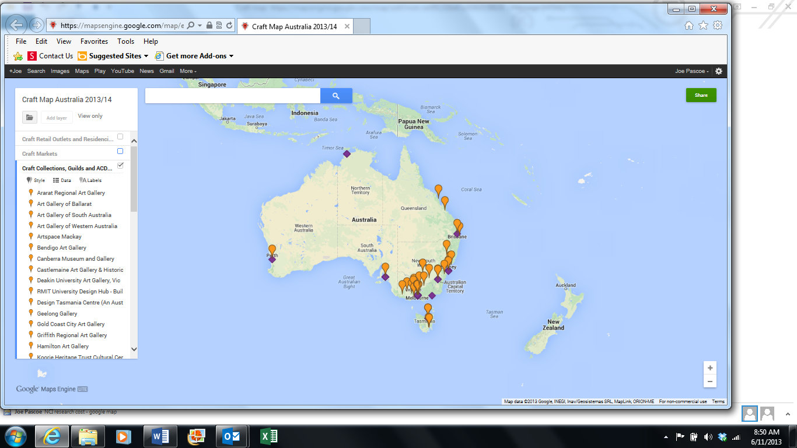

3.2 A short history of Australian craft

In considering the Google craft map of Australia it is important to appreciate that those vast sections of the continent which hardly have any ’dots’ on them represent the origins of Australian craft.

The Indigenous people of Australia have occupied the continent for an estimated 40,000 years, prior to Captain Cook claiming their land for the English crown in 1770. For Aboriginal people, craft remains a whole of culture artform, which each piece potentially connectable to another, through systems of kinship and dreamings.

Indigenous craft is still being made for tribal purposes, as well for designated craft purposes as an item for sale or use. Many major collections of Indigenous work are housed in Australian museums, with outstanding rock paintings and middens remaining in natural environments.

The place of Indigenous craft in Australian craft is no mere myth or easily translated tale. Melbourne’s purchase by John Batman for beads, blankets and scissors and the like places craft in a position of trade and novelty. In Eugene von Guerard’s painting ‘The Barter’ (1854), held in the Geelong Art Gallery, the protagonist are each in ‘national costume,’ peacefully trading items by the side of a river.

1856 marks the establishment of the Museum of Victoria, with 1867 being the start of the National Gallery of Victoria Art School. The gold rushes also gave the proud colonial cities exceptional buildings that reflected the styles of Europe, though with more generous proportions. The gold and silver that was mined helped establish high quality jewelers, resulting in impressive tableware and trophies. Australian craft, in this sense, was beginning to emerge as a style. Earlier examples of bricks and bottles, made with clay from around Sydney Cove have been collected as revered objects, often possessing a pathos of those hard times of settlement.

The prevalence of horses would have encouraged leatherwork and blacksmithing, and each domestic kitchen would have been a site for some form of craft work, such as knitting, sewing and making do. The Royal Exhibition Buildings in Melbourne were home to a world trade fair in 1880, which acted as a showcase of craft and many products. In 1901 Australia’s federation as a nation gave rise to many of the decorative motifs, popularized in the Federation housing style epitomized in the Sydney suburb of Haberfield.

Craft in these contexts inhabits the familiar field of practicality, commercial enticement through design and signifier of social standing. Its ability as an artform to be so flexible, was demonstrated by the rapid changes occurring in Australian society.

Merric Boyd, who is generally regarded as Australia’s first studio potter, held his first commercial exhibition in 1913. He did very well over the next two decades in both Sydney and Melbourne, often demonstrating in public the ‘magic’ of throwing a pot. His added twig-like handles were a vernacular, nouveau representation of England’s Art & Craft Movement. Many readers would know of his famous painter son, Arthur Boyd, who also made pottery 35 years later at Murrumbeena, near Melbourne. In retrospect it appears novel that such an occupation – artist craftsman – could appear in Australian society at this stage, and it required a person of exceptional talent to make it viable. It’s not historically clear who had taught him how to throw pots, but the skill was common in the many clay works around Melbourne, to which he added his artistic sensibilities.

WW1 gave us craft as a form of comfort as well therapy, first with women knitting socks for the solders to keep them warm in the trenches of Europe, then later at Soldiers Potteries, where wounded men learnt to make pots. By the 1930s it is evident by craft works in public collections, that most states of Australia had active craft studios. Training was practical and sometime wrote-learning based, and available from institutions like the Working Mans College, now known as RMIT University.

Post-World War Two the pace quickens. As Grace Cochrane outlines in her text for this report, a love of craft blossomed through the influx of displaced Europeans from ravaged Europe, and was further super-charged by the counter-cultural instincts of the international craft movement:

The interest in crafts as a studio activity from the 1940s followed the experience of the second world war and a desire for a fulfilling way of life, a dissatisfaction with manufactured products and an interest that so many people continue to have for working with materials and making things by hand – potters, jewellers and metalworkers, glassmakers, textile artists and other craftspeople, as well as studio woodworkers like yourselves. This interest of course, can apply over a range of levels from professional to amateur, but the contemporary crafts movement was largely focused on professional practice – and it occurred in many countries at the same time, largely in the Western world, but drawing very much on traditions from elsewhere.

Cochrane notes that this enthusiasm took a more formal form and became the foundation of an organised movement in Australia, with a national Crafts Council of Australia, and state branches, which are the antecedent organisations for today’s well known craft organisations, like Object in Sydney. This period, from 1960 to 1980, was also the founding period of many of the guilds and associations, as listed in Attachment F.

With the establishment of the Australia Council in 1975 and the inclusion of the Crafts Board as a founding board, the crafts were at a peak in terms of public excitement and government support. A mere 12 years later the Crafts Board and the Visual Arts Board were rolled into one, as part of an Australia Council wide restructure designed to reduce administration cost – too many committees, too many niche grant programs was the management mantra.

So began the rocking-horse debate between the differences or not between art and craft, which was later, in the eyes of some, further confused by the temporary appearance of the Design Board of the Australia Council, a short lived experiment indicative of what can happen when policy gets too far ahead of practice. These shifts at national funding level were not occurring in isolation – they were being fuelled by the opening up of tertiary education, a legacy of the Whitlam government, and the experiences of crafts people who sought an international career. Art schools, commercial galleries and state and regional galleries were all embracing contemporary art in different media, of which the crafts were a beneficiary and participant.

The Australian Council was in turn partnering with State Governments in the funding of organisations, with the rule of thumb being that State Governments would support infrastructure costs, whilst the Australia Council would support project costs. This basic division persisted up until the 1990s, and to some extent represented the sub-contracting of creative arts policy by State Government to Federal Government, a mutually appreciated arrangement in the challenging arena of contemporary culture. To appreciate this arrangement one would have to accept it as rather Australian to begrudgingly accept the idea of ‘culture’ without having it too closely affirmed.

In 1989 Robert Bell launched his ground breaking International Craft Triennial series at the Art Gallery of western Australia. Naming this multi-faceted exhibition series a triennial differentiated it from visual arts biennales, whilst laying claim to similar curatorial strategies. By the 1990s craft making was enjoying a relation with a wide variety of influences. The Meat Market Craft Centre in North Melbourne had come and gone, with its demise hastened by financial problems. It became insolvent as the cost of maintaining workshops in glass, timber, textiles and so on became prohibitive, in a scenario that reflected wider changes in the Australian economy. The Meat Market Craft Centre was an historic building converted to craft usage by the Victoria Ministry for Arts, which was the first state arts ministry in Australia.

Robert Bell’s curatorial stance was more than just product differential, it marked a departure from the Meat Market Craft Centre agenda, to engage in a non-media specific way with a wider cultural dialogue, whilst still staying connected to craft’s nomenclature – the term ‘contemporary craft’ came to mean work which could engage with such formats, yet still share space with terms like ‘jewellery’.

In freeing craft making from its boundaries, some craft organisations cast off the mantle of membership, arguing that they no longer served the needs of groups such as potters, but were funded to advocate for contemporary practice. New directions were embraced that chased the cutting edge of practice. The work of Susan Cohn is especially indicative of the new, with her Workshop 3000 studio becoming a base for extending jewellery into fresh areas.

By 2000 most of the Craft Councils had rebranded, adopting names like Form, Object and later on Artisan, as signifiers of their willingness to expand and support emerging craft makers. Coincidently, and largely away from the officially sanctioned contemporary craft, so-called Indie craft had arrived. Indie aesthetics offered a sense of permission to participate, and spored numerous bands, festivals, drugs, food, clothing and a widening of craft practice to embrace non-precious materials. It was not just to be a recycling of hippie fashion, as first thought, but became a serious vehicle for the examination of ideas regardless of wherever they came – including popular culture. Craft makers had a new issue to debate, with concerns about quality becoming a talking point. Indie as a style had the ability to morph into different artforms, like music and posters, which energised its content and retail appeal.

By 2005 we start to witness a commercial boom in retail shops, as the 270 or so retail stores listed in the Attachment testifies. Also coming into the craft space was the establishment of social craft projects, such as the Social Studio, Collingwood, by Grace McQuilton, which today assists African refuges gain a TAFE qualification in fashion.

In 2006 Brian Parks curated ‘Freestyle: new Australian design for living’ on behalf of Object, while in 2007 Grace Cochrane curated ‘Smart Works: Design and the Handmade, on behalf of the Powerhouse Museum, Sydney. Both exhibitions discussed how craft production could be achieved with integrity and were documented by authoritative catalogues, with the issues being discussed at the Smart Works conference. Both strived for a lasting position for Australian craft as a valued part of society, adding to its economic and social wellbeing.

Contemporaneously, Craft Australia and Object partnered to establish the Living Treasures project in 2004, which was a strategy to recognize and honor Australia’s great craft makers. A series of major exhibitions toured nationally. It would be exciting to see this concept re-emerge, especially for its capacity to place contemporary craft in the public domain.

To rejoin the story with Australia’s Indigenous people, we shift back to the early 1970s, when the extraordinary Aboriginal arts movement took off. The ‘empty’ parts of the Google craft map of Australia, would at various times have had up to 40 Indigenous arts centres, of which the weaving workshop at Carnarvon, Western Australia is an active example. Indigenous work has the ability to mesmerize and inspire, with the glass fish trap made by Jenni Kenmarre Martiniello, winner of this year’s Telstra prize, cited by Steve Pozel, Director, Object, as ‘a beautifully realized vocabulary of what is possible through craft’ .

Today the craft scene has multiple stakeholders holding every conceivable position. The digital era has given us 3D printing and screen culture has become a pandemic, to which craft making is for some, an antidote. Craft as an artform remains a site for experimentation and a vehicle for a wide variety of experiences.

As such, and as the survey data shows, there are now many ways of crafting. The crafts in Australia are an open, participatory artform, enjoyed at a making level by over 1.3 million children and 2 million adults, in a country of 22 million people.

3.3 Timeline

Dreaming – Aboriginal time; woven eel traps, hunting implements, bark paintings, musical instruments.
1770 - Captain Cook claims Australia; cartography, watercolor painting.
1788 – Establishment of penal colony at Sydney; clay bricks and pipes.
1834 – Robert Hoddle lays out Melbourne’s city grid, eventually giving rise to its laneway culture, including Flinders Lane garment district.
1850s – Gold rush in several states – impetus for public buildings including museums.
1880 – Royal Exhibition Buildings, Melbourne, world trade fair.
1901 – Australia’s federation as a nation; emergence of a national decorative style seen in craft media as flora and fauna decoration.
1913 – Merric Boyd commercial exhibition of ceramics.
1920-30s – establishment of Soldiers Potteries for rehabilitation. Studio pottery movement noticeably appears in Tasmania, Victoria, west Australia, and New South Wales.
1942 – Murrumbeena Pottery established; Arthur Boyd, John Perceval, et al.
1942 – Sturt Workshop established, New South Wales. Bernard Leach publications become popular
1951 – Harold Hughan first exhibited stoneware, reflecting he influence of the Leach-Hamada school.
1956 – Australian Galleries established; Australia’s oldest continuously running commercial gallery.
1967 – Margaret Dodd travels to USA and comes back to make her ‘Holden’ cars, and Funk takes off.
1970 – Crafts Council of Australia established (‘Craft Australia’)
1973 – JamFactory, Adelaide, established.
1973 – Victorian Ministry for the Arts established.
1974 - Australian Tapestry Workshop established.
1975 - Craft Board of the Australia Council established.
1978 – Art Gallery of Western Australia appoints Robert Bell as Curator of Curator, the first such professional appointment in Australia.
1979-1999 – Meat Market Craft Centre, North Melbourne, established as an active centre for the crafts.
1981- Workshop 3000 established by Susan Cohn.
1987 – Craft Board, merged with the Visual Arts Board to form the Visual Arts/Craft Fund.
1989, 1992, 1998 – International Craft Triennial series, Art Gallery of Western Australia, curated by Robert Bell and positions Australian craft in an international context.
1992 – Grace Cochrane publishes her seminal book The Crafts Movement in Australia: A History, NSW University Press.
1995 – Delinquent Angel: Australian Historical, Aboriginal and Contemporary Ceramics exhibition tours to Italy, Japan, Singapore and Australia, curated by Joe Pascoe as a Craft Australia initiative.
2004 – Living Treasures series initiated by Craft Australia and Object
2005 – June 18 2005, Etsy US launches
2006 - ‘Freestyle: new Australian design for living’ curated by Brian Parks, Object, Sydney.
2007 - ‘Smart Works: Design and the Handmade,’ curated by Grace Cochrane, Powerhouse Museum, Sydney.
2009 – The Social Studio, Collingwood, established.
2011 – Craft Australia National Sustainability Forum
2012 – Craft Australia ceased.
2013 - Stephen Benwell survey exhibition curated by Jason Smith, Heide Park and Art Museum, Melbourne.

3.4 Trends and impacts

The basic trend that emerges from a consideration of the history of craft development in Australia is one of emergence from the necessities of establishing a new society from about 1788 onwards, to an appetite for celebrating ‘Australiana’ with federation in 1901, to the post WW2 influx into the community of many people from different countries, to today’s complex, multi-faceted craft making environment.

Throughout this period craft has continually mirrored social change whilst ‘shape shifting’ to meet economic circumstances. Since its first peak of popularity in the late 1970s it has further engaged the world of ideas, to develop as an artform.

In some ways the training situation has remained relatively constant, with a blend of opportunities from personal mentoring to accredited courses from tertiary institutions. The professionalization of craft has often occurred through relatively short, intensive courses whilst being stimulated by the development of the art market in Australia, as seen through the growth of a commercial gallery system.

In recent times, the retail offer has dramatically grown, which has in turn affected the viability of funded craft organizations. The ‘Freestyle’ exhibition of 2006 was a curated example of this phenomena and prescient in its conception.

The audience for craft has changed dramatically over time. In some sense an audience for craft was ‘invented’ in the post WW2 period, through participation, which fed into the development of government funded craft organizations, and the establishment of the Crafts Board of the Australia Council. Today the situation is different again for that popularity is now feeding into a large retail sector, epitomized by the rise of markets and the many trendy shops that enliven shopping areas.

The short survey of publications currently on offer in Australia, as shown in Attachment M , shows that are some 86 titles across magazines and books – 45 magazines are current in publication in Australia with a strong craft focus. This indicates a high level of interest in the crafts, and an audience for a variety of writings about the many aspects of the industry.

Comment

This diversity of circumstances has arisen over a reasonably short period of time and has stimulated artform development, allowing craft makers to pick and choose their modes of craft making. As a cocktail of influences it has been fruitful for new enterprises such as the Social Studio (2009), who have based their business models on meeting well defined needs. However, it threatens to undermine the need for a fully funded craft sector, unless that sector can differentiate its offer and combine to deliver significant national projects that add measurable value to society.

4. Current Landscape

Data was collected via an online survey, interviews, literature and desk research. This approach engaged with much that Australia has to offer in the way of craft. A democratic approach was taken so as to capture input from a wide range of stakeholders. Academics, craft makers, craft organizations, funding agencies, guilds and associations, retailors, state gallery curators, and sector experts all gave their views (See Attachments for full survey responses, interviews, etc).

4.1 Craft Makers

In considering the survey results for self-definition, education and income it is apparent that while the definitions of types of being a craft maker have widened, and respective education levels risen, the income levels of Australian craft makers have remained static.

Self-definitions
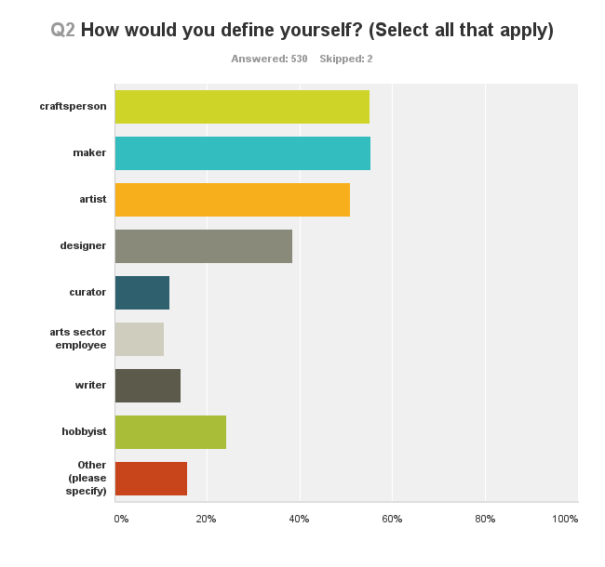
Respondents held an almost equal preference for the self-defining terms of ‘Maker’ or ‘Craftsperson’, sometimes double-picking both, with ‘Artist’ coming a close third. This flexibility in nomenclature suggests a broadening of interest in the crafts, where people are prepared to adopt a more general term that reflects the act of crafting as much as for identifying as a craftsperson. This has significant relevance in terms of the growing popularity of the crafts and how industry leaders might choose to relate to creative stakeholders. The terms chosen for the survey were initially researched through consideration of the terms used on Australian craft websites and their apparent frequency.

In Felicity Abraham (ed) The Crafts In Australia: Report of the Committee of Enquiry into the Crafts (the Crafts Enquiry) Crafts Board Australia Council Sydney 1975, page 3, nomenclature was recognised as an issue, with the preferred term being ‘craftsman’ or ‘professional craftsman’. In 2006 Craft Australia’s report National Craft Mapping Project by Jenny Deves & Catrina Vignando, refers to professional craft artists’, ‘designer/makers’, with ‘craft practitioner’ the most preferred term. In 2012 the Crafts Council of UK report Craft in the Age of Change consistently uses the term ‘Maker’. The other categories in the graph reflect the other recipient categories to which the survey was open.

Education
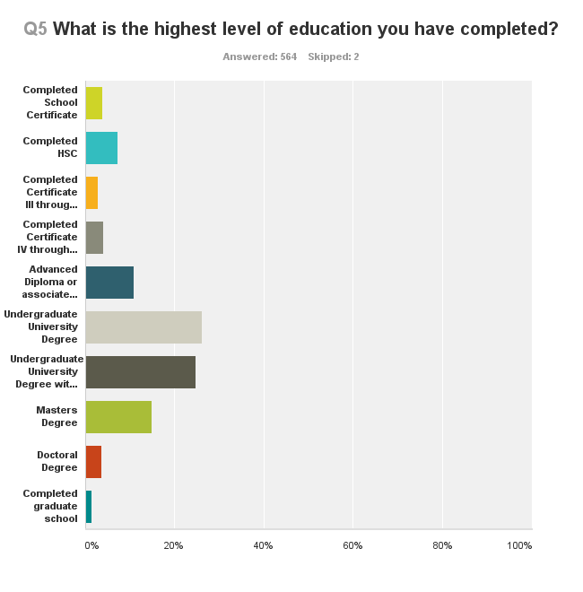

From the data collected in this survey, the craft fraternity appears to be highly educated, with tertiary education being the norm, with over 65% of respondents having a tertiary degree. This implies a vocal sector, which has a high regard for professional training. The changes in TAFE and University courses will potentially have a major impact on the crafts in the reasonably near future, if training opportunities decline. It is especially significant that over 15% of respondents are engaged with post-graduate study, which emphasizes the esteem with which the craft is held by many within its fold, and runs counter intuitively to the wind down of some TAFE and tertiary craft-related courses.

The situation in 1975 (Abrahams 1975) was different in that arts teachers were receiving training at teachers colleges and Institutes of Technology, which were defacto providers of craft training. Then as now, fulltime training was more likely to lead to fulltime crafting, with self-taught makers aligning to leisure activity, supporting the continuing popularity of workshops as delivered by craft organizations and craft makers themselves. The TAFE sector has been a very significant provider of entry level training – its demise, should it occur further, will have an impact on the embedding of craft skills in the community and probably affect the flow of interested people into higher education pathways as noted in the graph above.

A Melbourne based lecturer working in this education environment noted as follows:
Claire Beale
Q32: What programs or educational courses do you deliver for craft artists and designers/makers?(if applicable)
RMIT BA Textile Design undergraduate program courses & short courses DIA Textile Practice Group - professional networking, development and workshops
Q35: What do you see as potential areas for collaboration between organizations?
Collaborative workshops, forums, events & influencing government policy recognition for the design & craft professions (e.g. further Accredited status within professional organisations.

Attachments K, and L which survey the current educational opportunities in Australia, show a relatively wide range (80) of Certificate III, IV and Advanced Diploma and Associate Degrees being offered through the TAFE/RTO system in Australia. However, as noted in the Summary Document K, the number of courses offered at this level has significantly declined over the past 5 years.

There are at least 72 university (Bachelor, Honours, Master, PhD level) qualifications currently being provided by Australian universities that offer education applicable to craft practice. Some areas of study are more commonly offered than others, with a total of 37 different qualifications existing at a higher education level in textile studies, and only one institution (the Australian National University) offering Gold and Silversmithing as a degree-level qualification.

Education in craft can also come with a significant cost. Although many higher-education level qualifications are covered by the HECS scheme, according to the Australian Government’s “Study In Australia’ website, the average cost of an undergraduate Bachelor degree in Australia is $15,000 to $33,000, while a Postgraduate Masters Degree will likely cost between $20,000 to $37,000. In the case of many of the courses listed here, course fees may increase to include the cost of materials and specialised studio space. The average cost of a Vocational Education and Training qualification (Certificates I to IV, Diploma and Advanced Diploma) will be between $4,000 and $22,000. These costs acquire significance in relation to likely income levels for craft makers.

Income
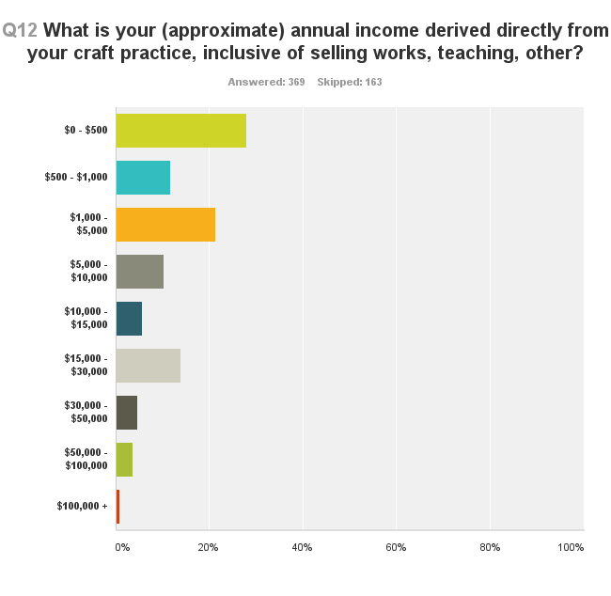
The low income for craft makers is in line with the income of many artists in the Australian arts sector (Throsby 2001), with its implication of the need for further business up-skilling from craft organizations coming through. Throsby & Hollster (2003 Chapter 8) notes the median income for craft practitioners was about $14,300. Given consumer price increases over the past 10 years, the statistical bump in the above graph for the group who opted for $15,000 to $30,000 complies with Throsby & Hollster’s conclusions. Their work, which remains the authorative source, unfortunately implies that little has changed since 2001.

The financial data gained through this voluntary online survey has some value, however, there is evidently a need to encourage the ABS to collect craft-centric data using new categories, to facilitate a better understanding of the sector.

Looked at in terms of what is known of retail data and approximations of the size of the retail sector in Australia, there is more economic activity than the above graph implies. It is important for industry leaders to get to know their members changing needs for business skills training, so as to provide opportunities that enable the people in the ‘bump’ to stay in the sector and hopefully prosper. Whilst it is encouraging to see that about 4% of craftspeople are evidently earning around $50,000 per year, as a total sum such an income does not seem adequate for the level of talent and knowledge required to be an outstanding craft maker.

A snap-shot of the daily reality of being a young maker comes from Brisbane:
Stephanie (BrisStyle Creative Activists)
Q33: What opportunities do you see for the future development of the crafts sector nationally and internationally?
Feedback suggests that local crafting in/around Brisbane is of international quality (reliable, positive comparisons with large overseas movements such as Renegade in Austin, USA) with enormous potential for tourist development. While the Brisbane City Council has been supportive of BrisStyle, and similarly Ispwich I believe has been supportive of The Handmade Expo, this needs to continue and strengthen to realise the full potential of a genuine, self-directed arts-and-crafts movement nationally.

Q34: What policies (government and otherwise) would facilitate these developments?
More positive physical support for craft markets together with a sympathetic approach to insurance, workplace health and safety, and other regulations and requirements for nurturing crafting and craft markets. Arts-and-crafts must be allowed to self-generate and self-direct within a conducive, open, nurturing framework.

Q35: What do you see as potential areas for collaboration between organizations?
Two recent events of which I have first-hand experience have involved highly successful collaborations: Brisbane City Council Tip Shop Competition (with artists and the Endeavour Foundation); and BrisStyle Eco Bazaar (BrisStyle members, Queensland Museum). Brisbane City Council libraries have also worked with BrisStyle to provide craft workshops at various locations around Brisbane. These are all models of excellent collaborations that have had positive results for all parties concerned that continue well after the events themselves have concluded.

From the desk research Retail/Online Outlets, it is evident that there are a wide range of retailing opportunities across Australia. While the list in this attachment is by no means comprehensive, it can be seen that income sources for Australian craft practitioners are highly diverse, ranging from small-scale, community volunteer-run retail stores in rural and regional Australia to large, high-end retail outlets such as ‘Planet’ in Sydney. The significant growth in online retail outlets is notable. Also of note are the 160 Markets and Fairs listed in Attachment V which represent another key income stream for practitioners.

The desk research conducted as part of this project indicates a number of opportunities for income diversification and support. 103 grants at a national, state and territory level are identified in Attachment S, with the average maximum grant amount offered for individual practitioners (based on this survey) across Australia sitting at $11,123. In Attachment R, 33 potential funding opportunities are identified through private foundations, trusts and philanthropists. Attachment Q – Scholarships, Awards and Prizes – outlines 81 additional funding opportunities, ranging from certificates and industry recognition (27 of the identified 81 opportunities) to $100,000 for an established artist who is selected as a Creative Australia Fellow.

4.2 Craft makers consider their future

Several of the survey questions give us a glimpse of the future that craft makers see for themselves. The first graph splits the field into a sizable emerging group and hobbyists, while the second graph highlights the newness to craft making of the survey respondents, and the third demonstrates a high degree of optimism for the future. The fourth in this set is mildly ambiguous about the prospects of good career progression. This is an appropriate response in terms of the likely outcomes for many people. An anecdotal comment that came up when interviewing industry leaders was the pressure some mid-career craft makers felt in relation to the rising competition from a growing cohort of emerging craft makers.

Emerging, Mid-career, Professional, Pastime

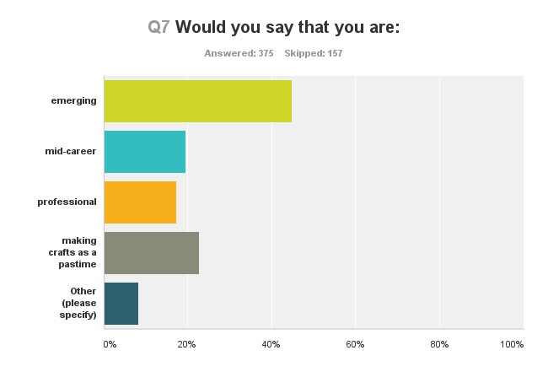
Although emerging is the largest amongst the survey respondents with close to 50%, there is a relatively even distribution of the other self-defining terms of around 15% each. The response implies a whole of life attitude to crafting with an implied good rate of progression through the different stages of the career ladder, once you survive ‘emerging’. The large number of emerging practitioners was noted by some industry leaders as compressing the middle ground of established makers, with the professional makers perhaps being well able to fend for themselves. A caveat to this interpretation is that the survey may have appealed to emerging makers as an online experience, however, the data spread implies that today there are multiple ways of being a craft maker.

This situation is markedly different from 1975 (Abrahams 1975 page 21), where ‘Most of the craftsmen surveyed were middle-aged with only 17% of them under thirty years of age and just over half between thirty and fifty. Assuming age to be a major factor in ‘emerging’, the appeal of craft today has broadened and currently enjoys high support from a greater number of people from an earlier age.

Industry leader Lynda Dorrington (CEO, FORM) makes the point in her interview that the terms ‘emerging’ and ‘established’ are outdated terms and do not adequately describe the trajectories of digital artists, and that the terms are limiting funding opportunities to artists (see Attachment – Industry leaders interviews).

A number of funding opportunities outlined in Attachment S – Grants and Attachment Q – Scholarships, Awards and Prizes – offer funding and opportunities targeted at practitioners in various career levels – key examples being the $100,000 Creative Australia Fellowship for an ‘established’ artist, and the “Realize Your Dream” professional development grant – including international flights and $5,000 cash – which is aimed at “emerging practitioners in the first 10 years of their practice”.

How many years have you been a craft practitioner?
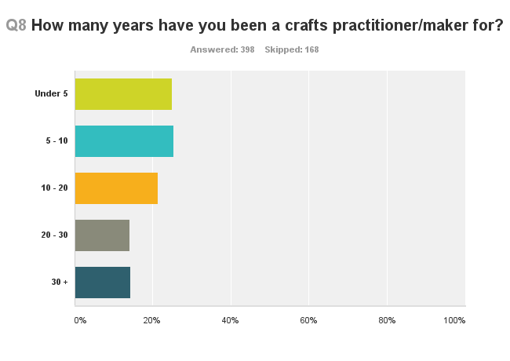
There are two main implications to be drawn from this graph. The first is that craft makers in Australia evolve through the various stages of professionalization given a commitment of say ten to fifteen years - nearly equal proportions of about 25% respectively of respondents have been crafting for five to ten years and ten to twenty years , and secondly, people may be inclined to produce less craft as they age. In any case, craft is an artform that appeals significantly to young people, which suggests it will continue well into the future.

The response also suggests that the opening gap in the education sector will create significant opportunities for the provision of high quality training. The data also infers that services, including membership services, should be offered online, as forecast by Deves & Vignando (2006 page 28) where participation in the online environment is encouraged, so as to extend the participation rates of people who have been crafting for less than ten years. As shown in Attachment K, approximately 60% of courses identified as offered in Australia at a TAFE/RTO level are provided by registered, non-government training authorities.

I expect my craft business to grow in the next five years?

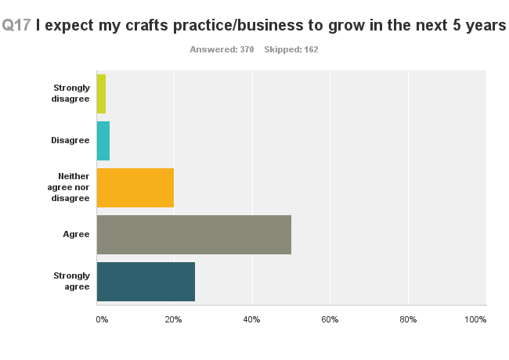
The ‘optimism’ question received a 75% positive survey response. It implies a need to grow the market for Australian craft to meet the supply side of the market equation. It also means we should ‘expect the unexpected’ as new entrepreneurs enter the fray with novel business ideas and outstanding craft, thereby creating new demand.

A comment from Sydney:
Jane Burns
Q33: What opportunities do you see for the future development of the crafts sector nationally and internationally?
Identity within the general public audience of the complexity and beauty of both functional and non-functional contemporary three-dimensional objects.
Q34: What policies (government and otherwise) would facilitate these developments?
Distinguishing the work of contemporary craftspeople by adequate promotion and by identifying this unique sector of the visual arts as contemporary craft rather than the generic design.
Q35: What do you see as potential areas for collaboration between organizations?
Allowing national/international initiatives to be channelled for example through Craft ACT rather than muddle state focussed and/or nonspecific crafts based organisations with this role; re-think the way state crafts organisations make themselves a focus for individual practitioners and potential buyers/collectors.

And a comment from Darwin:
Hayley Barich
Q33: What opportunities do you see for the future development of the crafts sector nationally and internationally?
For the top end of Australia there is considerable opportunity to network and collaborate with Asia. It is already happening and I think there is great potential to share those relationships with the rest of Australia.
Q34: What policies (government and otherwise) would facilitate these developments?
Australia's visa restrictions make it quite hard for visiting artists.

A comment from a Melbourne-based architect:
Paul Loh
Q30: Which organization do you work for/with? (If applicable)
University of Melbourne
Q31: What types of services do you deliver for craft artists and designer/makers? (if applicable)
We run a design studio and maker workshop as well as teache design in Architecture. Part of our service is to assist artists and makers to produce prototype using CNC technology.
Q32: What programs or educational courses do you deliver for craft artists and designers/makers?(if applicable)
Master program in Architecture
Q33: What opportunities do you see for the future development of the crafts sector nationally and internationally?
I think there is going to be more cross disciplinary approached to design and making. This tendency is happening is some sector but I think will become more prolific over the coming years.
Q34: What policies (government and otherwise) would facilitate these developments?
I think the main issue is contractual relationship between collaborative efforts. This is sometime ill defined. Another aspect that could be facilitate cross-disciplinary approach is additional funding and grant to actively encourage maker to cross disciplinary threshold.

Attachment O identifies 173 retail outlets – of the bricks and mortar retailers, 41% of all stores surveyed had a functional online store, while 57% did not. This high level of online integration across Australia’s craft retail is interesting in light of an observation made by Jenny Deaves in the 2006 report, National Craft Mapping Project: “Website representation is a critical promotional tool for organizations. Seventy-six percent of membership based organizations surveyed provide some sort of website representation. At present most organizational websites tend to focus on the organization’s activities and not on internet exposure for individual artists and their work.” As online retail has continued to grow, not only for craft organisations, but also for more traditional shopkeepers and galleries, the need for website representation and training in this area still appears a relevant consideration in craft business futures.

4.3 Craft Makers and making

The following set of three graphs present an image of a highly versatile artform in terms of time commitment, which can take advantage of a wide variety of source materials, ranging from expensive to found. Many people are making craft in the home, with various studio options available depending on circumstances.

How many days a week do you spend on your practice?
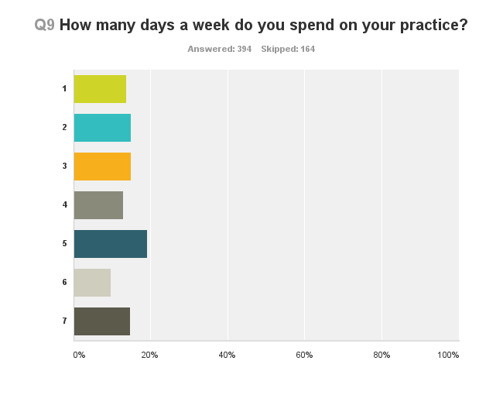
The most common figure in terms of commitment to crafting is five days per week by 20% of craft makers. Beyond that people are very flexible in terms of time commitment, ranging from one day per week to seven days. The distribution of responses infers that many craft makers are part-time, though this may be a reflection of economic necessity, as noted by Throsby & Hollster (2003), which put craft makers income in the sub $20,000 per year category. Another view connects crafting with the home, as indicated in the Where do you craft? survey question, which has over 70% of respondents craft making from home. With a spread from occasional to continuous, one can appreciate the widespread popularity of craft participation as noted by Australian Bureau of Statistics, which notes 2 million adult Australians make craft.

Craft mediums
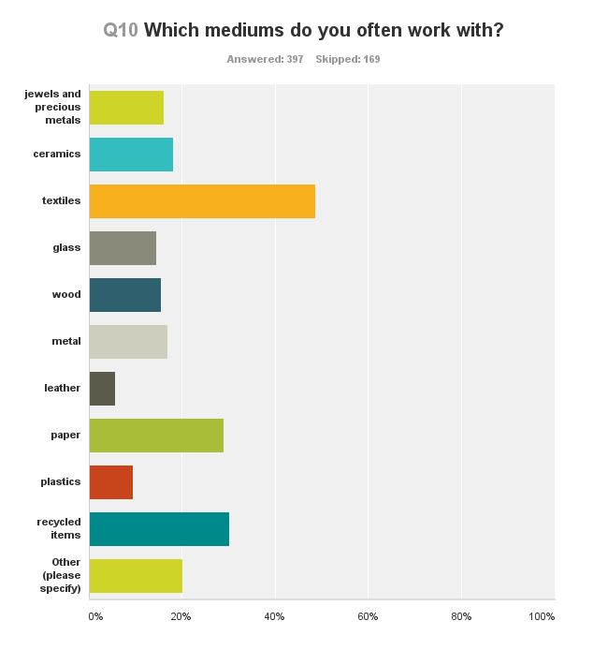

The above graph indicates something of the range of materials used in craft, and extends beyond the traditional media, such as ceramics and textiles, etc. Many craft makers are using a variety of media, including ‘new’ media such as plastics and re-cycled materials. The traditional media specific divisions of ceramics, glass, fibre, wood, metal etc., as noted in Abrahams 1975 report, still holds for the majority of craft practitioners. The list of possible materials in use is now extensive in the sector. The most popular material or media is by far textiles with almost 50%, followed by paper at almost 30%, ceramics 19% and glass 14%. The distribution of results with its implication of multiple answers, affirms the idea that many craftspeople now use a range of materials, which differs from the 1970s. By way of comment, there is considerable opportunity for craftspeople to become ambassadors for innovation, as they often have in the past, by engaging with different materials in a variety of project situations.

In Attachment M, a survey of key Australian industry producers of goods used in craft production, 65 key industry producers were identified and catalogued, with a web link, summary of their activities, type of material being produced and a note of any sponsorship, partnership or other opportunities. Australia is a notable producer of wool, timber, stone, metals and minerals with some of the world’s biggest businesses are based here.

Where do you work on your craft making?

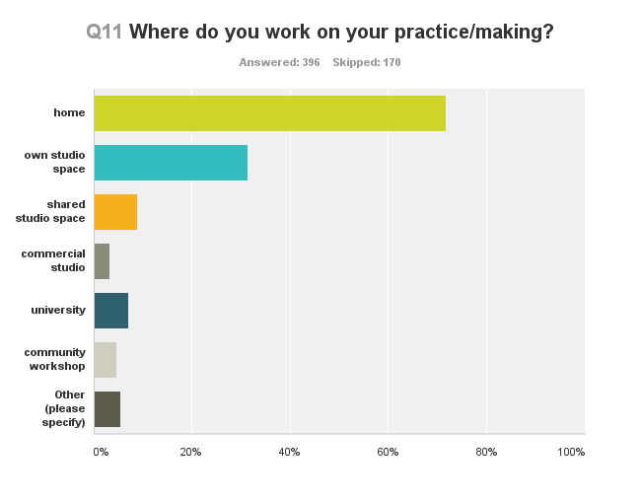
This data implies that over 70% of craft makers are working from home, which suggests a high degree of integration of crafting in peoples everyday lives, which would feed into the survey data on how many days per week do you craft and the associated commentary regarding the very high rate of participation by Australian people in craft, as previously noted.

People are also keen on studio spaces of one type or another, with own studios and shared studios scoring similar rankings of 30% each, which as a statistic probably represents some form of duplication in terms of responses. University and community workshops each score about 6%, which is interesting consider in terms of the equally impressive lists of Guilds and Residences contained in the Attachments – there is a reasonable degree of choice depending on your type of interest as a craft maker.

The prevalence of studios, when compared to the data on how many years have you been a craft maker implies that a pathway from the home to the studio is a marker of professionalization for many craftspeople. The advent of ‘ABNs’ (Australian Business Numbers) and the progressive normalization of micro businesses in terms of taxation treatments, would suggest this trend will continue.

4.4 Sector experts comment

In addition to the online survey extended interviews were conducted with sector experts to develop a broad understanding of the current landscape of the craft sector. The selection included people who were each well qualified in a number of ways, but collectively representative in terms of gender, age, location, occupation, type of craft involvement and to some extent, Indigenaity.

The sector experts interviewed were:
- Basketry NSW; Meri Peach, member of the group
- Dr Robert Bell AM; Senior Curator, Decorative Arts and Design, National Gallery of Australia
- Dr Grace Cochrane; Independent Curator, Sydney
- Etsy; Kirsteene Phelan, Marketing Manager Australian Program, Melbourne
- Jon Goulder; furniture designer maker, Adelaide
- Dr Patsy Hely; Senior Lecturer, Graduate Coursework and Honours Program Convenor, ANU School of Art, Canberra
- Dr Kevin Murray; Independent Curator, Melbourne
- Dr Rohan Nichol; Associate Lecturer, Foundation Design Arts, ANU, Canberra
- Nomad Art Darwin; Angus and Rose Cameron, Directors, Darwin
- Catherine Truman; Contemporary Jeweller, founding partner Gray Street Workshop, Adelaide
- Associate Professor Liz Williamson; Weaver and Living Treasure, Head of the School of Design Studies, College of Fine Arts, University of NSW, Sydney.
- Tamara Winikoff; Executive Director, National Association of Visual Artists, Sydney

Which organization do you work for/with?

The interviewees worked for a range of organizations and/or themselves; craft makers who have achieved international standing for their craft work in jewelry, ceramics and furniture, a guild, three universities, the Australian National Gallery, an Indigenous commercial gallery, an international online provider, two national service organizations and distinctly, two ‘personal research centres’.

Of the latter, it is Grace Cochrane who notes:

This is a significant time, in that the field is represented by several generations of crafts practitioners in all media, from the post-war leaders who are still practising or providing models and mentorship, to recent graduates who may never have heard of them but who still benefit from their experience. The practice of hand-making today is diverse: across these generations, you could perhaps describe an arc between art, crafts and design with people located at different points; those in the centre who are dedicated to contemporary expression and ideas based on traditional values, forms (often functional), materials and processes in the crafts, those who work out of that background to make works that are conceptual in their purpose as ‘art’ in its intent, and those who work out of that background to make works in a ‘design’ context, often using new technologies and specialist industries, but with a crafts approach to materials and skills at the core.

Kirsteene Phelan, Marketing Manager Australian Program, Etsy brings us up to today in terms of the online retail environment:

Etsy is a marketplace where people around the world connect to buy and sell unique goods. Our mission is to re-imagine commerce in ways that build a more fulfilling and lasting world. Etsy offers a platform and ecommerce solution for tens of thousands of Australian creative businesses. People can buy and sell items in three categories – Handmade, Vintage and Craft supplies. Handmade is by far our largest category with sellers from hobbyist to professional practitioners creating and selling a wide range of traditional and contemporary craft items such as jewelry, ceramics, art, woodwork, leatherwork, screen-printing, furniture and clothing. Each week we estimate there are thousands of new buyers using Etsy. Australia is ranked in the top five global buyer and seller’s market for Etsy. The company is based in New York with offices in London, Berlin, San Francisco, Dublin and Toronto with a high level ongoing attention given to delivering an outstanding online environment.

Catherine Truman, a craft maker for 35 years who has exhibited widely offers the insight of a Master Craftsperson, which is both intimate and national:

I am a craft practitioner and my practice has evolved with the industry in Australia over a 35-year period. I have watched it grow from the vantage point of South Australia, which has a particularly rich craft history. I’ve also gained an international perspective through extensive travel and consistent involvement with overseas projects and the more I travel, the more I’ve come to appreciate how strong the crafts are in Australia, especially in Adelaide which is home to a very sophisticated and highly developed community of practicing craft professionals. However, I fear that the growth and enrichment of this community is under threat from a lack of understanding and support at a federal policy level.

An Indigenous gallery perspective is explained by Angus and Rose Cameron from Nomad Art Darwin, established 2005:

We work with a range of organizations and institutions including:
- National, State and University collections
- Research schools such as the Australian National University School of Humanities (ANU), Charles Darwin University (CDU)
- Northern Territory Centre for Contemporary Art
- Indigenous Art Centres
- Art Back NT, Regional Galleries and exhibiting University Galleries Nationally
- Association of Northern Kimberly and Arnhem Aboriginal Artists (ANKAAA) and DESART
- Funding Bodies such as Gordon Darling Foundation, Australia Council, Myer Foundation, NT Research and Innovation, Arts NT
- Educational organizations such as National Science Week
- Festivals such as the Darwin Festival and Brisbane Rivers Festival

Comment

In considering these four responses from different parts of Australia we see that the answers to: “who do you work for/with?” reveal a porous structure of arts and community engagement. At no point is craft management separate from the craft community in this selection of responses. There is a tendency to use a wide range of networks that cross many types of boundaries, though most interviewees seem to be emotionally invested in their location. In this sense it is reasonable to say that the crafts are contributing to the development of regional cultures in Australia as well to a multi-layered form of national identity.

As evident in desk research Attachment W, Forms of Support Offered by Public, and Peak Bodies and Other Government Departments, there are a great many other forms of support for craft practice – with 91 forms of support listed.

What types of services do you deliver for craft artists and designer/makers and what programs or educational courses do you deliver for craft artists and designers/makers?

The Basket makers NSW Guild is very practical:

The Guild provides a meeting place for those with an interest in spinning and weaving in particular but also felting, knitting and allied crafts. This is a place for sharing ideas and provides some opportunities for members wishing to sell some of their hand crafted items. We also participate through the Guild in charitable activities such as producing trauma teddies and the recent 5000 Poppies event. The Guild offers workshops, social outings, sharing days and lessons for people wishing to learn to spin and weave (including Tapestry weaving). We participate in local events including the Royal Geelong Show, Celtic Festival, WOW Fest and National Trust Open Days. We also demonstrate in schools. The Guild has an extensive library for members to use and equipment which can be borrowed.

As a senior academic as well as a ceramist of national repute, Dr Patsy Hely gives this overview:

The practical side of an art school is very important too. Within our budgets we constantly seek to update equipment, though students often need to contribute to materials for their various craft workshops. Industry related professional practice is incorporated into all streams, on both a formal and informal basis. I see the main issue for craft practitioners as the declining opportunity for accessing good quality craft education. Associated with this is the lack of theoretical discourse about the crafts and the unfortunate absence of craft history, especially in comparison with the visual arts, in most teaching environments.

Jon Goulder, furniture designer maker and new Head of Furniture Studio at the JamFactory notes:

Prior to moving to Perth I had been involved in a very interesting project in Launceston, Tasmania, called one/third which saw contemporary designer makers work with an existing business that was facing some difficulties, to create a new range of furniture products. It worked very well as a model and that enterprise is still going well.

Robert Bell gives the public an exceptional visitor experience through his role as Senior Curator, Decorative Arts and Design, Australian National Gallery;

In 2000 I had the opportunity of taking the newly established position of Senior Curator Decorative Arts and Design at the National Gallery of Australia, which brought together its Australian and International decorative arts collections into a single department. These collections had been developed, rather inconsistently, since the Gallery’s establishment in the late 1970s by Assistant Curators in both the Australian and International Art departments. Today something like seven percent of the Gallery’s entire art collection is Australian craft related, which speaks of the importance of craft as an artform in Australia.

And Liz Williamson, Head of the School of Design Studies, College of Fine Arts, University of NSW and an outstanding weaver, speaks of a very particular experience available via her institution:

In India, I’ve been substantially engaged with a number of institutions in the city of Ahmedabad, Gujara , India. I’ve been instrumental in forging a relationship between my university, UNSW and the National Institute of Design in Ahmedabad. I’ve developed close links with many artisan groups in Gujarat as well as working with weavers in West Bengal. I now take students in groups of 15 to 20 from Australia to India every year. The impact on all concerned is profound. The students are exposed to short workshops and in return, discuss design concepts, collaboration and share information on textiles. The challenge for the local artisans is to reach new markets, one layer at a time, working through the complexities of India’s social structure. You feel a closeness to the local artisans (printers, weavers, embroiderers and Bandani (tie-dye) artisans), as you would expect, as textiles is such an intimate medium.

Comment

This selection of interview comments indicates the wide role that the craft sector plays as a provider of services in Australia, and beyond, through a range of organizations and institutions. Craft is an especially generous artform in terms of what it can give people. The issue that stems from this diversity is the need for a policy framework, at high level, that provides a rationale for a wider variety of grants and resources for the crafts sector, so that such services can continue to be delivered. The example of Jon Goulder and the Launceston project is especially noteworthy in this context, as is that of Liz Williamson, for ideas on how craft can assist with market development through a strategy of skills development.

The skills development opportunities outlined here in Desk Research Attachment X indicate that there is a wide range of other opportunities, but the services outlined here in the sector interview comments are indicative of common threads in service provision. For example, training in marketing, online skills and design skills are offered across the board.

4.5 Industry leaders comment on the craft sector with regard to craftspeople

The following industry leaders where consulted with regard to key issues for craft makers and their organisations.

- Avi Amesbury; Executive Director, Craft ACT, Canberra
- Mark Bergin; Creative Director Design100, Melbourne
- Sarah Body; Chair of Tactile Arts, Darwin
- Jess Booth; Researcher, Aboriginal and Torre Strait Island Art Economics Project, Melbourne
- Lisa Cahill; Executive director, Australian Design Alliance, Sydney
- Pippa Dickson and Rye Dunsmuir; Chair and Director of the Tasmanian Design Centre
- Lynda Dorrington; Executive director, FORM, Western Australia
- Geelong Handweavers and Spinners Guild Inc. Kate Williams, Victoria
- Liana Heath; CEO Artisan, Queensland
- Ann Jakle; Director, Glassworks, Canberra
- Rebecca Jobson; Acting CEO and Business Development Manager, Craft Victoria
- Anna Maas; Director, Skepsi Gallery, Melbourne
- Rae O’Connell; Executive Director, Guildhouse, Adelaide
- Brian Parkes; CEO & Artistic Director, JamFactory, Adelaide
- Steve Pozel; Director, Object, Sydney
- Robert Reason; Curator of European and Australian Decorative Arts, Art Gallery of South Australia
- Jane Scott; CEO & Artistic Director, Craft Victoria
- Jen Standish-White; Executive Officer, Central Craft, Alice Springs
- Antonia Syme; Director, Australian Tapestry Workshop, Melbourne
- Dr Mark Viner; Head of Sturt Craft Centre, Mittagong
- Kerri White; Strategic Planning Coordinator, Tactile Arts, Darwin

Avi Amesbury sees international pathways as particularly important to craftspeople:

I see international support as a significant issue for craftspeople that is not supported sufficiently. In the Australian Council funding guidelines there are no strong programs supporting international activities for Australian craftspeople, apart from participation in art fairs, which tends to place craft into a singular niche market.

Sarah Body, Chair of TactileARTS, Darwin notes:

The cost of crafting in Darwin actually makes it a hobby. That is the cost of materials and the limitations of the market make it difficult to become a professional craftsperson in terms of making a living. Most of us make craft out of passion and to engage with the community. It’s like a ‘paying hobby’ with funds we make often going back into workshops or the occasional conference. The more commercially successful of us would be making about $20,000.

Pippa Dickson and Rye Dunsmuir from Design Tasmania, observed:

At Design Tasmania we find we are working more with an older age group of experienced craftspeople, who have the skills to make significant works for the market. The centre sells into Melbourne and Sydney as much as locally, which is due to the reputation of Tasmanian craft, particularly with regard to wood and furniture. People are attracted to the work because of the reputation of the timbers themselves as well as the great skill that the craftsmen exhibit.

Our model is under pressure though as the new forms of popular craft do not have the same skill base, plus there is a gradual demise in the mentorship system which had allowed craftspeople to acquire their exceptional skills. Tasmania still has an outstanding university art school system, located in both Hobart and Launceston, and strengthening in Launceston, but there is a growing financial pressure that impacts on the provision of the practical aspects of courses. Launceston is gradually building its identity as a design destination – it helps to be thought of as a natural destination for fine furniture and design education.

Lynda Dorrington from FORM in Western Australia noted:

I would say the main issue for craft practitioners, and here I reference Western Australia, is that the severe lack of studio facilities which impacts on training and entry into the market. It is evident that the changes in academia and the associated investment in teaching resources for crafts, such as kilns and other substantial equipment has significantly declined. It’s probably a trend that is hard to reverse, because without high quality equipment enrollments are likely to continue to fall. The situation has become serious here in the west.

Liana Heath speaks to the issues of craftspeople in her state of Queensland:

I think craftspeople in Queensland sometimes feel isolated, with a desire to feel connected to other makers and opportunities, which Artisan tries to broker through skills development strategies. We see our role is to capacity build on a number of levels. Certainly the retail environment here in Queensland for high quality handmade craft is limited, so it’s actually quite a complex situation; individual makers have to have both a virtual presence and an actual presence yet probably less than half of acknowledged craft makers have websites.

We are seeing more and more emerging makers, much like in Melbourne, with more established makers feeling the squeeze in terms of economic sustainability. Queensland as a place is highly diverse and in the north of the state Kick Arts in Cairns serves the craft community too, often linking to Indigenous makers. Around Brisbane there is a growth in studios and aligned businesses such as trendy cafes, reflecting a new youth culture. Often regional craftspeople go ‘metro’, to see what is happening, such as for a jewelry conference.

Rebecca Jobson from Craft Victoria noted:

I see hobbyist, emerging and established makers as facing different issues.
While there are a plethora of options to engaging in craft at a hobby level, makers seeking to build professional practices need access to quality educational experiences in environments that encourage peer networking and intergenerational skill sharing in conjunction to business support especially in the areas of copyright, marketing and promotion to ensure long term careers.

Anna Maas, an experienced retailer of craft in Melbourne, observed:

I don’t think there is any issue as such with regards to retailing craft, because it is simply a matter of recognizing that the situation has changed from 20 or 30 years ago. 30 years ago craft was a movement, it was fashionable and popular – it belonged to a whole generation as part of the counter culture. The generation that followed had different views, which as a retailer of craft you must recognize to stay in business, or to start a new business.

Steve Pozel from Object, Sydney, talks about change:

I believe that there are multiple interventions impacting on the arts and on the idea of the handmade. The real key to what is going on seems to be a shift in the idea of craft practice, with whole new systems about to arrive. For example, 3D printing is now becoming common practice and we can assume that other developments will quickly follow.

The issue for craft practitioners is not whether 3D printing represents real craft, but what does it do to our notions of appreciating materiality and process. Coupled to this new way of considering craft are the changes that are happening in the market place. Etsy as an example of opening up the craft market online and is a natural extension of what we are seeing via new technologies.

Mark Viner, from the Sturt Craft Centre, portrays the situation as a paradox:

The main issue I see is sector sustainability. It’s the basic problem of artists trying to make a living. In our particular case we offer a wide range of training workshops throughout the year, and many of those people who have completed our courses quickly go on to offer their own courses, and thus become to some extent our competitors in an oversupplied market (too many people who regard themselves as teachers and not enough people considering themselves as students). It’s a business cycle that undermines our own situation, and probably leads to market saturation.

Comment

The recurring issue that comes up for industry leaders when asked about issues facing craft makers is financial sustainability, in particular, the market is seen as too susceptible to external pressures, with the implication being that craft is purchased with discretionary income. Some industry leaders, notably from Brisbane and Melbourne, speak of the squeeze on established makers due to the influx of younger, emerging makers.

Changes in artform practice are cited by Steve Pozel at Object, Sydney, and Lynda Dorrington at FORM in Western Australia. Both observe the rise of the digital era as being profound. They both see it as a new gift of technology, which will raise valuable questions about craft. They are also concerned about how the existing models of financial support, such as grants, will help.

Pippa Dickson and Rye Dunsmuir of the Tasmanian Design Centre, identify the need to create integrated production, supply and point of sale chains as essential. They also infer that this suits some craft media more than others, mentioning glass and furniture.

The Northern Territory as represented by contributions from Sarah Body from TactileART in Darwin and Jan Standish-White from Central Craft of Alice Springs, indicated that their makers are caught in a cycle of low demand and limited supply of materials. The Top End is being analyzed by Jess Booth, who is managing a survey of Indigenous craft, speaks of the need to build resilience into the Indigenous market, through further training support at remote arts centres.

For Avi Amesbury, CEO, Craft ACT in Canberra, the presence of the international diplomatic corps is a special opportunity to showcase Australian craft, while Mark Viner’s comment captures the irony of the situation in recognizing that the wider craft environment is completing what was once the mission of the funded craft organizations.

4.6 The industry leaders comment on their craft organisations

What do you see as the main issues for the Australian craft sector with regard to craft organizations such as yours?

In Adelaide Brian Parkes refers to the JamFactory’s rising national role:

Our issue as an organization is basically, ‘are we being too ambitious given our level of funding?’ We find ourselves scoping international ideas. For example, it would be very good to have international residences here in Adelaide. The Jam has stayed with its original ethos and now we actually feel a moral obligation to the nation to keep our workshop facilities going, as so many universities have closed down their kilns and the like. I estimate that every public dollar spent on the Jam Factory has at least a doubling effect on producing real incomes for artists. An amazing amount of economic benefits are generated by the Jam Factory. It is for this reason that we continue to invest in our own infrastructure.

Ann Jakle, as Founding Director of the Canberra Glassworks, offers a unique perspective of dealing with the first few years of a new institution:

As Founding Director of the Canberra Glassworks I have had the unique privilege to develop this institution and can offer some useful reflections on the original business plan. Looking back there was a tendency to overestimate earned income and to under estimate expenses. It’s quite interesting; the income from artists rentals was over estimated, whilst wages for creative staff where not initially understood, and of course maintenance and energy costs for a facility such as this are vulnerable to outside influences. I am proud to say that today we earn 60% of our turnover of $1.6m which I am told is an impressive achievement. However it often feels very tight here as we are in a close relationship with the wider economy, with little buffer in between.

Lynda Dorrington from FORM in Western Australia pin-points the need for a national marketing campaign on the value of craft:

I believe there is a strong need for a national marketing campaign to promote the crafts. In particular I suggest that such a campaign needs two foci; messages about ‘why to buy’, and sub-messages that communicate the significance of material culture in our society. The why to buy message has the advantage of helping to encourage a new generation of collectors, and the emphasis on material culture should appeal to the public on a number of levels. It will also help establish a more sophisticated basis for international exposure, either through brand alignment with national icons like Qantas or through our international network of embassies (both Australian embassies overseas or international embassies located in Australia).

Jess Booth offers some comments on the structure of the Indigenous market for crafts:

In comparing craft practitioners to visual artists, its mostly true to say that the paradigm of emerging and established makers is not prevalent in Indigenous craft, whereas it has a definite place in the structure of the Indigenous visual arts market. There are a surprisingly low number of retail outlets for Indigenous craft in Melbourne and Sydney, whilst Darwin has excellent galleries such as Nomad Art.

Avi Amesbury raises the issues of salaries and how it affects the craft sector:

Craft ACT has a special issue when it comes to salaries. With so many national cultural institutions in Canberra, our salaries at Craft ACT are non-competitive - too far below the public service levels- and the history is that many excellent arts administrators and creative who have worked here leave for higher salaries, going onto the National Gallery of Australia or Museum of Australia or elsewhere in Canberra. This has a serious impact on the organization. The upside is that we have terrific relationships with all those institutions and often partner with them – last year I counted up 33 such partnerships! These can include very interesting ones like CSIRO.

Jane Scott, CEO and Artistic Director, Craft Victoria, puts the case for a major new institution for the crafts:

Internationally, Craft Museums and Centres hold prominent positions in the cultural landscape of most major cities. Their remit is to showcase the work of talented crafts people and designers, present exhibitions of international crafts, and display collections that are significant to the history and culture of their city/country. In Australia we have many proactive and inspired directors of institutions proudly supporting the exhibition of Australian craft, but the sector needs more. We need a National Museum of Craft, we need the Australia Council to be pro-active and committed to craft funding. Funding for the sector should benefit it and not unrelated interests; an example being the rents paid on private commercial property. State governments need to ensure that crafts centres are appropriately housed in public buildings. Our political and cultural leaders should have a grand vision for Australian craft that matches the growth and interest of our people.

Kevin Murray ponders a radical alternative:

What could a new type of craft organization look like? It would be good to try out some options. Craft is often in the shadow of visual arts, but what about placing it alongside theatre or dance? The performative dimension of making would be a wonderful way of occupying spaces that are often only used at night. As more of life occurs in the ‘cloud’, there is a growing fascination for the offline, such as vinyl records. A contemporary craft organization could look at engaging these trends, rather than following the familiar route. I also feel strongly that it should engage with the lively exchange of ideas about craft that circulate in the North as well as the rich cultures of the South. There should be an Australian organization at the table of the World Crafts Council, along with all the other countries of our region. A regular lecture series and commissioned online essays from local and international experts would be welcome.

Comment

The issues for organizations in the craft sector are fundamental; the demands of meeting local requirements of craft stakeholder groups, finding sufficient resources for major projects, ageing infrastructure, keeping staff in a low wage environment and attempting to build audiences.

Whilst these are typical issues in the small to medium arts sector, they somehow seem inappropriate for a sector that has been highly active for forty years.

It’s apparent that most organizations tend to re-invent themselves every few years, though the larger ones are able to sustain a strong direction. However, there is little evidence of collaboration between craft organizations in the area of marketing, or macro planning across sections of the infrastructure.

However, a positive ideas culture permeates through the sector, which expresses itself in a capacity to think both big and small, an ideal skill set in a sector where individual craft makers are just as important as large institutions.

4.7 How the craft sector looks

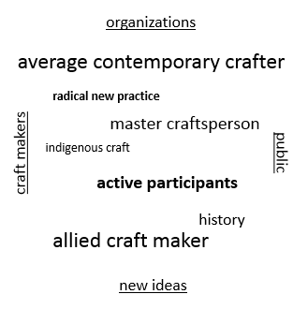

This diagram suggests, craft in Australia can be understood as operating in a framework bordered by four main elements. On one side are the craft makers and their needs, on the next side are the organizations which support the craft sector (e.g. ACDC group, galleries, guilds etc.), on the third is the public who consume craft experiences, and on the last side are the new ideas (e.g. creative industries, universities etc.).

Inside the box is a series of words describing different types of craft maker profiles; ‘average contemporary crafter’ (e.g. female, aged late 30s, makes jewelry), active participants (e.g. could be a guild member), ‘radical new practice’ (e.g. engaging with new technology), Master Craftsperson (e.g. ceramicist Owen Rye), ‘allied craftsperson’ (e.g. might make craft beer), Indigenous craft (e.g. Thancoupie). A further category is ‘historical craft maker’, to take into account the growing intergeneration knowledge transfer issue that is arising, as senior craft makers die. However specifically considered, the important concept is that the types of makers are sufficiently different to have quite different calls on the four ‘walls’ that surround them.

What they do have in common is that are all highly valued and contributing to the ongoing development of craft in Australia. This includes so-called historical craft, as Australia now has a canon of deceased craft makers who have contributed to current understanding of craft, and whose work needs preserving.

The situation is interpretable in many ways, and the lines of the box may be of different lengths and thicknesses for different people. The craft maker line could be a series of dashes of different lengths to denote different types of making, the organization line may have gaps in it and be uneven, the line representing the public is likely to be bulbous at different points, representing a wide range of stimuli, and the line representing the new ideas could be fine and illusive, or shiny!

Visualizing the Australian craft sector in this way demonstrates that there is little overall in the structure that is predictable, and that there is a need to make all the elements, as described, either more clearer or at least, better understood by a greater portion of the sector.

If elements of the framework were to disappear it would be a cause for alarm. At the moment the funded part of the organization line is static, and some new types of social enterprises are arising. The art museum section of the line is strong but perhaps could be longer, through more proactive collection. The public line is interesting, as it always stays connected to the craft maker line, as that is what the public mostly wants, and it tends to usually connect to the organizations line, however it gets attracted to those shiny new ideas.

Comment

Australian craft continues to excel in terms of the works produced. However, the unevenness of the structure represents the reality of ongoing change and uneven funding issues. It also strongly suggests that the sector needs to develop an awareness of itself through an inclusive policy development process, so as to further enrich its outstanding contribution to Australian society.

4.8 Impact of research to date

The following reports have had considerable effect on the Australian craft sector, some with unintended outcomes. The reports in themselves have affected the perceptions of how the sector perceives itself, and indeed, what comprises the sector:

- Felicity Abraham (ed) The Crafts In Australia: Report of the Committee of Enquiry into the Crafts Sydney 1975
- Report of the contemporary visual arts and craft inquiry (‘Myer Report’), 2001
- John Freeland Report, Australia Council, Sydney 2002
- Don't Give Up Your Day Job, Throsby, D. and Hollster, V., 2003
- National Craft Mapping Report, Craft Australia, Deves, J. and Vignando, C., Canberra 2006
- Visual Arts and Crafts Strategy Evaluation Report, Australia Council, Sydney 2010
- Powering Ideas, Craft Australia, Canberra 2010
- Tipping Point, Craft Australia & ACDC, Canberra 2011

In 1975 The Crafts in Australia: Report of the Committee of Enquiry into the Crafts (ed. Felicity Abrahams) set the scene and led to the establishment the Crafts Board Australia Council. Three years in the making, it was driven by a high powered committee that included James Mollison, then Director of the Australian National Gallery. Its brown handmade paper cover set the scene with impressive black and white pages of craft makers, or craftsmen as they were called, inside printed edge to edge. Its recommendations literally framed the grant programs of the inaugural Craft Board of the Australia Council.

The Report of the contemporary visual arts and craft inquiry (Myer Report), 2001 (‘Myer Report’) resulted in substantial new funds for the entire visual arts and craft sector, and ushered in an era of professional business planning for small to medium arts organizations. The impact of the Myer Report was very substantial; almost doubling grant funds, better management practices for organisations, and formalised co-funding arrangements with all State Governments, and one Territory.

In 2001 John Freeland took an overview of the craft sector based on a gap analysis of services offered by the organizations and then put forward a governance-style structure as a model for how the sector could perform. The report was commissioned by the Visual Arts Board with the aim of addressing structural issues within the craft sector, and resulted in the appointment of a Policy Officer who developed several funding frameworks for strategic initiatives including participation at international events, in what was an unclear outcome.

Throsby’s and Hollster’s 2003 Don’t Give Up Your Day Job continued their seminal work on artists incomes, and highlighted the plight of artists generally in terms of the issue of low incomes, opening up important reforms championed by the National Association of Visual Artists (e.g. taxation, resale rights etc.), which also contributed to the continuation of the Visual Arts and Crafts Strategy funding (which has since been rolled into Australia Council funding).

The 2006 Craft Australia report National Craft Mapping Report, Craft Australia, Deves, J. and Vignando, C., Canberra, analysed the services provided by craft organisations and anticipated the impact of websites and social media. Its methodology focused on a recruited set of craft practitioners who were selected by the craft organisations themselves. The intent was to understand the behaviours of these craft practitioners, and to encourage a better cross over with the services being offered by the funded key organisations. Even though the sample size was small and selected, the reports finding correctly predicted the significance of the new digital trend.

Tipping Point, a report co-authored by the funded craft organisations and Craft Australia was meant to be the sector’s contribution to the then pending review of the Myer Funding, which was due for renewal. Complex in structure it was an attempt to take on too many ideas in one small document, and consequently affected the reputation of Craft Australia. Its ambition was to showcase how the sector had embraced ‘design’, which it had, and then to argue for substantial new funding on the basis of the sector’s capacity to be innovative, and ultimately, to act as vehicle for the arts inclusion within Prime Minister’s Science Education Innovation Council (‘PMSEIC’).

In 2007 Catrina Vignando, gave a paper at the Smart Works conference, Power House Museum, on the role of craft and design as innovators, and its capacity to become an active component of the creative industries in Australia. The development of the creative industries as a concept had been championed by Queensland University of Technology, and has acted as a catalyst for engagement with creative industries agendas in Queensland and New South Wales, with outcomes associated with technology and intellectual property, with an emphasis on new economies operating at some distance from hand made crafts. In the UK craft was deleted from the list of official creative industries, which caused the craft sector much concern. Here the term is not so defined in terms of its components, and there may be a capacity for elements of the Australian craft sector to engage.

In Victoria the RMIT has conducted a sophisticated design debate, which is now evidenced by the built structure of the Design Hub – housing a range of courses and projects, notably the RMIT Industrial Design headed by Prof. Soumitri Varadarajan, and Interior Program and a Design Research Centre, with a planned materials library The now 15 year trajectory of the creative industries topic in Australia, has seen sufficient iterations that the craft sector could find a role in providing a public face to the research, as it has done in previous times, such as seen via its enthusiastic engagement with the digital environment.

A common feature of this research work, and one shared by this report, is the desire to understand the evolving role of craft makers in Australian society, and to analyze their issues and to put forward ways to ameliorate the issues. The fundamental problems of low incomes and the need for constructive relationships between craft organizations and their stakeholders have weathered on, whilst significant change has occurred in the arts landscape around the crafts.

Due to this history of research, there have been significant developments, particularly in how craft makers and organizations operate, but there remains a need for large scale strategies that engage the public, in a way that is artistically and financially sustainable.

The competition for cultural space that is constantly occurring in Australia is an arena in which contemporary craft is an active participant. An example of a substantial project that is arising in the craft and design sector is the establishment of an ethical ‘Code of Practice for Craft and Design’, which is being developed by Kevin Murray via the Sangram Project. In its first iteration the code is being discussed and informed by an Australia-India cooperative platform, which is seeing a wide variety of issues being brought to the fore, such as retail chain transparency. The ongoing work of ‘The Social Studio’, led by Grace McQuilton, in Collingwood, Melbourne, has established a new benchmark for achievement in this area, enabling African refugees to be trained in fashion production.

And across Australia new studios based on group capitalism concepts continue to come into existence, such as ‘NorthCity4’, in Brunswick, near Melbourne, which is focused on jewelry and has a public program strategy to help ensure its sustainability. This type of enterprise, and the other new iterations mentioned, continue a trajectory started in the 1970s in the first community arts period. The significance of these projects, apart from their obvious virtue, in that they place craft in a wider environment than either the studios of craft practitioners and indeed rival some of the funded craft organizations.

4.9 International craft policies

The diversity of views and directions expressed through the surveys and interviews suggests that an overarching craft policy for Australia would have great value, at least in helping to align disparate projects within broad themes, to enable new efficiencies to be identified. In this sense, such a policy would function as an atlas rather than a road map, and allow individuals and organizations to make their own journeys, and assist in identification of sector colleagues.

There is value in looking internationally at those few countries that have a declared craft policy to see different types of policy at work. These include Canada, United Kingdom, South Africa, Tonga and Sweden. The major events that occur in the United States such as SOFA Chicago would hint that that country would have a distinct policy, however, it is to the north of America in Canada that we see a consolidated policy statement, associated with the Canadian Craft Federation, which is funded by the Department of Canadian Heritage. Canada is a bi-lingual nation with competing notions of regional identity, and has a cultural dialogue that often focuses on preserving traditions and balancing rural and urban concerns. Tourism and crafts enjoy a positive relation there and compares with the United Kingdom, Scotland.

Craft Scotland as an organization has positioned itself as part of ‘brand Scotland’. Ancient skills such as basket weaving sit alongside experiences of single malt whisky and contemporary ceramics. The Government of Scotland has invested substantially in craft through a multi-million pound investment in the ‘V&A at Dundee’ project. When the Victoria & Albert at Dundee is completed it will be amongst the premier craft institutions worldwide, with an outstanding research and exhibition program. Something of its ilk could be developed in Australia and act as an international hub for the Asian-Pacific region, perhaps as a form of Australian Craft Museum.

Craft of an altogether different purpose, though that is arguable, was given much attention by the Government of South Africa, post-Apartheid. Craft was identified as one of six major cultural expressions and given entrepreneurial investment as part of a broad strategy to encourage democratic nation building. The report South African Craft Industry, talks early on about job creation and labor absorption. Lyndel Wischer notes that South Africa is one of very few countries to have craft policy as legislation.

Closer to Australia, in the Pacific, the nation of Tonga produced a seminal report in 2011 for the Tongan Government that had a different role, recognizing the twin issues of high unemployment and tourism potential, albeit within the context of the Kingdom of Tonga, which remains one of the few royal kingdoms in the Pacific area. Craft for Tongans is fundamental to their culture – tatau and tapa carry symbols which identify people, lineages and ceremonies across the hundreds of islands in the pacific. The report was used to reinforce the value of creative good quality craft for tourism and to support social cohesion.

Sifting through the nearby cultures of Japan, Korea, Indonesia and China would reveal similar uses of craft. Our Australian experience is continually being influenced by such craft cultures, as much as it ever was by the mythology now associated with the Scandinavian countries of post-war Europe. As we wrestle on a Saturday afternoon, with our newly acquired IKEA shelves, it is good to recall IKEA’s values as stated on the employment section of their website; ‘work hard, be yourself’. Each IKEA product is named for a village in Sweden. Is this the ultimate outcome of the English Arts & Craft Movement? Certainly the pilgrimages made by Australians to the Scandinavian countries in the 1960s embedded a refined taste in many an Australian house and allowed many local factories to imitate and prosper. Consequently Australia is a place that has a multi-layered and unique craft culture.
Skvensk Form, a design (and craft) policy supported by the Swedish government remains an influential example of a government endorsed policy and acts as a centerpiece for manufacturing support.

Craft in Europe has often been placed on arc from ‘rescue’ of tradition skills going back centuries, through to economic application – a summary of related policies is available via the Compendium of Cultural Policies and Trends in Europe.

But as is regularly observed, Australia is not part of Europe and has become more and more a part of Asia. We can influence Asia as much as it influences us, at least with regard to craft, by ceasing to think of it as the ‘other’.

Desk research Attachment U – a list of Key International Organisations – illustrates the many opportunities for international connections. The list of 48 organisations includes national craft councils, form-specific networks, such as the European Textile Network, foundations and museums.

4.10 Crafting a policy for Australia

A standalone policy for the crafts is unlikely to be developed by an Australian government in this era of widely based cultural policies. And policies put forward by sectorial must avoid looking like shopping lists. Alternatively, the potential power of the craft sector being able to describe itself is inestimable.

A process for developing a policy for Australia craft could be as follows; establish a policy steering committee via the NCI program and have it distribute an online form structured as below, the committee then presents a summary of responses and a draft for discussion at the pending NCI conference to be held in 2015. The policy would be discussed and adopted as ‘edition one’ with subsequent reviews into the future as required. The main aim of the first national craft policy for Australia would be state core beliefs, concerns and ambitions.

Questions and prompts for the online submissions could include:

- What do you see as the benefits of having a national craft policy?

- What areas of the crafts would you most like it to focus on?

- What ‘old’ ideas worked well (when & why)?

- What new ideas should work well (What & how costly)?

- What should the policies short term goals be?

- What should the long term goals be?

- Are there any particular relationships with non-craft areas that you would like it to address?

5. Key Issues

The Australian craft sector is being challenged by an extensive array of issues, as identified through the online surveys, interviews and desk research.

5.1 For craft makers the main issues to emerge were:

- Low incomes

- Too many people are entering the sector as emerging craft makers

- An over optimistic view of the likelihood of future success

- High possibility of disturbances in training opportunities due to changes in the TAFE and university environments.

- Cost of tertiary education

- Prevalence of making at home, which may lead to ‘de-professionalizing’

- Craft making, as seen by funding agencies, remaining too embedded in the pre-digital era

The nature of craft practice is not necessary changing but it is certainly diversifying. There are now many ways of crafting. A model of considering the range of contemporary craft making is as follows:

- Average contemporary crafter’ (e.g. female, aged late 30s, makes jewelry) (see Survey responses re Gender, Income, I expect my craft practice/business to grow in the next 5 years, What is your age?)

- Active participants (e.g. could be a guild member)

- Radical new practice’ (e.g. engaging with new technology)

- Master Craftsperson (e.g. ceramicist Owen Rye) (see Attachment re Exhibitions)

- Allied craftsperson’ (e.g. might make craft beer) (see Attachment re Commercial and Social Enterprises)

- Indigenous craft (e.g. Thancoupie)

- Historical craft (e.g. Marea Gazzard, deceased 2013)

Comment

Coincidently, in the above list of issues and framework for considering the types of craft makers there are some seven issues and seven types of craft maker, which means that the diversity in the craft maker sector in terms of the primary issue of sustainability is a complex matter to consider. A craft maker may change segments as his or her craft career evolves, when craft makers were more clearly aligned with media.

The essential finding is that it has become too difficult for external agents, such as funding agencies and craft organizations to focus on the needs of more than a small sample of the above. The assumption of the past that craft organizations for example should support a generic craft maker in his or her development has gone. Instead, craft making has become highly fluid, with days worked varying from one day per week to seven, and media distinctions blurring. The range of non-‘craft’ industry support – that is, opportunities for support for crafts practitioners that are outside the ACDC/Australia Council/guilds network has grown.

The orthodoxy that was established to support craft makers in the 1970s has been replaced by a new regime of many commercial opportunities, as noted in the Google map and Attachment re retail.

The entry point to becoming a craft maker has, however, remained associated with experiencing training opportunities, as noted in the rising interest in higher education. Given the spread of craft making over all age brackets, as noted in the survey question on age, people engage throughout their lives, and presumably seek training as required. The disjunction shown between the evident interest in future training from practitioners in our industry survey and the decline in publicly-funded post school educational opportunities indicates a future demand issue.

The social attitudes of crafts people have remained solid, in that most still consider themselves as part of a community, as noted in the survey, and many feel connected to new ideas, and would attend a national craft conference.

Finding

In summary, the position today is that it is necessary for crafts makers to generally manage their own careers by accessing a changing range of opportunities, as outlined in the Attachments, for grants and residences – and curate their own careers, and in all likelihood, utilize social media at some point to promote themselves and their craft work.

The needs that therefore need addressing are:

- Training in career management

- Training in business skills

- Accessing new ideas on craft

- Accessing advice regarding new opportunities

- Upgrading skills re curating one’s own craft work.

5.2 For craft organizations the main issues to emerge were:

- The crafts are making a highly significant contribution to Australian society, in a series of individualized ways, but the craft organizations are failing to deliver a national message regarding the value of craft

- The craft organizations are not operating on a similar template to each other and therefore do not combine to achieve major goals

- There is little evidence of craft organizations working together to develop projects

- The funded craft sector remains project orientated in its activities

- The funded craft sector has apparently developed in an uneven way over the past 40 years

- International pathways are being seen as important to some craft organizations

- Competition is deriving from private providers for services and training workshops

- Increasing competition from a large retail sector, which is affecting income streams

- Wage levels and senior staff fatigue are two issues which are significantly affecting craft organizations.

Different types of funded craft organizations

It is instructive to take three examples of affected craft organisations to gain an understanding of the current funding situation affecting craft organisations; TactileARTs (Darwin, Northern Territory), Craft, (Melbourne, Victoria) and the and (JamFactory, Adelaide, South Australia).

These three facilities range from small to large, are geographically separate and have different approaches to audience development, yet all have a similar commitment to contemporary craft makers.

TactileARTS is located in parkland adjacent to the Museum and Art Gallery of the Northern Territory. It was previously known as Craft Council of Northern Territory. It comprises a small gallery, generous workshop areas and a separate shop, across town in the foyer of the Northern Territory Parliament. Tactile Arts has a turnover of about $190,000 per year and receives as an operating grant of $50,000 from the Government of the Northern Territory, and the rest is earned income from sales and workshops. TactileARTSs occupies its site rent free and is assisted with its building costs. As is remarked in the interviews with Chairperson Sarah Body, the organisation is rebuilding from the base up, and does not currently receive Australia Council funding. Its membership base is developing anew and like many small arts organisations in Darwin, leverages off partnerships in the cultural sector to deliver a lively, relevant program. TactileARTS has about two to three staff, and a membership base of about 150 people.

Craft (i.e. Craft Victoria) is located in a converted warehouse space in Flinders Lane, Melbourne, where it contributes to the contemporary culture of the city. Its annual report outlines a healthy financial picture based on a turnover of $1.1m which includes Australia Council funding of $175,000 State government funding of $278,000, City of Melbourne funding of $25,000 and substantial earned income through its shop and public programs. Such income is offset by having to make its way in all matters, including rent, computer infrastructure and an equivalent full-time component of seven. Clearly Craft plays a complex policy game, satisfying three masters at three levels of government. It gains its sense of authority as an organisation due to its strong relationship to its membership base, which comprises over 500 craft makers.

The JamFactory is an impressive neo-industrial building near the centre of Adelaide, adjacent to a university. It has four major workshops (ceramics, furniture, and glass, metal), a large shop and generous exhibition galleries which meet modern museum standards. As a significant investment of the South Australian Government, it is also a destination in itself for many visitors and today is the leading contemporary craft organisation in Australia. A recent major initiative was the establishment of publicly accessible studios at Seppeltsfield in the wine growing Barossa Valley. The JamFactory has a turnover of $3.2m, with about $1m from State Government, c$200,000 from Australia Council and a substantial portion from sales and other special project funding.

Comment

One thing TactileARTS, Craft and JamFactory have in common is that there were all established bout 40 years ago, with a similar ethos, which continues today in terms of organisational culture. To visit any of these three craft organisations is to engage with staff who personally like craft, and your experience will be a connection with values of the craft movement.

They each directly engage with local makers, and have an audience mix comprising a ratio of new visitors to repeat visitors, determined in part by the characteristics of their respective physical locations. Stepping through the door will feel similar at each place.

What differs is their respective capacity to present craft projects, be they exhibitions, workshops of craft works for sale. They each have a ‘halo’ effect in terms of their extended influence. For TactileARTS the talks can be about Bali and attending workshops in Indonesia, accessing opportunities there. For Craft the conversation may be about other craft projects in the city and inner Melbourne. And for the JamFactory the dialogue may be about long economic value chains, as they create and distribute craft across Australia.

These three examples illustrate the impact of the diversity of funding arrangement for craft organisations in Australia, and of course, whilst these three represent ‘official’ organisations which receive funding, many craft organisations do not. The funding situation is historically derived and lacks a national policy framework within which participants might see themselves and their organisations.

A focus on survival skewers the possibility of widespread cooperation and macro planning across the sector, which has caused it to develop unevenly and with very limited cross-support between craft organisations.

Finding

The principle set of issues which are affecting the development of sector craft organisations are:

- The impact of shifting stakeholder needs

- The inevitability of the planning routes determined by the wide use of the same business planning template across Australia, as required by government funding agencies, which focuses on accentuating points of difference in the market

- The apparent lack of liaison at any significant level between organizations.

5.3 Issues with regard to relating to the public

- The high participation rates by the Australian public with regard to craft of 1.3 million children and 2 million adults each year, are not being reflected in attendances at funded craft organizations.

The non-craft making public are often experiencing craft as a form of content in magazines, and the online environment (which tends to lack an envelope of critical discourse). The online environment has to some extent ‘replaced’ actual visitation for many people in terms of how they consume craft

- The public’s engagement in craft experiences, such as through buying craft, has become more linked to the health of the broader economy

- There is a lack of major collecting institution focused on the crafts, which affects the public’s perception of the craft.

Comment

The public are of course free to enjoy craft in whatever way they wish, and this sense of democratic participation has led to a huge enlargement of the offer to the public of craft experiences. The number of markets around Australia is close to 100, and the amount of retail stores selling craft is approaching 300 across Australia. The public like the backstory to the objects they purchase, gaining value through that process in a similar way that brand names add value to the regular sopping experience.

These observation speak of the health of the sector on way level, but not on another. The lack of deeper meanings and history are not easily communicated in a market purchase or screen shot. The craft organizations have a continuing role to support new talents and honor great achievements, and therefore need to adopt the techniques of the wider public space for craft, if they are to retain their relevance as funded organizations.

The public is not going to change, and the craft sector has the ongoing issue of competing for financial resources in a crowded arts funding environment. When it does tap into manufacturing situations, as it may do with regard to furniture making, it succeeds in appreciable ways if all the conditions for demand analysis, investment, creative input, marketing and distribution are in place. The Maker to Manufacturer to Market scheme (‘MMM’) supported by the Australia Council from 2002 to 2007 was such a model. An updated version of this model may be for craft organizations to establish ‘Business Councils’ in much the same way that public art galleries establish foundations.

However, looking across the spectrum of craft makers as outlined earlier, the multiple types of makers have an equal, if not greater, range of publics, which has led to an increasingly niched market. And as such, this situation is counter intuitive to long term commitment at either end of the economic value chain.

Naturally some craft makers acquire an enduring reputation, whilst others may gradually falter, hence the importance of craft makers self-curating their practice and locating their information in an accessible place, such as a website or library.

The rising trend of social media usage across the community, includes the stakeholders in the craft sector. The message in this for the craft sector is to consider radically altering how it programs its activities so that it carries its messages in a spirit of reciprocity with the public’s interest. This process can be managed by increasing the frequency of low-cost, online surveys to evaluate the offer and mining the data that often sits inside organizations.

Finding

The primary issue with regard to how the craft sector is interfacing with the public is that the high participation rates of the public are not being matched by visitation at craft organizations, which is in turn affecting the sustainability of craft organizations, their political clout and the effectiveness of their relationships with craft makers.

To counter this trend craft organizations need to:
- Work together and develop sector wide marketing messages and communicate them in a coordinated way to targeted sections of the public

- Program external events such as markets or community projects as part of their remit

- Partner with community based organizations so as to widen stakeholder patterns

- Curate more substantial exhibitions and schedule them for longer periods, incorporating within them experiences for public participation

- Continually update their inline communication strategies.

5.4 Issues with regard to Indigenous craft

- Art and craft making has an especially important role in Indigenous society as a way of keeping culture strong and supporting community, however craft making sits at a lower price point

- Support for Indigenous arts centres can be irregular

- While the Indigenous art market is being supported by a group of well-organized commercial galleries, the Indigenous art market can lack resilience

- Significant support for Indigenous art and craft tends to be associated with major projects, such as the Telstra Art Award

- Distances within Australia remain a problem for reaching different markets, sourcing materials and engaging with opportunities, for both Indigenous and non-indigenous craft makers.

Comment

No discussion of Australian craft is complete with consideration of the role ad importance of Indigenous work. This importance is aesthetic, cultural and economic, as it is for all Australian craft makers.

There are several systems of support for Indigenous craft which are highly valuable to consider:

- The ‘ANKAAA’ (Association of Northern, Kimberly and Arnhem Aboriginal Artists) umbrella organization system of supporting and marketing remote art centres enables Indigenous craft to be made and retailed through accredited retailors, to tourists and collectors, in a highly creditable way.

- The ‘Koori Night Market’ in Melbourne’, which supported by local government, Arts Victoria and other agencies, is a model that supports the development of point-of-sale retail skills, which is a feature that the remote communities are less able to deliver.

- A third model is the large scale award-style project, such as the Telstra Art Award, which is juried and then awards a significant prize to an individual, along with other benefits to participants, such as catalogue documentation. The Telstra Art Award has a significant presence in the Australian cultural landscape and breaks new ground in terms of the general public’s perception of where Indigenous art is at, usually through mainstream media coverage.

- Another model is the curated traveling exhibition, which can have the advantage of taking Indigenous craft to new markets overseas and explore new modes of making craft.

- Permanent displays of Indigenous art in public art galleries are highly effective, as they tend to display the work in context, in a professional manner.

Findings

- The Indigenous arts and craft market has identified distribution and marketing systems that enhance its position

- Indigenous craft is sitting at a lower price point to visual art, and therefore can lack incentive in terms of production

- The strategies for supporting Indigenous art and craft incorporate protections in law

- Tourist work is identifiable so, due to the presence of projects and models which assert the higher quality Indigenous work

- The non-indigenous craft sector and Indigenous craft sector have much in common, and are in a position to share more skills in the areas of business skills and cultural knowledge.

6. Where should we be heading?

As an industry leader I can report that the last couple of years of my working life have been the most challenging of all, with a dramatic learning curve greeting every new direction. Exhilarating is how I would describe it! Project partners now include entities like the State Library and Telstra, and traditional monetary sponsorships have shifted to exciting new territories in the realm of shared creative projects.

It’s timely that we all come together to develop through the NCI new craft and design policies for Australia. One last thought – I was recently struck by the sheer beauty and humanity of a glass fish trap made by Jenni Kenmarre Martiniello, winner of this year’s Telstra prize; just such a beautifully realized vocabulary of what is possible through craft.

Steve Pozel, Director, Object, Sydney

The craft sector in Australia has within itself the capacities – intellectual, financial, organizational – to create a new future for itself in Australia. The following five priorities are designed to be implemented broadly in the sequence as indicated, with little new funding. It is suggested that the changes be advanced by the National Craft Initiative whilst being embraced by the sector.

PRIORITY ONE

To inform the development of the 2015 NCI event and its discussions.

Objectives
To have an effective National Craft Initiative event, where a wide variety of views, needs and imperatives are discussed.

Method
The development and structure of the conference should have the capacity to appeal to all elements of the craft sector, including craft makers, industry leaders and interested members of the public, with sessions streamed as follows:
- International craft makers including Australian Indigenous craft makers
- Showcase of outstanding new developments in Australia and Asia
- Discussions of issues
- Strategic development workshops to scope new projects that encompass more of the sector and embrace specified public audiences (including projects derived from this report’s recommendations)
- Scoping of over-the-horizon government industry policies, including in the creative industries space

Issues for consideration:
- Discussion on international engagement, particularly with Asia
- Discussion on new training models for craft making in Australia, that references academic, professional and community models
- Discussion on the development of a craft policy for Australia, with international input

PRIORITY TWO

Define the future work priorities of the National Craft Initiative organization

Methods
1. Establish an information portal for craft makers – use the google craft map and information as outlined in the Attachments to present real time information under the following headings:
- education opportunities
- workshops
- mentorships
- residencies
- grants.

NB: this service should be semi-automated and monetized, with data updated on the basis of online submissions and fees, so as to keep the portal market-based and sustainable.

2. Deliver outcomes with regard to the issue of intergeneration knowledge transfer, with a focus on establishing an online register of post graduate and doctoral research on all aspects of Australian craft.

NB: The ‘Craft Knowledge’ portal must be visually attractive and include utube clips to introduce topics, as well as standard library search systems for publications and archives.

Budget
Estimated cost is $3,000 for website upgrade and ongoing support for the NCI Manager role to 2018 (to be integrated into NAVA administration and governance as a further three contract post 2015).

PRIORITY THREE

Improve the ecology of the Australian craft sector

Objective
To have a craft sector in Australia that is able to use its resources in a more flexible and purposeful manner, so as to improve its ability to contribute to society.

Methods
1. Engage with Australia Council with regard to the business planning framework, so as to create the opportunity for joint ventures (‘JV’), and to reduce the fracturing and silo effects of the current system. The JVs could include other not-for-profit organizations, donated funds, government departments, or existing enterprises with a good track record.

Current Australia Council business plan model
Purpose
Executive Summary
Context
Goals and KPI’s
Strategies Matrix
Artistic Plan
Marketing Plan
Financial Plan
Management.

New model for consideration
Purpose
Executive Summary
Context
- Immediate
- Macro opportunities
- Resource inputs
- Joint venture arrangements
Goals and KPI’s
Strategies
Artistic Plan
Marketing Plan
Financial Plan
Management & Governance
Self-evaluation template, including management & governance performance

2. Change the name of the Australian Craft and Design Centers organization to ‘Australian Craft Association’ (or similar) and open the membership to all craft organizations that share a similar philosophy (as defined by the ACDC).

NB: For advice re legal framework see Australian Charities and Not For Profit Commission website

Budget
- No cost re Australian Council Business Plan change.
- Estimated $2,000 for establishing ‘Australian Craft Association’ plus basic logo and design work, to be funded by current ACDC member organizations as an expression of commitment (e.g. estimated contribution of $200 per organization each).

PRIORITY FOUR

Develop a sector-led craft policy for Australia

Objective
Establish a policy framework that reflects the Australian craft sector that allows for self-recognition within its framework, and gives guidance to the sector.

Method
Establish a Craft Policy Development steering committee that presents an interim report to the NCI conference, through a process of developing a template (e.g. purpose/s, principles, desired outcomes, updating methodology), seeking initial input to the template via an online form, discussion within committee, development of draft for circulation and feedback, report and potential adoption at NCI conference).

Budget
$10,000 for meetings and minor website work on NCI site, with costs met by NCI and NAVA.

PRIORITY FIVE

Encourage new modes of craft making through the active support of new innovative models and platforms for craft making, which have the ability to enhance the Australian craft sector.

Objective
Encourage the development and integration of new or existing craft organizations to the craft sector, that are directly engaged with encouraging new modes of craft making, that are measurable in terms of social and economic benefit.

Method
NCI Manager, in consultation with NCI Steering Committee, to directly broker an outcome on the basis of a limited call for expressions of interest basis.

Examples may include: The Social Studio, Etsy Hub concept (see Etsy interview) and the Sangram Project.

Budget
Estimate $20,000 as an NCI pilot project.

.

.

7. Recommendations

7.1 Recommendation

It is recommended that the forthcoming NCI conference seek to have a broad foot print in the Australian craft sector, so as to cross fertilize the sector, and re-establish the crafts (and its organizations) as a significant component of the Australian cultural landscape.

The email data base that has been established as part of the on line survey for this report should be utilized as part of a long-view pre-conference communications strategy to foster engagement in the conference. The conference location should be Adelaide as it offers good facilities, appropriate cultural immersion opportunities and reasonable access from all parts of Australia.

7.2 Recommendation

It is recommended that NCI start planning to establish an online portal by 1 June 2014 that offers highly relevant career enhancing information to Australian craft makers, and, that the portal has an easy to use ’Craft Knowledge’ section that acts as an online register of post-graduate and doctoral research on all aspects of Australian craft.

The data for such a portal has been assembled as part of the research for this report, and should be put in the public domain before it goes stale. The new NCI website would need to be modified to carry the data, and the NCI Manager would require administrative support for the implementation of the Craft Knowledge component, including moving image promotional material.

7.3 Recommendation

It is recommended that the NCI Steering Committee engage with the Australia Council to discuss and implement changes to the Business Planning template advocated by the Australia Council for the funding of cultural infrastructure, which has the capacity to introduce macro planning concepts into the sector, including joint ventures with cultural outcomes.

Either party could take the first step, however, it is suggested that a letter be forwarded by the NCI Steering Committee to the Australia Council by 1 March 2014, outlining the concept, so as to allow the matter to be considered by the Australia Council as part of its pending strategic review.

7.4 Recommendation

It is recommended that the NCI Steering Committee engage with Australian Craft and Design Centres to re-birth ACDC into an ‘Australian Craft Association’.

The initial step to take would be to convene a meeting of the ACDC, to discuss the concept, and to gain majority support from those present (and by proxy), to establish the new organization. The assets of the ACDC, which are minor, could be draw down over time to support the ACA. The next step would be to legally form the new organization, and then invite interested parties, such as guilds and association to join.

7.5 Recommendation

It is recommended that a policy be developed for supporting Australian craft, through a sector led process.

Establish a Craft Policy Development steering committee that present an interim report to the NCI conference, through a process of developing a template (e.g. purpose/s, principles, desired outcomes, updating methodology), seeking initial input to the template via an online form, then discussion within committee of submissions, followed by the development of a draft for circulation and feedback, then report and potential adoption at NCI conference.

7.6 Recommendation

It is recommended that the National Craft Initiative encourage new modes of craft making through the active support of innovative new models and platforms for craft making.

NCI Manager, in consultation with NCI Steering Committee, to directly broker an outcome on the basis of a limited call for expressions of interest basis.

Bibliography and Sources

Bibliography

Abrahams, Felicity (ed) The Crafts In Australia: Report of the Committee of Enquiry into the Crafts (the Crafts Enquiry) Crafts Board Australia Council, Sydney 1975

Anisef, Jen Craft on the Outskirts: Bringing regional Ontario creative communities into focus, OCAD University, Toronto, Commissioned by the Ontario Crafts Council 2012
http://craft.on.ca/userfiles/Craft%20on%20the%20Outskirts(1).pdf

Anisef, Jen Tracing Emerging Modes of Practice: Craft Sector Review, commissioned by the Ontario Craft Council 2010 http://www.arts.on.ca/AssetFactory.aspx?did=7095

Casswell, P. (ed) The Code of Practice for the Australian Visual Arts and Crafts Sector, National Association of Visual Artists, Sydney 2004

Craft In An Age of Change Report, Craft Council UK 2012 http://www.craftscouncil.org.uk/files/professional-development/Craft_in_an_Age_of_Change.pdf

Cochrane, Grace The Crafts Movement in Australia: a history, Kensington, N.S.W, New South Wales University Press, 1992

Cultural Mapping, Planning and Policy: Tonga By Seu‛ula Johansson Fua, Tu‛ilokamana Tuita, Siosiua Lotaki Kanongata‛a, and Koliniasi Fuko. Published by the Secretariat of the Pacific Community on behalf of the Ministry of Education, Women’s Affairs and Culture, Government of Tonga, Nuku’alofa, Tonga, 2011

Deves, Jenny and Vignando, Catrina National Craft Mapping Project – Service Provision for Professional Craft Artists and Designer Makers, Catrina Vignando, Craft Australia, Goanna Press, ACT, 2006

Jenke, Terri Visual Cultures: Protocols for producing Indigenous Australian visual arts and craft, Australia Council for the Arts, Sydney, 2002

Marmalade, annual publication by Jam Factory, Adelaide, first published 2013

Parkes, Brian Freestyle: new Australian design for living, Object, Sydney, NSW, 2006.

Pascoe, Joe Delinquent Angel – Australian, Aboriginal and Contemporary Ceramics, Muse della Ceramiche, Faenza, Italy, Centro Di 1995.

Pascoe, Joe Preliminary Statistical Analysis of Australia Council Craft/Visual Arts Funding 1980-2001, Visual Arts Board Policy Paper, Sydney, 2002.

Powering Ideas – an innovation agenda or the 21st Century, Department of Innovation, Introduction by Senator Kim Carr, ACT, 2010

Report of the Contemporary Visual Arts and Craft Inquiry 2002 (‘Myer Report’) Commonwealth of Australia

Talking Points – A Snapshot of Contemporary Visual Arts 2013, Phip Murray, Australia Council for the Arts 2013.

Throsby, David and Hollster, Virginia Don’t Give Up Your Day Job – an economic study of professional artists in Australia, Australia Council 2003 http://www.australiacouncil.gov.au/__data/assets/pdf_file/0007/32497/entire_document.pdf

Government of South Africa, The South African Craft Industry Report, Department of the Arts, Culture, Science and Technology 1998

Visual Arts and Craft Strategy, Evaluation Report, Introduction by Ted Snell, Australia Council 2010

Wischer, Lyndel National craft policy in Australia – a case for the future, Research paper, Advanced Arts Policy AMGT 90011, Melbourne University 2013

Sources

ANKAAA – Association of Northern, Kimberly and Arnhem Aboriginal Artists website; http://www.ankaaa.org.au/

Australian Charities and Not For Profit Commission
http://www.acnc.gov.au/ACNC/Home/ACNC/Default.aspx?hkey=3e39ac62-4f04-44fe-b569-143ca445c6bf

Australia Council and Australian Bureau of Statistics
http://artfacts.australiacouncil.gov.au/creative-participation
http://artfacts.australiacouncil.gov.au/visual-arts-participation

Australia Council Business Plan framework
http://www.australiacouncil.gov.au/resources/reports_and_publications/subjects/management/national_business_plan_framework_for_arts_organisations

Australian Guilds, societies and associations website
http://basement.craftaustralia.org.au/organisations/

Australian visual and craft organisations website
https://www.visualarts.net.au/directory/visualartsandcraftsectororganisations

Canadian Craft Federation website; http://canadiancraftsfederation.typepad.com/
Craft Australia defunded; http://www.craftaustralia.org.au/library/presidentsreport.php?id=2011-11-08 2011

Craft Victoria website http://www.craft.org.au/
- See; http://www.craft.org.au/see/
- Learn; http://www.craft.org.au/learn/
- Craft Culture; http://www.craft.org.au/learn/craft-culture/

Craft - Where is it? Culture Victoria, Arts Victoria website; http://www.cv.vic.gov.au/stories/craft-where-is- it/

Cochrane, Grace Smart Works: Design and the Handmade, Power House Museum 2007 http://www.powerhousemuseum.com/smartworks/exhibition.php

Danish Handcraft Museum website; http://en.wikipedia.org/wiki/Danish_Museum_of_Art_%26_Design

Design Institute of Australia website http://www.dia.org.au/index.cfm?id=82

IKEA; http://www.ikea.com/ms/en_US/jobs/join_us/ikea_values/#

Koori Night Markets
http://www.koorienightmarket.com.au/

material An exhibition curated by Joe Pascoe for Craft Cubed HYBRID 2011, with works by Roseanne Bartley, Emma Davies, Penny Malone, Scott Mitchell and Adele Varcoe; http://www.craft.org.au/Learn/Craft_Culture/material-essay/

Murray, Kevin website; http://kevinmurray.com.au/

National Arts Council of South Africa website; http://www.nac.org.za/

NorthCity4; http://northcity4.com/

The Social Studio, Collingwood, Melbourne; http://www.thesocialstudio.org/

Varadarajan, Soumitri website https://plus.google.com/107109956810388052985/about

Visual Arts Sector Plan, Australia Council 2011-2013 http://www.australiacouncil.gov.au/__data/assets/pdf_file/0010/130978/Visual-Arts-Sector-Plan-2012-13-WEBSITE.pdf

8. Attachments

A. Key Craft Collections in Australia
B. Interviews – Industry Leaders
C. Interviews – Sector Experts
D. Online Survey Results
E. Online Survey Results – Additional Tables
F. Australian Craft Organisations
G. Examples of Success and Decline in Australian Craft
H. Regulations and Management
I. Examples of Craft Policies
J. Craft and the Creative Industries
K - Sample Survey of TAFE and RTO Craft Courses
L: Current Higher Education Provisions For Craft
N: Publications
O – Retail Outlets
P – Commercial and Social Enterprises
Q – Scholarships, Awards and Prizes
R – Private Sector/Trusts
S – Grants
T – Residencies and Exchange
U – Key International Organisations
V – Markets and Fairs
W – Forms of Support Offered by Public, and Peak Bodies and Other Government Departments
X – Skills Development Opportunities in the Creative Industries
Z – Methodology

Attachment A. Key Craft Collections in Australia

Across Australia there are numerous craft collections. In larger public museums they tend to be housed within the context of decorative arts collections, reflecting our colonial heritage, and amongst smaller or regional galleries, they tend to have higher profile as collections of craft. An example of the former is the National Gallery of Victoria with its large holdings of Australian art, and an example of a regional gallery with a craft related collection is Shepparton Art Gallery, which houses Australia’s foremost ceramics collection.

A detailed study of craft collections, in their various guises, in Victoria, was sponsored in 2011 by Arts Victoria and Craft; Craft - Where is it? Culture Victoria, Arts Victoria; http://www.cv.vic.gov.au/stories/craft-where-is- it/

The following list of craft collections covers the main public institutions. In Australia there are also major craft collections in private ownership. Such collections are extremely valuable and would benefit from the establishment of an Australian Craft Museum.

Ararat Art Gallery | Vic | Fibre and paper
Art Gallery of Ballarat | Vic | Historic and contemporary
Art Gallery of South Australia | SA | European Decorative Arts and Australian craft
Art Gallery of Western Australia | WA | Australian craft
Artspace Mackay | Qld | Artists books
Bendigo Art Gallery | Vic | European Decorative Arts and Australian craft
Canberra Museum and Gallery | ACT | Australian craft
Castlemaine Art Gallery and Museum | Vic | Australian ceramics
Deakin University Art Gallery | Vic | Australian craft
Design Archives RMIT | Vic | Design
Design Tasmania | Tas | Australian furniture
Geelong Art Gallery | Vic | European Decorative Arts and Australian craft
Gold Coast City Art Gallery | Qld | Australian ceramics
Griffith Regional Art Gallery | NSW | Contemporary jewelry
Hamilton Art Gallery | Vic | European and Australian Decorative Arts
Koori Heritage Trust | Vic | Australian Indigenous craft
La Trobe University Art Gallery | Vic | Australian craft
LaTrobe Valley Arts Centre | Vic | Contemporary craft
Macquarie Lake Art Gallery | NSW | Australian craft including Indigenous
Manly Art Gallery | NSW | Australian ceramics
Manningham City Gallery | Vic | Australian ceramics
Maroondah City Council Art Collection | Vic | Australian ceramics
Museum & Art Gallery of Northern Territory | NT | Australian Indigenous craft
Museum of Old and New Art | Tas | Ancient and Pan-Pacific craft
National Gallery Australia | ACT | Australian craft
National Gallery of Victoria | Vic | European Decorative Arts and Australian craft
Newcastle Regional Art Gallery | NSW | Australian ceramics and silver
Powerhouse Museum | NSW | Australian craft and design
Queen Victoria Museum and Art Gallery | Tas | European decorative arts and Australian craft
Queensland Art Gallery | Qld | European Decorative Arts and Australian craft
Rockhampton Art Gallery | Qld | Australian ceramics
Shepparton Art Gallery | Vic | Australian ceramics
Sturt Craft Centre | NSW | Australian craft
Tamworth City Art Gallery | NSW | Textiles
Tasmanian Museum and Art Gallery | Tas | European decorative arts and Australian craft
Wagga Wagga Art Gallery | NSW | Contemporary glass
Wangaratta Art Gallery | Vic | Textiles

Attachment B. Interviews – Industry Leaders

As part of the research methodology, interviews were conducted with the following industry leaders:

- Avi Amesbury; Executive Director, Craft ACT, Canberra
- Mark Bergin; Creative Director Design100, Melbourne
- Sarah Body; Chair of Tactile Arts, Darwin
- Jess Booth; Researcher, Aboriginal and Torre Strait Island Art Economics Project, Melbourne
- Lisa Cahill; Executive director, Australian Design Alliance, Sydney
- Pippa Dickson and Rye Dunsmuir; Chair and Director of the Tasmanian Design Centre
- Lynda Dorrington; Executive director, FORM, Western Australia
- Geelong Handweavers and Spinners Guild Inc. Kate Williams, Victoria
- Liana Heath; CEO Artisan, Queensland
- Ann Jakle; Director, Glassworks, Canberra
- Rebecca Jobson; Acting CEO and Business Development Manager, Craft Victoria
- Anna Maas; Director, Skepsi Gallery, Melbourne
- Rae O’Connell; Executive Director, Guildhouse, Adelaide
- Brian Parkes; CEO & Artistic Director, JamFactory, Adelaide
- Steve Pozel; Director, Object, Sydney
- Robert Reason; Curator of European and Australian Decorative Arts, Art Gallery of South Australia
- Jane Scott; CEO & Artistic Director, Craft Victoria
- Jen Standish-White; Executive Officer, Central Craft, Alice Springs
- Antonia Syme; Director, Australian Tapestry Workshop, Melbourne
- Dr Mark Viner; Head of Sturt Craft Centre, Mittagong
- Kerri White; Strategic Planning Coordinator, Tactile Arts, Darwin

Avi Amesbury
Executive Director, Craft ACT: Craft & Design Centre
I see international support as a significant issue for craftspeople, that is it is not supported sufficiently. In the Australian Council funding guidelines there are no strong programs supporting international activities for Australian craftspeople, apart from participation in art fairs, which tends to place craft into a singular niche market.

Craft makers need sustainable pathways, so that the whole sector develops more rigor and becomes sustainable in itself. The gap, and I suspect it applies more generally to micro-businesses everywhere, is the lack of government support for small business in comparison to big business. A near perfect situation recently was the awarding of five $10,000 grants for craftspeople to create memorabilia for Canberra’s centenary – but unfortunately such opportunities are very rare. As a model it had everything and has given those makers a clear pathway in their professional practice. An associated problem is that much arts funding is non-business in its orientation, and of course business funding is not art funding .The challenge is to encourage craftspeople to get the next level.

Craft ACT has a special issue when it comes to salaries. With so many national cultural institutions in Canberra, our salaries at Craft ACT are non-competitive - too far below the public service levels- and the history is that many excellent arts administrators and creative who have worked here leave for higher salaries, going onto the National Gallery of Australia or Museum of Australia or elsewhere in Canberra. This has a serious impact on the organization. The upside is that we have terrific relationships with all those institutions and often partner with them – last year I counted up 33 such partnerships! These can include very interesting ones like CSIRO.

We are operating in a two level environment – local and national – most of the time, but on a very thin resource base. Craft ACT often acts as a stimulant is such arrangements, brokering cross-disciplinary projects and platforms. We have enormous potential to deliver international programs, yet feel somewhat frustrated for the lack of financial and policy support. The smallness of the ACT also impacts on our ability to grow. Infrastructure upgrades like exhibition lighting, IT upgrades and website re-development are some of the inevitable consequences of this situation.

As Director of Craft ACT I have felt and continue to feel very privileged to have had the opportunity to bring so many wonderful projects to fruition. There is enormous potential in Canberra and I am optimistic for Craft ACT to become nationally recognized as a centre of excellence for craft and design. My vision is that we deliver international projects, and use the embassies here as a gateway to the world. I would also like us to have a street level frontage.

I admire many of my colleagues, especially Lynda Dorrington from FORM in WA. As a West Australian myself I can doubly appreciate what she has achieved. As an individual I feel the need to be supported by funding bodies, particularly because a sector like ours relies on strong individuals for it to prosper. I would like opportunities for more dialogue around basic questions without the barriers that can arise from highly structured funding categories.

The special thing that has happened in Canberra in the past few years is more and more emerging makers and craft practitioners are staying in Canberra, rather than heading off to Sydney or Melbourne. This is having an excellent effect on the local scene. A special mention should be made of Robert Bell, Senior Curator of Craft at National Gallery of Australia. He meets virtually every maker who exhibits here and thus models the extraordinary thing about Canberra being a place that is local, national and international all at the same time.

Mark Bergin
Creative Director, Design 100, 1/11/2013
I sought to establish the Australian Design Awards in 2013 after scoping the craft awards around Australia, and concluding that there wasn’t anything that approached the type of systems that was becoming the norm in the design sector, in terms of award platforms. I appreciate there are about ten prestigious awards in the mainstream craft sector which recognize excellence – City of Clarence (furniture), Hobart Art Prize, Shepparton Art Gallery (ceramics), Tamworth City Art Gallery (textiles) etc. – but there was nothing that was especially designed to act as a stimulant for ‘market ready’ craft based on the ‘accelerate’ ideas used in the commercial design sector.

After our first iteration of the Australian Craft Awards I admit I have learnt much! The interesting thing for me, after running literally hundreds of award programs since 1996 is that the crafts have an important point of difference. The difference is in the focus on the one-of object and a gradualist approach to market development. This comes out of the philosophy of the crafts and of course accounts for its special characteristics. The award platforms Design 100 has in place are incredibly efficient platforms and I can see how to converge the opportunities that environment has, with the develops that appear to be happening in the craft sector.

Our methodologies around jurying work, and around the application processes are good – what needs finessing is the approach to the ‘content’. For 2014 Design 100 will pilot a system where craft makers can enter a so-called commercial stream or a cultural stream for want of a better word.

Those makers who are more into product as multiples, with its various sub-categories, will presumably elect for the commercial stream. And those craft makers who are making one of craftworks will be encouraged into the cultural stream entry point.

I am also mindful of the important need to further nationalize the awards and will be moving away from state-based awards. This will truly mean that Design 100 will be able to announce an outright set of Australian winners. Why do this? The principal reason I sto creat genuine public interest, for both types of work.

As we move ahead I find myself becoming more and more engaged with identifying the various areas of potential in the craft sector. Design 100 now has awards operating for a wide variety of projects in Sydney, Melbourne, New York and London. Our ditaal imprint is becoming huge, and the areas in which we function each change a little each year. Certainly I find myself changing, and in doing so uncover new markets, and it is this opportunity that I am seeking to bring to the craft sector.

Sarah Body
Chair, Tactile Arts, Darwin and a forum of members, 3/6/2013
The cost of crafting in Darwin actually makes it a hobby. That is the cost of materials and the limitations of the market make it difficult to become a professional craftsperson in terms of making a living. Most of us make craft out of passion and to engage with the community. It’s like a ‘paying hobby’ with funds we make often going back into workshops or the occasional conference. The more commercially successful of us would be making about $20,000.

There are lots of opportunities outside Darwin and individual makers retail down south in Adelaide or in Canberra at the glassworks for example. It really is the joy of making, with the income a bonus. We do quite well at local festivals including our own markets. Most of the tutoring contracts at Tactile Arts are short term and we need to be multi-skilled sometimes. There are opportunities in Alice Springs, though we find the government grants for projects require too much paperwork. Fortunately Darwin has a cohesive arts environment - there is a need for more residencies in Darwin to ensure traditional skills survive as the population is too small.

In recent times Charles Darwin University has greatly reduced its facilities in Darwin though there some facilities in Alice Springs. At Tactile Arts we align craft with printmaking in a broad approach to craft. The future looks limited for tertiary craft courses as the new VET syllabuses tend to have more conceptual aims and less emphasis on skill development. Other parts of the Northern Territory have new initiatives, such as at Katherine with its regional arts program. Our own new re-branding (from NT Craft to Tactile Arts) is working as it is driven by a strategic plan developed during 2012.

In looking ahead five years it is likely that the university courses for craft will have dried up yet the public will be more interested in craft. Tactile Arts is building a new website and is looking to link with youth and young people, as well continue to interface with Indigenous opportunities. In Darwin a certain osmosis occurs at institutional level. Group marketing is probably the way to go as it recognizes the changing needs of a partiality transient population. The syndrome of ‘trailing spouses’ means that well educated people sometimes seek craft experiences. Likewise the ‘grey market’ is another distinctive craft market in the Northern Territory.

Our new philosophy is to see art as being about connectedness and to use Tactile Arts as a networking center that is open to the whole Darwin community. We can make this physical space a bit more attractive and reach the community in a strategic way. The staff and board are both very hands on, and together we have the feeling of working on something new!

Jess Booth
Researcher, Aboriginal and Torres Strait Islander Art Economies Project, 19/9/2013
I’ve been completing research on buyer behavior in the primary market for Indigenous art for nearly two years, as part of the Aboriginal and Torres Strait Islander Art Economies Project, which is coordinated and funded through the Co-operative Research Centre for Remote Economic Participation (Ninti One), Alice Springs. My project is one of a suite of very interesting projects which seek to contribute to a more resilient Aboriginal art sector. Generally my research has focused on the visual arts, though ‘art’ and ‘craft’ definitions are fluid and craft is certainly part of the markets I have studied.

To date I have surveyed some 900 people and have conducted interviews with a small sample of art buyers and sellers. Some broad observations are that the vast majority of people purchase Indigenous art for its aesthetic appeal, but there are a range of secondary criteria that vary between buyers and are often dependent upon a buyer’s knowledge of both the art and the market in which it is sold. There needs to be an emphasis on consumer education to support informed purchase choices.

Despite prevailing hierarchies which mean that craft products still often have lower price points than artworks of similar or even lesser quality, there is considerable creditability in the Indigenous craft scene as it is less prone to the over-supply issues that have affected sections of the visual arts market. However, buyer resistance can still be a factor, with purchasers displaying a reluctance to pay $300 for a basket. Again, once buyers are educated about the lengthy and complex process of collecting and preparing fibres to create these objects they are often completely converted!

In comparing craft practitioners to visual artists, its mostly true to say that the paradigm of emerging and established makers is not prevalent in Indigenous craft, whereas it has a definite place in the structure of the Indigenous visual arts market. There are a surprisingly low number of retail outlets for Indigenous craft in Melbourne and Sydney, whilst Darwin has excellent galleries such as Nomad Art.

The relationship between many craft objects and cultural maintenance is strong and clear, as it is exemplified by the process of collecting fibres ‘on country’ to create baskets. There is a regional specificity to much Indigenous craft work due to cultural practices and the materials available, for example, grasses from the centre, carvings from the Tiwi Islands and woven pandanus from Arnhem Land. Craft objects that have their origins in ceremony are still made, such as baskets for ceremonies in Arnhem Land.

There is scope for increased focus on craft sector development, particularly in light of its natural affinities with design, which is another growing area for Indigenous artists. By design I’m referring both to the use of reproductive technologies to create fabrics and other decorative elements, as well as new art forms commissioned by third parties (home furnishings, architectural design, etc). Occasionally still an area of contention due to past copyright abuses of Indigenous designs, there are many successful examples of collaboration. For example, Elcho Island Arts and interior design firm Koskela, who have together produced some beautiful lampshades and are paving the way for future design thinking in this area.

The prevailing issues, at least with respect to remote area artists, are to do with distance, inequities arising from language barriers and the funding support of sensitive infrastructure that can interface with Indigenous communities across Australia. The well-known Indigenous support organisations ANKAAA and Desart do an important job in supporting and promoting remote community art centres. Mentoring in all its forms is a key element, as the significance of relationships is especially potent in the Indigenous arena.

Lisa Cahill
Executive Director, Australian Design Alliance, 9/9/2013
The Australian Design Alliance (AdA) was formed in 2010 to promote the use of design to boost productivity, sustainability and innovation in Australia. Our key focus is to advocate and work with government for a national policy for design. The challenge is that, while we have excellent designers in all of the design professions here in Australia, design is not recognised as part of our cultural fabric as it is in many other countries that promote and champion design and designers.

The ACDC network is one of 13 members of the AdA.

The AdA is participating in the Australian Design Integration Network and the innovation industry precincts both of which are at an early stage of development but we would hope to see that work continued by the new federal government. At the state level we have seen pilot design integration in business programs that have demonstrated the value to the business bottom line of a design led approach. At the federal level, Enterprise Connect has also been working on design integration programs.

When we think of design here in Australia we tend to think in terms of interiors, objects and perhaps buildings rather than the much broader application of design and design thinking as creative processes for finding solutions to issues across all aspects of policy and service delivery. That is not to say that ‘things’ are not important, they are immensely important to our cultural fabric, our quality of life and our aesthetic appreciation of our environments, but it is important to realise that we can also tackle, for example, hospital emergency procedures, aged care services, immigration policy using a design approach.

While craft practitioners use design processes and designers are often skilled makers in their own right, I don't think that craft and design are the same thing. Politicians are notorious for thinking that design is about pure aesthetics and not understanding value adding productive activity across a range of professions and design as a process that can provide an alternative way of addressing a problem. That is the message the Australian Design Alliance is seeking to get across.

I think in Australia we are beginning to value our artists but see craft as a hobby activity rather than a professional skill so we need to identify and promote craft practitioners of excellence. At the same time need to acknowledge the pleasure, skill and learning that all of us can gain from craft as a hobby.

With a different hat on, I recently curated an exhibition with Steve Pozel of Australian Indigenous craft and design as part of a four-country program for the 2nd International Triennale of Craft at the 21st Century Museum of Contemporary Art in Kanazawa, Japan. We showcased some extraordinary work, such as that of Tasmanian shell worker Lola Greeno, a skill that is passed on from mothers to daughters and is in danger of being lost like so many traditional crafts. On the other hand, collaborations, like those of design company Koskela with the Tjanpi Desert Weavers and Elcho Island weavers translating traditional weaving into products for contemporary interiors is a wonderful showcase for traditional craft and design application.

The National Craft Initiative provides a platform to understand the issues that are important to the craft sector and develop a plan to resource and advocate for craft practice. As a national membership based organisation, NAVA is well placed to advocate on behalf of craft practitioners. We should ensure that this NCI process is used to strengthen the voices and ensure that there is leadership in the sector so that the voice is unified and has a better chance of being heard.

NAVA and the ACDC network of craft and design galleries are members of the AdA.

The main challenge for the AdA is to work with our member organisations and the design community to demonstrate the economic, social and cultural value of design so that we are able to grow a greater recognition, appreciation and profile both here and internationally.

On a personal note, as an avid devotee of Australian design and a maker of craft, I think it is important to explore the importance of craft in the community. Children from a very early age are introduced to craft and learn many different techniques which they then use to make sense of their environments, to express their ideas and as part of learning across the curriculum. Craft has been a community forming activity throughout our history and continues today – seen in the Country Womens Association shops in country towns all across Australia to a great recent example, the 5000 poppies project crafting poppies to commemorate the centenary of the ANZACs at Gallipoli http://5000poppies.wordpress.com/about/. Craft is strong in community cultural development activities and in community activism or craftivism: Magda Sayeg being a great example http://www.magdasayeg.com/home.php and Australian Sayaraphim Lothian http://www.craftymag.com/item/256-sayraphim-lothian.

Pippa Dickson and Rye Dunsmuir
Chair, Design Tasmania and Director, Design Tasmania, 29/8/2013
At Design Tasmania we find we are working more with an older age group of experienced craftspeople, who have the skills to make significant works for the market. The centre sells into Melbourne and Sydney as much as locally, which is due to the reputation of Tasmanian craft, particularly with regard to wood and furniture. People are attracted to the work because of the reputation of the timbers themselves as well as the great skill that the craftsmen exhibit.

Our model is under pressure though as the new forms of popular craft do not have the same skill base, plus there is a gradual demise in the mentorship system which had allowed craftspeople to acquire their exceptional skills. Tasmania still has an outstanding university art school system, located in both Hobart and Launceston, and strengthening in Launceston, but there is a growing financial pressure that impacts on the provision of the practical aspects of courses. Launcestion is gradually building its identity as a design destination – it helps to be thought of as a natural destination for fine furniture and design education.

It is critical to ensure that we have a strong ‘every day’ culture in craft and design but we are thinking that Tasmania would also benefit from having a signature event for the craft and design sector, which could be coordinated by Design Tasmania. It could embrace a number of commercially progressive design-aligned businesses and have as its central idea the idea of the forest. There is a need to successfully link supply and demand to help create sustainable livelihoods for makers, and a major event could work as a framework.

A widespread event with many access points would be a way of enlarging the market inspiring connectivity and potential social and economic returns. People need to see that they can and do have design and creativity more broadly as a normal part of their lives. The strategy is all about widening the public’s understanding of what design is – such an event could tie in timber mills, veneer workshops, fabricators and craft and design professionals, and be supported by Tourism and communications industries and potentially businesses not traditionally aligned to the timber and forests to provide a broad experience of design.

It is by joining together that Tasmanians have been able to survive, even with a small population and a limited economy. The advent of MONA has had a big impact in Tasmania helping everyday people appreciate the role of culture in society as well as the economy. Developing a high quality signature event that has appeal globally is something that that we think Design Tasmania can do through forming a steering committee and shaping some major ideas into a business plan. Otherwise it’s possibly a situation of diminishing support via the education and government funding systems and the all too ‘easy’ side of popular craft affecting the reputation of Tasmania’s craft and design achievements.

Tasmania is almost unique in Australia for having such a strong tradition of contemporary practice that is supported by a living oral and practical culture. Our designers and craftmakers benefit from their environment and have a rare capacity to make outstanding work. It’s our aim to share this experience to create a more sustainable future.

Lynda Dorrington
Executive Director FORM, 12/8/2013
I would say the main issue for craft practitioners, and here I reference Western Australia, is that the severe lack of studio facilities which impacts on training and entry into the market. It is evident that the changes in academia and the associated investment in teaching resources for crafts, such as kilns and other substantial equipment has significantly declined. It’s probably a trend that is hard to reverse, because without high quality equipment enrollments are likely to continue to fall. The situation has become serious here in the west.

The flow on impact is that craft courses are gradually disappearing, and with that, knowledge lost in terms of actual teaching. Craft is essentially a socially based activity and craftspeople, like other professions, benefit from exposure to other craftspeople. I would go a step further and say that craftspeople need public interaction. I am also concerned that this is happening in non-university environments and that there are not many other places where craft practitioners can go to learn. For me this heightens the importance of facilities such as the Jam Factory in Adelaide, which is an important model of successful government investment in the craft and design sector.

In this sense the increasing popularity of social and online media as conduits for artistic community building and interaction makes sense. It seems a logical progression given the demise in traditional teaching and learning facilities, which have also traditionally served as hubs for artistic communities. The pros for online communities are obvious – easier national and international connections and discussions, expanded market and profile opportunities. For a vast and geographically isolated state such as Western Australia, the opportunities for online engagement seem immense. However certain challenges remain unaddressed even with a fuller engagement with the online and digital world, for artists, and anyone working in the realm of tangible, sensory objects, still require some face-to-face interactions for purposes such as critical review of works or processes, sharing and learning specific skills and techniques, and meaningful relationship-building. Being so isolated from the majority of the nation and the ‘Western World’ presents both challenges and opportunities for Western Australia. Practitioners based here may have a sense of freedom in which to explore and create new trends, but the isolation can also result in conservative local networks and limited patterns of thought and process that would benefit from more interaction with a revolving palette of fresh minds and talent. In our programming we always try to address this through international residencies – visiting creative, mentors and entrepreneurial thinkers – but our geographic location and lack of competition in local services such as flights and accommodation means costs for bringing in talent tend to be very high. On the other hand, our proximity to Asia and our many remote and urban Indigenous communities reveals much unexplored potential in terms of modern applications of fine craft and creative skills honed through traditional cultures over millennia.

What is interesting from a broader cultural perspective is the dichotomy between online, virtual , mass communication experiences and a growing desire for something that can be tangibly held, touched and traced back to what is inherently human – interaction, culture, individualism, socialism. Where once this experience was most overtly found in traditional craft – through the knowledge that something was completely handmade in a distinctly local context – now we can see this begin to manifest in small or medium batch productions or even in the conception and design of works rather than the (hand) crafting of the final object. The individuality of the artist and their socio-cultural context is not lost, but rather, emphasised at different points in the process, or the creative narrative. Our Land.Mark.Art program is an example of this – predominantly Indigenous artists are mentored through a process that enables their existing artistic capacity (for example painting or small-scale object making) to be evolved and applied to creative opportunities in the fields of architectural design or public art, which then opens up more opportunities to participate in the economy via commissions and percent for art tenders. The process of this program is imbedded firmly in the journey and learning opportunities of the artists as they remain actively involved in every part of the process. This means the outcomes remain honest to the ideas and hand, or techniques, of the artists, and to their cultural heritage.

I believe there is a strong need for a national marketing campaign to promote the crafts. In particular I suggest that such a campaign needs two foci; messages about ‘why to buy’, and sub-messages that communicate the significance of material culture in our society. The why to buy message has the advantage of helping to encourage a new generation of collectors, and the emphasis on material culture should appeal to the public on a number of levels. It will also help establish a more sophisticated basis for international exposure, either through brand alignment with national icons like Qantas or through our international network of embassies (both Australian embassies overseas or international embassies located in Australia).

Investment in this scenario would require significant Government input, as much of the sector’s infrastructure is dated. Also to make this work we would need to collect and understand the available data that would arise regarding markets and opportunities – it would require a major push in terms of planning, commitment and resourcing. It would be best positioned as a national campaign so as to cover the range of great craft that is being created across Australia.

Some of our ways of thinking about creative people need to be updated. For example I sometimes consider that the terms ’emerging’ and ‘established’ are default terms for thinking about how artists develop that do not reflect the new realities. I am convinced that the lifecycle of a digital artist, and many craftspeople are also digital artists in some way, cannot be adequately understood in terms of emerging and established. It is almost counter intuitive to use the term ‘established digital artist’ for example – certainly a misnomer in view of the continuing role of radical innovation. Any skilled or innovative artist is always in this sense ‘emerging’ – testing new methodologies and ideas, exploring, pushing

The use of terms is very important because they can stay embedded in funding categories and unintentionally slow things down. An artist might come to FORM for example with a great idea but it can be very difficult to gain financial support if the project doesn’t fit well with an existing way of doing business. The situation can self-perpetuate too.

FORM has developed because it has responded to the market and created new questions about what is creativity and what is changing in terms of the role of crafts. We have often put the case to funding agencies that the new creatives are reaching major audiences, and I think we have now successfully made the case a few times. If we in the industry all continue to evolve our understanding of the arts then the public will be grateful too, as they are often open in terms of what constitutes creativity – they see and experience it in a wide variety of formats from film making to electronic gaming, as well as through lifestyle choices.

Many new projects are developed by highly creative people, who will come to an organization like FORM with a great idea. What’s important in all of this is the impact on the public. All our projects at FORM have very public outcomes in areas as diverse as social housing, Indigenous heritage, public art, new thinking, and so on. This public impact of creative processes is where the sector can really demonstrate the value of craft in contemporary society. For while those in the sector are of course aware of the intrinsic value of craft, over time we have seen some disconnect between this intrinsic knowledge and broader public perceptions. This approach is not the same as responding to an implied need to validate ancient and respected traditions in a capitalist culture, but rather it shows the finer grain of detail, the diverse and meaningful manifestations of craft and skilled creative processes to all facets of society, culture and community.

This, along with a national marketing campaign, would work to broaden and lift understanding of craft, as it sits within other best-practice creative practices and through this ideally lift the desire for the private and public sectors to invest. Investment is an ongoing problem for the sector nationally and in Western Australia it seems particularly challenging, not only for craft but for arts and culture as a whole, with anecdotal evidence that the state department for premier and cabinet will not be investing in new arts and culture initiatives.

This is always contentious, but the latter does link to arguments concerning where craft ‘sits’ in culture and creativity portfolios, and whether or not this is a useful discussion when most artistic disciplines experience similar fiscal and sustainability obstacles. We are well and truly moving through an era that is interested in the overlaps and interactions between differing points – phrases such as ‘inter-disciplinary’, ‘cross-sector’, even generic terms such as ‘innovation’, ‘creativity’ (both used perhaps too regularly in sector dialogue) and ‘multicultural’ point towards a desire to explore new ground, to see what good things might happen when different ingredients and principles are mixed. What this means is that the pairing of different creative disciples and sectors is almost inevitable but this does not mean that the integrity of individual disciplines is sacrificed. There is always room to celebrate and advocate for art and creativity as a whole while simultaneously working towards respect and sustainability for its individual components.

As an industry leader I think there needs to be a sabbatical system to allow leaders to re-charge. Such a system would have a considerable effect, far in advance of long service leave, which is often a ticket out of your job! One of the major initiatives I would like to achieve is a superb art gallery in the Pilbara. There is no such facility there at the moment and it would also act as a gateway to Asia.

I am very optimistic about the future and believe that Government will continue to play an important role in the arts. I see the big new thing as developing a shared understand that the idea of an artist has changed. In the crafts I see it all the time as more, as more people are harnessing their creativity through a variety of ways, including especially in those art forms that have a distinctly digital basis. Just as social media and its offshoot apps are growing like topsy, what we categorize as craft or art is morphing too. It’s a good thing and Australia is potentially a world leader.

Liana Heath
CEO, Artisan, Brisbane, 12/7/2013
I think craftspeople in Queensland sometimes feel isolated, with a desire to feel connected to other makers and opportunities, which Artisan tries to broker through skills development strategies. We see our role is to capacity build on a number of levels. Certainly the retail environment here in Queensland for high quality handmade craft is limited, so it’s actually quite a complex situation; individual makers have to have both a virtual presence and an actual presence yet probably less than half of acknowledged craft makers have websites.

We are seeing more and more emerging makers, much like in Melbourne, with more established makers feeling the squeeze in terms of economic sustainability. Queensland as a place is highly diverse and in the north of the state Kick Arts in Cairns serves the craft community too, often linking to Indigenous makers. Around Brisbane there is a growth in studios and aligned businesses such as trendy cafes, reflecting a new youth culture. Often regional craftspeople go ‘metro, to see what is happening, such as for a jewelry conference.

I sometimes think our connection as an organization with makers across Queensland is quite low, but our touring exhibition program is significant. We have at any one time about four major exhibitions of craft touring to cities like Cairns, Rockhampton, Townsville and Mackay as well as touring to towns like Ipswich and Pine River. Our exhibitions are really popular and connect contemporary craft with all sorts of themes, ranging from major jewelry surveys through to Rolling Stones magazine covers. This strategy creates an audience for craft and design, which major institutions like the Queensland Art Gallery and Queensland Museum are now tapping into with their own projects. Increasingly we are using our revised website to better promote all craft.

Financially we are profitable with a turn over above a million, though wages remains an industry issue. Artisan does not have a membership base however we have a significant supporter base, with the Governor of Queensland as our patron. Our board governance systems are excellent and produce strategic outcomes. I am looking more closely as e-commerce models, again to deal with that sense of geographic distance this state has.

The roll out of the Artisan brand just three year ago has gone well, with good name recognition in place. We have effective partnerships with Queensland University of Technology and the Queensland College of Art, while new events such as Finders Keepers Markets, rising collectives for fashion and jewelry indicate real growth, as does Artisans web traffic stats and database of over 4,000 self-subscribers.

Looking ahead five years I would like to see Artisan have several more sustainable income streams and a stronger Queensland-wide presence. It might be possible to relocate and have a different style of building – we are working to an old template, partially because of the building. Such a change would open up the opportunity for higher profile public programs for example.

For the crafts to go ahead I think we as a sector need to lose our ‘industry speak’ and open up more to people from the ‘outside’. There needs to be a balance of people from the outside with industry insiders so that skills transfer can happen. Ultimately we need ‘the people’ to advocate for the sector instead of the other way around. Culture needs to be championed by the political elite - our job is to make craftspeople more visible.

Ann Jakle
CEO, Canberra Glassworks, 5/8/2013
A major issue for glass artists is the diminishing number of opportunities for professional development due to the closure or re-structuring of university courses and art schools, such as Monash University Glass Department. I can see that in a few years a gap will open up, with fewer emerging glass artists coming through, and an ‘in-balance’ of major glass artists in the system. Glass, like most crafts, requires real hands on mentoring time to develop skills. A glass maker is always thinking through her body and hands. They embody their thoughts about their work. It’s what society also values about the crafts.

The broader economy plays into this. With the decline of the North American economy, Australian glass artists have also been affected. I’m not sure if it’s an opportunity or not for the Australian market to develop – on the one hand the impact on disposable income here has been just as great, but on the other hand there are new opportunities to grow the market here in Australia.

As Founding Director of the Canberra Glassworks I have had the unique privilege to develop this institution and can offer some useful reflections on the original business plan. Looking back there was a tendency to overestimate earned income and to under estimate expenses. It’s quite interesting; the income from artists rentals was over estimated, whilst wages for creative staff where not initially understood, and of course maintenance and energy costs for a facility such as this are vulnerable to outside influences. I am proud to say that today we earn 60% of our turnover of $1.6m which I am told is an impressive achievement. However it often feels very tight here as we are in a close relationship with the wider economy, with little buffer in between.

Our earned income is built upon providing a real experience of craft; people can come and watch glass makers work, and of course glass makers can come here and use world class facilities – the whole lifecycle of the craft experience is captured by our programs. When you go to an art gallery the art has already been made and you are unlikely to meet the artist – here the opposite is true!

To put that specifically, we offer curated exhibitions, glass courses, expert glass making, tours and retail.

This situation is stimulated by the eminent international standard glass artists who visit and use the Canberra Glassworks. It is important that we continue to invest in our infrastructure needs and we carry out much of the necessary maintenance ourselves. As glass making technology changes we make sure we are part of that discussion. Our building is iconic, which is great, though there are special costs with doing the right thing by it.

As an industry leader I of course grumble about funding, but for me the bigger picture is very exciting and I love to share it. There is something beautiful about seeing an emerging glass maker work with a senior maker who might have 20 years’ experience. And this sort of thing happens all the time here, with creative challenges that bring out the best in people. The public often get to witness this and thus complete the life cycle of the creative process. We just need to keep the electricity flowing – on all levels!

Rebecca Jobson
Acting CEO & Business Development Manager, Craft Victoria, Melbourne, 25/6/2013
I see hobbyist, emerging and established makers as facing different issues.
While there are a plethora of options to engaging in craft at a hobby level, makers seeking to build professional practices need access to quality educational experiences in environments that encourage peer networking and intergenerational skill sharing in conjunction to business support especially in the areas of copyright, marketing and promotion to ensure long term careers.

There is a tension between the popular understanding of craft and what I call the cultural understanding of craft. For me, as both consumer and maker I see craft as part of a broader lifestyle choice.

In Australia the business opportunities attached to high level craft is different from what you might see in the USA or UK, partially because there is not the same cultural understanding here of the value of craft objects. Europe and USA have a much longer history of decorative arts, where as in Australia the general population is more familiar with design. This is partially attributable to the popular media’s promotion of nostalgic domestic hobby craft and promotion of design as ‘intelligent’ and designers as superstars. That conversation is totally defunct. Unfortunately we often see represented as craft is work selected more by fashion than skill, not that those terms are exclusive but the lack of emphasis on skill can lead to the elevation of substandard work, which ultimately hurts the sector. Thankfully as there is now more general discussion around the values of local manufacture and artisanal practice there is also greater access to and understanding of the skill of craft makers and their work.

The funding models here in Australia do not overtly support craft, with the criteria often better suited to either visual and/or performance based practices, and once you become commercial, such as Craft Victoria has, you do not easily fit into the usual grants model. We get caught between utopian views and dinner-party notions of the crafts, whereas for me craft is one of the oldest expressions of humanity’s need to both problem solve and create beauty, it’s part of our DNA and needs to be respected and understood on its own terms.

As far as being an ‘industry leader’ I see myself as a facilitator, its my job to try and assist and support contemporary craft makers to have long term careers doing what they love.

Anna Maas
Director, Skepsi Gallery, Melbourne, 30/9/2013
I don’t think there is any issue as such with regards to retailing craft, because it is simply a matter of recognizing that the situation has changed from 20 or 30 years ago. 30 years ago craft was a movement, it was fashionable and popular – it belonged to a whole generation as part of the counter culture. The generation that followed had different views, which as a retailer of craft you must recognize to stay in business, or to start a new business.

Today’s craft offers a different perspective from the craft of the past. As dealers we try to tune into the next generation and offer something different and offer it differently. I would not stand behind a stall or a counter like I did in the past and expect people to come to me, I need to go out to my customer now, offer them knowledge about the craft, give them an experience. The ‘past’ craft was sort after, it saturated the market, now many collectors are trying to work out what to do with their collections. The past generation of collectors still exists but now purchase much less, as you would expect.

I have been a dealer for 16 years, previous to that I maintained a practice in ceramics, painting and drawing. In the best years of Skepsi Gallery, around 2005/2007, we retailed some $250,000 of ceramics per year, presented 15 different exhibitions a year, an exhausting task. I entered the market at about the same time as the GST was introduced, it affected many small businesses who found it too difficult to cope with. The well-known Distelfink Gallery had closed and the Meat Market Craft Centre had gone.

My own interest in craft came through my children's early childhood years when I gave away painting and drawing for an indulgence in sugar craft and cake decorating. For me, the transition from small sugar sculptures, novel cakes and icing to ceramics, was natural.

My observation of the current craft market is that it is still about informing, educating and introducing craft skills and experiences to people. It has become more powerful more important, as it offers an alternative to the intensity of the corporate world, the electronic world. Through craft making today, people find a sense of relief, a freedom, relax, talk to each other and share their thoughts. It is not the movement or the protest craft of the past. It’s much more about personal enjoyment, quietness, sharing, working with the world, caring for the environment, recycling.

The future should see even more take up of the crafts, I believe the current generation of young Australians to be sophisticated and sensitive even a little more than the group preceding it (after the baby boomers). Monsalvat Art Centre near Eltham is reviving its craft base, now run by a board of directors. An interesting dynamic at play as the old guard try to slow down the rate of change, while adding value through a questioning process. It’s a good combination I think.

Craft today is more extensive in its reach and embraces activities like cooking, which is very positive. It makes sense of popular culture, including within its remit fashion. People today have a passion for decorating themselves through clothing, jewelry, body art [tattoos] etc., as a form of expression. Craft is once again a group activity.

Rae O’Connell
Executive Director, Guildhouse, 18/7/2013
Makers report that their sales have been down since the Global Financial Crises and that promotion is their main need from an organization like ours. We have some 600 members and we focus on professional development, which in turn leads to some membership churn as craftspeople recieve what they need and move on. Our biggest growing group is emerging makers, and in the last two and a half years our membership has increased from 360 to over 600. I attribute this large increase to us opening up our programs and being a more welcoming organization. There are also signs of greater loyalty.

I see us servicing a broader sector including artists, designers and craftspeople, as more and more people want to access art as a living. In providing training we are usually providing for groups of about 30 and holding ten such sessions per year at our offices, with occasional use of university facilities for larger groups. The training sometimes includes hands on workshops, and often encompasses topics like using social media in your business.

On 1 August 2013 CraftSouth is being rebranded as ‘Guild House’ with a major launch at the Art Gallery of South Australia. This is a pivotal moment in our 40 year history as an organization and comes as the result of much strategic thinking, triggered by a re-think of the organization’s role. I still see us as remaining a service agency, though on an expanded basis, providing professional development and business technical skills, with a focus on emerging makers - I particularly like working with the TAFE as they share our practical sensibilities.

GuildHouse will initiate projects on the basis of researched needs. We recently surveyed our members using an online survey to feed into our understanding of what people want. We are very interested in collaborating with other organisations, especially the Jam Factory, with whom we have a complementary relationship. Recently we managed a project at the Museum of South Australia via a craftsperson in residence, and we are planning to run a similar style project at the Art Gallery of South Australia – again interpreting an aspect of the collection through a craftperson’s eyes.

I am concerned that in the crafts there is a form of ‘corporate amnesia’ and that part of our challenge is embedding understandings of craft, which is part of the rationale behind our re-branding from CraftSouth to Guild House. We have also reviewed our corporate governance and constitution, introducing terms of tenure for board members. Financially we are always having to model our activities as cost neutral as our opportunities as a non-exhibiting organization for sponsorship are limited.

We do not have a specific Indigenous connection as Tandanya has that role. And in the longer term I am concerned we might end up competing with NAVA in delivering professional development programs, due to the cost basis of delivering online as opposed to ‘actual’ skills based workshops. Also, I would like to see us develop a signature event – it need not be a conference but it needs to answer a real need. I’m increasingly reflective of the ‘Backing Indigenous Art‘ program I was involved with in northern Australia, which continues to have an impact today. It was well researched and led to ongoing outcomes. Guild House will aim to reach a wider constituency, on the basis of researched needs. Ideally, it will be a center of excellence that is not defined by state borders.

Brian Parkes
CEO & Artistic Director, Jam Factory, 18/7/2013
The number one issue for makers is financial sustainability – how to string together an income. Traditional methods of sales are increasingly being connected to teaching, consultancies and generally producing things for other people. A potter for example may ‘have to’ produce bespoke tiles for a bathroom. It’s a twisting of practice to produce new income streams, to establish new vehicles for sales. Craftspeople are sometimes hooking up with agents which is not necessarily a straightforward business model. It’s something you see in the glass sector.

It’s both a positive and a negative in terms of creative development. It can be too market based, leading to short cycles of production. However, there is a new ‘space’ emerging due to the impact of innovation between different media types, which often arises due to the demands of the market.

This all points to the need for new models of training, and indeed mentorships. The university courses are evolving and blending polytechnic type courses with academic studies, which is how I see the new courses at Monash University and RMIT University. In South Australia the textiles course is merging with sculpture at the moment. Broadly I see that there many emerging craft makers in South Australia and a diminishing or stressed mid-career group, and an unusually large grouping of senior makers. Our institutions are collecting the work of senior craftspeople – legends – you will see top quality craft at the Art Gallery of South Australia.
Our issue as an organization is basically, ‘are we being too ambitious given our level of funding?’ We find ourselves scoping international ideas. For example, it would be very good to have international residences here in Adelaide. The Jam has stayed with its original ethos and now we actually feel a moral obligation to the nation to keep our workshop facilities going, as so many universities have closed down their kilns and the like. I estimate that every public dollar spent on the Jam Factory has at least a doubling effect on producing real incomes for artists. An amazing amount of economic benefits are generated by the Jam Factory. It is for this reason that we continue to invest in our own infrastructure.

The launch of ‘Marmalade’ magazine has been a success that also serves to remind us of the public hunger for real publications, in a world that can be too virtual. Marmalade will continue to be an annual magazine that positions the Jam as a place where real things happen – where the ‘object is valued’.

Our big plans include the establishment of a Jam outlet in the Barossa Valley, as Sepplestown, which will link at a consumer level the idea of craft with wine production. As a joint venture it will have a sound economic base and match market interest with our own producing facilities – under the Jam brand.

I’m interested in ramping up publications and touring programs too, to communicate the history of the crafts in Australia. There is tremendous scope in this area as we are at a moment in time where people want to connect with the values implied in such narratives.

The Jam is moving forward for a number of reasons, one of which is the very high caliber of board members which is bringing highest level skills to the table. It’s an indication of government commitment as well as the factors I mentioned about what society is yearning for. The Jam never lost its way on these types of issues, but on a human level I still feel despair for our talented makers and the toughness of the market. Separate from this world view is the interesting idea of the successful niche, where a craftsperson preserves her own independence regardless of fashion or what we do as industry leaders – and I wholly respect that position too. I’m trying to ensure that our membership base grows and is open to all. I see it as having social power and enabling us to tackle philanthropy on a larger scale. My own biggest challenge, which I am enjoying, is managing all this development – it is still a sector that relies on strong individuals to survive and prosper.

Steve Pozel
Director, Object, 21/8/2013
I believe that there are multiple interventions impacting on the arts and on the idea of the handmade. The real key to what is going on seems to be a shift in the idea of craft practice, with whole new systems about to arrive. For example, 3D printing is now becoming common practice and we can assume that other developments will quickly follow.

The issue for craft practitioners is not whether 3D printing represents real craft, but what does it do to our notions of appreciating materiality and process. Coupled to this new way of considering craft are the changes that are happening in the market place. Etsy as an example of opening up the craft market online and is a natural extension of what we are seeing via new technologies.

We have seen for a while now that recent graduates can all build websites and often communicate their ideas through blogs. Those changes have already brought a massive increase in audience and a subsequent revolution in craft and design thinking.

For the maker, though, there has been a contradiction in the retail sector. On the one hand old types of shop retail are often struggling in line with broader commercial trends, whilst on-line retail has grown and becoming multi-niched. Whether demand for High Street style shopping has simply moved to shopping centres, and craft may follow in its own special boutique way, is yet to be seen. I do see that some craft practitioners are diversifying their online offer and may have 50 different products, and presumably fill orders as needed. One can see how the example of the 3D printer fits into this scenario, not that we are there just yet.

I know that in Chicago for example 17 year old school graduates now leave school equipped with skill sets that encompass all these new trend, and I saw similar iterations of the same trend in Japan recently. The ultimate question for Australian makers is whether to see this situation as a massive disruption of recent craft practice or something that can be harnessed. It is certain that for a while craft practitioners have been comfortable with the idea of having two streams of practice – one commercial, the other for curated exhibitions.

Object over the past 10 years has constantly engaged with such changes and thus has acquired a reservoir of corporate knowledge that can be called design thinking. I still firmly believe, however, that the handmade object lies at the heart of our enterprise. Our virtual traffic has quadrupled in the past two years, which points to the demand for craft in all its forms.

Our future is going to be incredibly exciting. We are planning a move to Barangaroo, as part of the large new waterfront development. My aim is to have a highly visible centre that attracts a huge audience through the conceptual and artistic position it takes. It will be a source of ideas as well as objects and may well offer consultancy style services that create enormous opportunities for craft practitioners. The NBN for example will soon be a reality and the consequences for the craft and design sector will be significant - consider the opportunities in the education sector for example. Whilst this all sounds very high and perhaps ephemeral, the new Object will offer an artisan experience to the actual visitor. This experience can be considered as a performative one, designed to engage and inspire people.

As an industry leader I can report that the last couple of years of my working life have been the most challenging of all, with a dramatic learning curve greeting every new direction. Exhilarating is how I would describe it! Project partners now include entities like the State Library and Telstra, and traditional monetary sponsorships have shifted to exciting new territories in the realm of shared creative projects.

It’s timely that we all come together to develop through the NCI new craft and design policies for Australia. One last thought – I was recently struck by the sheer beauty and humanity of a glass fish trap made by Jenni Kenmarre Martiniello, winner of this year’s Telstra prize; just such a beautifully realized vocabulary of what is possible through craft.

Robert Reason
Curator of European and Australian Decorative Arts, Art Gallery of South Australia, 1/10/2013
As a State gallery we tend to operate from an overarching historical perspective, with contemporary work of the highest quality book ending the historical side of the collection. We have a need to attract more bequest funds for the decorative arts, so as to be able to acquire craft in an even more strategic way. In this sense we ‘compete’ internally with the more richly endowed parts of the collection, such as paintings. Development of the collection is crucial and benefactors are playing a more significant role in the support of major acquisitions.

The Art Gallery of South Australia has an in-depth collection of decorative arts, which has as its core a considerable strength in South Australia craft and design, reflecting the outstanding developments that have occurred here. It is important that we promote this unique aspect of the collection as it helps better tell the major role that crafts have played in South Australia.

It would be useful if we could resource more Australian touring of craft and design as that would increase public awareness, knowledge and build future supporters. Opportunities also readily exist to receive international touring exhibitions of craft and design should funding be available. Also, undertaking curatorial research for exhibitions tends to open up possibilities for significant acquisitions. My own research has been well supported by the Gallery’s curatorial focus, resulting in several publications including a book on potter Gladys Reynell.

The Gallery has a good record of working with initiatives from the JamFactory and will usually enter in-kind partnerships to support conferences in diverse areas of the crafts. I program special events, such as talks and tours, as there is real interest displayed on behalf of the public. In 2014 we are increasing access to the collection through a partnership with the Guild House (formally Craftsouth), which will see two craftspeople functioning as artists in residence, seguing to dedicated exhibitions of their resultant work at the Gallery.

In the broad sense I see our role for the crafts as being one of consolidating knowledge, growing the collection and exhibiting the finest possible examples of craft. We acquire between 30 and 50 decorative arts works per year, reflecting the importance that is attached to the crafts by the Art Gallery of South Australia.

Jane Scott
CEO & Artistic Director, Craft Victoria, 19/11/2013
Australia has a rich history of talented artists whose practice is often referred to as craft. Craft is an established description of a range of art practices that acknowledges the significance of the materials used alongside the conceptual ideas delivered. The aegis of craft has enabled artists to exhibit and sell their work with and through craft dedicated funding avenues and venues. Sadly, over recent years craft has been undermined and devalued by a sector that, in the name of efficiency, has been looking for any opportunity to reduce support and downsize infrastructure. This is deeply wrong-headed. As an integral part of our cultural life, craft should be supported because of the quality of work being produced and the extent of engagement by the community.
Australia today can boast a vast diversity of senior, mid career and emerging artists delivering world standard artwork in a diversity of craft disciplines. This activity does not happen in a vacuum; craft has a massive amateur engagement, and this “have a go” crowd represents one of our major support groups. Their interest, appreciation and support of the Australian arts sector is fundamental to its wellbeing. For those artists whose craft practice is professional, the engagement and enthusiasm of the amateurs, who appreciate skill and creativity, is an essential element that produces new audiences, buyers and supporters for the arts. This engagement should be celebrated and actively encouraged.
Our goal should be creating new opportunities for the promotion of craft, that showcasing the very best being produced, providing context- both historical and contemporary- and developing a deeper understanding and appreciation of craft in Australia. A good start would be the establishment of a National and/or State Centres of Craft. Instead, we have been actively “down sizing” the support and acknowledgment of craft by disbanding or amalgamating collections, closing down centres and reducing training courses and facilities, and even denigrating the craft sector.

Internationally, Craft Museums and Centres hold prominent positions in the cultural landscape of most major cities. Their remit is to showcase the work of talented crafts people and designers, present exhibitions of international crafts, and display collections that are significant to the history and culture of their city/country. In Australia we have many proactive and inspired directors of institutions proudly supporting the exhibition of Australian craft, but the sector needs more. We need a National Museum of Craft, we need the Australia Council to be pro-active and committed to craft funding. Funding for the sector should benefit it and not unrelated interests; an example being the rents paid on private commercial property. State governments need to ensure that crafts centres are appropriately housed in public buildings. Our political and cultural leaders should have a grand vision for Australian craft that matches the growth and interest of our people.

Jen Standish-White
Executive Officer, Central Craft, Alice Springs, 5/9/2013
One of the craft issues we face in Alice Springs is the idea that craft is still about the knitting! Visitors are often pleasantly surprised to discover that we are exploring the fine line between art and craft. A special issue for craft practitioners in central Australia is the supply of craft material. There are two art supply shops in town and we supply some clay, however, for items like textiles and beads people need to go on line, which is fine if you know exactly what you want.

Central Craft has about 170 members and is very active. We have a relatively small gallery, offices and four excellent workshops. We are adjacent to the Araluen Arts Centre. Most of the members are local though because of the transient population, we actually have a diverse membership base. Members can exhibit here as part of the curated program. I see our role as nurturing the development of all forms of craft.

Central Craft enjoys good relationships with several Indigenous communities, and our responsibility in terms of geography stretches south to the border of South Australia and north as far as Tennant Creek. Funding comes in from Arts NT and we earn much of our other funds through sales and workshops.

The committee has worked hard to build up the centre and in recent years has made the strategic decision to employ two staff, so as to enlarge the scope of what we do. Craft for us has a social role and has done so throughout our 40 year history.

New initiatives include taking over the Wearable Art Award, which is regarded as an iconic event in Alice Springs. As part of this arrangement we have brokered a significant media sponsorship with Central Digital Television. There is a high degree of collegiality amongst arts organizations here, though, with resources so tight there is a significant degree of competition for project funding and related sponsorships. We are in effect seeking symmetry with support given for social service type organizations, which is probably a unique aspect to arts support that occurs here.

I am very positive about the future in terms of establishing creative projects but equally concerned about the pressures on our budget. My own story is like so many other people here – arrive intending to stay for a shortish time, then fall in love with the place!

Antonia Syme
Director, Australian Tapestry Workshop, 16/8/2013
The ATW is a collaborative organisation that works with living artists, designers and architects, in creating contemporary tapestries. Our model is easily recognised in the performing arts sector (theatre, orchestras, dance) yet struggles for recognition in the visual arts. This creates special problems for us in terms of access to funding as so much visual arts funding is predicated on the idea of individual practice.

We are one of a handful of tapestry studios left in the world producing high quality handmade contemporary tapestries, and we have produced major commissions in Australia and overseas in 37 years. The process of creating tapestries is very time consuming, and labour intensive (a large tapestry can take 3 weavers 6-7 months to create), therefore the cost is very high. We earn around 74 % of our income from commissions which is a challenge in the current economic climate. 13% govt funding & 13% foundation support provide additional income. Sustainability is our major concern.

The high cost of production presents significant challenges in attracting new commissions.
Business opportunities are more challenging due to the current economic conditions and nature of art market. It is increasingly difficult to attract new business as the cost of tapestries is so high, and the current market value low (as there is not the same level of appreciation and connoisseurship of tapestry/ decorative arts as there is in Europe and the USA).

The ATW does not have the capacity to invest in creating large tapestries for exhibition and sale, which somewhat limits our capacity to push the boundaries of the medium.

There is increasing demand on government (the three levels) funds and also philanthropic organisations from the arts and other sectors, and support from the State government has reduced over time from around 33% to around 13%. Support from the federal government has been infrequent and largely limited to large one off projects. Some government funding is critical to the survival of the organisation, a fact which was recognised by the Victorian Government when the ATW was originally established.

However, tapestry is becoming an increasingly exciting medium for high profile contemporary artists to work in. Tracey Emin, William Kentridge, David Noonan and Keith Tyson are working with handmade tapestry. Chuck Close, Craigie Horsfield, Mark Quinn and Grayson Perry are working with jacquard ( machine made tapestry). The ATW is hopeful that this high end engagement with tapestry internationally will help in increasing the level of interest and support for the ATW in Australia. The ATW is working with Keith Tyson on a project which we hope will help to breakdown assumptions about contemporary tapestry and raise the profile of the quality of our work more widely, and create new opportunities for wider engagement with artists, designers and architects.

One of the challenges is to have sufficient capacity to accommodate ideas which may be new and outside funding guidelines. Artists are usually unable to commission work directly with us due to the high investment cost, and are reliant on a sale or commission to be able to work in the medium in Australia. A long time frame usually involved in planning and executing commissions which can prove challenging in the management of production timelines and capacity.

Partnerships are increasingly important to maximise collaboration and shared beneficial outcomes. A recent project with Craft Victoria and the Australian Print Workshop funded by the Victorian government to increase audiences and raise our collective profiles in Victoria was worthwhile, but we do not have the resources to continue this without funding support. Local government support for training and workshops with Multicultural Arts Victoria has extended our capacity for community outreach, as has philanthropic support for weaving in hospitals. Without this support we would have limited capacity for important social outreach and community engagement programs.

Our online capacity to engage with new audiences has improved substantially in recent years, and this has also extended necessarily into development. An annual fundraising program has been developed, which is increasingly important to create new income streams in the current, uncertain economic environment. As our marketing budget is minuscule, we are reliant on strategic projects, events, publicity and our e-presence to raise the profile of the ATW.

There is a lack of vision and of a cohesive and inclusive strategy to promote Australian arts and design throughout Australia and overseas. Just imagine if our overseas posts, government offices and businesses used textiles, furniture, glassware and ceramics, lighting, visual arts and music etc exclusively by talented Australians artists/collaboratives to promote Australia as a creative centre of excellence. The concept of "buying Australian" and ensuring a future for the next generation of Australians through Australian enterprise seems to have been lost.

Staff costs and conditions need to be more closely aligned with the not-for-profit arts sector. Training and development of specialist weavers will be a challenge in the light of reduced training opportunities in the tertiary sector. Tertiary training opportunities for weavers has declined significantly in recent years and is unlikely to change in the foreseeable future. The Workshop's financial viability has been precarious throughout its 37 year history so it will be increasingly difficult to offer appropriate training or apprenticeships for the next generation of weavers.

The ATW has had to lay off a number of permanent weavers in the past few years to reduce costs. It employs contract weavers on an as needs basis, from a decreasing pool of skilled weavers. Many weavers are reaching the age of retirement and there is now a very small number of people learning to weave through TAFE and university courses. The level of skill required to make work of our current standard requires many years of training, and the ATW doesn't have the financial capacity to offer long term internships to train future staff at present. This poses a not insignificant risk for future capacity.

We will be starting a weaver exchange program with Dovecot (tapestry) Studios in Edinburgh UK in 2014 in order to increase international collaborative interaction and learning in tapestry weaving. We would love to offer our artist - in- residence program to national and international artists, but are unable to offer a stipend and accommodation.

Our staff are highly skilled and we are producing some of our finest work, but our situation is precarious and our continued existence is by no means assured. We have to be very nimble on our feet and lateral in our thinking to create opportunities to develop and maintain the art form in Australia.

Dr Mark Viner
Head of Sturt Craft Centre, Mittagong, 3/9/2013
The main issue I see is sector sustainability. It’s the basic problem of artists trying to make a living. In our particular case we offer a wide range of training workshops throughout the year, and many of those people who have completed our courses quickly go on to offer their own courses, and thus become to some extent our competitors in an oversupplied market (too many people who regard themselves as teachers and not enough people considering themselves as students). It’s a business cycle that undermines our own situation, and probably leads to market saturation.

The popularity of emerging craft and design and the tendency towards work designed in Australia but made in China (or other parts of Asia) is eroding the ageing, highly skilled makers, who in turn have a tendency to produce magnificent work that may or may not have a market. I see a declining outlook for the sector as we know it.

Sturt offers a substantial level of training, including a yearlong furniture course. Over summer we are presenting some 25 arts and craft courses, all within the context of a $1.3m turnover and a total equivalent of 2.5 administrative/management/education/curatorial staff. The facility is multi-faceted and includes a museum and extensive craft collection, café, gallery in addition to residential and non-residential workshops on 4 hectares of land with a heritage garden. Sturt is now Australia’s longest running craft organization, having been established in 1941. Being part of Winifred West Schools we have a dual role that includes providing some education services to students from years 7 to 12, but our main focus is supporting the development and sustainability of the craft sector through our residency programs, courses, producing studios, exhibition program and retail sales.

In addition to fine furniture we offer tuition in textiles, jewelry, metalwork and ceramics. Sturt is unique in Australia as a model. With such inbuilt diversity it is a challenge to keep all the areas of the organization functionally profitably, and being part of a larger organisation we are not in the position to accumulate individual reserves or operate as a normal independent business model. However, it is that place as part of a larger organization that has allowed Sturt to survive for 73 years.

I am concerned that the craft sector, as represented by funded organisations, does not work more collaboratively, as by working together we can enlarge the demand for craft. There needs to be more sharing of ideas amongst us industry leaders. For example, Sturt has an international program and a great legacy of past craft practitioners and is therefore an ideal venue for high value workshops. Another craft organisation might excel in another area. By reaching out to each other we could create a much more sustainable sector.

Kerri White
Strategic Planning Coordinator, Tactile Arts, Darwin, 3/6/2013
The main issue for us in Darwin is education, or more specifically, training for people in the community to learn basic craft skills but with limited pathways for further development due to lack of formalized education in a tertiary environment . Currently we (Tactile Arts) offer courses which may be run one day a week over several weeks. It’s a form of guided learning and works well but can be vulnerable to the availability of tutors. The second issue is related - to the idea of a craftsperson in Darwin being part of a larger context (nationally or internationally), as we have the problem of isolation due to geography. Some locals ‘go south’ for further skills training, and to do this they need confidence and Tactile Arts can and will help foster supportive professional relationships with other parts of Australia and nearby Asia. Our third issue for craft practitioners, and it is an extension of the previous two, is the importance of access to new ideas – what’s happening elsewhere? Residences would be a good way of delivering on these concerns – both ways, meaning residencies based in Darwin for visiting craftspeople and residences for us to go elsewhere, such as Bali. In short, as individual craftspeople we need to believe we can make these things happen! Our isolation even means we face issues like supplies of clay. Darwin has a transient population and we need, and devise, our own solutions.

The issues for Tactile Arts as an organization are interesting. We need to avoid the model of just relying on Government grants for support, so we are building community and corporate partnerships, and communicating with the community through our new website, emails, and introducing new craft fairs in strategic locations, and are now opening ourselves up to the community whilst being strategic with our limited resources. The total turnover is in the vicinity of $250,000 though we have an excellent workshop and gallery facility near the Museum and Arts Gallery of Northern Territory. We have about 150 plus members and see ourselves as going through a phase of proving our value to the community. We have a re-newed vision and see ourselves as a living arts centre that can be a gateway to Asia.

For me as an industry leader I see myself as walking a fine line between arts, craft and design with what we do. Craft is often thought of as a hobby and it’s true that in the Top End you are unlikely to fully make a living from it. There is still a large portion of the population that don’t truly value quality handcrafted work. Beyond our own circle of people it is limited, and we are often self-supporting. We need to connect to young people more and are working through a new strategic plan. Personally I really enjoy the idea of learning and actually doing new craft forms. Darwin has a very active arts community and Tactile Arts is opening up as an organization and making connections with the other arts organisations, which is fantastic!

Attachment C. Interviews – Sector Experts

As part of the research methodology, interviews were conducted with a wide spectrum of sector experts.

The interviewees were:
- Basketry NSW; Meri Peach, member of the group
- Dr Robert Bell AM; Senior Curator, Decorative Arts and Design, National Gallery of Australia
- Dr Grace Cochrane; Independent Curator, Sydney
- Etsy; Kirsteene Phelan, Marketing Manager Australian Program, Melbourne
- Jon Goulder; furniture designer maker, Adelaide
- Dr Patsy Hely; Senior Lecturer, Graduate Coursework and Honours Program Convenor, ANU School of Art, Canberra
- Dr Kevin Murray; Independent Curator, Melbourne
- Dr Rohan Nichol; Associate Lecturer, Foundation Design Arts, ANU, Canberra
- Nomad Art Darwin; Angus and Rose Cameron, Directors, Darwin
- Catherine Truman; Contemporary Jeweller, founding partner Gray Street Workshop, Adelaide
- Associate Professor Liz Williamson; Weaver and Living Treasure, Head of the School of Design Studies, College of Fine Arts, University of NSW, Sydney.
- Tamara Winikoff; Executive Director, National Association of Visual Artists, Sydney

Basketry NSW; Meri Peach
Which organization do you work for/with?
Basketry NSW is a member of Primrose Park Art and Craft Centre, Inc. (PPACCI). See
http://www.primrose-park.com.au/Basketry/basketry.html. Basketry NSW is a relatively
new group, only becoming an incorporated association in 2012 when we joined PPACCI. Prior to that the group, first established in 2007, met informally in members' homes.

Other members of the PPACCI are Primrose Paper Arts Inc., Primrose Park Photography, The Australian Society of Calligraphers Inc., and the Primrose Bookbinding group. See the Centre's website at http://www.primrose-park.com.au. PPACCI leases Primrose Park Art and Craft Centre from North Sydney Council, who also provide some practical support for the activities of the member groups.

We also collaborate with other basketry groups around Australia to organise the
biennial Basketry Gathering, which is held in different states in turn (see http://www.basketmakersofvictoria.com.au/-gathering-2015.html for details of the next
Gathering). Basketry NSW last hosted the Gathering in 2009.

What types of services do you deliver for craft artists and designer/makers?
Basketry NSW provides a space where people can come to work on their basket making with like-minded companions, and exchange skills, material and knowledge. We produce a quarterly e-newsletter on basketry and related topics. Our members have the opportunity to participate in an annual group exhibition at Primrose Park Art and Craft Centre, as well as larger, external group exhibitions with the other member groups at the Centre. We also participate in occasional market days and other external activities.

What programs or educational courses do you deliver for craft artists and
designers/makers?
We offer mini-workshops at our regular open days, as well as occasional full day
workshops. Other than that, the group provides skills development for basket makers on
an informal basis, by working together and sharing skills, materials and knowledge.

What opportunities do you see for the future development of the crafts sector nationally and internationally?
The time appears to be ripe for the formation of a national Australian Basketry organization. The various state groups have collaborated for a number of years on organising the biennial Basketry Gathering, and an increasing number of basket makers around the country are keeping in touch via the internet. The Gathering now has its own Facebook page https://www.facebook.com/BasketryGatheringAustralia), set up by the
Basketmakers of Victoria who are coordinating the 2015 Gathering. This is a small but perhaps significant step towards the formation of a national group that includes representatives from the various states.

A national group would also assist in raising the profile of basket making in Australia. Education of the public about the time and expertise involved in basket making is needed, to help basket makers obtain adequate compensation for their work. In the past basketry has often been seen as a "humble" craft, and baskets have accordingly been sold as cheap items. As hand crafted objects become rarer in a world of mass produced objects, there is an opportunity to increase the perceived and actual value of baskets, through education and publicity. The internet opens up many possibilities for networking, marketing and knowledge exchange among art and craft workers. A centralised, specialized craft web portal would
help facilitate this, on both a national and international level.

Indigenous basketry is well represented in art prizes, galleries and museums, and over
the past few decades there have been some excellent research projects and exhibitions
on Indigenous basketry. There is still the opportunity, and the need, to increase the
appreciation and value of Indigenous basketry. Indigenous basket makers are still paid
much less for their work than other Indigenous artists such as painters.

The work and traditions of non-Indigenous Australian basket makers is not so well
appreciated, and there is a lack of research in this area. This is interesting, and it
requires further investigation and support from government, perhaps through peak bodies like Basketry NSW. Some effort is needed to facilitate interest in, and development of skills, in other traditional forms of basketry, as well as supporting and encouraging artists working with non-Indigenous basketry methods, forms and materials. Like Indigenous basket makers, non-Indigenous makers also struggle to achieve sufficient financial compensation for their work.

On a national level, there appear to be some gaps in the knowledge and experience of
non-Indigenous basket makers, in terms of their historical basketry heritage in the UK
and Europe, and also their geographical context in Asia. This may be due to the
commercial basketry industry in Australia having largely disappeared by the mid-20th
Century, due to competition with imported baskets and other packaging types. In
particular, Australian basket makers now only have limited knowledge of willow and
bamboo basketry techniques, which are central to European and Asian basketry traditions. Learning about basketry is largely a hands-on experience, and in order for makers to gain knowledge funding is needed for overseas travel by basket makers, and for visiting tutors.

On the other hand, some contemporary Australian basketry trends are emerging, both in
Indigenous and non-Indigenous basketmaking, using a combination of international
techniques and local materials. Some group exhibitions in recent years have showcased these trends, but it is early days, and there are still many opportunities to document, develop, exhibit and market a modern Australian basketry idiom.

Imported rattan cane, a very popular basket material, is becoming harder to obtain lately due to trade restrictions and an overall decline in world rattan supplies. This may encourage Australian basket makers to source and grow more of their own materials in the near future. As a result, opportunities may arise in small scale commercial cultivation of local basketry plants and materials including native species of rattan.

As plastic bags are increasingly seen as environmentally unfriendly, it may be that baskets experience a resurgence in popularity. Increasing awareness of the concept of sustainability presents opportunities for basket makers to market their products and teach basketry techniques to an interested public. More and more basket makers are working with reclaimed/ recycled materials, and there is potential to combine sustainability/ waste education with basketry workshops.

To the best of our knowledge, there are now no formalised, dedicated courses in
basketry offered in educational institutions in Australia. Basket making is
occasionally offered as a small component of a wider textile/ design/ fibre course.
Otherwise, most Australian basket makers currently learn their skills in short workshops from other basket makers, or are self-taught. This lack of basketry education is probably because baskets are no longer in great demand as everyday functional items (having been replaced by plastic bags and other packaging), and because competition from imports has rendered basketry uneconomical on a commercial scale in Australia. Although there is probably insufficient demand to reintroduce formal basketry courses on a large scale, the growing interest in basketry could see a resurgence in short courses and visiting lectures on basketry within art schools, as well as longer term classes in more specialised craft schools such as Sturt.

What policies (government and otherwise) would facilitate these developments?
Increased funding for the arts and crafts sector generally would of course be welcome.
Seed funding to establish a national Basketry group would be most helpful at this point. Ongoing funding would also be needed for state representatives to travel to meetings, pay for accommodation etc. etc. and of course to run the Association. State groups could perhaps put some money towards this, but of course, government assistance would be desirable, and may in fact be necessary at least at the start.

For basket makers, funding for exchange programs and educational travel, to some extent within Australia, but more importantly with overseas countries, would be particularly
helpful. Policies supporting the following areas are also needed:
- Government funded business skill workshops targeted at craft and art workers using basketry methods, forms and materials.
- Provision of low cost ( preferably free) competent advice on business development based around craft work;
- Education for craft and arts workers on how to move from individual to mass production, or at least into limited edition work, to improve access to other markets, and to increase financial independence.

What do you see as potential areas for collaboration between organizations?
As has already been mentioned, although there are several state-based basketry groups, there is not yet any national Australian basketry organisation. As interest in basket making appears to be steadily growing at the moment, and the state organisations
already regularly collaborate on the biennial Basketry Gathering, this would appear to
be an opportune time to create such a body.

An Australian Basketry organization would facilitate greater co-ordination and funding
of basketry work within Australia, as well as collaboration and knowledge exchange with
overseas groups. It could perhaps co-ordinate an International Basketry Gathering on a
regular basis, allowing for collaboration with overseas basketry organizations. It
could hold prestigious regular exhibitions of Australian fibre work, and perhaps could
produce a Basketry Magazine. A national body could also source mentors who could assist makers in curating exhibitions.

There are also opportunities for existing basketry groups to form alliances with other
textile and fibre groups such as ATASDA, whereby members of each group have access to courses, exhibition entries and suchlike opportunities offered by the other group/s. The profile of a variety of crafts could be raised by holding joint themed exhibitions in high end galleries, involving collaboration among multiple craft organizations. These events could involve such skills as basket making, spinning, weaving, glass working, enamelling, engraving, jewelry, felting etc. There could be a general theme
that all participants have to work to, to showcase these crafts to the public. Fibre artists only exhibitions on a large scale, which feature the areas of basketry, spinning & weaving, knitting, tapestry, embroidery etc, are also desirable. As well as gallery exhibitions, these could include workshops, videos and multimedia to promote
fibre art.

Basket making could also have an effective role to play in reconciliation between
non-Indigenous and Aboriginal Australians. Basket makers generally are interested in
techniques, and often learn new skills by watching and doing, rather than talking, so
language is less of a barrier than it might be for other crafts. Knowledge exchange
between Indigenous and non-Indigenous basket makers has already occurred in many areas. Similarly, basketry has great potential for multicultural interactions and collaborations.

The need to rely more on locally grown basketry materials could be addressed by collaboration between basketry groups and horticultural and/ or botanical organizations, to research suitable plants and develop commercially available supplies of these.

Dr Robert Bell AM
Senior Curator, Decorative Arts and Design, National Gallery of Australia, 5/11/2013
In 1978 I was appointed Curator of Craft at the Art Gallery of Western Australia, which was the first such museum appointment in Australia to specifically focus on contemporary crafts within a broader decorative arts context. There was tremendous energy in the Australian craft scene at the time and a number of people within the sector in WA actively lobbied the Art Gallery to establish this position, coinciding with the Gallery’s move to its new building in Perth. The genesis of this interest was the Gallery’s 1977 exhibition Ten Western Australian craftsmen (in which I participated with works in ceramics and fibre).

I had trained in Perth (at the Western Australian Institute of Technology, now Curtin University) as a graphic and exhibition designer and had my own craft practice in ceramics and textiles from 1967. I had been employed at the Western Australian Museum as its Senior Exhibition Designer from 1967 to 1978 and my design and presentation skills allowed my first major curatorial projects to be especially influential as installations, which was an essential strategy for a new curatorial department – it had to work on several levels and be different from the standard presentation conventions of paintings and sculpture.

My first major project was curating the 1982 exhibition International directions in glass art, which was initiated and funded by the Crafts Board of the Australia Council to stimulate glass practice in Australia. The selection of artists and works was done through visits to studios abroad, an effective methodology which was used for the Australian International Crafts Triennial series which I initiated, curated and directed in 1989, 1992 and 1998. The funding from the Visual Arts/Craft Board of the Australia Council was very important as it allowed for development of these projects and the exhibitions that resulted. The scope of the first Triennial was ambitious, with four components; Australian crafts: the urban experience, American figurative ceramics, European metal: Jewellery and objects, and Japanese fibreworks. It had 93 invited exhibitors, with most of the international artists exhibiting in Australia for the first time.

It had a fantastic impact in WA and nationally and I still derive pleasure from viewing some of the installation photographs! More importantly, it placed Australian artists and their works into the highest context of the world’s leading artists working in craft media, while offering some of the international participants their first opportunity to participate in a curated international art museum exhibition, something which many of them still mention as important to their careers. Connections made by local artists with some of the overseas artists and curators visiting the exhibition have proved long-lasting and productive.

The second Triennial, Design Visions, followed this format with three sections: International directions in glass, American jewellery and metalwork, and Australia: New design visions, with 111 artists from 13 countries. The third Triennial, Nature as object: Craft and design from Japan, Finland and Australia, had fewer artists
(37, with 15 of them Australians) and was focused more on the theme of design and nature

The Art Gallery of Western Australia took the opportunity to acquire a large number of works from each of the Triennials, building an authoritative collection of major works by many of the world’s leading craft practitioners.

The first Triennial exhibition established was that there was huge audience for highly-developed contemporary studio craft, and secondly, contemporary Australian work was shown to be as vibrant and innovative and accomplished as any work anywhere. It had something to say and the exhibitions honoured craft in a new context within the art museum, not subservient to the histories and conventions of other art.

In 2000 I had the opportunity of taking the newly established position of Senior Curator Decorative Arts and Design at the National Gallery of Australia, which brought together its Australian and International decorative arts collections into a single department. These collections had been developed, rather inconsistently, since the Gallery’s establishment in the late 1970s by Assistant Curators in both the Australian and International Art departments. Today something like seven percent of the Gallery’s entire art collection is Australian craft related, which speaks of the importance of craft as an artform in Australia.

The Australian craft and design collection is displayed throughout the Gallery in the same galleries as other art, providing visitors with a broad view of Australian achievement from 1800 to now. I have curated two craft survey exhibitions here: Material Culture: Aspects of contemporary Australian craft and design in 2002, and Transformations: the language of craft in 2005, which included 86 artists, 35 of whom were Australian. This exhibition followed the methodology of the AGWA Triennials with artists being selected by interviews by me in their studios. The National Gallery acquired a large number of works from both of these surveys.

While it is clear that there is a strong field of craft practitioners whose work can be shown in such critical contexts as these exhibitions, today I am also very concerned for the diminishing support for craft in higher education, because I see that as impacting on skills development and the transfer of knowledge. Many craft courses have been abandoned and there is now an inconsistent field of opportunity across the country for the development of the rigorous skills and intellectual inquiry that studio-based craft practice needs to flourish in a competitive new arts and design environment.

I also have become concerned with the retention of corporate knowledge within collecting institutions, particularly in the area of crafts, applied arts, design and the decorative arts, where there is a decreasing number of trained and experienced specialist curators with responsibility for collection development and interpretation. Across Australia there is still considerable interest in collecting Australian craft within several State and regional galleries, and I appreciate the efforts of my colleagues in those organisations to continue to build collections where contemporary crafts can be seen and appreciated. We curators of craft and decorative arts feel rather lonely at times as the mantle seems to rest with us to preserve knowledge.

There has been a demise in consistent and high-level public support for outstanding craft and yet it keeps being made by highly experienced artists and developed into new and relevant expressions by a growing cohort of younger practitioners. This comprises a substantial number of people across the country, certainly in the thousands, and represents a real force of ideas and energy within the field of material culture that is not nationally recognised or celebrated, as sport or performing arts are for example. Australia’s craft and design history and its current manifestations have little place in our teaching institutions, with the result being a lack of general knowledge about this important aspect of life in this country. Smaller countries such as Finland, the Netherlands, Japan, Taiwan and Korea have all successfully made craft an important part of their national cultural identities and export programs, and we should be capable of orchestrating this here, instead of allowing gaps where foreign ‘brands’ can dominate our consciousness and desires.

A national museum of applied arts, design and crafts could help to define this sector, but it would need to be well-resourced over the long term to achieve its aims. There are models elsewhere, the Museum of Arts and Design in New York for instance, that have shown there is an audience ready to engage with the ideas that could be articulated though a strong acquisition, exhibition, outreach and educational program, particularly if housed in a building of innovative and advanced design by an Australian architect.

It is disappointing that Australia’s major cities cannot support more commercial galleries for contemporary crafts. With millions of residents, and many areas of extreme wealth and aspiration, it is surprising that the uniqueness, innovation and quality of Australian craft and design cannot find a more prominent place in the very sophisticated and well-developed retail environment of all of our urban centres.

Newer culture policy areas, such as those explored though the cultural industries sector, need consistent support to develop real strengths. New design and production technologies are offering artists and designers new ways to think about and operate businesses in making objects, but they are not ends in themselves. Such production needs to be informed by strong theoretical and intellectual constructs if the work is to find a place within a competitive arts environment.

If we are to support the best craft, then we need to focus on market development too, and assist our crafts practitioners to exhibit and retail their work internationally via well targeted projects. Increasing numbers of crafts practitioners are taking opportunities to develop their work overseas, particularly in China, and it will be interesting to see if they will be able to muster the resources needed to be competitive while retaining their Australian identity through their work.

The demise of a national craft organisation, Craft Australia, has left a gaping hole in our national consciousness about craft and its value to the economy. Its role in orchestrating craft projects, promoting Australian craft overseas and maintaining a communications program to keep Australians abreast of developments and opportunities was invaluable and created a model that was envied abroad. Regional craft organisations have taken on some aspects of this program but none have the national scope that is required to fill this role. I believe that a role for such an organization will again be articulated by practitioners and be able to attract funding to operate at the international level that Australian craft has demonstrated that it deserves.

The craft sector is fragmented and perhaps contrasts with the unifying fervour of the studio crafts revival of the 1970s, but that was well into last century and the world is now a different place, where nostalgia has little real value in defining who we are now and what we are capable of conceiving and producing. With small-scale and ‘niche’ industrial production of art objects now becoming a reality for manufacturers and individuals, the notion of exclusivity now has a different meaning. The demand for the absolutely unique object is palpable, as we can see from the burgeoning luxury goods trade, and this offers the studio crafts practitioner a privileged position from which to be able to design and supply desirable unique objects with deeply embedded meanings and cultural value.

I would like to see Government agencies and cultural bodies undertake research to develop programs of support for these opportunities and to celebrate and nurture the growing number of accomplished crafts practitioners and designers capable of defining new definitions of Australian art and design. What the experienced crafts practitioner offers is a model of how to control every aspect of an object’s production, from concept to its accomplished completion, and this is a rare quality when we seem to be increasingly reliant on outsourcing of skills.

I am currently writing a book on the NGA’s Australian decorative arts and design collection, which of course includes thousands of Australian craft objects. It will be timely and useful, I hope, in defining Australian excellence in crafts after two centuries of practice. This will be 35 years on from my first curatorial appointment, and I still feel fully confident in the sublime quality of Australian craft.

Dr Grace Cochrane
The state of the crafts in the current economic climate…
Extract of notes from a talk at Studio Woodworkers Australia meeting, 15/9/2013
http://www.studiowoodworkers.org.au/documents/SWA_Notes_for_talk_15_Sept-Grace_Cochrane.pdf
… The interest in crafts as a studio activity from the 1940s followed the experience of the second world war and a desire for a fulfilling way of life, a dissatisfaction with manufactured products and an interest that so many people continue to have for working with materials and making things by hand – potters, jewellers and metalworkers, glassmakers, textile artists and other craftspeople, as well as studio woodworkers like yourselves. This interest of course, can apply over a range of levels from professional to amateur, but the contemporary crafts movement was largely focused on professional practice – and it occurred in many countries at the same time, largely in the Western world, but drawing very much on traditions from elsewhere.

Through the work of a great many enthusiastic people, it became an organised movement in Australia through multi-crafts organisations such as the national Crafts Council of Australia and those in each state that were all in place by 1973 when a Crafts Board was formed within the new Australia Council. The Australia Council of course offered funding nationally for the first time across all artforms, including the crafts (until 1987), and was paralleled by the development of state funding bodies as well. An exciting time! 40 years ago!

Between the ‘60s and ‘80s many specialist crafts organisations had also been set up, at state and often national levels. Together with the crafts councils, they were influential in decisions made in education programs, funding organisations, marketing and promotion systems, museum and gallery collections, publications and cultural policies.

That movement has taken several shifts in direction over time and, as always, has been largely to do with changes in expectations and values in the broader society. One of the main issues in the development of studio crafts, as against industrial or domestic crafts, was the pursuit of art ideals. Studio craftspeople who started their careers in the postwar decades wanted some of the status they saw being given to individual artists working in the art world. So they sought to adopt or duplicate the institutions of the art world, emulate its attitudes and gain access to the same markets. This was very liberating, as people addressed issues of functional and non-functional, utilitarian and sculptural.

However, ‘art-craft’ also had to be accepted by the art world, and many years were spent being involved in what became known as the ‘art-craft debate’. At the same time, alongside undoubtedly innovative expression and ideas, I think that along the way many lost some of those important links with function, knowledge of materials, valuing of skills, connections with industry and serving a marketplace that was to do with more than simply ‘collecting’.

In later decades, ‘design’ also became something to aspire to, with a new respect for designing for production, and designers themselves also came to be seen as creative individuals, or be discussed as such. You could say the options evolved as ‘artists as individuals’ on the one hand, and ‘designers as heroes’ on the other. 2

Some people say the crafts movement is over. Some seek to stabilise it in a position they believe remains central to shared social values. Some anticipate that a new cycle or revival will retrieve what they see as values and skills already lost. Others celebrate the great diversity of current practice – a diversity that itself grows and changes. There remain many people like me, who will always admire and value people who know how to do something really well. While there have been many changes to education and funding in recent years the core of professional crafts practice is both resilient and progressive.

… So where does this leave the crafts, and Studio Woodworkers Australia, today? The following notes include some of my general thoughts on these topics:
- Scope of crafts practice
- Identity and values
- Organisations and infrastructure
- Education
- Marketplaces and audiences (to be followed by ideas from journalist and media
- consultant, Alex Fitch)
- Postscript: collections and archives

Scope of crafts practice:
- This is a significant time, in that the field is represented by several generations of crafts practitioners in all media, from the post-war leaders who are still practising or providing models and mentorship, to recent graduates who may never have heard of them but who still benefit from their experience.
- The practice of hand-making today is diverse: across these generations, you could perhaps describe an arc between art, crafts and design with people located at different points:
- those in the centre who are dedicated to contemporary expression and ideas based on traditional values, forms (often functional), materials and processes in the crafts
- those who work out of that background to make works that are conceptual in their purpose as ‘art’ in its intent, and
- those who work out of that background to make works in a ‘design’ context, often using new technologies and specialist industries, but with a crafts approach to materials and skills at the core
- Some focus on materials; some on functions; some on forms; while bringing all together in a personal interpretation of an idea.
- Some like an association with industry; some want an independent studio practice; others choose to employ skilled assistants; others want to work within a community.
- Some see their work as part of a philosophical path to self-fulfilment and many see it as an escape from the ‘rat-race’.
- Others see it as an important part-time amateur activity.
- Many choose (or need) to supplement their income elsewhere, such as through teaching, sales of supplies …
- Some work with traditional tools and processes; others enthusiastically embrace current technologies as ‘new tools’.
- Industry itself is changing, and in Australia is moving from large-scale manufacturing to small specialist industries that can be contracted for certain tasks, or with whom craftspeople can collaborate.
- At the same time, the value of new communication technologies is acknowledged by most people, for a range of purposes.
- Many follow several of these directions at the same time, seeking economic viability as well as creative satisfaction. Most people are extremely serious about what they do, however they see themselves, or describe themselves, and whatever sort of work they make.
Identity and values:
- The terms ‘craft or the crafts’ are tending to be dropped by those seeking legitimacy elsewhere (eg. art, design).
- The word is often seen as old-fashioned and associated with amateurism, or only to do with skills and not also with ideas and concepts.
- There is a tendency for some sectors of education, the marketplace, the media, collectors and so on, to promote either ‘art’ or ‘design’ at the expense of core values of crafts practice as it crosses both.
- However, as with all other arts and design fields, the crafts have also been seen as part of ‘cultural industry’; an infrastructure to do with valuing cultural activities in society as viable as well as creative practices.
- A recent new term, used particularly by funding agencies, is ‘creative industries’. This originated in the UK as a term used to describe the sale of intellectual property initiated by the cultural industries and other new media activities, and has since been used in different contexts often without redefinition.
- However, it has not been generally supportive of the primary activity in the practice of art, craft and design, and I believe use of the term needs to be reviewed and explained in most cases.

Issues:
- All approaches across that spectrum are valid in my view, as long as the notion of a craft approach to a way of working with ideas, materials, skills and processes remains at the core of this particular area.
- It is a word respected in other fields such as professional writing, film-making and so on, and needs to remain valued across the spectrum of crafts practice: a crafts approach means knowing how to do something very well.
- Without reinforcement, audiences and the marketplace will lose understanding of the core values of a crafts or hand-making approach, whether art or design, or both. They need to know what is possible, where to look and what to ask for.
- And makers need to be responsive to changing circumstances, know who their audiences might be, how to find them and what to say to them.

Organisations and infrastructure:
- Opportunities offered over time by the various funding bodies have included crucial support for professional development through establishment of studios; supporting development of new work, exhibitions and publications; travel for research, work experiences and networking; internships and mentorships; promotion; conferences, events and organisational infrastructure.
- The organisation Craft Australia was set up in 1971 as a national co-ordinating organisation, and was defunded in 2012.
- State multi-crafts organisations were founded in the 60s and early 70s, operating as a national network with Craft Australia, but with state responsibilities. These are now known as ACDC (Australian craft and design centres) and some have been renamed: eg. Object, Form, Artisan, Guildhouse, tactileARTS; while some remain as CraftACT, Craft (Vic).
- Also now included in the group are organisations such as JamFactory in Adelaide, the Sturt workshops in Mittagong, the Design Centre in Launceston and the Australian Tapestry workshop in Melbourne, which originated as crafts centres with training and often production studios.
- Specialist national groups include Australian Ceramics, Ausglass, Jewellers and Metalsmiths Group of Australia (JMGA) and now, Studio Woodworkers Australia.
- There are also many specialist state and regional groups in all fields, often with affiliations to national bodies.
- Across all organisations and institutions, in all media, and across all sectors of the approach to the crafts, there are many journals, newsletters, websites, exhibitions, conferences, fairs and workshops where craftspeople and those in the many aspects of the infrastructure focus on an activity of common interest. Some of these events and connections are international.
- Many of these activities involve others both in the immediate community, and those much further afield who have a related professional interest.
- There are also many professional design organisations (eg. Design Alliance), and industry bodies (eg. the Furniture Industry Association of Australia).

Issues:
- These organisations play an important role in providing information to professionals, students and their supporters, promoting their activities, and providing a professional support structure.
- But there is little communication across different specialist crafts groups, and sometimes between state coordinating organisations and the specialist groups, although they have a number of broad issues in common and could benefit from links between audiences.
- There is no easily found national listing of all crafts-based organisations, with links to their websites, journals and so on.
- It can be of value to cross-pollinate across crafts media with related professionals from another field, where related experience could be of value. Many of the people in specialist organisations have worked out exemplary working and business models for crafts practice, and have written or spoken about these. What they have discovered is also of value to those in other specialist areas, and it could be of benefit to put them together, or publish their papers across organisations. (Craft Australia’s on-line research journal craft+design enquiry, is currently managed by ANU School of Art.
- Events organised by these bodies for professional development, promotion and education are important occasions, yet for specialist groups are largely self-supported (membership organisations and participation fees).
- Sometimes there are benefits in linking to other like organisations, to share profiles, audiences, information, events.

Education:
- There is an increasing move across education sectors to measure value in economic terms rather than social or cultural terms.
- Many universities are closing or reducing courses in crafts fields, reducing staff numbers, and sometimes not only amalgamating faculties but also amalgamating workshop management (removing workshop heads). While offering opportunities for collaboration, this is seen by many as contributing to decreasing specialisation.
- University lecturers are increasingly required to gain higher academic qualifications and pursue research that is measurable as points that help define the funding level received by the institution. For arts practitioners this research can include creative work accompanied by an explanatory exegesis.
- TAFE colleges in several Australian states have lost funding for many crafts and visual arts programs, with the argument that these courses didn’t lead to job creation. Fees for those remaining have increased.
- The intent is that some gaps in TAFE sector will be filled by encouraging private tertiary institutions to take their place (with higher fees)
- Some classes are increasingly being offered in private studios and workshops, but usually can’t provide a concurrent contextual history/theory education offered by a broader institution.
- Secondary schools are not providing as many programs that would encourage students to pursue careers in the arts as were offered in previous decades.

Marketplaces and audiences:
- Over time audiences and marketplaces value different approaches and styles and are influenced by different events. Fashions and trends change.
- Both makers and audiences – in clothing, architecture, decorative objects and furniture – are the product of a history of changing attitudes about what art, craft, design or industry might be: of how values are placed on works produced in different media; what values are placed on skills, processes and attitudes to materials.
- Crafts practice is so broadly placed across art, craft, industry and design that there can be no single marketplace.
- In recent decades there has been a focus on selling through dealer galleries aimed at collectors. These are not widely available for all media (eg. textiles and furniture.)
- In some fields there is pressure from ‘art-craft’ collectors for craftspeople to not be identified with designing and making for production or to an external brief.
- But an important aspect of many people’s business is commissioned work for eg. trophies and restaurants, usually organised directly from the studio.
- Bespoke or custom-made one-offs or limited series by commission in some crafts fields, has also been important for many, largely through reputation, personal contact and word of mouth. (eg. New Parliament House furniture commissions…)
- As well, there is a continuing market for domestic wares, through galleries and other sales outlets – though not as strong as in earlier decades.
- But there is considerable competition from cheaper products. Opportunity for buyers to buy well-designed mass-manufactured items.
- And audiences increasingly look to the internet for what they are interested in. Dealers and makers respond by increasing promotion and information in this way. Increasing use of web pages and some online sales.
- The crafts are often identified in the context of DIY and newly found experiences of the handmade, which may not demonstrate knowledge of their predecessors.

Issues:
- Craftspeople have to acknowledge business issues of sustainability in pricing, efficient production, promotion etc. The world doesn’t beat a path to our doors. ‘We describe ourselves as professional craftspeople, but we tend to talk about everything except the business side of our craft. We choose heroes who are not commercially viable.’ (Evan Dunstone)
- Need to constantly reinforce or introduce to potential audiences the significance of the kinds of objects that craftspeople make, and that represent core values of eg. materials and skills.
- Tendency to continue to address known and specialist audiences, rather than seeking to infiltrate a broader audience which might be interested.
- There are issues for dealer galleries if craftspeople represented by a dealer start to sell from their own websites; need to have agreed working sales relationships.
- Need to place works that represent crafts values across crafts, art or design practices in mainstream as well as specialist venues and publications.
- There are possibilities for more overlap into related areas such as the food industry, interior design, architecture, tourism, corporate commissions, personal stories, and so on – without devaluing the field. (eg. Bison ceramics in food magazines.)
- Newspapers remain a key source of information and opinion, yet there is consistent inattention to, or inclusion of, this field in eg. home, office, food, travel, personal insights and stories, and what’s on, let alone in arts/design reporting. We need to feed information to them and let them know …

‘Our authenticity will be the key to the future. More and more people will react to the mass market by wanting to find independent, talented artisans who are lovingly making special things.” (Evan Dunstone, 2013).

As well as being creative in their ideas, and skilled in the way they go about resolving them, craftspeople need to understand their potential audiences and marketplaces, and work out a way of identifying that authenticity to them. How do you find them? How do they find you? At this point I think journalist and media consultant, Alex Fitch, is perfectly placed to continue this discussion and give us her ideas.
---------------------------------------------------------------------------------
Postscript: collections and archives
These notes were not discussed at the SWA meeting on 15 September, but are also important:

Posterity: Public and private collections:
- The crafts are included in all relevant state and national collections and many regional institutions, and at times have received significant attention through permanent and temporary exhibitions and publications. They are also identified in the increasingly detailed databases placed on line.
- However, with reductions in funding for most institutions, there is a related reduction in funding available from government sources for acquisitions.
- Some institutions have strong foundations which assist with acquisitions.
- Many important private collections have been given to these institutions, and have provided a foundation for, or enhanced, their collections.
- There are several important models of donation and bequest.
- The Cultural Gifts program offers incentive to donate objects and collections. Some programs such as that assessing the significance of cultural heritage objects and collections run by the National Library provide guidelines and assistance.
- Most galleries recommend that potential donors discuss potential donations to sort out the best solution in advance.

Issues:
- Many of the collectors of crafts active over the decades from the early post-war years, and following, are reaching an age or stage where they need to decide what to do with what they have collected. This phenomenon is universal in the countries where the crafts movement has developed.
- Very few collections can be accepted in full by regional/state/national collecting institutions, for reasons of resource, policy and sensible management. But the preference for many collectors is that they give their collection to an institution and few understand the constraints.
- While galleries and museums always suggest discussion first, not all collectors approach them. There could be a need for some kind of advisory service to offer.

Posterity: Documentation, research and archives:
- In a similar way to the above section, there are many important archives held by practitioners (memorabilia, documents, photographs, publications, materials samples and tests, key works made across time…).
- Related archives are held by individual historians and writers.
- Similarly important are the archives developed and held (or lost) by various crafts organisations, which record issues, event, people, visitors, policies etc.

Issues:
- These are an important part of the history and development of the contemporary crafts movement, and are in danger of being lost.
- It seems unlikely that so many physical archives will be able to be received by institutions interested in them, unless they are photographed, digitised and listed for on-line access.
- However, archives of actual physical items are also very important.

Etsy
Kirsteene Phelan, Marketing Manager, Australian Program, 2/10/2013
Etsy is a marketplace where people around the world connect to buy and sell unique goods. Our mission is to re-imagine commerce in ways that build a more fulfilling and lasting world.

Etsy offers a platform and ecommerce solution for tens of thousands of Australian creative businesses. People can buy and sell items in three categories – Handmade, Vintage and Craft supplies. Handmade is by far our largest category with sellers from hobbyist to professional practitioners creating and selling a wide range of traditional and contemporary craft items such as jewelry, ceramics, art, woodwork, leatherwork, screen-printing, furniture and clothing. Each week we estimate there are thousands of new buyers using Etsy. Australia is ranked in the top five global buyer and seller’s market for Etsy. The company is based in New York with offices in London, Berlin, San Francisco, Dublin and Toronto with a high level ongoing attention given to delivering an outstanding online environment.

In offering an online retail platform for the handmade, I see that we are aligning the lasting values of craft with what the new, unlimited virtual world offers. The Etsy community is large and growing. In 2012 our worldwide income was $892,000,000 and it is likely that in 2013 Etsy worldwide will exceed one billion dollars in revenue. Of this 96% is returned directly to the sellers. Thus providing many people with income across the world through the sale of handmade work.

In Australia we are starting to engage with the education sector and contributing to professional development courses at one or two universities. Anyone who uses our site is also able to access a considerable amount of practical business information, much of which is accessed via an archive as well regularly reported on in real time.

Our sellers fall into several categories and there is no doubt people in our environment up skill, if they wish, from hobbyists to full-time craft practitioners. As our sellers’ businesses grow they can apply for our Wholesale program. Etsy is growing alongside our sellers, providing a global solution for their ecommerce plus a supportive environment cognizant of the educational and community driven needs of our members.

We have worked in with local libraries and craft groups to deliver information sessions too. I sense that we are part of a broader cultural change in society, which is being spearheaded by the crafts. It’s about people seeking to empower themselves and achieve some economic control in a wasteful society perhaps. It’s interesting to reflect that it only costs 20 cents to put an object for sale on Etsy, and the company only receives 3.5% of the sale price as a commission. The range of items for sale is huge, meaning that the platform is meeting a wide demand.

I would love to see Etsy develop or co-partner with an appropriate organisation, some kind of workshop facility. It could be a hub where people come and use the equipment to learn new skills. Of course community workshops have been around before, but I think we could design and deliver a sustainable model that met today’s needs. It could be in a suburb like Richmond near Melbourne, or even regional. I can see that it would be exciting and really help foster a wide range of craft. It could be in a place like Newcastle in NSW, where it would help the community grow.

The ‘Etsy Hub’ could include access to professional services like an IP lawyer and have an online menu-based booking service. There are lots of exciting possibilities!

I do not think we will ever lose sight of the origin of craft as essentially a small business. It’s important to us that each individual feels valued and is achieving some kind of success. We are offering a successful form of ‘group capitalism’ and making a valuable contribution to craft in Australia. The future is still open as the company has only been operating for less than ten years and is constantly updating its content, due to real demand pressures. As craft develops, we will too!

Sample Etsy stores
https://www.etsy.com/blog/en/2013/featured-shop-sgh-store/
https://www.etsy.com/blog/en/2013/featured-shop-seventh-tree-soaps/
https://www.etsy.com/blog/en/2013/featured-shop-harvest-haversack/
https://www.etsy.com/blog/en/2012/featured-shop-so-little-time-co/
https://www.etsy.com/blog/en/2012/featured-shop-o-bliss-jewellery/
https://www.etsy.com/blog/en/2012/featured-seller-sandra-eterovic/
https://www.etsy.com/blog/en/2012/featured-seller-uptightso/

Geelong Handweavers and Spinners Guild Inc.
Kate Williams, Secretary, 8/11/2013
Our Guild meets on Tuesdays at the Girl Guide Hall in Highton, Victoria.
The Guild provides a meeting place for those with an interest in spinning and weaving in particular but also felting, knitting and allied crafts. This is a place for sharing ideas and provides some opportunities for members wishing to sell some of their hand crafted items. We also participate through the Guild in charitable activities such as producing trauma teddies and the recent 5000 Poppies event.
The Guild offers workshops, social outings, sharing days and lessons for people wishing to learn to spin and weave (including Tapestry weaving). We participate in local events including the Royal Geelong Show, Celtic Festival, WOW Fest and National Trust Open Days. We also demonstrate in schools. The Guild has an extensive library for members to use and equipment which can be borrowed.

The internet has definitely made sharing ideas and even meeting international travellers and seeing what is happening around the world much easier. Sites like Ravelry have provided access to other crafters all over the world.
We collaborate with other organizations in the Geelong Region through the Geelong Artisans Group. Through this membership we have participated in decorating local Trust properties at Christmas and will be doing the decorating of Fairhall for Christmas in 2014. Geelong Art Gallery is also looking at supporting groups through shared exhibitions. The Guild is also affiliated with the Handweavers and Spinners Guild of Victoria which gives us access to their shop, workshops and other activities.

Jon Goulder
Furniture designer maker, 6/11/2013
Until fairly recently I was in Western Australia, where for about seven years with FORM I helped establish the Midland Studios. The Midland Studios is housed in an old set of railway sheds about 20 kilometers north of Perth. The vision was to establish a manufacturing precinct for the craft design sector. I was very successful in that environment and regularly exported to the United States and elsewhere and employed up to eight people, with a significant financial turnover.

The clients where often architects who have moved on from wanting to incorporate standard European classics in to their buildings and foyers. Eames and Corbusier represent a look, and it has become uncool for Australian architects to default to that type of style. My furniture inhabits space in a different kind of way, as much as it can be said that our natural forms negotiate light and shade, and volume and weight, in a different way.

In 2011/2012/2013 I was involved in a very interesting project in Launceston, Tasmania, called one/third (http://onethird.com.au/ ) which saw contemporary designer makers work with an existing business that was facing some difficulties, to create a new range of furniture products. It worked very well as a model and that enterprise is still going well.

My own background is as a fourth generation furniture maker from near Bowral, New South Wales. The trades and factories make sense to me and I appreciate that base, especially in terms of designing new furniture. My practice as a craftsperson is centralised around three separate modes of practice that represent three streams of income; design for manufacture under license agreement (royalty), design and making high end limited edition collectables and one off experimental finely crafted exhibition pieces. Each practice compliments and informs the other. This is my personal model and one that has been developed to survive as a craftsperson in Australia. . It is about growing a practice that is diverse.

The first mode is the design and prototyping of furniture items which can be made in many places around the world, such as China. And the second is the continuation of the bespoke work, which might be destined for a collector in America. I am also making large, seemingly abstracted, pieces, which are sculptural in intent.

The Australian furniture maker needs to have a design element to his work, so that ‘design thinking’ becomes part of the process. Even when working toward offshore manufacturing, my proven method is to make a finished prototype and then take it to the factory and work through the manufacturing issues, in itself another creative process – or so it should be. It’s important for all concerned that the bugs be ironed out so that it sails sweetly off the production line.

My next substantial engagement is with the Jam Factory in Adelaide as Creative Director of the Furniture Department. It will be exciting working with Brian Parkes (CEO Jam Factory) developing innovative projects. The concept is to bring in a major Australian furniture company and design distributor as a partner to distribute Australian made furniture nationally, using the Jam as a base and as an incubator for design ideas and prototyping. The manufacturing will need to be established in local industry, this will generate new life into an industry that is struggling to keep up with overseas imports. It’s an ambitious but achievable project that should be very rewarding. It’s an approach my peers are all doing, in differing ways, and there is in fact a good furniture scene in Australia.

A major issue for the crafts, however, is the lack of a clear centralized voice for the crafts. Craft Australia’s closure was predictable but the gap that is now there represents a void that is having an impact on the crafts on how they are understood. There is a need for advocacy on tertiary education and the many other issues that affect the crafts. There is also a need for large scale, curated exhibitions and the surrounding discourse that raises questions about the direction of furniture/craft practice in Australia. I sense that there is younger generation, of which I count myself as one, who now need to own that space.

South Australia has large forests, like near Mt Gambier, and a manufacturing sector that can be encouraged to embrace new designs. There needs to some subsidiary in these types of industry projects, as factories, literally, have to slow down to accommodate the new designs. Government support is necessary so as to encourage buy-in by the manufacturer. Alexander Lotersztains and I, at the one/third project in Launceston was supported by a grant from Enterprise Connect, so the model is there on the web for all to see.

The new curators, teachers and designer/ craftspeople like Rohan Nicol are important as they think through the issues and curate the risky exhibitions that show what is possible, and impossible! I am greatly looking forward to taking up the role at the Jam Factory and working with Brian Parkes on delivering on our new vision for furniture, for Australia as an international country.

Dr Patsy Hely
Senior Lecturer, Graduate Coursework and Honours Program Convenor, ANU School of Art, 9/10/2013
I see the main issue for craft practitioners as the declining opportunity for accessing good quality craft education. Associated with this is the lack of theoretical discourse about the crafts and the unfortunate absence of craft history, especially in comparison with the visual arts, in most teaching environments.

A second serious concern is the decline in the number of places where you can actually see high quality craft. With the absence of a dedicated Australian craft museum, there isn’t anywhere you can go to celebrate Australian craft. Also, the commercial gallery scene is now quite limited. With the wide scale adoption of receiving works on consignment there has been an inclination toward trying to satisfy the buyers’ market instead of presenting more risky work. It was once the case that a commercial gallery would undertake to pre-buy some pieces at wholesale, thus offsetting the risk for the craft practitioner.

I think the demise of Craft Australia as an organization has added to the collective amnesia about the crafts. The loss of history and of a place to go for important information, is very unfortunate.

The Australian national University Art School calls craft ‘craft’, which is excellent. Jewelry, ceramics, textiles, glass and furniture are all a taught here, with dedicated, expert lecturers who are all senior craftspeople. It is one of the few art schools left in Australia to still offer this approach to craft. In my role as graduate course and honours program convener, I work across all the disciplines of the school, and it is probably a vote of confidence in the crafts that someone with my distinctive background in ceramics is entrusted with this broad role, a role that includes digital art for example. I enjoy my contact time with the students and teach study and research methodologies.

The ANU of course has its financial pressures, but the art school has maintained a commitment to the craft since its inception under David Williams and each successive art school director. There are just over 100 first year students at any one stage, with approximately a third focusing on the crafts. I am pleased that our teaching staff contingent is up to date, with some courses being reconfigured to ensure new research occurs. All our undergraduates experience theory and history concepts through units of study that examine craft, design and visual arts developments in both Australian and international contexts.

The practical side of an art school is very important too. Within our budgets we constantly seek to update equipment, though students often need to contribute to materials for their various craft workshops. Industry related professional practice is incorporated into all streams, on both a formal and informal basis.

My own practice has changed subtly over the years. I now tend to make distinctive, special pieces rather than larger groups of works. I particularly enjoy the process of seeking refinement of my ideas and techniques. I will always have a studio and regard myself primarily as a craft practitioner.

There is great work being made today. Craft is going well in terms of being object based, but I feel there needs to be a museum that collects the best work. There should be more recognition of the value of craft.

I think about our students and how they are progressing in the world. I feel confident that we empower them well and encourage their talent and sense of purpose, so that they leave here committed to their artform. It is very pleasing to witness their successes, be they craft or otherwise. The student intake is a mixture of mature age and school leavers, which helps foster a positive learning environment. It’s hard to define the education philosophy of the ANU Art School because it is a place where individual creative freedom is valued, as is the progression from student to professional artist. It remains concerning that the TAFE system has been so poorly affected recently by course closures, which I think may make the ANU even more of an oasis to be treasured.

Dr Kevin Murray
Independent Curator and Writer, 19/7/2013
There are five needs I see in the craft sector. For practitioners, the first is the need to belong to a group who share a common commitment to the skilled and imaginative making of things. The idea of the group is very important in the crafts, evident in the history of guilds and continuing vibrancy of workshops. Money, making a living, and balancing a day job with practice is the second main issue. The third is to have public recognition, particularly through exhibitions, collections, writing that enable the work to contribute to a dialogue about Australian culture.

The fourth need I see makers having is the notion of making good craftwork, sketching out new ideas and transforming them into meaningful objects and concepts. Artistic achievement is critical to a sense of worth. A fifth need – and its an extension of the community idea – is the search for ethical practice, which gives an honour to what you do, particularly in cultural and environmental sustainability. Several factors are driving growth in the crafts. Two in particularly are the shared resources in workshops and exchange of ideas through blogs and Facebook.

The challenge for organizations is how to provide opportunities for members to get together, in addition to exhibition openings, so as to nurture community. At the same time, organizations need to try to interpret and challenge that community in terms that will broaden the audience. It is a double-edged sword for makers because the focus on familiar local audience can limit ambition.

What could a new type of craft organization look like? It would be good to try out some options. Craft is often in the shadow of visual arts, but what about placing it alongside theatre or dance? The performative dimension of making would be a wonderful way of occupying spaces that are often only used at night. As more of life occurs in the ‘cloud’, there is a growing fascination for the offline, such as vinyl records. A contemporary craft organisation could look at engaging these trends, rather than following the familiar route. I also feel strongly that it should engage with the lively exchange of ideas about craft that circulate in the North as well as the rich cultures of the South. There should be an Australian organisation at the table of the World Crafts Council, along with all the other countries of our region. A regular lecture series and commissioned online essays from local and international experts would be welcome.

While following new ideas, we should still retain the ‘white cube’ as a display space, with its central proposition being the placement of objects of mystery in pristine space. The Danish Handcraft Museum has an excellent café for the public where the service is made by the same designers who are represented inside the galleries, giving audiences a chance to use their works. I think a new craft centre should or could be located in an inner city suburb, with all its atmosphere and accessible prices.

It’s important to give some historical context to what is happening today. While a permanent collection offers too much baggage, a craft organisation could host the collections of others.
Any new facility needs to aim for increased media content and produce content that has a context. This would allow for a continuing story to be told. And for new stories to emerge. In my mind it would necessarily be a not for profit institution, which has a governance structure that mixes craft maker members with other expert stakeholders.

A long-term participant in the craft sector, the main challenge I see is engaging in the region, that is, the Indian Pacific region. Craft is very important throughout our region as a platform for exchange of cultural information. Significant barriers include the different languages and the perception that craft is the province of ‘undeveloped’ countries. We should embrace the opportunities for partnerships in our region, to celebrate the beauty of craft skill and the constantly evolving local designs.

Facebook is now very popular. The omnipresent nature of such platforms is probably a disaster for craft, with people spending money on iPhones rather than craft! But there are elements of technology that the craft sector should embrace. 3D printing today embodies many of the values of traditional crafts. And the ‘relational economy’ places great value of objects that help people connect with each other. There are many exciting potential new platforms, such as craft libraries to which users subscribe, rather than hoarding objects.

We find in craft stories about Australian culture that are found in no other medium. These include the Aboriginal-settler exchanges in fibre art, the response of contemporary jewelers to our mineral riches, the gradual understanding of our temperamental timbers. We should find new ways of telling these stories to increase appreciation of what craft offers as a language of place.

Dr Rohan Nicol
Associate Lecturer, Foundation and Design Arts, Australian National University, 8/8/2013
Several themes come to mind as important issues to the ‘craftmakers’. Education is one. The majority of practitioners begin their career through training or education in Australian tertiary programs. It’s well-known that these programs and the schools that host them are under unprecedented pressure to change. This is a result of financial constraints and the ongoing requirement to align craft and design pedagogical models to mainstream university approaches, including curriculum and assessment models, course duration and contact times. Ultimately change to education will cast a new kind of graduate. For instance, deep material and tacit knowledge may be compromised but independence of thought may benefit?

Infrastructure fosters craft and so is an important issue, in particular to emergent practitioners. Craft practice often functions best as a community activity where the social infrastructure - that enables people - is convened through a physical infrastructure. This is where educational institutions can function well. Yet following graduation finding a new community to continue to nurture development is sometimes difficult. Isolation for a craftsperson can be especially challenging. Craft relies on its community base for skills transference – the deeper the connections, the deeper the skills transferred. We know the social context was an important element in teaching and learning for the traditional crafts and remains important to modern studio craft movement. Australian National Capital Artists (ANCA) studios in Canberra, The Jam Factory and the now defunct Pyrmont jewelry Studios are fine examples of this idea.

It’s interesting to pause and reflect on the fact that few professions expect a graduate to enter the ‘trade’ as a fully prepared individual. Business and legal firms regularly scaffold the entry and development of their junior staff through mentorships or internships and other strategies. The independent and sometimes isolated nature of craft profession can be a sink or swim affair.

Financial sustainability is the big issue. David Throsby has carried out an enormous amount of important research on this question for the Australia Council, now extending across more than two decades. So we know that incomes of Artists’ including craftspeople are falling. My own opinions about this fact are divided. Perhaps this has its basis in the idea that we as craftspeople produce both a cultural and commercial commodity. Sometimes I my motivations are absolutely disconnected from remuneration and other times I do wonder about the bills on the fridge.

I do believe in measured strategic initiatives to support commercial opportunities. Building stronger linkages between craftmakers and manufactures and distributors need to be fostered and shared. The role of craft practice as a hothouse for innovative and scalable practice is under sold to potential stakeholders. For instance, I have done this with support from OzCo to develop lighting products with a regional Australian manufacturing services firm. Jon Goulder, Alexander Loterstien, Adam Goodram and others have recently collaborated with a Tasmanian furniture manufacture and the Australian distributor stylecraft to launch a range of furniture. The Proactive, enterprising and integrated approach in this case echo’s elements of the Italian design industry in the 70’s, as described in Porters highly regarded book The Competitive advantage of Nations. While there is a role for mentoring and providing case studies it is the individual who must take responsibility build an enterprising approach of their own and its important not to fund unsustainable initiatives, but that is a difficult judgment.

Emerging from this point is the issue and need for the studio craft and design sector to clearly articulate our relationship, place and role within the ‘creative industries’. If the creative industries juggernaut is to have influence on the development of creative arts policy, then we are best to take a proactive role in that situation. While inclusion within the ‘creative industries’ provides studio craft and design with opportunities, it does possibly undermine the intrinsic and cultural significance of C+D and comes with the threat of lumping us with creative arts and media practices that operate on vastly different footing and which are clearly enabled to a greater degree - in a commercialization sense - than craft is by the digital revolution.

Ensuring representation and advocacy from a national voice is also an important issue for to C+D as I have indicated through some of my prior points. Its role would be to articulate some of the issues and themes that emerge through the NCI process and may involve the delegation of duties to state based organizations. There may be a means to achieve this through the existing ACDC networks from which a national representative board could be drawn and with its operational activities hosted by a nominated body such as The JamFactory or the Canberra glassworks.

As an educator the issues that I see for craft and design education include the flowing.
Seemingly tighter yearly budgets continue to be experienced in every creative arts program across the nation. I wonder where it will stop? A number of excellent programs across the nation have been collapsed, scaled back or closed down. So in this pressured environment I feel privileged to work at an institution that remains committed to the craft and design disciplines. The ANU is remarkable in that it continues to provide world class infrastructure and teaching for majors in five craft disciplines including; Ceramics, Glass, Gold & Silversmithing, Furniture and Textiles. The challenge is maintaining an agile curriculum with time and financial constraints. Providing students with access to a diversity of expertise and perspectives becomes challenging where staff lists shrink and finds for visiting scholars become more scarce and competitive. In addition, the staff profile of many academic institutions features later career makers at the cost of recruiting mid and early career makers and researchers. It’s a function of demography, however, it also impacts on the infusion of new ideas and course content that is reflective of contemporary practice.

When you ask of issues particular to my own practice I would say that the core issue or problem is actually the best part of it. That is, there is no job description for what we do and the closer you think you get to defining what it is we that we do the more diverse and impressively unquantifiable it seems. It makes drafting common concerns, aims and objectives extremely difficult, and will surly make interesting findings for this report. However I do know that being good at what we do, like anything is very hard. Common attributes of our most successful leaders include enterprise, motivation, resilience and the ability to generate and share new visions.

Nomad Art Darwin
Angus and Rose Cameron, 3/10/2013
Which organizations do you work for/with?
We work with a range of organisations and institutions including:
- National, State and University collections
- Research schools such as the Australian National University School of Humanities (ANU), Charles Darwin University (CDU)
- Northern Territory Centre for Contemporary Art
- Indigenous Art Centres
- Art Back NT, Regional Galleries and exhibiting University Galleries Nationally
- Association of Northern Kimberly and Arnhem Aboriginal Artists (ANKAAA) and DESART
- Funding Bodies such as Gordon Darling Foundation, Australia Council, Myer Foundation, NT Research and Innovation, Arts NT
- Educational Organisations such as National Science Week
- Festivals such as the Darwin Festival and Brisbane Rivers Festival

What types of services do you deliver for craft artists and designer/makers?
- Provide income to artists by promoting and selling their work.
- Exhibitions and openings.
- Market feedback
- Business advice re pricing, cost and return
- Marketing and product development
- 'Money Story' Education to Indigenous artists about systems of finance and running an art indigenous centre, (see below)
- how galleries work with artists as a partnership that works for both

What programs or educational courses do you deliver for craft artists and designers/makers?
Nomad Art had developed multiple Education Kits for exhibitions available to down load from our and other hosting institutional web sites. Thus expanding the audience, appreciation and understanding of the work in the exhibitions.
Education kits include National touring exhibitions:
- Replant: a new generation of botanical art
- Djalkiri: we are standing on their names
- Napalura Lorna Fencer
- Good Strong Powerful
and
Manme Mayh: Gardens of the Stone Country
Nomad Art has also developed and delivered Money Story for Indigenous Artists and Art Centres to explain the costs involved in Art/Craft production and return.

What opportunities do you see for the future development of the crafts sector nationally and internationally?
Research, Work with Business Partners, Corporations, encourage the development of small viable and successful business operators within the craft sector.
What policies (government and otherwise) would facilitate these developments?
Policies that support the viability of artists as small business and encourage the viability of handmade Art/Craft in Australia.
What do you see as potential areas for collaboration between organisations?
Assist projects that support the practice of artists and entities that support them.

Catherine Truman
Contemporary Jeweller, founding partner Gray Street Workshop, Adelaide, 9/10/2013
What do you see as the main issues for craft practitioners?
I am a craft practitioner and my practice has evolved with the industry in Australia over a 35-year period. I have watched it grow from the vantage point of South Australia, which has a particularly rich craft history. I’ve also gained an international perspective through extensive travel and consistent involvement with overseas projects and the more I travel, the more I’ve come to appreciate how strong the crafts are in Australia, especially in Adelaide which is home to a very sophisticated and highly developed community of practicing craft professionals.
However, I fear that the growth and enrichment of this community is under threat from a lack of understanding and support at a federal policy level.

- Adelaide cultivates a vibrant and accessible living craft culture that plays a critical role in an individual practitioner’s professional survival. There is a history of support from state government funding bodies and the wider arts communities in South Australia. This culture supports and encourages several significant specialised visual art and craft-based workshops such as the JamFactory, Gray Street Workshop, Gate 8, Fontanelle, The Mill, Tooth and Nail, George Street Studios, Six Hands and more. The continued presence of established ‘institutions’ such as the JamFactory (celebrating 40 years) and Gray Street Workshop (celebrating 30 years in 2015) play a major role in supporting and encouraging individual practitioners to pursue and develop sustainable careers in the industry. They also play a key role in educating the wider population about craft and the viability of craft practice.

- I am deeply committed to the role that professional craft-practitioner-run spaces can play in cementing sustainable career paths in the industry. Established in 1985, Gray Street Workshop endures as a successful model of collaborative studio practice, hosting over ninety emerging, mid-career and established local, interstate and international practitioners over the past twenty-eight years.

- In my opinion most new graduates of art schools emerge ill-equipped to sustain a career in the crafts and often need bridging experience to give them solid grounding. Gray Street tenants are encouraged to play an active role in the everyday running of the workshop and gallery. There is an ongoing exchange of resources, skills and experience between workshop members. After a period of establishment, tenants are offered the chance to develop and present a solo exhibition in our gallery and this opportunity provides scope for both formal and informal mentoring. It is always a time of considerable professional growth. Tenants gain significant confidence through this process and are better equipped to make independent choices and establish a solid professional career in the arts industry.

These are exciting practitioner-driven South Australian initiatives. These collaborative studios and workshops provide robust, viable and highly successful models that are relevant to the future of craft in Australia and indeed the rest of the world. Despite the global economic downturn new practitioner-driven initiatives are being established here. Many are not commercially driven enterprises, and this phenomenon seems to be overlooked by industry policy makers. It is in fact because they are more philosophically driven that they have endured.

- Support through specialised professional networks is critical at all levels of craft practice.
Through experience, I believe that in order to ‘grow’ a career in the crafts, practitioners need to develop a supportive network that sustains them on a number of levels. For each person this may differ, but in essence it means ready access to creative opportunities, medium-specific advice and the chance to participate in relevant contemporary forums.

- I feel that little is understood by the federal and some state arts funding institutions and the mainstream public about the different approaches to professional practice within the craft and design communities. There is a lack of understanding about the range of practices that are generically labeled as ‘craft’ and ‘design’- even in forums where one might assume participants were well informed, they rarely discussed in adequate terms.

- In particular, little is understood about those practitioners who practice what I would classify as ‘expressive craft’ (those who express concepts through process and medium in one-off works and are not primarily commercially driven) and those who base their practice firmly in the arena of ‘design’ (professionals who specialize in the design phase only or those who both design and oversee the production for ‘limited edition’ or ‘mass markets’). These are significantly different professional practices.

- Medium-specific assessment and advisory panels are critical. When thrown in the much broader pool of ‘visual arts’ practices both craft and design sectors suffer - neither is understood and both are marginalized. The level of competition is greatly increased and usually there is not the specialised knowledge base amongst the panel/committee members for a sophisticated appreciation of the individual complexities of these disciplines. Consequently opportunities for craft and design practitioners pursuing research and development at these refined levels are greatly diminished- highly developed capacities that should be celebrated and encouraged are denied. This kind of rationalism greatly diminishes opportunities for practitioners at all levels and threatens to impede the evolution of both arenas of professional practice.

- Another area of great concern is that of Art/Craft education. On a macro level I feel the tenor of national political debates has diminished the role of arts in education. In my opinion it would seem that federal politicians are generally not aware of the value of the arts and the important role they play in the economic and cultural growth of the nation.

As more and more tertiary craft-based courses are being cut I wonder how will the industry be fed? How will our creative culture continue to evolve?

- I think for the sake of our creative future, as a nation, we would benefit from some consistent level of discussion about art and artists across society. More in-depth research focused upon individual craft practitioners is needed in order to appreciate the range of resources the sector requires. There are a significant number of internationally successful and experienced practitioners throughout Australia who would be willing participants in this much-needed research.

- Providing case studies of successful practice is important. South Australia has a rich and vibrant community of professional, highly regarded crafts practitioners partly due to the consistent support of the State government over a period of decades. The South Australian government arts funding body and professional support bodies such as Guildhouse have recognized, respected and supported the diversity inherent in craft culture. Clear and direct avenues of communication/consultation between the craft practitioner community and government advisors, policy makers and professional networks are critical in order to build and maintain a strong innovative arts culture.

In South Australia this works very well at a state government level - there is adequate representation from the craft sector on funding and advisory committees, however it is failing at a federal level. Consistent, high level consultation with the sector and recognition of individual craft practitioners by these professional institutions through financial support and awards is vitally important.

- The new era of social media has enriched the culture of the industry, particularly at a theoretical level. Craft practitioners are sharing information more readily and increasingly the sector is benefiting from a higher profile. Online journals that facilitate high-level theoretical debate on contemporary craft are very important for Australia to remain internationally relevant in the field.

Intergenerational knowledge transfer within the sector as a more general educational tool is very important. Our collective knowledge of the crafts needs to be protected, constantly expanded and celebrated. In my opinion Australia has a strong, commensurate and highly professional community of craft practitioners of international standard however there are few opportunities to showcase this on a world stage. There is a need for a sector-specific representative body to consolidate our outstanding history, inspire critical debate, carry out relevant research and attract and generate national and international professional opportunities.

- In the immediate short-term, it is important to encourage a comprehensive national discussion focused on the crafts to understand the gaps in opportunities and support. Given the outstanding track record and quality of infrastructure and established networks of professional support and representation for craft practitioners in South Australia, I believe Adelaide would be an ideal location for a major craft event of this nature.

Associate Professor Liz Williamson; Weaver and Living Treasure, Head of the School of Design Studies, College of Fine Arts, University of NSW, Sydney, 22/10/2013
There has been a strong international component to my career as a weaver. As a textile artist and weaver, your work is often transportable - you can wear your scarves for example and show gallerists, who might in turn retail it for you once you develop a relationship, perhaps through a local residency. I am very pleased to have had a work recently acquired by the National Silk Museum Hangzhou, China. I have long enjoyed success in the United States, Canada and England.

Since visiting India 30 years ago, I’ve become involved through my interest in Indian textiles and the outstanding quality and expertise of the artisans. For the past 12 years I’ve been involved in various development projects in Asia; in particular in India, Vietnam, Pakistan and Tibet.

In India, I’ve been substantially engaged with a number of institutions in the city of Ahmedabad, Gujarat , India. I’ve been instrumental in forging a relationship between my university, UNSW and the National Institute of Design in Ahmedabad. I’ve developed close links with many artisan groups in Gujarat as well as working with weavers in West Bengal.

I now take students in groups of 15 to 20 from Australia to India every year. The impact on all concerned is profound. The students are exposed to short workshops and in return, discuss design concepts, collaboration and share information on textiles. The challenge for the local artisans is to reach new markets, one layer at a time, working through the complexities of India’s social structure. You feel a closeness to the local artisans (printers, weavers, embroiderers and Bandani (tie-dye) artisans) , as you would expect, as textiles is such an intimate medium. Establishing this engagement between students and artisan groups, NGO’s etc has been a passion and a success for the students. .
New designs come about because of it, and for the students it’s an eye opener. Next year I will be taking a group of 20 students, and I can see a day when I might take private parties, perhaps when I retire.

What I am effectively saying here is that craft has a unique role in cultural exchange - some of my former students undertake their own international projects now. The students themselves are often undertaking a masters by research, which is important as it consolidates the learnings and the program.

I see great value in this artisan model being extended. Given our proximity to Asia, there are many types of residencies that could be supported. In jewelry for instance, there are so many important skills that can be learnt, down to the detail of re-learning ways of working with materials and making catches for example. And the opportunities for exchanging ideas about design are endless. Even with small projects the impact can be large.

My earnest desire for craft in Australia is that it be much more respected, by us as a society.

I think we need policies that facilitate our cultural engagement with Asia. The touring exhibition model is still valid. Well curated exhibitions of craft going into Asia will have a ripple effect, with residency opportunities driving greater participation on all sides. There has been a strong focus on digital skills in higher education, and that’s good, though it need not be at the expense of material culture. Centuries of knowledge are available on our doorstep.

The proactive allocation of funds would be enormously beneficial, especially toward engagement with China, India and Indonesia. And naturally Indonesia is another truly significant destination for such programs. The other trend I see happening, that has value, is extending the training opportunities beyond university. It’s quite common for graduated people to need structure after leaving university, which international residencies could provide. And as a form of reverse idea, there could be support for small businesses to bring international craft people to Australia. To me it’s all about maturing your practice and making it distinctive.

Tamara Winikoff
Executive Director, National Association of Visual Artists, 2/10/2013
What do you as the main issues for craft practitioners?
I think one of the main issues with craft and design practice is that it is highly diverse so that understandings of what should be included are just as diverse. I contrast that with what has been the position with funding agencies, which tend to be siloed in their funding categories. There are many models of arts practice which are now routinely multi-platform, which means that term too has now wilted. All the borders between arts forms have become more fluid, and craft has been no exception in terms of being a site for new practice.

While it is useful to say ‘here is the nature craft practice’, its continuing capacity as an artform to produce new outcomes teases apart any original definition that may have been held. Likewise the borderline between commercial and non-commercial craft has evaporated as it is now commonplace to see similar conceptual integrity in either body of work from a crafts person. Both forms of practice inform each other, a truism given strength by the exploratory approach to making or manufacturing (some) craft. It can be observed that technical innovations that may derive from so-called commercial techniques can have a major creative effect, and result in a new body of work. This whole scenario is driven by our predilection as a cultural sector to always be striving to find the edge of artform practices.

We are often told we are part of a ’new economy’ which also seems to result in a pleasure to come up with new definitions for what artists do. Placing people is a process that can twist artists as they try to fit into the requirements of say tourism or some education of manufacturing requirement. I recognize the necessity of this but also see the need to be aware of the unintended impacts such expectations can have on artistic creativity.

What do you see as the main craft issue for your organization?
It has been part of NAVA’s approach now for over 20 years to keep apace with artistic changes. It is a process that has meant that we have constantly developed new support programs and advocacy arguments to bring to the fore the issues that are important. NAVA was probably the first national organization to really examine what it means to be a visual artists, and that habit of inquiry has stood us well in meeting the changes that have occurred – many by way of technology. Our professional development programs have nimbly responded to artists needs and in the crafts for example, the idea of ’business’ has become mainstream. All artists have a range of commercial and social needs as part of their lives, hence some of our campaigns around whole of life issues such as taxation fairness.

Over the past 20 years we have assisted society to understand what it means to be an artists, and that includes honoring those many artists who stay within a well-defined understanding of their practice – I believe that NAVA is just as relevant to a dedicated jeweler working in a studio as it is to a contemporary arts practitioner exploring new mediums. Another teaser that is sometimes put is the idea of dismissing popular culture as a legitimate art source. Once again I say that inspiration is the key. The term craft has likewise come a long way and is no longer a put-down. The statistics, as reported by the Australia Council, on participation in the crafts puts it at an astonishingly high figure.

What are some of challenges for yourself as an industry leader?
Thus it annoys me that this participation rate is not reflected in the formal avenues of support that goes toward the crafts from funding agencies. Such support should be forthcoming for the undoubted benefits that could follow. As an industry leader I have always embraced the crafts and it has been a part of my life since my early training as an architect. My responsibility is to be effective advocate and as a CEO I am constantly seeking to best modify our offer.

What policies (government and otherwise) would facilitate these developments?
The pathway to legislative change is a long one and involves a great degree of research before putting the arguments to politicians and then lobbying within the political world itself. It is an enormous workload to achieve outcomes in areas such as taxation, social services and insurance. Within Australian society every specialist advisory group is competing for the attention of political advisors.

A past Australia Council grant program that I observed as well targeted for the craft and design sector was ‘MMM’ (Maker to Manufacturer to Market, Visual Arts Board) which helped align creative people with industries, to bring new items to the Australian market place. It resulted in some outstanding products and demonstrated the potential that exists here in Australia.

The future could see new iterations reflecting changing market needs – turning the telescope around for example and working backwards from identified market needs, to the artist’s studio for design solutions, holds great promise in today’s networked society.

What opportunities do you see for the future development of the crafts sector nationally and internationally?
The arguments that are still to be won include the need for genuine funding for the arts to achieve international outcomes, so that our nation can find new ways to engage with other nations – an essential position for our distinctively multi-cultural society. NAVA is currently active in the education sector, influencing how arts education is perceived, however the gutting of the TAFE system and the commercialization of the universities in recent years, has impacted aggressively on the crafts in particular. Within the community it is apparent that the arts are seen as essential in primary school, however, something happens in higher secondary school to downplay their significance. I don’t accept this is ‘natural’ but see it as important to find out why.

Where will NAVA be in 5 years time? As with many other organization I intend that we will still be close to our constituency, and I intend that we will be influential. This will mean getting our online platforms running very well, synching our social media, and whatever comes next, into the whole information game. An organization like NAVA has a powerful reason to exist. And I believe it will always be a place where ideas are tested and put forward on the basis of evidence. We can all be proud that NAVA is an international trend setter, and yet, has its feet on the ground.

What do you see as potential areas for collaboration between organizations?
The Asian century is arriving and our next mission as a society is to make sure we are part of it culturally. It seems that Western culture has a difficulty in reconciling the new with tradition, a conundrum that is solved in our presence by the extraordinary Indigenous art that is constantly created in different media. With education come opportunity and that is probably the natural direction for NAVA. As an organization it is important that NAVA continues to engage with national arts policy as that process is the means through which artist and her environment is in the end assisted. I see a distinctive role in valorizing the craft and design sector as the potential there is still largely untapped. The key to moving forward is collaboration – collaboration on national wide strategies could have spectacular results! Collaboration could well be the theme for our first National Craft Initiative conference, set for 2014.

Attachment D. Online Survey Results

There were 56 questions in all in the Mapping the Australian Crafts survey, organized under the following headings:
- You
- Your Craft Practice
- Needs, Wants and Industry Issues
- Your Role for Craft
- Investing in Craft
- Your Craft Business

Using ‘Survey Monkey’, the survey was designed to capture statistical data and artform information, and allow for the expression of opinion through open fields (not attached). The survey was constructed to allow for comparison with previous craft sector surveys and to lay a pathway for the future, so that long term longitudinal data can be collected by running surveys every year or so, which would enable the sector to be monitored for various changes.

The survey was designed to allow for input from a range of interested stakeholders, with a central focus on craft makers. The survey received almost 600 responses following an extensive campaign during October 2013. The survey was widely promoted through online channels across Australia including craft organizations websites, associated facebook pages and electronic newsletters, as well as via individual targeting.

Responses to Individual questions
Respondents held an almost equal preference for the self-defining terms of ‘Maker’ or ‘Craftsperson’, sometimes double-picking both, with ‘Artist’ coming a close third. This flexibility in nomenclature suggests a broadening of interest in the crafts, where people are prepared to adopt a more general term that reflects the act of crafting as much as for identifying as a craftsperson. This has significant relevance in terms of the growing popularity of the crafts and how industry leaders might choose to relate to creative stakeholders. The terms chosen for the survey were initially researched through consideration of the terms used on Australian craft websites and their apparent frequency.

In Felicity Abraham (ed) The Crafts In Australia: Report of the Committee of Enquiry into the Crafts (the Crafts Enquiry) Crafts Board Australia Council Sydney 1975, page 3, nomenclature was recognised as an issue, with the preferred term being ‘craftsman’ or ‘professional craftsman’. In 2006 Craft Australia’s report National Craft Mapping Project by Jenny Deves & Catrina Vignando, refers to professional craft artists’, ‘designer/makers’, with ‘craft practitioner’ the most preferred term. In 2012 the Crafts Council of UK report Craft in the Age of Change consistently uses the term ‘Maker’. The other categories in the graph reflect the other recipient categories to which the survey was open.
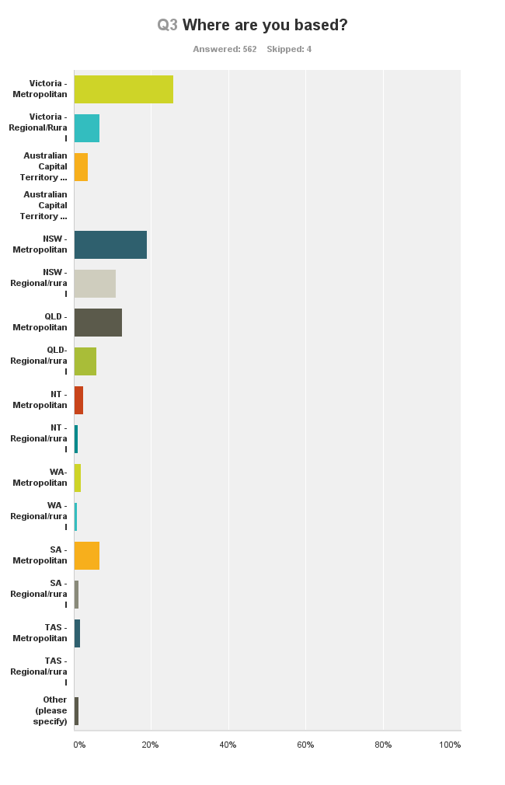
The regional/metropolitan split varied across Australia, which may be a function of survey penetration. however, it is reasonable to assume that generally craft practice has a metropolitan base of 75% participation and a regional base of participation of about 25% nationwide. This outcome implies the need to have localized marketing content, where possible, as part of a broader engagement strategy by industry organisations. The pattern of distribution of crafts people since Abrahams (1975) has not changed much, though our terms today to describe locations and real estate have altered – we are less inclined to say ‘small town’ or large town, and urban renewal cycles have given rise to such real estate terms as ‘studio’ to mean home office. Crafts people today, as before, live where everyone else lives.

About 10% of respondents indicated that they have a health issue, which is inconclusive in terms of arguing that craft has a has a role in term of health therapies and that people who self-identify as having a health issue are significant participants in crafting. However, 10% still represents a special opportunity in terms of public programing and underlines the need for access and participation issues to remain firmly on the table as important matters for craft organizations.
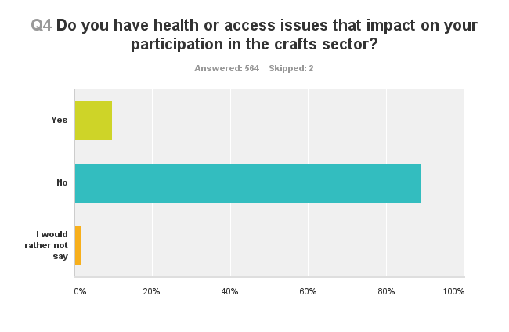

From the data collected in this survey, the craft fraternity appears to be highly educated, with tertiary education being the norm with over 65% of respondents having a tertiary degree. This implies a vocal sector, which has a high regard for professional training. The changes in TAFE and University courses will potentially have a major impact on the crafts in the reasonably near future, if training opportunities decline. It is especially significant that a significant proportion of the sector of over 15% is engaged with post-graduate study, which emphasizes the esteem with which the craft is held by many within its fold, and runs counter intuitively to the wind down of TAFE and some undergraduate craft related courses.

The situation in 1975 (Abrahams 1975) was different in that arts teachers were receiving training at teachers colleges and Institutes of Technology, which were both defacto providers of craft training. Then as now, fulltime training was more likely to lead to fulltime crafting, with self-taught makers aligning to leisure activity, supporting the continuing popularity of workshops as delivered by organisations. The TAFE sector has been a very significant provider of entry level training – its demise, should it occur further, will have an impact on the embedding of craft skills in the community and probably affect the flow of interested people into higher education pathways as noted in the graph above.

Although emerging is the largest amongst the survey respondents with close to 50%, there is a relatively even distribution of the other self-defining terms of around 15% each. The response implies a whole of life attitude to crafting with an implied good rate of progression through the different stages of the career trajectory, once you survive ‘emerging’. The large number of emerging practitioners was noted by some industry leaders as compressing the middle ground of established makers, with the professional makers perhaps being to fend for themselves. A caveat to this interpretation is that the survey may have appealed to emerging makers as an online experience, however, the data spread implies that today there are several ways of being a craft maker.

This situation is markedly different from 1975 (Abrahams 1975 page 21), where ‘Most of the craftsmen surveyed were middle-aged with only 17% of them under thirty years of age and just over half between thirty and fifty’. Assuming age to be a major factor in ‘emerging’, the appeal of craft today has broadened and currently enjoys high support from a greater number of people from an earlier age.

Industry leader Lynda Dorrington (CEO, FORM) makes the point in her interview in Mosaic of Views that the terms ‘emerging’ and ‘established’ are outdated terms and do not adequately describe the trajectories of digital artists, and that the terms are limiting funding opportunities to artists.

There are two main implications to be drawn from the graph belo. The first is that craftmakers in Australia evolve through the various stages of professionalization given a commitment of say ten to fifteen years - nearly equal proportions of about 25% respectively of respondents have been crafting for five to ten years and ten to twenty years , and secondly, people may be inclined to produce less craft as they age. In any case, craft is an artform that appeals significantly to young people, which suggests it will continue well into the future.

The most common figure in terms of commitment to crafting is five days per week by 20% of crafters. Beyond that people are very flexible in terms of time commitment, ranging from one day per week to seven days.

The distribution of responses infers that many craft makers are part-time, though this may be a reflection of economic necessity, as noted in Don’t Give Up Your Day Job – an economic study of professional artists in Australia (Throsby & Hollster 2003), which put craft makers income in the sub $20,000 per year category. Another view connects crafting with the home as an artform, with its capacity to enrich domestic life, as indicated in the Where do you craft? survey question, which has over 70% of respondents craft making from home.

The above graph indicates something of the range of materials used in craft, and extends beyond the traditional media, such as ceramics and textiles, etc. Many craft makers are using a variety of media, including ‘new’ media such as plastics and re-cycled materials. The tradition media specific divisions of ceramics, glass, fibre, wood, metal etc etc, as noted in Abrahams 1975 report, still holds for the majority of craft practitioners. The list of possible materials in use is now extensive in the sector. The most popular material or media is by far textiles with almost 50%, followed by paper at almost 30%, ceramics 19% and glass 14%. The distribution of results with its implication of multiple answers, affirms the idea that many craftspeople now use a range of materials, which differs from the 1970s.

This data implies that over 70% of craft makers are working from home, which suggests a high degree of integration of crafting in peoples everyday lives, which would feed into the survey data on how many days per week do you craft and the associated commentary regarding the very high rate of participation by Australian people in craft, as previously noted.

People are also keen on studio spaces of one type or another, with own studios and shared studios scoring similar rankings of 30% each, which as a statistic probably represents some form of duplication in terms of responses. University and community workshops each score about 6%, which is interesting consider in terms of the equally impressive lists of Guilds and Residences contained in the Attachments – there is a reasonable degree of choice depending on your type of interest as a craft maker.

The prevalence of studios, when compared to the data on how many years have you been a craft maker implies a pathway from the home to the studio is a marker of professionalization for many craftspeople. The advent of ‘ABNs’ (Australian Business Numbers) and the progressive normalization of micro businesses in terms of taxation treatments, would suggest this trend will continue.

The low income for craftmakers is in line with the income of many artists in the Australian arts sector (Throsby 2001), with its implication of the need for further business up-skilling from craft organisations coming through. Throsby & Hollster (2003 Chapter 8) notes the median income for craft practitioners was about $14,300. Given consumer price increases over the past year the statistical bump in the above graph for the group who opted for $15,000 to $30,000 comply with Throsby & Hollster’s conclusions. Their work, which remains the authorative source, unfortunately implies that little has changed since 2001. Looked at in terms of what is known of retail data and approximations of the size of the retail sector in Australia, there is more economic activity than the above graph implies. It is important for industry leaders to get to know their members changing needs for business skills training, so as to provide opportunities that enable the people in the ‘bump’ to stay in the sector and hopefully prosper. Whilst it is encouraging to see that about 4% of craftspeople are evidently earning around $50,000 per year, as a total sum such an income does not seem adequate for the required level of talent and knowledge required to be an outstanding craftsperson.

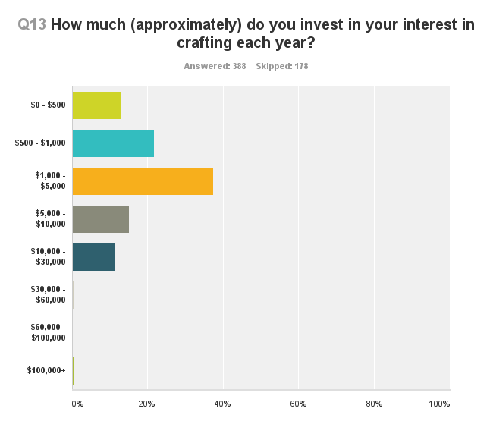

The graph shows that about 25% of craft makers invest less than $1,000 in their craft making each year, with 40% investing between $1,000 and $10,000 and some 20% investing above $10,000 per year. Craft is evidently an art form that requires low levels of investment for participation.

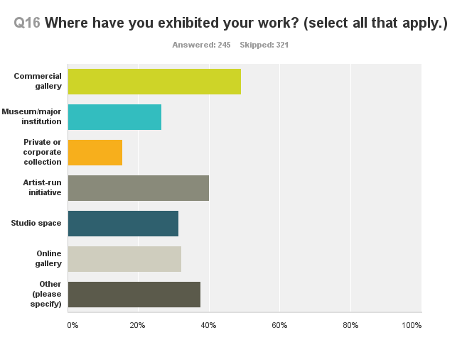

Of those craftspeople who have exhibited, the multiple responses allowed for this question make it apparent that craft makers seek to exhibit their works wherever possible, including online galleries, which may include personal websites.

An interesting ’new’ response was the Artist Run Spaces, which tends to be thought by some funding agencies such as the Australia Council, as the province of visual artists only. The sample list of retailors and markets located in the Attachments section of this report indicates the liveliness of the retail scene in Australia, which complements the exhibiting options open to craft makers.

The ‘optimism’ question received a 75% positive survey response. It implies a need to grow the market for Australian craft to meet the supply side of the market equation. It also means we should ‘expect the unexpected’ as new entrepreneurs enter the fray with novel business ideas and outstanding craft, thereby creating new demand.

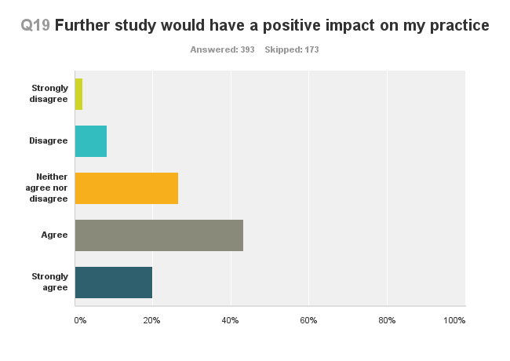

Well over 60% of respondents answered yes to this question, which is interesting given that the average craft person is well educated and holds a tertiary degree already. It is apparent that the crafts is an artform sector that constantly seeks training opportunities, which may become a considerable issue given the current scaling back of TAFE and university courses across Australia.

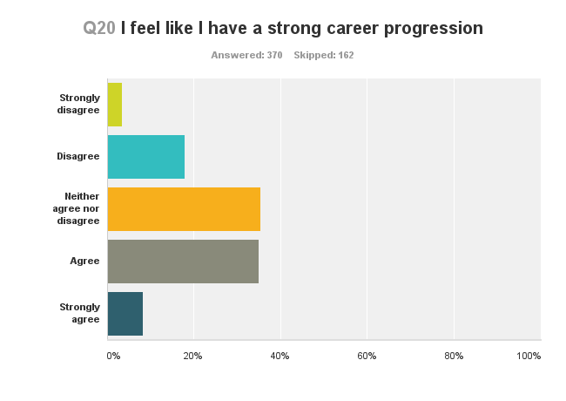
Results for this statement indicate mixed views with close to a fifty-fifty spilt, however, the use of the word ‘strong’ may have had an impact. When considered with the low incomes as noted earlier in this report, the optimism that is expressed possibly indicates that progression is more than simply monetary, and may extend to other features of life as a craftsperson such as artistic progress and wider acceptance through niche opportunities.

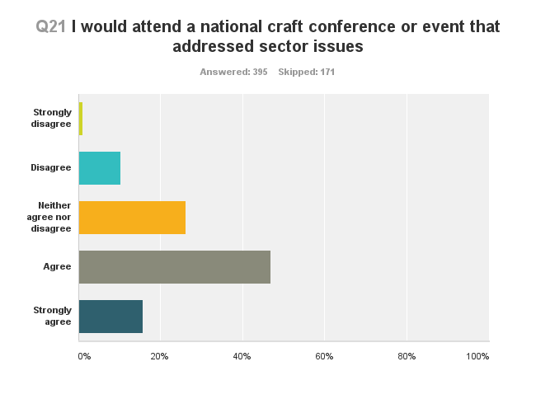

Over 60% of respondents answered in the in the affirmative as to whether they would attend a national craft conference. The high positive response to this question suggests a strong base for the planned forthcoming national conference for the crafts, especially from craft practitioners. There is a ’no’ rating of about 15% and an uncommitted rating of 26%. This mix suggest that the conference needs some special appeal factor to sway the naysayers, plus ensure the buy in of those who say ‘yes’.

Key note speakers including from overseas, the ability to be active during the conference and the opportunity to socialize may all be persuasive factors. Given that some 25% of crafters are rurally based, it is strongly suggested that targeted marketing across Australia to reach a wide range of communities with inviting messages. Also, conference ticket pricing must be affordable given the low wages of the sector.

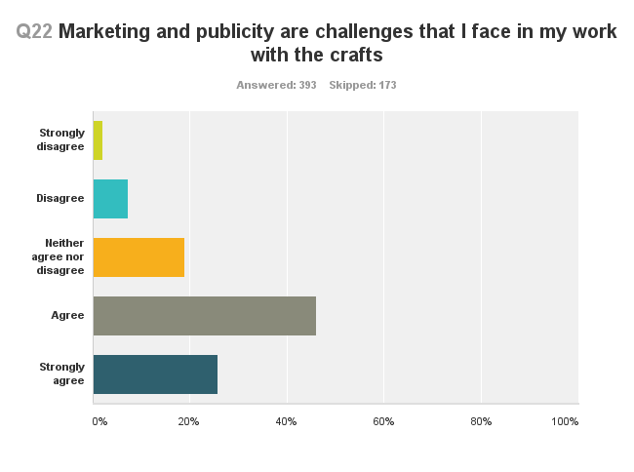

Over 70% of respondents see marketing and publicity as an issue. This suggests the need for strong national advocacy linked to niche marketing needs, so as to bridge the publicity gaps that are occurring. Historically this has been an issue within the crafts sector, with Abrahams (1975) and Deves & Vignando (2006) all highlighting the need for ’respect’ for craftspeople and the sector. This repeating concern is the basis for some of the recommendations arising from this report.

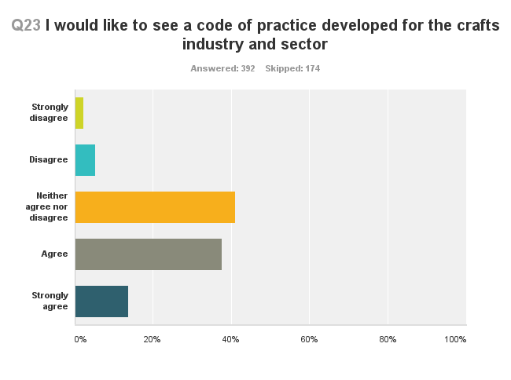

There is mixed response to this question, with almost 10% saying ‘no’, almost 40% saying ‘not sure’, and 50% saying ‘yes’. It is likely that more, simple information needs to be distributed as to what a code of practice, or, people are using the existing NAVA code of practice.

A conclusion that is also stated as a recommendation of this report, is that a code of practice needs to be developed for the craft sector, as both a devise for researching the economics of the sector and as a document that can inform craft makers of professional practice issues, filling a void opening up with the demise of tertiary education courses.

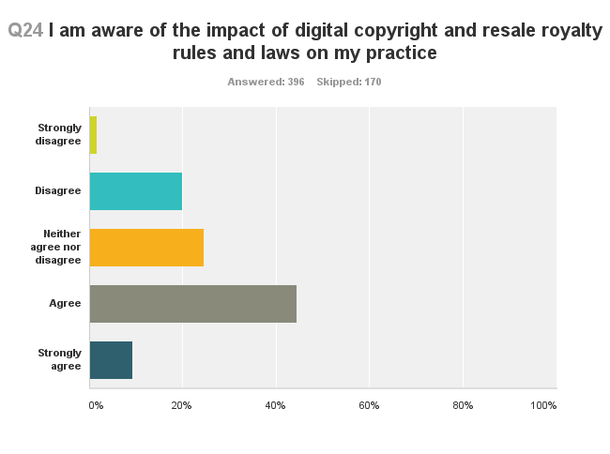
There was close to an even split in responses to this statement, which suggests that there is a further work to be done to more adequately inform the sector of these issues and what they actually indicate. It would be interesting to track this question in future surveys to measure related advocacy.

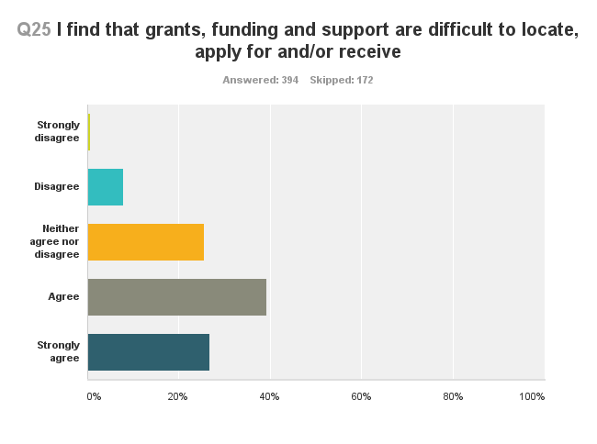

Certainly a considerable majority of close to 60% of respondents expressed some difficulty with this area of professional practice. However over 30% say the opposite, which suggest that there are issues of ‘self-identification’ when it comes to viewing grant opportunities.

The raw availability of grants is tempered with the specific nature of many grants and the narrowness of funding channels. Also, unlike the grant programs of the former Craft Board of the Australia Council, as noted in Australia Council grant handbooks from 1975 to 1987, grant opportunities are often generic and therefore highly competitive.

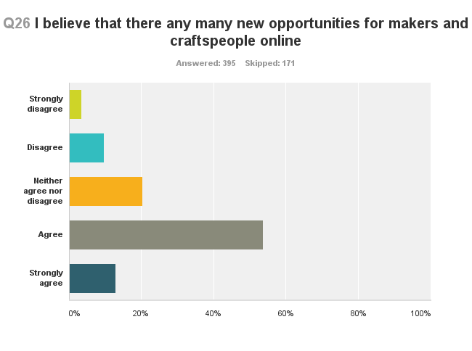

With over 65% of respondents answering in the affirmative, two reasonable conclusions are that there are a range of opportunities that are not official grants that are appealing to craft makers, who undertook this survey, and secondly, the online environment is now fully trusted as a source of information. The latter point has become an everyday reality in many fields, and together both conclusions are meaningful to organizations that seek to provide opportunities to makers. The ‘no’ rate of 10% seems to be a reoccurring characteristic of the no rate expressed throughout the survey.

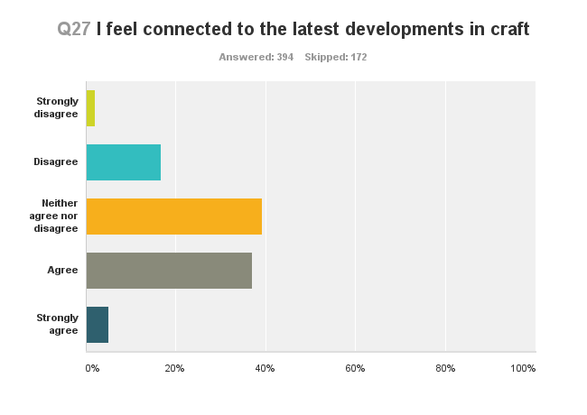

There is significant polarization in the mix of responses to this question, which implies – probably – that the craft sector is awash with many new developments. Almost 18% of people say ‘no’, 40% are ’not sure’ and just over 40% say they do feel connected to the latest developments in craft.

Put prosaically the dichotomous replies suggest that there is a lack of an accessible, centralized information service for the crafts in Australia that speaks to everybody. It also suggests that the forthcoming national craft conference needs to be a show case for new ideas and to make all people feel welcome, even if they do not perceive themselves to be part of the ‘in crowd’.

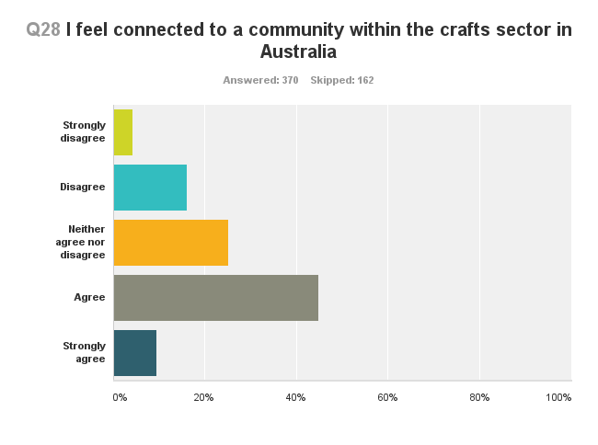
With over 55% of respondents feel connected to the craft community, it is apparent that there is a sense of community that comes with being a craft maker, which carries implications for marketing participation in the crafts in Australia. About 20% do not feel a sense of community connection and a further 25% are ambiguous in their response, which implies that there is a significant range of ways of being a craft maker.

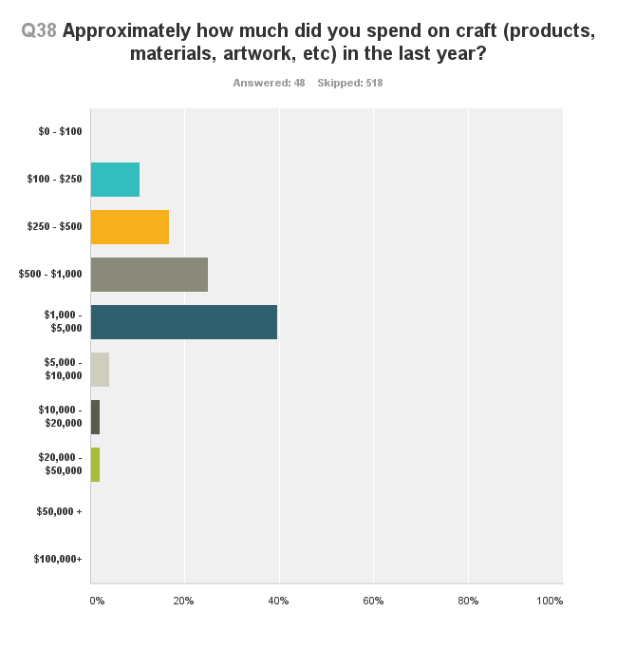

This question was completed by investors and consumers of craft products, and indicates that some 40% of such people spent between $1,000 and $5,000 on buying craft works each year, with a further 24% spending under a $1,000. This survey question was answered mainly by non-craft makers who undertook the survey.

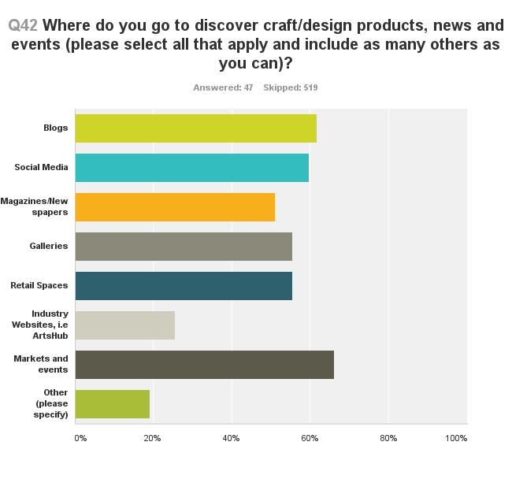

The responses indicate that craft information is widely sought across a range of multiple retail sources, social media used by 63% of respondents. The data implies that craft makes for good content, even if it not always purchased! Craft is evidently a driver of traffic for all forms of social media and is regularly sought out, though markets and galleries both still prevail, with each rating at over 50%, due to multiple choices being available on this question. This survey question was answered mainly by non-craft makers who undertook the survey.

Engagement with the online environment was identified as a priority in Deves & Vignando report though blogs and social media appear to have overtaken the emphasis once placed on industry websites.

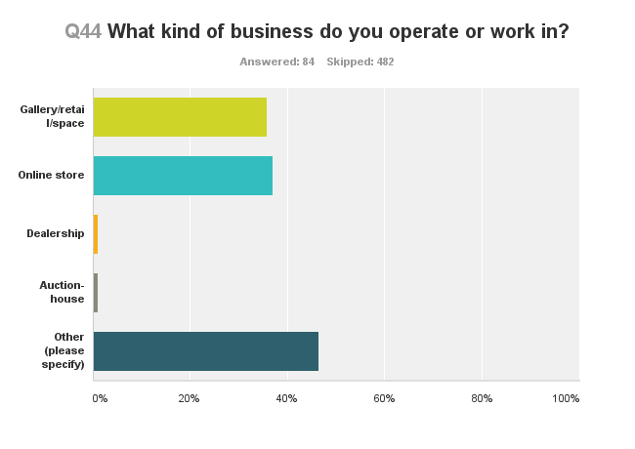
The close to even split between online stores and galleries is not straight forward in terms of interpretation, as there is often a cross-over or duplication between the two, with both rating at 37% - every shop would have a website. The suggestion that is available, however, is that online stores have a distinctive place in the sector with regards to promotion. The very low score for dealerships and auction houses of 1% points to the lack of a secondary market for craft in Australia. This question was answered mainly by non-craft makers who undertook the survey.

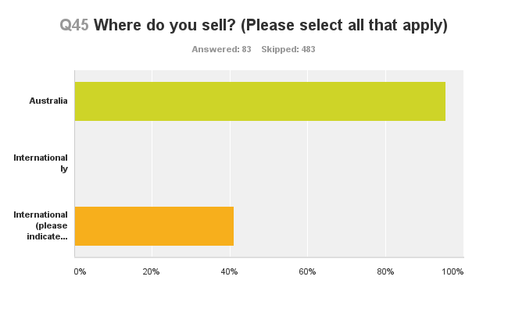
The data suggests that 95% of Australian crafts sell in Australia, and that 40% retail internationally.The surprise here is that so many craftspeople have found international markets for their craft, which is logical though, given the apparent underspend in Australia in relation to the production n of craft. There is also a small segment of about 5% of makers who evidently sell exclusively into the international market. This survey question was answered mainly by non-craft makers who undertook the survey.

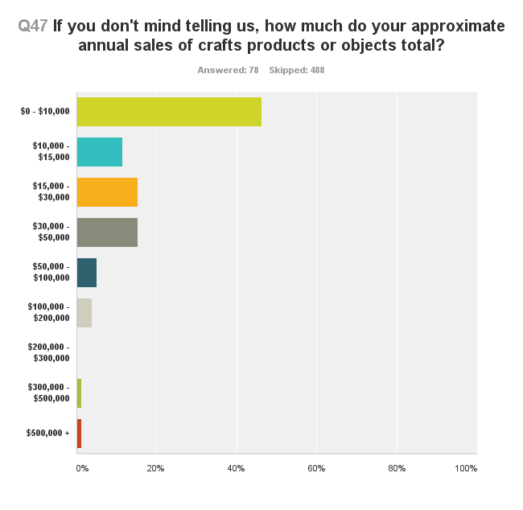

This question was asked primarily of retailers, who may also be makers. It indicates a range of sales at 40% of outlets of between $15,000 and $50,000. The data as collected is very likely an under representation of the total spend on craft, however, it presumably captures the likely shape of the ‘bell-shaped curve’ – the research question is , where on the horizontal line should the vertical axis sit? This survey question was answered mainly by non-craft makers who undertook the survey.

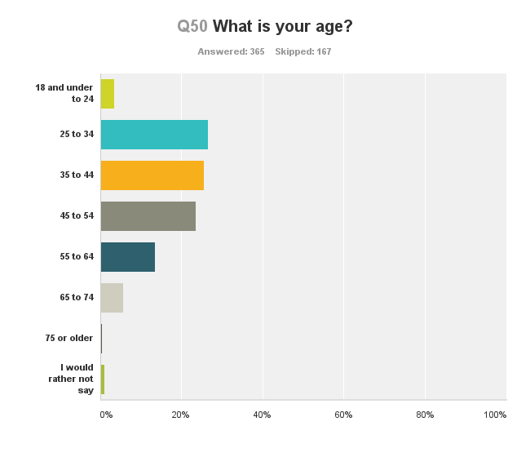
There is a reasonable spread of participation from 25 years to 64 years of age, which carries significant implications for those industry leaders concerned with marketing. Craft making is clearly enjoyed by a wide section of the community, regardless of age. This survey did not capture school aged children due to its distribution.

Compared to the 1970s, as noted in Abrahams, engagement with the crafts has grown in all directions, with a sizable increase in the young person segment, as seen in the rising number of emerging makers and the energetic take up of social media as a source of craft information. A common feature with the 1970s is the continued presence of what was once called ‘middle-aged’ people, the 35 years to 54 years segment represents 45% of the respondents to this survey question.

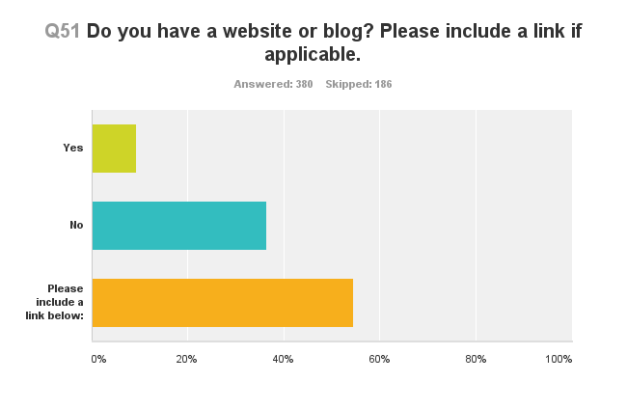
Whilst it seems commonplace for craft people to have their own website, in reality that is the minority position. However, when considered as raw numbers there are many craft websites. It is well to appreciate that the survey was an online survey, hence, presumably all respondents have email accounts and some digital presence. Also, a greater number of people provided a link than said they had websites, which might mean they are hosting their online information on another site, such as a gallery or shop. If the data is interpreted exactly as it appears in the table, about 10% of craftspeople do not have a site or blog, 36% do, but about 60% have a web or blog presence.

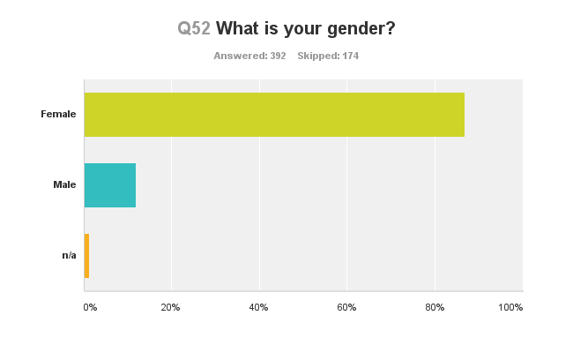

Over 85% of respondents identified as female and 15% as male. There is an interesting challenge here for industry leaders to broaden the appeal of crafting to males. This would be in line with other marketing challenges in Australian society, such as we have collectively seen in major sporting codes. There would be important learnings from the nation’s sporting leaders as to how to shift popular perceptions of so-called natural involvement in various activities. The sector appears to have become more feminine since the 1970s when Abrahams noted 20% male and 80% female.

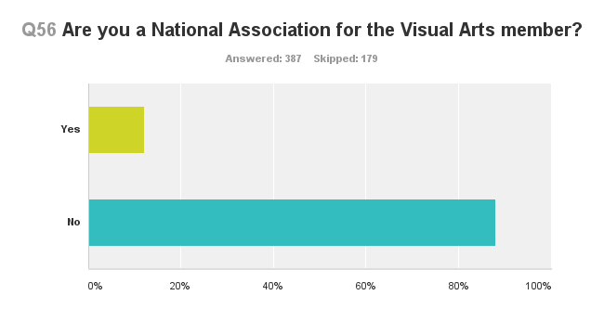
As a national arts organization offering a wide range of services, including to the crafts, it is noteworthy that about 15% of respondents identify as members of NAVA at this stage. The question itself received a strong response.

Attachment E. Online Survey Results – Additional Tables

Additional data table: Income and ‘I would like to see a code of practice developed for the crafts industry and sector’

This data table compares the incomes of craft makers with the prevalence of membership of NAVA, to see if there is a connection that might in turn be utilized to further drive membership of NAVA by craft makers.

The data table indicates that there is majority support in the craft sector for a code of practice from craft makers who are earning upward of $10,000, with an associated drop of negativity amongst craft makers as their income rises. If this is the trend, is suggests that the concept of a Code of Practice should include as part of its development the idea, that a code would help you increase your income.

– | Strongly disagree – | Disagree – | Neither agree nor disagree – | Agree – | Strongly agree – | Total –
Q12: $0 - $500 | 3.53%  3 | 9.41%  8 | 43.53%  37 | 34.12%  29 | 9.41%  8 | 85
Q12: $500 - $1,000 | 0%  0 | 2.50%  1 | 45%  18 | 37.50%  15 | 15%  6 | 40
Q12: $1,000 - $5,000 | 2.74%  2 | 5.48%  4 | 41.10%  30 | 36.99%  27 | 13.70%  10 | 73
Q12: $5,000 - $10,000 | 3.23%  1 | 0%  0 | 35.48%  11 | 45.16%  14 | 16.13%  5 | 31
Q12: $10,000 - $15,000 | 5.56%  1 | 5.56%  1 | 22.22%  4 | 61.11%  11 | 5.56%  1 | 18
Q12: $15,000 - $30,000 | 2.22%  1 | 4.44%  2 | 42.22%  19 | 31.11%  14 | 20%  9 | 45
Q12: $30,000 - $50,000 | 0%  0 | 12.50%  2 | 18.75%  3 | 43.75%  7 | 25%  4 | 16
Q12: $50,000 - $100,000 | 8.33%  1 | 0%  0 | 25%  3 | 41.67%  5 | 25%  3 | 12
Q12: $100,000 + | 0%  0 | 0%  0 | 33.33%  1 | 66.67%  2 | 0%  0 | 3
Total Respondents | 9 | 18 | 126 | 124 | 46 | 323

Compared questions – ‘average contemporary crafter’

The following groups of compared questions convey profiles of craft makers by income in relation to gender, media, desirability for a code of practice and age.

The dominant profile that emerges is of a female maker who earns about $30,000 per year, perhaps from jewelry or textiles, is aged in her late 30s, who is quite optimistic about the future, and is definitely interested in seeing an industry code of practice come into being. This suggest a certain wisdom and commitment to the crafts, based on a hard-earned reality as a practicing craftsperson, who is enjoying a reasonable level of success.

To find this ‘model crafts person’; consider the data box directly below of 90% response for a female in the salary range of $15,000 to $30,000, then note that jewelry rates highest amongst the media types by earnings at 32% in the box 2 for the same grouping, then incorporate the high optimism rating of 50% noted in the data box 3 for the same ‘type of person – and finally, go to data box 4 where you see that the highest score on comparing income and age is 38% , in the age range 35 years to 44 years.

(1) Income level and gender
– | Female – | Male – | n/a – | Total –
Q12: $0 - $500 | 88.16%  67 | 9.21%  7 | 2.63%  2 | 76
Q12: $500 - $1,000 | 90.91%  30 | 3.03%  1 | 6.06%  2 | 33
Q12: $1,000 - $5,000 | 90.48%  57 | 9.52%  6 | 0%  0 | 63
Q12: $5,000 - $10,000 | 89.66%  26 | 10.34%  3 | 0%  0 | 29
Q12: $10,000 - $15,000 | 76.92%  10 | 23.08%  3 | 0%  0 | 13
Q12: $15,000 - $30,000 | 90%  27 | 10%  3 | 0%  0 | 30
Q12: $30,000 - $50,000 | 76.92%  10 | 23.08%  3 | 0%  0 | 13
Q12: $50,000 - $100,000 | 72.73%  8 | 27.27%  3 | 0%  0 | 11
Q12: $100,000 + | 100%  3 | 0%  0 | 0%  0 | 3
Total Respondents | 238 | 29 | 4 | 271

(2) Income level and media

– | jewels and precious metals – | ceramics – | textiles – | glass – | wood – | metal – | leather – | paper – | plastics – | recycled items – | Other (please specify) – | Total Respondents –
Q12: $0 - $500 | 13.95%  12 | 12.79%  11 | 59.30%  51 | 8.14%  7 | 9.30%  8 | 12.79%  11 | 8.14%  7 | 45.35%  39 | 10.47%  9 | 31.40%  27 | 23.26%  20  Responses | 86
Q12: $500 - $1,000 | 15%  6 | 10%  4 | 62.50%  25 | 17.50%  7 | 2.50%  1 | 10%  4 | 2.50%  1 | 25%  10 | 10%  4 | 35%  14 | 25%  10  Responses | 40
Q12: $1,000 - $5,000 | 15.07%  11 | 16.44%  12 | 43.84%  32 | 19.18%  14 | 20.55%  15 | 24.66%  18 | 6.85%  5 | 30.14%  22 | 12.33%  9 | 35.62%  26 | 24.66%  18  Responses | 73
Q12: $5,000 - $10,000 | 12.90%  4 | 38.71%  12 | 45.16%  14 | 12.90%  4 | 16.13%  5 | 12.90%  4 | 9.68%  3 | 12.90%  4 | 3.23%  1 | 19.35%  6 | 22.58%  7  Responses | 31
Q12: $10,000 - $15,000 | 11.11%  2 | 33.33%  6 | 61.11%  11 | 16.67%  3 | 33.33%  6 | 16.67%  3 | 5.56%  1 | 27.78%  5 | 11.11%  2 | 38.89%  7 | 5.56%  1  Responses | 18
Q12: $15,000 - $30,000 | 32.61%  15 | 21.74%  10 | 26.09%  12 | 19.57%  9 | 21.74%  10 | 28.26%  13 | 8.70%  4 | 13.04%  6 | 13.04%  6 | 21.74%  10 | 17.39%  8  Responses | 46
Q12: $30,000 - $50,000 | 12.50%  2 | 31.25%  5 | 18.75%  3 | 31.25%  5 | 0%  0 | 18.75%  3 | 6.25%  1 | 12.50%  2 | 12.50%  2 | 18.75%  3 | 12.50%  2  Responses | 16
Q12: $50,000 - $100,000 | 30.77%  4 | 30.77%  4 | 38.46%  5 | 0%  0 | 23.08%  3 | 23.08%  3 | 0%  0 | 30.77%  4 | 7.69%  1 | 15.38%  2 | 23.08%  3  Responses | 13
Q12: $100,000 + | 33.33%  1 | 0%  0 | 66.67%  2 | 0%  0 | 0%  0 | 0%  0 | 0%  0 | 0%  0 | 0%  0 | 33.33%  1 | 0%  0  Responses | 3
Total Respondents | 57 | 64 | 155 | 49 | 48 | 59 | 22 | 92 | 34 | 96 | 69

(3) Income and ‘I expect my craft practice/business to grow in the next 5 years’

– | Strongly disagree – | Disagree – | Neither agree nor disagree – | Agree – | Strongly agree – | Total Respondents –
Q12: $0 - $500 | 2.33%  2 | 6.98%  6 | 34.88%  30 | 44.19%  38 | 13.95%  12 | 86
Q12: $500 - $1,000 | 2.50%  1 | 2.50%  1 | 17.50%  7 | 50%  20 | 27.50%  11 | 40
Q12: $1,000 - $5,000 | 1.37%  1 | 4.11%  3 | 10.96%  8 | 61.64%  45 | 23.29%  17 | 73
Q12: $5,000 - $10,000 | 0%  0 | 3.23%  1 | 6.45%  2 | 58.06%  18 | 32.26%  10 | 31
Q12: $10,000 - $15,000 | 0%  0 | 0%  0 | 22.22%  4 | 44.44%  8 | 38.89%  7 | 18
Q12: $15,000 - $30,000 | 4.55%  2 | 2.27%  1 | 22.73%  10 | 36.36%  16 | 34.09%  15 | 44
Q12: $30,000 - $50,000 | 12.50%  2 | 0%  0 | 6.25%  1 | 50%  8 | 31.25%  5 | 16
Q12: $50,000 - $100,000 | 0%  0 | 0%  0 | 25%  3 | 41.67%  5 | 33.33%  4 | 12
Q12: $100,000 + | 0%  0 | 0%  0 | 0%  0 | 100%  3 | 0%  0 | 3
Total Respondents | 8 | 12 | 65 | 161 | 81 | 323

(4) Income and age
– | 18 and under to 24 – | 25 to 34 – | 35 to 44 – | 45 to 54 – | 55 to 64 – | 65 to 74 – | 75 or older – | I would rather not say – | Total –
Q12: $0 - $500 | 9.21%  7 | 30.26%  23 | 13.16%  10 | 27.63%  21 | 10.53%  8 | 6.58%  5 | 1.32%  1 | 1.32%  1 | 76
Q12: $500 - $1,000 | 0%  0 | 33.33%  11 | 30.30%  10 | 15.15%  5 | 15.15%  5 | 3.03%  1 | 0%  0 | 3.03%  1 | 33
Q12: $1,000 - $5,000 | 1.59%  1 | 22.22%  14 | 28.57%  18 | 26.98%  17 | 17.46%  11 | 3.17%  2 | 0%  0 | 0%  0 | 63
Q12: $5,000 - $10,000 | 0%  0 | 20.69%  6 | 34.48%  10 | 24.14%  7 | 10.34%  3 | 10.34%  3 | 0%  0 | 0%  0 | 29
Q12: $10,000 - $15,000 | 0%  0 | 30.77%  4 | 15.38%  2 | 30.77%  4 | 7.69%  1 | 15.38%  2 | 0%  0 | 0%  0 | 13
Q12: $15,000 - $30,000 | 0%  0 | 33.33%  10 | 26.67%  8 | 13.33%  4 | 23.33%  7 | 3.33%  1 | 0%  0 | 0%  0 | 30
Q12: $30,000 - $50,000 | 0%  0 | 7.69%  1 | 38.46%  5 | 23.08%  3 | 30.77%  4 | 0%  0 | 0%  0 | 0%  0 | 13
Q12: $50,000 - $100,000 | 0%  0 | 18.18%  2 | 27.27%  3 | 45.45%  5 | 9.09%  1 | 0%  0 | 0%  0 | 0%  0 | 11
Q12: $100,000 + | 0%  0 | 0%  0 | 33.33%  1 | 33.33%  1 | 0%  0 | 33.33%  1 | 0%  0 | 0%  0 | 3
Total Respondents | 8 | 71 | 67 | 67 | 40 | 15 | 1 | 2 | 271

Attachment F. Australian Craft Organisations

National Association of Visual Artists (‘NAVA’)

The National Association of Visual Artists, ‘NAVA’, is funded by the Australia Council as a peak body and includes craft within its remit (NAVA and the ACDC are co-managing the NCI program).

National Association of Visual Artists (Nat)

Australian Craft and Design Centres (‘ACDC’)

Australia has a set of craft organizations which are supported by governments, Federal and or State, and sometimes Local or Capital City entities. The group is known as the ‘ACDC’ or Australian Craft and Design Centres, the leaders of which were interviewed for this report as industry leaders. (It is a recommendation of this report that the ACDC reconfigure as a more open body and become an ‘Australian Craft Association, and encourage guilds and other associations to join).

Artisan (Qld)
Craft (Craft Victoria) (Vic)
Craft ACT: Craft and Design Centre (ACT)
Guild House (SA)
Design Tasmania (Tas)
FORM (WA)
JamFactory: Contemporary Craft and Design (SA)
Object: Australian Centre for Design (NSW)
Tactile Arts (NT)

Australian Guilds and Associations

There are over 80 Guilds and Associations for the crafts in Australia. A guild or an association may be defined as an organization that exists for the mutual benefit of its respective members. The list below shows a cross section of types of organizations, ranging from traditional to contemporary, from regional to national, media specific and Indigenous. The guilds and associations all carry out an important role with regard to Australian craft, organising events and projects, preserving and enhancing craft skills, and contributing to the wider public’s appreciation of craft. They also contribute to professional standards and act as peak bodies.

Architectural Glass Design Australia Inc
Arts Nexus
Arts Nexus Eastern Hub
Arts Nexus Northern Hub
Arts Nexus Southern Hub
Arts Nexus Western Hub
Association of Northern, Kimberley and Arnhem Aboriginal Artists (ANKAAA)
Ausglass
Ausglass ACT
Ausglass NSW
Ausglass NT
Ausglass QLD
Ausglass SA
Ausglass Tas
Ausglass VIC
Ausglass WA
Australian Ceramics Association
Australian Ceramics Association
Australian Ceramics Association
Australian Eggshell Artists Association
Australian Enamellers
Australian Knifemakers Guild
Australian Lace Guild
Australian Network of Clay and Glass Artists
Australian Society of Calligraphers
Basketmakers of Victoria
Basketry South Australia Inc
Bead Society of Victoria
Canberra Craft Bookbinders
Darwin Patchworkers and Quilters Inc
Découpage Guild of Australia
Découpage Guild of NSW
Desart
Design Institute of Australia
Design Institute of Australia ACT Branch
Design Institute of Australia NSW Branch
Design Institute of Australia QLD Branch
Design Institute of Australia SA Branch
Design Institute of Australia Vic Branch
Design Institute of Australia WA Branch
Embroiderers Guild ACT
Embroiderers Guild of South Australia
Embroiderers Guild of Western Australia
Embroiderers Guild Tasmania
Embroiderers Guild, Victoria
Embroiders Guild of Queensland
Hand Spinners and Weavers SA
Handknitters Guild of South Australia
Handweavers and Spinners Guild of NSW
Handweavers and Spinners Guild Vic
Handweavers, Spinners, and Dyers Guild, TAS
Handweavers, Spinners, and Dyers Guild, WA
Jewellers and Metalsmiths Group of Australia
Jewellers and Metalsmiths Group of Australia WA
Jewellers Association of Australia
Jewellersand Metalsmiths Group of Queensland
Knitters Guild of NSW
Lapidary Club, Beenleigh
Leathercrafters Association Queensland
Leatherworkers Guild of NSW Inc
Megalo
NSW Guild of Craft Bookbinders
Papermakers Guild of Western Australia
Papermakers of Queensland
Patchworkers and Quilters Guild of Victoria
Penrith Museum of Printing
Porcelain Dollmakers Guild of WA
Queensland Bookbinders Guild
Quilters Guild of NSW
Society of Australian Ceramic and Porcelain Teachers
Tapestry Guild of Victoria
Victorian Egg Decorators Guild Inc
Victorian Guild of China Painters
Victorian Woodworkers Association
WA Bookbinders Guild
Western Australian Quilters Association
Western Leathercraft
Wooden Boat Association of NSW
Woodworkers Association of NSW
Woodworkers Association of NSW

Attachment G. Examples of Success and Decline in Australian Craft

Successes

The following craft events, websites and publications were selected as a representative list of high value craft projects that have taken place relatively recently in Australia. It includes two major museum exhibitions with established international reputations, a recent children’s book, a major retrospective exhibition, a website, new craft studios, a new annual craft publication, a touring jewelry exhibition, a remote Indigenous art centre and a large craft fair in a rural town.

All the projects selected have a clarity of purpose and have been well implemented. In several cases, such as the children’s book featuring ceramic tiles by Bern Emmerichs, there is an interesting production process at work, which in this case has resulted in 3,000 books being presold into public libraries. All the examples noted enjoy high visibility and have the capacity to contribute to a discourse on the role of contemporary craft. It should be noted that there many other candidates for such a list.

Asia Pacific Triennial of Contemporary Art, Queensland Art Gallery; established in 1993 a series of exhibitions that has gained an international reputation, this seminal projects regularly surveys and brings alive many culture from around the Asia Pacific region. (http://www.qagoma.qld.gov.au/exhibitions/apt )

Berbay Publishing, What’s your story? A children’s book illustrated in 2013 by ceramic artist Bern Emmerichs and written by Rose Giannone, printed in China and presold to Australian libraries. The project crosses several technologies and is a model for new craft practice. (http://www.berbaybooks.com/what-s-your-story/ )

Stephen Benwell – Beauty, Anarchy, Desire – A Retrospective; Heide Museum of Modern Art, curated by Jason Smith 2013. Major survey exhibition of this iconic ceramic artist, documented with an authorative catalogue available from the museum. (http://www.heide.com.au/exhibitions/future/exhibition/less-is-more/edate/2012-08-03/eid/133/exhibition/stephen-benwell-beauty-anarchy-desire-a-retrospective/edate/2013-08-08/eid/448 )

Craft website; Craft, also known as Craft Victoria, has a public focused website developed in 2012 by R-Co (Melbourne) who also managed the branding of the Australian Football League. The site carries a substantial amount of craft related information, through a brand and menu structure that reaches a wide audience across Australia; Craft - Us, See, Buy, Learn, News. (http://www.craft.org.au/ )

JamFactory at Seppelsfield; opened in 2013 these craft studios and retail shop located in historic buildings in the winegrowing Barossa Vallery, just north of Adelaide, are managed by the JamFactory in partnership with Seppelts winery. The project aligns wine making with craft making in a high quality way, adding value to the craft makers, the organizations involved and the visiting public; https://www.youtube.com/watch?v=FI1a6V3oKBA&feature=share&list=UUZmTIS8c3rghJAwvD0ZkqvA

Jilinbirri Weavers, Carnarv n, Western Australia; phone 0429 212 882. Email toni@gahcc.com.au Indigenous baskets making center using local plants. Outstanding work by ladies from the Gascoyne Region of coastal Western Australia.

Marmalade; Published in 2012 for the first time, Marmalade is the new annual publication of the JamFactory, Adelaide. It unselfconsciously references Australian craft in a wide context, profiling craft makers and events, offering commentary in an attractive format. It is significant in that it is calmly post-digital and should gather in a loyal readership. (http://jamfactoryshop.bigcartel.com/product/marmalade-publication )

Tinker Tailor Solder Sailor – 100 Women Artists 100 Broaches 100 Stories, 2011 Artisan touring exhibition, curated by Kirsten Fitzpatrick with contributing essay by Dorothy Erickson. Outstanding exhibition and catalogue that gathered in women’s stories and the breadth of jewelry practice in Australia. (http://www.craftaustralia.org.au/library/essay.php?id=erickson-inspired-brooches-inspired-women-tinker-tailor ).

Tasmanian Craft Fair, Deloraine, Tasmania; originally established in 1980, this fair has becomes a mecca for traditional and contemporary craft, both amateur and professional, in the form of over 200 attractive stalls – more than a market, a community embracing craft. (http://www.tascraftfair.com.au/ )

Telstra National Aboriginal & Torres Strait Islander Art Awards, Museum and Art Gallery of the Northern Territory; Initiated in 1984 and now approaching its 30th iteration, this ‘must see’ annual exhibition of contemporary Indigenous art is held annually in Darwin at the Museum and Art gallery of the Northern Territory. It presents a wide selection of Indigenous work from across Australia, and embraces craft and visual arts ( http://artsandmuseums.nt.gov.au/museums/natsiaa )

Decline

In considering where craft has declined in Australia it is a matter of lost opportunity as much as the failure of strategies or organisations. The following short list scopes some of the ‘down side’ of the craft sector in Australia.

Collecting craft; the most current example of a lost opportunity is the failure by public collecting institutions to establish craft curator roles and collect the craft work that is being produced today, or over the last en yeas. The recent surge in craft making has resulted in an extraordinary opportunity to establish craft collections at a reasonable price that reflect the excellence and meaning of the craft work being produced today in Australia. When one considers the initial reticence to engage with Indigenous art being produce with modern materials, and to curatorially position it with Tribal Art, and the way history has completely turned, it is interesting to consider if craft’s coupling with the decorative arts is able to be changed for the better. Several of the interviewees, noticeably Dr Robert Bell AM, Senior Curator, Australian National gallery and Jane Scott, CEO and Artistic Director, Craft Victoria, call for a national craft museum.

Craft Australia; Craft Australia was established in 1970 as the Crafts Council of Australia, and was thus the ‘mother organisation’ for the craft movement in Australia. Its defunding by the Australia Council in 2012 and subsequent closure the following year was regarded by many in the sector as a pivotal event. The reason for its de-funding was ‘non-excellence’, which pointed to its performance rather than mission. The decline of the organisation was gradual and the subject of ongoing analysis of the craft sector, by itself and by the Australia Council. Whatever one’s position in terms of that recent history, it left open the question of where to next for the craft sector. The National Craft Initiative was an outcome of that process. For a discussion regarding the actual defunding note Robert Reason, then Prsident of Craft Australia; http://www.craftaustralia.org.au/library/presidentsreport.php?id=2011-11-08

Craft Board of the Australia Council; the Crafts Board was a founding board of the Australia Council in 1975, along with a range of other artform boards such as visual arts, literature, music, Aboriginal art and so on. Interestingly, the scope of the Australia Council, as impressive as it was, did not include film, which had its own organisation. Other professional groups, such as architects have looked to the Australia Council at different times. The remit of the Australia Council was to progress Australian contemporary art, which was an excellent mission for the Crafts Board to embrace. By 1986 the Australia Council found that its running cost were too high, affecting the amount to be given as grants. The restructures, removed a layer of policy committees across Council and amalgamated the Crafts Board with the Visual Arts Board, to form the Visual Arts/Craft Fund. The grant programs tended to become generic, to cover both artforms, and as the artforms where often assessed in the same founding rounds, the matter of artform representation took over from more subtle considerations of artform development. The demise of the Craft Board shifted the expectations of the craft sector to Craft Australia, which was then placed in an awkward position, which ultimately became fraught.

Attachment H. Regulations and Management

Australian apprenticeships
For information see Australian Government, Australian Apprenticships; http://www.australianapprenticeships.gov.au/

Exporting craft from Australia

- Austrade – Australian Trade Commssion; assists Austrade assists Australian businesses contribute to national prosperity by succeeding in trade and investment, internationally, and promoting and supporting trade.
- http://www.austrade.gov.au/

- Australia Council for the Arts ‘Art Fare – Australian Art Export program’ grants; http://www.australiacouncil.gov.au/grants/2013/artfare-30-august
;

- Export Council of Australia; industry association; http://www.export.org.au/eca/export-community/export-council-of-australia-industry-association-members

- Victorian Government ‘Export Victoria’; the Victorian Government offers export grants and export assistance to potential and current exporters and their industry groups;
http://export.business.vic.gov.au/funding-and-assistance?gclid=CK-f3vO6kLsCFcU5Qgod93EAwQ

Intellectual Property

- ‘Indigenous peoples and intellectual property rights’ discussion; Parliament of Australia Research Paper Michael Davis, published Australian Department of Parliament Library 2005; http://www.aph.gov.au/About_Parliament/Parliamentary_Departments/Parliamentary_Library/pubs/rp/RP9697/97rp20

- Intellectual Property – understanding intellectual property law primer; http://www.ipaustralia.gov.au/understanding-intellectual-property/what-is-ip/ip-protection/

- Trademark registration service; http://legalvision.com.au/register-a-trademark-b/?gclid=CKm5uPSOlbsCFWQ6QgodXgMAEQ

- World Intellectual Property Organisation; Marketing Crafts and Visual Arts: The role of intellectual property – a practical guide; http://www.wipo.int/export/sites/www/freepublications/en/intproperty/itc_p159/wipo_pub_itc_p159.pdf

Management Advice
Two selected research papers that deal specifically with who makes the decisions in your organisation, and overall trends in concepts of leadership in Australian organisations. Both postdate the report of Prof. David Karpin of 1995 into concepts of leadership in Australian enterprises to, offer current explanations of managing for change.

- Australian Institute of Management; Management Research Series 1/2002: ‘Australian Leadership, organisational culture and job outcomes’http://www.aimnt.com.au/research/research_abls.html

- Australian Institute of Management; Management Research Series 1/2003: ‘Management Development Practice in Australia’ http://www.aim.com.au/research/mdp.html

Attachment I. Examples of Craft Policies

Worldwide there are few written craft policies, with the trend being toward social outcomes, most cultural policies for living art forms tends to be more general in terms of naming a particular artform. The following are some reference to craft policies used for this report.

‘A National Cultural Policy for a Creative Australia’, Simon Crean, Minister for the Arts, 2013
http://www.ifacca.org/national_agency_news/2013/03/13/national-cultural-policy-creative-australia/

Casswell, P. (ed) The Code of Practice for the Australian Visual Arts and Crafts Sector, National Association of Visual Artists, Sydney 2004

Cultural Mapping, Planning and Policy: Tonga By Seu‛ula Johansson Fua, Tu‛ilokamana Tuita, Siosiua Lotaki Kanongata‛a, and Koliniasi Fuko. Published by the Secretariat of the Pacific Community on behalf of the Ministry of Education, Women’s Affairs and Culture, Government of Tonga, Nuku’alofa, Tonga, 2011

Jenke, Terri Visual Cultures: Protocols for producing Indigenous Australian visual arts and craft, Australia Council for the Arts, Sydney, 2002

Government of South Africa, The South African Craft Industry Report, Department of the Arts, Culture, Science and Technology 1998

Skvensk Form, a design (and craft) policy supported by the Swedish government; http://www.designcouncil.org.uk/resources-and-events/schools-and-education/for-schools/design-around-the-world1/sweden/

Related sources

Canadian Craft Federation website; http://canadiancraftsfederation.typepad.com/
Craft Australia defunded; http://www.craftaustralia.org.au/library/presidentsreport.php?id=2011-11-08 2011

Danish Handcraft Museum website; http://en.wikipedia.org/wiki/Danish_Museum_of_Art_%26_Design

Canada Craft Federation; http://canadiancraftsfederation.typepad.com/canadian-crafts-federatn/about- us.html

Craft Scotland website; http://www.craftscotland.org/

European Cultural Policies Compendium ; Cultural Policies and Trends in Europe http://www.culturalpolicies.net/web/search.php?Realm=Compendium&Match=0&Terms=craft&maxhits=10&Rank=1

National Arts Council of South Africa website; http://www.nac.org.za/

South Africa Government, Department of Arts, Culture, Science and Technology, 1998, The

South African Craft Industry Report; http://www.info.gov.za/view/DownloadFileAction?id=70487

TAFE SA Creative Industries Centre
http://www.tafesa.edu.au/creative-industries-centre

‘V&A at Dundee’ project. See http://www.vam.ac.uk/content/articles/v/v-and-a-uk/

Attachment J. - Craft and the Creative Industries

Australian Research Council Centre of Excellence Creative Industries and Innovation
http://www.arc.gov.au/ncgp/ce/centres_2005/cultural.htm

Craft and Design and the Creative Industries: An Australian Perspective, Catrina Vignando, Craft Australia, Canberra, 2006
http://www.craftaustralia.org.au/library/presentation.php?id=design_and_creative_industries

Creative Industries – Austrade Industry Capability Information
http://www.austrade.gov.au/Buy/Australian-Industry-Capability/Creative-Industries/default.aspx

Creative Industries, a Strategy for 21st Century Australia, foreword by Simon Crean, Minister for the Arts.2011. Developed in association with the: Attorney-General‘s Department; Department of Broadband, Communications and the Digital Economy; Department of Innovation, Industry, Science and Research; Department of Foreign Affairs and Trade; and Department of Education, Employment and Workplace, 2011.

Creative Industries Toolbox – Arts Queensland
http://www.arts.qld.gov.au/publications/trend-stats/

Enterprise Connect Industry Support
http://www.business.nsw.gov.au/doing-business-in-nsw/industry-action-plans/creative-industries

NSW Trade and Investment - Creative Industries
http://www.business.nsw.gov.au/doing-business-in-nsw/industry-action-plans/creative-industries

Prime Minister’s Science Education Innovation Council
http://www.innovation.gov.au/science/pmseic/Pages/default.aspx

Queensland University of Technology – Creative industries
http://www.qut.edu.au/creative-industries/research/grants-and-achievements

RMIT Design Research Centre, Prof Mark Burry;
http://www.designresearch.rmit.edu.au/contact/researcher-directory/mark-burry

UK to drop craft from list of creative industries, de zeen magazine, 30/4/2013
http://www.dezeen.com/2013/04/30/uk-to-drop-crafts-from-list-of-creative-industries/

Desk Research Attachments

K – Y

Bridie Moran

Attachment K - Sample Survey of TAFE and RTO Craft Courses

To access the full research document, please visit: https://docs.google.com/spreadsheet/ccc?key=0AnNQ6DhaSaM2dEE3WjAySjdiUVZDWXUxclEtSU03QkE&usp=sharing

Summary – Sample Survey of TAFE and RTO Craft Courses

In conjunction with a survey of higher education providers, a sample survey was also made of TAFEs and Registered Training Organisations across Australia offering courses relevant to skills development for craft practitioners.

As the RTO field is wide, this survey is for sample purposes only and utilised the training.gov portal offered by the Australian Government to identify current courses relevant to craft. 80 current courses were identified as part of this research and key findings are outlined below:

- The most widely offered courses were Certificate II in Creative Industries (Media) (offered at 123 RTOs across Australia), Certificate III in Carpentry (offered at 116 locations) and Certificate II in Visual Arts
- (offered at 106 RTOs)
- The least widely offered courses – that is, only on offer currently at one campus across Australia – were Certificate II in Footwear Production, Certificate II in Opal Cutting and Polishing, Certificate II in Technical Textiles and Non-wovens, Certificate II in Technical Textiles and Non-wovens, Diploma of Furnishing Technology, Diploma of Art Craft and Design and Certificate IV in Musical Instrument Making and Repair.
- It is important to note that the TAFE/RTO provisions for craft have significantly declined over the last 5 years, with funding cuts across the TAFE system that have significantly impacted on craft, design and art studies. Although longitudinal data is not included in this sample survey, it is suggested by the researcher that this is a key area for future NCI research.
- It is also notable that ‘craft’ is not explicitly referred to in any of the course titles bar one. Up until 2011, however, Visual Arts Certificate I, II, and III were referred to as “Visual Arts and Contemporary Craft”. The removal of the term craft from the TAFE/RTO system could also be further explored in future research.
- According to the Australian Government’s “Study In Australia’ website, the average cost of a Vocational Education and Training qualification (Certificates I to IV, Diploma and Advanced Diploma) will be between $4,000 and $22,000

Attachment L: Current Higher Education Provisions For Craft

To access the full research document, please visit: https://docs.google.com/spreadsheet/ccc?key=0AnNQ6DhaSaM2dFpsOHNUdDlydlUzYjNCbTZaQmdyWFE&usp=sharing
Summary – Current Higher Education Provisions in Australia for Craft

- A survey was undertaken of the current provisions at a Higher Education level for training that could be applicable to craft practice in Australia. Accredited Australian universities were surveyed in October 2013. Key findings are below:

- A total of 72 Higher Education courses were identified, at levels ranging from Graduate Certificate to Masters. PhD provisions and some Masters level study were not included in this survey due to limitations of desk research. The majority of courses identified were at a Bachelor level.
- The majority of the courses listed explicitly state in the course outline the opportunity to specialize in or graduate with a major in a specific craft discipline and skills set. Here, a craft discipline or skills set is defined as being outside the category of sculpture. Course without a specific craft discipline but likely to offer craft skills as part of the course are listed as offering ‘various’ skills.
- According to the Australian Government’s “Study In Australia’ website, the average cost of an undergraduate Bachelor degree in Australia is $15,000 to $33,000, while a Postgraduate Masters Degree will likely cost between $20,000 to $37,000. In the case of many of the courses listed here, course fees may increase to include the cost of materials and specialised studio space.
- A total of 37 different qualifications exist at a higher education level in textile studies, and there are currently 20 object and product design courses offered. Some areas of study are only offered at one higher education institution, such as Gold and Silversmithing (on offer at the Australian National University). Other popular areas on offer were ceramics (with 16 courses) and jewellery (with 7).
- Two institutions – The University of Tasmania and the College of Fine Arts (Sydney) offered the widest range of disciplines to specialize in, with 11 distinct areas of study each. The majority of institutions surveyed only offer two or three craft-specific areas of major study.

- It is noted by the researcher that a longitudinal study into past higher education provisions for craft would be of much use, and this task is proposed for the next iteration of the NCI Research Project.
Attachment M: Key Industry Producers

To access the full research document, please visit: https://docs.google.com/spreadsheet/ccc?key=0AnNQ6DhaSaM2dE5fUTVmdWI2aExsWFlOVEdUbkR4aGc&usp=sharing

Summary: Key Industry Producers

A survey was conduced examining the key Australian producers of primary materials used in craft practice. 65 key industry producers were identified and catalogued, with a web link, summary of their activities, type of material being produced and a note of any sponsorship, partnership or other opportunities.

- Wool – 11 Australia wool producers were identified, including Nundle Woolen Mills, Bendigo Woolen Mills and Australian Country Spinners. Some of the larger mills – such as Creswick Woolen Mill – support charity and offer sponsorships.
- Timber – 7 key Australian timber producers are listed, including Hyne Timber and Britton Timbers. Of these, Carter Holt Harvey Timber, and Hyne Timber fund community and conservation projects. Aus Timber Supplies and Britton’s Timber fund, support and highlight architectural and design work produced with their timber.
- Stone – 7 stone manufacturers were identified, ranging from bluestone producers to marble. Only one of the stone manufacturers, Granites of Australia, listed any sponsorship opportunities. Australian Stone features opportunities for artisans to advertise their work.
- Steel – 5 major Australian steel manufacturers were identified, and all run community funding programs mainly focused in areas where they work.
- Paper – 3 key paper producers were found – Visy Paper Mills, Australian Paper and Norske Skog Albury. All offer community development (but not art or craft specific) funding or support
- Minerals/Gems – 6 producers of minerals and gems were identified. These included major Australian mining companies Hancock Prospecting and RioTinto, who have significant funds that could be utilsied for sponsorship.
- Metal – 3 key metal producers/merchants are listed – A&E Metals, AGS Metals and Australian Metals. None seem to have clear funding or sponsorship arrangements.
- Leather – 3 key leather producers were found, often associated with a strong artisan history.
- Glass – 4 key glass suppliers (of tools, materials and equipment) are listed and all sell online.
- Ceramics – 8 ceramics suppliers (clay, porcelain, tools and equipment) were located and two – Clayworks and Gold Coast China – feature online galleries for their artisan customers.

This survey is by no means exhaustive, and it is proposed that this survey be extended in the next phase of NCI Research.
Attachment N: Publications

To access the full research document, please visit: https://docs.google.com/spreadsheet/ccc?key=0AnNQ6DhaSaM2dHdlTk9GUXB4Zmt2Znh5cmMwejN1YUE&usp=sharing

Summary: Publications

A sample survey was conducted on publications related to craft currently available in Australia. This is not a full survey of all publications, but rather, focuses on key texts and the magazine market.

A total of 86 publications were identified and listed, with 45 of these magazines.

11 of these magazines were titles that are primarily related to the visual art industry but have a strong presence of craft on their pages. These magazine titles include Art Month and Australian Art Review. The remainder of the titles – 34 in total – are craft-specific and often related to a medium.

6 magazines focus on textiles – from Threads – a contemporary magazine for young sewing enthusiasts to Embroidery and Cross Stitch, a monthly title with regular patterns and guides. Other popular titles concentrate on covering quilting (4 magazines), knitting (4 magazines) and jewellery (4 magazines).

From the wide range of publications and topics available, and the prominence of some of these titles on our newsagency shelves – such as craft-focused women’s’ title Frankie – a clear market for craft publication is visible, as are audiences for titles specific to form.
Attachment O – Retail Outlets

To access the full research document, please visit: https://docs.google.com/spreadsheet/ccc?key=0AnNQ6DhaSaM2dGI5WlFJZm1xZGtVUHROYWRQZ2lfWFE&usp=sharing

Summary: Retail Outlets

173 retail outlets – both online and in storefront form – were identified as part of the research process. The criteria for inclusion in this list was that the retailer’s primary business had to be craft-based, and stock is sourced from a number of different producers.

Of these, 29 retailers operate online only.

18 operated in Queensland, 15 in South Australia, 18 in Tasmania, 22 in Victoria, 11 in Western Australia, 7 in the Northern Territory, 43 in NSW and 13 in the ACT. Locations spread across rural, regional and metropolitan areas.

Of the bricks and mortar retailers, 41% of all stores surveyed had a functional online store, while 57% did not.

This relatively high level of online retail indicates that training in online marketing and retail may be of value to practitioners across the sector.

Attachment P – Commercial and Social Enterprises

To access the full research document, please visit: https://docs.google.com/spreadsheet/ccc?key=0AnNQ6DhaSaM2dEJUaG5OMnBRbVo3NnltYi1CLWROVWc&usp=sharing

Summary: Commercial and Social Enterprises

49 commercial and social enterprises were identified through desk research that had a craft basis.

Of these, 23 were commercial enterprises – that is, manufacturing-driven craft product producers. Commercial production was most common in glass, and ceramics.

9 enterprises were run on a co-operative basis, and an additional four enterprises were both co-operative and commercial.

4 of the enterprises were social – often assisting those with a disability by providing meaningful production work – and a total of 5 were commercial/social enterprises, such as Melbourne’s Social Studio (discussed in this report).

Social production was most commonly textile-based.

Attachment Q – Scholarships, Awards and Prizes

To access the full research document, please visit: https://docs.google.com/spreadsheet/ccc?key=0AnNQ6DhaSaM2dGNIckxlNGE4bXVhelc4NUdlYmFCNVE&usp=sharing

Summary: Scholarships, Awards and Prizes

81 Scholarships, Awards and Prizes for craft practice were located that are currently being offered for Australian practitioners.

The scholarships, awards and prizes vary greatly in value, ranging from certificates and industry recognition (27 of the identified 81 opportunities) to $100,000 for an established artist who is selected as a Creative Australia Fellow.

Below, the other most moneyed scholarships, awards and prizes are outlined:
Design NSW Travelling Scholarship | Scholarship | Design | $18000 | Annual
Australians in New York Fashion Foundation Scholarship | Scholarship | Fashion and Textiles | Initial grant of USD 20,000, which will in turn cover:  -Accommodation and living expenses while in New York during the six months internship(s).  -Additional visa and related legal fees covered by AUSFF.  -Return flight to New York from state capital nearest to recipient’s home. | Annual
Tom Malone Prize | Prize | Glass | $12000 acquisitive prize | Annual
2013 RANAMOK GLASS PRIZE WINNER | Prize | Glass | $15,000 prize. | Annual
2014 Indigenous Ceramic Art Award (ICAA) | Award | Ceramics (Indigenous) | The prizes for the 2014 Indigenous Ceramic Art Award are:  First Prize $20,000 Acquisitive  Second Prize $10,000 Acquisitive  Encouragement Award (for a Victorian artist) $3,000 Acquisitive | Biennial

Most opportunities found are annual. Links for more information are included in the full desk research document.

15 opportunities are for all craft forms, and the most popular form, with 8 scholarships, awards and prizes, is ceramics.

Attachment R – Private Sector/Trusts

To access the full research document, please visit: https://docs.google.com/spreadsheet/ccc?key=0AnNQ6DhaSaM2dG1BNGdfZGlBT2VqSnczR0FUbnJ0cEE&usp=sharing

Summary: Private Sector/Trusts

This desk research survey identifies 30 foundations and trusts that have funded, or would be well placed to fund craft activities, scholarships, exhibitions and events.

Additionally, 13 known philanthropists are listed, who have previously supported craft-based activities through private funding.

In all listings, note is made of key interests, funding schedules (if applicable), and previous individuals, organizations and events funded.

Attachment S – Grants

To access the full research document, please visit: https://docs.google.com/spreadsheet/ccc?key=0AnNQ6DhaSaM2dFJmU3o4Y1lndU91MmI3QUNBTHdwTFE&usp=sharing
Summary: Grants

A survey of 103 grants at a national, state and territory level, the “Grants” attachment outlines a variety of opportunities for funding across Australia.

- 11 of the grants are offered by the Australia Council for the Arts.
- 18 grants are offered by state Regional Arts organisations.
- 38 grants are offered by state arts departments (i.e. Arts Victoria)
- 12 grants are offered by major metropolitan councils (i.e. City of Sydney)
- Other notable organisations giving out grants are the National Association for the Visual Arts, which has 5 annual grants, Creative Australia, with 3 major grant/fellowship opportunities and Creative Partnerships Australia, with 3 grants annually.
- The vast majority – approximately 90% - of grants are not specific to a particular craft form.

The average (maximum) grant amount offered for individual practitioners (based on this survey) across Australia is $11, 123.

Attachment T – Residencies and Exchange

To access the full research document, please visit: https://docs.google.com/spreadsheet/ccc?key=0AnNQ6DhaSaM2dFN0VDNQYm8wTWthQ2gzT2U3ZHZEN2c&usp=sharing

Summary: Residencies and Exchange

A total of 65 residency and exchange opportunities were catalogued that would be applicable for craft practitioners.

Of these, 11 were specific to ceramics practitioners, 7 were aimed at glass artists, and 25 were open for application by those working in any form. The residencies identified are spread across the world and offer varying provisions.

The approximately average length of these residency programs is 4.13 months.

Just over 25% of the residency opportunities were fully sponsored – excluding transport to the residency location and food. Approximately 30% of the residencies involved a cost to the artist of over AU$200 per week. This statistic shows that although there may be a number of residency opportunities available, financial assistance may have to be sought from elsewhere to allow individual artists to attend.

21 of the residencies located take place in Australia, and a number of these opportunities are exclusively open to Australian artists.

This list of residency and exchange opportunities is at this stage still a sample survey, and it is proposed by the researcher that this area be expanded as the NCI Research Project continues.

Attachment U – Key International Organisations

To access the full research document, please visit: https://docs.google.com/spreadsheet/ccc?key=0AnNQ6DhaSaM2dEdLbGI3d1VEQ0VkdWgxclY3VlE1dUE&usp=sharing

Summary: Key International Organisations

A list of 50 international organizations were catalogued and identified as an key body for craft. Ranging from national crafts councils (such as Canada’s Ontario Craft Council and Craft Scotland) to form-specific representative bodies – such as the European Textiles Network and the UK Association for Contemporary Jewellery – these key international organizations are potential partners for Australian practitioners, organizations and policy makers.

Representing a breadth of craft policy and practice, an analysis was conducted of the most common words in each organizations mission statement. Imaged below, there are clear common aims and concerns emerging.

The most shared concerns, based on this analysis, are ‘craft’, ‘design’, ‘art’, ‘international’, and ‘museum’. These concerns are reflective of the discussion and analysis on international craft within this NCI report.

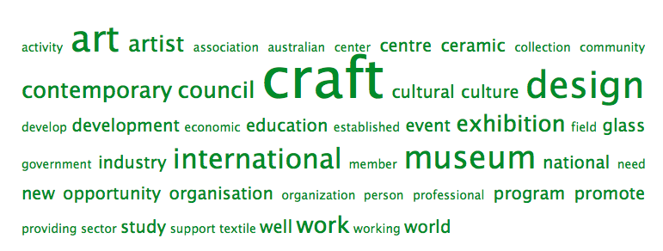

Attachment V – Markets and Fairs

To access the full research document, please visit: https://docs.google.com/spreadsheet/ccc?key=0AnNQ6DhaSaM2dEhucnRPcGVueXJpbWNvdXJXVms2bXc&usp=sharing

Summary: Markets and Fairs

Over 250 markets and fairs across Australia were identified and catalogued as a key part of the desk research project.

Over 35% of these markets/fairs are held in rural or regional areas, indicating that markets/fairs hold an important role in retail access for practitioners based in non-metropolitan areas.

While this research is relatively extensive, there are many more markets in existence that are not fully listed online. It is suggested that further research be conducted into the full breadth and spread of market opportunities in Australia for craft practitioners.

However, only XX of the markets listed were craft or handmade-only. While large markets and fairs like Finders Keepers have expanded interstate with specifically craft-based stalls, the majority of smaller markets are comprised of a mix of goods, with craft often listed as retailing alongside fresh fruits, performances and more.

It is proposed in this report that the data collected in this portion of the desk research will inform the development of a Google ‘Craft Map’ for Australia. A sample image of what this project will look like is included below:

Attachment W – Forms of Support Offered by Public, and Peak Bodies and Other Government Departments

To access the full research document, please visit: https://docs.google.com/spreadsheet/ccc?key=0AnNQ6DhaSaM2dEwyREppNHB1bG1wOXJTMlBGX25uM2c&usp=sharing

Summary: Forms of Support Offered by Public, and Peak Bodies and Other Government Departments

A survey of the varied non-grant or residency-based forms of support offered by public, and peak bodies and other government departments yielded 92 distinct results.

Of the forms of support listed, 27 were Australian Government Initiatives, from departments as varied as the Plantation Manufacturing Innovation and Investment Fund (PMIIF) and the AusTrade program. 10 of the support structures identified were not for profit peak bodies, including the National Association for the Visual Arts, and the Australian Council of University Art and Design Schools (ACUADS).

State Governments were shown to offer 17 distinct support mechanisms around the country, mostly through their arts departments, such as Arts Tasmania.

A word-based analysis of the most commonly occurring terms in each organisation’s form of support summary showed a high representation of activity based on: ‘Australian’, ‘art’, ‘business’, ‘community’, ‘cultural’, ‘government’, ‘community’, ‘creative’ and ‘development’.

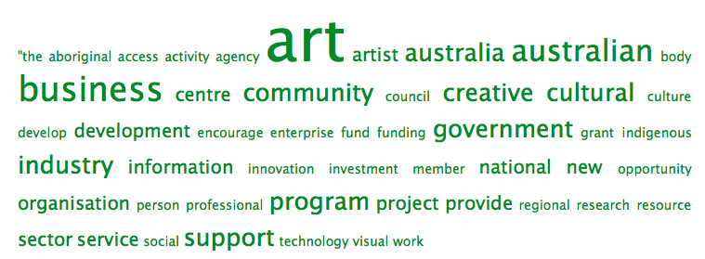

Attachment X – Skills Development Opportunities in the Creative Industries

To access the full research document, please visit: https://docs.google.com/spreadsheet/ccc?key=0AnNQ6DhaSaM2dGhhMWpWdUF2WnVaMHIyTVJBRDNpeHc&usp=sharing

Summary: Skills Development Opportunities in the Creative Industries

Attachment X – Skills Development Opportunities in the Creative Industries – attempts to outline some of the skills development opportunities that operate outside the regular education structures in the sector and offer development in ‘creative industries’ skills.

This survey is a sample only and it is proposed that this data set in expanded in future NCI Research.

The majority of these opportunities are delivered by four key bodies identified by the Australia Council in the creative industries ‘field’:

- ARC Centre of Excellence for Creative Industries and Innovation

- Creative Industries Innovation Centre (CIIC), University of Technology, Sydney

- Institute for Creative Industries and Innovation (iCi), Queensland University of Technology

- QUT Creative Industries Faculty

These bodies provide a wide range of innovative training, grants and support, including web development, internship programs and structured business mentorships.

A number of private providers of training, including some members of the Australian Centres for Craft and Design, were also surveyed, as they offer a number of key, form-specific training courses and mentorships.

Attachment Y – Major Exhibitions in Australian Craft 2009 – 20013 – A 5 Year Survey

To access the full research document, please visit: https://docs.google.com/spreadsheet/ccc?key=0AnNQ6DhaSaM2dGdmakhnRVkzM2p6cUc4OGZLeF80a0E&usp=sharing

Summary: Major Exhibitions in Australian Craft 2009 – 20013 – A 5 Year Survey

As part of the desk research component of this project, a survey was made of major exhibitions featuring Australian craft that have occurred in the last 5 years (with some notable exceptions outside this timeframe, including the 2007 Smart works exhibition at Sydney’s Powerhouse Museum).

Desk research was limited to what was listed online and therefore some data is missing for a number of galleries in latter years. It is proposed that these gaps in data collection are rectified in the next iteration of the desk research project.

All major state and national galleries were surveyed, along with Australian Centres for Craft and Design and notable regional galleries who feature a consistently strong craft exhibition program. The selection of these regional galleries was based on listings featured on the Craft Australia archived website. A total of 389 exhibitions were located and catalogued.

Key findings from this research are as follows:

- There were a significant number of craft related exhibitions in the past 5 years with 390 separate entries.
- The majority of exhibitions identified did not exclusively highlight one form of craft – approximately 33% (130 exhibitions) were classified as ‘various’ or mixed media.
- Of the exhibitions identified that were specific to medium, the most exhibited forms were textiles and ceramics, with an equal 52 exhibitions each. The third most popular form was glass (with 46 exhibitions) followed by jewellery, with 30 shows across the country.
- The state with the most craft exhibitions over this period was found to be the ACT – with 86 craft exhibitions over a 5-year period, followed by South Australia with 88 and NSW with 80.

There are many more major exhibitions that could indeed be added to this list and it is proposed by the author (NCI Program Manager, Bridie Moran), that this study be expanded to a 10-year period and more regional and commercial galleries included in an expanded survey.

Attachment Z. - Methodology

Background to the research project and methodology

During 2011 and 2012 the Australia Council for the Arts, through the Visual Arts Board, Australian Craft and Design Centers (‘ACDC’) and the National Association of Visual Arts (‘NAVA’) resolved to work together to develop and implement a major program for the benefit of contemporary craft in Australia. That program now has the formal title of the National Craft Initiative. This report Mapping the Australian Craft Sector – Findings and Issues was commissioned as part of that program.

This report has as its aims:
- To provide data about the Australian craft sector (a ‘state of the craft nation’), investigating three key areas:
  - Learning
  - Practice
  - Ecosystems (structures and taxonomy)
- To provide longitudinal data
- To articulate the current landscape – trends and imperatives - of craft and generate content and points for discussion for the 2015 NCI conference.

The methodology used was as follows:
- Desk research including widely based internet based searches of craft developments and studies here in Australia and internationally (see Attachments and Sources)
- Development and distribution of an online survey designed to engage primarily with craft makers around Australia, to form the basis of quantitative data on the learnings and practice of craftspeople (see Online Survey Outcomes)
- Discussion with industry leaders focused on the essential question of what do they think are the main issues for makers, organisations and themselves as leaders, to form the basis of the qualitative aspects of the report (see ‘Your role for Craft’ and Mosaic of Views)
- Analysis which aligns the outcomes of the quantitative and qualitative aspects of the report with other information such as previous surveys and government policies, to determine the main findings and allow the most important issues to surface (see Discussion).

Definition of Craft

A definition of an artform area as diverse and personally driven as the crafts is rarely attempted, for good reason, however, for this report the following definition has proved reasonable as a guideline:
- craft – most broadly but not exclusively, a type of art object or activity that generally exists in service to society and that has an aesthetic quality and or practical application, based on a creative process connected to materiality (Joe Pascoe, Craft Victoria Business Plan 2014-2016).

Issues

Methodology issues that arose during the research period included:
- the desirability of asking each interviewee exactly the same set of questions, however, the discussions that ensured reflected the topics of interests of the interviewees in addition to the survey questions and therefore gave additional value to the research.
- the desirability of gaining more online survey responses, however, the results were tracked on a real time basis and indicated true trend consistency at all times.

Whilst every effort has been made to ensure the accuracy of the information contained in this report, the author and NCI Office would be grateful to receive updates or corrections to enable any further related research outcomes to be amended.

Online survey questionnaire

The survey comprised 56 questions including open field responses. Further information may be available by request with regard to various combinations of the survey questions.

Hello, and thank you for taking a moment to undertake the National Craft Initiative's survey.
To undertake this survey, you just have to have some involvement in the world of craft in Australia whether you are a keen maker, professional crafts artist, collector, curator, educator or more.

By sharing your experiences, ideas and issues around craft, you are helping to shape the future of craft in Australia.
As a thanks for completing this survey, you go into the draw to win one of many amazing prizes, from NAVA, Etsy, Frankie and more.
10 minutes to do, with a lifetime’s impact on the crafts!

1. What is your name?

2. How would you define yourself? (Select all that apply)
craftsperson
maker
artist
designer
curator
arts sector employee
writer
hobbyist
Other (please specify)

3. Where are you based?
Victoria Metropolitan
Victoria Regional/Rural
Australian Capital Territory Metropolitan
Australian Capital Territory Regional/Rural
NSW Metropolitan
NSW Regional/rural
QLD Metropolitan
QLD Regional/rural
NT Metropolitan
NT Regional/rural
WA Metropolitan
WA Regional/rural
SA Metropolitan
SA Regional/rural
TAS Metropolitan
TAS Regional/rural
Other (please specify)

4. Do you have health or access issues that impact on your participation in the crafts sector?

Yes
No
I would rather not say

5. What is the highest level of education you have completed?
Completed School Certificate
Completed HSC
Completed Certificate III through TAFE or similar
Completed Certificate IV through TAFE or similar
Advanced Diploma or associate degree through TAFE or similar
Undergraduate University Degree
Undergraduate University Degree with Honours, Graduate Certificate, or Graduate Diploma
Masters Degree
Doctoral Degree
Completed graduate school
Other (please specify)

6. Do you have health or access issues that impact on your participation in the crafts sector?
Craft Practitioner
Craft sector/government employee, administrator or representative
Educator
Commentator/blogger
Craft buyer
Collector
Designer
Curator/Writer
Retailer
Other

7. Would you say that you are:
emerging
midcareer
professional
making crafts as a pastime
Other (please specify)

8. How many years have you been a crafts practitioner/maker for?
Under 5
5 10
10 20
20 30
30 +

9. How many days a week do you spend on your practice?
1
2
3
4
5
6
7
Other (please specify)

10. Which mediums do you often work with?
jewels and precious metals
ceramics
textiles
glass
wood
metal
leather
paper
plastics
recycled items
Other (please specify)

11. Where do you work on your practice/making?
home
own studio space
shared studio space
commercial studio
university
community workshop
Other (please specify)

12. What is your (approximate) annual income derived directly from your craft practice, inclusive of selling works, teaching, other?
$0 - $500
$500 - $1,000
$1,000 - $5,000
$5,000 - $10,000
$10,000 - $15,000
$15,000 - $30,000
$30,000 - $50,000
$50,000 - $100,000
$100,000 +

13. How much (approximately) do you invest in your interest in crafting each year?
$0 - $500
$500 - $1,000
$1,000 - $5,000
$5,000 - $10,000
$10,000 - $30,000
$30,000 - $60,000
$60,000 - $100,000
$100,000+

14. Who typically purchases your work? (List, i.e. "collectors", "home decorators", etc.)

15. Please list where you (mainly) sell your work:

16. Where have you exhibited your work? (select all that apply.)
Commercial gallery
Museum/major institution
Private or corporate collection
Artist run initiative
Studio space
Online gallery
Other (please specify)
Other (international)

17. I expect my crafts practice/business to grow in the next 5 years
Strongly disagree
Disagree
Neither agree nor disagree
Agree
Strongly agree

18. I expect my crafts business to grow in the next 5 years
Strongly disagree
Disagree
Neither agree nor disagree
Agree
Strongly agree

19. Further study would have a positive impact on my practice
Strongly disagree
Disagree
Neither agree nor disagree
Agree
Strongly agree

20. I feel like I have a strong career progression
Strongly disagree
Disagree
Neither agree nor disagree
Agree
Strongly agree

21. I would attend a national craft conference or event that addressed sector issues
Strongly disagree
Disagree
Neither agree nor disagree
Agree
Strongly agree

22. Marketing and publicity are challenges that I face in my work with the crafts
Strongly disagree
Disagree
Neither agree nor disagree
Agree
Strongly agree

23. I would like to see a code of practice developed for the crafts industry and sector
Strongly disagree
Disagree
Neither agree nor disagree
Agree
Strongly agree

24. I am aware of the impact of digital copyright and resale royalty rules and laws on my practice
Strongly disagree
Disagree
Neither agree nor disagree
Agree
Strongly agree

25. I find that grants, funding and support are difficult to locate, apply for and/or receive
Strongly disagree
Disagree
Neither agree nor disagree
Agree
Strongly agree

26. I believe that there any many new opportunities for makers and craftspeople online

27. I feel connected to the latest developments in craft
Strongly disagree
Disagree
Neither agree nor disagree
Agree
Strongly agree

28. I feel connected to a community within the crafts sector in Australia
Strongly disagree
Disagree
Neither agree nor disagree
Agree
Strongly agree

29. Would you like to tell us about any of your other activities in the crafts sector?
Yes, I want to talk about my work as an administrator, employee, curator or representative in the crafts sector!
Yes, I want to talk about how I purchase and collect craft objects and material!
Yes, I want to talk about my crafts business!
None of the above apply to me but I would like to say something else!
No, thanks, I am finished.

30. Which organization do you work for/with? (If applicable)

31. What types of services do you deliver for craft artists and designer/makers? (if applicable)

32. What programs or educational courses do you deliver for craft artists and designers/makers? (if applicable)

33. What opportunities do you see for the future development of the crafts sector nationally and internationally?

34. What policies (government and otherwise) would facilitate these developments?

35. What do you see as potential areas for collaboration between organizations?

36. Would you like to tell us about any of your other activities in the crafts sector?
Yes, I want to talk about how I purchase and collect craft objects and material!
Yes, I want to talk about my crafts practice and what I make!
Yes, I want to talk about my crafts business!
None of the above apply to me but I would like to say something else!
No, thanks, I am finished.

37. How many hand crafted items do you tend to invest in each year?

38. Approximately how much did you spend on craft (products, materials, artwork, etc.) in the last year?
$0 - $100
$100 - $250
$250 - $500
$500 $1,000
$1,000 - $5,000
$5,000 - $10,000
$10,000 - $20,000
$20,000 - $50,000
$50,000 +
$100,000+

39. What factors influence your investment in crafts products, works and materials?

40. What attracts you to a handcrafted/design product?

41. What might make you more likely to invest in a craft/design product, work, etc.?

42. Where do you go to discover craft/design products, news and events (please select all that apply and include as many others as you can)?
Blogs
Social Media
Magazines/Newspapers
Galleries
Retail Spaces
Industry Websites, i.e. ArtsHub
Markets and events
Other (please specify)

43. Would you like to tell us about any of your other activities in the crafts sector?
Yes, I want to talk about my work as an administrator, employee, curator or representative in the crafts sector!
Yes, I want to talk about my crafts practice and what I make!
Yes, I want to talk about my crafts business!
None of the above apply to me but I would like to say something else!
No, thanks, I am finished.

44. What kind of business do you operate or work in?
Gallery/retail/space
Online store
Dealership
Auction house
Other (please specify)

45. Where do you sell? (Please select all that apply)
Australia
International (please indicate where)

46. Approximately how much of your business is comprised of crafts products
(inclusive of art objects, handmade items, materials, etc.)?
0% 10%
10% 25%
25% 50%
50% 75%
75% 100%

47. If you don't mind telling us, how much do your approximate annual sales of crafts products or objects total?
$0 - $10,000
$10,000 - $15,000
$15,000 - $30,000
$30,000 - $50,000
$50,000 - $100,000
$100,000 - $200,000
$200,000 - $300,000
$300,000 - $500,000
$500,000 +
Other (please specify)

48. Would you like to tell us about your other activities and ideas in the crafts sector?
Yes, I want to talk about my work as an administrator, employee, curator or representative in the crafts sector!
Yes, I want to talk about how I purchase and collect craft objects and material!
Yes, I want to talk about my crafts practice and what I make!
None of the above apply to me but I would like to say something else!
No, thanks, I am finished.

49. Would you like to talk more about your experiences, ideas and needs in the crafts sector? Here's some space to have your say:

50. What is your age?
18 and under to 24
25 to 34
35 to 44
45 to 54
55 to 64
65 to 74
75 or older
I would rather not say
Other (please specify)

51. Do you have a website or blog? Please include a link if applicable.
Yes
No
Please include a link below:

52. What is your gender?
Female
Male
n/a
Other

53. What is your primary email address?

54. What is your address? (You may simply input your postcode if you would not like to enter our competition)

55. Thanks so much! Your answers and ideas are going to play a key role in shaping the National Craft Initiative and the future of crafts in Australia.
Would you like to stay in touch with the National Craft Initiative? We've got many exciting events coming up soon. Tick below to join our mailing list and go in the draw to win one of 10 National Association for the Visual Arts memberships, Frankie magazine prize packs, Peppermint magazine subscriptions and more.
As another thanks for taking the survey, all participants who would like to open an Etsy store can do so with 20 free listings! Simply visit https://www.etsy.com/promotions
And access free listings by using the code CRAFTSURVEY
Sign me up!
No, thanks, I'd rather not.

56. Are you a National Association for the Visual Arts member?
Yes
No
57. Thanks so much! Your answers and ideas are going to play a key role in shaping the National Craft Initiative and the future of crafts in Australia.

Merriam Webster online dictionary; http://www.merriam-webster.com/dictionary/craft
Pascoe, Joe Delinquent Angel – Australian, Aboriginal and Contemporary Ceramics, Muse della Ceramiche, Faenza, Italy, Centro Di 1995.
Attachment C, page 92
Attachment G
Attachment C
Attachment M
McNielage, Amy. Design Courses Hammered. Sydney Morning Herald, November 4 2013. Access online at: <http://www.smh.com.au/national/tertiary-education/design-courses-hammered-20131103-2wuor.html>
Figures according to Education Costs in Australia – Australian Government’s “Study In Australia” website. Figures accurate 2012 but subject to change. < http://www.studyinaustralia.gov.au/global/australian-education/education-costs>
Figures according to Education Costs in Australia – Australian Government’s “Study In Australia” website. Figures accurate 2012 but subject to change. < http://www.studyinaustralia.gov.au/global/australian-education/education-costs>
Attachment O
Deaves, J. National Craft Mapping Project. 2006. Craft Australia Press, Canberra, ACT
Attachments B and C
one/third (http://onethird.com.au/
Attachment B
Attachment B
Craft Victoria joined the World Craft Council in March 2013
Varadarajan, Soumitri website https://plus.google.com/107109956810388052985/about
Sangram Project; http://sangamproject.net/
The Social Studio; http://www.thesocialstudio.org/
NorthCity4; http://northcity4.com/
Victoria & Albert at Dundee, online visual fly-through; http://vandaatdundee.com/your-future/
Wischer, Lyndel National craft policy in Australia – a case for the future, Research paper, Advanced Arts Policy AMGT 90011, Melbourne University 2013
Attachment D
Attachment D
Attachment K
Attachment D
Attachment D
Attachment F
Attachment P
Attachment A
Attachment A
Annual reports; Craft Victoria, JamFactory, TactileARTS
Ibid
Attachment B
Annual reports; Craft Victoria, JamFactory, TactileARTS
Attachment N
Attachment O
Attachment B
Ibid
Ibid
Attachment B
McNielage, Amy. Design Courses Hammered. Sydney Morning Herald, November 4 2013. Access online at: <http://www.smh.com.au/national/tertiary-education/design-courses-hammered-20131103-2wuor.html>
This change is catalogued on the Training.gov website at: < http://training.gov.au/Training/Details/CUV10111>
Figures according to Education Costs in Australia – Australian Government’s “Study In Australia” website. Figures accurate 2012 but subject to change. < http://www.studyinaustralia.gov.au/global/australian-education/education-costs>
Figures according to Education Costs in Australia – Australian Government’s “Study In Australia” website. Figures accurate 2012 but subject to change. < http://www.studyinaustralia.gov.au/global/australian-education/education-costs>
This word analysis was generated using Stanford University program Word Sift, utilizing the full text from the “Functions” column of the Key International Organisations Desk Research Attachment U, available for view in the full data set link above. To see more, visit: <http://www.wordsift.com/visualize>
This word analysis was generated using Stanford University program Word Sift, utilizing the full text from the “Functions” column of the Key International Organisations Desk Research Attachment U, available for view in the full data set link above. To see more, visit: <http://www.wordsift.com/visualize>
List sourced from Australia Council for the Arts web page Creative Industries. Can be found online at: < http://www.australiacouncil.gov.au/research/hot_topics/creative_industries>

