
Sunshine Acres Camp and Conference Center
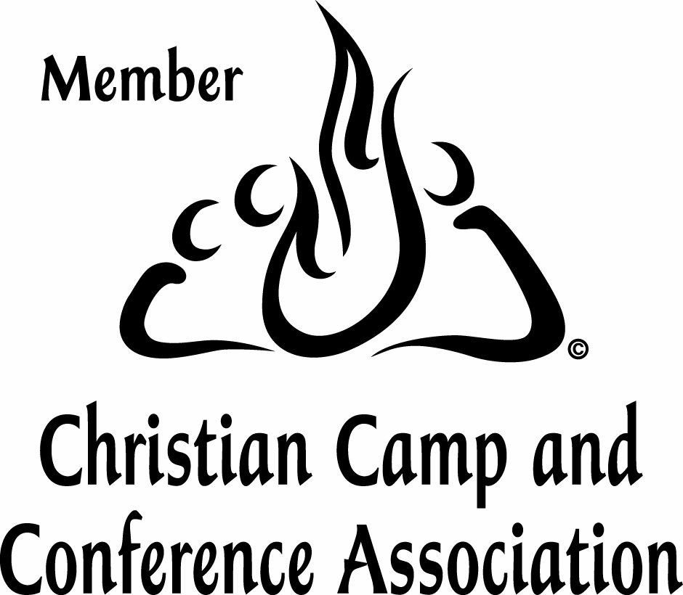
Young Peoples Baptist Union of Brooklyn and Long Island
www.sunshineacres.com

PARENT INFORMATION SHEET 2014

KEEP THIS SHEET. You will need it.

Dear Parents,
Sunshine Acres is run by a union of several Baptist Churches throughout Brooklyn and Long Island. Each church has a Church Rep who chooses the children who will go to camp. This sheet will walk you through the process of registering your child for camp. Please read this information and complete all forms front and back. Return them with your money order, copies of your insurance card and immunization information to your Church Rep. Questions should be directed to your Church Rep.
Church Rep:

Sticker Here

Session Dates:

Session 1 July 4-11 age 8-12
Session 2 July 11-18 age 8-12
Session 3 July 18-25 age 8-12
Session 4 July 25-Aug 1 age 8-12
Session 5 Aug 1-Aug 8 age 13-15 Teens
Camp Fees: It costs us over $400 for each camper to attend. We ask for a minimum of $240 per child. A non-refundable $40 deposit is due with registration. Money orders only (Payable to Sunshine Acres), no cash or personal checks.
Registration Deadline: All money and paperwork must be received by the registrar by 2 weeks before start of session. No one whose paperwork is incomplete 5 days before the bus leaves will be allowed to go.
Repeat Campers: Campers may attend more than one session during the summer, but not consecutive sessions. Parent must pay for the repeat session in full ($240).
Special Needs: Campers must be able to attend regular classes for children their age. We are not equipped for special needs.
The Bus: Please arrive at the bus stop between 10 and 11 AM on the morning your session begins. The bus leaves from Bellerose Baptist Church. Directions are on the back of this sheet. We will not wait for latecomers.
You must check in with the registrar to make sure you are properly registered and to drop off any medications.
Meet your child back at Bellerose Baptist at the end of the session. Pick Up time is 11:00 am. Please be on time.
Before You Leave
Please make sure your child is clean and free from lice or nits. You should examine your child’s head two weeks before camp and again within 2 days before camp. Children found to have head lice during camp inspection will be sent home.

Disciplinary Action:
If your child needs to be sent home during a camping session due to illness, disciplinary action, head lice, etc., you are responsible for your child’s transportation home.

Communicating With Your Child at Camp
Phone calls and visits from parents are not permitted during camp sessions. There is no phone available for campers to communicate with their parents. Cell phones are not allowed.
The best way to communicate is writing. We encourage you to send your first letter before your child leaves home so they have mail from you when they get to camp.
Please send camper mail to:
YOUR CHILD’S NAME, Sunshine Acres
165 Sportsman Road, Napanoch, NY 12458
We will also be glad to deliver faxed notes to your child.
(Be sure to put your child’s full name on the fax).
Fax #: 1-845-647-2871

If Your Child Needs Medical Attention:
Every effort will be made to contact you as a parent if your child needs medical treatment outside the camp.
If your child needs medical treatment, your medical insurance company is responsible for the cost. You as a parent are responsible for any communication with your insurance company that is needed.
During the time your child is at the camp, he/she is covered for medical expenses not covered by your insurance company within the limitations of the camp’s policy.
Do Not Bring: These items will be taken away and held until after your child leaves camp.
● Cell Phones, ipods, radios, electronic games or devices…
● Weapons, Army knives, etc.
● Drugs, alcohol, cigarettes, matches, lighters, fireworks…
● Food of any kind (except a bag lunch for the bus.)
● Anything that may cause camper distraction or disruption of the camp experience.

What to Bring:
Please make sure that all individual items and luggage are labeled clearly with the child’s name.
□ Clothing: Enough clothing for the # of days you will be at camp. Must be modest, inoffensive, casual and appropriate for playing sports. Don’t forget Sneakers and pants.
□ Bathing Suit, Towel, Shower Shoes, Sun Block, Bug Spray
□ Towels, Face cloths, Soap, Shampoo, Deodorant, Comb, Toothpaste, Toothbrush, Cup
□ Jacket, Rain Gear, Flashlight
□ Bible, Small Notebook, Pen, Stationery, Stamps
□ Sleeping Bag: (Optional.) Pillows, sheets and blankets are provided.
□ Medications: In their original packaging with your doctor’s instructions, in a Ziploc bag with your child’s name on it. You will need to turn this in at the bus. Nothing can be administered without the doctor’s permission on the medical form. Don’t forget car sickness meds if your child needs them.
□ Money: Dug Out (Snack Shop), Gift Shop and Offering: $30-35 is the average spent per child for snacks, offerings and souvenirs.
This money should be placed in an envelope marked with your child’s name. Your child will give it to his/her counselor upon checking in at camp.
□ Lunch: Bring a bag lunch for the bus ride.

Directions to the Bus Stop
Bellerose Baptist Church
240-20 Braddock Ave, Bellerose, NY 11426

From Manhattan or Bronx
(From Manhattan) Take the LIE
(From Bronx) Take Throggs Neck or Whitestone Bridge
to the Cross Island Parkway South
Exit 27W – Braddock Ave/Jamaica Ave
Right at STOP sign onto Braddock Ave
Church is 2½ blocks on your left.
From New Jersey & Brooklyn or Long Island
(From New Jersey & Brooklyn) Take Belt Pkwy East
(From Long Island) Take Southern State
to Cross Island Parkway North
Exit 27 Jericho Tnpk/Jamaica Ave
Make a Left onto Jamaica Ave
Make a Right at 240th Street
Parking lot is two blocks on your right.
Public Transportation
Take F train to 179th Street
Take Q1 Braddock Ave (not Springfield Blvd Bus)
Go to 240-20 Braddock Ave (Approx. 20 minutes)

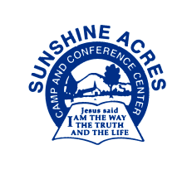 Sunshine Acres Camp and Conference Center
Young People’s Baptist Union of Brooklyn and Long Island
www.sunshineacres.com

Camper Application

Indicate Session you are Applying For: (See Parent Info Sheet for dates and age requirements)
__Session 1 __Session 2 __Session 3 __Session 4 __Session 5 (Teen Week)
____________________________________________________________________________________________________________
Please Print Clearly
Child’s Name: _______________________________ ________________________ Girl __ Boy__
(Last) (First)
Home Address: _______________________________________ Apt. #: __________

City: ______________________________ State: _______ Zip: ________________

Date of Birth: _____/_____/_____ Age: ______ Roommate Request: ____________________________
Name of Parent/Guardian: ________________________ Home Phone: _____________________________

Cell Phone: _____________________________ Work Phone: _______________________ Ext: ________

I hereby give my son/daughter permission to attend the summer program at Sunshine Acres. I understand that any photos taken of my child while at camp, the bus stop or any Sunshine Acres activity become the property of Sunshine Acres and may be used for any legal purpose including publicity and advertising.
________________________________________________ _____________
(Parent Signature) (Date)
This camper will take the camp bus__ I will arrange for my child’s transportation to camp__
__________________________________________________________________________________________Please return your completed forms, money order and copy of insurance card to your Church Rep no later than two weeks before the start of your camp session:
Church/Rep/Phone:

Sticker Here

For Camp Registrar Use Only – Do Not Write in this Space
Deposit □ Ck # __________________ Amt:_____ Camp Fee □ Ck #______________ Amt______
App Parent Sig □ Med Form □ Parent Sig □ Doc Sig □ Doc Name □ Doc Phone # □
Imm □ Ins Cd □ Resp Form □
Sent Postcard: Incomplete □ Date________ Complete □ Date ________

Confidential Form

To My Child’s Camp Counselor:

My child has problems with the following: (Check all that apply)

□ Bedwetting □ Sleepwalking □ Afraid of Dark □ Asthma*
□ Hyperactivity* □ Attention Deficit* □ Anxiety/Depression*
□ Learning Disability*
□ Other: _______________________________________________________________
*Is this under control enough that the child can attend a regular class for his/her age?
□ Yes, with medication. □ Yes, without medication. □ No

Here are Some Tips to Help:

Please take into account the following hardships my child is facing at home:
(Check all that apply)

□ Parents are divorced or separated
□ Severe illness or recent death of an immediate Family Member
□ Severe financial problems
□ Poor moral or spiritual conditions at home
□ Other: ____________________________________________________________

Notes:

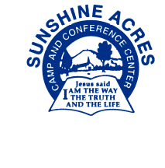Sunshine Acres Camp and Conference Center
Young People’s Baptist Union of Brooklyn and Long Island
www.sunshineacres.com

Medical Form
(To Be Completed by Parent or Guardian and Signed by Both Doctor and Parent)

Please Print Clearly
Child’s Name: _______________________________ ________________________ Girl Boy
(Last) (First)
Home Address: _______________________________________ Apt. #: __________ Session # ___________

City: ______________________________ State: _______ Zip: ________________ YPBU Church: ____________________

Date of Birth: _____/_____/_____ Age: ______ Church Rep: ______________________

Name of Parent/Guardian: ______________________________ Home Phone: __________________________________

Cell Phone: _________________________________________ Work Phone: _______________________ Ext: ________

Doctor’s Name: _______________________________________ Doctor’s Phone #: _______________________________

Emergency Contacts: List two other people to be notified if you cannot be reached in case of an emergency.

Name__________________________ Phone ______________________ Relationship to Child ______________________

Name__________________________ Phone ______________________ Relationship to Child ______________________
Health History Yes No Allergies Yes No Diseases Yes No
Convulsions ____ ____ Hay Fever ____ ____ Chicken Pox ____ ____
Diabetes ____ ____ Asthma ____ ____ Rubella ____ ____
Bedwetting ____ ____ Poison ____ ____ Rubella ____ ____
Sleepwalking ____ ____ Insect Bites ____ ____ Mumps ____ ____
Heart Problems ____ ____ Penicillin ____ ____ Pneumonia ____ ____
Kidney Problems ____ ____ Other Drugs ____ ____ Chronic Illness: ____ ____
Rheumatic Problems ____ ____ Foods (LIST) ____ ____ _____________
Surgery _________ ____ ____
Please explain any Yes answers above. Indicate Allergies & Dietary Issues: _____________________________________________________
________________________________________________________________________________________________________
Immunizations: Fill in below OR attach Immunization Record.
MMR:________ OR Measles:______ Mumps: ______ Rubella: _______
Polio: 1____________ 2____________ 3_____________ 4_____________
Dipth-tetanus: 1____________ 2____________ 3_____________ 4_____________

Medical Insurance: Does your child have medical insurance: Yes □ No □
If yes, please attach a copy of both sides of this child’s Insurance Card.
Name of Parent carrying insurance: _________________________________ Soc. Sec. #: _________________
Parent Birth Date: ________________________ Name of Insurance Carrier: ____________________________
ID#: ___________________________________ Group Number: ______________________________________

Consent For Medications: (Note: If you do not check it, we cannot administer it.)
Tylenol____ Motrin____ Pepto-Bismol_____ Benedryl______ Kaopectate______

This child has had a medical check-up within 12 months prior to arrival at camp. To my
knowledge there are no physical ailments which would prevent the above named
camper from taking part in all the activities, including athletics and sports, at Sunshine Acres.
You have my permission to authorize treatment or an operation on this camper in an
emergency at Ellenville or Benedictine Hospitals.
Parent Signature: ____________________ Date: _______ Doctor’s Signature: ___________________ Date:_______
Meningitis Response Form

Please Print Clearly
Camper’s Name: __________________________________ Date of Birth: ___________
Parent/Guardian’s Name: _____________________________________________________

Check one box and sign below:
- My child has had the Meningococcal Meningitis immunization (MenumuneTM) within the past 10 years. Date received: ____________

- I have read, or have had explained to me, the information regarding Meningococcal Meningitis Disease. I understand the risks of not receiving the vaccine. I have decided that my child will not obtain immunization against Meningococcal Meningitis Disease.

Parent’s Signature: ______________________________________ Date:__________

Dear Parent:
Please read the following information, then complete the Meningitis Response Form above.
New York State Public Health Law §2167 requires overnight children’s camps to distribute information about Meningococcal Disease and vaccination to the parents or guardians of all campers who attend camp for 7 or more nights. We are also required to keep documentation for each camper proving that we have done this and stating that either your child has been immunized, or you are aware of the availability of a vaccine but have chosen not to have your child immunized.
Information about the availability and cost of the vaccine can be obtained from your health care provider and by visiting www.meningitisvaccine.com. Sunshine Acres does not offer vaccines.
NEW YORK STATE DEPARTMENT OF HEALTH
Bureau of Communicable Disease Control
___________________ _____________________________________

Meningococcal Disease
Information for College Students and Parents of Children at Residential Schools and Overnight Camps.
- What is Meningococcal Disease?
Meningococcal Disease is a severe bacterial infection of the bloodstream or meninges (a thin lining covering the brain and spinal cord.)
- Who Gets Meningococcal Disease?
Anyone can get Meningococcal Disease, but it is more common in infants and children. For some college students, such as freshmen living in dormitories, there is an increased risk of Meningococcal Disease. Between 100 and 125 cases of Meningococcal Disease occur on college campuses every year in the United States; between 5 and 15 college students die each year as a result of the infection. Currently, no data is available regarding whether children at overnight camps or residential schools are at the same increased risk for disease. However, these children ca be in settings similar to college freshmen living in dormitories. Other persons at increased risk include household contacts of a person known to have had this disease, and people traveling to parts of the world where Meningitis is prevalent.
- How is the germ Meningococcus spread?
The Meningococcus germ is spread by direct close contact with nose or throat discharges of an infected person. Many people carry this particular germ in their nose and throat without any signs of illness, while others may develop serious symptoms.
- What are the symptoms?
High fever, headache, vomiting, stiff neck and rash are symptoms of Meningococcal Disease. Among people who develop Meningococcal Disease, 10 - 15% die, in spite of treatment with antibiotics. Of those who live, permanent brain damage, hearing loss, kidney failure, loss of arms or legs, or chronic nervous system problems can occur.
- How soon do the symptoms appear?
The symptoms may appear 2 to 10 days after exposure, but usually within 5 days.
- What is the treatment for Meningococcal Disease?
Antibiotics, such as penicillin G or ceftriaxone, can be used to treat people with Meningococcal Disease.
- Is there a vaccine to prevent Meningococcal Meningitis?
Yes, a safe and effective vaccine is available. The vaccine is 85% to 100% effective in preventing four kinds of bacteria (serogroups A, C, Y, W-135) that cause about 70% of the disease in the United States. The vaccine is safe, with mild and infrequent side effects, such as redness and pain in the injection site lasting up to 2 days. After vaccination, immunity develops within 7 to 10 days and remains effective for approximately 3 to 5 years. As with any vaccine, vaccination against Meningitis may not protect 100% of all susceptible individuals.
- How do I get more information about Meningococcal Disease and Vaccination?
Contact your family physician or your student health service. Additional information is also available on the website of the New York State Department of Health: www.health.state.ny.us. AND The Centers for Disease Control and Prevention: www.cdc.gov/ncid/dbmd/diseaseinfo. AND The American College Health Association: www.archa.org.

