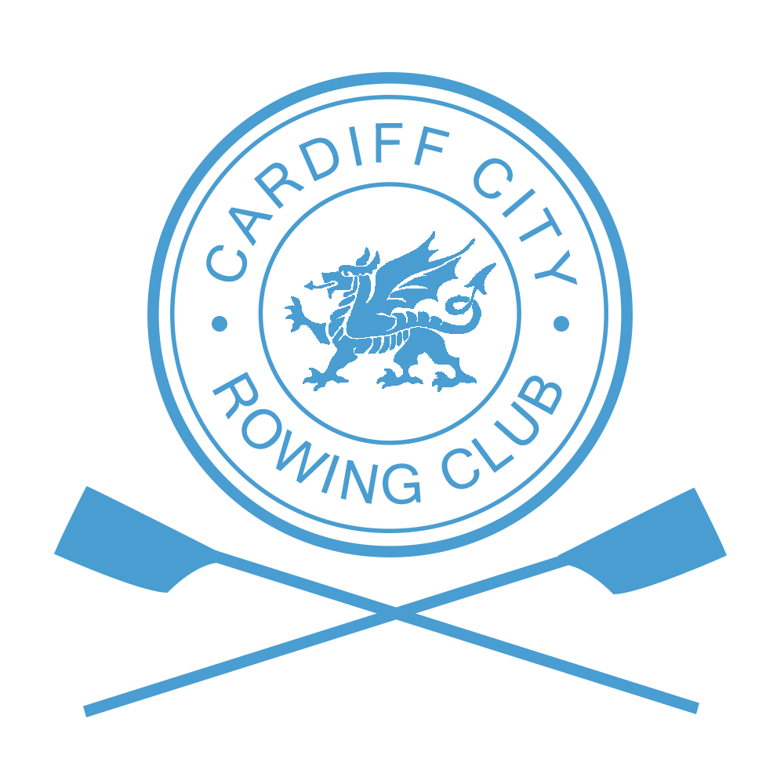

Competition Safety Plan

This safety plan has been formulated after completion of the risk assessment carried out by the Cardiff City Rowing Club safety officer for this event.

This document should be read in conjunction with the Safety Instructions and course map.

Boat Access and Storage
All Trailers will access the venue via Jim Driscoll Way. The marshal at the road entrance will direct trailer drivers to their allocated location where trailers must be unhitched and the towing vehicle removed for off-site parking. Boat rigging will take place on the grassed areas near the trailer.

All boats will launch from the rowing pontoons at Cardiff Bay Water Activity Centre (Channel View Centre).

Each crew will be responsible for ensuring their boat is safe and meets the requirements required by their respective Rowing Association. Spot checks will be carried out by race marshals.

Crew Briefing
A crew briefing will be held in front of the boathouse at Cardiff Bay Water Activity Centre before boating commences for each division. The Division 1 briefing will be held at 0830hrs prior to boating from 0845hrs. The Division 2 briefing will be held at 1215hrs prior to boating from 1230hrs.

Course Map
Copies of the course map will be available from the Club website.

After boating, all crews must row up to their respective start and line up in number order. Normal rules of navigation should be observed. All boats must keep to the city side of the river when rowing up to the start.

River Closure
The course will be inspected at 0730hrs. Safety launches will proceed up the river prior to the boating of competitors.

The river will be closed to all craft except those directly involved with the Head during racing. The river closure will be enforced by a member of the Cardiff Harbour Authority positioned downstream of the PDR Bridge.

Marshals and Safety Launches
A team of marshals will be deployed along the length of the course to ensure that visual cover of the course is maintained throughout the event. Each marshal will be provided with a radio/mobile phone and safety equipment designated for their location.

Safety launches will be positioned along the course throughout the event. Each launch will carry emergency equipment and a first aid kit. In the event of an emergency the nearest launch will attend the scene. The location of all launches and marshals is shown on the course map.

First Aid
The Civil Aid Voluntary Rescue Association (CAVRA) will provide assistance in the event of a serious accident. Qualified personnel will be available throughout the day. A first aid vehicle will be located by the slip way at Channel View.

Emergency Action Plan
The risk assessment recognises that the weather may affect this event.

The following weather conditions will determine if the race should continue.
- Water speed in excess of 60m³/s, the course will be shortened. If the flow is very fast the race will be abandoned.
- Wind speed in excess of 25mph, racing will be abandoned. If the wind is strong then vulnerable adults, juniors and single sculls will not be permitted to race.

Advice will be sought from Cardiff Bay Barrage Control (029 2070 0234) concerning weather and water conditions.

Process for Cancelling the Event
The Cardiff City Rowing Club Operating Procedure OP_02 (copy available on request to Regatta Secretary or on the day in race control) will be used throughout the event to determine whether racing can take place. The advice of the umpires will be taken before any decision is made by the organising committee.

Emergency Contacts
A full list of marshals, umpires and launch drivers together with their radio numbers and mobile phone numbers will be provided to each official. A copy will be available in Race Control.

The race organiser can be contacted by phone 07791 516177 from 0700hrs on the day of the race.

