KONA HONGWANJI
BUDDHIST TEMPLE



E - JIHO

September 2011

Theme & Slogan 2011: Path of Entrusting: Listen and Reflect!

MEMORIAL SERVICE for JAPAN’S EARTHQUAKE and TSUNAMI VICTIMS
Sunday, September 4, 2011 at 9:00 a.m.
Speaker: Reverend Shoji Matsumoto

PEACE DAY SERVICE
FRIDAY, September 16, 2011 at 7:00 p.m.

AUTUMN O-HIGAN SERVICE
Sunday, September 25, 2011 at 9:00 a.m.
Guest Speaker: Reverend Yuika Hasebe
Minister at Honpa Hongwanji Hilo Betsuin

SERVICE and UNITED BWA CONVENTION
Sunday, October 16, 2011 at 9:30 a.m.
Keynote Speaker: Reverend Ronald Kobata, Buddhist Church of San Francisco

KYODAN SPONSORED BAZAAR: SUNDAY, OCTOBER 23, 2011
Manju making – Saturday, October 22, 2011 at 7:00 a.m.
Detail information found under (FYI) “Bazaar” in this month’s Jiho

NEED THE ASSISTANCE OF THE MINISTER OR TO SCHEDULE SERVICES/ACTIVITIES
Please call the church office at 323-2993 Monday thru Friday 8:00 a.m. to 4:00 p.m. Office will be closed on weekends and holidays. If unable to contact the office clerk, leave a message on the answering machine. In case of emergencies and unable to contact office clerk, call Rev. Shoji Matsumoto at
323-2993 or cell 987-9900,or Stanley Kunitomo, at 328-2107 or cell 987-5524.

SEPTEMBER
1 Thursday …… 9:30 AM …. Minister’s Meeting in Kona
4 Sunday …….. 9:00 AM …. Memorial Service for Japan’s Earthquake and
Tsunami Victims
7 Wednedsay … 7:30 PM … Preschool’s Board of Director’s Meeting
9 Friday ……… 8:30 AM …. Senior Activity Program
10 Saturday …. 7:00 AM …. Cub Scouts Pancake Breakfast & Silent Auction
10 Saturday thru 11 Sunday ……. Lay Convention in Maui
11 Sunday ……. 9:00 AM …. English Family Service
12 Monday thru 15 Thursday …… Minister’s Seminar in Kauai
16 Friday ……… 7:00 PM …. Peace Day Service
17 Saturday ….. 9:30 AM …. HIUHBWA Pre-Convention Meeting
18 Sunday ………………………… NO SUNDAY SERVICE
Peace Day Parade in Honokaa
24 Saturday ….. 8:00 AM …. Hosha - #1; Food Prep - #3; Omigaki - #2
25 Sunday ……. 9:00 AM …. Autumn O-Higan Service
Guest Speaker: Rev. Yuika Hasebe
2:00 PM … Big Island Council Meeting @ Sangha Hall

OCTOBER
2 Sunday …….. 9:00 AM …. English Family Service
9 Sunday …….. 9:00 AM …. English Family Service
12 Wednesday .. 6:30 PM …. Board of Director’s Meeting
14 Friday ……… 8:30 AM …. Senior Activity Program
15 Saturday …… 8:00 AM …. Omigaki – Group #3
2:00 PM …. BWA – Hall Set-up
16 Sunday ……. 9:30 AM …. Service – BWA Convention
Keynote Speaker: Rev. Ronald Kobata of BCA
19 Wednesday thru 21 Friday ….. Kyodan Bazaar Prep
8am-12 pm 1pm-4pm and 6pm-8pm Rummage drop off
22 Saturday …… 7:00 AM …. Education Fund Manju Baking
23 Sunday ………………………… NO SUNDAY SERVICE
9:00 AM …. Kyodan Bazaar
30 Sunday …….. 9:00 AM …. English Family Service

CUB SCOUTS & BOY SCOUTS
EVERY MONDAY CUB SCOUT PACK 12 MEETING AT 5:00 PM
EVERY WEDNESDAY & THURSDAY CUB SCOUT PACK 12 MEETING AT 5:00 PM EXCEPT 1ST WEDNESDAY
EVERY TUESDAY BOY SCOUT TROOP 59 MEETING AT 7:00 PM
TAIKO PRACTICE
EVERY THURSDAY TAIKO PRACTICE AT 5:30 PM
TAIKO MEETING EVERY 2nd THURSDAY IN THE CONFERENCE ROOM AT 6:30 PM
JUDO PRACTICE
JUDO CLUB MEETING EVERY 1ST WEDNESDAY IN SCOUT ROOM
EVERY MONDAY AT 7:00 PM NIGHT CLASS
EVERY WEDNESDAY AT 6:00 PM NOVICE; 7:00 PM NIGHT CLASS
EVERY TUESDAY AT 6:30 PM ADULT BEGINNERS
EVERY THURSDAY AT 7:00 PM CHOKE ARM BAR CLASS
IKEBANA
EVERY 2ND SATURDAY AT 9:00 AM IN THE SCOUT ROOM
TAI CHI CLASSES
EVERY MONDAY & WEDNESDAY AT 10:30 AM
DHARMA TALK CLASSES
EVERY TUESDAY AT 9:00 AM and 7:00 PM IN THE CONFERENCE ROOM
KYUDO CLASSES
EVERY SATURDAY AT 1:00 PM IN THE JUDO HALL
URASENKE TEA CEREMONY
EVERY 1ST & 3RD THURSDAY FROM 9 AM IN THE SOCIAL; HALL ON THE STAGE

MEMORIAL SERVICES FOR SEPTEMBER and OCTOBER 2011

One Year (2010) September 13 KUMIKO OMORI
October 25 TOKIO TAKAMOTO

Three Years (2009) September 16 BRENT AKIO YANAGI
26 TOSHIO NAKAMOTO
October 18 YUKIKO K. KUROZAWA
22 MITSURU IRENE OKUMURA

Seven Years (2005) September 14 TORAMI “AMY” SATO
October 13 CLARENCE KIYOSHI MURATA
30 HIROSHI TANAKA

Thirteen Years (1999) October 9 RUBY SHIMEKO MURASAKI

Seventeen Years (1995) September 25 KAORU SHIKADA
27 LARRY MINORU MATSUYAMA
October 10 RONALD KIYOSHI ASAKURA
27 CHIYOKO NAKAMARU

Twenty-Five Years (1987) September 30 TORI INOUYE

Thirty-Three Years (1979) October 18 JOHN SHOTARO NAGATA

Fifty Years (1962) September 14 JITSUO NONAKA
19 LINDSEY AMINA
26 KAZUYAKI MASUDA
October 7 TOJI UCHIMURA
22 SANFORD YASUO YANAGI

One Hundred Years (1912) August 19 YUTARO TOKUNAGA
September 6 SETSU TAKEGUCHI
13 NOBORU YOKOYAMA
30 SHIKE YAMAGUCHI
October 15 TASABURO USHIJIMA
22 TOKICHI KANEO
22 YAKICHI SACHIDA
23 ASANO YAMASAKI

Humility, Compassion, and Gratitude by Rev. Shoji
I just re-read Lindsey Byars’ Jiho article in which she says, “The essence of Shin Buddhism as Shinran Shonin learned was to live with humility, compassion, and gratitude.” Her article helps me see the Buddha, the Dharma, and the Sangha in a new way.
I used to say that the teachings of the Buddha -- the tools of mindfulness, lovingkindness, wisdom, and compassion -- might certainly exist independently of the Buddha. And yet, from now on, whenever I say I go to the Buddha for guidance, I want to remember that the Buddha was a Bodhisattva in his past lives. For our sakes, this Bodhisattva, who has reached the threshold of Nirvana, has kept himself from taking the final step into Bliss. He has deliberately condemned himself to go on haunting the sorrowful treadmill of existence. And he has made this extreme sacrifice because of his love for us fellow sentient beings whose feet he can guide into the day of salvation so long as he pays the huge price of remaining sentient and suffering himself. With this image of the Buddha, I am momentarily saved. How humble and grateful I feel to this compassionate Buddha. Now I see the Buddha as my hero.
Next time when I say I go to the Dharma for guidance, I want to remember the Buddha’s wise Dharma. It goes like this. One day the Buddha said to his disciples: “What matters is how you treat people. Treat them with love and compassion. What happens will happen, no matter what you believe. What you do is the important part. Do not worry about the other people or about what they say. Remember that it is what you do and think that matters. All that we are is the result of what we have thought; it is built on our thoughts; it is made from our thoughts. If a man speaks or acts with evil thought, pain follows him. If a person speaks or acts with pure thought, happiness follows him.” From now on, I will let this wise Dharma encourage me to think, speak, and act humbly, compassionately, and gratefully.
The Sangha has been helping me practice humility and compassion, and its members are my dharma friends ready to help me at all times. For this I am grateful to them. With this in mind, I will continue to say I go to the Sangha for guidance. My life alone is perfectly worthless, not even imaginable. I need the Sangha to become fully myself. None of us is truly ourselves in isolation. At the same time, the Sangha needs us creative individuals. Each of us may find in his or her own mind the collective yearnings, the collective dreams, and collective potential of the whole human race. To grow in myself is inseparable from helping others, from helping them grow. To transform myself is to transform others, to transform our community, and, eventually, to transform our world.
Since my Buddhist life is the journey, my happiness does not reside at the destination but along the way. Each day I am given new chances to be present in the now, to touch and be touched by the people I meet, to learn to be humble, compassionate, and grateful.

Young Shakyamuni by William Tokuko Lundquist
This month I’d like to delve more deeply into what kind of man Shakyamuni really was. The earliest written record of his words is the Pali Canon, which first appeared about 400 years after his death. It is a vast work, running 5,500 pages in English translation. In the passages, Shakyamuni is variously portrayed as a solitary holy man, wandering remote forests, or as a public figure preaching to thousands and honored by the rich and powerful, or even as a superman with an appearance and powers beyond mere mortals. Some passages, however, describe a Shakyamuni we can identify with today.
In his book, “Confession of a Buddhist Atheist,” former Tibetan and Zen monk Stephen Batchelor wrote, “Yet in other passages he (Shakyamuni) is depicted as just an ordinary-looking monk, harassed by the ambitions of his family, frustrated by disputes among his followers, who spent his time walking up and down the North Road tirelessly trying to get his message across and prevent his community from fragmenting.”
You can look at Shakyamuni any way you like, and find passages in the Pali Canon to back you up, but I prefer to think of him as having feelings and problems just like the rest of us, even after his enlightenment. That means ordinary people like us can indeed become Buddhas, aware of the cause of suffering and joy in our lives, living happier lives because of that knowledge. I doubt Shakyamuni was really “the world-honored one” in his time, but for what he discovered and passed down to us, he truly deserves that title today.
We don’t even know his real name, but he was born into a clan called Gotama in the land of Sakiya in what is today northern India. “Shakyamuni” is a later title meaning “sage of the Sakiyas.” Sakiya had been a republic, governed by an assembly. His father, Suddhodana, was the head of that assembly, making him sort of like the speaker of the house today. Sakiya had been conquered by the kingdom of Kosala, so Suddhodana was really more like a governor. Shakyamuni grew up as a nobleman, but in a place where everything was made of sun-baked mud bricks. He wasn’t a prince and only lived well compared with others in his time and place.
The Pali Canon is mostly concerned with the teachings of the Buddha, not how he grew up, so it says little about the first 29 years of his life. We know more about Shakyamuni’s contemporaries: Pasenadi, king of Kosala, and Bandhula, a noble from Malla, another province of Kosala, who rose to command Pasenadi’s army. They, and other young men of Shakyamuni’s age and rank, were sent to study at the University of Taxila, the capital city of Gandhara, in the Persian Empire. Taxila was 780 miles northwest of Shakyamuni’s hometown of Kapilavatthu. The North Road ran all the way from Taxila in Persia, through Kosala, to Rajagaha, the capital of the neighboring kingdom of Magadha. Young noblemen from all along the road studied in Taxila. There is no proof Shakyamuni was among them, but it would be strange if he weren’t.
The sayings of Shakyamuni showed that he was familiar with Gandhara and its customs. He told a parable of ruined stone cities in the forest. There were none of these in Kosala, where cities were built of perishable mud brick, but ancient stone ruins did exist in Gandhara. Also, Mara, the devil or tempter, appears often in Shakyamuni’s stories, but the concept of the devil did not exist at that time in the Hindu world of Kosala. It came from the religion of the Persians.
So why does the connection between Shakyamuni and Persia matter? First, it would help explain why and how Shakyamuni launched a revolution against the traditional Hindu beliefs of his time. He rejected the idea of caste, that people are born above or below others based on their past lives. He elevated women from mere property to people capable of enlightenment. He eventually even took the step of allowing them to join his Buddhist order as nuns. Finally, he turned reality on its head by insisting there is no individual, unchanging soul within each human that passes on to heaven, hell or new lives. Much of this was influenced by Persia, whether Shakyamuni studied there or learned from others who had. Persia was west of India, which is why Buddha lands like the Pure Land are always described as being in the west. Rev. Shoji taught me that.
Second, if Shakyamuni studied in Taxila, and then maybe worked in the government or military of Kosala for a while, it would explain why he did not father a child until he was 28. Most noblemen in his society married in their teens. We always wonder how Shakyamuni could abandon the family he loved so much. Maybe the pursuit of enlightenment was always his first love. He may have returned home in his late 20s only to marry and sire an heir, fulfilling the obligation to his clan, before leaving to continue his goal. He would have known that his wife and son would have been well cared-for by the clan, so he had no obligation to provide for them.
Batchelor wrote, “His awakening is thus not a timeless mystical insight that appears out of the blue, but may have been the culmination of at least fifteen years of travel, study, reflection, discussion, meditation and austerity.” Does this Shakyamuni not seem like a real person who had to learn about life the hard way, like most of us? The hardest part was still ahead. Keep in mind this was some 1,500 years before Honen and Shinran discovered the “easy” path of Other Power and the Pure Land. Next month let’s take a look at what Shakyamuni learned and how that affected his life, and ours.

FOR YOUR INFORMATION

NOMINATING COMMITTEE
President Kunitomo appointed Norma Matsumoto, Alan Matsumoto and Lisa Ciriako to the Nominating Committee for the 2012 - 2014 Kyodan Officers and Board of Directors. Please kokua and don’t say “no” when asked to serve. The next few years will be interesting, challenging and critical as we strive toward financial stability. Say “yes” to bring fresh ideas and be part of the solution to guide our Kyodan into the next decade.

BAZAAR--Sunday, October 23, 2011
Members are asked to start gathering items no longer being used but in good condition to donate to the Bazaar. Items for sale will include rummage, produce, manju and plate lunch. Rummage should be brought to the social hall on October 19, 20 and 21, 2011 as the hall will be open from 8:00 am to 4:00 pm and 6:00 pm, to 8:00 pm. Do not leave items unattended. Check this month’s Jiho for manju and plate lunch pre-order forms. Additional manju and plate lunch will be available on day of Bazaar. Manju making will start at 7:00 a.m. on Saturday, October 22, 2011. We need help, please contact Betty Takeoka, Norma Matsumoto, Morris Nagata or Mary Katayama for more information.

T-SHIRT SALE
Kona Hongwanji T-shirts on sale for $15. Check article in Jiho for details. Available in the office. Contact office clerk at 323-2993 to order

POLO SHIRT
Available for $35. For men, colors are: White, Black, Dark blue. Front insignia is wisteria crest, with Kona Hongwanji Buddhist Temple. Back is plain. Sizes S, M, L, XL. Contact Judy to order.
For women’s polo shirt, contact Mary Katayama or office clerk to see sample and colors available. Same design in front (back plain). Cost $35.

2012 HONGWANJI CALENDARS
If you have not already done so, please call the church office (323-2993) to reserve the 2012 Hongwanji Calendar. All request for calendars must be submitted by September 11, 2011. Kona Hongwanji pays for the calendar and gives it free to our members, therefore we will order only the number requested and a few extras.

E-JIHO
To save mailing costs, if you are interested in receiving the Jiho through email, please contact Judy at the office at 323-2993 with your email address.

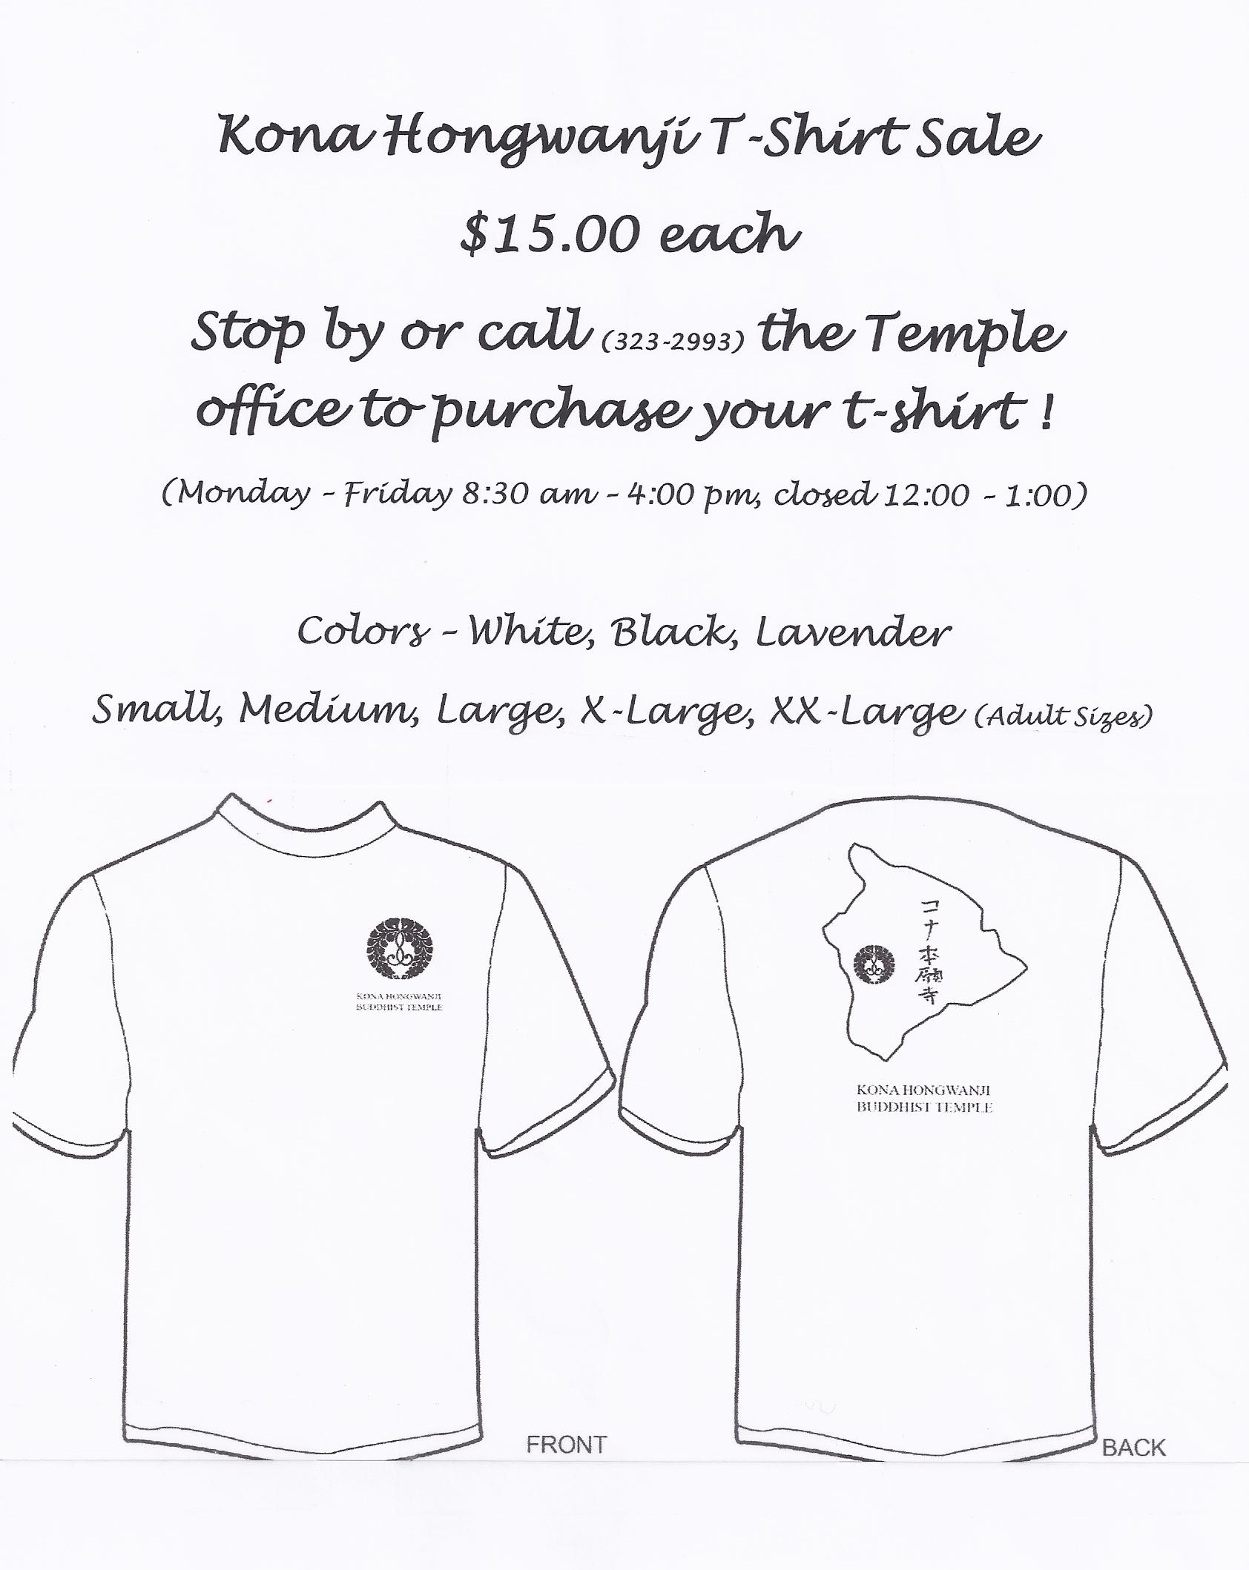

JISSEN GIRLS SCHOOL VISITATION

24 students and two teachers from the Jissen Girls School in Tokyo attended our 9:00 am Sunday service on July 31. 2011. They were accompanied by two teachers from their school, Travel Coordinator, Chieko Watanabe-Ramirez and 6 HPA students. Jr. YBA and Dharma School students hosted fellowship and lunch following the service.

The students spend 10 days at HPA learning English, visiting and participating in cultural/historic events and sites. Each year the school sends groups to the Big Island, Maui, Australia and New Zealand. The girls are all 14 or 15 years old.

The fellowship started with the Jissen School girls singing two songs accompanied on the keyboard by a fellow student. It was followed with Bon dancing and lei making, using yarns. Thanks to Daren, Taiko Club, Kristyn, Corinne, Betty, Lynn, Jr. YBA/Dharma School students and parents who led the visitors in “Cupid Shuffle and Beautiful Sunday”. Young visitors learn very fast and were dancing away and having a good time. Thank you Amy for demonstrating and teaching them how to make yarn leis. With translation from Chieko-san, the girls were able to complete and wear their leis.

Lunch included Beef Broccoli and Teriyaki Chicken prepared by “L & L” (Lynn and Lisa). Mahalo to Daren, Jordan, Colin, and Chad for grilling the chicken; Chizu and her ladies for the delicious desserts; Betty as MC for the fellowship; Morris for media; and all Dharma School/Jr. YBA students/parents and Kyodan members who participated in the fellowship. Visiting students and chaperones thoroughly enjoyed and expressed their deep appreciation for the warm welcome and fellowship.

Headquarter’s Update August 8, 2011

FRANK R. EGI, BEQUEST
The late Mr. Frank R. Egi, a member of the Hawaii Betsuin, bequeathed the cash portion of his estate to the Hawaii Kyodan. We gratefully acknowledge his gift of over $900 thousand.

PBA CAPITAL CAMPAIGN
At the Paci􀏐ic Buddhist Academy Capital Campaign Kick-off Ceremony, which was held on July 15, 2011 at Hawaii Betsuin Hondo, the check of $1,200,000.00 was presented from Hawaii Kyodan to PBA. This donation from Hawaii Kyodan was made as a part of Shinran Shonin’s 750th Memorial and Hawaii Kyodan’s 120th Anniversary Celebration Projects. Thank you very much everyone for your support and cooperation. This donation from entire members and friends of Hawaii Kyodan will be used to construct a new school building that will allow PBA to double enrollment and move closer to operating a self-sustaining educational program.
The anticipated start of construction is the Spring of 2012.

TAIKO GROUP NEWS

On Saturday, August 13, 2011, four members of the Taiko Group went to the Kona Koyasan Daishiji Mission to perform at their bon dance. The Honolulu group of dancers enjoyed the beating of the taiko drums with the bon dance music.

On Saturday, August 20, 2011, the Taiko Group performed at the Kona Hiroshima Peace Festival held at the Keauhou Shopping Center. The group performed along with bond dancers in the center courtyard (actually to the side because there were chairs in the center). They got audience participation by locals and tourists, too.

On September 29, 2011 at 5:30 p.m., we will be having our annual membership meeting. Anyone interested in joining the Taiko Group, can come on this day. It will be an informational meeting along with demonstration by the present Taiko Group. Anyone ages 6 – 106 is welcome to join.
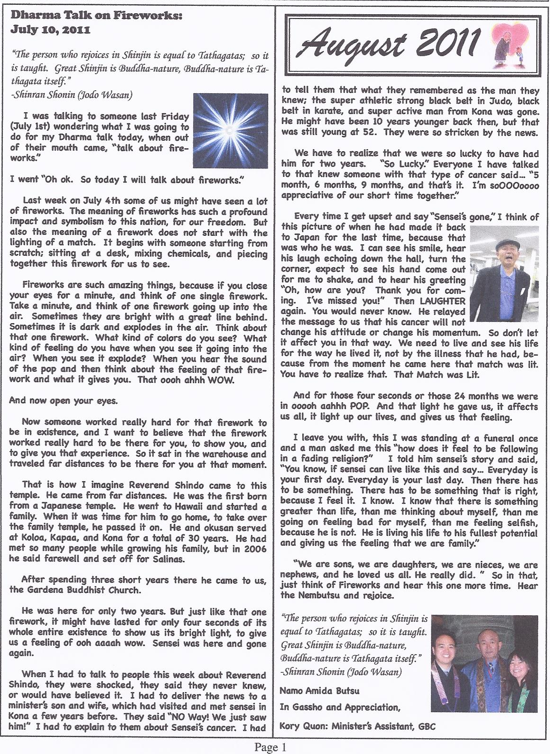

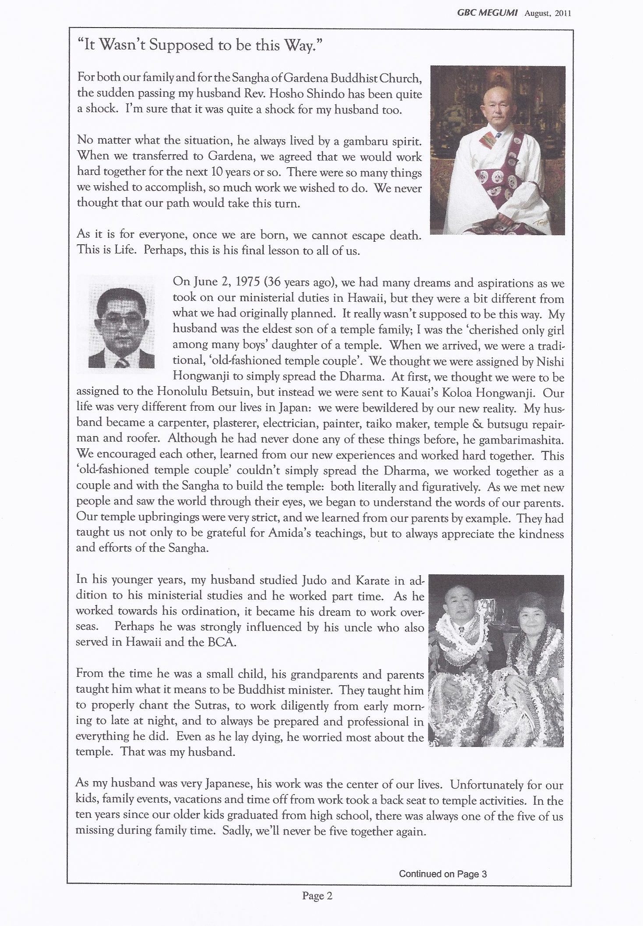

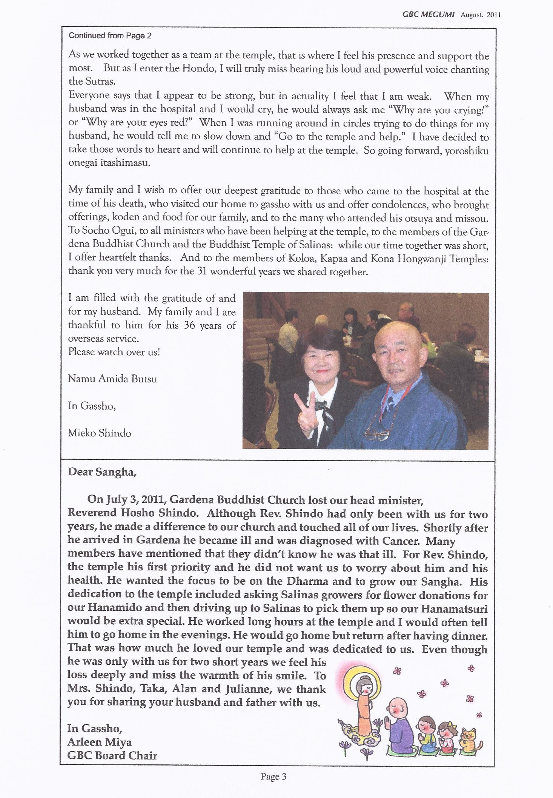

BWA CORNER:

The Board of Directors at its last meeting had approved the following:

- We had contributed $1,000.00 to the Board of Directors of Kona Hongwanji Mission to be used to assist its financial burden on the outstanding balance with its assessments to the Honpa Hongwanji Mission.

- To the earthquake and tsunami victims in Japan, $500.00 to its Relief Fund.

Kona BWA to Host the Hawaii Island United Hongwanji BWA Pre-Convention and Convention:

September 17, 2011 Pre-Convention Meeting:

Ladies all groups to help. Sally Murakami, co-chairperson will be calling upon you to assist in preparing for lunch. Your contribution for desserts will be greatly appreciated. Please call Sally Murakami at 323-2024.

7:30 AM Set up and preparation for lunch.

9:30 AM Pre Convention Meeting.

October 16, 2011: Convention:

Keynote Speaker is Rev. Ronald Kobata from San Francisco.

Ladies please mark your calendar. We will need all of your help in all areas.

You will be called by your caller for your head count before October 1. We will need flowers and desserts. Please let your caller know if you will be able to provide the following:

- Flowers for the Altar and decoration. Preferably anthuriums and some greenery.
- Desserts of all sorts.
- YOUR ATTENDANCE!

September 24
Hosha Group I
Omigaki Group II
Food Prep Group III

September 25
Autumn O Higan: Kyodan sponsor

JR. YBA NEWS

The Kona Unit of the United of Hawaii Jr. YBA will be having their installation service and membership drive dinner on Saturday, August 27, 2011 at 6:30 p.m. The service will be held in the temple and dinner to follow in the social hall. Any teenager (8th grade to 1 year after high school graduation), may join. We will also be recognizing the “Orange Family Caterers” for their years of service of helping us cook for our functions and fundraisers.

On September 16, 2011, Friday, the Kona Jr. YBA will be sponsoring the Annual Peace Day Service. The service will be held at 7:00 p.m. Because the members also participate in the Honkaa Peace Day Parade on Sunday, September 28, 2011, that’s why the Service is being held on Friday night.

We are still collecting Box Tops for Education. That’s the little pink and white coupon you see on products such as Ziploc, Kleenex, General Mills Cereals and Betty Crocker baking mixes. This year’s recipient will be Honaunau Elementary School. Last year’s recipient was Hookena Elementary School and we collected over 1200 box tops. Please let us exceed that goal this year. We have a jar in the temple which is put out at most Sunday services or you may drop them off at the office if you are unable to attend Sunday Services.
CUB SCOUTS PACK 12

All you can eat Pancake Breakfast & Silent Auction Fundraiser

Sept 10, 2011 (Saturday) Hongwanji Mission Hall 7:00am-11:00am

Mark your calendars!!! Plan to have a delicious breakfast with us and don’t forget to bid on our silent auction items too. The Pancake Breakfast raises “Seed” monies for our Cub Scout Pack to pay for leadership dues which cost us over a thousand dollars a year alone! Scout hand books, Scout leadership training, supplies (i.e. craft items, paint, paper, pine wood derby cars etc.) and activities (i.e. Community Service Projects, Camping trips, various day excursions, etc.) for our Cub Scouts because we are one of the few organizations that offer a 12 month, “All Year” around program.

This year’s tickets are $7.00. Please support scouting by purchasing a ticket or tickets from any one of our scouts or scout parents when approached. You may also contact Shelley Mandaguit (329-9567) or Lynn Gusman (324-0708) for tickets. Thank you in advance for your help and support.

Summer Camp - Milolii

July 29, 30 & 31st – GREAT days of summer to remember. Our gracious host Mr. Walter Kahiwa once again opened his beach house to our Pack. He was anxiously awaiting our arrival. He had the house set up for the adults to sleep on the beds inside the house and the scouts to sleep outside on the porch on cots. Mr. Kahiwa also made special arrangements with his cousin so that we had special permission to enter the beach cove thru private property. The weather was great. A great setting for days filled with swimming, fishing and camaraderie.

All the families participated in bringing down the supplies needed for camp, but special thanks to Norman Wessel and son Edward, who transported a majority of the camping supplies.

Our chefs for the camp were Cub Master Glenn Hirowatari and Tyrus Takimoto. Our first night was very relaxing once everyone was settled in. Some scouts played Chess while some adults played Hanafuda. Everyone brought enough food to share. Breakfast Saturday was rice, scrambled eggs, little smokies and bread. With tummies full we headed down to the beach for swimming, fishing and sun, sun, sun. Amazing how lunch at the beach seems to taste better. Thank you to the mommies for preparing cold cut sandwiches. For dinner we had Spaghetti, garlic bread and salad. Late night pupu’s for the adults, we ate miso soup (prepared by chef Tyrus) and grilled Kalbi compliments of Unit commissioner Lynn. The scouts made smore’s…yum yum. Per scout Edward Wessel, that was the first time he made and ate smore’s. That really hit the spot. Breakfast Sunday was rice, scrambled eggs, Portuguese sausage, miso soup and bread. Lunch was hot dogs and watermelons that is the ultimate summer lunch menu. Mmmm mmmm good.

We have our own version of FISHING TALES…Sunday morning after cleaning up at Uncle Walters’s house; we trucked it down to the private beach one last time. The tide was exceptionally low and Scout grandparent Ken Ono decided to take a walk on the rocks and check out what kind of fishes were out there. Low and behold as he was skimming the waters he saw what he thought was a “dead fish” in shallow water…so he bent over to check it out. Turned out it was just caught in the low tide. So Ken glanced back at all of us on the beach and wondered what should he do? Was his only solution…bend down and grab it??? He did the ultimate sacrifice…he removed his T-shirt and scooped it out of the water and carried it back to the beach. We were all stunned. It turned out to be over a foot long Parrot fish. Unfortunately for the fish it was not the one that got away!

Konawaena School – Meet & Greet

On July 27th Konawaena Elementary School held their annual open house. It was a perfect opportunity for us to recruit new scouts. Cub Scouting is open for boys from first to fifth grade. Our pack set up a display of past activities and all of our scouts showed up in uniforms anxiously waiting to welcoming any new boys that want to join. All new boys were invited to attend our August 15th meeting. The scouts had a great time greeting anyone interested. Seven boys showed interest in joining.

First meeting of the New School year

Summer went by in a flash!!! Our scouts are back in school and ready to continue scouting… We are already busy planning out our Year. As you can see above we are already busy planning for our “All you can eat pancake breakfast and silent auction fundraiser” plus awaiting more new scouts to join. All returning scouts are happy to be back…Let the fun begin….
Welcome new scout - Makamua Greenwell, son of William and Lehua Greenwell. Makamua’s mom signed up at the Konawaena Meet & Greet and was invited to attend our August 15th meeting, but they were so excited about joining scouts, they appeared on our August 8th meeting and filled out an application. Congratulation Makamua we are just excited to have you as part of our scouting program.

Congratulations Eagle Scout Len Nakamoto

Len Nakamoto, Kona Hongwanji Mission’s Troop 59 and once our own pack #12’s Den Chief. His Proud parents are Michael & Renee Nakamoto. Len’s Eagle project was building concrete steps at a place where it was unsafe for teachers and students to walk at Hookena School. Len’s project also including building a picnic table and concrete bench for the school.

UPCOMING EVENTS:

August 28 & 29—overnight camp at Hokulia
Sept 9th – Prep for Pancake Breakfast
Sept 10th– Pancake Breakfast and Silent Auction fundraiser Church Hall
Sept – Day camp to Imiloa Astronomy Center – Planetarium
Sept – Induction night
Sept 23-24 – Webelos overnight Camp at Honokaia

GIVE ALOHA AT FOODLAND AND SACK N SAVE
TO HELP US RAISE FUNDS!

Kona Hongwanji is again participating in Give Aloha, Foodland’s Annual
Community Matching Gifts Program. This program honors Foodland’s founder,
Maurice J. “Sully” Sullivan, and continues his legacy of giving back to the community.


How It Works
From Sept. 1 - 30, customers are invited to make donations of up to a cumulative total of $249 per person, per organization to participating Hawaii non-profit organizations at checkout. Foodland and the Western Union Foundation will match a portion of each donation.*

Matching Gift
The Western Union Foundation has generously donated $50,000 to add to Foodland's gift of $250,000 to non-profit-organizations participating in Give Aloha this year. Therefore, the total gift that will be given to all participating non-profit organizations combined is $300,000!

How To Donate
At checkout, present your Maika`i Card and inform the cashier that you would like to make a donation to the Kona Hongwanji. If you do not have a Maika‘i Card, you may request one. Our five digit registration code is 78465. Your donation will be added to your grocery purchase total. You may give up to $249 per organization (donations exceeding $249 will not be matched). The amount you have donated to us and our name will appear on your receipt. Any donation must be made payable to Foodland or Sack N Save. Donor names will not be released to us, so if you would like us to know of your gift, please contact us directly so that we may properly acknowledge your gift.

Are These Contributions Tax Deductible?
These contributions are tax deductible to the full extent of the law. Please save your store receipt for tax purposes since it will be the only record you will have of your donation.

*How Matching Gifts Will Be Calculated
Matching Gifts will be calculated after the end of the program. Organizations will receive 100% of all customer donations given to their organization, plus their % of Foodland's $300,000 matching gift. The portion of the matching gift that each organization will receive will be based on the total dollar amount of customer donations designated to that organization as a % of all customer donations received for all organizations.

Please ask your friends and family to also make a donation to support Kona Hongwanji when at the check-out counter, visiting any Foodland or Sack N or Foodland Farms. Just inform the cashier that you would like to make a donation to Kona Hongwanji registration code : 78465 .

ACKNOWLEDGEMENTS

Henrilyn Grace, Use of Facility
Keei Buddhist Church & Cemetery, Bon Services
Mr. & Mrs. Sueto Matsumura, Judo Club
Chizu Nakashima, Use of Facility
Okamoto Family, Obon In Memory of Frank & Wayne Okamoto
Saga Goryu Ikebana Class
Helen Hirata, Eitaikyo In Memory of Takaki Family and Teruyo Hirata
Mitsue Kurozumi
Mr. & Mrs. Ernest Fujikawa, O-Bon
Mr. & Mrs. Kenneth Komo, In Memory of Rose Deguchi
Alan Matsumoto, Karate
Roy Murata, O-Bon In Memory of the Late Clarence K. Murata and Doris Y. Murata
Marjorie Fergerstrom and Gilbert Nakayama, In Memory of Our Grandfather, Hikoshiro Nakayama’s 50th Anniversary
Charlotte Graham, O-Bon In Memory of Thomas A. Kobayashi
Gloria Ichishita, O-Bon
Ellen Nishikawa, O-Bon
Mr. & Mrs. Gary Higashi, Judo Club
Fusae Kamigaki, Hatsubon In Memory of Nellie Kamigaki
Toshio Shirai, In Memory of Minokichi and Umeo Shirai
Mr. & Mrs. Richard Kunitomo, O-Bon
Rev. M. Miyazaki, O-Bon Services
Hanae Yamashita, Nokotsudo
- Mr. & Mrs. Toshio Shirai, Anthuriums
Total - $2,320.00

MEMORIAL SERVICES

Elaine Chapman, 1st Year Service for Chayson Matsuoka
H.G.K. Chapman, In Memory of Chayson Matsuoka
Sharon Gouveia, Funeral Service & Related Expenses for Nancy H. Manago
Mr. & Mrs. Clayton Grace, 1st Year Service In Memory of Chayson Matsuoka
Trevor Grace and Sonya Ascino, 1st Year Service In Memory of Chayson Matsuoka
Hatsuyo Haimoto, 1st Year Service In Memory of Chayson Matsuoka
Iseri Family, 50th Year Memorial Service for Mitsue Iseri and 3rd Year Memorial Service for Misako “Mitzi” Iseri
Mr. & Mrs. Glenn Kobayashi, In Memory of Chayson Matsuoka
Norma Matsumoto, 49th Day Service for Kyle Matsumoto
Mr. & Mrs. Gifford Matsuoka, 1st Year Service for Chayson Matsuoka
Peter Matsuoka, 1st Year Memorial Service for Chayson Matsuoka
Sheldon & Joyce Tokeshi, 1st Year Service In Memory of Chayson Matsuoka
Mr. & Mrs. Gary Kirihara, 49th Day Service for Harold Hayashida
Roy Matsumoto, Graveside Service for the Matsumoto Family
Dr. & Mrs. James Mitchell, Service In Memory of Minoru Inouye
Mr. & Mrs. Mitsuo Nagai, Gene & Martha Yamada, Chad & Carol Yamamoto, Nora Kimura and Robert Sakata, 33rd
Year Memorial Service for Taju Nagai
Lynne Sasaki and Melvyn Hayashida, 49th Day Service for the Late Harold T. Hayashida
Kazue Teshima, 33rd Year Service In Memory of Taju Nagai
Total - $1,860.00

Acknowledgements Continued:
HAKASOJI

Mr. & Mrs. Sueto Matsumura Marjorie Fergerstrom Bessie Kakizoe
Mr. & Mrs. Kaoru Uyeda Mr. & Mrs. Gary Higashi Hanae Yamashita
Edna Yamashita
Total - $165.00

JIHO

Mr. & Mrs. Sueto Matsumura Janet Yanagi Hanae Yamashita
Mr. & Mrs. Gary Higashi
Total - $65.00

JULY SUNDAY SERVICES

Cash Offering Mr. & Mrs. Colin Byars Yasunori Deguchi
Mr. & Mrs. Nathan Chong Mr. & Mrs. Sadayuki Inouye Mary Katayama
Mr. & Mrs. Gilbert Kaneko Mr. & Mrs. Daren Katayama Bill Lundquist
Mr. & Mrs. Stanley Kunitomo Mr. & Mrs. Bert Maedo Chizu Nakashima
Mr. & Mrs. Gail Masunaga Mr. & Mrs. George Matsuoka Betty Yamagata
Mr. & Mrs. Michitoshi Murakami Mr. & Mrs. Morris Nagata Mr. & Mrs. Fred Uechi
Mr. & Mrs. Dale Shiraki Mr. & Mrs. Norman Takeoka
Mr. & Mrs. Arnold Tokuyama Mr. & Mrs. Chad Yamamoto
Total - $260.00

BON DANCE

Cash Offerings Leanne (Kaneko) Amano Sonja Acol
Mr. & Mrs. Kazuyoshi Aoki Mr. & Mrs. Nathan Chong Merilyn Ahtou
Mr. & Mrs. Glenn Davidson Mr. & Mrs. Gordon Fujino Annette H.
Meg, Shean, & Kyle Gass Mr. & Mrs. Clayton Grace Kazue Aoki
Mr. & Mrs. Alan Harada Mr. & Mrs. Walter Harada Cathy Arakaki
Mr. & Mrs. Kiyoto Aoki Mr. & Mrs. Keith Hayama D. Arase
Family of the Late Harold Hayashida Mr. & Mrs. Gary Higashi Jerby Ayoso
Mr. & Mrs. Myles Ikeda Mr. & Mrs. Miyuki Inouye Elaine Chapman
Mr. & Mrs. Francis Iwamoto Channa Kamanawa & Gwen Nelson Lisa Ciriako
Mr. & Mrs. Burt Kamigaki S. Kaneko & T. Kanda Yasunori Deguchi
Mr. & Mrs. Daren Katayama Mr. & Mrs. Naoto Katoku Nobuyuki Fukuda
Mr. & Mrs. Theodore Kawamoto Mr. & Mrs. Gary Kirihara Rie Furukawa
Mr. & Mrs. Joe Gusman Mr. & Mrs. Guy Kitaoka Hatsuyo Haimoto
Mr. & Mrs. Glenn Kobayashi Mr. & Mrs. Kenneth Komo Mae Harano
Mr. & Mrs. Eric Kunitomo Mr. & Mrs. Duane Kurozawa Melvin Harano
Mr. & Mrs. Albert Langsi Mr. & Mrs. Gail Masunaga Tamaki Harano
Mr. & Mrs. Glenn Matsumoto Mr. & Mrs. Sueto Matsumura Shikimi Hayama
Mr. & Mrs. George Matsuoka Mr. & Mrs. Gifford Matsuoka Rendell Hirano
Mr. & Mrs. Earl Matsuyama Mr. & Mrs. Michitoshi Murakami Akinori Imai
Mr. & Mrs. Reed Ichishita Mr. & Mrs. Joseph Iha Ethel Imai-Saito
Mr. & Mrs. Mitsuo Nagai Mr. & Mrs. Toshio Nagai Ann Inaba
Mr. & Mrs. Edwin Nagata Mr. & Mrs. Morris Nagata Dorsey Ito
Cynthia Nakamoto-Tomono Mr. & Mrs. Kiyoshi Nakamura Sandy Iwashita
Mr. & Mrs. Clayton Nishina Pauline Nishina-Goodwin Izuno
Mr. & Mrs. Gordon Ogi Mr. & Mrs. Claude Onizuka Melvin Kadohiro
Rodney & Karla Park Toyozki & Nourrie Park Mitzi Kadohiro
Mr. & Mrs. Sunao Kadooka Esteban & Moira Rabang Kaopiko Ohana
June & Trixy Sakata Mr. & Mrs. Richard Sasaki Lynn Karlson
Rodney & Shawn Sato Mr. & Mrs. George Shimamoto Mary Katayama
Susan Shirota & Owen Nishioka Mr. & Mrs. Kenneth Sugiyama Carol Kawachi
Mr. & Mrs. Yukito Takamoto Mr. & Mrs. Norman Takeoka Fern Kawaze
Acknowledgements Continued:

Mr. & Mrs. Raymond Takiue Mr. & Mrs. James Tashima Kaulukukui
Mr. & Mrs. Terence Terada Jenny Uemura-Sano S. Kunitomo
Velma Usui-Noda Mr. & Mrs. Kenneth Uyeda Mitsue Kurozawa
Mr. & Mrs. Albert Watanabe Mr. & Mrs. Chad Yamamoto Randy Magnus
Mr. & Mrs. Glenn Yano Mr. & Mrs. James Zane Mandaguit
Mr. & Mrs. Dean Uemura Mr. & Mrs. Jerry Uemura Mariana
Norma Matsumoto Dennis Mento Randy Millare
Bobby Miyashiro Kimie Mizoshiri You Sun Moon
Glenn Morimoto Sasae Murakami Jean Nakamoto
Chizu Nakashima Manabu Nishida Jeannett Nishikawa
Alyssa Norther Carl Nozaki Harumi Oda
Sandy Ogawa Joy Ohta Helen Oishi
Oshita May Otomo Iris Plunkett
Chikaharu Saito Marisa Taibang Kimi Takamoto
Takiyo Tanaka Terry Teruko Kazue Teshima
Kellen Matsumoto Randy Masutomi Yana
Itsuyo Yamane Bernice Yoshida
Reece, Kim & Riley Asakura, In Memory of Kumiko Omori & Ronald Lindner
Janet Lindner, In Memory of Kumiko Omori & Ronald Lindner
Family of the Late Shirley Hisako Ogata
Total - $3,548.03

HATSUBON

Cash Offering Mr. & Mrs. Francis Abe Elaine Chapman
Mr. & Mrs. Nathan Chong Lisa Ciriako Yasunori Deguchi
Family of the Late Harold Hayashida Mr. & Mrs. Sanford Higashi Tamaki Harano
Mr. & Mrs. Gary Ichishita Mr. & Mrs. Sadayuki Inouye Hisako Hatta
Mr. & Mrs. Daren Katayama Sandy Iwashita Mary Katayama
Mr. & Mrs. Kenneth Komo Edna Kitagawachi Wayne Kimoto
Mr. & Mrs. Stanley Kunitomo Nora Koyanagi Nancy Kurihara
Family of George Matsumoto Mr. & Mrs. Glenn Matsumoto Bill Lundquist
Mr. & Mrs. Takeshi Matsumoto Mr. & Mrs. Mitsuo Nagai Alan Matsumoto
Senkichi Nagai & family Mr. & Mrs. Dennis Nakano Kimie Mizoshiri
Mr. & Mrs. Takeo Nakasone Mr. & Mrs. Dale Shiraki Yooko Moriguchi
Mr. & Mrs. Kenneth Sugiyama Mr. & Mrs. Norman Takeoka Karen Morimoto
Mr. & Mrs. Fred Uechi Mr. & Mrs. Albert Watanabe Chizu Nakashima
Yaeko Ohata Helen Oishi Carol Okuna
Ethel Saito Daisy Sasaki Saeko Sato
Suga Suzuki Marjorie Fergerstrom Haruo Aoki
Mr. & Mrs. Kenji Fukumitsu Kimie Ege Tokino Hirata
Tomie Honda Kikuye Kadohiro Loretta Kitaoka
Mr. & Mrs. Gilbert Kaneko Mr. & Mrs. Bert Maedo Betty Matsuo
Albert & Pauline Morita Mr. & Mrs. George Nakamoto Mildred Morimoto
Mr. & Mrs. Colbert Nozaki Keith Nishihara Amy Okuno
Mr. & Mrs. Tadao Sakamoto Mr. & Mrs. George Sugi Mitsuo Oura
Mr. & Mrs. Masamori Takaki Mr. & Mrs. James Takauye Emiko Sato
Mr. & Mrs. Ernest Urada Mr. & Mrs. Frank Yamamoto Yaeko Shiotsuka
Hatsuko Shiraishi Susan Shirota Toshie Shirota
Akino Sonoda Yoshie Tanaka S. Teshima
Fumie Yoshida Sumiko Yamamoto Kimi Takamoto
Mr. & Mrs. Gifford Matsuoka & family
Anonymous, Hatsubon in Appreciation & In Memory of Richard Kitae Tanaka
Reece, Kim & Riley Asakura, Hatsubon In Memory of Kumiko Omori & Ronald A. Lindner
Hatsuyo Haimoto, O-Bon In Memory of Chayson Matsuoka & Kiyoshi Haimoto
Susan Tanaka Higuchi & family, Hatsubon In Memory of our Dad, Grandpa & Great-Grandpa, Richard
Mr. & Mrs. Gary Kirihara, Hatsubon In Memory of Richard Kitae Tanaka & Harold Hayashida
Acknowledgements Continued:

Janet Lindner, Hatsubon In Memory of Ronald Lindner & Kumiko Omori
Mr. & Mrs. George Matsuoka, Hatsubon In Memory of Chayson Matsuoka
Mr. & Mrs. Walter Okura, Hatsubon In Memory of Uncle Richard Tanaka
Tokiko Sakata, Hatsubon In Memory of Richard K. Tanaka
Takiyo & Lynette Tanaka, Hatsubon In Memory of Richard K. Tanaka
Nobue Teshima & family, Hatsubon In Memory of Earl T. Teshima
Vivian Teshima, Hatsubon In Memory of Earl
Lillian Yamamoto, Hatsubon In Memory of K. Omori & R. Lindner
Edna Yamashita, Hatsubon In Memory of Earl Teshima
Janet Yanagi, O-Bon In Memory of Michael & Brent Yanagi
Mr. & Mrs. James Zane, Hatsubon In Memory of K. Omori
Matsumura & Fukushima Families, In Memory of Kazuo & Matsuyo Fukushima, Hajime Fukushima and
Katsutaka & Kimie Fukushima
Mr. & Mrs. Michitoshi Murakami, from Kiyoshin Morita Family
Total - $3,532.00

CEMETERY BON SERVICE

Cash Offering Mr. & Mrs. Colin Byars Lisa Ciriako
Mr. & Mrs. Sadayuki Inouye Mr. & Mrs. Daren Katayama Yasunori Deguchi
Mr. & Mrs. Stanley Kunitomo Mr. & Mrs. Bert Maedo Mary Katayama
A. Matsumoto Mr. & Mrs. George Matsuoka Chizu Nakashima
Mr. & Mrs. Michitoshi Murakami Mr. & Mrs. Morris Nagata Kazumi Oshita
Mr. & Mrs. Dale Shiraki Mr. & Mrs. Norman Takeoka Mr. & Mrs. Fred Uechi
Mr. & Mrs. Arnold Tokuyama Mr. & Mrs. Chad Yamamoto Dean Uemura
Total - $157.00

MEMORIAL SERVICE for REV. HOSHO SHINDO

All offerings was forwarded to Mrs. Mieko Shindo & family

Capital Fund – 2011Total to Date $35,155.00

2011 Hawaii Kyodan Dues – Total to Date $8,540.00

Balance of Hawaii Kyodan Dues – Total to Date $10,285.00

2011 Japan Disaster Fund – Total to Date $5,240.00



