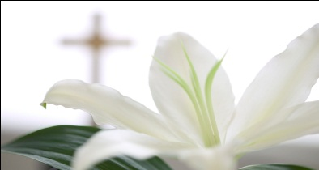 Faith Steps, A Ministry of Pat Owens presents “A Women’s View” An Evening at Easter
Maundy Thursday, March 28th 6:30-8:30 pm
Great Bridge Baptist Church
Dinner: Springtime Cold Plate ~ Chicken Salad Croissant, Pasta Salad, Fresh Fruit, Beverage, and Luscious Dessert
Dinner & Comedy will be followed by Worship and Candlelight communion in the Worship Center
Cancer Survivors will be honored at dinner. Two Relay for Life Teams will be recognized and supported.
Cost: $15 per Person or $110 Table of 8, One Check for Table
Reservation Deadline: Monday, March 25th
Make Check Payable to: Faith Steps
Mail to: Pat Owens
708 Tapestry Park Loop Apt. 517
Chesapeake, VA 23320
Reservations Also Available on Sunday at the ministry desk or daily at the church office. See Butch Crafton
Information Available at 729-0118 or 547-3901

