**Dirt Crits Race 9 - 10th December 2013**

**Junior Event**

As it was the last race before Christmas the children were encouraged to get into the spirit by decorating themselves/their bikes. Seth did a great job and received a reward for his effort.

The race format was a pairs race, and it was a great success!

Each older rider was paired with a younger rider and they took turns to ride, then tag their partner. Each rider rode twice.

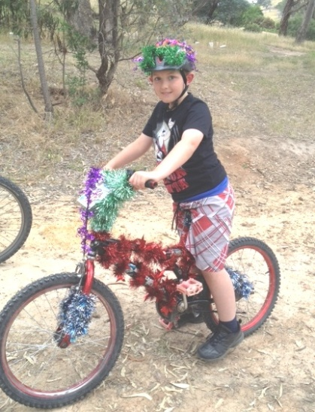

It was very close and all riders showed great enthusiasm, competitiveness and sportsmanship. They all encouraged their partners and seemed to really enjoy the race.

The first pair to finish was Declan and Seth, followed closely by Elise and Zali and in third place the two Cody's. Well done to all!

That was the last race of the season.

The first race for 2014 season will be held on Tuesday, 4th February.

By Kate Empey

**Senior Event**

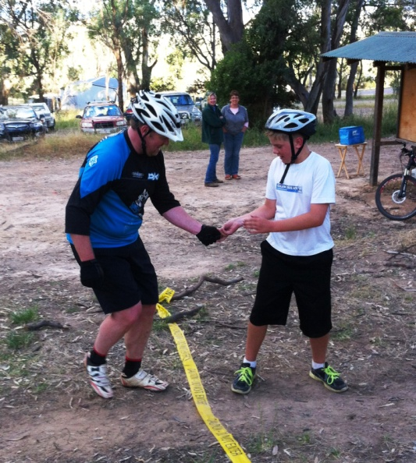Jostling could be seen on the start line as the athletes jockeyed for position in the Le Mans style start. The starter called ‘On your marks, get set and go!’ and go they did! Arms and legs went everywhere, as did Matthew Empey, as ten mountain bikers sprinted away from the start line on foot (yes, you read it correctly ‘on foot’). They headed towards the line of bunting to their bike handler, mounted their trusty steeds and were off on the first of three laps.

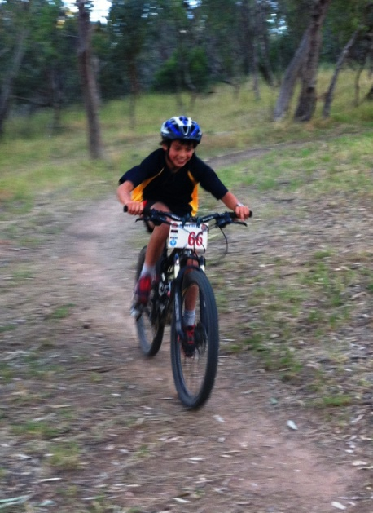That was the start of the final race of the Dirt Crits series for 2013. Cam Lachal had formulated the race and had matched the riders accordingly. Before the race began, the partners were announced. Each rider had to complete three laps of the course with a mix of long and short courses, so a strategy was formulated between partners.

At the end of each lap a playing card had to be exchanged in the transition (no bike zone). There were a range of places to store the playing card during the lap, in the back pocket, down a sock, up the leg of the bike knicks, etc.

After the first lap it was clear that the pair of Kian Lerch-MacKinnon and newcomer Colby Croxford-Demasi were going to be the team to beat! Close behind was the combination of Damian Grundy and Flynn Bowker.

The camaraderie was great amongst team members, with lots of encouragement being given out.

At the end of the race the combination of Flynn and Damian were clear winners over second placegetters Kian and Colby, with Nick and Anthony coming home in third place.

Thanks to Cam Lachal for creating the event and to Todd Howland and Dave Bock for helping Cam run it.

**Results-**

1st Flynn Bowker and Damian Grundy

2nd Kian Lerch-MacKinnon and Colby-Croxford Demasi

3rd Nick Watson and Anthony Plummer

4th Andrew Wettenhall and Brett Stevens

5th Jai Lerch MacKinnon and Keoni Bruner

6th Kieren Payne and Matthew Empey

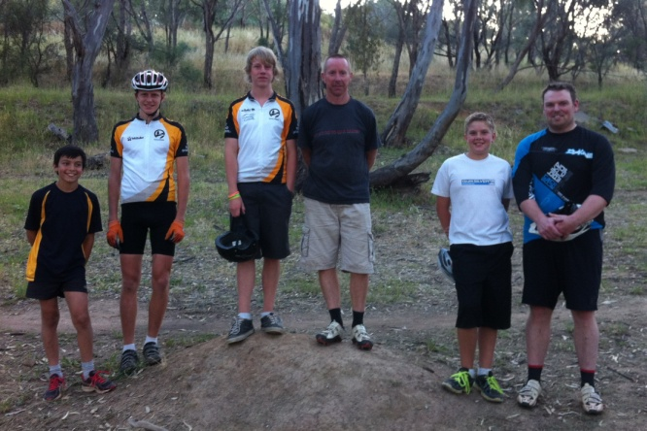7th Will Grundy and Noah Lachal

8th Rod Sergeant and Trevor Arnold

9th Nic Howland and Rachael Grundy

10th Aaron Sargeant and Josh Payne

The first race for 2014 season will be held on Tuesday, 4th February.

**Duty Roster**

Senior event- Brett Stevens and Matthew Empey.

**Elevation Series Round 3 Mount Buller**

The Mansfield Mount Buller Cycling Club had many representatives at Round 3 of the Elevation Series at Mount Buller last weekend.

U/13 2nd Matthew Empey, 4th Bella MacMunn

U/15 4th Aaron Sargeant

U/19 1st Mitch Greenway, 3rd Lawrence Prendergast

Veteran 1st Tom MacMunn, 18th Shannon Rademaker, 33rd Trevor Arnold

Super Masters 1st Dave Empey

**Christmas Social MTB Ride**

As part of the Mansfield Mount Buller Cycling Club Christmas festivities a social ride was held at Mt Samaria on Saturday at 9am.

Eleven riders rolled up to check out the trails. Some of the riders had not ridden at Samaria before, so it was a great introduction to some great trails. It was a very enjoyable ride, which also included some decent spills along the way.

Picture from Left- Ava Kappes, Aaron Sargeant, Rod Sargeant, Dave Empey, Laurie Harding, Dave Moore, Kian Lerch-MacKinnon, Matthew Empey, Craig Kappes and behind the camera was Jason Parker

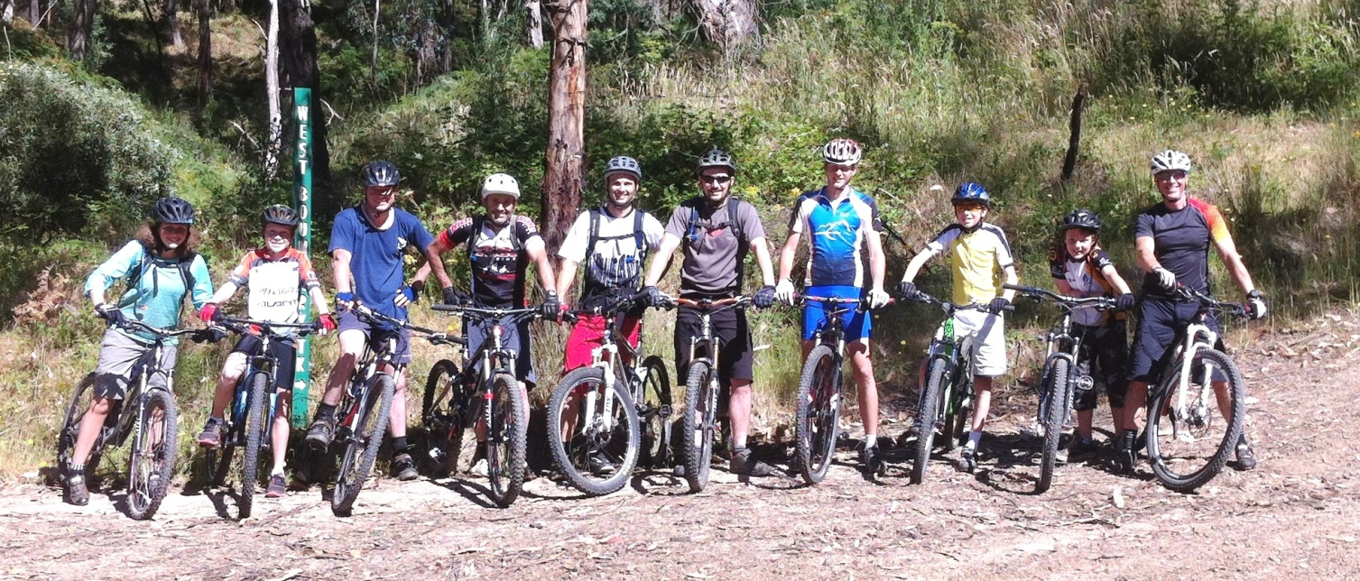

**Dirt Crits Spring-Summer 2013-2014 Series Points Table- Races 1-8**

|  |  |  |  |  |  |  |
| --- | --- | --- | --- | --- | --- | --- |
| **Name** | **Points Race 7** | **Points Race 8** | **Total** |  | **Place** | **Points** |
| Matthew Empey | 11 | 11 | **95** |  | 1 | 50 |
| April Lachal | 50 | 12 | **142** |  | 2 | 40 |
| Ross MacKinnon | 0 | 0 | **30** |  | 3 | 35 |
| Andrew Wettenhall | 20 | 0 | **98** |  | 4 | 31 |
| Anthony Plummer | 18 | 31 | **156** |  | 5 | 28 |
| Jarrod Appleton | 0 | 0 | **52** |  | 6 | 26 |
| Bruce Halket | 0 | 0 | **28** |  | 7 | 24 |
| Jason Parker | 14 | 0 | **67** |  | 8 | 22 |
| Damian Grundy | 24 | 24 | **77** |  | 9 | 20 |
| Foley Lachal | 0 | 16 | **64** |  | 10 | 18 |
| David Bock | 8 | 13 | **21** |  | 11 | 16 |
| Kieren Payne | 28 | 0 | **103** |  | 11 | 16 |
| Kian Lerch-MacKinnon | 0 | 14 | **93** |  | 12 | 15 |
| Trevor Arnold | 16 | 22 | **57** |  | 13 | 14 |
| Rachel Grundy | 9 | 35 | **82** |  | 14 | 13 |
| Mitch Greenway | 0 | 0 | **64** |  | 15 | 12 |
| Noah Lachal | 12 | 18 | **114** |  | 16 | 11 |
| Aaron Sargeant | 13 | 26 | **111** |  | 17 | 10 |
| Mike Davies | 0 | 40 | **156** |  | 18 | 9 |
| Cameron Lachal | 15 | 15 | **83** |  | 19 | 8 |
| Shannon Rademaker | 0 | 0 | **20** |  | 20 | 7 |
| Brett Stevens | 0 | 50 | **107** |  | 21 | 6 |
| Flynn Bowker | 40 | 0 | **107** |  | 22 | 5 |
| Nick Howland | 0 | 0 | **56** |  | 23 | 5 |
| Justin Sargeant | 0 | 0 | **79** |  | 24 | 5 |
| Brandon Smith | 16 | 0 | **41** |  | 25 | 5 |
| Jem Davies | 31 | 0 | **104** |  | 26 | 5 |
| Jai Lerch-MacKinnon | 0 | 20 | **61** |  | 27 | 5 |
| Andrew Clark | 0 | 0 | **8** |  | 28 | 5 |
| Will Grundy | 3 | 28 | **97** |  | DNF | 3 |
| Josh Payne | 10 | 0 | **77** |  |  |  |
| Toby Humffray | 0 | 0 | **69** |  |  |  |
| Rod Sargeant | 35 | 0 | **107** |  |  |  |
| Jodie Batchelor | 0 | 0 | **40** |  |  |  |
| Keoni Brunner | 26 | 0 | **46** |  |  |  |
| Dylan Harding | 0 | 0 | **74** |  |  |  |
| Nick Watson | 0 | 0 | **107** |  |  |  |

**Memberships**

Katie Bowker is looking after the memberships for the Dirt Crits this season. Katie has had a chance to gather all of the membership information together over the last few weeks and is currently compiling a list of current members. Katie spoke to a few of the riders at tonight’s Dirt Crits and asked them about the status of their membership.

It is important that all riders are insured at each Dirt Crits event by the MMBCC in the following ways- ‘Come and Try It’ statues, Day license or Full Membership.

If you are not currently a Mountain Bike Australia member, please join up this week, or you will be required to pay the $20 Day license fee each week.

To find out more about MTBA memberships, and to join up, click the link- <http://www.mtba.asn.au/join>

**Subaru National MTB Series Race 1- Friday 17th – Sunday 19th January**

Good luck to the club members that will be competing in Round 1 of the Subaru National MTB series to be held at the

foothills of the Lofty Ranges, Eagle Mountain Bike Park, Adelaide.