A monster came to visit you

He *roared*, he *roared*

A monster came to visit you

He *roared*, he *roared*

A monster came to visit you

His hair was green,

and his nose was blue

You could hear him roaring

Did he frighten you!!!! ***NO***

# One Little, two little, three little witches

Fly over haystacks, fly over ditches

Slide down moonbeams, without any hitches.

Heigh-ho, Halloween’s here!

*(Tune: John Brown had a Little Indian)*

**FIREWORKS**

Fireworks, fireworks up in the sky.

Fireworks, fireworks ever so high.

Colours sparkling ever so bright

Painting the sky on Halloween night!!

The Witch

A witch wears a long tall hat,

A witch has a big black cat.

She sits on a broomstick

As she goes by

And “oo-oo-oo-oo-oo-ooh”

Is her cry.

A witch has long black hair,

A witch flies through the air.

She sits on her broomstick

As she goes by

And “oo-oo-oo-oo-oo-ooh”

Is her cry.

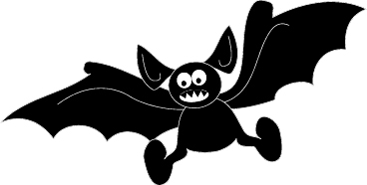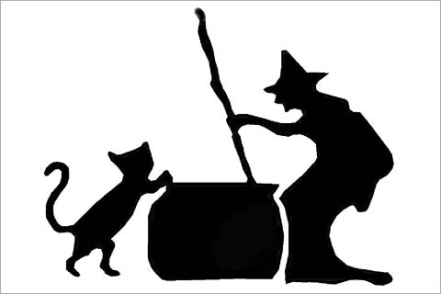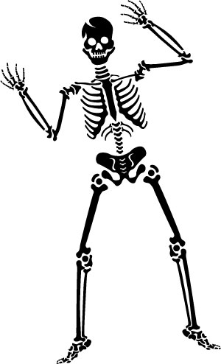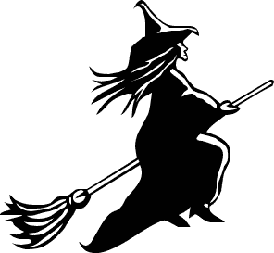

**The Witches of Halloween**

The witches of Halloween Ooooo

The ugliest you’ve ever seen Ooooo

They fly about at night and give you such a fright

The witches of Halloween Ooooo

The skeletons of Halloween Ooooo

The boniest you’ve ever seen Ooooo

They dance about at night and give you such a fright

The skeletons of Halloween Ooooo

The ghosts of Halloween Ooooo

The scariest you’ve ever seen Ooooo

They float about at night and give you such a fright

The ghosts of Halloween Ooooo

Halloween Surprise

(Tune; Sing a Song of Sixpence)

First you get a pumpkin

Big and round and fat

Then you cut the top off

To make a little hat.

Next you scoop the seeds out

Then make a mouth and eyes

That’s the way that you can make

a Halloween Surprise!!

Five Wicked Witches

5 wicked witches sitting on a broom

5 wicked witches sitting on a broom

And if one wicked witch

Decided to make more room …!

There will be 4 wicked witches sitting on the broom!!

4 3 2 1.

**Five Little Pumpkins**

*(Hold one hand up with all fingers up, move one finger at a time.)*

Five little pumpkins sitting on a gate

First one said, “Oh my, it’s getting late.”

Second one said, “There are witches in the air.”

Third one said, “Oh we don’t care.”

Fourth one said, “Let’s run and run and run.”

Fifth one said, “It’s Halloween fun.”

*(wave hands back and forth)*

WOOOOOOOO! Went the wind.

And out went the light!

*(clap hands once, roll hands and hide being back)*

Five little pumpkins rolled out of sight

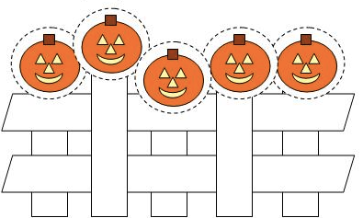

**Pumpkin Time**

*(to the tune of Mary had a little lamb)*

Pumpkin time is here again,

Time to play Trick or Treat.

Pumpkin time is here again,

Our spooky friends we’ll meet.

See the costumes we have on,

Monsters, ghosts, goblins too.

See the costumes we have on,

Hear us all shout “Boo!”

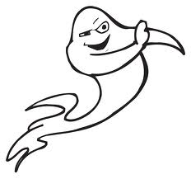

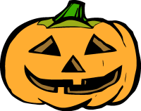

**Three Black Cats**

Three black cats, three black cats

In black hats, in black hats.

They all jumped into the Halloween brew,

They teased the ghosts and the goblins too

Did you ever hear such a hullabaloo

On Halloween

*(to the tune of “3 Blind Mice”)*

If you’re a ghost and you know it, say “Boo!”

If you’re a ghost and you know it, say “Boo!”

If you’re a ghost and you know it,

and you really want to show it,

If you’re a ghost and you know it, say “Boo!”

*(to the tune “If you’re happy and you know it.”)*

