How to Register for Fair (4-H Family)

- Go to www.fairentry.com
- Select your 4-H State and County.  - Click “Go” next to the Fair for which you would like to register. | 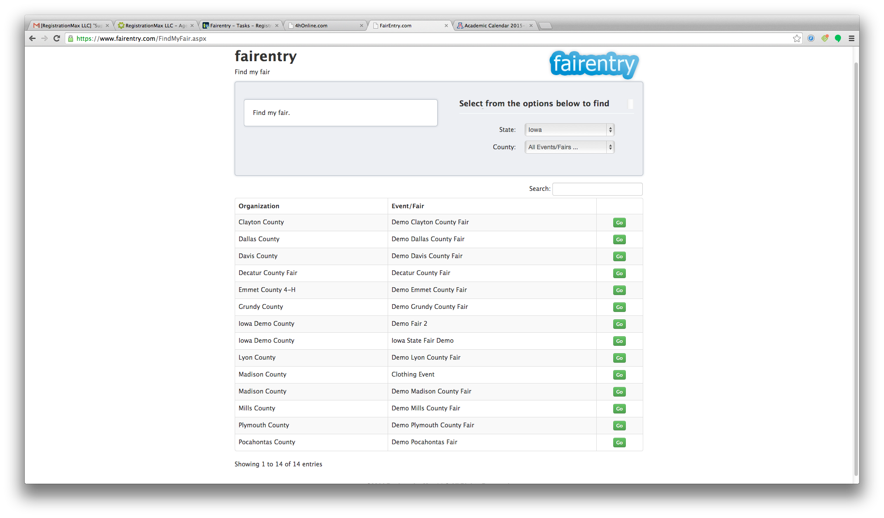
- Select to sign in with “My 4HOnline Profile.”  - Enter the login email address and password from 4HOnline.  - Click “Login.” | 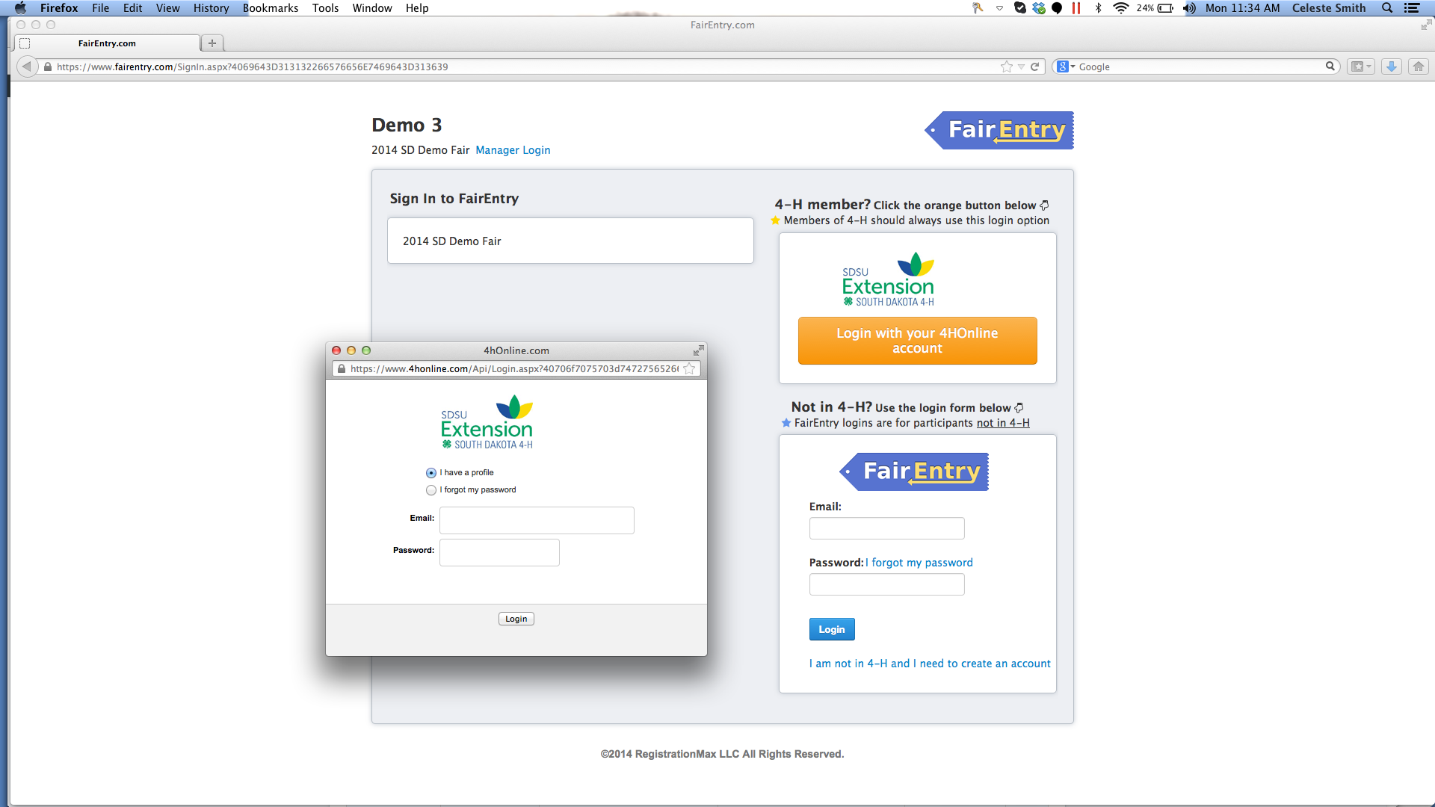
- If the family member you wish to register is not listed, click “Bring in my information from 4HOnline” to begin the registration.  - If the family member you wish to register is already listed, proceed to step 11. | 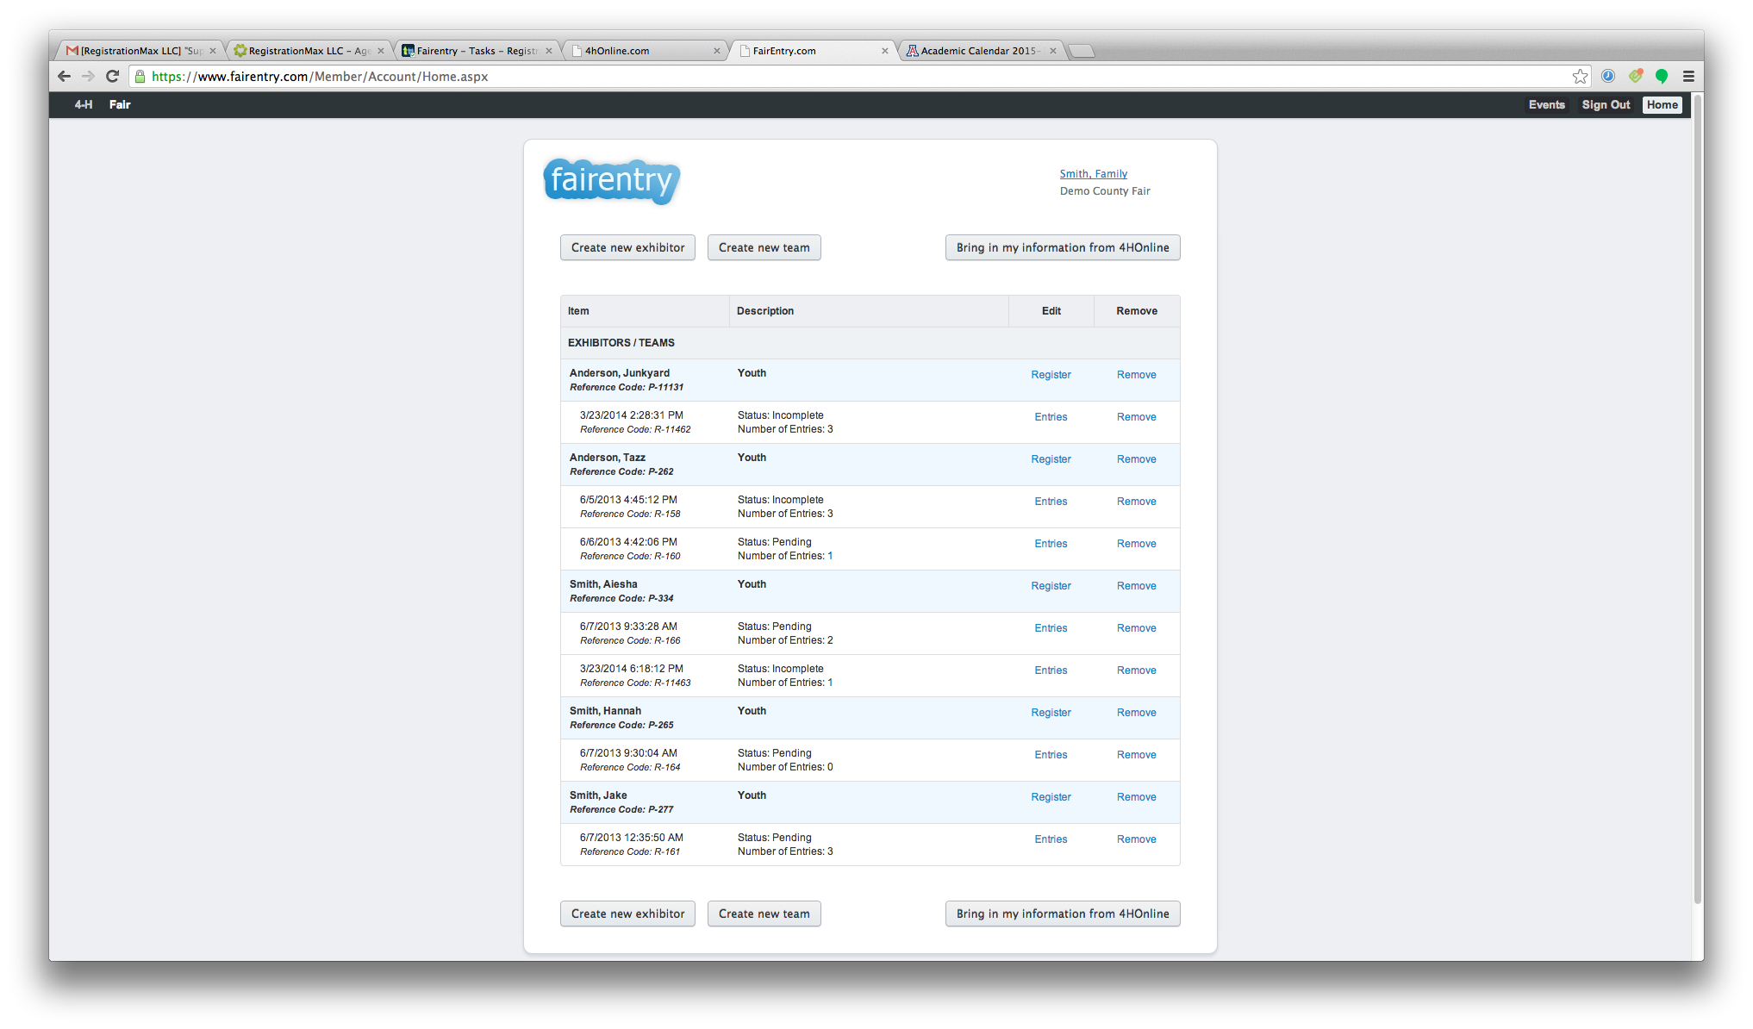
- Begin typing the member’s name in the search box.  - Select the member and click “Import Exhibitor” | 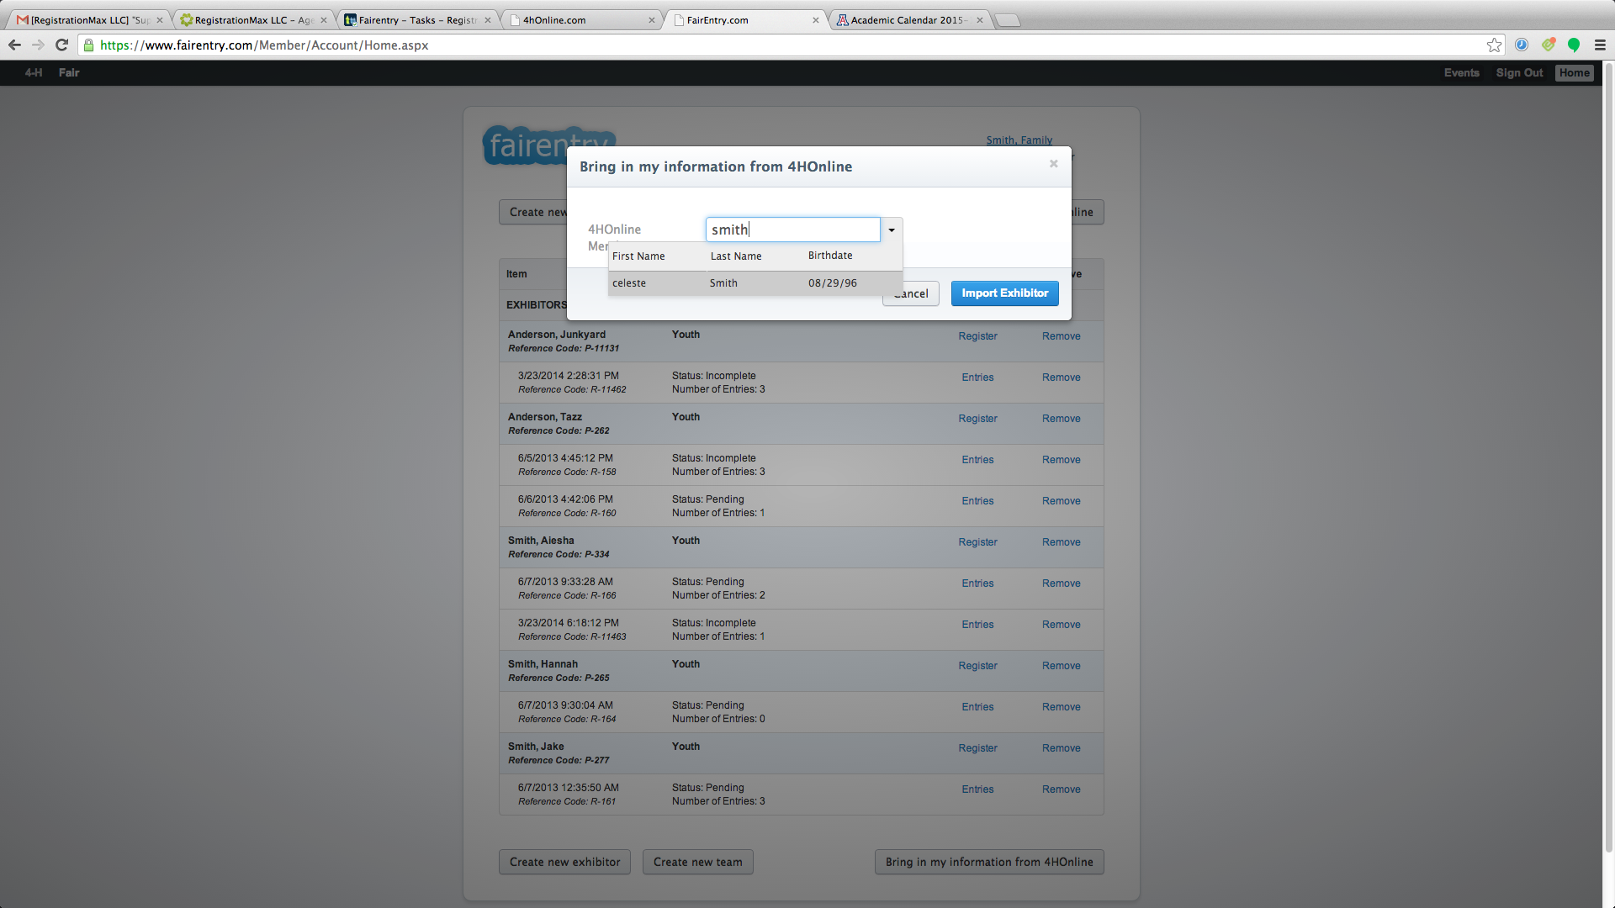
- Click “Register” next to the member’s name to begin the registration process. | 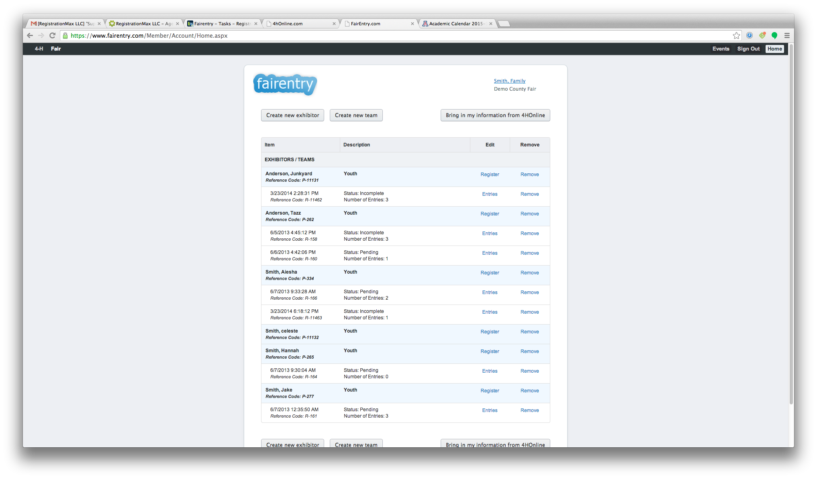
- Verify that the exhibitor information is correct.  - Make any necessary corrections NOTE: this will NOT change the information in 4HOnline. Be sure to log in to 4HOnline to make changes to the enrollment record.  - Click “Continue.” | 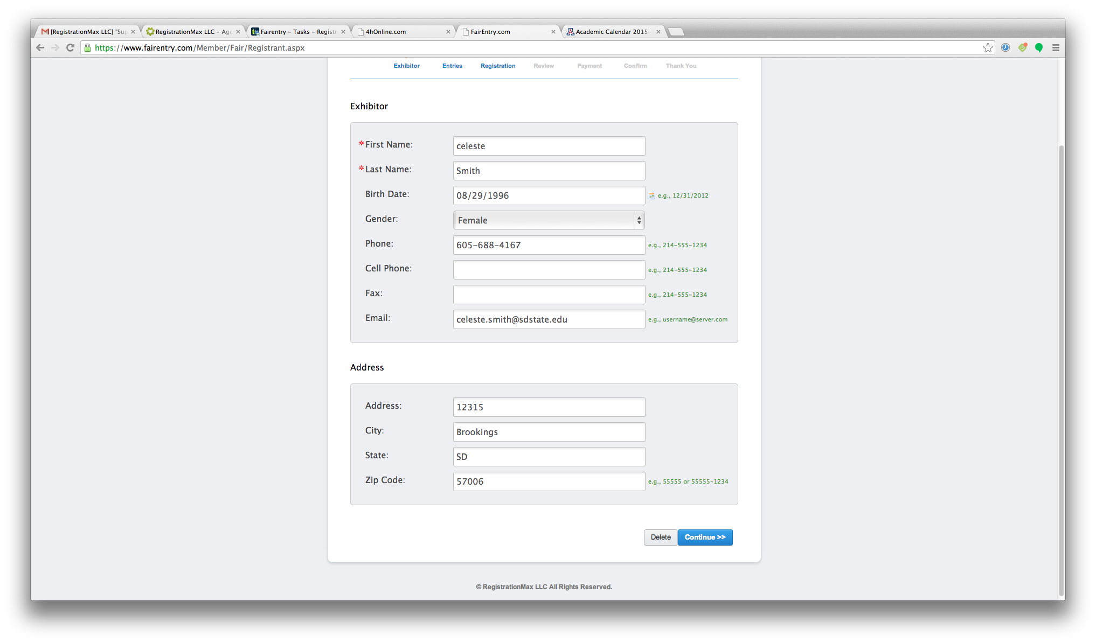
- Click “Create entry from an animal in 4HOnline” to add an entry for a specific animal identified in 4HOnline. | 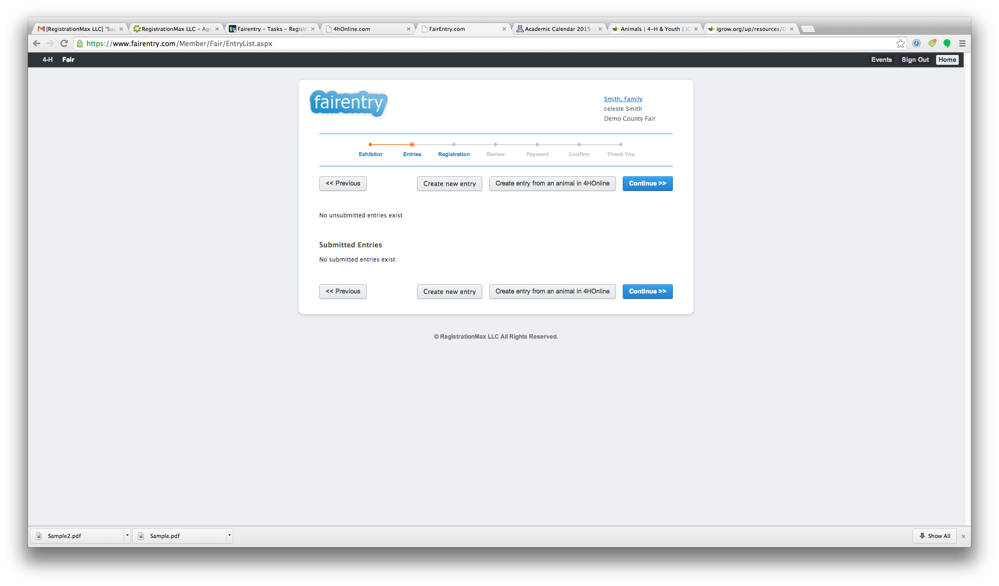
- Select the member’s animal. | 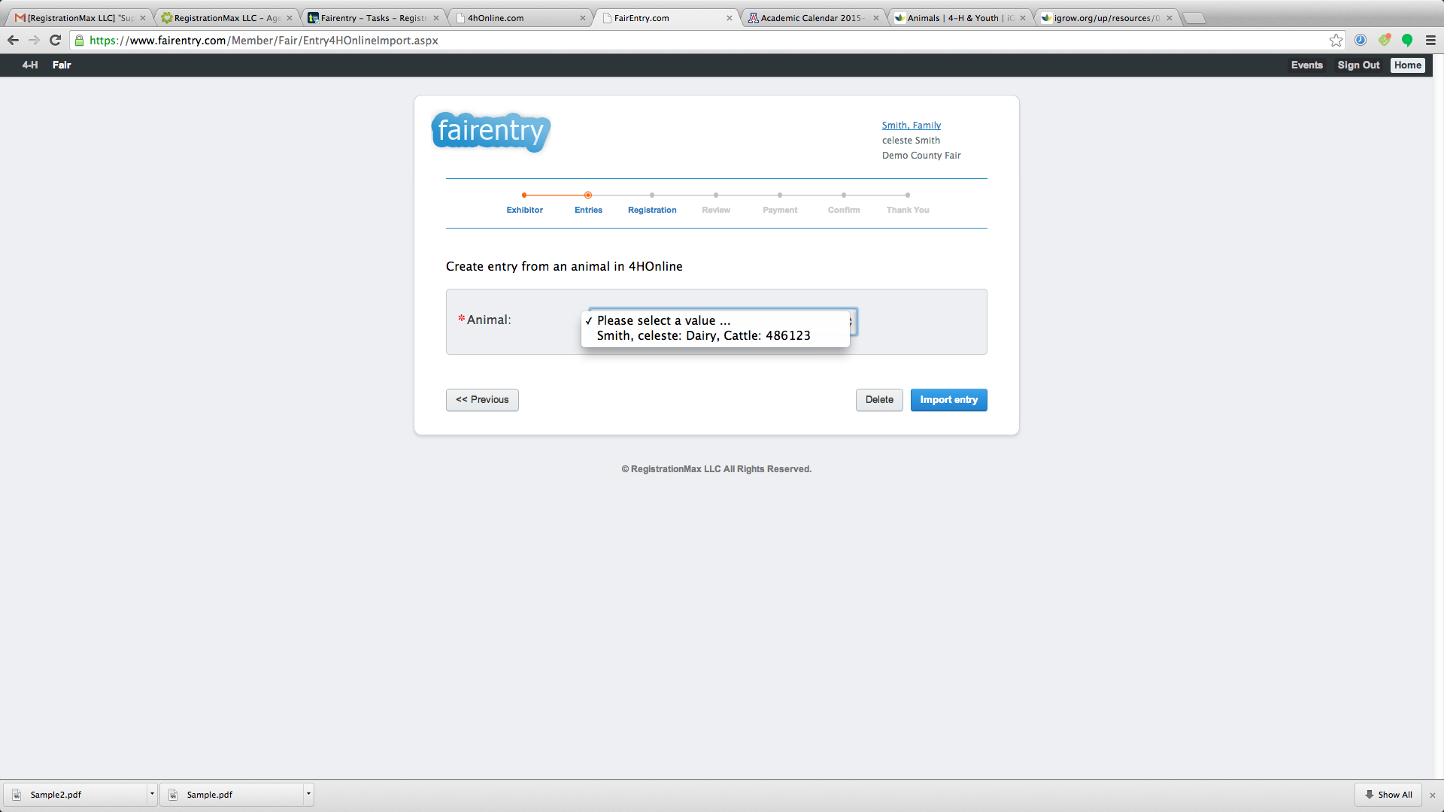
- Review the animal information to be sure the correct animal is selected. Click “Import Entry.” | 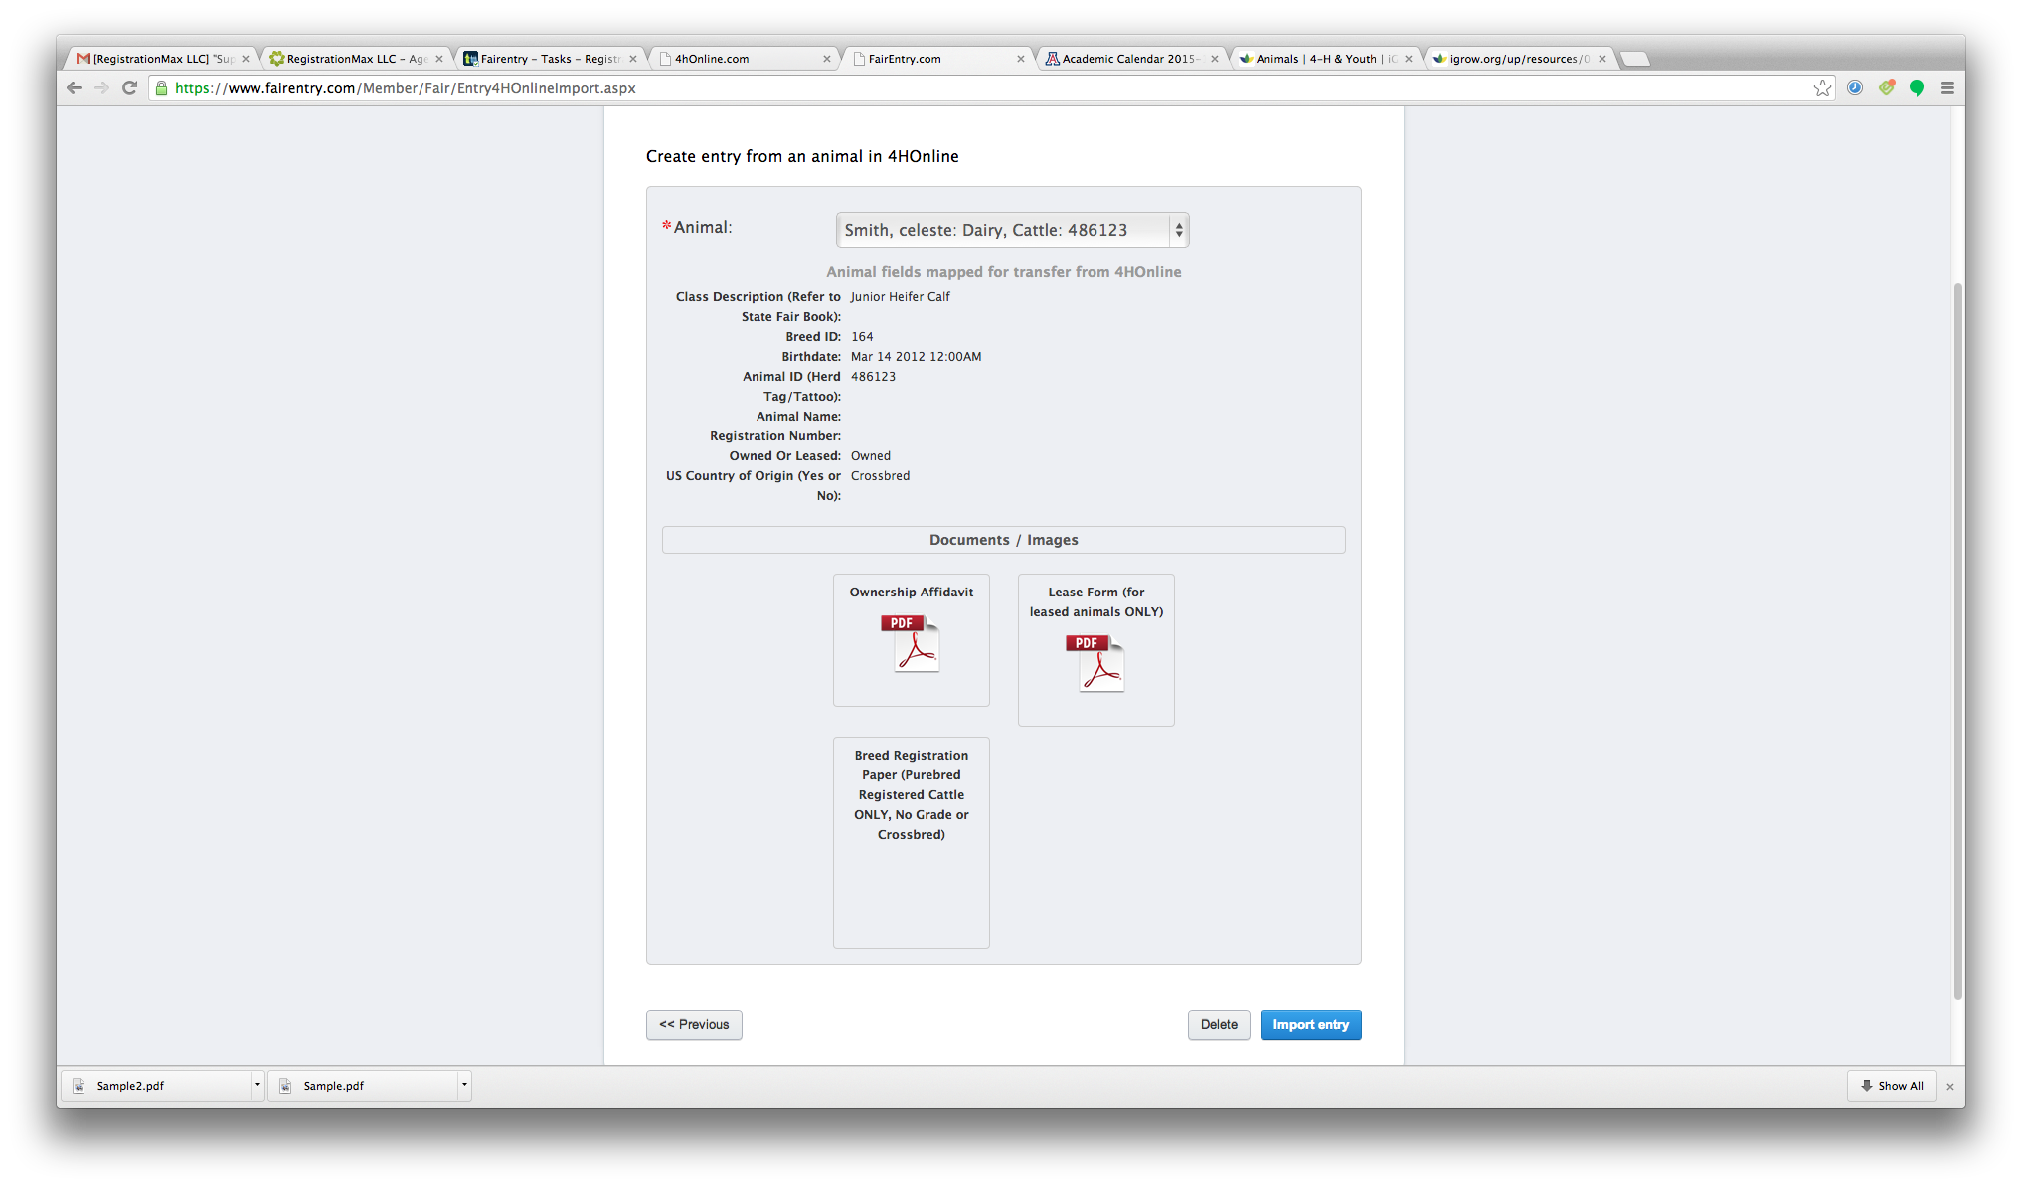
- Select the appropriate entry class.  - Enter any other required information.  - Click “Save entry” | 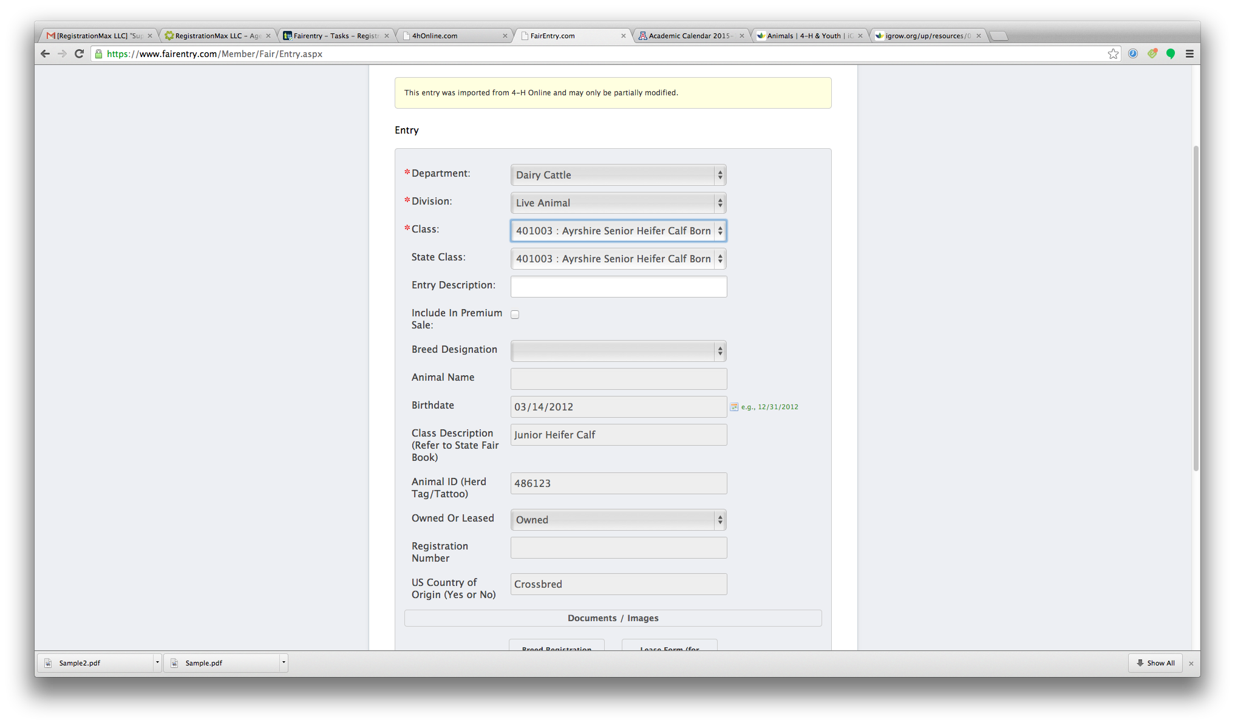
- To register a non-livestock entry, or an entry for which you will not choose an animal at this time, click “Create new entry.”  - Select the Division and Class and click “Create Entry.” | 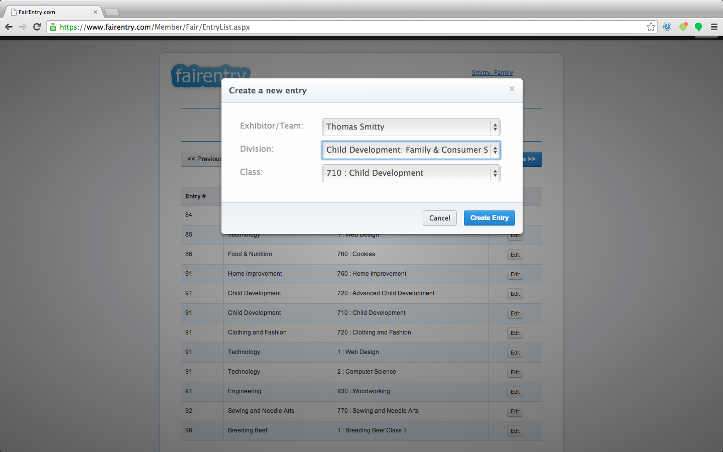
- Enter any other required information.  - Click “Save Entry” | 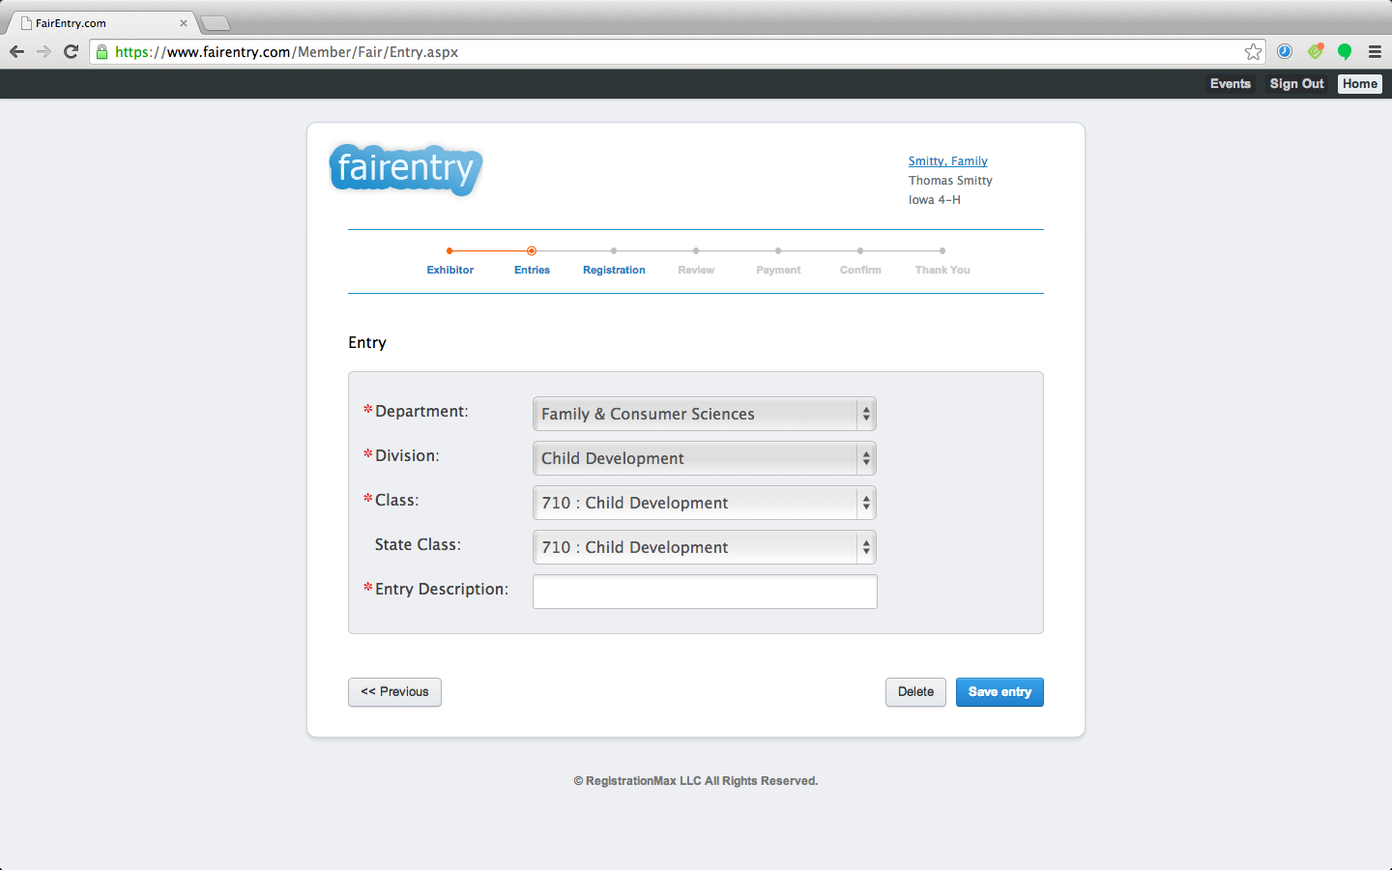
- After all entries have been added for the selected member, click “Continue.” | 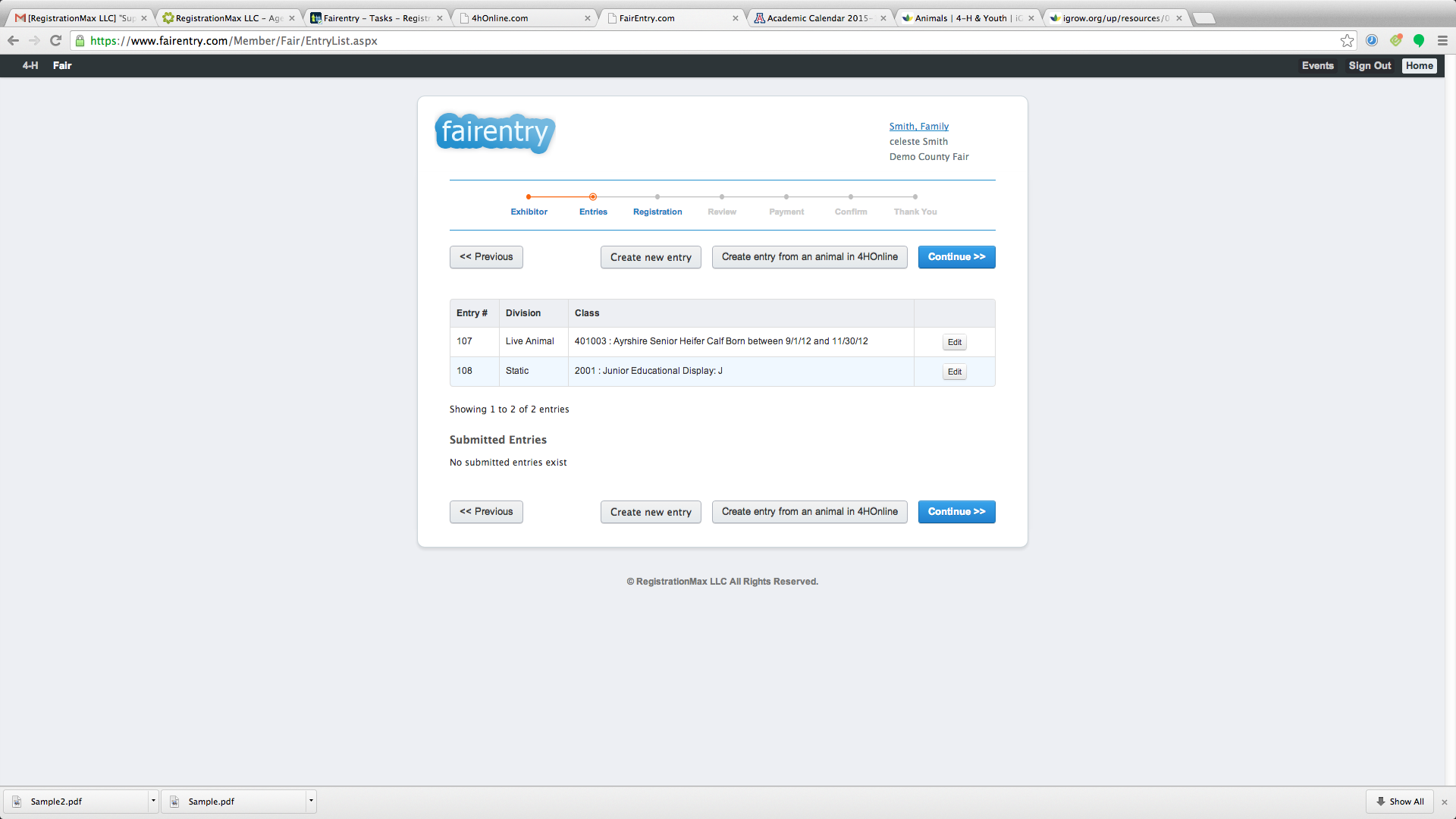
- Enter any additional registration information.  - Click “Continue.” | 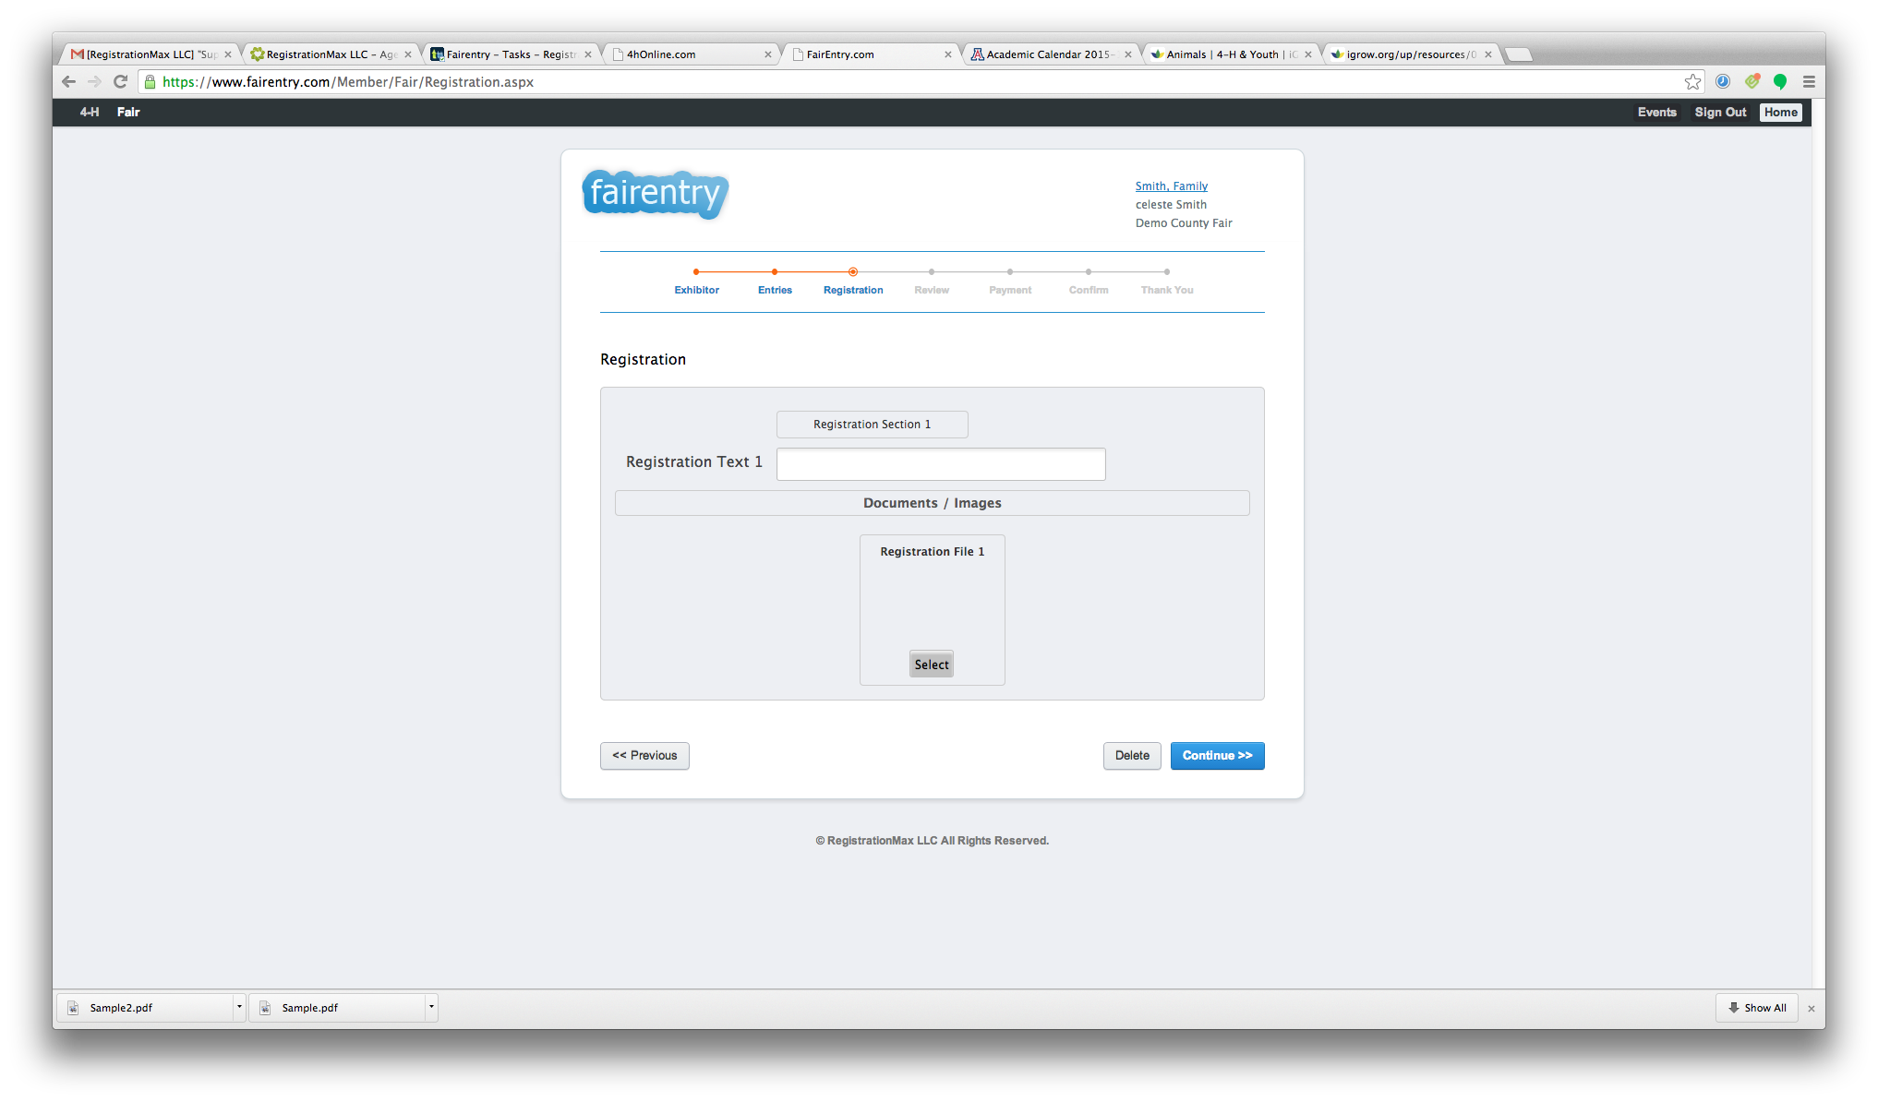
- Select “Register another exhibitor/team” to add entries for another family member.  - If all entries are complete, click “Continue.” | 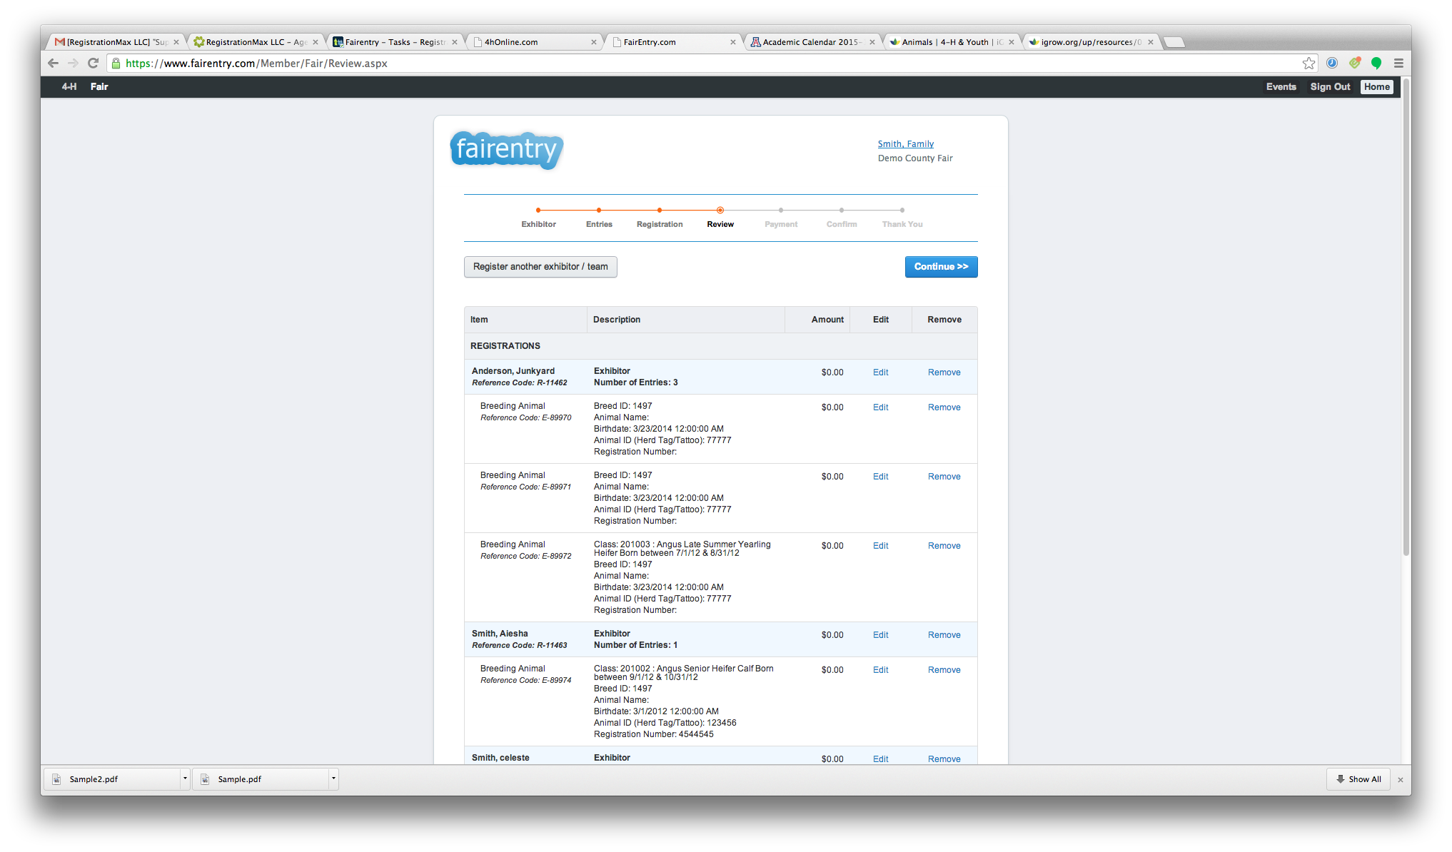
30. Review the invoice and click “Continue” | 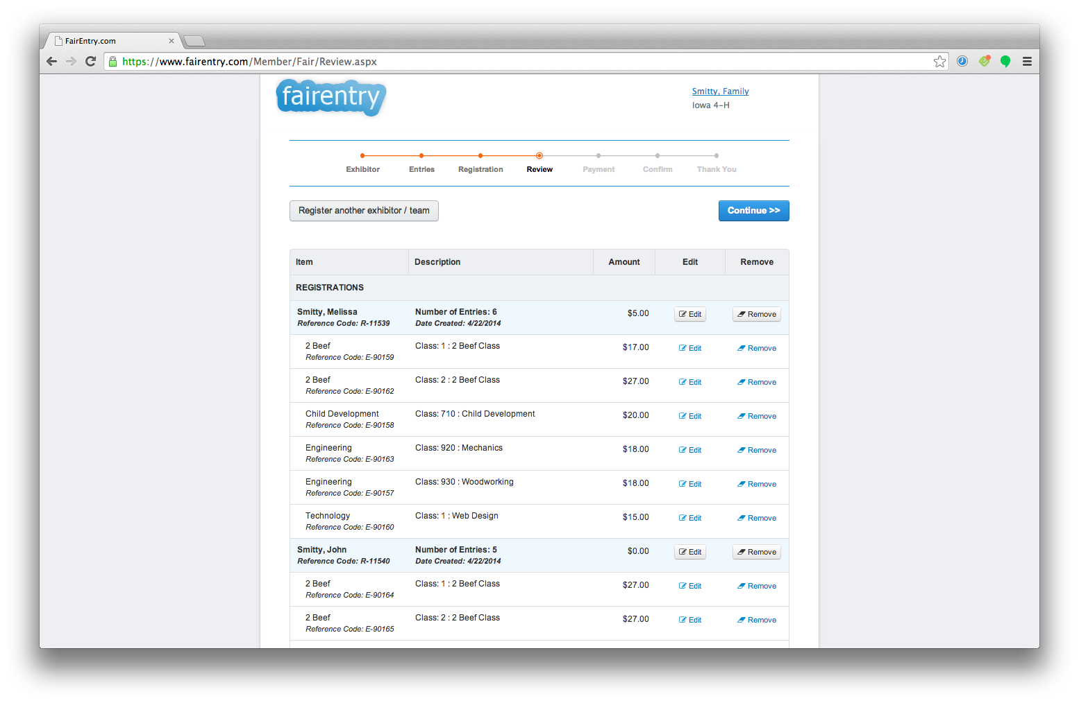
- Select the desired payment method and complete the billing address.  - Click “Continue” | 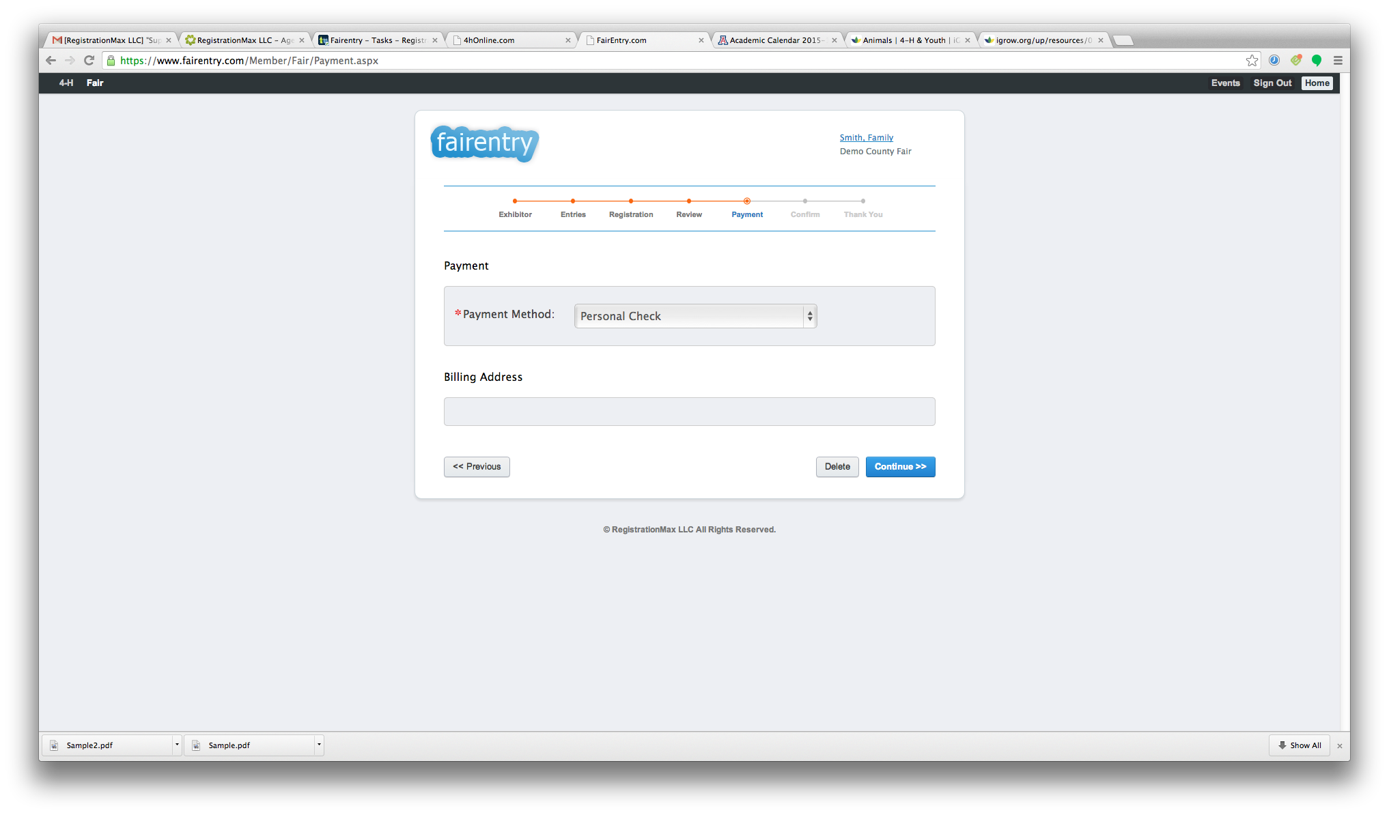
- Click “Confirm Order” to submit entries.  NOTE: Entries are locked for editing once they have been submitted. Contact your County/Event Manager to make any changes to existing entries. | 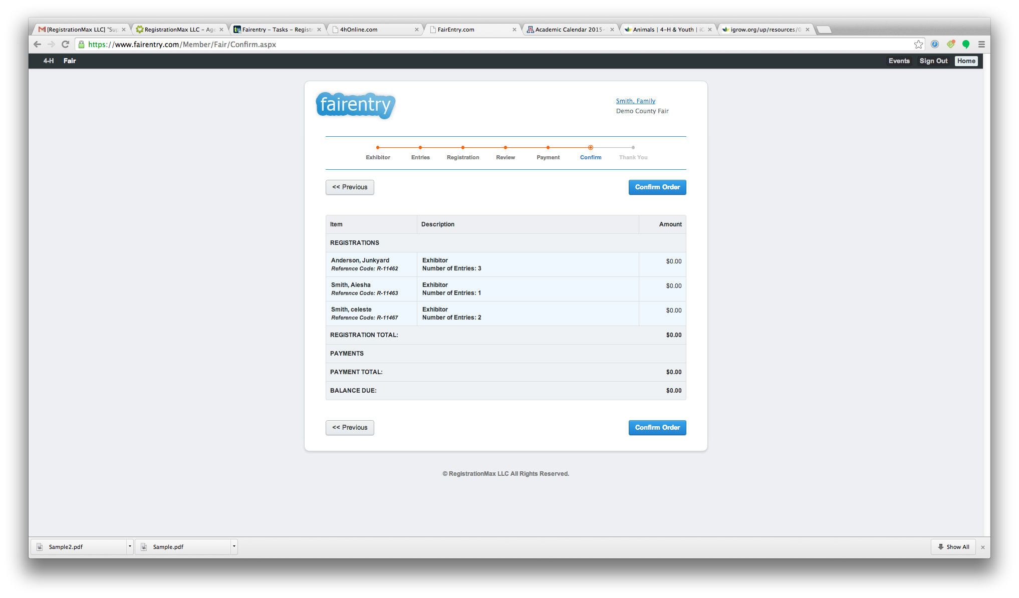
- Click on the Family Name at any point during the registration process to return to the family list of exhibitors and entries.

