January 2009

Approved: August 2009

TABLE OF CONTENTS

I. PLAN DEVELOPMENT
Contributors of Data / Introduction
Purpose / Objectives
Authorities and References

II. PLANNING PROCESS
Overview
Meetings
III. JURISDICITIONAL INFORMATION
Location Map / History
Geography/Topography
Geology and Soils
Climate / Precipitation
Annual Weather Extremes
Vegetation / Water /Watersheds
Watershed Map
Belle Fourche River Map
Demographics
Population
Transportation / County Road Map

IV. UTILITIES AND INFRASTRUCTURE
Water Services / Wastewater
Natural Gas / Telephone
Electrical / Emergency Services
Hospital/Nursing Homes/Day Care

V. HAZARDS
Overview
Weather Historical Data/Drought
Severe Thunderstorms
Flooding
Tornadoes
Winter Storms
High Winds
High Wind map
Earthquakes
Fire
Historical Forest Fire Map
Fires/ Landslide /Mountain Pine Beetle
Mountain Pine Beetle chart
Man Caused

V. HAZARDS continued
Special Events
Hazardous Materials Incidents / Hazardous Materials Facilities
FEMA Disaster Declarations
Probability / Risk
Risk by Area
Synopsis

VI. VULERABILITY
Overview
Critical Infrastructure Assessment
Critical Infrastructure List
County Vulnerability
Growth and Development
Sturgis
Faith
Piedmont
Summerset

VII. MITIGATION ACTIVITIES
County
Sturgis
Faith
Piedmont
Summerset

VIII. MITIGATION
County
Sturgis
Faith
Piedmont
Summerset

IX. GOALS
County
Sturgis
Faith
Piedmont
Summerset
Evaluations

X. ADDITONAL MATERIALS

I. PLAN DEVELOPMENT

The following provided data, or assisted in the development of the plan:

Federal Emergency Management Agency City of Piedmont
SD Office of Emergency Management City of Summerset
US Army Corps of Engineers US Geological Survey
US Environmental Protection Agency National Weather Service
National Interagency Coordination Center US Forest Service
Federal Emergency Management Agency US Bureau of Reclamation
Natural Resources Conservation Service City of Sturgis
Sturgis Planning and Zoning Committee City of Faith
SD Governor’s Office of Economic Development US Census Bureau
SD Dept. of Environment and Natural Resources SD Dept. of Agriculture
Meade County Office of Equalization & Planning Black Hills Land Analysis
Meade County Emergency Management Sate All Hazard Plan Elk Creek Conservation Dist. National Weather Service
Meade County Equalization and Planning

Introduction

Planning Requirements

The Disaster Mitigation Act of 2000, Section 322 (a-d) requires local governments have a mitigation plan in place as a condition for receiving federal disaster mitigation funds.

The Disaster Mitigation Act of 2000 Section 322 has two base requirements for receipt of increased Federal share for hazard mitigation measures.Each mitigation plan developed by local government shall:
(1) Describe actions to mitigate hazards, risks, and vulnerabilities identified under the plan
(2) Establish a strategy to implement those actions.

These two requirements contained in the Federal Register 44CFR, Part 201 to include some very specific actions that must be met to comply with the Disaster Mitigation Act of 2000.

1. After November 1, 2003, local governments must have a plan approved by the State and Federal government to qualify for Pre-disaster Mitigation planning grants.

2. After November 1, 2004, local plans must be approved to qualify for disaster related Hazard Mitigation Grant Program.

I. PLAN DEVELOPMENT

Purpose

The Pre- Disaster Mitigation Plan for Meade County is to meet the requirements of the Disaster Mitigation Act of 2000. The political subdivisions of the City of Faith, the City of Sturgis, City of Summerset, and Meade County are the jurisdictions involved in the development of this plan. Tasked with the mandated responsibility of providing protection for the residents and visitors of Meade County, The Meade County Board of Commissioners has undertaken the revision and updating of this plan. The plan will help to develop strategies to mitigate or reduce the loss of lives and property in a disaster within Meade County.

Objectives

      - To update the existing Pre-Disaster Mitigation Plan that will provide structure for emergency planning, preparedness, response, recovery and mitigation for the present and future.

- To involve residents and officials in the planning effort.

- To review those hazards that pose the greatest threat to the people and economy and are most likely to occur in Meade County

- Identify those persons or property at risk in Meade County.

- To develop mitigation strategies to ameliorate as is possible, against those hazards identified and reduce the risk to people and property.

- Identify those hazards that to mitigate will require expenditures of funds not currently available through local government funding mechanisms.

- Provide a Pre Disaster Mitigation Plan for the following jurisdictions:

- City of Piedmont
- City of Sturgis
- City of Faith
- City of Summerset
- Meade County

I. PLAN DEVELOPMENT

Authorities & References

Federal
Public Law 920; Federal Civil Defense Act of 1959; as amended
Public Law 93-288; Disaster Relief Act of 1974; (Stafford Act) as amended
Federal Response Plan 9230 -1PL
Title III, Superfund Amendments and Re-authorization Act of 1986
National Flood Insurance Program of 1968
National Environmental Policy Act of 1968
National Flood Insurance Reform Act of 1994 (NFIRA)
Disaster Mitigation Act of 2000

State
South Dakota Codified Law (SDCL)
1-24; Joint Exercise of Governmental Powers
33-15; Emergency Management
33-15-3; Coordination with Federal Government
33-15-25; Authority to accept Federal moneys, services or equipment
33-15-26; County emergency management organizations
33-15-27; Director of local organization-Duties and Powers
33-15-29; Contracting Powers of Local Subdivision

Local
Meade County Administrative Plan
Meade County Local Emergency Operation Plan
Meade County Pre Disaster Mitigation Plan

II. PLANNING PROCESS

Overview
Methodology
- The Meade County Board of County Commissioners authorized the development of the Pre-Disaster Mitigation for Meade County and tasked the Emergency Management Office and Director, Kathie Grant with the responsibility to develop, monitor, and implement the plan as appropriate. The county will collaborate with all the municipalities to produce the plan.

- The initial step of the planning process was gathering data and historically documented disasters.
- Research historical files and archived daily newspapers.
- Hazard assessments completed by residents
- Sheldus databases
- National Weather Service Data
- National Climatic Data Center
- Federal Emergency Management Agency

- Planning Group structure.
- Meade County Board of Commissioners
- Meade County Planning Committee ( Pre Disaster Planning Group)
- Cities of Sturgis, Piedmont, Summerset, Piedmont, and Faith
- Additional entities were invited to participate
School Districts
Rural Electrical Cooperatives
Water Districts
Other jurisdictions and agencies

- The Meade County Pre Disaster Planning Group will meet in formal public meetings, at the end of the Meade County Planning Committee Meetings. These meetings are open to the cities and public to attend.
- While jurisdiction representative will be invited to attend the formal planning meetings, because of scheduling and travel distance they probably will not attend, so separate meeting will be held with each jurisdiction. The meetings will be documented in the appendixes.
- The Emergency Manager will coordinate meetings with the participating cities.
- Public Meetings were held to gather support, and recruit participants to assist in the planning effort. The meetings facilitated public discussions on hazards and issues that concerned the attendees as far as those hazards. Explanation of the Pre-Disaster Mitigation Program and the planning effort were a component of the meetings. (See Appendix A for documentation)

II. PLANNING PROCESS
Overview continued

H. Meetings held and correspondence
DATE | JURISDICTION OR AGENCY | TOPIC
November 6, 2007 | Meade County Board of Commissioners | Update of PDM
January 22, 2008 | Meade County Planning Committee and PDM Planning Committee | Review of old PDM and suggest additions
March 17, 2008 | Meade County Planning Board Committee and PDM Planning Committee | Pre-Disaster Mitigation Plan – Hazards
April 15, 2008 | City of Piedmont – Public Meeting | Pre-Disaster Mitigation Plan – Hazard identification and discussion of hazards and vulnerability
June 3, 2008 | City of Faith- Public Meeting | Pre-Disaster Mitigation Plan – Hazard identification and discussion of hazards and vulnerability
June 16, 2008 | City of Sturgis- Public Meeting | Pre-Disaster Mitigation Plan – Hazard identification and discussion of hazards and vulnerability
July 21, 2008 | Meade County Planning Board Committee/ PDM Planning Committee | Update of New Vulnerability Hazard Assessment
August 7, 2008 | City of Summerset- Public Meeting | Pre-Disaster Mitigation Plan vulnerability hazard identification / discussion
August 12, 2008 | Meade County Board of Commissioners | Review hazards/ vulnerability/ flood parts of plan discussed plan, information, and how to display.
October 29, 2008 | City of Faith meeting with officials | Review of Faith data and hazard vulnerability
November 4, 2008 | City of Sturgis City Manager | Review of Sturgis data and hazard vulnerability
November 17, 2008 | Meade County Planning Committee and PDM Planning Committee | Draft of plan for review and discussion about maps and graphics
November 25, 2008 | SDEMA Region IV Emergency Managers | Meade County invited participation in PDM review
December 9, 2008 | Sturgis Planning and Zoning | review and discussion about goals for City
December 10, 2008 | Letter written to each Mayor | Request for goals from Cities
December 15, 2008 | Meade County Planning Board Committee/ PDM Planning Committee | Update on progress goals for City
December 16, 2008 | Email to Meade County Commissioners | Request for goals from Commissioners
December 22, 2008 | Letters to School Districts and Rural Electrical Cooperatives | Request for goals and information about goals
December 2008 | Public, neighboring counties, Cities and agencies | Distribution of Copies of the Plan to Jurisdictions and agencies for review, additions and corrections

II. PLANNING PROCESS

DATE | JURISDICTION OR AGENCY | TOPIC
December 2008 – January 2009 | Piedmont, Sturgis, Faith, Summerset | Phone calls and emails about plan, goals and review process
January 6, 2009 | Meade County Commissioners | Minor corrections made to plan and Resolution passed.
January 15, 2009 | City of Summerset | Resolution passed for PDM
January 19,2009 | City of Sturgis | Resolution for PDM
January 20,2009 | PDM planning Committee | Update on finalization process
January 20, 2009 | City of Piedmont | Resolution for PDM
January 20,2009 | City of Faith | Resolution for PDM

- Meetings held and brief summary (minutes of meetings and other documentation in Appendix A). Below is the list of meetings and activities held and brief summary of meetings

November 6, 2007 - Meade County Board of Commissioners met and the
Meade County Emergency Manager briefed the Commissioners on the need to update the Pre-Disaster Mitigation Plan and discussed the planning process.
Commissioners are part of the Meade County Planning Committee and it was determined that the Committee would be the best group to work on updating the plan. The Meade County Planning Committee will serve as the Pre Disaster Mitigation Planning Group. The Emergency Manager will meet individually with the cities in the counties and invite them to attend the planning group.

January 22, 2008 – Meade County Planning Committee / Meade County Pre Disaster Mitigation Planning Group met and the Emergency Manager provided the Planning Group with a copy of the basic jurisdictional information, a copy of the plan to be updated and an the new county specific data found in the State of SD Multi-Hazard Plan. The group will review the documents and provide comments, questions, suggestions, and additions to the next meeting.

On March 17, 2008 - The Emergency Manager met with the Meade County Planning Committee/ Meade County Pre Disaster Planning Group. Drafts of the Vulnerability Assessment and Flood Assessment were provided to the group. A discussion the ranking of hazards as to probability with a questionnaire also took place. Some changes in sections in the old plan were suggested and implemented.

April 15, 2008 – The Meade County Emergency Manager met with the City of Piedmont trusties. The City Council was briefed on what a Pre Disaster Mitigation Plan is, and what is required, as they are a newly incorporated City. They agreed to participate in the planning process and named the Chairman of Planning and Zoning to meet with the Emergency Manager to assist with the planning.

II. PLANNING PROCESS
Overview continued
Methodology

June 3, 2008 – The Faith City Council met and the Meade County Emergency Manager met with the council in a large public meeting. The City Council was briefed on the Pre Disaster Mitigation Plan, and the required update. They agreed to participate in the planning process. The public and elected officials participated in a discussion of hazards and probability. Where Faith has no streams and is on a hillside, the probability of flooding is almost very low. However, it was discussed that with the high probability of damaging winds and or tornadoes, a building storm shelter would be a good mitigation goal for the community.

June 16, 2008- The Sturgis City Council met with a large public crowd. The Emergency Manager distributed and received back questionnaires on hazard probability from the public and elected officials. The Pre-Disaster Mitigation Plan was discussed and the need for the city to form some mitigation goals. The City Engineer and Planning Committee will meet with the Emergency Manager to discuss the plan, review data, and formulate goals.

July 21, 2008 The Pre Disaster Mitigation Planning Group met at the end of the Meade County Planning Committee meeting. The Emergency Manager provided a new updated Flood Appendix, given the recent flooding in June. Some corrections to Vulnerability Appendix made. The Group will review the Flood Appendix.

August 7, 2008 The Meade County Emergency Manager met with the City of Summerset City Council. Questionnaires on hazard probability were distributed to the public and elected officials. The Pre-Disaster Mitigation Plan was discussed and the need for the city to form some mitigation goals. The City Engineer and Planning Committee will meet with the Emergency Manager to discuss the plan, review data, and formulate goals.

August 12, 2008, the Meade County Board of Commissioners met and the
Meade County Emergency Manager, briefed the Commissioners on the progress of the Pre Disaster mitigation plan. Copies of the Vulnerability Appendix and Flood Appendix were provided to the Commissioners. The Meade County Equalization Director and Assistant Director attended the briefing. It was discussed that there was a need for data concerning value of property in the various flood plains. Especially troubling is the Hazus program can’t be run for at this time. Various methods of determining property values in flood plains were discussed.

October 29, 2008, Faith officials were provided copies of hazards, vulnerability data also vulnerability and flood appendixes for review and correction. There was a discussion on Faith specific data and potential goals for Faith in the new plan. Discussion of water concerns and storm shelter will possibly be some goals listed.
II. PLANNING PROCESS
Overview continued
Methodology

November 4, 2008 The Meade County Emergency Manager meets with the Sturgis City Manager. Sections of the old plan about Sturgis were provided to him to review, correct or edit. In addition, the Vulnerability and Flood data and appendixes were provided. The City is requested to review data and comment.

November 17, 2008 the Meade County Planning Board and Pre-Disaster Mitigation Planning group met. A draft of the Plan was provided to the group. There was a discussion on the various maps needs and how to reflect various types of data. The Planning part of the Equalization and Planning office will provide the maps.

November 25, 2008 the SDEMA Region IV Emergency Managers meet in their quarterly meeting. Kathie Grant advised the group of the Pre Disaster Mitigation Plan progress and invited participation in review and editing process.

December 9, 2008 The Sturgis Planning and Zoning Committee were provided with Appendixes of the plan. A discussion of flooding issues and goals for the city of Sturgis. The Committee suggested a letter to the Mayor of Sturgis would be the most effective.

December 10, 2008 letters were drafted to each Mayor. Letters were sent to Piedmont, Sturgis, Faith and Summerset Mayors, requesting they provide goals for their cities to be listed in updated Pre-Disaster Mitigation Plan. See Appendix A.

December 15, 2008 Meade County Planning Board and Pre-Disaster Mitigation Planning group met. Provided was update of the plan and seeking goals for the plan. It was suggested the Commissioners should provide the goals.

December 16, 2008 and email was sent to the Meade County Board of Commissioners. See Appendix A.

December 16th thru December 30th. numerous emails and phone calls were conducted to complete goals for Summerset, Piedmont and County Commissioners.
These groups chose to set goals without formal meetings.

December 22, 2008 letters were sent to the school districts and rural electrical providers. They were giving them information about the Pre-Disaster Mitigation Plan and requesting their participation and contributing of goals if they choose.

II. PLANNING PROCESS
Overview continued
Methodology

December 23rd. thru January 9th. 2009 copies of the draft of the plan were distributed and review sign off sheets were collected. All together 19 jurisdictions or agencies were provided copies of the plan not all returned review sheets. Copies are found in Appendix A, Plan Review.

January 6, 2009 the Meade County Board of Commissioners reviewed the revised Pre Disaster Mitigation Plan some minor corrections were made and verbiage changes were made. The resolution for the Plan was passed with the approved changes.

January 15, 2009 the Summerset City Council passed a resolution to adopt the revised Pre Disaster Mitigation Plan.

January 15, 2009 the Sturgis Meade County Times newspaper carried two different articles about the revision of the PDM and where it was available to review.

January 20, 2009 the Rapid City Journal newspaper carried a small article about he revision of the Meade County PDM.

January 19, 2009 the Sturgis City Council passed a resolution to adopt the revised Pre Disaster Mitigation Plan.

January 20, 2009 the Pre Disaster Mitigation Planning Committee met for and update on the planning process.

January 20, 2009 the Piedmont Board of Trusties passed a resolution to adopt the revised Pre Disaster Mitigation Plan.

January 20, 2009 City of Faith, due to the distance between Piedmont and Faith the Emergency Manager could not physically attend the Faith meeting where the resolution was approved for the Mayor to sign adopting the revised PDM.

III. JURISDICTIONAL INFORMATION

Location

Meade County (in green on map) is located in the northwest portion of South Dakota; the Counties of Pennington, Lawrence, Butte, Perkins, Ziebach, and Haakon border it.
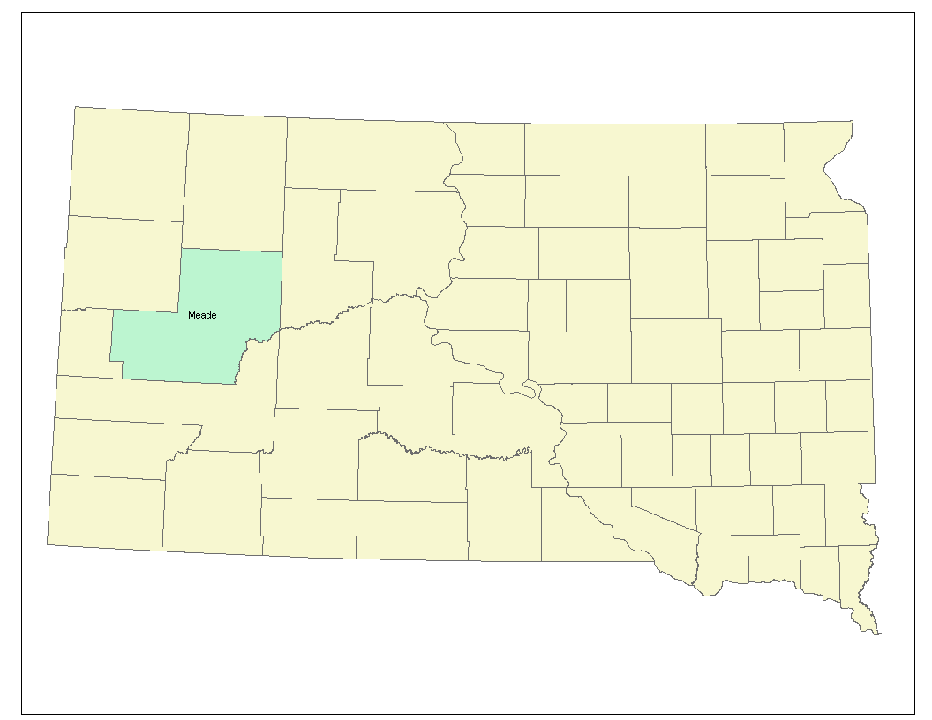

History

Prior to the late 1800s, Native Americans hunted and lived in western South Dakota.
In 1874, General George Armstrong Custer headed an expedition, which found gold in the Black Hills. By 1876, the Black Hills were abounding with gold miners, and the businesses that supplied their needs. To protect settlers and gold miners in the Black Hills, in July 1878 the US Army established Camp Sturgis. It was located several miles north of the present site of Fort. Meade. The present Fort Meade was established by the 7th. Cavalry in August 1878. The City of Sturgis was plotted in the fall of 1878. In 1889, South Dakota became a state. The organizing of the present Meade County from the unorganized counties of Scoby, Delano, and part of Lawrence County took place in 1897. Construction began on the first Courthouse in Sturgis fall of 1897.

III. JURISDICTIONAL INFORMATION
Geography / Topography

The geographic area of Meade County makes it the largest county in the State of South Dakota with 3,471 square miles or about 2 million acres. From the southwest corner of the county to the northeast corner is 140 miles. The majority of the county is rolling farm and ranch land. The southwest corner of the county is hilly, forest, and is part of the Black Hills National Forest. Bear Butte State Park, north of Sturgis, is also located within Meade County. The Belle Fourche River crosses the county from roughly the northwest corner to the eastern county line where it joins the Cheyenne River. The Cheyenne River makes up a portion of the southeastern county line. There are no natural lakes and only small earthen dams in the county. The following map shows the topography of the State of South Dakota and Meade County. The Cheyenne River makes up a portion of the southeast boundary

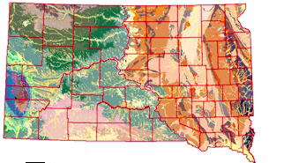

Geology and Soils

Most soils in Meade County are well-drained, loamy and silty types. They are medium to low in fertility and moderate or high available water capacity with a moderate or moderately slow permeability. Most of the dry farming in the area is in soils of this type. Conserving moisture and controlling erosion and soil blowing are concerns of management. Raising livestock and growing wheat are the best land uses. About 40 percent of the soils are soft clayey with medium to low fertility and moderate to very low available water capacity. Permeability is slow or very slow in most of these solid types and runoff is medium to rapid. Raising livestock is the best land use. These types of soil increase the risk of flash flooding and the impact is increased do to ease of erosion.

III. JURISDICTIONAL INFORMATION
Climate

The climate is not uniform due to the large size of the county and the changes of topography and elevation. The elevation at the Cheyenne River in the far eastern portion of the county is 2,200 feet above sea level. In the southwestern section in the Black Hills, the ridges and peaks are about 5,400 feet above sea level.

The following data was taken from National Weather Service Rapid City website.
January and February are the coldest months of winter. Daytime temperatures average in the 30s, but Chinook winds can warm temperatures into the 50s and 60s. Occasional intrusions of Arctic air are short-lived and temperature inversions sometimes produce warmer conditions in the Black Hills.
Low temperatures average from 10 to 20 degrees above zero. Below zero readings are common in the higher valleys of the Black Hills.
Average monthly snowfall ranges from 5 inches in Rapid City to 15 inches in the Black Hills. The snow on the plains usually melts within a few days, with deeper snow in the Black Hills.
January Average | High Temp | Low Temp | Snow | Days low temp < 0 E
Rapid City | 34 | 11 | 5.2 | 8
March and April is western South Dakota’s snow season and temperatures are still cool enough in the higher elevations to retain the snow cover. March is typically the snowiest month of the year, with average snowfall 15 to 25 inches in the northern Black Hills and 8 to 12 inches over the southern Hills. Normal highs are in the 40s and lows are in the 20s.
Snow often occurs in April, although temperatures are warmer. Normal snowfall for the Black Hills is 10 to 20 inches in the north and five to 10 inches in the south. Average daytime temperatures are in the 50s with lows in the 20s and 30s.
March Average | High Temp | Low Temp | Snow | Days with snow > 1.0"
Rapid City | 47 | 23 | 9.1 | 3

III. JURISDICTIONAL INFORMATION
Climate continued
May and June weather is mild and precipitation changes from rain showers to thunderstorms. Storms typically develop over the Black Hills during the afternoon and move onto the plains in the evening. There is an average of 20 clear to partly cloudy days.
Temperatures warm rapidly as summer approaches. Daytime highs average in the 60s during May and 70s during June. Overnight temperatures are still chilly, especially in Black Hills, where May minimums are in the 30s and 40s. Lows are typically in the 40s and 50s during June.
June Average | High Temp | Low Temp | Rain | Clear-partly cloudy days
Rapid City | 77 | 52 | 2.83 | 20
Summer is warm, dry, and sunny. July and August are the warmest months of the year, when daytime temperatures climb into the 70s and 80s--and sometimes 90s.
Early mornings are cool, Low temperatures average in the 50s, although 40s--and even 30s--can occur at the higher elevations like Deerfield.
Thunderstorms produce less rainfall, and drier conditions increase the wildfire potential in the Black Hills. Rapid City records an average of 9 thunderstorms days in August, but only 1.67 inches of rain.
Because the elevation of the Black Hills are between 4000 and 7000 feet, the sun is very intense.
August Average | High Temp | Low Temp | % Humidity | Days high temp > 90 E
Rapid City | 86 | 57 | 39 | 11
Sunny, mild days and cool nights are characteristic of September and October weather. Temperatures begin to cool around Labor Day, with September highs averaging in the 60s and 70s, falling into the 50s and 60s in October. Lows drop from the 30s and 40s into the 20s and 30s. The average first freeze in Rapid City is October 4 and late August through September in the Black Hills.
The area’s first snowfall is usually in October, although higher elevations sometimes receive snow in September. Occasional cold fronts moving through the area bring blustery northwest winds.

III. JURISDICTIONAL INFORMATION
Climate continued

October Average | High | Low Temp | Snow | Days low temp < 32 E
Rapid City | 62 | 35 | 1.8 | 11
November and December mark the beginning of winter in the Black Hills. Despite cooler temperatures and more snow, the area still has many mild, sunny days.
By December, daytime temperatures are in the 30s with nighttime readings in the teens and sometimes below zero in the Black Hills. Occasionally cold air from Canada will bring subzero temperatures to the entire area.
Snowfall averages about five inches each month with only two days typically receiving more than one inch of snow. Storms early in the season produce heavy, wet snow. As the winter progresses, storm tracks from the northwest bring drier snow. Rapid City’s chances for a white Christmas (defined as having inch or more of snow on the ground) is about 50 percent.
December Average | High Temp | Low Temp | Snow | Percent Sunshine
Rapid City | 36 | 13 | 5.3 | 55

Sunshine can be expected 62% of the time. In summer, the average wind speed is 10 miles per hour, in winter the average is 11 miles per hour. More specific wind data is recorded in the Hazard Vulnerability appendix of the plan. It should be noted with the consist wind there is a high evaporation rate from the soil.

Precipitation

Meade County as a whole is quite arid. A large portion of the county receives less then 18 inches of moisture annually. The county as a whole is vulnerable to drought, and wind erosion. Flash flooding is problematic because the soil often being too dry to soak up moisture when it comes. Bridges and culverts designed for the normally arid conditions, cannot handle above average precipitation. The following data is on the prairie portion of Meade County where precipitation is less then in the Black Hills portion. Precipitation during the growing season has ranged from a low of 5.92 in 1952 to a high of 14.18 in 1971. About once in every two years, a rainfall of an inch an hour occurs. Rainfall of 2 inches in 24 hours occurs once in two years and rainfall of 3 inches in 24 hours occurs once in 10 years.

III. JURISDICTIONAL INFORMATION
Precipitation continued

The smallest seasonal snowfall was 13.0, which occurred during 1960-1961 The highest seasonal snowfall has exceeded 52 inches in 1969-1970 and 1996-1997.
The average precipitation for the Black Hills portion of the county varies from 17 inches in the north to 21 inches in the south. Snowfall is normally far heavier in the Black Hills region then on the prairie. Because of steep canyon walls and high ridges and peaks, rainfall tends to increase flows of streams due to high runoff rates.

For the last 11 years, precipitation has been persistently below normal, documenting 11 years of drought conditions and reduced crop production.

. 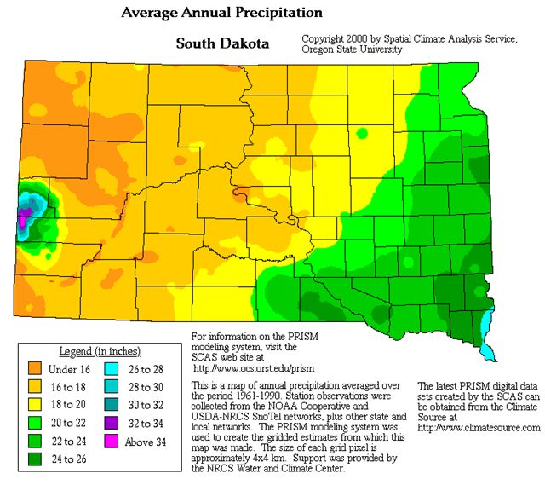

III. JURISDICTIONAL INFORMATION

Land Use

About 14 percent of the land is cropland, wheat, sunflowers, alfalfa, and hay as a product for sale. With the recent years of drought less land mass has been used for cropland, other then alfalfa and hay. About 4 percent is woodland, and most is in the Black Hills National Forest.
There are in excess of 6140 stock water dams in Meade County most are small.

Owners operate approximately 90 percent of the farms and ranches. The Bureau of Land Management has 17,440 acres; the Forest Service 37,145 acres; Air Force 3,847 acres; State land 66,210 acres; Game, Fish and Parks 1,540; urban use; 10,000 acres.
Water
Tributary streams that lead out of the Black Hills generally cease flowing by midsummer. The streams that begin in the Black Hills are prone to flash flooding due to the drop in elevation from the headwaters, and the narrow creek channels. Small ponds and surface water from dams provide much of the water for livestock.
Watersheds

Flash flood prone watersheds in western Meade County that drain into the Belle Fourche and Cheyenne Rivers are shown below by stream.

III. JURISDICTIONAL INFORMATION

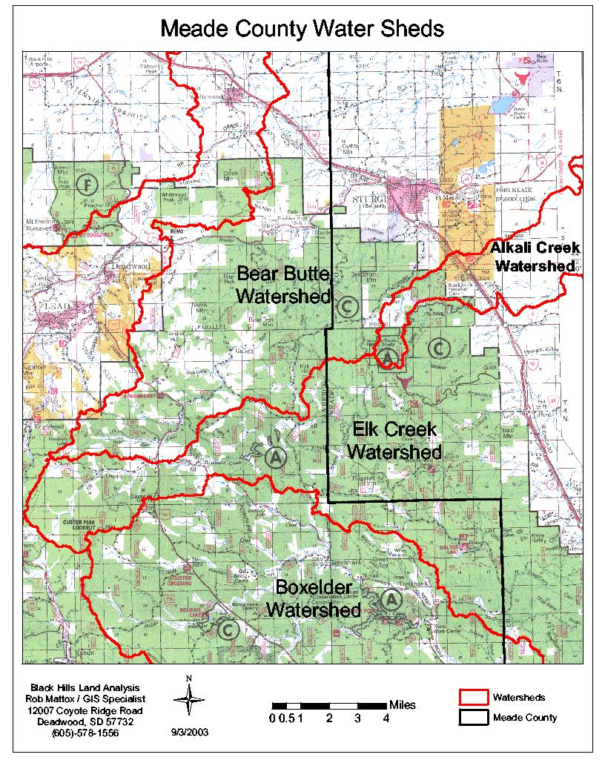

III. JURISDICTIONAL INFORMATION
Watersheds continued

The Belle Fourche and Cheyenne Rivers are surface streams that have a continuous flow. The Belle Fourche River is a natural stream that drains portions of Butte, Lawrence, and Meade Counties in South Dakota and flows to the Cheyenne River in Meade County. Orman Dam is along the river, dam failure would flood Meade County. The Bureau of Reclamation maintains the dam and has an Emergency Plan in place. The remainder of the county drains into the Cheyenne River through numerous small streams located both north of the Belle Fourche River watershed and south of the watershed.
To mitigate flash flooding, the Belle Fourche River was dammed in 2 locations.
The potential failure of the Orman dam is low probability but planning and exercises occur annually to mitigate a possible failure. There is a small population in Meade County along the Belle Fourche River. Few houses are near the river or would be in danger.

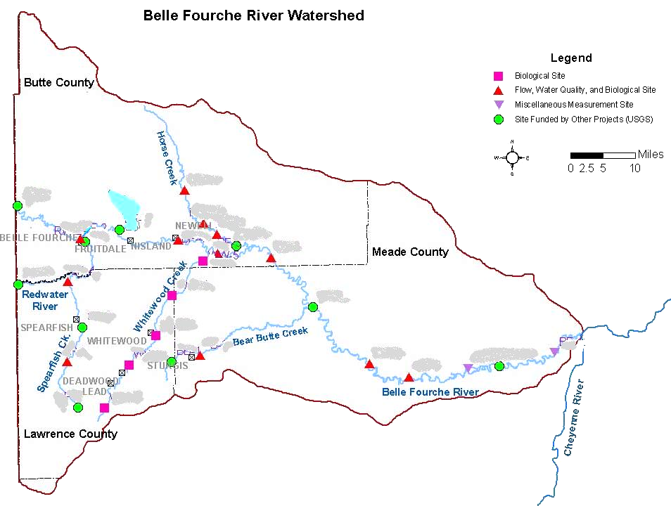

III. JURISDICTIONAL INFORMATION
Demographics
Best available data
SUBJECT | NUMBER | PERCENT | SUBJECT | NUMBER | PERCENT
Population 2006 estimate | 24,425 | 100 | HOUSEHOLD
SEX AND AGE |  |  | Total Households 2006 | 11,947
Ma Male |  | 50.4 | Owner occupied housing 2000 | Not available | 68.2
Female |  | 49.6 | Renter- occupied 2000 |  | 31.8
Under 18 years |  | 7.2 | 2002 Residential Building Permits * | Not available
65 years and older |  | 10.7 | Vacant housing units | 1,344
Median age (years) | 33.4 |  | Average home value | $100,000
RACE |  |  | Population in labor force 2000 | 13,280
White |  | 93.1 | Unemployed in 2000 | 453 | 2.5
Hispanic or Latino |  | 3.5 | 1999 latest per capita
American Indian or Alaskan |  | 2.1 | Personal income average | $17,680
Black or African American |  | 1.7 | Median household income | $44,516
Asian (all) & Hawaiian |  | 0.7 | Families below poverty status | Not available | 9.3
Source: US Census Bureau
Website 2006-2008

Leading Employers
- Ft. Meade Veterans Affairs, health care, is the largest employer with 600 plus employees.
- Meade School District, education, 300 plus employees.
- Black Hills Special Services, disability education provider with 200 plus employees in Meade County.
- Sturgis Regional Hospital, hospital, nursing home, home heath nurses, 200 plus employees.
- City of Sturgis with 150 plus employees.
- Meade County with 125 plus employees

The labor force especially in the rural areas commutes to work. Commute times show 49 % of commuters have a less then 18-minute commute. About 32 % of commuters take 15 to 29 minutes. . About 18 % of the employed population commutes 30 minutes or more. Almost 10,000 residents of Meade County are commuting to work, making them vulnerable to severe weather, especially weather that causes treacherous driving conditions

III. JURISDICTIONAL INFORMATION

Demographics continued

Population

September to June:
Sturgis is the county seat for Meade County. The county is currently experiencing rapid population growth. The number of residents with the zip code for the area of Piedmont and Summerset has increased by 130% in the last 16 years. New growth includes the incorporation of the newly built community of Summerset and the incorporation of the old community of Piedmont. In 1998, the population estimated for Meade County was 21,911. The population in 2008 was estimated at 24,425 people or about 7 people per square mile. There are 4 municipalities, Sturgis in the far west, and Faith in the far northeast corner, distance between communities is about 110 miles. Piedmont and Summerset are new cities in the southwest part of the county.

The population of the county is largely concentrated along Interstate 90 between Sturgis and the county line just north of Rapid City a distance of about 25 miles. There are numerous sub-divisions along this 25-mile stretch. Some development is occurring around Sturgis. The US Veteran’s Administration has a complex 3 miles east of Sturgis. Fort Meade is a hospital complex with some housing. Development is occurring in the area of Ellsworth Air Force Base, located partially in Meade County along the southern county line. The majority of the population of the county is located along the western edge of the county the only population group over 50 residents is about 480 residents in the town of Faith in the northeast corner of the county.
June to September

Tourism during the summer months causes the population to increase. The main tourist event is the Black Hills Motor Classic (Rally). The population in the county can exceed 400,000 for the week of the event, which is the first full week of August. The event draws enthusiasts from every state and about 15 foreign countries.

Transportation

Air Service

There is one small airport in Faith; it is used largely by crop spray operators or single prop airplane owners. Sturgis owns a small municipal airport that can accommodate only prop airplanes at this time. The runway is asphalt 60 feet wide by 4600 feet long, located about 6 miles east of Sturgis on Alkali Road. The airport service as a landing strip for private planes, small charter businesses, aircraft used in fire fighting, and air ambulances. Commercial air travel connections are available at Rapid City Regional Airport. Regular flights by national curriers are available.

III. JURISDICTIONAL INFORMATION
Transportation continued

Highways, Roads, and Railroads
The State of SD is responsible for all State and Federal highways. The Cities of Sturgis, Summerset, Piedmont and Faith are responsible for all streets and alleys that are in the boundaries of the communities and not state or federal highways. South Dakota provides maintenance for their roads. Meade County provides road maintenance on all roads and bridges that are part of the county system and some private roads and bridges. Townships and Road Districts also maintain road systems.

Meade County is a large county; the state maintains over 200 miles of highways in the county. Meade County’s size is approximately 3,470 square miles.
The county has 940 miles of gravel roads and 60 miles of asphalt roads with 107 bridges the county maintains.

The only rail line is about 30 miles long. The Dakota, Minnesota and Eastern Railroad follows the same route as Interstate 90, it carries largely woodchips and bentonite between Rapid City and Belle Fourche. The train schedule is usually one trip north per day and one return trip south.

Meade County Map

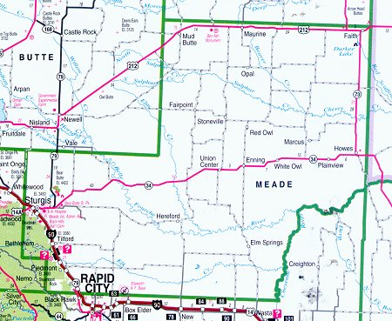

III. JURISDICTIONAL INFORMATION

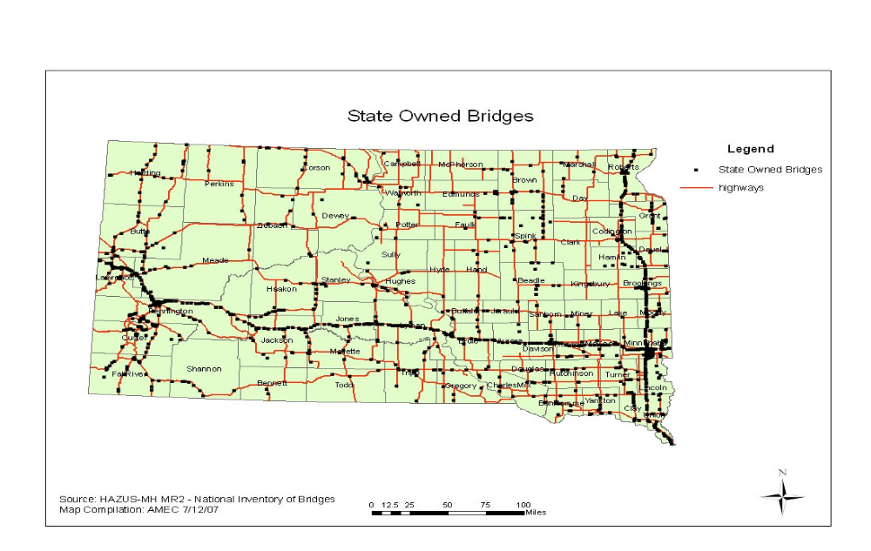

IV. UTILITY AND INRASTRUCTURE PROVIDERS IN MEADE COUNTY

Water Systems

There are a number of permanent water systems, some municipalities, some homeowner groups, or non-profit cooperatives, and some private companies. The City of Faith gets water from Tri-county Water Cooperative.

Waste Water Treatment / Solid Waste

City of Sturgis has the wastewater treatment system, as does City of Faith, and City of Summerset. Some of the subdivisions in the county also have small systems. Sturgis and Faith provide solid waste removal.

Natural Gas

The Williston Basin Pipeline follows Interstate 90 through Meade County. The line is underground and has been in place since 1954. All of Sturgis, as well as homes and businesses along the Interstate have access to natural gas.

IV. UTILITY AND INRASTRUCTURE PROVIDERS IN MEADE COUNTY

Telephone
Providers or those with physical property (substations) within Meade County, and vulnerable to ice storms, blizzards or high wind events include:
Faith Municipal Telephone Company, Qwest Communications
Black Hills Fiber Communications AT&T
Golden West Communications Cooperative Midcontinent Communications

Electrical Service
Sturgis and most of the Black Hawk and Piedmont area receive power from Black Hills Power and Light Company. Several of the power providers are non-profit entities, including the City of Faith. Providers or those with physical property (sub-stations) within Meade County include:
Grand Electrical Cooperative Western Area Power Administration
Tri-County Electric Butte Electric Cooperative
West River Electrical Cooperative Black Hills Power and Light Company
Faith Municipal Electric Company

The providers when contacted were not able to provide estimates of the potential replacement costs of their lines and poles within Meade County. Historically ice storms have caused a million dollars in losses to utility providers. Which was the case in with the FEMA Disaster Declaration of # 1647 and # 1811.

Emergency Services
City of Faith has Law Enforcement, Ambulance, Fire, Search and Rescue response. The City of Sturgis provides for Law Enforcement, Ambulance and Fire / Rescue response. There are multiple rural volunteer fire departments and one rural ambulance, which serve the center part of the county. The City of Summerset has a Police Chief. The Meade County Sheriff’s Office provides law enforcement as well as the emergency communications (dispatch) center, for all of Meade County.

Hospitals
Sturgis Regional Hospital is part of Rapid City Regional Hospital. It is the only public hospital in Meade County. Faith has a small clinic that services Faith. The Black Hills Medical Center at Ft. Meade, (VA Hospital) is for veterans only and has no emergency room.

Nursing Homes
Sturgis Regional Hospital has a nursing home facility with 85 beds. Black Hills Medical Center at Ft. Meade, (VA Hospital) has a nursing home wing, which includes 90 beds, for veterans only.

V. HAZARDS
Overview

Hazard assessment: is the process of identifying and prioritizing those hazards that directly affect or have the potential to affect a jurisdiction.

Vulnerability Assessment— is the process of measuring the potential probability, and severity of damage from hazards. Appendixes contain most of the Vulnerability information.

The following resources were used to identify hazards that may affect the State of South Dakota and Meade County:
- Federal disaster/emergency declarations
- FEMA’s Multi-Hazard Identification and Risk Assessment
- State of South Dakota Multi-Hazard Mitigation Plan
- National Climatic Data Center
- NOAA and National Weather Service data

The following natural hazards are not included because they do not threaten South Dakota: avalanches, costal erosion, coastal storms, hurricanes, land subsidence, tsunamis, and volcanoes.
There exists the possibility of terrorist activities and epidemic or pandemic. Further agriculture or animal health emergencies are a possibility as well as technological or cyber incidents. There is a possibility for transportation accidents and critical infrastructure failure. The risk for these events is no greater than normal for the rest of the United States, and will not be addressed in this document.

While Meade County has a number of dams, most are small and used for stock watering. When there is a drought water levels drop drastically and the risk of dam failure diminishes. There are only 2 known residences below dams in Meade County, so the risk of loss of life or property is low.

Meade County is susceptible to natural hazards listed below and man caused hazards. The hazards listed below have occurred in recent history or there is a reasonable probability of occurrence. Most hazards listed here have the potential to occur anywhere in the county. Notable exceptions Special Events and forest related issues are limited generally to Western Meade County.

1. Weather Hazards

  - Drought
  - Severe Thunderstorm
  - Flash Flood
  - Tornado
  - High Winds
  - Winter Storm

V. HAZARDS
Overview continued

2. Natural Hazards

  - Wild Fires (Forest / Grass)
  - Earthquake
  - Landslides

  - Pine Beetle (de-foresting which increase risk of flash flooding and forest fires)

3. Man Caused
- Special Events – annual Black Hills Motor Classic—Terrorism or civil disturbance
- Hazardous Materials
- Aviation Accidents

Weather and Historical Data

The National Weather Service, (NWS) Rapid City South Dakota, compiled the following data specifically for Meade County, detailing hazardous weather statistics. Sources: National Weather Service Storm Prediction Center.

Drought

Drought is a frequent occurrence causing a negative economic impact on the county and communities in the county. Some areas of Meade County did not have adequate drinking water for people or livestock under normal conditions, drought conditions further exacerbates the situation. Drought conditions also increases the risk of both wildland fire and wildland-urban interface fire.
2000 – Spring 2008 - drought has been on going, more severe in western part of state slightly less in the Black Hills. January to December 2007, the precipitation recorded at the National Weather Service has been about 66% of normal.

Drought Historical Events

- Drought was statewide, known as “Dust Bowl” years. Most severe years were 1931, 1933, 1934, and 1936.
- 1954-1962 Drought statewide. The most severe occurred during 1956 – and 1959 in the Black Hills where most severe was during 1961.
- 1973-1977 Drought, most severe 1976, the part of county in the Black Hills least affected.
- 1985-1987 Drought was severe in western part of state, with the greatest impact on the Black Hills area.

V. HAZARDS continued
Weather and Historical Data continued

Severe Thunderstorms (Hail, Wind, Intense rain / Downbursts)

The NWS defines a severe thunderstorm as one with ¾ “or larger diameter hail and/or 58 mph or stronger wind gusts. From 1950 to 04/28/2008, there have been 269 Thunderstorms. Thunderstorms can consist of hail, heavy rains, high winds, and lightning, which start fires.
The National Climatic Data Center reflects that peak wind gusts on average range between 61 miles per hour and 73 miles per hour for western SD.

Large Hail

- Since 1950 their have been 362 hailstorms.
- Since 1990, 28 thunderstorms have produced hail of 2” or larger in Meade County. Five of the storms had hail 4” or larger.
- About one thunderstorm with hail 2” or larger can be expected in Meade County every summer.

Thunderstorm Wind Gusts

- 18 Thunderstorms have produced wind gusts 75 mph or higher; another 8 storms caused damage due to the winds themselves or with large hail.
- Expectations are for one thunderstorm with wind gusts 75 mph or higher in Meade County every summer.
- Expectations are for one thunderstorm with strong wind gusts and large hail that causes damage in Meade County every summer.

July 5, 1996 a thunderstorm with winds estimated around 100 mph and large hail crossed through Meade County in the early morning hours. Extensive damage in a path 5 miles wide and 100 miles long roughly following the Belle Fourche River resulted. Bark and leaves were stripped from trees, barns and out buildings damaged or destroyed; small and young animals were killed. Windows, siding and roofs were damaged; car and truck glass, and light covers were damaged on most vehicles in area. Approximate non-insured damage was $ 250,000.

July 5, 1998 a microburst hit the City of Faith. Winds estimated at about 100 mph caused extensive damage to metal out buildings and storage buildings, broken tree limbs, downed power lines, and damaged signs. Approximately $ 500,000 in damage resulted most insured property.

V. HAZARDS continued
Severe Thunderstorms

August 6, 1999 a microburst reportedly hit Ellsworth AFB with winds over 100 mph only light damage was reported due to the industrial type local.

August 2000, a microburst that started in a Lawrence County crossed the City of Sturgis prior to the Rally. There was 1 person seriously injured, and minor injuries to others, vender tents were destroyed causing over $ 500,000 in damage.

The summer of 2006, 3 thunderstorms with high winds hit the City of Faith. Winds were in excess of 80 miles an hour causing power outages, damage to trees, metal buildings and telephone lines. One home lost part of the roof.

August 18, 2007 a powerful thunderstorm stalled over the Piedmont area. The same area was previously deforested in the Ricco Fire most of the rain and hail ran off carrying debris, and plugging culverts. Rain gages were broke, unofficial estimates were at more then 5 inches in about 2 hours. Hail fell for over 1.5 hours much of it over 4 inches in diameter. About 90 to 95% of all homes suffered hail or flood damage. Hundreds of cars were damaged, totally loosing windshields, and rear windows. There was more then $ 1 million dollars of damage to insured homes and vehicles.

Flooding

Meade County is not subject to low land flooding. The City of Faith located on a hill, and has no streams so does not experience flash floods. The cause of flash flooding in Meade County is by intense rainfall in a short period. A single thunderstorm can cause localized flash flooding. Flash flooding happens most often in the months of May, June and July. Because of the terrain, most flooding is of a flash flood nature

- Steady rain over the northern Black Hills for a few days causes more widespread flooding. The creeks originating in the Hills flood, then the water flows into the Belle Fourche River, which floods pastures a few days later.
- May and early June is the most common time for this type of flooding.
- The Cheyenne River is prone to ice jam flooding of pastures in the spring.
- Rapid snowmelt caused by temperatures warming quickly after a heavy snowstorm or rain falling on the snow also causes minor flooding in the spring.

Flash Flooding by creek 1990 to Present
- Belle Fourche River: 4 floods caused by heavy rain falling in the tributaries
- Bear Butte Creek: 6 floods City of Sturgis
- Elk Creek: 6 floods of pasture land.
- Sulphur / Cherry Creek (including Red Owl, White Owl, Beaver, Brushy Creeks): 4 floods of pasture land
- Box Elder Creek 4 floods
V. HAZARDS
Flooding

Recent Flooding Specifics
- In May 1995, no structures were lost but the Sturgis Public Works worked around the clock for most of a week to protect the Sturgis bridges during a week of high water in Bear Butte Creek. There was no access to the High School and Fort Meade from Sturgis due to water over Highway 34 in an area known as the “S” curves between the two areas. Approximate cost includes; damaged utility lines and poles, overtime and stabilization materials, road repairs, low water crossing replacement, totally over $ 419,000.00. On Elk Creek (both branches Big Elk and Little Elk), an adult and child had to be rescued out of Big Elk Canyon due to high water. Little Elk Road and Tilford Road were washed out. Debris building up on Railroad bridges, tracks, and Interstate bridges. Damage to county roads was about $ 50,000.

- The flooding that occurred as part of the 1996-1997 snow storms added to the damage to utilities, lagoons, dams, roads, culverts and bridges. The total in Meade County was over $ 306,000.

- August 17, 2007 flooding occurred in the City of Piedmont. Large hail and heavy rain of 5 inches or more fell in less then 2 hours on the old Ricco Fire area. Due to lack of vegetation, the water ran off the hillsides bringing debris and plugging culverts. Approximately 20 structures had water in the basement or main floor.

- During May 2008, moisture fell in abundance in the form of both snow and rain.
By June the ground was saturated and when numerous micro bursts occurred flooding of homes and businesses occurred due to run off and ground water infiltrating into basements. Streams and rivers rose and damaged bridges, culverts, low water crossings, fences and electrical power lines.

Repetitive Flooding

The State of South Dakota has compiled a list of historical emergencies and disasters occurring since the settling of the territory in the 1870’s. The following compellation includes local historical data prior to 1991.

- Sturgis flooded regularly until the advent of a storm drainage system and improvement to the numerous creek drainages through Sturgis.
- Historically flooding was recorded: 1883,1889,1901,1904,1906,1907,1909, 1912,1916,1922,1933, 1941, 1946, 1952, 1962, 1965, 1972, and 1976.

V. HAZARD
Flooding continued

Repetitive Flooding
- June 14, 1907 Elk Creek flooded west of Piedmont, a sawmill, and several homes were washed away, it also resulted in the deaths of a woman and 2 children. Sturgis also flooded that day with less serious consequence, the reports showed roads damaged and the train tracks between Piedmont and Sturgis washed out at Elk Creek and other creek crossings.
- May 1952 flash flooding to Bear Butte Creek in Sturgis. Streets and gas pipelines were tore up, bridges were washed out and rockslides occurred.
- Summer of 1962 a rainstorm dropped more then 3 inches of rain over the entire northern Black Hills, most communities flooded including Sturgis, where over half the homes had minor to moderate flood damage.
- May 18, 1965 Heavy snows and rain in excess of 7 inches caused flash flooding in Northern Black Hills, estimated damage for 3 counties was in excess of $ 2 million. Sturgis lost 1 residence along Bear Butte Creek.
- June 9, 1972 a rainstorm dumped as much as 14 inches of rain, some areas averaged 8-10 inches of rain. Estimate of over 1.5 million dollars in damage occurred with 275 homes and 25 businesses affected. Several homes were lost in Sturgis and the Black Hawk area. Damage extended to almost every road and highway with many bridges destroyed.
- June 13 and 14, 1976 up to 10 inches of rain fell. June 15th and 16th 2-3 inches of rain and snow fell. Flooding caused damage to roads, sewers, water systems and bridges in Sturgis and Meade County. Sturgis north of Bear Butte Creek was accessible only by foot over 1 damaged bridge. Over half the homes in the area had minor flooding. The flooding affected all communities in western part of Meade County along I-90. The county suffered $ 3.5 million in flood damage.
See Flood Appendix for additional information.

Tornadoes

Probability According to the National Climatic Data Center, there were 1,485 tornadoes in South Dakota between 1950 and 2006 (57 years). Based on this information, the probability that at least one tornado will occur in South Dakota in any given year is 100 percent. Annualized losses are estimated at $10.7 million.

V. HAZARDS
Tornadoes

Tornadoes occur anywhere but are usually weak and short-lived, are a moderate risk.
Number of Tornadoes (actual touching down)
- 41 tornadoes in 52 years ( averaging one tornado every 1.3 years)

Strength (41 storms rated)
- 27 Tornadoes had F0 (winds 40-72 mph; light damage)
- 9 Tornadoes had F1 (winds 73-112 mph; moderate damage)
- 3 Tornadoes had F2 (winds 113-157 mph; significant damage)
- 2 Tornadoes had F3 tornadoes (winds 158-206 mph; severe damage)

Tornado Path Length (32 recorded) Average: 2.0 miles;

Path Width (31 recorded) Average: 230 feet, widest: 1500 feet

FATALITIES (RECORED SINCE 1916): None
INJURIES (since 1950): 29 injured; 4 in 1989; 25 in 1991
DAMAGE (38 recorded; not adjusted for inflation):
No damage: 19
Less that $ 50: 3
$ 50-$500: 2
$5000-50,000; 6
$500,000-$5,00,000: 1

- In the period of 1950-2007 had over 1,250 tornado were documented, the tornadoes are usually weak, touch down briefly and are short duration.
- Damage is rare but not unheard of; damage exceeded $ 500,000 in one occurrence when a tornado hit Weston Heights Subdivision in 1991.
- No tornadoes have touched down since 1998.

V. HAZARDS
Winter Storms (Ice storms, Heavy Snow, Blizzards)

The National Weather Service describes different types of snow events as follows:
- Blizzard—Winds of 35 mph or more with snow and blowing snow-reducing visibility to less than ¼ mile for at least 3 hours.
- Heavy snow is 8 inches or more of snow in 24 hours.
- Ice storm is an weather event that starts with rain or freezing rain

According to the National Weather Service, most of South Dakota has an annual mean snowfall of 24.1 to 36 inches. Some areas in the northwest, where Meade County is located have an annual mean snowfall of 36.1 to 48.0 inches.

An average winter storm affects all parts of the county and presents a moderate risk to most of the population. However, a severe winter storm can have significant risk due to the potential for loss of life and livestock. In the rural community, it is viewed as being a significant risk.

Associated with winter storms are ice, or freezing rain. Ice coating sidewalks, roads, power lines, and livestock, creates dangerous conditions for people and livestock. Heavy accumulations of ice can bring down trees and topple utility poles and communication towers. Ice can disrupt communications and power for days. Ice can be extremely dangerous to motorists and pedestrians and those who depend on electricity for heat.

In the period 1990 thru 2007;
- 27 winter storms occurred, producing heavy snow.
- 14 produced at least 12 inches of snow.
- The average is 2.2 winter storms with 12 inches of snow per winter season and 0.73 winter storms with 12 inches of snow per winter.
- 9 storms have produced 18 inches of snow.
- 21 winter storms were blizzards; 6 had total snowfall of 12 inches or more.
- Average is 1.6 blizzards per winter season
- Winter storms with heavy snow or high winds are most likely during late winter February through April. 11 year period their have been only 1 ice storm.
- There was over $ 306,000 in damage the winter of 1996-1997 in damage to infrastructure due to repetitive blizzards and rapid snowmelt causing flooding. West River Electric Association estimated loss of power poles and electrical lines due to a winter storms cost $ 620,000.
- The same winter 1996-1997 ranchers lost in excess of 9,000 head of livestock in SD. Ice on lagoons, dams resulted in scouring of the shorelines, and repairs costs were extensive.
- In April of 2006 an ice storm, resulting in a Disaster Declaration damaged over $ 1 million dollars of power lines and poles just in Meade County.

V. HAZARDS
Repetitive Winter Storms

Blizzards damage the political subdivisions economies through increased snow removal costs, loss of crops, and animals to the local agriculture. Storms damage structures due to falling trees or excessive weight on roofs. Downed power and telephone lines and outages have further added to the blizzard damage. Debris removal of trees and plant matter can also cost jurisdictions time and increase storm costs.

- Blizzard of January 1888, temperatures were -28 degrees. Thousands of head of livestock died as did wild game. Over 174 people died in the storm statewide
- May 1905 Blizzard resulted in thousands of head of livestock lost in just western South Dakota.
- Blizzard of January 1949 affected entire state and conditions lasted for weeks. Temperatures hovered about -2 to -8 with heavy snows totaling 24 inches for the month and winds recorded from 40 to 73 mph. Airplanes were pressed into service to deliver food, fuel, and medicine for stranded people. Many people were lost in the storm as were thousands of head of cattle. Snowdrifts were documented in places at 35 feet deep.
- January 1952 was a repeat of the Blizzard of 1949, cattle loss and human loss was high. Snowed in for months, people depended on airplane for supplies.
- Blizzard of April 1967 resulted in several feet of snow in the northern Black Hills Sturgis and Spearfish each had over 3 feet of snow with more in the higher hills. The storm paralyzed the area for 2 days. The late spring storm caused cattle losses especially in young calves.
- Blizzard of March 1973 resulted in 3 feet of snow in the Sturgis/Meade County area paralyzing the community for 2 days.
- 2 Blizzards in 1975 both caused loss of life and loss of livestock, statewide.
- 1977 Repetitive snow storms/blizzards hit South Dakota in February, March and November. Repetitive closing of Interstate 90 occurred; due to 6-8 foot deep snow. 6 people died and large numbers of livestock.
- October 9, 1981 ice and snowstorm heavily damage to power lines and trees, many homes damaged due to falling limbs and trees. Snow was 3 to 6 foot deep with winds 40-70 miles per hour. The storm lasted 3 days hitting the northern Black Hills the hardest.
- October 26, 1996 was the first blizzard in the winter of 1996-1997. Repetitive blizzards occurred at least monthly with heavy snowfall. Little or no melting occurred. See details in Vulnerability Appendix, both FEMA 1156-DR and FEMA-1161-DR occurred due to the blizzards.

V. HAZARDS
High Winds

High velocity horizontal wind is a defined as high winds sustained at 40 mph or stronger and /or gusts 58 mph or stronger. High winds events are county wide but are only recorded in two locations in the county, so data is incomplete. Most high winds occur in the winter with snow, but they can also accompany a thunderstorm.

Damage from high winds tends to occur along the western side of the county where the forested terrain gives way into the plains. It also occurs more often in the northeast corner of the county, in the area of the City of Faith.

- 14 events with wind gusts of 70 mph or higher, have occurred in 10 years.
- The average is 1.3 per year.
- Most high wind events have occurred from October through May 2 events have occurred in February.
- In 1990, damage occurred to airplanes and hangars at Sturgis Airport.
- In 1996, a sign blew down damaging cars.
- In 1999, the destruction of a barn, killed animals in the collapse, the damage was about $ 150,000.
- In 2006, a barn used by a veterinarian practice in Faith was destroyed the insured building cost approximately $ 125,000.

See the Vulnerability Appendix for more detailed information.

V. HAZARDS
Earthquakes

There will be repetitive earthquakes, causing minor structural damage presenting considered low risk, as only 2 have ever been reported for Meade County.

Earthquakes in South Dakota since 1900
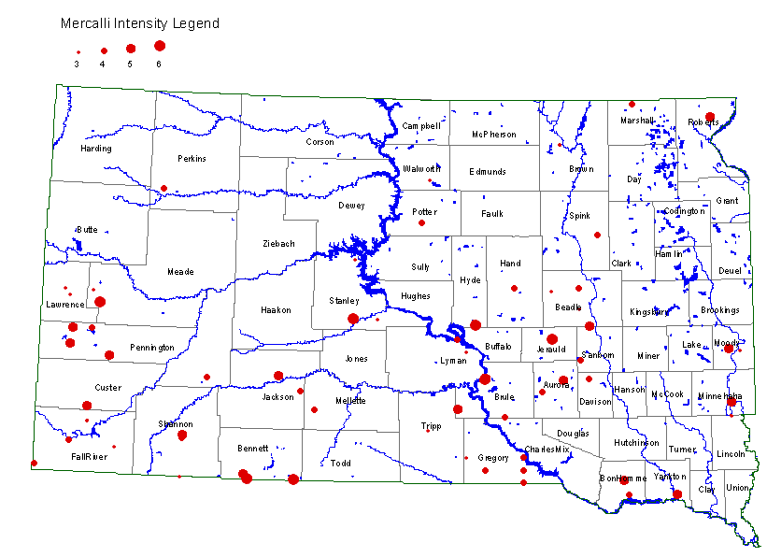
- May 11, 1941 Earthquake intensity III, (minor) near Sturgis, no report of damage.

- June 26 1966 Earthquake between Bethlehem and Tilford; Magnitude 4.1, (minor) slight damage reported mostly concrete cracking.

Further data is contained in the Vulnerability Appendix.

V. HAZARD
Fire

Fire is listed here under natural hazards due to the high percentage of the large fires started by lightning strikes. The larger forest fires in Meade County have been started by lightning. The drought conditions of the last 12 years, along with Pine Beetle infestation have made for a higher fire danger and more small and large fire events. Lightning caused fires burn more acreage because of often having multiple lighting fire ignitions, occur in less accessible areas often at night, and occur in the hottest portion of fire season.

Fires involving grass, prairie, or timber can cause destruction of property and vegetation. Meade County’s semi-arid climate, highly flammable native vegetation, rugged terrain, and populated wildland-urban interface compose its wildfire hazard.

The Black Hills are an outcropping of the Rocky Mountains, lying along the state’s western edge. In the Black Hills, terrain varies from open valleys; rolling topography; mountainous terrain and steep, narrow canyons.
Fuels are generally conducive to high rates of spread, represented by National Fire Danger Rating System fuel models “L,” “K,” and “C.” Grass predominates in the broad valley bottoms. Ponderosa Pine grows on all aspects, and extensive pure forests of Ponderosa grow in the Black Hills. Mixed grass and timber stands occur in many areas depending on aspect. Fuel loading is heaviest in the northern Black Hills.
Weather—During the summer months, temperatures is often in the 90’s and low 100’s with relative humidity in the teens. The average annual precipitation is approximately 17.5 inches. Some of this precipitation comes in association with thunderstorms that bring lightning during the fire season, but at times heavy enough to put out the fires that start as result of positive lightning strikes.

Fire has a high probability of occurrence and is high risk. The semi-arid climate, highly flammable vegetation, rugged terrain, and populated wildland-urban interface make up the wildfire hazard. In Meade County, the terrain varies from rolling plains to mountainous terrain with elevation over 5,200 feet in elevation; and steep narrow canyons, which are part of the Black Hills.

The chance of fire is increased by “fire weather” or fire hazard severity. The National Weather Service in Rapid City is responsible for issuing the fire hazard severity for a given day.

The land ownership pattern in western Meade County includes a mix of private, Black Hills National Forest, South Dakota State Park land, Bureau of Land Management, and private ownership with homes. The state primarily maintains fire protection responsibility on private and state lands, but protects a small amount of Federal land as well. Single-family dwellings exist throughout the state’s protection area in Meade County.
V. HAZARD
Fire continued

Critical Fire Weather

The National Weather Service Office in Rapid City estimated that for the summer of 2007, the fire danger for the Black Hills area was in the extreme category for approximately 50 days. The extreme category for grasslands began occurring intermitted in early May and ended in late November of 2007 In 2008 the fire danger only reached extreme a few days in July and August due to temperatures and wind.

The greatest concentration of subdivisions is located in the southwestern part of the county within 6 to 8 miles of the southern county line.

Recent Forest Fires Western Meade County

- In 2003, the Little Elk Fire near Piedmont burned about 600 acres with about $ 2 million in cost for fire suppression.
- In July 2005, the Ricco Fire near Piedmont burned 4,200 acres and took one home.
- In July 2006, the Eastridge Fire near Piedmont burned 3,204 acres, 8 homes and over 23 outbuildings were lost.
- In July 2007 the Box Elder Fire near Nemo, burned 700 timbered acres, there was evacuation of 200 homes, and fire suppression cost about $ 2 million dollars. The fire started in Lawrence County but most evacuations of subdivisions took were in Meade County.

Recent Grass Fires (Central and Eastern Meade County)

- In August 2006, the White Owl Fire was a grass fire that burned 16,600 acres.
- In August 2006, the Wilcox Fire was a grass fire burned 4,500 acres.
- In August 2006, the Red Owl Fire was a grass fire burned 2,000 acres.
- In August 2007, the Plainview Fire, a grass fire, burned over 2,000 acres.

Historical Grass Fires

- Numerous large fires have occurred on the prairie. A large fire in 2000 pushed by high winds burn over 10,000 acres near Faith in northeast Meade County.
- In 2002, a county firefighter lost his life in an arson wildland prairie fire.

Historical Forest Fires

The map on the next page displays the major forest fires in the Black Hills for the last twenty years.

V. HAZARD
Fire continued
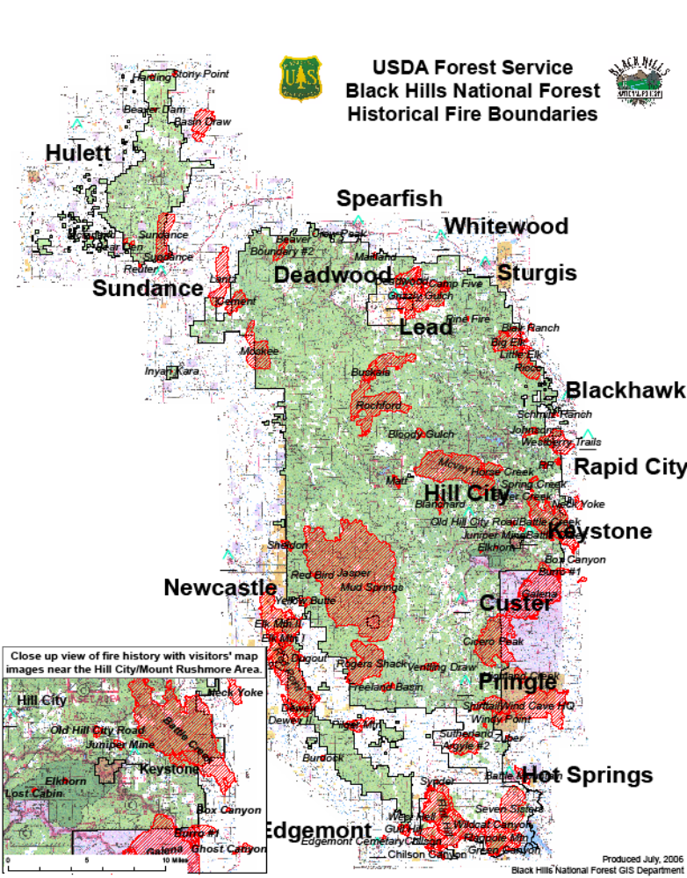
V. HAZARD
Fires continued

Historical fires
  - Wild fires have been a repetitive occurrence in Meade County and the Black Hills. In 1949, a large fired burned for several days in the Piedmont area.
- In recent history, the 1998 Westberry Trails fire, which started in Pennington County, burned some of the forest in Meade County before being contained.
- In 1994, lightening started a fire in Stagebarn Canyon in the Piedmont/Black Hawk area only 112 acres burned at a cost in excess of $ 159,000.
- August 1996 Bear Butte Fire burned the entire mountain.
See Appendix F for additional information

Landslides

Landslides are a very infrequent occurrence. They most usually occur in connection with very heavy rains, and disrupting of ground cover such as; forest fire, loss of vegetation as in construction projects. The most recent landslide occurring in Meade County took place after heavy rains in May of 1996. The hillside had been cleared of vegetation immediately next to Highway 34 east of Sturgis. The landslide covered 1.5 lanes of a 4-lane highway for about 30 feet. The dirt was replaced and stabilizing structures and large rocks added. There has been no reoccurrence. Landslides have been rare and caused by excessive rain. Probability is considered medium to low.

Mountain Pine Beetle

Any situation that has the potential to increase risk to a given area, and increase the intensity of the impact of a hazard must be considered when evaluating hazards. While the infestation is not a risk to the residents, it increases the risk to other hazards, which are erosion of the terrain with greater then 10% slope, destruction of the ecosystem of the Black Hills, loss of aesthetic value, increase risk of forest fire, and increase in flash flooding.

The forested area of Meade County, west of I-90, had a severe Mountain Pine Beetle infestation, which kills the Ponderosa Pine trees. They are the predominate tree in the Black Hills. The combining of drought, excessive undergrowth, and dead and dying trees, because of the Mountain Pine Beetle, has increased the probability of a large forest fire. Without the pine vegetation, the eco-system for the forest will be disrupted. The lack of health vegetation increases the run off from intense thunderstorms, which increases erosion and the risk of landslides. This increases the risk of flash flooding.

V. HAZARD
Man Caused

The least predictable of hazards are those directly attributed to man. It cannot be limited to violence or terrorism incidents. The Meade County Emergency Operations Plan addresses aviation, and transportation incidents, health emergencies, mass casualty, and terrorism.

Probability
The possibility of a man caused occurrence is medium to low, due to the low population and rural location.

Because a small local jurisdiction can do little to mitigate against these types of events, they will not be addressed in this document. The jurisdiction does expend time and funds to mitigate implications of the annual mass gathering that occurs and the multiple secondary hazards that present themselves at the gathering. These could include over taxing of emergency services, or the medical community, as a primary hazard or secondary hazard. These are addressed in local Rally planning, but will not be included here; they are mitigation strategies used for 2 weeks of the year.

Special Events

The Black Hills Motorcycle Classic known as “Rally” is the largest special event in South Dakota generating millions of dollars for the economy. The event is a public space open-air event; there is no control of access. Annual attendance is estimated, but has exceeded 250,000 people annually for the last 10 years. The event affects Sturgis, western Meade County, and all the Black Hills. National and foreign press and television cover the event. Attendance includes people from every state in the union and usually at least 14 foreign countries.

- The event is listed by SD Office of Homeland Security as being at risk for terrorism activity.
- The potential exists for civil unrest or violence is higher during this time.
- The congestion of the crowds, in a restricted area becomes a risk in and of its’ self.
- The worldwide appeal of the Black Hills Motorcycle Classic increases the chance of an outbreak of a contagious disease.
- Large concerts are held during the Rally, large concerts can be dangerous to individuals attending. Attendance has been reported to exceed 40,000 with internationally known entertainment.
- The motorcycle is the main means of transportation and is vulnerable to accidents and severe weather
- Over 100,000 people stay in tents or small campers in the area during the event, they are vulnerable to severe weather.

V. HAZARDS
Hazardous Material

Meade County has an LEPC and an LEPC Coordinator. In the county, there are several SARA Title III facilities. Most are facilities with large batteries, bulk fuel distributors, or propane distributors. Only 1 facility in the county is a chemical warehouse, which is full compliant with all SARA Title III requirements. Most hazardous material incidents are secondary to motor vehicle accidents. Some illegal dumping of chemicals also has occurred.

The following page has the listed SARA Title III filers. Missing from this list are some state and federal installations in Meade County including Department of Transportation shops, and Ellsworth Air Force Base. See additional information in Vulnerability Appendix.

V. HAZARDS
Hazardous Material continued
Hazardous Material Facilities

FACILITY | LOCATION | PRODUCT | PRODUCT
Hawkins Water Treatment Group | Summerset | Acid Hydrochloric | Acid Hydrofluosilicic
Hawkins Water Treatment Group | Summerset | Acid Nitric 42 | Acid Sulfuric
Hawkins Water Treatment Group | Summerset | Aluminum Sulfate | Anhydrous Ammonia
Hawkins Water Treatment Group | Summerset | Chlorine | Soda Caustic
Hawkins Water Treatment Group | Summerset | Sodium Hypochlorite | Sulfur Dioxide
Cenex Oil Company | Union Center/ Sturgis | Diesel | Gasohol
Cenex Oil Company | Union Center/ Sturgis | Gasoline | Motor Oil
Cenex Oil Company | Union Center/ Sturgis | Propane
H&H Ag Aviation | South - Hereford | Furadan 4F
McPherson Propane Inc | East - Sturgis | Propane Bulk
D & R Propane Inc. | Faith | Propane Bulk
Qwest Communications Sub | Black Hawk | Lead | Sulfuric Acid Batteries
Sturgis Transit Mix Plant | Sturgis | Concrete Additives | Flyash
Sturgis Transit Mix Plant | Sturgis | Motor Oil new and used | Portland Cement
Sturgis Community Center | Sturgis | Calcium Hypochlorite
Yenter Companies Inc. | Piedmont | ANFO | Blasting Agents
Yenter Companies Inc. | Piedmont | Detonators | Nytroglycerine
Yenter Companies Inc. | Piedmont | Trinitrotoluene
VA Black Hills Health Care Sys. | Fort Meade | Sulfuric Acid/Batteries | Chlorine
VA Black Hills Health Care Sys. | Fort Meade | Diesel fuel | Unleaded gasoline
PEMI-EAFB-Propane Air Mix Plant | Ellsworth AFB | Propane
Dakota Mill & Grain Inc. | Sturgis | Fumitoxin | Pro-Zap Zinc Phosphide Oat
Golden West Telecom | Enning | Sulfuric Acid / Batteries
Golden West Telecom | Maurine | Sulfuric Acid / Batteries
Golden West Telecom | Faith | Sulfuric Acid / Batteries
McGas Propane | West-Sturgis | Propane bulk
SDARNG – OMS # 1 | Sturgis | Diesel
Faith Electrical Substation | South-Faith | Petroleum Electric Insulator Oil
Maurine Electrical Substation | Maurine | Petroleum Electric Insulator Oil
AT & T Hereford | Hereford | Diesel | Sulfuric Acid Batteries
Mobile Bulk Plant | Faith | Diesel | Gasoline
IV. HAZARDS
Disaster Declarations continued

Most of the data is from the FEMA, others from USDA. Some additions have been made from lists existing from South Dakota Office of Emergency Management and Meade County Emergency Management.

Number | Declared | State | Description
1811 | 12/2008 | South Dakota | Snow Storm
1774 | 07/2008 | South Dakota | Flooding
2716 | 07/21/2007 | South Dakota | Box Elder Fire
2658 | 07/27/2006 | South Dakota | East Ridge Fire
USDA | July 2006 | South Dakota | Drought Declaration
1647 | 06/05/2006 | South Dakota | Severe Winter Storm
2565 | 07/10/2005 | South Dakota | Ricco Fire
USDA | 07/2004 | South Dakota | Drought Declaration
2513 | 11/20/2003 | South Dakota | Mill Road Fire
USDA | 09/2003 | South Dakota | Drought Declaration
Meade | 07/17/2002 | South Dakota | Little Elk Fire
1173 | 04/07/1997 | South Dakota | Severe Storms/Flooding
1161 | 02/28/1997 | South Dakota | Severe Winter Storms
1156 | 01/10/1997 | South Dakota | Severe Winter Storms/Blizzards
1052 | 05/26/1995 | South Dakota | Severe Storms, Flooding
1045 | 03/14/1995 | South Dakota | Severe Winter Storms
2109 | 08/16/1994 | South Dakota | Stagebarn Canyon Fire
State list | 1985-1988 | South Dakota | Drought
State list | 1980-1982 | South Dakota | Drought
511 | 06/25/1976 | South Dakota | Flash Flooding, Mudslides
3015 | 06/17/1976 | South Dakota | Drought
336 | 06/10/1972 | South Dakota | Heavy Rains, Flooding
197 | 05/26/1965 | South Dakota | Flooding
132 | 07/27/1962 | South Dakota | Floods / Tornadoes

The following two pages are Hazard / Risk / Vulnerability assessments completed by Meade County Emergency Management using the data from assessments completed by residents of the county.
V. HAZARD
Probability/ Risk continued
EVENT | PROBABILITY in COUNTY |  |  |  | RISK - worst case
Revised 10/30/07 | HIGH | MED | LOW | NONE | LIFE | HEALTH/ | HIGH | MOD | LOW
* Kathie R. Grant |  |  |  |  | THREAT | SAFETY | DISRUP- | DISRUP- | DISRUP-
 |  |  |  |  |  |  | TION | TION | TION
HUMAN EVENT
Mass Casualty |  | x |  |  | x
Hazmat Exposure |  |  | x |  | x
Terrorism Chem. |  |  | x |  | x
Terrorism Biolog. |  |  | x |  | x
Hostage Situation |  |  | x |  | x
Rally/Civil Disturb. |  | x |  |  |  |  |  | x
Bombing |  |  | x |  | x
Hostage/Violence |  |  | x |  | x
TECHNOLOGICAL
EVENTS
Electrical Failure |  |  | x |  | x
Transportation issue |  |  | x |  |  |  |  | x
Fuel Shortage |  |  | x |  |  |  | x
Natural Gas Failure |  |  | x |  |  | x
Gas line rupture |  |  | x |  | x
Water Failure |  |  | x |  |  | x
Sewer Failure |  |  | x |  |  |  |  | x
Communications Fail |  |  | x |  | x
Information Sys. Fail |  |  | x |  |  | x
NATURAL EVENT
Tornado |  | x |  |  |  | x
Thunderstorm / Wind | x |  |  |  |  |  |  |  | x
Snow fall | x |  |  |  |  |  |  |  | x
Blizzard | x |  |  |  |  | x
Ice Storm |  | x |  |  |  | x
Wild Fire | x |  |  |  | x
Landslide |  |  | x |  |  |  |  |  | x
Contagion human |  |  | x |  | x
Contagion animal |  |  | x |  |  | x
Flash Flood | x |  |  |  |  |  |  | x
Earthquake |  |  | x |  |  |  | x
Drought | x |  |  |  |  |  |  |  | x
V. HAZARDS
Risk by Area continued

RISK BY AREA
Checked boxes indicate area vulnerable to possible occurrence
Revised 10/30/07 | Sturgis | Piedmont | Summerset | Faith | Rural
HUMAN EVENT
Mass Casualty | x | x | x | x
Hazmat Release | x | x | x | x | x
Hostage Situation | x | x | x | x
Rally/Civil Disturb. | x
Bombing | x
Hostage/Violence | x | x | x | x
TECHNOLOGICAL
EVENTS
Electrical Failure | x | x | x | x | x
Transportation issue | x | x | x | x | x
Fuel Shortage | x | x | x | x | x
Natural Gas Failure | x | x | x
Gas line rupture | x | x | x
Drinking water vulnerable |  | x |  | x | x
Sewer Failure | x |  | x | x
Communications Failure | x | x | x | x
Information Sys. Failure | x | x | x | x
NATURAL EVENT
Tornado | x | x | x | x | x
Thunderstorm | x | x | x | x | x
Snow Storm | x | x | x | x | x
Blizzard | x | x | x | x | x
Ice Storm | x | x | x | x | x
Wild Fire | x | x | x | x | x
Landslide | x | x
Contagion human | x | x | x | x | x
Contagion animal |  |  |  |  | x
Flash Flood | x | x | x
Earthquake | x | x | x | x
Drought |  |  |  | x | x

V. HAZARD
Synopsis

In evaluation of hazards, an occurrence of one event can cause a domino effect resulting in secondary event. More fires occur during drought conditions, more transportation events occur during ice and snowstorms. Other then events with common secondary events, anticipation of an event is not possible.
Based on the data provide in this document, result in the following assumptions:

- Drought conditions will occur in cycles and affects the economy of the county.
- While the chance of wild fire exists every summer, drought conditions increase the size and number of occurrences.
- Wild fire has been the most frequent occurring hazard in the last 12 years.
- Severe Thunderstorms occur regularly results in high straight-line winds, large hail, lightning, flash flooding, and tornadoes.
- Hazardous Material incidents related to transportation are likely to occur.
- Severe winter storms and blizzards occur at least annually, if not oftener. These events can cause power outages and can result in livestock deaths.
- Heavy snows with rapid melt or heavy rains can cause rapid onset, or flash flooding of streams and the Belle Fourche River in Meade County
- Failure of or damage to infrastructures can have severely affected a jurisdiction, this can include dams, bridges, and other physical structures such as lagoons and water lines.
- Disruption of transportation, utilities, or technology could cause serious consequences not only to the immediate area affected but nation wide.
- Man cause hazards including terrorism or violence are a possible occurrence.
- Wide spread health emergencies are the least likely to occur, but have the highest potential, to devastate all levels of society and cause massive disruptions nation wide.
- Earthquakes have been weak with a low probability of causing minor damage to foundations and city / county infrastructure.

Rural area
The land mass of Meade County is approximately 2 million acres, and is predominately ranches; the impact of hazards differs from the impact to urban areas. Severe winter weather has historically influenced the entire county. Drought is a common occurrence and greatly affects the economy of the rural community. Severe thunderstorms with large hail damages farm equipment, homes, barns and sheds. It also kills livestock and crops, fortunately these storms are usually small geographically. Blizzards or large amounts of snow, seldom damage farm buildings but kill large numbers of livestock. Wild fire and has a large impact on the rural areas of Meade County but large forest fires also have destroyed homes. In drought, years there are more then 15 grass fire occurrences yearly, and on average, at least 1 will exceed 1,000 acres.

V. HAZARD
Synopsis continued

Flash flooding of streams, the Belle Fourche and Cheyenne Rivers, occur from time to time, but the land use minimizes the impact. The rural areas of Meade County would not be impacted by an earthquake unless extremely strong and centered directly under a small community or farm complex.
Most man caused hazards would have a minimal impact with the exception of hazardous materials, which are used in rural applications. A health emergency especially among livestock would greatly disrupt the lives and economic health of the rural areas in Meade County.
The rural community is not as dependent on technology and an event of this type would not disrupt their lives as much as urban areas, with the exception of fuel shortages.

Far western Meade County is mountainous covered with forest. The Cities of Sturgis, Summerset, and Piedmont are in this area. All the Disaster Declarations listed have affected this area of the county. This area is frequently impacted by severe thunderstorms, because of the topography enhances the run off rate and speed of water increasing the number of flash flood events. The area suffers from Pine Beetle infestation, which increases the risk of forest fire in the area. Forest fires of size have occurred 3 times in the last 10 years. The forest fires impact is increased by the increasing areas of urban development in the forested area along interstate highway 90. Snow is predominately heavier in the far western area, and heavy snow has a large impact on interstate highway 90, which runs the length of western Meade County.
All hazards listed on the previous pages can occur in this area of the county. This is the area most impacted by tourism and the Special Event, Rally.

Sturgis would be most impacted by a strong earthquake because of the multi-story structures in the city. While flash flooding can occur along any stream, Sturgis has historically been impacted the most and several disaster declarations were for Sturgis flooding. Sturgis is the most vulnerable to man caused hazards due to a centralized population and the Rally event.

The City of Faith is located in the far northeast corner of the county. The man caused hazards could affect Faith but the chance of them occurring is low. State highways 212 and 73 intersect Faith. All natural hazards can occur and affect Faith, with the exception of flash flooding. Faith sits on a hill and there are no streams in the city. High winds historically have caused the most damage. Failure of the water system has occurred for part of a day. Failure of communication, electricity, or technology, or transportation systems would severely isolate Faith. The repetitive high wind events have affected Faith over the last 10 years.

VI. VULNERABILITY

NOTE: Much of the following information about Meade County vulnerability to hazards is taken from the State of South Dakota Multi-Hazard Mitigation Plan. It is the best available data to identify vulnerability. Specific maps and charts are available in the Vulnerability Appendix and the Flood Appendix.

When identifying what is at risk; several issues are considered including the value of that which is at risk.
Assigned monetary value and value to the community may not have the same value. For the purposes of this plan, geographic space and social space will be dominated in the identifying of vulnerability. Vulnerability as far as the affects will also be evaluated, from the political, social, economic, and resiliency aspects. Again, these aspects can be of a far greater consequence and of a longer or even potentially permanent nature.

In every community, there is an “at risk population”, the young and elderly are at higher risk in an emergency or disaster. A recent addition to this category is pregnant women. This population is affected in a greater magnitude then the other segments of the population due to their age and or medical condition.

In Meade County, there are about 5,605 children under 14 years of age and about 3,020 people over 63 years of age. This is about 36 % of the population. These segments of the county are especially vulnerable to disruption of the community’s infrastructure. The disabled may not receive and understand warning notifications or be able to respond appropriately. Statistically, they will be underserved in adverse conditions. Because many of these categories combine, it is estimated that about 40% of the population would be considered at risk. Property belonging to the elderly or those of lower income is more at risk to loss.

Vulnerability cannot be discussed without discussion of the risk to the population or critical infrastructures. The population of Meade County is in excess of 24,425, the estimate for 2006 by the US Census. During the summer months, tourism increases the population of the area.

There are 3 school districts in Meade County with at least 19 separate school buildings.

There are 8 Assisted Living Centers or Nursing Homes in the county, 1 in Faith and 1 in Black Hawk. The largest is the Sturgis Regional Hospital with approximately. 84 residents. The other Assisted Living Centers are smaller having 4 to 16 residents each.

VI. VULNERABILITY continued
Overview

Critical Infrastructure

For the purpose of this document, critical infrastructure is defined as those facilities, which if incapacitated, destroyed, or debilitated, would severely affect the ability of the local city and county governments to provide minimal operations and services to the residents and businesses in the county. Meade County has the infrastructure as is common to all counties in South Dakota. While disaster declarations are based on value of property, the greater value is in the highly trained personnel, and the functions contained in the buildings. See Vulnerability Appendix for a detailed list of physical structures and approximate values.
Half of Ellsworth Air Force Base is in Meade County. It would be considered a very high value terrorism target. The base does not provide services directly to the community. Other then national security the community does not depend on the base for normal day-to-day operations. The base is a major employer in the area.

Any number of natural hazards could severely damage a critical facility in Meade County. The most likely to cause catastrophic damage would be a large earthquake, centered very near Sturgis, or centered in the I-90 corridor. A direct hit by a F5 Tornado, or a Terrorist event are the only other events that could badly damage the structures listed on the following pages. Flash Flooding is a possibility but with the exception of the Sturgis Community Center and the Sturgis Post Office, none of the major facilities are in the 100-year flood plain and at risk.

Agriculture Industry at Risk
Based on 2002 figures, Meade County has 895 farms or ranches, the acres in use are 2,028,839. Total cropland is 432,483. The average size farm in Meade County is 2,490 acres. Based on January 1, 2007 figures: Meade county has about 110,000 cattle, of that 77,000 were beef cattle. Hay is the most abundant crop but no data was available on acres harvested and yield. Wheat is the largest documented crop with about 57,500 acres planted and a production of 1,573,000 bushels for 2007. Corn is the second largest produced crop with 2,500 acres planted and about 49,000 bushel harvested.

VI. VULNERABILITY
Overview continued

Meade County Assessment/ Property at Risk
The total value of properties in Meade County is in excess of $949,227,147. The value does not include properties considered as tax exempt such as the 36 churches, 20 plus schools and government facilities. Excluded also is the value of Ft. Meade VA Hospital, and the portion of Ellsworth Air Force Base in Meade County.

Meade County Owned Property

Property Name | Location | Dimensions | Building & Contents Value
Courthouse | 1425 Sherman St. | 38,400 sq. feet | $ 3,575,238
Law Enforcement | 1400 Main | 31,584 sq. feet | $ 3,801,961
Maintenance Bldg. | 5th. St. | 3,000 sq. feet | $230,000.00
Highway Main Shop | East of Sturgis | 7,200 sq. feet | $ 326,423
Extension Office | 1029 5th St. | 3,000 sq. feet | $ 203,913
Piedmont Shop | Piedmont | 2,877 sq. feet | $ 79,445
Grader Shed | East of Sturgis | 2,304 sq. feet | $ 58,984
Marcus Shop | Marcus | 1,248 sq. feet | $ 34,748
Union Center Shop | Union Center | 1,200 sq. feet | $ 40,152
Elm Springs Shop | Elm Springs | 1,152 sq. feet | $ 39,127
Hereford Shop | Hereford | 1,152 sq. feet | $ 26,991
Red Owl Shop | Red Owl. | 1,080 sq. feet | $ 37,341
Weed and Pest | East of Sturgis | 3,200 sq. feet | $ 135,000
Opal Shop | Opal | 840 sq. feet | $ 31,718
Red Owl Shop | Red Owl | 1,080 sq. feet | $ 37,341
Evidence Storage | East of Sturgis | 600 sq. feet | $ 15,558
Hwy.Dept Tire Shed | East of Sturgis | 800 sq. feet | $ 62,050
Total | Estimate only | In excess of | $ 8,858,000

Meade County Growth and Development

The segment of the county experiencing the fastest growth is that area between Sturgis city limits and southeast along I-90 to the Pennington County line. This area is legally described into township/ranges; Twp 2 Range 6, Twp 3 Range 6, Twp 4 Range 6, Twp 5 Range 6, Twp 2 Range 7, Twp 3 Range 7, Twp 4 Range 5, and Twp 5 Range 5.

VI. VULNERABILITY continued

Meade County Growth and Development

The development area for Sturgis is limited, because of its location in a natural basin; it is limited on the east by BLM property, on the south by Black Hills National Forest property. There is new residential construction occurring in Sturgis. The City of Sturgis now lists the population at 6,400.

Summerset and Black Hawk area in the far southwest corner of the county grew from 1,995 in 1990 to 2,432 in the 2000 census, a 22 % increase. The Piedmont zip code area had 1,262 residential addresses in 1990 and grew to 2,915 addresses by 2000, a 130 % increase. The 2000 census counted 5,347 totals for the two areas. Black Hawk, Piedmont, and the Summerset areas have been growing at 17 % annually. The projection is for a population of 20,000 in just this area in 10 years. The rural areas of Meade County and City of Faith as most rural areas and small towns, are suffering a slow decrease in population. This statistically reduces the overall growth figures for the county. The new development area is vulnerable to all hazards common to the county.

STURGIS

The City of Sturgis is the county seat for Meade County. The residential population is 6,800. Legal description is portions of section 3,4,5,6,7,8,9,10,15,16,21, T,5N R.5E, B.H.M.. Meade County, South Dakota. For tourists it is described as in west central South Dakota, on the northern edge of the Black Hills on Interstate 90 between exit 30 and 32. The city consists of about 2440 acres. The number of businesses is about 282 with about 2460 residential structures.

The economy of Sturgis is dependent on local retail, light manufacturing, agriculture, summer tourism, and health care. The City of Sturgis, the Black Hills communities, businesses, and the State of South Dakota are highly dependent on the Black Hills Motorcycle Rally for tourism revenue. At least 445,000 people annually attend the Motorcycle Rally, but bike enthusiasts visit Sturgis all year round.

The majority (over 95%) of the streets are paved with asphalt cement or Portland cement surfacing. About 4%, of the remaining streets are gravel. The majority of the paved streets, over 75 %, have concrete curb and gutter.
An extensive storm sewer system is in place within the curb and gutter portions of the city streets. The storm sewer system includes 15 direct discharges to Bear Butte Creek in pipe sizes ranging from 18 inches to 60 inches. A concrete drainage channel, the Deadman Channel, also runs through Sturgis. This was constructed after the extensive damage done during the June 1972 flood. It was designed to take a 100-year storm for the Deadman Creek drainage. There are numerous discharge points for the storm sewer system into the Deadman Channel.

VI. VULNERABILITY continued

STURGIS
There are 3 city bridges over Bear Butte Creek as well as a railroad bridge, 2 bridges on the interstate 1 on the service road, and 4 culvert / low water crossings. All of these structures are in danger when high water flooding occurs in Bear Butte Creek and require repair work after even minor storms.

Property in the 500-year flood plain
The approximate value of the private property located within the 500-year flood plain is $18,000,000. The lands within the 500 year flood plain, over 250 acres, are used for approximately 50% residential and 50% commercial type land uses. Most of the business community of Sturgis is located in the flood plain.

Property in the 100-year flood plain
The approximate value of the private property located within the 100-year flood plain is $24,000,000. The lands within the 100-year flood plain, over 250 acres, are used for approximately 60% residential, 10% commercial, and 30% recreational type land uses.
Within the flood plain of Sturgis is; the Community Center, City Street Maintenance Office, and maintenance yard, City Parks and recreational facilities.
Also within the flood plain are the new United States Post Office, a school, a large grocery store/pharmacy, and some residential areas.

Detailed data about the flood plain in Sturgis is contained in the Bear Butte Creek Channel Stabilization Report Sturgis, South Dakota prepared by the US Army Corps of Engineers, 1998. Data that is more current is in the Bear Butte Creek Flood Control and Channel Stabilization prepared by Ferber Engineering Company, August 2000. Both documents are part of the original plan are found in the attachments. They have not been included here as they are already on file.

With tax-exempt property added, property and land in Sturgis is valued over $225,000,000.

Critical Infrastructure Tax Exempt Property in Sturgis

Those are:
Meade County Courthouse SD National Guard maintenance yard and offices
United States Post Office SD Department of Health and Human Services
Sturgis Regional Hospital US Department of Agriculture office complex
6 school buildings 21 churches
Law Enforcement Center Sturgis City Hall / Library
Sturgis Maintenance Shop Sturgis Community Center
SD housing – Hillview High Rise Meade County Maintenance Building
County Office buildings

VI. VULNERABILITY continued

STURGIS

Several drainages run through the city and discharge into Bear Butte Creek. These drainages consist of Vanoaker Canyon, Deadman Creek, Dolan Creek, Cook Canyon as well as Bear Butte Creek. . The city is set on a series of alluvial fans and the resulting sedimentation formation from the fans. As is typical of older communities the original town was located close to the main waterway, Bear Butte Creek. Thus, a large portion of the downtown business/commercial area is located within the 100 and 500-year flood plains for Bear Butte Creek. NOTE: Bear Butte Creek, does not produce low water flooding, all flooding is flash flooding, affecting only those properties within about 150 feet of the creek. The main impact of a flash flood is erosion of the creek banks and erosion of bridges and culverts. The other drainages Vanoaker Canyon, Deadman, Dolan Creek, and Cook Canyon, run through residential areas. These creeks flow only in the spring during snowmelt or during summer severe thunderstorms.

Sturgis is subject to heavy runoff from snowmelt and spring rains. On the average, once every 5 years an event causing flooding/damaging runoff involves Bear Butte Creek. When one of these events occurs, there is damage to streets bridges, and utilities that cross Bear Butte Creek. The unstable and rocky soil that lines Bear Butte Creek easily erodes in a flash flood. The groundwater table also rises during these events causing infiltrating and damaging buried utilities, businesses and private homes.

Part of the downtown business district, consists of buildings that are over 100 years old. The buildings are located in a 2-block area in the center of the town. The buildings have only one thickness of brick between them, very old electrical wiring and do not have sprinkler systems. The risk for fire is high. The possibility of collapse caused by earthquake or tornado is high. The city is surrounded by pine covered hills, the chance of an unban interface forest fire is high.

Heavy winter snowstorms with high winds can severely hamper travel in the community, this occurs about every 4 years. Sturgis has a large number of senior and low-income housing complexes. Most are depend on electricity for heat. A prolonged power outage during a snowstorm could be life threatening to this population group.
Sturgis is subject to violent thunderstorms, which have damaging lightening, hail, and high winds. Such storms occur 1 or 2 times annually.

Tornadic cloud formations have been documented immediately east of Sturgis, no activity has been documented over Sturgis.

VI. VULNERABILITY continued

STURGIS
Sturgis is vulnerable to all the hazard common to Meade County. Sturgis is located on I-90 with highways 14A, 34, and 79 Intersecting the town. Because of the Rally during the later part of July and the first 2 weeks of August the population increases. The population peaks about 250,000, spread out in various campgrounds, roadways, and the downtown area of Sturgis. The large population is on motorcycles and a large number stay in tents or campers. Because of the camping and the means of transportation, this large population is more vulnerable to natural hazards.

The Sturgis Regional Hospital has capability for 25 patients and capability for 5 Emergency Room patients. Total staff on a normal day is 80-100. During the Rally, this small facility has treated 60 patients in the ER. The nearest Trauma Center is Rapid City Region Hospital.

The Black Hills Health Care Systems Fort Meade Veterans Administration Medical Center has a census of approximately 109 patients total at most times. There are about 90 in long-term care, the capability for 4 in intensive care, and 15 patients on the surgery-medical floor. Employee’s usually on facility is approximately 460, including engineering, security and firefighters.

Sturgis is vulnerable to the hazards common to Meade County with a slightly higher chance of damage due to flooding, earthquake, and tornado. City owned property value exceeds $ 15 million dollars.

FAITH
Population of the greater Faith area is around 500 people. A significant event could cause a domino effect causing failure of communication, electricity, or technology, or transportation systems would severely isolate Faith. The repetitive high wind events have affected Faith over the last 10 years. The largest event was July 1998 when approximately $ 500,000 in damage occurred from a severe thunderstorm with high winds.

The City of Faith is located largely in sections 3 and 10 with a small portion in sections 4 and 9 of T12N and R17E Meade County, South Dakota. Faith is in the northeast corner of Meade County approximately 110 miles from Sturgis. The size of Faith is approximately 646 acres. The Faith is relatively compact and the city limits almost form a square. There are approximately 40 businesses in Faith. There are approximately 203 occupied residential housing units in Faith with 158 owner occupied and 45 being rented.

The City of Faith is located on the northwest prairie of South Dakota. Most land within the City is utilized for residential or commercial business use; however, some areas are used for livestock pastures.
VI. VULNERABILITY continued

The closest community to Faith is Eagle Butte (population 619) located on the Cheyenne River Indian Reservation 40 miles to the east. The area served by the City of Faith would be about 1000 square miles and people in that area depend on Faith for various services. Should an incident occur help to assist Faith would be delayed further the resources of Faith would be severely taxed given the large area.

The city includes a post office, school, library, medical clinic, veterinarian, grocery store, financial institutions, and other small businesses. There are three churches, a Legion Hall, community hall, museum, and community center. It has a volunteer fire and ambulance service. The economy of the City of Faith is driven predominately by agriculture, in particular, the raising of livestock and dry land farming. There are also a number of over the road trucking companies operating from Faith.

There are 2.3 million square feet of roadway within the City of Faith of which about 95 % is chip sealed or asphalt. There are no bridges located within the City of Faith. The estimated value of the roads is 3.6 million dollars. The wood poles within the city and owned by the city are valued at a total of over $ 400,000, other electrical poles are valued at $ 50,000 replacement costs. The City of Faith provides telephone, water, electricity, sewer, and garbage. The telephone system consists of the outside plant and switching electronics. There is about 7 miles of cable of which about 93% is aerial. Historically high winds and ice storms cause the most damage to electrical and telephone lines and poles in Faith. Tornadic activity has been spotted by weather spotters in the Faith area, but no documented tornadoes have touched down in Faith.

The electrical system consists of about 15 miles of cable of which roughly 94 % is aerial. The estimated value of the outside plant is over $ 400,000 and the switching electronics is $ 340,000. Total value of the telephone system is over $900,000.00.
Infrastructure continued Faith does not have a complete storm sewer system.

VI. VULNERABILITY continued
City of Faith Property Values

Description | Location | Value
City Hall and Recreation Center | Lot 1 of lot A/Outlot H | $ 1,851,850
Fire Hall/trucks/ Museum | 205 E. 1st. St. | $ 1,342,000
Old Fire Hall | Lot 5&6 Block 4 | $ 501,000
Old City Hall & Police Dept | Lots 9-18 Block 9 | $ 1,505,000
Water Tower | Lots 5&6 Block 4 | $ 261,000
Water Storage Tank | Lot 2, Outlot O | $ 183,000
Grandstand | Lot 2 of Lot 1 of Outlot H | $ 345,000
Livestock Exhibit Bldg. | Lot 2 of Lot 1 of Outlot H | $ 45,000
Durkee Lake Rec. Complex | Durkee Lake | $ 73,000
Boat Docks | Durkee Lake | $ 5,000
Library | Lot 1, School 2nd. Addition | $ 423,000
City Park Complex | Tract C | $ 34,000
City Shop | Block 32 | $ 182,000
Sewage Lagoon | Approx 35 Acres | $ 400,000
Sports Complex | Lot A of Outlot I | $ 34,000
Airport / Hangers Complex | About 1 mile NE of Faith | $ 1,000,000
Fairgrounds Complex | Outlot H | $ 173,500

Approximate value of all City owned property: is over $ 7 million dollars of which $1,600,000.00 is located outside the municipal limits. Total approximate value of all property located within the City of Faith: $22,000,000.

Specific Hazard Vulnerability

On a regular basis high winds strike causing damage in Faith. This occurs on a yearly basis with damage done to electrical and telephone lines. Thunderstorms and snowstorms have also caused damage to electrical and telephone lines. Since the City of Faith administers the telephone and electrical service, this is a hardship for the City. Occasionally these storms cause damage to steel buildings, outbuildings, and roofs.
The largest potential future threat to the City is the potential loss of it’s’ water source.
In a structure fire, it would be a struggled to provide adequate water supply to Faith. They are also vulnerable as the rest of the county to wild fire.

Faith sits on a hillside and there are no streams or major drainage ditches through the city. Durkee Lake is located 3 miles south of Faith. The lake is mainly used for recreational and wildlife purposes. No population group exists below the dam.

Faith sits at the junction of South Dakota State Highways 212, and 73. Highway 212 is a major east-west highway across the northern part of the state the possibility of a hazardous material incident exists.

VI. VULNERABILITY continued

High winds occur often, causing damage in Faith. This occurs on a yearly basis with damage done to electrical and telephone lines. Thunderstorms and snowstorms have also caused damage to electrical and telephone lines. Since the City of Faith administers the telephone and electrical service, this is a hardship for the City. Occasionally these storms cause damage to steel buildings, outbuildings, and roofs.
The largest potential future threat to the City is the potential loss of it’s’ water source.
The water provider, Tri County Water Association has struggled to provide adequate water supply to Faith. The city has a robust volunteer base to respond to an emergency or disaster. Faith is a minimum 35 miles from the nearest community where there is a doctor and hospital.

Because state Highways 73 and 212 intersect Faith. Some agricultural chemicals are transported so there is a risk to a hazardous material release. The city does not have natural gas, and heats with propane. Faith is vulnerable to all the hazards except for flooding

PIEDMONT

Piedmont is located about 16 miles southwest of the county seat of Sturgis, located on Highway 79 and Interstate 90. The town incorporated August 14, 2007. The incorporated portion of Piedmont consists of a few blocks of the older part of town, which has about 155 residents. The community consists of home and a packaged liquor store, 2 bars, a Post Office, Daycare Center, Senior Citizen Center, and a meat processing plant. There is also an American Legion hall, Library, Fire Hall, park, and a couple of home based businesses. The City of Piedmont elected the first board of governing officials in November 2007. The City Library / City Hall is owned by the city.
It has a volunteer fire and ambulance service. Located in western Meade County Piedmont is vulnerable to several hazards especially wild fire and flash flooding.

Specific Hazard Vulnerability

On August 17, 2007, the town suffered a severe thunderstorm, with large hail and heavy rain. Large hail, heavy rain, and flooding combined to destroy a couple of very old mobile homes, and a camper trailer. A frame built duplex was badly damaged. It was later demolished. Many homes and businesses had water in the basements. Streets and allies suffered erosion and gravel wash.

In May 2008, unusually heavy moisture fell as both snow and rain. In mid June, heavy downbursts caused flood damage. It was limited to a few homes, two school buildings, and roads. Approximately 12 to 15 houses are in the flood zones A and B as are a couple of the businesses. As Piedmont annexes property, owners these numbers will change.
Piedmont is vulnerable to all the hazard common to Meade County.

VI. VULNERABILITY continued

SUMMERSET

Summerset is located about 21 miles southeast of the county seat of Sturgis.
Summerset .officially incorporated June of 2005. It has a population in excess of 1,200. Summerset is comprised partially of a new subdivision and dozen or more surrounding businesses. These include a large motel, bank, hardware store, restaurant, large grocery / gas business, several camper, and mobile home sales businesses. A Police Department was recently hired, and contract crews are posting speed limit signs, as well as placing streetlights in all areas. The City has purchase the sewer system and is working to purchase land in Summerset.

Summerset located in western Meade County is vulnerable to the same hazards as the rest of the county. Summerset is a new development and upon incorporation included many businesses including a medical clinic. Summerset is dependent on other communities for EMS and fire suppression.

Specific Hazard Vulnerability

On August 17, 2007, Summerset had minor flash flooding due to some drainage issues; some homes also suffered roof damage due to large hailstones. The City Engineer and the Planning and Zoning Committee are reviewing drainage issues due to recent severe thunderstorms. Summerset is vulnerable to the hazards common to Meade County.

Repetitive Loss

The best documentation of repetitive damage to property in Meade County has been because of flash flooding and been to specific culverts, and streets in Sturgis and Piedmont. Some damage has occurred to rural culverts and roads, from flooding and snowstorms but specific locations for the most part were not recorded. Township road repetitive damage has been documented for a few low water crossings. Repetitive loss to power lines and poles is not mapped, or documented, in a manner to identify areas of higher vulnerability. Each ice storm results in about $ 1 million in damage to poles and lines in Meade County.
There is no documentation of repetitive loss to homes or businesses.

VIl. MITIGATION ACTIVITIES

Meade County has the following, or is developing them:

Comprehensive Plan
Planning and Zoning Commission
Building Codes
Outdoor Warning System
NOAA Weather Radio
Weather Spotters
Equipment for winter storm response
Emergency Power for power outages
Pre-Planning for Winter Operations
Continual maintenance or upgrades to infrastructure

Regular dam inspection
Response plan for dam failure
Full participation and compliance with NFIP and regulation of flood hazard zones

Regular Training for First Responders
NIMS compliant in training and planning
Support and funds the Meade County Fire Fighter Association

Annual exercises to test emergency plans
Emergency shelters designated
Preparedness Education for public
Mutual Aid Agreements between neighboring counties

Mutual Aid Agreements between departments

Equipment to respond to Hazardous Material incidents
Fire bans and water bans
Fire Fuel Reduction Plan
Increased security and training to prevent terrorism

Regular road maintenance and repair
Emergency Operations Center/ ICS Interface

Local Emergency Operations Plans
Digital Infrastructure mapping
911 Addressing
Local Emergency Planning Committee

VIl. MITIGATION ACTIVITIES (Past and Present)

Meade County
- Meade County achieved a large portion of the first goal from the previous PDM in that 13 warning sirens were installed for emergency notification.
- Annual updating of County All-Hazard Plan known as the Meade County Emergency Operation Plan.
- County Compliance with all FEMA and SD Office of Emergency Management planning efforts.
- The NIMS implementation goal has been met with training, and NIMS has implemented into exercises and all emergency response plans.
- Annual emergency exercises held to test emergency response plan.
- On going training of first responders through the individual agencies and departments.
- Adherence to state certification requirements for communication dispatch, law enforcement, emergency medical services, and firefighting.
- Meade County is fully NFIP compliant and has ordinances in place guiding subdivision development.
- SD Game, Fish, and Parks conducts inspections of dams in Meade County, emergency plans are edited and updated as inspections indicate.
- Promotion of the use of NOAA weather radio.
- Funding of the Meade County Firefighter Association, which promotes training and upgrading of coordination and equipment for the fire departments, especially the numerous small rural departments.
- Meade County has encouraged residents to participate in the South Dakota Fire Hazard and Fuels Reduction Program.
- Participation on part of county in statewide digital radio system upgrade to insure communication interoperability.
- Meade County Planning Commission, work to provide guidance in building construction, subdivision development, and flood plain issues.
- Participate in County Mutual Aid Agreement with other counties in South Dakota, to reduce costs in an emergency or disaster.
- Meade County participates with the City of Sturgis and the USGS in providing flood gages in Meade County.
- On going work of digitalization of county data and mapping.
- Ordinance No.27 provides for banning of fireworks, campfires, and any open burning when the Grassland Fire Danger reaches very high.
- Meade County now requires new subdivisions with 41 plots or more to place a warning siren, which will be activated by Meade County.
- FEMA flood maps are being updated for county.
- Meade County has enacted ordinances to provide for safer homes and developments through regulations that mitigate against substandard construction and unwise use of land for residential development.

VIl. MITIGATION ACTIVITIES (Past and Present)

Sturgis specific

- Updating of the flood plain map for Sturgis, was an identified goal from the previous PDM, this was achieved in 2008.
- The warning sirens installed by the county, resulted in 3 being placed in the Sturgis area.
- Sturgis has been active to reducing loss along Bear Butte Creek due to flooding; the creek and culverts are maintained and kept free of debris.
- Additionally the city purchased a trailer court and trailers along Bear Butte Creek further reducing potential loss. due to flooding.
- An Additional sewer lagoon was added to further prevent infiltration and
overflow problems because of flooding.
- Planning and zoning regulations to protect residents from building in high hazard areas.
- A regular storm sewer maintenance program has been developed whereby every storm sewer within the City is flushed and inspected at least once a year.
- Several bank stabilization projects have been constructed to control high erosion areas, bi-annual bridge inspections are made and maintenance performed on the bridges within the City.
- Construction has been completed on larger fire hall in Sturgis.
- Sturgis Water Department is upgrading fire hydrants to ensure that water pressure and volume is adequate for fire fighting needs.
- Annual maintenance occurs on the Deadman Channel; repairs are made to damaged concrete, removal of debris, and control of vegetation growth. Maintenance of the Deadman Channel debris basin is an ongoing project to remove excess material from the basin.
- The City of Sturgis has a ban on all open burning and a fire works ban within the city limits.
- In an effort to find a more permanent solution to the Bear Butte Creek flooding problems and bank stabilization the City, the City has funded a study by Ferber Engineering.
- Sturgis Planning and Zoning, provides guidance in building construction, subdivision development, and flood plain compliance.
- The City of Sturgis is revamping its winter storm response after a recent blizzard November 2008.

VII. MITIGATION ACTIVITIES (Past and Present)

Faith Specific
- All services to the residents are provided by the City of Faith, which continues to upgrade electrical, telephone, and sewer and water services.
- The City of Faith has completed a new fire hall to enhance fire .department capabilities and response.
- The City is has enhanced radio communication for response agencies.

Piedmont Specific
- The City is collecting drainage studies conducted by the South Dakota Department of Transportation.
- They have purchased larger culverts to install.
- They have a study in progress concerning a water and sewer system for Piedmont.
- They recently became part of the National Flood Insurance Program.

Summerset Specific
- Summerset is working with Meade County to correct drainage problems within the new subdivisions.
- Summerset is working to provide a safe community.
- Summerset is working on comprehensive emergency management.

Previous PDM goals

The original plan’s Objectives are listed below. The Objectives are based on the following broad goals.

 Reduce injuries and loss of life from hazards
 Reduce damage to existing and future structures within hazard areas
 Reduce the losses to critical facilities, utilities, and infrastructure from hazards
 Reduce impacts to the economy, the environment, and cultural resources from hazards
 Support and assist local / tribal mitigation capabilities and efforts

Objective 1 Meade County – upgrade warning systems.
Met- 13 new sirens were installed and partnership on flood gages continues.

Objective 2 Meade County – drinking water needs.
Unmet- City of Piedmont is pursuing issue but did not want to list as goal

Objective 3 Meade County –Incident Command integration
Met and on going – Not felt to be an appropriate goal for this plan
VII. MITIGATION ACTIVITIES (Past and Present)
Previous PDM Objectives continued

Objective 4 Meade County- Improve Community Preparedness
Met and on going – Not felt to be an appropriate goal for this plan

Objective 1 Sturgis – reduce flooding and damage Bear Butte Creek
Work is on going – goal is listed on new plan

Objective 2 Sturgis Upgrade warning systems
Met by Meade County – Sturgis will not pursue goal

Objective 3 Sturgis - update Flood maps
Met with FEMA updated maps

Objective 4- Sturgis upgrade and enhance emergency routes
Met with the new belt road on the west side of Sturgis

Objective 1 Faith secure adequate and affordable water supply
Unmet but Faith is in the process of securing funding and drilling well

Objective 2 Faith – replace utility lines with underground lines
Unmet – With further study, the objective is not cost effective – objective dropped

Objective 3 Faith - Control run off from Sale Barn
Met – corrections made to property

Objective 1 Townships – Improve emergency response
Met- Meade County enhanced and assisted fire response

Objective 2 Townships- Improve communications systems in rural areas
Met- Meade County enhanced communications and radios were purchased

Objective 1 Smithville Township specific- Make Mule Deer Dr. crossing, flood resistant.
Unmet- with Cost Benefit objective is not cost effective – objective dropped

VIII. MITIGATION

Mitigation Strategies
Prevention - includes but is not limited to:

- Enforcement and adhering to regulations and codes concerning hazards
- Public education
- Planning to include land use and emergency guidelines
- Zoning
- Floodplain and wetland management
- Storm water management
- Development management
- Land management
- Emergency Services preparedness
- Fuel reduction programs to potentially reduce fire fuels

Protection – includes but is not limited to:

- Activity that will decrease potential damage to infrastructure, and public and private structures
- Actions taken to protect the life and safety of the public from potential hazards
- Public Education
- Mutual Agreements
- Coordination of jurisdictions and the response community

The Mitigation projects are those identified by the specific cities or areas.
The projects are part of long range planning goals already identified by the cities, county.

The following projects listed are broke down by the area that will benefit.

Meade County

Meade County has just developed a Five Year Comprehensive Plan of which items listed are identified along with other improvement projects.

To do the most to protect lives and property in all types of hazards would be the enhancement of all types of warning, and communication systems in Meade County.

- MITIGATION continued
Mitigation Strategies

The greatest community concern is for a dependable supply of clean drinking water, with special emphasis on Faith and greater Piedmont area.

Flooding of Elk Creek is a concern that will need to be addressed. This hazard has caused the largest loss of life. Because of development along Elk Creek and Little Elk Creek, the risk to lives and property has increased.

Communication shortfall is a concern for response agencies. There is a need for communication capabilities to dispense warnings to the public and interoperability between agencies in a response. Meade County has just completed a major communication upgrade of the Meade County Telecommunication Center. More is planned under the Five Year Plan.

In the area of coordination and control, there is a need for integration of better management tools. Both of these are in the Five Year Plan. This would include:

- Implementation of a workable Emergency Operations Center/Incident Command System Interface.
- Enhance integration of the Incident Command System as a management tool throughout the response agencies, through training and exercising of system.

Sturgis

Control of flash flooding a major concern for the City of Sturgis. It is the hazard having occurred most often in the last 100 years and caused the greatest loss of property. Sturgis has been working toward mitigation of this hazard through the expended of funds to acquire 2 different flood studies. Further Sturgis is concerned potential flooding from the drainages that enter the city from the south and are pursuing options to mitigate potential flooding.

Faith

The City is concerned that it may not be able to access more water if needed in an emergency. Faith is able to store only 190,000 gallons of water. This limited amount of water would not be adequate in a fire. The City of Faith purchases water from Tri County Water Association. Faith is exploring options and funding at this time.

The largest natural hazard to Faith is high winds. The hazard often strikes with out any warning. Accurate and early weather forecasts would be a benefit.
- MITIGATION continued
Mitigation Strategies

Faith

The hazard is exacerbated by the fact that 99% of all electrical, telephone and cable lines are aerial. A goal of the City of Faith is to bury these lines to decrease the damage cause by high winds.

To control pollution run off from the livestock sale barnyard, the City of Faith needs to add a cell to the city lagoon. Faith is exploring options and funding mechanisms.

Due to a shortfall in warning and communication systems, there is a need to enhance response capabilities through improvements to warning systems, emergency equipment, and communication systems.

VIII. MITIGATION

Piedmont

The town does not have a comprehensive water or waste water system. It is a long range goal for the City to install a city water system or become part of an existing system. During the August 17, 2007 hail and flash flood, the local wells were under floodwater. Approximately 100 of the approximately 200 wells tested were contaminated. The flooding was enhanced due to undersized culverts and shallow drainage ditches. Another goal of the City is to improve drainage and culvert size.

Summerset

The City is pursuing placing early warning sirens in the community. They are also studying problematic drainages through the community. The City sees to good signage and traffic control. The City is evaluating other emergency planning issues.

IX. GOALS

For the plan to be complete goals must be determined. The mitigation actions are based on the following broad goals.

 Reduce injuries and loss of life from hazards
 Reduce damage to existing and future structures within hazard areas
 Reduce the losses to critical facilities, utilities, and infrastructure from hazards
 Reduce impacts to the economy, the environment, and cultural resources from hazards
 Support and assist local / tribal mitigation capabilities and efforts
- GOALS

For a mitigation action to be identified it must have met the following criteria.

- Does the public support the mitigation action?
- Is the mitigation action feasible?
- Is the entity able and willing to support the mitigation action and administer activities?
- Do the elected and appointed officials support the mitigation action?
- Is it within the jurisdiction’s legal authority?
- Is the jurisdiction able to fund the project, or willing to pursue funding options?

X. MITIGATION ACTIONS

POTENTIAL MITIGATION PROJECTS

Hazard | Area of Concern | Potential Projects
All Hazards | All County and Cities | Maintain compliance with NFIP, FEMA, and SD Office of Emergency Management requirements
All Hazards | County and City residential areas | Increase early warning capability into all residential areas.
All Hazards | County | Generators to provide heat and lights for several critical facilities in a power outage
All Hazards | County and Cities | Limit construction in high vulnerability areas. Ensure structures follow building codes and are resistant to damage from natural hazards.
Flooding | Sturgis | Deadman Drainage - provide additional drainage south of Interstate to reduce flash flood damage potential
Flooding | Sturgis | Bear Butte Creek devises to control flash flooding.
Flooding | Sturgis | Reduce flood damage to culverts by traffic route redesign or culvert sizing.
All Hazards | Sturgis | Early warning devises such as sirens to notify public of emergency
Flash Flooding and Health Concern | Piedmont | Sewer and Water project to provide safe drinking water and a comprehensive sewer system.
All Hazards | Piedmont | Improve streets for evacuation routes
Flooding | Piedmont | Improve drainages and increase culvert size to reduce flood damage
All Hazards | Summerset | Warning sirens to alert population to severe weather and the need to take shelter
Flooding | Summerset | Improve Castlewood Mulberry drainages
Flooding | Summerset | Improve USA drainages
All Hazards | Faith | Emergency generators for Ambulance Hall, Police Station and medical clinic
All Hazards | Faith | Install additional siren in south central part of town and a wireless system to activate the siren.
Fire and Health | Faith | Obtain dependable water supply

IX. MITIGATION ACTIONS

The mitigation actions’ importance is prioritized by each individual jurisdiction and by number. However, should funding become available, priorities could change dependent upon the funding or if other factors influence the priorities. Goals mitigate hazards for new and existing infrastructure, and new and existing homes and businesses.
Ratio is an estimate of the cost versus cost in historical damage. Potential funding cannot be assigned and exact dollar amount, but can be evaluated in relationship to benefit.

Meade County

Mitigation Action 1 | Generators for Critical Infrastructure within the county to include County facilities, emergency shelters, schools and other critical facilities
Description | Meade County often suffers severe winter weather, if electrical power is lost, it becomes a life threatening situation for residents
Priority | High
Hazard | All Hazards
Problem Statement | Recently the area suffered a power outage that for some areas, lasted 48 hours
Funding Sources | High – Federal grants- ODP/ EMPG/ HMPG/ USDA programs/ other grants
Responsible Jurisdiction | Meade County
Target Completion Date | In next 5 years
Cost Benefit | I is a life safety issue to be able to function.  Because of the cost and size needed, the ratio is 1 to 4.
IX. MITIGATION ACTIONS
Meade County

Mitigation Action 2 | Continue to participate in NFIP
Description | Meade County will continue to be compliant with the National Flood Insurance Program.
Priority | High
Hazard | Flood
Problem Statement | It is necessary for the county to be compliant with the NFIP
Funding Sources | High– County funded
Responsible Jurisdiction | Meade County
Target Completion Date | On going
Cost Benefit | The cost to the county is in flood manager salary, which is minimal compared to the potential loss to flooding and loss of various funding opportunities. Ratio 1 to 10.

Meade County

Goal 3 | For FEMA to approve updated Pre-Disaster Mitigation Plan
Description | Meade County will continue seek approval of plan
Priority | High
Hazard | All Hazard
Problem Statement | It is necessary for the county to have plan approved.
Funding Sources | High - County funded
Responsible Jurisdiction | Meade County
Target Completion Date | 2009
Cost Benefit | The cost to the county was minimal for materials, cost was in  re-tasking of emergency manager, versus the potential loss of various funding opportunities. About 1 to 10.

IX. MITIGATION GOALS

Meade County

Goal 4 | Early Warning System for residents and visitors in county
Description | Install sirens or other devises in high population areas in county
Priority | High
Hazard | Tornadoes  Severe Thunderstorms  Hazardous Materials
Problem Statement | The need to alert the population to potentially dangerous situations over widely separated areas.
Funding Sources | Medium / Federal grants- ODP or other
Responsible Jurisdiction | Meade County
Target Completion Date | On going
Cost Benefit | The saving of lives is worth the cost of devises. Ratio 1 to 4.

Faith

Goal 1 | Generators for Ambulance Building, Police Station, and Medical Clinic
Description | Because of Faith’s extreme rural location, power outages occur several times a year. In wintertime, power for critical facilities is necessary. Without power to heat and power critical facilities medical supplies and equipment at the ambulance and medical clinic are damaged. Inability to provide services occurs at each facility.
Priority | High
Hazard | All Hazards
Problem Statement | In the past Faith has, lost power and medical supplies were damaged. Minor surgery was done by flash light.
Funding Sources | Medium – Federal grants- ODP/ EMPG/ HMPG/ USDA programs/ other grants
Responsible Jurisdiction | City of Faith
Target Completion Date | In next 5 years
Cost Benefit | At all the facilities, it is a life safety issue to be able to function.  Because of the cost and size needed, the ratio is 1 to 4.

IX. GOALS

Faith

Goal 2 | For FEMA to approve updated Pre-Disaster Mitigation Plan
Description | Continue seek approval of plan
Priority | High
Hazard | All Hazard
Problem Statement | It is necessary for the cities and county to have plan approved.
Funding Sources | High- County funded
Responsible Jurisdiction | Meade County and cities in county
Target Completion Date | 2009
Cost Benefit | The cost was to the county to the city it was minimal compared to the potential loss of various funding opportunities. Ratio 1 to 10.

Faith

Goal 3 | Install a siren in the center of town and wireless system to sound siren.
Description | The City of Faith depends heavily on the siren system to alert first responders to fires and other emergencies. The siren system also warns residents of an emergency or storm approaching.
Priority | High
Hazard | All Hazards
Problem Statement | The current siren does not reach the south side of Faith, because first responders and residents depend on the system to alert them this is a large concern. There are no local radio or television stations.
Funding Sources | Medium- Federal grants / ODP/ EMPG/ USDA programs
Responsible Jurisdiction | City of Faith
Target Completion Date | In next 5 years
Cost Benefit | The expense will be less then $ 30,000 and would potentially save lives. Ration 1 to 8.

IX. GOALS

Piedmont

Goal 1 | Install comprehensive water system for City of Piedmont
Description | Flash flooding results in contamination of shallow wells from the septic tanks.
Priority | High
Hazard | Flood  Health of residents
Problem Statement | When flash flooding occurs the water enters the septic tanks and systems it then enters shallow wells in the area contaminating the drinking water
Funding Sources | Medium – Federal grants – USDA programs
Responsible Jurisdiction | City Piedmont
Target Completion Date | Within next 5 years
Cost Benefit | The cost to the city will be high but the cost to the population from contaminated water is much higher in illness and potentially death.  Ratio 1 to 2, due to high cost of water projects.

Piedmont

Goal 2 | Install comprehensive sewer system for City of Piedmont
Description | Flash flooding results in contamination of shallow wells from the septic tanks.
Priority | High
Hazard | Flood  Health of residents
Problem Statement | When flash flooding occurs the water enters the septic tanks and systems it then enters shallow wells in the area contaminating the drinking water
Funding Sources | Medium- Federal grants / USDA programs
Responsible Jurisdiction | City Piedmont
Target Completion Date | Within next 5 years
Cost Benefit | Potential solutions have not reached the cost stage. Solutions would have to have a ratio of 1 to 1.5 or better to pursue.

- GOALS

Piedmont

Goal 3 | Continue to participate in NFIP
Description | Piedmont will continue to be compliant with the National Flood Insurance Program.
Priority | High
Hazard | Flood
Problem Statement | It is necessary for the City to be compliant with the NFIP
Funding Sources | High – Piedmont will fund
Responsible Jurisdiction | Piedmont
Target Completion Date | On going
Cost Benefit | The cost to the city is minimal compared to the potential loss from flooding and loss of various funding opportunities. Ratio 1 to 8.

Piedmont

Goal 4 | For FEMA to approve updated Pre-Disaster Mitigation Plan
Description | Piedmont will continue seek approval of plan
Priority | High
Hazard | All Hazard
Problem Statement | It is necessary for the cities and county to have plan approved.
Funding Sources | High - County will fund
Responsible Jurisdiction | Meade County and cities in county
Target Completion Date | 2009
Cost Benefit | The cost was mainly to the county. City was minimal compared to the potential loss of various funding opportunities. Ratio 1 to 10

IX. GOALS

Piedmont

Goal 5 | Improve streets in the City of Piedmont
Description | The streets are crooked, narrow and gravel surfaced.
Priority | Medium
Hazard | All Hazards – evacuation routes
Problem Statement | The streets are crooked and narrow when flash flooding occurs the water damages the streets/
Funding Sources | Medium- Federal grants and USDA loans
Responsible Jurisdiction | City Piedmont
Target Completion Date | Within next 5 years
Cost Benefit | Potential solutions have not reached the cost stage. Solutions would have to have a ratio of 1 to 1.5 or better to pursue.

Sturgis

Goal 1 | Reduce flash flooding on Vanoaker Creek.
Description | Construct drainage system to mitigate potential flood damage.
Priority | High
Hazard | Flood
Problem Statement | Sturgis has been developing in the Vanoaker Creek drainage area. As roadways have been constructed, the drainage has been changed. New FEMA Flood maps indicate a need to mitigate potential flooding in the drainage.
Funding Sources | Medium Federal grants ODP/ HMPG/ PDM/ USDA programs
Responsible Jurisdiction | City of Sturgis
Target Completion Date | In next 5 years
Cost Benefit | The cost will be in excess of $ 1 million dollars. Exact projected costs do not exist. Because of the involvement of an Interstate exit, it will probably have a ratio of 1 to 1.5, or greater dependent on costs.

IX. GOALS

Sturgis

Goal 2 | Reduce flash flooding on Bear Butte Creek.
Description | Lessen flash flooding and mitigate potential flood damage.
Priority | Medium
Hazard | Flood
Problem Statement | Sturgis has aggressively worked on this hazard for more then 40 years but flash flooding continues to cause damage in Sturgis.
Funding Sources | Medium PDM/ HMPG/ USDA programs
Responsible Jurisdiction | City of Sturgis
Target Completion Date | On going
Cost Benefit | The cost will be in excess of $ 1 million dollars for the suggested activities. In the last calculation, the best ratio was 1 to 1. Flash flood damage in the summer of 2008 may have improved the ratio. Because of the lack of significant repetitive damage, it may be hard to justify expense.

Sturgis

Goal 3 | For FEMA to approve updated Pre-Disaster Mitigation Plan
Description | Continue seek approval of plan
Priority | High
Hazard | All Hazard
Problem Statement | It is necessary for the cities and county to have plan approved.
Funding Sources | High- County funded
Responsible Jurisdiction | Meade County and cities in county
Target Completion Date | 2009
Cost Benefit | The cost was to the county, to the city is minimal compared to the potential loss of various funding opportunities. Ration is 1 to 10.

IX. GOALS

Sturgis

Goal 4 | Continue to participate in NFIP
Description | Sturgis will continue to be compliant with the National Flood Insurance Program.
Priority | High
Hazard | Flood
Problem Statement | It is necessary for the City to be compliant with the NFIP
Funding Sources | High – Sturgis will pay
Responsible Jurisdiction | Sturgis
Target Completion Date | On going
Cost Benefit | The cost is minimal compared to the potential loss of various funding opportunities. Ratio is 1 to 10.

Summerset

Goal 1 | Castlewood Mulberry Drainage improvements
Description | Flash flooding results in excess water damaging property
Priority | High
Hazard | Flood
Problem Statement | Summerset is located in a valley. None of the drainages that cross through the city is identified streams. No flood mapping has been done for the Summerset area. When large amounts of water comes down the drainages, it causes minor flooding to homes damage to property
Funding Sources | High The city expects to fund part or all, other sources HMPG/ PDM/ USDA programs
Responsible Jurisdiction | City of Summerset
Target Completion Date | Within next 5 years. Lower drainage in 2009 and upper drainage in 2010 funding permitting.
Cost Benefit | Potential solutions have not reached the cost stage. Solutions would have to have a ratio of 1 to 1.5 or better to pursue.

IX. GOALS

Summerset

Goal 2 | USA Drainage improvements
Description | Flash flooding results in excess water causing damage to property
Priority | Medium
Hazard | Flood
Problem Statement | Summerset is located in a valley. None of the drainages that cross through the city are identified streams. No flood mapping has been done for the Summerset area. When large amounts of water comes down the drainages, it causes minor flooding to homes and damage to property
Funding Sources | Medium the city hopes to fund all or part or seek grants possible – PDM/HMPG/ USDA programs
Responsible Jurisdiction | City of Summerset
Target Completion Date | Within next 5 years
Cost Benefit | Potential solutions have not reached the cost stage. Solutions would have to have a ratio of 1 to 1.5 or better to pursue. The city may try to fund project that does not have a good ratio.

Summerset

Goal 3 | Alert and warning system for City residents
Description | Initially install sirens or other warning devises
Priority | High
Hazard | Tornado  Severe thunderstorm  Hazardous Materials
Problem Statement | The need to alert the population to potentially dangerous situations over widely separated areas.
Funding Sources | Medium Federal grants ODP/ EMPG/ USDA programs
Responsible Jurisdiction | Summerset
Target Completion Date | 2009
Cost Benefit | While the cost is significant, the loss of life would be higher. Ratio is 1 to 8.

IX. GOALS

Summerset

Goal 4 | For FEMA to approve updated Pre-Disaster Mitigation Plan
Description | Will continue to seek approval of plan
Priority | High
Hazard | All Hazard
Problem Statement | It is necessary for the cities and county to have plan approved.
Funding Sources | High- County funded
Responsible Jurisdiction | Meade County and cities in county
Target Completion Date | 2009
Cost Benefit | The cost was to the county, cost to city was minimal compared to the potential loss of various funding opportunities. Ratio is 1 to 8.

Evaluations

Meade County goals 2, and 3, as well as Faith goal 2, Piedmont goals 3, and 4, Sturgis goals 3, and 4, and Summerset goal 4, do not have alternative actions.

Meade County goal 1 is for emergency generators there are no other alternatives in the case of a power outage in the winter time.

Meade County goal 4 is for warning sirens, which is the most cost efficient. The only alternative given technology limitations would be for each home to have a weather radio. The sirens are to warn people of severe weather and do not require that people are inside near their radios. The cost would be in excess of $ 350,000 to purchase radios, and use cannot be guaranteed.

City of Faith goal 1 is for emergency generators for specific critical infrastructure facilities. There is no cost efficient alternative for the critical structures listed. It has been determined that placing utilities underground is cost prohibitive and would do no good if the outage occurred on the feed system to Faith

- Goals
Evaluations

Faith goal 3 at this point the siren location at the fire hall on the north side of Faith is not covering the southern part of Faith. It is possible that the moving of the existing siren might be more cost efficient, but again coverage could be a problem. Studies need to be done to determine siren coverage and most cost efficient approach to goal.

City of Piedmont goal 1 is for a clean supply of drinking water. While such projects are expensive, Congressional delegations often sponsor such projects. Some federal grants are available as well as rural development loans. While cost is high, the benefit far out weights the cost. The goal does not state if the city will drill a well or if they will attach the city to Black Hawk Water District. Since all the homes in Piedmont are attached to private wells, any project will involve water mains and lines to each home and business. The only alternative to the goal listed is for people to continue to use contaminated water in their homes. Doing nothing is not an option.

City of Piedmont goal 2 is for a sanitation system. While such projects are expensive, some federal grants are available as well as rural development loans. The cost will be high but the benefit out weighs the cost. The City cannot legally continue to allow the ground water to be contaminated from the multiple old septic systems in Piedmont.
At some point the cost of fines would be more then the project. Sewer lines would have to be installed and the run several miles to either the nearest sewer treatment system or install a sewer treatment plant. It has not been determined which system is the best and most cost efficient. Doing nothing is not an option.

City of Piedmont goal 5 is for street improvements. While the goal is listed as in the next 5 years, revenue for the City of Piedmont would have to increase greatly. Citizens expect good streets and the pressure on the trusties will be great to improve streets, so doing nothing except in the short term is not an option. Some options the city is considering is partnering with the State of South Dakota National Guard as training exercise for the Engineering unit. Some streets can be straightened and increased in width by the National Guard. The City will also be pursuing assistance from the county, who provides snow plowing now.

City of Sturgis goal 1 is for reducing flash flooding on Vanoaker Creek. For the short term, doing nothing is the only option. This is the goal the City very much wants to pursue. With the economic conditions, it will be the option followed until funding can be found. The goal will be pursued when it becomes cost efficient for the City to correct the problems.

- GOALS
Evaluations

City of Sturgis goal 2 is for reducing flash flooding on Bear Butte Creek. For the short term, doing nothing is the best option. The City has worked over the last 40 years to reduce flooding on the creek. With the economic conditions, the option to do nothing will be followed until funding can be found. The goal will be pursued when it becomes cost efficient for the City to correct the problems.

City of Summerset goal 1 is Castlewood Mulberry drainage improvements. The City of Summerset is budgeting for at least some work on this drainage. Work will be dependent on budget issues. The homes in Summerset are new homes and only a few have suffered some damage in their basements. It may be more cost efficient for the individual home owners to make changes to their homes. For some homes the use of the basement as living space may need to change. Appliances and furnaces may need to be elevated. The mitigation efforts are in the study stage at this time.

City of Summerset goal 2 is Summerset USA drainage improvements. The City of Summerset is budgeting for at least some work on this drainage. Work will be dependent on budget issues. The homes in Summerset are new homes and only a few have suffered some damage in their basements. It may be more cost efficient for the individual home owners to make changes to their homes. For some homes the use of the basement as living space may need to change. Appliances and furnaces may need to be elevated. The possible mitigation efforts to the drainage are in the study stage at this time.

City of Summerset goal 3 is to install sirens is for warning sirens, which is the most cost efficient method at this time for alert residents of severe weather. The only alternative given technology limitations would be for each home to have a weather radio. The sirens are to warn people of severe weather and do not require that people be inside near their radios. Further insuring purchase of radios and use by each home owner would be impossible.

- ADDITIONAL MATERIALS

Acronyms and Abbreviations
Elk Creek Conservation District ECCD
Federal Emergency Management Agency FEMA
Local Emergency Planning Committee LEPC
Pre-Disaster Mitigation Plan or Planning PDM
United States Geological Survey USGS
Department of Commerce National Weather Service NWS
Office of Domestic Preparedness ODP
National Flood Insurance Program NFIP
South Dakota Emergency Management Association SDEMA

Updates
6/24/2004 City of Sturgis Data
01/04/05 County Mitigation Goals
01/08/06 Review of hazards
03/05/07 Plan review meeting
11/11/07 Review of property list and values and updated

Appendixes
- Planning Documentation
- Charts and Scales
- Sheldus data
- Vulnerability
- Flood
- Fire
- New Development
- Resolutions
I. Plan Maintenance

Definitions

Hazard assessment: is the process of identifying and prioritizing those hazards that directly affect or have the potential to affect a jurisdiction.

Risk: is the type and kind of disruption that could occur including disruption of life in a community.

Vulnerability
Degree to which people, property, resources, systems, economic, and environment are susceptible to harm, degradation, or destruction from natural or man caused hazards.

