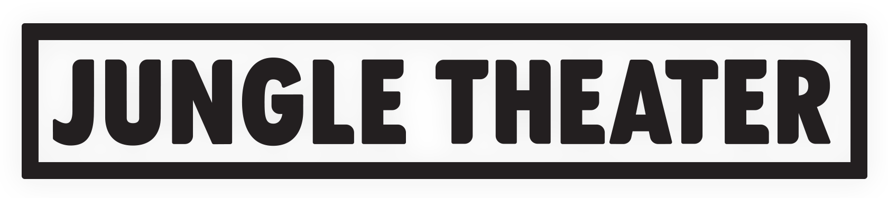
CONTACT
Anne Q. Ulseth
AQUA Public Relations
anne@aquamn.com | 612.272.0588

A DOLL’S HOUSE, PART 2 (regional premiere)
by Lucas Hnath
Directed by Joanie Schultz
January 15-February 23, 2020
Previews: January 15-16
Media Night: January 17
Jungle Theater
2951 Lyndale Ave. S., Minneapolis
Tickets: $40-$50
Box Office: 612-822-7063 or www.jungletheater.org

THE NEW YEAR BRINGS NEW WORK TO JUNGLE THEATER
2019-20 Season continues with regional premiere of
“A Doll’s House, Part 2”
On Stage January 15-February 23

(MINNEAPOLIS; December 13, 2019) – A 2017 Broadway hit, A Doll’s House, Part 2 comes to the Jungle Theater this winter in a taut new production starring Christina Baldwin, Steven Epp, Megan Burns and Angela Timberman as Anne Marie. The “smart, funny and utterly engrossing” play (The New York Times) is on stage January 15-February 23 at the Jungle, located in Minneapolis’ Lyn-Lake neighborhood at 2951 Lyndale Ave. S. Tickets are on sale at www.jungletheater.org.

The acclaimed play by award-winning Lucas Hnath is based on Ibsen’s 1879 novel, A Doll’s House, which examined the rules of society and gender. In the final scene of the groundbreaking masterwork, Nora Helmer makes the shocking decision to leave her husband and children, and begin a life on her own. This climactic event instantly propelled world drama into the modern age. Many years have passed since Nora’s exit. Now, there’s a knock on that same door. Nora has returned. But why? And what will it mean for those she left behind?

The Hollywood Reporter said that A Doll’s House, Part 2, “delivers explosive laughs while also posing thoughtful questions about marriage, gender inequality and human rights…as much an ingenious elaboration and deconstruction of A Doll’s House as a sequel, and it stands perfectly well on its own…With unfussy eloquence, [the play] asks how much, in a century-plus, life has changed for Nora and women like her in a world that often still has firm ideas about where they belong.”

The Jungle production will be helmed by Chicago-based director, Joanie Schultz, who directed her own adaptation of Ibsen’s original A Doll House at the WaterTower Theatre in Addison, Texas, in 2018. Jungle Artistic Director Sarah Rasmussen remarked that “I’m excited to introduce a new director to our artists and audiences. Joanie is a brilliant director who has a deep understanding of the two astonishing works. She’s a long-time collaborator of set designer Chelsea Warren, and everyone will be blown away by what they’ve come up with for this production.” Schultz’s creative team also features Marcus Dilliard (lighting), Sean Healey (sound), Mathew J. LeFebvre (costumes) and John Novak (properties).

Performances are Tuesdays ($40), Wednesdays ($40), Thursdays ($40), Fridays ($50) and Saturdays at 7:30 p.m. ($50), and Sundays at 2 p.m. and 7:30 p.m. ($45). Preview performances ($15) are January 15-16 at 7:30 p.m. Rush tickets are offered every night of the week, based on availability two hours prior to the performance, and there is special Friday night pricing for students, 55408 neighborhood residents and employees, and those under 30 years of age. Tickets and more information are available at (612) 822-7063 or www.jungletheater.org.

About the Jungle Theater
The Jungle Theater creates courageous, resonant theater that challenges, entertains and sparks expansive conversation. As a neighborhood theater with national impact, the Jungle tells stories that matter, with deep care and attention to detail. Artistic Director Sarah Rasmussen, entering her fifth season, was named “Artist of the Year” in 2018 by the Star Tribune and is noted for bringing new voices and gender parity to the stage.

Connect with the Jungle on Facebook, Twitter and Instagram: @jungletheater
Promotional photos will be available at jungletheater.org/press in the press room files.

