***National Wildlife Program Leader***

**GS-0401-13/14**

Outreach Notice

***Exciting National Leadership Position with U.S. Forest Service!***

[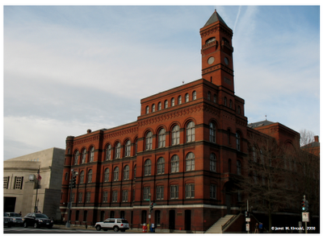](http://2.bp.blogspot.com/_KKM-Bq5Rbm8/SBo3tMYBrcI/AAAAAAAACcE/ZsABzWedgT0/s1600-h/15.2_YatesFedBldg.jpg)The U.S. Forest Service’s National Forest System is looking for highly qualified candidates to lead an important national-level program in the agency’s headquarters office in Washington, DC. Working in the Washington Office, you’ll have a direct opportunity to make a lasting impact and ensure the continued successful management of the Forest Service’s 193 million acres.

Working in the headquarters office of the Forest Service is an exciting experience filled with unmatched benefits and challenges, and many find it uniquely satisfying. You’ll have the opportunity to work in an exhilarating, fast-paced environment collaborating with diverse staff groups and a broad array of teams. Stakeholder interaction—whether with researchers, other agencies and Departments and/or non-governmental organizations (NGO’s) —is an essential part of working in the Washington Office. You will be involved in many national efforts including program implementation, development of directives and guidelines under the 2012 planning rule, and addressing ecological, management and political changes. Regardless of the specific focus, you’ll have the opportunity to make a lasting contribution to public policy and public service by helping lead the agency’s national-level programs so crucial to the health and diversity of America’s wildlife, forests and grasslands.

*The Sidney Yates Federal Building, home of the Forest Service’s headquarters office in Washington, DC.*

**GS-0401-13/14 National Wildlife Program Leader in the Watershed, Fish, Wildlife, Air, and Rare Plants Staff**

The National Forests and Grasslands provide an abundance and diversity of wildlife. Wildlife is an integral component of the ecosystems managed by the Forest Service and is of great public interest; enjoyed by many recreational visitors. Effective and integrated management of this important resource on our National Forests and Grasslands is a high priority for the agency.

*Duties and Opportunities Associated with this Position:*

The National Wildlife Program Leader in the Watershed, Fish, Wildlife, Air and Rare Plants (WFWARP) staff will play a key role in the Forest Service’s management of complex and challenging natural resource issues on a national scale. Major responsibilities of this position include, but are not limited to planning, direction, development, evaluation and administration of all aspects of the wildlife program necessary to maintain the health and diversity of wildlife habitat and wildlife populations on the nation’s forests and grasslands now and into the future. In addition to a working knowledge of wildlife management principles, wildlife ecology, current research and pertinent laws and regulations (including the National Forest Management Act) we are looking for an individual with proven leadership skills, with the ability to motivate those around them while being a team player.

Specific Duties include:

* Providing national leadership, scientific expertise and expert recommendations to Department of Agriculture, USFS Washington Office and Field Units regarding agency-wide policy, current issues, and wildlife program management.
* Management of national wildlife program on 193 million acres of national forests and grasslands
* Developing and recommending national wildlife guidelines and/or policy based on the 2012 Planning Rule that ensure ecological and adaptive management approaches, conserve biological diversity and maintain long-term productivity future generations.
* Fostering relationships within all branches of the Forest Service (National Forest Systems, International Programs, State and Private Forestry, Research and Development) other federal and state agencies, partners and stake holders to accomplish wildlife program and agency goals and objectives.

This position directly supervises one employee.

*How to apply for this position:*

This position will likely be advertised under both Merit System (Federal government-wide) and Demonstration Project (DEMO) authorities. Under DEMO, interested individuals need not have present or previous status as a Federal employee in order to apply. All potential applicants who respond to this outreach will be sent a link to the vacancy announcement when it is available. The vacancy announcement will be posted at http:// [www.usajobs.gov](http://www.usajobs.gov) by mid-to-late April, 2014.

For more information*,* contact:***Chris Worth****,* Assistant Director – Wildlife, Threatened & Endangered Species, Planning, Air, and Soils Resources by phone at (202) 205-3199 or e-mail at[*cworth@fs.fed.us*](mailto:cworth@fs.fed.us)*.* You may also touch base with***Steve Segovia****,* Deputy Director – Watershed, Fish, Wildlife, Air and Rare Plants at (202) 205-1066 or [*ssegovia@fs.fed.us*](mailto:ssegovia@fs.fed.us).

**Community Information**

A city of iconic monuments and idyllic vistas, Washington, DC commands attention from every corner of the world. As the Nation’s capital and the center of a metropolitan area that more than five million people call home, the Washington area offers unparalleled access to shopping, nightlife, restaurants, the arts, museums, sports, outdoor recreation, and more. The region, which stretches across portions of both Maryland and Virginia, has a strong economy, diverse and well-educated population, pleasant weather, excellent public transportation, top-notch health care, and myriad of educational opportunities. While Washington, DC may be the home of our Federal government, it is much more—a cosmopolitan city with endless opportunities that attract residents and visitors from around the world. (For more general information on the Washington, DC area, [click here](http://www.frommers.com/destinations/washingtondc/0035010001.html).)

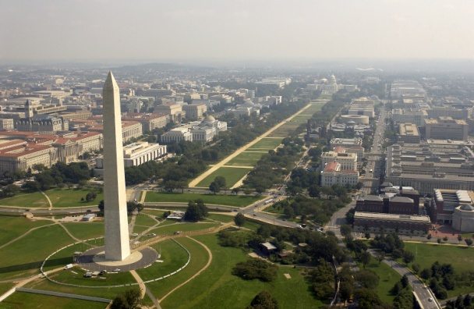

*Aerial view of the Washington Monument and National Mall in the core of Washington, DC.*

A highly educated workforce and diverse economy hosting jobs in government, law, high-tech enterprises, scientific research, education, and more come together in Washington, DC—and the region’s economy is humming. The unemployment rate is just over 5 percent. Even at the height of the Great Recession, the region’s unemployment peaked at just 7 percent, well below the national average of over 10 percent. Incomes are high and rising and local property values are recovering. (For more on Washington area neighborhoods, [click here](http://www.washingtonpost.com/real-estate/neighborhoods/index.html).)

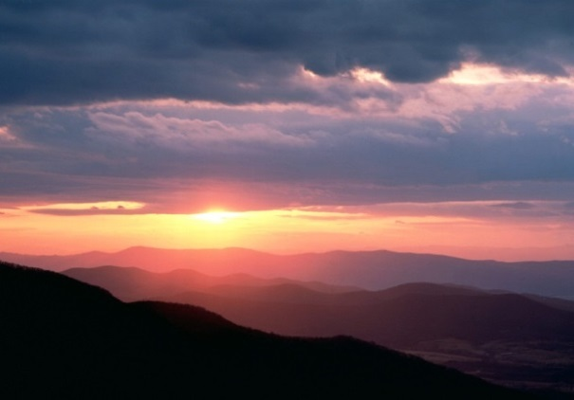Weather in the Washington area is known for its mild springs and autumns, and the winter and summer months are relatively enjoyable as well. In the winter, temperatures normally rise into the mid 40s by afternoon, and, although DC can be walloped by an intense blizzard now and then, some winters see virtually no snow at all. In the summer, temperatures dip to near 70 overnight, and normally rise to near 90 by afternoon. Bountiful sunshine and blue skies are typical of most summer days.

This generally mild climate allows outdoor recreation enthusiasts to take advantage of all the region has to offer. There are numerous trails, greenways, and urban parks within the city itself, and the larger Washington region has paved trail networks, hiking trails, lakes, waterways, and more. National parks and forests are within easy driving distance, west toward the Appalachian Mountains. And the Atlantic Ocean is just three hours away. Or you can run your toes along the sandy shores of the Chesapeake Bay, just 40 miles east of Washington. (For more on outdoor activities within Washington, DC, [click here](http://washington.org/DC-guide-to/outdoor-activities-families).)

*Sunset over Shenandoah National Park, within easy driving distance of Washington, DC.*

After exploring the great outdoors during the day, perhaps you’re looking for something to do at night. Maybe a baseball game. Or Broadway show. Dinner at a world-renowned restaurant? Whatever you want, DC has it—thousands of restaurants, clubs, and the highest concentration of museums and art galleries in the nation. Many of these museums line the “Nation’s Backyard,” the National Mall, a park and green space running five miles through the core of the city. (For a look at activities over a recent weekend in the Washington region, [click here](http://www.washingtonpost.com/gog/best-bets/weekendbest,86065.html).)

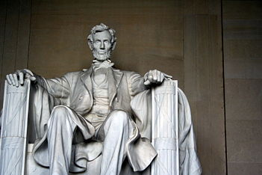Transportation facilities within the metropolitan area are top-notch, and include a subway and bus system that connects the city and its suburbs. There is a subway station just one block from the Forest Service office in downtown Washington, DC. Commuter buses and rail systems connect to the city’s subway and bus system and service the larger metropolitan area (public transportation subsidies are available to employees). Air service is also superb, with three airports serving the nation’s capital region. (For more on Washington’s public transportation, [click here](http://dc.about.com/od/transportation/a/DCPublicTrans.htm).)

*The Lincoln Memorial is just one of Washington’s many memorials and monuments accessible by public transportation.*

Educational opportunities are among the best in the country. Excellent elementary and secondary schools can be found in almost any community, and many private and church-affiliated schools and day-care facilities are also available. There are also several institutions of higher learning in the immediate area, including George Washington University, Georgetown University, American University, Gallaudet University, George Mason University, Howard University, and Marymount University.

The region has a large and excellent medical community with a wide variety of specialists and numerous clinics and hospitals. George Washington University Hospital is a nationally renowned, interdisciplinary center, and Georgetown University Hospital is one of the most recognized teaching hospitals in the country. In addition, the National Institutes of Health is located in Bethesda, Maryland, just outside the city limits.

###