
St. Matthew’s Messenger
SEPTEMBER 2015
St. Matthew’s Episcopal Church, Pennington, N.J. 08534

To receive the monthly Messenger and Constant Contact announcements please go to our website http://stmatthewspennington.org/, click on the link “sign up for emails” under “About us” to add yourself to our mailing list.



FROM OUR NEW RECTOR:

The boxes are stacked over my head and the shelves are bare. We must be getting close to moving day! The van is scheduled to arrive at St. Matthew’s rectory anytime between September 2-5. We will get there before it, arriving on September 1.

Undoing one life to embrace another is filled with the contrast of joy and sorrow, excitement and trepidation, eagerness and resistance, all of it shot through with love. You and I are each holding this adventure in our own way. Each of us are carrying hopes, dreams, and expectations we have perhaps held for a long time. What will the Holy Spirit do now that she has brought us together for the glory of God and our profound joy? I can’t wait to discover this with you!

I had to laugh this morning when while praying, the two stories from Scripture that came to mind as I was thinking about the momentousness of moving were 1: When Jesus tells his disciples to go out into the world to proclaim the kingdom of God and to heal the sick, [Mt 10: 5-15], but to take nothing for the journey; and 2: When God tells Noah to build the ark and to take two of everything. [Gen. 6:11-19] .

Well, which is it—all or nothing? The Briggs have chosen the Anglican way and sought out middle ground. We’ve made a compromise and are coming with some of it. Mostly, we are coming with open hearts, knowing that when God calls people together, it is for their mutual joy—so they will thrive and discover the face of Christ in everyone they meet, and I can’t wait to meet you.

With love in Christ,

Barbara


OFFICE HOURS: Monday, Wednesday and Thursday all day, 9am-4pm. Tuesday and Fridays half days.
Parish Office (609) 737-0985 or Pattiecurtiss@verizon.net

WHEN YOU’RE IN THE HOSPITAL: Due to the HIPAA Rules, hospitals no longer notify the Church if you are in the hospital, unless you request they notify us. If you would like us to visit, or be aware of your hospital stay, or to offer prayers, please call St. Matthew’s Church 609-737-0985.


WHEN YOU CHANGE YOUR EMAIL: Please be sure to contact the parish office at (609) 737-0985 or Pattiecurtiss@verizon.net to notify the office of any email address change.

IF YOU MOVE: Please let us know your new address and any change of phone number.

FROM THE WARDENS:
Welcome back everyone. The summer is an opportunity to enjoy some much deserved down time with family and friends and we hope you all got that chance. It is also a good time to reflect on the past and wonder about the possibilities of the future.

We welcome our new rector, The Rev. Barbara King Briggs.

We are so excited to begin this new chapter in our journey with Christ! We’d be remiss, though, if we didn’t take a little time to reflect on our journey to this point and give thanks for the blessings we’ve received.

We were blessed to have the Rev. Peggy Hodgkins as our interim rector to guide and support us through a good deal of our transition process. Additionally, we are so thankful for the tremendous group of lay leaders who have given their time and talent to see us through our discernment and beyond:

Profile Committee: Paul Bell (chair), Tim Cooper, Howie Dumhart, Diana Drake, Tammy Eng, Annie Gribbins, Janice Kinnamon, Teri Lawver, Mark Lederer, Elizabeth Luciano, Katherine Spych and Bruce Weise
Search Committee: Diane Zompa (chair), Tim Cooper, Diana Drake, Debbie Linthorst, Fred Lorenz, Jim Morrison, Eleanor Pennington, Kim Sherman, Caroline Sieber, Elise Thompson, Bruce Weise and Ginny Whitaker
Vestry: Colleen Bell, Tom Bruhl, Brogann Sanderson Bowden, William Compton, Gary Driscoll, Ian Hammet, Gayl Martinez, Steve Spencer, Scott Watterson, Bruce Weise and Diana Zompa
Transition Committee: Tom DiMuzio (Chair), Kati Angarone, Paul Bell, Jim Benton, Jon Bowden, Gary

Driscoll (Vestry Liaison), Karen Griswold, Lily Horsman, Joe Lawver, Gioia Miranda, Sara
Ottinger and Denny Rodgers

We said goodbye to our interim rector earlier this year and for the past seven months have welcomed guest clergy each Sunday to celebrate and worship with us and to care for the pastoral needs of our parishioners. We extend our thanks to them for their ministry, care and compassion.

The Rev. Cannon Joan Fleming The Rev. Cannon Ginny Sheay

The Rt. Rev. George Councell The Rev. Robert Legnani
The Rev. Dr. John Goerss The Rev. Cannon John Sosnowski
The Rev. Fletcher Harper The Rev. Neil Turton
The Rev. Dennis Olsen The Rev. Robert Haller
The Rev. Wendy Billingslea The Rev. Valerie Redpath
The Rev. Meghan Farr The Rev. Lisa Caton

There are many other lay leaders who continue to give their time and talent to keep programs, events and outreach going throughout the year. We give heartfelt thanks to all those involved for their faithful service to: pastoral care, prayer partners, hospitality, communications, PLG, Kairos, Destinations, LOGOS, adult education, stewardship, property, finance, altar guild, rummage, Christmas bazaar, mission, choirs – adult, children & hand bell, lay ministers, acolytes, ushers & greeters, lay readers, collection counters, nursery caregivers, and grocery program. We give special thanks to Tom DiMuzio for his faithful leadership as senior warden during a good portion of our transition, Scott Watterson as property chair for his dedicated service in renovating the rectory, and Tom Bruhl for his patience and diligence in coordinating our lay worship leaders.

Finally, we give thanks for the St. Matthew’s staff for their professionalism, faithfulness and dedication during this time – Lori Cooper, Pattie Curtiss, Tammy Eng, Rory McCorkle and Ron Rabel.

As a congregation we have grown over the past 26 months as we journeyed through the transition and discernment process. We’ve grown stronger, more compassionate and resilient as we’ve cared for one another, celebrated milestones and mourned losses. It is the foundation that our former rector helped build that we drew from during some difficult times. We pause to give thanks for The Rev. Cannon John C. Belmont and the legacy he has left us.

We now turn our attention to our future. With great joy, we welcome Barbara and look forward to building a faithful future with her as we continue our journey with Christ.

It has been an honor and privilege to witness the calling of Barbara as our new Rector. We are blessed to be partnering with her as she begins her ministry at St. Matthew’s.

Blessings to all,

Kate and Jim

Transition Team…..
It is now time for the Transition Team to take over and smooth the process of getting our new pastor acclimated to St. Matthew’s.

The Team will be involved in helping with housing matters, school needs, recreation and socialization into the community, the congregation, and the Diocese.

Imagine moving into a community and being asked to start your new job within a few days of your arrival. That portrays the situation our new pastor and family will be in early September.

Our hope is that the Transition team members can help by smoothing out the bumps, by making introductions, setting up meet and greets, providing guidance to the local area, and creating the most welcoming environment for our new Rector and her family.

The members of the Transition Team:
Tom DiMuzio, Chair Karen Griswold
Kati Angarone Lily Horsman
Paul Bell Joe Lawver
Jim Benton Gioia Miranda
Jon Bowden Sara Ottinger
Gary Driscoll, Vestry Liaison Denny Rodgers

Please feel free to reach out to any of them if you can offer any assistance.

Tom DiMuzio
Transition Team Lead


St. Matthew’s Prayer Partners ministry starts up again after Labor Day this September and will continue until church school ends in the spring.

What is Prayer Partners? It is a means by which anyone attending the 10 AM Sunday service can receive confidential prayers in the chapel, during or after communion for themselves or a loved one, from a St. Matthew’s prayer team.


Ladies' Luncheon will be the 23rd of September, 12:30pm, at Barbara von Oehsen's home, 238 South Main Street , Pennington. Barbara will make the main course, the Ladies can bring side dishes, salads and desserts. Please contact her at her e-mail bvono@aol.com or call her at 609 737- 0002.



13th Annual Battle Against Hunger Bike Tour
Team St. Matthew’s will honor Chuck Inman’s legacy by participating in another ride supporting TASK and The Rescue Mission of Trenton.

Riders Kevin Margiatto, Bruce Weise, Ginny Buchanan, Amy Eckel, Vance Smith and Denny Rodgers will tackle hills for anywhere from 60 to 200 miles.

Performing SAG (Support and Gear) are Pam Inman, Phyllis & Mick Jones, Lynne Garner, Paul Bell, Ron Buchanan, Andy & Sue Swords, Tom & Ti Pearse-Drance Lauren LoVerde & Tim Wilson Penny Rodgers and Jack & Sandy Belmont.

Donations can be made by check to Battle Against Hunger, given to any rider or SAG person or mailed to PO Box 800, Pennington, NJ 08534-0800. On-line donations at Battleagainsthunger.org.
Kairos Korner

We are excited to begin the 2015-2016 Kairos school year!

This year we are introducing a meaningful change to our Sunday schedule for the youngest of our congregation as well as our registration process. I am thrilled to be able to offer online registration!

For this year, we are merging our Primary and First/Second grade classes. This class will now be called “P-2”. The dynamics of a mixed age group can be wonderful and we feel it is worth exploring. The former First/Second grade room will now be our Young Elementary classroom, directly across from the library on the main floor of the building.

This change will also mean that our youngest Episcopalians will now join the 10am service at the Peace as our older grades do instead of waiting until first grade to experience the service in the “big church” on Sundays. Therefore, all grades will be joining the 10am service at the Peace.

Registration is OPEN! Online registration is up and running! To register your child, please:
Use the following link: https://www.easyreg.org/cgi-bin/acct/3O9IFZQYTB/displayForm.pl?V34S1C6M_2015
OR access the form via our website:
- Go to www.stmatthewspennington.org
- Select “CHILDREN & YOUTH”
- Choose the link for KAIROS (located at the end of the Sunday Morning Children’s Program section)
- Click on the REGISTRATION FORM link :
- Please register your child as soon as possible. Thank you so much!

Our first day of classes is Sunday, September 20th
Welcoming time begins at 9:45am. All classes begin at 10am. ALL grades will join their families in Church during the Peace. Please visit our website www.stmatthewspennington.org for detailed information on our children’s programming located via the CHILDREN & YOUTH link.

Please note: Children are invited to begin attending Kairos classes at age 4 yrs (must be 4 as of October 1st and able to take care of their bathroom needs. Thank you!.

Kairos classrooms:
Primary – 2nd grade Classroom A (first floor)
Third/Fourth grade Classroom D (downstairs)
Fifth/Sixth grade Classroom C (first floor)
Seventh/Eighth grade Library (first floor)

Kairos Kalendar
September 6: Welcome Back Service! Blessing of the Backpacks, Nursery Care returns
September 13: Kairos Teacher Commissioning
September 20: First day of classes
September 27: Regular lessons

Should you have any questions, please contact our Director of Children’s Ministries, Lori Cooper, at StMattKairos@verizon.net. Thank you!


Nursery Care RETURNS
Nursery care, located downstairs in St Matthew’s Nursery School, will resume on Sunday, September 6^{th .}

BLESSING OF THE BACKPACKS !
On Sunday, September 6th at the 10am service - children are invited to bring their backpacks or book bags to church in order to receive a blessing in the context of worship. It is a wonderful way to acknowledge the beginning of a new school year.

From the Director of Music Ministry:
There are a variety of opportunities to participate in the leadership of worship at St. Matthew's. One of these opportunities is participating in our music ministry. We want you to join us in praising the Lord through song, whether playing or singing. If you have an interest in singing, playing handbells, or have a particular musical talent that you would like to offer occasionally in a service, please do not hesitate to speak to me in church, by phone (mobile 717-575-5273), or by e-mail (rorymccorkle@verizon.net).

We are always welcoming of new people in all of our choirs. If you are interested, please contact a chorister or myself.

Rehearsal/performance schedules can always be found on the choir bulletin board (around the corner from the Rector’s office) or online at http://www.stmatthewspennington.org/music-drop/


Adult Choir: The adult choir leads the congregation in singing of hymns and service music at the 10 a.m. service every Sunday, while also offering anthems and other pieces. This choir also sings at special services and events through the year. The adult choir is for intended for teens to adults. The ability to read music is very helpful in this group. Rehearsals will begin Wednesday, September 9 at 8pm in the sanctuary. The first singing Sunday will be September 13.


Children's Choir: The children’s choir is for children of Kairos age (approximately 5 to 12). They sing about once a month in church. The ability to read music is not required. Rehearsals will begin Sunday, October 4 in the downstairs classroom (new wing, across from the multi-purpose room).


Handbell Choir: The handbell choir includes both adults and young people, particularly those 12 and older. They play about 8 times during the choir year (September – May). The ability to read music is required for this group. Rehearsals will begin Wednesday, October 14 in Classroom A (across from Library).

Oh sing to the LORD a new song; sing to the LORD, all the earth (Psalm 96:1)! I look forward to seeing you this fall.

Rory



COME JOIN US FOR SOME FUN AND FELLOWSHIP
OCTOBER 3 - 7:00-9:30PM IN BELMONT HALL
BEER AND WINE TASTINGW/ A SILENT AUCTION
TICKETS ARE $20.00
(THIS IS AN ADULTS ONLY EVENT)
The Parish Life Guild is excited to announce another October Beer and Wine Tasting in Belmont Hall!

This is a fun social event with our favorite connoisseurs, Amy Vestor and Andy Swords, leading the evening.

(PLEASE NOTE: Donations are needed: We are looking for all sizes of Auction tems: Vacation Homes, weeks or weekends, Theme Baskets of goodies, Services or other Items of value.)

We also plan on having some Silent Auction items available for you to bid on. This will provide additional funds for our PLG outreach initiatives to support the broader community.

We look forward to seeing you there!!

Tickets can be purchased from Katie Riggs or Mary Kay Krokowski between services and following the 10am service on Sundays in September.


September 17- The Warden
This is the first novel in Anthony Trollope's classic Chronicles of Barchester series. Beautifully written, reflective of its time and age. The characters are appealing and so very recognizable in our times too, with same constant strife to live by principles and resist modern temptations.

October 15 - Crossing to Safety - Wallace Stegner
﻿Called a “magnificently crafted story . . . brimming with wisdom...Crossing to Safety has, since its publication in 1987, established itself as one of the most cherished American novels of the twentieth century. Tracing the lives, loves, and aspirations of two couples who move between Vermont and Wisconsin, it is a work of quiet majesty, deep compassion, and powerful insight into the alchemy of friendship and marriage.

November 19 -Our Souls at Night by Kent Haruf
“Haruf’s great subject was the struggle of decency against small-mindedness, and his rare gift was to make sheer decency a moving subject. . . . [This] novel runs on the dogged insistence that simple elements carry depths, and readers will find much to be grateful for.” —Joan Silber, The New York Times Book Review
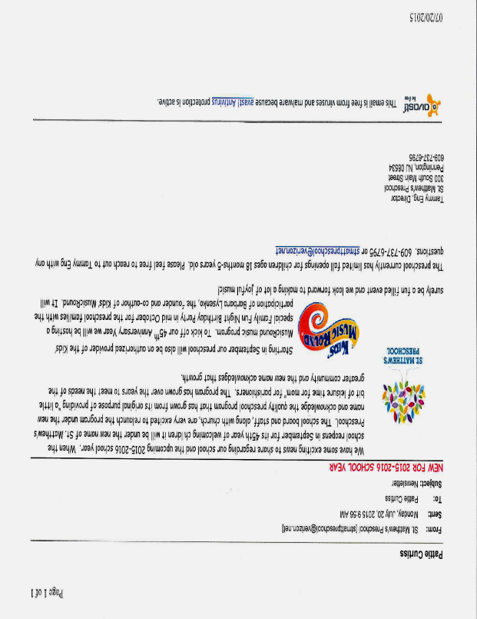
NEW FOR 2015-2016 SCHOOL YEAR
We have some exciting news to share regarding our school and the upcoming 2015-2016 school year. When the school reopens in September for its 45th year of welcoming children it will be under the new name of St. Matthew’s Preschool. The school board and staff, along with the church Vestry, are very excited to relaunch the program under the new name and acknowledge the quality preschool program that has grown from its original purpose of providing “a little bit of leisure time for mom” for parishioners. The program has grown over the years to meet the needs of the greater community and the new name acknowledges that growth.

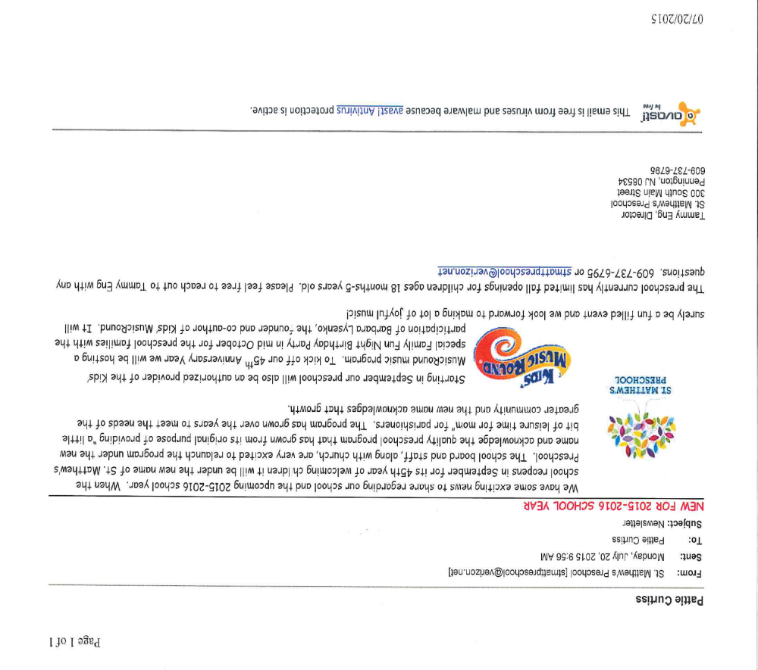
Starting in September our preschool will also be an authorized provider of the Kids’ MusicRound music program. To kick off our 45th Anniversary Year we will be hosting a special Family Fun Night Birthday Party in mid October for the preschool families with the participation of Barbara Lysenko, the founder and co-author of Kids’ MusicRound. It will surely be a fun filled event and we look forward to making a lot of joyful music!

The preschool currently has limited fall openings for children ages 18 months-5 years old. Please feel free to reach out to Tammy Eng with any questions. 609-737-6795 or stmattpreschool@verizon.net


Hospitality Committee 2015-16 Update:
Hospitality Committee Members: We’re in search of new members to help with Hospitality events during the year. This is not a huge commitment, and members are not expected to assist with every event. Events to include: special coffee hours, a newcomers’ breakfast and other special occasions. Responsibilities may include, but not be limited to: event set up/clean up, providing a dish/dessert or tablecloths/supplies, being a host/hostess at these events – or anything that you may do to help foster a spirit of warmth and hospitality. Note: preteens/teens are strongly encouraged to be committee members as well!


Coffee Hour Hosts: Beginning on Sunday September 13, we are looking for Coffee Hour hosts to serve after the 10am service. Coffee and tea, sugars and all paper products are supplied by the church (as well as juice for the kids). We just ask that you bring a quart of creamer and a quart of milk. It is optional, not required, if you’d like to supply baked goods, cookies or other treats. Instructions are provided, and we are happy to walk you through the process.

Hosts need to arrive about 30 minutes prior to the service in order to set up. Sign-up sheet is located on the board to the right of the kitchen door, or you may contact Debbie Linthorst at dlinthorst@comcast.net or (609) 902-2905. Ideas: Host a coffee hour as a family, older children may sign up together and parents may assist them with hosting, do it with a friend, etc.

If you are interested in becoming a Hospitality Committee member, or have any questions, please contact Debbie at the email/phone number listed above. Thank you.
FOOD CERTIFICATE PROGRAM

Thanks to all who have supported this program over the years. The purpose of this program is to raise additional funds that are given to the Vestry to help meet the annual budget. It’s a simple and painless process. We purchase gift certificates for grocery purchases at Pennington Market, Shop Rite (good for any Shop Rite), Stop and Shop or Marrazzo. You purchase the certificates at face value to redeem for your grocery purchases. There is no additional cost to you and St. Matthew’s receives a 5% donation - example:($100 = $5.00 to St. Matthew’s).



