
St. Matthew’s Messenger
March 2015

St. Matthew’s Episcopal Church, Pennington, N.J. 08534

To receive the monthly Messenger and Constant Contact announcements please go to our website http://stmatthewspennington.org/, click on the link “sign up for emails” under “About us” to add yourself to our mailing list.

SCHEDULE FOR HOLY WEEK AND EASTER

Wednesday, April 1 7am, Lenten Eucharist, The Rev. Canon Joan Fleming
Maundy Thursday, April 2 8pm, Holy Eucharist w/Foot Washing, The Rev. Canon Joan Fleming
Good Friday, April 3 12 noon, Ecumenical Good Friday Service,
The Rev. Canon Joan Fleming;
3pm, children’s service, Led by Lori Cooper, Dir. Children’s &
Family Ministry
Holy Saturday, Saturday, April 4 8pm, The Great Vigil of Easter, The Rev. Canon Joan Fleming
Easter Sunday, April 5 8 & 10am, services, The Rev. Canon Joan Fleming

Holy Week at St. Matthew’s
“Through the Paschal mystery, dear friends, we are buried with Christ by baptism into his death, and raised with him to newness of life” (BCP, 292). Join us this Holy Week as we walk through the last week of Jesus’ earthly life and consider how our own lives follow this pattern of life, death, and resurrection:

Maundy Thursday – April 2, 8:00pm

On this night we celebrate the last meal Jesus shared with his disciples, the communion meal of bread and wine we share each Sunday. The service ends in silence with the stripping of the altar.

The Watch – April 2 & 3 – 9:00pm to Noon Friday

The Watch begins in the Chapel immediately following the Maundy Thursday service. It recalls the hours prior to Jesus’ arrest and trial, when he went to the Mount of Olives and Garden of Gethsemane to pray for strength to face what was to come. Sign up for shifts in the Narthex, then come and read Scripture or meditate in silence.

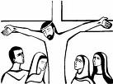
Good Friday – April 3– 12:00pm, 3:00pm Children’s Service
At our Noon Ecumenical Liturgy, we join with other Pennington churches in observing the death of our Savior, experiencing the Passion narrative in its entirety. We face Christ’s and our own suffering honestly, only to find God working in and through it for our healing and salvation. The Children’s Good Friday liturgy at 3 pm will again be a modified, interactive
Stations of the Cross service designed to help them experience the meaning of this day.

The Great Vigil of Easter and Feast – April 4, 8:00pm
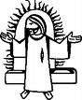
Join us for the most spectacular liturgy of the year. From the lighting of the new fire in the deep darkness, we watch as the light of Christ breaks into the world. We hear Israel’s stories of freedom and salvation and celebrate the salvation that is now ours through Christ. After renewing our baptismal vows, we celebrate the Easter eucharist – thus completing our passage with Christ from death to new life. Don’t forget to bring bells for the”unburying” of the Alleluias!! Immediately following the Vigil, we will gather in Parish Hall for a potluck feast and celebration.


Easter Sunday – April 5 – 8:00am, 10:00am
Alleluia! Christ is risen! Join us as we celebrate the victory over sin and death that is ours through the resurrection of our Lord. Our adult choir will join both the 8 am amd 10am services with song and celebration. Bring bells!


KAIROS KORNER

We invite children of all ages to experience the Children’s Good Friday Service on Friday, April 3rd at 3pm. This unique service is an interactive walk through the Stations of the Cross where the children are given the opportunity to experience visually and tangibly the events that Jesus experienced on His way to the cross – the scent of hyacinth in the Garden of Gethsemane, the heavy wood of the cross, the sharp thorns of His crown, the cold and darkness of the pitch black tomb.

On Sunday, April 5th, we will release the alleluias when we celebrate the Great Mystery of Easter! All ages are encouraged to join in this glorious celebration therefore we will not have Kairos classes on Easter Sunday.

I WONDER…

Why does the date for Easter fluctuate so much from year to year?
As stated in the Book of Common Prayer (pgs. 880-885), Easter Day is always the Sunday after the full moon that occurs on or after March 21 (a fixed date, which is typically the spring equinox). Jesus celebrated the Passover Feast with His disciples on the night that He was arrested. He was crucified, died and was buried and on the third day He rose again. In this way, Easter is related to the Passover. The Jewish calendar is lunar. Passover can fall on any day of the week; the date of Passover also changes from year to year. Therefore, the date of Easter changes as well. Easter is always on a Sunday and may fall between March 22nd and April 25th.


Second Grade Eucharist Instruction
Eucharist instruction for our second graders will be held on Sunday, April 19th and Sunday, April 26th with a Family Worship Service in honor of our Eucharist class on Sunday, May 3rd! Second Grade parents were sent a letter in March with details. Please register your child by March 29th by sending an email to Lori Cooper at StMattKairos@verizon.net. Thank you!

Clergy Support
We pray that our parish family stays safe and healthy during this period of transition. However if you find yourself or a family member in need of clergy support, please call the church office. Several clergy friends of St. Matthew’s are providing pastoral care as needed. If your need occurs during an evening or weekend please contact one of the wardens.
Kate Westbrook (732)322-3545
Jim McGuire (609)468-5595


SAINT MATTHEW’S LADIES LUNCHEON
APRIL 15 at 12:30pm
The Ladies Lunch for April will be at home of Kay & John Goerss on April 15. at 12:30 pm , 63 Lexington Dr., Pennington, NJ. Kay and John will provide the entrée and wine, everyone attending is asked to provide a salad, side-dish or desserts.

Please contact Kay and John at jmgoerss@princeton.edu or phone 609-737-6320


Destinations for April 14th
Destinations, our middle school youth group, will gather on
Tuesday, April 14th. Interested in joining our parent email list? Contact Diana Drake at drakeink@aol.com or at 609-730-9037


LOGOS will not be meeting on April 5th due to Easter; however, we will be meeting on April 12, 19 and 26

LOGOS in the Kitchen!
High school youth, join the LOGOS team, including Diane Zompa, will gather on April 12th in the St. Matthew's kitchen to prepare several meals for parishioners in need. Get ready to measure, chop, mix and bake on during this fun pastoral-care ministry. Regular meeting time: 5 pm to 7 pm.

Happening 24 – Diocesan Youth Event – 9th -12th Graders
April 10-12, 2015

Where: Camp Murray, Lanoka Harbor
Begin: 7:00 p.m. (4/10) - End: 4:00 p.m. (4/12)
Lodging: Sleeping bags on the floor
Cost: $75 per person
Happening is a Christian event presented by teenagers for teenagers with the help of clergy and lay leadership. It is a program of The Episcopal Church to engage young people in the gospel and encourage them to live passionately into their faith. Happening seeks to bring youth to a fuller knowledge and relationship with Jesus Christ, and a deeper level of apostleship. This occurs through large and small group activities. Worship, music, fun, food, and free time are also a part of the event.
Register online at newjerseyyouth.org.


St. Matthew’s Book Club

APRIL 16 at 7:30pm, in CLASSROOM c
Orphan Train Christina Baker Kline - in the Sunday school classroom nearest the library

Orphan Train, by Christina Baker Kline, is the compelling story of Vivian, a 91-year-old widow once orphaned as a child, and Molly, a troubled teen who has been shuffled from one unstable foster home to another. The two women develop a bond, with Vivian treasuring her Irish immigrant roots and Molly finding comfort in her ancestral Native American tradition. The novel sheds light on an era when thousands of orphaned children were taken from crowded cities to face uncertain futures in the rural Midwest and connects with the importance of heritage and memories in shaping who we are, the value of intergenerational relationships, and the fundamental power of family.

Rules of Civility, by Amor Towles, May 21 - 7:30 pm in the library
Elegant and captivating, Rules of Civility, by Amor Towles, turns a Jamesian eye on how spur of the moment decisions define life for decades to come. A love letter to New York City at the end of the Depression. “A wonderful debut novel…Towles plays with some of the great themes of love and class, luck and fated encounters that animated Wharton’s novels.” —The Chicago Tribune

A Night Out At “The Belmont Hall" - A St. Matthew’s PLG FUN Raiser
$5/person with proceeds to go to Episcopal Relief and Development

This is an evening of Fun and Fellowship, to gather together as we enjoy re-connecting after a long winter! Adults of all ages are invited and encouraged to join us on Saturday, April 18, starting at 7 p.m.
Please bring an appetizer or dessert to share, a beverage of your choosing. Non-alcoholic beverages will be provided by the PLG.


Pennington 125th anniversary
2015 signifies the 125th anniversary of Pennington’s incorporation from Hopewell Township. On Sunday, April 26th from 2 to 5 pm St. Matthew’s along with other churches in town will host an open house. Jim Morrison has graciously offered to act as St. Matthew’s host for this event. Anyone interested in assisting Jim is encouraged to speak with him. An Ecumenical service is also scheduled on April 26th at 6pm at a location yet to be determined.

St Matthew’s Little Leisure

is now registering for fall classes.

Join us for the 2015-2016 school year!

Little Pebbles
(18 months and a steady walker on/before September 1st)

Wednesdays
9:00 AM – 12:00 Noon
(2 years old on/before October 1st)
Monday/Thursday or Tuesday/Friday
9:00 AM – 12:00 Noon or 9:00 AM – 1:00 PM

Stepping Stones
(3 years old on/before October 1st)
2, 3, or 4 day option
9:00 AM – 12:00 Noon or 9:00 AM – 1:00 PM

Pre-Kindergarten
(4 years old on/before October 1st)
3, 4 or 5 day option
9:00 AM – 12:00 Noon or 9:00 AM – 1:00 PM

For further information or to make an appointment to observe
a class, contact Tammy Eng, Director
609-737-6795, littleleisure@verizon.net



Vacation Bible School 2015
Mark your calendars! The date has been set for this summer’s Vacation Bible School!

Monday, July 27th – Friday, July 31st from 9:15am – 12:15pm

at

Pennington Presbyterian Church
We are currently in the process of finding volunteers to make this wonderful community of faith program happen. We are looking for adults and teens to serve as teachers (adults only) and assistant teachers (adults/teens*) for grades preschool through 6th. We are also in need of adults and teens to help with arts & crafts, snack, activity time, playground time and adults to help with child care (for the children of teachers only).

If you would like to volunteer for a day, two days – the entire week – please contact Lori Cooper at StMattKairos@verizon.net. Thank you!

~As soon as we have secured our teaching staff we will open registration~

*Teens must be entering 7th grade or higher in September 2015.

AROUND THE DIOCESE

Bishop's Spring Conference: Discipleship and Mission
A One-Day Conference, Saturday, April 18, 2015 9 AM - 3 PM
Trinity Cathedral, Trenton
Join us for an event that will bring together spectacular leaders of Christian Formation in a exploration of new strategies for forming disciples in today's challenging and transforming twenty-first century landscape. Beginning March 17, the registration fee rises to $20.
Training for Lectors
April 25 @ 9:00 am - 3:00 pm
St John the Evangelist, 189 George Street, New Brunswick, NJ 08901
Training for Lectors, Eucharistic, Ministers, and Eucharistic Visitors
Sponsored by the Committee on the Priesthood
This workshop is intended to be a source of help and practice for those who participate in the ministries of Eucharistic Minister, Eucharistic Visitor, and Lector. Participants will receive information based on sound Biblical theology as well as hands-on practice with seasoned professionals. You may wish to stay for the entire day as you seek to expand the ministries that you provide to your church or you may focus on the ministry that you already engage in at the church. Training will be based on the Diocese’s Manual for the Licensing of Lay Ministries which contain the most recent changes in the Canons of The Episcopal Church and requires periodic training for those persons called to these ministries. This training does not lead directly to the receipt of any lay licenses for these ministries. Such licenses are issued by your rector based on your involvement in these ministries at your church. The morning session of the Licensed Ministries Training will be devoted to a workshop entitled Reading Aloud Effectively. It is designed to give Lectors and Eucharistic Ministers the skills and techniques to help them read Scripture aloud and to assist the congregation in their understanding of the various texts. A coaching session will be included. The afternoon session will enable Eucharistic Ministers and Visitors to practice administering the Chalice and Paten and to reflect on the theological and pastoral aspects of these ministries.
Schedule:
Lectors – 9 am-noon Lunch – noon -12:30 pm
Eucharistic Ministers and Visitors – 12:30 to 3:00 pm
No cost, lunch provided. When you register, please indicate whether you desire lunch.

Register by Monday, April 20 online or email spaige@dioceseofnj.org. Or fax registration form to 609 394-9546, mail form, or phone Sarah Paige, 609 394-5281, ext. 10. Contact The Reverend Jayne Oasin, 856 642-6467 or revjayne@comcast.net


Search Committee Update

I’m pleased, once again, to share that our Search continues to go well…

The Search Committee has received a good response to the posting for the Rector position at St. Matthew's which is now closed. We are in the interviewing phase of the search process which is on schedule for a Call of our new rector in the early summer months.

The quality of our process and our steady progress has been possible only because the members of St. Matthew’s supplied the critical tools for an effective Search: a Parish Profile that conveys clearly, sincerely, and beautifully who we are, what we have accomplished, the ways in which we want to grow as a parish and the challenges we know we must address to achieve that growth; a Search Committee – 12 very hardworking and dedicated parishioners entrusted to represent the needs and desires of the parish, as reflected in the Parish Profile in order to discern the right next rector for our Church; and Prayer, from the mouths and hearts of those who fill the pews at 8:00 and 10:00 every Sunday:
Almighty God … guide the minds of those who shall choose a rector for this parish, that we may receive a faithful pastor , who will care for your people and equip us for our ministries; through Jesus Christ our Lord. Amen.

But there is one more tool we continue to need at this time … Patience from all of you who eagerly await the arrival of the good shepherd, the right shepherd, and from your Search Committee who are hard at work to discern very diligently and very surely the right faithful pastor for our treasured community.

We continue to make progress. I remain confident that we will complete this journey successfully and that with God’s help, by early Summer, we will find the right match between our needs and a good shepherd who can lead us to their fulfillment. We ask for your continued prayers and patience.

Respectfully submitted,
Diane Zompa, Search Committee Chairperson

schedule of preachers for Sunday worship

We are very blessed to have Rev. Canon Joan Fleming with us through mid-April and will miss her when she leaves.
However, we are excited about the diverse and dynamic clergy we have scheduled to celebrate/preach with us through
June. Please join us as we welcome a biblical scholar, an environmentalist, long-time friends of St. Matthew’s and
Diocesan clerical leaders.

March 29th - Rev. Canon Joan Fleming, celebrant; Rev. John Goerss, preacher – retired Lutheran minister &
Lutheran chaplin at Princeton University and fellow St. Matthew’s congregant.
April 5th - Rev. Canon Joan Fleming
April 12th - Rev. Canon Joan Fleming, her last Sunday with us
April 19th - Rev. Fletcher Harper, Executive Director of GreenFaith
April 26th - Rev. Dennis Olsen, Chairman of the Biblical Studies Dept. at Princeton Theological Seminary
May 3rd – 8am – Mark Lederer leading Morning Prayer
10am – Rev. Meghan Farr, Curate St. Luke’s Gladstone
May 10th - Rev. Virginia Sheay, Priest Associate at Trinity Solebury, Former Priest Associate at St. Matthew’s
and one of the first women ordained in the Episcopal Church
May 17th - Rev. Robert Legnani, Diocesan Chaplin to the Retired Clergy
May 24th - Rev. Canon John Sosnowski, Canon to the Ordinary
May 31st - TBD
June 7th - TBD
June 14th - TBD
June 21st - Rev. Robert Legnani, Diocesan Chaplin to the Retired Clergy
June 28th - Rev. Canon John Sosnowski, Canon to the Ordinary

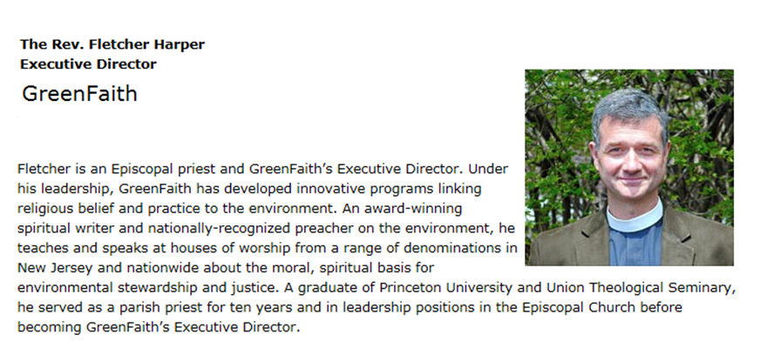
APRIL 19th: The Rev. Fletcher Harper, Executive Director, GreenFaith

Fletcher is an Episcopal priest and GreenFaith’s Executive Director. Under his leadership, GreenFaith has developed innovative programs linking religious belief and practice to the environment. An award-winning spiritual writer and nationally-recognized preacher on the environment, he teaches and speaks at houses of worship from a range of denominations in New Jersey and nationwide about the moral, spiritual basis for environmental stewardship and justice. A graduate of Princeton University and Union Theological Seminary, he served as a parish priest for ten years and in leadership positions in the Episcopal Church before becoming GreenFaith’s Executive Director.

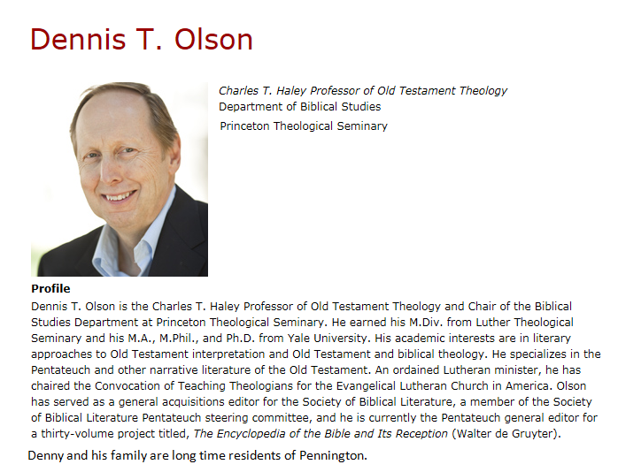
APRIL 26TH: The Rev. Dr. Dennis T. Olson, Professor at Princeton Theological Seminary
Dennis T. Olson is the Charles T. Haley Professor of Old Testament Theology and Chair of the Biblical Studies Department at Princeton Theological Seminary. He earned his M. Div. from Luther Theological Seminary and his M.A., M.Phil., and Ph.D. from Yale University. His academic interests are in literary approaches to Old Testament interpretation and Old Testament and biblical theology. He specializes in the Pentateuch and other narrative literature of the Old Testament. An ordained Lutheran minister, he has chaired the Convocation of Teaching Theologians for the Evangelical Lutheran Church in America. Olson has served as a general acquisitions editor for the Society of Biblical Literature, a member of the Society of Biblical Literature Pentateuch steering committee, and he is currently the Pentateuch general editor for a thirty-volume project titled,
The Encyclopedia of the Bible and Its Reception (Walter de Gruyter).

Denny and his family are long time residents of Pennington.

May 3rd (10am service – 2nd grade Eucharist celebration):

The Rev. Meghan J. Farr, Curate, St. Luke’s, Gladstone
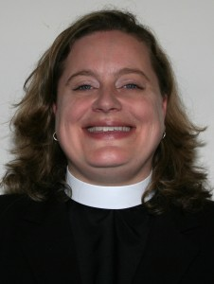
Meghan was called to St. Luke’s to serve as Curate in July of 2013 after graduating from Nashotah House Theological Seminary with a Master of Divinity. She served previously as the Seminarian intern first at Holy Trinity Episcopal Church in Melbourne, FL and then All Saint’s Episcopal Cathedral in Milwaukee, WI. Meghan graduated Magna Cum Laude from the University of Florida in 2003 with a B.A. in History. She met her husband Daniel there and they were married in 2003. Both are proud members of the Gator Nation (Go Gators!). They have two boys—Aidan Wallace, a 3rd grader at Bedwell Elementary and 2.5 year old Declan Alan. Prior to entering seminary, Meghan worked as a Program Director for a non-profit substance abuse prevention and treatment agency in Melbourne Florida. Daniel is a chef at Ninety Acres Culinary Center at Natirar.
Meghan keeps busy as a mom but in her free time she loves reading and exploring restaurants with Daniel. They are both avid sports fans (yes even the same teams!) and enjoy traveling and all things historical.

