
St. Matthew’s Messenger
JANUARY 2015

St. Matthew’s Episcopal Church, Pennington, N.J. 08534

To receive the monthly Messenger and Constant Contact announcements please go to our website http://stmatthewspennington.org/, click on the link “sign up for emails” under “About us” to add yourself to our mailing list. The Church is open for prayer and meditation during parish office hours on weekdays: Monday, Wednesday, Thursday from 9am-4pm and Tuesdays and Fridays till 12noon.

Happy New Year 2015!

Dear Friends,

Grace and peace to each of you as we greet the New Year, the Year of Our Lord 2015.

In the symbolism of the secular calendar, the old year goes out like an ancient man bearing a scythe, so close to death. And the New Year about to be born is like a baby in its freshness, full of hope, and still wearing diapers.

In contrast to the secular calendar, the church marks time in a different vein. New Year’s Day in the church begins with the Feast of the Holy Name on January 1st. What a life-giving way to begin anew--to rejoice in the Name of Jesus, who brings us salvation. His very name Yeshua (the original Hebrew name of Jesus) means salvation or “God helps.”

Last year we made a huge shift in our congregation, gradually separating from the past and preparing ourselves for the mission that greets us from the future. With this New Year, we are about to embrace the transition of leadership once again as I depart from St. Matthew’s for my next assignment, and you await a new rector.

Throughout this shift, the blessing of belonging to a community of faith like St. Matthew’s is knowing where our salvation comes from. “Salvation comes from the Lord” (Micah 7:8), who called us to live in peace with one another. Patience and dialogue, in the form of compassionate communication, are vital in this time of change. We make this change trusting in the gifted lay leadership of the Wardens, Vestry, and the Search Committee, and acknowledging our dependence on the Holy One whom we worship.

To live out our dreams for our parish, let us ask the God of salvation to work alongside us, so that we might grow into the people God created us to be.

May this New Year of 2015 be for you a time of great blessing. Through the challenges that lie ahead, may you be drawn into a deeper faith for engaging with them, and may you know the joy of believing in God’s never failing love and care.

With deep gratitude for the privilege of being your rector in this interim time, I remain
Yours in Christ,

Peggy+

The Rev. Margaret R. Hodgkins
Interim Rector

THE FEAST OF EPIPHANY
Join us Tuesday, Jan. 6 at 6pm for a special service for all ages, with a visit from the Three Kings! Followed by a potluck dinner in the parish hall - Sign up on the bulletin board in the foyer for the dinner and bring something to share.
KAIROS KORNER

Happy New Year to all!

Reverend Peggy invites our families to come together for a festive Epiphany service on Tuesday, January 6th at 6pm. We will have a visit from the Three Kings and a King’s cake! There will be a potluck dinner following the service. Please bring a dish to share.

Our Annual Parish Meeting will take place on Sunday, January 25th. We will have just one service that morning at 9am therefore we will not have Kairos classes. Child care will be provided during the service as well as during the annual meeting.

Kairos Lesson Schedule

January 4th: Lessons
January 11th: Lessons
January 18th: Lessons
January 25th: NO KAIROS CLASSES, Annual Parish Meeting

Looking Ahead:
Children’s Ash Wednesday Service will be held on Wednesday, February 18th at 4:30pm.
Children’s Good Friday Service will be held on Friday, April 3rd at 3pm.

From the Finance Committee As we begin 2015, if you have not paid your 2014 Pledge in full we hope that you would complete it in 2015. If you use envelopes, continue to use your 2014 envelopes to make payments on your 2014 pledge or you can use a plain envelope and write 2014 Pledge on it or you can just put your check in the offering plate. Whether you use an envelope or not please write 2014 Pledge on the memo line of your check. Do not use your 2014 envelopes for your 2015 pledge payments. If you have any questions about the balance of your 2014 Pledge or how to pay the balance please contact John Eckel our Recording Clerk at 609-737-8591 or amyeckel1@verizon.net. Thank you.

Missions Update This year's teams to El Hogar and Urban Promise, Camden have formed and will start meeting on Jan. 4. We have our largest number of participants going this year and there is a lot of enthusiasm. We thank the parish, in advance, for their prayerful support for us and for the ministries of El Hogar and Urban Promise. Please, join us for our fundraisers in January and February -- Chili and Hoagie sales on Jan. 25 and Feb. 1, Wildflowers night out on Jan. 27, and the Shrove Tuesday pancake supper on Feb. 17.



A YOUNG ADULTS EPIPHANY PARTY
January 9, 2015 at Diocesan House

Mix and Mingle with Other Young Episcopalians
and Shake Off the Post-Holiday Blues
8 PM - Midnight
Diocesan House, 808 West State Street, Trenton, NJ 08618
RSVP: dclarke@dioceseofnj.org
Enjoy food, fun, and fellowship with other young Episcopalians
ages 18 (high school graduate) through 30. We'd love to see you there!
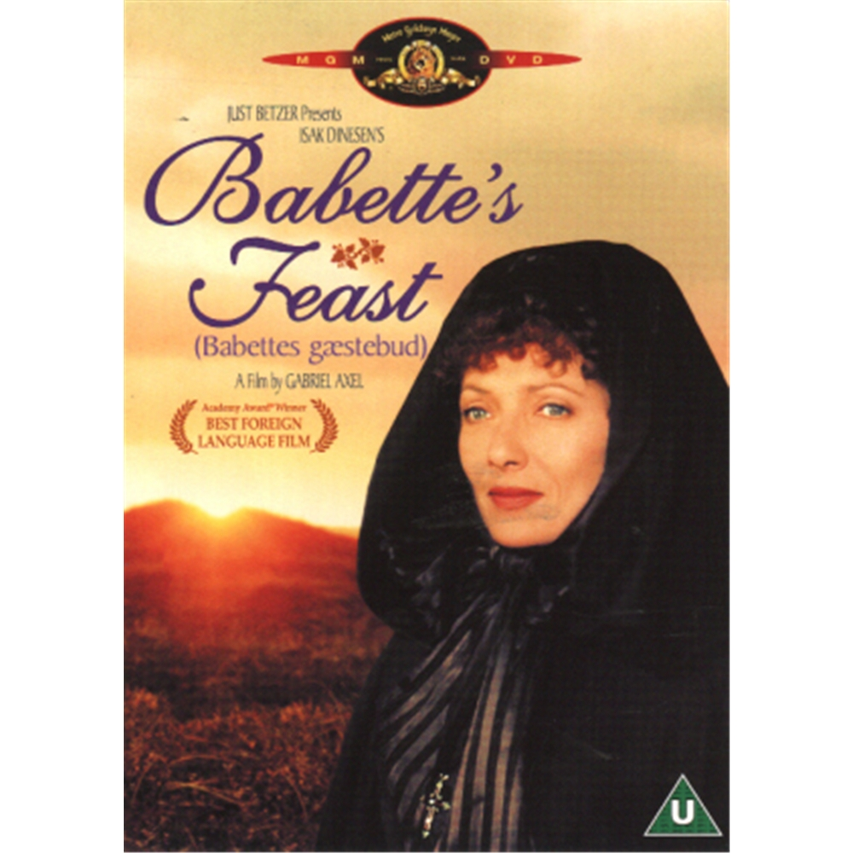
SUPPER AND MOVIE NIGHT!!
The Adult Education Committee will be presenting Supper and a Movie on January 18 at 6:30pm. We will begin with soup and breads prepared by the committee and we will conclude with potluck contributions of fancy desserts. Because the film will be Babette’s Feast, these dessert creations may be in continuity with out theme of French culinary arts. This Danish movie, which won an Academy Award for Best Foreign Language Film, is based on a short story by Isak Dinesen. The movie is spoken in French with English sub-titles. It is a literate and visually lovely film, which compels us to meditate upon the needs of the flesh, and the needs of the spirit. It is also about choices, talent, gratitude, friendship, grace, and hope.


Destinations for January
Destinations, our middle school youth group, will gather on Wednesday, January 21st. Interested in joining our parent email list? Contact Diana Drake at drakeink@aol.com or at 609-730-9037

Book Club Thursday, January 22, in library at 7:30 pm.
Now I See You: A Memoir by Nicole C. Kear about losing her sight. Told with humor and irreverence, Now I See You is an uplifting story about refusing to cower at life’s curveballs, about the power of love to triumph over fear. But, at its core, it’s a story about acceptance: facing the truths that just won't go away, and facing yourself, broken parts and all.


SAINT MATTHEW’S
ANNUAL PARISH MEETING
St. Matthew’s Annual Parish Meeting will be held on Sunday, January, 25th immediately following the 9 AM service (There will only be one service on this day). The Annual Meeting is the time when we come together to elect our leadership and to discuss the business of our congregation.

ALL parishioners are encouraged to attend. Child care will be provided.


TIME TO REGISTER FOR FALL CLASSES!

Open House will be held on Saturday, January 24th from 10AM-12:00 PM

St. Matthew’s Little Leisure will begin accepting enrollment applications on Monday, January 12th for the 2015 - 2016 school year. We accept children 18 months old through 5 years old.
Priority will be given to parishioners and currently enrolled families whose applications are received on/before Saturday, January 24th at 12 Noon. Enrollment packets will be available beginning the second week of January in the Church Narthex, Vestibule, and Little Leisure office. Packets can also be sent via email.
If you have any questions or would like to observe a class, please call Tammy Eng at (609) 737-6795, or email us at littleleisure@verizon.net .
Our Open House will be held on Saturday, January 24th from 10:00AM- 12:00 PM. Please join us to meet the teachers, visit the classrooms and learn more about our church nursery school program. Everyone is welcome! Please invite your friends and neighbors. We look forward to seeing you!

Snow date is on Saturday, January 31st from 10:00AM- 12:00 PM

GreenFaith Energy Conservation Workshop
We would like to cordially invite you to GreenFaith Energy Conservation Workshop on Saturday, January 17th in Trenton. Attendees learn how to save energy and green their facilities by changing human behaviors and making small, but powerful changes in their operations. These steps cost little or nothing, and are proven to lower energy costs by 10-20%. We'll also talk about energy efficient lighting, HVAC, and solar, and show how to finance these capital projects.
Agenda:
9:15-9:30 am Coffee and Light Breakfast

9:30-10:30 am: No-Cost and Low-Cost Energy Conservation Strategies for Houses of Worship
Fletcher Harper, Anne Rahikainen, GreenFaith
10:45 - 11:15 am: Saving and Greening with Solar Installation
Elvin Frost, Geoscape Solar
11:15 -11:45 am: How to Finance Energy Efficiency Upgrades with State Funding
Pete Hatton, Hutchinson Mechnical Services
Location: Episcopal Diocese of NJ Office, Matthews Room (behind Episcopal House), 808 West State Street, Trenton NJ 08618

RSVP - Anne Rahikainen, arahikainen@greenfaith.org by Monday, January 12, 2015


FAREWELL TO THE REV. PEGGY
Please join us on Sunday, February 1st following the 10am service for a special celebration to thank and say farewell to the Rev. Peggy Hodgkins, our interim rector these past 20 months. Peggy will begin a new ministry as the 25th Rector of Trinity Church in Southport, Connecticut starting Monday, February 16th. We all wish her well and know that the light she brought to us will be carried forward to those to whom she pastors in the future.

OUR SEARCH FOR A NEW RECTOR
Please direct all interested candidates and inquiries to:
Canon Cecelia Alvarez
Diocese of New Jersey
808 West State Street
Trenton, NJ 08618
calvarez@dioceseofnj.org


Women’s Conference February 6 @ 5 pm-9 pm & February 7 @ 9 am-5 pm: IF:Central Jersey, a local expression of the IF:Gathering (ifgathering.com), will be hosting a local gathering in Ewing, New Jersey on February 6&7. Join women from all over Central Jersey as they come together to hear a live simulcast of the IF:Gathering in Austin, Texas. Time together will include inspirational teaching and meaningful conversation. Registration information is available at bitly.com/centraljersey. Contact Brogann Sanderson Bowden with questions (brogannsanderson@gmail.com).
The theme for the weekend will be BELIEF. “And blessed is she who believed that there would be a fulfillment of what was spoken to her from the Lord.” Luke 1:45

Time and Talent

“St. Matthew’s is blessed with an active and capable group of lay leaders.” In this period of transition, we have leaned heavily on this group to fill roles previously handled by clergy, and to lead us in the thoughtful and deliberative process of finding our next Rector. These leaders are having a direct and positive impact on the St. Matthew’s Community.

We are asking that you consider sharing your time and talent with St. Matthew’s. Find out how meaningful and fun it can be to serve the Church in new ways. Please contact Joe Lawver (609-937-6177 or jlawver@yahoo.com) or your wardens, Kate Westbrook (Libbys_mom_2000@yahoo.com) and Tom DiMuzio (thomasdimuzio@hotmail.com) to explore how you your time and talents can best be used for St. Matthew’s. Thank you.

From the Episcopal Church:

Racial Reconciliation
"So if anyone is in Christ, there is a new creation: everything old has passed away; see, everything has become new! All this is from God, who reconciled us to himself through Christ, and has given us the ministry of reconciliation."(2 Corinthians 5:17-18)
"Q. What is the ministry of the laity?
"A. The ministry of lay persons is to represent Christ and his Church; to bear witness to him wherever they may be and, according to the gifts given them, to carry on Christ’s work of reconciliation in the world; and to take their place in the life, worship, and governance of the Church." (Book of Common Prayer, p. 855)
"Celebrant: Will you seek and serve Christ in all persons, loving your neighbor as yourself?"
"People: I will, with God’s help."
"Celebrant: Will you strive for justice and peace among all people, and respect the dignity of every human being."
"People: I will, with God’s help." (Baptismal Covenant, Book of Common Prayer, p. 305)
Reconciliation lies at the heart of what it means to be an Episcopalian; it is simultaneously that which we long for, and that which remains elusive. How do we define the “ministry of reconciliation” in our daily lives and ministries? Are there barriers that may impede our reconciliation with God and one another?
In the ministry of Racial Reconciliation, there are as many perspectives on what reconciliation looks like as there are Episcopalians. While we share the commitment to justice and equity proclaimed in our Baptismal Covenant, the heartfelt and legitimate differences between us can prevent our listening deeply to one another and seeing Christ in one another. Yet, in the face of these differences and challenges, Episcopalians throughout the Church are engaged in important ministries of reconciliation and healing, and are building loving, inclusive, and resilient communities in a diverse range of social, cultural, and political contexts. See episcopalchurch.org for more information.
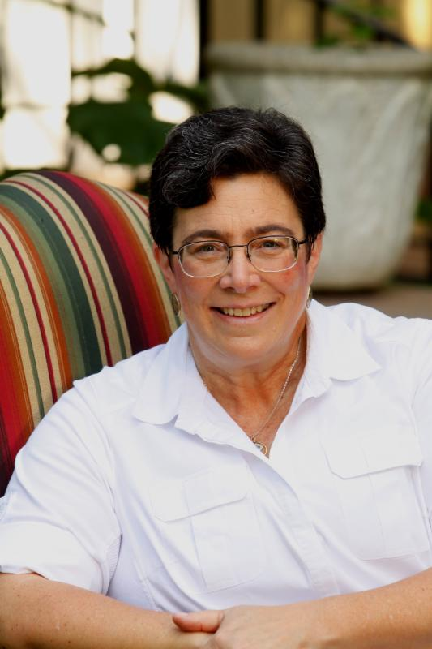
End-of-Year Financial News You Can Use

Christmastide Greetings!

As this year comes to a close, I want to share with you some valuable resources that provide essential advice and assistance regarding your congregations' financial matters--the below items contain up-to-date and easy-to-absorb information on a variety of topics.

Episcopal Church Foundation's (ECF's) Top 10 Vestry Resolutions for 2015--the gift that keeps on giving - PLEASE READ:
http://www.ecfvp.org/posts/top-10-resolutions-for-church-leaders-in-2015/

Compiled from questions asked by people just like you, I can only say "AMEN" not only to the contents of the list but also to the priority order in which it's ranked and the resources to which it links. My only addition for those of you who haven't already, to be added at the top of the list, would be--subscribe to ECF Vital Posts NOW: http://www.ecfvp.org/account/register

Planned Giving: have you heard about Planned Giving on demand?http://www.episcopalfoundation.org/programs/planned-giving/pg-on-demand-info

How about the IRA Charitable Rollover gift option, especially valuable for those over 70.5 years of age who are required to take minimum distributions? http://www.episcopalfoundation.org/about/news/26/notice-ira-charitable-rollover-available

Or making gifts of appreciated securities? http://www.episcopalfoundation.org/about/news/22/boost-giving-with-appreciated-securities
What else might we be able to help you with? Contact the Diocesan Planned Giving committee through the Finance Office.
If you have any questions about the above items, please feel free to contact me.
All of us at Diocesan House wish you continued joy and love this Christmas season. We look forward to seeing you and working together in the New Year.

Faithfully Yours in Christ,
Canon Phyllis B. Jones,
Chief Financial Officer
Episcopal Diocese of New Jersey
808 West State Street
Trenton, NJ 08618
pjones@dioceseofnj.org
Phone: 609.394.5281 x31

Chili/Hoagie Fundraiser
for Summer Mission Trip

January 25 and February 1, 2015

El Hogar in Tegucigalpa, Honduras – July 11-18, 2015

Urban Promise in Camden, NJ – July 26-31, 2015

Sign up for chili, hoagies or both. You can pick up chili only on January 25 or both chili and hoagies on February 1 before or after the 10am church service!

Name _________________________________

Item | Quantity
Con Carne Chili (1 quart containers)
$ 10.00 per container
Vegetarian Chili (1 quart containers)
$ 10.00 per container
Italian Hoagie (Italian Cheese, Ham, Salami, Lettuce, Tomato)
$ 8.00 each 6” Sandwich
Turkey Hoagie (Swiss Cheese, Turkey, Lettuce, Tomato)
$ 8.00 each 6” Sandwich
Total | $

Turn in this form early (by Jan 16) so we know how many to make, and pay when you pick up on January 25 or Feb 1.
Look for the collection box in the Narthex!

