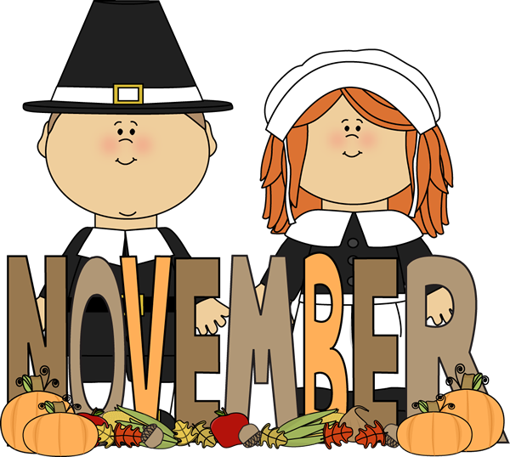
St. Matthew’s Messenger
NOVEMBER 2013
St. Matthew’s Episcopal Church, Pennington, N.J. 08534

To receive the monthly Messenger and Constant Contact announcements via email, please contact Lynn Lorenz at admin@justmultiples.com.

The Church is open for prayer and meditation during parish office hours on weekdays:
Monday, Wednesday, Thursday from 9am-4pm and Tuesdays and Fridays till 12noon.

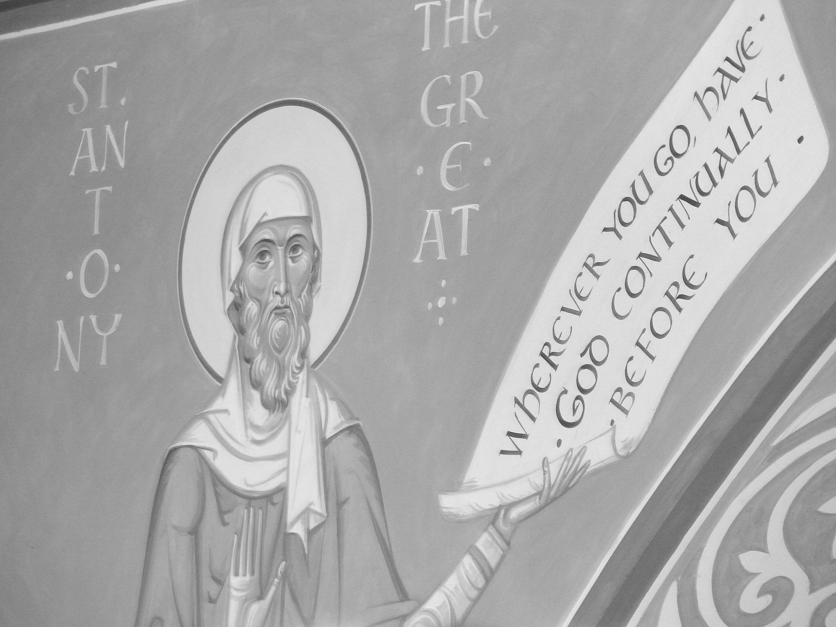
Celebrate the Consecration
of
the XII Bishop of New Jersey
The Rev. Canon William (Chip) Stokes will be consecrated as our new Bishop on Saturday, November 2nd at 11am, at Trinity Cathedral, 808 W. State Street,
Trenton, NJ. You must register: www.newjersey.anglican.org

AN INVITATION FOR you!
Asset Mapping and Pizza Lunch
Dear Friends,

Come out and take part in planning the future of St. Matthew’s!!
I hope to see you on November 3rd at our festive All Saints Sunday service at 10am, followed by a parish-wide pizza lunch at 11:30 with a special presentation. All are welcome!

You will hear a summary of our survey results by warden, Kate Westbrook and a special program offered by our gifted consultant, the Rev. Dr. Bud Holland. His article below will give you a preview of our program, especially designed to show us how we can build on our strengths during this interim year.

A pizza lunch and beverages will be provided, and parishioners are asked to make a free-will offering toward lunch. RSVP to stmatthewspizzalunch@gmail or use the sign-up sheets, so that we know how many people to expect – and how many pizzas to order!

Yours faithfully,

Peggy Hodgkins+

The Rev. Margaret Hodgkins
Interim Rector
WHAT IS ASSET MAPPING?
by the Rev. Dr. Bud Holland, Transition Consultant

Asset mapping seeks to embrace possibilities of engaging in mission from the perspectives of identifying and utilizing assets that we and others bring to the work. Using asset mapping does not negate the need from time to time for solving problems using other methodologies. The value of asset mapping is that it focuses on the interests, energies, and gifts that we bring which heightens our ability to embrace life and work in deep and sustaining ways. In addition, asset mapping helps in identification of new work and directions that looking at issues from only a problem solving perspective may miss. Another benefit is that asset mapping helps individuals and groups recognize and celebrate giftedness in ways that honor our understanding of ourselves in relationship to our baptismal covenant and that keep us from getting stuck.

We have assets from many sources. In our baptismal covenant we are sealed by the Holy Spirit in baptism and marked as Christ’s own forever. Our greatest asset is that we are known, loved, forgiven, and empowered for mission and ministry by God. St. Paul stated in the Book of Romans “nothing can separate us from the love of God”. In our baptismal covenant we are reminded that we are connected not only with God but also with one another and with the stranger with whom we are about to meet. We sense these realities not only in the promises of the covenant but also in the peace that we exchange at the time of the Holy Eucharist. When we exchange peace we realize three important things: we don’t gather at the table by ourselves but with others (our journeys are inextricable connected with others’ journeys); the Eucharist isn’t just what I can get out of the Eucharist but also what the Eucharist can do through me to be for others (we are dismissed to go into the world); and the most important work we have to do in life is to share and receive the peace of Christ (a work done in many ways).

So we have a most significant asset in God’s work of reconciliation, love, peace-making, justice, mercy, and forgiveness. Our mission and ministry is in response to this most incredible gift that has been given to us and to the world. We also have other assets and gifts some of which we hold in common with others and some of which are unique to each one of us. Using asset mapping we can not only identify and celebrate these gifts with intention but also can realize the value of who we are and what we can do, thereby being good stewards of the gifts with which God has entrusted us. In the process we can also realize our connectedness with others and in that realization know that we are not so alone.

Do we know our value as human beings, much less as active ministers of God’s grace and love? We are often tempted to start at “gifts discernment” only or to just see the gifts that we are interested in as serving only the local congregation. It is helpful to have gifts discernment and identification of assets in the context of a hospitable and loving community where people can have the opportunity to get connected with their intrinsic self worth and where the opportunities of exploration are not bound by an identifiable need to fix a problem in the community

I remember in the many ways I was engaged in team sports that individual gifts and assets were identified in ways that not only helped them do their particular job on the team-- but also in ways that complemented the abilities of others on the team-- so that the team’s gifts were even greater than the sum total of the gifts of individuals on the team!

One of the ways that we have learned not to recruit teachers for church school is to say that we need someone to help with 4th grade. Do we need someone (anyone?), or do we need to recruit someone with the interest, personal attributes, and abilities to connect with young people in the 4th grade so that those students will have the best and healthiest experience possible.

It is helpful for the community to be involved in the discernment of another’s gifts and assets because sometimes persons have an unrealistic understanding of their gifts. Yet who would not opt for a teacher of 4th grade students who has a real interest in them as persons, and brings special gifts/assets to their interaction with them. So asset mapping in these and other ways are already known to us. The opportunity here is to understand asset mapping from yet another vantage point and potential usefulness to individuals, congregations, and communities. How does it work? It involves the exploration of possibilities of engaging in our common life and work from another point of view.

The key question for Asset Mapping: “Where have I seen evidence of God’s grace lately?”

+ + +

PASTORAL LETTER FROM OUR BISHOPS
Parishioners will have the opportunity to discuss this letter at our upcoming cottage meetings.—Rev. Peggy

October 21, 2013

Dear Brothers and Sisters in Christ:

Grace to you and peace in the name our Lord Jesus Christ.

This past Friday, The New Jersey Supreme Court ruled that same-sex marriages can proceed in the State of New Jersey beginning Monday, October 21. We have both publicly stated our clear support of this right for same-sex couples and rejoice at the court's decision. Many same-sex couples have longed to have their relationships afforded the same civil rights and privileges as heterosexual couples. It is also true that many same-sex couples long to be married in the Church and to have the sacramental nature of their relationship acknowledged and blessed by, and within, the Church. Equally, many clergy have a strong desire to respond to the pastoral and sacramental needs of same-sex couples committed to their charge by performing same-sex marriages. We are writing to clarify the implications of the State Supreme Court's ruling and to provide provisional guidance for the clergy of the Diocese of New Jersey.

In 2012, General Convention adopted an amended resolution (A049) titled "Authorize Liturgical Resources for Blessing Same-Gender Relationships." Below is a link to the final legislation:
http://www.generalconvention.org/resolutions/download/115-1342125335

As a result of this legislation, I Will Bless You and You Will Be a Blessing: Resources for the Witnessing and Blessing of a Lifelong Covenant in a Same-Sex Relationship was released for the Church's use by The Standing Commission on Liturgy and Music. This resource addresses various theological, pastoral and canonical concerns and issues and also includes liturgical resources for blessing rites. Follow the link below to order this resource where you can also find a free PDF of the liturgy licensed for congregational use:
https://www.churchpublishing.org/products/index.cfm?fuseaction=productDetail&productID=9743

During the House of Bishops' consideration of the question of A-049 at the 2012 General Convention in Indianapolis, the question was asked if the resolve that read, "That bishops, particularly those in dioceses within civil jurisdictions where same-sex marriage, civil unions, or domestic partnerships are legal, may provide generous pastoral response to meet the needs of members of this Church" could be interpreted to mean that clergy in jurisdictions that allow civil marriage of same-gender couples, were permitted to officiate at those services? The Chairperson for the Special Committee answered that yes, that was what they had had in mind. No amendment was offered. Resolution A049 passed by a nearly 2/3 majority (See The Right Reverend Mark Sisk, Letter to the Clergy of the Diocese of New York - July 19, 2012 at http://archive.constantcontact.com/fs039/1102067254998/archive/1110523536861.html).

- We, therefore, concur that "generous pastoral response" in the Diocese and State of New Jersey in light of the State Supreme Court's decision allows clergy, who so desire, to officiate at the marriages of same-sex couples. Consequently, if a cleric of the Diocese of New Jersey feels moved by conviction and pastoral need to respond affirmatively to a request to perform a same-sex marriage, he or she has our permission to do so on or after October 21, 2013 under the following guidelines: Clergy will provide the same pastoral care and counseling to same-sex couples leading up to the ceremony that they would provide heterosexual couples. They will also have the same standards and expectations for participation in the life and worship of the congregation that they have of heterosexual couples. At least one of the parties shall have been baptized.
- Clergy will inform the leadership of the congregation that the blessing of same-sex marriages is to be a part of the ministry of the congregation; and seek their support.
- A priest needs to pronounce the blessing; a deacon may participate.
- Clergy should use the common liturgy for same-sex blessings approved at the 2012 General Convention and found in I Will Bless You and You Will Be a Blessing: Resources for the Witnessing and Blessing of a Lifelong Covenant in a Same-Sex Relationship. Please note: The marriage liturgy from the Book of Common Prayer is not authorized for use with same-sex couples.
- Clergy are permitted to sign civil marriage licenses and/or to have a state official (e.g., Justice of the Peace, Judge) do so, while the clergy person presides at the liturgical blessing. Clergy are not required to officiate at any wedding, or blessing service, whether it is a same-sex couple or an opposite-sex couple.
- If a clergy person is approached by a same-sex couple who desire to be married or receive a blessing in the church and that clergy person is unable to support them based on theological grounds or grounds of conscience, we direct that the clergy person refer that couple to a colleague who can in good conscience support them.
- If a clergy person chooses to sign civil marriage licenses, the clergy person

Faithfully yours In Christ,

The Right Reverend George E. Councell, D.D., The Reverend Canon William H. Stokes,
Bishop of New Jersey Bishop-elect of New Jersey


WARDENS CORNER

Transition Update by Tom DiMuzio and Kate Westbrook

Now that we have collected over 100 surveys, we will begin to analyze the results and kick off the next phase of the transition.

On November 3rd., we will hear from Bud Holland our Transition Consultant regarding Asset Mapping. This will be an exploration of the many assets of St. Matthews to include our history, buildings, spirituality, programs and all other aspects of life at St. Matthews.
This will officially start our “Building a Profile” stage of the transition.
We will host a number of “cottage meetings” to listen and document what the Congregation has to say, as we prepare for the next 5-10 years at St. Matthew’s.

A leader of the Profile Team will be selected and will oversee the steps of that process along with a team of people tasked with fulfilling all of the requirements associated with building that profile.

This stage will take us into early 2014, as we prepare this document in anticipation of then turning it over to the Diocese for their review and approval before starting the Search phase of the Transition.


Property Work Day
Nov. 2nd, Saturday morning from 9:00 AM – 1:00 PM
There are many small jobs that are not covered by our cleaning crew or our outside contractors because of the added expense. Parishioners can help defray the cost of maintaining our building by sharing our time and talents.

Help for an hour, two hours, or more, but definitely come and enjoy the fun and fellowship of working together. Bring your favorite scrub brush, hammer and screwdrivers, or paintbrush!
If you have any questions, please contact Scott Watterson at (609) 818-0918.


LOGOs-- teen events for November:
- Sunday, Nov. 3, 4 - 6pm, Belmont Hall, Part I - Anti - Racism Program with Phyllis Jones (dinner will be provided).
- Sunday, Nov. 17, 4 - 6pm, Belmont Hall, Part II - Anti - Racism Program with Phyllis Jones (dinner will be provided).
- Sunday, Nov. 24 - LOGOs sponsored coffee hour immediately following the 10am service
- Sunday, Dec. 1, 4 - 6pm, Belmont Hall - Holiday Baking, Liturgy Prep, and Singing practice (for our upcoming holiday caroling) (No meal provided)
- Sunday, Dec. 15, (time TBD), LOGOs Holiday Party and Caroling

Please join us for any or all of these exciting events!
For any questions, please contact, Mrs. Kim Hansen, kbhansen@yahoo.com.
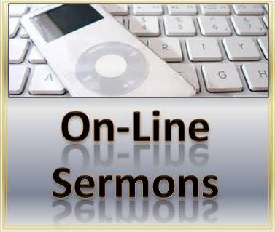
SERMON LINKS
Oct. 13 - El Hogar mission trip sermons at St. Matthew’s, Pennington by high school students Christina Lederer at http://wp.me/p3CTP6-4b and Tom Sherman http://wp.me/p3CTP6-46

Oct. 22 – Rev. Peggy Hodgkins’s sermon for the Ordination to the Diaconate service at St. George’s, Rumson is posted at www.stgeorgesrumson.org/go/downloads

Oct. 27 – Rev. Joanne Epply-Schmidt’s sermon on Prison Ministry at St. Matthew’s, Pennington will be posted soon on our parish website: www.stmatthewspennington.org

Adults Who Work With Youth
Round Table Discussion
With
Bishop Elect Chip Stokes
Date: Thursday, November 7, 2013
Time: 6:30 – 9:00 PM Place: Diocesan House
808 West State Street, Trenton, NJ 08618
Who: Any adult who work or volunteer with youth, parents and clergy.
*Dinner will be served*
R.S.V.P.: By Monday, November 4, 2013 to The Rev. Canon Debi Clarke
609-394-5281 ext. 36 or dclarke@newjersey.anglican.org



Anti-Racism Conference-
No More in My Church

Race-based Inequities in the Health Care System in Access,
Treatment and Outcomes

When: Saturday, November 16, 2013 from 9:30 am to 3:00 pm
Where: Trinity Cathedral, Trenton

Early registration will be $10, registration on the day of the event will be $15. This price will include lunch. Register through www.newjersey.anglican.org.


CONFIRMATION CLASS BEGINS IN NOVEMBER!
For 8th-12th grades, if you desire to be confirmed in your baptismal vows by the Bishop on March 16, 2014, please contact the Rev. Peggy Hodgkins or Ms. Claire Cannon to sign up, or to answer your questions: peggyhodgkins@gmail.com or call 609-737-0985.

Parents' Information Meeting - Tuesday, Nov. 12 at 6:30 p.m.
First Class starts - Tuesday Nov. 19 at 6:30 p.m. and includes dinner!
INQUIRERS CLASS for adults wishing to be confirmed by the Bishop or received into the Episcopal Church. Starts in late Jan. or early Feb. 2014.
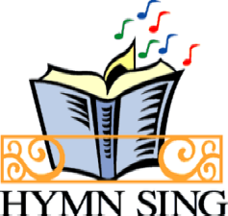
HYMN SING AND POTLUCK NOVEMBER 17 AT 5PM "Join Music Director, Rory and enthusiastic parishioners for a fun hymn sing! Choose your favorites and much loved tunes in an evening of music and fellowship. We will have a potluck supper afterwards. Questions? Contact Nora Sirbaugh, sirbaugh.nora@gmail.com or Rory McCorkle, rorymccorkle@verizon.net. Come and make a joyful noise to the Lord!"


St. Matthew’s Book Club is open to all interested readers and meets monthly in the church library. Our reading selections offer a way to explore books through fellowship and discussion and are led by a different parishioner each month. Our discussions have been thought provoking and enlightening. Contact Holly Weise (609-737-1064) for more information or suggestions.
November 21 - 7:30 pm (library) The Burgess Boys by Elizabeth Strout - Hotshot lawyer Jim and big-hearted Bob Burgess come together over a prank perpetrated by their sister’s son and discover that their distrust of each other has never really gone away. But then, neither has their love. “Reading an Elizabeth Strout novel is like peering into your neighbor’s windows. . . . There is a nuanced tension in the novel, evoked by beautiful and detailed writing. Strout’s manifestations of envy, pride, guilt, selflessness, bigotry and love are subtle and spot-on.”—Minneapolis Star Tribune

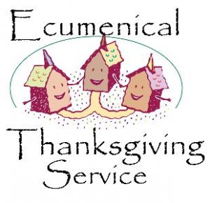
THANKSGIVING SERVICE
We will join our brothers and sisters in Christ at the Pennington Presbyterian Church for the annual Ecumenical Thanksgiving Service at 7pm on Wednesday, November 27th.

Please note:St. Matthew’s will not be having its own Thanksgiving Day service this year.

Parish Life Guild NEWS
The Parish Life Guild wants to thank everyone who worked on the Rummage Sale and congratulate chairs Betsy Slover and Karlie Lorenz. We are thrilled to celebrate the amazing efforts of everyone involved in making the sale such a success once again.

We are also looking forward to the Christmas Bazaar. We will be hosting a Bazaar night on 11/16 at 7pm to help prepare for the bazaar. There will be crafting, cooking, conversation, and fellowship. We will provide light refreshments and wine (so leave the kids at home!).

At our meeting on October 14, we also considered proposed changes to the bylaws of the PLG and discussed strategies to improve parish involvement in outreach. Our next meeting, which is open to all, will be held at 7:30 on Monday, November 11 in the library.

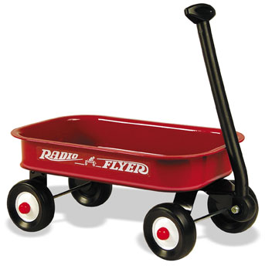
RED WAGON SUNDAYS
The first Sunday of each month, there will be a red wagon in the Narthex to collect non-perishable food items for the Crisis Ministry of Princeton and Trenton. These items will be presented during the Offertory along with the bread and wine as part of our sacred act of thanksgiving to God.

There continues to be a crisis of hunger in our communities and the food banks, soup kitchens, etc. continue to have an increased demand for the basic staples that families need to survive in this current economy. With the increase in need these facilities are having great difficulty providing those in need with non-perishable food items to keep their families fed.

Wondering what kinds of food to give? Items for a Thanksgiving Dinner, canned goods, or check the lists in the Narthex.


Coat Drive for HomeFront
The Webelos of Pack 44 are collecting gently used winter coats and gear for HomeFront. Coats, hats, gloves and mittens for children and adults will be collected until November 15th. Please place your donations in the brightly wrapped box labeled Webelos Coat Drive in the foyer next to the coat room. Thank you for your support and if you have any questions, please call Joe or Rowland Lawver at 609-818-9522.

Kairos Korner

On November 17th, all of our classes will come together to make children’s meal bags for the Trenton Area Soup Kitchen. Our goal is to make 300 children’s meal bags but to do this we need your help! We will be collecting items through November 10th. Please see the “Kairos Outreach 2013” announcement below for detailed information on donations.

Kairos Calendar
November 3: Lessons on the Saints in honor of All Saint’s Sunday (Daylight Saving Time Ends)
November 10: Lessons (Last Sunday for Outreach donations!)
November 17: Group Outreach Project
November 24: Thanksgiving weekend, regular classes

Kairos Outreach 2013
Each year our Kairos classes come together for an outreach project giving them the opportunity to think about those in our community who need our help. On Sunday, November 17th, we will be making children’s meal bags for the Trenton Area Soup Kitchen. To make this effort possible we need your help! Through November 10th, we will be collecting the following food items:

- Chef Boyardee SINGLE SERVING microwavable containers of ravioli, spaghetti, lasagna, mac n’ cheese – hot meals please!
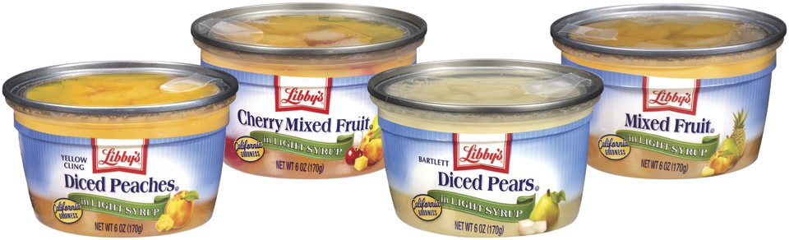
- SINGLE SERVING fruit cups


- SINGLE SERVING desserts (pudding, cookies, fruit roll ups)
- 100% juice boxes (6.75oz please not the tiny ones)

All items must be in SINGLE SERVING containers and not in need of any kind of preparation aside from microwaving. Juice must be 100% juice in 6.75oz containers.

If you prefer, a monetary donation can be made and we will do the shopping for you! Please give your check or cash to either Lori Cooper.

The collection bin, labeled “KAIROS OUTREACH PROJECT”, is located in the foyer next to the coat room. Thank you in advance for your generosity!

St. Matthew’s Children’s Christmas Eve Play
Straighten those angel wings and dust off the shepherd’s staff! It’s time to prepare for the Children’s Christmas Eve Play, “The Story of Christmas”.

Youth ages 3 and up are encouraged to participate. Parents, we need your involvement as well for “crowd control” (the sheep tend to wander), costume fittings, rehearsal snacks etc. All sign-up sheets are posted on the Kairos bulletin board.

November 3-17: Sign-up
December 1: Scripts distributed, costume fittings

REHEARSAL SCHEDULE
December 8: Rehearsal for SPEAKING ROLES ONLY
December 15: Rehearsal for ALL ROLES
December 22: Rehearsal for ALL ROLES, Props/Lighting and Music
December 24: Rehearsal at 1:30pm for ALL ROLES, Props/Lighting and Music.
Play is presented at 3pm

- Rehearsals follow the 10am service unless otherwise noted.
- A snack and beverage are provided.
- Play rehearsal ends at 12:30pm
- Christmas Eve rehearsal includes one rehearsal without costumes, snack and then dress rehearsal. The play will be presented at 3pm.

Any questions or comments? Contact Kelly Rick (coolscience101@hotmail.com)

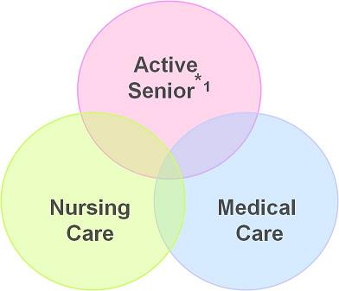
November 10th Adult Education Series
The Retirement Years: Being a proactive person as you age
Join parishioners, Colleen Bell, RN, MSN, Nurse Practitioner and Mary Kay Krokowski, RN, MSN, Elder Care Specialist, as they talk about being proactive in your retirement years. Both of these professionals have decades of experience in working with the elder population.

Topics covered will include education about preventative health care, being smart about your advanced planning and what resources are available to your within your community. As well as end of life care and the new POLST form, recently made legal in New Jersey.

Please come with questions. This is open to the entire community. Bring your friends to this informative program!


St. Matthew's 2nd Annual Bazaar Night will be held Saturday, November 16 at 7:00PM. Come cook and craft your way to a evening of fun and fellowship all the while helping prepare for the Christmas Bazaar. Lite fare and adult beverages will be served. (no childcare).


Destinations for November
Destinations, our middle school youth group, will gather on Wednesday, November 20 at 6pm in Parish Hall for our monthly meeting. Interested in joining our parent email list? Contact Diana Drake at drakeink@aol.com or at 609-730-9037.

CHRISTMAS WREATHS AND POINSETTIAS

PRE-ORDER FORM

Fresh Green Christmas Wreaths / Poinsettias

Pick-up at our Christmas Bazaar on December 7th

or after Services on the following Sunday

Place completed Pre-Order Forms in the box labeled “Christmas Wreaths and Flowers Orders” in the Narthex as soon as possible!


No payment due until you pick up your order

WREATHS

Wreaths will cost $14.00 each, pre-ordered. Some additional ones will be available at the Bazaar for $17.00. Your advance order will help us plan ahead.

Name: ______________________________________ Number of wreaths:____

Phone Number: ________________________


Christmas Plants

Plants  Poinsettias: | Price (per plant) | Quantity | Color (circle choice)
4 ½” Pot (3 – 4 blooms) | $5.00 |  | Red
6 ½” Pot (5+ blooms) | $7.00 |  | Red, Pink or Marble
7” Pot (10+ blooms) | $13.00 |  | Red, White, Pink or Marble
8” Pot (15+ blooms) | $18.00 |  | Red
10” Pot (18+ blooms) | $25.00 |  | Red or White
Others:  6” Amaryllis | $8.00 |  | Red
6” Cyclamen | $8.00 |  | Assorted – Preference: _____

Name: ____________________________________ Phone Number: ______________
If you have a special request or if you are seeking a large order, please contact Diane Zompa (609-737-0645) and she will do her best to help!

THANK YOU FOR YOUR ORDER!

St. Matthew’s Annual Christmas Bazaar
Saturday, December 7th, 2013
10:00 am - 4:00 pm

Bazaar Set-up: Sunday, Nov. 24rd, After 10:00am service
Bazaar: Saturday, Dec. 7th, 10am-4 pm
Bazaar Takedown: Saturday, Dec. 7th, after 4pm (classrooms)
Sunday, Dec. 8th, 12:30 pm (Belmont Hall)

General Bazaar questions should be directed to the Bazaar Chair – Becky Morrison at BeckyMorrison44@hotmail.com

Workshop: The PLG is Proud to Sponsor the 2nd Annual "Bazaar Night!" on November 16th at 7pm.

Bazaar set up: We welcome all who are available to stay after the 10am service on November 24th to help with setup. There will not be coffee hour that day. Any questions, please contact Ginny Buchanan @ vbuchanan@lawrenceville.org.

Frozen Casseroles and Soups: These items are big sellers each year! We are looking for delicious family friendly casseroles and soups that freeze well to be donated to the Bazaar. If you have a favorite recipe, consider doubling it and donating one batch. We have suggested recipes we can share with you as well. Any questions, please contact Becky Morrison at BeckyMorrison44@hotmail.com

Calling all bakers!!: We really need your delectable delights for the baked goods table - Cookies, cakes, candies, jams, and chutneys. These are some of the most requested specialties at St. Matthew's Christmas Bazaar. Please email Cheryl Watterson at Cheryl.watterson@verizon.net and let her know what you’ll be bringing so we can be prepared.

Cookies: Who doesn’t love a home baked cookie? Why not whip up a batch of your favorites for the bazaar. Drop off cookies in the parish kitchen from Thursday, December 5th until Friday December 6th at 4pm.

Other Baked Goods: It wouldn’t be a bazaar without yummy brownies, cakes and pies! Please donate your best baked goods to the bazaar. Items can be dropped off on Friday, Dec 6th until 6pm or Saturday, Dec 7th before 9am.

Also… donations of containers for cookies, cakes, etc are accepted. Please place in the coat closet, clearly marked.

Sweet Table: We are looking for bakers that love sweets! Fudge, Pralines, Ribbon Candy , etc…We will package and label for you. Just provide the name and ingredients and we'll take of the rest. Please contact Amanda Morrison 609-737-9391 or Amanda_morrison@ml.com if you can help with the Sweet Table!

Oh Give Me A (New) Home for the Holidays: Please consider donating your new and gently used holiday items to the Bazaar – a great money maker for the Church, and a nice way to find a new home for those unused items in your attic or garage. Please contact Debbie Linthorst at dlinthorst@comcast.net with questions and instructions for donation.

The Antique Table: We need antiques and collectables for this popular table. Check your cupboards and drawers for anything you may be able to "live without" that others would love to live with. Please contact Penny Rodgers with any questions - dennypenny@verizon.net

Secret Santa Room: This is a great place for the younger members of St Matthew's to shop on their own for family gifts. Donations of new or gently used (typically inexpensive) items are accepted – think of gift shop items – stationery, lotions and soaps, candles, picture frames, you name it. Donations can be place in the box placed in the coatroom. Please contact Becky Morrison with any questions – beckymorrison44@hotmail.com

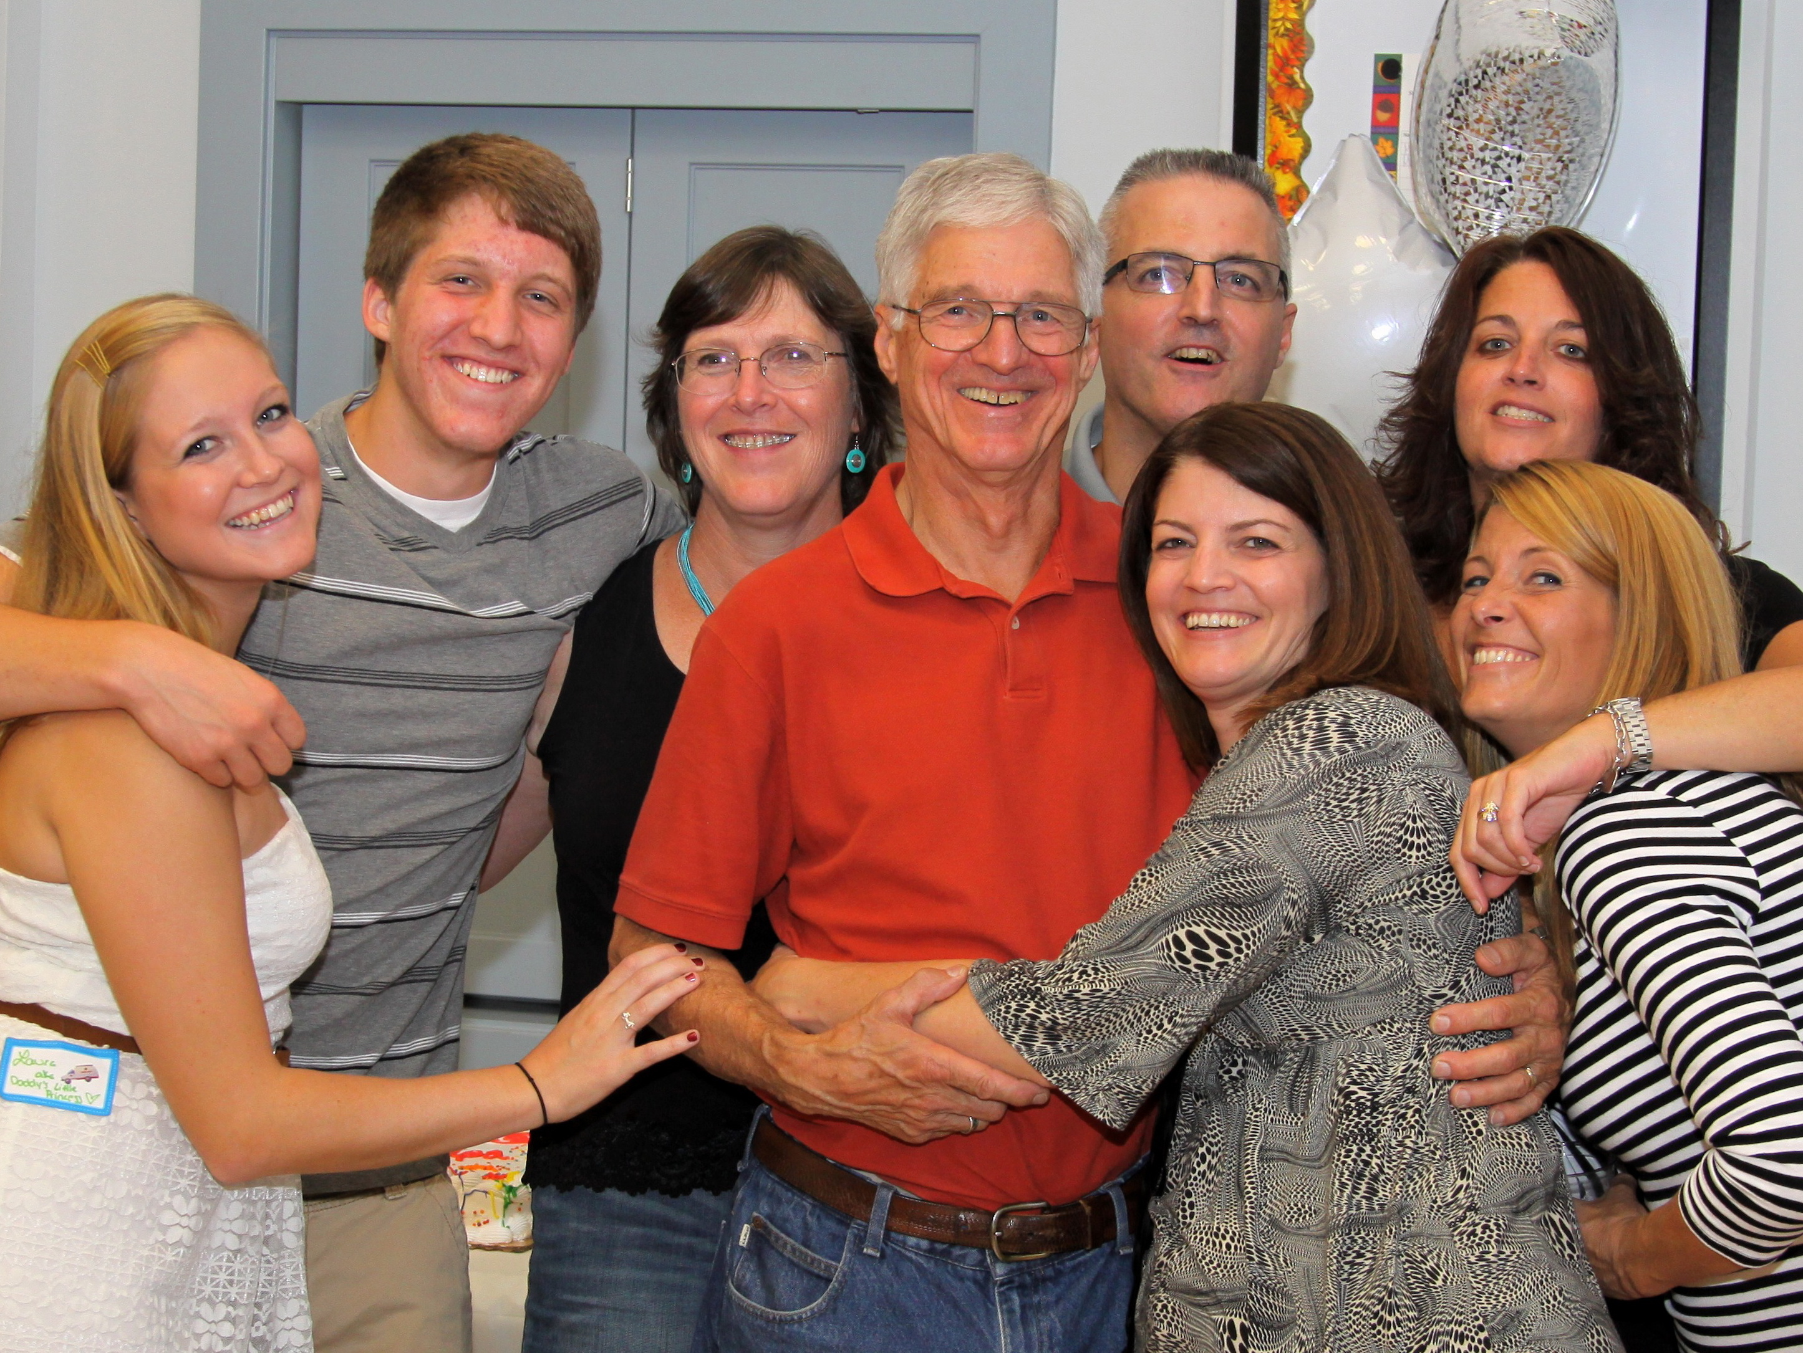

GETTING TO KNOW YOU

The Eckel Family

Just about twenty-three years ago, two wonderful things happened at St. Matthew’s; John and Amy Eckel tied the knot, and the church welcomed two of the most delightful and devoted newcomers to the parish. The newlyweds chose St. Matthew’s due to its location and great feeling of community, inclusion, and warmth.
John was born in Jersey City, New Jersey and spent much of his early childhood traveling with his parents while his father was in the service. The family settled down in Stirling, New Jersey where John grew up. After graduating from high school, John joined the U.S. Air Force. While stationed in Colorado and New Jersey, he became a nuclear weapons technician and also trained to become a pilot. Later, John attended Mercer County Community College and went on to work for Western Electric/Bell Labs. John also flew for U.S. Air Express for seven years before becoming a stay at home dad.
Amy was born in Lexington, North Carolina and grew up in Chapel Hill, New Bern, and Raleigh. She received her B.S. and Ph.D. in Chemical Engineering from North Carolina State University, along with a Masters degree in Supply Chain Management from Arizona State University. In 1982, after graduate school, Amy moved to New Jersey to work as a chemical engineer for Bell Labs. John and Amy met while working for the company in their Engineering Research Center in Hopewell. Amy continues to work for the same company, which is now known as Alcatel-Lucent. She currently specializes in Supply Chain Management and works virtually, on a more-than-full-time basis, out of her home. She seems to enjoy the short commute, but can do without the long workdays!
The Eckel’s are blessed to have a large family. They have a daughter, Laura (21), and a son, Mike (18), as well as Bruce (47), Kathy (46), Cindy (45) and Christine (43) from John’s first marriage. They also have seven grandchildren: Todd (22), David (21), Felecia (17), Erika (22), Taylor (17), Christiana (18) and Nick (11). If that wasn’t enough, they also have a pet dog named Mocha!
John and Amy’s daughter, Laura, is now a senior at the University of North Carolina, Greensboro, and Mike just became a freshman at the University of Puget Sound in Tacoma, WA. Both were active members of Destinations and LOGOS. Additionally, they served as acolytes, were involved in church mission trips to Honduras and Camden, and were on the SAG (Safety and Gear) team for the Battle Against Hunger.
Over the years, John and Amy have dedicated an extraordinary amount of their time and talent to St. Matthew’s, and for this we are truly grateful. Amy is currently treasurer and has been for the past twelve years! She has also served on the Vestry, was Warden for two terms, and also helped to jump-start Destinations. In addition, she was lay reader for six years, has chaired the Christmas bazaar, and rode six times for the Battle Against Hunger. Along with her church activities, she is also a board member of the Hopewell Karoka Alliance and is now riding for Anchor House, just to name a few.
John’s St. Matthew’s resume is equally impressive. He has been the church recording clerk for the past twelve years and has led the St. Matthew’s volunteer team at TASK (Trenton Area Soup Kitchen) for the past ten years. He is also a three-time Battle Against Hunger rider and was twice a member of the SAG team. John has been on a mission trip to Honduras and most recently, a mission trip to Urban Promise, Camden. A few years back, John also led a coalition of Pennington churches (and TPS) in building a home for a needy family in Trenton through Habitat for Humanity. At one point, he was also involved with the Boy Scouts of America.
In addition to their passion for giving to St. Matthew’s, John and Amy enjoy traveling, hiking, biking, and photography. John also enjoys flying, motorcycling, and corn tossing (yes, corn tossing!) with fellow parishioner, Denny Rodgers. Amy’s other pastimes include gardening and exercise.
We can only hope and pray that John and Amy’s children will someday tie the knot at St. Matthews. Oh, the possibilities!



