
St. Matthew’s Messenger
OCTOBER 2013
St. Matthew’s Episcopal Church, Pennington, N.J. 08534

PLEASE NOTE: If you wish to receive the monthly Messenger and Constant Contact announcements via email, please contact Lynn Lorenz at admin@justmultiples.com.

The Church is Open for prayer and meditation during parish office hours on weekdays: Monday, Wednesday, Thursday from 9am-4pm and Tuesdays and Fridays till 12noon.
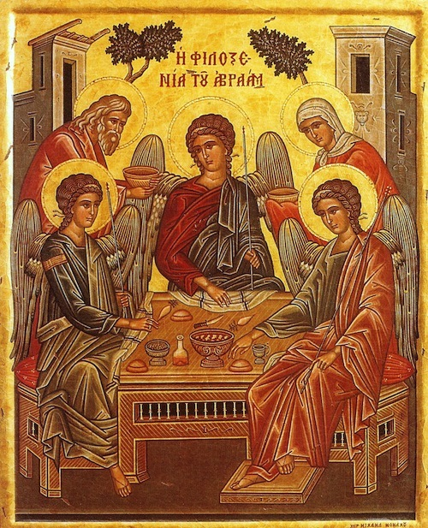

Do not neglect to show hospitality to strangers, for by doing that some have entertained angels without knowing it. (Hebrews 13.1-2)

Dear Friends,

One Halloween long ago, one of our children had a costume all picked out…but no one to go trick-or-treating with her brother had his friends, and her sister had her pals, but somehow she was left out. As the parents, we offered to go out with her, but that idea fell flat. Suddenly, a friend called who invited my child to join her daughter’s group. Off they went to ring doorbells, and my daughter forgot all about her sadness. That is the power of invitation.

I too have felt the power of invitation. Since arriving at St. Matthew’s in the summer, I have been moved by the generous hospitality you have shown me as your new interim rector. You have shared your stories and your rich experiences. Not only have you welcomed me and my family warmly, you have also welcomed many other new families who have arrived recently.

The idea of “invitation” is central to our faith. God invites us into a relationship with the divine. The relationship goes two ways between the Creator and the created. In a new stained glass window by artist Alan Davies at Hexham Abbey in England, the theme of hospitality is shown by God’s helping hand reaching down from the cosmos to engage with hands reaching up.

Isn’t it true that often a warm welcome can spawn another warm welcome, and on and on? Most people come to church for the first time because someone invited them. Could we become intentional about leaving our comfort zones to invite a friend to church? We would be offering that person something wonderful, something that we value deeply—namely, a loving faith community. That is the power of invitation.

As we consider the assets of our parish this month in cottage meetings and through our parish survey, we might note what a strong aptitude we have for opening our church doors to newcomers in the community.

Faithfully,

Peggy+

The Rev. Margaret Hodgkins



WARDEN’S CORNER
Our transition journey has begun and we are starting to gather the information needed to create our Parish Profile¹. Our first step is the survey that was sent out electronically earlier this week, and is also available in hardcopy form in the Narthex and in Belmont Hall. Its purpose is to evaluate parishioners’ impressions of St. Matthew’s at this point in time. This will not be your only opportunity to share your thoughts, ideas etc.
Our intention is to use the results of this survey as discussion points in several small group cottage meetings we will offer in October and November. We also have a parish event on November 3rd to discuss our assets. Finally, for those who prefer, we will offer the opportunity to share thoughts with us in writing.
Our goal is to have every parishioner (adults, teens and kids) participate in creating our Parish Profile by sharing their history and hopes for the future. Teens participating in LOGOS will have the opportunity to complete this questionnaire at their next gathering.
Beginning later this year or early 2014 a Profile Committee will take all the information gathered through questionnaires, cottage meetings, asset mapping and other means and begin creating our Profile.
If you have any questions please feel free to speak to either of the wardens or a member of the vestry.
¹The Parish Profile is an assessment of a parish, its history, and its desired future. The Profile is the first documentation that potential candidates see about the parish. It will include such things as a mission statement, goals for the future, congregational and diocesan history, programs, worship style, housing arrangements, financial information and demographics.


Blessing of the Animals
In celebration of the Feast of St. Francis, please join us for a Blessing of the Animals on the front porch of the church following the 10:00 a.m. service on Sunday, October 6th. Whether your pet waits for you or you need to run home to fetch it, we hope you can bring your special creature of God to Church for a blessing that morning.


GUEST PREACHERS
Sunday, October 27 - The Rev. Joanne Epply-Schmidt, Former Associate Rector at St. Matthew’s
Sunday, November 24 – The Rev. Greg Bezilla, Chaplain at Rutgers University

Destinations for October
Destinations, our middle school youth group, will gather Wednesday, October 16th at 6p.m. in the Belmont Hall for our regular monthly meeting. Questions? Contact Diane Drake at drakeink@aol.com.


Are you called to serve as a leader in the Diocese of NJ? Please consider whether you would like to be nominated for election for such ministry as the Standing Committee, Diocesan Council, Cathedral Chapter, Standing Commission on Clerical Compensation, Trustees of the Diocesan Trust Fund, Finance and Budget Committee, the Audit Committee, the Disciplinary Board, and more. Please see Rev. Peggy Hodgkins for further information, or email her at peggyhodgkins@gmail.com.

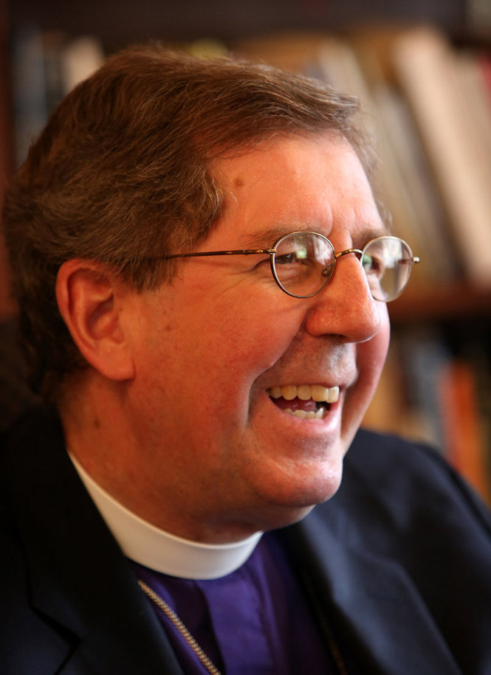
You're invited to a
Celebration of the Holy Eucharist
in thanksgiving for the ministry of

The Right Reverend George E. Councell
Eleventh Bishop of New Jersey
Sunday, October the thirteenth
Three o'clock in the afternoon
Trinity Cathedral
801 West State Street
Trenton, New Jersey
Reception to follow in Synod Hall
There are three ways to register:
Online: tinyurl.com/lnpcqdg
Email Sarah Paige: spaige@newjersey.anglican.org
Telephone: 609 394-5281 ext. 10

A RETIREMENT GIFT
The Bishop Councell UrbanPromise Fund

In lieu of gifts, all may honor the ministries of Bishop George Councell and his wife Ruth Councell by making a donation to a fund designated by them to advance the StreetLeaders program of UrbanPromise in Camden and Trenton: "Bishop Councell Fund for UrbanPromise StreetLeader Ministries."

Please make your check payable to the Diocese of New Jersey, include "Bishop Councell UrbanPromise Fund" on the memo, and mail to:

Canon Phyllis Jones
Chief Financial Officer
Diocesan House
808 West State St.
Trenton, NJ 08618-5326

For more information about UrbanPromise or about the Bishop Councell UrbanPromise Fund, please contact Canon Phyllis Jones pjones@newjersey.anglican.org or 609-394-5281 x31.

Your donation is tax deductible.


St. Matthew’s Church
Fall Rummage Sale - October 4th -5th, 2013
(Proceeds from the sale benefit Outreach Projects and Church Education Programs)

Your Help is needed with any and all details of the sale!

Pre-Sale Set up: Saturday, September 28th. Set up tables and racks, store church items to protect them, and move rummage items from storage.

Pre-Sale Sorting/Organizing Schedule: Monday-Thursday 9:00am – 5:00pm, and Mon., Tues., and Wed. evening 6-9pm. Fold and place casual clothes on tables, hang-up coats/dresses, organize the linens, electronics, toys, children’s books, housewares or front porch items.

Presale prices to be approved by a chairperson. There will be several new volunteer options this year in addition to sorting and pricing. Check the bulletin in the coming weeks for more details.

Sale Hours: Friday October 4th – 9:00am – 5:00pm
Friday Evening – $10.00/ Bag Sale – 6:00pm – 8:00pm
Saturday October 5th – $5.00/bag sale – 9:00am – 12noon

Donations: Please only items in good condition ready for sale – clothing should not be soiled or have holes. Electronics in good working order, gently used toys, linens, house-wares, etc. should all be in good resale condition. No analog TVs will be accepted this year.

By law, No – Medical supplies, propane tanks, oil containers, flammables, or tires.

We no longer accept: Adult books or any cassette tapes.
**Larger furniture items or cribs need to be approved by a chairperson. We are also willing to post a picture of larger items.

Donations Drop Off: Sunday – after church, Monday–Wednesday, 9:00am – 5:00pm. Put them in Parish Hall if you are unable to sort them. If leaving items at night, place them on the Church porch or in the Parish Hall (Sun.–Wed. only).

Post Sale Take-down: Saturday, October 5th from 11:45am-1:45pm. Bag left over items for the Rescue Mission and take them to the street. Put the Church back the way it was found.

Our Co-chairs will be Betsy Slover and Karlie Lorenz. If you would like be a co-chair with Betsy and Karlie you can contact Betsy. Questions? Contact Betsy Slover at (609) 433-7043.

Kairos Korner
Teacher Appreciation Brunch
Our wonderful Kairos teachers and staff play a vital role in the life and future of the church and in the lives of the children of St. Matthew’s. On October 20th we will honor them with an Appreciation Brunch following the 10am service. Whether you have a child or grandchild in the Kairos program or would simply like to express your gratitude for what our teachers and staff do, please sign-up to bring a dish for the brunch. You will find sign-up sheets posted on the Kairos bulletin board in the hallway leading to the classrooms. Thank you in advance for your support!


Kairos Outreach 2013
Each year our Kairos classes come together for an outreach project giving them the opportunity to think about those in our community who need our help. On Sunday, November 17th, we will be decorating and assembling children’s meal bags for the Trenton Area Soup Kitchen. To make this effort possible, we need your help! Sunday, October 13th through November 10th , we will be collecting the following food items:
- Chef Boyardee single serving microwavable containers of ravioli, spaghetti, lasagna, mac n’ cheese – hot meals please!
- Single serving fruit cups
- Single serving desserts (pudding, cookies, fruit roll ups)
- 100% juice boxes (6.75oz please not the tiny ones)

All items must be in SINGLE SERVING containers and not in need of any kind of preparation aside from microwaving. Juice must be 100% juice in 6.75oz containers.

If you prefer, a monetary donation can be made and we will do the shopping for you! Please give your check or cash to either Lori Cooper or Pastor Peggy.

Collection bins labeled “KAIROS OUTREACH PROJECT” will be located in the foyer next to the coat room beginning October 13th. Thank you in advance for your generosity!

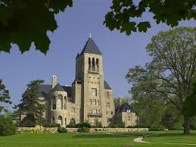
visit Glencairn Museum – sign-up in september
Adult Ed is organizing a field trip on October 12th at 1pm to the Glencairn Museum in Bryn Athen, PA--a suburb of Philadelphia. Glencairn Museum presents religious life through the ages by means of a remarkable collection that illustrates religions as varied as ancient Egyptian, ancient Greek and Roman, medieval Christian, Islamic, Asian, and American Indian. In the weeks preceding the trip, we will have a sign-up outside Belmont Hall beginning in September. Plan on spending a day with fellow church members to visit this lovely museum. If you think you might be interested, visit http://www.glencairnmuseum.org/ and watch the museum's short film "Embracing the Sacred" on their website. Hope you can join us. Watch for notices in the bulletin.

Like to Cook? Join a Logos Cook Team!

We're looking for people to help prepare meals for our high school youth group's Sunday evening gatherings. You don't need to have a teen in the group; you don't need to do everything yourself. We can even offer suggestions for meals! Sign up as an individual or with a group by contacting Kim Hansen at kbhansen@yahoo.com. We are currently looking for cooks for the following dates, Nov. 3 and 17.

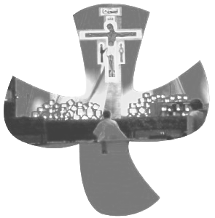
Taizé at St. Matthew’s Returns
Looking for worship that is simple, ecumenical, quiet and contemplative?
Welcome to Taizé.
Our 5 pm Taizé service will resume in the Chapel on Sunday, October 6. This service will be held on the 1st Sunday of each month during the 2013 – 2014 school year. Most Sundays, Eucharist will be offered as part of the service. Taizé worship is quiet and personal, with a focus on prayer, silence, and meditative singing. If you have any questions about the service, please speak to Rev. Peggy or Rory, Director of Music.
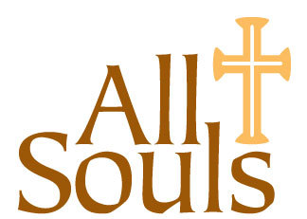
All Souls Eucharist
Sunday, October 27 at 5:00pm
“We do not live to ourselves, and we do not die to ourselves. If we live, we live to the Lord, and if we die, we die to the Lord; so then, whether we live or whether we die, we are the Lord’s.” - Romans 14:8

Please join us on the Sunday before the Feast of All Souls as we hold up our loved ones who have died to the light of God’s grace and to the hope of eternal life promised us in Christ. This year, St. Matthew’s choir will be joined by soloists from Westminster Choir College to present portions of the Requiem composed by Marc Antoine Charpentier.

All will be given a chance to write the names of deceased loved ones in a “Book of Names” as they arrive. You may bring pictures or other small remembrances as well. We’ll then place them in front of the altar and read the names aloud during the service, offering them up to the One to whom we all belong - in life and death, and in life beyond death.

After the service, we cordially invite all to a potluck supper in the Parish Hall. Please bring something for the table and join in fellowship after our time of worship.

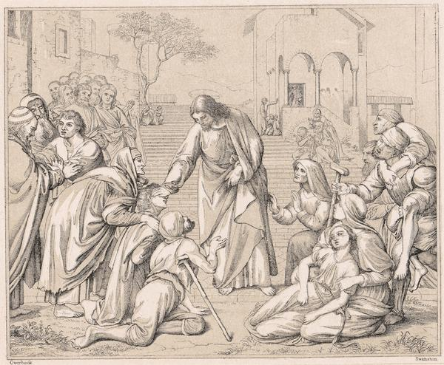
The “Messianic Secret” in the Gospel of Mark

In Mark’s Gospel Jesus numerously refers to the “secret” nature of his mission. Why does this occur? What does this tell us about Mark’s intended audience? How does it enhance our understanding of the Gospel’s place in the New Testament canon? Join parishioner and adult education facilitator John Eory in the Chapel to discuss this unique and fascinating topic at 9:00 a.m. on October 27. No preparation is necessary.


St. Matthew’s Book Club is open to all interested readers and meets monthly in the church library. Our reading selections offer a way to explore books through fellowship and discussion and are led by a different parishioner each month. Our discussions have been thought provoking and enlightening. Contact Holly Weise (609-737-1064) for more information or suggestions.
October 17 – 7:30 pm (library) Hotel on the Corner of Bitter and Sweet by Jamie Ford “This impressive, bitter, and sweet debut novel explores the age-old conflicts between father and son, the beauty and sadness of what happened to Japanese Americans in the Seattle area during World War II.” - Lisa See Jamie Ford will be the guest speaker at the Hopewell Valley Book Lovers’ luncheon on October 27, 2013 at Green Acres Country Club.
November 21 - 7:30 pm (library) The Burgess Boys by Elizabeth Strout - Hotshot lawyer Jim and big-hearted Bob Burgess come together over a prank perpetrated by their sister’s son and discover that their distrust of each other has never really gone away. But then, neither has their love. “Reading an Elizabeth Strout novel is like peering into your neighbor’s windows. . . . There is a nuanced tension in the novel, evoked by beautiful and detailed writing. Strout’s manifestations of envy, pride, guilt, selflessness, bigotry and love are subtle and spot-on.”—Minneapolis Star Tribune


St. Matthew's 2nd Annual Bazaar Night will be held Saturday, November 16 at 6:30 PM. Come cook and craft your way to a evening of fun and fellowship all the while helping prepare for the Christmas Bazaar. Like fare and adult beverages will be served.


Save the date!
Property Work Day
Saturday morning – October 26th
9:00 AM – 1:00 PM

There are many small jobs that are not covered by our cleaning crew or our outside contractors because of the added expense. This is where we, as parishioners, can help defray the cost of maintaining our building by sharing our time and talents.

Help for an hour, two hours, or more, but come and enjoy the fun and fellowship of working together. Bring your favorite scrub brush, hammer and screwdrivers, or paintbrush!

If you have any questions, please feel free to contact Scott Watterson at (609) 818-0918.

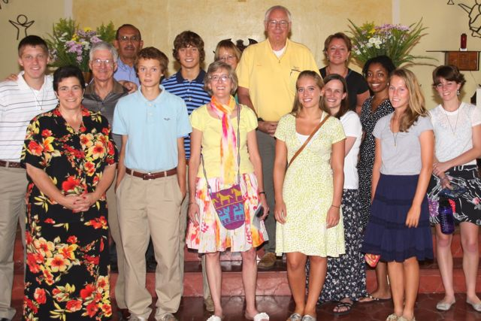
El Hogar Update!
On Sunday, October 13 at both services – we will have a special presentation from Team El Hogar IV. Come learn about the mission team’s experience this past summer in Tegucigalpa, Honduras. Hear and see what our mission team did, and how you can help maintain the connection until our next mission trip. In between services, we will have a potluck brunch, a panel discussion with team members available to answer your questions, share additional stories and pictures.

El Hogar Reflection from Katie Seitz
It is difficult to put into words the things you see and experience while at El Hogar for a week. So many wonderful memories and experiences pop into my mind when I look back on my two trips to El Hogar. When I tell people that I went to Honduras this summer many people are confused as to why I would go there. My response to them, is why would I not? Prior to going to Honduras in 2011, that would not have been my response to that question. I had no idea what was in store for me at El Hogar and whether or not it was going to be worth the long trip, if I wasn’t even sure if I was going to make an impact.

Now having been to El Hogar two times, I can say that spending time with the children and staff of El Hogar is truly an eye opening and rewarding experience. The children are so loving and appreciate your presence at all times. It’s the little things you do that the children appreciate you the most for. A simple greeting will brighten their day. These kids come complete poverty and have such a positive attitude about the people and world around them. Their stories inspire me and fuel me to achieve my future goals as well. This is also the reason why others and myself continue to go back to El Hogar, year after year. The children inspire us and the relationships we form with them continue to develop over time with each journey back to Honduras. I cannot wait to return to El Hogar and I encourage others to consider experiencing what El Hogar and Honduras has to offer despite some fears and anxieties many people may have.

The Diocese of New Jersey
The Consecration of our Twelfth Bishop

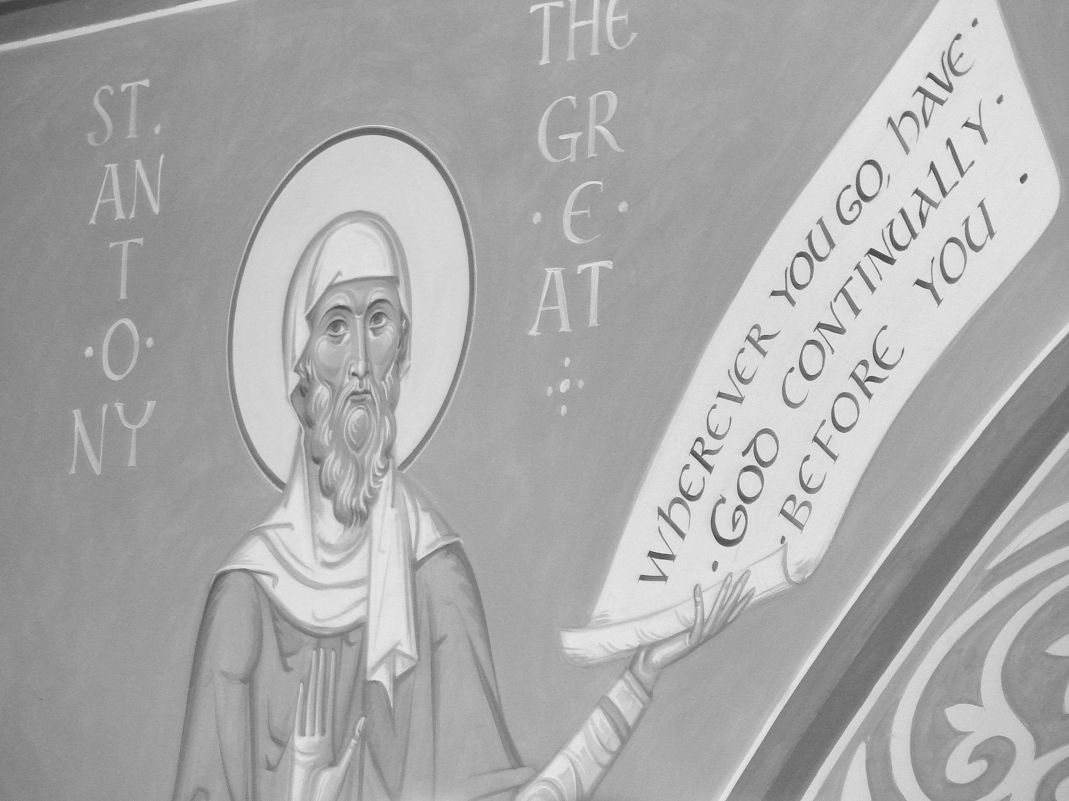
Dear Members of the Diocese of New Jersey:

The ordination and consecration of the Rev. Canon William H. Stokes as the Twelfth Bishop of New Jersey is scheduled for:
Saturday, November 2, 2013
11:00 a.m.
Trinity Cathedral in Trenton

ALL must register to attend the consecration: http://tinyurl.com/l2wtvsp or contact spaige@newjersey.anglican.org.

Parking: There will be no parking in the lot of Trinity Cathedral or on W. State St. All parking will be in remote parking lots protected by security officers. A continuous shuttle service will transport you from the parking lots to Trinity Cathedral from 9 a.m. - 4 p.m.

Handicapped parking is available only at Trenton Central High School West Campus at the corner of West State Street and Parkside Avenue. A shuttle bus will operate from 9 a.m. to 4 p.m.
Directions to Handicapped Parking Lot: Trenton Central High School West Campus, 1001 W. State St., Trenton, NJ http://tinyurl.com/khg9hpg

All other parking is located at the Department of Labor Parking-John Fitch Plaza, Trenton, New Jersey 08625: From Route 29 North and South, Exit Memorial Drive. Proceed through the light and continue to stop sign. Turn left and lot is on your right.

Carpooling is encouraged. Please plan to arrive early to allow time to park, ride the shuttle.

Offertory Collection: Bishop-Elect Stokes has requested that the offering at the Holy Eucharist be designated jointly for Hurricane Sandy Relief and to advance the mission of UrbanPromise of Camden and Trenton. A plate collection will be taken in the worship, and collection baskets will be available at the Reception. Checks may be made payable to the Diocese of New Jersey and include in the memo "Collection Offering."

Childcare will be available in the Cathedral under the supervision of staff from UrbanPromise. Please indicate childcare if needed while completing registration.

Reception 1-3 p.m: A splendid reception will commence immediately after the consecration. Shuttle bus to the parking lots will continue to operate until 4 p.m.

