
St. Matthew’s Messenger
May 2013

St. Matthew’s Episcopal Church
Pennington, NJ 08534

PLEASE NOTE: If you wish to receive the monthly Messenger and Constant Contact announcements via email, please contact Lynn Lorenz at admin@justmultiples.com.

CALENDAR OF EVENTS
Friday 3 7:00pm, Beer and Wine Tasting Adult Social Event
Friday 10-11 9:00am, Rummage Sale
Saturday 11-12 Plant Sale Fundraiser
Sunday 12 5:00pm, Final Taize Service
Wednesday 15 6:00pm, Destinations
Sunday 19 10:00am, Special Pentecost Celebration “Wear Red”
5:00pm, Final Logos Meeting
7:00pm, “The Long and Winding Road”; One Artist’s Journey in Faith
(led by Ruth Councell)
Wednesday 22 7:00pm, Christmas Bazaar Meeting
Thursday 23 7:30pm, Book Club Meeting (library)


Save the Date – May 3 from 7pm-9pm
Beer and Wine Tasting Adult Social Event at St. Matthew's!
The PLG invites you to an entertaining evening of wine tasting with our very own expert, Amy Vester, on Friday, May 3rd from 7pm – 9pm in the Parish Hall. The suggested donation is $10 per person. We will provide finger foods. Feel free to invite some friends. Come learn more about pairing your meals with your wines and beers.

Sign-up sheets will be available after both the 8am and 10am services starting today. Please make sure to sign up ahead of time so we have enough finger foods, wine and beer available. There will not be childcare available. This is an ADULT only event.

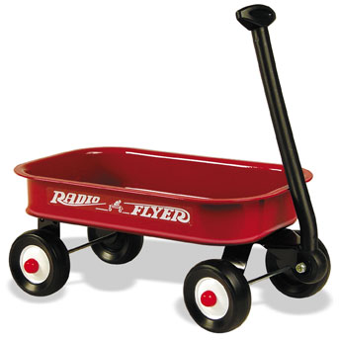
RED WAGON SUNDAYS
The first Sunday of each month, there will be a red wagon in the Narthex to collect non-perishable food items for the Crisis Ministry of Princeton and Trenton. These items will be presented during the Offertory along with the bread and wine as part of our sacred act of thanksgiving to God.

Wondering what kinds of food to give? Lists are available in the Narthex.


THE WARDEN’S CORNER
Transition

The process of selecting an interim rector is moving along in partnership with the diocese and the faithful assistance of our Interview Committee and vestry. We anticipate having the process complete and making an announcement within the next few weeks via Constant Contact, the church website and Sunday bulletin. Thank you for your continued support during this time of transition.

Tom DiMuzio and Kate Westbrook, Wardens
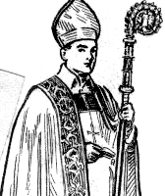
Search for the 12th Bishop of New Jersey
As we hope you are all aware, Bishop Councell will be retiring in October, 2013. After a year of discernment, the Election Committee has presented a slate of six nominees for the position of 12th Bishop of New Jersey. Additionally, through an independent nomination process, three other individuals have been presented as candidates.

An Electing Convention will take place at Trinity Cathedral in Trenton on Saturday, May 4th. The representatives from St. Matthew’s who will attend this convention and vote for the 12th Bishop are Father Jack and the three lay delegates elected at St. Matthew’s 2013 Annual Meeting. They are:
Tom DiMuzio, Debbie Linthorst, and Kate Westbrook.

Detailed information on the nine candidates as well as the Electing Convention process can be found at: http://www.bishopsearchnj.org/ . Candidates will be available on several dates in April to meet with diocesan clergy, staff, convention delegates and other interested parties. Information on these “walk-abouts” can be found on the bishop search link.
Please feel free to speak with any of the St. Matthew’s delegates to share your opinions about any of these candidates or if you have any questions.


Destinations for May
Destinations, our middle school youth group, will gather Wednesday, May 15th . Questions? Contact Diane Drake at drakeink@aol.com.

Kairos Korner

Sunday, May 19th is Pentecost! Fifty days after Easter, Pentecost is the day on which the Holy Spirit came to the apostles in the rush of a mighty wind and came to rest as tongues of fire upon their heads. The liturgical color for Pentecost is red to remind us of the flames of the Holy Spirit. We encourage everyone to wear red on the 19th! We have something fun and festive planned for the 10am service as well as a special reception to follow in Parish Hall. We hope you will join us!

Our Kairos church school year will come to an end on Sunday, June 2nd. This will be the last Sunday of classes as we break for the summer as well as a day of appreciation for our wonderful teachers and staff. The End of the Year Media Presentation will be shared at both the 8am and 10am services, highlighting our fantastic teachers, children and special moments from the 2012-2013 Kairos year.


"The Long and Winding Road: One Artist's Journey in Faith"
Sunday, May 19th at 7pm
Illustrated with slides of her own, and of other artists' work, Ruth Councell takes us on a walk down her own yellow-brick road, sharing her ever-changing, ever-challenging life as an artist and as a woman of faith.

We will begin at 7 pm with coffee and dessert at 6:30 pm.
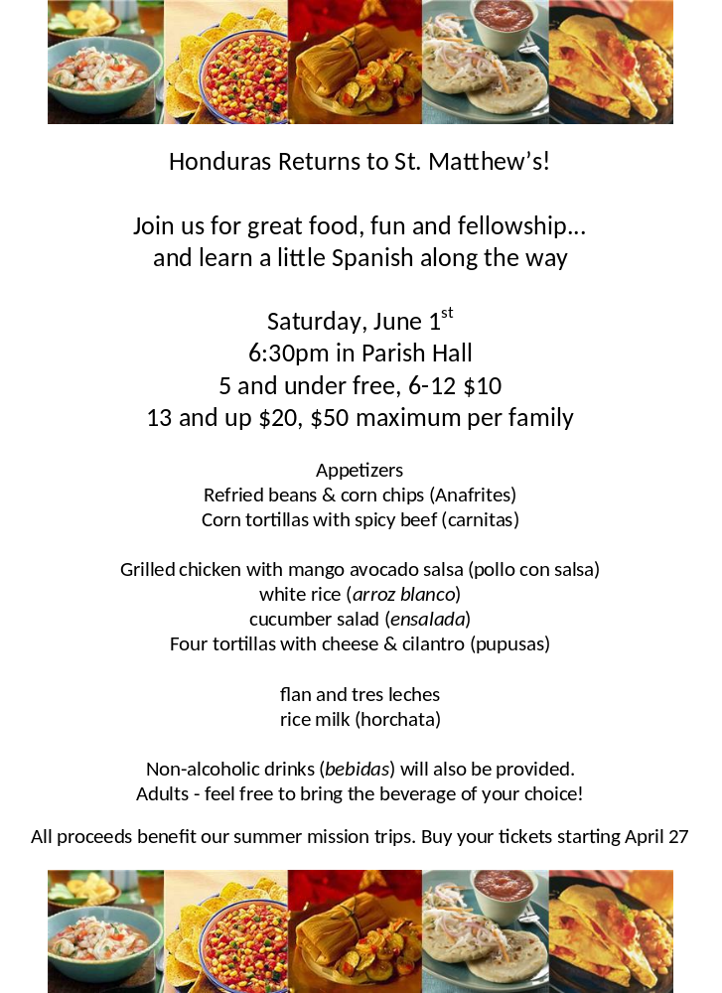



St. Matthew’s
Spring Rummage Sale
May 10 and 11

(Proceeds from the sale benefit Outreach Projects and Church Education Programs)

Sale Hours: Friday, May 10- Sale - 9:00am-5:00pm;
Friday Evening, May 10 - $10 / Bag Sale, 6:00pm-8:00pm
Saturday, May 11 - $5 / Bag Sale - 9:00am-Noon.

Your help is needed with any & all details of the sale!

Pre-Sale Set-up: Saturday, May 4th. Set up tables and racks, store church items to protect them, and move rummage items from storage.

NEW Pre-Sale Prep: Sunday, May 5th, 12noon – 5pm: Many of our parishioners don’t have time to help sort during the week so we will start to sort on Sunday following church services. We can start sorting adult and children’s clothes by sizes and display them on tables and racks. Please join us to help organize and price donations.

Pre-Sale Sorting / Organizing Prep during the week: Monday -Wednesday 9:00-5:00, and Mon.-Wed. evening from 6pm-9pm. Sort adult cloths by sizes and display on tables and racks. Help organize and price donations.

Donations: Please only items without stains or holes, toys and electronics in working order,
Baskets, crafts, linens (please mark linens with sizes). Jewelry, shoes, purses, etc. We will accept children’s books ONLY.

NOTE: This year we are limiting housewares to “Nearly New” items and items suitable as small gifts. No large sets of dishes or glassware, NO plastic containers or coffee mugs.

By law we can't sell: Medical supplies, children’s car seats, cribs, propane tanks, oil containers, flammables, or tires.

We no longer accept: Cassette tapes, CD’s, no analog TV’s.
No large furniture items, unless approved by a chairperson.

Photographs of larger items can be placed on the easel in the Foyer with all contact information. We are unable to pick these items up.

Donation Drop Off: Sunday after church, Mon.-Wed. 9:00am-5:00pm. Put them in Parish Hall if you are unable to sort them. If leaving items at night, place them on the Church porch or in Parish Hall (only Sun.-Wed.)

Post Sale Take Down: Saturday, May 11, 11:45am -1:45pm. Bag left-over items for the Rescue Mission & Viet Nam Vets & take them to the street. Put the church back the way it was found.

See April and May bulletins for information about new volunteer opportunities. Questions? Contact Betsy Slover: 609-433-7043.


A Few Words About St. Matthew’s Christmas Bazaar:

Bazaar Organizational Meeting – Wednesday, May 22 at 7PM (Parish Hall)
Please join us as we kick off the planning for another St. Matthew’s Christmas Bazaar. Plans are well underway, and WE NEED YOU – whether you’ve been involved for many years, or have never even attended a St. Matthew’s Bazaar – ALL ARE WELCOME and your input is greatly appreciated. The Bazaar is St. Matthew’s biggest fundraiser of the year; but perhaps more importantly, it puts St. Matthew’s on the map. There are not many parishes in this area that hold a traditional Christmas Bazaar anymore, at least not on this scale and level of participation. The Bazaar has been a Pennington tradition for over 40 years. The event encourages non-parishioners to visit our community and, as such, serves as a spiritual/evangelical event that ushers in the Christmas season.

The Bazaar Organizational Committee
A new committee structure has been put in place with the hopes that no one will feel overburdened and so that Bazaar planning can truly be an activity filled with fellowship and FUN. Committee involvement will involve a limited, specific set of tasks which may include, but are not necessarily limited to the following:
- Attendance at the Bazaar on Saturday, December 7 from 10:00-4:00
(for at least for a portion of the day)
- Attending a meeting or two between now and the big day
- Most tasks can be completed from the comfort of your own home; encourage a friend or two to join you and make it a social event!
Examples of areas in which help is needed are as follows:
- Collecting donations for sale or use at the event
- PR/Advertising for the event
- Table chair/vendors registration/participation
- Assisting with Bazaar pre-sales in the weeks leading up to the event
- Decorating for the event; gathering decorations, putting up the tree, etc.
- Logistics – Bazaar set up, maintaining floor plan for event

Bazaar Tables/Groups
The Bazaar is comprised of various themed tables and vendors. Almost all tables at the Bazaar are run by groups formed within our St. Matthew’s community; most dedicate 100% of their proceeds back to the Church (minus some expenses). These funds are then donated to charitable organizations and causes supported by the Parish Life Guild - such as Little Leisure Nursery School and El Hogar ministries. They are also dedicated to St. Matthew’s operating budget and are earmarked for Christian Education purposes within the parish. About one quarter of the Bazaar tables are run by outside vendors; some vendors are required to give a predetermined percentage of their proceeds to the Church, while others are non-profit organizations from within our community who keep their proceeds for their charitable causes (e.g., the Battle Against Hunger, Trenton Area Soup Kitchen, Seeds to Sew, etc.)
You might consider serving as a Table Chairperson. This does not have to be an overwhelming task; it may involve overseeing the activities of those who work in the group, organizing meetings of the group or just facilitating communication amongst the group to make sure that everyone is up to speed. And again, many of the table-related tasks can be completed from your home or at a Church workshop, if needed. Past Bazaar Tables (Groups) have included: Antiques, Baked Goods, Frozen Meals and Soups, Gourmet Items, Hostess Gifts, the “Just Foods Café,” Needle Creations, Pictures with Santa, Plants, Quilt Raffle, Secret Santa, Craft Tables, Sweet Shop, Teen Room, Sewing Group, and Wreaths.
As you can see, there are so many ways to get involved with the Bazaar. We have so many talented, generous people in our Church family – and we need “all elves on deck” to make this event a success. It cannot be done without YOU! You are encouraged to participate in any of the ways mentioned above or to bring your own ideas and suggestions to the table – they are ALWAYS WELCOME!
So please mark down Wednesday, May 22 on your calendars for our Christmas Bazaar Organizational Meeting. 7PM in Parish Hall – wine and other beverages and snacks to be served. Any questions, please contact Debbie Linthorst, Bazaar Trustee, at dlinthorst@comcast.net or (609) 730-9480. Thank you.
NURSERY SCHOOL REGISTRATION CONTINUES
ST. MATTHEW’S LITTLE LEISURE
(Our church sponsored nursery school)

It’s fun to play with other children…
be creative with paint, glue & playdough…
read stories and sing songs…
run, climb, slide & dig in the sand outside…
and oh, so-o much more!
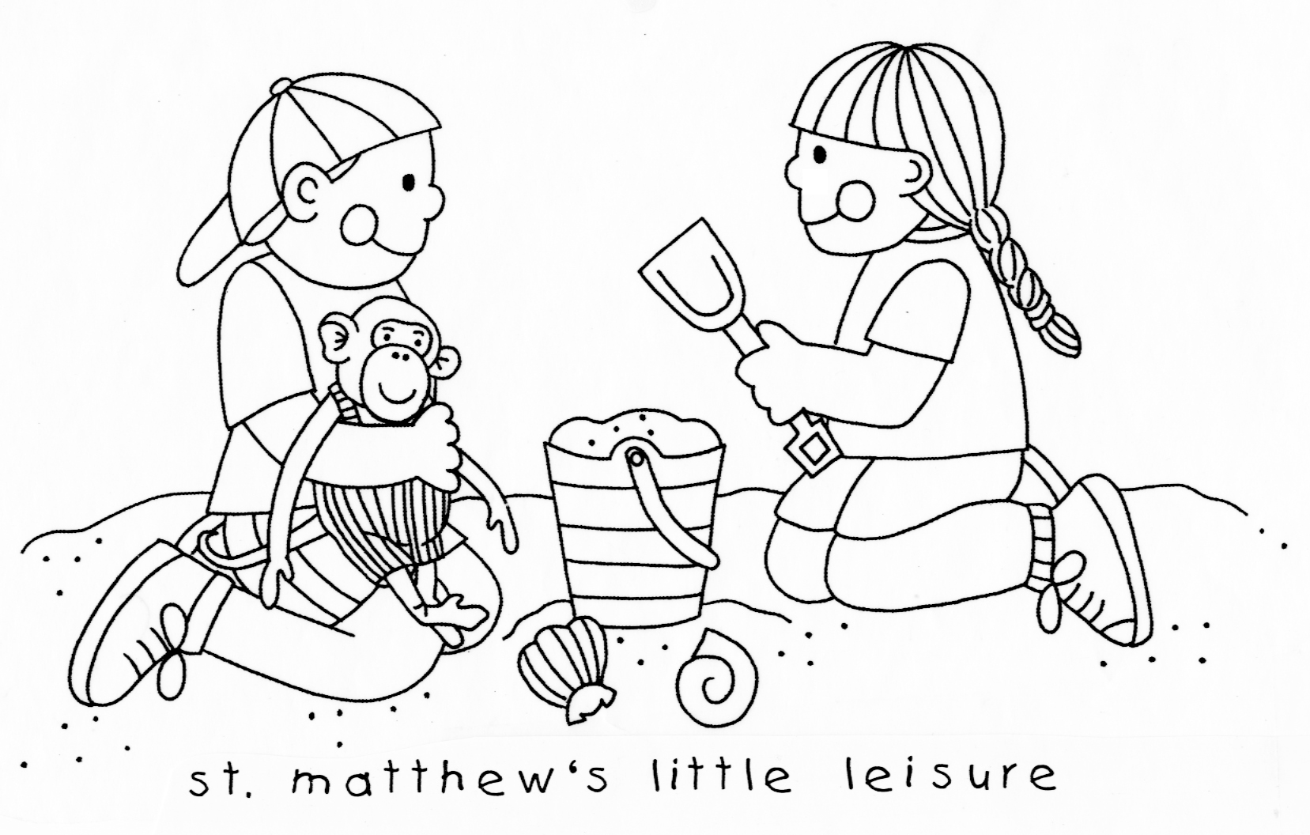
LIMITED OPENINGS REMAIN FOR…
18-24 Months
Wednesdays
9:00 AM-12:00 Noon

4-5 Year Olds, Pre-K Class
3-5 Mornings a Week
9:00 AM – 12:00 Noon or 9:00 AM – 1:00 PM

For further information call Tammy Eng, 737-6795 (office) or email littleleisure@verizon.net

How About a Cup of “Joe”?
If you are looking for a time-efficient way to become more involved at St. Matthew’s, and to meet more folks in the church community, please consider joining the Hospitality Committee, and/or hosting a coffee hour after either service.

The Hospitality Committee assists with special events, such as the autumn brunch for Sunday school teachers. Individuals also host the occasional coffee hour, and help “newbie” coffee hour hosts with the process (the giant coffee urns are very user-friendly, but it’s always nice to have another pair of hands). This is a low-meeting commitment; most of our work is done via phone and email, and on event days.

All members of the church community are welcome – and encouraged -- to host coffee hour after either service. Just sign up on the sheet. Directions for coffee hour are posted in the kitchen, and can be emailed to you. Feel free to contact the committee with any questions, or if you’d like a “buddy” with you, the first time you host. To sign up for the committee, or with questions about coffee hour, contact Elizabeth Luciano at lizluci@yahoo.com or 215-493-8131.

