**St. Matthew’s Messenger**



**OCTOBER 2012**

**St. Matthew’s Episcopal Church, Pennington, N.J. 08534**

**PLEASE NOTE**: If you wish to receive the monthly Messenger and Constant Contact announcements via email, please contact Lynn Lorenz at [*admin@justmultiples.com*](mailto:admin@justmultiples.com).

**CALENDAR OF EVENTS FOR OCTOBER**

Sunday 7 9:30am, Children’s Choir Practice Resumes

7:00pm, An Update on Pastor Emily’s Sabbatical Project

Monday 8 7:30pm, Parish Life Guild Meeting

Tuesday 9 6:00pm, Newbie Tuesday

Wednesday 10 Final Day for Rummage Drop-off

7:00pm, Handbell Choir Practice Resumes

Thursday 11 6:00pm, Pricing Thursday

Friday 12 9:00am, Rummage Sale (til 5pm), $10 Bag Sale (6-8pm)

4:30pm, Logos Bay Head Retreat

Saturday 13 9:00am, Rummage Sale $5 Bag Sale followed by Clean-up

Sunday 14 9:00am, Newcomers Breakfast

5:00pm, Taizé Service

Monday 15 7:30pm, Vestry Meeting

Wednesday 17 5:30pm, Destinations (NOTE TIME CHANGE!)

Sunday 21 11:15am, Kairos Staff Appreciation Brunch

3:00pm, Diocesan Hymn Sing at Trinity Cathedral

Tuesday 23 7:00pm, Parent Orientation to Confirmation

Saturday 27 8:30am, Godly Play Commuter Core Training – Part II

Sunday 28 5:00pm, The David Story – Dinner and Discussion

5:00pm, Taizé Service

Tuesday 30 5:45pm, Youth Confirmation Class Begins

**Kairos Korner**

Our wonderful Kairos teachers and staff play a vital role in the life and future of the church and in the lives of the children of St. Matthew’s. On October 21st, we will honor them with an Appreciation Brunch following the 10am service. Whether you have a child or grandchild in the Kairos program or would simply like to express your gratitude for what our teachers and staff do, please sign-up to bring a dish for the brunch. You will find sign-up sheets posted on the Kairos bulletin board in the hallway leading to the classrooms. Thank you in advance for your support!

**Kairos Outreach 2012**

Each year our Kairos classes come together for an outreach project giving them the opportunity to think about those in our community who need our help. On Sunday, November 18th, we will be making children’s meal bags for the Trenton Area Soup Kitchen. To make this effort possible, we need your help! Sunday, October 14th through November 11th , we will be collecting the following food items:

* **Chef Boyardee** **single serving** microwavable containers of ravioli, spaghetti, lasagna, mac n’ cheese – hot meals please!
* **Single serving fruit cups**
* **Single serving** **desserts** (pudding, cookies, fruit roll ups)
* **100% juice boxes** (**6.75oz** please not the tiny ones)

All items must be in SINGLE SERVING containers and *not in need of any kind of preparation* aside from microwaving. Juice must be 100% juice in 6.75oz containers.

If you prefer, a **monetary donation** can be made and we will do the shopping for you! Please give your check or cash to either Lori Cooper or Pastor Emily.

Collection bins labeled “KAIROS OUTREACH PROJECT” will be located in the foyer next to the coat room beginning October 14th. Thank you in advance for your generosity!

**CALLING ALL EMAIL ADDRESSES!**



We are working to update our email database. Whether you are currently receiving emails from St. Matthew’s or not, **if you would like to receive church news, we need you to verify (or add) your current email address**. You may include several emails per family. Please take a minute to include your name and email address to the “CHURCH EMAILS” list in the narthex, or send an email to [justmultiples@yahoo.com](mailto:justmultiples@yahoo.com). Thank you for your help with this important project!

**St. Matt’s Next Big Read: The David Story**

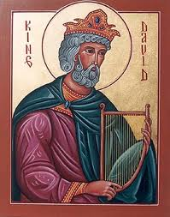

Even 3000 years ago, the relationship between religion and politics was complicated. This fall, as we consider the qualities we want in our own national leaders, St. Matthew’s Adult Education Committee invites you to join us in reading the story of King David (I Samuel 8 to I Kings 3:15). As in real life, it is not always easy to discern heroes from villains. Perhaps tracking God’s love and faithfulness amidst this tale of sex, violence and political intrigue will sharpen our ability to sense God’s presence and follow the Almighty’s lead in our own messy lives.

Join the conversation on our blog: stmattsondavid.blogspot.com. NOTE: We have recently changed the settings to make it easier to post a comment. Please click on “comments” to add your reflections or questions!

A suggested reading schedule is available on the blog or on the table by the coat room. Read at your own pace, and then join us for a celebratory potluck and presentation on **Sunday, October 28th at 5pm**!

Reading Schedule and Reflection Questions for the David Story

The Rise of Saul – I Samuel 8-11

*Questions to Ponder: When is it not a good thing to get what we want? Are the people rejecting God in wanting a king to fight their battles?*

The Rejection of Saul – I Samuel 12-15

*Questions to Ponder: Are Samuel’s charges against Saul fair? Can God change God’s mind?*

The Rise of David – I Samuel 16-20

*Questions to Ponder: What leadership qualities does David exercise in these chapters? Why is the LORD with him?*

Saul Chases David – I Samuel 21-24, Psalms 34, 56, 57, 63

*Questions to Ponder: Does the psalmist sound like the David we read about in these chapters? Why or why not?*

The “Return” of Samuel – I Samuel 25-28

*Questions to Ponder: How does one define the “enemy”? Who receives mercy in these passages, and who does not?*

The Death of Saul – I Samuel 29–II Samuel 1

*Questions to Ponder: What do you make of Saul’s death and David’s grief? What is owed to the LORD’s anointed?*

David Becomes King – II Samuel 2-6

*Questions to Ponder: “Is the sword to keep devouring forever?” (2:26) Why does David bring the ark of God to Jerusalem? What do you think about his dancing before the LORD?*

David Consolidates His Kingdom – II Samuel 7-10

*Questions to Ponder: Is the LORD’s promise to David too good to be true? Why might the LORD not want a house?*

David and His Sons – II Samuel 11-14, Psalm 51

*Questions to Ponder: Do the “punishments” in these chapters fit the crimes committed? How do Nathan and the wise woman of Tekoa speak truth to David? Does God take away life?*

David’s Friends and Enemies – II Samuel 15-19

*Questions to Ponder: Can the LORD really be implicated in these palace intrigues and power reversals? Who exhibits loyalty in these chapters?*

David’s Offering – II Samuel 20-24

*Questions to Ponder: Was David rewarded according to his righteousness? (22:21) Does the poet of chapter 22 at all resemble the David depicted in the surrounding chapters – and, if so, how?*

The Rise of Solomon – I Kings 1-3:15

*Questions to Ponder: What do you make of David’s last words to Solomon? Who chose Solomon to be king? What has Solomon learned from his father about leadership?*

**An Update on Pastor Emily’s Sabbatical Project:**

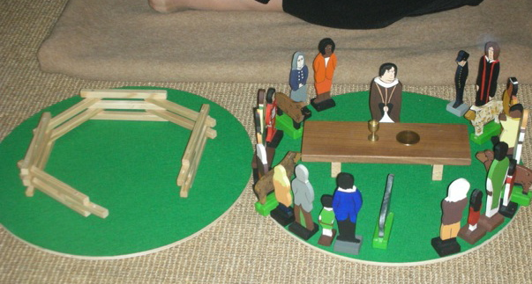

**Children, Grief and Godly Play**

**Sunday, October 7th at 7:00pm in the Chapel**

Thanks to a grant from the St. Martin’s House Fund and the generous donations of several parishioners, Pastor Emily spent most of June and July on sabbatical at a retreat center in upstate NY - working with Godly Play (the Montessori-based method of spiritual formation we use here in our church school) to develop additional resources for children who are dealing with issues of death and grief. The sabbatical also involved a weeklong visit to the Children’s Medical Center in Dallas, where they have been using Godly Play with sick children and their families for the last 25 years, as well as to the Center for the Theology of Childhood in Denver.

Come learn more about what she read, wrote and discovered along the way by joining us for a presentation and discussion in the Chapel. Questions? Contact Pastor Emily at 609-737-0985 or at [emilygriffin@verizon.net](mailto:emilygriffin@verizon.net).

**Eighth Annual Trinity Cathedral Community Day**

**October 8th  at Mercer Oaks Golf Course**

Events for the day include: Communion service at the Golf Course officiated by Bishop Councell

Golf competition where teams compete to win the Bishop’s Cup

Continental Breakfast, Box Lunch and Buffet Dinner

Prizes for the winning teams, raffles for great gifts and an auction for trips and wonderful outings for family and friends

Teams are comprised of fellow Episcopalians meeting for a day of fellowship and camaraderie in a beautiful setting for a marvelous cause. All proceeds go to supporting Trinity Cathedral. To date, this event has raised over $ 125,000.

This is a multi-generational event (Bryce Caton was the best golfer at the tournament last year) and open to men and women alike. An individual fee for the day is $ 160.00. St. Matthew’s has participated with at least one foursome for all previous seven years, and we are planning on at least two teams this year.

Please reach out to Tom Di Muzio at 609-737-6686 or cell 609 410-3809 or [thomasdimuzio@hotmail.com](mailto:thomasdimuzio@hotmail.com) if you have interest.

**RED WAGON SUNDAYS**

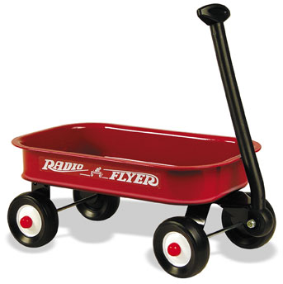

The first Sunday of each month, there will be a red wagon in the Narthex to collect non-perishable food items for the Crisis Ministry of Princeton and Trenton. These items will be presented during the Offertory along with the bread and wine as part of our sacred act of thanksgiving to God.

Wondering what kinds of food to give? Lists are available in the Narthex.

**Support Group: COM-PASSION (Feeling With)**



Support group for anyone dealing with anxiety and/or depression. We will explore anxiety/stress reduction methods and coping skills, including: Centering prayer, Reiki, Scheduling, Energy work, Heart math, Yoga, Visualization, Mindfulness meditation, Hypnosis, Volunteerism, Active listening, Massage therapy, Exercise, Journaling and whatever else helps.

Any questions? Call Denny Rodgers at (609) 883-5701.

**Special Evening Hours to Volunteer for the**



**Annual Fall Rummage Sale**

**Tuesday, October 9 and Thursday, October 11 from 6-8pm**

For those of us whose days are too busy, the PLG is once again hosting a special evening sorting party called NEWBIE TUESDAY. Join us for pizza, sorting and fellowship. Bring your donations to the Rummage Sale on Tuesday evening, October 9th from 6-8. Bring your friends' and neighbors' stuff too. We'll have lots of hands to do lots of sorting so we need lots of good stuff to sort while we're here! Plastic bins, boxes, laundry baskets and lawn and leaf bags--load them up and bring it all. We'll provide instruction for any Newbie. It's a great way to learn about and participate in one of our most important fundraisers.

New this year is PRICING THURSDAY. Our Rummage Sale Co-Chairs tell us they need a lot of help pricing the donations. They'll give us the parameters and we'll pitch in with the pricing--a great skill for anyone to learn.   
  
Questions about Newbie Tuesday or Pricing Thursday? Email [stacy@blackdogmediainc.com](mailto:stacy@blackdogmediainc.com).



**St. Matthew’s Church** **Fall Rummage Sale**

**October 12th and 13th, 2012**

(Proceeds from the sale benefit Outreach Projects and Church Education Programs)

**Your Help is needed with any and all details of the sale!**

**Pre-Sale Set up**: Sunday October 7th. Set up tables and racks, store church items to protect them, and move rummage items from storage.

**Pre-Sale Sorting/Organizing Schedule**: Monday-Thursday 9:00am – 5:00pm, and Mon., Tues., and Wed. evening 6-9pm. Fold and place casual clothes on tables, hang-up coats/dresses, organize the linens, electronics, toys, children’s books, housewares or front porch.

**(Volunteers of at least 2 hours may shop that day)**

Presale prices to be approved by a chairperson. There will be several new volunteer options this year in addition to sorting and pricing. Check the bulletin in the coming weeks for more details.

**Sale Hours:** Friday October 12th – 9:00am – 5:00pm

Friday Evening – $10.00/ Bag Sale – 6:00pm – 8:00pm

Saturday October 13th – $5.00/bag sale – 9:00am – 12noon

**Donations:** Please only items in good condition ready for sale – clothing should not be soiled or have holes. Electronics in good working order, gently used toys, linens, housewares, etc. should all be in good resale condition. **No analog TVs will be accepted this year.**

**By law, No** –Medical supplies, propane tanks, oil containers, flammables, or tires.

**We no longer accept**: Adult books or any cassette tapes.

**Larger furniture items or cribs need to be approved by a chairperson. We are also willing to post a picture

of larger items.

**Donations Drop Off:** Sunday – after church, Monday–Wednesday, 9:00am – 5:00pm. Put them in Parish Hall if you are unable to sort them. If leaving items at night, place them on the Church porch or in the Parish Hall (Sun.–Wed. only).

**Post Sale Take-down:** Saturday, October 13th from 11:45am-1:45pm. Bag left over items for the Rescue Mission and take them to the street. Put the Church back the way it was found.

Questions? Contact Betsy Slover at (609) 433-7043 or Brenda McNeil at (732) 309-1332.

**OR**

Check us out on Facebook at <http://www.facebook.com/stmatthewsepiscopalchurchrummagesale>

**CALLING ALL ST. MATT’S SENIOR HIGH...**



**St. Matt’s Goes to the Shore!**

**Friday, October 12th to Saturday, October 13th**

Once again, we’ve decided to roll a lock-in and beach trip into one. All Saints Church in Bay Head has graciously agreed to host us for the night. We’ll gather here at 4:30pm and return to St. Matt’s on Saturday by Noon. During this time, we’ll have a chance to reflect on what it means to live our faith publicly and worship together at a midnight Eucharist. We’ll also have plenty of time just to relax and have fun. Whether or not you’ve been part of our youth groups in the past, know that you’re welcome to join us!

Cost: $15 per person - includes Friday dinner and Saturday breakfast

*Checks payable to St. Matthew’s Church*

What to Bring:

Sleeping Bag, Pillow, Toiletries, Modest Sleepwear,

Bathing Suit and Towel, Change of Clothes, Favorite Snack

RSVP to Phyllis Jones at [pj_soccermom@yahoo.com](mailto:pj_soccermom@yahoo.com) by October 7th to confirm your spot!



**Sunday, October 14th at 9:00am**

Are you new to the St. Matthew’s Church family, or have you been with us for some time but would like to meet and mix with us? The Vestry would love to have the pleasure of your company at a Newcomers Potluck Breakfast on October 14th between the 8am and 10am services.

Please RSVP to Debbie Linthorst at [dlinthorst@comcast.net](mailto:dlinthorst@comcast.net) or (609) 730-9480. We look forward to sharing fellowship and hospitality with you.

**Destinations for October**



Destinations, our middle school youth group, will gather on **Wednesday, October 17th** at **5:30pm** (NOTE TIME CHANGE!) in Parish Hall for our monthly meeting. Interested in joining our parent email list? Contact Diana Drake at [drakeink@aol.com](mailto:drakeink@aol.com) or at 609-730-9037.

**Diocesan Hymn Sing at Trinity Cathedral**

**Sunday, October 21st at 3:00pm**

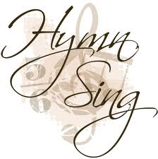

Join congregations all over the Diocese at our Cathedral (801 W. State Street in Trenton) and come ready to sing - let’s fill the rafters with our voices! We’ll sing hymns of all types and styles as well as from all time periods. Composers represented will be both local and far-reaching. Questions? Contact Rory McCorkle, Director of Music Ministry, at [rorymccorkle@verizon.net](mailto:rorymccorkle@verizon.net).

**Youth Confirmation Class 2012-2013 News**

The first meeting of our Youth Confirmation* class will be **Tuesday, October 30th** **from 5:45 to 7:15 pm** in Parish Hall. All young people presently in the 8th grade (or higher) who wish to be confirmed should attend this session. During these classes, we talk about the basics of our faith and what it means to make a mature commitment to Christ. This is a great opportunity to ask questions - to think about what we believe and why. Supper will be provided at each session.

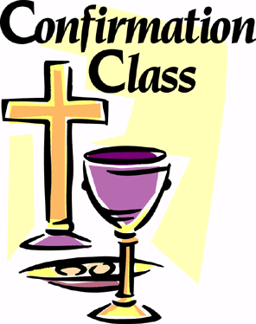

We ask that at least one parent of each confirmand join us for a **Parent Orientation** the previous **Tuesday, October 23rd at 7pm** in Parish Hall. At that time, we will discuss over dessert and coffee how you can support your teen(s) as they prepare for this significant commitment. We’ll also review the schedule for the next several months so you can plan accordingly. Please contact one of us with any questions or concerns - and let us know that you’re coming!

Blessings and Peace,

Fr. Jack ([jackbelmont@verizon.net](mailto:jackbelmont@verizon.net)) and Pastor Emily ([emilygriffin@verizon.net](mailto:emilygriffin@verizon.net))

**\* Con∙fir∙ma∙tion** *n.* the rite in which a baptized person makes a mature public commitment to Christ and officially takes on the responsibilities of Baptism.

**A Diocesan-Wide Event to Support NetsforLife**



**Soles for the Harvest**

**5K Race and 1 Mile Fun Run from 9am – 11am**

**October 27, 2012**

**Cream Ridge Winery near Allentown, NJ**

The parish sending the most participants to this event will receive the Bishop’s 5K Plaque and bragging rights to go with it. If you wish to participate as a runner or walker or wish to offer financial support, please contact Lou Cavaliere, the MDG Coordinator, at (484) 433-3478 or [captainusn@comcast.net](mailto:captainusn@comcast.net). Entry Forms, Pledge Forms and Sponsorship Forms are available in the Narthex.

The course setting is bucolic and flat, passing through farmland and grazing fields. It will be a perfect background for an autumn morning out. There will be additional information displays and children’s activities on site.



**PLG Fall Fun Fest - Dinner Dance and Auction**

The Parish Life Guild is sponsoring another Family-Friendly Fundraiser! The Fall Fun Fest is a dinner, dance and silent auction that will be held on 11/3 from 5:30-8:30pm. Babysitting will be available. Join us for fellowship, casual fare, DJ and terrific silent auction items--great for gift-giving or keeping for yourself! Stay tuned for more information. Tickets will go on sale in October after services.

**All Souls Eucharist**

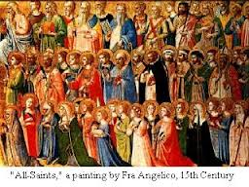

**Sunday, November 4th at 5:00pm**

*“We do not live to ourselves, and we do not die to ourselves. If we live, we live to the Lord, and if we die, we die to the Lord; so then, whether we live or whether we die, we are the Lord’s.”;*                - Romans 14:8

Please join us on the Sunday after the Feast of All Souls as we hold up our loved ones who have died to the light of God’s grace and to the hope of eternal life promised us in Christ. This year, St. Matthew’s choir will be joined by choristers from Trinity Cathedral to present portions of the Requiem composed by Malcolm Archer. This musical piece is a modern, reflective setting of the traditional words at the Requiem Mass. All will be given a chance to write the names of deceased loved ones in a “Book of Names” as they arrive. You may bring pictures or other small remembrances as well. We’ll then place them in front of the altar and read the names aloud during the service, offering them up to the One to whom we all belong - in life and death, and in life beyond death.

**St. Matthew’s and St. Michael’s:**

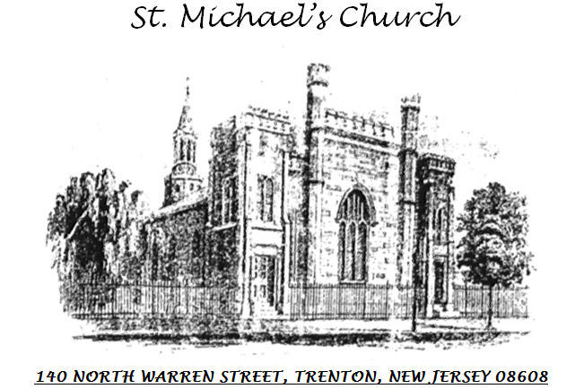

**Sister Churches?**

Did you know that one of the oldest Episcopal churches in the state is right down the road from us? St. Michael’s in Trenton was founded in 1703. During the Revolutionary War, both Continental and British armies occupied the church. Some of the fighting of the Battle of Trenton happened in their church yard. While times have changed greatly since then, a worshipping community continues there – and we would like to stand alongside them. We are starting to explore a partnership between our churches – to see how we can help each other and learn from each other. Interested in learning more about this historic, urban congregation and how we can support each other’s ministries? Contact Pastor Emily at [emilygriffin@verizon.net](mailto:emilygriffin@verizon.net).

**Wednesday Lunchtime Eucharist at St. Michael’s**

St. Michael’s Episcopal Church (140 N. Warren St. in Trenton) holds a Eucharist with individual prayers for anointing and healing each Wednesday at 12:10pm in their Chapel. For the last year, Pastor Emily has taken turns leading this service with the Rev. Daphne Hawkes, an old friend of St. Matthew’s. Please know that you are welcome to join us. Free parking is available in a lot immediately behind the church just south on Perry St. between Warren and Broad.

**More St. Michael’s News**

Several of the women at St. Michael’s are involved with the Needlework Guild of America (NGA). They are currently holding their annual drive for NEW clothing, linens, towels, toiletries, etc., which are then donated to several charities in the City of Trenton such as Capital Health System, Morris Hall, and Children’s Futures. If you would like to donate, please contact Ms. Mary Miller (home: 609-599-3332/ cell: 609 658-5903). The items will be distributed at the NGA’s annual meeting which will be held on October 17th in Ewing. Anyone interested in going to the meeting is also invited.