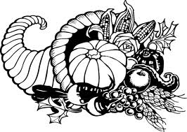
St. Matthew’s Messenger
NOVEMBER
2011
Saint Matthew’s Episcopal Church
Pennington, N.J. 08534

CALENDAR OF EVENTS FOR NOVEMBER

Wednesday 2 7:30pm, Christmas Bazaar Crafts Workshop

Saturday 5 5:00pm, PLG Bazaar Night

Sunday 6 Christmas Bazaar Pre-Sales Begin

10:00am, All Saints’ Family Worship

5:00pm, All Souls Service

7:00pm, Introduction to Celtic Spirituality - Part I

Tuesday 8 7:00pm, Parent Orientation for Confirmation

Wednesday 9 7:30pm, Bazaar Workshop

Sunday 13 9:00am, Newcomers Potluck Breakfast

11:15am, Special Parish Meeting

5:00pm, Taizé

7:00pm, Introduction to Celtic Spirituality Part – II

Monday 14 7:30pm, Parish Life Guild Meeting

Tuesday 15 6:30pm, Youth Confirmation Begins

Wednesday 16 6:00pm, Destinations

7:30pm, Christmas Bazaar Crafts Workshop

Sunday 20 10:00am, Kairos Outreach Project

5:00pm, Hymn Sing/Potluck Dinner
7:00pm, PLEASE NOTE THE DATE CHANGE!!

St. Catherine’s Monastery & “The Sisters of Sinai” Part II

7:30pm, Logos Visit to ECP at Princeton University

Monday 21 7:30pm, Vestry Meeting

Thursday 24 10:00am, Thanksgiving Day Service

Wednesday 30 7:30pm, Bazaar Workshop


Please Read!!!! From the Rector
I hate being an alarmist, but I wanted the parish family to know that when I attended a meeting of the Parish Finance Committee last month, I discovered that through September, we were $13,000 behind in our budgeted receipts from pledges!

While it is not unusual for pledges to be a bit behind as we come out of the “summer lull,” our Treasurer and Assistant Treasurer are concerned about our cash flow and our ability to make timely payments on our bills, salaries, and other financial obligations.

By now, all who have made pledges to the parish for 2011 have received their third quarter financial statement in the mail. If you find yourself behind, I would appreciate your willingness to make your pledge as current as possible. I realize that some of you are being affected by the economic circumstances of which we are all critically aware. If you are unable to follow through with your pledge, I urge you to contact our recording clerk, John Eckel (737-8581) and advise him. Please understand that all pledge information is handled with the utmost confidence.

Faithfully,
Fr. Jack
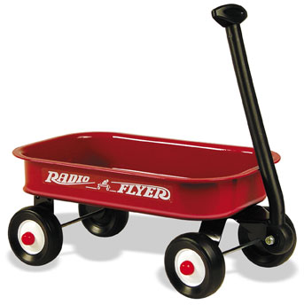
RED WAGON SUNDAYS
The first Sunday of each month, there will be a red wagon in the Narthex to collect non-perishable food items for the Crisis Ministry of Princeton and Trenton. These items will be presented during the Offertory along with the bread and wine as part of our sacred act of thanksgiving to God.

Wondering what kinds of food to give? Lists are available in the Narthex.

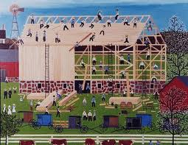
A Good Ol' Fashioned Barn-Raising, Episcopalian Style
Saturday November 5th is Bazaar Night at St. Matthew's!

Please join the PLG and the Bazaar Committee on Saturday, November 5th, starting at 5pm in the Parish Hall for fellowship and fun as we create meals (to be frozen), treats and crafts, all for sale at the Bazaar in December. In response to requests for more homemade and more affordable items for sale at the Bazaar, we are striving to offer more of these types of items. But the Bazaar Committee needs our help to do so (as they have many other tasks still remaining).

If you can join us, please contact Ian Hammett either by email (at ith-law@comcast.net) or cell phone [(609) 610-9114] for more details about what you can bring to help us make the meals, treats and crafts. We will have specific recipes and crafts in mind, so certain supplies will need to be purchased and donated for us to use. If you can help out, please let Ian know. (Our alternative is to send out folks on sort of a scavenger hunt on Bazaar Night to bring back supplies.)

Sue Nelson, our Bazaar chairperson this year, as well as Debbie Linthorst and Kate Westbrook, last year's chairpersons, have a number of projects in mind for which they could use our help (and donations). No experience needed, so all can help, and have fun working. (And we will figure out an easy, "no fuss" meal, so please bring a few dollars to chip in for the "table." Your beverages as well as a dessert or snack are, of course, welcome additions to the table.)

The Christmas Bazaar is without question the single largest fundraising event in our parish program year, so we ask that you spend Saturday night with us getting ready for it. Thank you and hope to see you there.

Youth Confirmation Class 2011-2012 News
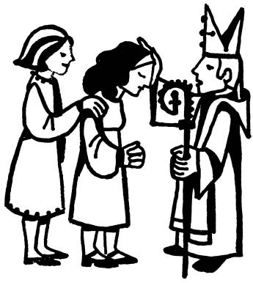
For the last few years, we’ve heard comments about the long gap between the end of confirmation class (usually in February) and the start of Logos in the fall. The teens don’t want to wait that long to get back together! So we’ve decided (in conjunction with Bishop Councell’s schedule) to hold our youth confirmation class a little later in the program year. Here are the dates you need to know at this point:
Tuesday, November 8th from 7 to 8pm Parent Orientation
Tuesday, November 15th from 6:30 to 8pm 1st Official Confirmation Class
Sunday, April 15th at 10:00am Confirmation with Bishop Councell

All young people presently in the 8th grade (or higher) who wish to be confirmed may join us. During these classes, we talk about the basics of our faith and what it means to make a mature commitment to Christ. This is a great opportunity to ask questions - to think about what we believe and why. Supper will be provided at each session.

Again this year, we ask that at least one parent of each confirmand join us for a Parent Orientation. At that time, we will discuss over dessert and coffee how you can support your teen(s) as they prepare for this significant commitment. We’ll also review the schedule for the next several months so you can plan accordingly. Please contact one of us with any questions or concerns - and let us know that you’re coming!

Peace,
Father Jack (jackbelmont@verizon.net) and Pastor Emily (emilygriffin@verizon.net)

NEWCOMERS BREAKFAST
November 13, 2011 at 9:00am
Are you new to the St. Matthew’s Church family, or have you been with us for some time but would like to meet and mix with us? The Vestry would love to have the pleasure of your company at a Newcomers Potluck Breakfast on Sunday, November 13 between the 8am and 10am services.

Please RSVP to June Vester at (609) 737-2179 or by email at bestvester@gmail.com. We look forward to sharing fellowship and hospitality with you.

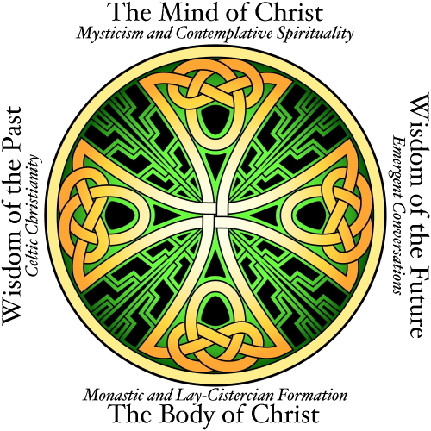
Celtic Spirituality Presentation

November 6th and 13th at 7 PM in the Parish Hall

Celtic Spirituality is a re-discovery of the ancient mystical tradition which is the heartbeat of our Anglican Communion. The Belmonts and the Castellons made a pilgrimage to Ireland and Scotland this past June to experience and learn more about the Celtic way. They traveled to many of the ancient places inhabited by our ancestors of the faith and would like to share their experiences with the parish through sight, sound and taste! Please let us know you are coming by using the sign-up sheet on the bulletin board next to Fr. Jack’s office.

All Souls Eucharist
Sunday, November 6th at 5:00pm

“We do not live to ourselves, and we do not die to ourselves. If we live, we live to the Lord, and if we die, we die to the Lord; so then, whether we live or whether we die, we are the Lord’s.” - Romans 14:8

Please join us on the Sunday after the Feast of All Souls as we hold up our loved ones who have died to the light of God’s grace and to the hope of eternal life promised us in Christ. During the Eucharist, the Choir will sing portions of the Rutter Requiem - with a small orchestral set for accompaniment. All will be given a chance to write the names of deceased loved ones in a “Book of Names” as they arrive. You may bring pictures or other small remembrances as well. We’ll then place them in front of the altar and read the names aloud during the service, offering them up to the One to whom we all belong - in life and death, and in life beyond death.


Special Parish Meeting
Sunday, November 13th at 11:15am

In response to Bishop Councell’s call for the election of a new Bishop in the fall of 2013, each congregation in the Diocese has been asked to hold a special parish meeting on November 13th. The purpose of this meeting is to elect six lay delegates who will represent St. Matthew’s at a special Convocation meeting on December 11th. This group will then vote to elect two Convocation representatives (one clergy, one lay) to the Episcopal Election Committee. Please join us immediately following the 10am service on the 13th as we begin this process of discernment.

DESTINATIONS...UNKNOWN!
Attention Middle Schoolers!
Are you ready for our next MYSTERY DESTINATION?
We're going to have so much fun at _______________!!!
Don't you wish you knew where?
Sorry...I can't tell, and please don't ask
because I have been sworn to secrecy!
Mark your calendar for WED., NOVEMBER 16TH (6-8p.m.) to find out!
Meet us in Parish Hall and bring your appetite.
Questions? Contact Lynn Lorenz (admin@justmultiples.com or 609/818-1121)

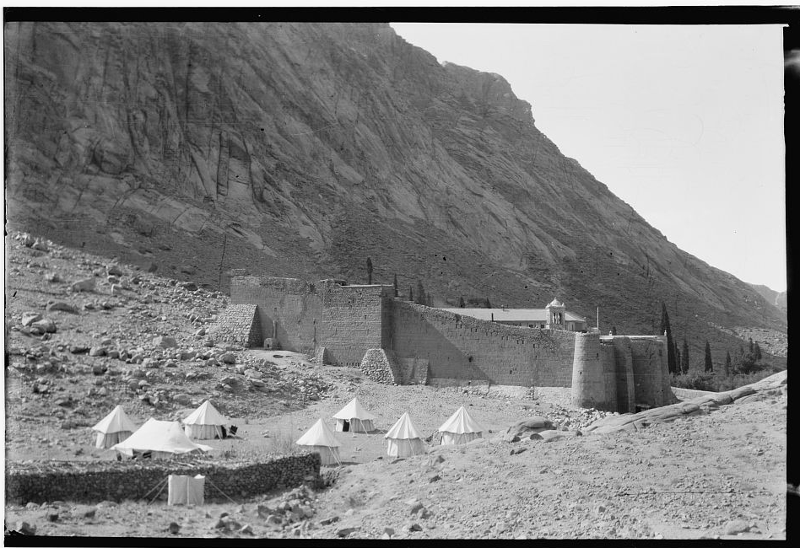
PLEASE NOTE THE DATE CHANGE!!

St. Catherine’s Monastery and

“The Sisters of Sinai” Part II
Sunday, November 20 at 7:00pm
Led by Rev. Dr. John Mark Goerss and Dr. Katherine Goerss
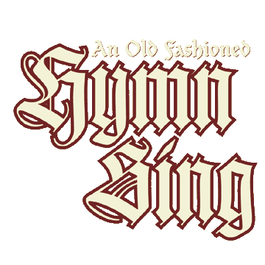
This presentation and discussion will focus on the book “The Sisters of Sinai: How Two Lady Adventurers Discovered the Hidden Gospels” by Janet Soskice. The book tells the true story of how two Victorian Sisters from Scotland traveled to Sinai in 1892 and discovered the earliest-known copy of the Gospels in ancient Syriac at the Monastery of St. Catherine. The book is a thrilling historical account that reads like a novel. The Archbishop of Canterbury has said that it is a book every church library should own. The book may be purchased from Amazon.com, but it is not necessary to have read the book before tonight’s presentation.
Hymn Sing
- Sunday, November 20th at 5:00pm
“A hymn is the praise of God with song; a song is the exultation of the mind dwelling on eternal things, bursting forth in the voice.” - Thomas Aquinas

One of the consistent themes in Christian worship throughout time is song – and for centuries, the singing of hymns. On November 20, we will hold our 2nd Annual Hymn Sing, giving all of you the opportunity to request your favorite hymn and join in listening, reflecting on, and singing hymns. Be on the lookout for a sign-up sheet on the Choir bulletin board so you can request your favorite hymn in advance! The hymn sing will be followed at 6:00pm by a potluck dinner in Parish Hall.
Kairos Korner

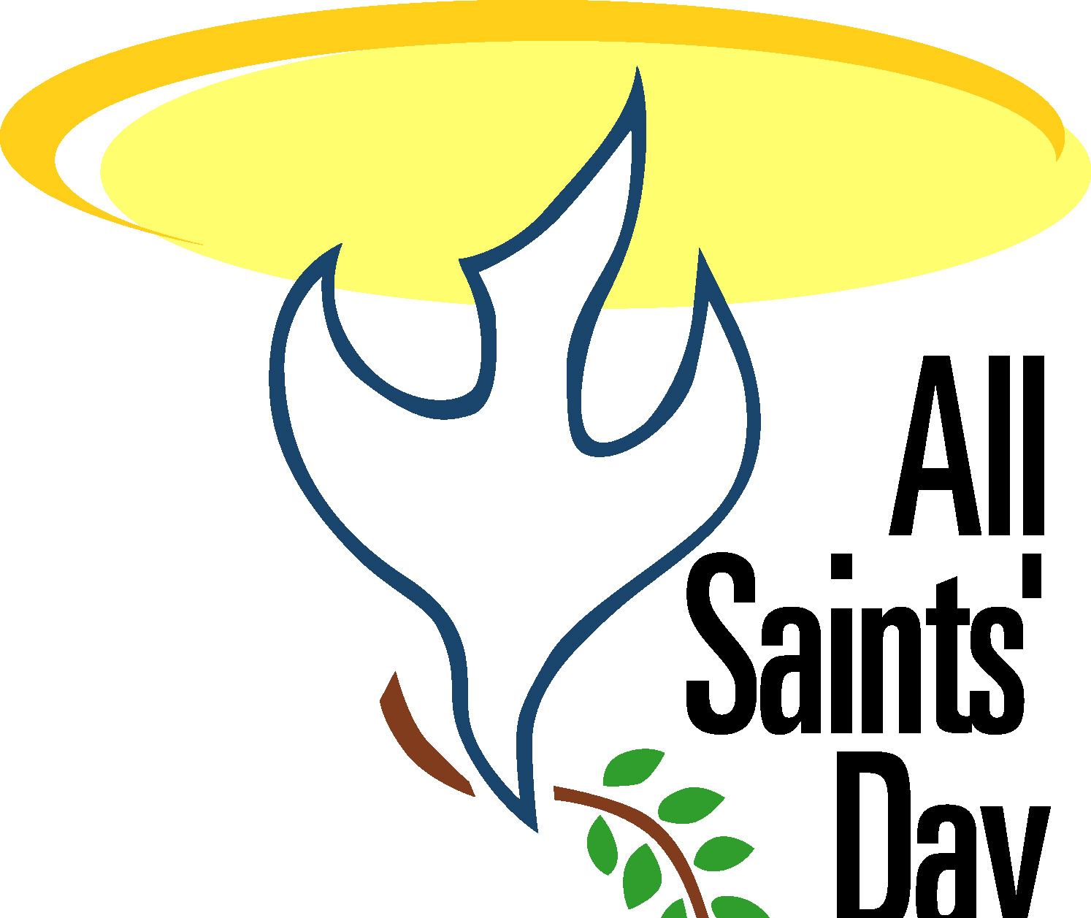
On Sunday, November 6th, we will begin the month with a Family Worship Service to celebrate All Saints’ Day. Our older youth will participate as ushers and readers and the children will be invited to come forward for the best seats in the house during the children’s homily! We will have Worship Bags in the Narthex for younger children to use during the service.


On November 20th, all of our classes will come together to make children’s meal bags for the Trenton Area Soup Kitchen. Our goal is to make 300 children’s meal bags but to do this we need your help! We will be collecting items through November 13th. Please see the “Kairos Outreach 2011” announcement for detailed information on donations.


The first Sunday of Advent is November 27th! It is also the day we will begin decorating candles for Christmas. This is a beloved tradition for our Kairos youth. They create a one of a kind gift to share the Light of Christ with someone special. The candles will be blessed during the 10am service on Sunday, December 11th.

Kairos Calendar

November 6: No Classes - All Saints’ Family Worship Service
November 13: Lessons (Last Sunday for Outreach donations!)
November 20: Group Outreach Project
November 27: First Sunday of Advent - Lessons and Christmas candle decorating


Kairos Outreach 2011
Each year our Kairos classes come together for an outreach project giving them the opportunity to think about those in our community who need our help. On Sunday, November 20th, we will be making children’s meal bags for the Trenton Area Soup Kitchen. To make this effort possible, we need your help! Through November 13th, we will be collecting the following food items:
- Chef Boyardee single serving microwavable containers of ravioli, spaghetti, lasagna, mac n’ cheese – hot meals please!
- Single serving fruit cups
- Single serving desserts (pudding, cookies, fruit roll ups)
- 100% juice boxes (6.75oz please not the tiny ones)

All items must be in SINGLE SERVING containers and not in need of any kind of preparation aside from microwaving. Juice must be 100% juice in 6.75oz containers.

If you prefer, a monetary donation can be made and we will do the shopping for you! Please give your check or cash to either Lori Cooper or Pastor Emily.

Collection bins labeled “KAIROS OUTREACH PROJECT” are located in the foyer next to the coat room. Thank you in advance for your generosity!

St. Matthew’s Children’s Christmas Eve Play
Straighten those angel wings and dust off the shepherd’s staff! It’s time to prepare for the Children’s Christmas Eve Play, “The Story of Christmas”.


Youth ages 3 and up are encouraged to participate. Parents, we need your involvement as well for “crowd control” (the sheep tend to wander), costume fittings, rehearsal snacks etc. All sign-up sheets are posted on the Kairos bulletin board.

November 1-13: Sign-up

November 20: Scripts distributed, costume fittings

REHEARSAL SCHEDULE

December 4: Rehearsal for SPEAKING ROLES ONLY
December 11: Rehearsal for ALL ROLES
December 18: Rehearsal for ALL ROLES, Props/Lighting and Music
December 24: Rehearsal at 1:30pm for ALL ROLES, Props/Lighting and Music.
Play is presented at 3pm

- Rehearsals follow the 10am service unless otherwise noted.
- A snack and beverage are provided.
- Play rehearsal ends at 12:30pm
- Christmas Eve rehearsal includes one rehearsal without costumes, snack and then dress rehearsal. The play will be presented at 3pm.

Any questions or comments? Contact Lori Cooper (stmattkairos@verizon.net)

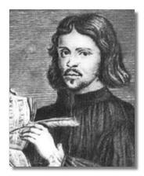
LOOKING AHEAD...

Advent Quiet Day
The Life and Music of Thomas Tallis
Saturday, December 10th
9:00am to Noon in the Chapel

Thomas Tallis was one of the first musicians to write for the new Anglican liturgy of 1547–53. He again composed to English words in the reign of Elizabeth I. Born in the first decade of the 16th century, his life and career spanned the tumultuous religious and political upheavals of that century, composing for the chapel and court of Henry VIII, Edward VI, Mary Tudor, and finally, the great Queen Elizabeth. Join parishioner Dr. Nora Sirbaugh, Professor of Music at TCNJ, in a not-so-quiet Advent Quiet Day - examining the life and music of a composer recognized for music suffused by warmth and humanity, sometimes by wit, and almost always by a deeply poetic quality that places it among the most enduring products of its age.

Rummage Sale Update!
Thank you to all who contributed their time, talent and effort to the Fall Rummage Sale which supports the Christian Education programs of the church and our many outreach programs.

We are still awaiting the final tally. When that net amount is calculated, we will list it in the newsletter and on the bulletin board along with all the names of the wonderful people who helped make the sale a success . Please notice all the names at that time and do join us next May for the fun and fellowship that transpires during the entire week. Perhaps, an unimagined treasure will be waiting for you amongst all that perceived rummage.

Thank you again, Penny & Denny Rodgers and Sally Turner

2011/2012 STEWARDSHIP PLEDGE CAMPAIGN

GOD LOVES A CHEERFUL GIVER

PLEASE RESPOND BY COMMITMENT SUNDAY, NOVEMBER 13.

Dear Parishioners:

Keep in mind that every pledge matters, regardless of the amount. All of us, every single household, are being called to contribute to the Stewardship Campaign, because all of us gain by being members of Saint Matthew’s Church.

Our opportunities are limitless with your support. We have achieved much, because of the countless and unselfish acts of donated time, talent and treasure. One of the ways we show our faith is through our generous response to God’s love.

PLEDGE REPORT

2012 STEWARDSHIP PLEDGE CAMPAIGN
REPORT DATE: OCTOBER 30, 2011
 | Activity | No. of Pledges | Actual  Pledge  2011 | Actual  Pledge  2012 | Increase | Decreases
 | Increase | 23 | $66,294 | $69,683 | $3,389
 | Unchanged | 27 | $42,188 | $42,188 | - | -
 | Decrease | 7 | $17,538 | $16,320 |  | ($1,218)
 | New Pledge | 3 |  | $ 3,260 | $3,260
 | No Pledge | 1 | $ 1,560 |  |  | ($1,560)
 | TOTAL | 60 | $127,580 | $131,451 | $3,871

Average Pledge $43.25/wk.

Average New Pledge $20.90/wk.

2012 Budget Goal - $425,000 31% of Goal Reached
2012 Pledge Goal – 210 pledges 60 Received to Date

Respectfully submitted,
The Stewardship Committee


Getting to Know You

Derk Huibers and Family

Derk and Elizabeth Huibers have lived in Pennington since 1971, and have two sons, Paul who now lives in Stratham, NH and Andrew who likes the excitement of Silicon Valley and lives in Sunnyvale, CA. They have one grandson, Evan. Derk and Elizabeth met and married in Buffalo, NY. Derk is from the Netherlands and came the first time to the U.S. in 1957 on a Fulbright Scholarship to Lehigh University in Bethlehem, PA, where he studied chemistry. Then, after returning to the Netherlands for two more years to complete his PhD in chemical engineering, he emigrated to the U.S. to Buffalo, because he was offered a research position with a division of Wallace and Tiernan. Elizabeth is a native of Buffalo and attended Buffalo schools, and SUNY Buffalo. She holds a master’s degree in speech therapy which she practiced in West Windsor and Hopewell Valley. She knows sign language and also worked at the Katzenbach School.

Before moving to Pennington, they lived in several places, including Berkeley Heights and Madison, NJ, Asheville, NC, and spent brief periods in Europe. Derk’s diverse chemical engineering career has included process research, development and plant design, water and air pollution control, applying liquid oxygen and hydrogen as fuel for the Saturn rockets that were used in the Apollo missions, coal conversion to oil, and finally the last 15 years were with the former Union Camp Research Center in Lawrenceville, NJ, in process development utilizing byproducts from paper manufacturing in a wide variety of commercial products, including flavors and fragrances. Derk holds 35 patents, including one that solved the vapor problem on the Saturn rocket engines!

Since retiring 11 years ago, Derk finally has time to read all those books he has been collecting, keep up with his profession through monthly meetings in Princeton, swim at Penn Brook almost daily during the summer, and take trips to visit family.

Parishioners for almost 30 years, the Huibers were attracted to St. Matthew’s because it was a friendly community church. When they came to Pennington, Father Jack gave Paul his first job: cleaning the snow off the church steps. During his high school years, Andrew served as an acolyte. Elizabeth was on the Parish Life Guild, and Derk served on the Finance Committee.

CHRISTMAS WREATHS AND POINSETTIAS

PRE-ORDER FORM

Fresh Green Christmas Wreaths / Poinsettias

Pick-up at our Christmas Bazaar on December 3rd

or after Services on the following Sunday

Pre-order Now!!!!!!
Place completed Pre-Order Forms in the box labeled “Christmas Wreaths and Flowers Orders” in the Narthex as soon as possible!

No payment due until you pick up your order


WREATHS

Wreaths will cost $14.00 each, pre-ordered. Some additional ones will be available at the Bazaar for $17.00. Your advance order will help us plan ahead.

Name: ______________________________________ Number of wreaths:____

Phone Number: ________________________

----------------------------------------------------------------------------------------------------------------------------


Poinsettias
Poinsettia: Quantity Color Choice
4 ½ “ Pot (3 – 4 blooms) RED or MARBLE $5.00 each _______ ________
6” Pot (5-7 blooms) RED, PINK or MARBLE $7.00 each _______ ________
7” Pot (10 – 15 blooms) RED, WHITE, PINK $13.00 each _______ ________
8” Pot (15 - 20 blooms) RED, PINK or MARBLE $18.00 each _______ ________
10” Pot (20 – 25 blooms) RED or PINK $22.00 each _______ ________
10” Table Top RED, PINK or WHITE $14.00 each _______ ________
10” Hanging Basket RED or MARBLE $14.00 each _______ ________

Name: ____________________________________ Phone Number: ______________
If you have a special request or if you are seeking a large order, please contact Diane Zompa (737-0645) and she will do her best to help!

THANK YOU FOR YOUR ORDER!


2011 Christmas Bazaar Information

Chairperson: Sue Nelson, 397-9021

IMPORTANT DATES

Bazaar Set-up: Sunday, Nov. 20th, 11:00am

Bazaar Booth Set-up: Sunday Nov. 27th through Friday, Dec. 2nd.
Bazaar: Saturday, Dec. 3rd, 10am-4pm
Bazaar Takedown: Saturday, Dec. 3rd, after 4pm (classroom space);
Sunday, Dec. 4th, noon (Parish Hall)

Workshops: Wednesday, November 2nd, 7:30-9:30pm
Wednesday, November 9th, 7:30-9:30pm
Wednesday, November 16th, 7:30-9:30pm
Wednesday, November 30th, 7:30-9:30pm

Don’t worry no special talent is required. If you can boil water and use scissors, we can use your help.

Bazaar sign-up sheets will be posted in the hallways shortly.
Please volunteer your time and talent.

Pre-sale items
After both services on Sundays, November 6, 13 and 20th, we will be having many items available for pre-sale including gourmet treats, Nativity sets, Advent wreaths and calendars. Shop early, and don’t miss out.

We still need Chairs and Volunteers

Secret Santa

Secret Santa has been a valuable part of our Annual Christmas Bazaar for many years. We are looking for an adult supervisor and several teens to work on the Secret Santa Booth. Please speak to Sue Nelson at (609) 397-9021 if you are interested in taking on the very important room designed specifically for our youngest shoppers.

Calling all Cooks!

Frozen Casseroles, Entrees and Soups
With many people having such busy schedules, these items are a big seller each year. We have some recipes available or your own favorite recipe is always a most welcome donation. A sign in sheet and ingredient cards will be available next to the freezer when you drop off your donation. Questions, please contact Sue Culliton at (609) 737-7468 or Tricia Adams at (609) 397-3562 or triciaadams@verizon.net

Baked Goods
We are looking for bakers to make cookies (absolutely any kind they like to bake), cakes, pies, or whatever your specialty is, to contribute to the baked goods tables. We would simply ask that you email one of us with what you will be making so we have some idea of what to expect and will have a nice assortment of baked goods. We would like the baked goods, if at all possible, dropped off by Friday (12/02/11) so that we have time to weigh cookies and price. If you can’t possibly bring them on Friday (12/02/11), we will still accept donations in the morning of the Christmas Bazaar (12/3/11). Contact: Karen Bunsa (kbunsa@comcast.net) or Cheryl Watterson (Cheryl.watterson@verizon.net).

Gourmet Treats
A bazaar tradition! Fruity preserves, buttery shortbread, decadent fudge, not to mention chutney and other exotic sauces. Please consider making some of your specialty for the bazaar. Drop-off is in the parish kitchen on Thursday, Dec. 1st. after 4pm. Questions, please contact Sandy Belmont (609) 466-1665.


