
St. Matthew’s Messenger
SEPTEMBER 2011
Saint Matthew’s Episcopal Church, Pennington, N.J. 08534

CALENDAR OF EVENTS FOR SEPTEMBER

Saturday 7 8:00pm, First Senior Choir Practice

Friday 9-11 Battle Against Hunger Bike Ride

Sunday 11 Sunday Morning Services Return to 8 and 10AM

10:00am, Kairos Registration/Commissioning of Kairos Staff

10:45am, Coffee Hour Returns

Monday 12 5:30pm, Tai Chi (Beginners)

7:30pm, Parish Life Guild Meeting

Wednesday 14 7:00pm, Organizational Meeting for Christmas Bazaar

Saturday 17 8:00am, Tai Chi (intermediate)

Sunday 18 10:00am, First Day of Kairos/Church School

10:00am, Prayer Partners Return

5:00pm, LOGOS Returns

Monday 19 7:30pm, Vestry Meeting

Friday 23 6:00pm, Dinner and a Movie at St. Matt’s – Shadowlands

Saturday 24 9:00am, Memorial Garden Dedication

Sunday 25 9:00am, Team Camden Presentation on Urban Promise

Wednesday 28 6:00pm, Destinations Returns


The St. Matthew’s Prayer Partners ministry took a little time off this summer, but it will be functioning again after Labor Day this September and will continue until church school ends in the spring.

What is Prayer Partners? It is a means by which anyone attending the 10 AM Sunday service can receive confidential personal prayers in the chapel during or after communion for themselves or a loved one from a St. Matthews’ prayer team.

From the Director of Music Ministry:

We have a variety of opportunities to participate in the leadership of worship at St. Matthew's. One of these opportunities is participating in our music ministry. We have a variety of choirs you can participate in; if interested, please do not hesitate to speak to me in church or by phone (mobile 717-575-5273).

This year, we have a particular need for Children’s and Handbell Choir members. If interested, please contact me or one of our choristers.

Rehearsal/performance schedules can always be found on the choir bulletin board (around the corner from Father Jack's office) or online at http://www.stmatthews-nj.org/Music/music.html


Adult Choir: Rehearsals will begin Wednesday, September 7 at 8:00 pm in the sanctuary. We are always accepting new singers - all are welcome!


Children's Choir: Rehearsals will begin Sunday, October 9 from 9:30 to 9:55 a.m. in the downstairs classroom (new wing, across from the multi-purpose room). Their first Sunday singing in church will be November 6 at the 10:00 a.m. service.

Handbell Choir: Rehearsals will begin Wednesday, October 5 at 7:00 pm in Classroom A.

I look forward to seeing you all this fall.

Rory


Coffee Hour Returns on September 11th!

Looking for a small way to give back or meet new people? Sign up to provide Coffee Hour sometime this fall - after either the 8:00am or 10:00am services. Sign up sheets and detailed instructions are posted in the kitchen. Any questions? Contact June Vester, Hospitality Chair, at 609-737-2179 or at bestvester@gmail.com.

Tai Chi Classes 2011

What can you do to increase bone density, increase flexibility and balance, and improve immune function all at one time?

Tai Chi practioner Bev Tucker will show you a personal wellness model that includes Tai Chi and Qigong for health, healing, and personal growth.

→Beginners class – Saturday, September 17, 2011, from 8:00 a.m. to 9:00 a.m.

→Intermediate-Monday, September 12, 2011 from 5:30 p.m. to 6:30 p.m.

Location: St. Matthew’s Church, 300 South Main Street, Pennington NJ 08534

Cost $90.00 for ten sessions.

Call Bev Tucker at 609-737-1384 to register or for more information.

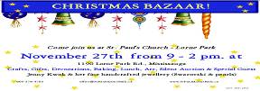

Saint Matthew’s Christmas Bazaar 2011

Organization Meeting on Wednesday, September 14th at 7PM

Everyone is invited to attend our first organization meeting. Especially past chairs - let me know if you will be chairing your tables this year or if you would like to do something different.

This year, I need chairs to take full responsibility for their tables. This includes communicating with their volunteers and contributors, gathering together the items, table set-up and take-down, and organizing volunteers to work the day of the Bazaar in shifts. You may want to recruit at least one other team member to work with you on this.

This is a great way to get involved in this great fundraising event for our Church and the ministries we support!

If you have any questions or ideas, please contact Sue Nelson at 609-397-9021.


ATTENTION ALL SENIOR HIGH YOUTH:
LOGOS RETURNS SEPTEMBER 18TH!

Logos - St. Matthew’s Senior High Youth Group (9th Grade and Up) - officially reconvenes for the 2011-2012 year with a BBQ on Sunday, September 18th from 5 to 7pm. Whether you’re a Logos vet, have been thinking about it but weren’t able to join us in the past, or are simply looking for a place to explore new friendships and deepen your faith, please join us.

Questions? Check out our Facebook page (under Places - St. Matthew’s Logos) for the latest updates or contact Phyllis Jones at pj_soccermom@yahoo.com.


Like to Cook? Join a Logos Cook Team!

We’re looking for people to help prepare meals for our high school youth group’s Sunday evening gatherings. You don’t need to have a teen in the group; you don’t need to do everything yourself. We can even offer suggestions for meals! Sign up as an individual or with a group by contacting Elizabeth Luciano at lizluci@yahoo.com.

Exciting News!

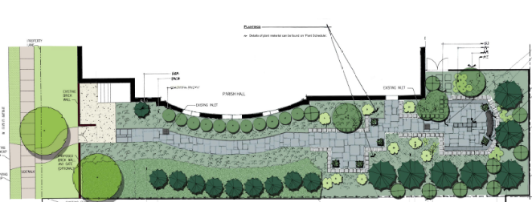
emorial Garden Dedication

Saturday

September 24, 2011

9:00 AM

The Right Rev. George Councell, Bishop of New Jersey, will preside at the dedication of St. Matthew's Memorial Garden on Saturday, September 24th. You are invited to join us at 9:00 AM in the garden for the dedication liturgy. Following the service, we will gather in the Parish Hall for a reception hosted by the Memorial Garden Committee.

The Memorial Garden patio and walkway were installed this summer, thanks to the dedicated work of the Committee. The garden is a work in progress and will be completed as funds become available. Still to be accomplished after the rear wall of the Parish Hall is re-surfaced are the plantings, an entry way to the garden and a fence.

But, since the walkway and patio are finished, we are now ready to do interments and to allow parishioners and their families to purchase space in the garden as a place for Christian burial. Information will be made available should you have an interest. Also, if you would like to make a donation toward the total completion of the garden, you are encouraged to contact the parish office at 609-737-0985..

In the meantime, we hope you can join us for the service of dedication on September 24th.

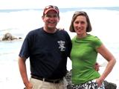

“Getting to Know You”- The Bells

Paul & Colleen have been parishioners at St. Matthew’s since 1983. They were attracted by the vibrancy of our parish where it seemed that “there was something happening on days besides Sunday”. Paul is currently finishing his second term as Warden, as well as being a member of the Choir, Lay Reader, and Chalice Bearer. He has served on the Vestry, Parish Life Guild, and Commission on Ministry. His leadership has also included Chairing the Capital Campaign and serving as Deputy to the Diocesan Convention multiple times. Colleen is currently serving as P.L.G. President and as a Prayer Partner. Her past leadership has included Chairing the Christmas Bazaar, where she has gained years of admiration for her incredible quilting skills. Colleen has also served on the Vestry, Altar Guild, and Music and Worship Committee.

When not attending to Parish business, Paul is Vice President for Partner Businesses at The Wall Street Journal and Colleen is a Nurse Practitioner in Palliative Medicine at Hunterdon Medical Center. In his leisure time, Paul serves as a “professional volunteer” on the Board of Trustees of the Silver Bay YMCA of the Adirondacks, a conference and retreat center on Lake George, N.Y. In addition to quilting, Colleen loves gardening and photography. They both enjoy traveling to experience new cultures. The picture above was taken on a recent trip to Maui.

Paul and Colleen met at University of North Carolina where Colleen was raised. Paul grew up in Bergen County, New Jersey. The Bells have raised two children in Pennington, Kaley (age 27) who lives in New York City and Whitt (age 22) who lives in Syracuse.
Kairos Korner

As we enjoy the last days of summer, we also look forward to the beginning of our Kairos year. On Sunday, September 11th, registration for our Sunday morning Kairos program will begin and our beloved teachers will be commissioned during the 10am service (we are back to 10am on the 11th!). Registration forms will be available in Parish Hall as well as information on all of our youth programs and opportunities for parents/guardians to be involved in this ministry.

Sunday, September 18th, is our first day of classes!
Welcoming time begins at 9:45am. All classes begin at 10am. We ask the parents of Primary children to pick their little ones up from their classrooms directly following the service. Older grades will join their families during the Peace.

Children are invited to begin attending Kairos classes at age 3 1/2 yrs (children must be fully potty trained and able to sit still for lessons, thank you!).


Kairos classrooms:
Primary B (3½ yrs to Kindergarten) Classroom B (first floor)
First/Second grade Classroom A (first floor)
Third/Fourth grade Classroom D (downstairs)
Fifth/Sixth grade Classroom E (downstairs)
Seventh/Eighth grade Library (first floor)

If you have any questions or comments, please contact our Director of Children’s and Family Ministries, Lori Cooper at stmattkairos@verizon.net or 737-0985.

Feast Bread Bakers Needed!


Mrs. Ottinger’s Prayer
“Our life, our health, our joy depends,
upon the bounty that God sends.
May this our food by Thee be blessed,
and as we eat, be Thou our guest…
and God bless all of these wonderful children.”

This prayer was a gift given to the children of St. Matthew’s by Jay Ottinger’s mother. She would say it with the children every Sunday before they would break bread to celebrate “the Feast”. Mrs. Ottinger has since passed away, but her spirit and her love of Christ and His children lives on in this prayer that we continue to say with our young ones every Sunday morning.

“The Feast” is our communion time for the Primary classes (3 ½yr olds to kindergarten) and our feast bread is provided by volunteer bakers. Copies of the recipe are on the Kairos bulletin board above the sign-up sheet. Typically, our bakers make the bread on Saturday and then bring a loaf in on Sunday morning for the children. The little ones LOVE sharing the Feast, so please know that the time you spend baking is greatly appreciated!

Whether you are interested in giving it a try or have been an active baker already, please consider signing up. Thank you!

Please contact Lori Cooper (StMattKairos@verizon.net) with questions or to volunteer.


Nursery Care is Moving Back!
NURSERY CARE will be moving back to the Little Leisure classroom beginning Sunday, September 18th.


Nursery and Kairos Sick Policy
In the hopes of reducing the spread of illness among our children, their caregivers and teachers, we ask that you be very thoughtful before bringing a child who is or has recently been sick into the nursery or a classroom.

Our sick policy follows that of our school district:
- Child should be completely fever free for 24 hours
- Child should have no intestinal/stomach issues for 24 hours
- No goopy noses or coughs
- No red eyes with discharge

Thank you!
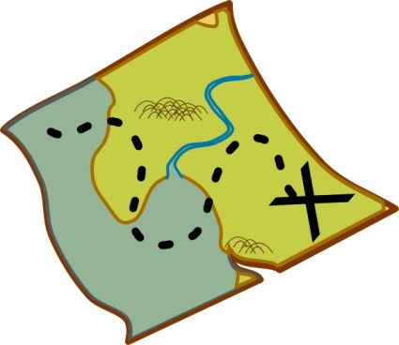

DESTINATIONS…UNKNOWN!

ATTENTION MIDDLE SCHOOL STUDENTS (and Parents):
Would you like to go on fun “mystery” trips with your St. Matthew’s friends?
Do you like delicious food…like pizza, tacos, ice cream (and salad, if you so desire)?
Would you like to do all of this and learn something interesting about the Bible?
If yes, then…
Mark your calendar for Wednesday, September 28th (6-8 p.m.).
Meet us in the Parish Hall and bring a parent for dinner and a brief informational meeting
about our monthly Destinations (Middle School) Program.
Then, get ready to go on an exciting MYSTERY DESTINATION!
(Sorry I can’t tell you where… I have been sworn to secrecy!)

Questions? Contact Lynn Lorenz at admin@justmultiples.com or (609) 818-1121.
Hope to see you then!



Learn More about the 1st of our TWO Summer Mission Trips...


Please join us for a potluck breakfast as we share reflections and pictures from our July 2011 intergenerational trip to Urban Promise in Camden -

Sunday, September 25th - 9:00am in Parish Hall

Hope to see you there!
Team Camden III
(aka Chris Bunsa, Matt Bunsa, Bryce Caton, Pastor Emily, Tiffany Haytaian, Phyllis Jones, Jesse Kinnamon, Jack Krisulewicz, Olivia Ludwig, Jay Ottinger, Denny Rodgers, Sydney Seitz, Lauren Swords, and Cheryl Watterson)

Here’s a reflection from one of this year’s Team members:
Over the past three summers, I have been fortunate enough to be able to spend a week in Camden working with Urban Promise. Before I headed down to Urban Promise in 2009, I did not know how much it would change me. I thought that I would never find myself wanting to go back every chance I get, but that is exactly what has happened. I look forward to any event at Urban Promise where I can go and help. I wanted to go and try and make a positive impression on a child who might not have anything positive to look forward to. Working with the children of Camden has been a life changing experience for me. Each trip I have tried to give back to the kids but they always end up giving back so much more. I have built many great relationships on these trips. It is always nice knowing that a positive impact has been made on a child when I return and a camp kid remembers my name.

It is important that St. Matthew’s returns to Urban Promise so new relationships can be formed and old ones can be expanded upon. Some people have the idea that a mission trip is about going to a foreign place and just doing construction work to better an area. With my trips to Urban Promise, I have been blessed to see how the building of relationships can be more important than building a structure. The bonds formed with the children of Camden will be something I remember for the rest of my life.

-Chris Bunsa

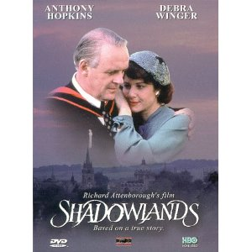
Dinner and a Movie at St. Matt’s: Shadowlands
Friday, September 23rd in Parish Hall
Potluck Dinner at 6:30pm, Movie at 7:30pm

This lavishly mounted 1993 adaptation tells the true story of the doomed love affair between novelist and noted Christian scholar C.S. Lewis and a Jewish-American poet, Joy Gresham. Anthony Hopkins stars as C.S. “Jack” Lewis, an Oxford professor and successful author of the Chronicles of Narnia. A confirmed bachelor, Jack’s existence is an inward life of the mind. Somewhat detached from the world, his only social contact is evenings out at the local pub discussing philosophy and religion with his fellow lecturers. Jack has been corresponding with an American poet, Joy (Debra Winger), who arrives to visit him, with her young son Douglas (Joseph Mazzello) in tow. She tells Jack that she has fled an abusive marriage and plans to divorce her husband. Later, Jack astonishes friends and family by agreeing to a platonic marriage with Joy so that she can obtain British citizenship. Genuine romance follows as their marriage turn into a real commitment of love. Together as one, they share the brief happiness life allows until they must endure the unendurable. Love does not conquer all, but as St. Paul tells us, “Love never gives up, never loses faith, is always hopeful, and endures every circumstance.” This movie presents two people who experience God’s love in the shadow of tragedy.



More Urban Promise...in Trenton!

This summer, Urban Promise benefited from the time and talent of St. Matthew’s parishioners in two locations. In addition to the annual summer mission trip to Camden, Urban Promise opened operations in Trenton with a full day Camp Truth program at Trinity Cathedral, Trenton.

Camp Truth was led by Trenton Urban Promise Executive Director Carl Clark and included many volunteers from St Matthew’s who staffed the program’s reading and writing enrichment sessions.

Sixty inner city children participated in the five week camp. Reading and writing enrichment was provided in two afternoon sessions each week, where the St. Matthew’s volunteers encouraged children to write and illustrate their own visions of how they are the promise of the city.

Urban Promise Trenton will continue operations through the school year with an after school program. Carl is looking for individuals to sponsor the children in the program. Each child sponsorship will cost $30.00 monthly. If you would like to participate by sponsoring a child in the program, visit www.urbanpromisetrenton.org.

If you’re interested in volunteering in the after school program this fall, contact Phyllis Jones at pj_soccermom@yahoo.com for more information.


Blessing of the Animals – Sunday, October 2rd
In celebration of the Feast of St. Francis, please join us for a Blessing of the Animals on the front porch of the church following the 10:00 a.m. service on Sunday, October 2nd. Whether your pet waits for you in the car or you need to run home to fetch it, we hope you can bring your special creature of God to Church for a blessing that morning.

THE RUMMAGE SALE IS COMING

- Save the dates: Friday & Sat. Oct 14 & 15.
Friday (9:00-5:00) & (6-8); Sat. (9:00-12:00)

- The church needs many more of you to participate by:

  - Collecting your gently used items now to donate between Sunday - Wed. (10/10 – 10/12)

  - Organize your schedule for fellowship together: Sorting = Mon.-Wed. (9:00 - 5), and/or Selling = Fri. - Sat. (see above)

- Additional information to follow. See you soon!!!

(Denny & Penny Rodgers & Sally Turner)



Taizé at St. Matthew’s
2nd and 4th Sundays at 5pm - Starting in October

Looking for worship that is simple, ecumenical, quiet and contemplative? Welcome to Taizé.

The 5 pm Taizé service will start for the 2010-2011 school year on Sunday, October 9th. This service will be held on the 2nd and 4th Sundays of each month, with the Holy Eucharist also being offered on the 4th Sunday. Taizé worship is quiet and personal, with a focus on prayer, silence, and meditative singing. If you have any questions about the service, please speak to one of the clergy or Rory, Director of Music.
LOOKING AHEAD...ADULT EDUCATION AT ST. MATTHEW’S
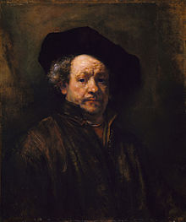

Rembrandt: The Artist
Sunday, October 16th at 7:00 pm

Rembrandt Harmenszoon van Rijn (1606 –1669) was a Dutch painter and etcher. He is generally considered one of the greatest painters and printmakers in European art history and the most important in Dutch history. His contributions to art came in a period that historians call the Dutch Golden Age. In preparation for the visit to view the exhibition, “Rembrandt and the Face of Jesus” at the Philadelphia Museum of Art (October 22), join Pam Krisulewicz as we explore who Rembrandt was and the many artworks that he created. For additional information, contact Pam Krisulewicz at pleekris@live.com or 730-1217.

SAVE THE DATE AND RESERVE YOUR SPOT NOW!

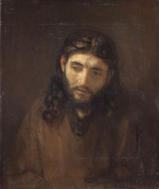
Saturday, October 22, 2011

Rembrandt and the Face of Jesus
Philadelphia Museum of Art

Rembrandt is universally acclaimed as the greatest master painter of the Dutch Golden Age. Rembrandt and the Face of Jesus, the first Rembrandt exhibition in Philadelphia since 1932, includes seven paintings of an exceedingly rare and singular series. Complemented by more than fifty related paintings, prints and drawings, this exhibition allows visitors to consider the religious, historic and artistic significance of these works.

St. Matthew’s would like to reserve a block of tickets for this exhibition by Sunday, September 18th (provided we can get at least 15 to participate!) Ticket prices (including an audio tour and museum admission) are $25 for adults, $23 for seniors (age 65+), and $20 for students and youth (ages 13-18). Payment is due at the time of reservation.

Participants are responsible for their own transportation. The current plan is to gather at the Museum at 11:15am on October 22nd and enjoy the exhibition together, with lunch afterwards for those who choose to stay.

To reserve your spot or ask questions, please contact Pam Krisulewicz at pleekris@live.com or at 609-730-1217.

LOOKING AHEAD...ADULT EDUCATION AT ST. MATTHEW’S (Continued)
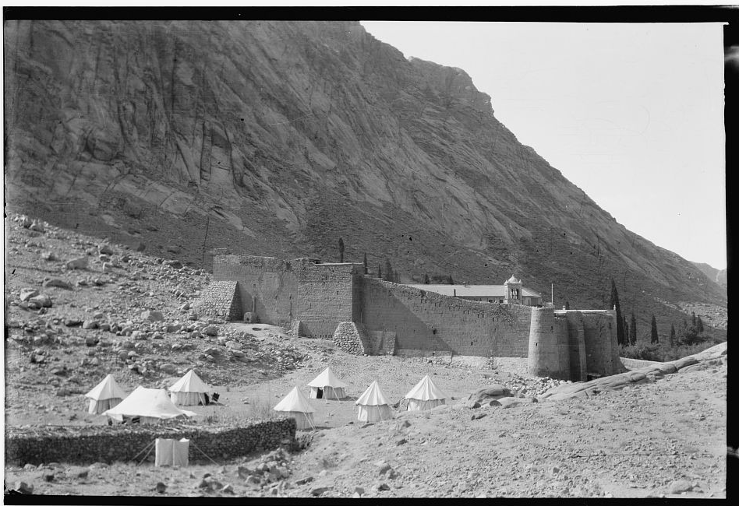

St. Catherine’s Monastery and “The Sisters of Sinai”
Sundays, October 23rd and 30th at 7:00pm
Led by Rev. Dr. John Mark Goerss and Dr. Katherine Goerss

Sunday, October 23 at 7:00 PM

St. Catherine’s Monastery and “The Sisters of Sinai” Part I

Through photos, books, a personal account, and brief video we will visit the Greek Orthodox Monastery of St. Catherine located at the foot of Mount Sinai, where Moses received the Ten Commandments, on the site of Moses’ encounter with God in the Burning Bush. Dating back to 324 AD and housed in buildings constructed by Emperor Justinian in 527 AD, St. Catherine’s Monastery is thought to be the oldest continuously inhabited Christian monastery in the world. The monastery is the repository of priceless early Christian manuscripts, including 4th Century Codex Sinaiticus and a copy of the Gospels in ancient Syriac, and has a collection of over 2000 icons, including the oldest known icons in existence dating back to the 6th century.

Sunday, October 30 at 7:00 PM - St. Catherine’s Monastery and “The Sisters of Sinai” Part II

Tonight’s presentation and discussion will focus on the book “The Sisters of Sinai: How Two Lady Adventurers Discovered the Hidden Gospels” by Janet Soskice. The book tells the true story of how two Victorian Sisters from Scotland traveled to Sinai in 1892 and discovered the earliest-known copy of the Gospels in ancient Syriac at the Monastery of St. Catherine. The book is a thrilling historical account that reads like a novel. The Archbishop of Canterbury has said that it is a book every church library should own. The book may be purchased from Amazon.com, but it is not necessary to have read the book before tonight’s presentation.


From the Shelves of Our Library

New books have been added to our parish library. Among them are:
- Made for Goodness - and Why This Makes All the Difference [SP] by Archbishop Desmond Tutu and his daughter, Mpho Tutu, also an Episcopal priest. They share their secrets of why they have so much
joy and hope.
- Huston Smith’s World Religions [HIST] has been called the best one volume book on the world’s major religions. It covers essentials of the world’s predominant faiths, with special attention to Zen, Tibetan Buddhism, and the teachings of Jesus.
- Janet Soskice in Sisters of Sinai: How Two Lady Adventurers Discovered the Hidden Gospels [HIST] tells the great adventures of twin sisters in the Middle East in the Victorian era, as they make one of the most important scriptural discoveries of their time: the earliest-known copy of the Gospels in ancient Syriac.
- Five Books of Moses: A Translation with Commentary [B/C] by Robert Alter draws on both Christian and Jewish commentaries and close reexamination of the importance of words in this excellent new translation of the Torah. Generous footnotes add to the value of the work.

Already in the library are two additional books, valuable for their coverage of two very different topics. Well- known preacher Barbara Brown Taylor’s Leaving Church: A Memoir of Faith [BIO] honestly portrays her struggle to serve God as a priest, and to just be one of his beloved children. It is humbling to share her journey in today’s world. Equally humbling is Why Jesus Crossed the Road: Learning to Follow the Unconventional Travel Itinerary of a First-century Carpenter and His Ragtag Group of Friends ... and Generally Go Where Most People Don't, [CW] by Bruce Main, President of Urban Promise. He tells how God can use your own ‘crossings’ to redirect your life and those you meet. Come and browse!

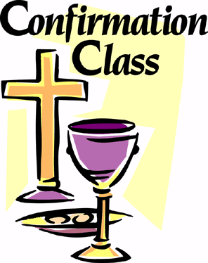
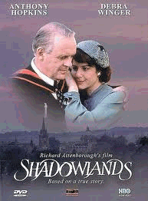
Youth Confirmation Class 2011-2012 News

NOTE DATE CHANGES!

For the last few years, we’ve heard comments about the long gap between the end of confirmation class (usually in February) and the start of Logos in the fall. The teens don’t want to wait that long to get back together! So we’ve decided (in conjunction with Bishop Councell’s schedule) to hold confirmation class a little later in the program year. Here are the dates you need to know at this point:

Tuesday, November 8th from 7 to 8pm Parent Orientation
Tuesday, November 15th from 6:30 to 8pm 1st Official Youth Confirmation Class
Sunday, April 15th at 10:00am Confirmation/Reception with Bishop Councell

More details to come next month! In the meantime, feel free to contact one of us with questions or concerns -

Peace,
Father Jack (jackbelmont@verizon.net) and Pastor Emily (emilygriffin@verizon.net)



Join the One Book Campaign!

Becoming an Anti-Racist Church: Journeying Toward Wholeness

The Diocese of New Jersey (per Bishop Councell’s invitation) invites everyone to read and discuss one book in the fall of 2011: Joseph Barndt’s Becoming an Anti-Racist Church (2011). (A copy may be found in the parish library.) Why isit that 11:00 on Sunday morning is still the most segregated hour of America, and what can we do to change that? Look for more on this book in next month’s newsletter. In the meantime, you’re invited to join the Diocese on Saturday, November 12th from 9:30am to 3pm at Trinity Cathedral in Trenton as the Rev. Barndt and Bishop Councell present “Tearing Down Walls and Building Bridges: Reclaiming an Anti-Racist Gospel.” To register, visit newjersey.anglican.org and click on “Ministry Institute.”

