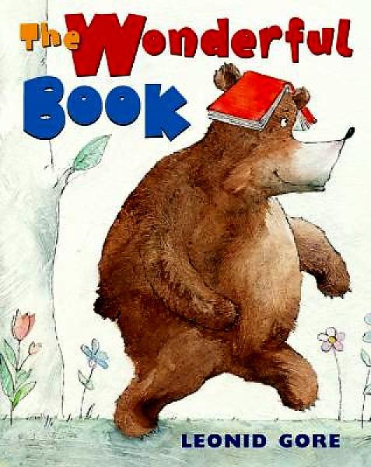Read Aloud Program: Book Enrichment Guide

**Title:** The Wonderful Book

**Author:** Leonid Gore

**Age Range:** 3-5

**Topics/Themes:** forest animals, books, reading

**Vocabulary**: curious, slither, scampered, strutted

**See examples of this book read loud here:** [The Wonderful Book](http://www.youtube.com/watch?v=mwHBk49doy8&list=PLB4A3308372A2B9F7&index=53&feature=plpp_video)

**Enrichment Activities**

1. **components of Book** (review each session)
   1. Author, Illustrator (roles of each)
   2. Title; front and back covers; spine
2. **Introduction** (prep Questions)

* What do you see on the cover?
* Why do you think the bear has a book on his head?
* What do we know about books? What do we do with them?

1. **Story time**
   1. **Discussion Questions**

* Would you like to read a book to your animal friends? If so, what kind of story?
* What do you think the bear should have done with the book instead of put it on his head?
* If your pet found a book, what would it do with it?
* Can you remember all the things the different animals did with the book? (made it a, bed, hat, table,etc.)
* What are your favorite books? Do you read any to your family?
  1. **Other**
* Discuss the proper way to handle and care for books
  + This story could be told using puppets and a prop book that is covered in red paper.
  + Children can participate by making appropriate animal sounds.
  1. **Related Songs, Rhymes & Finger plays** [(source)](http://molib.org/awards/buildingblock/2012/Wonderful%20Book.pdf)

Rhyme:

**“Books” by Susan Dailey**

Big books, little books (hold hands out wide, bring together)

Short books, tall (hold one hand above other, spread apart)

Thin books, fat books (hold thumb and pointer close together, spread apart)

I love them all! (place hand over heart)

This is my book; it will open wide, (palms together, open outwards)

To show the pictures that are inside. (point to one palm)

I read about a ball, so big and round. (make ball shape with hand)

It gets tossed in the air and rolled on the ground. (toss imaginary ball in air, roll arms)

I read about an umbrella to keep me dry, (put hands together above head)

When the raindrops fall from the cloudy sky. (flutter fingers downwards)

I read about a kitty with a loud, loud purr. (say “meow”)

I’d love to stroke her soft, warm fur. (make stroking motion)

Songs:

**“The More We Read Together”**

The more we read together (together, together)

The more we read together, the happier we’ll be!

We read your books and my books, and my books and your books, The more we read together, the happier we’ll be!

**“Read a Book!”** (to the tune of “If You’re Happy and You Know It”)

If you want to know an answer, read a book!

If you want to know an answer, read a book!

If you’re wondering where the moon goes, if you’re wondering how the grass grows, If you want to know an answer, read a book!

If you’d like to learn to draw, read a book!

If you’d like to learn to draw, read a book!

If you’d like to draw a dog, or a frog upon a log, If you’d like to learn to draw, read a book!

If you’d like to learn to cook, read a book!

If you’d like to learn to cook, read a book!

If you’d like to make some candy, or a pizza that is dandy, If you’d like to learn to cook, read a book!

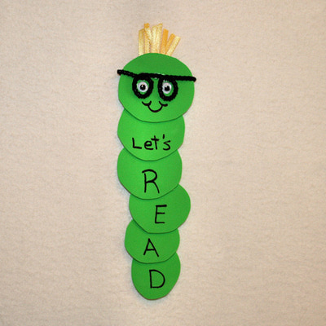

1. **supplementary Activities**

**Treating Books Like Treasures!**

Use the story to talk about appropriate ways to handle and treat books with care. Using the cards in the template section, sort the cards into “Things we do with books” and “Things we DON”T do with books”.

**Book Worm Bookmark** [(source)](http://familycrafts.about.com/od/bookmarks/ss/bookwormbm.htm)

Cut out green circles for body. Glue in overlapped pattern. Draw eyes and glasses on top circle and “let’s read” down the body of the bookworm.

1. **Templates **