

Mission
Inspire the Youth Foundation is a non-profit organization which implements programs to help improve the lives of the deserving, vulnerable and orphaned youth in Zimbabwe, Africa.
Programs
A. To influence community service and environmental awareness
- Impacting a life with education scholarships: school fees, levies, materials & supplies
- Providing access to medical attention
- Establish cleaning projects and planting of trees
Aspirations
B. To develop housing, education and skills development centers for the orphaned youth
- Provide a healthy, home-caring environment
- Feed, clothe and educate the children (sewing, shoemaking, etc.)
- Build boreholes for clean drinking water
C. To provide transportation for the elderly to stores, meals and medical attention
Mentoring
D. To continue the afterschool mentoring for the deserving, vulnerable and orphaned youth
- Our current participants are representing 10 schools in Bulawayo, Zimbabwe, Africa
- Encouraging the children to be productive vs. being destructive
Donations
We request any support that you are able to give in this effort. Thank you for what you are able to do. We should keep in our hearts that when you help a deserving child, you are contributing in the development of the society.
Contact
Inspire the Youth Foundation P.O. Box 831209 Tuskegee, Alabama 36083 334.552.0897 www.inspiretheyouth.org director@inspiretheyouth.org Dingani Nkuchwayo, Founder and Director
Volunteer to Help a Child in ZIMBABWE, AFRICA
Children’s Education Supplies and Personal Items
Pens, Notebook paper, 3-ring binder, Backpacks, Folders, Composition books, Colored pencils, Shoes, Tennis shoes, Socks, Shirts, Jackets, Sweaters, Uniforms, Soccer balls, Ball bags, Shin Guards, Soccer Cleats, Training soccer goals
Be Part of Building a Children’s Home and Education Center
Building materials, Computers, Internet access, Rugs, Furniture, Bedding, Mosquito nets, etc.
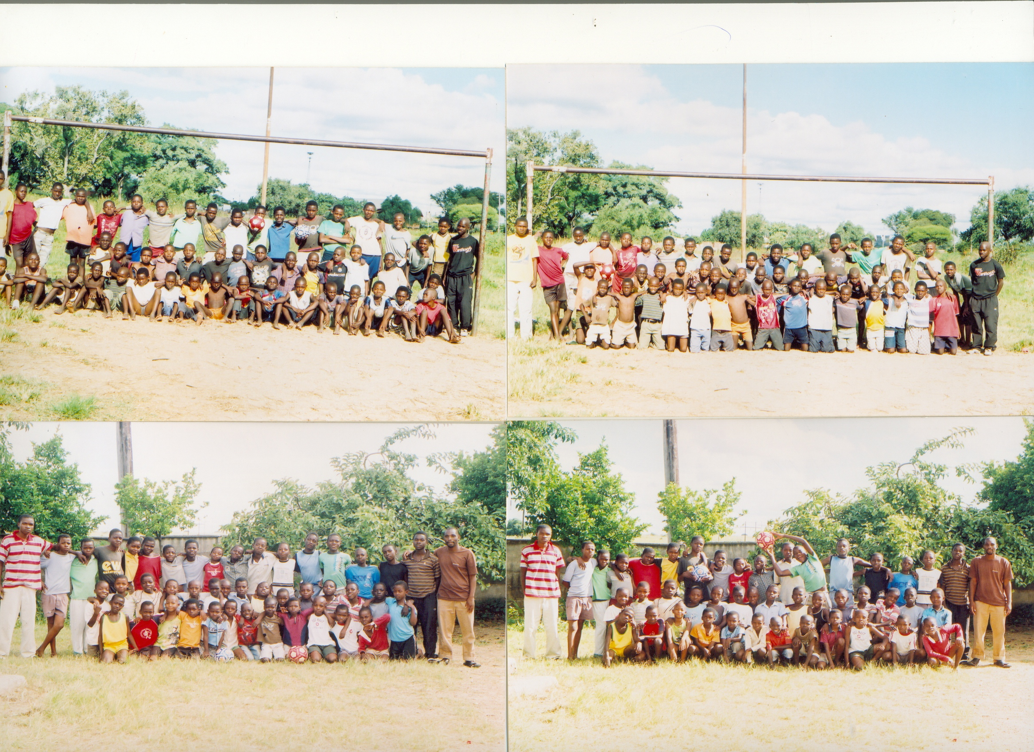
S p o n s o r a C h i l d ‘s E d u c a t i o n
S u p p o r t a T e a m

Inspire the Youth Foundation P.O. Box 831209 Tuskegee, Alabama 36083 334.552.0897 www.inspiretheyouth.org director@inspiretheyouth.org Dingani Nkuchwayo, Founder and Director

