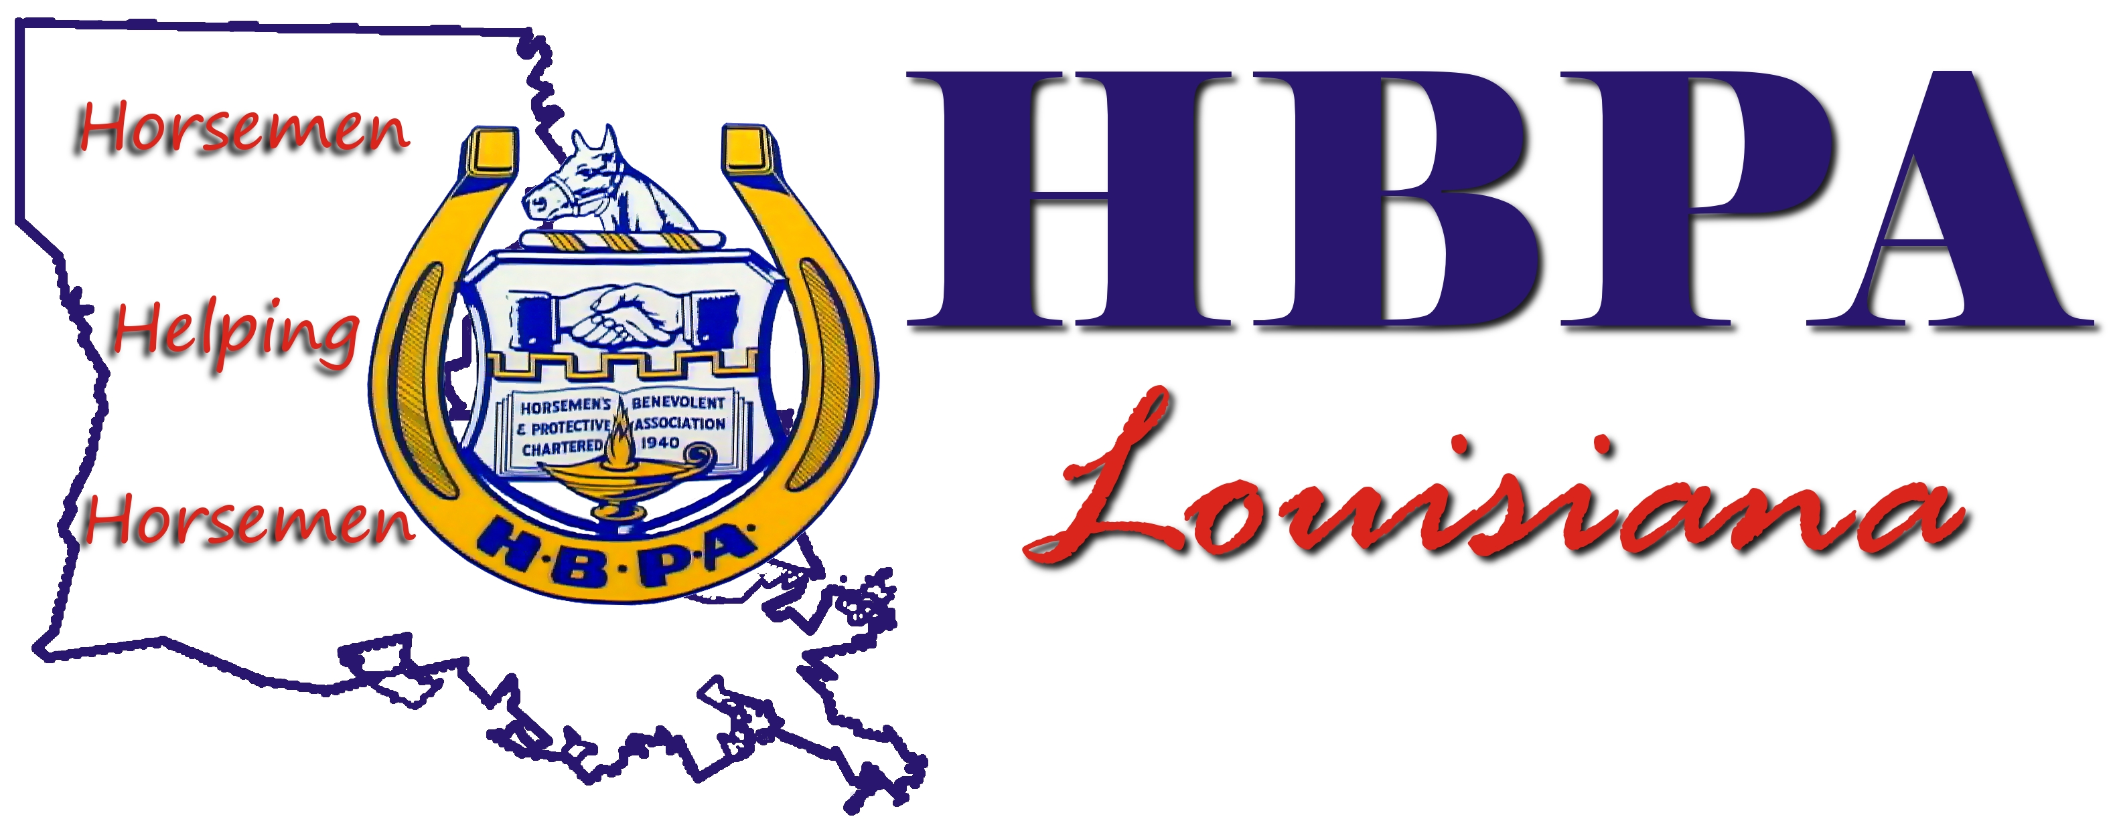
AGENDA

Louisiana Horsemen’s Benevolent and Protective Association 1993, Inc.
Board of Directors Meeting
Monday, January 10, 2011 @ 2:00 pm
LAHBPA - Main Office New Orleans

OPENING

1. Call To Order: Larry Robideaux
2. Roll Call and Declaration of Quorum: Ed Fenasci
3. Opening Prayer:
4. Waiver of 10-day Notice
5. Approval of BOD Minutes of Dec 7, 2010

REPORTS

Legal Report: Settlement with Harrah’s Louisiana Downs - Jim Gelpi
Seelig and Morrell Derivative Suits - Liz Roussel
Review of Composition of Boards and Committees of Related Entities - Ed Fenasci and Jim Gelpi
Horsemen’s Alliance (PAC)
The Louisiana Horsemen’s Medical Benefit Trust
The Louisiana Horsemen’s Pension Trust Agreement
Louisiana Horsemen’s Benevolent and Protective Assn. Charitable Foundation Inc.
Horsemen’s Alliance Holdings, Inc.
Status of resignations from Sean Alfortish and Mona Romero From All Related Boards, Positions, Committees and as Signatories - Ed Fenasci
Status of HBPA 2011 Legislative Program - Jim Gelpi
Status of Delinquent Workers’ Compensation Accounts - Mike Fenasci
Homeland Security Meeting of January 3, 2011 - Ed Fenasci and Jim Gelpi
Status of Item No. 3 of Stakelum 11/19/10 Demand Letter – Don Hargroder and Carrol Castille

OLD BUSINESS
Consideration of Civil Recovery Actions and Other Possible Actions Including those Potentially Identified in Recent Indictments and New Information Received and Status of Expenditures Identified in Indictments
Consideration of HBPA Litigation Position in the Derivative Suits Following Recent Indictments and New Information Received

NEW BUSINESS
Election
Consideration of Approval of Mailing Election Ballots Approximately 9 Days Earlier than
Provided for in the Bylaws
Consideration of Approval of Composition of Election Committee
Consideration of Election Committee Duties on or Before Election Day in Relation to
Independent Election Contractor
Consideration of Initiation of Backside Workers Compliance Project

OTHER NEW BUSINESS
Consideration of Motion to Adjourn

