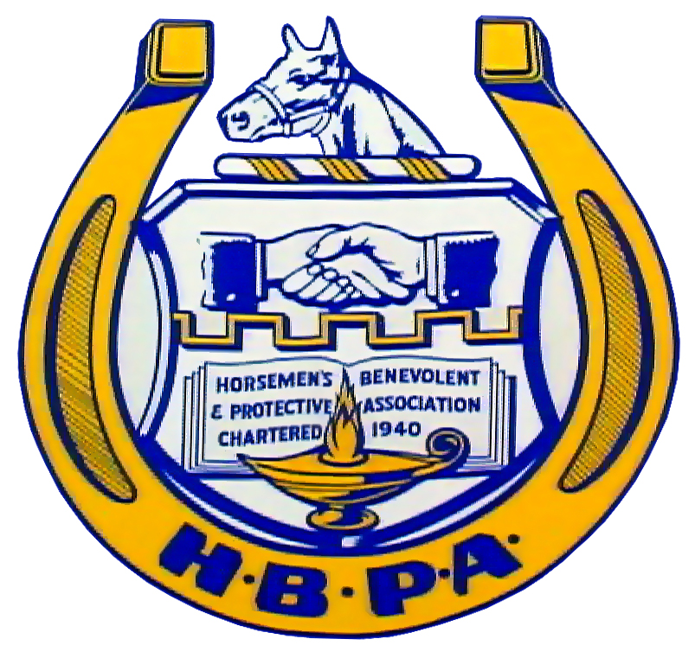

LAHBPA
Board of Directors Meeting

When:
Wednesday, January 19, 2011
At 10:00 A.M.

Where:
LAHBPA MAIN OFFICE
1535 Gentilly Blvd.
New Orleans, LA 70119

*LICENSED MEMBERS ONLY MAY ATTEND*

