**Executive Summary**

The Champaign Health District (CHD) conducted this collaborative community health assessment (CHA) to summarize Champaign County’s population health status and needs. The findings of this CHA will inform community decision-makers, help identify priority public health issues, and guide health improvement strategies. CHD will use data to engage stakeholders in the development and implementation of a community health improvement plan (CHIP) for Champaign County. The coalitions who will develop the CHIP will focus on five areas of health: *Nutrition and Wellness, Mental Health, Substance Abuse, Early Child Wellness,* and *Social Determinants of Health.*

The data presented in this CHA is from multiple sources, included secondary data from the United States Census Bureau, the Ohio Department of Health, the United States Department of Agriculture, the Ohio Department of Education, and other sources. Information from these sources is summarized into nine sections: *Morbidity Statistics, Demographics, Market Potential Data, Food Access, School Data, Birth Statistics, Death Statistics, Cancer Statistics,* and *Infectious Disease Statistics.*

Additionally, primary data was collected from the Youth Risk Behavior Survey (YRBS), the Behavioral Risk Factor Surveillance System (BRFSS), and the Community Health Assessment And Group Evaluation (CHANGE) tool. The CHANGE tool was administered in four of the most at-risk neighborhoods in Champaign County as determined by the primary and secondary data analyses.

The most concerning topics that came out of this assessment include: *Health Behaviors, Social and Economic Environment, Health Outcomes,* and *Physical Environment.* The most concerning focus areas that came out of this assessment include: *Income, Housing and Transit, Employment, Education, Family and Social Support, Tobacco use, Diet and exercise, Quality of life, Length of life, and Communicable disease* The most concerning measures that came out of this assessment include: *Families in poverty, nonfamilies in poverty, families no earnings, Vacant homes, Unemployed, High School Graduation, Smoking, Exercise, Diet, Food access, Education standards, Education performance index score, Prenatal visits, Cancer, Heart disease, Chronic lower respiratory diseases, Cerebrovascular diseases, Alzheimer’s disease, Diabetes, Suicide, and Hypertension.*

**Key Community Health Indicators**

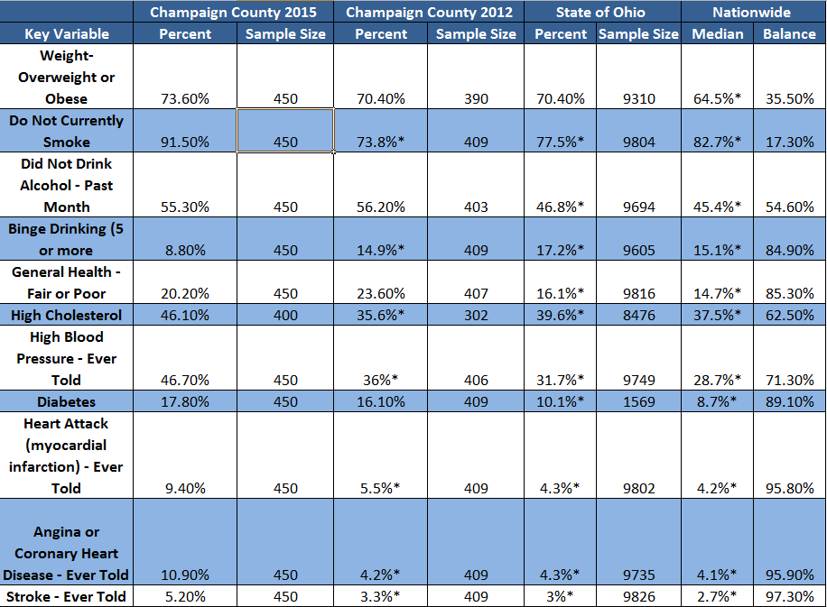

|  |  |  |
| --- | --- | --- |
| **Nutrition** | | |
| **Adult Data (BRFSS)** | **Champaign County** | |
| Percent of adults who are overweight or obese | 73.60% | |
| Percent of adults told they have high cholesterol | 46.10% | |
| Percent of adults told they have high blood pressure | 46.70% | |
| Percent of adults with diabetes | 17.80% | |
| **Middle School Data (YRBS)** |  | |
| Percent of students who described themselves as slightly or very overweight | 33.50% | |
| Percent of students who went without eating for 24 hours or more to lose weight or to keep from gaining weight during the past 30 days | 19.80% | |
| Percent of students who took diet pills, powders, or liquids to lose weight or to keep from gaining weight | 6.20% | |
| Percent of students who vomited or took laxatives to lose weight or to keep from gaining weight during the past 30 days | 4.70% | |
| Percent of students who are overweight | 16% | |
| Percent of students who are obese | 12.80% | |
| Percent of students who are overweight or obese | 28.40% | |
| Percent of students who did not eat breakfast during the past 7 days | 9.30% | |
| **High School Data (YRBS)** |  | |
| Percent of students who describe themselves as slightly or very overweight | 37.10% | |
| Percent of students who went without eating for 24 hours or more to lose weight or to keep from gaining weight in the past 30 days | 17.20% | |
| Percent of students who took diet pills, powders, or liquids to lose weight or to keep from gaining weight | 9% | |
| Percent of students who vomited or took laxatives to lose weight or to keep form gaining weight during the past 30 days | 7% | |
| Percent of students who are obese | 24% | |
| Percent of students who are overweight or obese | 40.30% | |
| Percent of students who did not drink 100% fruit juices during the past 7 days | 33% | |
| Percent of students who did not eat fruit during the past 7 days | 14.20% | |
| Percent of students who did not eat other vegetables during the past 7 days | 21.10% | |
| **Community Level Data (CHANGE Tool)** | | |
| *In some areas throughout the county……..* | | |
| Does not encourage community garden initiatives. | | |
| Does not enhance access to public transportation to supermarkets and large grocery stores. | | |
| Does not promote the purchase of fruits and vegetables at local restaurants and food venues. | | |
| Does not adopt strategies to recruit supermarkets and large grocery stores in underserved areas. | | |
| Does not institute nutritional labeling (low fat, light, heart healthy) at local restaurants and food venues. | | |
| Does not provide comfortable, private spaces for women to nurse or pump in public places to support and encourage residents’ ability to breastfeed. | | |
| **Secondary Data Points (Community Health Assessment)** | | |
| The food environment index, the index of factors that contribute to a healthy food environment, was 8. | | |
| Likelihood of population checking ingredients on food products before purchasing low in some areas. | | |
| Fruit and vegetable consumption low in some areas. | | |
| Food access low in some areas. | | |
| **\*Maps of lowest scoring areas available** |  | |
| **\*Maps available** |  | |
| **Physical Activity** | | |
| **Adult Data (BRFSS)** | **Champaign County** | |
| Percent of adults ever told they had a heart attack | 9.40% | |
| Percent of adults ever told they have coronary heart disease | 10.90% | |
| Percent of adults ever told they have had a stroke | 5.20% | |
| **Middle School Data (YRBS)** |  | |
| Percent of students who were physically active at least 60 minutes per day on less than 5 days (during the past 7 days) | 38.90% | |
| Percent of students who watched television 3 or more hours per day | 30% | |
| Percent of students who played video or computer games or such a computer for something that is not school work 3 or more hours per day | 45.80% | |
| Percent of students who did not attend physical education classes in an average week | 60.80% | |
| Percent of students who did not play on sports teams during the past 12 months | 35.50% | |
| **High School Data (YRBS)** |  | |
| Percent of students who were physically active at least 60 minutes per day on less than 5 days | 36.10% | |
| Percent of students who used computers 3 or more hours per day | 48.10% | |
| Percent of students who did not attend physical education classes in an average week | 33.50% | |
| **Community Level Data (CHANGE Tool)** | | |
| *In some areas throughout the county….* | | |
| Does not require sidewalks to be built for all developments. | | |
| Does not require bike facilities to be built for all developments. | | |
| Does not adopt a complete streets plan to support walking and biking infrastructure. | | |
| Does not adopt strategies to enhance personal safety in areas where people are or could be physically active. | | |
| **\*Maps of low scoring areas available.** | | |
| **Secondary Data (Community Health Assessment)** | | |
| The percent of adults who reported no leisure time physical activity was 28.4 | | |
| The percent of adults who have access to exercise facilities or a place to participate in leisure time physical activity was 60.1. | | |
| Likelihood that people will exercise or purchase exercise products low in some areas. | | |
| **\*Maps available.** |  | |
| **Mental Health** | | | |
| **Behavioral Risk Factor Surveillance System (BRFSS)** | | **Champaign County** | |
| Mentally unhealthy days (age adjusted per person) | | 4.1 | |
| Mentally unhealthy days (per person) | | 4 | |
| Mentally unhealthy days: adults (per person) | | 3.7 | |
| **Secondary Data** | |  | |
| Alzheimer's disease or related disorders medicare beneficiaries | | 310 | |
| Depression Medicare beneficiaries (count) | | 699 | |
| Depression Medicare beneficiaries (percent) | | 17.98% | |
| Age-adjusted death rate to due Alzheimer's disease | | 26.3 | |
| People with a mental disability | | 5.4 | |
| Age-adjusted death rate due to suicide | | 15.5 | |
| Suicide deaths (per 100,000) | | 14.6 | |
| **Youth Risk Behavior Survey - Middle** | |  | |
| Percent of students who have ever been bullied on school property | | 57.8% | |
| Percent of students who have ever been electronically bullied | | 34% | |
| Percent of students who have ever been the victim of teasing or name calling because of their weight, size, or physical appearance | | 44.5% | |
| Percent of students who disagreed or strongly disagreed that their parents or other adults in their family have clear rules and consequences for their behavior | | 7% | |
| Percent of students who did not eat dinner at home with their family with at least one of their parents or guardians during the past 7 days | | 6.7% | |
| Percent of students who would not feel comfortable seeking help from any adults if they had an important question affecting their life | | 17.4% | |
| Percent of students who seriously considered attempting suicide | | 28.8% | |
| Percent of students who made a plan about attempting suicide | | 20.6% | |
| Percent of students who attempted suicide one or more times | | 11.9% | |
| **Youth Risk Behavior Survey - High** | |  | |
| Percent of students who have ever been bullied on school property | | 22.5% | |
| Percent of students who have ever been electronically bullied | | 18.2% | |
| Percent of students who have ever been the victim of teasing or name calling because of their weight, size, or physical appearance | | 30.4% | |
| Percent of students who disagreed or strongly disagreed that their parents or other adults in their family have clear rules and consequences for their behavior | | 13.5% | |
| Percent of students who did not eat dinner at home with their family with at least one of their parents or guardians during the past 7 days | | 10.8% | |
| Percent of students who would not feel comfortable seeking help from any adults if they had an important question affecting their life | | 12.8% | |
| Percent of students who ever felt sad or hopeless almost every day for 2 weeks or more during the past 12 months | | 31% | |
| Percent of students who seriously considered attempting suicide | | 20% | |
| Percent of students who made a plan about attempting suicide | | 15.4% | |
| Percent of students who attempted suicide one or more times | | 14.1% | |

|  |  |  |  |
| --- | --- | --- | --- |
| **Alcohol** | | | |
| **Adult Data (BRFSS)** | | **Champaign County** | |
| Percent of respondents who binge drink (5 or more drinks on one occasion) | | 8.80% | |
| Percent of respondents who did not drink alcohol in the past month | | 55.30% | |
| **Middle School Data (YRBS)** | |  | |
| Percent of students who have ever had at least one drink of alcohol at least 1 day | | 28.40% | |
| Percent of students who rode in a car or other vehicle being driven by someone who had been drinking alcohol one or more times | | 24.70% | |
| Percent of students who drank alcohol for the first time before age 13 | | 19.60% | |
| **High School Data (YRBS)** | |  | |
| Percent of students who had at least one drink of alcohol on at least one day in the past 30 days | | 22.90% | |
| Percent of students who rode in a car or other vehicle being driven by someone who had been drinking alcohol one or more times | | 23.20% | |
| Percent of students who drove a car or other vehicle one or more times during the past 30 days when the student had been drinking alcohol | | 12.90% | |
| Percent of students who drank alcohol for the first time before age 13 | | 16.30% | |
| Percent of students who had 5 or more drinks of alcohol in a row within a couple of hours | | 22.60% | |
| **Drugs** | | | |
| **Secondary Data** | | **Champaign County** | |
| Number of overdose related diagnoses for residents in 2015 | | 166 | |
| **Middle School Data (YRBS)** | |  | |
| Percent of students who have ever used marijuana one or more times | | 9% | |
| Percent of students who have ever sniffed glue, breathe the contents of aerosol spray cans, or inhaled any paints or sprays to get high | | 7.30% | |
| Percent of students who have ever taken a prescription drug without a doctor’s prescription one or more times | | 8.90% | |
| **High School Data (YRBS)** | |  | |
| Percent of students who tried marijuana for the first time before age 13 | | 10.40% | |
| Percent of students who have ever used any form of cocaine one or more times | | 9.80% | |
| Percent of students who have ever used heroin one or more times | | 7.60% | |
| Percent of students who have ever taken steroid pills or shots without a doctor’s prescription one or more times | | 7.60% | |
| Percent of students who have ever used a needle to inject any illegal drug into his/her body one or more times | | 6.40% | |
| **Tobacco Use** | | | |
| **Adult Data (BRFSS)** | | **Champaign County** | |
| Adults who are current smokers | | 19.10% | |
| **Middle School Data (YRBS)** | |  | |
| Percent of students who have tried cigarette smoking, even one or two puffs | | 17.60% | |
| Percent of students who smoked a whole cigarette for the first time before the age of 13 | | 8% | |
| Percent of students who smoked cigarettes on at least 1 day during the past 30 days | | 6.10% | |
| Percent of students who ever smoked at least one cigarette every day for 30 days | | 1.80% | |
| Percent of students who smoked cigars, cigarillos, or little cigars on at least 1 day in the past 30 days | | 4.00% | |
| **High School Data (YRBS)** | |  | |
| Percent of students who smoked cigarettes on school property on at least 1 day in the past 30 days | | 5.40% | |
| Percent of students who smoked more than 10 cigarettes per day | | 13.10% | |
| Percent of students who ever smoked at least one cigarette every day for 30 days | | 12.70% | |
| Percent of students who used chewing tobacco, snuff, or dip on at least 1 day | | 13.30% | |
| **Community Level Data (CHANGE Tool)** | | | |
| *In some areas throughout the county….* | | | |
| Does not institute a tobacco-free policy 24/7 for outdoor public places. | | | |
| Does not institute a tobacco-free policy 24/7 for indoor public places. | | | |
| Does not ban tobacco advertisement. | | | |
| Does not regulate the number, location, and density of tobacco retail outlets. | | | |
| Does not increase the price of tobacco products and generate revenue with a portion of the revenue earmarked for tobacco control efforts. | | | |
| Does not provide access to a referral system for tobacco cessation resources and services, such as a quitline. | | | |
| **\*Maps of low scoring areas are available.** | |  | |
| **Secondary Data (Community Health Assessment)** | | | |
| Likelihood that people will purchase cigarettes in one week high in some areas. | | | |
| Likelihood that people will purchase a smoking cessation product low in some areas. | | | |
| **\*Maps available.** | |  | |
| **Young Child Wellness** | | |
| **Secondary Data** | **Champaign County** | |
| 4th grade students proficient in math | 81.9% | |
| 4th grade students proficient in reading | 88.08% | |
| 8th grade students proficient in math | 83.04% | |
| 8th grade students proficient in reading | 89.08% | |
| Students eligible for the free lunch program | 33.3% | |
| Student-to-teacher ratio | 17.67 | |
| Children with asthma | 20.8% | |

|  |  |
| --- | --- |
| **Social Determinants of Health** | |
| **Education** | **Champaign County** |
| Less than 9th grade | 3.2% |
| 9th to 12th grade, no diploma | 8.6% |
| High school graduate (includes equivalency) | 44.9% |
| Some college, no degree | 19.7% |
| Associate's degree | 7.5% |
| Bechelor's degree | 11.0% |
| Graduate or professional degree | 5.1% |
| Percent high school graduate or higher | 88.1% |
| Percent bachelor's degree or higher | 16.0% |
| **Disability** |  |
| Total civilian noninstitutionalized populatih with a disability | 14.4% |
| Under 18 years with a disability | 4.9% |
| 18 to 64 years with a disability | 13.5% |
| 65 years and over with a disability | 33.3% |
| **Employment** |  |
| Unemployment rate for population 16 years and over | 10.2% |
| Unemployment rate by race |  |
| Unemployment rate by poverty status in the past 12 months | 48.5% |
| Unemployment rate by disability status | 14.3% |
| Unemployment rate by educational attainment |  |
| **Households by Type** |  |
| Male householder, no wife present, family | 4.5% |
| Female householder, no husband present, family | 11.7% |
| **Mariltal Status** |  |
| Males 15 years and over, now married, except separated | 57.9% |
| Males 15 years and over, divorced | 10.0% |
| Females 15 years and over, now married, except separated | 54.0% |
| Females 15 years and over, divorced | 14.7% |
| **Fertility** |  |
| Unmarried women (widowed, divorced, and never married) | 34.1% |
| Rate per 1,000 unmarried women | 40 |
| Rate per 1,000 women 15 to 19 years old | 9 |
| **Grandparents** |  |
| Number of grandparents living with own grandchildren under 18 years | 1150 |
| Responsible for grandchildren | 35.6% |
| **Residence 1 Year Ago** |  |
| Different house in the US | 15.0% |
| Same county | 9.4% |
| Different county | 5.6% |
| **US Citizenship Status** |  |
| Foreign-born population | 378 |
| Naturalized US citizen | 29.4% |
| Not a US citizen | 70.6% |
| **Language Spoken at Home** |  |
| Language other than English | 2.1% |
| Speak English less than "very well" | 0.8% |
| **Occupation** |  |
| Management, business, science, and arts occupations | 28.0% |
| Service occupations | 16.7% |
| Sales and office occupations | 21.5% |
| Natural resources, construction, and maintenance occupations | 9.0% |
| Production, transportation, and material moving occupations | 24.8% |
| **Income and Benefits (in 2014 inflation-adjusted dollars)** |  |
| Median household income (total households) | 49840 |
| Mean household income (total households) | 60340 |
| With supplemental security income | 6.0% |
| With cash public assistance income | 4.9% |
| With Food Stamp/SNAP benefits in the past 12 months | 14.2% |
| Median family income | 59258 |
| Mean family income | 68227 |
| Per capita income | 23573 |
| Median earnings for workers (dollars) | 27267 |
| Median earnings for male full-time, year-round workers (dollars) | 47116 |
| Median earnings for female full-time, year-round workers (dollars) | 36579 |
| **Health Insurance Coverage** |  |
| Civilian noninstitutionalized population with health insurance coverage | 90.2% |
| With private health insurance | 71.1% |
| With public coverage | 32.9% |
| No health insurance coverage | 9.8% |
| **Percentage of Families and People Whose Income in the Past 12 Months is Below the Poverty Level** | |
| All families | 8.0% |
| With related children under 18 years | 15.4% |
| With related children under 5 years only | 11.9% |
| Married couple families | 5.4% |
| Families with female householder, no husband present | 20.8% |
| Families with female householder, no husband present with children under 18 years | 29.1% |
| Familes with female householder, no husband present with children under 5 years only | 41.8% |
| All people | 12.6% |
| Under 18 years | 21.0% |
| Related children under 5 years | 17.6% |
| Related children 5 to 17 years | 21.5% |