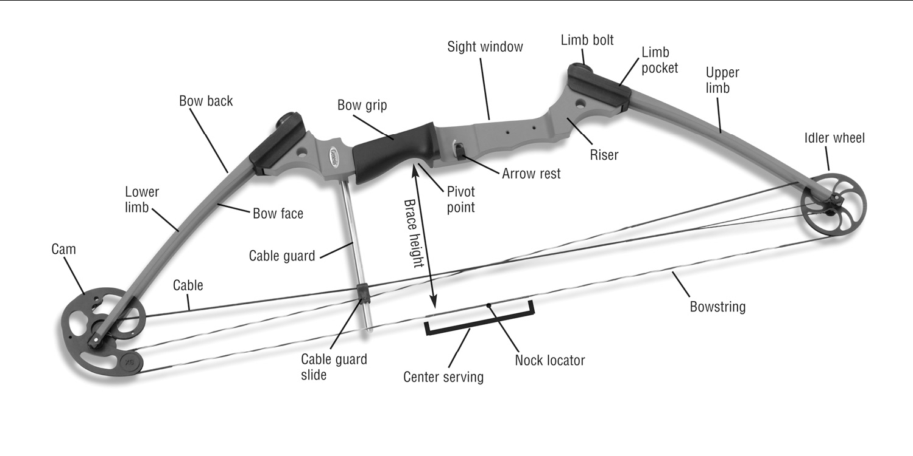**Parts of the Bow**

**and Arrow**

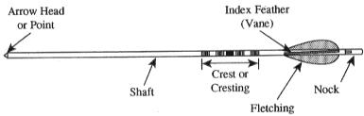

Scout Archery Clinic



**SELECT ARCHERY FACTS FROM HISTORY & LITERATURE**

Archery is VERY OLD, possibly as old as 80,000 years old.

Earliest known archery was approximately 8,000 to 10,000 years ago.

Archery was important in warfare, but was gradually replaced in battle by firearms in the 1500’s and 1600’s. Many primitive cultures used the bow and arrow in warfare even in the modern age.

The Battle of Agincourt is the most famous archery battle in human history.

Henry V of England invaded France in the year 1415 as part of what is known as the Hundred Years War. On October 25th, the English met Charles VI and his French army at the Battle of Agincourt. Severely outnumbered, Henry V won a historic victory thanks to his reliance on a large number of archers equipped with the famous English longbow. 2015 marked the 600th Anniversary of Agincourt.

William Shakespeare wrote about the Battle of Agincourt in his play, Henry V.

Archery is the national sport of the Kingdom of Bhutan.



Archery became an Olympic sport in the 1900 Summer Olympics. In 1924 it was discontinued and it was reintroduced in 1972. In the 1904 Olympics, archery was the only women’s sport.