Terms and Conditions of Agreement Between

The Governors
of Athabasca University
(the Board)

And

Athabasca University
Faculty Association (AUFA)

Terms and Conditions: July 1, 2015 to June 30, 2019

Salaries and Benefits: July 1, 2016 to June 30, 2018

TABLE OF CONTENTS
Terms and Conditions of Agreement Between 1
Headings 7
Interpretation 7
Letters and Memoranda of Agreement 7
1. Definitions 9
2. Scope, Duration, Renewal and Amending Procedures 12
2.1 Scope 12
2.2 Duration 13
2.3 Renewal and Amendment 13
2.4 Security of Employment 14
3. Regular Appointment, Probation, Determination and Performance of Duties, and Promotion for Academic Staff Members 16
3.1 Regular Appointment 16
3.2 Probation 17
3.2.7 Early Review 18
3.3 Determination and Performance of Duties 19
3.4 Term Assignment 21
3.5 Appointment Procedure 21
3.6 Promotion Of Staff Members 22
3.6.10 Procedure For Academic Staff Members 23
3.7 Criteria for Staff Member Appointment and Academic Promotion 24
3.7.3 Academic Positions 24
3.8 Guidelines for Application of Criteria 25
3.8.1 Academic Positions 25
4. Regular Appointment, Probation, Determination and Performance of Duties, and Promotion for Professional Staff Members 28
4.1 Regular Appointment 28
4.2 Probation 28
4.3 Determination and Performance of Duties 30
4.4 Term Assignment 32
4.5 Position Evaluation 32
4.6 Appointment Procedure 33
4.7 Promotion Of Staff Members 33
4.8 Criteria for Staff Member Appointment 34
5. Term Appointments 35
Establishment 35
Duration 36
Notice and Termination 37
Scope 37
6. Salaries and Economic Benefits 41
6.1 Salary and Increment Schedule 41
6.2 Benefits 41
6.3 Procedure for Negotiation / Impasse Resolution (of salaries and economic benefits) 41
6.4 Salary Increments 43
6.5 Other Salary Adjustments 44
6.6 Acting Pay 45
7. Discipline 47
7.9 Appeal Committee 49
7.10 Procedures 49
7.11 Decision 50
7.12 Fees 51
7.13 Timelines 51
8. Grievance Procedure 52
9. Appeal Procedure 55
Appeals with Respect to Position Evaluation 58
10. Discrimination and Harassment 60
11. Academic and Professional Freedom 61
11.1 General 61
11.2 Academic Freedom 61
11.3 Professional Freedom 61
12. Position Reduction 62
12.1 Financial Stringency 62
12.2 Redundancy 62
13. Professional Development 66
13.1 Principles 66
13.2 Individual Professional Development Fund 66
13.3 Academic and Professional Development Fund 66
13.4 Academic Research Fund 67
13.5 Professional Development Leave 67
14. Annual Research Leave 68
15. Research and Study Leave 70
15.1 Principles 70
15.2 Purpose 70
15.3 Eligibility 70
15.4 Duration 71
15.5 Financial Support 71
15.6 Application 72
15.7 Approval 73
15.8 Professional Staff Member Full Salary Option 74
15.9 Reporting 74
15.10 Economic Benefits 75
15.11 Travel and Relocation Fund 75
16. Other Leaves 77
16.1 General 77
16.2 Exchange Leave 78
16.3 Political Leave 78
16.4 Vacation Leave 79
16.5 Sick Leave 80
16.6 Maternity Leave 81
16.7 Parental Leave 82
16.8 Compassionate Care Leave 83
17. Time-Off 85
17.1 Association Business 85
17.2 Voting 85
17.3 Court Proceedings 85
18. Paid Holidays 86
19. Removal and Relocation Allowances 87
20. External Professional Activities 88
20.2 Conditions 88
21. Confidentiality and Access to Personnel Files 90
22. Resignation 91
22.1 Notice Period 91
22.2 Exit Interview 91
23. Death in Service 92
24. Retirement 93
25. Occupational Health and Safety 97
26. Equity 98
Principles 98
Employment Equity Committee 98
27. Casual Appointments 100
Schedule A-1: 101
Academic and Academic Professional Salary Rates and Scales – July 1, 2013 - June 30, 2015 101
Schedule A-2: 102
Professional Staff Salary Rates and Scales – July 1, 2013 - June 30, 2015 102
Schedule A-3: 103
Overload Payments 103
Schedule B: 104
Economic Benefits 104
Schedule C: 106
Positions of a Managerial or Confidential Nature 106

SCHEDULE D: …………………………………………………………………………………………. 107
Schedule E: 108
Position Evaluation System 108
THE SYSTEM 109
JOB EVALUATION FACTORS 110
A. Education/Experience 110
B. Communication 111
C. Supervision 111
D. Impact of Service or Product 112
E. Independence of Action 112
F. Complexity 113
G. Planning 113
WEIGHTING 114
POSITION EVALUATION COMMITTEE 115
EVALUATION APPEAL 115
SALARY IMPLICATIONS 115
DETERMINATION OF POSITIONS ON SCHEDULE D 115
Schedule F: 117
Research and Study Leave Conversion Table 117
Appendix One: 118
Letters and Memoranda of Agreement / Understanding 118
Memorandum of Agreement – Position Evaluation System 119
Letter of Agreement- Regarding the Annual Settlement of Benefit Premium Surpluses/Deficits 120
Letter of Understanding – Contracting Out 121
Letter of Understanding – Term Staff 122
Letter of Agreement - Market Supplements 123
Letter of Agreement - Professional and Academic Overload 124
Letter of Agreement - Productivity Awards 125
Letter of Understanding – Joint Benefits Committee and Benefits Plan Reporting 126
Letter of Agreement – Review of the Position Evaluation System for Professional Staff 127
Letter of Agreement-Accommodation of Staff Members with Disabilities 128
Letter of Agreement – Support and Mentoring of Academic Staff Members 131
Letter of Agreement – Heritage Resources Management Undergraduate Interns 132
Letter of Agreement – Editing and Indexing of the Terms and Conditions of Agreement 133
Letter of Understanding – Discretionary Benefit Funds 134
Letter of Agreement – Deans 135
Letter of Agreement – Regarding Pay Cycle Alignment – March 2014 137
Memorandum of Agreement – Between the Board and AUFA – April 23, 2014 139
Interest Arbitration Award - Between the Board and AUFA - October 10, 2013 154
letter of agreement - on call and callback pay committee 159

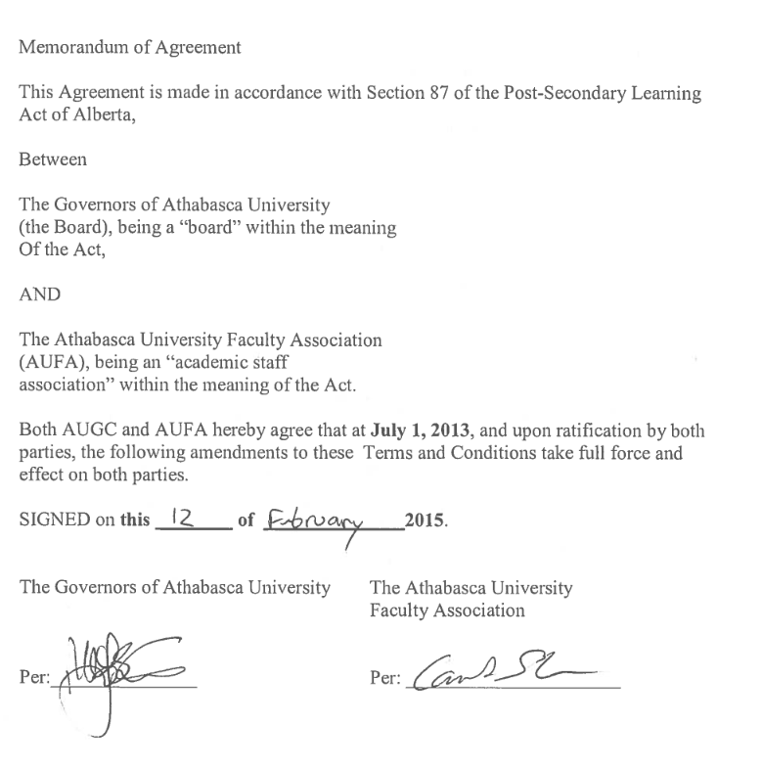

Headings

The captions and headings in this Agreement are for convenience of reference only and shall not affect the interpretation of any provision in this Agreement nor its scope or intent.

Interpretation

This Agreement shall be interpreted in accordance with the laws of the Province of Alberta.

Letters and Memoranda of Agreement

Attached to this Agreement, as Appendix One, are various Letters and Memoranda of Agreement.

Date Subject

December 14, 1983 Position Evaluation System
July 1, 1986 Economic Benefits Negotiation Process
July 1, 1996 Letter of Understanding – Contracting Out
July 1, 1996 Letter of Understanding – Term Staff
July 1, 2003 Letter of Agreement – Market Supplements (Amended July 1, 2006)
July 1, 2004 Letter of Agreement – Professional and Academic Overload
July 1, 2003 Letter of Agreement – Productivity Awards
September 28, 2015 Letter of Understanding – Joint Benefits Committee and Benefits
Plan Reporting
July 1, 2005 Letter of Agreement – Review of Professional Evaluation System
October 9, 2007 Letter of Agreement – Accommodation of Staff Members with Disabilities
October 9, 2007 Letter of Agreement – Support and Mentoring of Academic Staff Members
October 9, 2007 Letter of Agreement – Heritage Resources Management Undergraduate Interns
October 9, 2007 Letter of Agreement – Editing and Indexing of the Terms and Conditions Agreement
March 14, 2009 Letter of Agreement – Discretionary Benefits Fund
June 17, 2009 Letter of Agreement – Review of Articles 3.2, 3.5.4, 3.6, 3.7, 3.8, 4.2, and 4.6.4
February 18, 2011 Letter of Agreement – Deans

March 31, 2014 Letter of Agreement – Regarding Pay Cycle Alignment

October 10, 2013 Interest Arbitration Award – Between the Board and AUFA

April 23, 2014 Memorandum of Agreement Between the Board and AUFA April 23, 2014

September 28, 2015 Letter of Agreement – On Call and Callback Pay Committee

1. Definitions

1.1 A word used in the singular may also apply in the plural;

1.2 “The Board” shall mean the The Governors of Athabasca University (The Board) or a person or persons authorized or delegated to act in that capacity;

1.3 “Association” shall mean the Athabasca University Faculty Association (AUFA) as defined in the Post Secondary Learning Act;

1.4 “President” shall mean the person so designated by the Board or a person authorized or delegated to act in that capacity;

1.5 “Executive Officer” shall mean:

a. a Vice-President of Athabasca University acting as the senior administrative officer of a division of Athabasca University or a person authorized or delegated to act in that capacity;
OR
b. the President acting as the senior administrative officer for those organizational units or functions not within a division administered by a Vice-President;

1.6 “Centre Chair” shall mean the representative of an academic centre, nominated by and from the members of the centre, and appointed by the appropriate Executive Officer. Although the chair will undertake what might be termed managerial or supervisory duties related to centre activities, the chair will not be deemed a “supervisor” under the terms of this agreement.

1.7 “Division” shall mean a combination of organizational units and/or functions as specified by Athabasca University that are administered by a Vice-President or Executive Director;

1.8 “Agreement” shall mean these articles of agreement respecting terms and conditions of appointment, employment, and termination, including the schedules thereto, entered into between the Board as the employer and the Association on behalf of its members;

1.9 “Athabasca Region” shall mean the County of Athabasca, No. 12, the County of Thorhild, No. 7, Westlock County, the southeast portion of the Municipal District of Opportunity, No. 17 and the southwest portion of the County of Lakeland;

1.10 “Athabasca University Central Offices” shall mean those offices of Athabasca University situated in or immediately adjacent to the Town of Athabasca;

1.11 “Day” shall mean a period of 24 hours;

1.12 “Working Day” shall mean any day during which the Central Offices of Athabasca University are open (normally, Monday to Friday);

1.13 “Month” shall mean any period of twenty-one (21) successive working days;

1.14 “Year” shall mean any period of 365 successive days;

1.15 “Payroll Year” shall mean a period of time commencing the start of the first biweekly pay period of a year to the end of the last biweekly pay period of the year.

1.16 “Continuous Service” shall mean a period of time during which a Staff Member worked as normally scheduled on successive work days, or was on leave as outlined in this Agreement;

1.17 “Contract Year” shall mean a year commencing on July 1 and ending on the following 30th of June;

1.18 “Annual Salary” shall mean the amount of money paid to a Staff Member for the Staff Member’s stated period of work in any contract year;

1.19 “Age” shall mean any age of eighteen (18) years or older;

1.20 “Position” shall mean specific duties normally performed by one person which has been established by the Board, and which is then defined as full-time or part-time;

1.21 “Staff Member” shall mean those persons designated as academic staff by the Board pursuant to the Post Secondary Learning Act. This applies to all persons who are subject to this Agreement, of whom there are two sub-groups:

1.21.1 “Professional Staff Member” shall mean a Staff Member designated as such by the Board in the terms of the Staff Member’s appointment, and who is therefore subject to those sections of this Agreement that apply only to Professional Staff Members (P);

1.21. 2 “Academic Staff Member” shall mean a Staff Member designated as such by the Board in the terms of the Staff Member’s appointment, and who is therefore subject to those sections of this Agreement that apply only to Academic Staff Members (A). For Academic Co-ordinators, exceptions are noted in the relevant sections.

1.22 “Appointment” shall mean the employment of a person to an established position; appointments can be regular full-time or part-time, term, contingent, or probationary as outlined in the Agreement;

1.23 “Human Resources Officer” shall mean a person or persons so designated by Athabasca University or a person authorized or delegated to act in that capacity;

1.24 “Principle Residence” shall mean a house or an identifiable unit within a building (apartment, row house, etc.), where a Staff Member, in the settled routine of the Staff Member’s life, regularly, normally, or customarily lives.

1.25 “Academic Co-ordinator” shall mean an Academic Staff Member appointed to an academic position whose sole criterion for appointment shall be academic and professional effectiveness as described in Article 3.7.3.a.

2. Scope, Duration, Renewal and Amending Procedures

2.1 Scope

2.1.1 The Board recognizes the Association as the sole and exclusive bargaining agent for all Staff Members who occupy positions that have been designated academic as set forth in the Post Secondary Learning Act.

2.1.2 All Staff Members who are designated as academic staff shall become members of the Association and remain members throughout their employment as academic staff.

2.1.3 All members of the Association shall pay the Association’s membership fee, as determined from time to time by the Association.

2.1.4 Athabasca University shall deduct Association dues from each member’s salary and remit such fees to the Association.

2.1.5 The Board shall give the Professional Officer of the Association electronic access to the following:

a. on a biweekly basis:

    - a current list of all Staff Members designated academic, including their classification/rank and/or leave status;
    - Term appointments under 5.2 (g), as per article 5.8
    - Union dues report;
    - Overload contracts;
    - Copies of the templates for all AUFA letters of appointment.
    - Employee Id
    - Location of work
    - Department
    - Address
    - The Full time equivalency of every AUFA member (FTE)

b. on a yearly basis:

(i) Term appointments according to Article 5.11 (o)
(ii) List of contracts according to Letter of Understanding:
Contracting Out
(iii) Salary report by age, rank and hire date
(iv) Market supplements

2.1.6 The Board agrees that as long as standard serviced office space is available
at the Athabasca University Central Office, it will provide such space to the Association at no charge to the Association. The Board also recognizes the right of the Association to maintain a bulletin board outside its office. The Board will provide the Association with access to its internal computing, mail, and meeting room services at no charge to the Association. In addition, the Board shall provide the Association with software updates where licensing arrangements allow for them. However, any incremental costs associated with the activities of the Association must be borne by the Association.

2.1.7 Staff Members who occupy positions specified in Schedule C shall be subject to certain restrictions on their rights and responsibilities as Association members during their tenure in such a position. Such members shall:

a. not be eligible to serve in Association office, or on Association committees, or as Association representatives;

b. not have the grievance procedure as outlined in the Agreement available to them;

c. have an alternate procedure to the grievance procedure available;

d. be permitted to substitute a personal nominee to a position which would otherwise be filled by an Association representative on an appeal committee;

e. be eligible for all other rights and benefits available to any Association member.

2.1.8 Staff members who are elected or appointed to committees must resign from these committees if they are not in attendance at the University due to research and study leave or illness or other extended absence. Staff members who do not resign will be removed from the committee.

2.2 Duration

2.2.1 This Agreement shall be in full force and effect and shall be the only Agreement in effect between the parties from the date signed by both parties, and shall continue in force thereafter from year to year unless amended as provided hereunder.

2.3 Renewal and Amendment

2.3.1 No more than four (4) representatives of each of the Board and the Association shall meet at a mutually agreeable time before the 15th of October of every second year to discuss matters of concern to the parties, or at any other time at the mutual agreement of both parties.

2.3.2 At that meeting the representatives of the parties shall exchange proposals for amendments to this Agreement and shall begin discussion of the details of the proposed amendments. They shall meet as often as necessary to consider amendments to this Agreement as proposed by either party.

2.3.3 Amendments that are agreed to by the representatives of the parties shall be referred to the Board and to the Association for ratification.

2.3.4 Upon ratification by the Board and by the Association such amendments shall amend this Agreement and such amendments shall affect all persons governed by this Agreement.

2.3.5 Any amendment shall only take effect at the beginning of the following contract year unless both parties agree that it should take effect at another time.

2.3.6 In the event that either the Board or the Association fails to ratify an amendment within a reasonable time, the representatives of the parties shall reconvene within five (5) working days of the request of either party to attempt to resolve the matter.

2.3.7 Where no resolution of the matter occurs or where no ratification occurs prior to December 31, the status quo shall prevail.

2.3.8 Nothing in this Agreement shall preclude the parties from agreeing to an extension or change in deadlines or other conditions herein.

    - The Board shall publish and make available to the Association thirty (30) coiled printed copies of the amended Agreement for its executive and other members who use the Agreement on a regular basis. In addition, the Board shall provide every new member of the Association with a coiled print copy of the amended Agreement.

2.4 Security of Employment

    - The Association recognizes the authority of the Board to restructure the academic programs, activities, centres, and departments of Athabasca University from time to time. This includes the flexibility to create, add to, discontinue, delete from, and change academic programs and their support structures.

2.4.2 The Board recognizes the importance of tenure as a protection of academic freedom, the long-term commitment and value of Staff Members, and their ability to contribute to Athabasca University in many ways.

2.5 Joint Labour Management Process

2.5.1 The Association and the Board recognize that labour management issues will arise from time to time regarding the terms and conditions of the Agreement as well as Athabasca University policies and procedures.
2.5.2 To facilitate the discussion and resolution of labour management issues, a joint Labour Management Committee (LMC) shall be struck.
2.5.3 The LMC shall function in an advisory capacity to both parties. The LMC does not have the power to modify the terms and conditions of this Agreement. Discussions held within the LMC shall be without prejudice.

2.5.4 The Labour Management Committee shall consist of three (3) and not more than five (5) representatives of each party. Quorum for LMC meetings shall be four (4) representatives, two from each party.
2.5.5 Meetings shall be held at least once every four months, with dates and locations to be mutually set for subsequent meeting(s) at the conclusion of the prior meeting. LMC meetings shall also be held upon the request of either party.
2.5.6 LMC meetings shall require that agenda items and supporting documentation be exchanged between the parties no later than one (1) full day prior to the meeting.

3. Regular Appointment, Probation, Determination and Performance of Duties, and Promotion for Academic Staff Members

3.1 Regular Appointment

3.1.1 Regular Appointments, regardless of position, may be probationary, or continuing for an indefinite term, and shall be either full-time or part-time in nature. Regular appointments shall be made in accordance with the criteria in 3.7 and 3.8.

3.1.2 Normally, a regular full-time or part-time appointment at the Associate or Full Professor level shall commence with a two (2) year probationary period. All other full or part time appointments shall normally commence with a four (4) year probationary period.

a. In the case of appointment to the rank below Associate Professor, where such appointment is immediately preceded by a term appointment or by an appointment for an indefinite term at another educational institution, the probationary period may be reduced to no less than two (2) years upon the recommendation of the Search Committee and approval from the appropriate Executive Officer.

- Notwithstanding Section 3.1.2 a., in case of indefinite term employment at another educational institution, the President may, in exceptional circumstances, waive the probationary period.

3.1.3. The total number of full-time equivalent Academic Co-ordinators holding regular appointments shall not exceed 17 percent of regular full-time equivalent Academic Staff Members.

3.1.4 A research grant may be offered to new Academic Staff Members upon appointment. A grant shall be to a maximum of $15,000 per annum for up to three years. Academic Co-ordinators are ineligible to receive such a grant.

3.1.5 Unless directly stated otherwise in the Articles of this Agreement, an Academic Staff Member who holds a regular part-time appointment is eligible for all terms and conditions listed for regular full-time Staff Members on a pro rata basis.

3.1.6 When a regular position becomes vacant or is newly established and a term Staff Member, hired through open competition for the term work, has been satisfactorily performing the same job duties for at least eighteen months, the term Staff Member shall be appointed to the position. Article 3.1.2 shall apply in this case.

3.2 Probation

3.2.1 The purpose of the probationary period is to allow Athabasca University to ascertain the suitability of the probationary Staff Member and for the probationary Staff Member to demonstrate the probationary Staff Member’s ability to meet the requisite criteria and standards of performance.

3.2.2 Athabasca University must make a fair assessment and give the probationary Staff Member a fair opportunity to demonstrate the probationary Staff Member’s ability.

3.2.3 The Staff Member must make every reasonable effort to meet the requisite criteria and standards of performance.

3.2.4 a. The probationary period shall extend from the date of appointment.

- The probationary period shall be extended upon the Staff Member’s return to regular duties if, during the probationary period:

    - the Staff Member has been absent on one or more leaves under Article 16 that are at least six (6) months in total duration; and/or
    - the Staff Member has been absent on Long Term Disability.

  - The extension of a probationary period under 3.2.4 (b) shall be for a period of time equivalent to the total amount of time the Staff Member was on leave under Article 16 and/or on Long Term Disability, to a maximum of one year. The probationary period may be extended a further one year at the discretion of the Executive Officer.

3.2.5 a. Normally nine (9) months, but not later than four (4) months prior to the end of the term of the probationary period, a Tenure Review Committee shall review the appointment and performance and shall recommend, in writing, one of the following courses of action to the appropriate Executive Officer, for approval, with a copy to the supervisor:
i. appointment for an indefinite term;
ii. extension of probationary period for a further period not to exceed one year;
iii. termination of appointment prior to or at the end of the term of the probationary period.

- Not later than four (4) months prior to the end of the term of an extended probationary period, a Tenure Review Committee shall review the appointment and performance and shall recommend one of the following courses of action to the appropriate Executive Officer for approval:
  - appointment for an indefinite term;
ii. termination of appointment at the end of the term of the probationary period.

c. For the purpose of Tenure Review under Section 3.2.5, Academic Staff Members shall have their tenure review conducted by a Tenure Review Committee having a composition similar to that of the Search Committee recommending initial appointment.

d. i. The procedural guidelines governing tenure review shall be defined and publicized.
ii. Changes in the procedural guidelines as referenced in Section 3.2.5 (d)(i). shall not be effective unless and until there is mutual agreement between the President (or designate) and the President of the Association.

3.2.6 The appointee shall be advised of the decision under Section 3.2.5 in writing no later than three months prior to the end of the term of the probationary period.

3.2.7 Early Review

In exceptional cases, an Academic Staff Member at the Assistant Professor level or below, with the consent of the appropriate supervisor, may request that the review mentioned in Article 3.2.5. be conducted prior to the conclusion of the contracted probationary period.

The request may be initiated anytime following the end of the twenty-fifth (25) month of the probationary period. Such request, in writing, shall be forwarded to the appropriate Executive Officer.

3.2.8 The review of appointment and performance provided for in 3.2.5 and 3.2.7 shall involve the application of the criteria for appointment and promotion set out in Section 3.7 in accordance with the duties which have been assigned to the Staff Member over the period of reference.

3.2.9 An appointee who is advised that the appointee’s probationary period be terminated following the Early Review (Article 3.2.7) shall be granted a termination allowance calculated at the current monthly rate of salary such that the combination of notice and allowance is equivalent to three (3) months.

3.2.10 In those cases where the Tenure Review Committee recommends appointment for an indefinite term, the Committee may also recommend, in writing, to the appropriate Executive Officer for approval, with a copy to the supervisor; a change in designation of the appointment, and/or an evaluation of the rank to which the appointment is made, if either change appears to be warranted, and if the Staff Member consents to the change.

3.3 Determination and Performance of Duties

3.3.1 An individual becomes a Staff Member on appointment to an established position which has been defined by a set of inter-related duties and responsibilities supporting the objectives and functions of the department or organizational unit in which the position has been established. These duties and responsibilities shall be in accordance with the criteria in 3.7 and 3.8.

3.3.2 The duties and responsibilities associated with a position shall be defined by the supervisor and approved by the appropriate Executive Officer. The resultant job description shall be made available in writing to the incumbent of the position or any appointees thereto.

3.3.3 The supervisor shall be responsible for working with the Staff Member to ensure that the duties and responsibilities defined for a position are properly carried out by the incumbent.

3.3.4 The annual duties of a Staff Member shall be negotiated between the Staff Member and the Supervisor with due consideration given to all relevant factors including:

- Equitable distribution of the overall work of the Centre or equivalent academic unit;

- Comparisons with the duties assigned to Staff Members at the same rank in other Centres or equivalent academic unit;

- The full range of institutional responsibilities and workload of the Staff Member.

The annual duties and responsibilities negotiated between a Staff Member and a Supervisor shall be no greater than it is reasonably possible for the individual to accomplish in a working year (exclusive of leaves, time off and holidays to which the Staff Member is entitled under articles 16, 17 and 18).

3.3.5 A Staff Member’s performance of the duties and responsibilities of the Staff Member’s position shall be subject to periodic assessment. Such assessment is intended to promote a Staff Member’s professional development and help the Staff Member maintain or improve the Staff Member’s performance at or above a fully satisfactory standard.

3.3.6 In the event of a dispute between a Staff Member and the Staff Member’s supervisor with respect to the Staff Member’s duties, responsibilities, or the performance thereof, the Staff Member may apply to the appropriate Executive Officer and the President, in that order, for a written decision.

3.3.7 In the event the Staff Member’s supervisor is an Executive Officer other than the President, the President shall appoint another Executive Officer to act as the appropriate Executive Officer for the purposes of Article 3.3.5.

3.3.8 In the event the Staff Member’s supervisor is the President, the Chair of the Board shall appoint another Executive Officer to act as Executive Officer, and in the event the matter remains unresolved, shall appoint a second Executive Officer to act as the President for the purposes of Article 3.3.5.

3.3.9 Where the Staff Member is required to take on extra duties and/or responsibilities the Staff Member’s salary may be adjusted in accordance with Section 6.5.1.

3.3.10 If a Staff Member’s duties are changed significantly, the type of the appointment which the Staff Member holds may be changed to Professional, providing that both the Staff Member and the appropriate Executive Officer agree to the change.

3.3.11 If the Staff Member’s supervisor changes during the performance evaluation period, then the Staff Member’s performance shall be evaluated by:

- If the supervisory period is eight (8) months or longer, the new supervisor;

- If the new supervisory period is four (4) months or less, the old supervisor;

- If the new supervisory period is greater than four (4) months and less than eight (8) months, both the old and new supervisor;

- If the new supervisory period is less than eight (8) months and the old supervisor is no longer employed by the Board, the Executive Officer.

3.4 Term Assignment

3.4.1 Where a regular Staff Member is appointed for a specified term to a position on Schedule D, the Staff Member shall have the right to return to the Staff Member’s previous position or to an equivalent position at the salary and rank the Staff Member would have had if the Staff Member had continuously occupied that position. Prior to the commencement of the term assignment the Staff Member, the Staff Member’s supervisor, and the appropriate Executive Officer shall reach an understanding regarding which position the Staff Member is likely to return to.

3.5 Appointment Procedure

3.5.1 The Board shall establish each position to which the provisions of the Agreement apply, and shall specify the kind of appointment that may be made and the classification or rank approved for the appointment.

3.5.2 Availability of academic positions will be publicly advertised both internally and externally.

3.5.3 Applications for appointment to a continuing position shall be considered by a Search Committee.

3.5.4 If the appropriate Executive Officer approves a recommended candidate, the Executive Officer shall request the President to make an offer of appointment to the recommended candidate, specifying the classification/rank, salary, and other conditions, and the President shall enclose with the offer a copy of this Agreement.

3.5.5 Exemptions from the normal appointment procedure specified in this article may occur only if a position becomes vacant within six months after a new appointment to the position has commenced. In such a case, the Search Committee may choose to recommend another qualified candidate for appointment from the original search file rather than conduct a new search. In such cases the Association shall be consulted in writing prior to the Search Committee recommending such an appointment to the appropriate Executive Officer. The Association shall have 5 (five) working days, or longer at the mutual agreement of the parties, to respond.

3.5.6 A letter of appointment signed by the President specifying the classification or rank, salary, appointment date, and other conditions, countersigned by the appointee, and this Agreement together constitute a contract of employment between the appointee and the Board. Thereafter amendments to this Agreement as provided in Article 2 and elsewhere in this Agreement shall become part of such contract of employment.

3.6 Promotion Of Staff Members

3.6.1 An Academic Staff Member shall be promoted if, after a review has been conducted in accordance with the provisions of this Article and in recognition of the criteria in Section 3.7, the President approves a recommendation for promotion.

3.6.2 Academic Staff Members holding a regular appointment, who have completed two years of their probationary period are eligible for promotion with the exception of Academic Co-ordinators who are not eligible for the provisions of section 3.6.

3.6.3 An Academic Staff Member on probationary appointment who is awarded promotion shall be granted appointment for indefinite term, to take effect at the beginning of the appointment year subsequent to the year in which the request for promotion is made.

3.6.4 An Academic Staff Member may be recommended for promotion or may request promotion in writing to the appropriate Executive Officer, who shall acknowledge receipt of the request in writing and shall notify the Staff Member, in writing, of the Executive Officer’s recommendation within six (6) months of receipt of the request.

3.6.5 An Academic Staff Member shall have the right to appeal to the Appeal Committee as provided in Section 9.5 a recommendation of an Executive Officer respecting the Staff Member’s promotion.

3.6.6 Once a promotion has been approved by the President or the period for submission of an appeal against a negative recommendation has expired, all copies of the assessments made during the promotion review shall be destroyed according to current Athabasca University policy.

3.6.7 Promotion shall take effect at the beginning of the contract year subsequent to the contract year in which the request for promotion is made.

3.6.8 Where a request for promotion is unsuccessful, a new request may be made provided at least one year has elapsed from the date of the former request.

3.6.9 The President will notify the Association in writing at least one month prior to making changes in current Athabasca University policy as referenced in Section 3.6; (current University policy in this context shall be limited to the policies entitled: “Procedures for Promotion”, “Procedures for Probation”, and “Employee Personnel Records”).

3.6.10 Procedure For Academic Staff Members

a. An Academic Staff Member seeking promotion to the rank of Associate Professor or above shall provide the appropriate Executive Officer with the name of one external referee at a level equal to or superior to the rank being sought, in the same discipline or profession, together with any supporting documentation the Staff Member wishes to have considered by the referees.

b. The Executive Officer shall select a second external referee of senior status in the same discipline or profession as the Staff Member.

c. Adjunct professors and individuals who have been employees or on contract with the University in the previous two (2) years are not considered external referees.

d. The Executive Officer shall contact both external referees by letter and provide them with any supporting documentation provided by the Staff Member requesting promotion, together with a copy of this Agreement, a copy of the Staff Member’s current role description, and a copy of the current Athabasca University Calendar. The Staff Member shall receive copies of these letters.

e. Concurrent with the process in 3.6.10 (d), the Executive Officer shall conduct an internal review in accordance with 3.6.10 (h).

f. Once assessments are received from both external referees the Executive Officer shall conduct an internal review in accordance with 3.6.10(h).

g. Where the current rank of the Staff Member is below Assistant Professor the Executive Officer shall conduct an internal review in accordance with 3.6.10(h).

h. For an internal review, the Executive Officer shall strike a Review Committee composed of three Staff Members of rank at least equivalent to the rank to which promotion is sought. One shall be chosen by the Staff Member seeking promotion, one by the Executive Officer, and the third by agreement of the two thus nominated. A Human Resources Officer shall convene the first meeting of the Review Committee and shall ensure that relevant information is provided, including supporting documentation from the Staff Member seeking promotion, and, where applicable, the assessments from the external referees. The Review Committee may request further information relevant to the promotion review, and shall proceed according to current Athabasca University policy.

i. The internal Review Committee shall communicate the results of its review in writing to the Executive Officer who shall then advise the President either for or against the promotion of the Staff Member. The Executive Officer shall at the same time notify the Staff Member, in writing, of the nature of the Executive Officer’s recommendation. Should the Executive Officer’s recommendation be against the promotion, the Executive Officer shall provide the Staff Member with an indication of areas where further progress is required.

3.7 Criteria for Staff Member Appointment and Academic Promotion

3.7.1 Within the limitations set by this article, Athabasca University may develop supplementary policies relating to the criteria in the sections above. Such policies shall be made known to all Staff Members affected thereby.
3.7.2 The criteria shall be weighted according to the duties that have been assigned to the Staff Member over the period of reference, including those in administration, and shall be applied in recognition of the guidelines described in Section 3.8.

3.7.3 Academic Positions

The criteria for appointment for Staff Members appointed to Academic Co-ordinator positions shall be Academic and Professional Effectiveness and Service to University and Society (as described below), with the balance between the two areas agreed to by the supervisor and the Staff Member.

The criteria for appointment and promotion for Staff Members appointed to other Academic Positions shall be:

a. Academic and Professional Effectiveness
Academic and professional effectiveness implies a concentrated and successful effort to create the best possible learning experience for students or to develop and facilitate the functions supporting instruction. Where relevant it should involve continuing attention to course work, to course design, and to related activities; to the supervision of students in alternative modes of learning; and to the mentoring of colleagues. It may involve participation in seminars and colloquia, in the design of innovative methods of teaching, and in contributions to the instructional, academic support, and administrative support activities of the University. Effectiveness may be assessed by a variety of means including evaluation by fellow Staff Members and through institutional appraisals.

b. Research and Creative Activity
Efforts shall be made to evaluate the quality and originality of both published and unpublished scholarly work. Factors that may be considered include, but are not limited to, first, the publication of books, monographs, contributions to edited books, papers in refereed journals, formal publications, and events that demonstrate relevant creative activities; second, papers delivered at professional meetings or papers published in non-refereed journals; third, consulting work and other professional activities involving research competence; fourth, participation in panels; fifth, unpublished research including current work in progress; sixth, editorial and refereeing duties; and seventh, scholarship as evidenced by the Staff Member’s depth and breadth of knowledge and general contributions to the academic, professional, and research life of the University.

c. Service to the University and Society
Recognition shall be given to the contribution of Staff Members to the intellectual climate of the University through seminars, recitals, discussions, readings, and debates; to the effectiveness of contributions to the work of Athabasca University and its Councils and Committees including the Athabasca University Faculty Association; to activities related to the administrative functions of Athabasca University. General contributions to society shall include public lectures and participation in professional, academic, governmental, and community organizations related to the Staff Member’s field and appointment.

3.8 Guidelines for Application of Criteria

Note: Where years of experience are mentioned they refer to full-time experience.

3.8.1 Academic Positions

a. Professor
Demonstrated capability in and direct relevance of training, experience, and scholarly and professional achievement to distance, adult, and/or non-traditional higher education;

Minimum of ten years academic and/or, in selected disciplines, directly relevant professional experience, with at least five years at levels beyond an assistant professor equivalent;

Significant and consistent record of academic professional achievement and contribution to the Staff Member’s field (through refereed and/or other significant publication or achievement, or equivalent evidence of creative achievements);

Doctorate or equivalent combination of formal education and academic and/or professional, discipline-related experience;

Significant record of public and/or University service ability and contribution and/or a demonstrated national reputation in the Staff Member’s field of study.

b. Associate Professor
Directly relevant experience in distance, adult, and/or non-traditional higher education;

Five to ten years academic and/or, in selected disciplines, directly relevant professional experience, with a minimum of three years at or beyond assistant professor equivalent;

Effective record of contribution to the Staff Member’s field (through appropriate refereed publication, or equivalent evidence of creative achievements) or to the Staff Member’s profession with evidence of maturity of scholarship and/or professional achievement;

Doctorate or equivalent combination of formal education and academic preparation and/or discipline related professional experience;

Evidence of significant public or University service contribution.

c. Assistant Professor
Three to five years relevant academic and/or discipline related professional experience; distance, adult, and/or higher education experience desirable;

Doctorate (or anticipated completion within probationary period) or Master’s degree plus a minimum of five years directly relevant academic and/or professional experience;

Evidence of scholarship, professional achievement and service to university and society (or potential for achievement during the probationary period).

d. Lecturer
Master’s degree or specialized baccalaureate qualification with appropriate experience; or acceptable professional qualification directly relevant to the disciplinary area, for example, CA, RIA;

Some academic professional experience desirable.

- Academic Co-ordinator
One to three years directly relevant experience in distance, adult and/or non-traditional distance education. Strong course administration skills. Master’s degree or specialized qualification.

4. Regular Appointment, Probation, Determination and Performance of Duties, and Promotion for Professional Staff Members

4.1 Regular Appointment

4.1.1 Regular Appointments, regardless of position, may be probationary, or continuing for an indefinite term, and shall be either full-time or part-time in nature.

4.1.2 Normally, a regular full-time appointment shall commence with a two (2) year probationary period, except where such appointment is immediately preceded by a term appointment. In these cases the probationary period may be reduced to one (1) year upon the recommendation of the Search Committee and approval from the appropriate Executive Officer;

4.1.3 Normally, a regular part-time appointment shall commence with a probationary period of two (2) years from the date of the appointment unless otherwise determined by the appropriate Executive Officer.

4.1.4 Unless directly stated otherwise in the Articles of this Agreement, a Staff Member who holds a regular part-time appointment is eligible for all terms and conditions listed for regular full-time Staff Members on a pro rata basis.

4.1.5 When a regular position becomes vacant or is newly established and a term Staff Member, hired through open competition for the term work, has been satisfactorily performing the same job duties for at least eighteen months, the term Staff Member shall be appointed to the position. Article 4.1.2 shall apply in this case.

4.2 Probation

4.2.1 The purpose of the probationary period is to allow Athabasca University to ascertain the suitability of the probationary Staff Member and for the probationary Staff Member to demonstrate the probationary Staff Member’s ability to meet the requisite criteria and standards of performance.

4.2.2 Athabasca University must make a fair assessment and give the probationary Staff Member a fair opportunity to demonstrate the probationary Staff Member’s ability.

4.2.3 The Staff Member must make a reasonable effort to understand and meet the requisite criteria and standards of performance.

    - a. The probationary period shall extend from the date of appointment.

b. The probationary period shall be extended upon the Staff Member’s
return to regular duties if, during the probationary period:

    - the Staff Member has been absent on one or more leaves under Article 16 that are at least six (6) months in total duration; and/or
    - the Staff Member has been absent on Long Term Disability.

c. The extension of a probationary period under 4.2.4 (b) shall be for a
period of time equivalent to the total amount of time the Staff
Member was on leave under Article 16 and/or on Long Term
Disability, to a maximum of one year. The probationary period may
be extended a further one year at the discretion of the Executive
Officer.

4.2.5 Normally six months but not later than four months prior to the end of the term of an initial probationary period, a Review Committee having a composition similar to that of the Search Committee recommending initial appointment shall review the appointment and performance and shall recommend one of the following courses of action to the appropriate Executive Officer for approval:

a. appointment for an indefinite term;

b. extension of probationary period for a further period not to exceed two years;

c. termination of appointment prior to or at the end of the term of the probationary period.

4.2.6 The appointee shall be advised in writing with respect to continuation not later than three months prior to the end of the term of the probationary period.

4.2.7 Not later than six months prior to the end of the term of an extended probationary period, a Review Committee having a composition similar to that of the Search Committee recommending initial appointment shall review
the appointment and performance and shall recommend one of the following courses of action to the appropriate Executive Officer for approval:

a. appointment for an indefinite term;

b. termination of appointment at the end of the term of the probationary period.

The appointee shall be advised with respect to continuation not later than five months prior to the end of the term of the extended probationary period.

4.2.8 The review of appointment and performance provided for in 4.2.5 and 4.2.7 shall involve the application of the criteria for appointment set out in Section 4.8 in accordance with the duties which have been assigned to the Staff Member over the period of reference.

4.2.9 Where the appointee has not been advised with respect to continuation at least three months prior to the end of an initial probationary appointment or at least five months prior to the end of an extended probationary appointment, the appointee shall be granted a termination allowance calculated at the then current monthly rate of salary such that the combination of notice and allowance is equivalent to three months, or five months, whichever the case.

4.2.10 In those cases in which the Review Committee recommends appointment for an indefinite term, the Committee may also recommend to the appropriate Executive Officer for approval a change in designation of the appointment, and/or an evaluation of the rank to which the appointment is made, if either change appears to be warranted, and if the Staff Member consents to the change.

4.3 Determination and Performance of Duties

4.3.1 An individual becomes a Staff Member on appointment to an established position which has been defined by a set of inter-related duties and responsibilities supporting the objectives and functions of the department or organizational unit in which the position has been established.

4.3.2 The duties and responsibilities associated with a position shall be defined by the supervisor and approved by the appropriate Executive Officer. The resultant job description shall be provided in writing to the incumbent of the position or any appointees thereto. These duties may include the mentoring of colleagues as determined by joint agreement between the Staff Member and the Supervisor. Reasonable time shall be made available for the Staff Member to have the opportunity to participate in relevant Councils and Committees of Athabasca University including the Athabasca University Faculty Association. In extraordinary circumstances, operational requirements may take priority.

4.3.3 The annual duties and responsibilities assigned to a Staff Member shall be no greater than it is reasonably possible for the individual to accomplish in a working year (exclusive of leaves, time off and holidays to which the Staff Member is entitled under articles 15, 16, 17 and 18). A Staff Member has the right to meet with his or her supervisor to discuss any workload matter at any time. The Staff Member and the supervisor shall jointly resolve any disagreements regarding workload in a timely manner.

4.3.4 A Staff Member’s performance of the duties and responsibilities of the Staff Member’s position shall be subject to periodic assessment. Such assessment is intended to promote a Staff Member’s professional development and help the Staff Member maintain or improve the Staff Member’s performance at or above a fully satisfactory standard.

4.3.5 In the event of a dispute between a Staff Member and the Staff Member’s supervisor with respect to the Staff Member’s duties, responsibilities, or the performance thereof, the Staff Member may apply to the appropriate Executive Officer and the President, in that order, for a written decision.

4.3.6 In the event the Staff Member’s supervisor is an Executive Officer other than the President, the President shall appoint another Executive Officer to act as the appropriate Executive Officer for the purposes of Article 4.3.5.

4.3.7 In the event the Staff Member’s supervisor is the President, the Chair of the Board shall appoint another Executive Officer to act as Executive Officer, and in the event the matter remains unresolved, shall appoint a second Executive Officer to act as the President for the purposes of Article 4.3.5.

4.3.8 Where the Staff Member is required to take on extra duties and/or responsibilities, and where reclassification is not warranted, the Staff Member’s salary may be adjusted in accordance with Section 6.5.1.

4.3.9 If a Staff Member’s duties are changed significantly, the type of the appointment which the Staff Member holds may be changed to Academic, providing that both the Staff Member and the appropriate Executive Officer agree to the change.

4.3.10 If the Staff Member’s supervisor changes during the performance evaluation period, then the Staff Member’s performance shall be evaluated by:

- If the supervisory period is eight (8) months or longer, the new supervisor;

- If the new supervisory period is four (4) months or less, the old supervisor;

- If the new supervisory period is greater than four (4) months and less than eight (8) months, both the old and new supervisor;

- If the new supervisory period is less than eight (8) months and the old supervisor is no longer employed by the Board, the Executive Officer.

4.4 Term Assignment

4.4.1 Where a regular Staff Member is appointed for a specified term to a position on Schedule D, the Staff Member shall have the right to return to the Staff Member’s previous position or to an equivalent position at the salary and rank the Staff Member would have had if the Staff Member had continuously occupied that position. Prior to the commencement of the term assignment the Staff Member, the Staff Member’s supervisor, and the appropriate Executive Officer shall reach an understanding regarding the position to which the Staff Member is likely to return.

4.5 Position Evaluation

4.5.1 A Professional Staff Member, the supervisor, or the appropriate Executive Officer, shall be entitled to ask for a review once every twelve months or each time the job description has changed (as indicated by the receipt by a Human Resources Officer of a revised job description signed by the appropriate Executive Officer).

4.5.2 Upon receipt of a written request for a position evaluation review a Human Resources Officer shall call a meeting of the Position Evaluation Committee within 40 working days, and notify the requester and incumbent (if any) in writing of the Committee’s decision within 10 working days. Results of a position review may be appealed according to the Appeal procedure (Section 9.6).

4.5.3 In the event that the Position Evaluation Committee reviews the evaluation of a position and determines that the position should be revised upwards to a higher salary range, the new evaluation and salary range will take effect at the beginning of the month in which the written request was received in Human Resources (4.5.2) and will apply to the incumbent in the position. In this case, the Staff Member’s salary will be automatically increased to the minimum salary of the revised salary range. Where the Staff Member’s salary in the lower range exceeds the minimum of the revised range, one additional increment will be applied. Any further increase shall be handled in accordance with the provisions of clause 6.5.1.

4.5.4 In the event that the Position Evaluation Committee reviews the evaluation of a position and determines that the position should be placed in a lower salary range, the incumbent’s salary shall be adjusted in accordance with clauses 6.5.4, and 6.5.5 or 6.5.6.

4.5.5 Should the present salary of the incumbent who has requested position review be within the salary range for the position, the salary may still be raised in accordance with the provisions of clauses 4.3.8 and 6.5.1.

4.6 Appointment Procedure

4.6.1 The Board shall establish each position to which the provisions of this Agreement apply, and shall specify the kind of appointment that may be made and the classification or rank approved for the position.

4.6.2 Availability of professional positions will be publicly advertised both internally and externally.

4.6.3 Applications for appointment to a continuing position shall be considered by a Search Committee.

4.6.4 If the appropriate Executive Officer approves a recommended candidate, the Executive Officer shall request the President to make an offer of appointment to the recommended candidate specifying the classification/rank, salary and other conditions and the President shall enclose with the offer a copy of this Agreement.

4.6.5 Exemptions from the normal appointment procedure specified in this article may occur only if a position becomes vacant within six months after a new appointment to the position has commenced. In such a case, the Search Committee may choose to recommend another qualified candidate for appointment from the original search file rather than conduct a new search. In such cases the Association shall be consulted in writing prior to the Search Committee recommending such an appointment to the appropriate Executive Officer. The Association shall have 5 (five) working days, or longer at the mutual agreement of the parties, to respond.

4.6.6 A letter of appointment signed by the President specifying the classification or rank, salary, appointment date, and other conditions, countersigned by the appointee, and this Agreement together constitute a contract of employment between the appointee and the Board. Thereafter amendments to this Agreement as provided in Article 2 and elsewhere in this Agreement shall become part of such contract of employment.

4.7 Promotion Of Staff Members

4.7.1 a. Professional Staff Members may be promoted in two ways:

i. as outlined in the Position Evaluation section (Section 4.5)
ii. as a result of being successful applicant to any position on Schedule D to which a higher salary range is attached.

b. With reference to 4.7.1 a. ii. above, the following shall apply:

i. The appointment procedures as outlined in Section 4.6 shall apply.
ii. Notwithstanding Section 4.6, in the case of applicants with equal qualifications, first consideration shall be given to internal applicants.

c. In addition to (a) and (b) above, the Search Committee shall consider the applicant’s qualifications with reference to Section 4.8.1.

4.7.2 The President will notify the Association in writing at least one month prior to making changes in current University policy as referenced in Section 4.7; (current University policy in this context shall be limited to the policies entitled; “Procedures for Promotion”, “Procedures for Probation”, and “Employee Personnel Records”).

4.8 Criteria for Staff Member Appointment

4.8.1 The criteria for appointment for Staff Members appointed to Professional positions shall be based on the job description and the resultant position evaluation as outlined in Schedule E

5. Term Appointments

5.1 Only the following provisions of this Agreement shall apply to individuals on a term appointment:

Establishment

5.2 A term appointment shall be for a contractually limited period, and shall terminate automatically on a specified date. It shall not carry any implication that the term appointee will be considered for a regular appointment. A term appointment will normally be made where one or more of the following conditions apply:

a. the appointment is a replacement for a Staff Member on leave or on another assignment of duties;

b. the appointee is inappropriately qualified for regular appointment and is being appointed because a person with the required qualifications is not available at the time;

- the appointee is required to upgrade their educational qualifications in order to meet the requirements of a permanent professional position as a term and condition of employment (as identified in their letter of offer). Once the educational requirements are fulfilled, the probationary review process under Article 4 will commence twenty-four months into the term. If the staff member does not attain the required educational qualifications in the specified time, the term position will terminate and the staff member will not be considered for regular appointment or, at the discretion of the President, the term position may be extended;

- the duties associated with the position are for a limited period and are not expected to be required to be performed after the specified date;

- the appointment is necessitated by the sudden unforeseen departure of a Staff Member on regular appointment;

- the appointment is contingent upon one or more term-specific collaborative agreements signed between the University and a collaborative partner, including, but not limited to, other post-secondary institutions, Indigenous education centres, and private sector organizations;

- the appointment is dependent upon contingent or term specific (i.e., not regular operating) funding from Alberta Government or other funding sources. Tuition revenue is not contingent or term specific funding.

h. the appointment is to afford flexibility in program development as determined by the Board upon recommendation of the General Faculties Council in each specific instance;

i. for service during the first three years of a new program that is funded solely through tuition revenue. The first year of such a new program begins on the date the first Staff Member is hired for the program. Appointments made under this clause that continue beyond the third year shall be converted to regular appointments and the Staff Members occupying the term position shall be offered the regular positions.

5.3 Prior to the establishment by the Board of a term position under 5.2 b, c, d, f, g, and h, the President shall provide AUFA with five working days advance notice to provide advice thereon.

5.4 Term Academic appointments shall be made in accordance with the criteria in articles 3.7 and 3.8.

Duration

5.5 a. a term appointment may commence at any date during the year. With the exception of term appointments made under 5.2 c., f., and g., a term appointment will not normally exceed two (2) years;

b. a term position for which the need continues beyond the original term of the appointment normally shall be offered to the incumbent subject to satisfactory performance;

c. a term appointment of six (6) months or more duration shall be made in accordance with Sections 3.5 and 4.6 (Procedure).

5.6 A term appointee’s salary will be in accordance with the salary scales and rates as set forth in Schedule A-1 or Schedule A-2.

5.7 a. A term appointee is eligible to receive on a pro rata basis the benefits
outlined in Schedule B subject to any restrictions and/or regulations or
contract provisions with the plan carrier with the exception of Group
Disability Insurance unless the total of the employee’s term
appointments equals five (5) years or greater, in which case, they are
eligible to receive Group Disability Insurance coverage.
b. The following applies only to new part-time term appointees who
commence their initial appointments on or after July 1, 2004: Part-
time term appointees who commence their initial appointments on
or after July 1, 2004 shall be subject: Part-time term appointees on
a contract of less than eight (8) months duration shall not be eligible
to receive benefits listed in Schedule B, with the exception of
professional development funds and Alberta Health Care. The
appointee shall be eligible to receive benefits when they receive a
subsequent contract that gives them a total of eight (8) months
service, provided that the eight (8) months of service are within a
twenty-four (24) month period, or upon conversion to a full-time
term appointment or a full-time or part-time regular appointment.
This applies only to new part-time term appointees who commence
an appointment on or after July 1, 2004.

5.8 The biweekly report under Article 2.1.5 shall indicate Staff Members employed on a term appointment basis indicating any term appointment for which a higher than normal salary has been authorized. For appointments under 5.2 g. the nature and source of funds upon which the appointment is based shall be specified.

Notice and Termination

5.9 A term position may be terminated prior to the term end date when the conditions under which the term position was established fundamentally change. Prior to such termination, the President shall provide the Association with thirty (30) calendar days notice to provide advice thereon.

5.10 In the event of termination of appointment under section 5.9, the staff member affected shall be entitled to two month’s written notice (or pay in lieu thereof) and:

a. one (1) month’s salary for each year of service;and

- one (1) month’s salary for each unfulfilled contract year to a maximum of five (5) month’s salary.

Scope

5.11 The provisions of the following articles shall also apply to all term appointees:

- Article 1-Definitions

b. Article 2-Scope, Duration, Renewal and Amending Procedures

c. Article 3-Regular Appointments, Probation, Determination

d. Article 6-Salaries and Economic Benefits

e. Article 8-Grievance Procedure

f. Article 10-Discrimination

g. Article 11–Academic and Professional Freedom

h. Article 16–Other Leaves (with the exception of Articles 16.2 and 16.3)

i. Article 17–Time-Off

j. Article 18–Paid Holidays

k. Article 20–External Professional Activities

l. Article 21–Confidentiality and Access to Personnel Files

m. Article 23–Death in Service

n. A Staff Member with an initial term appointment of greater than five (5) years or with appointments totalling more than five (5) years will be added to the University’s Group Disability Insurance.

o. The Association and the Board agree to meet by December 1 of each year to review the appropriateness of all term appointments that have been filled for at least two years.

5.12 In addition to the Articles listed under 5.11, the following Articles will apply to Term Academic Staff Members:

- Article 3.5 – Appointment Procedure, for appointments of six (6) months duration or more)

- Article 3.6 – Promotion of Staff Members, with exception of Academic Co-ordinators, Article 3.6 will apply in its entirety with the following changes:
3.6.2 Academic Staff Members holding a regular appointment who
have completed two years of a term appointment are eligible for
promotion.

- Article 3.7 – Criteria for Staff Member Appointment and Academic Promotion Term appointments shall be made in accordance with the criteria in this article.

- Article 3.8 – Guidelines for Application of Criteria, Term appointments shall be made in accordance with the guidelines in this article.

- Article 9–Appeal Procedures, will apply in its entirety (except for references to probation)

- Article 13–Professional Development-Research (pro-rated for part-time)

- Article 14–Annual Research Leave, with the exception of Academic Co-ordinators who are not eligible for ARL, this Article applies only to Term Academic Staff Members whose initial or subsequent term of appointment exceeds one year (pro-rated for part-time).

- Article 15 – Research and Study Leave
This Article applies in its entirety with the following changes:

15.1.2 amended to include term Staff Members

15.3.1 to be amended “after having filled a term position for five consecutive years, a term academic Staff Member shall be eligible for such leave”.

15.10.4 replace “contained in ‘Schedule B’” with “pertaining to term academic appointments and contained in Schedule B”.

5.13 In addition to the Articles listed under 5.11 the following Articles will also apply to Term Professional Staff Members:

a. Article 4.6–Appointment Procedure, (for appointments of six (6) months duration or more)

b. Article 9–Appeal Procedure, (will only apply for appeals related to merit increments)

c. Article 13-Professional Development-Research, (except for Section 13.3 which applies effective date of appointment only to full time term professional Staff Members whose initial or subsequent term of appointment exceeds two years)

d. Article 15-Research and Study Leave, shall apply except for the following sections:

15.7-Approval, (and with the addition of the following clause):

15.3.2 (a) Leave or release time may be made available to a Term Professional Staff Member to take Research and Study Leave after the Staff Member has filled a term position for five consecutive years. Such leave may be granted if recommended by the supervisor and approved by the appropriate Executive Officer.

6. Salaries and Economic Benefits

6.1 Salary and Increment Schedule

6.1.1 The salary and increment schedule for each Academic rank shall be as set forth in Schedule A-1.

6.1.2 The salary and increment schedule for Professional positions shall be as set forth in Schedule A-2.

6.1.3 Salary scales and changes to benefit programs which have direct budget implications shall be negotiated between the Board and the Association.

6.1.4 When a salary schedule adjustment is authorized by the Board, each Staff Member shall receive a proportionate adjustment in salary.

6.2 Benefits

6.2.1 Economic benefits shall be as set forth in Schedule B.

6.3 Procedure for Negotiation / Impasse Resolution
(of salaries and economic benefits)

6.3.1 Prior to February 15 in any year the Board and the Association shall jointly establish a panel of selection officers. Should agreement on the composition of such a panel not be possible by February 15, the Association or the Board may apply to the Chair, Board of Industrial Relations, and Alberta Labour, who shall establish such a panel.

6.3.2 In the event of arbitration, the Board shall pay the first 50 per cent and each party shall pay a proportion of the remaining 50 per cent of the fees and expenses of any panel member called upon to act under the terms of this Article, the assigned proportion to be determined by the arbitrator.

6.3.3 Not later than February 15:

a. each party to the agreement shall select a negotiating team of not more than four (4) members and indicate their names to the other party;

b. each party to the agreement shall prepare and deliver to the others, a list setting out each and every item upon which it wishes to conduct negotiations, (“items for negotiation”) stating its position on each. No other items may be introduced into the negotiations except by mutual consent.

6.3.4 The provisions of existing salary and increment schedules and economic benefit arrangements which have not been specifically referred to and/or included in the list above shall remain in force in any ensuing salary year.

6.3.5 During the period February 15 to March 15 the parties’ negotiating teams shall meet as necessary in order to negotiate in good faith towards settlement of the items for negotiation.

6.3.6 Each team may utilize the resources of such consultants and resource persons as it sees fit.

6.3.7 Where an agreement has been reached, the agreement shall be referred to the Board and the Association’s membership for ratification, such ratification vote to be taken within thirty (30) days of the date of the completion of negotiations.

6.3.8 In the event that the Association or the Board fails to ratify the agreement, the negotiating teams shall resume negotiations for a maximum of ten (10) working days.

6.3.9 In the event that any of the items for negotiations have not been resolved by March 31 or when the negotiations provided for in Section 6.3.8 fail:

a. negotiations shall cease;

b. the negotiating teams shall determine by lot a Selection Officer from the panel forthwith;

c. each team shall, within a five (5) working day period, deliver to the other and to the Selection Officer a written statement of the final position of its principal with respect to each unresolved item in negotiation;

d. where either negotiating team has so been limited by its principals, the final position shall be confirmed by the Board and the Association’s membership; in this instance the final position shall be delivered to the Selection Officer in a sealed envelope. If the principals refuse to confirm the final position, negotiations shall be reopened for a maximum of ten (10) working days.

6.3.10 Within the ten (10) working day period provided for in Section 6.3.9 (d), the Selection Officer shall hold one or more hearings with the parties, giving each the opportunity to make such presentations as it desires. The Selection Officer shall establish the rules, practices, and procedures of such hearings.

6.3.11 Each party may have present a maximum of three (3) representatives at any hearing by the Selection Officer, one of whom shall be the spokesperson for the party.

6.3.12 If the parties have failed to reach agreement upon the items for negotiation by the final day of the ten (10) day period provided for in Section 6.3.9 (d) hereof, the Selection Officer shall on that day select the final position of the Board or that of the Association submitted pursuant to Section 6.3.9 (c) hereof and forthwith communicate a written decision to the Chair of the Board and President of the Association.

6.3.13 All items, periods, and dates herein before referred to may be altered by mutual consent of the parties.

6.4 Salary Increments

6.4.1 Salary increments shall be provided for merit and shall be awarded following assessment as provided for in sections 3.3 and 4.3.

6.4.2 A Staff Member shall be awarded a merit increment upon the recommendation of the appropriate Executive Officer and approval by the President.

6.4.3 A recommendation for a merit increment shall take into consideration information resulting from the assessment provided for in Sections 3.3 and 4.3 and such other information as may be considered by the Executive Officer as relevant to the recommendation.

6.4.4 When a merit increment is recommended it shall be one (1) increment. The value of the increment shall be 2.8 per cent of regular salary. When an eligible Academic Staff Member's salary is above the “merit ceiling”, the value of the increment shall be 2.0 per cent of regular salary.

6.4.5 The merit increment awarded a Staff Member shall neither remove the Staff Member from the Staff Member’s rank, nor from the salary range to which the Staff Member’s position is assigned, except when a Staff Member is simultaneously promoted.

6.4.6 A Staff Member shall have the right to appeal to the Appeal Committee, as provided in Article 9.5, a written recommendation for a salary increment of less than one (1) merit increment per year.

6.4.7 The President of the Association shall receive a salary increment for the period and portion of time he or she serves in this capacity.

6.5 Other Salary Adjustments

6.5.1 If a Staff Member’s duties or the location in which they are to be performed are changed significantly, the Staff Member’s salary may be renegotiated within the salary range established for the Staff Member’s rank/position providing both the Staff Member and the appropriate Executive Officer agree to do so.

6.5.2 At the end of the first year of a regular appointment, the salary of a Staff Member may be adjusted within the appropriate salary range on the recommendation of the supervisor and the appropriate Executive Officer.

6.5.3 Notwithstanding any other Section or Clause of this Agreement, a Professional Staff Member who has a salary greater than the maximum of the range to which the Staff Member’s position has been assigned shall:

a. receive as part of base salary 100 per cent of the cost-of-living adjustments agreed to by the Board and the Association in 1985 and successive years,

b. not be eligible for any further merit increments,

6.5.4 A Staff Member (other than those referenced by Section 6.5.3 above) whose position is reclassified to a lower salary range, shall:

a. not be eligible for merit increments in that or successive years.

b. on the 1st of July immediately following the evaluation decision, have the Staff Member’s base salary reduced by one increment step on the new salary grid which comes into effect on that same 1st of July.

c. shall have this annual reduction of one increment step continued each successive July 1st until the Staff Member’s base salary equals the maximum of the range to which the Staff Member’s position has been reclassified.

d. shall thereafter receive a base salary equal to the maximum of that range.

6.5.5 Notwithstanding Section 6.5.4 (a-d), a Professional Staff Member, who on the date of the reclassification of the Staff Member’s position downward, is receiving a salary equivalent to the Long Service Increment (LSI) Ceiling of the salary range to which the Staff Member’s position is assigned, shall be eligible for subsequent LSI increments after the July 1st following the reclassification.

6.5.6 Notwithstanding any other Section or Clause of this Agreement, a Professional Staff Member (other than those referenced by 6.5.3 or 6.5.4 above) or Academic Coordinator who has reached the LSI Ceiling of his or her salary range shall be eligible to receive long service increments (LSIs) as provided for below.

6.5.7 Each LSI awarded shall be added to base salary. The value of each LSI increment shall be 1.37% per cent up to the maximum of the range. The LSI shall not remove the recipient from the recipient's rank.

6.5.8 An eligible Professional Staff Member or Academic Coordinator shall receive the first LSI when he or she has:

a. Held a regular appointment for at least five(5) years; and

b. Been paid at the maximum of the Member's salary range for at least one (1) full year; and
c. Achieved satisfactory assessment of performance as of the 1st of July in any year.

6.5.9 An eligible Professional Staff Member or Academic Coordinator shall receive a further LSI on July 1 of every subsequent year after the awarding of the first LSI conditional upon achieving satisfactory assessment of performance during the preceding year until the staff member has reached the maximum of the range and not thereafter.

6.6 Acting Pay

6.6.1 When a Staff Member is assigned by the appropriate Executive Officer and serves for a continuous period of 42 working days or longer on an acting basis to a position on Schedule D that has a higher minimum salary than the Staff Member’s current salary, the Staff Member’s salary shall be the minimum salary of the range for the position to which the acting appointment was made.

6.6.2 When a Staff Member is assigned by the appropriate Executive Officer and serves on an acting basis in a position on Schedule D that has a lower maximum salary than the Staff Member’s current position, the Staff Member shall continue to receive the Staff Member’s current salary for the acting period.

6.6.3 Notwithstanding 6.6.1 above, the President, or the President’s authorized designee may approve the payment of a salary higher than stipulated by 6.6.1, provided the maximum salary for the position is not exceeded.

6.6.4 The acting period shall not exceed one year.

6.6.5 A Staff Member who has been serving in an acting capacity shall return to the Staff Member’s regular position, and the Staff Member’s salary shall be re-adjusted to that which would be in effect if the Staff Member had continuously occupied that position.

6.6.6 If the acting period is one hundred and thirty (130) working days or longer, the Staff Member’s salary shall be readjusted to that which would be in effect if the Staff Member had continuously occupied the position held prior to the acting period, plus a minimum of one additional increment.

7. Discipline

7.1 No Staff Member shall be suspended or dismissed, nor shall any other disciplinary action be taken, except in accordance with the procedures established by this Article.

7.2 The procedures established by this Article are designed to ensure that decisions about suspensions or dismissals will be rendered impartially through a process that results in neither the silencing of unwelcome opinions nor the protection of incompetence or neglect.

7.3 When the supervisor considers that a problem exists with a Staff Member, the matter shall be investigated by the supervisor and, as part of that investigation, the Staff Member and the Association Professional Officer and /or Grievance Officer shall be informed of the nature of the problem. In cases involving suspected criminal activity, the Association President and the President shall also be informed.

The Staff Member shall be informed of his of her right to Association representation, given an opportunity to respond to the concerns of the supervisor, and informed if and what corrective action is required.

7.4 Subsequent to the process in Section 7.3 or, if the supervisor has made all reasonable efforts to conduct the process under Section 7.3 but has been unable to do so, the supervisor may recommend to the appropriate Executive Officer that one or more than one disciplinary action be applied to the Staff Member.

7.5 When the appropriate Executive Officer considers that cause exists to warrant discipline:

a. if the discipline consists of one or more than one of:

i. a letter of reprimand or censure to be placed in the personal file of a Staff Member;
ii. suspension with pay;
iii. the denial of certain rights or benefits to be specified in the notification;

the Executive Officer shall give written notice that discipline is being applied, [giving particulars thereto, including specific details of the incident(s) leading to this disciplinary action] to the President, to the Association President in confidence, and to the Staff Member.

b. if the discipline consists of either:

i. suspension without pay [for a period not greater than two (2) months];
ii. dismissal;

the Executive Officer shall give written notice to the President, to the Association President in confidence, and to the Staff Member that such discipline will be applied pending the results of an appeal, if any, [giving particulars thereto, including specific details of the incident(s) leading to this disciplinary action].

7.6 Neither Section 7.5 (a) or (b) are to be construed as preventing the President from acting on the written request of the Staff Member or on behalf of the appropriate Executive Officer to relieve the Staff Member from duty temporarily with pay, pending investigation of a situation.

7.6.1 Where the President acts on the appropriate Executive Officer’s behalf the President must subsequently provide written reasons for the President’s actions that, in this case, are neither appealable nor grieveable. A suspension under Section 7.6 shall terminate with the conclusion of an appeal or at such earlier time as the President deems appropriate.

7.7 Subsequent to receipt of discipline pursuant to Section 7.5 (a), or to receipt of notice of impending discipline [Section 7.5 (b)], and in cases in which the President has not acted under Section 7.3 or Section 7.6 the Staff Member shall have ten (10) working days from date of couriering or hand delivering of the written notice under 7.5 to request in writing to the President that the discipline be withdrawn. Within ten (10) working days of receipt of the written request, the President shall inform the Staff Member of his or her decision in writing. If the discipline is not withdrawn, the Staff Member shall have ten (10) working days from receipt of the President’s written decision to notify the President that the Staff Member wishes to have the discipline decision submitted to appeal as provided herein.

7.7.1 In cases in which the President has acted under Section 7.3 or Section 7.6, subsequent to receipt of discipline pursuant to Section 7.5 (a), or to receipt of notice of impending discipline [Section 7.5(b)], the Staff Member shall have ten (10) working days from date of receipt of the written notice under Section 7.5 to notify the President that the Staff Member wishes to have the discipline decision submitted to appeal as provided herein.

7.8 In the absence of an appeal by the Staff Member within ten (10) working days, the discipline stands.

7.9 Appeal Committee

7.9.1 The Appeal Committee shall consist of three (3) persons; one to be appointed by the President; one to be appointed by the Staff Member; and a third to be appointed jointly by the other two members of the Appeal Committee. In the event that agreement cannot be reached upon the third member, the third member shall be appointed by a Judge of the Court of Queen’s Bench of Alberta upon application of either party with notice to the other.

    - If the President refuses or neglects to appoint a member to the Appeal Committee within ten (10) working days of the Staff Member having appointed and served written notice upon the President requesting the President to so appoint, then the Staff Member may, with notice to the President, apply to the Director of Mediation Services to appoint a member to the Appeal Committee to act on behalf of the President, and the person so appointed by the Court or a Judge thereof may proceed and act in all respects as if having been appointed by the President. If the Staff Member refuses or neglects to appoint a member to the Appeal Committee within ten (10) working days of the date of the Staff Member’s notice of appeal, under Section 7.7, the appeal will be considered abandoned.

7.10 Procedures

7.10.1 The Appeal Committee shall give not less than five (5) working days notice in writing of the time and place of the in camera hearing to the Staff Member and to the President.

7.10.2 The President shall furnish to the Appeal Committee all relevant records of Athabasca University, and the Committee shall put before the hearing all records and information which have been submitted for its consideration.

7.10.3 Both the Staff Member and the President may be represented by an agent or by legal counsel.

7.10.4 Each party shall have the right, either personally or by agent or counsel, to adduce evidence, to call and examine witnesses, to cross-examine witnesses, and to address the Committee, and the Committee shall have the right to call and examine witnesses.

7.10.5 If in any case any witness is not available at the time of the hearing, the Committee may at its discretion accept a Statutory Declaration from the witness in respect to such of the facts of the matters as are within the witness’s knowledge.

7.10.6 The Committee may proceed with the hearing notwithstanding the absence of the Staff Member or the President if both have been given the prescribed notice of the hearing.

7.10.7 The Committee shall determine the procedures to be followed and shall not be bound by the laws of evidence or the procedures of Court.

7.11 Decision

7.11.1 The Committee shall establish to its reasonable satisfaction that the disciplinary action recommended or some lesser disciplinary action is justified or that there are no grounds for disciplinary action.

7.11.2 The burden of proof of justification of disciplinary action rests on the President.

7.11.3 The Committee may also deal with such other matters as the President and the Staff Member may agree to submit.

7.11.4 The decision of the Committee shall be either that the Staff Member be disciplined for cause or that the action be dismissed. In the event that the Committee recommends that the Staff Member be disciplined, it may recommend a penalty as provided in Section 7.5 (a) or (b) hereof not more severe than that recommended by the President.

7.11.5 The decisions of the Committee respecting the justness of the charge and the penalty shall be final and binding.

7.11.6 When the Committee has reached its decision, it shall immediately notify by registered mail both the President and the Staff Member of its decision and its recommendations, if any, and of its reasons for the decision.

7.11.7 If the decision is that there was not cause for discipline, the President shall inform the Staff Member that the disciplinary action or the notice of impending disciplinary action [Section 7.5 (a) or 7.5 (b)] is revoked, and that the records which pertain to the incident shall be removed from the Staff Member’s personnel file.

7.12 Fees

7.12.1 The reasonable fees and expenses of the Committee shall be borne by the Board.

7.12.2 Any additional expenses arising out of any hearings of the Committee including expenses connected with the recording and transcription of testimony when directed by the Committee and the fees and expenses of witnesses called at the direction of the Committee, but not otherwise, shall also be borne by the Board.

7.12.3 Save as aforesaid, the Board and the affected Staff Member shall each bear their own expenses including those connected with the calling by them of any witnesses or the preparation and presentation of documents and the fees and expenses of counsel or advisers as the case may be. Notwithstanding the foregoing, the Committee may direct that the fees and expenses of a counsel, if one is engaged by the affected Staff Member, or some portion thereof, shall be borne by the Board where, in the Committee’s view of the circumstances, it considers it just and equitable that the Board should pay them.

7.13 Timelines

    - The timelines under Article 7 may be extended by mutual agreement of the Association and the President.

8. Grievance Procedure

8.1 Should any difference arise as to the interpretation, application, operation, or any contravention or alleged contravention of this Agreement or as to whether any such difference can be the subject of arbitration hereunder, the difference shall be settled in accordance with the following grievance procedure.

8.2 Notwithstanding the above, matters which are subject to review on appeal under the provisions of Articles 7 and/or 9 are not subject to grievance hereunder.

8.3 Before a grievance is claimed by either party to this Agreement, a reasonable attempt will be made to settle the difference by informal discussion. The written communication with the Board at the informal stage shall identify specific Article(s) of this Agreement alleged to be violated and shall outline damages resulting and relief requested. The Association may proceed to formal resolution of the grievance fifteen (15) working days after the first written communication (electronic or otherwise) with the Board representative if a settlement has not been reached by that time.

8.4 The Association shall have carriage of all grievances. The Board shall deal only with the Association with respect to a grievance.

8.5 Types of Grievance

(a) an individual grievance is a grievance initiated by the Association on behalf of an individual Staff Member;

(b) a group grievance is a grievance initiated by the Association on behalf of a group of Staff Members similarly affected by the Board’s action;

(c) a policy grievance is a grievance by the Association which may involve a matter of general policy or of general application of this agreement.

In addition, the President may claim a grievance on behalf of The Board. In the event that the President claims a grievance against the Association, the President shall present the grievance in writing to the Association. If the matter is not resolved to the satisfaction of the President within fifteen (15) working days of the Association having received the grievance, the President may refer the matter to arbitration hereunder.

8.6 A Staff Member who occupies a position that is listed in Appendix A of Letter of Agreement: Positions of a Managerial or Confidential Nature shall not have access to the grievance procedure.

8.7 In the event that there is no informal resolution of the grievance, the Association shall set forth the grievance in writing specifying that the procedure in 8.3 has been followed, stating the facts giving rise thereto, and specifying the relief or remedies sought. Such written grievance shall be submitted to the supervisor or designate and copied to the Director of Human Resources.

8.8 The supervisor or designate shall investigate the matter in such manner as the supervisor deems appropriate and shall submit a written report within ten (10) working days to Association with a recommendation for a resolution of the dispute.

8.9 The report and the recommendations of the supervisor or designate shall be deemed accepted by the Association and a satisfactory resolution of the grievance effected, unless within five (5) working days of receipt thereof the Association notifies the supervisor or designate to the contrary. If such a notification is given, the Association and the Executive Officer shall meet within five (5) working days thereafter to attempt to resolve the grievance.

8.10 In the event that the Executive Officer and the Association are unable to resolve the grievance within five (5) working days of their meeting, then the Association may within ten (10) working days of their meeting notify the President that the Association refers the matter to arbitration hereunder.

8.11 Grievances shall be referred for arbitration to a single arbitrator. The arbitrator shall be appointed by the agreement of the President of the University and the Association within ten (10) working days after the President has received notice of referral. Failing agreement within
those ten (10) working days, the arbitrator shall be appointed by the Director of Mediations Settlement on the application of either party to the grievance proceeding with notice to the other.

8.11.1 The arbitrator shall have no power to add to, subtract from, modify, or amend the provisions or terms of this Agreement.

8.11.2 The arbitrator shall confine herself or himself to the grievance submitted for arbitration and shall have no authority to determine any other issues not so submitted.

8.11.3 When dealing with a grievance involving claim of non-compliance with procedural requirements, if the arbitrator finds that procedural requirements have not been complied with, the arbitrator shall be limited to directing that the matter be reconsidered by the appropriate body in accordance with the procedures specified in the appropriate Article.

8.11.4 The arbitrator shall hear and determine the grievance and issue a decision that shall be final and binding upon the parties to the arbitration.

8.12 The time schedule of this grievance procedure or any part thereof may be abridged or extended by mutual consent, which consent shall not be unreasonably withheld.

9. Appeal Procedure

9.1 Nothing in this Agreement shall prevent the use of informal means to settle disputes on any matter that may become subject to formal appeal.

9.2 The use of informal means to settle disputes shall not affect the right to appeal a decision; and neither party shall by intimidation, threats of termination of employment, or by any other threat seek to cause a Staff Member to abandon an appeal or refrain from exercising this right.

9.3 A Staff Member shall not have the right to appeal a recommendation by the Search Committee respecting the Staff Member’s appointment to a position to which the provisions of this Agreement apply.

9.4 Nothing in this Agreement shall prevent a Staff Member from receiving the assistance of an outside party in pursuing an appeal.

9.5 Appeals with Respect to Probation, Salaries, and Academic Promotion

9.5.1 a. A Professional Staff Member shall have the right to appeal any recommendation for a salary increment of less than one (1) merit per year, or any recommendation regarding extension or termination of the Professional Staff Member’s probation period.

b. An Academic Staff Member shall have the right to appeal any recommendation for a salary increment of less than one (1) merit per year, any recommendation regarding termination of the Staff Member’s probation period, or any recommendation regarding the Staff Member’s promotion as an Academic.

9.5.2 If the Staff Member intends to exercise the Staff Member’s right to appeal the Executive Officer’s recommendation, the Staff Member shall provide the President with written notification within ten (10) working days of its receipt.

9.5.3 The President shall advise the Staff Member in writing of the names of the Appeal Committee members established in 9.5.10 (a) or (b) within ten (10) working days of receiving notification of the intent to appeal.

9.5.4 Within twenty-five (25) working days of receiving the Executive Officer’s written recommendation, the Staff Member shall submit to the chair of the Appeal Committee an appeal document specifying the grounds and argument of the appeal.

9.5.5 In arriving at its final recommendation the Appeal Committee may make such enquiries as it considers advisable in the circumstances.

9.5.6 Any and all information considered by the Appeal Committee must be seen and heard by the appellant and the Executive Officer whose recommendation is being appealed. Written information must be received by the appellant and the Executive Officer no later than ten (10) working days prior to the Appeal Hearing.

9.5.7 The Appeal Committee shall provide all parties to the appeal with not less than 20 (twenty) working days written notice of the time and place of the Appeal Hearing.

9.5.8 A Staff Member may receive assistance from another in preparing and presenting the Staff Member’s appeal.

9.5.9 The Procedural Guidelines governing the Appeal Committee and Appeal Hearing shall be defined and publicized.

9.5.10 a. For the purpose of hearing appeals under Section 9.5.1 (a), there shall be established an Appeal Committee consisting of the following regular full-time Staff Members:

i. An Executive Officer or designate who has not made a recommendation in the case under appeal, as chair;
ii. Five (5) non-probationary Professional Staff Members elected from and by Professional Staff Members, three (3) of whom shall be the primary members, the other two of whom shall be alternates. The members shall be elected for a two (2) year renewable term.
iii. Three (3) Professional Staff Members appointed by the Board, one (1) of whom shall be the primary member, the other two being alternates. The members shall be appointed for two (2) year renewable terms.
iv. One (1) Staff Member appointed by The Association (non-voting);
v. A Human Resources Officer or designate (non-voting).

Any elected or appointed members to the Committee, who are absent from the University on an extended leave, are deemed to have resigned from the Committee prior to the commencement of the leave.

9.5.10 b. For the purpose of hearing appeals under Section 9.5.1 (b) there shall be established an Appeal Committee consisting of the following regular full-time Staff Members:

i. A Vice President Academic (or other individual, holding academic appointment, named by the President, in consultation with the President of the Association), who has not made recommendation in the case under appeal, as Chair;

ii. Five (5) tenured Academic Staff Members elected from and by Academic Staff Members, three (3) of whom shall be the primary members, the other two of whom shall be the alternates. The members shall be elected for a two (2) year renewable term.
iii. Three (3) tenured Academic Staff Members appointed by the Board, one (1) of whom shall be the primary member, the other two being alternates. The members shall be appointed for two (2) year renewable terms.
iv. One (1) Staff Member appointed by the Association (non-voting).
v. A Human Resources Officer or designate (non-voting).

Any elected or appointed members to the Committee, who are absent from the University on an extended leave, are deemed to have resigned from the Committee prior to the commencement of the leave.

Staff Members on the Tenure Review Committee who considered the case in question may not serve on the Appeal Committee for this case.

9.5.11 When an elected primary committee member is unable to complete the primary Staff Member’s term the alternate shall be designated to complete the primary member’s term. In such event a new alternate member shall be elected to complete the balance of the alternate’s term.

9.5.12 When an appointed primary member is unable to complete the primary member’s term the alternate shall be designated to complete the primary member’s term. In such an event the Board shall name a new alternate member to complete the balance of the alternate’s term.

9.5.13 The Appellant shall have the right to challenge the presence of one (1) voting member of the Appeal Committee, prior to the Committee’s initial meeting, without question or prejudice. This member shall withdraw immediately from the committee and shall be replaced by the appropriate alternate.

9.5.14 When serving as a member of an appeal committee, the Chair, an Association appointee, or the Human Resources Officer shall not have a vote but shall be entitled to participate in all other respects.

9.5.15 Notwithstanding section 9.5.14, in the event of a deadlock vote, the Chair shall cast the deciding vote.

9.5.16 The decision of an Appeal Committee shall be in writing and copies will be delivered to both the President and the Appellant.

9.5.17 The decision of the Appeal Committee is final and binding and is not subject to further appeal within the Institution.

9.5.18 An Appeal Committee shall be empowered to make any recommendation that an Executive Officer is empowered to make in the case under appeal and its recommendation shall take precedence over the recommendation of an Executive Officer.

Appeals with Respect to Position Evaluation

9.6.1 A Professional Staff Member shall have the right to appeal the initial evaluation of the Staff Member’s position or any subsequent review pursuant to Section 4.5.

9.6.2 The appeal shall be made in writing and submitted to the Human Resources Officer within twenty-five (25) working days of receiving the results of the Position Evaluation Committee’s review.

9.6.3 The Position Evaluation Appeal Committee must meet within twenty (20) working days of receipt of notice of a position evaluation appeal, and shall be expected to complete its deliberations within ten (10) working days.

9.6.4 The Position Evaluation Appeal Committee shall consist of the following regular full-time Staff Members:

a. an Executive Officer (or other individual named by the President) who has not made a recommendation in the case under appeal, as chair;

b. three (3) Professional Staff Members elected from and by Professional Staff Members, one of whom shall be designated as alternate. The members shall be elected to two (2) year renewable terms;

c. four (4) Staff Members appointed by the Board; two of whom are designated as primary committee members; one of whom is designated as a first alternate, and one of whom is designated as a second alternate. The members shall be appointed to two (2) year renewable terms;

d. one (1) Staff Member appointed by the AUFA (non-voting);

e. a Human Resources Officer or designate (non-voting).

9.6.5 In the case of an appeal where one of the two primary committee members appointed by the Board is the supervisor of the appellant, that committee member shall be replaced, for the purpose of that appeal only, by the first alternate. Should the presence of either of the two Board appointees on the Committee then be challenged by the Appellant, the second alternate will replace the challenged committee member.

9.6.6 When it becomes necessary to replace a voting member of the committee the Staff Member who is elected or appointed (as is appropriate) shall complete the term of the Staff Member who is being replaced.

9.6.7 The Appellant shall have the right to challenge the presence of one (1) voting member of the Appeal Committee without question or prejudice. This member shall withdraw immediately from the committee and shall be replaced by the appropriate alternate.

9.6.8 When serving as a member of an Appeal Committee, neither the Executive Officer, the Association appointee, nor the Human Resources Officer shall have a vote but shall be entitled to participate in all other respects.

9.6.9 Notwithstanding Section 9.6.8, in the event of a deadlock vote, the Chair shall cast the deciding vote.

9.6.10 The decision of an Appeal Committee is final and binding and is not subject to further appeal within the institution.

9.6.11 An Appeal Committee shall be empowered to make any recommendation that an Executive Officer is empowered to make in the case under appeal and its recommendation shall take precedence over the recommendation of an Executive Officer.

10. Discrimination and Harassment

10.1 Notwithstanding any other provision of this Agreement the parties agree that there shall be no discrimination, interference, restriction, or coercion exercised or practised with respect to any Staff Member in regard to any matter including salaries, classification, rank, appointment, promotion, tenure, permanency, reappointment, dismissal, research and study leave, fringe benefits, or any other terms and conditions of employment by reason of age, race, language, creed, colour, ancestry, national origin, political or religious affiliation or belief, gender, sexual orientation, marital status, family relationship, disability, personal or social life style, clerical or lay status, physical characteristics, place of residence, membership or activity in the Association, or activity in any legally constituted association.

10.2 The parties recognize that Staff Members who move to and reside in the Athabasca area may face financial challenges that are not shared by their colleagues who remain in or return to urban centres. Policies developed to meet these challenges that have been approved by the Board in consultation with the Association shall not be considered discrimination under the terms of this collective agreement.

10.3 The parties agree, however, that no member of the Association or person acting as an officer of Athabasca University shall take part in formal discussions or vote with regard to the determination of any specific term or condition of employment of a member of that person’s immediate family.

10.4 The parties agree that Staff Members shall be able to work in an environment free from harassment. Instances of harassment shall be eligible to be processed as grievances. The parties acknowledge and endorse the fundamental principles of the Alberta Human Rights, Citizenship, and Multiculturalism Act (as amended) and the Athabasca University Anti-Harassment Policy (as amended with the consent of both parties to this agreement). The Parties agree that this agreement shall be applied in accordance with the terms of that Act and the Policy.

11. Academic and Professional Freedom

11.1 General

Although these statements occur within the body of this Agreement, the various items herein are not subject to negotiation, abrogation, or diminution in any way. They may, however, be subject to later interpretation. Staff Members shall not be hindered or impeded in any way by the the Board or the Association from exercising their legal rights as citizens, nor shall they suffer any penalties because of the exercise of such legal rights.

11.2 Academic Freedom

The common good of society depends upon the search for knowledge and its free exposition. Academic freedom in universities is essential to both these purposes in the teaching function of the university as well as in its scholarship and research. The parties agree that they will not infringe or abridge the academic freedom of any member of the academic community. Members of the University community are entitled, regardless of prescribed doctrine, to freedom in carrying out research and in publishing the results thereof, freedom of teaching and of discussion, freedom to criticize Athabasca University and the Association, and freedom from institutional censorship. Academic freedom does not require neutrality on the part of the individual. Rather, academic freedom makes commitment possible. Academic freedom carries with it the duty to use that freedom in a manner consistent with the scholarly obligation to basic research and teaching, course development and delivery in a honest search for knowledge.

11.3 Professional Freedom

Each Professional Staff Member must be free to pursue excellence in the professional’s field of competence, must be encouraged to contribute to the intellectual life of the University community, and must be encouraged to contribute to the intellectual life of the professional groups to which the Professional Staff Member belongs.

12. Position Reduction

12.1 Financial Stringency

12.1.1 Where the Board considers it necessary to discontinue staff appointments to alleviate financial exigencies which appear to be long term, the Board shall advise Staff Members whose appointments are to be discontinued in a written statement which indicates clearly the reasons for the discontinuation.

12.1.2 All Staff Members, other than those holding contractually limited appointments, whose appointments are to be discontinued because of the declared financial stringency, shall receive from the Board:

a. a period of notice of not less than twelve (12) months; and

b. one (1) month’s salary for each year of service to a maximum of six (6) months’ salary.

12.1.3 Staff Members whose appointments have been discontinued as a result of financial stringency shall, on request, receive prior consideration over other applicants and shall receive the first offers of appointment for the first available positions for which they are qualified. This prior consideration shall be given to Staff Members for a period of two (2) years in the case of probationary appointment and four (4) years in the case of a regular appointment.

12.1.4 Each Staff Member made an offer under Section 12.1.3 shall be given one (1) month from the date of receipt of notice of a vacancy to decide whether the Staff Member will accept the offer and shall be entitled to a further reasonable period of time to fulfill other employment commitments prior to returning to Athabasca University.

12.1.5 In the event that a Staff Member whose appointment was discontinued as a result of financial stringency is subsequently given a full-time appointment, the Staff Member shall receive such contractual status, right to leaves, and accumulated benefits as the Staff Member shall have enjoyed at the time of the discontinuation.

12.2 Redundancy

12.2.1 The Board shall not declare redundant, or by reason thereof, take action to terminate any appointment, without the President first having given the Association sixty (60) days to provide advice thereon.

    - Positions may be declared redundant when one or all of the following conditions exist:

- Academic Council recommends, in accordance with section 15.2.8 of The Board of Governors of Athabasca University Bylaw, that the University discontinue offering specific courses, disciplines or programs.

- Enrolments in existing courses, disciplines or programs decline or enrolments in new courses, disciplines or programs do not achieve anticipated levels such that the number of staff required to support those offerings must be re-evaluated.

- Existing courses, disciplines or programs undergo reconfigurations which result in the University re-deploying its staff in support of changing priorities.

d. The University reorganizes or eliminates activities, functions or departments and as a result the need for the number and type of staff must be re-evaluated.

12.2.3 Where the criteria in 12.2.2 exist, the President will notify the Association in accordance with section 12.2.1.

12.2.4 Both parties will use the time period in section 12.2.1 (60 days) to explore what, if any, options are available to mitigate the detrimental effects to members of the Association. Such options may include, but are not limited to:

- Retraining

- Redeployment of staff

- Early retirement

    - Where retraining is offered by the President as an alternative to discontinuance of appointments, Staff Members shall outline a program of study for the approval of the appropriate Executive Officer. Retraining shall include the continuation of salary and benefits for a period of time to be stated in the offer. Upon successful completion of retraining programs, Staff Members shall receive prior consideration over other applicants and shall receive first offers of appointment for the first available positions in their new fields which fall under the provisions of this agreement.

    - Where redeployment is offered by the Board as an alternative to discontinuance of appointments the revised set of duties may involve adding new duties to the Staff Member’s existing position, sufficiently changing the work associated with the position to justify changing the title of the position of the Staff Member, transferring the Staff Member to a different position within the University, or creating a new position by combining work previously associated with several positions.

If the revised set of duties results in the position being classified within a lower salary range, the Staff Member’s current salary will not be reduced even if it is greater than the highest salary in the salary range for the Staff Member’s revised position. In such a circumstance, the Staff Member’s salary may become red-circled.

The appropriate Executive Officer will consult with the affected Staff Member when establishing the revised set of duties.

    - In the event that discontinuation of staff appointments becomes necessary:

- Staff Members whose appointments are to be discontinued shall be so advised by the Board in a written statement which indicates clearly the reasons for the discontinuation.

- All Staff Members, other than those holding contractually limited appointments, whose appointments are to be discontinued because of the declared redundancy, shall receive from the Board:

i. a period of notice of not less than twelve (12) months, and

- one (1) month’s salary for each year of service to a maximum of six (6) month’s salary.

    - In the event that the provisions of section 12.2.7 are implemented the Board will attempt to mitigate the detrimental effect to permanent Staff Members, where it is deemed feasible by the President, by:

a. terminating any related contractees engaged as per the Letter of Understanding–Contracting Out, and

b. releasing from employment term Staff Members.

12.2.9 In the event that a Staff Member whose appointment was discontinued as a result of redundancy is subsequently given a full-time appointment, the Staff Member shall receive such contractual status, right to leaves, and accumulated benefits as the Staff Member shall have enjoyed at the time of discontinuation.

12.2.10 Staff Members whose appointments have been discontinued as a result of redundancy shall, upon request, receive prior consideration over other applicants and shall receive the first offers of appointment for the first available positions for which they are qualified. This prior consideration shall be given to Staff Members for a period of two (2) years in the case of probationary appointment and four (4) years in the case of a regular appointment.

12.2.11 Each Staff Member made an offer under 12.2.10 shall be given one (1) month from the date of receipt of notice of a vacancy to decide whether the Staff Member will accept the offer and shall be entitled to a further reasonable period of time to fulfill other employment commitments prior to returning to Athabasca University.

13. Professional Development

13.1 Principles

13.1.1 Staff members are encouraged to participate in the activities of the wider professional community associated with their discipline, profession, or specialty.

13.1.2 Financial assistance and leave or release time may be made available to support the participation of a Staff Member in the activities of the Staff Member’s professional community.

13.1.3 The amount of financial assistance which may be made available to Staff Members will be limited in any fiscal year.
13.1.4 There are three sources of funding for professional development and academic research:
i. Professional Development Fund
ii. Academic and Professional Development Fund
iii. Academic Research Committee Fund

13.2 Professional Development Fund

13.2.1 The Board will reimburse a Staff Member for activities consistent with Section 13.1.1 (above) to the maximum specified in Schedule B.

13.2.2 A Staff Member shall be eligible for Professional Development Funds (Schedule B) on a pro rata basis for that portion of the payroll year in which the Staff Member’s employment began or was terminated.

13.3 Academic and Professional Development Fund

13.3.1 The Board will establish an Academic and Professional Development Fund to which Staff Members holding regular or term appointment may apply for assistance for professional development activities beyond those provided in Section 13.2.1.

13.3.2 The Academic and Professional Development Fund Committee shall establish procedures for the awarding of assistance from the fund provided for in Article 13.3.1

13.3.3 Where activities supported under Article 13.3.1 or Article 13.3.2 involve absence from regular duties and responsibilities, such absence may be approved by the appropriate Executive Officer upon the recommendation of the Staff Member’s supervisor.

13.4 Academic Research Fund

13.4.1 The Board will establish an Academic Research Fund for the purpose of encouraging and assisting research activities by Staff Members. Monies from this fund shall be allocated by the Academic Research Committee.

13.5 Professional Development Leave

13.5.1 Regular full-time Staff Members shall be entitled to twenty-one (21) working days’ Professional Development Leave per r payroll year.

13.5.2 A Staff Member shall not begin Professional Development Leave without the approval of the Staff Member’s supervisor. Such approval shall not be unreasonably withheld.

13.5.3 Professional Development Leave shall not be earned during a leave without pay or a sick leave after the second month of leave without pay or sick leave in any year.

13.5.4 Salary in lieu of Professional Development Leave will not be paid.

13.5.5 A regular Staff Member shall be eligible for leave on a pro rata basis for that portion of the payroll year in which the Staff Member’s employment began or was terminated.

14. Annual Research Leave

14.1 The Board recognizes the importance of research within the responsibilities of Academic staff. Staff Members appointed to Academic Co-ordinator positions are not eligible for the provisions of Article 14.

14.2 The Board will provide up to twenty-one (21) days of Annual Research Leave for each Academic member of staff. This may be taken in addition to Professional Development Leave provided that the total number of days taken in a given payroll year for Annual Research and Professional Development Leave does not exceed thirty (30). Annual Research Leave shall be subject to the following conditions.

a. Eligible Staff Members will prepare a research proposal three months before the commencement of any research leave, such proposal to be filed with and approved by the supervisor of the Staff Member, who must in the event of denial give reasons in writing.

b. Research leave days are normally taken as a block of twenty-one (21) continuous days in order to maximize the effectiveness of time taken for research. No more than two such leaves within the twenty-one (21) day limit may be granted in a given payroll year.

c. Within one month of completion of research leave, the Staff Member will file with the supervisor a report detailing progress made during the leave and the project status at the completion of the leave period.

d. Academic Staff Members are eligible for research leave unless:

i. They are excluded from eligibility by 14.4;
ii. They are in their first full year of employment as an Academic Staff Member at Athabasca University. Annual Research Leave eligibility commences after the first full year of employment and is prorated during any partial year of employment.
iii. Annual Research Leave shall also be prorated in years during which Research and Study Leave is taken.

14.3 Eligible research activities shall be defined as activities that lead to potential publication of books or of articles in academic journals, to presentation at scholarly meetings, to recognized scholarly contributions via other media than print, or to other recognized contributions to an academic discipline. Research, the purpose of which is solely to keep abreast of developments in a staff member’s academic discipline, will not be considered as eligible for research leave; Athabasca University regards the conduct of this type of research as part of the normal duties of an Academic Staff Member, to be incorporated into an academic’s regular schedule, rather than as research leave.

14.4 Repeated inability of an Academic Staff Member, who has received Annual Research Leave, to publish, to present research results at scholarly meetings, or otherwise contribute to scholarly discussions, may result in loss of eligibility for future research leave to the Staff Member. Loss of eligibility for leave will occur only after consultation between the supervisor and the affected Staff Member.

14.5 A Staff Member may appeal to the appropriate Executive Officer.

a. rejection of a research leave proposal

b. refusal to grant time for an approved research leave proposal.

The decision of the appropriate Executive Officer will be justified in writing and be final.

14.6 Annual Research Leave cannot be carried over from one payroll year to the next.

14.7 Salary in lieu of Annual Research Leave will not be paid.

14.8 Nothing in the foregoing shall be construed to mean that ongoing research will not occur during times other than a research leave period. A research leave period however is to be seen as a period devoted exclusively to research.

14.9 Eligible Staff Members cannot be required to take research leave in any given year. The Board wishes to promote ongoing research activities but recognizes that, in any given year, some Staff Members, after consultation with their supervisor, will wish to devote themselves to other ongoing activities that research leave might hinder.

14.10 Annual Research Leave cannot be accumulated during Research and Study Leave.

.

15. Research and Study Leave

15.1 Principles

15.1.1 Research and Study Leave is viewed as benefiting Staff Members and the University.

15.1.2 Only Staff Members holding regular full-time and regular part-time appointment, and Term Staff Members (either Academic or Professional), who have filled a term position for five consecutive years are eligible to apply for Research and Study Leave. Such leave granted to regular part-time staff would be in accordance with Articles 3.1.4 and 4.1.4. Staff Members holding term appointments are eligible for Research and Study Leave in accordance with Articles 5.12 and 5.13.

15.1.3 Research and Study Leave will not be unreasonably denied, but the number of Research and Study Leaves granted may be limited in any year.

15.2 Purpose

Research and Study Leave is intended to provide opportunities for research, graduate study, and professional training, or combinations of these, which will increase or broaden the competence of the Staff Member and enhance the Staff Member’s value to the University. Where the purpose of such leave is primarily the pursuit of graduate study and/or professional training leading to higher qualification, the University’s need for staff with such qualifications shall be considered in evaluating the merits of an application for such leave.

For Academic Co-ordinators, Research and Study Leave is intended to provide opportunities for activities that are directly related to the teaching functions being performed and that will increase or broaden the competence of the Staff Member and enhance the Staff Member’s value to the University.

15.3 Eligibility

15.3.1 At the end of the twelve months following the granting of appointment for an indefinite term, Academic Staff Members shall be eligible for such leave. After having filled a term position for five consecutive years, a Term Academic Staff Member shall be eligible for such leave.

15.3.2 After the granting of appointment for an indefinite term, a Professional Staff Member shall be eligible for such leave.

15.3.3 Leave or release time may be made available to a Term Professional Staff Member to take Research and Study Leave after the Staff Member has filled a term position for five consecutive years. Such leave shall be granted if recommended by the supervisor and approved by the appropriate Executive Officer.

15.3.4 After three years of regular full-time continuous service, during which time no Research and Study Leave was taken by the Staff Member, a Staff Member shall again be eligible for such leave.

15.3.5 Eligibility shall accrue at the rate of two (2) months potential leave for every year of continuous full-time service.

15.3.6 Research and Study Leave may not be taken in anticipation of earning such leave.

15.3.7 Research and Study Leave entitlement may be accumulated.

15.3.8 A Staff Member holding a regular full-time appointment that was immediately preceded by a term appointment shall accumulate Research and Study Leave entitlement for all of the term and regular service at two months per year for full-time continuous service (prorated for part-time service).

15.3.9 For the purposes of determining full-time continuous service as established by Section 15.3.4, leave without pay and Research and Study Leave will not be considered as full-time continuous service.

15.4 Duration

15.4.1 A Research and Study Leave for Academic Staff Members shall be a minimum of six (6) months and a maximum of twelve (12) months duration, except where shorter leave is approved by the appropriate Executive Officer.

15.4.2 A Research and Study Leave for Professional Staff Members shall be a minimum of two (2) months and a maximum of twelve (12) months duration, except where a shorter leave is approved by the appropriate Executive Officer.

15.5 Financial Support

15.5.1 Except as provided hereunder, the Board shall provide to an Academic Staff Member 100 per cent of salary for the duration of a Research and Study Leave for such leave accrued after July 1, 2000.

15.5.2 In addition to the provision made for Research and Study Leave in Article 15.5.1, and in accordance with the existing terms of Article 15, and the following terms, the Board shall provide 100 per cent of salary to an Academic Staff Member who elects the Full Salary Option Research and Study Leave for such leave accrued prior to July 1, 2000:

- such leave shall be a minimum of six months and a maximum of 12 months duration, except where shorter leave is approved.

- such leave shall be converted and consumed in accordance with the provisions of Schedule F.

- an application for such leave must include a statement that the Full Salary Option Research and Study Leave is being selected.

- prior to the granting of such leave, Human Resources will provide to the applicant and the Executive Officer a calculation of the available leave time available to ensure that the requested leave period and salary option is available.

15.5.3 Except as provided hereunder and in Article 15.8, the Board shall provide to a Professional Staff Member eighty (80) per cent of salary for the duration of a Research and Study Leave.

15.5.4 A Staff Member on Research and Study Leave shall not be entitled to remuneration during the leave from all sources, in excess of 100 per cent of the Staff Member’s normal salary from Athabasca University without the prior approval of the Vice President Academic. Prior approval is not required for income sources that existed prior to the commencement of the Research and Study Leave.

15.5.5 A Staff Member on Research and Study Leave who in any calendar month is in receipt of remuneration that does not conform to the terms of 15.5.4 shall promptly report the sources and actual amounts to the Director, Human Resources. Remuneration in excess of 100 percent of normal monthly salary shall be deducted from the Staff Member’s next pay.

15.6 Application

15.6.1 Eligible Academic Staff Members shall make formal application to the supervisor in writing by October 1 of the year preceding the academic year (1 July to 30 June) in which the Research and Study Leave is to commence. Decisions on the granting of such leave shall be made by December 1 following the receipt of the formal application by the appropriate Executive Officer.

15.6.2 Eligible Professional Staff Members shall make formal application to the supervisor by October 1 or April 1 of any year. The application shall precede the date of the proposed leave by at least eight months. Decisions on the granting of such leave shall be made within two (2) months of the receipt of the formal application by the appropriate Executive Officer.

15.6.3 An application for study leave shall include:

a. the duration of leave requested;

b. a statement of what the applicant intends to do during the proposed
leave;

c. where the purpose of the leave is graduate study or professional training
the leave request shall include a plan that outlines steps and timeframes
for completion.

d. a statement of the value of the proposed activity to the professional development of the Staff Member;

e. a statement of the proposed activities’ value to the University;

f. an estimate of the remuneration expected by the Staff Member from sources other than Athabasca University, including research grants, travel grants, fees, honoraria, etc.

g. an estimate of any expenses the Staff Member may incur, including tuition fees, travel costs, etc.

h. salary option in the case of Professional Staff applications.

15.7 Approval

15.7.1 A Staff Member shall be granted Research and Study Leave, provided that:

a. the leave is recommended by the supervisor on the basis of the merit of the application;

b. the leave can be arranged within the priorities of the Division as determined by the supervisor;

c. the leave and the dates of the leave are approved by the appropriate Executive Officer.

15.7.2 Where Research and Study Leave meets the criteria for approval on the basis of merit of the application but the leave is denied due to financial or staffing constraints, the application will be given first priority the following year or application period and shall not be unreasonably denied.

15.7.3 In the event an application is denied, the applicant shall receive within thirty (30) days a written report outlining the reasons for denial.

15.8 Professional Staff Member Full Salary Option

15.8.1 Notwithstanding provision made for regular Research and Study Leave, and in accordance to the terms hereunder, Athabasca University shall provide 100 per cent of salary to a Professional Staff Member who elects this option.

15.8.2 Full Salary Option Research and Study Leave shall be converted and consumed in accordance with the provisions of Schedule F.

15.8.3 Decisions on the granting of such leave shall be made within two (2) months of the receipt of the formal application by the appropriate Executive Officer.

15.8.4 A full salary option Research and Study Leave may be taken:

a. In consecutive years provided there is a break of four months prior to the commencement of any subsequent Research and Study Leave;

b. Subsequent to an 80 per cent option leave after three years of regular full-time continuous service.

15.8.5 An eligible Professional Staff Member who has unsuccessfully applied for a full salary option for Research and Study Leave must wait at least one year before re-applying for either full salary or an 80 per cent salary Research and Study Leave.

15.9 Reporting

15.9.1 The Staff Member who is granted Research or Study Leave shall, within one (1) month of the Staff Member’s return from leave, submit a written report to the supervisor. This report shall include:

a. what was accomplished on the study leave;

b. a declaration of income as required by Section 15.5.5.

15.10 Economic Benefits

15.10.1 While on Research and Study Leave a Staff Member shall make contributions to the appropriate pension plan. Athabasca University shall make contributions at the rates provided for in the pension plan. Periods of Research and Study Leave shall be counted as time spent in full-time continuous service for the purpose of determining pension benefits.

15.10.2 While on such leave a Staff Member is eligible for promotion and salary increments as provided for elsewhere in this Agreement.

15.10.3 While on such leave the Staff Member shall continue to make contributions as required by statute.

15.10.4 While on such leave the Staff Member will continue to be eligible for the benefits contained in Schedule B of this Agreement. Athabasca
University is not responsible for maintaining the level of benefits if the benefits or the cost of the benefits are modified by the terms of the leave including the Staff Member’s level of salary and/or the Staff Member’s physical location while on leave.

15.10.5 Vacation leave and Professional Development Leave shall not accrue during the period a Staff Member is on Research and Study Leave.

15.10.6 Vacation leave and Professional Development Leave that, except for Section 15.10.5, would have accrued during such leave, shall be deemed to have been taken during such leave.

15.11 Travel and Relocation Fund

15.11.1 The Research and Study Leave Travel and Relocation Fund (RSLTRF) offsets travel and relocation expenses necessarily and reasonably incurred as a result of activities in accordance with Article 15-Research and Study Leave Activities:

a. When a Staff Member travels to locations and for activities integral to the conduct of his or her Research and Study Leave.

b. When a Staff Member and his or her family relocates residence as a result of a Research and Study Leave.

15.11.2 On April 1 of each year, $15,000 shall be placed in the RSLTRF. By March 31 of the following year, any amount not disbursed shall be carried over in the following year. The RSLTRF Committee will review fund usage at the beginning of each fiscal year.

15.11.3 Funds shall be disbursed in accordance with the Research and Study Leave Travel and Relocation Disbursement Policy.

15.11.4 The fund shall be administered by a RSLTRF Committee with four voting members:

a. One primary voting committee member and one alternate voting committee member selected by and from all Association members subject to schedule A-2.

b. One primary voting committee member and one alternate voting committee member selected by and from all Association members subject to schedule A-1.

c. A Human Resources officer or designate as a voting member.

d. The Vice-President, Finance and Administration or designate as a voting member.

e. An Executive Officer or designate appointed by the President as a non-voting chair.

f. RSLTRF Committee members serve two-year terms starting the first month following their selection. Committee members may serve subsequent terms.

g. Each party is responsible for ensuring that their representatives are appointed to the committee.

16. Other Leaves

16.1 General

16.1.1 A Staff Member may apply for and the supervisor may grant leaves of absence with or without pay in circumstances not covered explicitly by other articles.

16.1.2 A Staff Member on a leave of absence without pay may elect to remain a member of employee fringe benefit programs provided that the Staff Member bears the full cost of such participation and the Staff Member’s participation is limited to the terms of the current benefit contracts.

16.1.3 Leave with pay for a prescribed period may be granted to regular full-time or part-time Staff Members, and to term Staff Members with at least two years of consecutive service, by the Staff Member’s supervisor. The appropriate Executive Officer shall be consulted for leaves greater than three (3) days in length. . If it is an emergency that needs to be dealt with immediately, the supervisor can be contacted subsequently. Leave may be granted in the event of:

a. illness within the Staff Member’s immediate family where such leave is for the purpose of making arrangements for the care of the person who is ill or arrangements for the care of the children;

b. a death occurring within the Staff Member’s immediate family; and

c. attendance at the funeral of a relative or friend;

d. other circumstances warranting such treatment.

16.1.4 Leave with pay on the actual move day to a full-time Staff Member who maintains a self-contained household, and changes the Staff Member’s place of residence, and who therefore must move the Staff Member’s household effects during the Staff Member’s normal working hours, shall be granted up to one (1) work day per payroll year.

16.1.5 The applicability of the other Articles of this Agreement to a Staff Member on leave under the provisions of this Article shall be determined and declared by Athabasca University prior to the award of leave.

16.1.6 Notwithstanding anything else in this Agreement, when a regular Professional Staff Member goes on a leave the Staff Member shall normally have the right to return to the Staff Member’s previous position, or, if it is not available, to an equivalent position. Prior to the commencement of the leave, the Staff Member, the Staff Member’s supervisor, and the appropriate Executive Officer shall reach an understanding regarding which position the Staff Member is likely to return to.

16.2 Exchange Leave

16.2.1 A leave of absence without pay to provide professional assistance on a full-time basis to an outside organization or pursuant to an arrangement for faculty exchange may be granted a Staff Member when the following conditions are met:

a. The Staff Member’s primary duties can be covered by a replacement deemed to be satisfactory by Athabasca University.

b. Athabasca University’s obligations in this section do not extend beyond one (1) year’s leave for every six (6) years of continuous full-time service at Athabasca University. Nothing in this section shall preclude further leaves of absence being taken by mutual agreement between the Staff Member and Athabasca University.

c. Such leave may not be taken in advance of earning such leave except where Athabasca University agrees to waive the six (6) year continuous service section.

16.3 Political Leave

16.3.1 A Staff Member may apply for leave without pay in order to take part in a campaign for public political office. Such a leave will be allowed commencing with the declaration of the election and ending with the proclamation of the election results.

16.3.2 Arrangements for leave appropriate to the circumstances shall be made by mutual agreement for Staff Members elected to public office other than to appointment as a Minister of the Crown, or as an elected member of Federal Parliament.

16.3.3 A Staff Member who becomes an elected member of the Federal Parliament or Provincial Legislature or who is appointed as a Minister of the Crown shall be given leave of absence without pay during the Staff Member’s term of office. The leave shall not extend beyond the second term of office.

16.3.4 During the period of leave, a Staff Member shall retain the Staff Member’s employment status and shall be entitled to such benefits as are available.

16.4 Vacation Leave

16.4.1 a. Full-time Staff Members shall be entitled to twenty-two (22) working days vacation leave with pay per payroll year.

b. Full-time Staff Members shall be entitled to twenty-three (23) working days vacation after completion of 5 years service. This entitlement will commence at the beginning of the payroll year immediately following the year in which five (5) years service has been completed.

c. Full-time Staff Members shall be entitled to twenty-six (26) working days vacation after completion of ten (10) years service. This entitlement will commence at the beginning of the payroll year immediately following the year in which ten (10) years service has been completed.

d. Full-time Staff Members shall be entitled to twenty-seven (27) working days vacation after completion of fifteen (15) years service. This entitlement will commence at the beginning of the payroll year immediately following the year in which fifteen (15) years service has been completed.

e. Full-time Staff Members shall be entitled to thirty (30) working days vacation after completion of twenty (20) years service. This entitlement will commence at the beginning of the payroll year immediately following the year is which twenty (20) years service has been completed.

16.4.2 A Staff Member shall not commence vacation leave without the written approval of the Staff Member’s supervisor. Such approval shall not be unreasonably withheld.

16.4.3 Staff Members will normally be expected to take vacation leave entitlement every payroll year. However, the appropriate Executive Officer, on the recommendation of the Staff Member’s supervisor, may authorize an accumulation of vacation leave to the entitlement accrued over two (2) calendar years.

16.4.4 Where a paid holiday falls within a vacation leave, a compensating day of vacation leave shall be provided, normally the working day immediately preceding or immediately following the vacation leave.

16.4.5 Vacation leave shall not normally be earned during a leave without pay or a sick leave after the second month of leave without pay or sick leave in any year.

16.4.6 Vacation leave entitlement, to the extent earned, may be applied to an absence due to sickness after the expiration of sick leave entitlement or in conjunction with any period of leave without pay, thereby reducing the period without pay.

16.4.7 Staff Members are expected to take full advantage of the vacation leave provided. Except where a Staff Member is terminated by Athabasca University, salary in lieu of vacation leave will not normally be paid. (The Staff Member who has been terminated shall receive pay in lieu of vacation leave at the Staff Member’s regular rate.)

16.4.8 For Staff Members other than regular staff, rates of remuneration shall be calculated in a manner which accounts for vacation leave on a pro rata basis.

16.4.9 Vacation for part-time term appointments of less than one year in length will be paid in lieu of leave at a rate of 8%. After completing one year of part-time employment through a combination of appointments of any length, appointees shall begin to accumulate vacation leave entitlement.

16.5 Sick Leave

16.5.1 Regular full-time and part-time Staff Members shall be entitled to not more than six (6) months sick leave with pay and benefits per payroll year.

16.5.2 Notwithstanding the provision in Section 16.5.1, a term appointee shall be entitled to a maximum of twenty-one (21) work days sick leave with pay per calendar year. A term appointee’s sick leave with pay will be pro-rated per pay period Upon the termination of the appointment, all sick leave entitlements shall be cancelled and no payment shall be due.

16.5.3 Where the Staff Member is on illness leave, leave without pay for medical reasons, or Long Term Disability at the commencement of a new payroll year, the leave shall continue from the prior payroll year and not be credited with a new illness leave entitlement in the next year until the Staff Member has completed one (1) month of active service after the date of the Staff Member’s return to work.

16.5.4 The Staff Member, to be entitled to sick leave, may be required by a Human Resources Officer to provide proof of sickness. If the Staff Member does not or cannot provide satisfactory proof upon request, the Staff Member’s absence will be treated as leave without pay.

16.5.5 Sick leave does not include injuries covered under Workers’ Compensation.

16.5.6 Where a regular full-time or part-time Staff Member sustains an injury in the course of the Staff Member’s duties and is eligible for Workers’ Compensation, the Staff Member shall be paid that amount necessary to make up the difference between what the Staff Member receives as compensation and the Staff Member’s regular salary for the period for which the Staff Member would have been entitled to receive pay had the Staff Member been on sick leave. Such injury leave shall not reduce the Staff Member’s regular sick leave entitlement for that year.

16.5.7 In the event that the illness of a Staff Member exceeds or is expected to exceed six (6) months the Staff Member must apply for benefits under the disability insurance program.

16.5.8 In no case will salary continue to be paid to a Staff Member who is receiving benefits under the total disability insurance program.

16.6 Maternity Leave

16.6.1 A regular Staff Member shall be granted leave for maternity reasons for a period of not more than fifteen (15) weeks maternity leave plus thirty-seven (37) weeks parental leave from the date of leaving to the date of return provided that she has completed one (1) year of continuous service at the time of application as follows:

a. The Staff Member shall be paid her regular salary and benefits for a full three (3) month period commencing at the beginning of the leave or ending at the termination of the leave;

b. For the remaining period of leave during which salary is not paid, the Board shall pay its contribution to all those elements of the benefit program which can be continued during a period of maternity leave without pay.

16.6.2 a. A Staff Member holding a term appointment of less than five years shall be granted leave without pay for maternity reasons for a period not exceeding fifteen (15) weeks maternity leave plus thirty-seven (37) weeks parental leave from the date of leaving to the date of return provided that she has completed one (1) year of continuous service at the time of application.

b. A Staff Member with an initial term appointment of greater than five (5) years or with appointments totalling more than five (5) years will be eligible for maternity leave benefits as described in 16.6.1.

16.6.3 The Staff Member must provide the supervisor with at least twenty (20) working days notice in writing of the date upon which she intends to commence maternity leave. A Human Resources Officer may require a medical certificate giving the estimated date of delivery.

16.6.4 a. The Staff Member in consultation with her physician shall determine the date that maternity leave is to commence.

b. Notwithstanding any date initially selected for the start of maternity leave, if a Staff Member subsequently indicates in writing that she is no longer able to carry out her full normal duties, she may commence her maternity leave at an earlier date.

16.6.5 The Staff Member may return to work thirty (30) working days after the date of confinement except where she presents a medical certificate that indicates that she is able to return earlier. She shall be returned to her former position or be placed in a comparable position for which she is qualified upon her return to work provided that she had indicated her intention to return to work by notifying the supervisor at least twenty (20) working days prior to the date she wishes to return to work.

16.7 Parental Leave

16.7.1 A regular Staff Member shall be granted leave for parental reasons provided that the father or adopting parent(s) has completed one (1) year of continuous service at the time of application as follows:

a. The Staff Member shall be paid his or her regular salary and benefits for a three (3) month period commencing at the beginning of the leave or ending at the termination of the leave;

b. A Staff Member (father and/or adopting parent[s]) shall be entitled to not more than thirty-seven (37) weeks parental leave, with or without pay within the fifty-two (52) week period immediately following the birth (in the case of a father or same-sex partner) or the placement of the child with the adoptive parent(s).

c. If Staff Members are parents of the same child, one Staff Member may take parental leave wholly or it may be shared. Both parents may access parental leave, however, the combination of leaves cannot exceed twelve (12) months. Only one parent is eligible to receive the three (3) month period with his or her regular salary and benefits.

d. For the period of leave during which salary is not paid, the Board shall pay its contribution to all those elements of the benefit program that can be continued during a period of parental leave without pay.

16.7.2 a. A Staff Member holding a term appointment of less than five years shall be granted leave without pay for parental reasons for a period not exceeding thirty-seven (37) weeks parental leave from the date of leaving to the date of return provided that the Staff Member has completed one (1) year of continuous service at the time of application.

b. A Staff Member with an initial term appointment of greater than five (5) years or with appointments totalling more than five (5) years will be eligible for parental leave benefits as described in 16.7.1.

16.7.3 The Staff Member must provide the supervisor at least sixty (60) working days notice in writing of the date upon which he or she intends to commence parental leave. Supporting evidence may be required to substantiate the purpose and application of such leave. The Staff Member must indicate his or her intention to return to work by notifying the supervisors at least twenty (20) working days prior to the date of return to work. The earliest Parental leave can start is after birth. If the birth occurs after the date originally provided by the Staff Member, the Staff Member must provide to their supervisor the revised Parental Leave dares.

16.7.4 The Staff Member shall return to his or her former position or be placed in a comparable position for which he or she is qualified provided that he or she had indicated his or her intention to return to work by notifying the supervisor at least twenty (20) working days prior to the date he or she wishes to return to work.

16.8 Compassionate Care Leave

16.8.1 A Staff Member shall be granted leave of up to eight (8) weeks without pay to provide emotional support, arrange health care, or directly provide health care to an ill family member who has a significant risk of death. Leave for term staff shall not extend beyond the appointment end date.

16.8.2 Leave may be shared by two or more Staff Members of the same family to a cumulative total of eight (8) weeks.

16.8.3 For the duration of the leave, the Board and the Staff Member shall continue to pay the same portion of benefit premiums and pension contributions paid while the Staff Member was not on leave.

16.8.4 The period of the Staff Member’s leave shall be included in the calculation of her/ his length of service for other leaves under articles 13, 14, 15 and 16.

17. Time-Off

17.1 Association Business

17.1.1 The Board recognizes the value of a representative and effective staff association. Accordingly, periods of time-off shall be granted for all staff to attend scheduled monthly meetings of the Association, provided that such time-off does not exceed two (2) hours in any month or for any monthly meeting.

17.1.2 Representatives of the Association will be allowed reasonable time-off from work without loss of pay in order to meet with a representative of Athabasca University’s administration in connection with matters of mutual interest.

17.1.3 The Association President shall be released from up to 20 per cent of the Staff Member’s assigned duties and responsibilities in order to take care of Association business. In addition, Association bargaining team members and Association Executive Members other than the Association President may be released from up to 20 per cent of the Staff Member’s regular duties and responsibilities in order to take care of Association business. Time taken for such business should be planned in such a way as to minimize the effect on the Staff Member’s work unit, and should be approved in advance by the Staff Member’s organizational unit head.

17.1.4 Time-off for other Association business or activities will require approval of the appropriate Executive Officer.

17.2 Voting
17.2.1 A Staff Member shall be allowed reasonable time-off from work without loss of pay on any day on which a national, provincial, or municipal statutory election, plebiscite, or referendum is held, providing the Staff Member is entitled to vote in such election.

17.3 Court Proceedings

17.3.1 A full-time Staff Member served with a document requiring the Staff Member to appear as a witness during court proceedings or to serve jury duty shall be paid the difference between what the Staff Member would have earned for the Staff Member’s scheduled hours and the fee received. The appropriate Executive Officer may require the Staff Member to furnish the document which requires the Staff Member to appear for jury duty before approving any payment. The Staff Member is required to work during those scheduled hours that the Staff Member is not required to attend the court proceedings.

18. Paid Holidays

18.1 A full-time Staff Member shall be entitled to the following holidays with pay:

New Year’s Day Civic Holiday
Family Day Labour Day
Good Friday Thanksgiving Day
Easter Monday Remembrance Day
Victoria Day Christmas Day
Canada Day Boxing Day

18.2 In addition, a full-time Staff Member shall be entitled to three (3) “float” holidays with pay per payroll year scheduled annually in such a way that working days between Christmas Day and New Year’s Day are paid holidays in each year. Where “float” days remain they shall be taken by all Staff Members at the same time, selected by the Association in consultation with the President. The selection of times shall normally occur prior to the commencement of the year.

18.3 An additional statutory or official holiday declared or designated by appropriate Federal, Provincial, or Municipal authority will be recognised in addition to the paid holidays provided for in Section 18.1 above.

18.4 Where a paid holiday falls on the Staff Member’s first regular day off, the normal practice will be to grant the immediately preceding working day as compensating time off. Where a paid holiday falls on the Staff Member’s second regular day off, the normal practice will be to grant the immediately following working day as compensating time off.

18.5 The Staff Member, to be eligible for paid holidays, must be at work or on an approved leave with pay the working day immediately preceding the paid holiday and the working day immediately following the paid holiday.

19. Removal and Relocation Allowances

19.1 Upon initial appointment to Athabasca University, a regular Staff Member shall be eligible to receive a removal allowance to assist the new Staff Member in the costs of physical removal of the Staff Member, the Staff Member's immediate family, and necessary personal effects from the Staff Member's place of residence at the time of appointment to Athabasca University.

19.2 The value of the removal allowance shall not normally exceed one (1) month of salary. However, where long distances or exceptional costs are involved, the appropriate executive officer may extend eligibility for, or the amount of, a removal allowance.

19.3 A removal allowance is paid to the Staff Member to offset expenses necessarily and reasonably incurred in moving to the University.

19.4 The removal allowance will be paid to the employee on the employees first scheduled pay date.

19.5 Where the Staff Member is in receipt of a relocation allowance or grant from the Staff Member’s previous employer, it is taken into account in determining the amount of the removal allowance from Athabasca University. In general, the relocation allowance or grant from the previous employer plus the removal allowance from Athabasca University cannot exceed the actual expenses incurred by the Staff Member in the Staff Member’s move to the University.

19.6 Where a Staff Member voluntarily leaves the service of Athabasca University before completing two (2) years’ service, the Staff Member will be required to refund a portion of the removal allowance; each month of continuous service (exclusive of leave without pay periods) will be considered as discharging one-twenty-fourth (1/24) of the obligation.

19.7 A Staff Member who is required by Athabasca University to relocate shall have reasonable relocation expenses paid by Athabasca University.

20. External Professional Activities

    - The nature of the professional competence of many Staff Members affords opportunities for the exercise of that competence outside the Staff Member’s duties, on both remunerative and non-remunerative bases. Recognizing that such external professional activities can bring benefits to and enhance the reputation of the University and the capacity of Staff Members, Athabasca University agrees that Staff Members are encouraged to engage in part-time external professional activities, paid or unpaid, including participation in their professional associations, faculty associations, C.A.U.T., and/or learned societies, provided that such activities do not interfere with their obligations, duties, and responsibilities to Athabasca University as defined in this Agreement and subject to the conditions outlined in Section 20.2.

    - External full-time employment for full-time employees of the University is not considered as external professional activity and is prohibited.

    - External part-time employment or contract work for full time members of the University may qualify as external professional activity. If such employment or contract work is to take place during the normal working hours of the University the activity must have the prior written approval of the appropriate Executive Officer. This process is required to ensure that the Staff Member’s duties and responsibilities are maintained during the period of external activity. Such approval shall not be unreasonably denied.

20.1.4 The external employment or contract work for part-time staff members, that takes place during the employee’s normal working hours at the University, may qualify as external professional activity but must have the prior written approval from the appropriate Executive Officer. This process is required to ensure that the Staff Member’s duties and responsibilities are maintained during the period of external activity. Such approval shall not be unreasonably denied.

20.2 Conditions

    - A Staff Member shall notify the supervisor in advance of the nature and scope of any external professional activity conducted, in the case of full time employees, during the University’s normal hours of business, or, in the case of a part-time employee, during the employee’s normal hours of work.

    - Depending upon the extent of an external professional activity and the degree to which such an activity may detract from a Staff Member’s attention to duties and responsibilities, an arrangement may be made to permit a leave with pay or partial pay or a leave without pay to accommodate an external professional activity. Any leave approved under this Section must have approval in writing of the appropriate Executive Officer.

20.2.3 A Staff Member shall make appropriate arrangements in advance with Athabasca University for the use of facilities, equipment, supplies, and other services of Athabasca University in the conduct of the outside professional work.

20.2.4 A Staff Member may only accept remuneration from a research grant, or contract, administered by Athabasca University if:

a. The regulation of the supporting agency permits any use of funds for the payment of supplementary remuneration and;

b. The appropriate Executive Officer concurs with the arrangements in writing.

    - The name of Athabasca University shall not be used in any external professional activity unless agreed in writing by the appropriate Executive Officer, although nothing shall prevent the Staff Member from stating the nature and place of the Staff Member’s employment, rank, and title, provided that the Staff Member shall not purport to represent Athabasca University or speak for it, or to have its approval unless that approval has been given in writing.

    - Article 16.2 (Exchange Leave) and Article 15 (Research and Study Leave) are not considered External Professional Activities for the purposes of this Article. In addition, section 20.1.1 does not apply to Staff Members who are on an approved leave without pay.

21. Confidentiality and Access to Personnel Files

21.1 Every Staff Member or the Staff Member’s duly authorized representative shall have the right to examine the contents of the Staff Member’s personnel file except for confidential letters of assessment which will normally be destroyed or returned to a referee within twelve (12) months following decision on the matter to which the assessments are addressed.

21.2 A Staff Member may request and receive a list of all confidential letters of assessment, the names of the authors thereof, and a summary of their contents.

21.3 Upon written request, a Staff Member shall receive copies of the documents which the Staff Member has the right to examine.

21.4 A personnel file shall not contain anonymous items.

21.5 A Staff Member shall have the right to include the Staff Member’s comments on the accuracy or meaning of any of the contents of the Staff Member’s personnel file. A Staff Member may also add any relevant documents to the Staff Member’s personnel file.

21.6 Except as provided in this Agreement, documents and materials used by Athabasca University in the assessment of a Staff Member and the materials prepared for and used in the process of consideration for promotion or the granting of a regular appointment of a Staff Member shall not be made available to third parties except in the performance of their duties under this Agreement and under related Athabasca University documents and policies, or except at the prior written request of the Staff Member.

21.7 In the event of a grievance or appeal, an arbitrator, the members of arbitration or appeal committee, and the Staff Member filing the grievance or appeal shall have access to the complete file pertaining to the grievance or appeal.

22. Resignation

22.1 Notice Period

22.1.1 Regular full-time and part-time Staff Members are requested to provide at least twenty-one (21) working days notice of intention to resign, exclusive of accrued vacation.

22.1.2 Other Staff Members should provide reasonable notice.

22.2 Exit Interview

22.2.1 Normally, an exit interview with the Director, Human Resources will be arranged for Staff Members who have resigned.

23. Death in Service

23.1 In the event of the death of a regular full-time or part-time Staff Member, the Board shall pay to the Staff Member’s designated beneficiary two (2) times the average monthly pay received by the Staff Member over the Staff Member’s last three (3) calendar months of employment. Such payment shall include any partial month of salary due and shall be in addition to any earned vacation leave entitlement. Where a beneficiary has not been designated, payments under the provision will be made to the Staff Member’s estate.

24. Retirement

24.1 Staff Members are encouraged to begin discussing retirement plans with supervisors as early as possible.

24.2 For the purpose of this Article, the “normal date of retirement” shall be the June 30 coincident with, or following, the attainment of age sixty-five (65).

24.3 For the purpose of this Article, “early retirement” is defined as a decision to terminate employment under the provisions of this Article, at any date following the attainment of age fifty-five (55) but prior to the normal date of retirement. For the purposes of academic planning, the preferred retirement date is June 30.

24.4 A Professional Staff Member shall, normally, provide the supervisor six (6) months written notice of intent to take early retirement. An Academic Staff Member shall, normally, provide the supervisor twelve (12) months written notice to take early retirement. The supervisor shall forward the notice of early retirement to the appropriate Executive Officer and Human Resources Officer.

24.5 A Staff Member may choose to defer retirement. For the purpose of this Article “deferred retirement” is defined as a decision to terminate employment under the provisions of this Article beyond the normal date of retirement. For the purposes of academic planning, the preferred retirement date is June 30.

24.6 For the purpose of this Article, the “deferred date of retirement” shall be any date beyond the normal date of retirement.

24.7 Prior to the normal date of retirement, the Staff Member shall provide to the supervisor either:

- An irrevocable written notice of retirement, effective on the normal date of retirement. This date can be amended to an earlier date with sufficient notice; or
- A written notice of intent to defer retirement.
In order to enable both institutional planning and personal retirement planning, it is recommended that Staff Members provide as much notice as possible prior to the normal date of retirement: twelve (12) months for Academic Staff Members, and six (6) months for Professional Staff Members. The supervisor shall forward the notice of retirement to the appropriate Executive Officer and Human Resources Officer.

24.8 Prior to the deferred date of retirement, the Staff Member shall provide to the supervisor:

- An irrevocable written notice of retirement specifying the deferred date of retirement. This date can be amended to an earlier date with sufficient notice.
In order to enable both institutional planning and personal retirement planning, it is recommended that Staff Members provide as much notice as possible prior to the deferred date of retirement: twelve (12) months for Academic Staff Members, and six (6) months for Professional Staff Members. The supervisor shall forward the notice of retirement to the appropriate Executive Officer and Human Resources Officer.

Phased Retirement Periods

24.9 A full-time Staff Member shall be entitled to either a phased pre-retirement period of employment OR a phased post-retirement period of employment, provided the staff member complies with the appropriate notice periods. A staff member who has not provided the appropriate notices may be eligible for phased retirement but the decision of such eligibility shall be made by the Executive Officer.

24.10 At least three (3) months prior to completing arrangements for a phased retirement period, the supervisor and the Staff Member shall determine the duties to be performed from the beginning of the phased retirement period until the end of that academic year according to the provisions of Article 3.3 for Academic Staff Members and Article 4.3 for Professional Staff Members. Duties in subsequent academic years shall be determined during annual workplan meetings. An Academic Staff Member normally shall limit application for research grants to those projects that can be completed in the phased retirement period.

Phased Pre-Retirement Period

24.11 For the purposes of this Article, “phased pre-retirement period” is defined as a period of leave without pay from a portion of duties, immediately preceding an early, normal, or deferred retirement date.

24.12 A Staff Member shall be entitled to a phased pre-retirement period, providing written notice (at least twelve (12) months for Academic Staff Members, and six (6) months for Professional Staff Members) to the supervisor of the commencement date of the phased pre-retirement period. The Staff Member shall agree to retire immediately upon completion of the phased pre-retirement period. This retirement date shall be irrevocable.

24.13 The phased pre-retirement period shall consist of one of the following sets of conditions.

Options | Phased Pre-Retirement Basis | Maximum Period of Phased Pre-Retirement | Basis of Salary | Irrevocable Written Notice of Intent to Retire
1 | Leave without pay from 50% of duties | 2 years | 0.50 pay | Academics: 12 months plus 2 years prior to date of retirement;  Professionals: 6 months plus 2 years prior to date of retirement
2 | Leave without pay from 66.6% of duties | 3 years | 0.33 pay | Academics: 12 months plus 3 years prior to date of retirement;  Professionals: 6 months plus 3 years prior to date of retirement

24.14 During the phased pre-retirement leave period, the Staff Member shall be eligible to participate in the benefit programs provided in this Agreement and as outlined in Schedule B.

24.15 Subject to the provisions of the Universities Academic Pension Plan, the Staff Member may choose to establish the phased pre-retirement period as pensionable service under that Plan and, if so, the employer and the staff member shall make the appropriate contributions calculated on the basis of the unreduced salary rate.
Phased Post-Retirement Period

24.16 For the purposes of this Article, “phased post-retirement period” is defined as a period of re-employment immediately following an early, normal or deferred retirement.

24.17 A Staff Member shall be entitled to a phased post-retirement period if the Staff Member has not taken a phased pre-retirement period and by providing as much notice as possible: twelve (12) months for Academic Staff Members, and six (6) months for Professional Staff Members is recommended.

24.18 The phased post-retirement period shall consist of one of the following sets of conditions.

Options | Phased Post-Retirement Basis | Maximum Period of Phased Post -Retirement | Basis of Salary | Irrevocable Written Notice of Intent to Retire
1 | 50% of full-time duties | 2 years | 0.50 pay | Academics: 12 months prior to date of retirement;  Professionals: 6 months prior to date of retirement
2 | 33.3% of full-time duties | 3 years | 0.33 pay

24.19 During the phased post-retirement period, the Staff Member shall be eligible to participate in the benefits programs provided in this Agreement and as outlined in Schedule B.

25. Occupational Health and Safety

25.1 The Board acknowledges its responsibility to comply with the Alberta Occupational Health and Safety Act, as amended, to provide a safe and healthy working environment, and to provide any facilities, supplies, procedures, and services required by the Act to protect the health, safety, and security of employees as they carry out their responsibilities of employment on The Board’s premises.

25.2 The Board shall provide protective equipment whenever such equipment is required by the Act or regulations pertaining to the Act for the safe performance of a Staff Member’s responsibilities of employment.

26. Equity

Principles

26.1.1 The pursuit, creation and dissemination of knowledge through teaching and research, which are the essential functions of the University, are best achieved if the diverse composition of Canadian society is well represented among academic and professional Staff Members. Therefore the parties are committed to increasing the proportion of Staff Members from under represented groups, taking positive action to reduce barriers to advancement, and ensuring their full participation in the University community.

26.1.2 The parties therefore endorse the principle of equity in employment and agree to cooperate in the identification and removal of all barriers to the recruitment, selection, hiring, retention and promotion of women, aboriginal peoples, persons with disabilities and visible minorities, and other categories as may be defined in federal and provincial human rights legislation or agreed to by the parties.

Employment Equity Committee

26.2.1 Within (60) days of the signing of this agreement, an Employment Equity Committee shall be established, consisting of two (2) members appointed by the Association and two (2) appointed by the Board. At least one (1) of the members appointed by each party shall be a member of one of the groups designated in this article. The chair of the committee shall rotate between the parties.

    - The Employment Equity Committee shall:

- serve as a vehicle for discussions between the parties concerning the development, implementation and monitoring of the objectives established in this article.

- assist divisions, academic centres and non-academic units in the development of hiring goals and other measures to reduce barriers facing equity-seeking groups;

- advise on setting employment equity goals including those established under the Federal Contractors Program; amending the collective agreement to achieve employment equity goals; designing and implementing the University’s Employment Equity Program, including equity surveys, policy reviews for equity, the design, analysis and continuity of data collection; and the identification and implementation of best practices in this area.

26.2.2 The Employment Equity Committee shall report annually by 1 October to the Association and the Board.

27. Casual Appointments

27.1 The parties agree that the following provisions of this article are the only condition under which the Board may make casual appointments.

27.2 Casual appointments shall mean appointments to hourly paid positions recruited to for irregular employment for a period not to exceed ten weeks or for a maximum of 80 hours, whichever is less. A casual appointment may be extended for one time only for an additional period not to exceed three weeks or a maximum of 21 hours, whichever is less. Irregular employment shall mean hours of work or days of work that are not and cannot be fixed, and does not include graduate or undergraduate instruction.

27.3 If work continues or is available for more than ten weeks or 80 hours in accordance with 27.2, the casual position shall be converted to a continuing or term appointment in accordance with Article 3, Article 4 or Article 5. No individual shall have more than one casual appointment in any given ten-week period except with the express written consent of the President of the Association or designate.

  - A casual appointee’s salary shall be pro-rated hourly in accordance with the salary scales and rates as set forth in Schedule A-1 or Schedule A-2.

  - In addition to this article, the following articles of the Terms and Conditions of Agreement Between AUFA and the Board shall apply:

Article 1 (Definitions)
Article 2 (Scope, Duration, Renewal and Amending Procedures)
Article 6 (Salaries and Economic Benefits), not including 6.2
Article 7 (Discipline)
Article 8 (Grievance Procedure)
Article 10 (Discrimination)
Article 11 (Academic and Professional Freedom)
Article 17 (Time-Off)
Article 18 (Paid Holidays), except for 18.2
Article 21 (Confidentiality and Access to Personnel Files)
In lieu of receiving annual Vacation in accordance with Article 16.4, casual appointees shall receive eight percent (8%) vacation pay.

Schedule A-1:

Academic and Academic Professional Salary Rates
and Scales – July 1, 2017 - June 30, 2018

 |  | Annual
Academic Professional Level | Academic Rank | Minimum | Merit / LSI Ceiling | Maximum
AP-1 | Professor | 117,553 | 154,029 | N/A
AP-2 | Associate Professor | 94,249 | 124,157 | N/A
AP-3 | Assistant Professor | 71,506 | N/A | 100,202
AP-4 | Lecturer | 55,772 | N/A | 81,000
AP-5 | Academic Co-ordinator | 55,772 | 100,202 | 108,726

Schedule A-2:

Professional Staff Salary Rates and Scales – July 1, 2017 - June 30, 2018

 | Annual
Professional Level | Minimum | LSI Ceiling | Maximum
A | 57,073 | 76,488 | 82,993
B | 67,457 | 89,807 | 97,446
C | 79,569 | 105,328 | 114,287
D | 93,833 | 123,613 | 134,128
E | 111,026 | 145,662 | 158,053

Schedule A-3:

Overload Payments
Category of Work | Payment Schedule
Prior Learning Assessment | $60
MAIS Graduate Instruction

Individualized Study | $500 per student*
Reading Course | $550 per student*

* Not paid if the student withdraws within 30 days.

Schedule B:

Economic Benefits

The benefits contained in this Schedule are economic in nature, and together with other economic benefits contained within this Agreement may be negotiated only during negotiations of salaries and economic benefits as provided for in this Agreement. Information and updates on the benefits described in this Schedule will be made available on an annual basis to all members.

Benefit † | Contributor | Amount of Contribution
Academic Pension Plan | Athabasca University  Staff Member | Contributions as determined annually by the Universities Academic Pension Plan Board
Group Life Insurance | Athabasca University | 100 per cent of premium
Group Disability Insurance | Athabasca University | 100 per cent of premium
Extended Health Care Benefits | Athabasca University | 100 per cent of premium
Spousal and Dependent Life Insurance | Athabasca University | 100 per cent of premium  - $10,000.00 for spouse and $5,000.00 for each dependent
Alberta Health Care | Athabasca University | 100 per cent of premium
Group Accident Insurance | Athabasca University | 100 per cent or premium
Group Dental Insurance | Athabasca University | 100 per cent of premium  Reimbursement for dental services will follow the Blue Cross Usual and Customary fee guide.
Professional Development | Athabasca University | $2,000 (pro-rated for part-time)  - Can be accumulated for a period of five years eligibility
Payment of Professional Dues | Athabasca University | The Board will pay the professional dues for Staff Members who require registration in the Alberta Association of Registered Nurses as a condition of eligibility for employment with Athabasca University.

† Part-time term appointees on a contract of less than eight (8) months duration shall not be eligible to receive benefits listed in Schedule B, with the exception of professional development funds and Alberta Health Care. The appointee shall be eligible to receive benefits when they receive a subsequent contract that gives them a total of eight (8) months service, provided that the eight (8) months of service are within a twenty-four (24) month period, or upon conversion to a full-time term appointment or a full-time or part-time regular appointment. This applies only to new part-time term appointees who commence an appointment on or after July 1, 2004.

Athabasca University Course Allowance:

- Tuition waived for one (1), six-credit or two (2), three-credit undergraduate or graduate course(s) or equivalent credit weight per annum for the Staff Member and the Staff Member’s spouse or dependents.

- Tuition reimbursement, for Staff Members, spouses and dependents, upon successful completion, for all courses in excess of the one (1), six-credit or two (2), three-credit courses, or equivalent credit weight where appropriate, per annum to the maximum of a full load equivalent.

- Staff Members, spouses and dependents may take unlimited challenge exams at no cost to the Staff Member without prejudice to the fees exemption benefit, and the following Registry fees will also be waived: re-registration fees, prior learning assessment (PLA) costs, evaluation fee, letter of permission fee, change of credential program fee, multiple examination request fee, processing fee for withdrawal, extension fee, and transcript fee.

Vacation for Full Time Staff Members (see article 16.4.1 for detailed information):

- 22 days
- 23 days after five years
- 26 days after ten years
- 27 days after fifteen years
- 30 days after twenty years
- Vacation for part-time term appointments of less than one year in length will be paid in lieu of leave at a rate of 8%. After completing one year of part-time employment through a combination of appointments of any length, appointees shall begin to accumulate vacation leave entitlement.

Schedule C:

Positions of a Managerial or Confidential Nature

The following table lists the positions that at the time this Agreement was prepared were considered to be either “management” positions or positions that had responsibilities of a “confidential” nature. While the lists are not necessarily all-inclusive, they are intended to be substantially complete, save organizational changes. It is recognized that the Staff Members who occupy the positions listed are subject to Section 2.1.7, and Section 8.

Position # Position Title

10097 Dean, Faculty of Humanities and Social Sciences
10095 Dean, Faculty of Science and Technology
10096 Dean, Faculty of Business
10094 Dean, Faculty of Health Disciplines
A00329 Dean, Graduate Studies

Schedule D:

List of Positions for Position Evaluation

List was removed from the 2015 Terms & Conditions as agreed to between AUFA and The Board.

Schedule E:

Position Evaluation System

Introduction:

The Governors of Athabasca University (the Board) and the Athabasca University Faculty Association (AUFA) agreed during the fall 1982 Terms and Conditions negotiations to develop and implement a position evaluation system for positions listed on Schedule E. The resultant system was to be implemented on July 1, 1984.

Article 26-Position Evaluation, which was not continued in this Agreement, outlined the general process of developing and implementing a position evaluation system, while Schedule E listed the positions that would be subject to such a system. Established by Article 26, a Joint AUFA-the Board Position Evaluation Committee was formed with a membership of three representatives of the AUFA and three representatives of AU. To work actively on the system and attendant operating procedures.

Together with a select resource group of AUFA members, the Joint AUFA-the Board Position Evaluation Committee (the Committee) received presentations on various position evaluation methods and systems from six consulting firms. Two firms representing substantially different methodologies were asked to return to make a second presentation. After those presentations the Committee agreed to select William M. Mercer Ltd. as the consulting firm to assist the Committee with the design and implementation of a point factor position evaluation system which would follow the general attributes of the system marketed by William M. Mercer Ltd.

The Committee first met on April 13, 1983 and continued to meet as agreed through November 1983 in order to achieve its objectives as were outlined in Article 26. These objectives were:

“26.2” This committee will be charged with:

a. deciding on the use of internal or external resources to develop and implement the Position Evaluation System;

b. selection of an appropriate position evaluation method;

c. determining the parameters of the system including but not limited to:

- format of job descriptions
- classes of positions
- establishment of evaluation criteria
- proposed salary structure
- an evaluation/re-evaluation appeal process;

d. evaluation and development of other changes to this Agreement necessary to the implementation of this process;

e. monitoring the initial evaluation of all positions to be evaluated (see Schedule E);

f. ensuring that the above has been accomplished before negotiations concerning 1984-85 salaries/economic benefits take place.

The Committee presented a detailed position to the Board and the AUFA for ratification on October 13, 1983, but both parties directed their representatives to reopen the discussions of the Committee to attempt to resolve several areas of disagreement. The Committee held several meetings to resolve the outstanding issues and on November 8, 1983 completed a package that both parties agreed to take to their principles.

Following an AUFA ratification vote on November 21, 1983, the parties agree to implement the position evaluation system and related changes to the Agreement on July 1, 1984.

THE SYSTEM

A Staff Member who wants to know the specific wording regarding any issue is directed to the various sections and clauses of this Agreement, the AUFA, or to a Human Resources Officer.

A. Job Descriptions

As with most position evaluation systems, this system begins with a job or position description for every position on Schedule E. A job description serves as the basis for the evaluation of the job and results in the position’s assignment to a salary range.

Job descriptions will normally be prepared by the supervisor of the position in conjunction with the current incumbent of the position (if any). Job descriptions are subject to Executive Officer approval and will be made available to the incumbent of the position (Section 4.3.2). If the incumbent disputes the duties and/or responsibilities listed in the approved job description, and cannot resolve the issue with the incumbent’s supervisor, the incumbent may apply to the appropriate Executive Officer and the President, in that order, for a final decision regarding those duties and responsibilities (Section 4.3.5).

Approved job descriptions are sent to a Human Resources Officer who presents the description to the next meeting of the Position Evaluation Committee, the members of which will be charged with evaluating positions in accordance with the Position Evaluation system outlined herein (see #B3).

B. Position Evaluation:

The position evaluation process is intended to result in the objective evaluation of each position that is subject to the system, relative to each other position in the system.

It is important to recognize the following facts about the system:

1. It is always the position which is evaluated, not the incumbent. The skill, education, experience, seniority, or other attribute of the incumbent of a position will not be considered by the Position Evaluation Committee.

2. Positions are evaluated on the basis of the approved job description which describes the position as it exists, or as it will exist for a new position.

3. It is recognized that positions change over time and that a position will have to be reviewed if duties change significantly.

JOB EVALUATION FACTORS

The factors and levels which are now in use in the position evaluation system are as
follows:

A. Education/Experience

This factor defines the minimum of years of applicable education and/or related experience required to perform the job. Education in terms of this factor is defined as all formal programs available through recognized educational institutions.

Level Description

1. Less than 3 years applicable post secondary education and/or related experience required.

2. Minimum of 3 years post secondary education and/or related experience required.

3. Minimum of 5 years applicable post secondary education and/or related experience required.

4. Minimum of 7 years applicable post secondary education and/or related experience required.

5. Minimum of 9 years applicable post secondary education and/or related experience required.

6. Minimum of 11 years applicable post secondary education and/or related experience required.

B. Communication

This factor measures the main purpose of the communication that is required to perform the job. Communications can be verbal or written, and within or outside Athabasca University.

Level Description

1. Purpose of communication is to exchange clearly stated and easily understood facts or information.

2. Purpose of communication is to clarify or provide facts or information.

3. Purpose of communication is to discuss and investigate facts and information to address a variety of situations.

4. Purpose of communication is to interpret information to resolve problems.

5. Purpose of communication is to persuade counsel, influence or motivate.

6. Purpose of communication is to justify, defend, negotiate or settle matters.

C. Supervision

This factor measures the principle nature of the supervisory component of the position. Supervisory activities include: recruitment, selection, training, assignment or work, performance appraisal, and recommending salary changes and disciplinary action for Staff Members.

Level Description

1. No supervision of other positions is required.

2. Performs some supervisory activities on an intermittent basis (such as for freelance or project staff).

3. Performs some supervisory activities on a continuing basis.

4. Performs all supervisory activities on a continuing basis.

5. Performs all supervisory activities on a continuing basis and co-ordinates the supervision of diverse areas.

D. Impact of Service or Product

This factor measures the degree of impact that the service or product has on and/or for Athabasca University.

Level Description

1. Service or product is required to facilitate work of others; it has little impact beyond the immediate organizational unit.

2. Service or product has impact on the accuracy, reliability or acceptability of further processes or services.

3. Service or product has impact on the design or operation of systems, programs or equipment.

4. Service or product has impact on the work of others and on the development of major aspects of programs, products or projects.

5. Service or product has impact on the overall goals of the organization and affects large numbers of people on a long-term basis.

E. Independence of Action

This factor measures the independence of action and/or the degree and nature of work review received.

Level Description

1. Tasks require close control of accuracy, adequacy, and adherence to instructions.

2. Work and methods require review for accuracy, quality and compliance with instructions

3. Work and methods require review for accuracy and compliance with guidelines.

4. Actions and/or results are usually reviewed for soundness, appropriateness and conformity to policy and requirements.

5. Actions and results are generally considered sound and are reviewed only from an overall standpoint in terms of feasibility, compatibility and effectiveness.

F. Complexity

This factor measures the breadth, depth and diversity of the position functions.

Level Description

1. Work consists of duties that involve related steps, process or methods; analysis undertaken and/or responses made are readily discernable.

2. Work includes various duties that involve diverse processes and methods; analysis involves conditions and elements that must be identified and analyzed to discern interrelationships.

3. Work includes varied duties that require diverse processes and methods applied to a broad range of activities.

4. Work entails substantial depth of analysis within a broad range of activities in order to determine and apply the appropriate process/methods.

5. Work consists of broad functions and processes usually characterized by broad scope of application.

G. Planning

This factor measures the component of the position that requires the analysis of conditions, problems or questions and the extent of the planning which is required.

Level Description

1. Work involves treating a variety of conventional problems, questions, or situations in conforming with established criteria.

2. Work involves the routine investigation or analysis of conditions, problems or questions.

3. Work involves the investigation or analysis of unusual conditions, problems or questions.

4. Work involves planning to establish criteria, formulate projects, and assess program/function effectiveness.

5. Work involves extensive planning in order to develop and evaluate programs and their effectiveness and impact.

WEIGHTING

The weighting of each factor level in the Position Evaluation System is as follows:

Factors | 1 | 2 | 3 | 4 | 5 | 6 | Percent Weighting
A. Education/Experience | 46 | 53 | 63 | 77 | 94 | 107 | 20%
B. Communication | 56 | 64 | 68 | 78 | 93 | 107 | 24%
C. Supervision | 29 | 30 | 31 | 33 | 39 | - | 10%
D. Impact of Service Product | 18 | 20 | 22 | 28 | 30 | - | 7%
E. Independence of Action | 17 | 19 | 21 | 24 | 26 | - | 7%
F. Complexity | 64 | 71 | 86 | 101 | 119 |  | 25%
G. Planning | 17 | 18 | 21 | 26 | 28 |  | 7%

Example:

Factor and level awarded | Points awarded
Factor A: level 2 | 53
Factor B: level 3 | 68
Factor C: level 2 | 30
Factor D: level 4 | 28
Factor E: level 5 | 26
Factor F: level 4 | 101
Factor G: level 1 | 17
Total | 323

From Schedule A-2; 323 points falls in salary range “B”.

POSITION EVALUATION COMMITTEE

In September 1983 the University administration established a committee of Athabasca University managers known as the “Position Evaluation Committee”. The Association agreed that Athabasca University could, if it so wished, include Association members on this committee both then and in the future.

This committee evaluated each position on Schedule D by application of the factors and levels and then assigning the appropriate points. The total points for a position were then the basis for the allocation of the position to a salary range in salary grid A-2. The results of this committee’s “initial” evaluation in the fall of 1983 were made known to each Staff Member who occupied a position on Schedule E, and to the Association prior to the ratification votes.

Athabasca University has continued this committee to conduct position evaluations of new positions as well as reviews of re-described positions. This committee may call on the expertise of a Human Resources Officer to obtain clarification of the position if necessary, and may request the presence of an incumbent of a position, the supervisor of a position, or any other person whom the committee believes may assist the committee in the performance of its duties.

EVALUATION APPEAL

The Position Evaluation System for positions on Schedule D incorporates an appeal process to allow the incumbent of such a position to appeal the evaluation of the position the incumbent occupies. This process is outlined in Section 9.6 of this Agreement.

SALARY IMPLICATIONS

The Position Evaluation System for positions on Schedule E incorporates several procedures to ensure that the incumbents of such positions are fairly treated with respect to their personal salary, both on the implementation of the system on July 1, 1984, and in future years. These procedures are outlined in Section 6.5, and are reflected by Schedule A–2 of this Agreement.

DETERMINATION OF POSITIONS ON SCHEDULE D

Unless otherwise agreed to by the Association and the Board, the type of positions which are subject to position evaluation shall remain constant over time. These shall be positions which, by virtue of their job descriptions, are not of an “academic” nature; that is, positions other than academic co-ordinators and instructional designers. The implementation of the position evaluation system will not affect certain existing processes; in particular:

a. regular and term positions will continue to be established as either “Academic (A)”, or “Professional (P)” and appointments will be made on that basis;

b. other than as noted in c. below, Staff Members will be subject to the sections of this Agreement which apply to “A” or “P” appointments, depending upon the category of their current (pre July 1, 1984) position;

c. a Staff Member who held an Academic Professional appointment on June 30, 1984, but whose position was listed on Schedule D, may, if the Staff Member wishes continue to be subject to the sections of the Agreement which apply to Academic staff. That is, unless a current (pre July 1, 1984) Academic Professional agrees to change the Staff Member’s designation from AP to P, the Academic Professional Staff Member shall not be subject to the terms of employment resulting from a position evaluation system.

d. notwithstanding b. and c. above, a Staff Member who knowingly and willingly accepts a regular or term appointment which is different in type (Academic or Professional) from the Staff Member’s previous appointment, shall from that time forward be subject to the conditions of the agreement consistent with the Staff Member’s new appointment, and shall not continue to be subject to the conditions of the Staff Member’s previous appointment.

Schedule F:

Research and Study Leave Conversion Table
100 per cent Pay in Months | Equivalent Consumption in Months
2 | 3.00
3 | 4.50
4 | 6.00
5 | 7.50
6 | 9.00
7 | 10.50
8 | 12.00
9 | 13.50
10 | 15.00
11 | 16.50
12 | 18.00

Appendix One:

Letters and Memoranda of Agreement / Understanding

  - Memorandum of Agreement – Position Evaluation System, December 14, 1983
  - Letter of Agreement – Letter of Agreement- Regarding the Annual Settlement of Benefit Premium Surpluses/Deficits, Revised, November 2012
  - Letter of Understanding – Contracting Out, September 29, 1997
  - Letter of Understanding – Term Staff, September 29, 1997
  - Letter of Agreement – Market Supplements, Amended July 1, 2006
  - Letter of Agreement – Professional and Academic Overload, April 22, 2004
  - Letter of Agreement – Productivity Awards, September 3, 2003
  - Letter of Understanding – Joint Benefits Committee and Benefits Plan Reporting, September 28, 2015
  - Letter of Agreement – Review of Professional Evaluation System, July 1, 2005
  - Letter of Agreement – Accommodation of Staff Members with Disabilities, October 9, 2007
  - Letter of Agreement – Support and mentoring of Academic Staff Members, October 9, 2007
  - Letter of Agreement – Heritage Resources Management Undergraduate Interns, October 9, 2007
  - Letter of Agreement – Editing and Indexing of the Terms and Conditions Agreement, October 9, 2007
  - Letter of Understanding – Discretionary Benefit Funds, March 14, 2009
  - Letter of Agreement – Deans, Feb 18, 2011
  - Letter of Agreement – Regarding Pay Cycle Alignment , March 31, 2014
  - Memorandum of Agreement Between the Board and AUFA April 23, 2014
  - Interest Arbitration Award – Between the Board and AUFA - October 10, 2013
  - Letter of Agreement- On Call and Callback Committee- Between the Board and AUFA- September 28, 2015

Memorandum of Agreement – Position Evaluation System

Between Athabasca University Governing Council
And
Athabasca University Faculty Association

The A.U.F.A. and the A.U.G.C. agree to implement on 1 July 1984 the position evaluation system as negotiated between the parties and set out in Schedule D of the Terms and Conditions Agreement. The parties also agree to the supplementary changes which have been made to the Agreement, as negotiated, and further agree to make such editorial changes to the wording of the Agreement as may be necessary for reasons of grammar or consistency, and as agreed to by both parties.

AGREED to this 14th day of December , 1983.

A.U.G.C.

Per: "B. Wilkinson"

Per: "S. Griew"

A.U.F.A.

Per: "B. Spencer"

Per: "J. Smith"

Letter of Agreement- Regarding the Annual Settlement of Benefit Premium Surpluses/Deficits

Between

The Board of Governors of Athabasca University (the Board)

And

Athabasca University Faculty Association (AUFA)

Hereby agree:

1. Each August 1, there shall be an adjustment of the monthly benefit deduction paid by AUFA members based on the previous years' experience. The adjustment shall reflect changes to the Schedule B benefits premiums. Year shall be based on August 1 to July 31.

2. If premiums increase, AUFA members receiving benefits shall each pay an equal share of the increased costs through an adjustment of their monthly benefit deduction.

3. If premiums decrease, the monthly benefit deduction paid by AUFA members receiving benefits shall decrease by an equal share of the premium reduction.

4. In the case of the plan being in surplus, after consultation with the Board, AUFA will advise the Board that the surplus will be applied to one of the following:

a. The benefit plan; or
b. Payout to eligible staff members; or
c. Leave funds in reserve.

For the purposes of this calculation if the current cost of benefits, as at July 1, 2012, decreases by more than $76.00/month per Staff Member, this is defined as a surplus.

5. The Board will provide AUFA with 60 days of notice of any change in premiums and shall make available adequate documentation of any such change as well as the financial status of the benefit plan.

Signed at Edmonton, Alberta, this 5th day of November, 2012

The Board AUFA

Murray Walford Shawn Fraser

Letter of Understanding – Contracting Out

Between

Athabasca University Governing Council
And
Athabasca University Faculty Association
The parties acknowledge the right of the AUGC to contract with third parties in certain circumstances for teaching and other services ordinarily performed by members of the academic staff. These circumstances include but are not limited to the following:

a) in order to integrate members of the professional community into the academic program of a Centre or Department as part of a continuing affiliation; and

b) in order to obtain on a limited basis the services of a person who is employed elsewhere or who is self-employed.

AUGC shall, by December 1st of each year, provide the Association with the following information for each contract established between 1 November and 31 October of the preceding year: vendor number/identifier, nature and description of service, contract start and end dates, and contract values.

SIGNED on this 29th of September, 1997.

Amended on this the 1st of July, 2005.

The Athabasca University The Athabasca University
Governing Council Faculty Association

Per: "F. Pannekoek" Per: "L. Bonneville"

Letter of Understanding – Term Staff
Between

Athabasca University Governing Council
and
Athabasca University Faculty Association
Both parties agree to meet by December 1st of each year to review the appropriateness of all term appointments that have been filled for at least two years.

SIGNED on this 29`^{h} of September , 1997.
The Athabasca University The Athabasca University
Governing Council Faculty Association

Per: "D. Abrioux" Per: "B.A. Roberts"

Per: "J. A. Nutt" Per: "M. Richardson"

Letter of Agreement - Market Supplements

Between

Athabasca University Governing Council

And
Athabasca University Faculty Association

The parties agree to the following:

1. Market Supplements are salary payments made to academic or professional staff members in addition to their regular salaries.

2. Market Supplements may be paid to attract and retain individual staff members when competitive pressures in the market require such payments and may be offered in designated disciplines or professions as determined by the University following consultation with AUFA.

3. A Market Supplement of up to $15,000 (effective July 1, 2006) per annum may be offered for a term not to exceed five years (renewable).

4. A Market Supplement is a fixed amount and is not subject to economic, merit, or other adjustments.

5. When a Market Supplement is provided to a new appointee, current staff members in that discipline or profession may apply to the appropriate executive officer for a Market Supplement. If not satisfied with the decision, the staff member may appeal to the President whose decision is final.

6. When a staff member's Market Supplement is not renewed by the appropriate executive officer, the staff member may appeal the decision to the President whose decision is final.

Signed this 3rd day of September, 2003.
For the Council For the Association
"D. Abrioux" "J. Taylor"
"L. Bonneville"

Letter of Agreement - Professional and Academic Overload

Between
The Athabasca University Governing Council
And
The Athabasca University Faculty Association

The parties agree as follows:

When an Academic, Academic Professional, or Professional Staff Member and AUGC mutually agree that the staff member shall perform duties in addition to those that form his or her normal workload, the Staff Member shall be paid based on one of the following:
- Schedule A-3

- Tutoring or other work normally performed by CUPE, Local 3911 members shall be paid at the amounts equal to those that would be paid at the highest rate (currently Step 5) under the Athabasca University and The Canadian Union of Public Employees, Local 3911, Collective Agreement.

- Professional work shall be classified according to the equivalent position for the work in Schedule D and the range of rates will be paid according to Schedule A-2.

- For work not covered in the points above, the rate of pay shall be not less than the Staff Member's current rate of pay.

Overload work assignments and payment for such work must be approved in advance by the Staff Member's supervisor and the appropriate Executive Officer.
Payment for overload work shall not exceed the greater of $12,000 or twenty (20) per cent of the individual Staff Member's annual salary.

AUGC will provide AUFA with a monthly report containing the following information on each agreement concluded under this letter of agreement since the previous report: the name of the AUFA member entering into the agreement and the name or description of the project. In addition, AUGC will provide AUFA with a copy of every overload agreement upon request.

Signed this 22 day of April, 2004.

For the Council For the Association

"G. Martin" "J. Taylor"

Letter of Agreement - Productivity Awards
The parties agree to the following:

AUGC may provide staff members with productivity awards subject to the following:

1. For the purposes of this Letter of Agreement, a "productivity award" is an addition to pay and benefits in the form of a one-time lump-sum amount and is not applied to base salary. An addition to base salary, whether in recognition of increased productivity or not, shall not be deemed to be a "productivity award".

2. The award shall normally be paid (pro-rated for part-time) to staff members who have been continuously employed with the university since September Ist of the previous year and are on staff as at July lst of the year the award is to be paid. To be eligible, staff members must have a satisfactory or better performance assessment for the previous year.

3. Criteria for productivity awards shall be:

a) Overall institutional productivity, as defined by AUGC, for the previous year,
b) AUGC's ability to pay as defined by the AUGC,
c) Other institutional priorities as defined by the AUGC.

These criteria may be changed by mutual agreement of the parties.

4. AUGC's decision to offer a productivity award at any given time, the value of a productivity award, the criteria for a productivity award, a staff member's eligibility for an award, or any other matter related to a productivity award shall not be subject to grievance or appeal. In accordance with article 6, a Selection Officer shall not impose the payment of a productivity award on AUGC.

Signed this 3rd day of September, 2003.

For the Council For the Association

"D. Abrioux" "J. Taylor"

"L. Bonneville"

Letter of Understanding – Joint Benefits Committee and Benefits Plan Reporting

Between
The Athabasca University Faculty Association ("AUFA")
and
The Athabasca University Governing Council ("AUFA")
The parties agree as follows:
1. The Joint Benefits Review Committee consist of two (2) persons named by each party plus representatives from other benefits plan stakeholder groups that choose to participate in the deliberations of the Committee.
2. The Joint Benefits Review Committee shall be chaired by AUGC and AUFA on a six-month rotating basis with administrative support provided by Human Resources.
3. The Committee shall have a mandate to:
- review all plans with respect to experience, administration, adequacy of coverage, rates, plan design, and comparison to similar institutions, and recommend to their principals such alterations to any plan(s) it deems necessary;
- develop a strategy and implementation program for cost containment;
- review, in such a way as to not breach the confidentiality of individuals, all known problems arising with respect to the application of the benefits plans.
4. No changes shall be made or agreed to by the parties in respect of the benefits levels, coverage, or premium rates for each and all plans listed in Schedule B of the Terms and Conditions of Agreement Between AUGC and AUFA except as a result of written agreement between the AUFA and AUGC or as may be required by law.
5. AUGC will supply AUFA with a copy of the master policy of each of the Plans specified in Schedule B and copies of all correspondence, other than that dealing with individual claims, between AUGC, the carriers of the respective plans, and consultants with respect to the Plans specified in Schedule B.
6. The Joint Benefits Review Committee shall remain in full force and effect until June 30, 2013 and may be extended by mutual agreement of both parties.

Signed this 28 day of September 2015.

For the Council For the Association

"E.Lo" "D.Powell "
Letter of Agreement – Review of the Position Evaluation System for Professional Staff

Between Athabasca University Governing Council

And

Athabasca University Faculty Association

The parties agree to establish a joint committee to review the position evaluation system for professional staff and to make recommendations to the parties regarding modification of the system. The committee shall consist of two representatives from each party with a joint chair. The committee shall have its inaugural meeting on or before 30 November 2005. The committee's first order of business shall be to determine the goals of the project including cost impact and an implementation plan. The committee shall then proceed to hire a third-party consultant. The Council shall pay for the services of the third-party consultant
Signed this 1st day of July, 2005.
For the Council For the Association

"F. Pannekoek" "L. Bonneville"
Letter of Agreement-Accommodation of Staff Members with Disabilities

Between
Athabasca University Faculty Association ("AUFA")
and
Athabasca University Governing Council ("AUGC")

The parties agree to establish a joint AUFA-AUGC committee consisting of two (2) members named by each party to make recommendations regarding a potential Athabasca University Accommodation of Staff Members with Disabilities Policy that, upon agreement by the parties, will be referenced in the Terms and Conditions Agreement using language similar to that used in Article 10.4 with respect to the Athabasca University Anti-Harassment Policy.

The committee shall be constituted and shall meet for its first meeting no later than 30 September 2007. At that first meeting the AUGC members shall respond fully and substantially to the AUFA proposal that is contained in the appendix to this letter.

The Committee shall report to both parties by no later than 31 August 2008.
Signed this 9 ^{th} of October 2007

For the Council For the Association

"D. Watson" "L. Bonneville"

Appendix: Accommodation of Staff Members with Disabilities

1. Accommodation means any adjustment in the terms and conditions of employment or the physical environment which may be required as a result of a Staff Member's physical or mental disability, whether permanent or temporary. Such accommodation shall be reasonable and limited only by concrete evidence of undue hardship on the Council.

2. Staff Members with a physical or mental disability (permanent or temporary) have the right to accommodation, including modification of an existing accommodation. Accommodation shall entail any necessary adjustments to physical workspace and modification of any aspect of a Staff Member's workload or accepted work practices consistent with normal entitlement to research, research and study leaves, and other benefits under this agreement. Such accommodation also includes, but is not limited to, modification of workplans and annual assessments and of the time requirements for probationary review and promotion decisions. In all cases, the purpose of such accommodation is to guarantee to the Staff Member continuation of the full benefits of the career including, but not limited to, the ability to meet the accepted standards for probationary review, promotion, assessments and salary increments, etc., and may in particular cases require a modification to standards if it is determined that the standards themselves handicap the Staff Member from achieving full participation and/or recognition in the workplace, and no other accommodation alternative is available.

3. The duty to accommodate is a joint responsibility, but not necessarily an equal one. It is the Council's duty to investigate the accommodation options. All reasonable measures shall be considered up to the point of undue hardship. The Staff Member shall, to the extent reasonable in the circumstances, co-operate with the Council and the Association in development of the accommodation plan. Where the Staff Member is, or reasonably appears to be, suffering from a mental disability, the duty on both the Council and the Staff Member shall adjust in order to accommodate the particular needs of the Staff Member who may not be able to effectively participate in development of the accommodation plan to the same degree as individuals suffering from some physical disabilities.

4. No discrimination, interference, restriction or coercion, shall be exercised by reason of physical or mental disability, illness or incapacity except as may reasonably be imposed in good faith to meet the bona fide occupational requirement of employment, once accommodation of such disability, illness, or incapacity has been provided.

5. For the purposes of determining what limitations may reasonably be imposed in good faith to meet the bona fide occupational requirements of employment, every Staff Member is entitled to individual consideration, and past or present disability, illness or incapacity, including addictive illness, shall be considered only to the extent that it demonstrably affects the Staff Member's current ability to meet the bona fide occupational requirements of employment.

6. The report of the Staff Member's treating physician or registered mental health professional that the member has a disability requiring accommodation shall be accepted as verification of the disabling condition and need for accommodation.

7. Upon request of the Staff Member or upon consent of the Staff Member (or in response by the Staff Member to a Council offer where the Council has taken the initiative), the Council and the Staff Member shall negotiate an accommodation plan in consultation with the Association. In doing so, the parties may consult jointly with individuals having appropriate expertise.

8. No Staff Member shall be adversely affected in any way as a result of costs associated with the Council's obligation to accommodate Staff Members with disabilities.

9. No Staff Member shall be subjected to retaliation or reprisal for taking action to obtain accommodation for him/herself or any other person, including acting as an advocate or a witness in any proceeding resulting from an accommodation request or complaint.

Letter of Agreement – Support and Mentoring of Academic Staff Members

Between
Athabasca University Faculty Association ("AUFA")
and
Athabasca University Governing Council ("AUGC")

The parties agree to establish a joint AUFA-AUGC committee consisting of two (2) members named by each party to make recommendations regarding assistance to academic staff members who perform at a less than satisfactory standard and to provide guidance on the possible outcomes for such academic staff members if performance does not improve.

The Committee shall report to both parties by no later than 31 August 2008.

Signed this 9 ^{th} of October 2007

For the Council For the Association

"D. Watson" "L. Bonneville"

Letter of Agreement – Heritage Resources Management Undergraduate Interns

Between
Athabasca University Faculty Association ("AUFA")
and
Athabasca University Governing Council ("AUGC")

The parties agree as follows:

1. Term appointments of undergraduate interns may be made in the Heritage Resources Management Program;

2. The terms shall not normally exceed four (4) years;

3. All articles, schedules and letters of the Terms and Conditions of Agreement Between AUGC and AUFA shall apply with the following exceptions:

i. the Athabasca University Course Allowance referenced in Schedule B shall apply to courses in the Heritage Resources Management Program only;

ii. the appointment of an intern may be terminated with thirty days notice if the intern has not successfully completed two three-credit courses within the previous twelve months or with ninety days notice if Article 13.1 of the Memorandum of Agreement made as of the 28th of March 2006 between the Her Majesty the Queen in Right of Alberta and the Athabasca University Governing Council in invoked by either party to that agreement.

This Letter of Agreement expires on 31 March 2013.
Signed this 9 ^{th} of October 2007
For the Council For the Association

"D. Watson" "L. Bonneville"

Letter of Agreement – Editing and Indexing of the Terms and Conditions of Agreement

Between
Athabasca University Faculty Association ("AUFA")
and
Athabasca University Governing Council ("AUGC")

The parties agree to establish a joint committee consisting of one person nominated by each party. The joint committee shall oversee the copy-editing and indexing of the Terms and Conditions of Agreement.

SIGNED this 9 ^{th} of October 2007.

For the Council For the Association

"Don Watson" "Linda Bonneville"

Letter of Understanding – Discretionary Benefit Funds

Between
The Athabasca University Faculty Association ("AUFA")
and
The Athabasca University Governing Council ("AUGC")

The parties agree as follows:
- All Staff Members shall receive an annual discretionary benefit allotment of $875.00 each July 1. Staff Members appointed after July 1 each year shall receive a pro-rated amount reduced by 1/12th of the allotment per month past July 1.
- Staff Members shall determine by May 31 how much money to allocate to their Health Spending Account, how much money to allocate to their Professional Development Account (as set out in Schedule B), and how much money to allocate to a cash payment (taxable) in the following year and inform Human Resources. Staff Members appointed after May 31 shall make this determination at the time of hire.
- In the event an eligible Staff Member does not make an allocation, all monies shall be considered allocated to the Professional Development account.
- The Health Spending Account shall be managed by the Benefit Plan Carriers.
- The $875 allocation represents an increase of $125 over the 2008/09 allocation. In addition, AUFA recognizes that some members may realize an income tax benefit via this allocation method.

SIGNED this 14 ^{th} of March 2009

For the Council For the Association

"Vern Dery" "Bob Barnetson"

Letter of Agreement – Deans

Between

Athabasca University Faculty Association (AUFA)

And

Athabasca University Governing Council (AUGC)

The parties hereby agree to the following:
- This Letter of Agreement applies to Deans employed by Athabasca University.
- A Dean is an Academic Staff Member.
- Deans will be appointed following the AUGC policy and procedures.
- Schedule C of the Agreement is hereby amended to include the decanal positions while this Letter of Agreement remains valid.
- When a dispute arises that would otherwise be the subject of a grievance under Article 8, the Dean shall notify the Association and Dean’s supervisor of the nature of the dispute in writing.
- Where such a dispute cannot be resolved informally, it will be referred to the President for review. Both the Dean and the Dean’s supervisor will prepare a written statement regarding the dispute and its resolution. The President may select one other Executive Group member to assist in reviewing the dispute and will provide a recommended solution to the dispute.
- In the event that this recommendation does not resolve the dispute, the matter will be referred to arbitration. Arbitration shall be held as soon as is practical. AUGC will bear the cost of arbitration. Neither the Dean nor the Dean’s supervisor will use counsel or other representatives during the resolution of such grievances.
- The arbitrator in such situations shall be appointed by the agreement of the President of the University and the Association within ten (10) working days of notification under Item 5 (above). Failing agreement on an arbitrator within those ten (10) days, the Director of Mediation shall appoint an arbitrator by the application of the Association or the President of the University, in each case with notice to the other.
- The arbitrator shall have no power to add to, subtract from, modify, or amend the provisions of the Agreement. The arbitrator shall confine herself or himself to the agreed-to facts of the dispute submitted for arbitration and shall have no authority to determine any other issues not so submitted. The report of the arbitrator will constitute final and binding resolution of the issue(s) in dispute for all parties.
- In addition to the limitations set out in Article 2.1.7, the parties agree that Deans are not eligible to serve as Council representatives in collective bargaining conducted under Articles 2.3 or 6.3 of the Agreement.
- When a Dean is a Supervisor of a Staff Member, the Dean shall not delegate the Dean’s supervisory duty except to an Associate Dean.
- Deans shall earn Administrative Leave in lieu of Research and Study Leave for the duration of their term. Administrative Leave shall be earned and taken as per Article 15 of the collective agreement excepting Articles 15.2, 15.3.4, 15.4.1, 15.6.3(b), (c), (d), and (e), which do not apply.
- Notwithstanding Article 15.7, applications to take Administrative Leave at the expiry of a decanal term shall not be unreasonably denied. Deans shall have the option of converting existing Research and Study Leave entitlements into Administrative Leave upon accepting the position of Dean.

SIGNED this 18th of February 2011

For the Council For the Association

“M. Haughey” “D. Gregory”

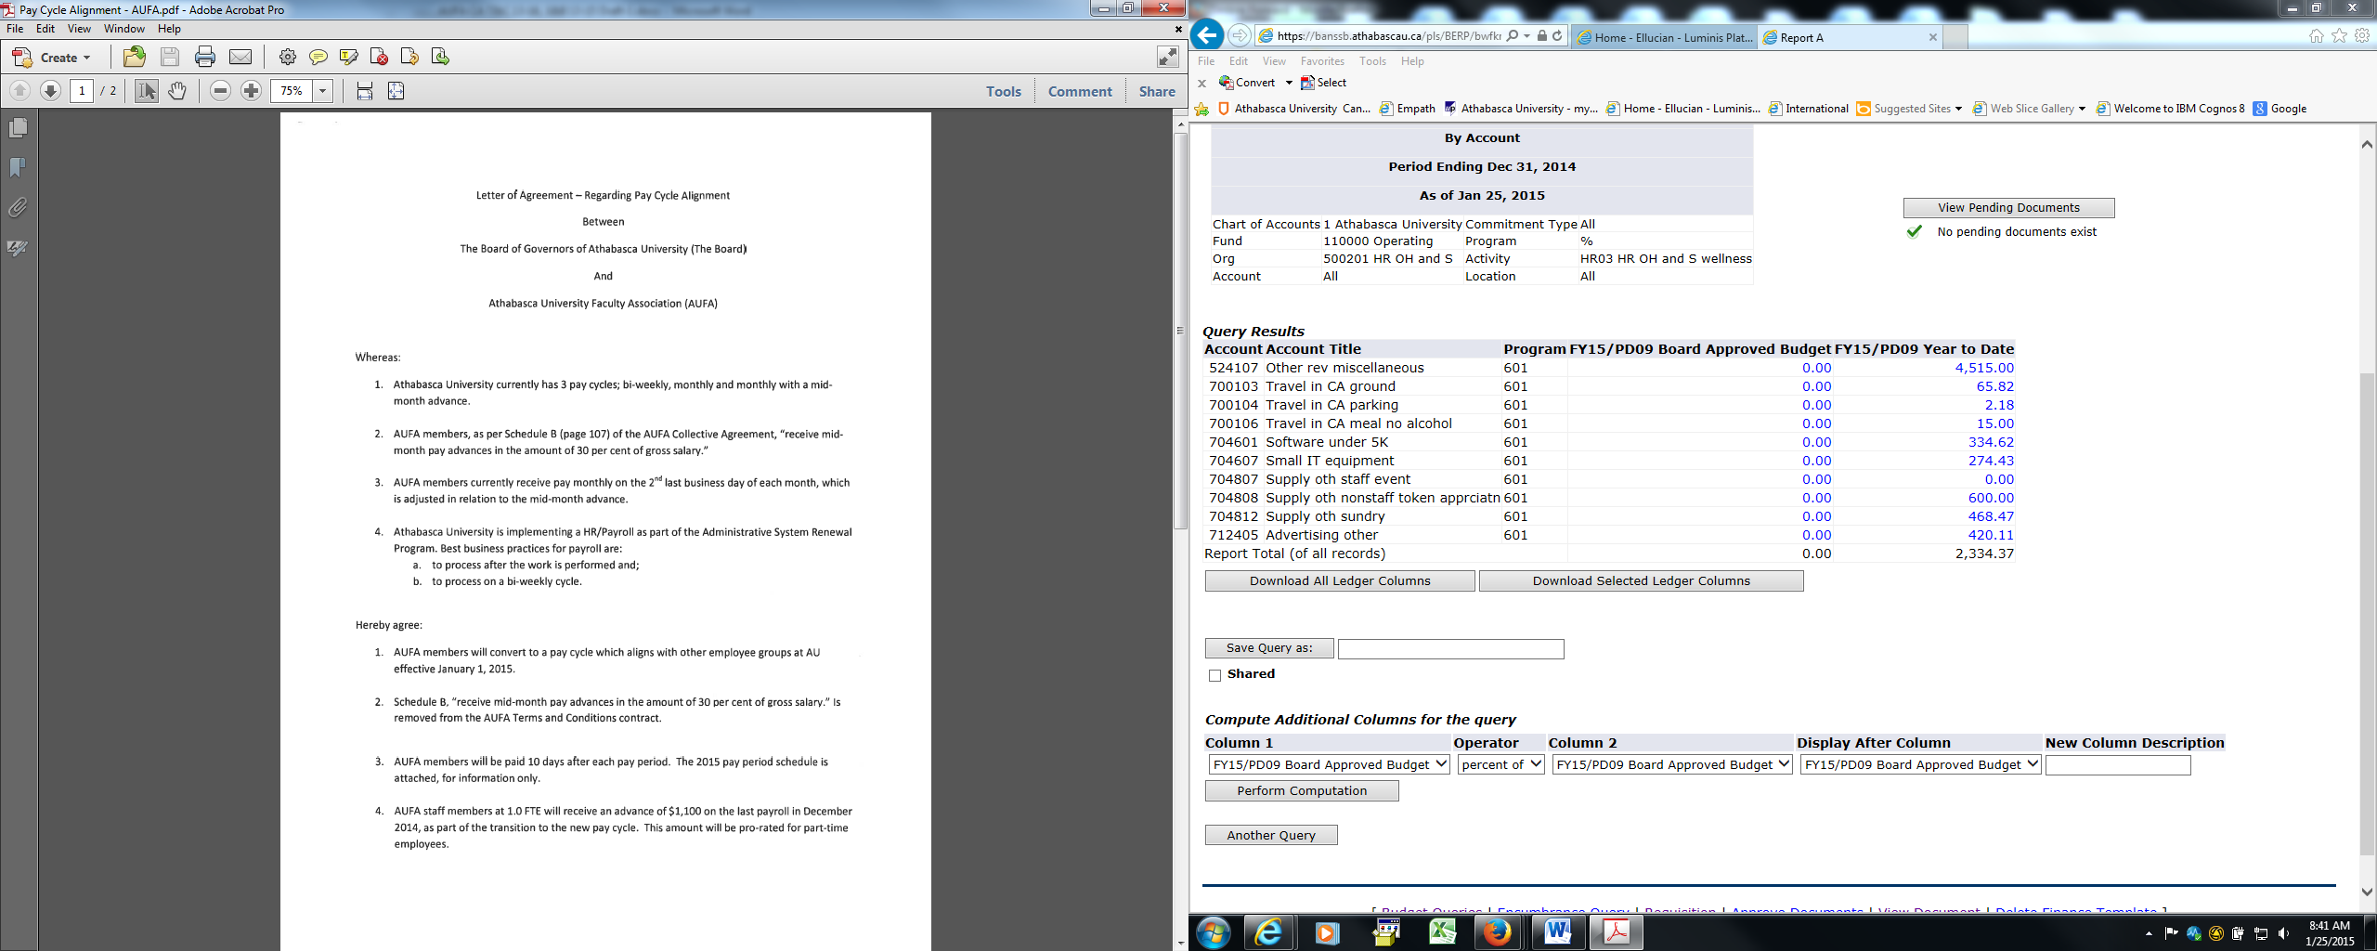
Letter of Agreement – Regarding Pay Cycle Alignment – March 2014

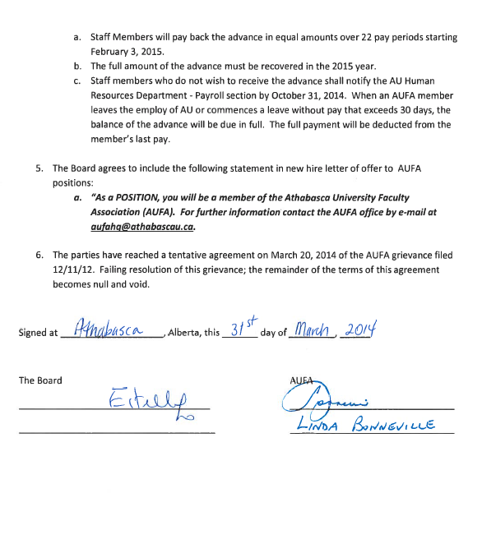

Memorandum of Agreement – Between the Board and AUFA – April 23, 2014
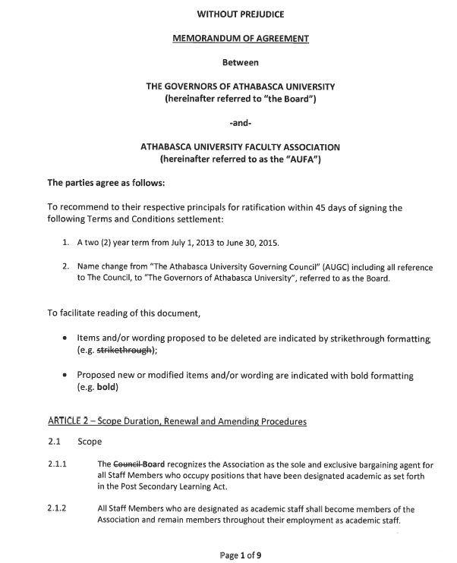
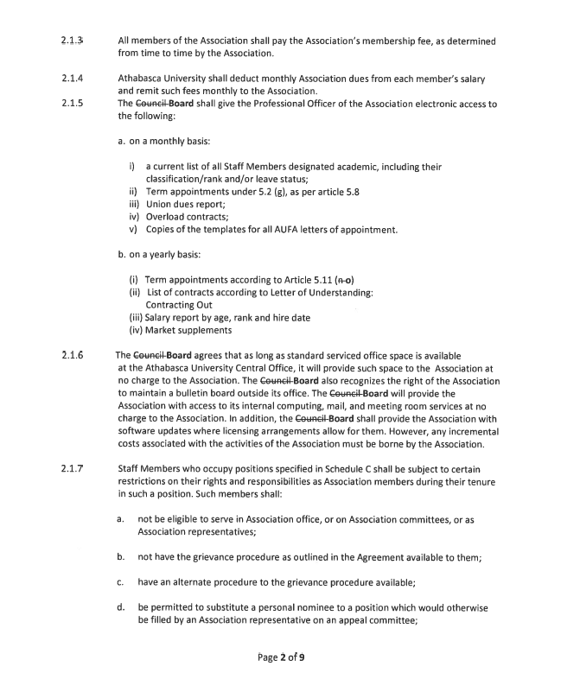

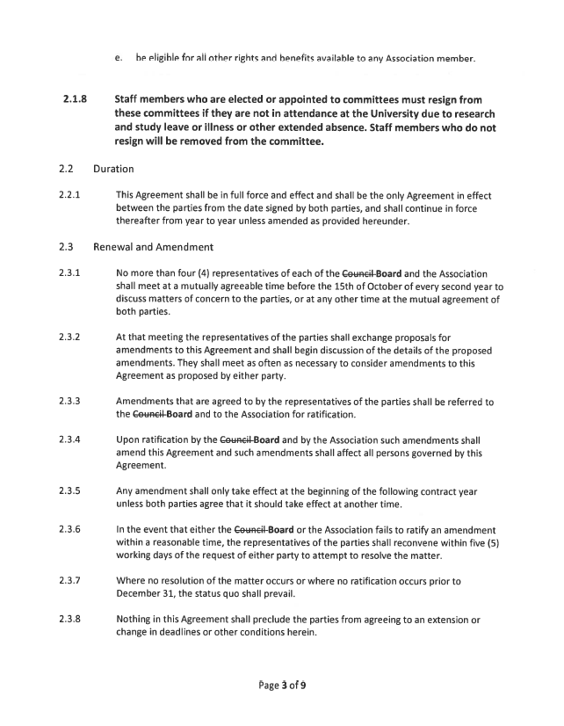

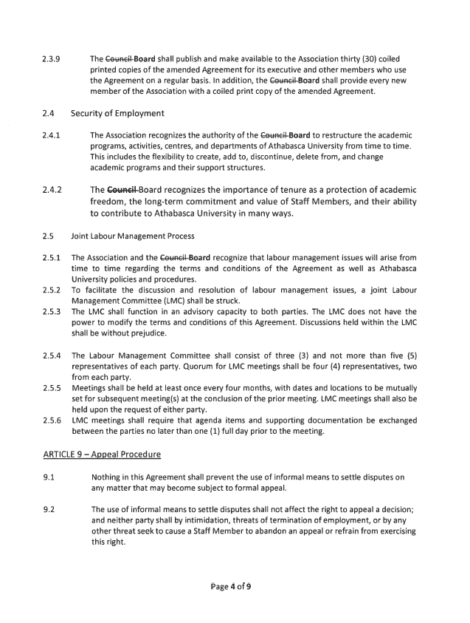

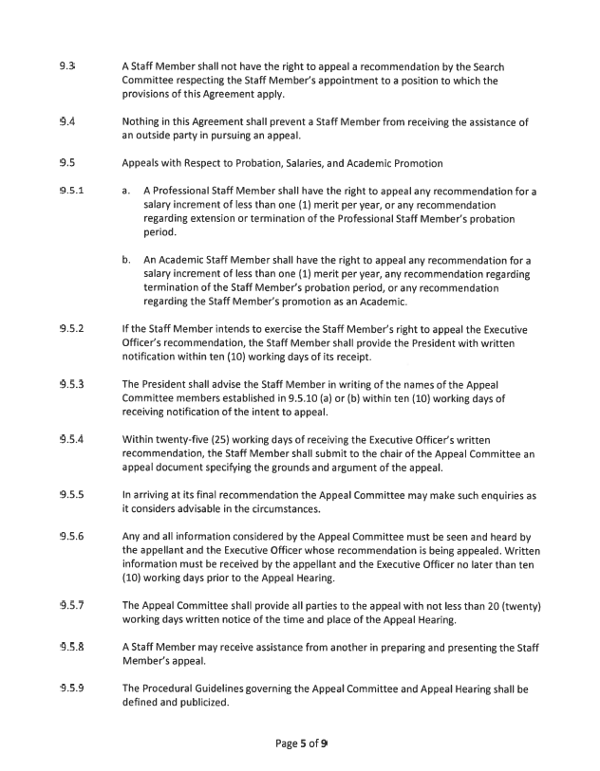

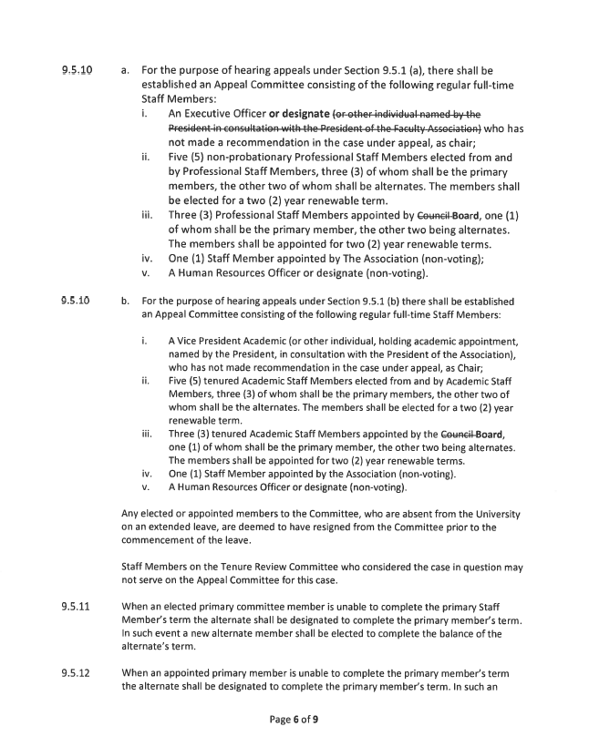

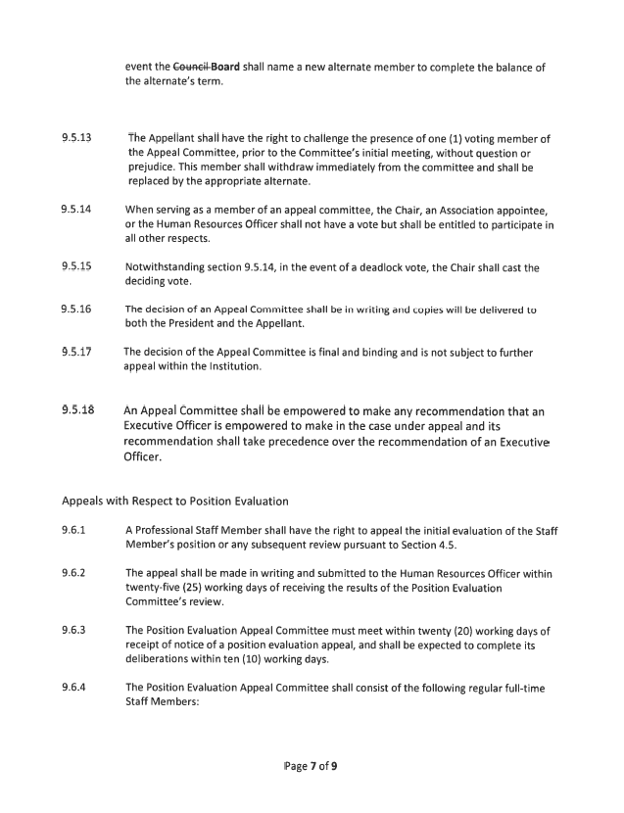

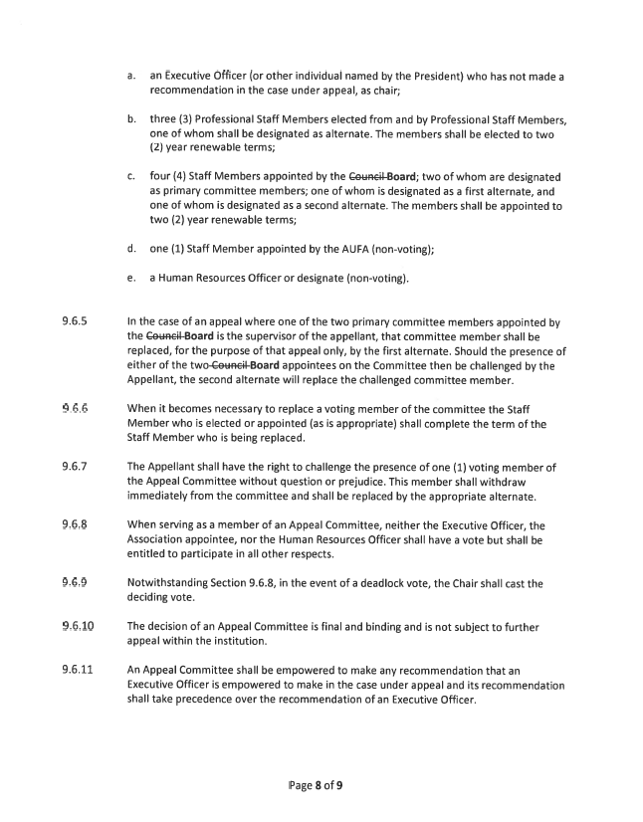

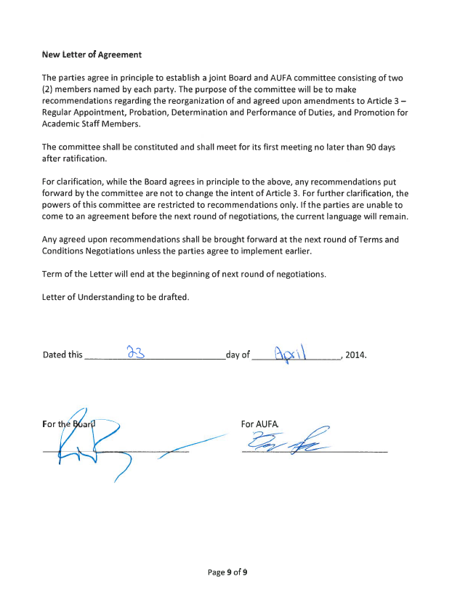

Interest Arbitration Award - Between the Board and AUFA - October 10, 2013
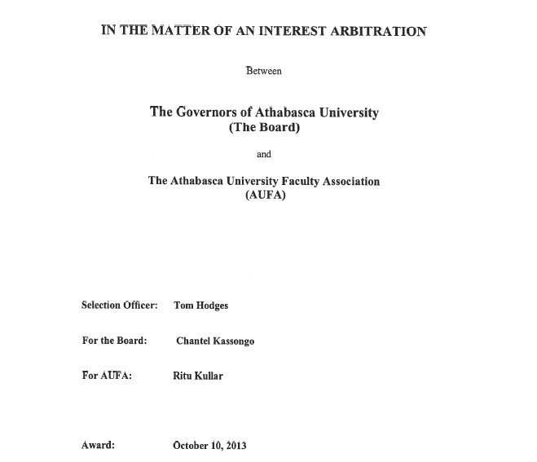

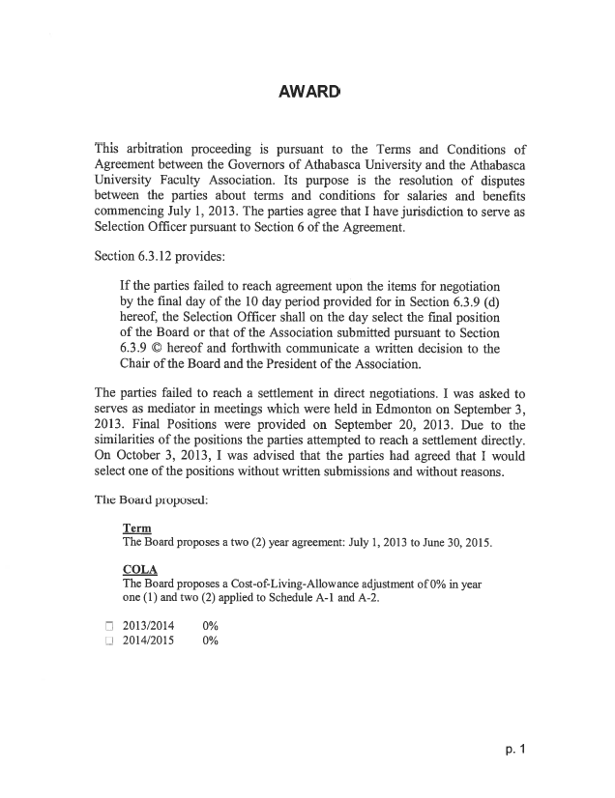

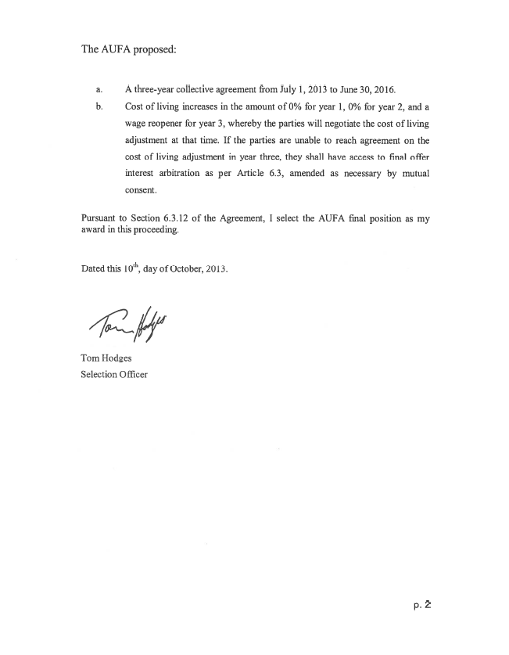

Letter of Agreement – On Call and Callback Pay Committee

Between

Athabasca University Faculty Association ("AUFA")

and

Board of Governors of Athabasca University ("The Board")

The parties agree to establish a joint committee consisting of three (3) persons nominated by each party. The joint committee shall be responsible for drafting language for placing Members on-call, and for callback pay.

The committee shall attempt to complete its work by December 15, 2015 unless this deadline is extended by the mutual agreement of the parties.

Within 90 days of agreement being reached regarding this issue, each party shall present the agreement to its principal for ratification and inform the other party of the results.

Signed this 28th of September, 2015

For the Board | For the Association
“Estelle Lo” | “David Powell”

