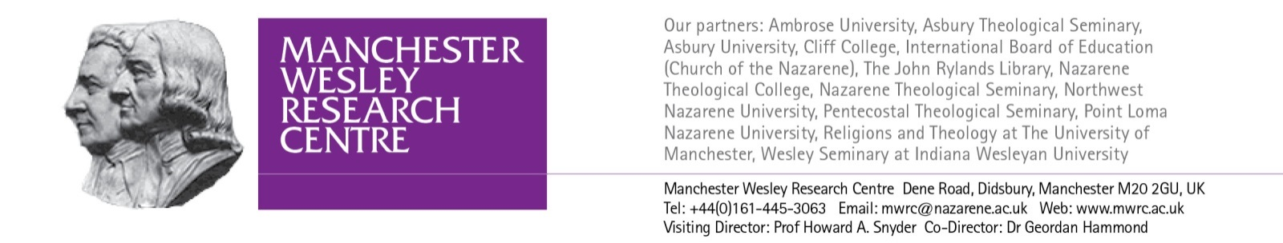

**Methodist Studies Seminar**

**Saturday 5 December 2015**

**Manchester Wesley Research Centre**

*The Oxford Centre for Methodism and Church History, Oxford Brookes University, and the Manchester Wesley Research Centre have worked in partnership for several years. In 2012, the centres established a bi-annual seminar series that has now extended to include the Wesley Study Centre, St John’s College, Durham University, and Wesley House, Cambridge. The seminars provide an opportunity for established and emerging scholars of Methodist Studies to present the findings of their research. We conceive of Methodist Studies broadly and aim to provide opportunities for students of history, theology, literature, art, material culture, and other fields related to Methodism.*

**9.30am Arrivals, Tea, & Coffee**

**10.00am** **Welcome** (Dr Geordan Hammond)

**10.05am** *Aldersgate – Wesley’s Conversion?*

Revd Mark Olson, University of Manchester/Nazarene Theological College

(Chair: Dr Geordan Hammond)

**10.45am** *The First Thousand Wesleyan Chapels*

Dr Clive Norris, Oxford Centre for Methodism and Church History, Oxford Brookes University

(Chair: Dr Peter Nockles)

**11.25am**  **Tea & Coffee**

**11.40am**  *Batting for Christ or Agent of the Devil? The Emergence of Methodist Cricket Clubs in Halifax and the Calder Valley to c.1920*

Dr Dennis O’Keefe, University of Huddersfield

(Chair: Dr John Hargreaves)

**12.20pm** *Wesleyan Chaplains in the British Army during the First World War*

Andrew Pickering, University of Cambridge

(Chair: Prof Edward Royle)

**1.00pm Lunch**

**2.00pm** *Charles Wesley and Hans-Georg Gadamer: Poetic Texts as Bearers of Theological Truth –*

*A Philosophical Framework of Knowledge*

Revd Julie Lunn, Nazarene Theological College

(Chair: Dr Peter Forsaith)

**2.40pm** *Stewardship and Participation: Wesleyan Social Ethics in an Age of Migration?*

Professor Michael Nausner, Reutlingen School of Theology

(Chair: Dr Stephen Wright)

**3.40pm Closing Announcements**

Livestreaming:

The seminar will be livestreamed at <http://www.livestream.com/ntcmanchester>

Before logging in, please read our ‘webstreaming guidelines’ at

<http://nazarene.ac.uk/wp-content/uploads/2014/04/Guidance-for-viewing-streaming-events-through-NTC-Manchester.pdf>

Registration:

There is no cost for attending the seminar or for the lunch which will be provided; however,

please register by 27 November by emailing, Helen Stocker, the MWRC Assistant at:

[hstocker@nazarene.ac.uk](mailto:hstocker@nazarene.ac.uk)

Venue:

The Emmanuel Centre

Nazarene Theological College

Dene Road, Didsbury

Manchester M20 2GU

Directions: <http://www.mwrc.ac.uk/location/>

*\*\*\*The 2016 seminars will be in Durham on Wednesday 27 April and in Cambridge later in the year.*