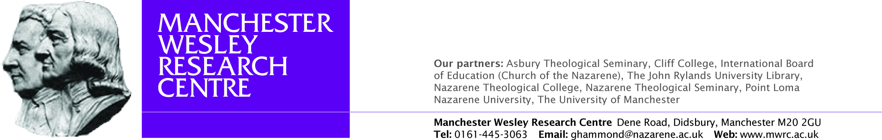

Fourth Annual Manchester Wesley Research Centre Postgraduate Colloquium

Chris Foster: Ruach and Mysticism in Ezekiel

Josh McNall: Gunton and Augustine’s God: The Question of Monistic Imbalance in Augustine’s Trinitarianism

Joseph Wood: ‘The Spirit and the Word’: John Wesley’s Theology of Preaching

Jeffrey Rudy: Persons and Essence at the Cross: Exploring a Wesleyan Appropriation of the Cry of Dereliction

Arseny Ermakov: ‘Man does not live on bread alone’: Fr. Sergey Bulgakov on Relations between Christianity and Socialism

Friday 17 June 2011: 9 a.m. – 1 p.m.
Nazarene Theological College

Free lunch will be provided for those who book a place in advance by sending an email to: ghammond@nazarene.ac.uk

