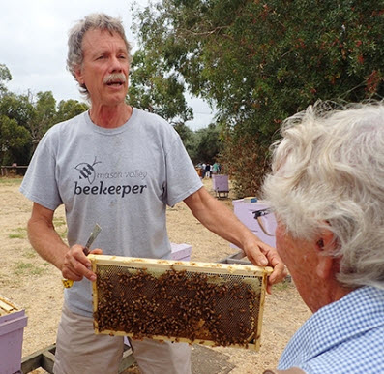

The workshop is: FREE to all current LACBA members. You can renew your membership ($20/yearly) at check in.  
**Again, this is by EVITE only and YOU MUST RSVP to the EVITE by Monday, August 20th.**If you did not receive your EVITE, check your spam box. If it’s not there, contact lacba.membership@gmail.com

**MAKE SURE you bring your protective clothing (BEE SUIT),** basic beekeeping tools, a notebook and pen. It may be HOT so BRING WATER to stay hydrated.

**Randy Oliver** is a world renowned speaker, educator, bee biologist, leading researcher, commercial beekeeper, and regular contributor to the American Beekeeping Journal. He is one of the premier beekeeping speakers in the U.S. and the owner/author of http://scientificbeekeeping.com .

Randy will be sharing his experience and provide **evidence based** and **scientifically-verified explanations** of the biological processes occurring in the hive, as well as the effects of various management options. After attending his workshop, beekeepers will be better informed when making practical management decisions about their hives.   
This is a rare chance to learn from one of the most respected researchers in beekeeping, and ask questions.

**SUNDAY – AUGUST 26th   
10:00AM-2:00PM**  
at **The Valley Hive**  
10538 Topanga Canyon Blvd.  
Chatsworth, CA 91311 (818) 280-6500  
Please park on Topanga Canyon Blvd.  
Check in at 9:30AM Workshop at 10:00AM.   
Includes: Light Lunch

**SATURDAY – AUGUST 25th   
9:00AM-3:00PM**  
at **Cal Poly Pomona Apiary**  
Pomona, CA 91768  
Check in at 8AM Workshop at 9:00AM.

Includes: BBQ Lunch

*Thank you to The Valley Hive and Cal Poly Pomona for providing the venues. Also, to all LACBA members for your countless volunteer hours throughout the year that provide the funding to make our events possible – Thank You!*

*These Randy Oliver workshops are sponsored by:*Los Angeles County Beekeepers Association  
PO Box 8051, La Crescenta, CA 91224  
www:losangelescountybeekeepers.com

Los Angeles County Beekeepers Association Presents

**Randy Oliver – Scientific Beekeeping  
DATA over DOGMA**

One day workshop with two separate locations   
**Saturday, August 25th OR Sunday, August 26th**

LACBA Members EVITE INVITATION ONLY.   
YOU MUST RSVP to the EVITE by Monday, August 20th.