**Andrea Kantrowitz, EdD**  is an artist and researcher, who has lectured and given workshops internationally on drawing and cognition. As director of the Thinking through Drawing Project at Teachers College, Columbia University, she organized a series of international drawing and cognition research symposia, in collaboration with colleagues from the University of the Arts L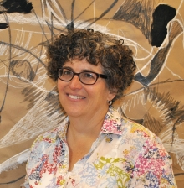ondon and Loughborough University, U.K. She holds a B.A in Art and Cognition from Harvard University and a MFA in Painting from Yale, taught foundation drawing at Pratt Institute in Brooklyn and graduate courses in contemprorary art at the College of New Rochelle. She has also been a teaching artist in the New York City for many years, involved in multiple local and national research projects. She recently completed an interdisciplinary doctorate at Teachers College which examined the cognitive interactions underlying contemporary artists’ drawing practices.  Her own art work is represented by Kenise Barnes Fine Art.



The Daughters of Leucippus, 2015, oil on canvas, 48 x 60 inches

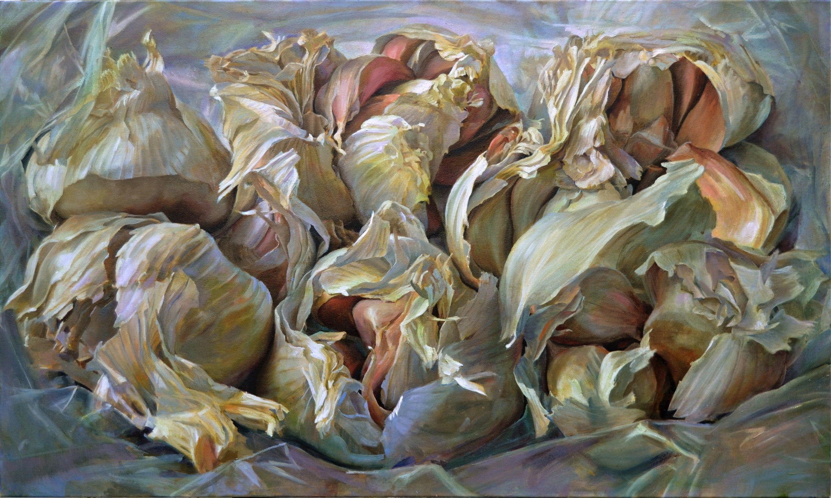

Seven Brides, 2014, oil on canvas, 36 x 60 inches

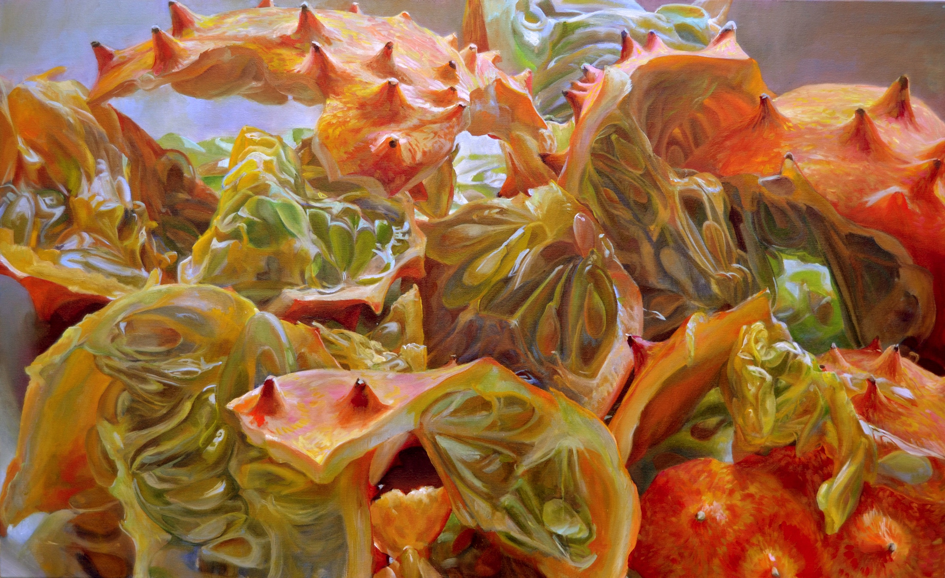

Myriad Ravines, oil on canvas, 36 x 60 inches

Teaching Innovations in the Studio Classroom

### Locate, extend, connect, reinforce and revise: A collaborative drawing exercise

A collaborative drawing exercise used a set of five fundamental drawing actions. A group process in this proposed exercise was used to simulate the feeling of a lack of individual control that experts use to facilitate surprise and generate new ideas.

|  |  |  |  |  |
| --- | --- | --- | --- | --- |
|  | Practical Instructions | | Rationale | |
| PRE- DRAWING PREP | Go for a walk around the building, or outside if possible. Record your walk with a pencil on paper, in the form of a line, noticing speed, direction and quality of movement | | A rich and diverse set of marks, cognitively linked to an actual embodied, physical experience, was generated in this way. | |
| Use a viewfinder to select an area in this initial drawing to enlarge on 6” x 6” square. Look for an interesting knot or intersection, a “happy accident” that you find intriguing for any reason | | An initial opportunity to practice Schon’s “reflection in action.” This is training to identify the kind of “regular mistake” that Thelonius Monk would repeat, echo and amplify in his improvisational compositions. This is the “burp” that Sharon described as key to her own creative breakthroughs. | |
| LOCATE | 1016954_10200238510220976_2010337005_nHere, students begin to place their individual squares on the large drawing surface. | | | |
| Take the square you have made, and place it somewhere on the 48” x 120” paper on the wall. Consider its relationship to the edges of the paper, and any other squares that may have been placed there already. Make sure to leave plenty of space between squares. | This action approximates the “Locate” function from this study. These small squares will be used to launch the drawing. The reflective process that is encouraged should result in a scattered distribution of these squares across the drawing surface, so there is plenty of room to develop extensions and connections between them. | | |
| EXTEND | Find a line you think is interesting (in someone else’s square) and extend it, continuing to do whatever it is starting to do and amplify it, letting it expand into the empty space. In other words, if it is jagged, continue that jagged quality and exaggerate it. If it is frenetic, make it even more frenetic, etc… | This action enacts the extending function. Again, “noticing the ‘things’ that happen” is essential to improvisational drawing. It is often easier to notice these “burps,” in someone else’s drawing, than in one’s own, especially for novices. | | |
| CONNECT | Find two or three areas that have been extended, them and connect them so they begin to form a coherent whole. | Here, students are beginning to connect parts into larger wholes. They are practicing what Suwa and Tversky have called “seeing into sketches,” starting to make discoveries and invent. | | |
| REINFORCE | Find a local area where you see interesting or surprising forms beginning to emerge. Reinforce these forms by adding shading or detail to call attention to them, and begin to make them appear to come forward or recede into a three dimensional space. | Students are beginning to develop visual hypothesis about what may become important in the drawing, where it might be headed. Through reinforcement, they are starting to define the characteristics of the final outcome. | | |
| 312368_10200238510460982_500964713_n  The drawing is beginning to cover the whole surface, as students take turns connecting and reinforcing. | | | |
| REPEAT | Stand back and notice where the drawing feels neglected or boring. Move to a new area of the drawing surface, and echo or repeat a form or configuration that you find interested in the developing drawing. | Implementing Bayesian inference to use the early development of certain areas and relationships to guide subsequent development. Taking a cue from a key area, students make inferences regarding what makes that area start to “work” and apply these inferences to an undeveloped section of the drawing. | | |
| REVISE | Stand back and look at the developing drawing. Notice places where the drawing is beginning to feel coherent. What can you do to amplify this sense of coherence? Notice where the drawing feels fragmented. What could you do to make it more coherent? | Here, an emphasis on overall coherence, rather than specific detail helps to pull the drawing together, and begin to define visuo-spatial rules that will make the final outcome logically consistent. | | |
| REFLECT |  | | | Once the drawing has been established, everyone takes an extended break, to evaluate what is starting to happen, and make plans for where the drawing needs to go. |
| At this point, everyone should stand back and look at the drawing as a group. What’s working? What’s not working? Where do you find your eyes drawn? Why? How can the drawing be made more coherent? Where does it need to be made more interesting, and where is a gap, or in-between space starting to take on volume or air? Take notes and post them next to the drawing to refer to in the next phase. | This group discussion is an external enactment of the internal dialogic process artists engage in with their drawings. By playing it out as an actual conversation, students will hopefully develop a more critical eye that they can then apply to their own individual work, and, if they are art educators, to their students’ work. | | |
| REPEAT | As students continue to develop the drawing, they alternate action and reflection, enacting the individual artist’s dialogic process with their drawing. | | | |
| Implement the ideas generated in the group discussion. Stand back occasionally as a group to repeat the drawing, until everyone one agrees that it is as interesting and coherent as possible. | The 17th century Chinese landscape painter Gong Xian said that for a work to be truly excellent, it must balance “stability” (“an,” peace) with the “bizarre,” (ch’i\_) the strange or surprising. (Wilson 1969) This is the goal students are encouraged to reach for in this project. | | |
|  |  | | | |

This collaborative drawing exercise helps to develop class cohesion and communication, setting the stage for more challenging, individually driven work.