Foundations Program
INSTRUCTOR’S MANUAL

Florida State University Department of Art & Design

Developed by Mary Stewart, with input from colleagues from FSU and nationally

SECOND EDITION: 2010-2012

TABLE OF CONTENTS
INTRODUCTION 3
- The FSU Foundations Program: Mission, Vision and Objectives
- Higher Education basics
- Woodshop Safety
- University Policies on Incompletes and Attendance
- Standard Vocabulary
Chapter 1: ART 1000: Success Strategies in Art and Design 21
- Notes to the beginning teacher
- Sample syllabus
- Assignment details
- Success Strategies Career Guide 27
Chapter 2: ART 1300: Drawing Foundations 32
- Notes to the beginning teacher
- Sample syllabus
- Assignment details
Chapter 3: ART 1203: Three Dimensional Foundations 47
- Notes to the beginning teacher
- Sample syllabus
- Assignment details
- Materials and Methods 75
Chapter 4: ART 1201: Two Dimensional Foundations 76
- Notes to the beginning teacher
- Sample syllabus
  - Assignment details
  - Quizzes on Readings 104
Chapter 5: ART 1602: Digital Imaging Foundations 115
- Notes to the beginning teacher
- Sample syllabus
- Assignment details
Chapter 6: ART 2205: Color Theory Foundations 148
- Notes to the beginning teacher
  - Sample syllabus, with Assignment details
  - Sample syllabus, with Assignment details for Drawing in Color course 152
Chapter 7: ART 2206?: Digital Color Theory Foundations 158
- Notes to the beginning teacher
  - Sample syllabus, with Assignment details
Chapter 8: ART 2330: Figure Drawing Foundations 164
- Notes to the beginning teacher
- Sample syllabus
- Assignment details
Chapter 9: ART 2003: Survey of Contemporary Art 170
- Notes to the beginning teacher
- Sample syllabus
- Powerpoint list and Sample lectures, Assignment details
Chapter 10: ART 2XXX: Creative Inquiry 174
- Notes to the beginning teacher
- Sample syllabus
- Assignment details

Foundation Bibliography and PowerPoints 184

A FINAL WORD by Anthony Fontana, Bowling Green State University 191

THE FSU FOUNDATIONS PROGRAM: AN INTRODUCTION

MISSION:
The Florida State University Foundations Program provides beginning art and design students with the fundamental skills, knowledge, and experiences essential to their further development as visual arts professionals. To maximize learning, each course includes challenging and purposeful assignments, high expectations, and a strong sense of adventure.

Philosophy:
In the Foundations Program, students will be encouraged to expand their technical skills, develop their critical judgment, explore interdisciplinary connections, refine their personal goals, and increase their understanding of contemporary art and design. Inventive concepts fuel devel-opment of compelling compositions and constructions. Our curriculum is designed to provide a solid basis on which BA and BFA programs in the School of Art & Design can be built.

OUTCOMES:
Upon successful completion of the Art and Design Foundations Program, students will gain:
- An ability to develop and solve visual problems using a variety of ideation strategies;

- Understanding of the basic elements and principles of design and the ability to use them effectively;

- Means of translating ideas into images, objects and experiences using a wide range of art materials, methods, and processes;

- A capacity to think critically and write and speak clearly about many forms of visual experience;

- Knowledge of contemporary visual expression in art, design, and the kinetic arts;

- A work ethic that reflects integrity, teamwork, dedication to professional growth, social responsibility and the confidence to take risks.

Foundations includes 4 required studios, 1 “bridge” course selected from a series of options, and 2 lecture courses. All coursework should be completed by the end of the third semester.

SAMPLE ASSIGNMENTS AND SYLLABI

Sample assignments and syllabi for each of our courses follow.
- First-time teachers usually follow the recommended assignment sequences closely, making adjustments in timing and emphasis based on student response.

- Experienced teachers should provide a brief description of a personal pedagogical plan for the semester. Any strategy is fine, as long as it fulfills the course objectives.

Every group of students has its own dynamics. Be attentive to the needs of your class, and speed up, slow down or increase assignment complexity as needed.
FOUNDATIONS CURRICULUM
STUDIO COURSES
__________________________________________________________________________________
ART 1300: Drawing Foundations (3) Creative expression and communication using a variety of black and white mediums.
This course combines straightforward observational drawing with basic composition and concept development via inventive homework assignments. Ideally, taken as a co-requisite with ART 1203.
___________________________________________________________________________________
ART 1203: Three-Dimensional Foundations (3). Experience in designing and constructing expressive three-dimensional forms using a variety of materials and methods.
This course offers a solid introduction to 3D composition and construction using a range of basic materials, including wood, wire and paper board. Ideally, taken as a co-requisite with ART 1300.
___________________________________________________________________________________
ART 1201: Two-Dimensional Foundations (3). Experience in conceptualizing, creating, and critiquing two-dimensional compositions using the elements and principles of design.
Three aspects of visual thinking are emphasized in this course: concept development, composition, and critique. Ideally, taken as a co-requisite with ART 1602.
___________________________________________________________________________________
ART 1602: Digital Imaging Foundations (3). Introduction to digital processes and the basics of time-based art and design. (Fulfills computer competency requirement for art and design majors.)
This course is designed to provide students with the fundamental digital understanding required professional success in contemporary art and design. Ideally, taken as a co-requisite with ART 1201.
___________________________________________________________________________________

OPTION 1: ART 2330: Figure Drawing Foundations (3) Exploration of the anatomical and conceptual complexities of the human form.
This course provides the drawing experience essential to further development of any form of figurative imagery, from animation to video.
OPTION 2: ART 2205: Color Theory Foundations (3). Experiments in color perception combined with uses of color in visual communication and visual expression.
By focusing on color, students can gain the in-depth understanding they need for effective and informed use of this elusive visual force. This course is offered in an additive and a subtractive version. OPTION 3: ART 2206: Digital Color Theory Foundations (3). Digital experiments in color perception combined with uses of color in visual communication and visual expression.
Emphasizing digital color rather than paint provides students with an expanded understanding.

LECTURE COURSES:
__________________________________________________________________________________
ART 1000: Success Strategies in Art and Design (1). Orientation course designed to increase first-year student success, introduce departmental concentrations and explore career possibilities.
Success Strategies will help students navigate through an increasingly demanding program, introduce them to a wide range of FSU resources, help them prepare for the BFA review, and provide an overview of possible careers.
___________________________________________________________________________________
ART 2003: Survey of Studio Art Practices (to become Survey of Contemporary Art.) (3) Lectures and visual presentations present the myriad forms and expressive content of contemporary visual culture.
This course provides a visual and conceptual barrage: a real eye- and mind-opener. A Gordon Rule course, it requires at least 3000 words in written work, including research papers and critical essays.
HIGHER EDUCATION BASICS
Why Read This Manual?
Freshmen have a lot to learn—about art and design, about college life, about visual arts professions, and about themselves. As the matrix on which all majors are built, Foundations must provide a broad base of essential knowledge. To create effective assignments, we must:
- deeply understand the essentials of visual expression;
- invent projects that are both compelling and comprehensible to beginners;
- communicate effectively and grade honestly;
- coach, cajole, and challenge first-time and continuing college students.

Recommended Methods of Instruction
- Break down complex concepts and processes into a series of comprehensible bits.
- Encourage students by continually cruising the classroom and talking one-to-one.
- Focus on skill development during class. Then, expand on class work by using inventive homework and sketchbook projects. We expect students to work 5 hours a week outside of class.
- Present inspiring examples of professional and student works. These examples are the key to comprehension to many beginners. Show lots of options, so that students see a range of solutions.
- Increase student ownership of their own learning progress through engaging critiques.
- Use monologues sparingly. Contemporary students learn best when they are highly engaged.
- Encourage students to become members of the art community by attending openings and lectures.
- When appropriate, share your experiences as an artist. Show your work. Model how art history, the liberal arts, science, etc. can be integrated into the experience of art making.
Making the course compelling
- Establish that you are knowledgeable, capable and committed. Arrive early and bring lots of visual examples, especially during the first month. If you get off to a great start, the rest of the term will go much more smoothly. Whenever possible, do a new assignment yourself a day or two before presenting it, then bring the resulting artwork in as an example.
- Convince your students that what you have to teach is worth learning. Connecting fundamental skills in class to more creative homework projects helps beginners value the basics.
- In critiques, remember to be instructive rather than punitive. Beginners are generally stunned by any type of criticism and often accentuate the negative. Start with positive observations, then provide multiple alternatives for them to weigh.
- Be mindful of the delicate balance between your dual roles as taskmaster and as cheerleader. Set high standards, then do all you can to promote student success. Grade honestly! Everything is NOT beautiful in its own way and the sooner students understand that, the better. College-level art and design courses require the same level of engagement as college physics, philosophy, etc.
- Have faith in your students and in yourself. Drawing, especially, is an accumulative process--a lot of practice is needed. The first month of work by a complete beginner can be astonishingly bad. Don’t give up: hard work pays off, and the work will get better.

When Things Go Wrong
Despite your best efforts, some students will behave foolishly, especially in the first and last month of the term. Class clown behavior can even rear its ugly head. Simply taking the student aside and telling him/her that such behavior is unacceptable at the college level often solves the problem.
When students complain about their grades, first talk to them one-to-one, describing more fully your rationale for the grade given and suggesting specific ways to improve the current project or subsequent work. Where appropriate, give them the chance to re-do the project or do extra-credit work.
If this doesn't solve the problem, send the student to the Foundations Director, with a complete description of the assignment and all of the work done, including preliminary sketches. He/she may be able to provide another perspective on the problem and re-direct student energy in a positive direction.
FROM MISSION TO OUTCOME: A Concise Guide to Curriculum Construction

In this section, we will explore relationships between a departmental Mission Statement, Curriculum Chart, Course Objectives, and Assignment Objectives.

Step 1: Having a Mission
A departmental Mission Statement provides a concise statement of purpose. In it, members of an academic unit determine what they want to achieve, why these goals are important, and what students will have achieved upon graduation. The Mission itself tends to be pretty broad. To construct your assignments, focus at the list of more specific objectives or outcomes, both for the program as a whole and for each course. Those are the more tangible targets you must hit.

Step 2: Charting your Curriculum
OUTCOMES | Drawing 1 | 3D Design | Success Strategies | 2D Design
Ability to develop and solve visual problems using various ideation strategies | in-class projects and ideas are expanded through daily use of sketchbooks. | at least 3 ideation strategies will be used, such as idea maps, distillation, and collaboration | lectures will include discussion of ideation strategies used by artists and designers | at least 3 ideation strategies will be used, such as convergent, divergent, and metaphorical thinking
Ability to translate ideas into compelling images and objects using a wide range of materials, methods, and processes | work with graphite, charcoal, conte and ink, rendering of basic forms, work with one- and two-point perspective | work with additive and subtractive processes using wire, board, wood, and plaster, use of band saw, drill press, sanders, hand tools | lectures will include discussion of materials, methods, and processes used by artists and designers | work with markers, collage, acrylics and other materials
Creating a simple graph can help you see connections among the various courses in your curriculum. Outcomes are listed in a column on the left, while the courses taught are lined up along the top. Then, simply fill in the resulting boxes. In what courses and by what means are the outcomes being met? If you wind up with an overload of information in one area and an absence of information in another, there is a mismatch between your mission and your curriculum. In that case, either the mission or your curriculum needs to be revised. Example:

Step 3: Constructing A Course
Foundations classes are taught by many instructors, with widely varied backgrounds. Clear and reasonable baseline objectives have been given for each course: see the sample syllabi that follow. These objectives provide an essential structure while retaining a reasonable level of independent initiative. More experienced and inventive members of the program can expand well beyond the baseline. For example:

THREE-DIMENSIONAL FOUNDATIONS

Course Description: Experience in designing and constructing expressive three-dimensional forms using a variety of materials and methods.

Course Objectives: Upon course completion, all students should be able to:
- Define and effectively manipulate the elements and principles of 3D design to create non-objective, abstract, and representational compositions;
- Use a wide variety of idea generation strategies confidently;
- Create projects that are structurally sound, using wire, board, wood, and clay;
- Use a band saw, drill press, sanders, and basic hand tools effectively;
- Speak and write critically about personal and peer artworks and propose alternatives
Step 4: Constructing an Assignment
A sense of purpose is essential: each assignment should advance the overall learning experience in a deliberate way. For clarity and simplicity, please use the following checklist:

- Title: An inventive or memorable title immediately attracts attention.

- Author. Give your name, institution, and contact information.

- Premise or Springboard: What is the intellectual or aesthetic context for the assignment? What concepts will the students explore?

- Problem: What will the students do? Describe the assignment in one or two sentences. Stick with essentials: details on why and how will follow in sections on objectives and strategy.

- Outcomes/Assessment Targets: What new knowledge will students gain through this assignment? Three to five objectives are ideal. Consider including a variety of learning experiences, from technical and perceptual experiences to critical and conceptual thinking. This helps students gain multiple skills simultaneously.
Objectives that lead to tangible results help with the assessment process: if there is no visual evidence of progress, it is hard to know what students actually accomplished. Thumbnail sketches, maquettes, and rough drafts expand creativity and provide evidence of ideation, so require and grade them as appropriate.

- Materials: List the tools, equipment and supplies needed.

- Strategy: How will the work be accomplished? When appropriate, identify the thinking processes, organizational methods, and in-progress deadlines. When an ambitious assignment unfolds through a series of steps, more ideas and variables can be addressed without losing half the class.

- Examples: List 6-12 artists whose work is related to the assignment, or provide recommended readings. Since freshmen generally know little or nothing about contemporary art, it is important to include recent as well as historical references.

- Key Questions: To expand critical thinking and increase personal responsibility, list three or four practical questions students need to ask themselves as they complete the assignment. Examples:
  - Experiment with wire, Bristol board, cardboard, and plaster gauze. Which material will best communicate your idea?
- How can lighting enhance mood or expand meaning in your drawing?
  - What are the conceptual implications of the objects included in your assemblage?
  - In creating your story, whose point of view should dominate? A 6-year old boy has a very different perspective that a 12-year old girl or a 40 year-old man.

- Critiquing Strategy: Determine the type of critique best suited to the problem and work out the logistics. Using a variety of techniques throughout the term can increase student involvement.

- Timetable: As appropriate, determine due dates for various stages in the problem as well as the final deadline.

NOTE: Use this structure as an organizational framework. If more interesting alternatives develop as the assignment unfolds, modify your plan. Use your intuition as well as your intellect!

Step 5: Assessing the Results
A simple rubric can speed up the grading process and give students a clear sense of the areas of strength and areas needing more development. Simply put your objectives into the to the criteria column.
Remember, you can set any criteria you want, provided there is a direct match between the objectives or outcomes you present to the students and the assessment criteria you ultimately use. For a process-based assignment, you might use “contributions to collaborative team” and “range of ideas explored” while a more product-based assignment tends to focus on composition and craft.

SAMPLE ASSIGNMENT RUBRIC: Rating: 5 = highest

CRITERIA | 1 | 2 | 3 | 4 | 5 | COMMENTS
Range of colors created

Rich color interaction

Craft

Inventive translation of object into image

Conceptual invention

Contributions to critique
GRADE:

A Well-Designed Course
All courses must meet the baseline objectives listed on the sample syllabi. HOW you meet these objectives is your choice: be inventive! Use the following to increase focus, clarity and variety.

- A sequential structure can help students gain momentum and continually expand ideas. Starting at a basic level, each assignment builds on the preceding problem and anticipates the subsequent problem. Using this approach, complex concepts can be mastered through a series of comprehensible steps.

- Variations in timing, presentation, conceptual objectives, problem-solving processes, and critique strategy can add substance and increase interest in your course.

- A balanced approach increases breadth and adds interest. Vary the pace and assignment content, including quick experiments as well as extended investigation.

- Bottomless assignments can provide variations in the degree of difficulty. Whenever possible, create assignments you find interesting--assignments that can apply to beginning or more advanced study. Use simple, single-solution problems very sparingly. Rigid, one-answer questions rarely challenge the more ambitious students.

- Honor the individual. Each student is unique, possessing his/her own values, experiences, temperament and vision. Help each student find and express his/her own truth, rather than simply imposing your own truth. Developing a personal voice is of vital importance to freshmen and a source of great energy and motivation.
Communication 101

- Arrive at least fifteen minutes early. Collect your thoughts and organize the room.
- Write assignment info and due dates on the board, and insist students write them down.
- Create silence before you begin to speak.
- Be succinct. Clearly, simply, and directly, say what needs to be said. Emphasize due dates.
- Develop and use a variety of critique strategies. Rearrange furniture in the room as necessary, so that the work can be easily seen and the speakers can be heard.
- Periodically work with small groups in order to analyze a project more fully. Discussing weaknesses in a more personal setting generally reduces defensiveness and increases engagement.
- Start and end class decisively. Provide overview in the first 10 minutes; review the day’s work in the last 10 minutes. Start ON TIME—even if only half the class is there. Waiting for the late-comers simple teaches everyone to arrive late!
- At the end of each class, clean up and re-organization the room.

If you are making an earnest effort and clearly know the material, freshmen will readily forgive minor mistakes such as a temperamental computer, a botched demonstration, or forgetting someone's name. We're all human; stuff happens.
Students are much less forgiving when they feel that course policies are being applied unevenly or believe that they are being neglected while a few "stars" get all the attention.
Abide by the policies established on the first day of class, and refer back to the syllabus as necessary.

Syllabus Basics

In the syllabus, you lay out policies for the entire term. Be sure that your syllabus includes:
- The catalog description, as listed on Page 4 of this manual. This was approved by the State of Florida: if you invent your own course description, you will be teaching a special topics class!
- Clear course objectives--what can the student expect to accomplish. Use examples provided.
- Assessment criteria.
- Description of grades.
- Foundations Program Attendance policy. A program-wide policy raises standards and reduces confusion.
- Required books and supplies. Students rarely buy “recommended texts.” ABE books is a good source for used books, and we also put basics texts on reserve in the library.
- Your contact info (such as office hours, or if you have no office, email contact).
- The FSU Honor Code. Use specific wording provided by University.
- ADA accommodation. Use specific wording provided by University.
- As appropriate, rules for woodshop use or sample writing assignments.

Foundations Attendance Policy and Grades
Arrange an individual appointment with a student as soon as a pattern of absences or other poor performance becomes clear. Learn more about the problem, and seek a solution. Get help from the Foundations Director or Advisor as needed. In some cases, course withdrawal is the student’s best option.
A program-wide standard for attendance and grades reduces confusion and complaints. Please include the following text in your syllabus, or write something of your own that is essentially the same.

Attendance: Attendance is required. It is impossible to fully “make up” a missed demonstration or critique. Arriving late also derails learning.. More than two unexcused absences will result in a C or below. More than 3 unexcused absences will result in a D or below.

Please bring documentation for excused absences. For the FSU list of approved excused absences, see: http://www.fsu.edu/~fasenate/attendance.html.
Incompletes: A grade of Incomplete can only be assigned to a student with an otherwise passing grade who is unable to complete the course due to some serious illness or personal tragedy, such as a death in the immediate family. Incompletes are assigned at the discretion of the faculty.
Grades will be defined as follows:
A = Outstanding performance. Expansive investigation of ideas; excellent composition and/or construction. All assignments completed on time, with at least one extra credit project done well. Insightful contributions to critiques. Goes well beyond minimum requirements in quality and quantity.
B = Above average performance: Substantial investigation of ideas, very good composition and/or construction. All assignments completed on time, good contributions to critiques.
C = Average competence. Assignments done competently and completed on time.
D= Marginal performance, due to two or more late projects, limited investigation of ideas, poor craft, incoherent compositions, minimal contribution to critiques. May have more than 2 unexcused absences.
F = Unsatisfactory work. Course failure due to minimal idea development, poor craft, disjointed compositions, lack of participation, late assignments. May have more than 3 unexcused absences.
Note: One project will be accepted one day late without penalty. One additional late project will be accepted with a one letter-grade penalty for each day it is late.

Start strong; End strong
By starting class decisively you establish your credibility and justify the students’ faith in your commitment and knowledge. This is especially important during the first month of the term. The pattern set during the first two weeks of class tends to become the pattern for the term.
Ending strong is equally important. Be sure your last assignment for the term is both challenging and engaging. A “Capstone Assignment,” through which the student demonstrates knowledge gained throughout the term is one good option.
Or, to avoid the “end-of the-term-crunch,” you might complete your Capstone project two weeks early, then end the term with a shorter assignment. Individual appointments during exam week are highly recommended.

SPOTS Reports
Students evaluate the course using SPOTS reports. Pick them up in the Art Office. Have a responsible student oversee their completion while you step outside. The student returns the completed forms to the office; you get the results at term’s end.

PLEASE NOTE: SPOTS reports are just one indication of your achievement. They can be misleading, as personable teachers with loose standards tend to get high evaluations while more demanding teachers tend to get low evaluations. In studio courses, student work quality is a much better indicator of teaching effectiveness, and thus most highly valued.

Inflating grades tends to result in higher SPOTS evaluations—but can have negative consequences when weak students seek admission to the limited access BFA programs. Essentially, they have unrealistic expectations because their Foundations grades were inflated.

Please grade honestly.

Critique Strategies

- To determine the success of compositional decisions relative to their aesthetic intentions, students must receive a thoughtful, thorough, and honest response.
- By playing an active role in the critiquing process itself, students develop their vocabulary while increasing their visual awareness.
- As students develop their critical thinking, they become more independent and self-directed, increasingly able to pose questions as well as solve problems.

Match the critique to the assignment, using dialogs, team meetings, and written formats as appropriate. Students learn more when they are active participants. Bring several specific questions to each critique, and use a variety of approaches, including:

- Turn Up the Heat. How can the initial design be made 50% stronger?
- Visual Math. What should be added, subtracted, multiplied, or divided?
- Description. The first step is to look carefully and report clearly. Without making value judgments or telling stories, each student writes two or three paragraphs careful describing the facts of visual organization in another student's work.
- Cause and Effect. In this critique, students identify the compositional cause that creates a conceptual effect.
- Compare/Contrast. A compare/contrast approach works best with an assignment that has clear, definite criteria, yet allows a wide range of interpretations. When the solutions are presented, have each student choose the piece most similar to his/her own and the piece most dissimilar.
- Greatest Strength/Unrealized Potential. By mid-term, students have more confidence
in themselves and more trust in others. This is a good time to introduce an in-progress critique designed to help students expand and refine ideas.

A critique helps us determine which drawings and designs are the most effective, and why. A critique is neither a combat zone nor a mutual admiration society—and as such, is difficult to run well. Chapter 7 in Launching the Imagination, Writing About Art by Henry Sayre, and Critique Workbook by Kendall Buster and Paula Crawford are good resources.

Potential Questions for a Formalist Critique

LINE
- What is the dominant orientation of the lines and shapes in your design-- diagonal, vertical? horizontal? what is the expressive effect?
- what happens when lines are repeated? or when lines intersect?
- What are the advantages of an outline and what are the advantages of a solid shape?
SHAPE
- Experiment with rectilinear, curvilinear, geometric and organic shapes. Which shape type will best express your idea?
- Are the positive and negative areas in your composition equally intentional?
- What happens when you combine flat solid shapes with gradated shapes?
- Representational, non-objective and abstract approaches have been presented. Which approach will best express your idea?
TEXTURE
- How can texture be used to increase the illusion of space?
- What happens to your design when flat shapes and textured shapes are combined?
- What is the relationship between texture and visual movement?

COLOR AND VALUE
- What is the advantage of a wide value range? What is the advantage of a narrow value range?
- What is the advantage of a wide range of hues? A narrow range? Which is best for your design?
- What happens when you invert the values—that is, the black areas become white and the white areas become black?
- Would your design benefit from a stronger illusion of space? If so, how can value be used to increase the illusion of space?
UNITY
- What strategies have you used to unify your composition?
- What gives your composition variety?
- Is the balance between unity and variety appropriate for the content?
- What would happen if your composition were constructed using a pattern or grid?
BALANCE:
- Which is the "heaviest" shape in your design? Does its weight match its importance?
- How does the shape of your design of affect overall compositional balance?
- In your composition, how does negative space affect overall balance?
- Various forms of balance have been presented. Which is most effective for your specific content?
SCALE/PROPORTION
- What would happen to your composition if you dramatically changed its scale or shifted its proportions?
- Is there a dominant shape in your composition? If so, is it the shape you most want to emphasize?
- Is there a focal point in your composition? If not, should there be?
ILLUSION OF SPACE
- What is the spatial depth of your composition? Does it need more or less depth?
- How can depth be increased or decreased?
- What happens when flat and spatially deep areas are combined in your design?
ILLUSION OF MOVEMENT
- Can the illusion of movement enhance the idea you want to express? If so, how can you create the illusion of movement?
- What happens when static (unmoving) and dynamic (moving) shapes are used together in a design?
- How are you directing the viewer's eye's around the page and through the entire book?

Portfolio Reviews: Frequency and Focus
Have a clear purpose for each review. Students need to know what projects will be included in the review, and what skills they need to demonstrate. For example, in a drawing class, you might use the following:
Review #1: Diagnostic Portfolio. Schedule individual appointments at the end of the first month. Assess the work done up to that point. This approach can reveal recurrent strengths and weaknesses and provides an opportunity for direct conversation and advice. Giving a pretty tough “preliminary grade” at this point can demonstrate course expectations to freshmen: an A should be given only when the work is truly extraordinary, not simply because the student showed up and worked hard. Generally, preliminary grades between C and B are best.
Review #2: Midterm Portfolio. Now, actually grade the work, including revisions made following the diagnostic review. Require evidence of the student’s exploration of content as well as his/her understanding of form and technique in this review.
Review #3: Final Portfolio or Capstone Project, Exam week. Students must present a comprehensive portfolio of at least 12 two-dimensional pieces, demonstrating their mastery of course objectives, or a comprehensive Capstone Project. Establish requirements for signing, fixing, matting, and submitting work. Schedule individual appointments, at least twenty minutes in length.
Projects for 2D and 3D FOUNDATIONS often must be graded on completion, due to limited storage space. It is still valuable to schedule individual appointments at midterm and during exam week, to provide direct input and advice.
BASIC VOCABULARY: ELEMENTS AND PRINCIPLES

ELEMENTS:
LINE: a point in motion, 2. a series of adjacent points, 3. a connection between points, 4. an implied connection between points. Lines can divide, connect and define a composition.
-calligraphic line: derived from the Greek words for beautiful and writing; an expressive line, highly personal line. Calligraphic lines are often produced with brush and ink and generally vary in thickness.
outline: a line that simply defines the outer edges of a form. no suggestion of three-dimensionality.
-contour line: a line that defines the inner and outer edges of a form and suggests three-dimensionally.
-cross contour: multiple, curving, parallel lines running over the surface of an object horizontally and/or vertically which describe its surface topographically. A cross-contour drawing is much like wire framing in three-dimensional computer modeling.
-crosshatching: a technique used in drawing and printmaking to shade an object using two or more networks of parallel lines. Darker values are created as the number of linear networks increases.

SHAPE: a flat, enclosed area created when 1. a line connects to enclose an area, 2. an area of color or texture is defined by a clear boundary, 3. an area is surrounded by other shapes.
-definition: 1. the degree to a shape is distinguished from both the ground area and from other shapes within the design. Clearly defined shapes tend to advance while blurred shapes tend to recede. 2. the degree of resolution or focus of an entire image.
-figure: the primary or positive shape in a design; a shape which is noticeably separated from the surrounding ground or negative shape. The figure is the dominant, advancing shape in a figure-ground relationship.
-figure/ground reversal: an arrangement in which positive and negative shapes alternatively command attention. Also known as positive and negative interchange.
-geometric shape: a shape derived from or suggestive of mathematics. Geometric shapes are characterized by crisp, precise edges and mathematically consistent curves.
-negative shape: 1. any clearly defined area around a positive shape. 2. the receding shape in a figure-ground relationship. 3. a shape created through the absence of an object rather than through the presence of an object.
-non-objective shapes: circles, squares and other shapes which are not based on a specific perceptual source.
-organic shape: a shape based on forms from the natural world or suggestive of living organisms. also know as biomorphic shape.
-positive shape: the principal or foreground shape in a design and the dominant shape or figure in a figure-ground relationship
-rectilinear shape: a shape whose edges are created by straight lines and angular corners.

TEXTURE: the surface quality of a two dimensional shape or a three dimensional volume. characteristic texture: the inherent or familiar texture of a material, such as the gritty texture of sand versus the bumpy texture of burlap.
-contradictory texture: the unfamiliar use of a texture or the addition of an unusual texture to the surface of an object.
-actual texture: texture that can be felt physically
-visual texture: 1. a surface treatment that simulates an actual physical texture, 2. any covering of a surface with multiple marks.

COLOR:
-accent color: a color that stands out from its surroundings. Often used to attract attention to a specific part of a design.
-additive color: color created by combining projected beams of chromatic light. The additive color primaries are red, green and blue and the secondarys are cyan, magenta, and yellow.
-afterimage: a ghostly image that continues to linger after the actual image has been removed. Often used to demonstrate various aspects of color theory.
-analogous color: a color scheme based on hues that are adjacent on a color wheel, such as red, red-orange, orange and yellow-orange.
-chroma: the purity, intensity, or saturation of a color.
-chromatic gray: a gray made from a mixture of colors rather than using black and white.
chromatic value - every color in itself has a value. Pure yellow is very light in value, while pure purple is dark in value. Mixing white, black, gray, or other colors to create a new value can create further values. Value and color are related.
-complementary colors: Hues that oppose one another on a color wheel. When juxtaposed, complementary colors create contrast; when mixed, they neutralize each other.
-color key: a color that dominates an image and provides an overall visual or emotional effect.
-hue: the name of a color, such as red or yellow, that distinguishes it from others and assigns it a position in the visual spectrum and on the color wheel.
-intensity: the purity, saturation, or chroma of a color. For example, fire engine red is a high intensity color, while brick red is a low intensity version of the same hue.
-monochromatic color system:: a color system based on variations in a single hue. For example, a light, pastel blue, a medium navy blue and a dark blue-black may be used in a monochromatic color scheme.
-primary colors: the additive primaries (colors created directly using light) are red, green and blue. The subtractive (or pigment) color primaries are yellow, magenta red and cyan blue.
-secondary colors: hues mixed from adjacent primaries. In paint, the secondary colors are violet, green and orange.
-shade: a hue that has been mixed with black.
-simultaneous contrast: the optical alteration of a color by a surrounding color. For example, when a square of blue is placed on a yellow background, the blue appears dark and cool. The same blue will much lighter when it is placed on a black background.
-spatial illusion: when colors are used, high contrast values comes forward visually, whereas areas of lesser contrast generally recede into the background. Usually bright colors and warm colors will come forward in space and the dark and cool colors will recede into space.
-split complementary: a complementary color plus the two colors on either side of its complement on the color wheel.
-subtractive color: color created when light is selectively reflected off a pigmented or dyed surface. For example, when an object is painted red, the molecular makeup of the red pigment absorbs (subtracts) all of the spectral light except the red wavelength, which is reflected back to the viewer's eyes. The subtractive primaries are yellow, magenta red and cyan blue.
-symbolic color: a color that has been assigned a particular meaning by a society. Example, in the United States, a white wedding gown symbolizes purity; in Borneo, white symbolizes death.
-temperature: the physical and psychological heat generated by a color. An aspect of hue.
-tertiary color: a hue that is mixed from a primary color and an adjacent secondary color.
-tint: a hue that has been mixed with white
-tone: a hue that has been mixed with black and white
-triadic harmony: a color scheme using three colors which are equidistant on a color wheel.
-value: 1. the lightness or darkness of a color, 2. the relative lightness or darkness of a surface.

Expanded Vocabulary for Value
-gradation: any gradual transition from one color to another or from one shape or volume to another. In drawing, shading created through the gradation of grays can be used to suggest three-dimensional form.
-lighting: the deliberate manipulation of light to increase emotional or visual impact through value.
-shading: in drawing, a continuous series a grays which are used to suggest three-dimensionality and to create the illusion of light.
-value scale: a range of grays which are presented in a consistent sequence.
-value contrast: the relationship between areas of light and dark. General contrast values between joined areas are termed "low-value", "mid-value", and "high-value". Theoretically, between white and black there could be an almost unlimited number of values. When value contrast is minimized, the range of values creates a subtle effect. When the value contrast is high, the effect is more "high-contrast" or dynamic.
- value pattern: this is the arrangement and the amount of variation in light and dark areas. By adjusting the number of values, contrasts, and patterns, will affect the emotional feel of a painting or design.

Additional 3D Design Vocabulary
space the area within or around an area of substance. The artist/designer defines and activates space when constructing a three-dimensional object.
mass a solid three-dimensional form.
volume 1. an empty three-dimensional form. 2. in two-dimensional design, a three-dimensional form that has been represented using the illusion of space. 3. in time design, the loudness of a sound.

PRINCIPLES
BALANCE: equilibrium between interacting and/or opposing forces in a visual composition.
-asymmetrical balance: equilibrium among visual elements which differ in size, number, weight, color, or texture. Asymmetrical balance is generally dramatic and dynamic.
-module: a standardized unit or compositional component
-system: a group of interrelated elements of parts forming a collective entity. The system is the way you place your modules next to each other. One may start in a corner and work across and down, or one may start in the center and work in a growing spiral outward.
-symmetrical balance: a form of balance that is created when shapes are mirrored on either side of an axis, as in a composition that is vertically divided down the center.
-radial symmetry: a form of balance that is created when shapes or volumes are mirrored both vertically and horizontally, with the center of the composition acting as a focal point.
-visual weight: 1. the inclination of shapes to float or sink based on their solidity and compositional location. 2. the relative importance of a visual element within a design.

EMPHASIS: special attention given to some aspect of a composition, which gives it prominence.
-accent: a line, shape, or color that has been emphasized. Using an accent, a designer can bring attention to a specific part of a composition, shift visual balance, and increase the rhythmic variety within a pattern.
-anomaly: an obvious break from norm in a design. Often used to emphasize an idea.
-contrast: the degree of difference between compositional parts or between one image and another. High contrast tends to be eye catching, and is often used to create dynamic, highly readable images.

SCALE AND PROPORTION
-scale: a size relationship between two separate objects, such as the relationship between the size of the Statue of Liberty and a human visitor to the monument.
-proportion: a comparative relationship between the parts to a whole. For example, in figure drawing, the model's head is often compared to the overall height of the body.

UNITY AND VARIETY:
gestalt: a complete configuration which we perceive through psychological closure. This configuration is often different from and more complete than the sum of its parts. In a gestalt, all elements operate in relation to the whole.
-unity: the oneness or wholeness in a design which occurs when all parts work together to create a cohesive whole.
-variety: the differences which give a design visual and conceptual interest
Basic ways to increase unity: repetition, containment, continuity, proximity, similarity, pattern, closure.
Basic ways to increase variety: contrast in size, shape, color, scale, etc., emphasis, and anomaly.
OTHER BASIC VOCABULARY

ILLUSION OF SPACE:
-amplified perspective: the exaggerated use of linear perspective to achieve a dramatic and engaging presentation of the subject. Amplified perspective is often created using a unusual viewing position, such as a bird's eye view, an accelerated convergence, or some form of distortion.
-atmospheric perspective: a visual phenomenon in which the atmospheric density progressively increases, hazing over the perceived world as distance increases. Overall definition lessens, details fade, contrasts become muted and in a landscape, an blue mist descends.
-one-point perspective: a form of linear perspective in which the lines receding into space converge at a single vanishing point of the eye line (also called the horizon line).
-two-point perspective: a form of linear perspective in which the lines receding into space converge at a two vanishing points of the eye line (or horizon line), on to the left of the object being drawn and one to the right of the object being drawn. Used when the object being drawn is placed at an angle to the picture plane.
-three-point perspective: a form of linear perspective in which the lines receding into space converge at a two vanishing points of the eye line (one to the left of the object being drawn and one to the right of the object being drawn) plus a third vanishing point above or below the eye line. Used when the picture plane must be tilted to encompass an object placed above or below the eye line.

CONCEPT DEVELOPMENT:
analogy: a similarity or connection between things which are apparently separate and dissimilar. Analogies are often used to explain a difficult concept or unfamiliar skill. For example, when a teacher describes wet plaster as having the "consistency of cream," she is using an analogy.

Brainstorming: includes a wide variety of strategies designed to expand ideas, including mind-maps, kinds/causes/effects, and lists of related objects, experiences, and emotions.

convergent thinking: a problem-solving strategy in which a pre-determined goal is pursued in a linear progression using a highly focused problem-solving process. Six steps are commonly used:1. define the problem, 2. do research, 3. determine your objective, 4. devise a strategy, 5. execute the strategy, 6. evaluate the results.

dialectical thinking: a form of brainstorming that focuses on idea expansion through opposites. For example, a crowded elevator might be contrasted with an expansive desert.

divergent thinking: an open-ended problem solving strategy. Starting with a broad theme, the designer explores in all directions, expanding ideas in all directions.

metaphor: a figure of speech in which one thing is directly linked to another dissimilar thing. Through this connection, the original word is given the qualities of the linked word. For example, when we say, "she's a diamond in the rough" we attribute to a woman the brilliance and value of an unpolished gem.

WOODSHOP SAFETY RECOMMENDATIONS

Know the power tool. Instructors must read and understand the owner’s manual or receive solid instruction from the woodshop technician. Keep owner/operators manuals and literature in a safe place for future reference.

Ground all tools unless double insulated. When a tool is equipped with a 3-prong plug, it must be plugged into a 3-hole electric receptacle that you know is grounded.

Do not abuse cords. Never carry a portable tool by its power cord or yank tool or extension cords from the receptacle. Keep power and extension cords away from high heat, sharp edges, and damp/wet areas.

Avoid dangerous environment. Do not use power tools in damp, wet and/or explosive atmospheres (fumes, dust or flammable materials). Keep your work area free of clutter and well-lit.

Focus. Do not talk to other students when operating power tools. And, do not overreach. Keep proper footing and balance at all times.

Do not force tools. Tools do a better and safer job when used with a respect for their limitations. Use the right tool for the job.

Keep safety guards in place and in proper working order.

Hold work in place. Use clamps or a vise to hold work-in-progress whenever possible.

Use goggles and masks. Use safety goggles or safety glasses with side shields, and a dust mask. This applies to all persons in the work area. Also use a hard hat, ear protection, gloves, safety shoes and dust collection systems when required.

Store idle tools. When tools are not in use, store them in a dry, secure place. Inspect tools for good working condition prior to storage and before re-use. Change blades often.
General Safety
Wear proper apparel. Do not wear loose clothing, dangling objects, or jewelry. Long hair must be tied back. Gloves should not be worn when operating certain power tools.

When a tool is used outdoors, use only extension cords marked “For Outdoor Use.” Extension cords, when not in use should be stored in a dry and well-ventilated area.

Avoid accidental starting. Do not carry a plugged-in tool with your finger on the switch. Be certain the switch is “OFF” when plugging a tool into the electrical power supply. In event of power failure, while a tool is being used, turn the switch off to prevent surprise starting when power is restored.

Disconnect tools when not in use, before servicing, adjusting, or installing attachments. Never use a tool with a malfunctioning switch.

Remove adjusting keys and wrenches. Always check tools before use to see that keys and wrenches are removed before connecting the tool to its power supply.

Maintain your tools. Keep cutting edges clean and sharp for safer operation of the tool. If any abnormal vibrations or noise occurs, turn the tool off immediately and have the tool repaired before further use.
Extension Cord Use.
A. Use only ‘Listed’ extension cords. If used outdoors, they must be marked “For Outdoor Use.” Those cords having 3-prong grounding type plugs and mating receptacles are to be used with grounded tools.

B. Replace damaged or worn cords immediately.

C. Check the name plate rating of your tool. Use of improper size or gauge of extension cord may cause unsafe or inefficient operation of your tool. Be sure your extension cord is rated to allow sufficient current flow to the motor. For the proper wire gauge for your tool, see chart.

D. CHART FOR MINIMUM WIRE SIZE OF EXTENSION CORD. If in doubt, use larger cord!

Nameplate  (AMPS) | CORD LENGTH (IN FEET)
 | 25’ | 50’ | 100’ | 150’
0-6 | 18 | 16 | 15 | 14
6-10 | 18 | 16 | 14 | 12
10-12 | 16 | 16 | 14 | 12
12-16 | 14 | 12 | NOT RECOMMENDED

Be sure to MATCH voltage requirements of tool to incoming power source.

Ground fault circuit interrupters. If work area is not equipped with a permanently installed Ground Fault Circuit Interrupter outlet (GFCI), use a plug-in

Cordless tools (battery powered).
A. Cordless tools get their power from batteries. They demand the same respect as “corded” tools. Electrical power source and cord recommendations herein do not apply to cordless tools themselves, but do apply to their chargers. Perform charging in a dry location, away from all combustible materials.

B. Do not operate cordless tools in or near flammable liquids or in gaseous or explosive atmospheres. Motors in these tools normally spark and the sparks may ignite fumes.

C. Always recharge a cordless tool and its battery with its own specified charging unit. Never attempt to recharge a cordless tool in a unit not specifically recommended by the manufacturer.

D. Do not short the battery pack. A battery pack short can cause a large current flow, overheating, and possible burns or a fire. Do not touch the terminals with any conductive material. Do not store the battery pack in a container with metal objects such as wire, nails or coins. Do not expose the battery pack to moisture. Do not incinerate battery pack or throw it into water even if it is damaged or is completely worn out. Battery packs can explode in a fire.

E. Be aware that a cordless tool can always be in an operating condition because it does not have to be plugged into an electrical outlet. Unless the batteries are removed, the tool can function at any time the switch is turned on. Remove batteries or lock the switch in its “OFF” position before changing accessories, adjusting or cleaning tools. This removes the power supply while hands are in vulnerable locations such as near switches, bits, or blades.

F. Cordless tools may contain nickel cadmium batteries. To preserve natural resources, please recycle or dispose of properly. Local, state or federal laws may prohibit disposal of nickel cadmium batteries in ordinary trash. You may call 1-800-8-battery for disposal information.

When cutting, drilling, or driving into walls, floors, or wherever “live” electrical wires may be encountered, do not touch any metal pars of the tool. Hold the tool only by the insulated gripping surfaces to prevent electric shock if you contact a “live” wire.

Do not touch the drill bit, blade, cutter or the workpiece immediately after operation. They may be extremely hot and may burn you.

Do not expose battery cartridge to moisture, frost or temperature extremes of over 110 degrees Fahrenheit or under -20 degrees Fahrenheit.

Cleaning and Lubrication. Use only soap and a damp cloth to clean your portable tools. Many household cleaners are harmful to plastics and other insulation. Never let liquid get inside a tool. Clean and lubricate your tools only as directed in the owner/operators manuals that describe them. It is generally recommended that portable tools be taken or sent to the manufacturer’s authorized service facility for cleaning, inspection and lubrication.

Never operate tools while under the influence of drugs or alcohol.

UNIVERSITY POLICIES (Excerpted from the FSU Faculty Handbook)

Attendance (student)
The instructor decides what effect unexcused absences will have on grades and will explain class attendance and grading policies in writing at the beginning of each semester. Instructors must accommodate absences due to documented illness, deaths in the family and other documented crises, call to active military duty or jury duty, religious holy days, and official University activities and must do so in a way that does not arbitrarily penalize students who have a valid excuse. Consideration should also be given to students whose dependent children experience serious illness. All students are expected to abide by each instructor’s class attendance policy. Students must also provide advance notice of absences (when possible) as well as relevant documentation regarding absences to the instructor as soon as possible following the illness or event that led to an absence. Regardless of whether an absence is excused or unexcused, the student is responsible for making up all work that is missed. University-wide policy requires all students to attend the first class meeting of all classes for which they are registered. Students who do not attend the first class meeting of a course for which they are registered will be dropped from the course by the academic department that offers the course.

Grades
The University employs a plus/minus grading system where grades earn the following quality point values. Instructors must explain, in writing, an evaluation (grading) statement that will be used to determine grades in each course.
* A 4.00
* A- 3.75
* B+ 3.25
* B 3.00
* B- 2.75
* C+ 2.25
* C 2.00
* C- 1.75
* D+ 1.25
* D 1.00
* D- 0.75
* F 0.00

Final grades should be reported to the Registrar’s Office by the deadline set each semester and in accordance with the procedures that will be communicated by each academic department.

“Incomplete” (“I”) grades should be recorded only in exceptional cases when a student, for documented reasons, has failed to complete a well-defined portion of a course, but was passing the course up until the time he or she failed to complete the work. Even under these circumstances, the authority for determining whether to grant an “Incomplete” rests with the instructor. Graduate Teaching Assistants must have approval from the supervising faculty member to grant an “Incomplete.” (One exception to this guideline occurs when an “Incomplete” is applied as a result of allegations of academic dishonesty that have not been resolved by the end of a semester.) Deans’ offices can often provide guidance to instructors regarding individual cases. Unless an extension of time is requested by the instructor, “Incomplete” grades turn into “Incomplete Expired” (computed as “F” or “U” grades, depending on the course grading format) at the end of the next semester in which the student is enrolled. For this reason, it is critical that faculty work closely with the student and with department staff regarding the clearance of an “Incomplete” grade.

Counseling Center
The University Counseling Center provides support services that help each student grow and develop emotionally, interpersonally, and intellectually. All currently registered students are eligible for free services at the UCC. The UCC offers various counseling methods tailored to meet students’ individual needs. (See http://counseling.fsu.edu/.)

Health Center
Thagard Student Health Center, staffed by a team of dedicated professionals, provides healthcare, prevention, education and outreach services to a diverse student population and eligible recipients in a safe and supportive environment. The Center also promotes campus wellness, encouraging healthy lifestyles and personal responsibility to enhance students’ capacity for reaching academic and personal goals. (See http://www.tshc.fsu.edu/.)

Sexual Harassment
Sexual harassment is contrary to the University’s values and moral standards, which recognize the dignity and worth of each person, as well as a violation of federal and state laws and University rules and policies. Sexual harassment cannot and will not be tolerated by the The Florida State University, whether by faculty, students, or staff; or by others while on property owned by or under the control of the University. For more information about reporting sexual harassment, see http://www.auditservices.fsu.edu/sh/policy.html.

Copyrighted Materials
U.S. Copyright Law (http://www.copyright.gov/title17) protects the interests of those who create knowledge and works of art; faculty must comply with its requirements. Written permission must be obtained to place duplicated articles on reserve for longer than a semester at the library. Local copy centers will help obtain permission to duplicate articles that are submitted well in advance for inclusion in student course packets. Also, see “Copyright and Fair Use” in Section 6 of this Faculty Handbook.

Final Exam Policy
* Final examinations in all undergraduate courses are discretionary within any given department.
* All students enrolled in an undergraduate course having a final examination, including graduating seniors and graduate students, are required to take the examination at the time scheduled.
* The scheduling of a final examination or a test in lieu of a final examination at any time other than the regularly scheduled final examination period is a violation of University policy.

Chapter One

success strategies in art and design

Notes to the Beginning Teacher:
The Perils and Possibilities of SUCCESS STRATEGIES IN ART & DESIGN

Ideally, students take this course right away, in the fall semester of their first year. It is designed to help them get oriented, improve their time management, build brainstorming and critical thinking skills, explore FSU opportunities, and begin to develop a career-building strategy. That is a lot to pack into a one-credit course, so, balancing your ambition with a sense of reality is essential.

Strengths of this course include:
Room for invention. Anything that advances course objectives is fair game, including lectures by FSU and visiting faculty, visits to Master Craftsman, the Leadership Center, and Student Success Center, brainstorming sessions, and short papers or presentations. Make it substantial and engaging!

Connection to Advising. The School of Art and Design Advisor and BFA Director give presentations on their responsibilities and student responsibilities. A full session needs to be devoted to these discussions.

Significance. This course helps students understand the logic on which the Foundations curriculum is built and helps both students and upper division faculty contextualize the entire undergraduate experience.

Potential Pitfalls include:
Over-reaching. You are likely to develop far more ideas and see far more opportunities than you can pack into a 1-credit course. Make an extensive checklist of possible presentations, papers, and topics for discussion, and then distill it down to the real essentials. Written work should not exceed 2000 words.

Under-reaching. As a one-credit course, students may underestimate the importance of Success Strategies, and as a result, devote too little time and effort to the course. Be sure to have terrific guest speakers in right away, and provide students with a checklist of assignments (including examples). This will help establish this course as an essential component of their learning experience.

Feeling disconnected. Typically, class size is quite large: 40 students or more. For those of us accustomed to teaching 19 students per studio class, the larger size can be a challenge. Requiring a biographical statement plus submission of two or three examples of artwork can help you get to know the students. A substantial written response to their first paper helps them get to know you.

Variations in Guest Speaker Presentations. Generally, the FSU faculty values this course and arrives well-prepared and ready to go. However, their presentations are an add-on to their busy schedules, and they often need a reminder a week ahead of time and also the day before.
For faculty that are visiting for the first time, be sure to meet ahead of time to discuss course goals and help contextualize their presentation. Have a back-up presentation of your own in place, in the event that a guest fails to arrive or ends a presentation earlier than you expected. Three such back-up presentations are included in the pages that follow.

SYLLABUS: ART 1000: SUCCESS STRATEGIES IN ART AND DESIGN. Sec. 01
FALL 2010, Monday 4:00-5:20, FAB 332
Prof. Mary Stewart mstewart3@fsu.edu Office Hours: Monday 3:00-3:45pm

Course Description: Orientation course designed to increase first-year student success, introduce departmental concentrations and explore career possibilities.
Course Objectives: Upon successful course completion, students will be able to:
- Use local exhibition venues to expand their understanding of art and design;
- Effectively analyze peer and professional artworks;
- Develop a rough draft plan for completion of a BA or BFA within four years;
- Begin to plan career and long-term goals.

Books: Part 2 in Launching the Imagination, and Success Strategies in Art and Design include most of the required readings; additional information will be sent to you digitally. Art and Fear, by Bayles and Orland, and The Art of Innovation by Kelley are additional resources of greatest value.

Assessment Criteria:
Class participation, including contributions to class discussions, will count for 49% of your grade. Five short writing assignments will count for the other 51%. Required papers include:
- Biographical Statement (Due September 1)
- First Friday at Railroad Square (Due October 13)
- Artist’s Statement (Due October 27)
- Top Ten List of Ways to Improve Performance (Due November 3)
- Self Reflection (Due December 10)
Plan on 2 hours a week for papers, museum visits, and other homework.

Attendance: Any absence will reduce your learning experience. Since the class meets only once a week, more than 1 unexcused absence will result in course failure. For details on University approved excused absences, go to http://www.fsu.edu/~fasenate/attendance.html. You can make up a one missed class by writing a 1000 word paper on a topic related to the subject you missed.
The bottom line: Regardless of the reason, you are just as gone whenever you miss class. This class will present an exuberant mix of ideas and images using lectures by professional artists and designers. It will be fast-paced and intensive. Turn off that cell phone and fasten your seatbelt!

PROJECTED SCHEDULE
1. AUGUST 25: EXPANDING CREATIVITY
Focus: Relationship between idea expansion and idea selection. Foundations curriculum rationale and structure. Speaker: Mary Stewart

2. SEPTEMBER 1: LABOR DAY: NO CLASS Send your bio by email by 11am, so that I can read them and respond before next class.

3. SEPTEMBER 8: ENTERING THE DOMAIN
Focus: Visual overview, presenting departmental faculty and student work.
Speaker: Director of the School of Art and Design

4. SEPTEMBER 15: YOU CALL THAT ART??
Focus: Criteria for judgment and characteristics of critical writing. Speaker: Adam Jolles

5. SEPTEMBER 22: YOU CALL THAT GOOD DESIGN??
Focus: Design objectives; traditional characteristics of good and bad design. Speaker: Tony Archer.

6. SEPTEMBER 29: Traditional and transformative
Focus: Balancing between traditional and contemporary. Speaker: Carrie Ann Baade

7. OCTOBER 6: THE THIRD DIMENSION
Focus: Various 3D approaches. Speakers: Holly Hanessian, Terry Lindbloom and Judy Rushin.

8. OCTOBER 13: PICKING YOUR PATH: BA or BFA
Focus: Advising. Speakers: Meredith McMacklin, Anne Stagg, Chad Eby

9. OCTOBER 20: MOVING IMAGES
Focus: Animation and Video. Speakers: Owen Mundy and Keith Roberson

10: OCTOBER 27: DISCIPLINARY and INTERDISCIPLINARY
Focus: Breadth and Depth. Speakers: Denise Bookwalter and Paul Rutkovsky

11. NOVEMBER 3: A JOB WELL DONE
Focus: Site Visit to Master Craftsman program, Bob Bischoff presenting.

12: NOVEMBER 10: PHOTOCENTRIC
Focus: Various approaches to photography. Speakers: Photo Program faculty

13, 14, 15. NOVEMBER 17 & 24 and DECEMBER 1: Small Group meetings with Mary. Stewart, Ann. Stagg, and Advisor Meredith McMackin

16. DECEMBER 8: If possible, attend Foundations Showcase, Museum of Fine Arts, 11-1pm. Self-reflection discussion: what were your greatest accomplishments for term, plans for next term?

HOMEWORK #1: BIOGRAPHICAL STATEMENT DUE BY EMAIL, SEPTEMBER 1
The purpose of this assignment is to provide me with some background on your work and to give you practice writing about your ideas. Write anything you want, up to 1000 words, double-spaced, 12-point type. Please proofread, and use spell-check!
Consider: How long and for what reason have you made art? What are the sources of your ideas? Under what conditions do you learn the most? What is your definition of success as an artist or designer? Really give this assignment some thought—it is the basis on which I will begin to build the intensity level of this course. Concise sample:

BIOGRAPHICAL STATEMENT: ART 1000, Monday, 4:00pm Jane Doe
"Every child is an artist. The problem is how to remain an artist once s/he grows up” Picasso

When I was about six years old, I drew a Christmas card with a stable, the star, sheep, Mary and the baby Jesus. I was very proud of this card, and when I showed it to my mother, she photocopied it and sent it to relatives.
In fact, if my parents hadn't been so supportive of my creativity, I doubt that I would have pursued art beyond making cut outs and mud pies. I have worked hard to get to this point in my life. I've had to teach myself many things and have used instinct on the rest. All along the way, the gentle critiquing and positive reinforcement my parents offered helped me gain confidence.
I do not know why I have always drawn. As a child, I knew that it was something that set me apart from my friends. Even though being able to draw gave me a certain prestige, it also scared away some of the kids, who were interested in sports or music. I kept drawing, though, constantly trying to make things look more realistic.
As I entered middle school, I was labeled as the weird artist type. I hated middle school. High school was a big improvement. I found so many ways to express myself and got involved in everything from drama to soccer. Unfortunately, my happiness was short lived when I realized that my school's art department was extremely weak.Instead of giving up, I looked elsewhere for guidance and experience. I took painting lessons with a local artist, learning a lot about color in the process. I was also able to take a series of workshops at a junior college, studying ceramics and watercolor. I even took a clown class!
I have many sources of inspiration. That, however, doesn't make it easy for me to create things. On the contrary, I'm the kind of artist that has to get things just right or not at all. I always see the flaws in my work and want to start over. As a result, it is hard for me to finish things. I hope that this class will help me get past this perfectionism so that I can enjoy all aspects of the creative process
IMPORTANT DATES

- Aug. 25, 2008 | - Classes Begin.
- Aug. 25–Aug. 28, 2008 | - Late Registration ($100.00 late registration fee.)
- Aug. 28, 2008 | - Last day to Drop/Add and have fees adjusted.
- Aug. 29, 2008 | - Fifth Day of Classes.  - Last day to cancel enrollment and have fees removed.
- Sept. 1, 2008 | - Labor Day. No Classes.
- Oct. 10, 2008 | - End of seventh week of semester.  - Last day to submit form requesting S/U grading or to change S/U option back to a regular grade.  - Last day to reduce course load without the permission of academic dean  - Last day to drop a course without receiving a grade.  - Last day to withdraw without receiving a grade.
- Nov. 11, 2008 | - Veterans’ Day Holiday. No Classes.
- Nov. 14, 2008 | - End of 12th week of semester.  - Deadline for late drop with dean’s permission.
- TBA | - Homecoming: No classes after 1:10 p.m.
- Nov. 27–28, 2008 | - Thanksgiving Day Holiday. No classes.
- Dec. 8–12 | Final Exam Week.
- Dec. 12 | - Semester Ends.
- Dec. 17 | - Grades available online.

ACADEMIC HONOR POLICY: The Florida State University Academic Honor Policy outlines the University’s expectations for the integrity of students’ academic work, the procedures for resolving alleged violations of those expectations, and the rights and responsibilities of students and faculty members throughout the process. Students are responsible for reading the Academic Honor Policy and for living up to their pledge to
“.. . be honest and truthful and . . . [to] strive for personal and institutional integrity at Florida State University.” (Florida State University Academic Honor Policy, found at http://dof.fsu.edu/honorpolicy.htm.)

AMERICANS WITH DISABILITIES ACT: Students with disabilities needing academic accommodation should: (1) register with and provide documentation to the Student Disability Resource Center; and (2) bring a letter to the instructor indicating the need for accommodation and what type. This should be done during the first week of class.
This syllabus and other class materials are available in alternative format upon request. For more information about services available to FSU students with disabilities, contact the: Student Disability Resource Center 874 Traditions Way, 108 Student Services Building, Florida State University, Tallahassee, FL 32306-4167 (850)644-9566, (voice) (850)644-8504 (TDD) sdrc@admin.fsu.edu http://www.disabilitycenter.fsu.edu/

WHO’S TEACHING THIS COURSE SECTION
The primary teacher is Mary Stewart, Foundations Program Director for the School of Art and author of Launching the Imagination: A Comprehensive Guide to Basic Design. Additional presentations will be given by various members of the faculty and by visiting artists. See www.marystewart.info
OTHER SAMPLE PAPERS FOR SUCCESS STRATEGIES IN ART AND DESIGN

Artist’s Statement (WRITE up to 200 words) This example is based on a paper written by Alex Gonzales.
I am always looking for fresh ways to view the common-place and the mundane. I feel that there is so much beauty in the world that is overlooked, simply because no one has ever classified it as “beautiful” before.
When I work with my camera, I want to concentrate on composition, timing, and the beauty of the subject rather than focus primarily on technique. Black and white film allows me to explore composition most thoroughly. The resulting photographs inherently force viewers to think more about the content and visual construction rather than superficially judging the image based on its subject matter.
My grandfather, who was a professional photographer, encouraged and inspired me. Other influences include Abelardo Morell, Walker Evans, Richard Avedon, Robert Frank, and Cindy Sherman.

Self Reflection (WRITE UP TO 750 WORDS) This example is based on a paper written by Lauren Fontaine.
I’ve learned a lot about time management this term. I like to have time for “me”, so I’ve had to calculate when I eat, work, exercise and relax so as to still get as much sleep as I like. I’ve also learned a lot about self-sufficiency. Like most kids, I could always count on my parents as a resource that was close by for questions about topics like laundry or banking. However, now that I’ve moved away from home, I’ve learned to address these questions on my own. I need to take to find out the answer, and regardless of the cost to my pride (as with asking where in Strozier one went to return a book and being directed to three different locations!).
The most valuable skill I’ve learned, though, comes with regard to people. I’ve never had much ease talking with kids my own age (I tend to be able to converse more easily with adults), and that changed when I got here. I decided that I was going to jump right in and engage people socially. I started by sitting down with a different, unknown person every morning at breakfast (happily, that’s how I met most of the friends I have now). I don’t know if it was the college atmosphere, or the opportunity presented by having a “clean slate”, but I’m much more of a people person than I was before, and I’m happier now that I am!
The three most valuable assignments I completed would have to be the first sculpture project in 3D Foundations, the room installation design in 3D Foundations, and the paper-cutting project in 2D Foundations. The first one, where we designed a sculpture playing with volume, helped increase my understanding of positive and negative space, and how to create illusions with both. The room installation project challenged my problem-solving abilities, as well as my talent for raw construction and basic photography. The paper-cutting assignment in 2D Foundations introduced me to a medium that I had never worked in before, and made me slow down and evaluate each move I made.
I’d like to improve my overall dedication to classes next term. For most of my courses, I’ve been pretty vigilant about taking all the notes I needed and turning in all of my assignments on time, but I admit that I’ve slacked off a bit in my math class (I felt it was too easy and became overconfident). Next semester, and for whatever remains of this one, I’m going to dedicate my mind to the subject of the class I’m in, regardless of the topic. My downfall is that I enjoy doodling on the margins of my notebook pages, and while these are immensely amusing to look over later, they clutter up my notebook and make it difficult to study. If I make a concentrated effort to keep my notes clean, and my mind focused, I’m certain that I’ll have no trouble with any of my classes next term.
Overall, I’m enjoying college life very much. I trust myself to have fun without breaking the law, and it’s wonderful to be surrounded by so many people my own age. There’s a sense of community here that I’ve never felt beforeI met my goal of completing all my courses with an above-average grade (I was insanely paranoid about the famed “flunked first semester” stories) and of still managing my time to a point where I could keep myself physically and emotionally healthy.

FIRST FRIDAY REVIEW (WRITE UP TO 750 WORDS)
I visited three exhibitions. The first was an exhibition of MFA student work at the Big Bend Contemporary Gallery, in Railroad Square. It included wooden sculptures by Master of Fine Arts students David McLeish and Matt Gordon and a series of black and white drawings by Jeremy Waltman. The second was an exhibition of altered photographs by Holly Roberts at 621 Gallery, also in Railroad Square. The third was a landscape painting exhibition at the Museum of Fine Arts, on campus. This show included thirty large-scale oil paintings from American and Canadian artists.
The image I found most amazing was Mark Messersmith’s Edge of Town, dated 2003. This 60x76” oil painting presents an apocalyptic vision of the destruction of nature.
I was especially intrigued by the use of color and the distorted space in this painting. The composition is dominated by dark blues, with pools of orange light creating focal points. A logging truck rushing into the background pulls the viewer into the painting while a pile dead animals atop a hunter’s car pushes outward, toward the viewer. A tree in the foreground traps the frenzied action, forcing the space to swirl around a central compositional pole like horses on a merry-go-round. As we look down into a flaming car and upward toward the white birds, we become even more disoriented. The space seems to bulge, twist and rotate.
The Success Strategies CAREERS Guide

Developed by Elizabeth Taylor, 2009, Edited by Mary Stewart
When we tell others we’ve chosen an art field, we may hear “Good luck on finding a job, ” or some other remark about the difficulties we face in making a living. While it is true that finding a job in an art field is harder than finding a job in engineering or business, opportunities abound for those who entrepreneurial, know the angles, and are strongly motivated. This guide provides an overview of resources on campus and an introduction to strategies art majors use in creating opportunities for themselves.

The FSU Career Center www.career.fsu.edu
The FSU Career Center is located on the first floor of the Dunlap Student Success Center. The Career Center offers many different opportunities for all students, from career advising and counseling to finding a job or internship. With career advising and counseling, the Career Center can help you with your resume, cover letters, personal statements, and guidance with your career path. The Career Center can also help you with graduate school applications, decisions for career fields, as well as scholarship or grant opportunities.
One of the most convenient and useful of these resources is SeminoleLink, which is located online at http://career.fsu.edu/seminolelink/index.html.
SeminoleLink is a directory where employers post job and internship opportunities. However, to be able to access these benefits, you must upgrade to Plus! Services. This is very easy to do and only involves you uploading a resume and then notifying the Career Center. Once you have done this they will upgrade your account within 24-48 hours. When the upgrade is complete, you can view all of the jobs and internships available as well as apply to many of the positions directly from SeminoleLink.
On SeminoleLink you can narrow your search by type of job and career field. It is very useful for finding an internship in Tallahassee or a summer internship elsewhere in the state, as well as a finding job once you have graduated. Another benefit of SeminoleLink is that because it has a listing of graduates from FSU who have placed their information there, and are willing to be contacted by students, you can connect to alumni directly. These kinds of contacts are very important because, as with many other careers, success in the art field is often increased through networking. Who you know can be as important as what you do!

Undergraduate Part-time Jobs Listing
Also available from the Career Center website is its listing of undergraduate part time jobs (http://career.fsu.edu/sep/index.cfm), here you need no upgrade and are always free to view its contents. While this listing is harder to narrow by search criteria, it lists many jobs that are available to students, most of which are located in Tallahassee.

Career Center Library and Other In-House Resources

The Career Center also has access to many other databases and books listing employers and opportunities. Many of these databases and the Career Center library resources have to be used in the Career Center, but there are also available resources online at http://career.fsu.edu/library/links.html.

Career Expos and Networking Days
While typically the Career Expos and Networking Days are aimed at other majors (such as Business or Communications,) many of the employers offer positions for all majors, and sometimes have opportunities for practical applications of art majors such as some aspect of graphic design. These expos and networking days are advertised around campus and can also be found on the Career Center Website.

Career Portfolio
The Career Center now offers you the opportunity to use their website to host your portfolio. You can give any potential employer a login password to view your portfolio online. To set up a portfolio, the portfolio site can be accessed directly from the main Career Center website (career.fsu.edu).
Finally, the Career Center has many talented individuals working there willing to help you make the best of your college experience and to negotiate a successful career path. Determine what you want (finding a summer internship, looking over a resume, etc.), make an appointment, and then get their help in using all of the resources that the Career Center has available.

Other Opportunities
While the FSU Career Center is a valuable resource, there are also many other opportunities to find a job or internship as an art student. Two immediate resources when looking for a job or internship are Internet search engines and the telephone book. Search engines can lead you to places you never would have found otherwise just by using a few key words and having the dedication to search through many links. The telephone book is a great resource because it organizes local employers by section.

Museum and Galleries
As an art major, one possible direction for your career is to work in a museum or gallery. FSU offers a minor in Museum studies; contact Allys Palladino-Craig if you have specific questions. And, museums and galleries also often have a need for graphic designers in their marketing department. There are also many museums and galleries in Tallahassee offering unpaid internships. While unpaid, these internships are invaluable when it comes to the experience you receive. Often after graduating and applying for jobs, your prospective employers look at resumes with 2-3 years of experience. These kinds of unpaid internships count towards that experience. Additionally, if you are considering a summer internship outside of Tallahassee, there are museums that offer paid internships along with some help for housing during that time. The Internet is probably your best source to locate internships of this nature. Bear in mind that these institutions often email the Art History Department or the FSU Museum of Fine Arts. You can contact these two departments to ask whether they know of any opportunities.

Main Museums and Galleries in Tallahassee
- Mary Brogan Museum of Art and Science
- LeMoyne Center for the Visual Arts
- FSU Museum of Fine Arts
- 621 Gallery
- The Tallahassee Museum
- Museum of Florida History
Master Craftsman

Master Craftsman Studio is a unique and valuable experience offered by Florida State University. The studio was commissioned for many of the works on campus including cast sculpture, stained glass, restorations, and many other projects. Master Craftsman offers the opportunity to work in their studio gaining real life experience through active participation in the production of their commissions. The studio is a self-sustaining part of FSU, meaning they generate their own income through work that they complete. You won’t receive course credit for work at Master Craftsman, but you will receive valuable knowledge, experience, and an excellent addition to your resume. Working in the studio, students get to observe successful business practices and gain an understanding of all the details to creating a commissioned artwork. This experience will most likely appeal to students who enjoy working and learning about the demanding dynamics of becoming a professional artist. To participate, MCS simply requests dedication to a regular work schedule. Students interested in gaining this valuable experience need recognize it is an exchange of knowledge for labor. If you work with them, you will learn from them. Their website can be viewed here: http://craft.fsu.edu/index.htm

Office of Undergraduate Research

The Office of Undergraduate Research offers you an opportunity to gain insight into various fields through an alternative method to courses and traditional study. Through research, a student can examine a problem or situation. In the sciences, this is done in a laboratory setting, in English and history this is done by examining archives and preexisting writing, and FSU now offers artists the opportunity to take on this challenge through artwork. It is an amazing opportunity that gives FSU art students the chance to have their work validated on the same level as a research paper or experiment done in another field. Through this process, you will work with an esteemed professor of your choosing that will guide you during the project. There are also opportunities to win funding and to present your findings and process in a public forum. This kind of project will still involve write ups and further examination by the art student, but it will give you a great experience, a great addition to your resume/CV, and great work to add to your portfolio. Their site can be viewed here: http://undergradresearch.fsu.edu/ .
Arts Organizations
Council on Culture & Arts
COCA, the arts council for Tallahassee/Leon County (http://www.cocanet.org/) hosts a blog (http://coca.typepad.com/) that lists opportunities for both interning within museums and galleries as well as opportunities for visual artists. Ask them if they need interns, and also ask to be added to their email list. They send weekly email newsletters, providing an overview of area opportunities.

The Art Students League is a student-run organization for art majors. Organizes shows and events.

The Entrepreneurial Spirit

Marketing is an essential component of success in art and design. What is the point in having great artwork if no one ever sees it? How will you support yourself if you have no means of generating income? Developing an entrepreneurial mind-set and developing a professional network over the next four years can provide a terrific springboard into your future career. Start developing the following NOW.

Curriculum Vitae/Resume
A Curriculum Vitae provides more depth than a regular resume, giving details that are appropriate to an artist’s skills. The College Art Association has a great reference at http://www.collegeart.org/guidelines/
Creating an Artist’s Resume is also different from other fields. As a graphic designer, you definitely shouldn’t be submitting a standard, Microsoft Word Template resume. Your employer wants to know that you have both creativity and the ability to convey information clearly, and your resume is your first chance to showcase these skills. AIGA, the American Institute for Graphic Arts, is a great resource and provides many examples.

Portfolio
Developing and maintaining a digital portfolio is a major part of any artist’s career. Keep your portfolio current, including only your best work. A short portfolio of great pieces is always better than padding it with mediocre work. Consider your audience. Are you applying to graduate school? In that case, focus more on fine art and conceptually ambitious projects. Are you applying for a job in advertising? Then, you will probably want to highlight your corporate or business pieces. If you lack the skills or resources needed to create a personal website, use the Career Center’s portfolio site https://apps.oti.fsu.edu/CareerPortfolio/jsp/login.jsp
Get all the input your can from your professors, then choose the work that best reflects your goals and the work that you can present most persuasively. Generally, if the work isn’t visually compelling, it will not attract the attention you need.

Calls to Artists
The first step in becoming a successful visual artist is getting your foot in the door. Getting your work and name out there and developing a network of people who know you and your work is very important. Pay attention to “Calls to Artists” offered by COCA and other organizations and participate as often as possible: these are great ways to get your work before the public. Also, make sure to keep track of the events you participate in with details such as whether they were juried or non-juried. This will be important when you put together your Curriculum Vitae.
- Oglesby Gallery – Oglesby Gallery is always looking for student work for both fall and spring exhibits.
- The Artbrary – Strozier library looks for artwork to display during the fall and spring.
- The UnFair – The Art Students League puts on this student run, one night only, art exhibition during the fall and spring semesters. They have a theme and they accept everything, so it’s a great first exhibition.
Working with an Artist
Working in an artist’s studio or gallery is also a great way to get experience and insight into the art field. Working with an artist gives you the chance to see into another artist’s process. This can help you evaluate the way you yourself work and also gives you experience with the business side of an art career through work with budgets, employees, outsourcing, scheduling, pricing, commissions, etc. In addition, working with an artist puts you in contact with valuable people that can later help you to launch your own career. Finding a position like this can be difficult because it is hard to locate initial contacts. However, after finding these artists, you’ll often find them very willing to take on an extra hand (if their work requires this kind of assistance). To find artists, try the art faculty (each of them are practicing artists), the yellow pages, SeminoleLink (using the networking section), and talking to the curators at the FSU Museum of Fine Arts.
Professors/Advisors/Teachers
The FSU Career Center is a great place to get valuable advice with your Graduate school applications, personal statements, resumes, etc., but never discount the experience and expertise of your professors, advisors, and teachers (especially graduate students). These people have all been in your position before and many are willing to offer very helpful advice on how to excel in the visual arts. Developing relationships with your professors is equally important for Letters of Recommendation. Often, when applying to schools or for a position or scholarship, you will need at least three letters of recommendation. It’s important to select people who know you well enough to detail your strengths and can offer suggestions in places where you can improve. Also, your professors are a great source when you have to develop your artist’s statement.

Chapter Two

DRAWING FOUNDATIONS

Notes to the Beginning Teacher:
The Perils and Possibilities of DRAWING FoundationS

Each foundation course offers distinct challenges and opportunities. Two-Dimensional Foundations tends to focus on developing and composing visual ideas. Three-Dimensional Foundations presents technical was well as conceptual challenges. Students must master computer skills in Digital Foundations. Drawing focuses on heightening perception and providing various means of visual notation.
For many students, drawing is the most difficult. There is a relentless honesty to drawing. There is no place to hide when the proportions are off or the perspective is muddled. Students and teachers must bring an endless supply of patience, persistence, energy, and optimism to each and every class meeting.
As you begin teaching, it may be useful to collaborate with your students in making a “Top 10 List” of characteristics of great drawing. This can be used as a reference as the course unfolds. My own list includes the following. Quotes from Edward Hill’s, Language of Drawing can add pizzazz and insight.
1. Vitality. Drawing is about immediacy, energy and insight. Gesture can be an end in itself or it can provide the underlying framework on which a more extended drawing can be built.
“Drawing discloses the heart of visual thought, coalesces spirit and perception, conjures imagination; drawing is an act of meditation, an exorcism of disorder, a courting of artistic ideas; above all it is the lean instrument of visual formulation and the vortex of artistic sensibility.”
2. Subtlety. Drawing is also about intimacy and thoughtful observation. Every edge, volume and shadow is carefully observed and sensitively rendered.
3. Sensitivity to materials. Brush and ink, graphite, charcoal, and pastel are as different as Chinese, English, and Spanish. In the best drawings, the artist is eloquent in the material chosen.
“Drawing” is the act of making a mark, line, or incision on a surface.”
4. Appropriate rendering of three-dimensional form. Some drawings gain strength from the bold use of flat shapes. Others gain strength from confident manipulation of illusionistic space. Which is best for your idea?
5. Design for the Page. The best drawings are authoritatively positioned on the page. Every square inch contributes to the feeling and/or concept.
6. Transformation of Thought and Feeling into Object, Image or Experience. Drawing is the most direct conduit between the mind and the hand—the first step in getting turning an intention into an action.
“Drawing diagrams experience. It is a transposition and a solidification of the mind’s perceptions...For the artist, drawing is actually a form of experiencing, a way of measuring the proportions of existence at a particular moment.”
7. Personal Vision/Personal Voice. What do you see and what do you have to say?
“One must be cautious of accepting another artist’s method of form-making and wary of instruction directing one How to Draw. To accept another’s technique is to accept also his way of seeing. The methods must grow from one’s own vision—style is a manifestation of an individual spirit.”
Taught well, Drawing Foundations can heighten perception, develop a variety of technical and compositional skills, and expand the definition of drawing.
SAMPLE DRAWING FOUNDATIONS SYLLABUS

ART 1300: Section 10, FALL 07 Monday/Wednesday 9:05-11:35, FAB 330
Professor Jane Doe jdoe@fsu.edu Office Hours: Monday/Wednesday 11:45-12:30

Course Description: Creative expression and communication using a variety of black and white media.

Objectives: Upon successful completion of this course, you will be able to:
- Identify and map the underlying structure in a single object or a complex still life;
- Render cubes, cylinders, spheres and composite forms convincingly;
- Create a convincing illusion of space using perspective, overlap, and focus;
- Use graphite, charcoal, conte and ink effectively;
- Effectively critique personal and peer artworks and propose alternative solutions;
- Complete an ambitious Capstone Project.

Assessment Criteria: Grades will be based on three major factors.
- Skill acquisition and application. In a “realistic” drawing, is the illusion of space convincing? Is the composition deliberate and effective? Have materials been used effectively? (40%)
- Idea Development. How effectively have you used thumbnail sketches and other idea generation strategies? How wide a range of possibilities did you explore? (40%)
- Learning Process. Do you come to class prepared? Do you take risks? Complete assigned readings? How substantial and consistent are your contributions to class discussions? (20%)

Attendance: Attendance is required. It is impossible to fully “make up” a missed demonstration or critique. Arriving late also derails learning. Students that miss more than 8 hours of class for any reason generally earn a C or below. More than two unexcused absences will result in a C or below. More than 3 unexcused absences will result in a D or below. Bring documentation for excused absences.

For the FSU list of approved excused absences, see: http://www.fsu.edu/~fasenate/attendance.html.
Incompletes: A grade of Incomplete can only be assigned to a student with an otherwise passing grade who is unable to complete the course due to some serious illness or personal tragedy, such as a death in the immediate family. Incompletes are assigned at the discretion of the faculty.

Grades will be defined as follows:
A = Outstanding competence. Expansive investigation of ideas; excellent composition and/or construction. All assignments completed on time, with at least one extra credit project done well. Insightful contributions to critiques. Goes well beyond minimum requirements in quality and quantity.
B = Above average competence: Substantial investigation of ideas, very good composition and/or construction. All assignments completed on time, good contributions to critiques.
C = Average competence. Assignments done competently and completed on time.
D= Marginal work, due to two or more late projects, limited investigation of ideas, poor craft, incoherent compositions, minimal contribution to critiques. May have more than 2 unexcused absences.
F = Unsatisfactory work. Course failure due to minimal idea development, poor craft, disjointed compositions, lack of participation, late assignments. May have more than 3 unexcused absences.
Note: One project will be accepted one day late without penalty. One additional late project will be accepted with a one letter-grade penalty for each day it is late.

Recommended Texts: Drawing: Space, Form and Expression, Enstice & Peters and Drawing from Observation - Curtis
Other Readings: Figure Drawing - Goldstein The Art of Responsive Drawing - Goldstein
Drawing: A Contemporary Approach - Betti & Sale Perspective Drawing - O'Connor
Mendelowitz's Guide To Drawing – Wakeham & Faber The Craft of Drawing - Wood
Drawing from Life - Brown & McLean
Basic Supplies:
3 ebony pencils and 2 graphite sticks: 3B or softer Pad of 18 x 24” Strathmore 400
3 soft charcoal pencils Spiral-bound sketchbook, 9x12”
Black and white Conte crayon: soft 4 sheets gray charcoal paper, 19x25”
Utility box, Drawing board and bulldog clips Spray fixative
plastic and kneaded eraser; chamois Artist’s tape or Masking tape

Final portfolio will consist of ten to twelve pieces, including:
- Perspective drawing of architectural interior or exterior;
- Ellipse study;
- Cross contour or planar analysis of drapery, exploring surface variation;
- Basic figurative study, such as planar analysis of skull or contour drawing of hands;
- One example of idea generation, such as visual journal;
- Four examples of extended work with value.
- Capstone project.

PROJECTED ASSIGNMENT SEQUENCE
WEEK 1: Discussion of the nature, purposes, and types of drawing. Mapping and measuring.

WEEK 2: Creating a Composition: The Negative/Positive Dialogue.

WEEKS 3 & 4: Structural Basics: Cubes, cylinders composite forms. PORTFOLIO REVIEW #1

WEEKS 5 & 6: Perspective: Theory and Practice. One- and two-point perspective.

WEEKS 7 & 8: Constructing Content PORTFOLIO REVIEW #2

WEEK 9: Linear Networks: Contour and Cross-Contour.

WEEK 10: Form and Value: Drapery. Planar analysis and expanded work with value.

WEEK 11: Value Distribution and Bouncing Light

WEEK 12: Structural and Expressive Skull CAPSTONE PLANNING REVIEWS

WEEK 13: Structural and Expressive Head CAPSTONE PLANNING REVIEWS

WEEKS 14 &15: Capstone: Expressive Value FINALS WEEK: FINAL PORTFOLIO REVIEW

ACADEMIC HONOR POLICY: The Florida State University Academic Honor Policy outlines the University’s expectations for the integrity of students’ academic work, the procedures for resolving alleged violations of those expectations, and the rights and responsibilities of students and faculty members throughout the process. Students are responsible for reading the Academic Honor Policy and for living up to their pledge to
“.. . be honest and truthful and . . . [to] strive for personal and institutional integrity at Florida State University.” (Florida State University Academic Honor Policy, found at http://dof.fsu.edu/honorpolicy.htm.)

AMERICANS WITH DISABILITIES ACT: Students with disabilities needing academic accommodation should: (1) register with and provide documentation to the Student Disability Resource Center; and (2) bring a letter to the instructor indicating the need for accommodation and what type. This should be done during the first week of class.This syllabus and other class materials are available in alternative format upon request. For more information about services available to FSU students with disabilities, contact the: Student Disability Resource Center 874 Traditions Way, 108 Student Services Building, Florida State University, Tallahassee, FL 32306-4167 (850)644-9566, (voice) (850)644-8504 (TDD) sdrc@admin.fsu.edu http://www.disabilitycenter.fsu.edu/
HOMEWORK #1: BIOGRAPHICAL STATEMENT DUE BY EMAIL, SEPTEMBER 1

The purpose of this assignment is to provide me with some background on your work and to give you practice writing about your ideas. Write anything you want, one to three typed pages, double-spaced, 12-point type. Please proofread, and use spell-check!
Consider: How long and for what reason have you made art? What are the sources of your ideas? Under what conditions do you learn the most? What is your definition of success as an artist or designer? Really give this assignment some thought—it is the basis on which I will begin to build the intensity level of this course. Concise sample:

BIOGRAPHICAL STATEMENT: ART 1300, MONDAY/WEDNESDAY, 9:05AM, Submitted by Jane Doe
"Every child is an artist. The problem is how to remain an artist once he/she grows up” Picasso

When I was about six years old, I drew a Christmas card with a stable, the star, sheep, Mary and the baby Jesus. I was very proud of this card, and when I showed it to my mother, she photocopied it and sent it to relatives.
In fact, if my parents hadn't been so supportive of my creativity, I doubt that I would have pursued art beyond making cut outs and mud pies. I have worked hard to get to this point in my life. I've had to teach myself many things and have used instinct on the rest. All along the way, the gentle critiquing and positive reinforcement my parents offered helped me gain confidence.
I do not know why I have always drawn. As a child, I knew that it was something that set me apart from my friends. Even though being able to draw gave me a certain prestige, it also scared away some of the kids, who were interested in sports or music. I kept drawing, though, constantly trying to make things look more realistic.
As I entered middle school, I was labeled as the weird artist type. I hated middle school. High school was a big improvement. I found so many ways to express myself and got involved in everything from drama to soccer. Unfortunately, my happiness was short lived when I realized that my school's art department was extremely weak. Instead of giving up, I looked elsewhere for guidance and experience. I took painting lessons with a local artist, learning a lot about color in the process. I was also able to take a series of workshops at a junior college, studying ceramics and watercolor. I even took a clown class!
I have many sources of inspiration. That, however, doesn't make it easy for me to create things. On the contrary, I'm the kind of artist that has to get things just right or not at all. I always see the flaws in my work and want to start over. As a result, it is hard for me to finish things. I hope that this class will help me get past this perfectionism so that I can enjoy all aspects of the creative process.
In this course, I especially want to strengthen my understanding of perspective so that I can create the most convincing illusion of space. I would like to pursue animation as a career, and being able to move objects through space confidently is essential. Being able to rotate, enlarge and reduce objects is also important to me. Finally, I would like to make the drawings in themselves as expressive as possible. Simply creating another skillful drawing of bottles and chairs isn’t enough for me. I want my drawings to attract attention and express ideas and emotions.

SAMPLE ARTIST’S STATEMENT DUE BY EMAIL, NOVEMBER 10

I am always looking for new ways to view the commonplace and the mundane. I feel that there is so much beauty in the world that is overlooked, simply because no one has ever classified it as “beautiful” before.
Photography is my primary interest. When I work with my camera, I am able to concentrate on composition, timing, and the beauty of the subject rather than focus primarily on technique. Black and white film allows me to explore composition most thoroughly. The resulting photographs inherently force viewers to think more about the subject and composition rather than superficially judging the image based on its subject matter. I enjoy viewing things from angles that people would not ordinarily see, so that I can expose even more the unseen possibilities in the everyday.
I had almost no experience with drawing when I entered this course, and still find it very difficult. Getting things in proportion and creating a convincing illusion of space are especially challenging. Rather than simply draw realistically, I am most interested in expressive and abstract approaches. I believe that my camera is the best tool for realistic documentation. Drawing then allows me to draw scenes from my imagination.
My grandfather, who was a professional photographer, encouraged and inspired me. Other influences include Abelardo Morell, Walker Evans, Richard Avedon, Robert Frank, and Cindy Sherman. Through photography and drawing, each artist provides the viewer with a fresh perspective on reality.

SAMPLE ASSIGNMENT DETAILS: ART 1300: DRAWING FOUNDATIONS
Unless otherwise noted, drawings are on 18x24” Strathmore or equivalent, using graphite.

BE SURE TO SUPPLEMENT IN-CLASS ASSIGNMENTS WITH INVENTIVE HOMEWORK PROBLEMS, REQUIRING AT LEAST 5 HOURS OF OUTSIDE WORK PER WEEK. JOURNALING CAN BE A MAJOR COMPONENT OF HOMEWORK IF YOU WISH.

WEEK 1: INTRODUCTION TO DRAWING

Session 1: Establishing a Benchmark

Plan: Using slides, syllabus, and hands-on work, provide a verbal, visual and technical introduction to beginning drawing.

Objectives:
- To define course content and expectations clearly;
- To develop a dialog with students, creating a community of learners;
- To establish a benchmark on which to build;
- To provide an introduction to contemporary Drawing.

You need to bring: copies of syllabus, at least 30 examples of terrific student drawings and 20 examples of master drawings, textbook, grade book, class list, sample materials, and start-up supplies (ebony pencils, graphite sticks, charcoal, erasers, and white drawing paper).

Strategy:
- Using an approach you find appropriate, introduce yourself to the students and get
them talking a bit. (I quiz them on “difference between drawing and reality,” and make a checklist on the blackboard: reality is big, drawing is small; reality is 3D, drawing is 2D, etc. Since this course emphasizes representation, this checklist helps us determine the skills needed for “realistic” drawing.)
- Orient students to the facility, including use of easels and drawing boards, location of bathrooms, and vending machines, lockers, etc.
- Discuss the syllabus and materials needed, showing examples.
- Distribute the “start-up” supplies and ask students to draw a still-life object—their choice.
any approach, for the purpose of determining their familiarity with the materials. Collect the drawings as baseline data. Do NOT grade this initial effort: it is primarily diagnostic.
- End class with a discussion of the types and purposes of drawing. This is a good time to show slides, which can be used to foreshadow the skills and concepts that will be presented in class.

Readings:
Enstice & Peters: Introduction; Glossary of Media Betti & Sale: Chapter 1; Guide A: Materials

Suggested Homework: Defining Drawing
Scan through the images in at least three books on drawing. Find five drawings that you love and five that you detest. Photocopy and insert into your journal. For you, what are the qualities of the best drawings?
Think it over, and then create your “Top 10 List” of the characteristics of the best drawings.

Session 2: Gesture and Organizational Line

Plan: Use ebony or graphite stick. Starting with simple gestural masses, gradually “map” the picture plane by analyzing the north, south, east and west location of objects within a loose grid. (Think Giacometti! Think Mondrian!) Several still life composed of four to six large objects can be distributed around the room.

Objectives:
- To practice working from the general to the specific;
- To use gesture and mapping to establish relative size and location of objects;
- To give students a feel for the 18x24” format.

Strategy:
Start with very generalized blobs, quickly and lightly drawn. Then, begin mapping, extending vertical lines off of corners and edges of objects to create the grid. Demonstrate use of pencil as a plumb line and as a proportion-measuring device. Stay with the same drawing for at least an hour (or longer, if necessary). Just keep erasing and adjusting until objects and spaces are mapped convincingly. Advanced students can turn grid into a matrix, creating a greater sense of space.

Readings:
Enstice & Peters: Chapter 1 and 3, Curtis Betti & Sale: Chapter 2

Suggested Homework: Homage to Giacometti
Do three sketchbook studies of room interiors or desktop objects in the manner of Alberto Giacometti.

WEEK 2: CREATING A COMPOSITON

Session 1: Negative and Positive
Plan: Complete two to three negative space drawings by focusing on the space between objects. Ideal subject: spatially rich set-up (using ladders, chairs, etc). More advanced students can be challenged to create more variations, then de-construct and re-construct as a collage, to create a larger scale design.

Objectives:
- To practice shifting attention from positive to negative;
- To demonstrate connections between drawing and design;
- To explore the push-pull relationship created by edge variation
- To introduce value mediums.

Supplies: 18x24" paper, light blue or yellow highlighter, black Sharpie and felt marker.

Strategy:
- Using the highlighter, start with a light gestural sketch, representing the negative shapes in the set up.
- Use angle measuring to establish the relationships of objects to picture plane
- Fill these in the shapes in black to make a bold design.
- Repeat, seeking more complex relationships and more inventive designs.

Reading: Enstice & Peters: Chapter 2

Suggested Homework: Push/Pull
Do three sketchbook studies focusing on negative and positive, now using up to four values to
make some shapes push OUT at the viewer and make other shapes to PULL the viewer in.
Session 2: Layers of Space

Plan: Create a more complex drawing, now assigning one or more middle values to "mediate" between the negative and positive shapes. More advanced students can be challenged to increase compositional interest by selectively softening edges, gradating shapes, or adding a focal point.

Objectives:
- To expand discussion of composition
- To use of edges and value range to create push-pull effect
- To introduce a reductive technique.

Supplies: sturdy 18x24" paper, black NuPastel, chamois, eraser.

Strategy:
- Lay in an even ground, using NuPastel. It won’t erase easily, so creating a light ground is essential!
- Using eraser, create a light gestural sketch, representing the negative shapes in the set-up.
- Use angle measurement to correct the relationships of objects to picture plane.
- Develop three values based on spatial position, such as black foreground, grey middle, white background or the reverse.

For More Advanced Students
Plan: Create more complex drawing, now assigning a greater number of middle values. Add interest using push-pull, dissolving edges, eye movement around composition, cast shadows.

Suggested Homework: Night Drawing. Complete a mysterious 18x24” drawing at night, of night, using value. Could also be done as a series of smaller studies.

WEEK 3: STRUCTURAL BASICS: SPHERE, CUBE, CONE, CYLINDER

Sessions 1: Cylinders and Ellipses
Plan: Using line, complete one or two structural drawings, focusing on sphere, cone and cylinder.

Objective: To gain spatial and compositional understanding of curving forms.

Strategy: Thoroughly describe ellipses and demonstrate drawing of simple cylindrical forms in various orientations. Use a simple set-up comprised of cylindrical objects cones and spheres; coach students continuously.

Suggested Homework: Distribute transparent plastic cups with a bamboo shish kabob skewer inserted to create the “core line.” By drawing the cup at least 8 times in various sizes and orientations, students will get lots of practice with ellipses. Encourage them to act like animators—make the cup tumble and dance through space. This assignment is harder than you think: most students will have to do it at least twice.

Readings: Basic Principles of Design, V. 1, by Maier; Enstice & Peters, Chapter 4; also review chapter 3

Session 2: Cylinders and Ellipses #2
Plan: Build on the above assignment, now working with value mediums such as conte or black pastel. How does light strike a curving surface? What happens to the cast shadows?

Suggested Homework: Re-do the plastic cup drawing, exaggerating the space and adding cast shadows to make the cups “float.”
WEEK 4: STRUCTURAL BASICS: COMPOSITE FORMS

Session 1: Composite Forms
Plan: Make a series of “transparent” drawings of composite forms, such as milk cartons, plastic egg cartons, watering cans, teapots, etc. Transparency helps demonstrate the continuity of form.

Objective:
- To heighten awareness of the three-dimensionality
- To build forms complex forms using basic forms (cube, cone, cylinder, sphere)

Supplies: Ebony pencil on 18 x 24" paper, black and white conte, eraser

Strategy: Focus on form, then selectively use black and white conte to heighten edges or accentuate negative space, a la Degas.

Suggested Homework: Students’ Choice. Brainstorm with the class on possible homework that they might use to build skills and begin to introduce concepts.

Session 2: More Composite Forms: Expand on Session 1.

PORTFOLIO REVIEW #1: Collect examples of work to date; grade, using rubric.

WEEKS 5 and 6: PERSPECTIVE BASICS: INTERIORS

Plan: Complete an extended one or two-point perspective drawing

Objectives:
- To understand the theory of perspective;
- To identify differences between one-, two-, and three-point perspective;
- To highlight the relationship between objects and the edges of the picture plane;
- By the end of the assignment, to create a resolved perspective drawing.
Supplies: 18 x 24" paper, ebony pencils, eraser

Strategy: Using slides and your own drawings, demonstrate the basic principles of perspective. (If you are rusty on this, see Perspective Drawing, by O'Connor and read Illusion of Space in Launching the Imagination.) Then, have students practice drawing interiors, with special attention to eye level and vanishing points, building the drawing from the back of the room and moving forward.

WEEKS 7 and 8: CONSTRUCTING CONTENT

Plan: Three options follow. In each case, all of the skills developed to date are used to create conceptually inventive artworks.

OPTION 1: CREATING AN IMAGINARY MUSEUM

Assignment by Selena Kimball, George Mason University, www.selenakimball.com

Museums are powerful places, especially for artists. Here we have our first direct experience of the great works of art, and perhaps our first encounter with the artist as maker. Museum displays help us conceptualize and concretize our world and our history. In essence, creating a museum requires the formulation and presentation of a world.

Assignment:
Draw an imaginary museum. You are given unlimited funds, and can focus on any topic. What will your museum display, investigate, or preserve? Will it explore a theme, present a slice of history, or will it be purely fantastic?

Objectives/Assessment Targets
- Generate at least 20 solutions to the key question: what is a museum and what can it become?
- Distill your ideas down to a well-organized 3-5-minute presentation, including sample images.
- Create a well-crafted drawing that adheres to the principles of one and two point perspective.
- Position your "collection" effectively in the space you have constructed.

Supplies: 18"x24" Bristol paper, graphite pencils (B-6B), erasers

Timetable:

PART I: We have learned to construct the illusion of space in drawing using one- and two-point perspective. Use these skills to draw a hallway in and interesting building on campus. Work on your concepts as well, creating at least three sketches of ideas for your Imaginary Museum.

PART II: Complete in-class hallway drawing. Now, draw your Imaginary Museum directly on top.

Key Questions:
- Will you be altering the architecture (the walls, ceiling or floor) of the hallway itself to better suit the concept of your museum, or is your focus primarily on the display of objects themselves?
- Will you use traditional modes of display such as pedestals and dioramas or seek alternate means of exhibition?

Lecture Examples: Wunderkammer, the curiosity cabinet of the 17th century, Athanasius Kircher, examples of traditional museum displays, David Wilson’s “Museum of Jurassic Technology,” Museum Practice of Fred Wilson, Mark Dion’s “Bureau of Surreal Investigation.”
Recommended Reading: Mr. Wilson’s Cabinet of Wonder, Lawrence Weschler

OPTION 2: STILL LIFE AS STAGE
Session 1:
Plan: Create a series of drawings of chessboards and chess pieces in various eye levels and orientations.

Objectives:
- To expand work with perspective and proportion;
- To explore graphite as a value medium and eraser as drawing implement.
Supplies: 18 x 24" paper, graphite stick, eraser

Strategy: As in previous sessions, start with very generalized masses, quickly and lightly drawn. Then, begin mapping, extending vertical lines off of corners and edges of objects to create a loose grid. Emphasize use of pencil as a plumb line and proportion-measuring device.

Session 2:
Plan: Create a more evocative drawing. The chessboard and chess pieces should become as interesting and animated as actors on a stage.
Objectives: As above, expanded.

Supplies: 18 x 24" paper, woodless pencil, or charcoal, eraser
Strategy: Create a more complex dialog between line and shape. Challenge students to use overlap, size, angles and edges to create a kinetic sense of form and space and enhance the illusion of space.

Readings: Enstice & Peters: Chapter 3 Betti & Sale: Chapter 8

OPTION 3: PLACE AND SPACE

Dream up some cool application of perspective drawing--if you can give students a compelling reason to USE perspective, their interest will increase. At this point, most students will find this work pretty dry, and using perspective to create something expressive will be helpful. Examples follow.

#1: INDIANA JONES ESCAPES!
Assignment: Drawing an invented archeological site based on actual buildings.

#2: EMOTIONAL INTERIOR
Assignment: Use perspective and value to create an emotionally charged interior. Using masterworks, show how perspective can be used expressively. Works by Magritte, Disney's Mulan, graphic novels and many forms of illustration provide great examples.

#3: ZOOM IN/ZOOM OUT
Assignment: Complete three drawings of the same object. Start with a long shot, move to a medium shot and conclude with a close up. Or reverse this order. How does the perceptual distance change the expressive impact? See handout on storyboarding.
Readings: Sight, Sound, Motion - Zettl, also Chapter 13, Launching the Imagination

PORTFOLIO REVIEW #2: Up to ten works, including homework and classwork, all signed on back and spray fixed. Students appreciate meeting with you one-to-one, twenty minutes each.

WEEK 9: LINEAR NETWORKS
Session 1: Contour

Plan: Complete one blind and several contour drawings of a skull in various orientations.

Objectives:
- To heighten awareness of edges;
- To explore use of line weight as a way to suggest space and create emphasis;
- To introduce foreshortening;
- To increase concentration.
Supplies: 18 x 24" paper, ebony pencil, eraser

Strategy: First do a very slow blind contour drawing, following each edge with excruciating attentiveness. Then, do a series of observed contours, varying the skull’s orientation. As students become more familiar with the process, encourage them to vary line weight and challenge themselves with more difficult foreshortening.

Session 2: Cross Contour
Plan and Strategy: In sketchbook do four gestural studies of a hand-held object that has emphatic, repeated lines. Examples are corn, bananas, pine cones. Establish the dominant direction of the object, playing with its spatial relationship to the picture plane. Compose the final 18x24” drawing using 3 views of the object. Emphasize selected areas using darker contours. Complete as homework.
Objectives:
- To create depth of field through line variation
- To suggest movement through position, direction and scale
- To suggest emotion through object depiction
Supplies: 18 x 24" paper, ebony pencil, eraser

WEEK 10: FORM AND VALUE: Drapery

Session 1: Structural Analysis

Plan: Complete a linear structural analysis of striped fabric.

Objective: To expand further our understanding of form in space.

Strategy: Start with the light gesture of the drapery, noting major masses and intersections. Then, map more carefully, using pencil as a plumb line as a way to note NSEW positioning. Then, carefully define folds, primarily using cross contour lines or by defining planes. This will be labor-intensive, so have students select and detail the most interesting third of the drawing, as if putting that section under a microscope. That way, they can study that area in greater detail.

Readings: Enstice & Peters: Chapter 6 Betti & Sale: Chapter 5

Session 2: Reductive Value

Plan: Complete a simple still life drawing erasing the charcoal or lifting the light in the same directional manner as the preceding cross contour drapery study.

Objectives:
- To capture six levels of value;
- To use directional marks to enhance the sense of form;
- To create compositional movement.

Supplies: 18"x24" drawing paper, charcoal, kneaded, mars plastic and Tuff Stuff retractable erasers, chamois, gray blending stumps

Strategy: Work with striped drapery cascading over simple cubic forms. Take some time to create explicit folds and a nice compositional flow. Use strong directed light to make distinct cast shadows Tone the paper with charcoal to a deep mid-value. Begin lifting the charcoal to block out the composition engaging the entire picture plane. Work from the general to the specific achieving a full range of value.

Reading: Enstice & Peters Chapter 7 Betti / Sale: Chapter 4

WEEK 11: VALUE DISTRIBUTION AND BOUNCING LIGHT

Plan: Focusing on the relationship between local color, value, and direction of light, create a complex value composition. Do not go faster than the students can grasp successfully.
Objectives:
- Develop wide value range (at least 8 stages)
- Edit, and select an interesting point of view
- Visually describe light variation starting from local color
Session 1: Basic reductive drawing

Supplies: 18"x24" drawing paper, charcoal and assorted erasers, chamois, spray fix

Strategy: Set up a still life with various objects of differing local value. Select some forms with highly reflective surfaces and use drapery. Keep it fairly simple with strong directed light. Working reductively block out the major areas working from general to specific.

Session 2: Expanded reductive and additive drawing, building on drawing from Session 1.

Supplies: drawing from Session 1, charcoal and assorted erasers, chamois, spray fix

Strategy: Establish three levels of tone with charcoal; quarter tone, half tone and three quarter tone, then work both additively punching out with black and reductively lifting out the light.

NOTE: If appropriate, you can challenge more advanced students with the following:

Bouncing Light, Expanded
Supplies: 18"x24" tinted paper, conte black, white, assorted erasers, chamois, spray fix

Strategy: Set up groupings of clear glass bottles filled to varying heights with water on a white flat plane. Use several direct lights to shine through the bottles creating light onto the ground as well as the reflections bouncing off the glass. Lightly tone the paper then lift the three quarter tones to highlights. Push the blacks, then add white conte to create a full value range.

WEEK 12: STRUCTURAL SKULL

Plan: Complete a series of carefully observed planar analysis drawing, as if the skull had been constructed from sheet metal.

Objectives:
- To heighten awareness of spatial structure within a curved mass;
- To demonstrate the exaggerations necessary to make complex curves read as volumes;
- To provide a bridge into 2000 level Figure Drawing.

Session 1 Strategy: Start with a light gesture, noting major masses and intersections. Then transform your skull into the Tin Man.

Session 2 Strategy: Expand of ideas from session 1, using multiple views of the skull, value, or combining the skull with other objects.

WEEK 13: STRUCTURAL HEAD

Session 1 Plan: Complete a series of carefully observed planar analysis drawing, as if the head had been constructed from sheet metal. You can hire a model or pair students up for alternate posing.

Objectives:
- To heighten awareness of spatial structure within a curved mass;
- To demonstrate the exaggerations necessary to make complex curves read as volumes;
- To provide a bridge into 2000 level Figure Drawing.
Strategy: Start with a light gesture, noting major masses and intersections. Then transform your model into the Tin Man or a member of the Borg hive from Star Trek.

Session 2 Plan: Use foreshortening to expand on Session 1. Defining the skull using basic volumes, complete one drawing with model looking down, and one with model looking down and to the side.

Objectives:
- To provide a preliminary introduction to anatomy;
- To explore the “volume summary’ technique;
- To provide students with a more interesting and more challenging subject.

Strategy: Describe basic divisions of head and point out major volumes, such as the wedge-shaped nose or boxy chin. Emphasize changes in all orientations as model looks up, down, or to the side. With students sitting at horses facing each other, trade off modeling, with one posing for twenty minutes (have them read a book), then the other.

Reading: Enstice/Peters: Chapter 7 Betti & Sale: Chapter 3

Suggested homework: During this week, complete two direct observation self-portraits, using value.

WEEKS 14 & 15: CAPSTONE: EXPRESSIVE VALUE
Expand on the preceding value work with an inventive Capstone assignment of your own. Examples:

# 1: VANITAS: Use objects to create a personal self portrait and meditation on mortality.

#2: TO BE OR NOT TO BE: Skull studies, expression through process, symbolism, addition of one color

#3: SELF-PORTRAIT: Working with photographs plus direct observation, create a 30x40” drawing.

#3: FILM NOIR: SETTING THE STAGE: Use silhouettes, evocative objects, shadows and focus to create an expressive interior. (See Film Art, by Bordwell &Thompson; Sight, Sound, Motion by Zettl)

FINAL PORTFOLIO: PREPARATION and REVIEW

If your students need time to re-work previous assignments or otherwise prepare their final portfolios, you can use the last week of regular classes for this purpose. Teach them how to mat their work and discuss with them the criteria on which their final portfolio will be reviewed. Individual appointments during exam week are an excellent way to conclude the course.

VISUAL Journal

This assignment will continue throughout the term. Complete at least 4 pages a week.

A journal serves many purposes. In it, you can:
- Keep a record of your experiences;
- Classify, arrange, and explore information;
- Brainstorm new ideas;
- Examine your existing beliefs and analyze the beliefs of others;
- Record your responses to critiques;
- Make connections among your various classes.

Recording your ideas at the end of one class and reviewing them at the beginning of the next can help you construct your own learning. Anything that gives you ideas is fair game:
- Plans for projects, such as thumbnail sketches and rough drafts;
- Comments on how your projects and the projects of others in the class could have been improved;
- Notes on textbook chapters;
- Clippings from magazines or quotes from readings;
- Connections to art history lectures and notes on visiting artists or gallery visits;
- Technical notes or information on materials used in class;
- Questions you want to pose in the next class meeting.

Your record-keeping can take many forms, including:
- Sketches, drawings, and diagrams;
- Written ideas, descriptions, and lists;
- Vocabulary words;
- Poetry or other excerpts from literature.

Ask yourself:
- What was the single most compelling image I saw today? What made it compelling?
- What was the most compelling or offensive comment I heard today? Why was it compelling or offensive?
- What similarities and differences were there between my studio classes this week?
- What connections were there between my lecture classes and studios?
- What do I know today that I didn't know yesterday? How can I learn it?
- What do I need to know in order to push my ideas further?

Viewing the journal as a record of your creative process is liberating. Just let your ideas flow. Often, a seemingly off-beat idea can help you solve a problem later in the term.

And, be sure to review the journal as you move into upper level classes. Many projects that were too ambitious for a first-year class are perfectly suited to further development at the junior or senior level.

With thanks to Dr. Suesi Metcalf for help in developing this information.

Chapter Three

Three-dimensional FOUNDATIONS
Notes to the Beginning Teacher:
The Perils and Possibilities of Three-Dimensional FOUNDATIONS

For several reasons, Three-Dimensional Design is an especially challenging class to teach.
- Three-dimensional concepts are often harder to grasp than comparable two-dimensional concepts.

- Three-dimensional Design usually requires working with unfamiliar tools, materials
and processes.

- Three-dimensional Design requires a good deal of manual skill.

It is wise to describe these challenges to students up front, and then describe ways they will be addressed during the course. As an instructor, you can improve

1. Start with simple problems you are confident you can teach effectively. The following list
of assignments includes problems of varying complexity. Start with simple, low-tech problems, then add complex problems as you become more experienced.

2. Work out the problem yourself step by step before you assign it. Ideally, it is best if you actually do the problem as if you are one of your own students. This helps you understand assignment objectives and provides an opportunity to find the pitfalls. Please note that the average student requires at least twice the time it takes for you to do the same task.

3. Schedule the more technical and conceptual parts of the problem for class time and the busy work for homework. Many three dimensional activities and processes are unfamiliar to students and they will require your direct supervision to get started. Be sure your students thoroughly understand what you require before dismissing class. Explicitly list the technical, compositional, and conceptual objectives of each assignment.

4. Pay attention to safety issues. Most three-dimensional assignments require the use of tools that, if not used properly, can cause serious bodily harm. Safety precautions are a top priority. A detailed explanation of tools and processes such as measuring, cutting, gluing, is essential.

5. Strengthening critiques. The verbal, visual and material vocabulary of 3D design is unfamiliar to beginners. This makes them especially tongue-tied in critiques. As necessary, have them bring a typed paragraph introducing their work. Think of wall text that might accompany work in a gallery. It shouldn’t tell us about what we actually see; rather, it should tell us about the ideas and intentions behind the work. Critiques help students build their vocabulary as well as hone their evaluative and articulation skills, and need careful planning and sufficient time.

Sample 3D FOUNDATIONS Syllabus

ART 1203: Section 10, FALL 07 Monday/Wednesday 9:05-11:35, FAB 107
Professor Jane Doe jdoe@fsu.edu Office Hours: Monday/Wednesday 11:45-12:30

Course Description: Experience in designing and constructing expressive three-dimensional forms using a variety of materials and methods. This is a studio course, including critiques, demonstrations, presentations and hands-on work.

Course Objectives: Upon course completion, all students should be able to:
- Define and effectively manipulate the elements and principles of 3D design to create non-objective, abstract, and representational compositions;
- Use a wide variety of idea generation strategies confidently;
- Create projects that are structurally sound, using wire, board, wood, and clay;
- Use a band saw, drill press, sanders, and basic hand tools effectively;
- Speak and write critically about personal and peer artworks and propose alternatives.

Recommended Textbook: Launching the Imagination: A Comprehensive Guide to Basic Design, OR
for transfer students, Launching the Imagination: 3D
Additional Readings: See Foundations Reserve List, especially Elements of Design

Assessment Criteria: Grades will be based on three major factors.
- Skill acquisition and application. Has each element and principle of design been used fully? How fully and effectively do your projects engage the third dimension? (40%)
- Idea Development. How effectively have you used maquettes and other idea generation strategies? How wide a range of possibilities did you explore? (35%)
- Learning Process. Do you come to class prepared and receptive? Do you take risks? How substantial and consistent are your contributions to class discussions? (25%)

Attendance: Attendance is required. It is impossible to fully “make up” a missed demonstration or critique. Arriving late also derails learning. Students that miss more than 8 hours of class for any reason generally earn a C or below. More than two unexcused absences will result in a C or below. More than 3 unexcused absences will result in a D or below. Bring documentation for excused absences.

For the FSU list of approved excused absences, see: http://www.fsu.edu/~fasenate/attendance.html.

Incompletes: A grade of Incomplete can only be assigned to a student with an otherwise passing grade who is unable to complete the course due to some serious illness or personal tragedy, such as a death in the immediate family. Incompletes are assigned at the discretion of the faculty.

Grades will be defined as follows:
A = Outstanding competence. Expansive investigation of ideas; excellent composition and/or construction. All assignments completed on time, with at least one extra credit project done well. Insightful contributions to critiques. Goes well beyond minimum requirements in quality and quantity.
B = Above average competence: Substantial investigation of ideas, very good composition and/or construction. All assignments completed on time, good contributions to critiques.
C = Average competence. Assignments done competently and completed on time.
D= Marginal work, due to two or more late projects, limited investigation of ideas, poor craft, incoherent compositions, minimal contribution to critiques. May have more than 2 unexcused absences.
F = Unsatisfactory work. Course failure due to minimal idea development, poor craft, disjointed compositions, lack of participation, late assignments. May have more than 3 unexcused absences.
Note: One project will be accepted one day late without penalty. One additional late project will be accepted with a one letter-grade penalty for each day it is late.
Basic Supplies:
• 9”x12" sketchbook • 90 degree angle • mat knife
• X-acto knife • masking tape • scissors
• paint brushes, as needed • Elmer’s glue • ruler
• Personal planner or calendar • sandpaper • scotch tape
• 16”X20" self-healing cutting surface • long nose pliers • pencils

PROJECTED ASSIGNMENTS
Week 1 and 2: From 2D to 3D
Head Case, introducing tunnel book and slotted structures. Reading: C9, LTI
Written Assignment: Biographical statement
Week 3: Dominant and Subordinate.
Expanded 3D composition and construction, using one line, one to six planes, and one simple volume. After producing a series of drawn and constructed sketches, we will complete a single refined study demonstrating compositional dominance. Reading: C10, LTI
Weeks 4 & 5: Balance and Proportion.
Exploration of variations in orientation and deliberate use of the base. Reading: C10, LTI
Weeks 6, 7, and 8: Narrative Mask or Becoming Borg
Transformations using wire and plaster gauze. Reading: C12,LTI
Weeks 9, 10, 11: Transformation Reading: C5, 6, & 7
Learning basic woodshop skills and researching non-Western art and design
Weeks 12, 13, 14, and 15: Collaborative Capstone Project, such as
Audio Assemblage, Thirty Second Marble, or Superhero Mask, etc. Reading: C12

Week 15: Final Reviews / Final Critique

Biographical Statement due next class meeting
Write a two to three page paper introducing your background. Write freely about your life, education, or art. Consider: How long and for what reason have you made art? What were your major interests in high school? What are the sources of your ideas? Under what conditions do you learn the most? What gives you most confidence/motivation?

Research Topic: due during week 4
Write a two to three page paper researching a contemporary three-dimensional artist or designer. This could include background information, exhibition history, thematic focus, and cultural relevance. Choose an artist or designer you admire but don’t already know well. Try to find a unique person who is pushing the limits and visual understanding of what three dimensional design can be.

ACADEMIC HONOR POLICY: The Florida State University Academic Honor Policy outlines the University’s expectations for the integrity of students’ academic work, the procedures for resolving alleged violations of those expectations, and the rights and responsibilities of students and faculty members throughout the process. Students are responsible for reading the Academic Honor Policy and for living up to their pledge to “.. . be honest and truthful and . . . [to] strive for personal and institutional integrity at Florida State University.” (Florida State University Academic Honor Policy, found at http://dof.fsu.edu/honorpolicy.htm.)

AMERICANS WITH DISABILITIES ACT: Students with disabilities needing academic accommodation should: (1) register with and provide documentation to the Student Disability Resource Center; and (2) bring a letter to the instructor indicating the need for accommodation and what type. This should be done during the first week of class.This syllabus and other class materials are available in alternative format upon request. For more information about services available to FSU students with disabilities, contact the: Student Disability Resource Center 874 Traditions Way, 108 Student Services Building, Florida State University, Tallahassee, FL 32306-4167 (850)644-9566, (voice) (850)644-8504 (TDD) sdrc@admin.fsu.edu http://www.disabilitycenter.fsu.edu/
The following section is based on notes written by Oliver Schemm
Hand Power Tools
Drill. Depending on the bit used, this tool can drill holes and insert screws. There many bits, ranging from large holes (paddle bits) to regular bores. Most drills have chucks and chuck keys. The chuck is the three-toothed holder of the bit.
Screw Gun (Cordless). Can drive a hole and screw in a screw at the same time. Practice on scrap before using on actual project.
Router. This tool can remove straight lines of wood and also an area of wood while fixing the depth. It has a great amount of torque and must be used in a counter clockwise direction if the edge you are cutting is closest to you. There are a myriad of bits you can use. Ask and you shall receive.
Belt Sander- This tool is designed to smooth out large areas of flat wood. Multiple grits available.
Orbital Sander. Great for localized sanding. You must move the head of the sander to match the surface of the object you are sanding. Start with coarser grits (such as 80) and gradually progress to fine grits.
Angle Grinder- This tool consists of a disc that spins at very high rpms. The disc is perpendicular to the handle and can both remove wood and metal depending on the disc surface. The grit can be as low as 36 and will remove great quantities of material. Be extra careful of hair and clothes, as toque on this tool can be especially dangerous.
Jig Saw- This tool is a hand held version of the Band Saw and does essentially the same thing except at a different orientation (upside down). There are different blades for different materials. Curves straight lines and large circles can be created
Dremel Tool. It is a tool that you hold in one hand and does detail work. Depending on the bit you use you can sand, carve, rout, and basically define a design in your artwork. Good for developing textures.
General-Use Standing Power Tools
Band Saw: Your best friend. The band saw is great for cutting gently curving lines in the wood. Use a heavy duty band saw for thicker wood and a small band saw for thinner wood.
Drill Press: The drill press does a good job of drilling multiple holes in an object. It is essential that you clamp the piece so that it does not move around as you drill.
Belt Sanders: Helps finalize forms. Be sure that you remove any long hair and sleeves or any hanging fashionable accoutrements from the region of the belt sander as it will eat them up!
Lathe- The lathe is designed to turn a square piece of wood that is horizontal into a round cross-section. There are chisels that accompany it and are stashed in a nearby cabinet.
Standing Power Tools Used by Shop Assistants
Miter Saw The miter saw is best for cutting both regular angles as well as compound angles. You must hold the object you are cutting especially firmly. Do NOT use this tool yourself. Table Saw- The table saw cuts straight and the fence must always be used. Do NOT use this tool yourself.
Seek the sweet spot where each tool removes just the right amount without force or complaint!
SAMPLE 3D FOUNDATIONS ASSIGNMENTS

DOMINANT AND SUBORDINATE

Problem: Create three preliminary dominance studies, each using one plane, one line and one volume. Select the best, and re-construct it, focusing on craft as well as composition.

Objective: To begin to learn the basic principles of design, to become familiar with 3D drawing, and to understand the importance of compositional hierarchies.

Materials: Bristol paper, cardboard or chipboard, glue and masking tape, Exact-o-knife.

Strategy:
In your sketchbook, do at least 10 drawings exploring various compositional possibilities.

All of the elements must meet at right angles, including the base. Only one of the three elements can touch the base.

To see how your designs will look constructed, make a series of quick 3D maquettes using cardboard or bristol paper. Don't worry about refined craft at this stage--just try out ideas.

Each preliminary sketch must have a different dominant element. (One sketch will have a dominant plane, the second will have a dominant line, and the third a dominant volume.)

Finalize your project using cardboard or chipboard. Select one of your preliminary studies, the revise and refine it, using glue rather than tape. Excellent craft will greatly strengthen the overall effect. A final coat of paint is the crowning touch.

Reading: Chapter 10, LTI

Instructor’s Notes:
Have the students begin by cutting and taping together thin strips of cardboard to create the line, two pieces of square or rectangular cardboard for the plane, and six pieces to make a cube or rectangular box for the volumetric shape. A more advanced example of the project might be to use shapes that are more organic or more geometrically complex.

The initial studies can be constructed using masking tape. Each must include a base. Have the students tape the edges evenly for a more streamlined look, leaving even amounts on each side of an edge. This helps to establish basic craftsmanship.

The final maquette must NOT have any tape. Use the tape to hold the pieces together while they glue the inside edges. Remove the tape from the cardboard. Be sure not to damage or rip the cardboard with the tape. Stress craftsmanship: No glue marks, tape damage, all elements at right angles, etc.

Timetable: 15-20 hours, including sketches for homework.

NEGATIVE AND POSITIVE

Problem: Create a dialog between multiple lines, planes volumes and space.
Study #1: 50/50 negative/positive; #2: roughly 70% negative; #3: roughly 70% positive.

Objective: Building off of the basic principles presented in Dominant and Subordinate, we will now create a dialog between positive and negative.

Materials: Cardboard or chipboard, glue and masking tape, and Exact-o-knife.

Strategy:
All elements can connect or dissect each other at different angles. Thus, more complex relationships can be developed.

Explore dominant and subordinate negative spaces.

Be more inventive with the base. What role can it play?

Several maquettes can be made to determine the best composition.

The final design will be made using chipboard for the base and must be completely glued together. A coat of paint is the crowning touch.

Readings: Chapter 10, LTI

Instructor’s Notes:
Inspire the students to use more organic or geometrically advanced shapes. This may call for a demonstration of different techniques, such as scoring the cardboard to get a more pliable surface used for curving shapes.

Brainstorm ways to create negative space.

Suggest that students use shapes from nature or their surroundings as inspiration.

The final design must NOT have any tape. Use the tape to hold the pieces together while gluing the inside edges. Remove the tape from the cardboard. Be sure not to damage or rip the cardboard with the tape. Stress craftsmanship: No glue marks, tape damage, all elements at right angles, etc…

Timetable: 15-18 hours.

THREE-DIMENSIONAL BALANCING ACT

Problem: Create a complex composition using curvilinear and rectilinear forms.

Objective: Building off of the basic principles presented in the preceding two assignments we will now begin work with more complex composition. Dominance and the dialog between positive and negative will be stressed in this assignment, along with balance, scale, and proportion.

Materials: Cardboard or chipboard, glue and masking tape, and Exact-o-knife.

Strategy:
- Forms can connect or dissect each other at any angle.
- Be more inventive with the base.
- One to two rough maquettes should be made to determine the best composition
- A final will be made using chipboard for the base and must be completely glued together.

Reading: Chapter 10, LTI

Instructor’s Notes:
• Inspire the students to use more organic or geometrically advanced shapes. This may call for a demonstration of different techniques, such as scoring the cardboard to get a more pliable surface used for curving shapes.
• Encourage students to use shapes from nature or their surroundings as inspiration.
• The final maquette must NOT have any tape. Use the tape to hold the pieces together while they glue the inside edges. Remove the tape from the cardboard. Be sure not to damage or rip the cardboard with the tape. Stress craftsmanship: No glue marks, tape damage, all elements at right angles, etc. Timetable: 15-18 hours.
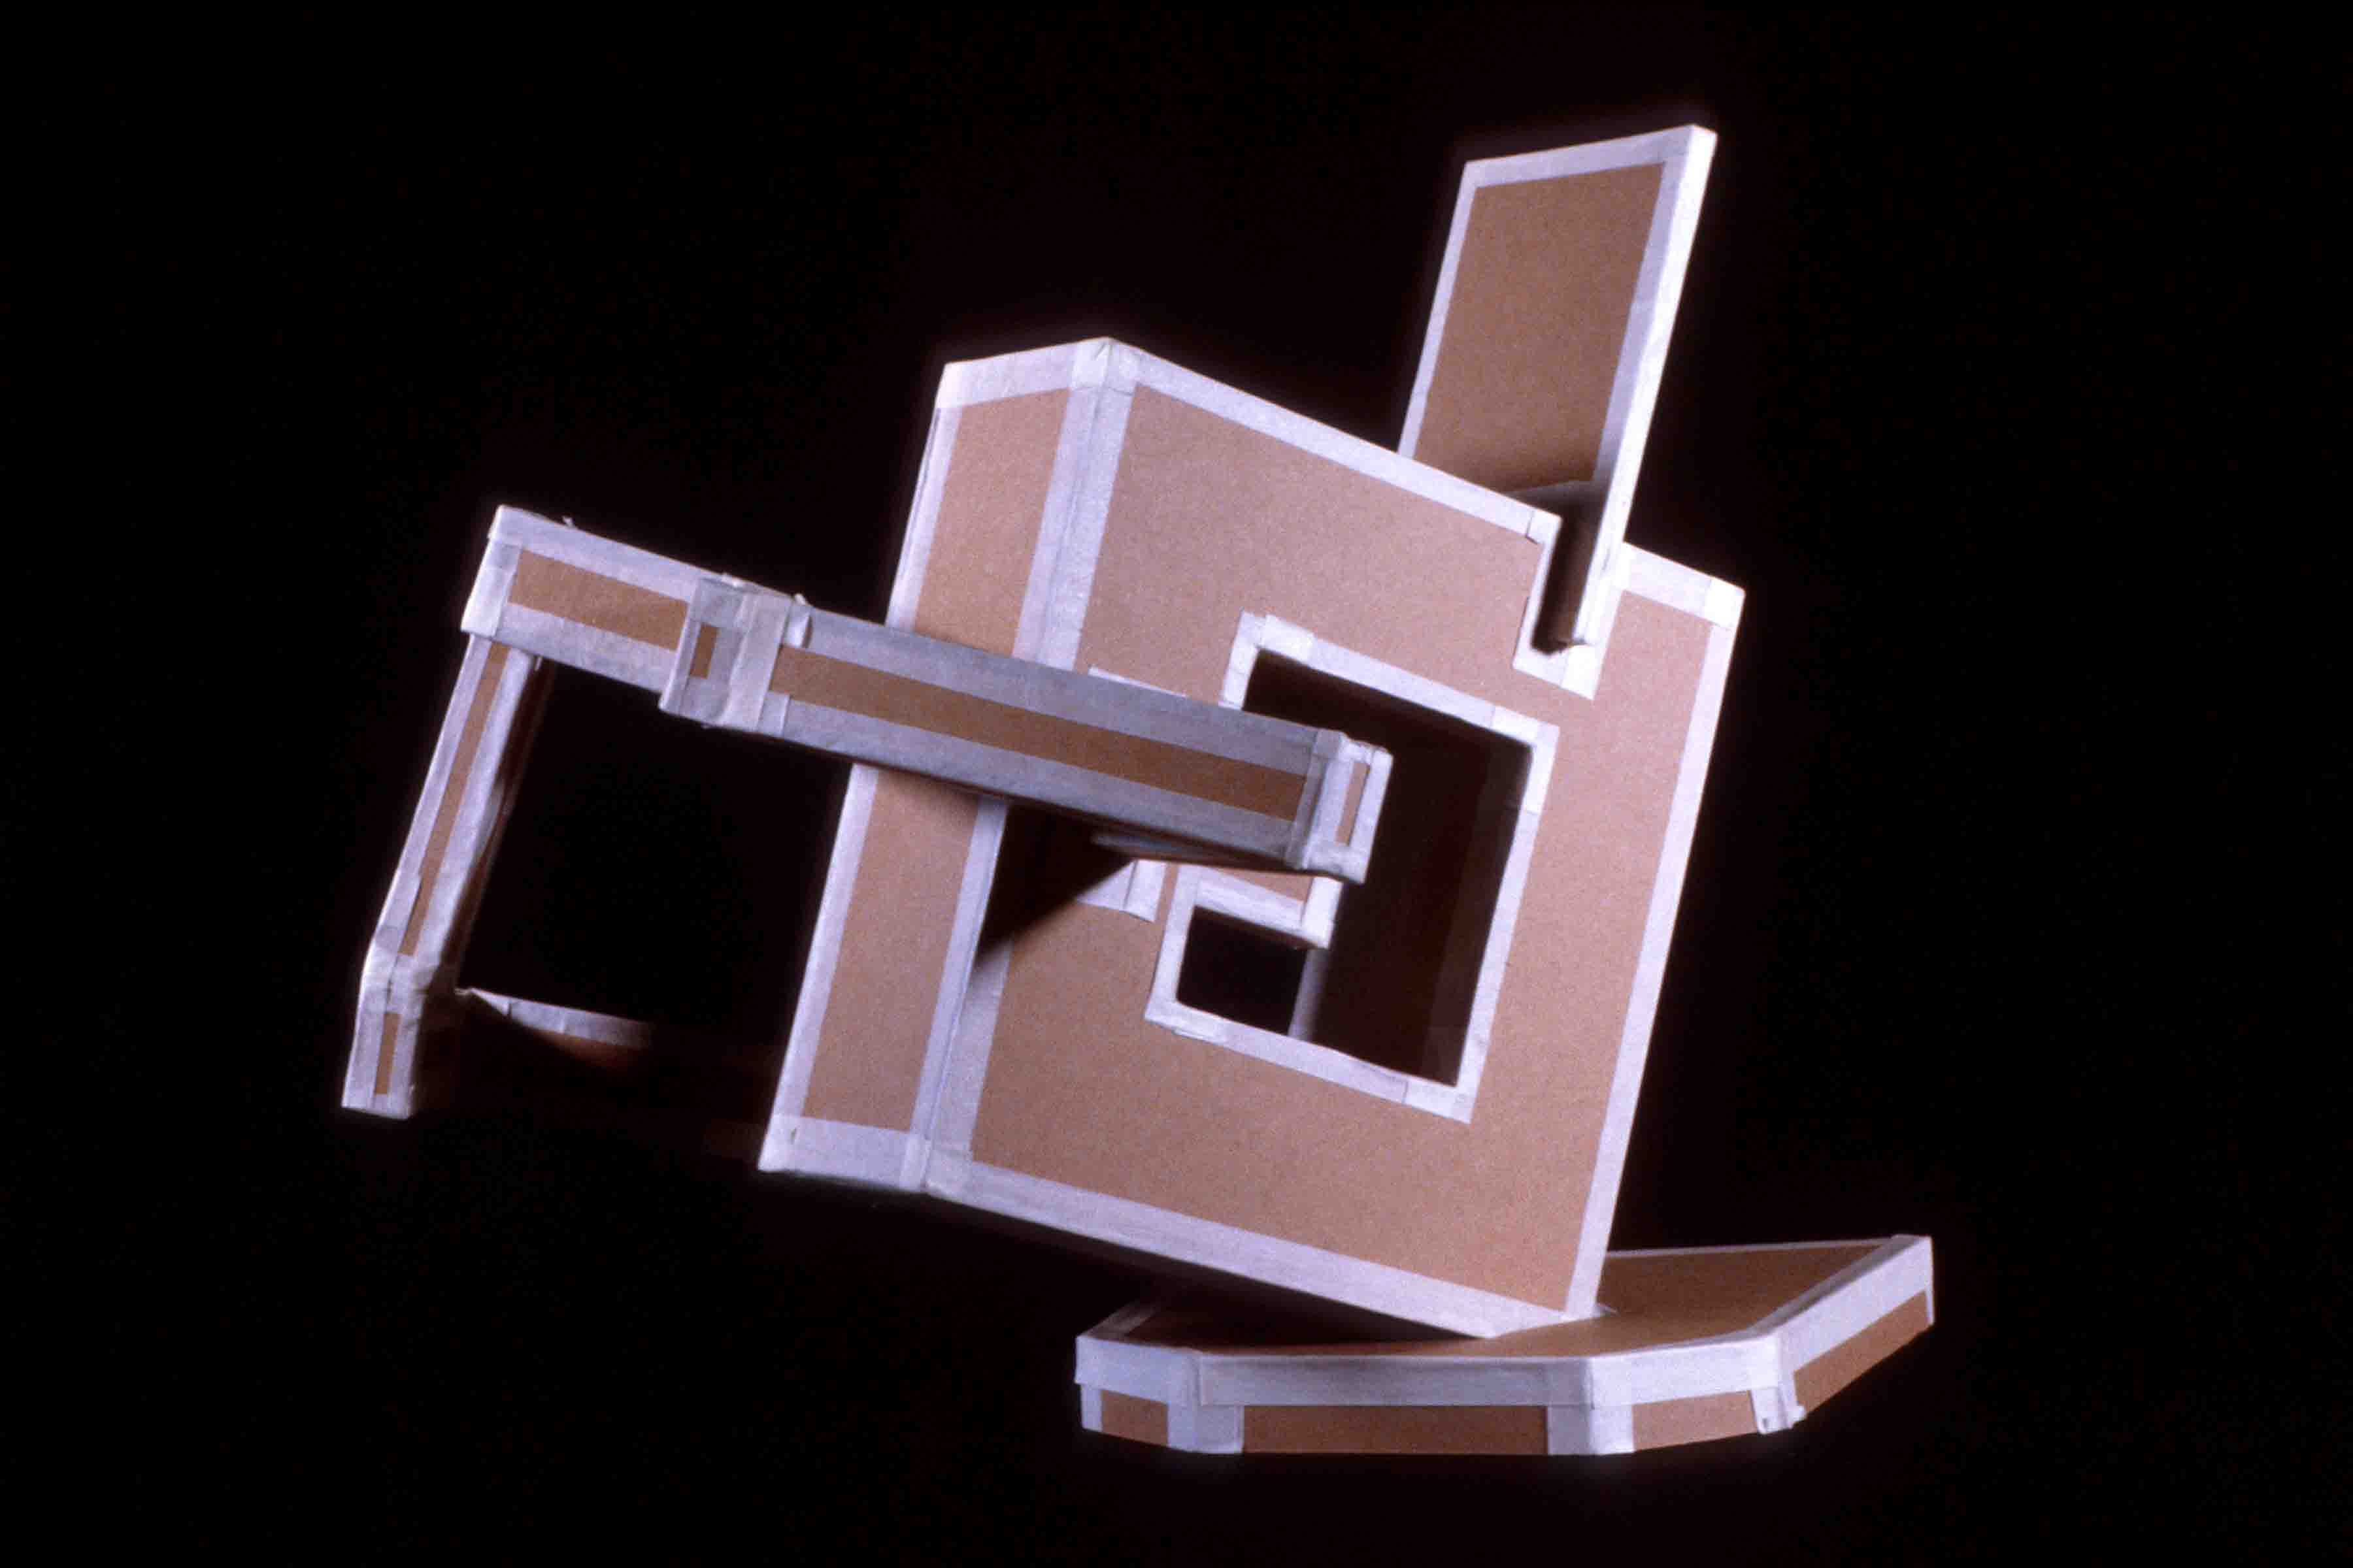

SPHERES OF INFLUENCE #1
Assignment created by Rick Paul, Purdue University

Problem: Build a 12" sphere with a tolerance of plus or minus 1/4" that will roll freely down a 12-degree inclined plane. You are limited to using found (not new) corrugated cardboard; no glue or additional materials may be used.

Objective: The objectives of this problem are two-fold. First, to design and build form with a curved surface from a planar material. Secondly, to divide and organize the interior space of a sphere.

Materials: Corrugated cardboard from used boxes

Strategy: A sphere is an example of a solid with a complex surface that bends in two directions. Materials like wood, paper, cardboard and sheet metal do not bend to form a complex surface. Nevertheless, these planar materials can be used to describe a spherical form. It is easy to make a sphere that will meet the criteria of the problem. The real design issue is how to divide the space within the sphere and which shapes will be used to do so.
Our attitude toward a material may be prejudiced by cultural bias or past experiences with the material. No material is inherently “good” or “bad,” “beautiful” or “ugly,” acceptable or distasteful. This problem also challenges you to examine a discarded material objectively.
1. Begin your work by examining the corrugated cardboard carefully. Is it a homogeneous material or does it have component parts? Does it have grain or can it be used without regard to orientation? What is necessary to bend it? How might you incorporate the printed information, if any, into your design?
2. Making three to four half-scale preliminary models to arrive at a unique solution. Your objective during this modeling process is to discover what shapes to use, how to arrange them and what process you will use to attach these shapes together.
3. Construct your final solution. Keep the creative juices flowing during this process as you become more familiar with the material.

Reading: Chapter 9, LTI

Instructor’s Notes: This problem introduces students to model making as a way of developing ideas. Using models, students can discover unique solutions and invent various forms of construction.
Levels of difficulty:
Most difficult:
• No shape passes through the center of the sphere.
• Shapes are folded to make secondary shapes.
• The scrap cardboard has been selected for its surface printing and this printing has been effectively incorporated into the design.
• A secondary interior volume, such as a cube at the center, is incorporated into the design.
• Method of construction is unique; how the object is held together is integrated into the design.
Average difficulty:
• No shape used passes through the center of the sphere. Method of construction goes beyond making use of slots.

Limited difficulty:

• The sphere is described by circles of the same size all intersecting at a line passing through the center.
Timetable: Two to three hours of presentation and model making in class and three hours of work out of class.
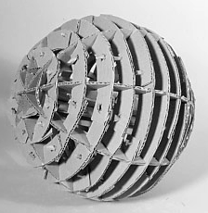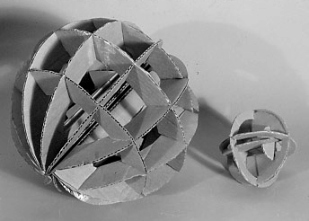Spheres of Influence #1 – examples of student work using cardboard and no adhesives.

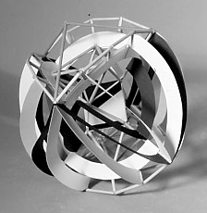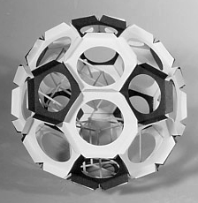Spheres of Influence #2 – examples of student work using planes and linear elements

SPHERES OF INFLUENCE #2

Problem: Using 1/8”, 3/16” dowels or ¼” balsa wood square stock and black and white poster board, construct a 12 inch sphere. Your sphere must contain a second simple real or implied volume such as a cube, pyramid, cone, or cylinder.

Objectives:
• To make a unified composition using linear and planar elements.
• To experience and understand the difference between real and implied volumes
• To rationalize the relationships between two volumes within one composition including placement, proportion and scale.

Materials: Balsa or 1/8” 3/16” dowel rods, black poster board and white poster board.

Strategy:
1. Begin by experimenting with ways to attach poster board to the dowel or square stock. Notice that a variety of joints may be necessary to solve this problem. For example, sticks may be attached on a surface, along an edge of a surface or meeting a surface at an angle. Each type of joint should be thought out before considering your design. A glue gun works well but the resulting joint may not be strong enough. White glue may necessary to ensure strong enough joints. Remember that the strength of a glue joint depends on how much gluing surface is shared by the pieces you are gluing together. Look for ways to increase the amount of glue surface between the stick and planar pieces you wish to glue together. In some cases your design may require a poster board tab that encase the stick or gussets between a stick and poster board.
2. You can start the design process with a circle between 9” and 12” in diameter. Cut a simple shape (square, circle or triangle) out of the circle. Experiment with folding the resulting shape one or two times along “logical” lines to make the piece three-dimensional. Add sticks and planes as needed to establish the two volumes required to solve the problem. Black and white shapes should be arranged to unify to your composition. Some compositions are more obvious than others. Asymmetrical compositions are more interesting but also more challenging.

Reading: Chapter 9, LTI

Instructor’s Notes: Learning how to join dissimilar materials is an important part of this problem. Encourage ambitious students to design interesting fasteners to join stick to plane. These fasteners must be integrated into their design. A good solution to this problem will make equal use of linear and planar as structural elements. I have found it helpful to keep the amount of the material used to a minimum. Stress that glue should not be used as a material to fill gaps– a good glue joint should have little glue showing. Based on the amount of surface area between crossing sticks it is unrealistic to expect such a joint to have any strength. Crossing sticks require some type of gusset to be held together.

Timetable: Two to three hours of presentation and model making in class and four hours of work out of class.

HEAD CASE: EXPLORING PLANAR CONSTRUCTION

Problem: Combining architecture and anatomy, create a six to ten- plane tunnel book or slotted book, measuring up to 12"x12"x 24" in size.
Objectives:
• To explore the interplay between space and planar structure.
• To demonstrate the structural versatility of the plane.
• To introduce use of tabs and slotted structures.
Materials: Twenty 5”x8" cards, two sheets of poster board or Bristol paper, one 18”x24" sheet of two-ply chipboard and one 18”x24" sheet of three ply chipboard, Elmer's glue, double-sided tape, glue stick and photocopies.

Strategy
- Find an interesting photograph of an architectural site, or take at least 24 photographs of a building that is spatially complex. Explore the space thoroughly, especially noting entrances, exits, transitions, spatial sequencing, and staircases.
- Choose one photograph to serve as a beginning point for a tunnel book. It needs to present four well-defined spatial layers. A compositional frame (such as an entry arch) is also helpful, both visually and structurally.
- Make twelve 5”x8" copies of the photograph on card stock or glue the copies to index cards.
- Distill the image into four layers of space and structure: foreground, middle ground #1, middle ground #2, and background. Cut out these "layers of space" from the cards, being sure to leave a 1" border on the bottom and sides. In a tunnel book, the first plane has the most cut away. As you move toward the back of the tunnel, less and less is removed, until the final plane is solid. An accordion structure is then attached to the right and left sides. A double tunnel book can be entered from both ends, with the solid wall positioned at the center of the book.
- Make two tunnel books or two slotted books, exploring the distance between the planes. These prototypes will then be critiqued.
- Finally, based on everything you have learned, combine these with a simple structure of a human head, so that the tunnel book creates an entry into the mind.

Reading: Chapter 9, LTI

Instructor’s notes: For more complex structures, get a book on pop-up book construction. Sheets of Plexiglas or acetate can be used to create a very different planar effect.

CALDERESQUE SELF-PORTRAIT
Assignment by Rick Paul, Purdue University

Problem: Make a life-sized three-dimensional bust using 60” of soft steel wire. You may include personal attribute in your portrait that makes you distinctive such as eyeglasses or hat.

Objective: to distill three dimensional design down to its most essential form

Materials: soft steel wire, pliers with side cutters, needle nosed pliers.

Strategy:
• Before you begin, make a list of significant physical features and details you want to include in your self-portrait.
• Make a list of objects you may want to include in your self-portrait. There are no restrictions as to what objects you may be included. You are welcome to listing objects slightly out of context, such as a distinctive shoe, or fish, which speak about you and your interests.
• Make several continuous contour and continuous blind contour drawings of yourself.
• Make several continuous contour drawings of you and your object together. How might the placement or scale of you object add additional meaning to your portrait?

Reading: Pages 175 to 189

Instructor’s Notes: Alexander Calder’s simple wire sculptures are perfect examples of how to eloquently and efficiently use wire to describe objects with spatial lines. The key to solving this problem successfully is to use the wire in the most efficient way, i.e. use as little wire as possible to describe a maximum amount of visual information.

Consider:
What are the similarities and differences between drawing in space with wire and drawing with a pencil on a two-dimensional surface? It may be necessary to use knots to hold your wire portrait together. If you used knots, did you incorporate them into your design or did they appear simply where convenient? Was “line quality” one of your design considerations? Did you consciously use specific shapes in your design? Is the unity of your design simply the result using one piece of wire or did you organize specific design elements to achieve unity?
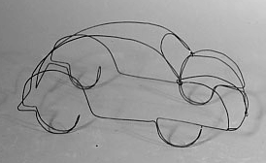

BECOMING BORG

Problem: Create one or more studies of hands using plaster gauze and wire. In these studies, explore the transition from human to machine, based on the Star Trek Borg civilization.

Objective:
• To compare and contrast linear notation in two and three dimensions.
• To investigate the effect of materials on meaning.
• To explore body language.
• To learn basic construction skills.

Materials: ebony pencils and drawing paper, materials, plaster gauze, 14, 18 and 24 gauge galvanized wire, one found object, if needed.

Strategy:
1. Create a series of drawings of body parts in pencil. Consider: Where does the human end and the machine begin? What is the most eloquent dialog between a wire “skeleton” and the plaster gauze “skin”? If a found object will be incorporated in the structure, what structural and conceptual role should it play?
2. To de-bug technical problems, make a rough life-sized wire “drawing” in space.
• What is the best way to create junctions?
• Technically, how can the gauze and wire work together effectively?
• How much wire is needed to create a sturdy sculpture?
3. Determine the best way to “stage” your sculptural idea. A vertical plane, a plinth, or a base may be used as a support. The sculpture may wrap around the support, extend outward, be suspended, etc.

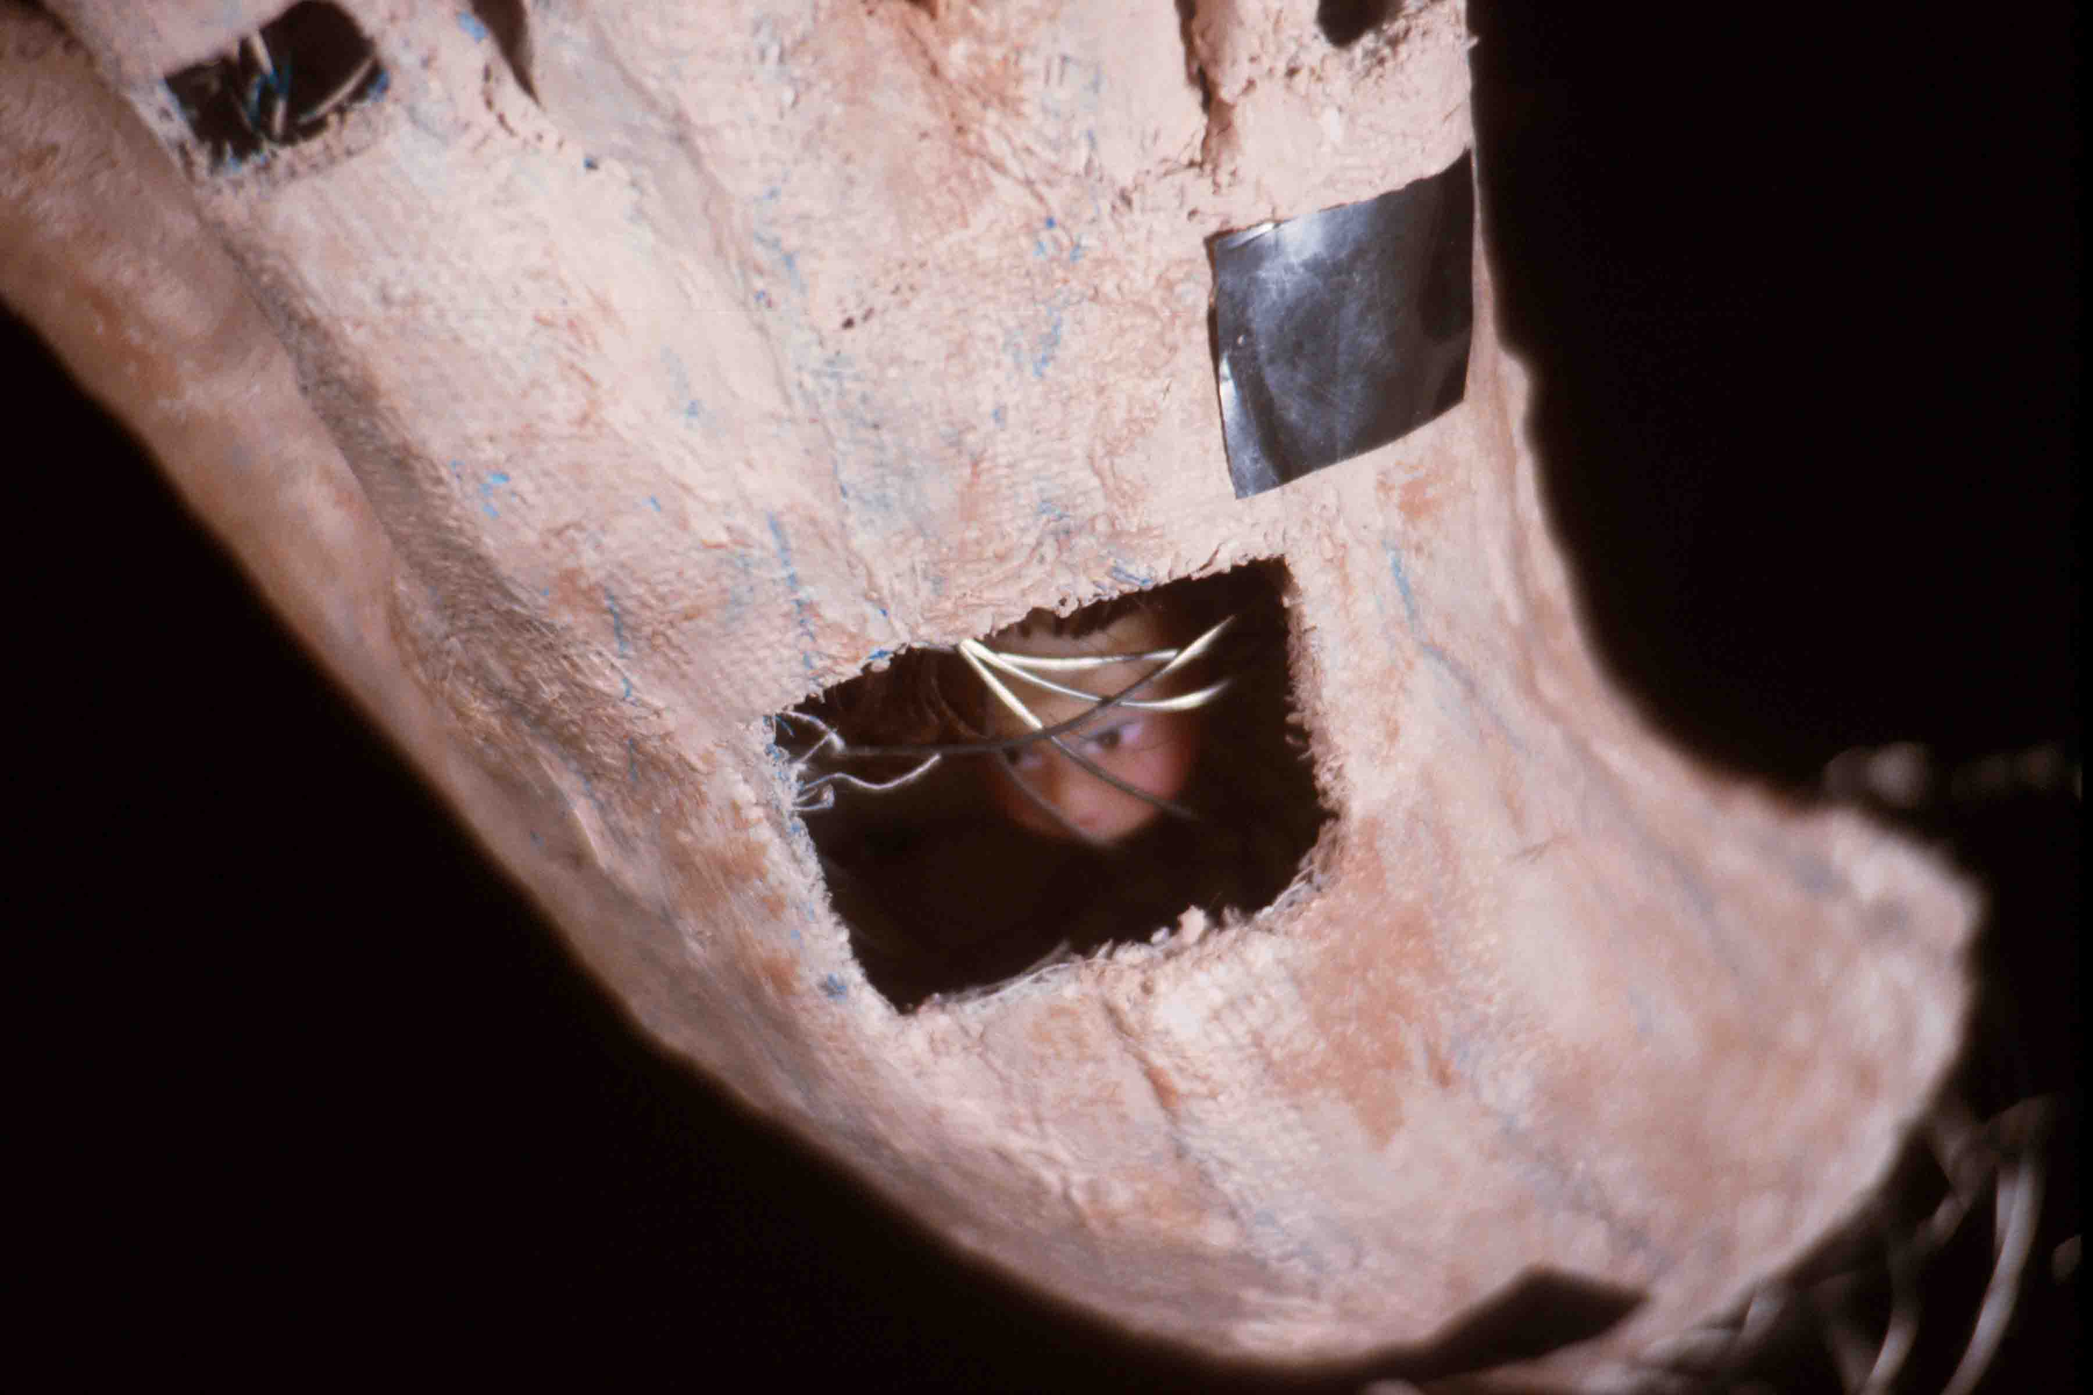
Reading: Chapter 11, LTI Timetable: 15-18 hours

Torn, Torque, Taut, Textile
Assignment designed by John Regan

Problem: Using cloth in any of its many social and/or political guises, explore the role of the pliable plane to both conceal and reveal in a ¾ or freestanding sculptural form.

Objectives:
- To explore uses of textiles in both art and design;
- Using the pliable nature of cloth to both conceal and reveal forms that exist below the surface.
- To distill a sculpture down to its essentials, thereby asking the viewer to contribute their own conclusions to the work.

Materials: ½ to 2 yards of cloth, sculptural objects, rope, string, wire, or other binding/banding element.

Strategy:
- Assemble your collection of sculptural forms into a ¾ or freestanding sculpture. Don’t go out and buy things for this, the world is full of garbage dumpsters, back alleys, or garages that offer a multitude of interesting forms and shapes.
- After your inner armature form is assembled you can begin to apply your cloth to create an activated and engaging “skin”.
- Consider how different cloth offers different tactile, visual, and social information to the work. Sheer cloth such as a fine silk organza will reveal most all of the inner form(s) and reflect some light off the surface, Stained bed sheets will conceal more of the inner form and could suggest childhood, puberty, or personal trauma, while socially loaded cloth such as flags, dresses, jockstraps, or religious vestments can dramatically change the “read” of the final work.
- After you’ve assembled the form(s) and the textiles, use the binding element to bring the cloth in contact with the form, thereby revealing some of the form while still perhaps concealing other parts of the whole. How you utilize this element will also have an impact on the final presentation. A form that is covered in cloth that is twisted and torn, then covered in an abundance of carefully constructed knotted cord will differ from a form covered in stretched Lycra and bound in only two distinct areas.

Instructor’s Notes: This is NOT simply a glorified papier-mache assignment where one applies a neutral skin to a temporary armature. The extent to which the textile surface of the sculpture is manipulated and bound will have a substantial impact on how the viewer will understand the content of the work, relate the surface material to the form(s) within, and most importantly be intrigued enough to want to spend time considering the artist’s intent through the use of materials.

References:
- Christo and Jean-Claude
- Anthony Gormley
- Todd Slaughter
- Kendall Buster
- Rick Paul
- Kenneth Snelson

DISCOVERING MASS
Assignment created by Rick Paul, Purdue University

Problem: Part 1: Make a complex sculptural object from foam rubber.
Part 2: Carve a replica of your foam object from a plaster block.

Objective: To explore a subtractive process and investigate uses of mass.

Materials: Foam rubber scraps, “Sharpie“ marker, string, wire, corrugated cardboard, duct tape or masking tape, simple hand carving tools, 10 pounds of number one molding plaster.

Strategy:
1. Create a sculptural object from scraps of foam rubber. Cut, twist, fold and tie the foam rubber into an interesting form that has concave as well as convex surfaces. Draw a 1/2” grid on the foam before starting. This grid helps to reveal how surfaces are stretched and distorted. It may be necessary to insert a stiff wire in the foam rubber to retain a desired form.
2. Construct a corrugated box with the same proportions as your foam rubber model. To do this, place your model on a piece of paper and draw the smallest rectangle possible around it. Measure the height of the model. Build a corrugated box proportionate to these dimensions. Use duct tape to make your box strong and watertight. Wrap the top perimeter of your box twice with duct tape to reinforce it.
3. Fill the box with plaster. You may need to brace the box with heavy objects (bricks or blocks of wood) to better maintain its shape while the plaster sets. Store your block in an airtight plastic bag to keep it damp while carving.
4. Carve the plaster object. Using charcoal or ebony pencil, begin by drawing 6 profile drawings on each of the sides of your block. Be careful not to favor a single view or side as you proceed with your carving. Carving sides in a regular sequence helps to accomplish this.
5. Use 220 grit wet/dry paper and water to sand the surface to a high polish.
Reading: Chapter 10 and 11, LTI
Instructor’s Notes: Get foam rubber scraps from a foam rubber dealer. Encourage students to experiment with cutting and tearing and otherwise manipulating the foam. For part 2, it may be necessary to scale the model up or down to a workable size. Do not let students sand their carvings in a sink as plaster will clog drains. Sand plaster outside using a water hose or over a floor drain.
Timetable: One hour to work with foam rubber maquette, one hour to construct the container and cast a plaster block, four to six hours to carve the plaster.

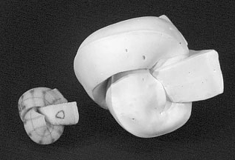

WALKING STICK

Problem: Transform a 24” long plank of 2" thick pine into a walking stick or wizard’s staff. For extra credit, build in a second "transformation," through a series of changes from the top to the bottom of the stick or staff.

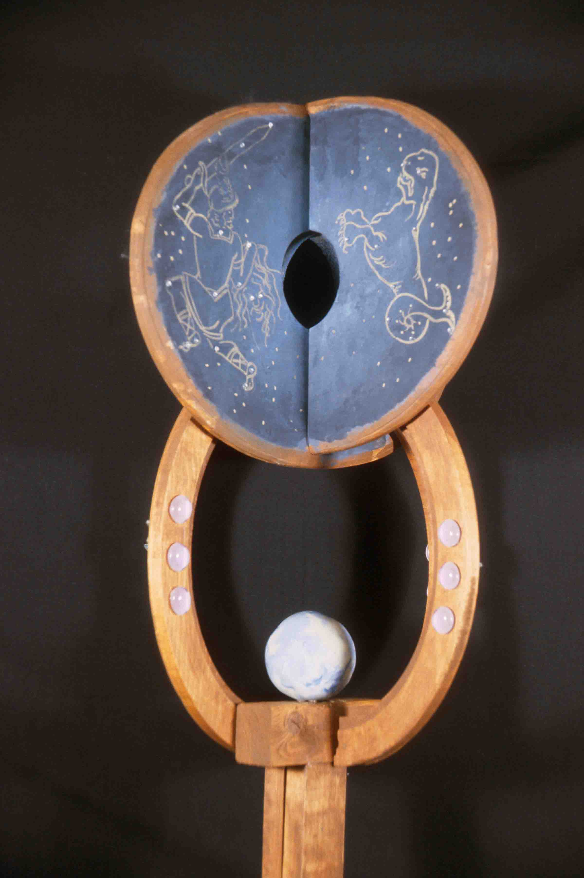
Objective: This project is designed to give you an introduction to the woodshop. By mastering a drill press, sander and band saw, you can greatly expand your capabilities for two-dimensional as well as three-dimensional work.

Materials: wooden plank, sand paper, glue, screws. All basic materials will be supplied.

Strategy:
As with all 3D work, this project will require both conceptual and structural research.
1. Find and print out at least 6 examples of walking sticks or staffs, using the Internet and/or library resources. Hint: Many nomadic cultures use walking sticks or staffs extensively and staffs have all kinds of ceremonial implications.

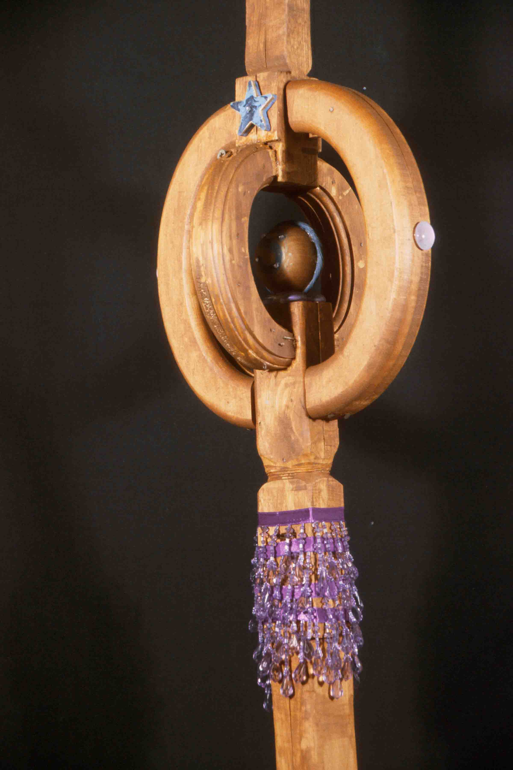
2. Draw at least 10 rough ideas, then choose the best for further development

3. We will then head up to the woodshop, for an introduction to the equipment. Pay close attention to everything the technician says, and follow the technician’s advice. Used properly, the equipment is safe and easy to use.

4. Using a piece of scrap wood, extensively experiment with all of the tools. Re-design your project, based on the skills you have learned. Make the piece, being especially attentive to composition, function, balance, and physical connections. Finally, paint or stain the wood.

Assignment Criteria:
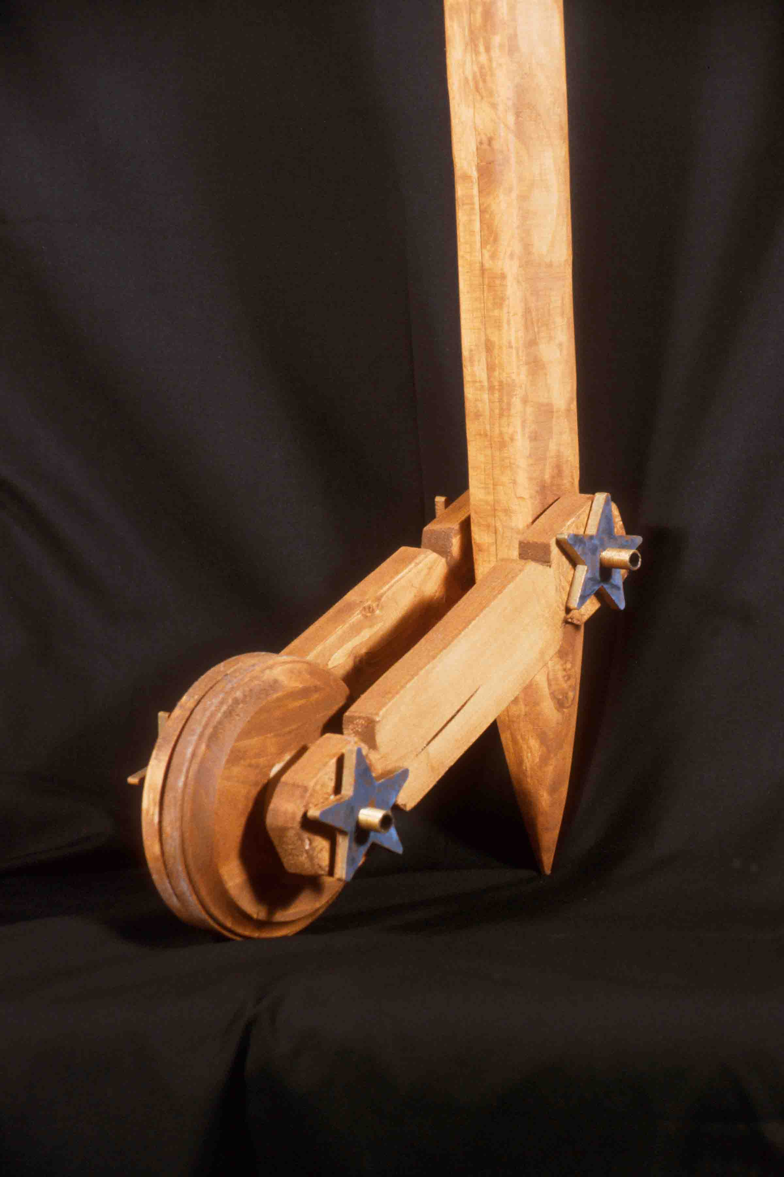
• Did you really transform the plank? Do we still "see" the plank, or do we now see a staff?
• Is it functional? Is there a good handgrip? Is the stick strong enough to provide support, but light enough to carry easily?
• Are the conceptual and compositional “connections” appropriate and effective?
• How about the craft, including sanding? Does the project meet an appropriate degree of refinement, detailing, etc.

Readings: Review Part 3, LTI

Timetable: 20-25 hours.

BUILD A CONCEPT GENERATOR

Problem: Create a three-dimensional puzzle or toy. When manipulated, this object should help the user generate a rich and varied response to the subject matter.

Objective: To expand library research and explore non-linear narrative.

Materials: Two-and four-ply chipboard, photocopies, double-sided tape and glue, acetate

Strategy: Begin by researching a word, idea, or phrase using mapping, list making, and a library or Internet key word search.
Part #1: Find and photocopy at least twelve images from library sources. Organize six of the images on the six exterior surfaces of a four-inch cube, with one image per side. When the cube is turned, the images should serve as a conceptual stimulus for the viewer, helping him/her think about the subject matter.
Part #2: Using a second four-inch cube, organize up to twelve photocopies to create a more fluid design. Images can wrap around edges to create compositional and conceptual flow.
Part #3: Using a third four-inch cube, organize photocopies and up to twelve words to activate both the interior and exterior surfaces. Those who are more ambitious can expand the problem using multiple cubes or cubes within cubes.
Part #4: Invent your own conceptual toy, designed to generate the greatest number of concepts or evoke the most powerful emotions when manipulated. Invent boxes, puzzles games etc.
Part #5: Expand the Concept Generator toy to create a collaborative installation

Reading: Part 2 and Art in Boxes, by Mogelon.

Instructor’s Notes: Linear narrative was a primary concern in the True Lies assignment. Using a traditional codex book structure, we worked sequentially, using images on each page to develop a story with a deliberate beginning, middle, and end. By contrast, this assignment gives students experience with non-linear thinking. On a cube, the order in which the images will be seen is unpredictable, and any direction the viewer travels must offer rich possibilities and powerful implications. No longer telling a story, the Concept Generator serves as a stimulus for the thoughts the viewer develops him or herself.
The most inventive students will be able to create a great project using any word. Less confident students should be encouraged to start with an especially meaningful word. A Roget’s International Thesaurus (the kind that is not alphabetical) can help students identify words with great potential.
Discuss the importance of archetypes and the recurrence of certain images across many cultures: why are circles so powerful and used so widely? How many images and meanings can be derived from the word “water?” or “hidden?” or “parallel?” Can a Concept Generator evoke irrational dream-images, rather than remaining in the rational world? This assignment offers endless possibilities: encourage students to play with all sorts of ideas!
Extensive library research can greatly expand the possibilities. Try to find a librarian to serve as a collaborator. As the project evolves, the source images can be substantially transformed using enlargements, reductions, collage, drawing and so forth, to produce work which is conceptually inventive and visually compelling.

Timetable: 18 hours for Parts 1 to 4, 12 -18 more hours for Part 5 (optional)
Tangible Dreams

Problem: Create a set design model or an assemblage (up to 18x18x24” in size) combining photographic imagery with everyday objects. In this artwork, explore relationships between the magic of dreams and the substance of reality.

Objectives:
- To expand creativity by re-thinking both ephemeral and the prosaic experiences;
- To explore the distinctive characteristics of two, three, and four-dimensional construction;
- To envelop the viewer in narrative—linear, non-linear, or both;
- To use collaboration in the construction and criticism of an artwork;
- To heighten self-awareness: What are your unique strengths and areas of interest?

Materials: Your choice.

Strategy:
- As homework, write brief descriptions (up to 50 words or so) of six compelling dreams and email it to your partners. These can be personal dreams you want to share, literary dreams (such as Raskolnikov’s dream in Crime and Punishment), Martin Luther King’s “I Have A Dream” or even dreams based on ambitions, such as “I want to be an astronaut when I grow up.”
- Read all of the choices carefully and consider possible means of visualization. From the entire list of 24 dreams, which 4 interest you the most, and why?
- Working within your 4-person team in class, present your choices and the rationale for each to the group. After all presentations are complete, vote as a group to select four possibilities for the actual assignment.
- Choose the possibility you most want your team to complete for the final assignment, and as homework, work up thumbnails or other ideas, so that you can “sell” that option to your partners.
- In the next class meeting, both “sell” vigorously and listen attentively. One of your partners may have a terrific idea that can be combined with your own approach, or simply offers richer possibilities.
- Now comes the crucial choice: will your compete one mega project as a group, or four separate projects, to present together? Either is a valid solution.
- Complete the project, using a mix of worktime and critique, with your partners as sounding boards.
- Upon completion, write a 1-page self-evaluation, listing your strengths as a team-member and your points of resistance or confusion in the process.

References: Crime and Punishment, Giving Fear a Proper Name, The Oxford Book of Dreams, Joseph Cornell, Surrealism

SUPERHERO MASK / HEADGEAR DESIGN
Assignment created by Anthony Fontana

Problem: Construct a mask or a piece of headgear that represents the attributes of:
- A person you consider your hero
- A superpower you would like to have (such as flying, x-ray eyes, etc.)
- A political or moral value you would stand up for.
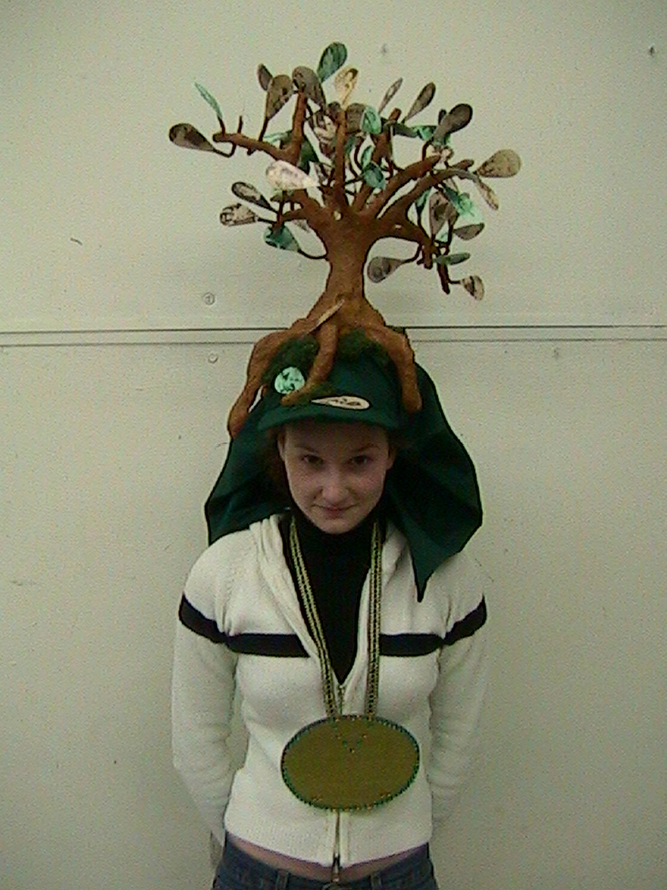
Some of the options can also be combined (example: combine a father as a hero, who was an anti-war protestor during Vietnam, and you can make “Father Peace.”) Each piece must be wearable, at time of presentation.

Objective:
• To explore new materials.
• To connect materials and meaning.
• To introduce an aspect of performance.

Strategy:
1. Brainstorm ideas. Come up with multiple solutions to the problem. Refer to LTI: Chapter Five. Any idea may be viable, no matter how strange it may seem!

2. Write a description of your Superhero. This may include a fictional or non-fictional history of the Hero, his/her attitude, personality, or general interests.

3. In your sketchbook draw out ideas for how to convey your concept in three-dimensional space. Do not limit yourself, but pay strict attention to what materials you will use to portray that superhero. For example, the Man of Steel’s helmet would probably not be made out of yarn.
Consider ways to make your piece stand out from the typical comic book superhero. It can have moving pieces or multiple parts. Think about hairstyles and hat designs. Go to the library for research. You can also make an accessory object (such as a weapon) to go with your headgear. This would count as extra credit.

4. Once you have a design for your helmet or mask, do a drawing on 18”x24” drawing paper with colored marker or colored pencil. It should incorporate multiple views of the piece and may include the bio. This will be a companion piece for your project.

5. Gather the materials needed and begin assembling your artwork. Pay strict attention to detail. In the movies we don’t see the glue holding the Penguin’s nose on or a string holding Cyclops’s glasses to his head. Good craft helps make your mask believable.

6. Wear mask. Photos will be taken of you wearing your mask or headgear.

Instructor’s notes:
Have the students work in teams of three to four. Meet with the teams and have students share results from each stage.

Reading: Chapters 5, 7, 10, 11, 12 Timetable: 20-30 hours, depending on complexity

AUDIO ASSEMBLAGE
Assignment created by Anthony Fontana

Problem: Using found materials, create an assemblage that can be used as a musical instrument.

Objective:
- To explore ways to combine and unify disparate source materials.
- To connect art and music.
- To expand ideas through collaborative thinking.

Materials: Open: be inventive! Cardboard, chipboard, wood, wire, and plaster are all available for use. Collect objects from your daily habits to incorporate into the project.

Strategy:
1. Spend time listening to the sounds you hear on a normal day. The noise your shoes make on different surfaces, the sound of a soda popping as you open it or even the music of tearing up your junk-mail can be inspirational. Brainstorm in your sketchbook. Make at least 10 thumbnails of your ideas. Think about those things that make noise and how you could 1) make them into an instrument and/ OR 2) how they can be transformed into art.

2. Make a detailed drawing (18”x24”) of the purposed idea using color markers or pencils. Title your piece and give detailed descriptions of the purpose of each element. You can also include a smaller drawing of a reverse angle view of your piece.

3. Collect the objects you will need to make an instrument. Decide what materials you will use to connect or unify all the sounds together.

4. Begin construction of your instrument. Craftsmanship is VERY important! Remember, you are unifying all of your sound-making elements into one piece.

Reading: Chapters 5, 7, 10, 11, and 12

Instructor’s Notes:
- Have the students focus on creating a central area that produces a range of similar sounds. For example, different sized bottles can make similar sounds but at different tones.
- Encourage students to collect items from their daily habits or routines. These objects can be used to produce sound or embellish your instrument.
- Some students shy away from being loud or musical with their piece. Encourage them with lots of positive feedback and teamwork, as necessary.
- Avoid the cliché! When unchallenged half the class may show up with glass bottles and a fork. Stress the importance of innovation!
- Show slides of tribal, cultural, or electric instruments. Sometimes the redesign of an already familiar instrument can be very effective.
- Introduce installation works. An audio assemblage does not have to be an object—it can be a setting.

Timetable: 20-30 hours, depending on complexity.

MYTHS AND MASKS
Assignment created by Linda Vanderkolk, Purdue University

Problem: Create a three-dimensional wearable mask for a specific occasion. Use photocopied images to add content to your mask.

Objective:
• To transform planar material into a functional & representational 3-D object.
• To effectively use low relief and simulated texture as applied surface design.
• To effectively convey content.

Materials: White poster board, high-quality bond typing paper, heavy-duty paper stapler, glues, string or elastic, photocopier or scanner access and theme-related objects.

Strategy:
1. Brainstorming. Name activities during which masks are customarily worn. Name ceremonies, rituals, events, or traditions where masks are not worn but could be. Name daily events or common activities where you’ve never considered wearing a mask. Then select an occasion for your mask and the content of your mask. It may be serious, humorous, poignant or sarcastic.
2. Build your mask. Begin with a single sheet of 18”x24” poster board. Use paper manipulation techniques (cutting, scoring, curling, folding, tabs, etc.) to transform it into a three-dimensional form. Take measurements of your own head to insure your mask is wearable.
3. Surface embellishment. Create computer printouts or photocopies to apply to your mask. What interesting items (related to your content theme) could you copy? Consider these characteristics when selecting printed matter to apply to the mask’s surface:
visual or literal content value patterns
aesthetic interest repetition

illusionary 3-D Texture rhythm
negative & positive shapes style
computer or photocopy quality texture values

directional attributes inventiveness
You may wish to have more than one copy of some images. The textures/images should cover at least 70% of the mask’s surface. Some of your copied material should be applied in a manner that creates additional relief. If black paper is additionally allowed, it should cover no more than 30% of the mask. Think carefully about your mask’s composition and be sure to look at it from a variety of viewpoints. Faces are generally symmetrical. Does the mask’s form or surface decoration need to be symmetrical? When your mask is finished, attach strings so it may be worn or hung on the wall.
4. Give your mask a title that addresses the content of the mask. Write this title and your name on the interior of the mask.

Reading: Parts 2 and 3, LTI

Instructor’s Notes:
• Show examples of artists who use titles to add content to their art.
• Show examples of art with simulated texture information that reinforces the artist’s content intent.
• Show examples of masks with textures and/or humor from various cultures (Native American, African, etc.), especially any with materials related to the masks’ purpose. Examine 2D mask patterns that become 3-D forms.
• Can the mask be constructed without the use of glue, tape, or staples? Heavyweight paper could possibly be substituted for the poster board. Students can practice with a sheet of 18”x24” newsprint, but stiffness will matter for some techniques. Best use of a single sheet may not mean starting with the center of the mask in the middle of the page. Use leftover paper for additional attachments. Students may wish to construct forms related to images they will be applying (watering-can nose, computer-shaped head, etc.)
• Have them look at the value pattern of their decorations from a distance.
• Rather than randomly or flatly adhering all copies to the mask’s surface, create new relief or emphasize the 3-D form with value choices. (Dark textures in areas relating to shadows on a form & lighter ones relating to highlights can strengthen the dimensional appearance). Inform them that only black and white will be allowed (or decide to allow color).
• Give due dates for completion of each step. Make copies outside of class time. Before applying textures, compare and critique construction, creativity, craftsmanship and form.
• Papers applied to the surface can reinforce weak construction.
• Caution students that no adhesives should show.

Topic for critique:
• Ask students to identify examples where the following have been used effectively:
texture shape rhythm
value line visual flow
repetition expression pattern

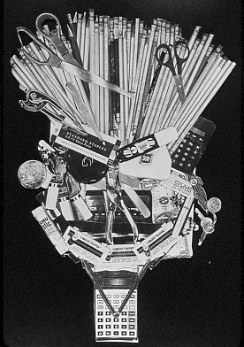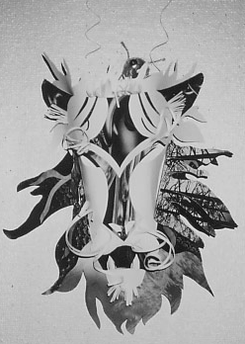Timetable: 3 to 4 hours of class time, 2 to 5 hours outside of

BOOK TRANSFORMED
Assignment created by Linda Vanderkolk, Purdue University

Problem: Transform a used hard-covered book into a new object.

Objectives:

• To explore the original book’s form, construction method, and materials.
• To consider the book’s literal content as resource.
• To create a dramatically new form with a minimum of new materials.

Materials: Several used books, glue gun and glue and miscellaneous hand or power tools (e.g., awl, clamp, drill, sander, band saw, etc.)

Strategy:
1. You are limited to using the materials of one book and adhesives. Begin by thoroughly examining your book for its materials, content and form. List these aspects and any other physical characteristics or formal qualities you discover.
2. You may cut, tear, or otherwise rearrange any parts of your book to solve the problem. To jumpstart your imagination, visualize the results that these actions could have on a book:
remove crush wrap sew bend divide
bind bite glue sand shred cut
imbed scratch drill rip incise wedge
pleat Xerox fold explode cook coat
curl gouge staple crumple soak wax
score twist tape burnish weave nail
prick burn knot knit carve shoot
burrow patch erase mark sandwich intersect
alternate extrude skewer pleat peel elongate

You may find power tools helpful. If shop tools are used, be sure you have been taught how to use them safely.
3. Now that you’ve experience the variety of forms your new object can take explore a content related object or scene to depict. Use creative, elegant and/or subtle ways to address content instead of obvious stereotypes or cute clichés. Be sure to create a strong overall form rather than focusing only on decorative aspects. Forget how you are normally asked to treat books. Don’t forget that you are designing a new object!

Reading: Chapters 11 and 15

Instructor’s Notes:
• Introducing the problem before students select books will enhance the aesthetics and content of solutions.
• Schedule this to coincide with community book sales, give specific used book sources in your location, or buy bags of books at local library sales in anticipation.
• Encourage students to purchase several inexpensive books so they can experiment freely.
• Use hard-backed books only. Dissect one book in class to discover how books are made. Ask students to identify and list those aspects they specifically have to work with (i.e. absorbent, heavy, gilt-edged, flexible, delicate, miniature, mass, planes, colors, shapes, textures, lines, paper, cloth, cardboard, gauze, folds, corners, etc.). Use a preliminary book to experiment with cutting and construction methods. Consider subtraction, manipulation, addition, and rearrangement. List tools that may be applicable. If power tools are used, teach safety precautions. Specify exactly what you consider an adhesive. (Acrylic medium? Thread? Wax?)
• Show book-artist video segments (i.e. Inner-Views, 1986), slides of artwork incorporating books (i.e. Ann Hamilton’s text as balls of yarn), or imaginative handmade books for inspiration.
• “Straddling” is an idea that artists sometime use to increase viewer interest. (The transformational midpoint that connects both book and new object may be more intriguing than either ‘blatantly-still-a-book’ or ‘can’t-tell-it-ever-was-a-book’.)
• Remind them to consider the viewpoint, details, characteristics, etc. of their object depiction possibilities, rather than starting with their first thought. Ask that they sketch ideas before they begin transforming.
• This problem could be a partner or group assignment if time is limited.

Timetable: 2 to 3 hours of class time, 2 to 6 hours outside of class.
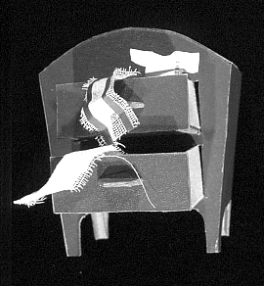

ABSTRACTED OBJECT FRAGMENTED
Assignment created by Rick Paul, Purdue University

Problem: Build a fragment of a common object out of Bristol board and other paper products. Even though your result is an accurate replica of an object fragment, the object it represents should not be recognizable.

Objective: The primary objective of this problem is to use your design skills to disguise an object and mislead the viewer. Through selection and a change in scale and materials, your object should be translated into a pure form, without a conceptual reference. In this project you will also learn the techniques and skills necessary for building a detailed object and practice ways of organizing work when solving complex problems.

Materials: Two ply Bristol board and glue or strong double-stick tape.

Strategy: The complexity of this problem requires a step-by-step procedure.
1. Select a unique and interesting object. Mechanical objects (can openers, staplers, tools) are especially well suited to this problem because they are generally dominated by crisp edges and definite masses. Organic objects (seed pods, fruit, sports equipment, etc.) are generally dominated by complex curves and thus more difficult to construct. Your object should be large enough to measure parts accurately to 1/32 of an inch.

2. Determine the fragment you wish to construct. Look for interesting joints and junctions, the overall flow between composite forms, variations in texture, and so forth.

3. Make your fragment by using flat planes to cut through the object. Using masking tape, mask off and eliminate the part of your object you are not building. Use the ground plane as a cutting plane, a dramatic surface from which you object rises. Cutting your object in a logical manner does little to disguise it, so cut your object in an unexpected way.

4. Make working drawings of your fragment from various viewpoints. These drawings should include accurate measurements.

5. Determine the scale. Your finished project should measure no more than 16 inches in one direction. With this in mind, divide the longest distance on your fragment into 16 to determine a scale multiplier. Use this multiplier and the dimensions on your drawing to determine the size of the various parts.

6. Construct your solution. Complex fragments can often be made with one primary structure combined with smaller additions.

Reading: Chapter 9

Instructor’s Notes: This is a difficult problem that requires good organizational skills as well as good compositional skills. Carefully demonstrate cutting, scoring and gluing, especially showing how to glue a curved plane to a curved shape. Encourage students to use tabs where possible to expedite construction.
In developing the design, encourage your students to pay particular attention to the relationship between the primary structure and the base plane. The way in which the object is sliced at the base can make all the difference between a really imaginative solution and a more prosaic solution. Some designs may even extend out from the wall or down from the ceiling if constructed carefully enough.
Timetable: 15-25 hours. Allow two to three hours to introduce problem, determine fragment and make working drawings.

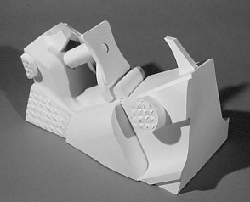

Abstracted Object – example of student work, squirt gun trigger.

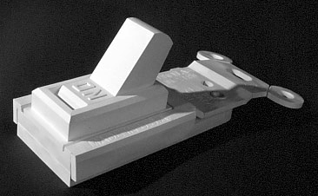

Abstracted Object – example of student work, light switch.
“Merzbau” Transformed by John Regan, Columbia College, Chicago

Research Paper due March 21 / Final Critique on April 6

Premise: German artist Kurt Schwitters began constructing the Merzbau, a combination of collage, sculpture, and architecture, in a corner of his studio in Hanover, Germany in 1920. Also called the Cathedral of Erotic Misery, this was Schwitters's private world. It eventually took over his entire living quarters, the apartment above, and part of the yard, and was divided into rooms-the Biedermeier Room, the de Stijl Room, the Goethe Cave, the Mondrian Cave, and the Mies Cave, among others. It was destroyed during an Allied bombing raid in 1943.

Research Assignment
Using all of the on-line sources listed below (as well as library sources), familiarize yourself with this legendary work. I would suggest that you use your sketchbook to take several pages of notes that will then aid you in composing a three-page TYPED essay with your reflections on these readings. Reflections must be your own words and not a clever application of some cut and paste work! They must include your observations of 10 different ways in which this work relates to your study of the principles and elements of 3-D design. (Here’s a hint… the class text and the 3-D vocabulary sheet I’ve handed out will be a VERY good guide.)

http://www.rochester.edu/in_visible_culture/Issue4-IVC/Mansoor.html
http://www.merzbau.org/Schwitters.html http://www.stunned.org/mz1.htm

Studio Assignment
Working in teams of four, you will begin transforming 4 distinct areas of a classroom into a modern day Merzbau using corrugated cardboard and your own found objects. Following up on our earlier constructions exploring the relationships between point, plane, and volume as well as the push and pull between varying percentages of negative and positive compositions, specific emphasis will be given to the study of scale, balance, and proportion in this assignment.

As noted in our earlier critiques of the former assignments, these applications have many similarities with elements of architecture and its’ design. In these room-sized assemblages this aspect will become increasingly apparent. As you build these as of yet un-named “cathedrals”, consider its interaction with the body and sounds in addition to the other formal elements. Does the constructed form allow for a comfortable home or an unsettling space for the viewer? Like Schwitters included personal mementos in his structures, is there something hidden within the inner realm of the grotto that requires the viewer to interact rather than merely observe? If so, how does it inform the work?

How the team chooses to enhance the final presentation should connect to the content. I strongly suggest that you avoid cliché’s (i.e. decoupage) in favor of more elegant and subtle choices that rely more on the strength of your construction and its unique features that separate it from those of the other teams.

INTRODUCTION TO BASIC MATERIALS

At the first-year level, students often arrive with virtually no hand skills or knowledge of even the most basic materials. Woodshop supplies are typically bought in bulk using lab fees. The notes that follow give students advice on materials they are likely to buy themselves. These notes are drawn from Launching the Imagination: A Comprehensive Guide to Basic Design, by Mary Stewart; McGraw-Hill, publisher.

Boards
Bristol board is like thick, stiff paper. It is available in various thicknesses from 1-ply (similar to good drawing paper in weight) to 5-ply (which is similar in weight to illustration board). A cold-pressed (or vellum) surface is slightly textured, while a hot-pressed (or plate) surface is very smooth. The vellum surface is best for graphite, charcoal, pastels, and colored pencils. The smooth hot-pressed surface is good for felt markers and pen and ink. Either can be used for model building, book arts, and planar structures.
Chipboard is a dense, gray, uncoated board made from recycled paper. Most drawing pads have a chipboard backing. Single-thickness chipboard can be cut with an exacto knife or a heavy-duty paper
cutter; use a utility knife to cut all heavier board.
Foamcore is light, strong, and rather unforgiving. It must be cut with a very sharp exacto knife or a scroll saw, and dents in the surface or cutting errors are difficult to repair. It is widely used in architecture classes for model-building.
Corrugated cardboard is strong, light-weight, cheap, and amazingly versatile. It is often used for large-scale projects. Through careful planning, you can use the grain (corrugation direction) to create
curving planes or even expose the “grain” it to add texture to your design.

Glues
White glue is nontoxic and water-soluble when wet. It can be used with most porous materials, including all of the boards described in the previous section. It is not suitable for paper-to-paper adhesion, as most
papers will buckle as they dry.
Glue stick is a water-soluble acrylic that is acid-free, and nontoxic. Designed as an adhesive for thin paper, glue stick is generally ineffective for gluing any kind of board.
Rubber cement is a traditional paper adhesive that can be “erased” when misapplied. However, because rubber cement is highly toxic, flammable, and impermanent, it has limited use in three-dimensional design classes.
Hot glue is a wax-based, translucent material that is heated in a gun and applied as a hot, viscous fluid. It is most effective in adhering nonporous materials, and it provides a quick way to create an assemblage. It can also be used to tack cardboard structures together while the white glue dries.
Dry mounting tissue is distributed in sheets of thin, clear plastic. Adhesion occurs when this material is heated, either in a drymount press or using an iron. This is an excellent adhesive for most papers and light-weight cloth, and it is widely used in photography and book arts.

Tapes
Transparent tape (“Scotch tape”) is an all-purpose, light-weight, temporary adhesive for paper. It is not an effective adhesive for boards.
Masking tape is tough, flexible crepe-paper tape. It is designed to mask off unpainted areas, as with
painting a car. It is a good temporary adhesive for boards, especially during the model-building stage.
Drafting tape and artist’s tape are like masking tape but have less glue. They can be removed without damaging the surface to which they are applied.
Double-sided encapsulating tape has acrylic adhesive on both surfaces. A layer of thin paper protects
one side until the tape is actually applied. An archival version of this material is sold by bookbinding
stores, and it can be used for well-crafted final projects.

Chapter Four

TWO-DIMENSIONAL DESIGN FOUNDATIONS

Notes to the Beginning Teacher:
The Perils and Possibilities of Two-Dimensional FoundationS

Each foundation course offers distinct challenges and opportunities.
For many students, drawing is the most difficult. There is a relentless honesty in drawing
and there is no place to hide when the proportions are off or the perspective is skewed. Students and teachers must bring an endless supply of patience, persistence, and optimism to each and every class meeting.
Three-Dimensional Foundation presents a range of technical and physical challenges. To translate ideas into three-dimensional form, students must gain a working knowledge unfamiliar materials and competence in using drills, saws, and a variety of adhesives.
Superficially, Two-Dimensional Foundation may appear to be the easiest course to teach. Students can manipulate simple shapes and construct photographic collages regardless of their drawing ability or familiarity with power tools. Furthermore, in most Foundation Programs, Two-Dimensional Foundation is the most open-ended of the studio courses. Projects can be constructed using a wide range of mediums, and various ideas and approaches can be addressed.

Several pitfalls do exist, however. As you begin to construct your course, be aware of the following hazards:
1. Putting the conceptual cart before the compositional horse. The basic elements and principles of design may seem sterile and outdated at times. Work with line, shape, texture, and color may seem less engaging than work with social commentary or other conceptual possibilities. However, moving immediately to concepts without thoroughly teaching basic compositional skills will handicap students in the long run.
2. Detaching the formalist horse from the conceptual cart. A mix of simple exercises and complex problems is offered throughout this manual. The simple exercises help students analyze and manipulate the elements and principles of design. The complex projects then give students the opportunity to use these skills in the development and communication of more personal ideas. A course that is entirely devoted to form is pretty meaningless to students.
3. Overloading. It is important to accept the fact that you will not be able to teach your students everything they need to know in one semester. Foundation courses provide the matrix on which more complex conceptual and visual structures can be built, in each major. Carefully weigh each assignment. What are the primary objectives? When connected together to create a course, do these assignments provide a balanced body of transferable knowledge? When teaching beginnings, it is much better to present ten ideas well than to present fifty ideas badly.
4. Drag racing. Challenging students with high standards and fresh ideas is exhilarating. To some extent, the more information you can pack into your course, the richer the experience will become. Careful pacing is essential, however. When beginners are bombarded with too many assignments, they retain little of the information presented. To build on the Foundation experience, students must “own” the information themselves: it cannot simply be imposed from outside. In general, students gain much more knowledge and produce much better work when major assignments are done in greater depth.
Taught well, Two-Dimensional Foundation can encourage creative problem solving, develop a variety of technical and compositional skills, and produce a wonderful range of exciting assignments. By avoiding the pitfalls and exploring the possibilities, you create a terrific course. Good luck!

Sample 2D FOUNDATIONS Syllabus
ART 1201: Section 10, SPRING 09 Monday/Wednesday 9:05-11:35, FAB 301
Professor Jane Doe jdoe@fsu.edu Office Hours: Monday/Wednesday 11:45-12:30

Course Description: Experience in conceptualizing, creating, and critiquing two-dimensional compositions using the elements and principles of design. This is a studio course, including hands-on work, critiques, demonstrations, and presentations.

Course Objectives: Upon successful completion of this course, you will be able to:
- Effectively manipulate the elements and principles of two-dimensional design to create non-objective, abstract, and representational compositions;
- Use a wide variety of idea generation strategies confidently;
- Demonstrate an understanding of correlation between concept and composition;
- Speak and write critically about personal and peer artworks and propose alternatives;
- Research an idea and develop an ambitious Capstone solution.

Assessment Criteria: Grades will be based on three major factors.
- Skill acquisition and application. Is the composition deliberate, well-crafted, and effective? (40%)
- Idea Development. How effectively have you used thumbnail sketches and other idea generation strategies? How wide a range of possibilities did you explore? (40%)
- Learning Process. Do you come to class prepared? Do you take risks? How substantial and consistent are your contributions to class discussions? (20%)

Attendance: Attendance is required. It is impossible to fully “make up” a missed demonstration or critique. Arriving late also derails learning. Students that miss more than 8 hours of class for any reason generally earn a C or below. More than one unexcused absence will result in a C or below. More than 2 unexcused absences will result in a D or below. Bring documentation for excused absences.

For the FSU list of approved excused absences, see: http://www.fsu.edu/~fasenate/attendance.html.
Incompletes: A grade of Incomplete can only be assigned to a student with an otherwise passing grade who is unable to complete the course due to some serious illness or personal tragedy, such as a death in the immediate family. Incompletes are assigned at the discretion of the faculty.

Grades will be defined as follows:
A = Outstanding competence. Expansive investigation of ideas; excellent composition and/or construction. All assignments completed on time, with at least one extra credit project done well. Insightful contributions to critiques. Goes well beyond minimum requirements in quality and quantity.
B = Above average competence: Substantial investigation of ideas, very good composition and/or construction. All assignments completed on time, good contributions to critiques.
C = Average competence. Assignments done competently and completed on time.
D= Marginal work, due to two or more late projects, limited investigation of ideas, poor craft, incoherent compositions, minimal contribution to critiques. May have more than 2 unexcused absences.
F = Unsatisfactory work. Course failure due to minimal idea development, poor craft, disjointed compositions, lack of participation, late assignments. May have more than 3 unexcused absences.
Note: One project will be accepted one day late without penalty. One additional late project will be accepted with a one letter-grade penalty for each day it is late.

Basic Supplies: Always bring 9x12" sketchbook, pencil, ruler, exacto knife, scotch tape, and scissors
4 non-toxic markers: black, gray, blue Mars white eraser and Uhu glue stick
fine point felt pen, black exacto knife and 25 extra blades (#11 size)
1 22x30" sheet Black Arches paper 4 Prismacolor pencils: 2 metallic, 2 non-metallic
2 19x25" sheets black construction paper 24" cork backed stainless steel ruler
1/2x60" artists's tape 12x18" or larger self-healing cutting surface
Additional supplies will be needed for your Capstone project, for which you choose the medium.

Required Text: Launching the Imagination: A Comprehensive Guide to Basic Design

SECTION 1: BASIC ELEMENTS
Week 1: Line
Assignments: Line Inventory; 4 Lines/4 Times; Line Dynamics.
Written assignment: Biographical Statement. Reading: LTI, Introduction; C 1
Week 2 & 3: Shape
Assignments: Shape Inventory; Black and White Reading: LTI, C 4
Weeks 3, 4, & 5:Texture
Assignment: Texture Inventory; Visual Alchemy Reading, LTI, C 5, 6

REVIEW #1 INDIVIDUAL APPOINTMENTS

SECTION 2: BASIC PRINCIPLES
Week 6: Abstraction and Organization
Assignment: Architectural Abstraction: balance, emphasis, scale, proportion, density
Written assignment: Turn Up the Heat critique. Reading: LTI, C 3
Week 7, 8: Simplicity and Complexity
Assignments: Labyrinth Collage #1 and #2, exploring movement and illusion of space
Written assignment: Alternatives Critique Reading: LTI, C 11
Weeks 9, 10,11: Multiplicity
Assignment: Labyrinth book: Continuity, contrast, framing Reading: LTI, C 12, 13
Written Assignment: Visual Vocabulary test
REVIEW #2 INDIVIDUAL APPOINTMENTS

SECTION 3: CONCEPTS AND COMMUNICATION Reading: LTI, C 7
Weeks 12-15: Capstone Project
Reading: LTI, C 7, Written and drawn assignment: Visual Vocabulary

ACADEMIC HONOR POLICY: The Florida State University Academic Honor Policy outlines the University’s expectations for the integrity of students’ academic work, the procedures for resolving alleged violations of those expectations, and the rights and responsibilities of students and faculty members throughout the process. Students are responsible for reading the Academic Honor Policy and for living up to their pledge to
“.. . be honest and truthful and . . . [to] strive for personal and institutional integrity at Florida State University.” (Florida State University Academic Honor Policy, found at http://dof.fsu.edu/honorpolicy.htm.)

AMERICANS WITH DISABILITIES ACT: Students with disabilities needing academic accommodation should: (1) register with and provide documentation to the Student Disability Resource Center; and (2) bring a letter to the instructor indicating the need for accommodation and what type. This should be done during the first week of class.
This syllabus and other class materials are available in alternative format upon request. For more information about services available to FSU students with disabilities, contact the: Student Disability Resource Center 874 Traditions Way, 108 Student Services Building, Florida State University, Tallahassee, FL 32306-4167 (850)644-9566, (voice) (850)644-8504 (TDD) sdrc@admin.fsu.edu http://www.disabilitycenter.fsu.edu/
HOMEWORK #1: BIOGRAPHICAL STATEMENT DUE BY EMAIL, SEPTEMBER 1

The purpose of this assignment is to provide me with some background on your work and to give you practice writing about your ideas. Write anything you want, one to three typed pages, double-spaced, 12-point type. Please proofread, and use spell-check! Consider: What are the sources of your ideas? Under what conditions do you learn the most? What is your definition of success as an artist or designer? Really give this assignment some thought. Concise sample:

BIOGRAPHICAL STATEMENT: ART 2330, MONDAY/WEDNESDAY, 9:05AM, Submitted by Jane Doe
I do not know why I have always drawn. As a child, I knew that it was something that set me apart from my friends. Even though being able to draw gave me a certain prestige, it also scared away some of the kids, who were interested in sports or music. I kept drawing, though, constantly trying to make things look more realistic.
As I entered middle school, I was labeled as the weird artist type. I hated middle school and just seemed out of place. High school was a big improvement. I found so many ways to express myself and got involved in everything from drama to soccer. Unfortunately, my happiness was short lived when I realized that my school's art department was extremely weak. Instead of giving up, I looked elsewhere for guidance and experience. I took painting lessons with a local artist, learning a lot about color in the process. I was also able to take workshops at a junior college, studying ceramics, Japanese and watercolor. I have many sources of inspiration. That, however, doesn't make it easy for me to create things. On the contrary, I'm the kind of person that has to get things just right or not at all. I always see the flaws in my work and want to start over. As a result, it is hard for me to finish things.
I hope that this class will help me get past this perfectionism so that I can enjoy all aspects of the creative process. I especially want to strengthen my understanding of foreshortening so that I can create the most convincing illusion of space and most expressive approach to the figure. I would like to pursue animation as a career, and being able to move objects through space confidently is essential. I would like to make the drawings in themselves as expressive as possible. Simply creating a skillful drawing of a well-proportioned figure isn’t enough. I want my drawings to attract attention and express my ideas.

CAPSTONE PROJECT GUIDELINES __ PROPOSAL DUE BY EMAIL, NOVEMBER 10

Problem: Design and complete an ambitious project requiring at least 30 hours of work, in class and out, over a three week period.
Objectives: In this project, you will need to demonstrate the following:
- Extensive idea generation, resulting in numerous alternatives;
- Clear decision-making. Of the alternatives you invent, which will best convey your idea?
- Capacity to turn concepts into compositions;
- Self discipline and effective time management.
Strategy: Assess your strengths, weaknesses, and interests. What would you most like
to explore in this final assignment? Write up a clear, concise proposal, describing the project, suggesting questions to address, and determining how the work can best be completed. Example:

VISUALIZING THE INVISIBLE MAN Jane Doe janedoe@fsu.edu ART 2330
Description: I plan to complete a series of five 22x30” conte drawings based on the concept of invisibility as defined by Ralph Ellison in The Invisible Man. I will interpret his idea of invisibility using the various design elements and drawing techniques I have learned this year, including forms of balance, degrees of definition, contrast, and illusion of space. The first and last images will serve as a prologue and epilogue, from the narrator’s point of view. The remaining three images will be designed to express the points of view of the three major characters in the book.
Primary Concerns:
- How many ways can I visually suggest invisibility?
- How can cropping and focus suggest invisibility on a more psychological level?
- How can I show the power plays that are so closely related to the concept of invisibility in the book?
- Should they work in any narrative way, or should each stand alone?
Time Management:
- Week One: Idea Development and Rough Drafts
- Week Two: Completion of two drawings.
- Week Three: Completion of three drawings.

LINE INVENTORY

Problem: Using the template provided at the end of this manual, place four different kinds of lines in the first row of squares. Then, invent a series of variations on each line in the remaining columns.

Objectives:
- To introduce basic visual and verbal vocabulary.
- To demonstrate the unique power of different types of line.
- To explore how the format affects the composition.

Assessment will be based on extent to which objectives are met.

Materials: Photocopies of the template (card stock recommended) and writing pens.

Strategy: Try working with very different kinds of line. As you work your way down each column, try to increase the power of the original line.

Reading: Pages 13 to 22

Instructor’s Notes: Line is one of the simplest and most versatile elements of design. Line may be defined as a point in motion, a series of adjacent points, a connection between points, or as an implied connection between points. Lines can connect, dissect or define shapes and spaces within design.
It is a good idea to let students explore a bit first. When they have generated a page of studies, suggest they consider:
- what are the advantages of each different type of line?
- how does a change in format affect line dynamics?
- what happens when lines are repeated?
- what happens when lines intersect?

Timetable: 20 minutes for drawing, 20 minutes for discussion
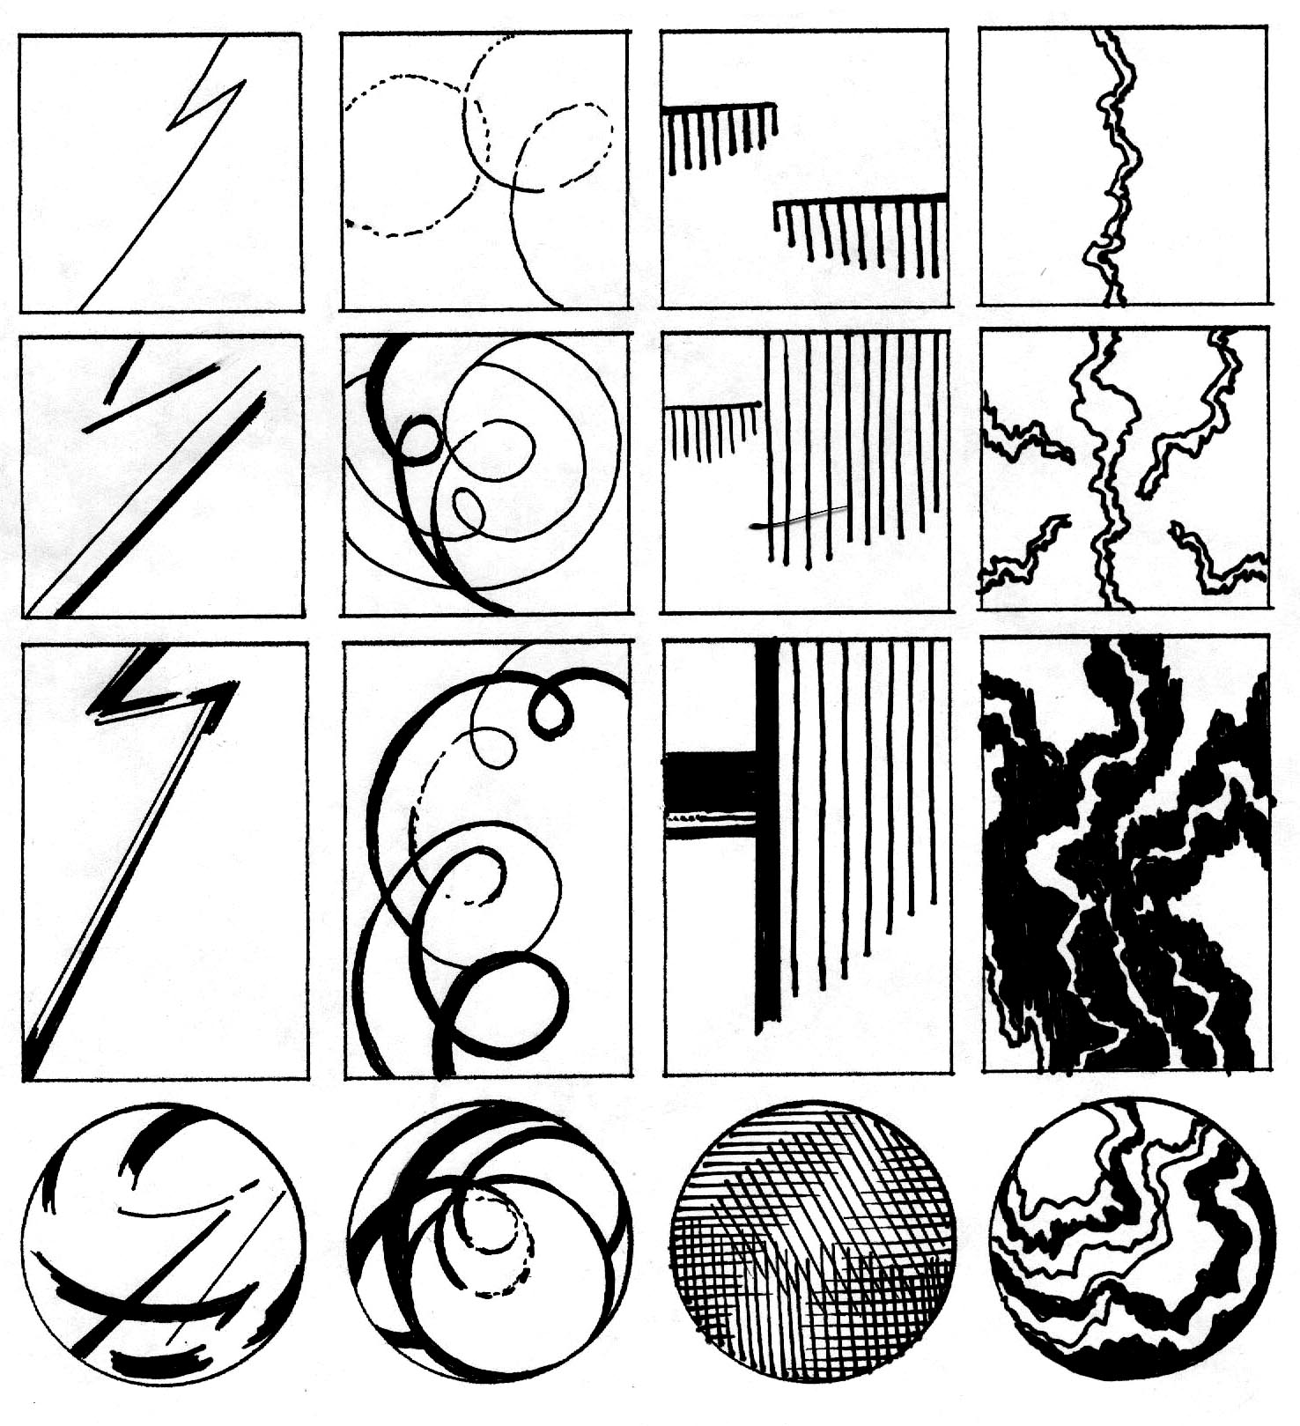

“The art of teaching is the art of assisting discovery.”
-Mark Van Doren, 1965

FOUR LINES, FOUR TIMES

Problem: Using the template provided, explore ways in which four straight, four curving, and four jagged lines can be used to create simple compositions. In the final column, use all four types of lines to create more complex compositions.

Objectives:
- To create simple linear compositions
- To explore uses of the illusion of movement and the illusion of space
- To begin to build the habit of making thumbnail sketches.

Materials: Photocopies of the template (card stock recommended); felt pen

Strategy: Four lines are used in each of the sixteen compositions in this exercise. In the first twelve studies, a single type of line is repeated four times. In the final four studies, three different types of line are used in each composition. Consider:
- What are the advantages of using just one type of line in a composition?
- What are the advantages of working with different kinds of lines?
- What is the effect of variations in line weight?
- How can line velocity be increased or decreased?

Reading: Pages 13 to 22
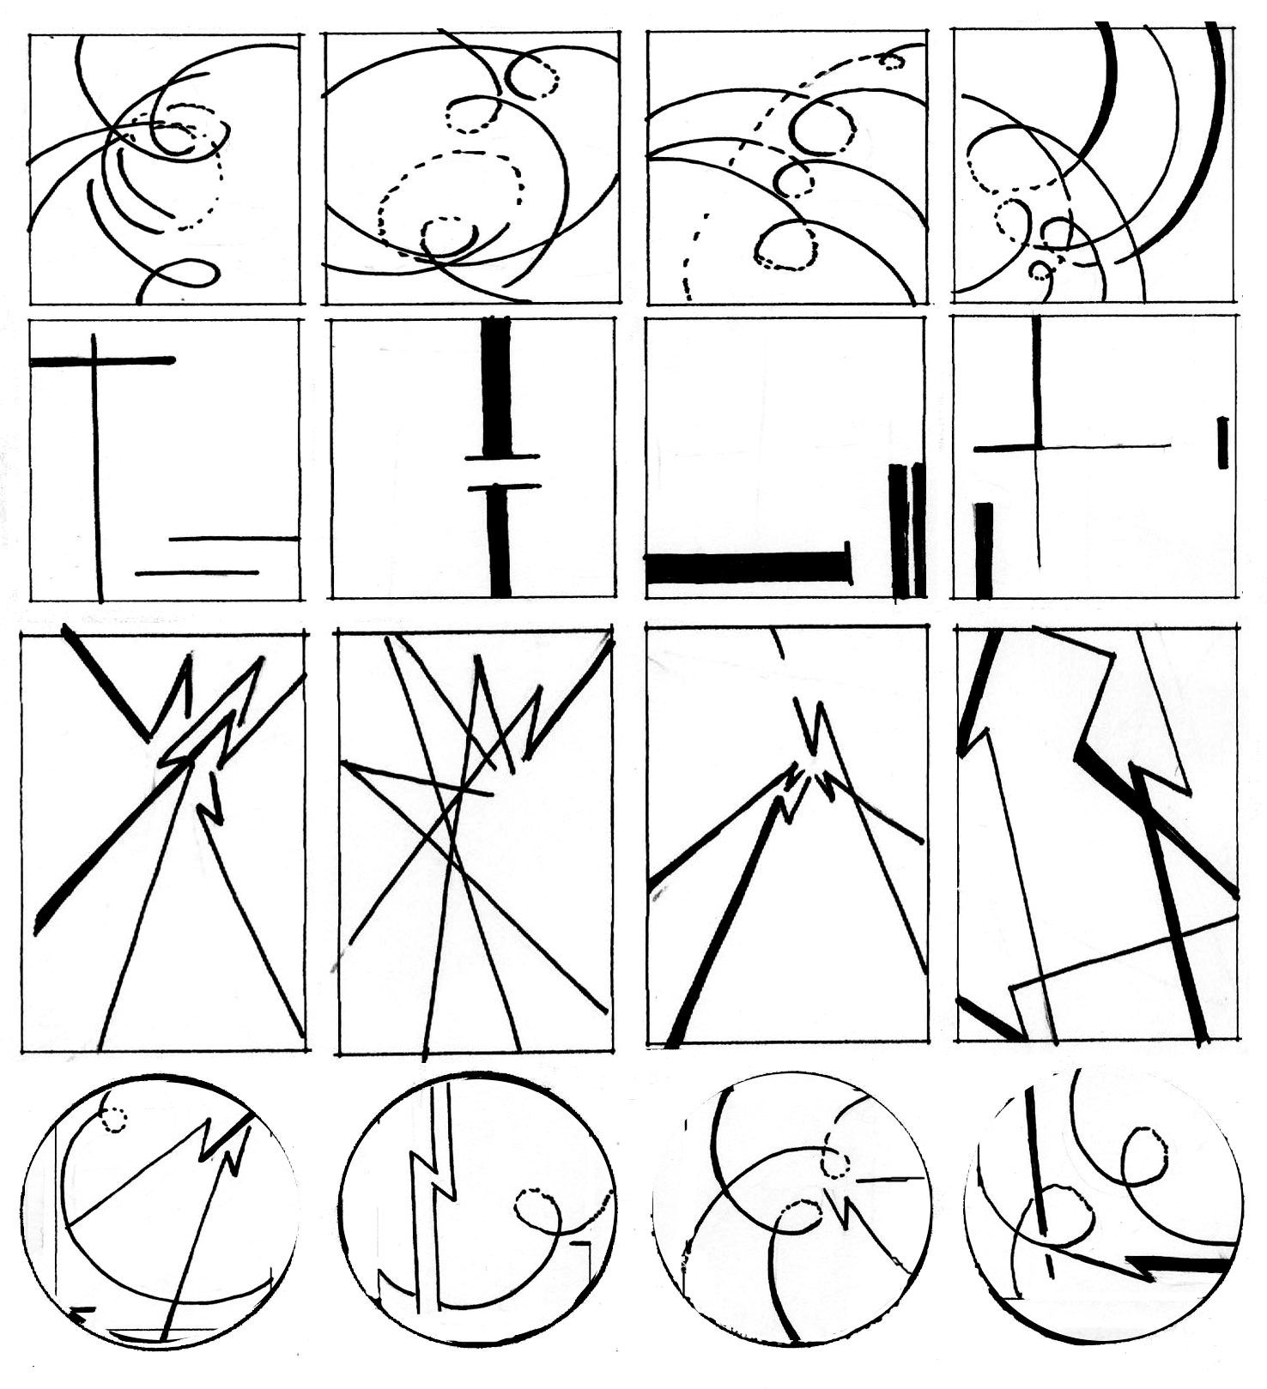
Instructor’s Notes: It has often been said that the first line we draw is the fifth line in the composition. In this exercise, pay particular attention to the four edges of the rectangular format.
It is a good idea to let students explore on their own first. When they have completed a page of studies, start the critique by asking:
• How does line continuity or discontinuity affect the design?
• What happens when a line appears to extend beyond the format edge?
• How can lines be used to move our eyes around the composition?

Timetable: 15 minutes for drawing, 30 minutes for discussion, possibly in teams.
LINE DYNAMICS

Problem: Develop three dynamic, non-objective designs, using line, shape and texture.

Objectives:
- To fully engage the edges of each composition.
- To create an illusion of space.
- To experiment with forms of balance.
- To explore ways of increasing visual impact.

Materials: Black felt markers and four or eight sheets of 18" x 24" drawing paper

Strategy: Use thumbnail sketches to rough draft at least ten ideas.
- Pay special attention to the edge of the composition. When a line or shape intersects this edge, the composition can to visually extend beyond the page and into the viewer’s world.
- Overlap, variations in size, location, and degrees of definition can be used to increase the illusion of space. The illusion of space gives more room for movement, increasing the overall energy in the design.
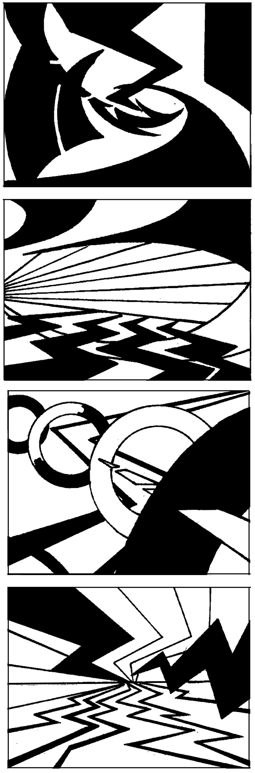
- Experiment with forms and degrees of balance. Symmetrical balance is often used when stability is needed, while asymmetrical balance is generally more dynamic.

Reading: Chapters 1 and 3

Instructor’s Notes: Working in larger scale, students can more fully explore the inherent dynamism of line. Dynamic designs are generally dominated by diagonals and curves, which tend to suggest movement and imply change. When lines are connected, shapes can be formed, adding variety and complexity to the design.
This seemingly simple assignment can actually provide an overview of the elements and principles of design. To create a dynamic design, students must understand balance and use it effectively. By creating the illusion of space, they can suggest movement from foreground to background. And, a focal point can provide a dramatic pivot point for the entire composition.
As shown in figure 3.22, an empty cardboard box can be used to physically demonstrate the meaning of the words “static” and “dynamic.” Simple blackboard drawings can be used to show various ways to create the illusion of space.
Beyond this basic information, it is best to simply respond to the designs the students produce, especially noting means by which compositions have been unified, describing dominant and subordinate visual patterns, and applauding areas of strength. Consider:
- How deep is the space in the composition?
- How does spatial depth contribute to visual dynamism?
- Is there a dominant movement in the composition?
- If so, how was this movement created?
Timetable: 15-40 minutes per drawing, 15-40 minutes per critique. Continually alternating between drawing and critique works well.

SHAPE INVENTORY

Problem: Using the template provided, place four different kinds of shape in the top row of squares. Invent a series of variations on each shape in the columns below.

Objectives:
- To explore different types of shape
- To demonstrate the unique power of each type of shape
- To expand use of thumbnail sketches.

Materials: Photocopies of the template (card stock recommended) and felt pen

Strategy: Explore the unique power of rectilinear, curvilinear, geometric and organic shapes.

Reading: Pages 22 to 33

Instructor’s Notes: A shape is created when a line connects to enclose an area; an area of color or texture is defined by a clear boundary, or when an area is surrounded. Open shapes are generally buoyant; closed shapes are generally more substantial. Gradation can be used to add the illusion of space. Creating a dialog between the positive shape (or figure) and the surrounding area (or ground) is an essential aspect of design.
After students have experimented on their own, it is useful to describe various kinds of shape and their applications. Note the implications of the format itself: generally, we create a very different design when using a circular format instead of a rectilinear format.
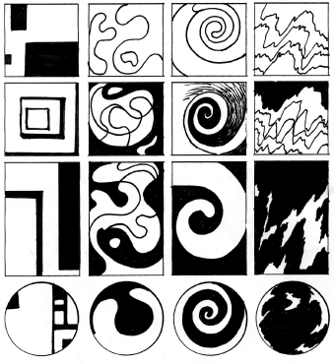
Timetable:
20 minutes drawing, 30 minutes for discussion

THE PARTS AND THE PUZZLE

Problem: Working with a curvilinear shape, a line, and a simple rectilinear shape, create a minimum of six compositions within a 3:4 format. Any 3:4 relationship will work: 3" x 4,” 6" x 8,” 9" x 12.”
Objective: This assignment requires imaginative thinking within strict limitations. You will be put in a box, then invited to break your way out. Seek
- To create the widest possible range of solutions while meeting the limitations
- To use negative shapes to increase compositional complexity
- To fully use every square inch of the composition.

Materials: Four sheets of Coloraid paper (any contrasting colors), Bristol paper, backing and adhesive. This assignment can also be done digitally.
Strategy:
First, be sure you understand the game rules.
- Any type of curvilinear shape can be used, from a circle to an amoeba. Any type of line can be used. The rectilinear shape cannot have more than ten perpendicular angles.
- You must use the same three components in each study. Thus, if you choose a jagged line for the first study, a jagged line must be used in all subsequent studies. If you choose a square for the first study, a square must appear in every study.
- Any component can be multiplied as needed. For example, you could have 2 squares, 2 circles, and two straight lines in one of your studies. However, do not exceed a total of 6 positive shapes.
- Any component can be enlarged or reduced as needed.
- Any shapes that extend beyond the boundary should be cut off.
There are two equally effective approaches to this assignment.
1. Develop at least 20 solutions, via thumbnail sketches, choose the best six, then finalize using Coloraid paper.
2. Cut out at least 20 of your curvilinear shape, 20 lines, and 20 rectilinear shapes in various sizes. Play around for a while, experimenting with various ways of relating the shapes. Then, organize them to create the six compositions required.

Reading: Pages 74 to 95

Instructor’s Notes: Buckminster Fuller, one of the most influential of American designers, described design as “the character of the organization of relationships.” Thus defined, individual components are less important that the interdependent means by which they are organized. This assignment gives students experience with the design process as well as a design product. The seemingly intractable limitations can actually be used to stimulate creative thinking, as they seek to “break out” of the box. Awareness of the interplay between negative and positive shapes, proximity, dominance and subordination, and balance can help students refine their compositions.
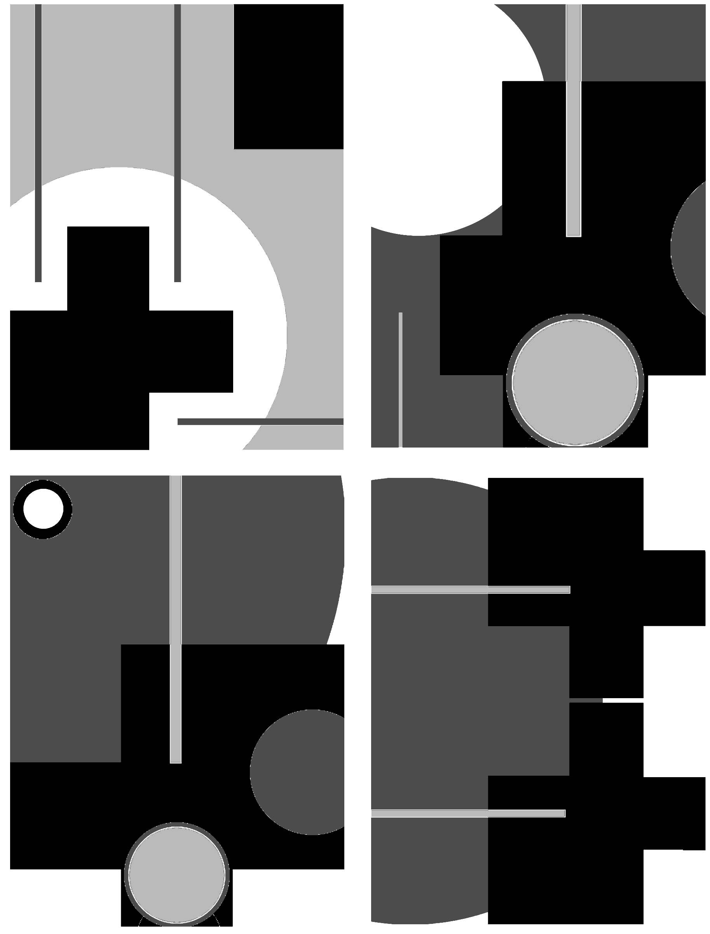
Timetable: 6-9 hours
BALANCING ACT
(Inspired by assignment in Visual Literacy, by Richard & Judith Wilde, Watson-Guptill 1993, pg 16-27)

Problem: Using the template provided, organize four squares and one circle in such a way as to communicate two of the following words: trapped, escape, order, individuality, opposition.

Objectives:
- To demonstrate the effect of the format on balance
- To make a direct connection between composition and concept.

Materials: Felt markers or cut paper. This assignment can also be done digitally.

Strategy: Brainstorm at least 40 variations using the template provided, Then, complete 4 refined versions of the design, using a 6"x6" square; a 6" circle, or a 6"x9" horizontal rectangle. The circle and three squares can be any size, and the four shapes can be connected or overlapped as necessary.

Reading: Pages 74 to 95

Instructor’s Notes: This seemingly simple assignment can become remarkably complex. It is best to start with solid shapes, using variations in size, orientation and proximity to convey the four concepts given. To expand the project, more experienced students can experiment with open shapes, gradated shapes, and figure ground reversal.

Timetable: 4 hours trapped escape individuality opposition
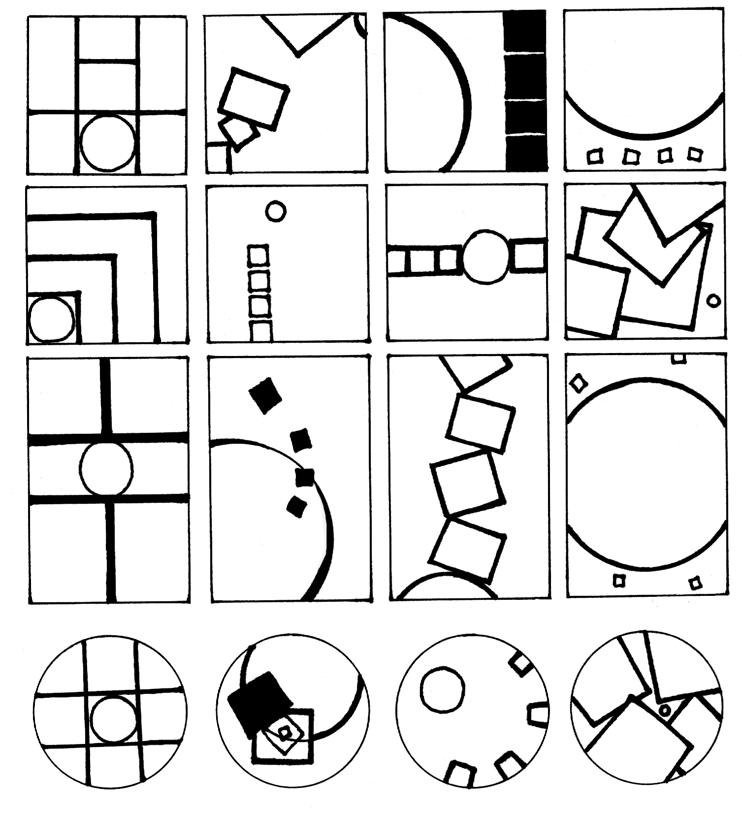

TEXTURE INVENTORY

Problem: Using the template provided, draw four kinds of texture in the first row of squares. Invent a series of variations in the columns below.

Objectives:
- To invent as many types of texture as possible
- To continue to explore the use of different formats.

Materials: Photocopies of the template and writing pens.

Strategy: Experiment with textural density, direction and variety. Try to alter or enhance the viewer’s understanding of the format through the textures used.

Reading: Pages 33 to 38

Instructor’s Notes: Texture determines the surface quality of a two-dimensional shape or a three-dimensional form. Physical texture can actually be felt. Visual texture, which is created using multiple shapes or through simulation of physical texture, can be seen but not felt. Through an appeal to our senses, texture creates a unique connection between the artwork and the audience.
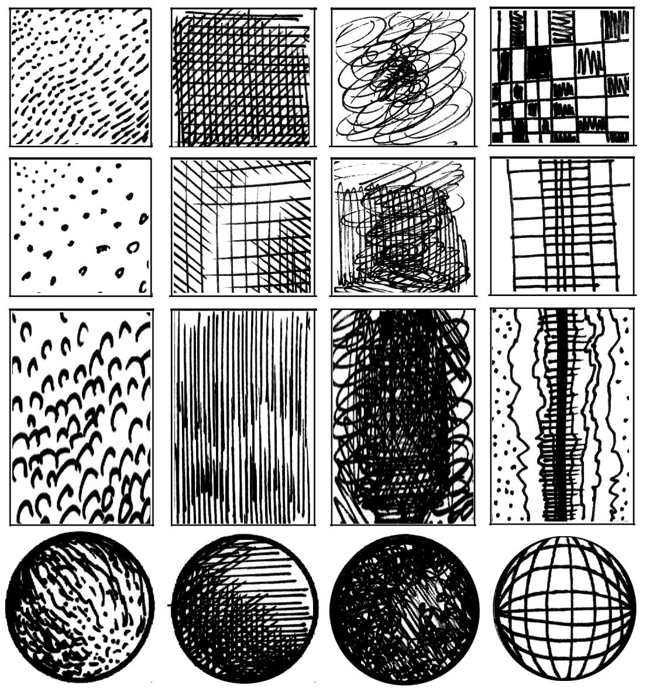

STRATA
Based on Breakdown, created by Janet Ballweg, Bowling Green State University

Problem: Choose a complex interior or exterior setting in which multiple objects are positioned at various distances in space. Transform the objects into three silhouettes, describing the foreground, middle ground, and background. When combined, these silhouettes should create distinct layers of space, or strata.

Objective: To heighten awareness of the spatial location of objects and provide another approach to abstraction.

Materials: Colored paper or colored pencils or paint on illustration board. The colors can also be added digitally.

Strategy:
1. Look for an interesting site. A cityscape, architectural setting, landscape, automobile showroom, or large greenhouse are all suitable sites.
2. Draw the shapes you see, fusing all of the foreground information into a single silhouette, then continuing this process as you create the middle ground and background silhouettes.
3. Fill in the silhouettes using paint or colored pencils or use cut paper to define the various layers.

Reading: Pages 95 to 101

Instructor’s Notes: The flat shapes commonly used in 2D design classes are a mixed blessing. On one hand, they help to clarify compositional relationships. On the other hand, they can result in spatially flat images, with every piece of information jammed into the foreground. In this composition, students combine the simplicity of flat shapes with the complexity of spatial layering.
Note: The resulting design can also be used in the Scope Assignment described in the Time Design section.

Timetable: 6 to 9 hours

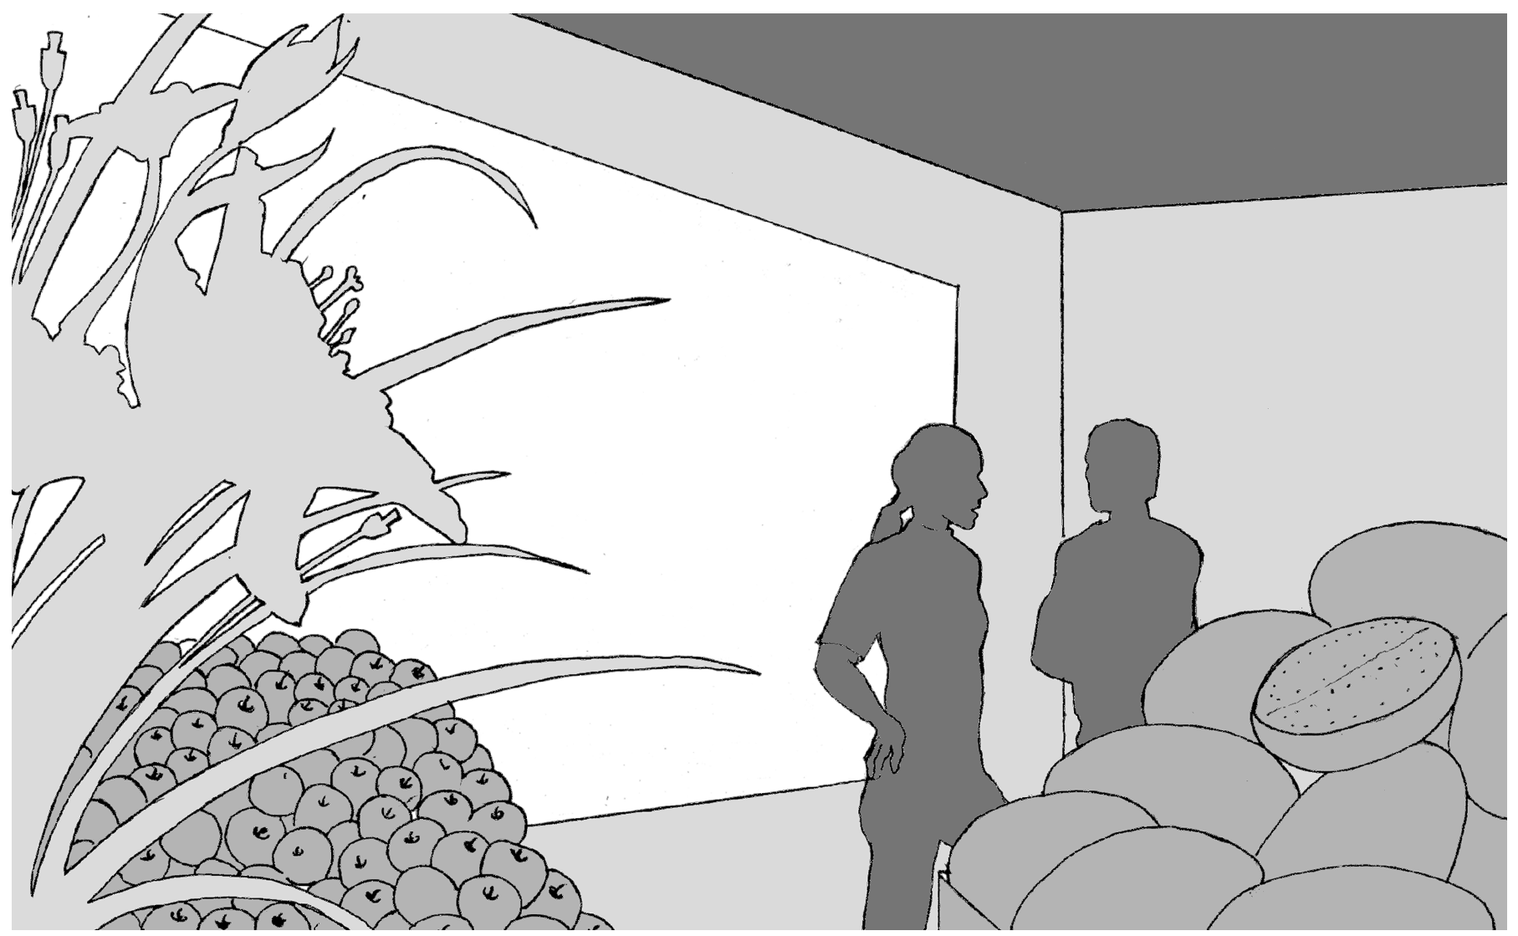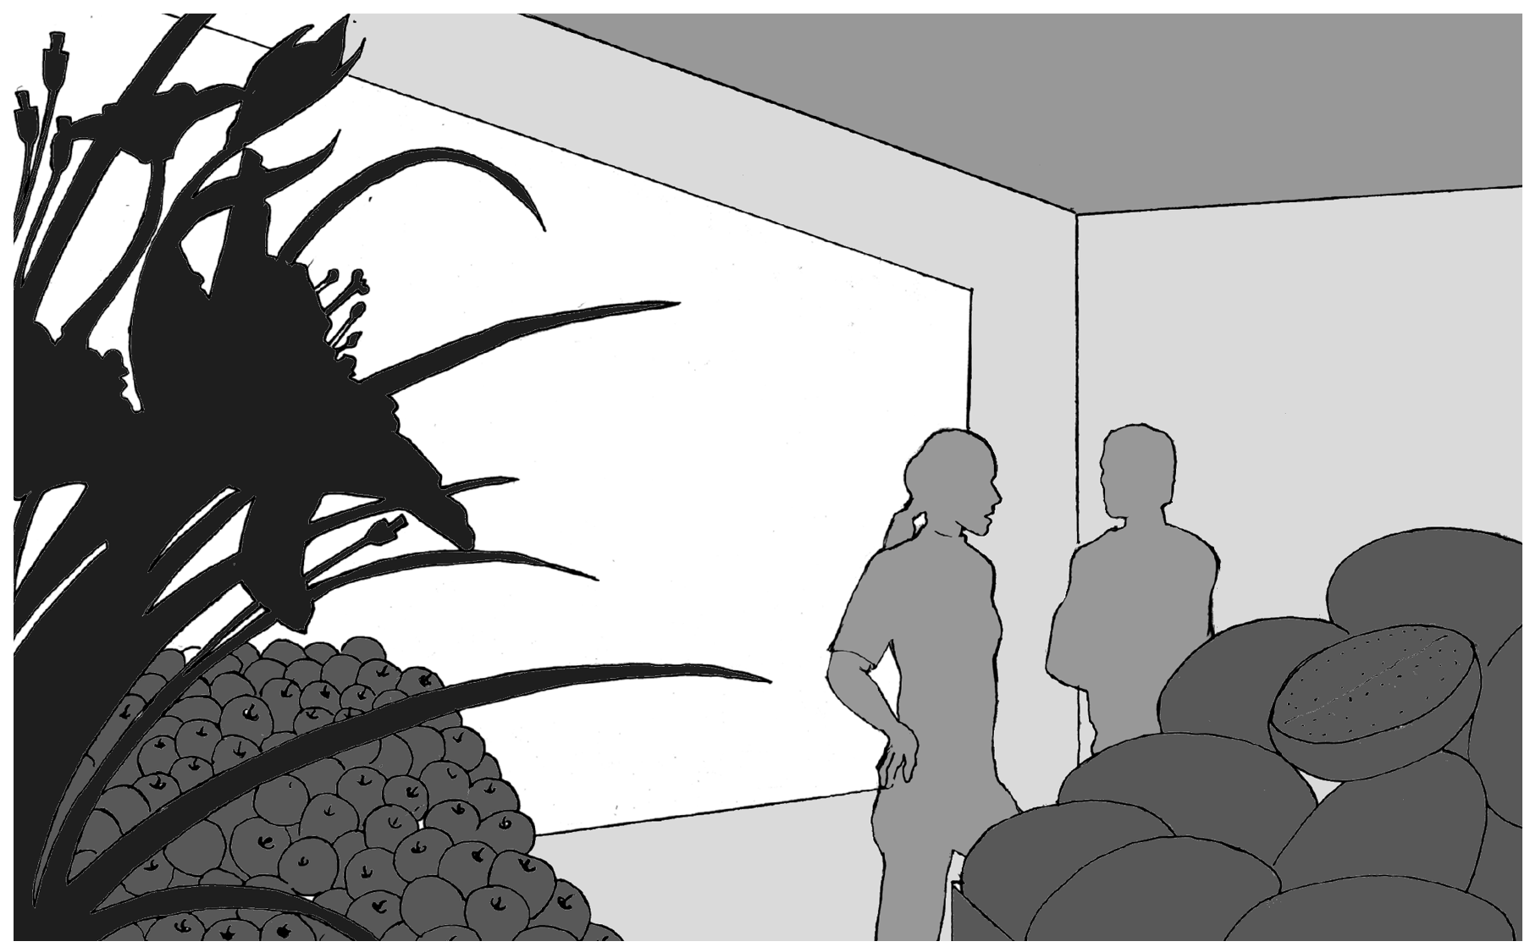

OBJECT LESSON

Problem: Analyze a single object hand-held in depth. Complete three designs:
• Version 1: a black and white analysis of the lines, shapes and textures on the surface and interior of the object,
• Version 2: a black, white and gray study animating the object, creating an implosion, explosion or a spinning effect,
• Version 3: a study in color adding a single word to create a metaphor or analogy.

Objectives: This is the first assignment with substantial conceptual potential. Assessment will be based on:
- Sensitive and eloquent translation of the object into an image.
- Compositional integrity. Is every square inch of the design being used fully?
- Inventiveness. How can an ordinary object become a fascinating design?
- Degree of idea transformation. How much change occurs from version to version?
- Conceptual Expansion. What is the most effective use of metaphor?

Materials: Markers, felt pens, illustration board and various color materials.

Recommended Objects: seed pods, bottles of pills, clock parts, pomegranates, etc.

Strategy:
Version 1
1. Start with a hand-held object that can be opened and is varied in texture.
2. Draw the object from various views. Analyze how it is constructed, noting every detail.
3. Choose the most interesting view or combine several views to create an interesting black and white design. The design can mostly be done with line, can combine lines with solid shapes of black and white, or can combine line, shape and texture (such as dots or networks of small lines). Use every square inch of the format to the best advantage. Note especially how the corners and edges of the design are used.
4. Make 10 photocopies of the resulting design. Make at least two copies at the original size, plus various enlargements and reductions.
Version 2:
1. Cut apart the photocopies, then scotch tape them back together to create a collage. Use superimposition (layering) and repetition to make the object appear to rotate, explode, or implode.
2. Based on this collage, create a second design in black, white and gray.
Version 3:
1. Think of a word that will expand the meaning of your object. What happens when the word “hidden” is combined with a wallet full of ID cards? Or "anger" is combined with a broken doll?
2. In the final version of the assignment, combine the word and the image to create a compelling color version of the object.

Reading: Chapters 1 and 5

Instructor’s Notes: This is a complex assignment, requiring more time and deeper investigation. A thesaurus and a dictionary can help students expand their ideas in the final stage.

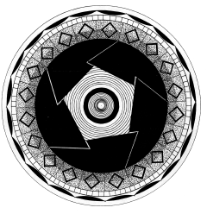

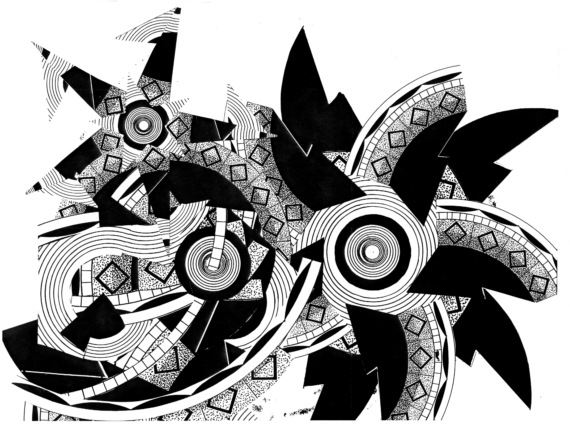
Object Lesson – Step one

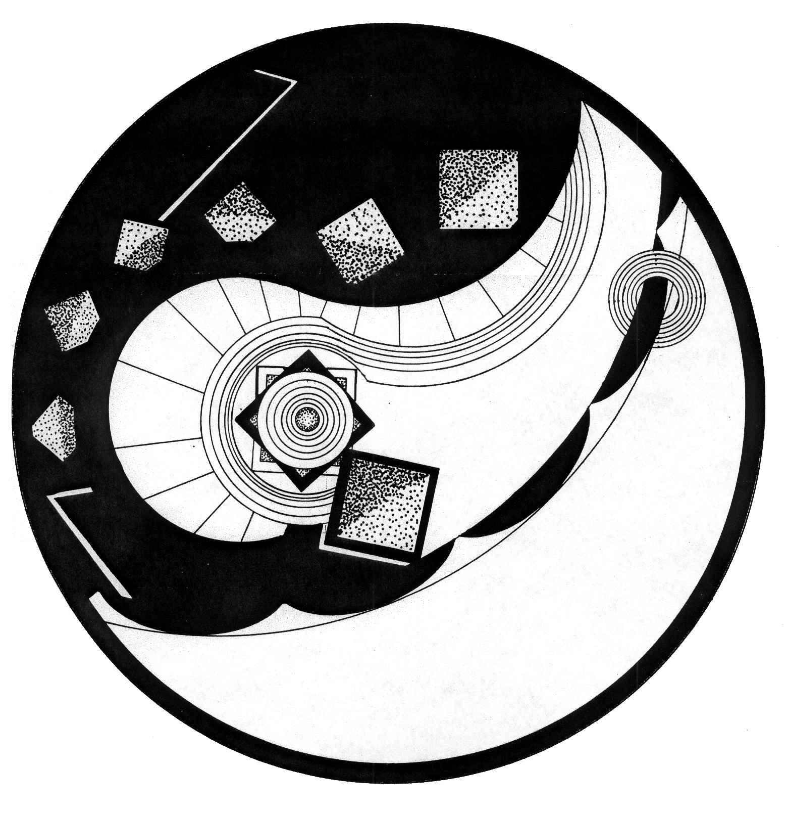

Object Lesson – Step two collage

Object Lesson – Step two design

PAPER CUT PROJECT
Assignment created by Janae Easton, Florida State University

Problem:
Create an 11x17” or larger design, using three layers of paper plus negative space.

Objectives:
- To create an active dialog between positive and negative.
- To create a well balanced composition that utilizes foreground, middle ground, and background.

To evoke texture with variations in line.

To use variations in line and shape to add energy to a composition.

Materials and Directions;
- X-acto knife, and extra blades: You will want to change blades frequently. This will allow for the smoothest cuts, as well as clean lines.
- Matte cutting board: this will allow your blade to sink into the matte, which will allow for a smooth line.
- Glue for mounting paper: many students have suggested using the glue pens to dab small amounts of glue on the back of the finished cut paper.
- Illustration or matte board to mount paper onto
- Canson paper: I have seen the best results with this paper. It has a great weight and comes in a large variety of colors.
- Carbon paper: some students use carbon paper to copy their drawing onto the final paper.

Strategy
1. You will research your subject, bringing in several images of examples of how you want your paper cut to look. The focus will be on positive and negative shapes to create a dynamic cut paper image.
2. Use your drawing skills to create an interesting design, images, or pattern, which may be non-objective, stylized or naturalistic.
3. Copy your design onto your final paper where you will be making the necessary cuts to illuminate the original drawing.
- You will decide if you will use one sheet of paper, or several to layer your image. The final image will be cut from a flat sheet of paper, not folded.
- You will invest a great amount of time in revealing the intricate details of your subject.

Timetable
20 hours in and out of class

Instructor’s Notes
We will look at the history of paper cuts, as well as contemporary examples of artists’ that use cut paper in their own work. Many of the artists we will look at consider space, be it personal, landscape, memory or literal. Think about spaces and your relationship to space as a place to get started.

Artists to look at for further inspiration
Mexican, Amish and Chinese Paper cuts David Thorpe
Kako Ueda, http://www.kakoueda.com/ Simon Periton,
Chris Natrop Paper Forest—a great blog on paper arts

ESSENCE/TOTALITY

Problem: Create an abstract composition based on a complex still life. In your composition convey the essence and/or the totality of the set-up.

Objectives:
- To practice pulling abstract shapes from actual objects
- To explore various degrees of representation.
- To explore personal interpretations of reality.

Materials: 18" x 24" drawing paper and other materials of your choice.

Strategy:
1. Look carefully at the set-up. All of the tables, stools, mirrors, etc. contained within the masking tape line on the floor and extending directly up to the ceiling can be considered part of the problem.
2. Begin recording your thoughts visually. For the sake of clarity, focus first on the question of essence. What qualities distinguish this set-up from any other set-up you have seen? What is the distribution of negative and positive space? Is the set-up dominated by diagonal lines? Is there any apparent pattern in the distribution or orientation of the objects?
3. Next, consider the question of totality. Study the set-up from all sides and if possible, climb inside it. Draw close-ups as well as distance shots. Many small sketches will help you to translate your ideas into images.
4. Then, begin to develop a more refined design. Avoid the two wrong answers to this assignment. First, do not do a conventional, representational drawing: this is a problem in abstraction. Second, do not replace the “boring” tables, chairs, etc. with unrelated subject matter, no matter how thrilling: no tables transformed into race cars, please! This is an abstraction problem requiring scrutiny of the actual objects and their relationships.

Reading: Pages 28 to 33

Instructor’s Notes: There is no such thing as a truly “realistic” drawing. The actual time and space of the physical world can only be suggested when we are working two-dimensionally.

Some artists and designers embrace this separation between drawing and reality and make no effort to create an illusory world on a flat surface. Others embrace the visual world and use perspective and lighting to create a convincing illusion. Most artists and designers use reality as a springboard for their imagination. Excellent artwork can be made using any of these approaches.

The textbook provides these terms to describe the various degrees of representation:
- Representational images are derived from specific subject matter and strongly suggest perceptual reality.
- Non-objective images are created without reference to specific subject matter. No attempt is made to reference the visual world.
- Between these two extremes, abstract images are derived from a perceptual source, but are so transformed that they bear little resemblance to the referent.
This assignment gives students a chance to explore degrees of abstraction and to discuss their personal perceptions of reality.

Be sure that you have at least an hour for constructing the set-up. It needs to be large and complex. Ordinary studio furniture works well; adding a mirror or two will give it pizzazz. Building a dominant movement into the composition (such as a spiral) will help students understand the concept of totality.

Take time at the beginning of class to define the words essence and totality. While these are common words, students generally need help in understanding their visual implications. As the students begin to unravel the problem, encourage, prod and cajole—but do not direct. Many beginners will be unfamiliar with abstraction and confused at first. Ask questions rather than suggesting solutions, and give them lots of encouragement. Showing slides midway through the sessions can help a lot.

Timetable: 3 hours in class, 6 hours for homework.

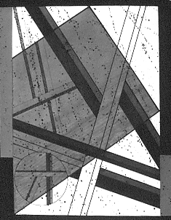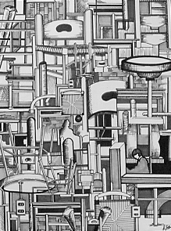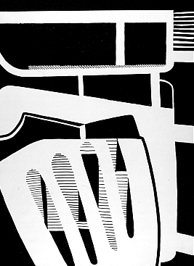

Essence/Totality: exploring abstraction – examples of students’ work.

ARCHITECTURAL ABSTRACTION

Problem: Using the template provided, distill the lines and shapes from three architectural fragments to create a series of elegant line drawings. Each composition should then be drawn a second time to increase its power. In the second drawing, delete all extraneous information.

Objective: To use line in perception-based drawing and to provide a basic introduction to perspective.

Materials: Photocopies of the template (card stock recommended) and writing pens.

Strategy:
1. A 3" x 4" window cut from a 5" x 7" piece of poster board, can help you identify the most promising compositions. Especially note repetitions and intersections among lines and try to use each of the four corners in the composition in a different way.
2. If you have difficulty determining how to draw a line that extends back in space, place your pencil directly in front of your poster board window. Rotate the pencil until it appears to rest on the line you wish to draw, note the angle needed, and transfer it to your drawing.
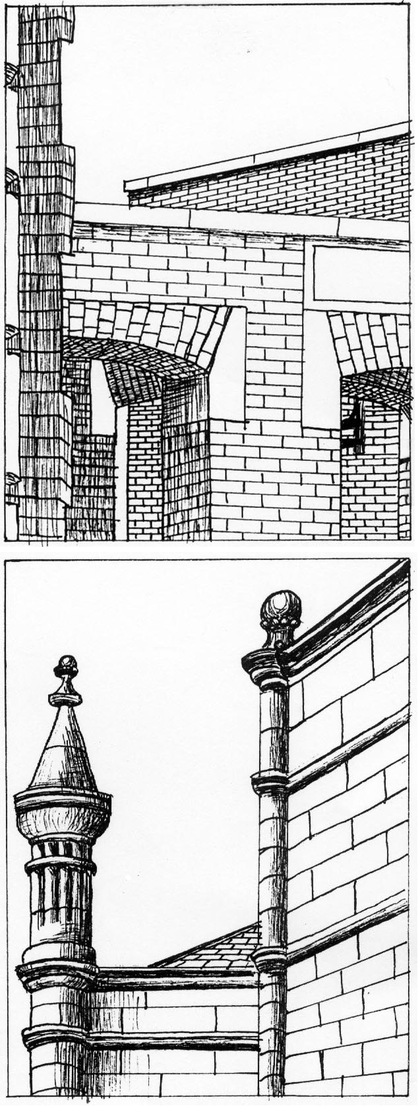
3. Establish a basic composition first, and then refine it in the remaining three boxes. Try creating one composition that is 75% white/ 25% black, another that is about equally black and white, and a third that is roughly 75% black and 25% white. Stippling (shading using tiny dots) can be used to add interest.

Reading: Pages 3-13 to 3-37

Notes: A boundary is the point at which images; objects, ideas or experiences separate or connect. Lines can create boundaries quickly and easily. In this exercise, lines are used to define the architectural boundaries. Encourage students to look for interesting room corners, staircases, rooftops and corridors and note similarities between the previous non-objective work and this assignment in abstraction.
• how is the edge of the format being used?
• what is the effect of variations in line weight?
• how are we visually directed around the composition?
Note differences between the previous non-objective work and this assignment in abstraction.
• Are there any surprises presented by perceptual reality?
• what is the impact of the illusion of space?
• by what means can architectural fragments be transformed into compelling compositions?

Timetable: 30-40 minutes per study. This is an excellent homework assignment.

“He teaches not by speech, but by accomplishment.” Lao-Tzu, 6th century BC

LABYRINTH COLLAGE AND BOOK

Problem:
Part 1: Transform an interesting building on campus into an 18”x24” visual labyrinth.
Part 2: Redesign this labyrinth image to create a sixteen-page 11”x7.5” book.

Objectives:
- To experiment with the role of chance in the creative process.
- To explore the unique advantages of a multiple-image narrative.
- To expand connections between concept and composition.

Materials: 18”x24” white paper, markers, 3 Prismacolor pencils (including at least one metallic), 1 sheet 22”x30” black Arches paper, photocopies

Strategy: Consider every possible definition and visualization for the word “labyrinth.”
lab-y-rinth: 1: a structure full of intricate passageways that make it difficult to find the way from the interior to the entrance or from the entrance to the center (for example, the labyrinth constructed by Daedalus in which the Minotaur was confined) 2: a maze in a park or garden formed by paths separated by high, thick hedges 3: something bewilderingly involved or tortuous in structure: a complex that baffles exploration 4: a situation from which it is difficult to extricate oneself 5: the internal ear, or its bony or membranous part 5: a body structure made up of a maze of cavities and channels 6: intricate, sometimes symbolic pattern, such as pattern inlaid in the pavement of a medieval church 7: in metallurgy, series of troughs through which water passes for washing pulverized ore.

1. Using a thesaurus, make a list of words and ideas your associate with a labyrinth: confusion, traps, mystery, and so forth. Invent as many approaches and ideas as you can: is a symphony a labyrinth? Is DNA a labyrinth? Is the presidential election a labyrinth?
2. Make at least twenty drawings of various doorways, staircases, room corners, textures and so on. (This can be done using the Architectural Abstraction assignment.) Multiply and combine these drawings to create a complex collage of architectural shapes, then complete an 18”x24” design based on this collage.
3. After an extensive critique of this design, refine and lightly re-draw the image on the front and back of the sheet of black Arches. Re-drawing the full design on the front and an enlarged fragment of the design on the back tends to work well.
4. Begin elaborating on the design, lightly working up the shapes using Prismacolors.
5. When the drawings are about 50% developed, tear the paper into four 7.5”x22” strips.
6. Fold the strips in half and organize in either a dowel book format or a codex book format. At least an hour should be spent organizing the pages—they can be inverted or folded from inside out. Seek visual flow from page to page.
7. Re-draw as necessary to integrate the entire composition and add drama.
8. Bind the book and finalize the drawings.

Reading: Pages 318 to 322 and 344 to 354

Instructor’s Notes:
This assignment consistently results in an astonishing array of inventive books. Some students introduce characters into the setting, creating a simple narrative. Others use the illusion to space to move the viewer through mysterious corridors and down precipitous staircases. Others use light and pattern to create a world of enchantment and beauty. Because the word "labyrinth" is so open to interpretation, the generative potential is great.

TRUE LIES: DESIGNING FICTION

PROBLEM: Use a minimum of twelve photographs to tell a story
OBJECTIVES:
- To research a complex visual idea
- To express this idea effectively using visual narrative
- To strengthen time management skills
MATERIALS: Photocopies or computer prints and other materials as needed

STRATEGY:
WEEK 1: Using library resources, find twelve or more great photographs. Then, using a copier or Photoshop, enlarge, reduce, superimpose and collage images as necessary to make your first version of the story.
DISCUSSION FOCUS: SOURCES
Conceptual Sources. Anything you have ever seen, read, or felt can provide the beginning point for this project
Visual Sources: Anything in the library is fair game. The twelve basic source images must be derived from books or magazines, not from the Internet. This will improve image quality and give you an opportunity to explore library offerings.
Verbal Sources. Do you need background information on your topic? Oral histories and documentary videos can be especially useful.

WEEK 2: Present your images and ideas in a small group discussion. Bring three questions and one great example of a visual narrative to this meeting. Then, continue work, expanding and refining your idea.
DISCUSSION FOCUS: STRUCTURE
Narrative structure. What sequential organization will best convey your idea? Should the story be told from a particular point of view? To what degree need characters be developed?
Format. What is the best structure? A codex book? A family album? A file folder? A triptych of three hinged panels? Consider what you want to show, how to show it, and when to show it.
Editing. How many images are needed, and how complex need they be?
Openings and Closings: where does the story begin and end? Why?

WEEK 3: In the small group discussion, present your final draft as a rough cut--all images and ideas developed and format determined. Final refinements and construction should be the only remaining tasks.
DISCUSSION FOCUS: DRAMA
Image manipulation. How can the source images be transformed and integrated into the final piece? To what degree should images be enlarged, blurred, or combined?
Repetition. Photocopies are inherently repetitive. Can this be used to increase visual or emotional impact?
Pivot points and focal points. If you are working with a single large mural, is there a specific focal point? If you are working with a book or video, is there a pivot point, a moment in which the direction of the story is altered?
WEEK 4: Critique. The results will be quite varied, and everyone will want substantial feedback on his or her project. Use this time to hone your critiquing skills! Consider:
- What stories most intrigue you? Why?
- How compelling are the images presented?
- Was the re-structure chosen appropriate for the idea or emotion presented?
- If you were to re-do the project, how would you strengthen the results?

Reading: Chapters 5 , 12, 13 Timetable: 30 hours, in and out of class
HOMAGE TO HOCKNEY
Inspired by an assignment by Gail Hoffman, Syracuse University

Problem: Make at least 36 photographs of a single person or a single site at various times of day. Take the film to a commercial lab and get at least 72 prints made from this roll. Cut and paste the resulting prints to create a complex collage.

Objective: To explore relationships between time and space.

Materials: One 36-exposure roll of film, 72 color prints, adhesive and illustration board

Strategy: First look at your surroundings. What buildings are most interesting? What happens in the laundry room? What different positions does your roommate take as she studies for an exam? Dynamic subject matter makes this problem easier to solve, so look for sites you can traverse or for subject matter that moves.
Then, consider the type of composite image that will best express your subject matter. Some of the options include:
• A panoramic scene,
• A small object that will appear monumental,
• An interior, showing all four walls,
• A person in motion, seen from various positions.

Reading: Pages 3-30 to 3-37

Instructor’s Notes: This assignment is both simple and complex. The photographic process itself heightens awareness of time and space. When the images are combined to create the collage, proximity, continuity and closure become as important as time and space. The assignment can be expanded by using additional photocopies of the source images or by working digitally.

Timetable: 3 hours for the photography, 4-6 hours for the collage

“More important than the curriculum is the question of the methods of teaching and the spirit in which the teaching is given.” -Bertrand Russell, 1926

HIDDEN MEANINGS #1

Problem:
Part 1: Using a 3" x 5" card and three letters or numbers as stencils, create a 8"x10.5" linear design in which some shapes are revealed while others are concealed.
Part 2: Expand the assignment, using letters and phots that inherently carry meaning.

Objectives:
- To create a lively dialog between figure and ground
- To experiment with closure, emphasis, and visual movement
- To integrate concept and composition.

Materials: Bristol paper and a mechanical pencil with HB lead. This assignment can also be done digitally

Strategy, Step 1:
1. Begin by tracing ten or more shapes on a 11”x14" piece of bristol paper, using the 3" x 5" card and the letters or numbers. Don’t worry too much about details at first. Just generate a lot of raw material by drawing too many shapes.
2. Delete about half of all of the lines and draw a border around the most interesting 8"x10.5" fragment. Consider which shapes are the most important and how the orientation and location of shapes can direct the viewer’s eye. Use overlap, transparency, and variations in size to emphasize some shapes while concealing others.
3. Then, add lines and shapes to create a balance between unity and variety.
4. Critique the results. How does the viewer navigate through the design? What areas dominate? How is this dominance established?

Strategy, Step 2:
Now, add content. Using the same work process, create a second design based on meaningful letters and shapes. For example, the word "stress" may be accompanied by an image of a clock, a calendar page and a pack of cigarettes. The word "identity" may be accompanied by an ID card or driver's license and an enlarged finger print. To create a strong connection between Step 1 and Step 2, it is best to work with fairly flat shapes, such as the objects you might find on your desktop. Once again, use various compositional strategies to reveal some aspects of the design and conceal others.

Reading: Pages 74 to 83 and 92 to 95

Instructor’s Notes: Determining the dominant and subordinate aspects of a design can greatly improve communication. Just as verbal chaos results when twenty actors all try to speak at once, so visual confusion can result when all shapes in a composition are emphasized equally.
Every square inch in a design contributes to the overall effect. The negative shapes define and support the positive shapes; the positive shapes define and support the negatives. Likewise, subordinate shapes increase the prominence of the dominant shapes while the dominant shapes provide a context for the subordinate shapes.
The design process is fully engaged in this assignment, as shapes are generated, then refined or discarded based on their contribution to the design as a whole. Intersections among shapes create focal points or visual pivots. Shared edges create visual continuity.

As the designs evolve, try to help students identify muddled areas and suggest alternatives. Consider:
- What strategies can be used to create bridges among visual elements? Look carefully at the orientation, character and size of each shape. Any similarity will add unity.
- How can spatial depth add to the composition? Overlap and size variation can increase the illusion of space.
- is the negative space being used fully?
- What shapes do not fit in the overall design? Deletion can be as important as addition in a design of this kind.
- How does the viewer navigate through the design? Is there an obvious visual pattern or are there many paths to follow? What is the advantage of each approach?

Timetable: 3 hours for each part.

HIDDEN MEANINGS #2

Problem: Assign values to either design developed for HIDDEN MEANINGS #1

In the first variation, use solid black, white and grays in roughly equal amounts. In the second variation, gradate all shapes, using black, white and grays. In the third variation, make roughly 65% of the design dark and 35% of the design light.

Materials: Photocopies on card stock and acrylic paint, markers, colored pencils or gouache. This assignment can also be done digitally.

Objective: To demonstrate the dramatic impact value can have on a design.

Strategy: You will need at least eight copies of the basic design: four for the assignment itself and four to ruin. It is important to value the “failures” as highly as the successes: in general, we learn more from the designs that fail than from the designs that work!
If the problem will be completed manually, photocopy the linear design on card stock (which is much heavier than ordinary paper) and color in the shapes using markers, colored pencils, or paint. If the problem will be completed digitally, scan the linear design and use the paint bucket or gradation tool to fill in the shapes.

Reading: Pages 39 to 45

Instructor’s Notes: The context in which a value is placed greatly affects its impact. Contrasting values can bring energy to a design and increase the illusion of space. A solid white shape tends to advance when it is placed in an otherwise dark composition; a solid black shape tends to advance when it is placed in an otherwise light composition. Gradated shapes can create illusionistic volumes, which suggest three-dimensional forms.
The addition of value can substantially change the linear composition created for Concealing/Revealing #1. Shapes, which were previously hidden, can be emphasized through the values chosen; shapes that were previously emphasized can now be hidden.
It is wise to encourage students to explore a wide range of options so that they clearly see how the addition of value changes the composition.

Timetable: 2 hours if done digitally; 8 to 12 hours if done manually. This is a good homework assignment to follow HIDDEN MEANINGS #1.

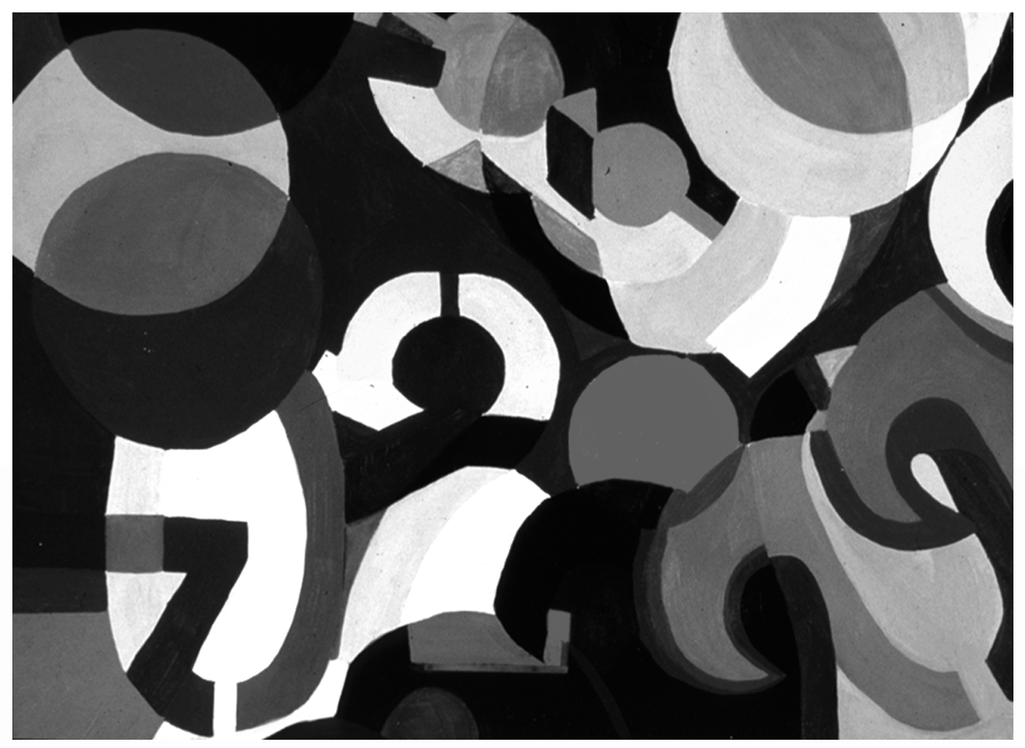

HIDDEN MEANINGS #3

Problem: Assign colors to one of the designs developed for HIDDEN MEANINGS #1, part 2.Use flat, gradated, and transparent shapes as necessary to create at least six distinctively different designs.
- Same hue, different value
- Same hue, different intensity
- Same value, different intensity
- Same intensity, different value
- Two additional studies of your choice.

Objectives:
- To demonstrate understanding of basic color vocabulary.
- To increase compositional complexity through color.
- To experiment with push/pull
- To explore the expressive implications of color.

Materials: Photocopies on card stock, with paint or markers. For a wider range of variations, this assignment can also be done digitally or with acrylics.

Strategy: By using a combination of solid, transparent, and gradated shapes, you can produce a wide range of solutions. Try to change the visual dynamics and meaning in the design through the colors chosen.

Reading: Pages 63 to 71, Chapter 7

Personal Geographies
Inspired by an assignment by John Regan, Northern Illinois University

Problem: Explore an aspect of your “personal geography” and create an artists’ map of any size or shape. Your final presentation should present evidence of your newly acquired knowledge of the elements and principles of design as we have covered in the first half of this semester.

Backstory:
Mapmaking fulfills our deep-seated desire to understand the world and our place in it. But maps need not just show continents and oceans. There are maps to heaven and hell, to happiness and despair. There are maps to popular culture, from Gulliver's Island to Gilligan's Island. There are speculative maps of the world before it was known, and maps to secret places known only to the mapmaker. And artists' maps show another kind of uncharted realm: the imagination.
Similar to maps, books can have many forms and functions. They can inform, direct, entertain, guide, educate, and/or hold factual details. The form of the book can impact how the reader/user/viewer is directed to the information within its covers. A dictionary or encyclopedia work in a different fashion than a mystery novel, and neither of those possess the intimacy of reading a journal filled with pages of handwritten entries. A codex bound or Japanese stab bound book have an established sequence by nature of their bound pages, while a portfolio box of separate pages operates more like a deck of cards encouraging the audience to establish their own sequence. Books speak in an implied voice of their creator. Some SHOUT, while others whisper. Some are clinical, while others are satirical.
Maps and books share many common elements. They frequently take you somewhere new or unfamiliar. They guide you along a path filled with “roadside attractions” you can explore or drive past. Be it a mileage and symbol legend or tables of contents, most maps and/or books provide a guidepost to getting to the goal in a logic and informed fashion.

Pattern Saturation
Inspired by an assignment by John Regan, Northern Illinois University

Problem: Create a complex pattern that activates both the foreground & background of the picture plane.

Objectives: To research a variety of pattern structures (i.e. brick, half-drop, rotating grid), to demonstrate an ability to render a pattern consistently and precisely thereby exhibiting a mastery of line and edge quality and control, and to explore the dynamic use of pattern as a way to activate the picture plane.

Materials: 1- sheet of heavy weight 22x30 white drawing paper, a metal ruler, 4-6 Sharpie black markers, a pencil, scissors, glue stick, and a variety of templates as needed.

Strategy: Using your ruler and a pencil, measure and draw a light line down the center length of the paper. Measure and divide the length of the page into 5 equal widths perpendicular to the initial line.

Find a shape that doesn’t easily reveal its’ subject in a magazine or other source. Mount with glue stick onto card stock and trim with scissors, creating a template. Lightly trace this abstracted shape at least once in each of the 10 regions on the page. Push the shape off the edges in some regions, or flip the image over to trace its’ mirror image shape. After you have shapes lightly outlined in each region, begin to outline these shapes (but not the lines you used to divide the paper). After you have outlined the shapes making needed editing decisions, erase the grid and traced lines. Each separate shape should have a consistently rendered pattern. Create a second background design that differs in scale or source.

Notes: Every square inch in a pattern design is important. The negative shapes define and support the positive shapes: the positive shapes define and support the negatives. Likewise, subordinate shapes increase the prominence of the dominant shapes while the dominant shapes provide a context for the subordinate shapes. Determining the dominant and subordinate aspects of a design can improve communication. Just as verbal chaos results when 20 people all try to speak at once, so visual chaos can result when all shapes in a composition are given equal importance. The design process is fully engaged here, as patterns are generated, then re-workedbased on their overall contribution. Intersections among shapes/patterns create focal points or visual pivots. Shared edges create visual continuity.

Things to Consider: What strategies can be used to create bridges among visual elements? How can spatial depth add to the composition? Overlap and size variation can substantially increase the illusion of space. Is the negative space being used to the best advantage? What shapes/patterns do not fit in the overall design? How does the viewer navigate through the design? Is there an obvious visual direction or are there many paths to follow? What is the advantage of each approach?
A pivotal part of this assignment is to demonstrate your mastery of line quality, edges, and precise repetition of shapes/patterns using the Sharpie marker. NO smudges, visible pencil lines, or creases in the final design. Produce a fully engaged picture plane saturated with pattern structures.
MODULAR DESIGN: Exploring Pattern
Assignment created by Frank Kulesa, Northern Illinois University

Problem:
Using the modular (grid) system of working similar (but not limited) to the shown examples, produce two compositions; one with only black and white values, and one with black, white, and shaded values.

Objective:
This project deals with the theory of modular design composition. Modular design is used within the fine art, design, textile, and architectural fields. Primary examples range from modular dwelling construction, floor/wall design, textile patterns, modular Op/Abstract painting/printmaking, and commercial design layouts.
A modular design may seem limited in its scope to produce dynamic imagery, but with just a small number of operations one can easily create interesting compositions. To make an interesting modular composition, you need to start with an interesting module. One needs to experiment with numerous modules before choosing one as the key design.
Strategy:
1. The size and type (square, polygonal) of module is optional. Execute the project with the computer, ink, paint, magic marker, etc. The medium is up to the student, but keep in mind the grade will be influenced by the craftsmanship of the finished project. Be careful that your shapes are consistent in value through out the composition and that the shapes have sharp and clean edges.
2. Do not make the final composition so small it is hard to see or so large that you run out of time to meet the project deadline.
3. Present the two individual key modules separately for identification.

Instructor’s Notes:
The actual space in which the module exists will influence certain potential design key points. For example; a square modular space could contain eight evenly spaced key points (see picture below) one in each of the corners and one as the bisection of each side. Using these key points when designing a module will invite greater interaction between the positive and negative shapes. This method makes is easy to join shapes into a seamless composition.

Operations of the Module
- Identity/Translation - repeat without rotation or reflection or inversion.
- Rotation - turning the module (degree of rotation depends upon modular space and shape.
- Inversion - 180 degree rotation.
- Reflection - mirrored image.
- Subtraction - the removal of some positive area.
Using one or more of the above operations in different sequences can dramatically effect the look of your composition.

Pattern and Symmetry
This project also introduces the design principle of pattern and symmetry. Pattern is created through the repetition of one or more visual elements within a composition. Using a constant grid structure as in this project will create a design that has symmetry. Using pattern and symmetry generally is associated with static design, but with interesting modular shapes and using the abovementioned operations, very interesting and dynamic designs can be created.

LTI CHAPTER 1 QUIZ: 2D FOUNDATIONS Your Name_____________

LINE Create 3 lively designs
Please provide 4 definitions of line.
_________________________________________________
_________________________________________________
_________________________________________________
_________________________________________________

Please list 4 qualities or aspects of line
_________________________________________________
_________________________________________________
_________________________________________________
_________________________________________________

SHAPE
Please list 4 ways to create shape
_________________________________________________
_________________________________________________
_________________________________________________
_________________________________________________

6 types of shape are discussed in C1. List 4 of them.
_________________________________________________
_________________________________________________
_________________________________________________
_________________________________________________

TEXTURE
List 4-6 ways texture can be used to strengthen a composition.
_________________________________________________
_________________________________________________
_________________________________________________
_________________________________________________
_________________________________________________

“KEY QUESTIONS” are given throughout the chapter. They are designed to help you apply chapter content to your our artwork. What questions do you ask yourself when assessing your work? List 3 of your own.
_____________________________________________________________________
_____________________________________________________________________
_____________________________________________________________________
LTI CHAPTER 2 QUIZ: 2D FOUNDATIONS Your Name_____________
Define additive color.
_____________________________________________________________________

List the additive primaries.________________________________________________

Define subtractive color.
_____________________________________________________________________

List the subtractive primaries.______________________________________________

What is simultaneous contrast?
_____________________________________________________________________

Define Hue. ___________________________________________________________

Define Value. __________________________________________________________

Define Intensity. ________________________________________________________

To create a tint, add ______________ to a color.

To create a tone, add ______________ to a color.

To create a shade, add _____________ to a color.

Define the following color schemes and give a brief example.

Monochromatic ________________________________________________________
Analogous ____________________________________________________________
Complementary ________________________________________________________
Triadic _______________________________________________________________
What is a chromatic gray?
_____________________________________________________________________

What is a color key?
_____________________________________________________________________

List four compositional effects of color.
_____________________________________________________________________
_____________________________________________________________________
_____________________________________________________________________
_____________________________________________________________________
LTI CHAPTER 3 QUIZ: 2D FOUNDATIONS Your Name_____________

Name the six aspects of basic gestalt and draw an example of each.

1. _______________ 2. _________________ 3. ________________

4. _______________ 5. _________________ 6. ________________

Name the three common types of balance and draw an example of each.

1. _______________ 2. _________________ 3. _______________

Rhythm is ____________________________________________________________.

List three common ways to create emphasis and draw an example of each.

1. _______________ 2. _________________ 3. _______________

List four ways to create the illusion of space and draw simple examples.

1. ____________ 2. ______________ 3. _____________ 4. ____________

Give an example of “the decisive moment,” as described by photographer Cartier-Bresson.

_____________________________________________________________________

Create your own “Key Questions” for analyzing compositional strengths & weaknesses.
____________________________________________________________________________________________________________________________________________________________________________________________________________________________________________________________________________________
_____________________________________________________________________
LTI CHAPTER 4 QUIZ: 2D FOUNDATIONS Your Name_____________
List four simple ways to create the illusion of space and draw examples.

1. ____________ 2. ______________ 3. _____________ 4. ______________

Draw examples or one, two and three-point perspective.

1-Point 2-Point 3-Point

How might the illusion of space be used to strengthen a composition?
__________________________________________________________________________________________________________________________________________________________________________________________________________________
________________________________________________________________________________________________________________________________________________________________________________________________________________________________________________________________________________________
______________________________________________________________________
______________________________________________________________________

LTI CHAPTER 5 QUIZ: 2D FOUNDATIONS Your Name_____________
List six of the seven common characteristics of creative thinking.

1.______________________________ 2.______________________________

3.______________________________ 4.______________________________

5.______________________________ 6.______________________________

List four characteristics of good goals.

1.______________________________ 2.______________________________

3.______________________________ 4.______________________________

List 3 characteristics of time management and note how you are/are not using them.

1.___________________________________________________________________
_____________________________________________________________________
2.___________________________________________________________________
_____________________________________________________________________
3.___________________________________________________________________
_____________________________________________________________________

Seven “habits of work” used at Auburn University are listed in the chapter. What are your own most effective “habits of work?”

1.___________________________________________________________________
_____________________________________________________________________
2.___________________________________________________________________
_____________________________________________________________________
3.___________________________________________________________________
_____________________________________________________________________
4.___________________________________________________________________
_____________________________________________________________________
5.___________________________________________________________________
_____________________________________________________________________
LTI CHAPTER 6 QUIZ: 2D FOUNDATIONS Your Name_____________

List four of your personal sources of ideas.
1.________________________________________________________________
2.________________________________________________________________
3.________________________________________________________________
4.________________________________________________________________
List four of the characteristics of a well-defined problem.
1.______________________________ 2.______________________________
3.______________________________ 4.______________________________
What are the six major steps in convergent thinking?
1.______________________________ 2.______________________________
3.______________________________ 4.______________________________
5.______________________________ 6.______________________________
When is divergent thinking most effective?
____________________________________________________________________
____________________________________________________________________
Choose one of the following words, and using an idea map, create as many ideas as you can from it: chain, tricycle, passage. Or, choose a generative word of your own!

LTI CHAPTER 7 QUIZ: 2D FOUNDATIONS Your Name_____________

Critical thinking requires:
1.____________________________________________________________________ 2.____________________________________________________________________
3.____________________________________________________________________

In analyzing the criteria of a problem, what questions might you ask?
_____________________________________________________________________
_____________________________________________________________________
_____________________________________________________________________
_____________________________________________________________________

Form is ______________________________________________________________.
Subject is ____________________________________________________________.
Content is ___________________________________________________________.

Write a brief formal analysis of the image distributed with this quiz.
_____________________________________________________________________
_____________________________________________________________________
_____________________________________________________________________
_____________________________________________________________________
_____________________________________________________________________
_____________________________________________________________________
_____________________________________________________________________
_____________________________________________________________________

Trade one of your work-in-progress with someone else in class. Analyze his/her artwork, and propose at least 6 ways to strengthen the work.
_____________________________________________________________________
_____________________________________________________________________
_____________________________________________________________________
_____________________________________________________________________
_____________________________________________________________________
_____________________________________________________________________
_____________________________________________________________________
LTI CHAPTER 8 QUIZ: 2D FOUNDATIONS Your Name_____________

Iconography is ________________________________________________________.

To communicate, you must be able to build bridges. List 4 bridge-building strategies.
1. ___________________________________________________________________
2. ___________________________________________________________________
3. ___________________________________________________________________
4. ___________________________________________________________________
Invent or list four metaphors or analogies
1. ___________________________________________________________________
2. ___________________________________________________________________
3. ___________________________________________________________________
4. ___________________________________________________________________
Briefly describe two ideas you are considering for your Capstone Project.
_____________________________________________________________________
_____________________________________________________________________
_____________________________________________________________________
_____________________________________________________________________
_____________________________________________________________________
_____________________________________________________________________
_____________________________________________________________________
_____________________________________________________________________
_____________________________________________________________________
_____________________________________________________________________
Choose one. List at least 6 ways you can strengthen the concept and the composition.
_____________________________________________________________________
_____________________________________________________________________
_____________________________________________________________________
_____________________________________________________________________
_____________________________________________________________________
_____________________________________________________________________
_____________________________________________________________________

Chapter Five

DIGITAL IMAGING FOUNDATIONS

The Perils and Possibilities of Digital Imaging Foundations

The inclusion of Digital Imaging at the Foundation level offers a rich array of new visual and conceptual possibilities. The value studies done in a traditional drawing class take on new meaning when the implications of theatrical lighting are discussed. Interior spaces can be seen as settings for dramatic action, and gesture studies can be used to explore and choreograph movement.
First-year students generally love working with sequential imagery and are fascinated by digital imaging. Raised on movies, television, comic books and the Internet, they often find it natural to express their ideas through multiple images.
As a new addition to a traditional curriculum, digital imaging may seem daunting at first. Few senior faculty members have extensive experience in this area and we rarely have a familiar model on which to develop a complete course.
As demonstrated by the following assignments, however, while desirable, specialized equipment is not necessary and all of us already have the basic skills needed to teach time design effectively.
The following strategies can help you get moving:
1. Start where you are.
If you are a painter, consider the temporal of drawing, such as
• Changes in light due to the passage of time
• Simultaneous actions within a single setting
• the subtleties of body language.
If you are a sculptor, consider:
• Ways in which sequential experiences create conceptual content
Objects at rest and objects in motion
• Presence and absence; permanence and decay
• Ways to compress and expand both time and space.
If you are a graphic designer, explore:
• Juxtaposition as a way to heighten communication
• The advantages of very large or very small scale
• Public and private narratives
• Relationships between the audience and the artwork.
2. Use what you’ve got. If your classroom is equipped with tables, chairs, and a photocopier, explore time using storyboards, simple performance works, and visual books. If you have access to a computer lab, work with iMovie or PowerPoint to create simple sequences with temporal variations. If you have video equipment, encourage students to record their impressions and experiences in a “video sketchbook,” which can then be manipulated to create simple narratives.
3. Get help. If you are unfamiliar with specific equipment, get help from technical support personnel, your colleagues, or your students. Someone is sure to know how to use each basic piece of equipment.
4. Try it yourself. Make a sample design yourself before trying it out with your students. Direct experience is the best way to debug the problems, consider ways to critique the results, and determine the best timing for the assignment.
5. Have fun. Enthusiasm is infectious. When you are exhilarated by new ideas and fresh experiences, your students are likely to forgive your mistakes and support your initiatives.

Sample Assignments:
- Collaboratvie Compositions: digitally creating a collaborative collage
- Poster Design: integrating words and images and the importance of research
- Work/Image Synergy: how juxtaposition affects communication
sample syllabus: ART 1602: DIGITAL IMAGING FOUNDATIONS

ART 1602: Section 10, SPRING 09 Monday/Wednesday 9:05-11:35, FAB 107
Professor Jane Doe jdoe@fsu.edu Office Hours: Monday/Wednesday 11:45-12:30

Course Description: Introduction to the theory and practice of digital imaging and the basics of time-based art and design. Fulfills computer competency requirement for art+design majors.

This introductory-level visual-arts class will emphasize creative inquiry using computer-based tools. We will explore visual organization theory, concept development, aesthetics, and visual structure.
You will develop your computer skills through projects using vector imaging (Adobe Illustrator), raster imaging (Adobe Photoshop) and time-based video (primarily, Final Cut Express). A PowerPoint presentation on a contemporary digital artist or designer will complete the digital toolbox for this course.
In order to fulfill FSU’s Computer Competency Requirement: the student must earn a “C-” or better in the course, and in order to receive a “C-” or better in the course, the student must earn at least a “C-” on the computer competency component of the course. If the student does not earn a “C-” or better on the computer competency component of the course, the student will not earn an overall grade of “C-” or better in the course, no matter how well the student performs in the remaining portion of the course.
Since this entire course is designed to provide computer competency, that means that you will need a “C-“ for the course as a whole.

Class Format: Studio format, including hands-on work, critiques, demonstrations, and presentations.

Technical skills are most meaningful when paired with creativity, and we will actively pursue both.

Course Information
Announcements, syllabus, resources, and several critical readings are posted on the online Blackboard site for this course. You must check this evolving website often! Go to https://campus.fsu.edu/webapps/login

Recommended Readings:
Digital Foundations, Adobe Photoshop CS3 Studio Technique, Launching the Imagination: A Comprehensive Guide to Basic Design, Film Art by Bordwell and Thompson

Course Objectives: Upon successful completion of this course, you will be able to:
- Use basic vector, raster, presentation, and video editing programs effectively;
- Effectively combine elements of temporal organization to create narrative and associative compositions;
- Effectively utilize the power of juxtaposition, implication and metaphor;
- Employ collaborative as well as individual approaches to creativity;
- Speak and write critically about personal and peer artworks and propose alternatives.
Major Questions for this course include:
- How are digital images constructed?
- How can ideas be expanded using digital means?
- What are the characteristics of time and how can they be visually manipulated?

The Bottom Line
Classes within the Art Department are unique within the University system in that you are actively encouraged to discuss and critique the work of your peers and to cite areas where it excels, and where it needs improvement. To achieve this, we all work together to build an environment of trust, honesty, and strong listening skills. This course has a heavy workload. If your schedule is heavy, drop the course now. This class will require at least 7 hours of work outside of class per week.

Assessment Criteria: Grades will be based on three major factors.
- Skill acquisition and application. Based on the assignments you complete, how confidently and effectively can you use a range of computer skills and compositional strategies? (40% of grade)
- Idea Development. Based on the sketches, rough drafts, and problem-solving proposals you submit, how many compositional possibilities did you invent? What range of ideation strategies are you using in creating effective work? (35% of grade)
- Learning Process. Based on attendance, motivation and participation, are your contributions to brainstorming sessions and critiques substantial? Do you take risks? (25% of grade)
Each art and design project presents its own unique challenges. The most “effective” solution is the one that most fully communicates your ideas.

Attendance: Attendance is required. It is impossible to fully “make up” a missed demonstration or critique. Arriving late also derails learning. Students that miss more than 8 hours of class for any reason generally earn a C or below. More than two unexcused absence will result in a C or below. More than three unexcused absences will result in a D or below. Bring documentation for excused absences.

For the FSU list of approved excused absences, see: http://www.fsu.edu/~fasenate/attendance.html.
Incompletes: A grade of Incomplete can only be assigned to a student with an otherwise passing grade who is unable to complete the course due to some serious illness or personal tragedy, such as a death in the immediate family. Incompletes are assigned at the discretion of the faculty.
Attention: Please silence your cell phone during class. If you are in the midst of a family crisis (such as a parent in the hospital), put it on vibrate and let me know that you may have to leave during class.
Grades will be defined as follows:
A = Outstanding competence. Expansive investigation of ideas; excellent composition and/or construction. All assignments completed on time, with at least one extra credit project done well. Insightful contributions to critiques. Goes well beyond minimum requirements in quality and quantity.
B = Above average competence: Substantial investigation of ideas, very good composition and/or construction. All assignments completed on time, good contributions to critiques.
C = Average competence. Assignments done competently and completed on time.
D= Marginal work, due to two or more late projects, limited investigation of ideas, poor craft, incoherent compositions, minimal contribution to critiques. May have more than 2 unexcused absences.
F = Unsatisfactory work. Course failure due to minimal idea development, poor craft, disjointed compositions, lack of participation, late assignments. May have more than 3 unexcused absences.
Note: One project will be accepted one day late without penalty. One additional late project will be accepted with a one letter-grade penalty for each day it is late.

Basic Supplies:
• An basic digital camera: Canon Powershot A590 is good • fine point felt pen
• At least 6 blank CD-R disks • 9”x12" or 11”x14" sketchbook
• portable storage device (flash drive, at least 4GB or portable hard drive)

Proposed Lectures, Blackboard information, or Handouts
- Lecture 1: The Nature of the Digital
- Lecture 2: Basic Raster Techniques
- Lecture 3: How Things Move
- Lecture 4: Image and Narrative; The Kuleshov Effect and Montage Editing
- Lecture 5: Framing; Composition in Space and Time
- Lecture 6: Modeling Space with Light; Basic 3-point Lighting for Lens work
- Lecture 7: Digital Sound Synthesis, Recording, and Editing
- Lecture 8: Digital Media Formats; AVI to ZIP
- Lecture 9: Publishing on the Web with Bare-Bones Tools
Projected Calendar
Jan 7 – Course Intro, Assessment, and Intro to Lab Computers, Observation Exercise
Jan 12 –Mac OS and Intro to Design (White Space, Figure/Ground) Vector Exercise #1
Jan 14 –Text and Typography
Jan 21 –Anchor Points, Intro to Color Theory, RGB vs. CMYK, and Vector Exercise #2
Jan 26 –Tool Bar, Menus and Interface; In-Depth Pen Tool, and Vector Exercise #3
Jan 28 –Mandatory Lab Day. Must Bring Sketches and Materials for Project One.
Feb 2 – Mandatory Lab Day. Pixels and Resolution, Outputting Your Files. LAB TIME
Feb 4 – CRITIQUE: PROJECT #1

Feb 9 – Intro to Photoshop & Raster! File Browsing with Bridge. Resolution Exercise
Feb 11–Basic Image Editing, Auto-Tools
Feb 16–Adjustment Layers and Adjustment Tools
Feb 18–Selection Tools, Refining Edges, Target Resolution, Scanning. Selection Exercise.
MID-TERM GRADES DISTRIBUTED

Feb 23–Blending Modes, Styles and Effects, MORE Adjustment Layers, Type Tool
Feb 25–Mandatory Lab Day. Must Bring In-Progress work.
Mar 2 –Printing From Photoshop and Our Inkjet Printers. LAB TIME
Mar 4–CRITIQUE: PROJECT #2

Mar 16– Intro to the Digital Composite. Extractions, Layer Masks, and Channel Masks.
Mar 18 –Using Brushes for Painting, Healing, and Cloning. Portrait Retouching.
Mar 23 –CRITIQUE: PROJECT #3

Mar 25 –Intro to Time Based Art and Time Based Tools. Artist Presentation Content Due.
Mar 30 –Working with Final Cut Express, Making Clips, Capturing Video and Adding Sound.
Apr 1 – Editing Guidelines, In class Editing Exercise
Apr 6 – Portfolio Introduction and Assignment. Tips for Working in Powerpoint.
Apr 8 – Stop Motion Demo, Continuing Editing Exercise
Apr 13 –Mandatory Lab Day. Must Bring In-Progress work.
Apr 15 –Outputting Video to DVD and Other Formats
Apr 20 –Exam, then Lab Time.
Apr 22 –CRITIQUE #4 (Project Four Due- Do NOT Be Late!)

CAPSTONE ASSIGNMENTS:
Each new program will be introduced through a series of short exercises. You must demonstrate your knowledge of each program and its creative potential through a culminating Capstone assignment.

ACADEMIC HONOR POLICY: The Florida State University Academic Honor Policy outlines the University’s expectations for the integrity of students’ academic work, the procedures for resolving alleged violations of those expectations, and the rights and responsibilities of students and faculty members throughout the process. Students are responsible for reading the Academic Honor Policy and for living up to their pledge to “.. . be honest and truthful and . . . [to] strive for personal and institutional integrity at Florida State University.” (Florida State University Academic Honor Policy, found at http://dof.fsu.edu/honorpolicy.htm.)
AMERICANS WITH DISABILITIES ACT: Students with disabilities needing academic accommodation should: (1) register with and provide documentation to the Student Disability Resource Center; and (2) bring a letter to the instructor indicating the need for accommodation and what type. This should be done during the first week of class.This syllabus and other class materials are available in alternative format upon request. For more information about services available to FSU students with disabilities, contact the: Student Disability Resource Center 874 Traditions Way, 108 Student Services Building, Florida State University, Tallahassee, FL 32306-4167 (850)644-9566, (voice) (850)644-8504 (TDD) sdrc@admin.fsu.edu http://www.disabilitycenter.fsu.edu/

IMPORTANT DATES

Jan. 6, 2009 | Classes Begin.
Jan. 6, 2009 | Late Registration ($100.00 late registration fee.)
Jan. 11, 2009 | Last day to Drop/Add and have fees adjusted.
Jan 12, 2009 | Fifth Day of Classes.  Last day to cancel enrollment and have fees removed.
Jan. 19, 2009 | Martin Luther King, Jr. Day. No Classes.
Feb. 20, 2009 | End of seventh week of semester.  Last day to drop a course without receiving a grade.  Last day to submit form requesting S/U grading or to change S/U option back to a regular grade, Last day to reduce course load without the permission of academic dean, Last day to withdraw without receiving a grade.
Mar. 9–13, 2009 | Spring Break.. No Classes.
Apr. 3, 2009 | End of 12th week of semester.  Deadline for late drop with dean’s permission.
Apr.27-May 1, 2009 | Final Exam Week.
May 1, 2009 | Semester Ends.
May 6, 2009 | Grades available online.

HOMEWORK #1: GOALS STATEMENT _____ DUE BY EMAIL, SEPTEMBER 1

The purpose of this assignment is to provide me with some background on your previous work and learn more about your aspirations for this course. Write anything you want, one to three typed pages, double-spaced, 12-point type. Please proofread, and use spell-check!
Consider: How long and for what reason have you made art? What are the sources of your ideas? What digital skills are your bringing to this course? What do you most want to develop? How can digital imaging expand or enhance your creativity? Concise sample:

GOALS STATEMENT: ART 1602: DIGITAL IMAGING FOUNDATIONS
Jane Doe MW 9:05 SECTION jdoe@fsu.edu

Photography is my primary interest. When I work with my camera, I am able to concentrate on composition, timing, and the beauty of the subject rather than focus primarily on technique. I enjoy viewing things from angles that people would not ordinarily see, so that I can expose even more the unseen possibilities in the everyday.
Many contemporary photographs are done digitally, and that is the mode in which I have worked the most. As a result, I feel that I have a good working knowledge of PhotoShop CS3, and I look forward to updating my skills wth CS4. I know nothing about Illustrator, and look forward to mastering vector-based drawing. I want to learn Flash, which is also a vector program, and these skills will help me with that.
Of all the programs included in this course, Final Cut Express is of the greatest interest. I love shooting videos, and am eager to develop the skills needed to edit them effectively. I’ve worked with IMovie, which provides a very basic introduction to editing. Being able to push these basics further will greatly expand my possibilities. I am especially interested in “man on the street” interviews, as a way to illuminate the different perspectives we all have on current affairs. I would also like to explore ways in which sound enhances or changes meaning.

SAMPLE ASSIGNMENTS FOR DIGITAL IMAGING FOUNDATIONS
We anticipate that both student competence and instructor experience will vary from section to section of this course. Thus, as long as basic objectives are met, we encourage instructors to be highly inventive: try a range of pedagogical approaches. Examples follow.

Assignment #1:THE PARTS AND THE PUZZLE

Focus: Introduction to Digital Imaging through organization of a set of basic visual components.

Example A: BREAKING OUT OF THE BOX
Problem: Working with a curvilinear shape, a line, and a simple rectilinear shape, create a minimum of 8 compositions within a 3:4” format.
Objective: This assignment requires imaginative thinking within strict limitations. You will be put in a box, then encouraged to break your way out! Seek to
- create the widest possible range of solutions while meeting the limitations
- use negative shapes to increase compositional complexity
- fully engage every square inch of the composition.

Result: Final studies will be done digitally, using Illustrator
Strategy:
First, be sure you understand the game rules.
- Any type of curvilinear shape can be used, from a circle to an amoeba. Any type of line can be used. The rectilinear shape cannot have more than ten perpendicular angles.
- You must use the same three components in each study. Thus, if you choose a jagged line for the first study, a jagged line must be used in all subsequent studies. If you choose a square for the first study, a square must appear in every study.
- Any component can be multiplied as needed. For example, you could have 2 squares, 2 circles, and two straight lines in one of your studies. However, do not exceed a total of 6 positive shapes.
- Any component can be enlarged or reduced as needed.

There are two equally effective approaches to this assignment.
1. Develop at least 20 ideas via thumbnail sketches, choose the best 8, then finalize, using Illustrator.
2. Invent your basic component (the 2 shapes and the line), then move directly to Illustrator to begin organization. Rough out at least 20 ideas on the computer, then refine the best eight.
Notes: Buckminster Fuller, one of the most influential of American designers, described design as “the character of the organization of relationships.” Thus defined, individual components are less important that the interdependent means by which they are organized.
This assignment gives you experience with the design process as well as a design product. The seemingly intractable limitations can actually be used to stimulate creative thinking, as you seek to “break out” of the limits set in the assignment.
Projected Timetable: 2 weeks

Lectures: The Nature of Digital Imaging Demo: Vector Basics: Introduction to Illustrator

Example B: TEXT/IMAGE SYMBIOSIS

Problem:
Step 1: Using images provided by instructor, complete six 8x10” images, exploring proportional relationships between a single figure and line of text or a sequence of numbers.
Step 2: Expand on the above, adding a second image, to provide a setting. Experiment with focus, contrast, and illusion of space
Step 3: As homework, do an expanded version of the assignment, using your own images.

Objectives:
- To demonstrate the effect of proportion and juxtaposition on communication.
- To introduce the basics of Photoshop, including scaling, cut/paste, degrees of definition.
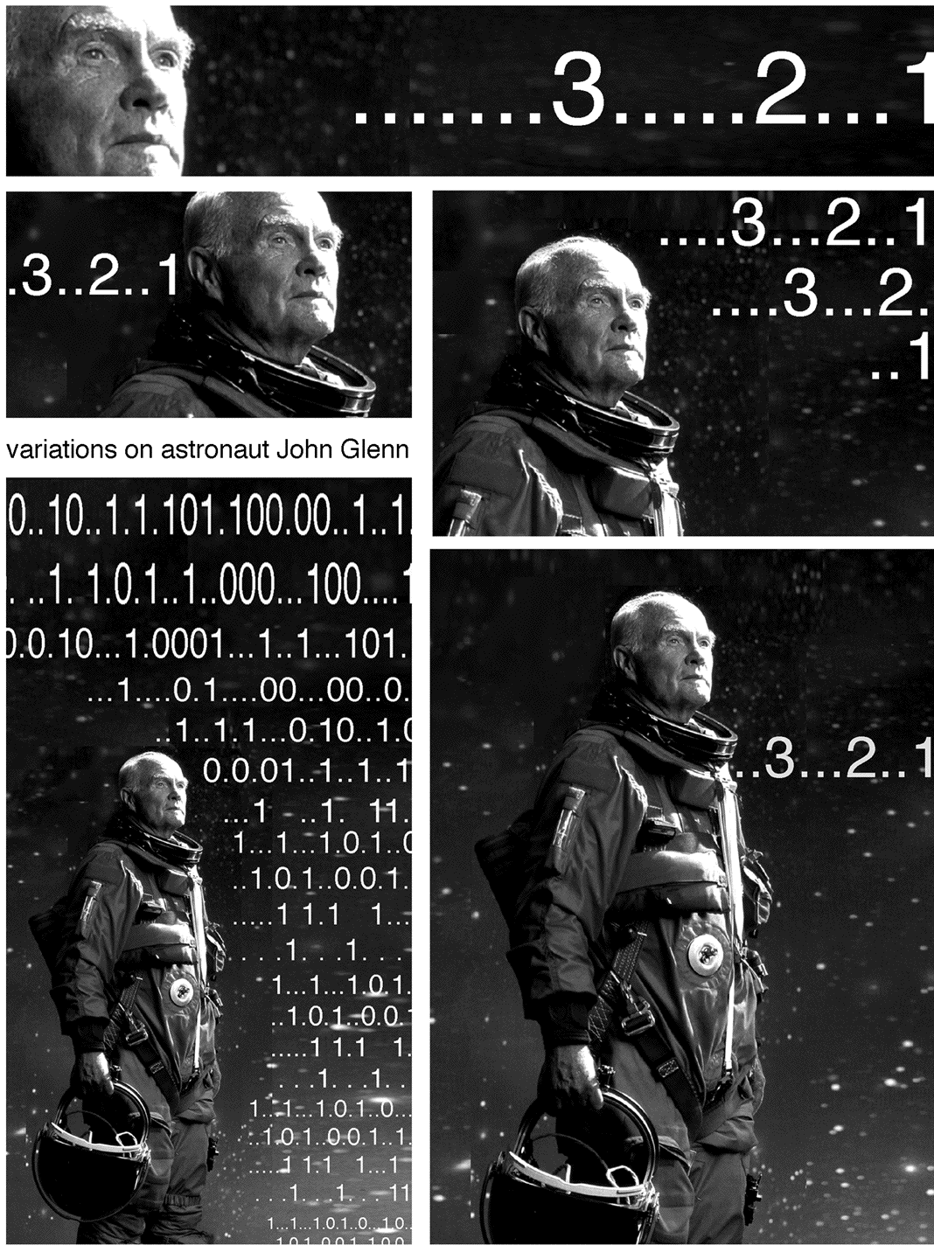
Strategy:
1. Choose a dramatic photograph and a line of text or sequence of numbers. If you wish, the text and numbers may have a direct relationship to the photograph.

2. Generate a wide range of variations. Try working with a very large figure and very small numbers; try using large numbers and a small figure; try overlapping the figure and the numbers. What happens when an extreme close up of a man’s ear is combined with 14-point type? What happens when a tiny figure is shown in silhouette surrounded by the same sequence of numbers in 48-point type? Repeat the text or numbers as necessary to create the most intriguing results.

3. Complete at least 6 rough variations, then finalize the 3 best and print them on good paper.

4. Enlarge one or two of the designs to 11x17" to demonstrate the effect of scale on communication.

Notes: Limiting the variables to a single figure and a single phrase or numerical sequence demonstrates the impact proportion has on communication. Enlarging or reducing the design can demonstrate the impact of scale. Encourage students to choose their texts carefully. Brevity is a virtue!
Timetable: 2 weeks
Lecture: Basic Raster Techniques

Assignment #2: COLOR AND COMMUNICATION

Focus: Use of digital variations to explore a range of color harmonies and uses.

Example A: POSTAGE STAMP FOR AN INVENTED COUNTRY

Problem: Design 4 postage stamps for a country you invent. Include the country name and a price within the stamps.

Objectives:
- Master basic methods of research;
- Demonstrate understanding of the role of the boundary in design;
- Expand ideas through variations on a theme.
- Learn color vocabulary and use various forms of harmony and disharmony effectively.

Strategy:
1. Invent your country. Using actual countries as a point of departure, make a list of its characteristics: location, climate, chief export, topography, political system, cuisine, national sport, major literary figures, etc. Your “country” can also be a virtual community or an interest group, such as chess players. Give your country an appropriate name.
2. Given these characteristics, what type of stamp is right for your country? Experiment with circular, triangular, and square formats as well as the more familiar rectangle.
3. When you have the basic designs down, experiment with traditional forms of color harmony, including monochromatic, analogous, complementary, and triadic schemes, and with disharmony. What is most effective?

Reading: Chapters 2, 6 and 8. Launching the Imagination Timetable: 2.5 weeks

Example B: AMERICAN DREAMS: LOST, FOUND, AND RE-WRITTEN

Problem: Create an 11x17” color poster commenting on some aspect of American society

Objectives:
- See and effectively use visual metaphor
- Learn the role of visual research
- Acquire critical thinking skills and express these skills both visually and verbally
- Relate text to image both aesthetically and conceptually
- Learn about design process. Use a sketchbook or loose-leaf notebook to keep a record of your ideas and research.
Process
1. Brainstorm 3 critical issues. What do you see in the world around you that is not the way it should be? Avoid overworked national issues, instead open your viewers eyes to some peculiarity that they may not have thought about before; they will be more receptive to your message if they haven’t already developed an opinion about it. Consider:
- What’s amiss in American society?
- What do people think about America that isn’t true? What is all too true about America?
- What do I see that should be, but isn’t?

2. Group brainstorming for issue selection. Select the most promising issue by asking yourself: does it ring true? (or all too true), is it unique? what ideas are really thought-provoking?

3. Do visual research to determine the visual metaphors associated with your issue.

4. Match your concept with one or more principles of design. What compositional strategies are suggested by the concept?

5. Using the principles of design that you selected, develop sketches. What combination of images would convey your concept most effectively? The image should effectively communicate the concept... no headline yet.

6. Take or find two images that can be combined to convey your message. Look in children’s books, or the library. We aren’t going to publish this poster, so copyright won’t be an issue. Your images must be sizable to 300 dpi. You cannot effectively add dots to an image, so they must be there from the beginning. Some online images will work. You may have to join or pay something for the image, but if it’s a good image, it may be worth it. Your online image must be at least 1000 dots on a side, so do only large image searches. Good sources: iStockPhoto.com, FreeFoto.com, Corbis.

7. Bring the images into Photoshop by scanning or using digital images. The poster will be
11 x 17, so you must begin working at that size; adjust image quality if necessary. Cut and combine the images to create an image that communicates your concept visually.

8. Look at the image, considering what is unsaid. What quip would let the audience in on the visual incongruity you have created? This will take the form of commentary on the issue rather than a restatement of the message on the poster.

9. Identify the grid in the image, and place the text so that it is compatible with the image.

10. Experiment with various color palettes and choose the most effective for the incongruous situation you are creating.

11. Flatten your image for printing, save as a TIFF, but save the original layered PSD as a separate file. Allow enough time to make adjustments if print quality or color isn’t satisfactory.

Assignment #3: LINEAR NARRATIVE

Focus: Use of digital variations to explore story-telling

Example A: PIVOT POINTS: THE EXTRACTED NARRATIVE

Problem; Starting with Poe’s Tell-Tale Heart, Bierce’s Occurrence at Old Creek Bridge, Severed, Theseus and the Minotaur, or other highly dramatic short story, song, or play create a stop-motion animation between one and three minutes long, responding to the emotions evoked as well as the action depicted. Final result may be descriptive, metaphorical, or highly abstracted. Projects will be done by teams of 3 to 4 participants.

Objectives:
- Introduce the basics of narrative structure;
- Identify pivot points. What are the absolute essentials, both for plot and for emotional impact?
- Explore storyboarding as a means of idea development
- Practice effective team-work.
Reading: Chapters 14 and 13, Launching the Imagination Timetable: 3 weeks
Lectures: The Classic Narrative Demos: IStopMotion, Quicktime, IMovie

Example B: CONFLICT RESOLUTION

Problem: Create a dialog or some form of conflict between two opposing forces. What sets the conflict in motion? How is it resolved?

Objectives:
- To explore dialectical thinking;
- To expand definition of “forces”--could be between two characters; between two colors, two shapes, etc; between words and music, between light and dark, between artist and audience, etc.
- To expand discussion of temporal construction

Assignment #4: JUXTAPOSITION AND ASSOCIATION

Focus: Create meaning through juxtaposition—of images, texts, and sound

Example A: WORDPLAY

PROBLEM: Working in teams of 2 or 3, choose one word for temporal visualization. Explore the definitions, emotions and implications of your word. Using stopmotion and video editing, create the most compelling movie possible, up to 4 minutes in length.

Sample subject words: bridge, barrier, mind, game, blue, karate. silence.

Sample thematic words: identity, loss, community

OBJECTIVES:
- To build basic technical, compositional and conceptual skills;
- To experiment with at least two idea generation strategies;
- To explore the basics of associative editing.

STRATEGY:

1: Final Cut basics. Using “stock footage” provided, master Final Cut basic tools.

2: Final Cut basics. Expand first draft, using sound. Complete at least 2 versions that are substantially different, based on the effects of sound and pacing.

3: Wordplay problem presentation, followed by mind map and emotion expansion brainstorming sessions--see Launching the Imagination, C5, for examples. Stopmotion basics presented.

4. Choose your word, begin visual and verbal research, rough out an idea, play with Stopmotion. (Each team will need 2 hours at a Stopmotion station)

5. Discuss results in team meetings; plan and complete final shooting.

6: Edit in Final Cut; refine audio.

7: Final draft due. Class critique followed by written self-assessment.

For self-assessment, answer the following questions:

What is the most compelling aspect of your final piece? What makes it compelling?

What is the least compelling? What is wrong with it, and how can it be changed?

Is there anything you would like to add, subtract, and expand in your movie?

What technical, compositional and conceptual skills do you most need to acquire?

How do you plan to acquire these skills?

Example B: SOUNDSTAGE

Problem: Maximum movie length is 3 minutes. Half of the time the screen will be blank: no image. How can sound create a bridge between periods of image and no image? what else can sound do? Work will be done in teams of two or three.
Objectives:
- To explore types and effects of sound
- To create compelling relationships between visual and audio
- To be relentlessly creative, witty. I am boxing you in: push the limitations set!
Strategy:
Session 1: Lecture/demo on sound; show examples of effective uses. HW: Develop ideas.
Session 2: Video basics, including hands-on experiments. HW: Shoot videos.
Session 3: Edit and insert audio, with each team-member creating a different “take” on the idea.
HW: Complete first draft.
Session 4: Critique of work in progress. HW: Complete final draft.

Assignment #5: Grand Finale

Example A: DIGITAL PORTFOLIO

Problem: In preparation for an “Early Decision” BFA review, create a digital portfolio consisting of 15-18 static images (from 2D Foundations, Drawing, 3D, your own studio work, etc.) and 3 moving images from this class, plus a one-page resume and a one-page artist’s statement.

Example B: INFINITE ZOOM COLLABORATIVE ANIMATION

Problem: Create a seamless experimental animation using large-group collaborative methods for generating a time-based artwork.
You will get to collaborate with all the students in the class to create a keyframed animation using the novel technique called "infinite zoom". A conceptual theme should be agreed upon by all participants. The project will include a soundtrack and a credits list for all content included.
Objectives:
- To create connections, relationships and dialogue among components of the animation;
- To create a compelling artwork that is both unified and marvelously varied;
- To heighten critique skills, focusing on how each contribution reacts or interacts with each other;
- To expand creativity. Just how many variations can be developed within the chosen theme?
Strategy:
Phase 1: Establish the theme and soundtrack.
Since a soundtrack will underlie the animation, students will bring in sample soundtracks (mp3s, etc.) that they think may be interesting to use for the animation. Each student will play excerpts from these and discuss possible themes or stylistic considerations for the project.
After hearing all the participants’ thematic ideas, students should debate and vote to determine the unifying theme and soundtrack. ( special consideration should be give to students who can generate their own soundtracks.)

Phase 2: Rough out concepts and determine linear order among students.
Students will show thumbnail sketches showing possible visuals following the determined theme. Students should discuss the various conceptual relationships and insights amongst the thumbnails and ideas relating to the theme. Students should ORDER THEMSELVES in a linear fashion, according to possible sequences amongst all the ideas discussed. Each student should discuss ideas and connections between their components of the animation with the students before and after them in the sequence.

Phase 3: Make the artwork.
Each student generates a Photoshop image 1440x972 pixels in size. This is the students image to create their portion of the animation. Using the fixed rectangular selection tool, designate a 720x486 area within the image where the student after you will place their image. Determine and record the CENTER COORDINATE of this inset rectangle. Create a new layer and execute your imagery.

Phase 4: Unify imagery and fix seams between images.
-Give a copy of your image to the student before you.
-Take a copy of the image belonging to the student after you.
-Resize their image to 720x480 and place it on a Photoshop layer under your imagery, positioned at the inset coordinates (this is a temp. version only to help you refine your own imagery.)
-Refine the boundaries between the images, extending imagery across the boundaries to obfuscate their harsh rectangular nature. Only work on YOUR layer.
-Delete the reduced size inset layer, so that a transparent hole frames the inset location.
-Collapse your Photoshop file, so only one floating layer contains your imagery. (don't completely flatten!)

Phase 5: Assemble the final animation from the components.
-Collect all the student's imagery, and compile the sequence of images using FCP, AE, Flash or other video editing software.
-Compile the images according to student order and use the position coordinates from Project Phase 3 to help determine the zooming keyframes and coordinates.
-Create keyframes, zooming through each layer, and use fades or blurring to help blend any remaining seams between the sequence.
-Adjust transition speeds and durations to best flow with the soundtrack.
-Add credits, titles, etc. and export this animation for final video playback.

Examples and Links:
Powers of Ten.wmv (1977 Charles and Ray Eames)
ZoomQuilt IIProject.swf (2007 collaborative project)
http://zoomquilt2.madmindworx.com/
Sito Collaborative Art Organization (http://sito.org)
check out their gridcosm:
http://www.sito.org/synergy/gridcosm/gridcosmviewer.swf

ADDITIONAL DIGITAL FOUNDATIONS AND PHOTO ASSIGNMENTS

TIME OBSERVED
Inspired by an assignment created by Gail Hoffman, Syracuse University

Problem: Sitting quietly for fifteen minutes, fully observe and record your thoughts and notice all of the activity in the world around you. Then, repeat the same process, now walking across campus for fifteen minutes, then returning to the classroom to write down the results.

Objective: To heighten awareness of time and space.

Materials: Writing pen and paper

Strategy: When sitting, it is important to be fully aware of each passing moment. Pay attention to everything—your breathing, the movement of your pen across the paper, the surrounding sounds and any thoughts that you have and any activity that you see. Imagine that this fifteen minutes of time has been deliberately staged for you. Apply the same awareness to your walking mediation but wait until you return to the classroom to write down the results.

Reading: Pages 287 to 291 and Zen Mind, Beginner’s Mind- Shunryu Suzuki

Instructor’s Notes: Because it is so elusive and pervasive, we tend to take time for granted. This exercise can heighten awareness of time and act as a springboard for an extended group discussion of the aspects and implications of time. In the group discussion it is wise to note the apparent compression or expansion of time based on our awareness of an event, the importance of memory, the effects of anticipation, the importance of deadlines, and so forth.
The meditative process in this assignment has some similarities to Zen practice, which has greatly influenced many artists for the past fifty years, including Bill Viola, Naum June Paik, and Robert Irwin. A slide show of works by these artists can help expand the conceptual possibilities.

Timetable: 60-90 minutes of writing and discussion

SEQUENTIAL RELATIONSHIPS

Problem: Using stock images provided by the Instructor, create four designs, each containing four to six separate images. Demonstrate your understanding of graphic, spatial, temporal, and rhythmic relationships in these four designs. For this exercise, don’t combine the images to make a collage. Leave a separation between the images to reinforce the idea of sequencing.

Objective: To strengthen the composition of multiple image structures through awareness
of basic visual relationships.

Materials: Twenty photocopies (supplied by the Instructor), at least six 4"x18" strips of black construction paper, and adhesive

Strategy: First, be sure you understand the four basic relationships under discussion.
They are described and illustrated on pages 10-3 and 10-4 of the textbook.
Next lay out all of the photocopies and consider ways they can be used to solve the problem. For many people, the graphic relationship is the simplest. For example, an image of a globe, a full moon, the round face of a clock, and the round face of a child are all essentially circles. Don’t glue anything down until you have considered solutions for all four compositions.
For extra credit, try combining categories (such as a spatial and a rhythmic relationship), or invent more complex possibilities of you own.

Reading: Pages 291 and 294

Instructor’s Notes: This problem goes very quickly if you bring in stacks of photocopies of stock images you have chosen. My set of images includes a variety of circular objects (such as the clock, moon and globe described above), a crying child, a laughing child, a smiling man, a woman looking out a window, and various room interiors. Enlargements and reductions of each basic photograph greatly expand the possibilities.
If the strips of black paper are folded back and forth to create strips of six 3"x4" panels, students will immediately think in frames rather than simply making one continuous collage. This is essential: to create a sequence, you must have some degree of separation. And, when organized in this way, the resulting design can free-stand, creating a simple accordion book.

Timetable: 3 hours in class; can be expanded with additional homework

TEMPO
Inspired by the Hand Drawn Film created by Gail Hoffman at Syracuse University
Problem: Make a ten-second film demonstrating one or more of the basic relationships explored in the Sequential Relationships assignment. Dramatically vary the tempo to increase interest while retaining simplicity
Objective: To see connections between story boarding and the traditional time arts, such as film and video.
Materials: Clear 16mm leader, fine point Staedtler felt pens, splicing tape
Special equipment: At least two 16 mm projectors and at least 4 simple splicers
Strategy: Using the template provided, create a storyboard for a hand-drawn film. In this storyboard, each box represents six film frames, or 1/4 of a second. Space has been provided for you to plan two versions of the film. At twenty-four frames per second, you will have 240 frames to draw, so use simple shapes inventively. Do not try to compete with Disney, Pixar, or other big animation studios, and please do not use any text.
Instead, experiment with tempo, the rate at which change occurs. If a circle is drawn the same way twenty-four times, it will be visible for one second. If it is drawn twice, the viewer will not really see it at all. A lot of movement can be created even with very simple shapes. For example, gradually enlarging the circle will make it appear to advance in space.
Then, draw directly on the leader, roughing out at least three feet of film. Since you are drawing on such a small format, registration is important to reduce the amount your images jump around on the screen. Here is a simple registration technique:
1. On white paper, trace the outside edges and sprocket holes of an 8” length of leader
2. Remove the film, and using a ruler, draw two vertical lines down the inside edges of the sprocket holes.
3. Again using the ruler, draw horizontal lines connecting the opposite sprockets and then draw two diagonal lines from the four corners of each frame to create an “X.”
To improve registration, place your leader over this chart as you draw and then move the film successively up onto the chart as the work continues. Experiment with various types of movement, including:
• A dot that moves into a line that connects to create a shape.
• A shape that advances or recedes in space.
• A shape that emerges into the frame or goes off the edge.
• A change in background color.
Remember to leave at least one foot of blank film at the beginning and end for feeding it through the projector. Run it through the projector to see the results. Continue this process until you have all 240 frames roughed out, then fine tune the drawings and add more color. If a section of the film is really terrible, remove it, splice in a new section of clear leader, and re-draw that part.
Reading: Pages 287 to 297 and The Animation Book Crown Publishers 1979.
Instructor’s Notes: Consistently, I have found that students are fascinated by this low-tech (and seemingly simple) assignment. With minimal instruction, they figure out how to use the projectors, and often take a very playful approach to the problem. By splicing all of the films together and showing the result brings the project to an exuberant conclusion. Vigorous, rhythmic music is a great addition.
Timetable: 5-6 hours

CHRONOLOGY

Problem: You will receive six starter images:
• A close-up of a hand opening a safe,
• Men in suits, running down a street,
• A man cautiously looking out a window,
• A man running down a flight of stairs,
• A woman watching the evening news, and
• An explosion.

Create four different stories by changing the order in which the images occur. At least four of the starter images must appear in each study, and any image can be repeated if necessary.

Objective: To explore the impact of chronology on meaning.

Materials: The Instructor will provide starter images.

Reading: Pages 306 to 308, and Structure of the Visual Book, by Keith Smith

Instructor’s Notes: Chronology refers to the order in which events occur. A change in chronology can enhance communication or change the story altogether.

Timetable: 1 hour

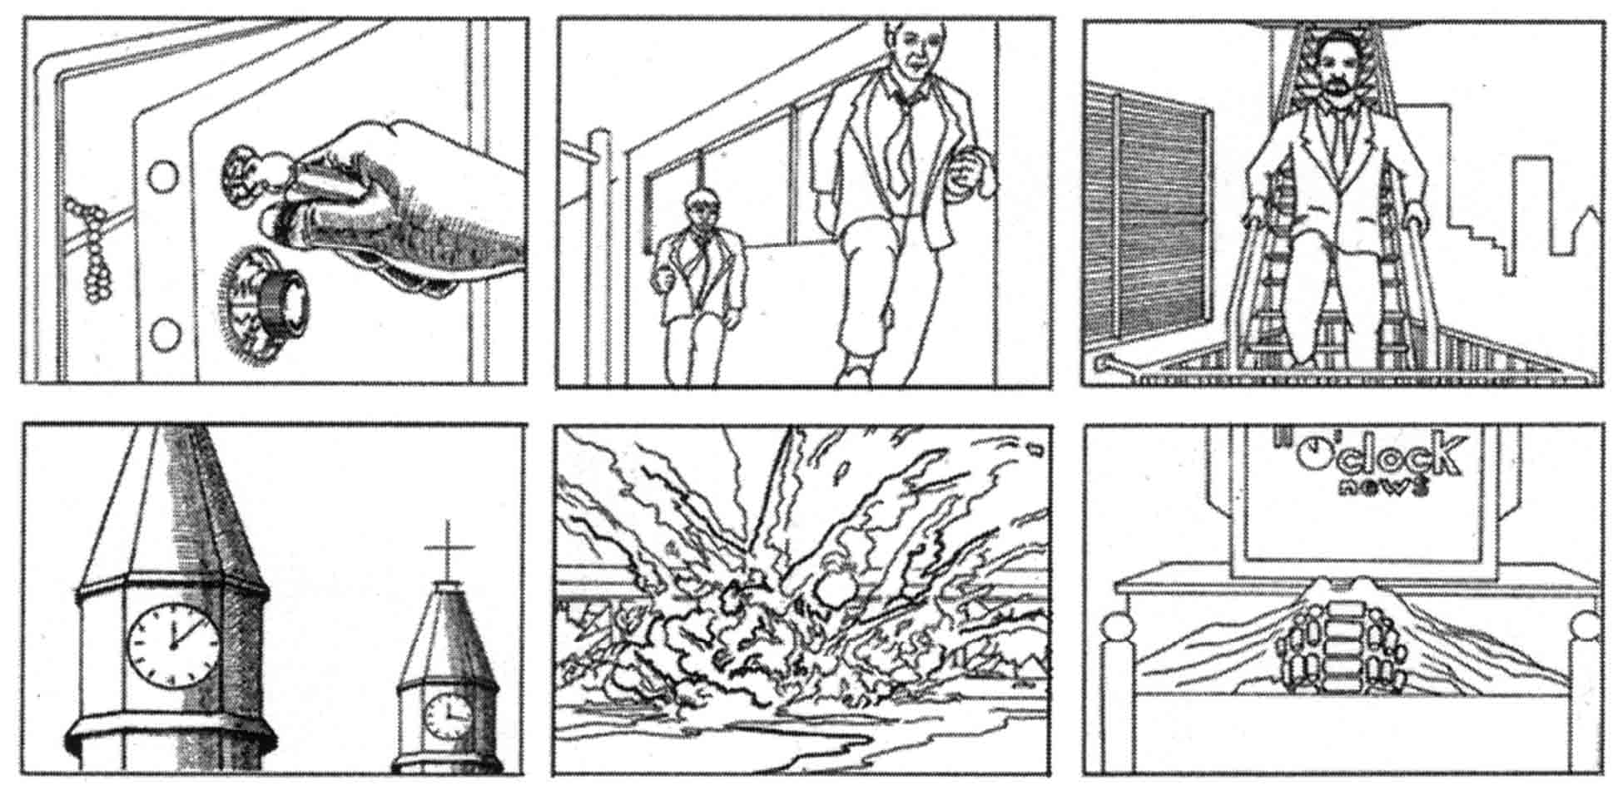

INTENSITY

Problem:
Option 1: Working with video, drawing, or photographic images of a single performer, create three versions of an event, gradually increasing the intensity.
Option 2: Working with your own voice quality, timing, and one prop, deliver four different readings of a brief text, varying the intensity.
Objective: Often overlooked, intensity is actually one of the most complex and important aspects of time design. A wide range of solutions to the same problem, from a very low-intensity performance to a very high-intensity performance, helps to demonstrate the significance of this critical aspect of time.
Materials: Video footage, drawings, or photographs as needed
Strategy:
Option 1: Choose a dramatic event requiring an outstanding performance by a single person, such as an ice skater at the Olympics, a timid employee confronting an abusive boss, or a pianist in a competition. Collect or draw at least twenty images of the performance and present them chronologically. Then, increase the intensity of the event using close-ups, contrast, and editing.
Option 2: Choose a very brief but very compelling text. The New York Trilogy by Paul Auster and many stories by Italo Calvino are packed with great material. Memorize it and consider how variations in delivery can strengthen or weaken its intensity. Using a single, simple prop (such as a chair, an item of clothing, or a candle), present four variations to the class.
Reading: Pages 297 to 298
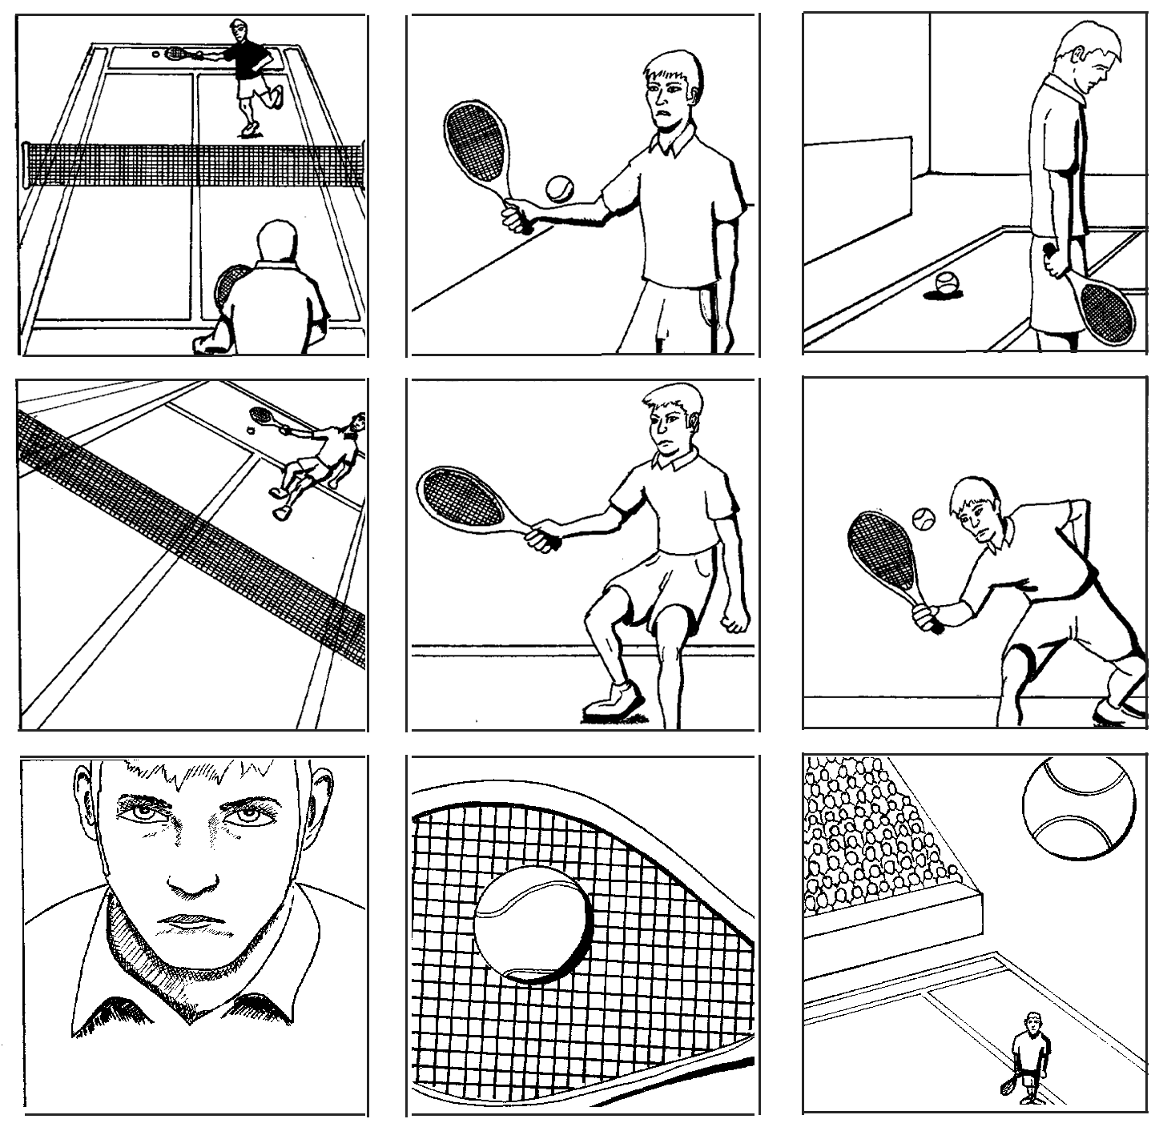
Instructor’s Notes: Intensity refers to the level of energy in a performance or the quality of observation of an event. You can demonstrate intensity through variations in voice or through a very “flat” performance of a repetitive action (such as a karate kata) compared to a highly charged performance of the same action. Encourage students to use intensity to manipulate meaning and demonstrate how contrast, volume, and lighting can increase or decrease intensity. Timetable: 3 to 12 hours, depending on the approach taken.
Low intensity

Medium intensity

High intensity

COUNTDOWN

Based on an assignment by Patrick Fitzgerald, North Carolina State University

Problem: Organize a minimum of ten images, objects, or actions to create a countdown (from ten to one) or count up (from one to ten).

Objective: In this assignment we will explore ways to compress or expand time. In a countdown, a sequence of preliminary moments is used to heighten awareness of a culminating moment.

Strategy: Start by brainstorming, listing every conceivable situation in which a sequence of moments culminates in a definitive event. A rocket ship blasting off is perhaps the most obvious. Consider the countdown from pregnancy to birth, the countdown to graduation, or the countdown to the beginning of a foot race. Explore personal implications, (such as the countdown to that last cigarette before you finally quit smoking) as well as global implications, (such as the events preceding a nuclear war). Consider ways in which a countdown can expand time as well as ways in which a countdown can compress time: both have expressive potential.
Then, begin turning your ideas into thumbnail sketches. Which of your ideas can be visualized most effectively? Is every moment in the sequence equally charged with energy, or does the tension noticeably rise as the end nears? Try to avoid jumping between high and low intensity. A gradual and accelerating rate change is generally more effective for this problem.
Finally, develop your ideas into a refined artwork. It is a good idea to start with too many images, then edit, finally creating the most powerful result.

Reading: Chapter 12.

Instructor’s Notes: This assignment can be as concise or as complex as you see fit. The brainstorming stage can take a week or it can be completed in an hour. The ideas can be expressed through simple drawings or through complex actions or sculptural objects.

Timetable: 6-12 hours
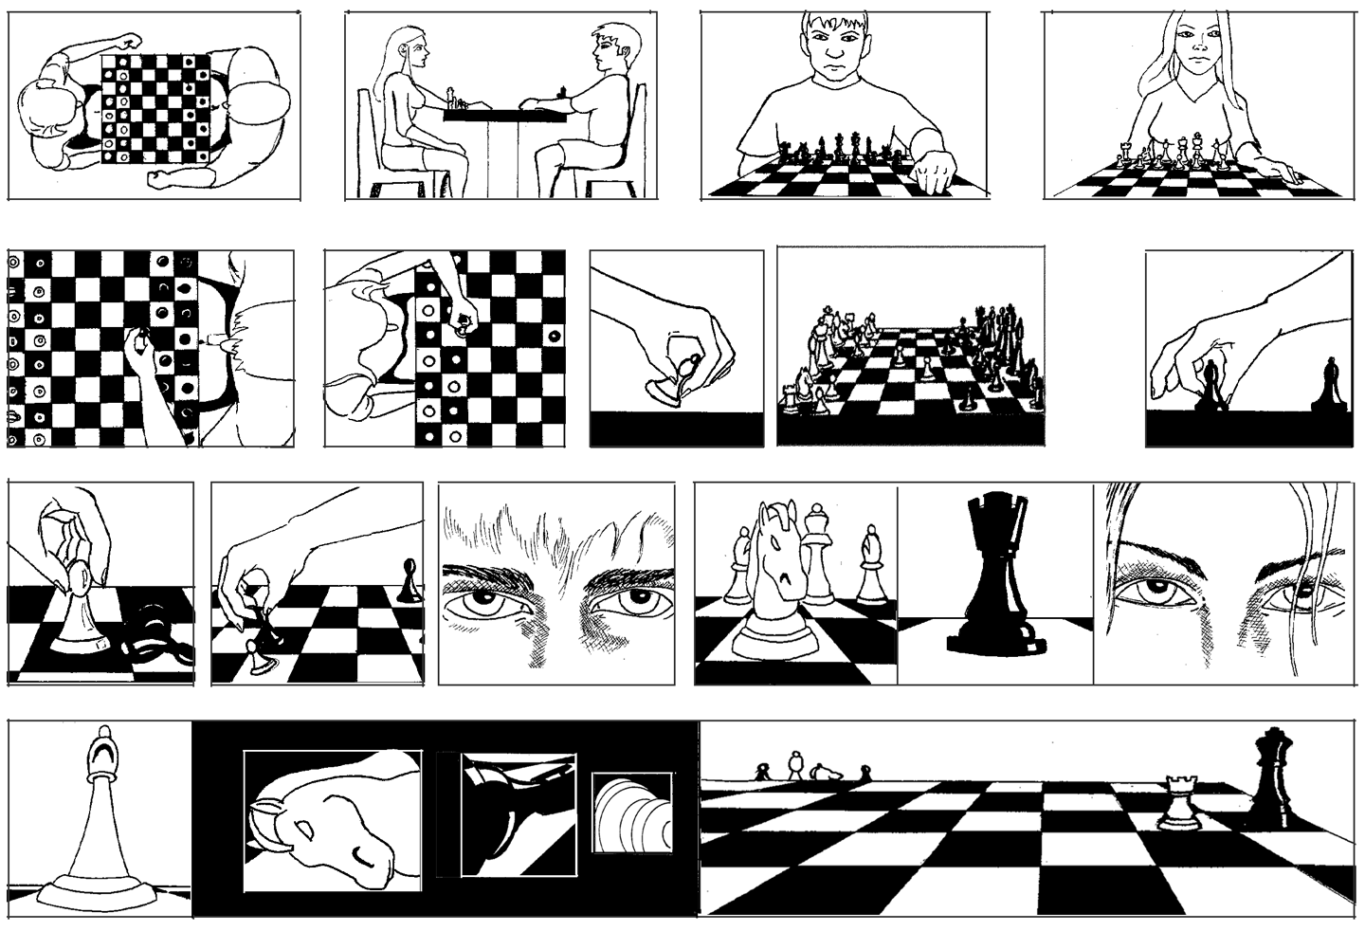

CHANGING THE SCENE CHANGES THE STORY

Problem: Draw or find photographs of one or two human figures. They may be sitting on a bench talking, walking hand and hand, engaged in physical combat, etc. Then, place your characters in four different settings. How does the setting affect the ideas or emotions being expressed?

Objective: To demonstrate the importance of setting.

Materials: Drawing materials or photographs. This assignment can also be done digitally.

Strategy: Begin by considering the characters and their relationship. What happens when they are two twenty-year old women? Does the interaction change if a twenty-year old and an eighty-year old women are used? How about a twenty-year old man and a twenty-year old woman? Experiment with various positions and gestures. The figures can be physically connected (holding hands, perhaps), or can be physically separated.
Then, photocopy, scan or draw images of at least ten different, settings, such as a circus, a cemetery, a grocery store, an dark alley, a locker room, and so on.
Finally, place your character(s) in the settings which most dramatically change the story. You must use the same characters throughout, but can enlarge, reduce or distort the figure(s) as necessary.
Reading: Pages 301 to 304. Timetable: 3 hours

SCOPE

Problem: Create a panoramic silhouette of a large site, such as a public beach, a track meet, or a circus. Then, add at least four windows to that design, showing specific simultaneous events within the site.

Objective: To heighten awareness of scope and compositional complexity.

Materials: Two-dimensional materials of your choice

Strategy:
1. Make a list of at least twenty settings in which multiple events occur—grocery store, expressway interchange, political rally, football game, etc.
2. Then consider how many events can occur in that setting at one time. For example, you might develop a panoramic design of a horse race, then add close-ups of a gambler placing a bet, a stable hand grooming a horse, an trainer talking to a jockey, a racing fan studying the program.
3. Finally, create an elegant silhouette showing the site as a whole, then add images of at least four events occurring at the site.

Reading: Pages 298 to 300; and Tuesday, a children’s book by David Wiesner.

Instructor’s Notes: In time design, scope refers to the range of action that occurs within a given moment. Stories that are narrow in scope often gain intensity and have great immediacy. Broad scope is often used for stories that are more complex or are universal
in nature.
Timetable: 12 to 15 hours

ARRESTED TIME
By Mathew R. Kelly, Whitman College

Problem: Create a dynamic sculpture from a captured moment in time.

Objective: To imply motion or potential motion using a static material.

Materials: A 6"x6"x9" block of urethane foam for each student, files or rasps, handsaws, small dowels and or toothpicks, lightweight wire.

Strategy: You may work subtractively by carving the piece out of the block of foam or additively by cutting up the block and assembling the piece.
Think of the block as your supply of material and consider how you can get the most mileage out of it. Consider relationships between organic and geometric forms, and the implications of physical forces, such as torsion, tension, compression and expansion. Can a hard-edged geometric form begin to flow? Billow? Twist? Take the piece beyond the obvious.
1. Generate a list: Think of something flowing, billowing, exploding, imploding, collapsing, tumbling, melting, swirling, splashing etc. Write down at least 20 examples, and consider how to communicate your ideas sculpturally. Making several thumbnail sketches of each idea will greatly expand your brainstorming process.
2. Focus: Determine which option has the most potential. Which solution best expresses the idea of arrested time? How can this solution be made into a compelling sculpture?
3. Create a working sketch or maquette: Make a detailed drawing or maquette of your proposed sculpture.
4. Finalize the piece: Start sculpting with the urethane foam but keep yourself open to changes that might present themselves along the way.

Reading: Review Part 3: Three-Dimensional Design

Instructor’s Notes: Many of arrested time can be found in various media, including:
• Photographer Henri Cartier-Bresson’s “Behind the Gare St. Lazare, Paris, 1932” in which he captured a man in mid-stride, just before his foot hits a puddle of water.
• Many photographs by Harold Edgerton, who used the strobe light to capture moments in time, such as a bullet hitting an apple.
• Isamu Noguchi’s “Cube”, which balances precariously on its corner rather than safely on its side. The perceived potential of this cube to tip over is what creates tension in this piece, increasing its dynamism. If limitations in time and equipment make it impossible to do this sculptural assignment, have students explore the idea photographically instead.

Timetable: 4 hours in class, 4 hours outside of class.

TIME PIECE
Assignment created by Mathew Kelly
Problem: Take the ordinary mechanism of a clock and expand upon it to communicate a time-related theme of your creation.
Objective: To combine function with a conceptual interpretation exploring ways to integrate the needs of both without one being subservient to the other.
Materials: A battery powered clock mechanism, (found at craft stores) cardboard or mat board for the maquette and a variety of drawing tools and materials such as wood, mat board, foam core, plastic, etc. for the final piece.
Strategy:
1. Time and the marking of time play a major role in our lives. We are slaves to our own invention. How many people do you know who don’t have a watch? Think of all the different ways we mark time from the obvious such as a watch or calendar to the indirect like birthdays, biological clocks, and circadian rhythms (sleeping habits). Think about different kinds of time such as “daytime,” “nighttime,” “geological time,” and “dinner time.” Think of phrases like “time is running out” or “time is money.” Most of all think about the way time affects your life.
2. Make at least three preparatory sketches of three different ideas about the way time is affecting you. Avoid conventional ways of displaying a clock where the time-telling function is the main concern. Include in these sketches the working clock. How can you make the clock an integral part of your sculpture and not have it look like it was just stuck on as an afterthought?
3. Once you have decided upon a solution that communicates a theme, start building a maquette or small-scale model of your idea out of cardboard or mat board. Keep an open mind and continue to experiment. Remember that the basic elements and principles of design still apply.
4. When the maquette is complete you may start building the actual sculpture. You have some construction issues to think about. The clock mechanism itself is quite light, yet with the battery it becomes a bit heavier, this will help determine what kind of material you are going to use for the clock face. The shaft that turns the hands of the clock is of a specific length, which cannot be adjusted, whatever kind of clock face you create is going to have to accommodate that specific length. You need to also consider that the hands of the clock are slowly turning so there shouldn’t be anything in their way or the functional aspect of this piece fails. Even at this stage you should still remain flexible with your idea. You will find certain materials do not behave the way you would like them to so that will help determine the kind of things you actually use.
5. Write a statement, no longer than a single page, discussing the theme you have chosen, why it is significant to you, and why you chose it for this project.
Reading: Chapter 5, sections on problem solving, brainstorming, conceptual expansion, pages 5-4 through 5-14. Additional reading: Longitude by Dava Sobel (Walker Publishing Company, Inc, 1995) and the Royal Observatory at Greenwich website: http://www.rog.nmm.ac.uk/.
Instructor’s Notes: This project has left quite a bit of freedom within materials and concepts and often times students will think of the function of the piece as being the most important part of the project. This has the potential to get out of hand with elaborate designs so, depending on the dynamics of the class and availability of equipment, you may want to consider adding a few more restrictions in order to help focus your students.
Timetable: 3 to 6 hours in class, 6 to 8 hours outside of class

POSTER DESIGN
Inspired by an assignment created by Max Hein, Santa Rosa Junior College
Problem: Design an 11"x17" black-and-white poster.
Objective: To provide experience with applied design and explore word/image connections.
Materials: Photocopies or computer prints, Bristol paper and black felt markers. This assignment can be done digitally
Strategy:
1. First, find out as much as possible about the event the poster will publicize. Talk to your client, read up on the event, and for a concert, listen to the music.
2. Next, develop at least ten 4"x6 1/2" thumbnail sketches exploring compositional alternatives. Carefully consider the relationship between words and images.
3. Develop an 11"x17" rough, refining and expanding earlier ideas.
4. Finally, complete the black-and-white poster that is camera-ready. Provide a 1/2" border around the image to improve print quality. Black areas must be solid and any stray marks must be removed from the white areas. Tonal areas can be created through cross-hatching.
Reading: pages 132 to 141, Chapter 3 and look at posters in Graphis Design and Print.
Instructor’s Notes:
Poster design is a difficult problem for most freshmen. Appearing in context with other visual notices, a poster must aggressively compete for the viewer’s attention. An effective poster requires integration of text and images, clarity of communication, and visual invention. The following checklist can help students stay on track.
1. Posters are basically pictorial statements. Visual communication precedes verbal communication. You should allow about 70% of the total area for pictorial imagery and 30% for the verbal text.
2. The content must be communicated quickly. Eliminate all non-essential information.
3. Consider the context in which it will be shown. Including a border in the design helps make a poster stand out on a cluttered wall.
4. A vertical format is preferable. It is more familiar and makes good use of display space.
5. A poster should have a focus and impact. Let one element or idea dominate.
6. Strong contrast (light/dark) is essential for readability and can increase impact.
7. All elements should be carefully selected to reflect the nature of the event.
8. Photographs must often be changed if they are to be effective in a poster. A poster is a graphic statement—not reality.
9. Distinctive or exotic type styles are best used for the main heading. Neutral type styles, such as Helvetica, Palatino, or Garamond are usually used for most of the copy. Limiting students to two typestyles can be helpful.
10. The verbal information must be carefully integrated into the overall design. It shouldn’t look like an afterthought.
11. Copy should be organized and sized according to importance. The usual ranking is: 1. Name, 2. Date, 3. Place, 4. Time, 5. Admission.
12. A simpler, more neutral style of type is preferred for copy of lesser importance. Lower case letters are easier to read than all capitals.
14. Economy is a virtue.
15. A bad design can ruin a good idea. Poor craft can ruin a good design.
Timetable: 16 to 20 hours

AMERICAN DREAMS: LOST, FOUND AND RE-WRITTEN
Inspired by an assignment by Jane Venes

Problem: Create an 11x17” poster critiquing or celebrating an aspect of American history or culture.

Objectives:
- See and use visual metaphor
- Learn and use visual research techniques
- Relate text to image both aesthetically and conceptually
- Develop a print quality constructed image in Photoshop
- Use a sequential design process approach
NOTE: Please create a record of your design process. This will take the form of a sketchbook or loose-leaf binder in which you store your ideas, sketches, and visual research. This process notebook is a major component of your completed project.

Process
1. Individually brainstorm 5-10 critical issues. What do you see in American culture that is appalling or exhilarating? Try to open your viewers’ eyes to some peculiarity that they may not have thought about before; they will be more receptive to your message if they haven’t already developed an opinion about it. Possible questions to pose to friends and family:
- What’s amiss in America? What great American quality are we overlooking?
- What do others think about us that isn’t true? What is all too true about America?
- What peculiarities do you see in America that don’t follow our national myths?

2. “Market test” your idea. Get together in groups of 3 or 4. This is a circular scripted group process. The first student reads one of his or her critical concepts. The next student must say, “What’s wrong with that?” or, if its a “People think... issue, the question is, “Why do they think that?” Then the next question is, “What’s wrong with that?” All the students in the group must respond to the “What’s wrong with that question,” while the author takes notes. If you don’t have two or more immediate answers, throw the issue out: it isn’t critical. If the issue really IS critical, it’s author then asks, “How bad is it?” Here the group develops wild exaggerations about the issue...

3. Select the most promising issue by asking yourself: Does it ring true? (or all too true); Is it fresh, distinctive? Does it make sense?

4. Do visual research to develop visual metaphors that might be associated with your issue. (Editorial cartoons often use visual metaphors brilliantly.) Try doing an image search using key words and develop at least 16 thumbnails to illustrate the metaphor. Bring these in for discussion.

5. Match your concept with one or more elements and principles of design. What compositional strategies are suggested by the concept?

6. Then, develop at least 20 sketches. What combination of images would convey your concept? The image itself should fully communicate the concept... no headline yet.

7. Shoot or find two images that can be combined to convey your message. Look in children’s books, or the library. We aren’t going to publish this poster, so copyright won’t be an issue. Your images must be sizable to 300 dpi. Online images may be used. You may have to join or pay something for the image, but if it’s a good image, it will be worth it. Your online image must be at least 1000 dots on a side, so do only searches for large images. Try iStockPhoto.com, FreeFoto.com, Corbis.

8. Bring the images into Photoshop by scanning or using digital images. The poster will be
11 x 17, so you must begin working at that size; adjust image quality if necessary. Cut and combine the images to create an image that communicates your concept visually. Be aware of the relationships of one shape to another in the photographic space provided by the images.

9. Seek surprise or something unexpected. What is unsaid? What quip would let the audience in on the visual incongruity you have created? This provides your commentary on the issue rather than simply restating the basic message on the poster.

10. Identify the grid in the image, and place the text so that it is compatible with the image, but doesn’t clutter it. Choose a font that is consistent with your message. Simple is usually best.

11. Flatten your image for printing, save as a TIFF, but save the original layered PSD as a separate file. Allow enough time to make adjustments if print quality or color isn’t satisfactory.

The completed submission
Your completed poster will be an 11 X 17 color print that must be high-quality. Mount the poster on mat board or foam core allowing a 1½” margin. Craftsmanship is important in both photo quality and mounting. Turn in your process notebook along with the final poster.
Evaluation: American Dreams
Fundamentals
________ Has critical content
________ Communicates visually
Visual Communication
________ Quality of visual message
  - makes sense and rings true
  - is fresh, distinctive
  - use of visual metaphor
________ Formal / aesthetic properties

Use of Text
________ Text complements message
  - Placement grounds text within the image framework
  - Font choice is appropriate
________Technology
  - Seamless image
  - Layers are named
  - Number of layers is not excessive
  - Resolution
________Craft and print quality

A PLACE IN SPACE
Inspired by an assignment by Jane Venes

Problem: Working with Final Cut Express, develop a time-based composition based on a specific location using a combination of photographs and video clips. Your mission will be to increase the value of the original images using chronology, tempo, transitions, and sound. Try to maximize the communicative, aesthetic, emotional and metaphoric value of the temporal media.

Objectives:
- To explore a location photographically
- Develop a temporal composition based on multiple source images
- See similarities and differences
- Create and manipulate change over time
- Use tempo and sound to enhance a temporal composition

Process:
1. Explore a location thoroughly using a digital and video camera. Show your viewers the selected location from common and unusual perspectives. What does it look like at different times of the day, in different weather, when it is occupied, when it is empty?

2. From your images, rough out two potential storyboards; one using a narrative approach, and one using an associative approach.

3. Consider cropping any of your images to increase their impact, and distill your video clips a LOT.

4. Apply motion strategies such as zoom and pan to add a sense of motion to your images. Remember you can use the same image several times with varied durations. More rapid appearance and disappearance will increase the tempo of the composition. Consider what the tempo should be for the message/effect you want to produce. You can also create variations on the image using Photoshop.

5. Choose your transitions carefully. They can really add or detract: use “gimmicky” transitions sparingly or stick with the basics: fade, cut, wipe, dissolve.

6. How does sound enhance or change the meaning of the composition?

Extra credit: Do a second version, using sound to change the meaning and emotion substantially.

Evaluation:
Analyze at least 5 temporal projects from the Digital Foundations archive. What qualities characterize the best and worst compositions?

Consider the following key questions:
- Duration: Is it long enough to develop the message yet short enough to sustain viewer attention?
- Tempo: How does the tempo help us re-think or re-experience a familiar site?
- Chronology: Does image order build content—or does it seems unnecessarily dis-jointed?

COLLABORATIVE COMPOSITION
Assignment by Mathew Kelly, Whitman College

Problem: Using Photoshop (or Final Cut Express), work collaboratively with three others to develop a complex piece on a shared theme. Integrate a small design from another student into a larger composition of your own, and then give a small portion of your own design to someone else to be used in the same way. Then, as a group, decide how to best integrate the four designs into one compelling unit.

Objectives:
  - To introduce basic steps of scanning material and digitally manipulating an image.
  - To explore the advantages and disadvantages of working collaboratively.
  - To develop increasingly complex compositions.

Strategy for Photoshop Version: You will be assigned to a team with three other students. Your team will have a digital folder, and within that folder will be a folder each member of the team. Your team will share designs, as detailed below, in order to create a larger composition on a shared theme.
1. Decide on the theme. Is there a common experience or interest that everyone in your group shares? Are you all involved with theater? Sports? Art? What is the common thread that will conceptually unify your collaborative project?
2. Collect and scan the material. You will need to collect a set of images related to the agreed upon theme. Gather photographs, actual objects small enough to place on the scanner, and create hand-drawn images. The more images you have the easier it will be later in the project. Scan everything at the same resolution and in the same kind of file format, preferably TIF.
3. Create a 6"x9" composition. Your composition should be made up of a minimum of one hand-drawn image, a photograph and a scanned three-dimensional object. Experiment with your images but don’t forget about the basic elements and principles of design. Each individual image should be strong in itself.
4. Share part of your composition. When your composition is done, select a small portion that is roughly no larger than 9" in area (e.g., a 3"x3" square, a 1"x9" rectangle, a 3" diameter circle, etc.) Title the selection and put it in the folder of one team member, as instructed.
5. Incorporate a team member’s selection into your composition. Open your folder and find your collaborator’s work-a selection from his/her composition. You must incorporate that selection into your own complete composition.
6. Put the pieces together. When everyone is finished incorporating his/her collaborator’s work, the team will have four compositions. As a group, decide how to put the four compositions together to form a single coherent work. You could line them up, stack them, arrange them in a grid, etc. Together you may also further manipulate the combined image.

Reading: Pages 128 to 139 Instructor’s Notes: Do not flatten the images until the final piece is done.
Timetable: 6 to 8 hours in class, 6 to 8 hours outside of class.
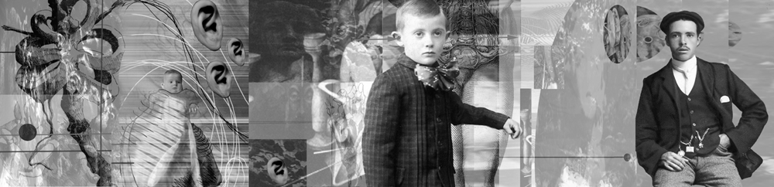
Illustrating Aesop
By Charles Badland
(in part from Professor Copper Giloth, Director of Academic Computing UMass Amherst)

Overview-
Vector drawing programs are capable of creating clean, editable illustrations. An image made with Adobe Illustrator can be resized, re-purposed, re-colored. Paths, fills, stroke, text can all be modified and transformed with no loss in image quality. Vector drawing programs are ideal for creating simple graphics, cartoons and logos.

In this project you will design original art for a four-way Commemorative Stamp Set based on the fables of Aesop.
First research this Aesop fellow (“Google is your friend”); peruse his “moral” fables and choose one to four of his stories as the basis for artwork for the stamp set.
Next do some research on postage stamp art. Look for designs that have simple drawings that have children’s themes. Look at colors used, scale of the images, how text is incorporated.
Once you have chosen a fable(s) to illustrate, sketch out your artwork ideas. Create simple mock-ups of how the illustration will fit in a four-stamp model. What colors will you use? What text will you use in the design? What font? How will the stamp look at actual size? Save all of your sketches to be turned in with the assignment. Bring them to class to review with your fellow students and me.

Objectives-
- To create an effective design in a four panel grid.
- Learn basic vector drawing skills.
- To become proficient with the pen tool.
- To become proficient in creating and arranging shapes and paths
- Become acquainted with type tool, character and paragraph palette.
- Become acquainted with printing process and presentation of images

You can use any element of Illustrator to make your illustrations EXCEPT:
- No “Effects” from the Effects Menu
- No Patterns, Graphic Styles or Spray Can Symbols (unless you create them from scratch)
- Do not use Live Trace feature in CS2
- No imported bitmap art
- No clip art

NOTE: Typefaces do not travel with your Illustrator file! If you want to make sure your type does not change, go Type>Create Outlines. This will turn your type into vector shapes. ALSO, if you work on AICS2 in the FAB lab, you must save your files as an EPS file for AICS to work on in our class. Remember to SAVE Frequently!

What is Due Monday, October 2:
Be prepared to present your project in class (as electronic files). Save each illustration as a native .ai or ,eps file AND as a .pdf file. All documents must be uploaded in a folder with your name. Fonts in your Illustrator file MUST be vector objects (ei Type>Create Outlines)
You will also turn in a full-page print of your illustration AND a print at actual size of stamps. Also hand in a print-out of the fable(s), your sketches and time sheet. All prints should be in a folder with your name written on it.

Some examples of short Aesop Fables with “Moral of the Story” endings:

The Fox and the Grapes
ONE hot summer’s day a Fox was strolling through an orchard till he came to a bunch of Grapes just ripening on a vine which had been trained over a lofty branch. “Just the things to quench my thirst,” quoth he. Drawing back a few paces, he took a run and a jump, and just missed the bunch. Turning round again with a One, Two, Three, he jumped up, but with no greater success. Again and again he tried after the tempting morsel, but at last had to give it up, and walked away with his nose in the air, saying: “I am sure they are sour.”
“It is easy to despise what you cannot get.”

The Hare and the Tortoise
One day, the Hare ridiculed the short feet and slow pace of the Tortoise, who replied, laughing: "Though you be swift as the wind, I will beat you in a race." The Hare, believing his assertion to be simply impossible, assented to the proposal; and they agreed that the Fox should choose the course and fix the goal. On the day appointed for the race the two started together. The Tortoise never for a moment stopped, but went on with a slow but steady pace straight to the end of the course. The Hare, lying down by the wayside, fell fast asleep. At last waking up, and moving as fast as he could, he saw the Tortoise had reached the goal, and was comfortably dozing after his fatigue.
“Slow but steady wins the race.”

The Ant and the Dove

AN ANT went to the bank of a river to quench its thirst, and
being carried away by the rush of the stream, was on the point of
drowning. A Dove sitting on a tree overhanging the water plucked
a leaf and let it fall into the stream close to her. The Ant
climbed onto it and floated in safety to the bank. Shortly
afterwards a birdcatcher came and stood under the tree, and laid
his lime-twigs for the Dove, which sat in the branches. The Ant,
perceiving his design, stung him in the foot. In pain the
birdcatcher threw down the twigs, and the noise made the Dove
take wing.

“One good turn deserves another”

Before and After
Inspired by Clue Diptych, Mary Frisbee Johnson in Visual Workouts, Prentice Hall, 1983

Problem: Imagine a dramatic event. Then, invent two images, one showing the scene before the event occurred, the second showing the aftermath. Do not show the event itself. Instead, use objects and lighting to provide the clues the viewer needs to create his or her own story.

Objective: To demonstrate the importance of setting.

Materials: Two-dimensional materials of your choice

Strategy:
1. Start by making lists of dramatic events, environments, and objects. For example:
• Events: explosion in a toy factory, new home run record set, etc.
• Environments: circus, airport, chemistry lab, racetrack, cathedral, dentist’s office
• Objects: address book, stopwatch, telephone, elevator, escalator, ladder, car keys
2. Consider the stories each may conjure.
3. Add characters. They may be human, animal, robots, etc.—use your imagination! Consider any objects (props), which might be associated with each character.
4. Begin designing images. Experiment with lighting, camera angle, close-ups, etc. to get the most powerful effect. Pay attention to details: the news program on a TV set in the background may provide an essential clue.
5. Experiment with various mediums, such as graphite, computer graphics, and watercolor. Choose a medium which is appropriate to the subject matter and easy to use.
6. Consider:
• What role does the setting play? How can interiors, objects, and lighting contribute to the sense of anticipation and mystery; how can the setting heighten emotion?
• How much conceptual and/or narrative information need you provide to the viewer? You don’t want to be obscure, but over-explaining defeats the mystery.
• How much perceptual information is needed? To what degree need the objects and interiors be defined? When is suggestion more powerful than description?
• What is the observer’s position? Detached? Involved?
• How much time has elapsed between image #1 and #2? An hour? A day? Fifty years?

Reading: Pages 301 to 308, Chapter 13

Instructor’s Notes: This is a complex assignment and most students are confused initially. It is helpful to provide several specific examples, followed by relentless coaching.
A familiar and dramatic example works best. Consider the Oklahoma City bombing. It was a spring morning, shortly after the Murrah Federal Building had opened. Parents were dropping off their children at a day care center. In this story, the 8:03 am explosion of a fertilizer bomb is the event itself.
What occurred before the explosion and how can it be shown? Timothy McVeigh buying fertilizer? McVeigh watching news reports on the fire at the Branch Dravidian compound in Waco? The children walking into the federal building? A combination of these images? What occurred after the explosion and how can it be shown? Injured people and wreckage? The trial of McVeigh? Children playing in a park now being built at the site of the bombing?

Timetable: 18-24 hours, in and out of class

Vox Populi Video

Assignment: Using anything and anyone on Monroe Street as your subject, create a 3-5 minute video exploring “the people’s voice.”

Technical Objectives:
- Use hardware and software to acquire good quality images and audio.
- Master Final Cut basics: editing and integration of video, audio, and text.
- Use appropriate terminology and vocabulary surrounding video production.

Conceptual and Compositional Objectives:
- Mine an everyday site for the richest possible story.
- Use the elements and principles of time-based media to create a cohesive statement.
- Balancing intuition and intellect, Use video to express and convey personal vision.

Strategy: Explore Monroe, from Orange Avenue to Thomasville road.
- Find a topic of interest—from gas stations along the way to eateries to pawnshops.
- Generate a set of questions related to your topic
- Gather video interviews with people on the street or at businesses.
- Gather supporting video as needed, such as shots of the area.
- Create supplemental graphics, and text; gather or create audio.
- Capture/transfer and organize all media within a Final Cut Express project.
- Construct an engaging interview-based documentary.

Interview essentials:
- Seek good lighting. Good side lighting will add clarity and drama.
- Focus. What is it you want to learn about the person or the topic you have chosen?
- Listen. Just ask enough questions to get things started and keep things going.
- Listen some more. Note body language. If the person is really ill at ease, back off.
- Thank the person for the interview, and if possible, get them to sign the attached release. As a classroom project without any commercial intent, the release isn’t essential—just preferable.

Keep in mind the following basics of media literacy:
- All media are carefully crafted constructions. Gathering the raw footage is just the first step.
- All media construct new realities. As you are creating your project, seek the substance of an idea or interview, not just the surface. Rather than assuming that a barber is gregarious or a ticket taker at a movie is bored, seek out the story beyond the façade.
- Different audiences respond to the same information differently. Both as artists and as viewers, we each bring our own anxieties, passions, and experiences to each event we observe. Value and express your own voice in creating your project. It may be comic or tragic, elegiac or exuberant. Equally, value and support the unique voice of your peers when critiquing the projects.

VIDEO DOCUMENTARY INTERVIEW RELEASE FORM

My signature below will confirm my agreement with filmmaker/photographer,
_____________________________, regarding the disposition of video documentary and photographs of interviews conducted with me, _______________________, on (date) ____________ .

I understand that the tapes both of me and transcripts (if transcribed) of the
interview(s) will be maintained and made available indefinitely by the
filmmaker/photographer for such research, production (e.g., radio, television, film
festivals, World Wide Web, exhibitions and educational purposes as the filmmaker/photographer shall determine.

I hereby grant, and transfer to the filmmaker/photographer all rights, title, and interest in
the interview and video documentary, including without limitation the literary rights and
the copyright. I hereby release filmmaker/photographer from all claims and liability relating to said documentary and photographs.

The filmmaker/photographer agrees to retain the integrity of the interviewee's image and
voice, neither misrepresenting the interviewee's words nor taking them out of context.

I attest that I have voluntarily agreed to be interviewed and that this document contains
the entire and complete agreement concerning the use and preservation of my interview.

Signature of Interviewee: _________________________ Date____________

Name (printed):_________________________________

Signature of Interviewer: _________________________ Date____________

Name (printed):________________________________

THE WORLD IS A STAGE: The Transformative Effects of Value

Problem: Using lighting, transform the everyday world into a world of magic, murder or mystery. Shoot 36 photographic prints, get them processed; bring the twelve best and six worst to the critique.

Objectives:
- To increase our awareness of light.
- To demonstrate the emotional impact of light.
- To practice cropping images through a camera lens.

Materials: Camera and good quality printer paper.

Strategy: Use natural or artificial light. Time of day, angle and direction of light, and the effects of shadows are essential aspects of natural lighting. Artificial lights (such as clamp-on floods) provide great opportunities for back, side, and fill lighting. A single light source tends to be emphatic and dramatic, while multiple sources can be used to create more complex effects. Experiment!
Search out extraordinary images in an ordinary world. How can a simple glass of wine become a shimmering source of light and shadow? Can a pile of wood at a construction site or a simple stone wall become a beautiful composition? Compose each image carefully, framing the moment as well as the shapes in the design.
Reading: Pages 1-20 to 1-23
Instructor’s Notes: One of the great benefits of photography is its relative speed. While students may spend hours identifying subject matter and adjusting lighting, the actual recording process is relatively fast. Disposable cameras and commercial film processing can make this assignment accessible to anyone. And, the ease with which images can be produced encourages experimentation.
Lighting can increase or decrease the illusion of space, emphasize an object or an action, and strongly influence our emotional response. When working photographically we actually draw with light. When critiquing the results, consider the basic composition of each photograph as well as the lighting. Consider:
• How was the image selected? What made it stand out? Why was it worth recording?
• How was it cropped? Why shoot this particular fragment of reality and not another?
• Is it spatially shallow or spatially deep? What does spatial depth contribute to a composition?
• Is the image balanced? If so, how? If not, is the absence of balance an advantage?
• What creates variety? Is the balance between unity and variety appropriate to the subject?
• What is truly essential? Could anything be deleted from this image?

Timetable: 4-6 hours

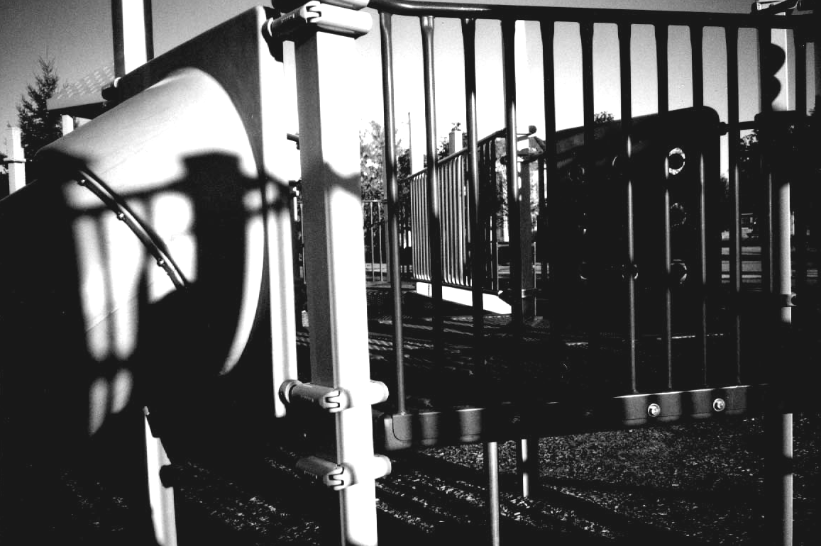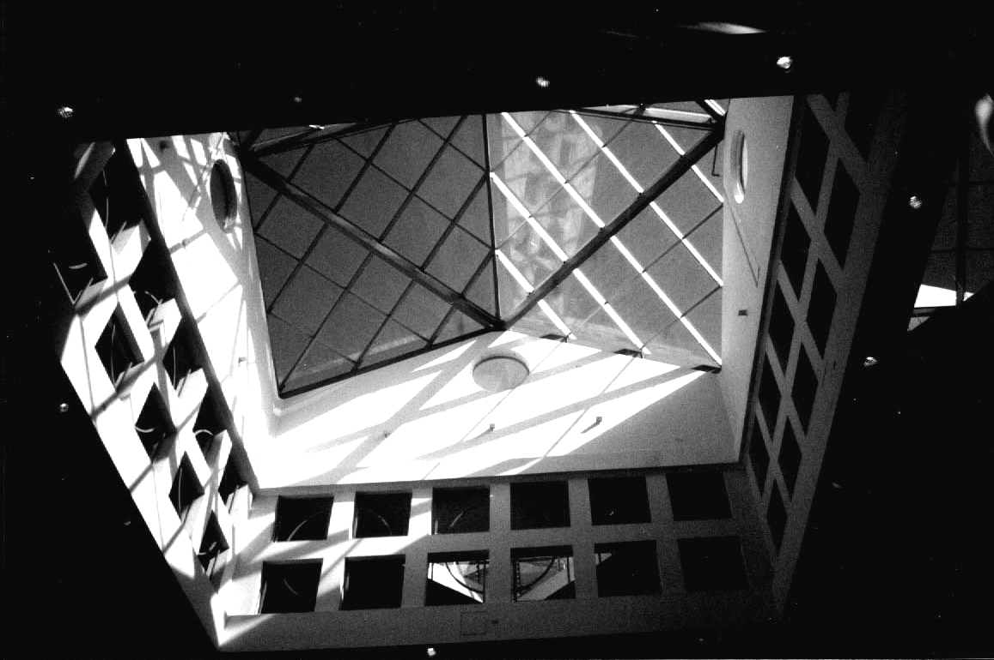

TIME PORTRAIT: Symmetrical Balance
Assignment created by Frank Kulesa, Northern Illinois University

Problem:
Using the concept of time, show a chronological sequence of figures and other images that represent your development from a youth to now or the future.
Objective:
Use a variety of figures and other images to create a composition that goes beyond a simple illustration of past and present images. Give the viewer a strong sense of who you are.

Strategy:
The final composition can flow from left to right or from bottom to top.
The final composition has to be larger than the 8.5 X 11-inch print out from the lab printer. So a stiff backing board is required for mounting you printed images together. Test prints should be printed before the mounting step. Check for good readability and contrast of the images. Since the printout will be from the lab printer, it might be better to work in grayscale mode versus color.
1. Collect and scan pictures of yourself, family, friends, interests, etc. Images of your environment and own artwork are a rich source of content to work with. Gather as many images as you can. It is better to have more than not enough images to work with. Scan all the images at the same resolution.
- Type out a paragraph listing the theme of the composition and what is significant to you.
- Develop several rough sketches with the main images to represent your idea.
- Put the scanned images into different sequences, juxtapositions, layers, values, etc.
2. All your images should be scanned and your major ideas for the background/s and foreground/s chosen.
- Clean up and enhance the scanned images for contrast, lighting, readability, and details.
- The main locations and the main images should be positioned.
- Print test prints and loosely position the printouts and view the composition at full scale.
- Study your timeline and project theme. Are they communicated well?
3. Fine-tune both the visual composition, time flow, and message of your theme.
- Does you composition flow cleanly and smoothly from the beginning to the end.
- Printout the composition in sections and neatly mount the sections together onto stiff mounting board.

This project is an excellent way to explore the many effects of paint application software and design/artistic techniques: layering, overlapping, transparency, blending, blurring/sharpness, cut and paste, scale, value, contrast, juxtaposition, distortion, rhythm, etc.

NOTE: as a reminder, do not flatten your layers as you are working on the project. Keep your layers, and save the project as a PhotoShop file. Later you can flatten the layers and print as a JPG or TIF file. The better you become familiar with a variety of PhotoShop effects, the better your composition will be.

Instructor’s Notes: Think about: Your history, Your goals, Your interest, Light and shadow, Your desires, Sequential experiences, Changes in light due to time, Chronology and tempo.
This project has a lot of freedom in what you want to say. The theme can be complex with more than one message or it can be simple as having a goal to graduate from college or have a career as an artist or designer.

Chapter Six

COLOR THEORY FOUNDATIONS

SAMPLE SYLLABUS: COLOR THEORY FOUNDATIONS

ART 2205: Section 10, FALL 09 Monday/Wednesday 9:05-11:35, FAB 107
Professor Jane Doe jdoe@fsu.edu Office Hours: Monday/Wednesday 11:45-12:30

Course Description: Experiments in color perception combined with uses of color in visual communication and visual expression. This course includes lectures, experimentation, facilitated discussions and hands-on work.

Structure: This course is divided into two parts. Roughly half of the time will be devoted to color exercises and experiments. These studies will include work with hue, value, saturation, warm and cool interactions, and push/pull. The remaining half will be devoted to a series of assignments using color to expand communication and expression.

Objectives: Upon successful completion of this course, you will be able to:
- Articulate an understanding of the historical evolution of color theory including discussion of Albers, Itten, Hofmann, and Munsell;
- Demonstrate how visual communication and expression are affected by color choices;
- Effectively use color theory to expand critical and creative thinking;
- Use color to strengthen personal artwork.
Assessment: Grades are based on four major factors.
- Perceptual Sensitivity. Is the work coloristically inventive? Have you gone beyond clichés? Do your color choices effectively advance your conceptual intentions?
- Compositional Cohesion. Is every square inch of the composition fully engaged? Is the image appropriately unified? Energized? Balanced? Well crafted?
- Learning Process. Did you use class time effectively and come prepared? Did you take risks? How many solutions did you invent for each problem?
- Critical Thinking. How substantial were your contributions to team meetings and critiques?

Attendance: Attendance is required. It is impossible to fully “make up” a missed demonstration or critique. Arriving late also derails learning. Students that miss more than 8 hours of class for any reason generally earn a C or below. More than two unexcused absences will result in a C or below. More than 3 unexcused absences will result in a D or below. Bring documentation for excused absences.

For the FSU list of approved excused absences, see: http://www.fsu.edu/~fasenate/attendance.html.
Incompletes: A grade of Incomplete can only be assigned to a student with an otherwise passing grade who is unable to complete the course due to some serious illness or personal tragedy, such as a death in the immediate family. Incompletes are assigned at the discretion of the faculty.

Grades will be defined as follows:
A = Outstanding competence. Expansive investigation of ideas; excellent composition and/or construction. All assignments completed on time, with at least one extra credit project done well. Insightful contributions to critiques. Goes well beyond minimum requirements in quality and quantity.
B = Above average competence: Substantial investigation of ideas, very good composition and/or construction. All assignments completed on time, good contributions to critiques.
C = Average competence. Assignments done competently and completed on time.
D= Marginal work, due to two or more late projects, limited investigation of ideas, poor craft, incoherent compositions, minimal contribution to critiques. May have more than 2 unexcused absences.
F = Unsatisfactory work. Course failure due to minimal idea development, poor craft, disjointed compositions, lack of participation, late assignments. May have more than 3 unexcused absences.
Note: One project will be accepted one day late without penalty. One additional late project will be accepted with a one letter-grade penalty for each day it is late.
Attention: Please silence your cell phone during class. If you are in the midst of a family crisis (such as a parent in the hospital), put it on vibrate and let me know that you may have to leave during class.
Materials:
Gouache: lemon yellow, golden yellow, ultramarine blue (deep), sky blue, alizarin crimson, scarlet, burnt sienna, yellow ocher, Payne’s gray, raw umber, large tube of permanent white
9x12” two-ply vellum Bristol board, water container and paper towels, ½ inch flat aquarelle brush, permanent glue stick, scissors and a utility knife, plastic cup palette, toolbox, portfolio.

Recommended Text: Color: A Workshop Approach, David Hornung, McGraw-Hill. 2005

PROJECTED SEQUENCE OF LECTURES AND ASSIGNMENTS
WEEK 1: Seeing Color. Introduction of Subtractive and Additive systems, experiments with incandescent, florescent and natural light, introduction to simultaneous contrast and Bezold effect.

WEEK 2: Characteristics of Color. Experiments with variations in hue, value and saturation.

WEEK 3: Color Systems and Traditional Harmonies. Focus on Itten and Munsell systems; monochromatic, complementary, analogous, split complementary and quadratic systems.

WEEK 4: The Power of Disharmony. Experiments with chromatic and achromatic grays, unexpected juxtapositions, shifts in proportion.

WEEKS 5 & 6: Combining Compositional and Coloristic Strengths. Use skills gained so far to dramatically re-invent and strengthen a previous project that you did in black and white.

WEEK 7: Simultaneous Contrast. Expanded studies, based on Albers assignment sequence.

WEEKS 8, 9: Push/Pull: Color and Space. Discussion of work of Hans Hofmann, experiments with warm and cool colors, variations in contrast, saturation, juxtapositions, proportions.

WEEKS 10 & 11: Invented Landscape. Using simultaneous contrast and push/pull, create an abstract landscape painting starting from an observed site.

WEEKS 12-15: Capstone Project. Create a series of three to nine variations on a theme, any subject, any medium, using color as a primary force in communication and expression. Each design must be able to exist in and of itself and as part of a more elaborate or ambitious design. The structural basis for each design and as a series will demonstrate your understanding of the basic elements of design according to the principles of color and design with which you have been working all semester.

ADDITIONAL SOURCES:
Albers, Josef, Interaction of Color. Yale University Press, New Haven and London, 1963.
Bailey, Adrian, & Holloway, Adrian, The Book of Color Photography. Alfred A. Knopf, New York, 1979
Berry, Susan/Judy Martin, Designing With Color: How the Language of Color Works, North Light Books, Cincinnati, OH, 1991
Chijiiwa, Hideaki, Color Harmony, Rockport Publishers, MA, 1987
Forest, John, The Natural History of the Traditional Quilt, University of Texas Press, Austin, Texas 1995
Itten, Johannes, The Art of Color. Reinhold Publishing Corp., New York, 1961
Libby, W.C., Color and the Structural Sense. Prentice-Hall, Inc., Englewood Cliffs, New Jersey, 1974.
Kandinsky, Wassily, Concerning the Spiritual in Art. Wittenborn Art Books, Inc., New York, 1947
Klee, Paul, The Thinking Eye. Wittenborn Art Books, Inc., New York, 1961
Munsell, Albert H., A Color Notation. The Munsell Color Co., Baltimore, 1926
Norman, Richard B. Electronic Color, New York: Van Nostrand Reinhold, 1990.
Osborne, Roy, Lights and Pigments: Color Principles for Artists. Harper & Row, New York, 1980.
Stewart, Mary, Launching the Imagination: A Comprehensive Guide to Basic Design, third edition. McGraw-Hill, Publishers, New York, 2008.
Wong, Wucius, Principles of Color Design. Van Nostrand Reinhold, New York, 1987.
Zettl, Herbert. Sight, Sound, Motion: Applied Media Aesthetics. Wadsworth, Belmont, California, 2004

ACADEMIC HONOR POLICY: The Florida State University Academic Honor Policy outlines the University’s expectations for the integrity of students’ academic work, the procedures for resolving alleged violations of those expectations, and the rights and responsibilities of students and faculty members throughout the process. Students are responsible for reading the Academic Honor Policy and for living up to their pledge to “.. . be honest and truthful and . . . [to] strive for personal and institutional integrity at Florida State University.” (Florida State University Academic Honor Policy, found at http://dof.fsu.edu/honorpolicy.htm.)

AMERICANS WITH DISABILITIES ACT: Students with disabilities needing academic accommodation should: (1) register with and provide documentation to the Student Disability Resource Center; and (2) bring a letter to the instructor indicating the need for accommodation and what type. This should be done during the first week of class.This syllabus and other class materials are available in alternative format upon request. For more information about services available to FSU students with disabilities, contact the: Student Disability Resource Center 874 Traditions Way, 108 Student Services Building, Florida State University, Tallahassee, FL 32306-4167 (850)644-9566, (voice) (850)644-8504 (TDD) sdrc@admin.fsu.edu http://www.disabilitycenter.fsu.edu/

Sample Artist’s Statement
I am always looking for new ways to view the common-place and the mundane. I feel that there is so much beauty in the world that is overlooked, simply because no one has ever classified it as “beautiful” before.
When I work with my camera, I am able to concentrate on composition, timing, and the beauty of the subject rather than focus primarily on technique. Black and white film allows me to explore composition most thoroughly. The resulting photographs inherently force viewers to think more about the subject and composition rather than superficially judging the image based on its subject matter. I enjoy viewing things from angles that people would not ordinarily see, so that I can expose even more the unseen possibilities in the everyday.
My grandfather, who was a professional photographer, encouraged and inspired me. Other influences include Abelardo Morell, Walker Evans, Richard Avedon, Robert Frank, and Cindy Sherman. Through photography, each artist provides the viewer with a fresh perspective on reality.

ADDITIONAL INFORMATION: SAMPLE DRAWING IN COLOR SYLLABUS

ART 101, Section 10, Fall 2004 Monday/Wednesday 1:00-3:29, Still 01
Professor Jane Doe jdoe@niu.edu Office Hours: after class or by appointment

Course Description from Undergraduate Catalog: Further exploration of basic drawing media, with an emphasis on work in color. Development of skill in the representation and interpretation of various subjects. Prerequisite: Art 100.

Course Objectives: Upon completion of this course all students should be able to:
- define and effectively manipulate hue, temperature, value, and intensity;
- define and effectively use four types of color harmony plus disharmony;
- demonstrate substantial skills with dry or oil pastels plus Prismacolor pencils;
- demonstrate understanding of the spatial and expressive implications of color;
- design and complete an extended narrative project;
- identify strengths and weaknesses in personal and peer artworks and propose appropriate alternatives.

Final portfolio should include at least fifteen pieces, including:
2 18x24' value studies, exploring composition and lighting
4 18x24" color studies, exploring variations in hue, temperature, value, intensity
1 pastel study and 1 colored pencil study, demonstrating technical skill
2 Self-portrait drawings 2-part Clue Diptych or other narrative project

Assessment Criteria: Grades will be based on three major factors.
- Skill acquisition and application. Has each drawing medium and method been used fully? In a “realistic” drawing, is the illusion of space convincing? Is the composition deliberate and appropriate for the idea you want to express?
- Idea Development. Have you demonstrated a solid grasp of problem content? How expressive and inventive is your work? Have your ideas evolved over time?
- Learning Process. Do you come to class alert and ready to learn? Do you consistently take risks? How tenacious are you? Do you explore a wide range of possible solutions? How much positive change has occurred in your work? Are you expanding your drawing ability, or just repeating skills mastered in high school?

Attendance: Attendance is required. Your grade will drop by one letter for every unexcused absence beyond three. It is impossible to fully “make up” missed demonstrations or critiques, and getting the information second-hand is inadequate. Arriving late also derails learning. If you miss more than 8 hours of class for any reason, you are likely to receive a final grade of C- or below. For details on University approved excused absences, go to: http://www.fsu.edu/~fasenate/attendance.html.

Grades will be defined as follows:
A = Outstanding competence. Expansive investigation of ideas; excellent composition and/or construction. All assignments completed on time, with at least one extra credit project done well. Insightful contributions to critiques. Goes well beyond minimum requirements.
B = Above average competence: Substantial investigation of ideas, very good composition and/or construction. All assignments completed on time, good contributions to critiques.
C = Average competence. Assignments done competently and completed on time.
D= Marginal work, due to two or more late projects, limited investigation of ideas, poor craft, incoherent compositions, minimal contribution to critiques. May have more than 3 absences.
F = Unsatisfactory work. Course failure due to minimal idea development, poor craft, disjointed compositions, lack of participation, late assignments. May have over 6 absences.
Note: One project will be accepted one day late without penalty. One additional late project will be accepted with a one letter-grade penalty for each day it is late.

Recommended Readings: Drawing: Space, Form and Expression, Enstice &Peters 3rd Ed. Claudia Betti & Teel Sale Drawing: A Contemporary Approach, 5th Ed. (Harcourt, 2004).

Course Fees and Distribution:
The $25 fee is used for bulk orders of start-up supplies, basic tools, photocopies, visiting artist fees, and other costs directly related to instruction.

Basic Supplies:
18-24 Color Expressionist brand Craypas (oil pastels) Strathmore Drawing Pan, 18” x 24”
18-24 Color Nupastel or Rembrandt Chalk Pastels Newsprint pad, 18” x 24”
18-24 Prismacolor colored pencil set 9” x 12” sketchbook
Other papers and materials will be needed at different points in the semester.

HOMEWORK #1: BIOGRAPHICAL STATEMENT
The purpose of this assignment is to provide us with some background on your work and to give you practice writing about your ideas. Write anything you want, one to three typed pages, double-spaced, 11or 12 point. Please proofread, and use spell-check!
Consider: How long and for what reason have you made art? What are the sources
of your ideas? Under what conditions do you learn the most? Really give this assignment some thought! Sample:
Biography for ART 101 Jane Doe jdoe@fsu.edu
"Every child is an artist. The problem is how to remain an artist once he/she grows up." -Picasso

When I was about six years old, I drew a Christmas card with a stable, the star, sheep, Mary and the baby Jesus. I was very proud of this card, and when I showed it to my mother, she photocopied it and sent it to relatives.
In fact, if my parents hadn't been so supportive of my creativity, I doubt that I would have pursued art beyond making cut outs and mud pies. I have worked hard to get to this point in my life. I've had to teach myself many things and have used instinct on the rest. All along the way, the gentle critiquing and positive reinforcement my parents offered helped me gain confidence.
I do not know why I have always drawn. As a child, I knew that it was something that set me apart from my friends. Even though being able to draw gave me a certain prestige, it also scared away some of the kids, who were interested in sports or music. I kept drawing, though, constantly trying to make things look more realistic.
As I entered middle school, I was labeled as the weird artist type. I hated middle school. High school was a big improvement. I found so many ways to express myself and got involved in everything from drama to soccer. Unfortunately, my happiness was short lived when I realized that my school's art department was extremely weak.
Instead of giving up, I looked elsewhere for guidance and experience. I took painting lessons with a local artist, learning a lot about color in the process. I was also able to take a series of workshops at a junior college, studying ceramics and watercolor. I even took a clown class!
As a result, I have many sources of inspiration. That, however, doesn't make it easy for me to create things. On the contrary, I'm the kind of artist that has to get things just right or not at all. I always see the flaws in my work and want to start over. As a result, it is hard for me to finish things. I hope that this class will help me get past this perfectionism so that I can enjoy all aspects of the creative process

SAMPLE ASSIGNMENT DETAILS: DRAWING IN COLOR
Please develop inventive homework assignments that expand on the classwork presented below. Students are expected to work four to five hours a week outside of class.
___________________________________________________________________________
SECTION 1: COMPOSITION AND VALUE

Weeks 1 & 2: Compositional Basics: Gesture and value studies exploring balance, emphasis, focal point, contrast, and negation of edge.

Subject: Use basic still life set-up comprised of simple volumes.

Objectives:
- To review visual and verbal vocabulary from Art 100
- To review perspective
- To create a compositional bridge between Art 101 and Art 102
- To introduce critique strategies and objectives.

Supplies:
18”x 24” Strathmore Drawing Pad or Newsprint thumbnail sketch templates
Ebony pencils Charcoal or black Nupastel

Strategy: Begin by creating up a simple still life with fairly neutral lighting. Have the students lay out a composition using gesture and organizational line. Reposition the students and begin another composition. Use thumbnail sketch templates to expedite exploration of composition. Continue this process, gradually building momentum and reviewing the principles of design and perspective.

Week 3: Reductive Value: Using black Nupastel or charcoal, explore back lighting, side lighting, and key lighting, plus negation of edge. Review of perspective.

Subject: Still life, white objects or drapery only.

Objectives:
- To develop sensitivity to nuances of value
- To demonstrate relationship between value and the illusion of space
- To introduce a new technical approach
- To expand critique skills.

Supplies:
18”x 24” Strathmore Drawing Pad thumbnail sketch templates
chamois and eraser fixative Charcoal or black Nupastel

Strategy: Set up a still life with varied lighting--from extreme to subtle. Lightly lay down a ground of black Nupastel or soft charcoal. Then erase away lighter areas of value or add more pastel for the shadowed areas.

Week 4: Reductive Monochromatic Study: Reductive single-color drawing expanding understanding of value and exploring use of expressive color keys. Can add limited accents
of a second color at the end of the work period if appropriate.
Subject: Still life (white objects), or group of monochromatic objects. Light it dramatically.
Objectives:
- To develop sensitivity to nuances of value range within a single color
- To further demonstrate the relationship between value and the illusion of space
Supplies:
18”x 24” Strathmore thumbnail sketch templates fixative
chamois and eraser chalk pastel: one dark color

Strategy: As before, set up a still life that varies lighting from extreme to subtle. Students may choose any primary or secondary color except yellow or orange. Have them cover the entirety of their page in chalk then erase away lighter areas of value or add more pastel for the shadowed areas. Point out the different mood created by the various colors.

Review #1: Diagnostic Portfolio
___________________________________________________________________________
SECTION 2: COLOR CHARACTERISTICS

Week 5: Analogous Color And Complementary Color:
Option 1: Reductive/constructive three-color drawing further exploring use of expressive color keys and compositional distribution of values.
Option 2: Reductive/constructive two-color drawing further exploring complementary colors and beginning work with push/pull.
Depending on the prior experience of your students, you can assign Option 1 to the beginners and Option 2 to the more advanced students, or can do one drawing as class work and the other as homework.

Subject: Still life, white objects or simple striped drapery or collection of appropriately colored objects. Light it dramatically.

Objectives:
- To further expand understanding of color
- To begin exploring the spatial effects of intensity
- To begin to explore the narrative or metaphorical implications of objects.

Supplies:
18”x 24” Strathmore chamois and eraser fixative, if needed oil or chalk pastel

Strategy: Keep building on momentum from preceding weeks. Increasingly introduce narrative or metaphorical implications of still life. Depending on the prior experience of your students, you can assign Option 1 to the real beginners and Option 2 to the more advanced students,
or can assign one drawing as class work and one drawing as homework.

Recommended Homework Assignment: Color Wheel and Sphere variations, Prismacolor.

Week 6: Spatial Color: Temperature: Explore spatial effects of color using warm and
cool complements.

Subject: Create a still life using warm and cool objects against white background.
Light dramatically.

Objectives:
- To use complements to create neutrals
- To begin work with push/pull
- To expand understanding of warm and cool nuances in highlights and shadows.

Supplies:
18”x 24” Strathmore chamois and eraser fixative, if needed oil or chalk pastel

Strategy: Light the set up to emphasize highlights and shadows as well as warm and cool local colors. Emphasize use of complementary mixtures to create nuances.

Recommended Homework Assignment: Color Wheel and Sphere variations, Prismacolor.

Week 7: Spatial Color: Intensity: Use intensity to strengthen depiction of form & space.

Subject: Still life made up of objects of varying intensity, including a color accent.

Objectives:
- To explore impact of intensity on the illusion of space
- To further develop the students’ ability to discern and mix color
- To explore use of anomaly to create focal point.

Supplies: 18”x 24” Strathmore Prismacolors

Strategy: Set up an extended still life with dramatic lighting and brilliant color. Since working with Prismacolors can be time consuming, it helps to limit the amount of space the students have to cover. Begin by having the students square off a 13” x 19” rectangle on their page. Compositionally, have the students divide their drawings into foreground, middle ground, and background. Use the foreground for the most intense color, gradually reducing as objects recede into the middle ground and then fade in the background. Using color pencils develops the students’ sense of process by building layers to vary intensity.

Recommended Homework Assignment: Complete Color Wheel and Sphere assignment. Add more squares concentrating on issues of intensity.

Review #2: Midterm Portfolio

Week 8: Color and Light: Full Spectrum drawings exploring effects of colored light. especially noting color of highlights and shadows.

Subject: Full color still life.

Objectives:
- To explore relationships between color and light
- To tackle full color orchestration.

Supplies: 18”x 24” Strathmore Medium, student's choice

Strategy: Set up an extended still life with dramatic lighting and vibrant color. Introducing a transparent or reflective object can increase interest.

Suggested Homework Assignment: Continue Color Wheel and Sphere assignment.
Add more squares concentrating on full color.

Review #2: Midterm Portfolio
___________________________________________________________________________

SECTION 3: COLOR AND EXPRESSION

Week 9: Analogous and Complementary Studies of Head. Emphasis on planar analysis, mark direction, and use of value to create the illusion of space.

Objectives:
- To apply color theory to a more personal subject
- To heighten color mixing
- To use mark direction to add energy and enhance space.

Supplies: 18”x 24” Strathmore color medium of student's choice

Subject: Self-portrait

Week 10: Disharmonious Color: Using unconventional colors for expressive purposes.
Can combine line, shape, texture and color, if students can handle more complex work.

Objectives:
- To expand understanding of expressive uses of color
- To create more complex compositions
- To use mark direction to add energy and enhance space.

Supplies: 18”x 24” Strathmore or colored charcoal paper color medium of student's choice

Subject: Self-portrait or work with model

Weeks 11 and 12: Self Portrait: Extended work with expanded definition of self-portrait.

Subject: Self-portrait

Objectives: Teacher's choice. Can be treated perceptually, conceptually, or expressively.

Supplies: 22x30 Rives or other good quality paper color medium of student's choice

Strategy: Teacher's choice. Can be treated perceptually, conceptually, or expressively.
___________________________________________________________________________

SECTION 4: EXPLICIT AND IMPLICIT

Weeks 13, 14, 15: Capstone Project: Such as Clue Diptych or other narrative assignment. Two-part narrative using visual clues to show conditions before and after an event.

EXAM WEEK: Review #4: final Portfolio

NOTE: Students may need to revisit perspective, depending on the strength of their ART 100 experience. This section may be inserted into the course at the instructor's discretion.

Chapter Seven

DIGITAL COLOR THEORY FOUNDATIONS

SAMPLE SYLLABUS: DIGITAL COLOR THEORY FOUNDATIONS

ART 22XX: Section 10, FALL 09 Monday/Wednesday 9:05-11:35, CarothersMac Lab 309
Professor Jane Doe jdoe@fsu.edu Office Hours: Monday/Wednesday 11:45-12:30

Course Description: Experiments in color perception combined with uses of digital color in visual communication and visual expression.
Focus: Through lecture, video, slide shows, demonstrations, in-class exercises and projects promoting creative problem-solving, this course will cover:
- Fundamentals of light and vision, color perception, metamerism and color harmonies.
- Use of color and color groups in communication and visual expression.
- Understanding models of digital color encoding and management of color for predictable output to various devices, such as photo-quality inkjet printers, off-set press, photo labs and the internet.
We will be using Adobe Photoshop and Illustrator for the exercises and projects. A studio art course includes hands-on work, critiques, demonstrations, and presentations. Since technical skills are most meaningful when paired with innovative problem solving, this course will actively advance both proficiency with digital art making tools and imaginative approach to art and design.
Objectives: Upon successful completion of this course, you will be able to:
- Describe how color is created, manipulated and managed in a digital context;
- Demonstrate how visual communication and expression are affected by color choices;
- Effectively use color theory to expand critical and creative thinking;
- Use color to strengthen personal artwork.

Course Information
All project descriptions, handouts, announcements, syllabus, course calendar, and other resources will be posted on our online Blackboard site. Please use this as a resource. Students are required to remain familiar with the content of this evolving website. Login at https://campus.fsu.edu/webapps/login

Assessment Criteria: Grades will be based on three major factors.
• Skill acquisition and application. Based on the assignments you complete, how confidently and effectively can you use a range of computer skills and compositional strategies? (35%)
• Idea Development. Based on the sketches, rough drafts, and problem-solving proposals you submit, how many compositional possibilities did you invent? What range of ideation strategies are you using in creating effective work? (35%)
• Learning Process. Based on attendance and participation, are your contributions to brainstorming sessions and critiques substantial? Do you take risks? (30%)

Attendance is required. Absences and tardiness will negatively affect your final grade. You are allowed THREE absences and late arrivals with no penalty. Each additional day missed will lower your final grade one-half grade. Additional late arrivals will lower your final grade one-quarter. It is impossible to really “make up” missed lectures, demonstrations or critiques. Getting the information second-hand is rarely effective. Attendance exceptions can be made for designated Lab days with prior approval by your instructor. For University approved excused absences, see http://www.fsu.edu/~fasenate/attendance.html
Incompletes: A grade of Incomplete can only be assigned to students with an otherwise passing grade who are unable to complete the course due to some serious illness or personal tragedy. Incompletes are not given lightly.
Attention: Please silence your cell phone during class. If you are in the midst of a family crisis (such as parent in hospital), put it on vibrate and let me know that you may have to step out briefly. Texting, twitting, twerping, tweeting, instant messaging, chattering and the like are not allowed during class time. However, tweening is allowed if you are working on an animation project!

Grades will be defined as follows:
A = Outstanding competence. Expansive investigation of ideas; excellent composition and/or construction. All assignments completed on time, with at least one extra credit project done well. Insightful contributions to critiques. Goes well beyond minimum requirements in quality and quantity.
B = Above average competence: Substantial investigation of ideas, very good composition and/or construction. All assignments completed on time, good contributions to critiques.
C = Average competence. Assignments done competently and completed on time.
D= Marginal work, due to two or more late projects, limited investigation of ideas, poor craft, incoherent compositions, minimal contribution to critiques. May have more than 2 unexcused absences.
F = Unsatisfactory work. Course failure due to minimal idea development, poor craft, disjointed compositions, lack of participation, late assignments. May have more than 3 unexcused absences.
Note: One project will be accepted one day late without penalty. One additional late project will be accepted with a one letter-grade penalty for each day it is late.
Attention: Please silence your cell phone during class. If you are in the midst of a family crisis (such as a parent in the hospital), put it on vibrate and let me know that you may have to leave during class.
Required Materials:
digital camera 9”x12" or smaller sketchbook black matboard for mounting projects
portable storage device (flash drive or portable hard drive) at least 2 GB
access to recent versions of Adobe Photoshop and Illustrator
Additional materials for open assignments

PROJECTED SEQUENCE OF ASSIGNMENTS (from basic Color Theory Foundations—we need similar for color theory)
WEEK 1: Seeing Color. Introduction of Subtractive and Additive systems, experiments with incandescent, florescent and natural light, introduction to simultaneous contrast and Bezold effect.

WEEK 2: Characteristics of Color. Experiments with variations in hue, value and saturation.

WEEK 3: Color Systems and Traditional Harmonies. Focus on Itten and Munsell systems; monochromatic, complementary, analogous, split complementary and quadratic systems.

WEEK 4: The Power of Disharmony. Experiments with chromatic and achromatic grays, unexpected juxtapositions, shifts in proportion.

WEEKS 5 & 6: Combining Compositional and Coloristic Strengths. Use skills gained so far to dramatically re-invent and strengthen a previous project that you did in black and white.

WEEK 7: Simultaneous Contrast. Expanded studies, based on Albers assignment sequence.

WEEKS 8, 9: Push/Pull: Color and Space. Discussion of work of Hans Hofmann, experiments with warm and cool colors, variations in contrast, saturation, juxtapositions, proportions.

WEEKS 10 & 11: Invented Landscape. Using simultaneous contrast and push/pull, create an abstract landscape painting starting from an observed site.

WEEKS 12-15: Capstone Project. Create a series of three to nine variations on a theme, any subject, any medium, using color as a primary force in communication and expression. Each design must be able to exist in and of itself and as part of a more elaborate or ambitious design. The structural basis for each design and as a series will demonstrate your understanding of the basic elements of design according to the principles of color and design with which you have been working all semester.
ACADEMIC HONOR POLICY: The Florida State University Academic Honor Policy outlines the University’s expectations for the integrity of students’ academic work, the procedures for resolving alleged violations of those expectations, and the rights and responsibilities of students and faculty members throughout the process. Students are responsible for reading the Academic Honor Policy and for living up to their pledge to “.. . be honest and truthful and . . . [to] strive for personal and institutional integrity at Florida State University.” (Florida State University Academic Honor Policy, found at http://dof.fsu.edu/honorpolicy.htm.)
AMERICANS WITH DISABILITIES ACT: Students with disabilities needing academic accommodation should: (1) register with and provide documentation to the Student Disability Resource Center; and (2) bring a letter to the instructor indicating the need for accommodation and what type. This should be done during the first week of class.This syllabus and other class materials are available in alternative format upon request. For more information about services available to FSU students with disabilities, contact the: Student Disability Resource Center 874 Traditions Way, 108 Student Services Building, Florida State University, Tallahassee, FL 32306-4167 (850)644-9566, (voice) (850)644-8504 (TDD) sdrc@admin.fsu.edu http://www.disabilitycenter.fsu.edu/

Recommended Reading -
- Real World Color Management (2nd Edition)- Bruce Fraser, Chris Murphy & Fred Bunting. Peachpit Press, 2008
- Vision and Art: The Biology of Seeing- Margaret Livingstone. Abrams Press, 2008
- Contemporary Color: Theory and Use- Steven Bleicher. Delmar, Cengage Learning, 2005
- Lynda.com Online Training Color Management Essential Training by Chris Murphy

Some Online Resources:
- DAM - Digital Art Museum http://dam.org/dox/2315.aBbgc.H.1.De.php
- Adobe Design Center and Gallery http://www.adobe.com/designcenter
- Bert Monroy http://revision3.com/pixelperfect
- Julieanne Kost http://www.jkost.com
- Handprint http://www.handprint.com
- Color Matters http://www.colormatters.com
- RGB Color Model; Wikipedia http://en.wikipedia.org/wiki/RGB_color_model
- Computer Darkroom - Ian Lyons http://www.computer-darkroom.com
- Lynda.com - Tutorials and Online Training http://www.lynda.com
- Adobe Kuler (web based color theme generator) http://kuler.adobe.com
- Russell Brown - Sr. Creative Director Adobe Systems http://www.russellbrown.com/tips_tech.html
- Adobe Forums-Color Management, Photoshop and Illustrator
  - http://forums.adobe.com/community/design_development/color_management
  - http://forums.adobe.com/community/photoshop
http://forums.adobe.com/community/illustrator
- Color Management Theory: Additive vs. Subtractive color (brief, but accurate video)
  - http://www.youtube.com/watch?v=TRbZNfkYZ1w

Trapped
(In part from Visual Literacy, by Richard Wilde & Judith Wilde, Watson-Guptill 1993)

Problem: organize four squares and one circle in such a way as to communicate the following words:
trapped, escape, individuality, opposition.

You’ll need to make three drawings of each word. (Turn in 12 drawings total – four letter-size prints, each print associated with trapped, escape, individuality, and opposition.) For each word, one drawing should be a square format, one a circle, one a rectangle. See template examples:

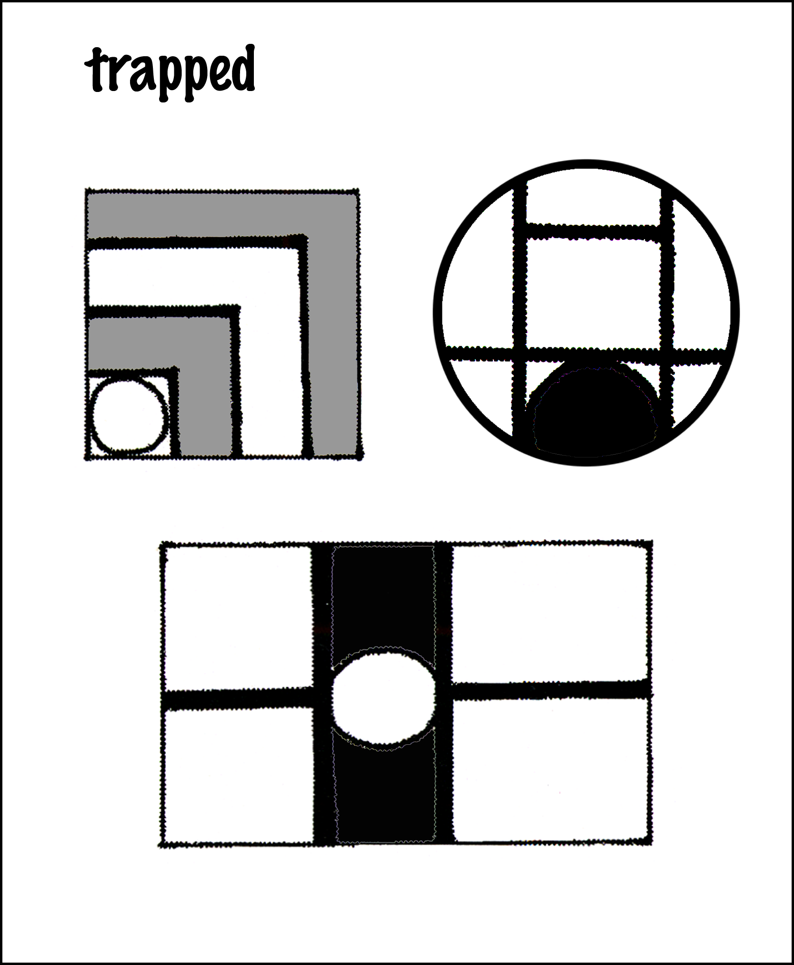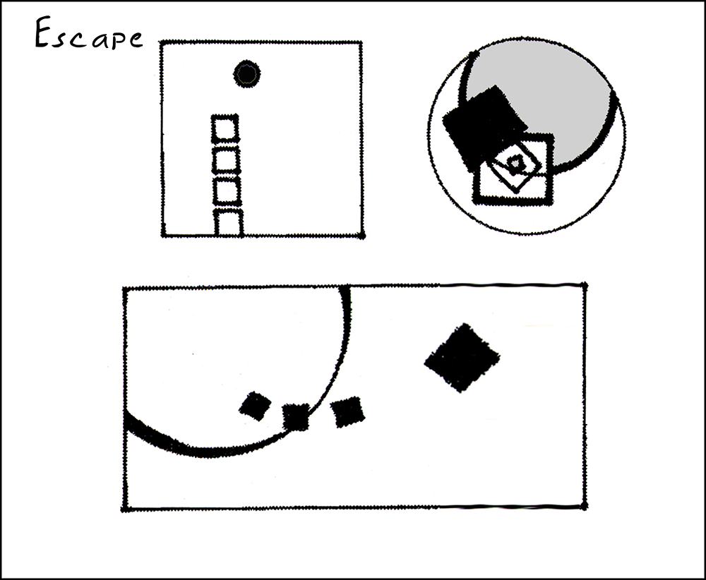

Objectives:
To demonstrate the effect of format balance
To create a connection between composition and concept
To use value contrast to heighten communication
To balance figure/ground relationships
To gain working knowledge of shape tools, fill, and stoke in Adobe Illustrator

Circle and squares must be black, white or gray Can have solid fill and stroke (or no fill color). No gradient or effects. Shapes may extend beyond the box, but must be clipped with mask to hide them.

Instructor’s Notes: This seemingly simple exercise can becomes remarkably complex. It is best to start with solid shapes, using variation in size orientation and proximity to convey the four concepts given. Integrate your canvas (square, circle and rectangle) into the design. Be aware of figure/ground relationships.
Remember, shapes can extend beyond the borders of their canvas, but must be hidden. You can achieve this by creating a “clipping mask” as demonstrated in class.
Color me very…

Problem: using kuler™ (or the Illustrator swatch panel) create a color group of 3-5 swatches that you feel express each of your three randomly drawn adjectives from class last week.

You’ll create one abstract (nonrepresentational) vector composition of each word you picked using the color group you created in kuler™. Download the .acs files from your kuler™ site and load them into your Illustrator swatch library.

You may only use the Pen Tool, Ellipse Tool and the Rectangle Tool to create your art. Fill must be solid, but you can have blending and/or transparency (found in the Transparency Panel) applied to your shapes.
NO effects or other tool may be used in project. (i.e. no drop shadow, no gradient, no gradient mesh, no envelope distort, no distort, no glow, no Warp Tool, no Blend Tool, no Live Paint Tool, no 3-D, no Appearance Panel effects… you get the idea.)
The illustrator files must be RGB mode.

Objectives:
- To demonstrate the effect of format balance
- Explore using a color palette to express concept
- Experiment with color and value contrast and harmonies
- Experiment with creating figure/ground relationships
- Become familiar with shape and pen tools, color panel and color guide, fill and stoke choices.

What is due at end of class:
Turn in one .PDF document with your three designs (it can be a multiple page pdf file if you want). Each design must have the adjective name either next to the art, or incorporated into the art. Your last name must be part of the file name, with “ex2” for “exercise 2” as part of the file name.
some examples by one student: 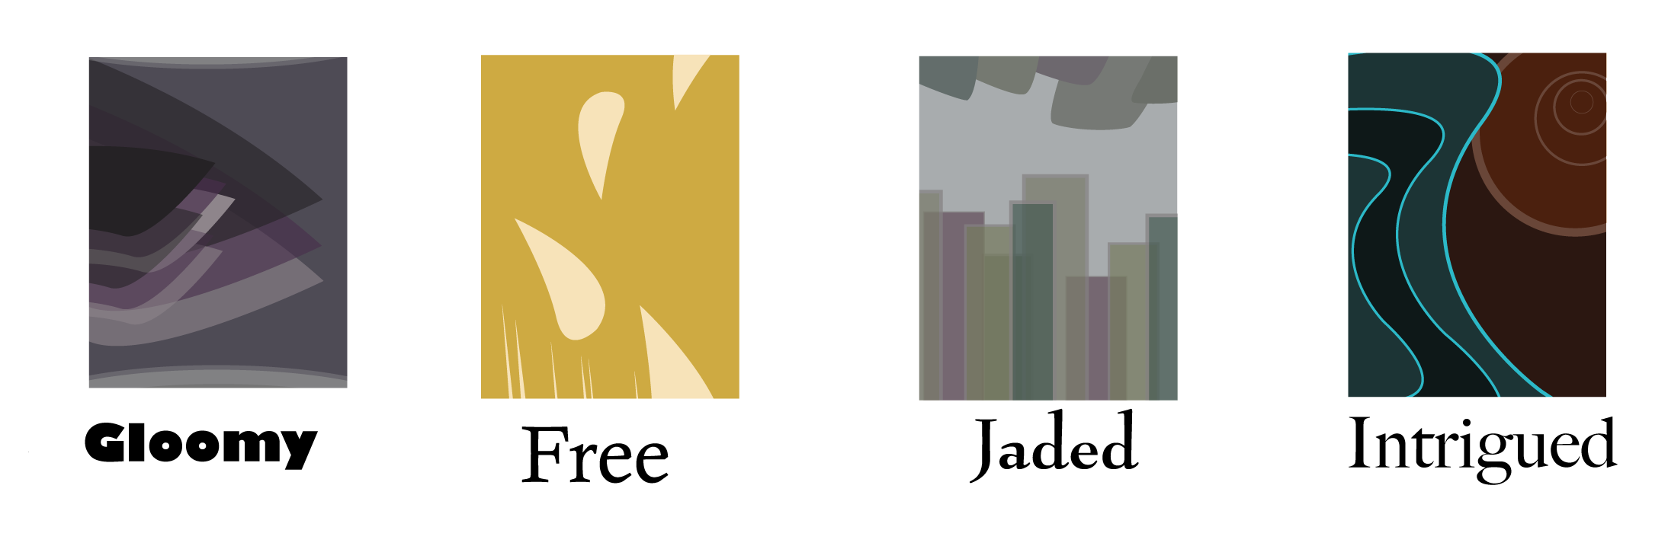

Chapter Eight

FIGURE DRAWING FOUNDATIONS

Notes to the Beginning Teacher:
The Perils and Possibilities of figure DRAWING FoundationS

Figure Drawing Foundations is one of the most exciting courses to teach—and one of the most challenging. A rigorous introduction to anatomy must be balanced by understanding of the emotional implications of the body.

As with Drawing Foundations, it may be useful to start the course by making a “Top 10 List” of characteristics of great figure drawing. This can be used as a reference as the course unfolds. My own list includes the following. Quotes from Drawing from Life by Brown and McLean can add pizzazz!
1. Vitality. Figure drawing is about animation and insight. A “dead” figure is never compelling, no matter how skillfully it has been rendered. Gesture can be an end in itself or it can provide the underlying framework on which a more extended drawing can be built.
“Drawing from Life refers not only to the time-honored tradition of drawing from the life model but also to the larger experiences of life, with all its shifting meanings and nuances.”
2. Subtlety. Figure drawing is also about empathy and attentive observation. Every edge, volume and shadow is carefully observed and sensitively rendered.
“One of the truisms of art is that you must first learn to see before you can learn to draw.”
3. Understanding of anatomy. In addition to mastery of the structure and function of bones, joints and muscles, the best artists understand anatomical kinesthetics: how the figure moves.
“One cannot learn to draw simply by having someone describe the process or explain how it is done.”
4. Appropriate rendering of three-dimensional form. Some drawings gain strength from the bold use of flat shapes. Others gain strength from confident manipulation of illusionistic space. Either can be used to create a great figure drawing.
“Portraits are often said to have captured not only the subject’s likeness but the essence of the individual’s personality. The very word portrait comes from the Latin portrahere, which means ‘to draw forth and reveal.’”
5. Design for the Page. The best figure drawings are authoritatively positioned on the page. Every square inch contributes to the feeling and/or concept.
“One of the expressive tools of artists’ drawing from their imaginations is their ability to present convincing details that imbue their drawings with all the elements of truth.”

Sample FIGURE Drawing Foundations Syllabus

ART 2330: Section 10, FALL 07 Monday/Wednesday 9:05-11:35, FAB 330
Professor John Doe jdoe@fsu.edu Office Hours: Monday/Wednesday 11:45-12:30

Course Description: Exploration of the anatomical, conceptual and expressive complexities of the human form. Studio course, including hands-on work, critiques, demonstrations, and presentations.

Course Objectives: Upon successful completion of this course, you will be able to:
- Convey movement and action through gesture drawing;
- Using foreshortening and proportion, convincingly represent the figure in any pose;
- Demonstrate substantial knowledge of the human skeleton;
- Create a compelling illusion of volume through a variety of shading techniques;
- Convincingly incorporate the figure in an environment;
- Propose and complete an ambitious Capstone assignment

Assessment Criteria: Grades will be based on three major factors.
- Skill acquisition and application. Is the anatomy convincing? Is the composition deliberate and effective? Have various mediums been used well? (40%)
- Idea Development. How effectively have you used thumbnail sketches and other idea generation strategies? How wide a range of possibilities did you explore? (35%)
- Learning Process. Do you come to class prepared? Do you take risks? How substantial and consistent are your contributions to class discussions? (25%)

Attendance: Attendance is required. It is impossible to fully “make up” a missed demonstration or critique. Arriving late also derails learning. Students that miss more than 8 hours of class for any reason generally earn a C or below. More than two unexcused absences will result in a C or below. More than 3 unexcused absences will result in a D or below. Bring documentation for excused absences.

For the FSU list of approved excused absences, see: http://www.fsu.edu/~fasenate/attendance.html.
Incompletes: A grade of Incomplete can only be assigned to a student with an otherwise passing grade who is unable to complete the course due to some serious illness or personal tragedy, such as a death in the immediate family. Incompletes are assigned at the discretion of the faculty.
Grades will be defined as follows:
A = Outstanding competence. Expansive investigation of ideas; excellent composition and/or construction. All assignments completed on time, with at least one extra credit project done well. Insightful contributions to critiques. Goes well beyond minimum requirements.
B = Above average competence: Substantial investigation of ideas, very good composition and/or construction. All assignments completed on time, good contributions to critiques.
C = Average competence. Assignments done competently and completed on time.
D= Marginal work, due to two or more late projects, limited investigation of ideas, poor craft, incoherent compositions, minimal contribution to critiques. May have more than 3 absences.
F = Unsatisfactory work. Course failure due to minimal idea development, poor craft, disjointed compositions, lack of participation, late assignments. May have over 6 absences.

Note: One project will be accepted one day late without penalty. One additional late project will be accepted with a one letter-grade penalty for each day it is late.

Basic Supplies:
3 graphite sticks 3 soft charcoal pencils 18 x 24” pad Strathmore 400 and Pad of newsprint, rough
plastic and kneaded erasers; chamois Artist’s tape or Masking tape
Spiral-bound sketchbook, 9x12” Black and white Conte crayon: soft
4 sheets charcoal paper, 19x25” Utility box, Drawing board and clips Spray fixative
Recommended Text: Drawing: Space, Form and Expression, Enstice & Peters
Other Readings:
Drawing: A Contemporary Approach - Betti & Sale Drawing from Observation - Curtis
Figure Drawing - Goldstein Human Anatomy for the Artist - Peck
Mendelowitz's Guide To Drawing – Wakeham & Faber The Craft of Drawing - Wood
Drawing from Life - Brown & McLean Perspective Drawing - O'Connor

FINAL PORTFOLIO WILL CONSIST OF AT LEAST FIFTEEN DRAWINGS, INCLUDING:
- Planar analysis study
- Foreshortening study
- Multiple figure composition
- Examples of idea generation, such as extended work with variations on a theme
- Examples of extended work with value
- Anatomical studies
- Final Capstone assignment

TYPICAL ASSIGNMENT SEQUENCE
Week 1: In-class Drawing: Mass-Volume Gestures, Linear Gestures
Anatomy Homework: Basic proportions, center of gravity, and weight distribution

Week 2: In-class Drawing: Tonal Gestures, Foreshortening
Anatomy Homework: The Arm, bone and flesh (scapula/clavicle to wrist)

Week 3: In-class Drawing: Composition. Framing the body and using negative space as a drawing aid and an aesthetic device. Anatomy Homework: Hands and Feet.

Week 4-6: In-class Drawing: Tonality - white charcoal on black paper
Anatomy Homework: The Leg (ankle to hip); The Pelvis.

Week 7-9: In-class Drawing: Temperature - black and white charcoal on brown paper.
Anatomy Homework: The Torso (spine and thorax).

Week 10: In-class Drawing: Ink wash on cream paper plus white acrylic for cool values
Anatomy Homework: The Skull.

Week 11-12: Self-portrait studies. Capstone proposals due, Week 13-16: Capstone projects.

ACADEMIC HONOR POLICY: The Florida State University Academic Honor Policy outlines the University’s expectations for the integrity of students’ academic work, the procedures for resolving alleged violations of those expectations, and the rights and responsibilities of students and faculty members throughout the process. Students are responsible for reading the Academic Honor Policy and for living up to their pledge to “.. . be honest and truthful and . . . [to] strive for personal and institutional integrity at Florida State University.” (Florida State University Academic Honor Policy, found at http://dof.fsu.edu/honorpolicy.htm.)

AMERICANS WITH DISABILITIES ACT: Students with disabilities needing academic accommodation should: (1) register with and provide documentation to the Student Disability Resource Center; and (2) bring a letter to the instructor indicating the need for accommodation and what type. This should be done during the first week of class.This syllabus and other class materials are available in alternative format upon request. For more information about services available to FSU students with disabilities, contact the: Student Disability Resource Center 874 Traditions Way, 108 Student Services Building, Florida State University, Tallahassee, FL 32306-4167 (850)644-9566, (voice) (850)644-8504 (TDD) sdrc@admin.fsu.edu http://www.disabilitycenter.fsu.edu/
HOMEWORK #1: BIOGRAPHICAL STATEMENT DUE BY EMAIL, SEPTEMBER 1

The purpose of this assignment is to provide me with some background on your work and to give you practice writing about your ideas. Write anything you want, one to three typed pages, double-spaced, 12-point type. Please proofread, and use spell-check! Consider: What are the sources of your ideas? Under what conditions do you learn the most? What is your definition of success as an artist or designer? Really give this assignment some thought. Concise sample:

BIOGRAPHICAL STATEMENT: ART 2330, MONDAY/WEDNESDAY, 9:05AM, Submitted by Jane Doe
I do not know why I have always drawn. As a child, I knew that it was something that set me apart from my friends. Even though being able to draw gave me a certain prestige, it also scared away some of the kids, who were interested in sports or music. I kept drawing, though, constantly trying to make things look more realistic.
As I entered middle school, I was labeled as the weird artist type. I hated middle school and just seemed out of place. High school was a big improvement. I found so many ways to express myself and got involved in everything from drama to soccer. Unfortunately, my happiness was short lived when I realized that my school's art department was extremely weak. Instead of giving up, I looked elsewhere for guidance and experience. I took painting lessons with a local artist, learning a lot about color in the process. I was also able to take workshops at a junior college, studying ceramics, Japanese and watercolor. I have many sources of inspiration. That, however, doesn't make it easy for me to create things. On the contrary, I'm the kind of person that has to get things just right or not at all. I always see the flaws in my work and want to start over. As a result, it is hard for me to finish things.
I hope that this class will help me get past this perfectionism so that I can enjoy all aspects of the creative process. I especially want to strengthen my understanding of foreshortening so that I can create the most convincing illusion of space and most expressive approach to the figure. I would like to pursue animation as a career, and being able to move objects through space confidently is essential. I would like to make the drawings in themselves as expressive as possible. Simply creating a skillful drawing of a well-proportioned figure isn’t enough. I want my drawings to attract attention and express my ideas.

CAPSTONE PROJECT GUIDELINES __ PROPOSAL DUE BY EMAIL, NOVEMBER 10

Problem: Design and complete an ambitious project requiring at least 30 hours of work, in class and out, over a three week period.
Objectives: In this project, you will need to demonstrate the following:
- Extensive idea generation, resulting in numerous alternatives;
- Clear decision-making. Of the alternatives you invent, which will best convey your idea?
- Capacity to turn concepts into compositions;
- Self discipline and effective time management.
Strategy: Assess your strengths, weaknesses, and interests. What would you most like
to explore in this final assignment? Write up a clear, concise proposal, describing the project, suggesting questions to address, and determining how the work can best be completed. Example:

VISUALIZING THE INVISIBLE MAN Jane Doe janedoe@fsu.edu ART 2330
Description: I plan to complete a series of five 22x30” conte drawings based on the concept of invisibility as defined by Ralph Ellison in The Invisible Man. I will interpret his idea of invisibility using the various design elements and drawing techniques I have learned this year, including forms of balance, degrees of definition, contrast, and illusion of space. The first and last images will serve as a prologue and epilogue, from the narrator’s point of view. The remaining three images will be designed to express the points of view of the three major characters in the book.
Primary Concerns:
- How many ways can I visually suggest invisibility?
- How can cropping and focus suggest invisibility on a more psychological level?
- How can I show the power plays that are so closely related to the concept of invisibility in the book?
- Should they work in any narrative way, or should each stand alone?
Time Management:
- Week One: Idea Development and Rough Drafts
- Week Two: Completion of two drawings.
- Week Three: Completion of three drawings.

DUALITIES

Problem: Create a 300 square inch drawing that shows two sides of your personality. Include at least some areas of disharmonious color, gradation, visual texture, and transparency.

Objectives:
- To integrate line, shape, texture, and color in a complex composition
- To explore expressive uses of composition
- To translate personal insight into public communication.

Materials: Paint and illustration board.

Strategy: Hard-edged painting helps to clarify design relationships and is a “safe” way to create a polished product. A looser style of painting and the addition of collage can become chaotic, but the results are often more personal. Choose the best strategy for the ideas you wish to express.
This will be an extended project, and time management is essential.
- Week 1: Bring a pencil layout of a design, using the paint-by-number style we used to lay out the HIDDEN MEANINGS project. If you feel confident about your idea and direction, you can lay this out directly on illustration board. If you have a lot of questions about your design and approach, lay it out on paper, at least in half scale. You can refine it after the critique.
- Week 2: Paint at least 50% of the design. Extended progress report with team of 5 students.
- Week 3: Completed project due.

Reading: Chapter 3

Instructor’s Notes: The personal quality of this assignment tends to motivate students. Confusing personal expression with public communication is one hazard, however. Because the painting is personally significant, students may believe that it is automatically meaningful to a wider audience. Providing students with a list of assessment criteria can help clarify the importance of good composition, regardless of the content.
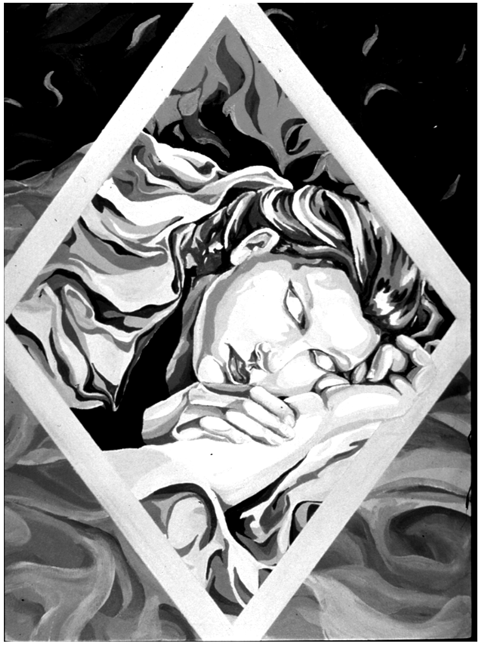
Some of the questions I usually ask are:
• What do you want to say? What aspects of your personality are being shown?
• What range of emotions have been included in the image? Have they been conveyed in a conventional manner (such as red for anger) or is color being used in a more innovative way?
• In the hard edged paintings, is the craft clean and crisp?
• In the progress reports, did you actively contribute, or simply sit on the sidelines, as a passive observer?
• How ambitious and independent was the creative thinking during this project?
• What did you learn about yourself and others?
Timetable: 12 to 20 hours

Chapter Nine

SURVEY OF CONTEMPORARY ART

SAMPLE: SURVEY OF CONTEMPORARY ART SYLLABUS

ART 2003: Section 02, FALL 09 Monday/Wednesday 10:00-11:35, FAB 249
Professor Jane Doe jdoe@fsu.edu Office Hours: Monday/Wednesday 11:45-12:30

Course Description:
Introduction to contemporary theory and exploration of creative processes in art AND design.

Premise: Art and design profoundly influence our daily lives. Photography influences our perception of daily events, our physical reality is largely defined by the buildings we enter and the tools we use, the films we see and the exhibitions we attend bring emotional and intellectual meaning to our lives.
In this course we will explore ways in which contemporary artists and audiences construct meaning from visual experience.

Course Objectives: Upon successful completion of this course, you will be able to:
- Discuss the conceptual intent and analyze the visual construction of modern and contemporary artworks;
- Write an insightful critique of an exhibition of contemporary art.
- Effectively and appropriately use digital technologies in the creation of a PowerPoint that incorporates discussion and expression of the techniques, theories of studio practices and methods. This includes analysis, planning/imagining, implementation, and evaluation.

Required Textbook: In the Making – Linda Weintraub
Additional Readings: Theories of Contemporary Art- McDaniel and Robertson

Assessment Criteria: Grades will be based on two major factors.
- Demonstrated understanding of concepts presented.
- Capacity to connect art concepts to personal creativity
You can demonstrate your understanding and creative applications of course concepts in two ways:
- Five course papers and two exams (75% of grade)
- Personal creativity book and participation in class discussions. (25% of grade)

Attendance: Attendance is required. It is impossible to fully “make up” a missed lecture or discussion. Arriving late also derails learning. Students that miss more than 8 hours of class for any reason generally earn a C or below. More than one unexcused absence will result in a C or below. More than 2 unexcused absences will result in a D or below. Bring documentation for excused absences.

For the FSU list of approved excused absences, see: http://www.fsu.edu/~fasenate/attendance.html.
Incompletes: A grade of Incomplete can only be assigned to a student with an otherwise passing grade who is unable to complete the course due to some serious illness or personal tragedy, such as a death in the immediate family. Incompletes are assigned at the discretion of the faculty.
Grades will be defined as follows:
A = Outstanding competence. Expansive investigation of ideas; excellent composition and/or construction. All assignments completed on time, with at least one extra credit project done well. Insightful contributions to critiques. Goes well beyond minimum requirements in quality and quantity.
B = Above average competence: Substantial investigation of ideas, very good composition and/or construction. All assignments completed on time, good contributions to critiques.
C = Average competence. Assignments done competently and completed on time.
D= Marginal work, due to two or more late projects, limited investigation of ideas, poor craft, incoherent compositions, minimal contribution to critiques. May have more than 2 unexcused absences.
F = Unsatisfactory work. Course failure due to minimal idea development, poor craft, disjointed compositions, lack of participation, late assignments. May have more than 3 unexcused absences.
Note: One assignment will be accepted one day late without penalty. One additional late project will be accepted the next class period with a one letter-grade penalty. That’s all, folks.

LECTURES PLANNED

Week 1: Modernism: A Visual Revolution
Focus: The Past is Prologue to the Present, The Present is Prologue to the Future
Week 2: Postmodernism: Counter-Revolution and Beyond
Focus:Expanding definitions of art & design; new audiences, new technologies, new aesthetics
Week 3: Visual Communication
Focus: How do artists and designers communicate ideas and express emotions? How/why is the visual message different than other forms of communication?
Week 4: Conception and Creation
Focus: How do artists and designers get ideas and how do they develop them into effective artworks?
Week 5: Materials and Meanings
Focus: What materials do artists and designers use, and how does material choice affect meaning?
Week 6: Compositional Elements and Principles
Focus: From Visual Grammar to Visual Eloquence
Week 7: Designing Time
MIDTERM EXAM

Week 8: Contexts, Curators and Consumers
Focus: Meaning In = Meaning Out
Week 9: Reading and Writing About Art
Focus: Clarifying and communicating your responses
Week 10: Matters of Life and Death
Week 11: Visions of Power
Week 12: Individuality and Identity
Week 13: Tell Me a Story
Week 14: Cross-disciplinary Creativity
Week 15: Multiple Realities

FINAL EXAM
Writing Assignments Planned. Each should be around 500 WORDS, typed, double-spaced, spell-checked, with clear paragraph structure. Badly written papers will be returned for re-writing!

1. TWO COMMENTARIES ON VISITING SPEAKER PRESENTATIONS
- Provide a brief bio on the speaker, description of the artwork presented.
- What did aspect of the presentation did you find most surprising?
- Put yourself in the position of the speaker. What would you do if you were asked to do a project in his or her style? What would you do differently? How would you expand his/her approach?
- Based on the presentation, what would you say were the speaker’s criteria for excellence?

2. TWO EXHIBITION REVIEWS
- Describe the exhibition, giving venue, artist name or names, number of pieces, mediums.
- Describe the three most impressive artworks, including comments on subject matter, style, composition, and overall impact.
- Summarize your overall impressions of the show, and note whether you recommend I attend.

3. TWO PERSONAL COMMENTARIES
Select and read two articles from the reader, then answer the following questions:
- What was the basic content or argument presented?
- What aspect of the reading did you find most surprising?
- To what degree did it confirm, expand, or challenge your existing assumptions?

WRITING SAMPLE: FIRST FRIDAY REVIEW, ART 2003, TUESDAY 4:45 PM, JANE DOE
I visited three exhibitions. The first was an exhibition of MFA student work at the Big Bend Contemporary Gallery, in Railroad Square. It included wooden sculptures by Master of Fine Arts students David McLeish and Matt Gordon and a series of large black and white drawings by Jeremy Waltman. The second was an exhibition of altered photographs by Holly Roberts at 621 Gallery, also in Railroad Square. Starting with traditional photographic silver prints, Roberts had obscured or re-worked parts of each image, using oil paint. The third was the “Maximalist Painting” exhibition at the Museum of Fine Arts, on campus. Curated by Dr. Tatiana Flores in collaboration with Professor Lilan Garcia-Roig, this show included thirty large-scale oil paintings.
I spent most of my time in the Maximalist Painting exhibition. Most of the paintings were four to eight feet in length, and packed with visual information. The image I found most amazing was Mark Messersmith’s Edge of Town, dated 2003. This 60x76” oil painting presents an apocalyptic vision of the destruction of nature. In addition to the painting itself, seven boxes line the bottom edge, trapping an animal sculptured from plastic trash bags, fragments of magazine photographs, decorative plastic plants, and shaped sheets of copper.
I was especially intrigued by the use of color and the distorted space in this painting. The image is dominated by dark blues, with pools of orange light creating focal points. A logging truck rushing into the background pulls the viewer into the painting while a pile dead animals atop a hunter’s car pushes outward, toward the viewer. A tree in the foreground traps the frenzied action, forcing the space to swirl around a central compositional pole. As the viewer looks down into a flaming car and upward toward the white birds, he/she becomes even more disoriented. The space seems to bulge, twist and rotate.

ACADEMIC HONOR POLICY: The Florida State University Academic Honor Policy outlines the University’s expectations for the integrity of students’ academic work, the procedures for resolving alleged violations of those expectations, and the rights and responsibilities of students and faculty members throughout the process. Students are responsible for reading the Academic Honor Policy and for living up to their pledge to “.. . be honest and truthful and . . . [to] strive for personal and institutional integrity at Florida State University.” (Florida State University Academic Honor Policy, found at http://dof.fsu.edu/honorpolicy.htm.)

AMERICANS WITH DISABILITIES ACT: Students with disabilities needing academic accommodation should: (1) register with and provide documentation to the Student Disability Resource Center; and (2) bring a letter to the instructor indicating the need for accommodation and what type. This should be done during the first week of class.This syllabus and other class materials are available in alternative format upon request. For more information about services available to FSU students with disabilities, contact the: Student Disability Resource Center 874 Traditions Way, 108 Student Services Building, Florida State University, Tallahassee, FL 32306-4167 (850)644-9566, (voice) (850)644-8504 (TDD) sdrc@admin.fsu.edu http://www.disabilitycenter.fsu.edu/

PRELIMINARY DRAFT

ART 2XXX: CREATIVE INQUIRY

Notes to the Beginning Teacher:
The Perils and Possibilities of Creative Inquiry
Students are most motivated when they are engaged conceptually. Seeking to fully communicate their ideas, they are more likely to explore multiple compositional variations. The following strategies can help students get started.
Start small. A concept may be defined as a well-developed thought. Any thought can serve as a beginning point. Using the brainstorming skills described in Part 2 of Launching the Imagination, even the most modest thought can be enhanced and expanded.
Think big. Encourage students to explore their ideas fully, even when the results may be technically or financially impossible to implement. Many freshmen have never been encouraged to dream big dreams, and the opportunity to do so is exhilarating and enlightening. A big idea can always be distilled down to create a more feasible solution, whereas a truncated or timid idea is just a tragedy. By distilling big ideas down to their essential meaning, students can often strengthen their intentions and create more compelling compositions.
Try anything. The best way to have good ideas is to have a lot of ideas. Dismissing an underdeveloped idea discourages student risk-taking and re-enforces student self-criticism. Inventing twenty rough solutions to a problem, then choosing the three best for further development works well.

And, most importantly,
Connect the conceptual cart to the compositional horse. Developing a great idea is just the beginning. To reach an audience, the idea must be communicated visually (and/or physically), through composition and construction. Thumbnail sketches and model making can be used to connect concepts to composition from the very start. While they are often initially resistant to such preliminary work, students quickly adopt this approach when they realize its value.

Possible Assignments
- Limited /Unlimited: pushing beyond apparent limitations
- Microcosmos / Macrocosmos: connecting simple & complex forms
- Materials and Meanings: exploring inherent and abhorrent uses of materials!
- Visual Music: exploring degrees of abstraction in two, three and four dimensions
- A Slice of Pi: numerical mysteries
- 36 cm x 36 meters x 36 kilometers: processing scale and proportion
- Natural Selection: to open eyes
- Condensed Book: seeking the heart of the matter
- Severed: another approach to narrative
- A Game of Chess: collaborative and confrontational creativity
- Build a Concept Generator: a basic cube turns into a conceptual toy
- Think Outside the Box: how can a cliché be transformed into a personal statement?
sample syllabus: ART XXXX: CREATIVE INQUIRY FOUNDATIONS

ART xxx: Section 03, SPRING 2010 Monday/Wednesday 9:05-11:35, FAB 107
Professor Jane Doe jdoe@fsu.edu Office Hours: Monday/Wednesday 11:45-12:30

Course Description: Expanded investigation of technical and historical research, creative processes, ideation strategies, and critical thinking for studio art and design. Pre-requisites: ART 1300, 1203, 1201, 1602, 2003. 1000.
Class Format: Studio format, including hands-on work, critiques, demonstrations, and presentations.

Course Information: Announcements, syllabus, resources, and several critical readings are posted on the online Blackboard site for this course. You must check this evolving website often! Go to https://campus.fsu.edu/webapps/login

Recommended Readings: In the Making – Linda Weintraub, Film Art by Bordwell and Thompson, Design: The New Basics – Ellen Lupton and Sinclair, Launching the Imagination: A Comprehenisve Guide to Basic Design- Stewart, Photography – Stone, Drawing: A Contemporary Approach – Betti and Sale, Bird by Bird – Lamott, Lateral Thinking –De Bono, Uncommon Genius: How Great Ideas are Born- Shekerjian, The Creative Habit -Tharp, The Art of Possibility Zander, Boundries by Maya Lin, The Art of Innovation – Kelly, Drawing: Space, Form and Expression, Enstice & Peters
Course Objectives: Upon successful completion of this course, you will be able to:
- Use various forms of research to contextualize your ideas and enhance their complexity;
- Use two, three and time-design approaches as needed to express your ideas more fully;
- Effectively combine found and newly generated source materials:
- Use the power of juxtaposition, implication and metaphor to expand meaning;
- Employ collaborative as well as individual approaches to creativity;
- Speak and write critically about personal and peer artworks and propose alternatives.

Major Questions for this course include:
- What are the sources of creativity?
- What are the strategies used by the most creative people?
- What are the essentials of your concepts and feelings and how can they expressed most fully?
- What are your own best creative strategies?

Assessment Criteria: Grades will be based on three major factors.
- Skill acquisition and application. Based on the assignments you complete, how confidently and effectively have you used materials and construction methods? (25% of grade)
- Idea Development. Based on the sketches, rough drafts, maquettes and problem-solving proposals you submit, how many possibilities did you invent? What range of ideation strategies are you using in creating effective work? (30% of grade)
- Research. What depth and breadth have your brought to your research? (15% of grade)
- Learning Process. Based on attendance, motivation and participation are your contributions to brainstorming sessions and critiques substantial? Do you take risks? (30% of grade)
Each art and design project presents its own unique challenges. The most “effective” solution is the one that most fully communicates your ideas.

Attendance: Attendance is required. It is impossible to fully “make up” a missed demonstration or critique. Arriving late also derails learning. Students that miss more than 8 hours of class for any reason generally earn a C or below. More than two unexcused absence will result in a C or below. More than three unexcused absences will result in a D or below. Bring documentation for excused absences.

For the FSU list of approved excused absences, see: http://www.fsu.edu/~fasenate/attendance.html.
Incompletes: A grade of Incomplete can only be assigned to a student with an otherwise passing grade who is unable to complete the course due to some serious illness or personal tragedy, such as a death in the immediate family. Incompletes are assigned at the discretion of the faculty.
Pay Attention: Please silence your cell phone. If you are in the midst of a family crisis (such as a parent in the hospital), put it on vibrate and let me know that you may have to leave during class to take a call.
Grades will be defined as follows:
A = Outstanding competence. Expansive investigation of ideas; excellent composition and/or construction. All assignments completed on time, with at least one extra credit project done well. Insightful contributions to critiques. Goes well beyond minimum requirements in quality and quantity.
B = Above average competence: Substantial investigation of ideas, very good composition and/or construction. All assignments completed on time, good contributions to critiques.
C = Average competence. Assignments done competently and completed on time.
D= Marginal work, due to two or more late projects, limited investigation of ideas, poor craft, incoherent compositions, minimal contribution to critiques. May have more than 2 unexcused absences.
F = Unsatisfactory work. Course failure due to minimal idea development, poor craft, disjointed compositions, lack of participation, late assignments. May have more than 3 unexcused absences.
Note: One project will be accepted one day late without penalty. One additional late project will be accepted with a one letter-grade penalty for each day it is late. Don’t be late a third time!
The Bottom Line
Classes in the Art Department are hands-on and high intensity. You are expected to discuss and critique the work of your peers, cite areas where it excels and recommend strategies for improvement. We all work together to build an environment of trust, honesty, and strong listening skills. If your schedule is heavy, drop the course now. This class will generally require 7 hours of work outside of class per week.

Basic Supplies:
• A basic digital camera: Canon Powershot A590 is good • fine point felt pen
• 9”x12" or 11”x14" sketchbook
• portable storage device (8GB or larger flash drive) • Other materials of your choice

Proposed Lectures, Blackboard information, or Handouts/Proposed Assignments. Specific week-by-week schedule will depend on the level of your ambition. I will provide an updated calendar each month.
- Lecture 1: Creativity Overview/Anijam
- Lecture 2: Frameworks; Health and Safety Presentation/Microcosmos/Macrocosmos
- Lectures 3-4: Materials and Meanings/Material and Immaterial
- Lecture 5: Levels of Abstraction/Visual Music
- Lectures 6-7: Cross-Disciplinary Creativity/Visual Music
- Lecture 8: Habits of Work; Habits of Mind/ Natural Selection
- Lecture 9: Series, Sequence and Narrative/Condensed Book
- Lecture 10: Metaphor and Allegory/Condensed Book
- Lecture 11: Critical Thinking as Creative Thinking/Condensed Book
- Lectures 12-14: Variations on the Theme/Capstone Assignment
- Lecture 15: The Arts and the Creation of Mind/Think Outside the Box (which becomes final exam)

ACADEMIC HONOR POLICY: The Florida State University Academic Honor Policy outlines the University’s expectations for the integrity of students’ academic work, the procedures for resolving alleged violations of those expectations, and the rights and responsibilities of students and faculty members throughout the process. Students are responsible for reading the Academic Honor Policy and for living up to their pledge to “. . be honest and truthful and . . . [to] strive for personal and institutional integrity at Florida State University.” (Florida State University Academic Honor Policy, found at http://dof.fsu.edu/honorpolicy.htm.)
AMERICANS WITH DISABILITIES ACT: Students with disabilities needing academic accommodation should: (1) register with and provide documentation to the Student Disability Resource Center; and (2) bring a letter to the instructor indicating the need for accommodation and what type. This should be done during the first week of class.This syllabus and other class materials are available in alternative format upon request. For more information about services available to FSU students with disabilities, contact the: Student Disability Resource Center 874 Traditions Way, 108 Student Services Building, Florida State University, Tallahassee, FL 32306-4167 (850)644-9566, (voice) (850)644-8504 (TDD) sdrc@admin.fsu.edu http://www.disabilitycenter.fsu.edu/

IMPORTANT DATES

Jan. 6, 2009 | Classes Begin.
Jan. 6, 2009 | Late Registration ($100.00 late registration fee.)
Jan. 11, 2009 | Last day to Drop/Add and have fees adjusted.
Jan 12, 2009 | Fifth Day of Classes.  Last day to cancel enrollment and have fees removed.
Jan. 19, 2009 | Martin Luther King, Jr. Day. No Classes.
Feb. 20, 2009 | End of seventh week of semester.  Last day to drop a course without receiving a grade.  Last day to submit form requesting S/U grading or to change S/U option back to a regular grade, Last day to reduce course load without the permission of academic dean, Last day to withdraw without receiving a grade.
Mar. 9–13, 2009 | Spring Break.. No Classes.
Apr. 3, 2009 | End of 12th week of semester.  Deadline for late drop with dean’s permission.
Apr.27-May 1, 2009 | Final Exam Week.
May 1, 2009 | Semester Ends.
May 6, 2009 | Grades available online.

HOMEWORK #1: GOALS STATEMENT _____ DUE BY EMAIL, SEPTEMBER 1

The purpose of this assignment is to provide me with some background on your previous work and learn more about your aspirations for this course. Write anything you want, one to three typed pages, double-spaced, 12-point type. Please proofread, and use spell-check!
Consider: How long and for what reason have you made art? What are the sources of your ideas? What digital skills are your bringing to this course? What do you most want to develop? How can digital imaging expand or enhance your creativity? Concise sample:

GOALS STATEMENT: ART XXXX: Creative inquiry FOUNDATIONS
Jane Doe MW 9:05 SECTION jdoe@fsu.edu
(We need something similar to this—but for Creative Inquiry course. This was written for Digital Foundations)
Photography is my primary interest. When I work with my camera, I am able to concentrate on composition, timing, and the beauty of the subject rather than focus primarily on technique. I enjoy viewing things from angles that people would not ordinarily see, so that I can expose even more the unseen possibilities in the everyday.
Many contemporary photographs are done digitally, and that is the mode in which I have worked the most. As a result, I feel that I have a good working knowledge of PhotoShop CS3, and I look forward to updating my skills wth CS4. I know nothing about Illustrator, and look forward to mastering vector-based drawing. I want to learn Flash, which is also a vector program, and these skills will help me with that.
Of all the programs included in this course, Final Cut Express is of the greatest interest. I love shooting videos, and am eager to develop the skills needed to edit them effectively. I’ve worked with IMovie, which provides a very basic introduction to editing. Being able to push these basics further will greatly expand my possibilities. I am especially interested in “man on the street” interviews, as a way to illuminate the different perspectives we all have on current affairs. I would also like to explore ways in which sound enhances or changes meaning.
SAMPLE ASSIGNMENTS FOR CREATIVE INQUIRY

ANIJAM

Problem: Using a circle, square or triangle as a beginning point and a circle, square or triangle as an end point, create a 24-image storyboard or a five- to eight-second animation exploring the creative possibilities of these basic “prompts,” Working in collaborative teams is encouraged.
Objective: To learn through play.
Materials: Flash, Illustrator, or felt pen for storyboards will work well.

Strategy: Through rough storyboards, explore the possibilities of each basic shape. You can keep the project non-objective or can introduce characters and settings as you see fit. The more complex each drawing becomes, the more time-consuming the project is likely to be. Focus on

Viewing: various versions of Anijam, Duck Amuck by Chuck Jones, Yo-Yo, Origin of Species

MICROCOSMOS/MACROCOSMOS
Assignment developed by Mathew Kelly, Whitman College

Problem: Create a unified composition out of 20- 25 smaller images that are all related to a single motif.
Objective: To enhance visual awareness and discover the simple shapes within complex forms.
Materials: A computer with Photoshop, digital camera, and printer.

Strategy:
1. Choose a simple theme from the following menu:
- Circles, cycles, and spheres,
- Squares, rectangles and cubes,
- Triads, triangles, trios and tetrahedrons,
- Bridges
- Boundaries
2. Collect the images. Using a digital camera take a minimum of 20 pictures of objects, pieces of objects, or negative spaces that fit your basic theme. Forget about what the objects are and focus on the shapes they create.
3. Bring them together. In an 8"x10" format arrange the images into a unified composition comprised of 20 two-inch squares. Focus on figure/ground relationships, proximity, balance, and boundaries.
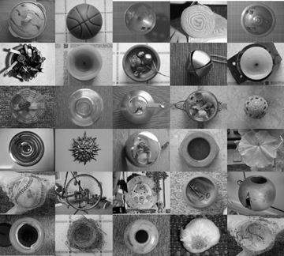
4. Turn up the heat: Take the color composition, copy it, and change it to a gray scale image. How does the lack of color change the dynamics within the composition? Combine the color and gray scale images to create additional possibilities. Finally, combine words and images to create a poster sized composition expressing your simple theme as fully and eloquently as possible.

Reading: LTI Chapters 3, 5, 6, 7 Timetable: 18 to 24 hours

Instructor’s Notes: This assignment really occurs in three stages: transcribing, translating, and transforming. In step one, search for similarities among the most improbable objects. In step two, explore a wide range of compositional possibilities. In the final design, transform the basic information into a compelling visual essay on perception, collection and cognition.

MATERIAL AND IMMATERIAL

Premise: “Truth to materials” and “form follows function” are pillars of Modernist thinking. Modern architecture tends to exploit the unique characteristics of metal: plastics and glass often accentuates the very means of construction. At the same time, modern painters such as Barnett Newman and Ellsworth Kelly embraced the flat picture plane as the idea playing field for their visual expression.
By comparison, Postmodernists tend to emphasize conceptual complexity over compositional refinement, and use all sorts of materials and methods to express themselves. Kiki Smith constructed life-sized figures from beeswax, Joseph Beuys used a dead rabbit and a live coyote in his artwork, broken furniture has served as a beginning point for many assemblages. And, the Conceptual artists of the 1970’s often presented art as ideas alone, without any physical manifestation.
Are you a purist, an anarchist, or even a conceptualist, moving beyond the material realm entirely?

Problem: This problem will explore materiality in three ways.
- Working with a single material, explore every use and modification you can within the limitations of safety. If you are taking ceramics, painting, sculpture, etc., consider exploring one of the materials used in those courses. If not, very simple materials, such as cardboard, fibers, ivy leaves, or paper can be used. See me if you are interested in working with any form of plastic, including Styrofoam. Then, create an artwork that uses the inherent qualities of your material inventively and expressively.
- Working with the same material or a different selection, explore ways to work against our expectations. What happens when a hammer is constructed from rose petals? A teacup is lined with fur? A portrait is made of nuts, bolts, and other hardware?
- Create a final piece, using immateriality to push your ideas even further. How can traces of materials expand communication and emotion? What happens if your artwork is purely an idea?

Objective: To expand creativity through multi-dimensional investigation. Materials: Open

Strategy:
- Start with technical and conceptual research. How has your material been used in the past? What are its physical limitations? How can it be taken apart and then re-formed, as an artwork? Create at least 30 thumbnail sketches,10 maquettes and/or test strips for discussion in class. Then, complete Stage 1 (described above).
- For Stage 2, consider trying a material that is not commonly associated with art. Expand your conceptual research as well as your technical research. Create at least 30 thumbnail sketches,10 maquettes and/or test strips for discussion in class. Then, complete your second artwork.
- For Stage 3, consider the implications of material residue. For example, a fossil can be any evidence of past life—from a dinosaur’s footprint to an earthworm’s burrow track. And, what ideas are best expressed through concepts rather than physical construction?

Reading: Sculpture Magazine, Art in America, LTI Chapters 8, 11, and 12.

Artists: Ned Kahn, Marcel Duchamp, Liza Lou, Joseph Kosuth, Rudolf Stingel, Xiao Min, Tom Friedman, Robert Irwin, David Adjaye

Instructor’s Notes: Find the balance between wide-ranging experimentation and safety, including limitations in uses of dorm rooms, and expect to do a lot of demos. This is also a great time to invite colleagues in to talk about their uses of materials.

Timetable: 20 to 40 hours, depending on number of variations, level of collaboration, complexity of construction.

VISUAL MUSIC

Premise: Music is one of the most powerful forms of abstraction. From the pure emotion of a Brahms symphony or the contrapuntal complexity of a Bach fugue to the relentless rhythm of rap and the exuberant energy of swing, we each have our favorites.
Musicians and artists have often collaborated or switches roles, as an artist shifts to music or a musician becomes an artist. Music has also inspired art from Kandinsky to Disney, and art has often inspired music: Moussorky’s Pictures at an Exhibition is just one example.
How can connections between art/design and music expand our creativity?

Problem: This problem will explore music in three ways.
- Working with a single piece of music, create a two-dimensional design that best communicates the abstract emotions it embodies or evokes. Start with thumbnail sketches, and then expand.
- Working with the same music or a different selection, create a three-dimensional response to music, using the material(s) of your choice.
- Working with the same music or yet a third selection, create a time-based response, up to five minutes in duration.

Objective: To expand creativity through multi-dimensional exploration.

Materials: Open

Strategy:
- Start with research. Listen to a variety of musical pieces, seeking those that are most compelling to you. Then, find out the story behind the music, including the composer, the concept, the instrumentation, etc.
- Expand with visual research, creating at least 30 thumbnail sketches and/or 10 maquettes.
- Share ideas. This is a great assignment to do collaboratively: find one or two others in the class that can serve as your “sounding boards!”

Reading: Sculpture Magazine, Art in America

Artists: Wassily Kandinsky, Pablo Picasso, Rodger Mack, Brian Evans, Laurie Anderson
Instructor’s Notes: Students love their music, and providing time and equipment for group listening to their selections can increase engagement and heighten exploration.

Timetable: 30 to 45 hours for the entire project.

THE SECRET POWER OF NUMBERS
Inspired by an assignment developed by Marcia Cohen, SCAD Atlanta

Premise: Using collection, accumulation, and categories to create works of art and design.

Problem: There are three options for this assignment.
- CountDown/CountUp. Working with a sequence of numbers, create a two, three, or four-dimensional design that best communicates the meanings it embodies or evokes. Start with thumbnail sketches, maquettes or temporal experiments, and then expand.
- The Collector. Collect at least 100 examples of a single object, such as 100 used lottery tickets, 100 shoes, 100 botanical illustrations, 100 toy soldiers, etc. Use them to construct an artwork or as inspiration for an artwork.
- Constructing Knowledge. Explore ways in which humans have organized information and created categories, such as genetics, historical research and taxonomies of all kinds. Use this information as a springboard into your own artwork.

Objective: To explore epistemology and expand use of ephemera.

Materials: Open Strategy: Open

Reading: Sculpture Magazine, Art in America Artists: Renee Green, (add others)
Instructor’s Notes: Many examples from Art 21 may be used here.

Timetable: 20 to 40 hours.

NATURAL SELECTION

Premise: Art as research; site-specific implications.

Problem: Study a single site measuring one meter, cubed. Use the images and ideas you extract as inspiration for your work.

Objective: To expand visual thinking and connect it to other disciplines, such as geology, biology, etc.

Materials: Open Strategy: Open Timetable: 10 to 15 hours

Reading: Consilience – E. O. Wilson Artists: Suzanne Stryk, Mel Chin, Karen Cox, Kendall Buster

CONDENSED BOOK

Premise: Reader’s Digest has been both rewarded and reviled for its development of the condensed book. On one hand, great literature is already condensed: every word is deliberate and necessary. On the other hand, the books chosen for the Digest series are generally autobiographies, historical novels or thrillers that are intended for quick reading. Condensing such books expedites consumption.
What would happen if great literature were visually condensed, with its richness retained and re-shaped?

Problem: Using Edgar Allen Poe’s Tell-Tale Heart, Lee Harper’s To Kill a Mockingbird, Ralph Ellison’s Invisible Man, or Philip Dick’s The Man in the High Castle as a source, create four to six images that extract and emphasize pivotal moments in the story.

Objective: To explore narrative in greater depth, and grapple with ways to distill and express ideas.

Materials: Open Strategy: Open Timetable: 20 to 40 hours for the entire project.

Reading: All of the sources listed above, and books on illustration.

Instructor’s Notes: This project would be a great exhibition. Seek venues before the term begins.

BUILD A CONCEPT GENERATOR

Problem: Create a three-dimensional puzzle or toy. When manipulated, this object should help the user generate a rich and varied response to the subject matter.

Objective: To expand library research and explore non-linear narrative.

Materials: Two-and four-ply chipboard, photocopies, double-sided tape and glue, acetate

Strategy: Begin by researching a word, idea, or phrase using mapping, list making, and a library or Internet key word search.
Part #1: Find and photocopy at least twelve images from library sources. Organize six of the images on the six exterior surfaces of a four-inch cube, with one image per side. When the cube is turned, the images should serve as a conceptual stimulus for the viewer, helping him/her think about the subject matter.
Part #2: Using a second four-inch cube, organize up to twelve photocopies to create a more fluid design. Images can wrap around edges to create compositional and conceptual flow.
Part #3: Using a third four-inch cube, organize photocopies and up to twelve words to activate both the interior and exterior surfaces. Those who are more ambitious can expand the problem using multiple cubes or cubes within cubes.
Part #4: Invent your own conceptual toy, designed to generate the greatest number of concepts or evoke the most powerful emotions when manipulated. Invent boxes, puzzles games etc.
Part #5: Expand the Concept Generator toy to create a collaborative installation

Reading: Chapter 7, Chapter 5, and Art in Boxes, by Mogelon.

Instructor’s Notes: Linear narrative was a primary concern in the True Lies assignment, used in 2D Design. Using a traditional codex book structure, we worked sequentially, using images on each page to develop a story with a deliberate beginning, middle, and end. By contrast, this assignment gives you experience with non-linear thinking. On a cube, the order in which the images will be seen is unpredictable, and any direction the viewer travels must offer rich possibilities and powerful implications. No longer telling a story, the Concept Generator serves as a stimulus for the thoughts the viewer develops personally.
Consider the importance of archetypes and the recurrence of certain images across many cultures: why are circles so powerful and used so widely? How many images and meanings can be derived from the word “water?” or “hidden?” or “parallel?” Can a Concept Generator evoke irrational dream-images, rather than remaining in the rational world? A Roget’s International Thesaurus (the kind that is not alphabetical) can help you identify words with great potential. Books on mythology are also good.
Extensive library research can greatly expand the possibilities. Try to find a librarian to serve as a collaborator. As the project evolves, the source images can be substantially transformed using enlargements, reductions, collage, drawing and so forth, to produce work that is conceptually inventive and visually compelling.

Timetable: 15-20 hours

CAPSTONE ASSIGNMENT

Problem: Design and complete an ambitious project requiring at least 35 hours of work, in class and out, over a three week period.

Objectives: In this project, you will need to demonstrate the following:
- Extensive idea generation, resulting in numerous alternatives;
- Clear decision-making. Of the alternatives you invent, which will best convey your idea?
- Capacity to turn concepts into compositions;
- Self discipline and effective time management.

Strategy: Assess your strengths, weaknesses, and interests. What would you most like
to explore in this final assignment? Write up a clear, concise proposal, describing the project, suggesting questions to address, and determining how the work can best be completed. Example:

VISUALIZING THE INVISIBLE MAN Jane Doe janedoe@fsu.edu ART 2330
Description: I plan to complete a series of five 22x30” conte drawings based on the concept of invisibility as defined by Ralph Ellison in The Invisible Man. I will interpret his idea of invisibility using the various design elements and drawing techniques I have learned this year, including forms of balance, degrees of definition, contrast, and illusion of space. The first and last images will serve as a prologue and epilogue, from the narrator’s point of view. The remaining three images will be designed to express the points of view of the three major characters in the book.
Primary Concerns:
- How many ways can I visually suggest invisibility?
- How can cropping and focus suggest invisibility on a more psychological level?
- How can I show the power plays that are so closely related to the concept of invisibility in the book?
- Should they work in any narrative way, or should each stand alone?
Time Management:
- Week One: Idea Development and Rough Drafts
- Week Two: Completion of two drawings.
- Week Three: Completion of three drawings.

ADDITIONAL BIBLIOGRAPHY

Visual Literacy
Rudolph Arnheim. Art and Visual Perception: A Psychology of the Creative Eye. Berkeley, CA, University of California Press, 1974.
John Berger, Ways of Seeing. London, British Broadcasting Corporation, 1987.
Donis Dondis, A Primer of Visual Literacy. Cambridge, MA, MIT Press, 1973.

Two-Dimensional Design
Roy R. Behrens, Design in the Visual Arts. Englewood Cliffs, NJ, Prentice-Hall, Inc. 1984
Gyorgy Kepes. Language of Vision. Chicago, IL, Paul Theobald, 1944.
Ellen Lupton and Jennifer Cole Phillips, Graphic Design: The New Basics, Princeton Architectural Press, 2008.
Jack Fredrick Myers, The Language of Visual Art: Perception as a Basis for Design. Orlando, FL, Holt Rinehart and Winston, Inc. 1989.

DRAWING
Drawing: Space, Form and Expression, Enstice & Peters
Drawing from Observation - Curtis
Figure Drawing and The Art of Responsive Drawing - Goldstein
Drawing: A Contemporary Approach - Betti & Sale
Perspective Drawing - O'Connor
Mendelowitz's Guide To Drawing – Wakeham & Faber
The Craft of Drawing - Wood
Drawing from Life - Brown & McLean
Color Theory
Josef Albers, Interaction of Color. New Haven, CT, Yale University Press, 1963.
Farber Birren. Light, Color and Environment. New York, NY, Van Nostrand Reinhold,1982.
David Hornung, Color: A Workshop Approach. New York, McGraw-Hill, 2004.
Harald Kuppers, Color: Origin, Systems, Uses. New York, Van Nostrand Reinhold, 1972.
Harold Linton, Color Model Environments. New York, Van Nostrand Reinhold, 1985.
Albert Munsell, A Color Notation. Munsell Color, 1981.
Richard B. Norman, Electronic Color. New York, Van Nostrand Reinhold, 1990.

Creativity
Mihaly Csikszentmihalyi, Creativity: Flow and the Psychology of Discovery and Invention.
New York, HarperCollins Publishers,1996.
John Briggs, Fire in the Crucible: Understanding the Process of Creative Genius. Phanes Press, 2000.
David Bohm, On Creativity. New York, Routledge, 2000.
John Dewey. Art As Experience. New York, NY, Capricorn Books, 1958.
Elliot Eisner. The Arts and the Creation of Mind. New Haven, Yale University Press, 2002.
Howard Gardner, Creating Minds: An Anatomy of Creativity Seen Through the Lives of Freud, Einstein, Picasso, Stravinsky, Eliot, Grapham, and Gandhi, New York, Basic Books, Inc., Publishers,1993.
Tom Kelley, The Art of Innovation and The Ten Faces of Innovation, Broadway Business, 2001 and 2005
Anne Lamott, Bird by Bird: Some Instructions on Writing and Life. New York, Anchor 1998.
Michael Le Boeuf, Imagineering. New York, McGraw-Hill, 1980.
George Prince. "Creativity and Learning As Skills, Not Talents." The Philips Exeter Bulletin, 1980.
Denise Shekerjian, Uncommon Genius: How Great Ideas Are Born. New York, NY,
Penguin Books, 1991.
Doris B. Wallace and Howard E. Gruber, editors, Creative People at Work. New York,
Oxford University Press, 1989.

Concept Development
James L. Adams,Conceptual Blockbusting. Reading, MA, Addison-Wesley Publishing Company, Inc.,1986.
Edward de Bono, Lateral Thinking. London, England, Ward Educational Limited, 1970.
Malcolm Grear. Inside/Outside: From the Basics to the Practice of Design. NY, Van Nostrand Reinhold, 1993.
Mary Frisbee Johnson. Visual Workouts: A Collection of Art-Making Problems. Englewood Cliffs, NJ, Prentice Hall, 1983.
George Lakoff and Mark Johnson. Metaphors We Live By. Chicago, Il, University of Chicago, 1981.
Ben Shahn. The Shape of Content. Cambridge MA, Harvard University Press, 1957.
Roger Von Oech, A Kick in the Seat of the Pants. New York, Harper and Row, 1963.
Roger Von Oech, A Whack on the Side of the Head. New York, Harper and Row,1986.

Critical Thinking
Sylvan Barnet, A Short Guide to Writing about Art, 6th edition, Addison, Wesley, Longman, 2000.
Kendall Buster AND, The Critique Handbook, 2nd Edition, Pearson Prentice Hall, 2011.
Terry Barrett, Criticizing Photographs: An Introduction to Understanding Images, 2nd edition. Mountain View, CA, Mayfield Publishing Company,1996
Henry M. Sayre, Writing About Art, 3rd edition. Upper Saddle River, NJ, Prentice-Hall, Inc., 1999.
Howard Smagula, editor. Re-visions: New Perspectives of Art Criticism. Englewood Cliffs, NJ,
Prentice Hall, 1991
Amy Tucker, Visual Literacy: Writing About Art. McGraw-Hill, Burr Ridge, IL 2002.

Three-Dimensional Design
Oliver Andrews, Living Materials: A Sculptor's Handbook, Berkely, CA, University of California Press, 1988.
Gaston Bachelard, The Poetics of Space, trans. Maria Jolas, Boston, MA. Beacon Press, 1969.
Frank Ching, Architecture: Form, Space, and Order, 2nd Edition. New York: Van Norstrand Reinhold, 1996.
Peter Dormer and Ralph Turner. The New Jewelry: Trends and Traditions. London, England, Thames and Hudson, Ltd., 1985.
Suzanne Frantz. Contemporary Glass: A World Survey from the Corning Museum of Glass. Abrams, NY 1989
Peter Lane, Ceramic Form: Design and Decoration, revised edition. New York: Rizzoli International Publications, Inc. 1998.
Susan Grant Lewin, One of a Kind: American Art Jewelry Today. New York: Harry N. Abrams, Inc., 1994.
John Lidstone, Building with Wire. New York: Van Nostrand Reinhold, 1972.
Martha Dreyer Lynn, Clay Today: Contemporary Ceramists and Their Work. Los Angeles: Los Angeles County Museum of Art and San Francisco: Chronicle Books, 1990.
Ezio Manzini. The Material of Invention: Materials and Design. Cambridge, MA, MIT Press, 1989.
Bonnie J. Miller. Out of the Fire: Contemporary Glass Artists.. San Francisco, Chronicle Books, 1991.
Nicholas Penny, The Materials of Sculpture. New Haven: Yale University Press, 1993.
Arthur Williams, Sculpture: Technique, Form, Content. Worcester, MA, Davis Pub., Inc. 1993
Wucius Wong, Principles of Form and Design. New York, NY, Van Nostrand Reinhold, 1993.
Charles Wallschlaeger and Cynthia Busic-Snyder. Basic Visual Concepts and Principles for Artists, Architects and Designers. Dubuque: William C. Brown, Publishers, 1992.

Sculpture History
John Beardsley, Earthworks and Beyond: Contemporary Art in the Landscape. New York:
Abbeville Press, 1998.
Jack Burnham, Beyond Modern Sculpture: The Effects of Science and Technology on the Sculpture of This Century. New York: George Braziller, Inc. 1968.
Howard Hibbard. Masterpieces of Western Sculpture from Medieval to Modern. Harper and Row, Publishers, 1980.
Janet Koplos. Contemporary Japanese Sculpture. New York, NY, Abbeville Press, 1991.
Nicolas de Oliveria, Nicola Oxley, Michael Petry, Installation Art. Washington,DC: Smithsonian Institution Press, 1994.
Jeremy Schmidt and Laine Thorn. In the Spirit of Mother Earth: Nature in Native American Art. San Francisco, CA, Chronicle Books, 1994.
Peter Howard Selz. Barbara Chase-Riboud, Sculptor. New York, NY, Hearry N. Abrams, Inc., Publishers. 1999.
Diane Waldman. Transformations in Modern Sculpture: Four Decades of American and European Art. New York, NY, The Solomon R. Guggenheim Foundation, 1985.
Virginia Watson-Jones. Contemporary American Women Sculptors. Phoenix, Oryx Press, 1986.
Gary Wyatt, Spirit Faces: Contemporary Native American Masks from the Northwest. San Francisco, CA, Chronicle Books, 1994.
Sculpture Inside, Outside. Various authors. Rizzoli International Publications, Inc. 1988

4D Design/Visual Narrative
Huntley Baldwin, How to Create Effective TV Commercials, 2nd edition. Lincolnwood, IL, NTC Business Books, 1989.
David Bordwell and Kristin Thompson, Film Art: An Introduction New York, McGraw-Hill, 2009.
Roselee Goldberg, Performance: Live Art Since 1960. New York: Harry N. Abrams,1998.
Stephen F. Gordon. Making Picture-Books: a Method of Learning Graphic Sequence. New York, NY, Van Nostrand Reinhold, 1970.
Lincoln F. Johnson, Film: Space, Time, Light and Sound. Holt, Rinehart & Winston, Inc. 1974.
Stephen D. Katz. Film Directing, Shot by Shot: Visualizing from Concept to Screen. Studio City, CA, Michael Wiese Productions, 1991.
Scott McCloud, Understanding Comics. New York, HarperPerennial, 1994.
Robert McKee, Story: Substance, Structure, Style and the Principles of Screen Writing. New York, HarperCollins, 1997.
Steve Riordan, editor. Clio Awards: A Tribute to 30 Years of Advertising Excellence, 1960-1989. Glen Cove, New York, PBC International, 1989.
David Ross, Bill Viola.. New York: Whitney Museum of American Art, 1998.
Herbert Zettl. Sight, Sound, Motion: Applied Media Aesthetics, 3rd edition. Belmont, CA,
Wadsworth Publishing Company, 2008.
Story and Discourse: Narrative Structure in Fiction & Film Seymour Benjamin Chatman, Cornell Press, 1980.
The Cinema Effect, Kerry Brougher (Author), Anne Ellegood (Author), Kelly Gordon (Author), Kristen Hileman (Author), Tony Oursler (Author) Hirshhorn Museum/D Giles Limited, 2008.
Video: The Reflexive Medium, Yvonne Spielmann, The MIT Press
Reading Images. The Grammar of Visual Design. Kress, & Theo Van Leeuwen, Routledge, 1996
Looking Awry, Slavoj Žižek, The MIT Press, 1992
Half-Real: Video Games between Real Rules and Fictional Worlds, Jesper Jul, The MIT Press, 2003
First Person: New Media as Story, Performance, & Game, Noah Wardrip-Fruin, The MIT Press, 2006
Book Arts
Johanna Drucker, The Century of Artists' Books, New York, NY, Granary Books, 1995.
Shereen La Plantz. Cover to Cover. Asheville, NC, Lark Books, 1995.
Joan Lyons. Artists' Books: A Critical Anthology and Sourcebook. Rochester, NY, 1985.
Keith A. Smith, Structure of the Visual Book. Fairport, NY: The Sigma Foundation, Inc. 1992.
Keith A. Smith, Text in the Book Format. Fairport, NY: The Sigma Foundation, Inc. 1991.
Christopher Vogler. The Writer's Journey: Mythic Structure for Storytellers and Screenwriters. Studio City, CA, Michael Wiese Productions, 1991.

FOUNDATIONS POWERPOINT ARCHIVE

- Altered Books
Re-purposing a used book into art. The lecture looks at how to transform a given book through journaling, embellishment, and the cut book as well as the sculptural book.

- Design in Art
Examining current trends in Design. We will focus on environmental design, furniture design, product design, wallpaper, and architectural design. Additionally, we will discuss what the division is between art and design.

- Sculpture and New Materials
Artists’ move beyond the pedestal sculpturally, creating floor, ceiling and site specific sculptures. We will look at how the artist uses a hybrid of materials and process to create sculpture.
- Installation Art
Creating an environment that surrounds the viewer. The senses are often heightened by the materials used.

- Drawing and Painting
Looking at the current trends in both drawing and painting. Exploring the relationships the artists’ have with their mediums and process; both technically and conceptually

- Collage I – Easton
Collaging fragments from paper, photos, fabric, personal drawings as well as magazine clippings is a fascinating art practice that has enthralled artists. Examining the unique differences in collage approaches. Thinking about how one uses the process of collage in other art making ways.
Collage II – Waltman
Looking at how collage may be used in the classroom. Showing historical as well as student examples.

- The Book as Art
Artists’ books are an intimate way for artists to create a narrative work. The narrative may be linear, fractured, or implied. We will discuss this growing practice and the history of the books use.

- Cut Paper transformed
Exploring the range of paper in art, from subtractive cuttings to additive sculptural practices. The works range from small intimate cuttings to oversized installations.

- Wonder Chambers and other Found Objects
Discussing our need to collect; curiosity, science, knowledge, art, love, desire. We will begin with the Wunderkammerns and lead into Andy Warhol, Victor Margolin as well as personal collections.

- Social and Political
Art can be a form of social and political activism. We will study different ways an artist approaches issues of controversy, politics, gender, race, as well as class.

- Graffiti and Street Art
Graffiti has been around since ancient time, as seen in the caves of Lascaux. We will look at the still present need and action of graffiti artists, as well as how graffiti and street art have moved into the gallery/museum.

- Fibers; Materials and Meanings
Discussing the material nature of objects. Looking at artists and designers that use fabric. Showing how fibers Arts is a diverse field and an important part of contemporary art.

- Outsider Art
The untrained artist creates with a rawness that is intriguing to both other artists and art historians. We will review how and why these artists’ came to make the work they do.

- Art and life
Looking at the art of Sophie Calle, Nan Goldin and Sally Mann. These artists use their rich daily lives as fodder for their art. Revealing that the line between art and life can be very thin.

- William Kentridge – Animation
Concentrating on William Kentridge’s ability to transform his drawings into emotional animations. Discussing the way art is a vehicle for communication. This will be part lecture and video.

- Humor in Art
Artists using satire, comedy, nostalgia, fantasy, comic relief, and absurdity to speak about issues of humor. Looking at both the visual and written forms of humor.

- Visual Journals – Worley/Davis
Thoughts, ideas and observations are freely developed with honesty in a visual journal. Exploring master artists sketchbooks as well as the beginning student.

- Chicago Public Art – Davis
Focusing on the urban landscape of Chicago, the lecture will discuss the myriad ways public art is used and discused.

- Mapping
Exploring the use of map as an analogy as well as a way of gaining further understanding of a subject. We will look at artists that map spaces, the body and the mind.

- Storytelling
When telling a story, the details of the story are important. We will discuss how one visually creates details; examining texture and pattern.

- Performance
A survey of performance over the last 40 years, an emphasis on the body will be emphasized.

- Portraiture
Developing an understanding of why the portrait is so important in art. We will concentrate on issues in Painting.

- The Nude –Blengit – LeFils
The naked body has mystery and drama that continues to hold both the artists and viewer’s attention. Describing the importance of The Nude, both technically and historically.

- Judy Chicago – Davis
Describing its importance of Chicago’s vast body of work, both visually and theoretically.

- You are What You Eat – Davis. A survey of how food has been portrayed throughout history.

- Survey of Art Practices Overview
Reviewing the contemporary artists that will be studied throughout the semester.

- Contemporary Art overview
Discussing how living artists and how they work with different techniques, materials and ideas.

- Ceramics – Guyot/Davis
Looking at the current trends in contemporary ceramics. Moving beyond craft and into the fine arts.

- Identity
The need to understand one’s self, history, childhood, emotions can embody one’s artistic practice. We will look at artists’ that explore issues of the self, be it individual or cultural.

- Survey of 2D Foundations
A broad look at what will be expected from each student in 2D Foundations. The lecture will give a good understanding of the projects as well as artists’ working in similar ideas/fields.

32. Visual Bricks, Visual Mortar: The Elements and Principles of Composition.
A FINAL WORD: TOP TEN THINGS EVERY GTA NEEDS
By Anthony Fontana

Every GTA is engaged in a complex juggling act. Teaching must be fit into a rigorous schedule of precious studio time, intense critique, heavy reading and study. For many. it has been a mere four to five years since they were sitting in the class they are now instructing. How can they become effective, FAST?
1. Clear job definition. Every GTA needs to understand the role s/he plays in the big picture of a Foundations Program and the bigger picture in the department. A GTA must know the significance of his or her job and have a clear sense of the responsibilities.
2. Knowledge of the program. Many first time instructors begin teaching using the same methods with which they were taught. This can add helpful variety and new ideas to a program. But often the ideals of the program from which the GTA received their own Foundations training don’t match the Foundation Program in which they will teach. Clear guidelines are essential.

3. Mentoring. Every GTA needs a Foundations Coordinator or appointed faculty member to provide support, instruction, and guidance. Simple questions arise from time to time and the GTA needs someone they can trust to turn to. This Mentor also serves as the superior to their position, holding the GTA accountable for their responsibilities.
4. A good role model. A smart mentor doesn't have to do all the work nor be the only model-teacher for the GTA to follow. Introducing newer GTAs to successful adjunct faculty or upper level GTA's presents them with positive influences. It is with this kind of synergy that GTAs realize they are not alone and camaraderie can be established.
5. The support of faculty. It is extremely important that the hard work of every GTA be recognized and supported and that upper division faculty “buys into” the Foundations mission. Mixed messages undermine both the Foundations program and the GTA, who is trying his or her best to teach the curriculum.

6. Guidance systems. Sample syllabi, lesson plans, books, and rubrics should all be ready for a GTA teaching a new course. A GTA without these tools is on a crash course to learn things the hard way.
7. Assessment. A GTA can be reviewed by: their students, their mentor, by efforts in class or out, by their lesson plans, or by their students' work. Every GTA needs to be rewarded for what they do well. Each GTA also needs to understand his or her shortcomings. These shortcomings can then be transformed into goals that the GTA can aim to achieve.
8. Goals. Every semester, as each GTA grows, they should set goals for themselves that will better their effort and focus their energy inside a classroom. These goals aren't meant to overburden the already pressured GTA, but instead be simple, insightful motivations for the student to succeed.

9. Methodology. It is important for GTAs to try different critiquing, lecturing, and demonstration styles to determine which ones work best for them. Starting with one method of instruction and always sticking to it is no way to improve your ability to educate.

10. Confidence. A graduate student is a highly motivated self-starter. Given the tools, knowledge, and resources to begin their career as an instructor, GTAs will do all they can to succeed!

