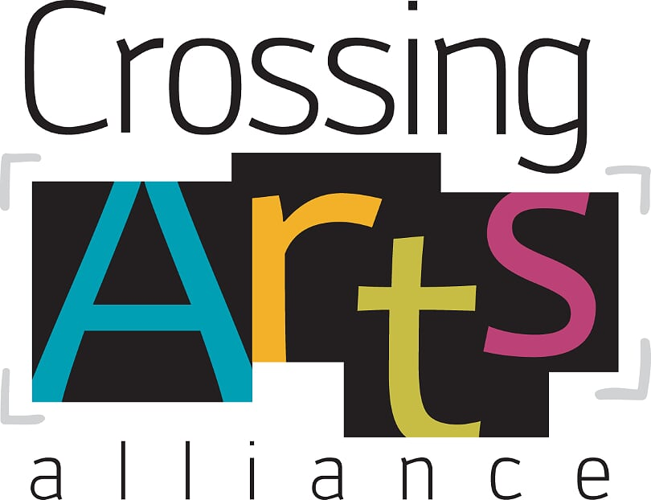

Artist Agreement

January 2022

**Artist Responsibilities:**

* The artist must be a member of The Crossing Arts Alliance in good standing.
* Artwork must be handmade of original design and the artists’ own work. Artist collaborations are allowed, however, one individual should be assigned as the primary point of contact and payment recipient.
* All artworks must be complete: canvas edges should be painted or be framed. Wall art should be ready to hang. Photography, prints and cards should be covered in appropriate size plastic sleeves.
* Each piece of artwork should be listed on an inventory sheet along with the retail price. Items that are similar and at the same price point will be grouped together at that price point.
* The retail price should include the 30% Crossing Arts Commission. The calculation for figuring out that price is to divide by .7 for example: In order to get $25 for a piece of artwork, it would need to be priced at 35.71 (You may round up or down at your discretion.) That is the price to write on your inventory.

**Price you want / .7 = Retail Price**

* If you are asked to pick up your work, please make an appointment to do so at your earliest convenience. We have extremely limited storage space. If your work is not picked up within a month of notification, and no other arrangements have been made, the work may become property of The Crossing Arts Alliance.
* Artists’ should consider insuring their work. The Crossing Arts Alliance will not be responsible for lost, stolen or damaged artwork, but will make every effort within reason to protect art from theft or damage.
* Artists may be asked to donate a piece of art to The Crossing Arts Alliance for fundraising purposes.

**Gift Shop Responsibilities:**

* Advertise sales hours through media, art events and Crossing Arts Membership.
* Provide point of purchase supplies such as bags, tissue and bubble wrap.
* Track inventory and sales,collect and pay sales tax as required, provide credit card services, pay card fees on all sales.
* Jury all work for appropriateness, quality, available space, marketability and uniqueness.
* Make every effort to protect art from theft or damage.
* Issue a check monthly from Crossing Arts for any work sold in the previous month, less 30% Crossing Arts Commission
* Arrange artists’ work in retail space to provide for most effective sales/marketing.

**Limits for Gift Shop Items**

Wall Art: 4-6 Small Pieces - (8x10 and smaller)

-Larger than 8x10- at the discretion of the gift shop staff

Pottery: 6 Mugs/5 Other -At the discretion of the gift shop staff

Prints: 6 Prints -Matted or on mounting board and in clear bags that fit the print

Jewelery: 20 Pieces -that must be on cards that fit our display racks and are large enough to put our barcode sticker onto

Cards: 30 cards -priced at a minimum of $4.00. Packs of cards will be counted as 1

Books: 5 Books

3D Pieces: Up to 5 -at the discretion of the gift shop staff.

Changes to the quantities of these guidelines will be up to the discretion of the Gift Shop Committee.

This Agreement will remain in effect until a new agreement is created and signed.

**I have read and understand The Crossing Arts Alliance Gift Shop Policy, Artist Responsibilities, Gift Shop Responsibilities and Limits for Gift Shop Work. I understand that I will be notified if the policy is changed for any reason. It is my choice whether to carry insurance on my works of art. I will not hold TCAA responsible for any lost, stolen, or damaged materials or works of art.**

Name_______________________________________________________

Email_______________________________________________________

Phone_________________________ Website______________________

May TCAA post your art for sale in the website store?

* Yes
* No