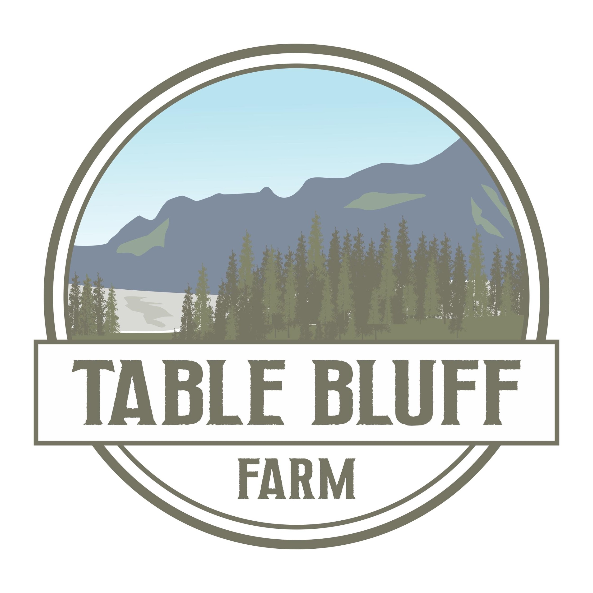
Table Bluff Farm ~ CSA Member Agreement

When you sign up for a CSA farm share at Table Bluff Farm, you are guaranteed wholesome, tasty freshness grown locally and regeneratively.

2022-23 Winter CSA Share Details
Please Read Carefully

- Length of Season: You are signing up and agreeing to pay for a weekly share for the 2022-23 season (from November 8 to March 29, or 20 weeks total, excluding the last week of December). However, we won’t charge you up front for the whole season like a traditional CSA does. It’s pay-as-you-go!

- What’s Included: For $20/week, get a seasonal variety of fresh veggies and other goodies (5-7 items per week). You’ll also have access to our online farm stand, where you can add on additional items like eggs, as available. Your weekly share will come in a reusable, collapsible, plastic Instacrate box that is sanitized in between uses. a weekly emailed newsletter with updates on the farm, the week’s share contents, and special announcements will be sent to you.

- Pick Up (or Delivery) Days, Times, & locations: You agree to pay for your weekly box on one of the following days for the entire 20-week season*:
- Doorstep Delivery on Tuesdays from 4:00–8:00 p.m. for members living in Fortuna, Eureka, Arcata, and McKinleyville (additional $5/week delivery fee)
- Pick up on Tuesdays & Wednesdays from 4:00–8:00 p.m. at the farm (101 Clough Road in Loleta)
- Pick up on Wednesdays from 4:30–6:30 p.m. at 2116 Harris Street in Eureka (our friend’s house)

*You may change your pick-up day/location with 3 days’ notice.

- Payment: Payment is due each week on or before your pick-up or delivery day. Accepted payment methods include: Credit cards or PayPal through our website, cash, Venmo, & checks (made payable to Table Bluff Farm). Bounced checks will incur a $25.00 fee. When possible, paying through our website is preferred to reduce our handling of your cards or cash. And signing up for autopay each week is even better!

- Vacation / Opt-Out days: We understand that you might not always be able to pick up your CSA share. You have 3 options when that happens: 1) You’re welcome to ask someone to pick it up for you, or 2) You can donate your box to our Pay It Forward program, giving it to someone in need, or 3) you can choose to opt out for 1 week in the season. We must have at least three days’ notice prior to your next pick-up/delivery day of your decision to opt out. Otherwise, you may forfeit that week’s box and be billed for the week.

- Cancellation: We understand that life happens and you might not be able to keep your CSA share. That’s A-OK! Just give us two weeks’ notice, pick up your boxes and pay for those remaining two weeks, and we’re good! That gives us enough time to find a replacement for your CSA share. If you cancel without giving two weeks’ notice, you will be billed for two remaining weeks while we find a replacement. you still have access to your share during those final two weeks. If you don’t show up without prior notice, we will assume that you have cancelled, and you will be billed for two weeks of shares.

Thank you for your support of local, regenerative food grown on a woman-owned farm!

Please complete the CSA agreement on the next page, then text an image or email a scan of the completed form to
707-890-6699 or info@tableblufffarm.com to sign up!

Table Bluff Farm Winter 2022-23 CSA Member Agreement

Member’s Name: __________________________________________

Member’s Mailing Address: ____________________________________________

City: ___________________ State: __CA__ ZIP: __________

Member’s Phone Number: ______________________ texts? (check one) __Y OR __N

Member’s E-Mail Address: __________________________________________
(one that you check weekly for our newsletter with recipes using the week’s contents)

Dietary Restrictions, Allergies, & preferences (vegetarian, gluten-free, no kale, love beets, etc.).
We will do our best to add a replacement item as available:

_________________________________________________________

Pick-Up/Delivery Day for the season (check one):

__ Pick up Tuesdays at the farm from 4-8 p.m.

__ Pick up Thursdays at the farm from 4-8 p.m.

__ Pick up Wednesdays at 2116 Harris St in Eureka from 4:30-6:30PM

__ Doorstep Delivery on Tuesdays from 4-8 p.m. for $5/week more (for those living in Fortuna, Eureka, Arcata, and McKinleyville). If this option is chosen, please include your physical address below or write “Same” if it’s the same as your mailing address.

________________________________________________________________________

I agree to the terms above. Namely, I agree to pay for one CSA share for the 2022-23 Winter CSA season. I understand that this CSA is “pay as you go” in that nothing is owed up front, but I am obligated to pay each week from November 8 through March 29 (20 weeks total, excluding the last week of December). I understand that I may be billed for up to two weeks of shares for cancelling without two weeks’ notice or failing to notify Table Bluff Farm of my inability to pick up. I understand that if I cancel with two weeks’ notice, I still have access to my shares for those remaining two weeks. I agree to use the Instacrate only for my weekly farm share and to pay $7.50 to replace it if I damage it.

_______________________________________________ ___________________
Member’s Signature Date

Please complete this CSA agreement, then text an image of the completed form to 707-890-6699 or email a scan of the completed form to info@tableblufffarm.com to sign up!

