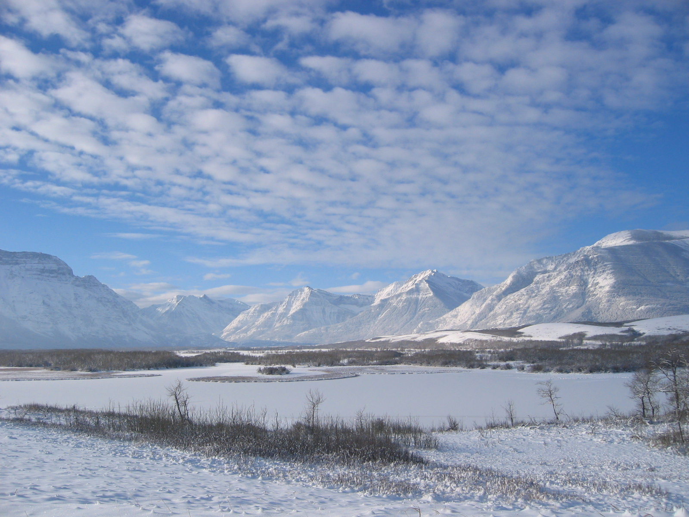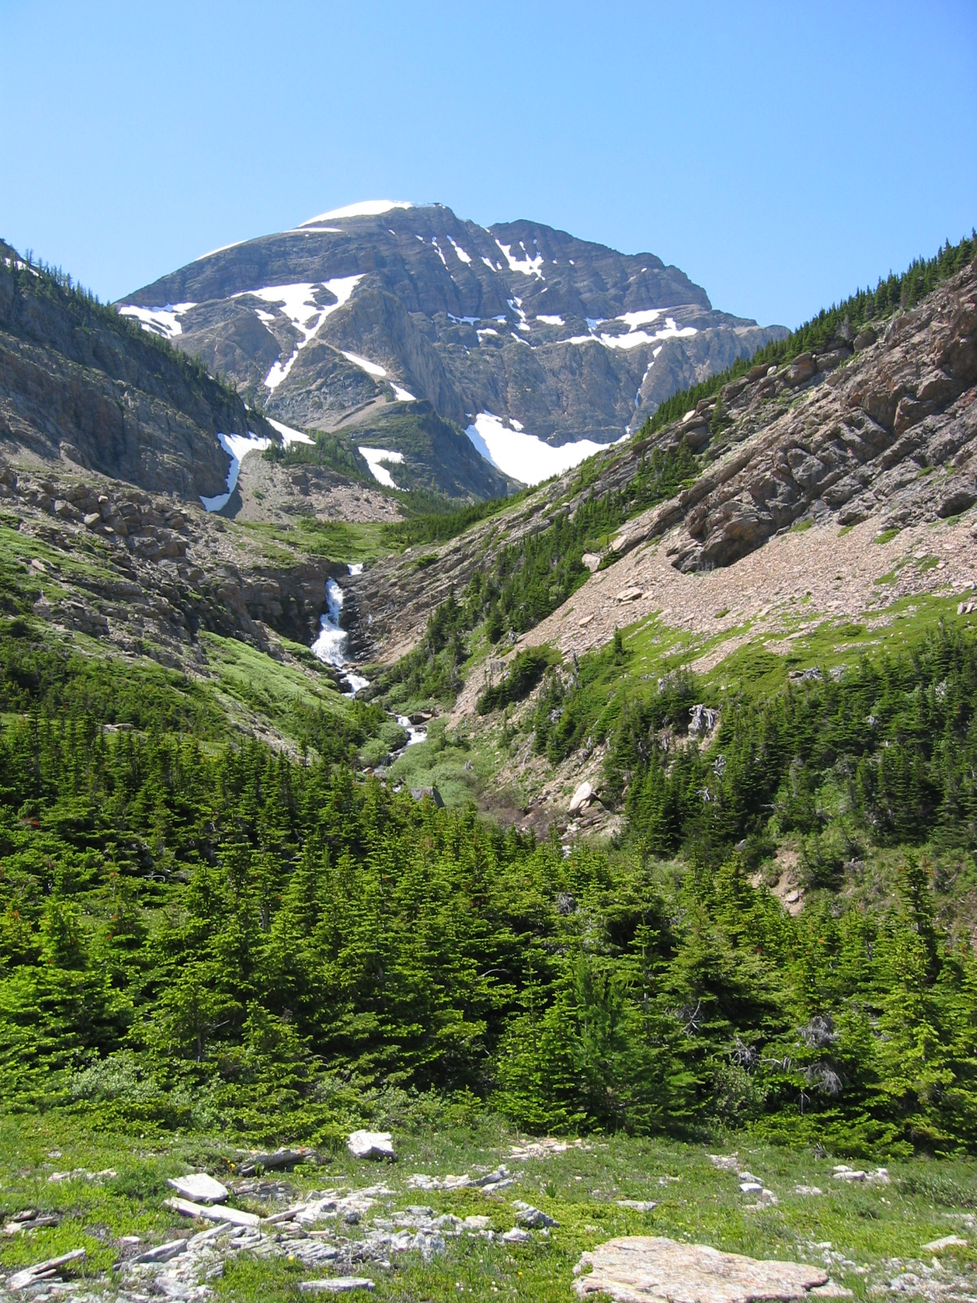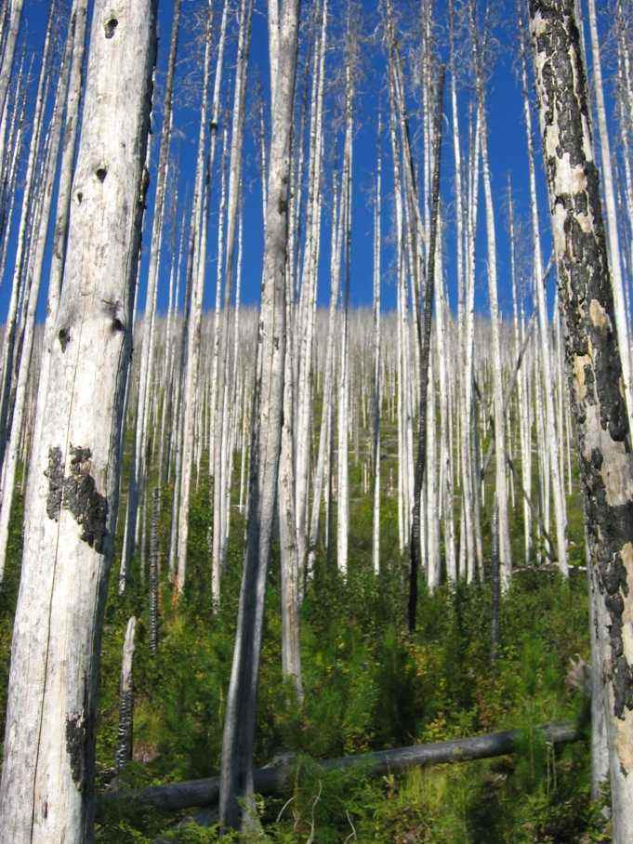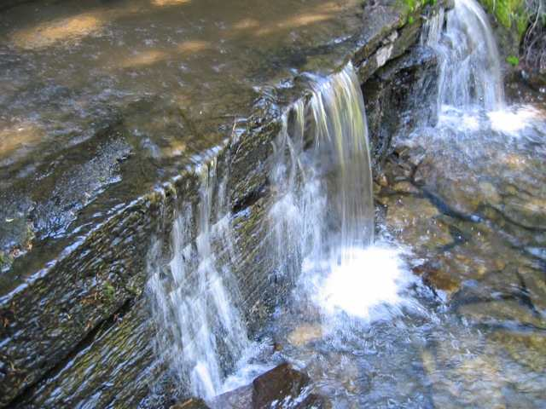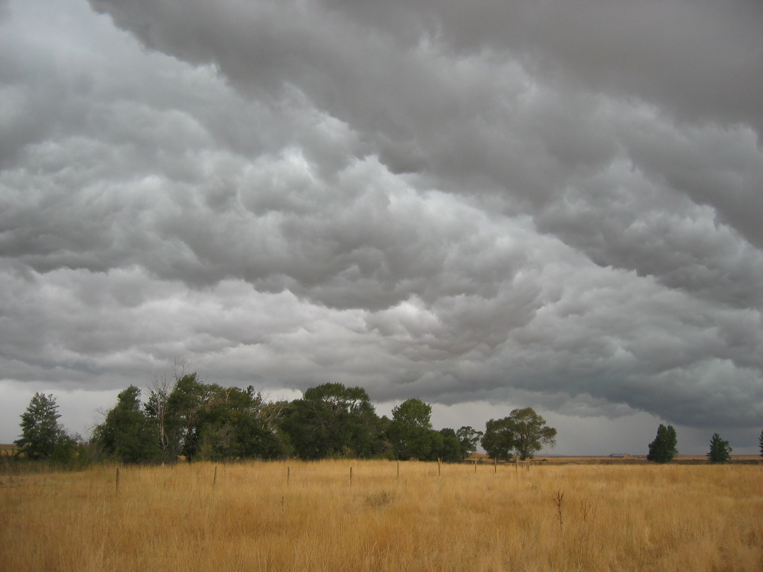

University of Missoula Campus, Missoula Montana

### March 17-19, 2014

### www.crownmanagers.org

ADAPTIVE MANAGEMENT FOR CLIMATE CHANGE IN the CROWN OF THE CONTINENT ECOSYSTEM

# Donec vitae tellus

2014 Crown Managers Partnership Forum